Original Research Article

Opportunities for the Development of Processed Tuna Products from Capture Fisheries Towards the International Market

.
ABSTRACT

Tuna fisheries are a strategic component of Indonesia’s capture fisheries, supported by substantial resources across the Indian Ocean, eastern Indonesian waters, and the Pacific Ocean. The catch is dominated by skipjack, yellowfin, and bigeye tuna, species that thrive in Indonesia’s warm and highly productive tropical waters shaped by strong currents and upwelling processes. These conditions have positioned Indonesia as one of the world’s leading tuna exporters. This study examines the potential and performance of processed tuna exports from the Cilacap Ocean Fishing Port, with a key role in supporting national fisheries exports. A descriptive approach was applied to analyze export volume and export value data for tuna products from 2020 to 2024. The data were processed using descriptive statistics and presented through tables, bar charts, and line graphs to illustrate export dynamics over time. The results indicate that PPS Cilacap exported 13 types of processed tuna products during the study period, with canned tuna and tuna pouches as the dominant products. Export composition showed marked fluctuations, with the highest level of product diversification occurring in 2021, followed by a reduction in product types and the absence of recorded processed tuna exports in 2024. Export volumes increased in 2021 and 2022 but declined sharply in 2023, with the downward trend continuing into 2024. This pattern reflects a broader decline in overall fisheries export performance at PPS Cilacap. The United States emerged as the primary destination for processed tuna exports. Although Indonesia remains competitive in fresh, frozen, and processed tuna markets, the processed tuna segment faces intense competition within an oligopolistic global market dominated by a limited number of major exporting countries. These findings underscore the need for more targeted strategies to enhance Indonesia’s competitiveness in the global processed tuna market.

Keywords: Cilacap, export, processed tuna product, production

1. INTRODUCTION

Tuna fisheries are among Indonesia's main potential sectors. Tuna resources are abundant across Indonesia, from the Indian Ocean (Nusa Tenggara, Bali, South Java, West Sumatra) to the eastern waters (Makassar, Flores, Banda, Arafura, Maluku, and Sulawesi Seas) and the Pacific Ocean (Pranowo et al., 2016; Rochman et al., 2015). Yellowfin (Thunnus albacares) and bigeye (Thunnus obesus) dominate the catch. Tuna primarily inhabit Indonesia's warm, nutrient-rich tropical waters, particularly areas with significant upwellings and strong currents, as these support their migration routes and high population levels (Zainuddin et al., 2015).

According to the FAO, Indonesia's tuna catches are quite high, dominated by skipjack tuna (Katsuwonus pelamis) at 52%, followed by yellowfin tuna (20%), bigeye tuna (15%), albacore tuna (11%), and southern bluefin tuna (1%) (Yosafat et al., 2025). These significant catches cater to the high demand from international markets. As a result, Indonesia has become one of the world's major exporters of skipjack and frigate tuna. The main export destinations for these commodities are Japan, the United States, and European Union countries (KKP, 2023).

One of the fishing ports near the Indian Ocean serving as a landing site for caught tuna is the Cilacap Ocean Fishing Port (PPS Cilacap). As a type A or ocean port, PPS Cilacap plays an important role in supporting fishery exports (Khoerunnisa et al. 2025). At this port, exported tuna products can include frozen, fresh, or processed forms, such as loin and fillet. These products from PPS Cilacap are primarily destined for the United States, Japan, and the European Union markets, thereby contributing to the country's foreign exchange up to USD 374.69 million (PPSC, 2024).

Exports of processed tuna from PPS Cilacap play a key role in the supply chain and can serve as a model for exporting this commodity from other fishing ports in Indonesia. Despite this, competitiveness needs to be enhanced for global export dominance. By using a descriptive approach based on port data, such as that available from PPS Cilacap, it is possible to identify value-added opportunities, address low export market share, and recommend sustainability strategies to maximize foreign exchange from processed tuna.

This study aims to identify the potential of processed tuna from capture fisheries for the international market. To achieve this aim, a descriptive approach and a fisheries database from the fishing port were used. The results are expected to provide recommendations for the development of Indonesia's processed tuna exports.

2. methodology

The research was conducted using fisheries statistical data from PPS Cilacap. The data used in this study were export data of processed tuna commodities from 2020 to 2024. The research location map is as follows (Figure 1).
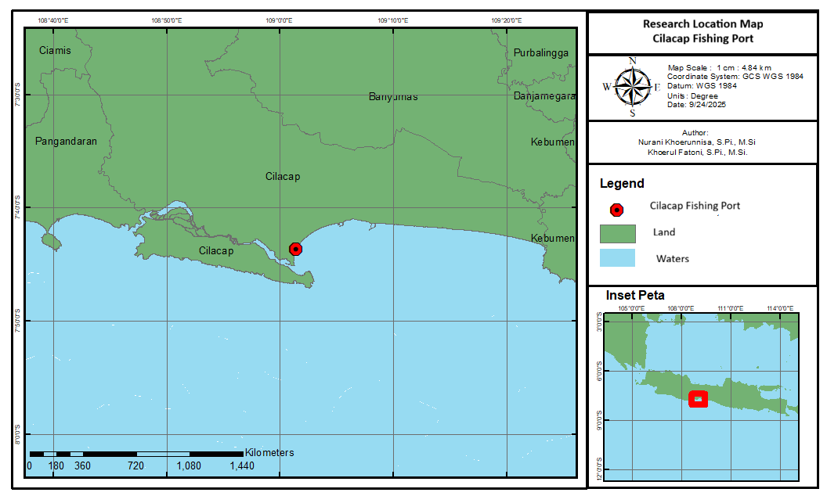
Fig. 1. Research location map, Cilacap Fishing Port

The data collected in this study are the volume and export value of tuna fishery commodities at PPS Cilacap from 2020 to 2024. The data were processed using descriptive statistics in tables, line charts, and bar charts. The analysis results are interpreted to show the performance of processed tuna exports at PPS Cilacap, to observe the potential for developing these commodity exports.

Following this overview of export destinations and considerations, the production volume data from 2020 to 2024 will be collected in Microsoft Excel and displayed in a bar chart to show trends across different processed tuna export products. Data on tuna processing types and destination countries will be compiled in a table to illustrate specific export preferences by country. Separately, production value data for each fish type from 2020 to 2024 will be visualized in a line chart, highlighting the economic trends and export developments over time.

3. results and discussion

The results of this study discuss the potential of processed tuna as an export commodity. This potential can be seen from the production volume, export market destinations, and the value of processed tuna products.

3.1 Export Production Volume of Processed Tuna

Tuna is a high-value export commodity from Indonesia. Tuna exports are usually handled by processing or deep-sea fishing companies based at oceanic fishing ports, which are the largest in Indonesia. One of these is the Cilacap Oceanic Fishing Port (PPS Cilacap). Tuna commodities at PPS Cilacap are exported in fresh, frozen, and processed forms. This study specifically focuses on processed tuna exported from PPS Cilacap, given the wide variety of processed products sent abroad. The volume of processed tuna exports from PPS Cilacap is shown in Figure 2.
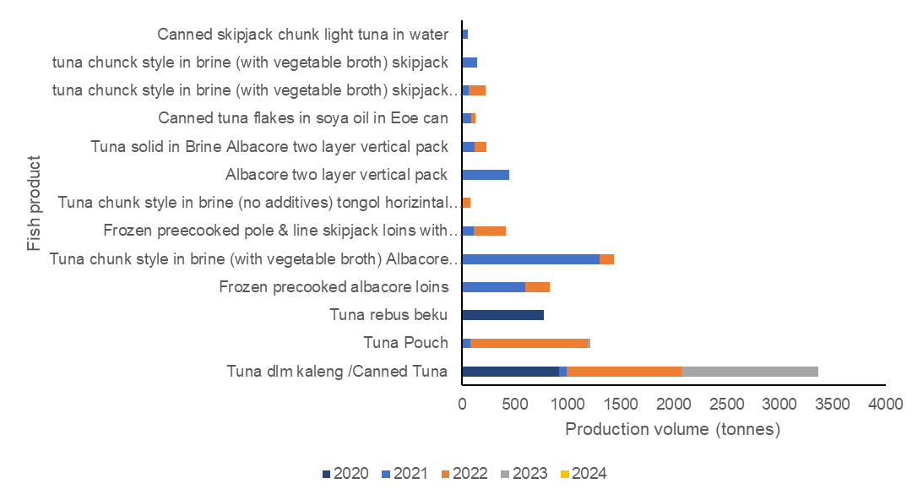
Fig. 2. Export production volume of processed tuna from PPS Cilacap in 2020-2024
Source: PPSC fisheries statistic 2020-2024 (with reprocessed data)

From 2020 to 2024, PPS Cilacap exported 13 types of tuna products: canned tuna, tuna pouch, frozen boiled tuna, frozen precooked albacore loins, tuna chunk style in brine (with vegetable broth) Albacore two-layer vertical pack, frozen precooked pole & line skipjack loins with flakes, tuna chunk style in brine with (no additives) tongol horizontal pack, Albacore two-layer vertical pack, tuna solid in brine Albacore two-layer vertical pack, canned tuna flakes in soybean oil EOE can, tuna chunk style in brine (with vegetable broth) skipjack two-layer vertical horizontal pack, tuna chunk style in brine (with vegetable broth) skipjack, and canned skipjack chunk light tuna in water.

The annual export composition of processed tuna from PPS Cilacap reveals key trends. In 2020, only canned and frozen boiled tuna were exported, with frozen boiled tuna discontinued thereafter. From 2020 to 2023, canned tuna remained the most consistently exported product. A notable diversification occurred in 2021, expanding to 12 export types without any frozen boiled tuna. In 2022, a few varieties were dropped, showing a narrowing focus. By 2023, exports concentrated on canned tuna and tuna pouches, and in 2024, no processed tuna exports were recorded.

The volume of tuna exports fluctuated from 2020 to 2024. Exports in 2021 increased by 1,401.782 tons from 2020. Similarly, in 2022, they increased by 164.699 tons from 2021. Meanwhile, in 2023, there was a decrease of 1,945.43 tons from 2021, and the decline continued in 2024.

This decline not only occurred in processed tuna exports but also in the average of all fishery product exports. According to PPS Cilacap data, the export volume from 2020 to 2024 decreased by an average of 1.27%, including fresh and frozen fish, with the highest export volume in 2022 at 3,877.38 tons (PPSC, 2024). Although several processed fish products declined, ribbonfish production actually increased. Export frozen ribbonfish production from 2020 to 2024 increased by 9.57%, from 660.17 tons in 2020 to 912.84 tons in 2024 (PPSC, 2024).

3.2 Export Market Destinations

Various processed tuna products from PPS Cilacap are exported to several countries. These export markets include the USA, Taiwan, and Thailand. The export destinations for processed tuna are shown in Table 1 below.

Table 1. Destination countries for tuna exports

Tuna Products | Export Destination Country
Canned Tuna | Taiwan
Tuna Pouch | USA
Tuna rebus beku | USA, Thailand
Frozen precooked albacore loins | USA
Tuna chunk style in brine (with vegetable broth) Albacore two-layer vertical pack | USA
Frozen precooked pole & line skipjack loins with available flakes | USA
Tuna chunk style in brine (no additives) tongol horizontal pack | Thailand
Albacore two-layer vertical pack | USA
Tuna solid in Brine Albacore two-layer vertical pack | USA
Canned tuna flakes in soya oil in Eoe can | Taiwan
Tuna chunk style in brine (with vegetable broth) skipjack two-layer vertical pack horizontal pack | USA
Tuna chunk style in brine (with vegetable broth) skipjack | USA, Thailand
Canned skipjack chunk light tuna in water | USA

Tuna products from Indonesia are marketed to international markets, including the United States, Taiwan, and Thailand, through exporting companies. Export fish commodities from Cilacap generally already have regular buyers. Several types of tuna and similar fish, such as skipjack tuna and longfin tuna, are exported through Jakarta in both fresh and frozen forms. Specifically, for fresh tuna commodities, the main export market is Japan (PPSC, 2024). In general, Indonesia has strong competitiveness in the global market for fresh, frozen, and processed tuna products (Suwarno et al., 2012).

Based on Table 1, the USA is the main export destination for processed tuna products from PPS Cilacap. This condition is suspected to be due to the relatively higher price of tuna in the USA compared to other countries. The high price is the main consideration for exporters, as it yields higher production value, making the USA the primary market for Indonesian tuna despite stricter export requirements (Arthatiani et al., 2020).

However, the full potential of capture fisheries has not yet been fully reflected in Indonesia's position as a tuna producer. In the ASEAN region, Indonesia is still ranked second after Thailand, influenced by differences in the level of resource exploitation, both in terms of production volume and the use of fishing gear technology (Putri et al., 2018). Thailand is the world's largest exporter of processed tuna, with a 46.75% market share, making it a dominant player in the global tuna trade (Lestari et al., 2013).

3.3 Export Production Value of Processed Tuna

The volume of tuna production and the countries of destination for tuna exports are related to the value of tuna production. The value of tuna production indicates the extent to which the price of processed tuna products contributes to the economy. The export value of processed tuna is shown in Figure 3.

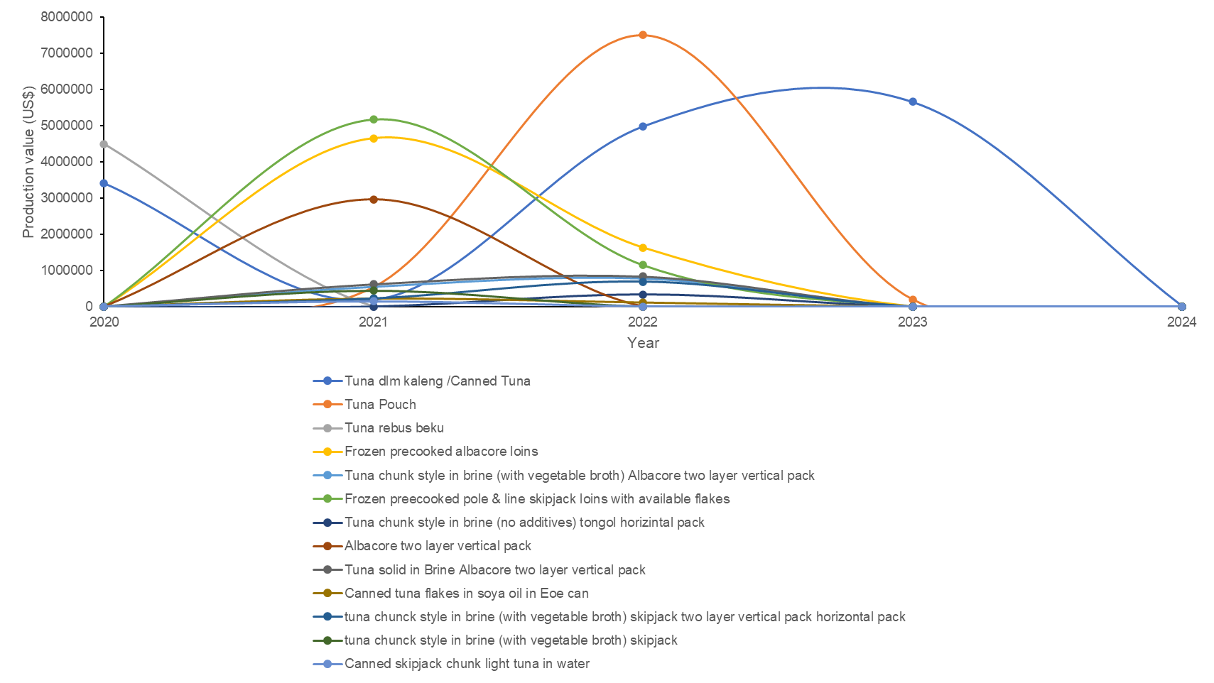

Fig. 3. Export production value of processed tuna at PPS Cilacap 2020-2024
Source: PPSC fisheries statistic 2020-2024 (with reprocessed data)

In terms of production volume, canned tuna exports contribute the highest production value at PPS Cilacap. Processed canned tuna has consistently remained an export product from 2020 to 2024, although its production value has been quite fluctuating. From 2020 to 2024, tuna pouches contributed the highest production value in 2022, reaching 7,503,795.17 US dollars. However, the production value of these tuna pouches decreased in 2023 and was not exported again until 2024. Meanwhile, boiled frozen tuna had the lowest production value, as it was only exported in 2020.

The fresh and frozen tuna markets tend to be characterized by perfect competition, with many business actors, relatively homogeneous products, and no price control by individual actors. In contrast, the processed tuna market is characterized by an oligopoly structure, in which trade is dominated by a small number of countries or large companies that exert strong influence over prices and market share (Osmaleli et al. 2023). This condition indicates that although the processed tuna market offers significant opportunities, the level of competition is much tighter than in the fresh and frozen tuna markets.

In this context, Indonesia needs to enhance the competitiveness of its processed tuna exports by developing appropriate strategies to survive and compete in the global processed tuna market. The export value of Indonesian tuna to destination countries is significantly influenced by tuna export prices, making price a key factor that requires serious attention. Therefore, the government has an important role in maintaining and managing tuna prices to remain competitive in the international market. The implications of these findings underscore the need for further research on sustainable tuna export management to enhance the economic benefits Indonesia gains.

4. Conclusion

The results indicate that PPS Cilacap has significant potential as a hub for processed tuna exports, particularly canned tuna products, which consistently generate the highest production value. However, the sharp decline in export volume and product diversity after 2022, culminating in the absence of processed tuna exports in 2024, signals structural challenges in competitiveness and market sustainability. The dominance of the United States as an export destination confirms the importance of price as a key determinant of export value, especially within an oligopolistic global processed tuna market. To enhance Indonesia’s position relative to leading exporters such as Thailand, strategic efforts are required to stabilize production, improve value addition, and maintain competitive pricing. Strengthening export-oriented processing capacity at fishing ports, supported by consistent government price and market policies, is essential. Further research on sustainable export management is needed to ensure that economic gains from processed tuna exports can be maintained and expanded over the long term.

References

Arthatiani, F. Y., Lusur, E. A., Suryawati, S. H., & Kurniawan, T. (2020). Journal of Marine and Fisheries Socioeconomics, 15(1), 69-82. http://dx.doi.org/10.15578/jsekp.v15i1.8343
Khoerunnisa, N., Aisyah, Fatoni, K. (2025). Optimization of frozen shrimp export commodity through correlation analysis of production volume and value at PPS Cilacap. Jurnal Pasir Laut, 9(2), 89-95. https://doi.org/10.14710/jpl.2025.77760
[KKP] Ministry of Marine Affairs and Fisheries. (2023). Indonesian fisheries export statistics. Jakarta: Ministry of Marine Affairs and Fisheries.
Lestari, W., Syarief, R. & Sumantadinata, K. (2013). Strategies to improve the competitiveness of Indonesian processed tuna in the international market. Agribusiness Forum, 8(1), 36-44.
Osmaleli, O., Hana, H., Tridoyo, K. (2023). What Market Structures and Factors Influencing Tuna Exports? (Case Study: Indonesia). BIO Web of Conferences MaCiFIC 2023, 70(06001), 1-8. https://doi.org/10.1051/bioconf/20237006001
[PPSC] Cilacap Ocean Fisheries Port. (2020). Fisheries Statistics 2020. Cilacap: Cilacap Ocean Fisheries Port.
[PPSC] Cilacap Ocean Fisheries Port. (2021). Fisheries Statistics 2021. Cilacap: Cilacap Ocean Fisheries Port. [PPSC] Cilacap Ocean Fishing Port. (2022). Fisheries Statistics 2022. Cilacap: Cilacap Ocean Fishing Port.
[PPSC] Cilacap Ocean Fishing Port. (2023). Fisheries Statistics 2023. Cilacap: Cilacap Ocean Fishing Port.
[PPSC] Cilacap Ocean Fishing Port. (2024). Fisheries Statistics 2024. Cilacap: Cilacap Ocean Fishing Port.
Pranowo, W. S., Kuswardani, A. R. T. D., Nugraha B., Novianto, D., Muawanah, U., Prihatno, H., & Yu, W. (2016). Ocean-climate interaction of South Eastern Indian Ocean for tuna fisheries & its socio-economy impacts. International Journal of Science and Research (IJSR), 5(4), 1956-1961.
Rahmansyah, R., Nuranini, C., Rofatin, B., & Mutolib, A. (2021). A Study of the Competitiveness of Indonesian Processed Tuna Export Products in the European Market. JSHP, 5(2), 180-189. https://doi.org/10.32487/jshp.v5i2.1154
Rochman, F., Nugraha, B., & Wujdi, A. (2015). Estimation of skipjack tuna (Katsuwonus pelamis, Linnaeus, 1758) population parameters in the Southern Indian Ocean of Java. Bawal Widya Riset Perikanan Tangkap, 7(140), 77–85.
Suwarno, Oktaviani, R., Siregar, H., Murniningtya, E. (2012). Competitive advantage and export supply of Indonesian tuna in the international market: constant market share analysis. Journal of Economics and Development Policy, 1(2), 120-143.
Yosafat, Y., Yusrudin, Sumaryam. (2025). Analysis of skipjack tuna (Katsuwonus pelamis) catch production in WPPNRI 572 landed at Nizam Zachman Ocean Fishing Port, Jakarta. Manfish: Scientific Journal of Fisheries and Livestock, 3(1), 339-354. https://doi.org/10.62951/manfish.v3i1.147
Zainuddin, M., Selamat, M. B., Ridwan, M., Hidayat, S., & Mallawa, A. (2015). Estimating total allowable catch and mapping potential fishing zones for tuna in the Flores Sea: A remote sensing-geographic information system perspective. Indonesian Journal of Ichthyology, 15(2), 129-141.

