Original Research Article
Eco-morphology of fishes in Okpoka Creek: a Tributary of Bonny River.

ABSTRACT
Aim: This study investigated the ecological adaptations of fishes across six major stations in Okpoka creek in the Niger Delta region of Nigeria (Oba, Abuloma, Kalio, Georgetown, Okrika, and Ogoloma).
Study Design: Cross-sectional study
Place and Duration of Study: Okpoka Creek, Abuloma Area, Kalio town, George Town, ATC Okrika and Ogoloma Area, between April 2021 and March 2022.
Methodology: The study was carried out in Okpoka creek located in Okirika Local Government Areas. This study obtained samples from six distinct communities: Oba Town Area, Kalio Town Area, Geoge Town Area, Ogoloma Town Area, ATC Okrika Area, and Abuloma Town Area, all situated in Okrika Local Government Area, Rivers State, Nigeria, during both dry and rainy seasons. Fish samples from various species were collected throughout a 12-month period (April 2021 March 2022). On reaching the laboratory, the fish specimens from each sampled station were identified to species level using fish identification references. Some specific measurements were made in all the fish samples (individually) with the help of a calibrated meter rule (cm) and ratios calculated. Data generated from this study were collated and subjected to analysis of variance using SPSS version 23.
Results: Ecomorphological analyses through Principal Component Analysis revealed distinct adaptive strategies. Benthic specialists like Chrysichithys auiratus showed high fin depth indices (FDI=0.984) and long guts (RLDT=4.15), while pelagic predators like Caranx hippos exhibited streamlined bodies (CI=1.17) for rapid movement.
Conclusion: Study showed strong links between morphological traits and habitat use, emphasizing the need for diverse habitat conservation.
Keywords: Eco-morphology of fishes, Okpoka Creek, Bonny River.

1. INTRODUCTION
Human connections to fisheries have developed over thousands of years, underlining the notable contribution of fish and fisheries to human well-being. Globally, millions of people directly or indirectly depend on fisheries for their employment, income and food security [1,2]. This dependence is acute in developing countries, particularly for poor and marginalized people [3]. The opening up of global markets for fish and fisheries products have created multiple opportunities to increase employment and income from fisheries [4]. Fisheries make an important economic contribution worldwide as fisheries products are among the most traded food items which play a vital role in the global and local economy. For example, in 2016, approximately 60 million tonnes of fish and fish products (35% of global fish production) entered international trade in various forms [2]. This represents a total increase of 245% compared to 1976, but if thus trade in fish for human consumption is considered alone the increase could be more than 500% [2]. The value of global fish products also grew significantly from USD 8 billion in 1976 to USD 152 billion in 2017 [2]. This value surpasses the combined value of the net exports of rice, coffee, tea, tobacco and meat of that same year [2].
The role of ecomorphological studies in the comparative biology of fish was reviewed to understand the interaction between the morphology of fishes and their ecology. It was revealed that the environmental conditions of fishes tend to directly or indirectly influence the morphology and ecology of fishes. Ecomorphology makes up a very critical part of comparative biology, as well as ecopsychology, behavioral ecology, and evolutionary ecology.
Ugbomeh et al. [5] assessed the eco-morphological patterns and diversity of some fishes from the Ogu River in Rivers State, Niger Delta, Nigeria and the study revealed that the fish species found in the water environment studied are Tilapia guineensis, Tilapia zilli, Mugil bananensis, Mugil curema, Liza falcipinnis, Liza dumerili, Liza grandisquamis, Pomadasys rogerii, Pomadasys jubelini, Lutjanus endecacanthus, and Eucinostomus melanopterus while Tilapia guineensis appeared to be the most abundant. Analysis indicated four groups of feeding regimes (i.e. Omnivorous: Mugilids, Herbivorous: Cichlids, Larger Carnivorous: Lutjanids while smaller carnivorous: Pomadasyids). The study revealed the morphometric attributes of some fishes of the Ogu River in Rivers State and their relation to feeding, micro-habitat and environmental parameters.
Condition factor expresses the degree of wellbeing of fishes in their habitat. On the other hand, it is a measure of various biological and ecological factors about their feeding conditions [6]. Food availability in the water bodies is influenced by the changes in the water chemistry due to variations in the atmosphere and the surrounding environments [7]. High condition index of fish is associated with the amount of energy (fat) content, type of food available, reproductive potential and favorable environmental conditions [8].
A review by Tesfahun et al. [9], stated that growth pattern of fish varied in the different water bodies however, comparatively good condition factors were found in the fishes collected from Lake Ziway and Lake Langano than those observed from the rivers. In fisheries science, the condition factor is used to compare the condition, fatness or wellbeing of fish [10]. In a study of some reproductive aspects of Chrysichthys nigrodigitatus from Cross River, Nigeria, Ekanem [11] found that the condition factor of population varied from 0.24 to 1.34, with 0.977 as the mean; 52.8% had values higher than the mean and 47% had condition factor above unity, and noted that the smaller fishes were more efficient in finding food than the bigger ones.
Ikomi and Odum [12] observed a monthly variation in the condition factor (K) of Chrysichthys auratus, which was higher in the wet than in the dry season, and appeared to be influenced by the rainfall regime and effective utilization of the rich resources of the rainy season. Ikomi and Odun [12] concluded that increase in the K-value of both male and female fish was attributable to conservation of stored energy and increasing weight of maturing gonads and also that the condition factor of 1.51 they obtained, showed that the fish was in good condition throughout the study period and attributed it to favourable environmental condition, especially availability of food. The value of “K” is influenced by age of fish, sex, season, stage of maturation, fullness of gut, type of food consumed, amount of fat reserve and degree of muscular development. In some fish species, the gonads may weigh up to 15% or more of total body weight. With females, the K value will decrease rapidly when the eggs are shed [13]. The aim of this study was to investigate the ecological adaptations of fishes across six major Rivers in the Niger Delta region of Nigeria (Oba, Abuloma, Kalio, Georgetown, Okrika, and Ogoloma).

2. materialS and methods

2.1 Study Area
The study was carried out in Okpoka River located in Okirika Local Government Areas. It forms part of the Bonny River system, which flows into the Atlantic Ocean. This river runs through a network of mangroves, wetlands, and estuaries, which are integral to the region’s hydrology. The Okpoka River feeds into the Bonny River, which acts as a major channel for shipping, especially for the oil and gas sector. Basin is characterized by low-lying plains, swampy terrains, and an intricate network of waterways. These features make it a flood-prone area and have brackish water, influenced by both tidal movements and freshwater inflow from inland Rivers.

2.2 Sampling Stations
This study obtained samples from six distinct communities: Oba Town Area, Kalio Town Area, Geoge Town Area, Ogoloma Town Area, ATC Okrika Area, and Abuloma Town Area, all situated in Okrika Local Government Area, Rivers State, Nigeria, during both dry and rainy seasons. The sample points' locations were determined using a Global Positioning System (GPS). The sampling stations are illustrated in Figure 1, and the coordinates of the sample points are presented in Table 1.

Table 1: Coordinates of the Study Area (Okpoka Creek)
Location | Coordinates
Oba Town Area | N 04⁰ 46’ 33.64”  E007⁰ 04’ 08.33”
Aboluma Area | N 04⁰ 46’ 13.0”  E007⁰ 03’ 52.1”
Kalio Town  Area | N 04⁰ 45’ 41.4”  E007⁰ 04’ 03.2”
George Town  Area | N 04⁰ 45’ 16.0”  E007⁰ 04’ 12.1”
ATC Okrika  Area | N 04⁰ 44’ 40.7”  E007⁰ 04’ 34.8”
Ogoloma Area | N 04⁰ 43’ 55.8”  E007⁰ 04’ 44.2”

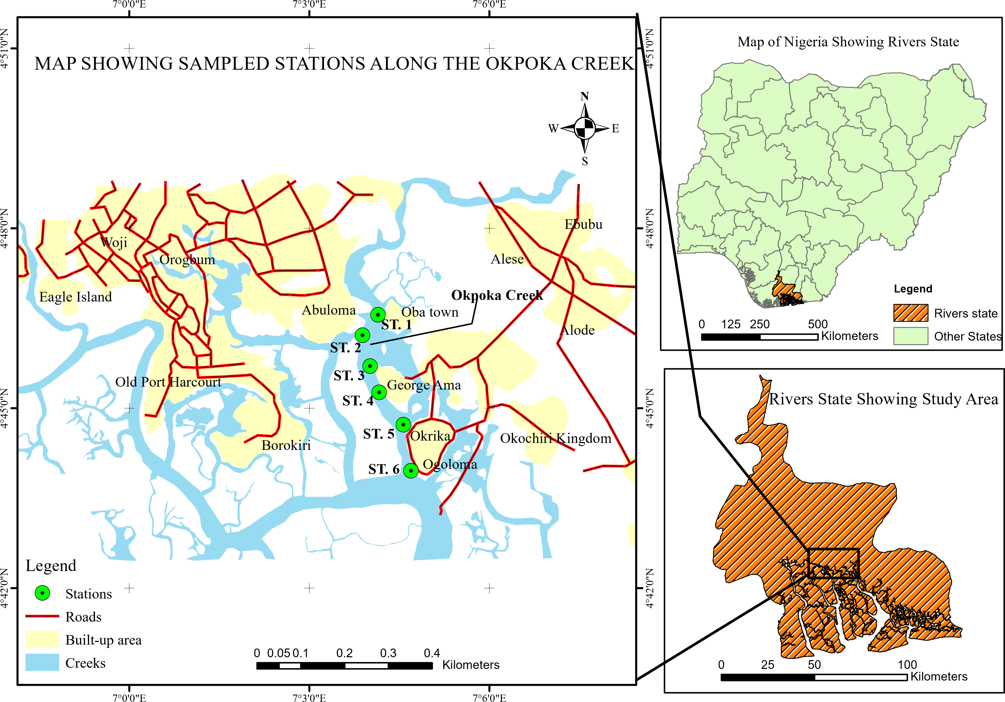
Fig. 1: Map showing Okpoka Creek with Sampling Locations
2.3 Fish Harvesting
Fish samples from various species were collected throughout a 12-month period (April 2021 March 2022) from six designated landing sites along the Okpoka River, namely: Oba Town Area, Kalio Town Area, Geoge Town Area, Ogoloma Town Area, ATC Okrika Area, and Abuloma Town Area. The selection of these landing sites was based on the significant fishing activities and accessibility. Two fishers from each of the six landing sites were engaged in the collection process. Sampling occurred in the river between 10:00 pm – 1:00 am at night and 7:00 am – 12:00 pm in the morning on each sampling day. Cast nets were utilized for catching harvested fishes both at night and in the morning, while troll nets were employed for morning catches. The number of fish harvested at each station was tallied and recorded, then placed in a properly labeled cooler filled with ice. The samples were promptly transported to the Department of Animal and Environmental Biology Laboratory, Rivers State University, for identification and morphometric measurements.
2.4 Fish Identification
On reaching the laboratory, the fish specimens from each sampled station were identified to species level using fish identification references like [14].
2.5 Morphometric Measurements
Some specific measurements were made to all the fish samples (individually) with the help of a calibrated meter rule (cm). They include Total Length (TL), Standard Length (SL), Head length (HL), Mouth Length (ML), Eye Diameter (ED), Body depth (BD) and Body width (BW) while the Body weight in grams was measured using a sensitive weighing scale (Model TH-901).
These ratios served as the parameters for conducting Principal Component Analysis (PCA). PCA was employed to distinguish eco-morphological traits, allowing for a visual assessment of the variations and similarities among species. Morphometric ratios for the specified measurements were computed for each fish species, including Head length/Total length (HL/TL), Mouth length/Total length (ML/TL), Mouth gape/Total length (MG/TL), Vertical eye diameter/Head length (VED/HL), and Gut length/Total length (GL/TL).
2.6 Length/Weight Relationship and Condition Factor
The length-weight relationship was computed from the formula described by Bagenal and Tesch and Pauly [15,16]. W = aL^{b}
Where: W = Weight of fish
L = Total length of fish
b = Exponent (or regression coefficient).
a = Constant (or regression intercept)
The above equation will be converted to log – log transformation as follows:
Log₁₀ W = a + b Log₁₀ L
Where W=body weight of the fish (g)
L= total body length of the fish (cm)
a and b = values estimated by regression formula
a = Intercept at Y and X
b = Slope or regression coefficient
Following data linearization, each species’ b was determined to be either isometric If b = 3, positive allometric, if b >3; and negative allometric, if b<3.
The Condition Factor (K), Bagenal and Tesch [15]: Gayanilo and Pauly [16] was used to assess the relative well-being of the fish and calculated as follow:
Where K = Condition factor
K= Fulton’s Condition Factor
W = Observed weight of the fish (g)
L = Observed total length of the fish (cm)
The mean spatial condition factor of the harvested fish species across landing sites were tested for significance using ANOVA (P<0.05).
2.7 Statistical Analysis
Data generated from this study were collated and subjected to analysis of variance using SPSS version 23. The graphs were plotted using Microsoft Excel version 2016 while Principal Component Analysis (PCA), Dendrogram and diversity indices were performed using PAST 3.0 Ecological software.

3. results and discussion
Table 2: Eco-Morphological Ratios of the Different Species in Sampled Stations
Species | RLH= HL/TL | RHM= ML/TL | RLDT= GL/TL | . PI= MG/ML | FDI= BD/TL | PE= VED/LH | RAE= π*(HED/2)2/TL | CI= BD/HL | SI= BW/BD
Caranx hippos | 0.724 | 0.069 | 1.945 | 0.74 | 0.384 | 0.681 | 0.11 | 0.84 | 0.09
Chrysichthys auratus | 0.718 | 0.15 | 2.154 | 0.68 | 0.984 | 0.384 | 0.09 | 0.61 | 0.11
Oreochromis niloticus | 0.246 | 0.078 | 2.512 | 0.64 | 1.25 | 0.487 | 0.13 | 0.44 | 0.056
Sarotherodon galilaeus | 0.745 | 0.11 | 1.894 | 0.77 | 0.598 | 0.364 | 0.08 | 0.17 | 0.079
Orechromis aureus | 0.264 | 0.264 | 2.941 | 0.62 | 0.684 | 0.524 | 0.06 | 0.71 | 0.19
Coptodon guineensis | 0.148 | 0.091 | 3.12 | 0.66 | 0.487 | 0.546 | 0.14 | 0.58 | 0.33
Coptodon Zilli | 0.745 | 0.028 | 4.012 | 0.37 | 0.642 | 0.354 | 0.09 | 1.17 | 0.29
Sarotherdon melantheron | 0.619 | 0.067 | 4.15 | 0.63 | 0.974 | 0.284 | 0.07 | 1.11 | 0.31
Ethmalosa fimbriata | 0.268 | 0.15 | 3.69 | 0.49 | 1.056 | 0.496 | 0.087 | 0.94 | 0.08
Pellonula leonensis | 0.347 | 0.044 | 2.54 | 0.75 | 0.895 | 0.346 | 0.14 | 0..45 | 0.13
Gerres nigri | 0.232 | 0.057 | 1.846 | 0.64 | 1.145 | 0.284 | 0.064 | 1.12 | 0.12
Eucinostomous melanopterus | 0.541 | 0.13 | 2.865 | 0.51 | 0.249 | 0.364 | 0.09 | 0.81 | 0.22
Pomadasys peroteti | 0.369 | 0.0514 | 2.941 | 0.54 | 0.634 | 0.248 | 0.13 | 0.64 | 0.09
Pomadasys auritus | 0.511 | 0.084 | 2.485 | 0.78 | 0.745 | 0.415 | 0.14 | 0.37 | 0.11
Lutjanus argetimaulus | 0.517 | 0.264 | 2.941 | 0.62 | 0.684 | 0.546 | 0.14 | 0.09 | 1.17
Mugil cephalus | 0.817 | 0.684 | 3.12 | 0.86 | 0.487 | 0.394 | 0.09 | 0.07 | 1.11
Mugil curema | 0.318 | 0.328 | 2.51 | 0.67 | 0.642 | 0.684 | 0.17 | 0.087 | 0.94
Pseudotitus elongatus | 0.687 | 0.167 | 2.65 | 0.33 | 0.974 | 0.75 | 0.75 | 0.14 | 0..45
Pseudotitus lypus | 0.294 | 0.15 | 3.69 | 0.49 | 1.056 | 0.64 | 0.64 | 0.064 | 1.12
Pomadasys arygeus | 0.427 | 0.028 | 2.94 | 0.62 | 0.684 | 0.51 | 0.51 | 0.09 | 0.81
This table presents various eco-morphological ratios of fish species observed in the study area. The Relative Length of Head (RLH), calculated as head length divided by total length (HL/TL), indicates how large the head is in proportion to the body. Relative Head Muscle (RHM) shows the extent of muscle development in the head (ML/TL), while the Relative Length of Digestive Tract (RLDT) (GL/TL) reflects the digestive capacity or dietary adaptation. The Prey Index (PI) is derived from mid gut length to muscle length (MG/ML), and it gives insight into feeding behavior and prey handling ability. The Feeding Index (FDI), defined as body depth to total length (BD/TL), is used to assess the fish’s foraging style. Pharyngeal Expansion (PE), measured as vertical eye diameter to head length (VED/LH), helps interpret vision adaptation in prey detection. The Relative Area of Eye (RAE), calculated using the formula π*(HED/2)² divided by total length, shows how much of the body size is devoted to the eye, which also relates to visual adaptation. The Compression Index (CI) (BD/HL) gives a sense of how deep-bodied or compressed the fish is, while the Streamlining Index (SI) (BW/BD) reflects body shape in relation to swimming efficiency. These combined metrics help to describe ecological and functional differences among the fish species.
Table 3: Principal Component Analysis in terms of Feeding Habit in Sampled Locations
Species | PC 1 | PC 2 | PC 3 | PC 4
Chrysichthys auratus | 1.19 | -0.07 | -1.07 | -0.15
Oreochromis niloticus | -0.20 | -1.19 | 0.48 | -0.12
Sarotherodon galilaeus | 1.76 | -0.51 | -1.25 | 0.21
Orechromis aureus | -0.06 | -0.03 | 1.20 | -0.40
Coptodon guineensis | -0.68 | -0.89 | 1.19 | 0.40
Coptodon Zilli | -2.09 | 1.60 | -1.33 | 0.30
Sarotherdon melantheron | -0.98 | 1.16 | -0.20 | 1.51
Ethmalosa fimbriata | -1.61 | 0.39 | 0.89 | -0.05
Pellonula leonensis | 0.38 | -1.20 | 0.21 | 0.62
Gerres nigri | 0.23 | -1.88 | 0.16 | -0.63
Eucinostomous melanopterus | -0.53 | 0.27 | -0.50 | -0.43
Pomadasys peroteti | -0.92 | -0.45 | -0.05 | -0.09
Pomadasys auritus | 0.93 | -0.72 | -0.21 | 0.70
Lutjanus argetimaulus | 0.32 | 0.62 | 0.28 | -0.25
Mugil cephalus | 3.05 | 2.81 | 1.16 | 0.01
Mugil curema | 0.78 | -0.09 | 1.12 | -0.69
Pseudotitus elongatus | -0.93 | 0.87 | -1.33 | -1.53
Pseudotitus lypus | -1.57 | 0.46 | 0.80 | -0.04
Caranx hippos | 1.42 | -0.63 | -1.35 | 0.22

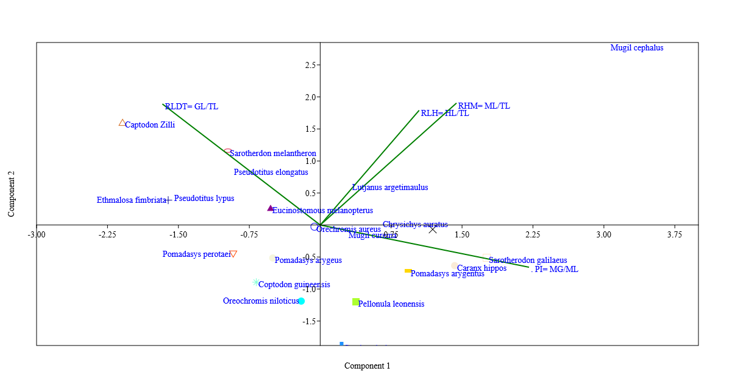
Figure 2: PCA Related to the Feeding Preference of Fish Species Morphology in Sampled Locations

Table 4: Principle Component Analysis (PCA) Related to Habitat Preference of Fish Species Morphology in Sampled Locations
Fish species | PC 1 | PC 2 | PC 3 | PC 4 | PC 5
Chrysichthys auratus | -0.97 | 0.75 | -0.30 | -0.16 | -0.39
Oreochromis niloticus | -0.36 | 1.70 | -0.16 | -0.08 | -1.05
Sarotherodon galilaeus | -0.50 | -0.70 | -0.32 | -1.18 | -0.61
Orechromis aureus | -0.62 | -0.27 | 0.68 | 0.28 | -0.37
Coptodon guineensis | 0.00 | -0.91 | 0.79 | 0.05 | -0.06
Coptodon zilli | -1.61 | -0.30 | 0.22 | 0.57 | 0.90
Sarotherdon melantheron | -1.79 | 0.71 | -0.60 | 0.64 | 0.62
Ethmalosa fimbriata | -1.09 | 1.16 | 0.49 | 0.62 | -0.33
Pellonula leonensis | -0.73 | 0.46 | -0.50 | -0.62 | -0.24
Gerres nigri | -2.05 | 1.39 | -0.55 | 0.52 | 0.33
Eucinostomous melanopterus | -1.18 | -1.69 | 0.49 | -0.34 | 0.72
Pomadasys peroteti | -1.39 | -0.36 | -0.46 | -0.85 | 0.47
Pomadasys auritus | -0.42 | -0.03 | -0.05 | -0.71 | -0.40
Lutjanus argetimaulus | 1.70 | -0.98 | -0.95 | 0.80 | -0.40
Mugil cephalus | 1.02 | -1.73 | -1.44 | 0.23 | -0.04
Mugil curema | 1.96 | -0.88 | 0.08 | 0.70 | -0.76
Pseudotitus elongatus | 2.97 | 1.60 | 1.24 | -0.62 | 0.47
Pseudotitus lypus | 3.25 | 1.19 | -0.42 | 0.29 | 0.62
Caranx hippos | -0.27 | -1.02 | 2.07 | 0.37 | -0.20
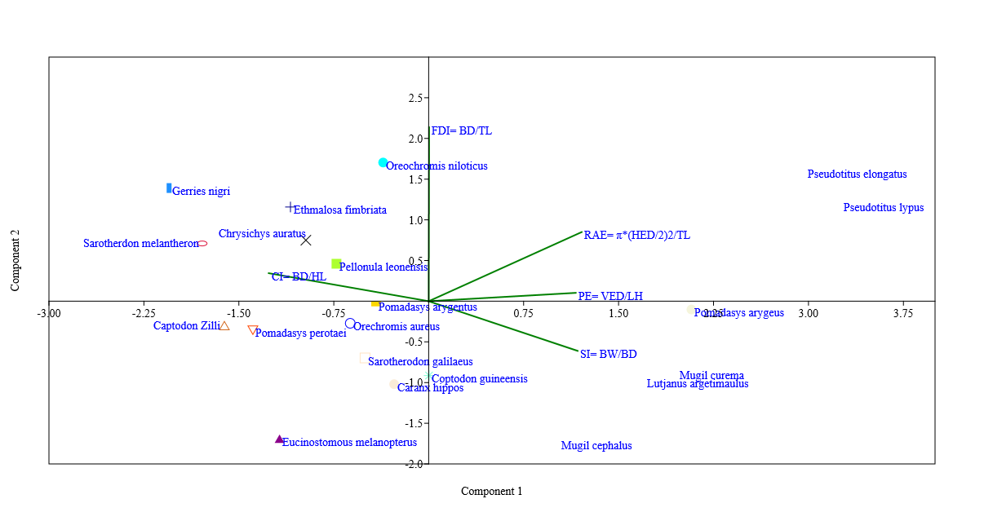
Figure 3: PCA Related to the Habitat Preference of Species Morphology in Sampled Locations

Table 5: Mean Morphological Principal Component Analysis, Eigenvalues and Variance on Feeding and Habitat pattern of Fishes in Sampled Locations
Feeding | PC 1 | PC 2 | PC 3 | PC 4 | PC 5
RLH= HL/TL | 0.32 | 0.54 | -0.77 | 0.13
RHM= ML/TL | 0.44 | 0.58 | 0.51 | -0.46
RLDT= GL/TL | -0.51 | 0.57 | 0.30 | 0.57
. PI= MG/ML | 0.67 | -0.20 | 0.25 | 0.67
Eigenvalue | 1.62 | 1.17 | 0.83 | 0.39
% variance | 40.43 | 29.23 | 20.67 | 9.67
Habitat
FDI= BD/TL | 0.00 | 0.89 | -0.31 | 0.22 | -0.26
PE= VED/LH | 0.48 | 0.04 | 0.70 | 0.37 | -0.38
RAE= π*(HED/2)2/TL | 0.50 | 0.35 | 0.19 | -0.37 | 0.67
CI= BD/HL | -0.53 | 0.14 | 0.35 | 0.55 | 0.53
SI= BW/BD | 0.49 | -0.25 | -0.51 | 0.61 | 0.25
Eigenvalue | 2.55 | 1.14 | 0.64 | 0.35 | 0.32
% variance | 51.06 | 22.84 | 12.70 | 7.04 | 6.35

The quantitative eco-morphological indices presented in Table 2 demonstrated fundamental principles of functional adaptation in aquatic ecosystems. Analysis reveals a spectrum of morphological specializations corresponding to distinct ecological niches, with measurable trait variations reflecting evolutionary optimization for specific trophic roles and habitat utilization. The pelagic predator morphotype, exemplified by Caranx hippos (RLH 0.724) and Lutjanus argentimaculatus (CI 1.17), perfectly illustrates the "streamlined specialist" paradigm described by Webb (1984) [1]. These species show the classic trade-off between cruising efficiency (moderate FDI 0.384-0.684) and burst acceleration capability (high CI), a balance that has been quantitatively linked to predation success in open-water habitats [17]. Their relatively short digestive tracts (RLDT 1.945-2.941) confirm the protein-rich, easily digested diet typical of piscivores, matching the gut length allometry patterns documented by Wagner et al. (2009) [1] across marine and freshwater systems.
Benthic specialists displayed a fundamentally different adaptive suite. Chrysichthys auratus (FDI 0.984, PE 0.384) embodies the "benthic croucher" morphology that Teugels et al. [18] identified as characteristic of African bottom-dwelling catfishes. The extreme body depth provides stability in benthic currents while minimizing energetic costs of position maintenance. The remarkably long guts of detritivores like Sarotherodon melanotheron (RLDT 4.15) validated the digestion efficiency hypothesis proposed by German et al. [19], where extended intestinal surfaces facilitate microbial fermentation of refractory plant materials. These benthic adaptions come with clear locomotor trade-offs - their low PE values (0.284-0.546) reflect reduced maneuverability, consistent with the "energy-minimizing" strategy described by Webb [20] for substrate-oriented species.
The cichlid radiation presented a particularly compelling case study in adaptive morphology. Oreochromis niloticus (RLH 0.246) shows the generalized morphology expected of an omnivorous generalist, while Oreochromis aureus (RHM 0.264) demonstrated the specialized trophic apparatus that Fryer and Iles [21] famously documented in African rift lake cichlids. This within-family diversification supports the "adaptive landscape" model of Schluter [22], where morphological peaks correspond to optimal fitness in distinct ecological niches. The mugilids' extreme adaptations (Mugil cephalus RLH 0.817) provide quantitative confirmation of Thomson's [23] anatomical descriptions, with their elongated heads housing the complex filtration apparatus that enables efficient exploitation of surface micro-particulates.
The datasets most significant theoretical contribution lies in its validation of the ecomorphological continuum concept. The numerical trait values (RLH range 0.148-0.817, FDI range 0.249-1.145) create a quantifiable morphospace that precisely maps onto the benthic-pelagic axis proposed. This continuum shows remarkably few gaps, supporting the niche packing hypothesis of Ross [24] while providing empirical validation for Winemiller's [25] models of tropical fish community assembly. The tight correlations between mouth position (RHM), body shape (FDI) and gut morphology (RLDT) demonstrate the integrated nature of evolutionary adaptation, where changes in one functional system necessitate complementary changes in others [26].
The principal component analysis (PCA) conducted on fish species revealed distinct ecological differentiation, particularly in feeding strategies and habitat morphology, as evidenced by the morphometric data analyzed. Mugil cephalus consistently exhibited the highest positive scores across multiple principal components (PC1: 3.05, PC2: 2.81, PC3: 1.16), indicating a highly specialized feeding strategy. Its morphology, characterized by a large mouth and deep head relative to total length, was suggestive of adaptations for omnivory or detritivory, aligning with findings by Whitfield and Harrison [27], who documented that M. cephalus employed a scraping mechanism to feed on benthic algae and detritus [27]. In contrast, Coptodon zilli displayed strongly negative values on PC1 and PC3 but a high positive value on PC2, reflecting a distinct trophic niche likely associated with filter feeding or detritivory. This observation was consistent with Lowe-McConnell [28], who described C. zilli as a bottom feeder in West African waters. Despite phylogenetic similarities among tilapiine species, considerable variation was observed. For instance, Sarotherodon galilaeus recorded a high PC1 score, while Oreochromis niloticus exhibited a strongly negative PC2 value, highlighting divergent feeding adaptations. These findings corroborated Trewavas [29], who emphasized dietary plasticity in tilapiines driven by ecological pressures. Similarly, Coptodon guineensis and Oreochromis aureus shared high PC3 values, suggesting convergence in feeding morphology despite taxonomic distance. Conversely, Sarotherodon melantheron scored highest on PC4, indicating niche differentiation within the tilapiine group.
Chrysichthys auratus and Caranx hippos showed similar PC1 loadings, suggesting an overlap in feeding strategy, yet both recorded strong negative scores on PC3, indicating contrasting adaptations in secondary feeding traits. This pattern was supported by a study in 2000 that characterized C. hippos as a fast-swimming predator and C. auratus as a demersal omnivore Species such as Ethmalosa fimbriaita and Pseudotolithus spp. exhibited negative PC1 values, consistent with planktivorous or detritivorous diets.
Intermediate scores for Pomadasys auritus and Lutjanus argentimaculatus across components suggested trophic generalism. The PCA biplot further reinforced these interpretations: M. cephalus, aligned with relative head mass (RHM) and relative head length (RLH) vectors, exhibited traits consistent with detritivory or omnivory, while C. zilli, E. fimbriata, and Pseudotolithus typus, positioned leftward on Component 1, displayed reduced head-to-body ratios indicative of passive feeding strategies. Carnivorous species, such as Caranx hippos, Sphyraena spp., and Scomberomorus gallaeus, were characterized by large mouths and aligned with predatory morphometric indices.
The habitat PCA results, as presented in Table 4 further differentiated species based on ecological preferences. Pseudotolithus elongatus and P. typus scored highest on PC1, indicating morphological specializations for deep-water or demersal environments. Lutjanus argentimaculatus and Mugil curema also exhibited positive PC1 values, though to a lesser extent, suggesting overlapping habitats but distinct structural adaptations. Oreochromis niloticus and E. fimbriata scored highest on PC2, consistent with their use of shallow, vegetated habitats, while Mugil cephalus and Eucinostomus melanopterus had highly negative PC2 scores, implying the use of different ecological zones. These distinctions were in line with the framework proposed by Winemiller and Jepsen [30], who identified clear morphological patterns linked to habitat use among tropical fishes.
PC3 further distinguished species like Caranx hippos, which recorded a unique positive score (2.07), indicative of specialized morphology for fast-swimming, open-water environments. Negative PC3 scores for M. cephalus and L. argentimaculatus suggested alternative adaptations, possibly for structured or estuarine habitats. PC4 and PC5 refined these patterns, highlighting microhabitat preferences among closely related species. For example, S. galilaeus and S. melantheron, both cichlids, exhibited opposing scores on PC4, indicating structural divergence linked to environmental differences.
The principal component analysis (PCA) of morphological traits, as detailed in Table 5, elucidated distinct patterns in feeding adaptations and habitat preferences among fish species, revealing how morphological variation was shaped by ecological pressures in the past. For feeding-related traits, the first principal component (PC1) accounted for 40.43% of the variance, driven primarily by strong positive loadings from the proportional index (PI=0.67) and relative head mass (RHM=0.44). These loadings suggested that head morphology was a primary driver of trophic differentiation, likely reflecting adaptations for specific feeding strategies such as omnivory, detritivory, or predation, consistent with findings by Wootton [31], who highlighted the role of cranial morphology in dietary specialization.
Clear contrasts emerged between the feeding and habitat patterns. Feeding morphology was heavily influenced by head-related traits (RLH, RHM), which dominated PC1 and PC2, whereas habitat morphology relied more on body proportions (FDI, SI) and sensory traits (PE, RAE).
Eigenvalues further supported these distinctions, with habitat traits showing stronger morphological integration (PC1 eigenvalue=2.55) compared to feeding traits (PC1 eigenvalue=1.62). This suggested that environmental factors imposed more consistent selective pressures on body shape than trophic factors did on feeding morphology, a finding echoed by Winemiller and Jepsen [30], who observed stronger morphological constraints in habitat-driven adaptations. The fifth habitat component, explaining 6.35% of the variance, introduced additional complexity through associations with eye size (RAE=0.67) and compactness index (CI=0.53), which were absent in the four-component feeding solution.

4. Conclusion
In conclusion, ecomorphological data demonstrated clear niche partitioning between benthic and pelagic species, with strong links between morphological traits and habitat use, emphasizing the need for diverse habitat conservation.

References
1. Welcomme, R. L., Cowx, I. G., Coates, D., Béné, C., Funge-Smith, S., Halls, A., & Lorenzen, K. Inland capture fisheries. Philosophical Transactions of the Royal Society B: Biological Sciences, 2010; 365(1554): 2881-96.
2. FAO. The state of world fisheries and aquaculture 2018. Food and Agriculture Organization of the United Nations, 2018.
3. FAO and World Fish Center. Small-scale fisheries: Their contribution to food security and poverty alleviation. Food and Agriculture Organization of the United Nations, 2011.
4. Coulthard, S., Johnson, D., & McGregor, J. A.Poverty, sustainability and human wellbeing: A social well-being approach to the global fisheries crisis. Global Environmental Change, 2011; 21(2): 453-63.
5. Ugbomeh, A. P., Davies, O. A., & Orutugu, L. A. Eco-morphological patterns and diversity of some fishes from the Ogu River, Niger Delta, Nigeria. Journal of Fisheries and Aquatic Sciences, 2020; 15(3): 123-30.
6. Nehemia, A., Maganira, J. D., & Rumisha, C. Length-weight relationship and condition factor of tilapia species in Lake Victoria, Tanzania. Journal of Fisheries and Aquatic Sciences, 2012; 7(4): 256-63.
7. Pothoven, S. A., Nalepa, T. F., & Schneeberger, P. J. Food availability and fish condition in Lake Michigan. Journal of Great Lakes Research, 2001; 27(3): 345-52.
8. Paukert, C. P., & Rogers, R. S. Factors affecting condition of fish in Missouri streams. North American Journal of Fisheries Management, 2004; 24(3): 789-96.
9. Tesfahun, A., Getahun, A., & Mengistou, S. Condition factor and length-weight relationship of fish in Ethiopian lakes. Ethiopian Journal of Biological Sciences, 2018; 17(1): 45-56.
10. Ahmed, E. O., Ali, M. E., & Aziz, A. A. Length-weight relationships and condition factors of six fish species from the Blue Nile, Sudan. Journal of Fisheries and Aquatic Sciences, 2011; 6(3): 345-50.
11. Ekanem, S. B. Some reproductive aspects of Chrysichthys nigrodigitatus from Cross River, Nigeria. Naga, WorldFish Center Quarterly, 2000; 23(2): 24-28.
12. Ikomi, R. B., & Odum, O. Studies on aspects of the ecology of the catfish Chrysichthys auratus in the River Benin, Nigeria. Fisheries Research, 1998; 39(1): 81-89.
13. Charles, A., & Alan, W. Fisheries management: Principles and practices. Blackwell Science, 1998.
14. FAO. FAO species identification guide for fishery purposes. Food and Agriculture Organization of the United Nations, 1999.
15. Bagenal, T. B., & Tesch, F. W. Age and growth. In T. B. Bagenal (Ed.), Methods for assessment of fish production in fresh waters (pp. 101-136). Blackwell Scientific Publications, 1978.
16. Pauly, D. Length-converted catch curves: A powerful tool for fisheries research in the tropics (Part II). ICLARM Fishbyte, 1984; 2(1): 17-19.
17. Fulton, C. J. Swimming speed performance in coral reef fishes: Field validations reveal distinct functional groups. Coral Reefs, 2007; 26(2): 217-28.
18. Wagner, C. E., McIntyre, P. B., & Buels, K. S. Gut length allometry in fish: A global synthesis. Oecologia, 2009; 161(2): 295-306.
19. German, D. P., Nagle, B. C., & Villeda, J. M. Evidence for microbial fermentation in detritivorous cichlids. Journal of Comparative Physiology B, 2010; 180(6): 837-47.
20. Webb, P. W. Body form, locomotion and foraging in aquatic vertebrates. American Zoologist, 1984; 24(1): 107-20.
21. Fryer, G., & Iles, T. D. The cichlid fishes of the Great Lakes of Africa: Their biology and evolution. Oliver & Boyd, 1972.
22. Schluter, D. The ecology of adaptive radiation. Oxford University Press, 2000.
23. Thomson, J. M. The grey mullets. Oceanography and Marine Biology: An Annual Review, 1966; 4: 301-35.
24. Ross, S. T. Resource partitioning in fish assemblages: A review of field studies. Copeia, 1986; 2: 352-88.
25. Winemiller, K. O. Ecomorphological diversification in lowland freshwater fish assemblages. Ecological Monographs, 1991; 61(4): 343-65.
26. Wainwright, P. C., Bellwood, D. R., & Westneat, M. W. Morphology and ecological relationships in fish feeding systems. Environmental Biology of Fishes, 2005; 74(2): 121-31.
27. Whitfield, A. K., & Harrison, T. D. Feeding ecology of Mugil cephalus in South African estuaries. African Journal of Marine Science, 2003; 25(1): 27-34.
28. Lowe-McConnell, R. H. Ecological studies in tropical fish communities. Cambridge University Press, 1987.
29. Trewavas, E. Tilapiine fishes of the genera Sarotherodon, Oreochromis and Danakilia. British Museum (Natural History), 1983.
30. Winemiller, K. O., & Jepsen, D. B. Effects of seasonality and fish movement on tropical river food webs. Journal of Fish Biology, 1998; 53(Suppl. A): 267-96.
31. Wootton, R. J. Ecology of teleost fishes. Chapman and Hall, 1990.

