Education, Identity, and Management: A Critical Review of Saraswati Shishu Vidya Mandirs in Odisha

Abstract
This article explores the unique educational style practised in Saraswati Shishu Vidya Mandirs (SSVMs) in Odisha and how their teaching methods, management structure, and cultural focus influence students’ learning. These schools, operating under the Vidya Bharati or Shiksha Vikash Samiti network, follow a holistic model where regular academic subjects are combined with yoga, moral and patriotic lessons, Sanskrit, and various co-curricular activities aimed at building discipline and national pride. The management is quite structured, guided by state-level committees that shape curriculum choices and value-based goals. Because of this organized system, many reports note that SSVM students often perform well academically and show strong discipline, something widely appreciated by teachers and parents.
At the same time, a few scholars point out that the strong cultural and ideological orientation of these schools may limit students’ exposure to wider cultural diversity. They argue that the emphasis on one set of values could affect social inclusion and shape identity formation in a particular way. This review brings together existing research to present both the strengths and the concerns, reflecting on how SSVMs try to balance academic outcomes with the broader effects of their value-driven educational philosophy.
Keywords: Saraswati Shishu Vidya Mandir, pedagogy, school management, cultural education, educational philosophy.
1. Introduction
Saraswati Shishu Vidya Mandirs (SSVMs) in Odisha form a major part of the Vidya Bharati schooling network, which was started to provide an alternate kind of education shaped mostly by Hindu cultural ideas and national values(Sarkar, 2022). Under the guidance of the Shiksha Vikash Samiti (SVS), these schools try to build children’s learning with a mix of discipline, patriotism, and traditional ways of living. Since the first SSVM opened in Bhubaneswar in 1977, the network has spread to many places across the state, and over time, students from these schools gained a name for doing pretty well in board examinations. Teachers and parents often point to this as a sign that the schools really focus on quality academics(Idnani, 2021).
But learning in SSVMs is not just about books and exams. Cultural and value-based activities play a big role in daily school life. Children learn Sanskrit, sing devotional and patriotic songs, begin their mornings with prayer and yoga, and actively take part in many cultural events all through the year. The school philosophy says a child should not only gain academic knowledge but also grow with discipline, cultural roots, and a kind of emotional connection with the nation. Many mission statements mention that children are “protectors of culture and tradition,” showing how serious the schools are about shaping character(Sarkar, 2022).
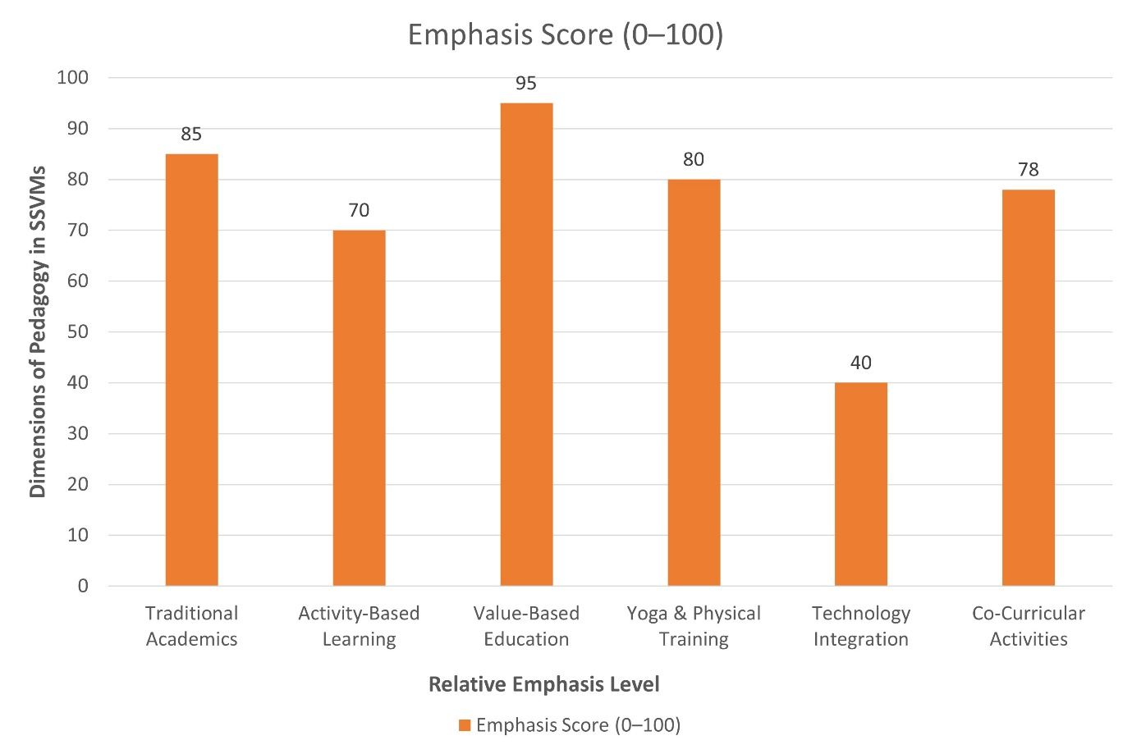
Figure 1. Column chart showing the emphasis levels of major pedagogical components in SSVMs, highlighting a strong focus on value-based education and traditional academics.
This review tries to understand how these different parts—teaching methods, management style, and cultural focus—affect the overall experience of students. It also looks at what parents, teachers, and observers feel about the impact of SSVM education on children’s personality and academic success. Since the schools combine formal subjects with cultural learning, it is important to know whether students feel this mixture is helpful, motivating, or, at times, maybe a little restrictive for them(Sarkar, 1994). To support this analysis, Table 1 has been added, which compares the major pedagogical components used in SSVMs. Along with that, the column chart shown above visually presents the emphasis score for each component, like how value-based education and traditional academics stand much higher compared to technology use(Sundar, 2004). By connecting classroom practices with the broader cultural aims, the introduction sets the base for discussing how SSVMs shape the educational landscape in Odisha and the kind of future citizens they are trying to prepare(Ball, 2006).
Table 1: Comparing Key Pedagogical Components in SSVMs, Odisha
Pedagogical Component | Description in SSVMs | Level of Emphasis
Traditional Academics | Standard subjects taught with structured lesson plans; strong focus on discipline and exam preparation. | High
Activity-Based Learning | Group discussions, use of science kits, charts, TLM corners; hands-on learning encouraged but varies by school. | Moderate–High
Value-Based Education | Moral stories, patriotic lessons, Sanskrit chanting, devotional songs, cultural assemblies. | Very High
Physical & Yoga Training | Daily yoga, drills, meditation, and physical exercise form part of the routine. | High
Technology Integration | Projectors, digital tools, and multimedia are used in some schools, but not consistently. | Low–Moderate
Co-Curricular Activities | NCC, music, dance, cultural programs, and community service for character development. | High

2. Literature Review
Studies on Vidya Bharati schools offer a clear picture of what SSVMs try to do and how they work in real practice. Many researchers describe these schools as places that aim to build a kind of national education rooted in Hindu cultural ideas. In Odisha, SSVMs often highlight that they are different from ordinary government or private schools because they mix classroom subjects with yoga, moral teaching, storytelling, patriotic songs and physical exercises(Dash et al., 2018). Teachers commonly use charts, maps, science kits and simple hands-on materials to make lessons more active. Many classrooms even keep small corners full of TLMs, which students can use during lessons. All these things suggest that SSVMs try not to depend only on lecture-based teaching but look for more active and engaging methods(Sarkar, 1994).
Some surveys with teachers, principals and parents show that group discussions, activity-based tasks, and lesson-diary planning are regularly used in SSVMs. Parents often notice that their children participate in group work and feel that such activities help their learning. Teachers also mention that they use different methods, although modern tools like projectors or digital screens are still less commonly used(Sarkar, 1994). So, while SSVMs do encourage student-centred learning to some extent, technology integration is still slowly developing. This contrast is also visible in the pie chart, where activity-based learning and technology show much smaller shares compared to value-based and cultural elements(Ball, 2006; Sundar, 2004).
Beyond the classroom, SSVMs place very strong emphasis on cultural and value-based education. Case studies from Odisha describe a highly disciplined environment where students learn punctuality, respect, and spiritual habits through daily routines and sometimes even hostel life(Ball, 2006). Students join physical and cultural programs like NCC, music, Sanskrit shloka competitions, and yoga sessions. These are not just extra activities but are used to build confidence, character, and patriotic feelings. In short, the teaching model mixes academics with cultural identity formation, emotional development and spiritual learning(Dash et al., 2018). This also matches the pie chart, where value-based education occupies the largest portion, showing how central this aspect is to the whole schooling experience.
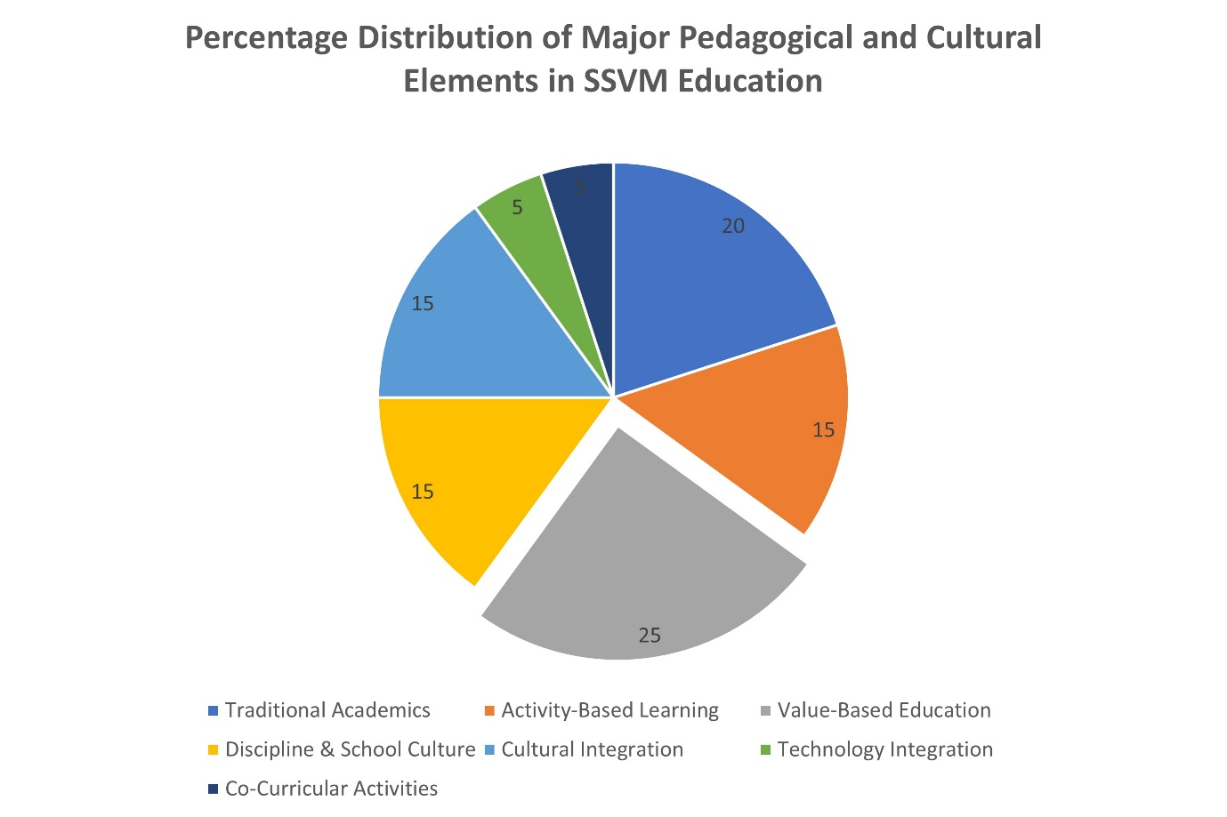
Figure 2. Distribution of key educational components in SSVMs.
The management system of SSVMs is also quite structured. The national body provides the overall vision, while the state-level committee in Odisha handles the direct management of schools(Ball, 2003). Each school has its own local committee, but it follows the guidelines set by the higher levels. Curriculum planning, teacher training and other major decisions usually flow from the top, so the whole system maintains a certain uniformity(Dey, 2025). Teachers are expected to follow both academic requirements and the cultural aims of the organisation. Even though many SSVMs show strong academic results, some comparisons with other model schools note that teaching quality sometimes varies, especially when it comes to modern infrastructure or updated pedagogy(Iwanek, 2015).
The cultural side of SSVM education is perhaps the most widely discussed. The organisation clearly states that education should be rooted in Indian and Hindu cultural values, and this is reflected everywhere—in classroom walls, textbooks, assemblies, and special celebrations. Students learn about national heroes, traditional knowledge, Sanskrit verses, and patriotic duties. Festivals and national events are celebrated with a lot of enthusiasm(Biswas, 2020). Many former students say these experiences shaped their personal identity in deep ways. The pie chart highlights this strong cultural presence, as cultural integration and discipline together form a large part of the overall educational environment(Manjrekar, 2011).
At the same time, some scholars express concerns. They feel the value-based system may sometimes be too uniform and might not fully support cultural diversity, especially for tribal or minority students(Dey, 2025). Local languages or customs may receive less importance when compared to the dominant cultural framework. This creates a tension: while supporters believe SSVMs preserve culture and build strong character, critics worry that the system might unintentionally limit pluralism. The mid-range percentage of “Inclusivity / Cultural Diversity” in the pie chart also reflects this mixed situation—it is neither too high nor too low, suggesting an area where improvement may be needed(Manjrekar, 2011).
Recent discussions also point out that children’s experiences can differ based on their home environment. Students who grow up with similar cultural practices may adjust easily, while others might need more time or support(Biswas, 2020). The factors behind this difference are shown clearly in Table 2, which highlights how things like home culture, language background, teacher mentoring, and the school’s value-based routines influence how students settle into the SSVM system. Teachers try to address these gaps through mentoring, festival participation, and value-based storytelling, though the results vary from child to child(Dash et al., 2018). Overall, the literature shows that SSVMs create a vibrant but sometimes debated form of cultural schooling, where academics and cultural shaping are closely connected(Dash et al., 2022). The table helps make this variation more visible, just like the pie chart earlier showed how different components share space in the SSVM model(Gupta et al., 2018).
Table 2: Variation in Student Experience in SSVMs
Factor | Description | Impact on Students
Home Cultural Background | Similarities or differences between school values and family traditions | Smooth adjustment for some; slower or difficult for others
Language & Community Context | Students’ mother tongue, tribal identity, or local cultural practices | May create cultural or linguistic gaps during early schooling
Teacher Mentorship | Guidance through storytelling, moral talks, and festival participation | Helps many students adjust; effectiveness differs school to school
School Cultural Activities | Yoga, prayers, Sanskrit chanting, patriotic songs, festival celebrations | Builds confidence & identity; some students may feel cultural pressure
Value-Based School Environment | Strict discipline, moral expectations, and shared cultural routines | Encourages discipline; limits space for individual expression sometimes

3. Analysis and Discussion
3.1. Pedagogical Practices.
SSVMs in Odisha follow a mix of regular academic teaching and value-based methods, which together create a pretty unique classroom environment. Most classrooms are known for being quite disciplined, as the schools place a strong focus on student behaviour and overall conduct(Froerer, 2007). Teachers often use different kinds of teaching aids like charts, maps, globes, simple science kits, and small TLM corners that help make learning more hands-on. Many classrooms try to involve students through group discussions and small activities, and parents often say that these group discussions really help their children understand lessons better(Idnani, 2021). Experiments and demonstrations, especially in science and math, are also a regular part of the teaching style, giving students a chance to see things more practically. However, when it comes to technology, things are a bit uneven. Some schools use projectors and multimedia tools often, while others barely use them, mostly because of limited resources or a lack of proper training(Joshee, 2024).
Beyond academics, the daily routine in SSVMs carries a strong cultural and physical training component. A normal school day might begin with a morning prayer, flag hoisting, and yoga practice. Physical drills, simple meditation, and breathing exercises are quite common too. Moral lessons are usually taught through storytelling, small incidents from mythology, and recitations of patriotic or inspirational poems(Goyal, 2009). Music and Sanskrit classes are built into many school schedules, showing the system’s attempt to keep traditional learning alive. Co-curricular groups—like NCC units, cultural groups, or sports teams—are not just for fun, but are used by the school to teach discipline, teamwork, and a sense of service(Goyal, 2009). In some schools where hostel facilities exist, students continue to learn values even after class hours through shared living, community tasks, and evening prayers, which extend the school’s discipline and cultural training throughout the day(Patra, 2023).
Teachers in SSVMs are expected to follow this holistic approach closely. They often attend training camps where they learn the teaching style, cultural expectations, and some traditional methods that the organisation encourages(Patra, 2023). Using lesson diaries and preparing structured lesson plans are part of their routine. Principals, often called Pradhan Acharyas, meet with the broader leadership to maintain consistency across schools(Sarkar, 2022). Over the years, many SSVMs have recorded high pass percentages and strong results in state-level exams, which suggests that the overall system does support academic success. Even so, some comparisons with newer and more resource-rich model schools show that SSVMs may still have a little room to improve, especially in terms of more modern teaching tools or updated teaching techniques. Still, the combination of strict discipline, cultural grounding, and regular academics seems to give SSVM students a strong learning foundation(Kingdon, 2020).
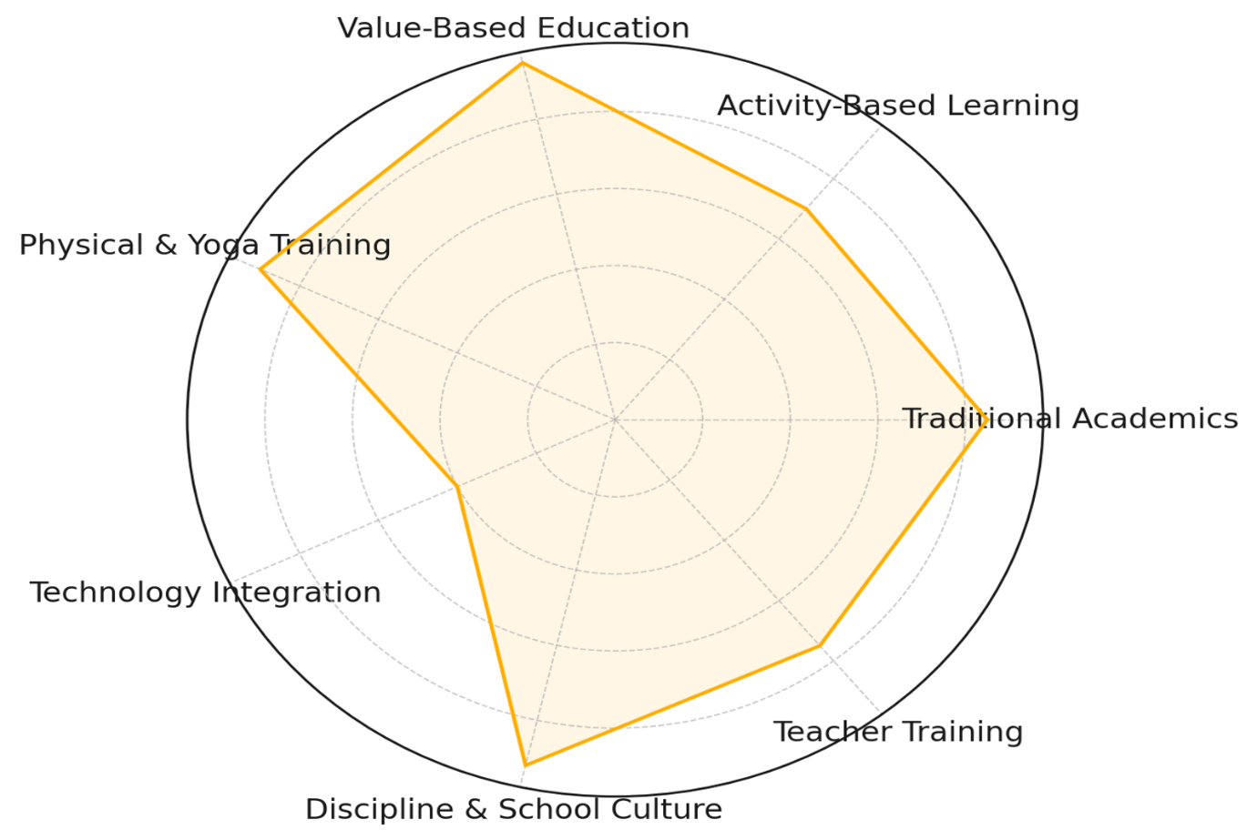
Figure 3. Radar chart showing emphasis on key pedagogical dimensions in SSVMs.
The emphasis placed on different teaching and cultural elements in SSVMs becomes clearer when viewed through a combined graphical approach(Idnani, 2021). The Pedagogical Emphasis Radar Chart highlights how value-based education, discipline, physical training, and traditional academics receive the highest attention, while activity-based learning and technology show moderate and lower emphasis(Mahapatra, 2024). Alongside this, the Daily Routine Flow Diagram visually presents how these elements appear in the everyday school schedule—from morning prayer and yoga to academic classes, Sanskrit lessons, and co-curricular participation. Together, these two visuals help explain how SSVMs blend academics with cultural and physical training to create their unique educational environment(Anand et al., 2022).
3.2. Academic Management
3.3. Cultural Implications
The cultural aims of SSVMs are very clear and openly practised. The school philosophy strongly believes that culture, values, and national pride should be an active part of day-to-day education. This means the curriculum mixes academic subjects with lessons about heritage, traditions, and ideas drawn from Indian scriptures or moral stories(Srinivas, 1956). In social studies or language classes, children often learn about national heroes, values like duty and courage, and stories meant to build character. School celebrations highlight major festivals, local traditions, and national occasions. Many students also get involved in cultural performances, prayers, or Sanskrit chanting, which makes the school environment feel strongly rooted in Indian traditions(Apple et al., 2004).
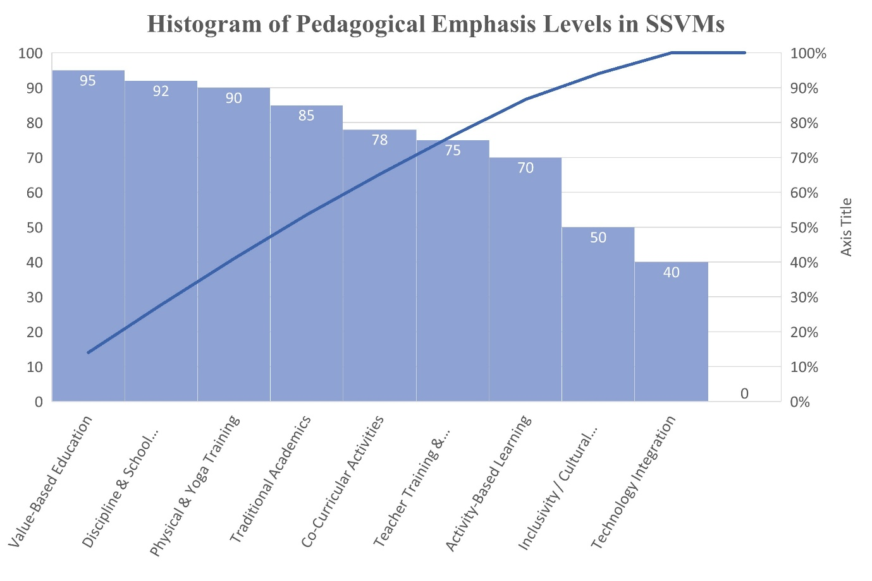
Figure 4. Radar chart showing emphasis on key pedagogical dimensions in SSVMs.

This approach has both positive and complicated effects. Many students benefit from a strong sense of identity and moral direction(Iwanek, 2022; Siege, 2022). They learn respect, discipline, and service-mindedness, and they grow up with pride in their culture and community. Supporters of the system often say that SSVMs provide spiritual grounding at a time when modern education sometimes feels too materialistic. They argue that the schools help young people stay connected to their roots, especially in areas where cultural values are slowly fading(Siege, 2022).
At the same time, critics worry that the worldview presented in these schools may be too uniform and not inclusive enough(Siege, 2022). Since most of the cultural teaching is based on one major tradition, children from minority backgrounds or different belief systems may feel uncomfortable or pressured to follow something that does not belong to their own family culture. Some teachers do try to bridge this gap by encouraging all students to participate in festivals and value education in a broad way, but the underlying ideology is still very dominant. Another concern is about academic balance(Iwanek, 2022). Time spent on rituals, prayers, Sanskrit lessons, and cultural programs is time not fully available for science labs, computer practice, or other modern subjects. Most SSVM students do well in exams, but a few graduates later say that adjusting to more diverse or secular environments can feel a bit challenging at first(Iwanek, 2022; Siege, 2022).
Still, supporters highlight that the schools want to build “ideal citizens” who are confident, disciplined, and culturally grounded. In today’s climate, where society debates the role of nationalism and cultural education, SSVMs receive both strong praise and sharp criticism(Iwanek, 2015; Siege, 2022). The reality is somewhere in the middle. These schools achieve many positive things because of their clear vision, strong community involvement, and organised management. But the same vision also limits how much cultural diversity students are exposed to, which makes some observers concerned about long-term impacts on openness and pluralism(Xiaoping, 2022).

4. Conclusion
Saraswati Shishu Vidya Mandirs in Odisha present a distinctive educational model that blends regular academics with a strong cultural and value-based framework. Their teaching methods rely on a mix of interactive learning, practical demonstrations, and daily discipline shaped through yoga, moral education, and structured routines(Anand et al., 2022). The management is highly organised, with a detailed hierarchy that guides everything from curriculum choices to school rituals. This clear system has helped many SSVMs achieve strong exam results and build a reputation for discipline and academic focus(Dash et al., 2022).
At the same time, the cultural agenda of the schools is very visible and cannot be separated from their identity. While this approach gives students a deep sense of cultural pride, discipline, and purpose, it can also limit exposure to diverse perspectives and make the overall atmosphere feel more uniform. Critics worry that such an environment may marginalise students who come from different backgrounds or who want a more open or balanced version of education.
In the end, SSVMs act as both academic and cultural institutions. Their strength lies in their structured teaching and community support, but their challenges come from the narrowness of their cultural focus. Policymakers and educators need to understand both sides: the good results and strong values, but also the limitations and concerns about inclusivity. More research is needed to follow SSVM graduates over the long term and see how they adapt to fast-changing, diverse environments. For now, this review shows how closely teaching, management, and culture are connected in the SSVM experience in Odisha.

COMPETING INTERESTS DISCLAIMER:
Authors have declared that they have no known competing financial interests OR non-financial interests OR personal relationships that could have appeared to influence the work reported in this paper.
References
Anand, K., & Lall, M. (2022). The debate between secularism and Hindu nationalism–how India’s textbooks have become the government’s medium for political communication. India Review, 21(1), 77–107.
Apple, M., & Apple, M. W. (2004). Ideology and curriculum. Routledge.
Ball, S. J. (2003). The teacher’s soul and the terrors of performativity. Journal of Education Policy, 18(2), 215–228.
Ball, S. J. (2006). The teacher’s soul and the terrors of performativity. Teacher Education: Globalisation, Standards and Teacher Education, 5(2), 77.
Biswas, T. (2020). Pedagogical curricula and educational media: The malignancy of saffronised otherisation in India. Zoon Politikon, 11(11), 146–199.
Dash, K. R., & Mohanty, S. P. (2018). Teaching Learning Practices in Schools under Shiksha Vikash Samiti, Odisha: Perception of Major Stakeholders. Journal on School Educational Technology, 13(4), 47–55.
Dash, K. R., Mohanty, S. P., Ball, S. J., Dey, S., Idnani, D., Sarkar, T., Sundar, N., Sarkar, T., Siege, E., Iwanek, K., Xiaoping, D., Iwanek, K., Anand, K., Lall, M., Mahapatra, S. K., Srinivas, M. N., Apple, M. W., Apple, M. W., Joshee, R., … Froerer, P. (2022). The teacher’s soul and the terrors of performativity. Endless Siege: Education and Nationalism in Vidya Bharati Schools, 18(2), 146–199.
Dey, S. (2025). The Saffronization of Public Knowledge in India. Public Humanities, 1, e10.
Froerer, P. (2007). Disciplining the saffron way: moral education and the Hindu rashtra. Modern Asian Studies, 41(5), 1033–1071.
Goyal, S. (2009). Inside the house of learning: The relative performance of public and private schools in Orissa. Education Economics, 17(3), 315–327.
Gupta, M., & Padel, F. (2018). Confronting a pedagogy of assimilation: the evolution of large-scale schools for tribal children in India. Journal of the Anthropological Society of Oxford Online, 10(1).
Idnani, D. (2021). Religious diversity, secular ethos, and schooling in a secondary school in India. International Journal of Humanities and Innovation (IJHI), 4(2), 42–47.
Iwanek, K. (2015). The Textbook of Chanakya’s Pupils. Vidya Bharati and Its Gauravśālī Bhārat Textbook in Uttarakhand. Archiv Orientální (ArOr), 83(2).
Iwanek, K. (2022). Endless siege: Education and nationalism in Vidya Bharati schools. Oxford University Press.
Joshee, R. (2024). Educational Equity in Schools in India: Perils & Possibilities. Dædalus, 153(4), 252–266.
Kingdon, G. G. (2020). The private schooling phenomenon in India: A review. The Journal of Development Studies, 56(10), 1795–1817.
Mahapatra, S. K. (2024). Peer interaction, exclusion and school participation: issues of schooling in a tribal village of Odisha. Contemporary Voice of Dalit, 2455328X241236648.
Manjrekar, N. (2011). Ideals of Hindu girlhood: Reading Vidya Bharati’s Balika Shikshan. Childhood, 18(3), 350–366.
Patra, U. (2023). Inspectors of the Raj: A Pedagogy of Critical Conservatism in Odisha. South Asia: Journal of South Asian Studies, 46(2), 318–335.
Sarkar, T. (1994). Educating the children of the Hindu Rashtra: Notes on RSS schools. Comparative Studies of South Asia, Africa and the Middle East, 14(2), 10–15.
Sarkar, T. (2022). History as patriotism: Lessons from India. Journal of Genocide Research, 24(2), 171–181.
Siege, E. (2022). Minstrels and Kings. Endless Siege: Education and Nationalism in Vidya Bharati Schools, 275.
Srinivas, M. N. (1956). A note on Sanskritization and Westernization. The Far Eastern Quarterly, 15(4), 481–496.
Sundar, N. (2004). Teaching to hate: RSS’pedagogical programme. Economic and Political Weekly, 1605–1612.
Xiaoping, D. (2022). Strong Roots, Myriad Branches. Endless Siege: Education and Nationalism in Vidya Bharati Schools, 87.

