Original Research Article

The Mediating Effect of the Perception of Interns on the Relationship Between Teaching Quality and Student Work-Readiness

ABSTRACT
Student work readiness is vital for successful graduate recruitment, as it signifies the possession of skills, knowledge, and behaviors that employers expect, enabling graduates to adapt quickly in a professional setting. This study determined the mediating effect of the perception of interns on the relationship between teaching quality and student work readiness among graduating college students. This study employed mediation analysis using a sample of 246 fourth-year college students selected through a stratified random sampling technique. For the statistical analysis, the statistical tools utilized included the Mean, Pearson R, and Path Analysis. The information was obtained from respondents using three adapted survey questionnaires, which were subjected to content validity. The findings demonstrated that teaching quality, perception of interns, and student work readiness had a very high descriptive level. Furthermore, there was a significant interrelationship between the three variables. In addition, it was revealed that there was a significant partial mediation of the perception of interns on the relationship between teaching quality and student work readiness among graduating college students. The result indicated that positive intern perception has a significant impact on student work readiness, in addition to the direct influence of teaching quality. The research findings suggested that improving teaching quality and positive internship experiences were crucial for strengthening students’ confidence in their professional abilities. Moreover, enhancing both instructional quality and internship experiences can lead to the development of more job-ready graduates.
Keywords - perception of interns, teaching quality, student work-readiness, mediation analysis, Philippines.

1. INTRODUCTION
1.1 Background of the Study
Work readiness, the combination of abilities, knowledge, and behaviors required for workplace success, is a pivotal concept in graduate recruitment and the transition to the workforce (Walters et al., 2022). In this interconnected global landscape, a core imperative for education lies in its capacity to cultivate within students the requisite knowledge, skills, and dispositions for a prosperous and fulfilling future (Gilchrest et al., 2022). Today’s job market demands that college graduates possess the requisite skills and qualifications for immediate employment (Belle et al., 2021). Academic institutions worldwide are increasingly concerned about students' preparedness for the global job market. Many graduates, particularly from vocational schools, are unemployed due to a mismatch between their skills and employer demands (Sutrisna & Barliana, 2019).
In Australia, graduate work readiness faces a major challenge due to the well-documented mismatch between the skills employers seek and the skills graduates possess (Prikshat et al., 2020). Similarly, recent studies indicate that Indonesian graduates often struggle to find suitable employment due to a significant mismatch between their qualifications and the demands of the job market. This includes discrepancies in skills, academic credentials, and the relevance of their chosen field of study to current industry needs (Priyono & Nankervis, 2019). In Bangladesh, recent studies have also revealed a mismatch between the skills of graduates and the expectations of employers, who often find graduates lacking in crucial areas such as communication, teamwork, problem-solving, and computer skills (Hoque et al., 2023). Low employability among graduates can be attributed to a lack of acquired skills and unidentified challenges (Chowdhury & Miah, 2019).
In the Philippines, the country faces challenges in students’ work readiness, largely due to shortcomings in education, practical skills training, and soft skills. Research indicates that a significant number of Filipino students do not possess the basic skills required by employers and industries when recruiting for open positions (Abad, 2019). Perhaps some Senior High School graduates may feel inadequately prepared for employment, lack confidence in competing with college graduates, and believe that few companies are willing to offer them job opportunities (CEDTyClea, 2021). The poor performance of Filipino students on international exams like PISA highlights a problem with their basic skills in science, math, and reading (Chi, 2023). These weaknesses can also make it harder for them to find jobs, also despite the K-12 program, many high school graduates choose to continue their studies instead of joining the workforce, suggesting that they still lack job readiness.
Numerous studies have been carried out internationally to explore the elements that impacted student work-readiness. However, the researchers had not found a study that linked the perception of interns as a mediating variable between teaching quality and student work-readiness. Hence, the researchers recognized the urgency to conduct this study to address the gap in the existing literature, particularly within the local context. The results of this study were expected to contribute to a deeper understanding of how teaching quality influences interns’ perception on their internship experiences, educators and institutions can improve their teaching methods and internship programs. This could lead to better student outcomes in the job market as they developed skills that aligned with industry standards. The findings may also influence policy decisions related to internships and curriculum development, emphasizing the importance of high-quality instruction in preparing students for the workforce.
1.2 Statement of the Problem
The study determined the mediating effect of the perception of interns on the relationship between teaching quality and student work-readiness among graduating college students in Santo Tomas, Davao del Norte.
Specifically, this sought to answer the questions outlined below:
1. What is the level of teaching quality in terms of:
1.1 teacher expertise characteristics;
1.2 teaching competence characteristics;
1.3 personal qualities characteristics;
1.4 course content characteristics; and
1.5 course organization characteristics?
2. What is the level of student work-readiness in terms of:
2.1 collaboration;
2.2 informed decision making;
2.3 commencement readiness;
2.4 lifelong learning;
2.5 professional practice and standards; and
2.6 integration of theory and practice?
3. What is the level of perception of interns in terms of:
3.1 importance of internships;
3.2 learning benefits; and
3.3 influence of supervisors?
4. Is there a significant relationship between:
4.1 teaching quality and student work-readiness;
4.2 teaching quality and perception of interns; and
4.3 perception of interns and student work-readiness?
5. Is there a mediating effect of the perception of interns on the relationship between teaching quality and student work-readiness among graduating college students?
1.3 Hypotheses
The following hypotheses outlined below were tested using a 0.05 level of significance:
1. There is no significant relationship between:
1.1 teaching quality and student work-readiness among graduating college students.
1.2 teaching quality and perception of interns among graduating college students.
1.3 perception of interns and student work-readiness among graduating college students.
2. There is no mediating effect of the perception of interns on the relationship between teaching quality and student work-readiness among graduating college students.
1.4 Theoretical Framework
This study was anchored on Human Capital Theory by Schultz (1961) which stated that training and education, including internships and quality instruction, can equip individuals with new skills, making them more employable and productive. Effective teaching methods and positive internship experiences directly contribute to students' skill development and prepare them for the job market. Moreover, in the study of Nandini and Latif (2024) stated that in Schultz's Theory, investing in education and skill development is crucial, as students who understand the value of human capital are more likely to succeed in their careers.
This study was anchored on Social Cognitive Theory by Bandura (1986), which stated that learning occurs through observation, and that personal factors and the environment interact to influence behavior. Positive internship experiences, including interactions with peers and mentors, as well as the overall work environment and individual self-efficacy, developed through high quality teaching and observation in the classroom, contribute to students' work readiness. Moreover, in the study Gerçek and Özveren (2024) stated that in Bandura's Theory, internships offered valuable real-world experience, connecting classroom learning to practical skills and significantly boosting career readiness. Positive teaching experiences resulted in optimistic outcome expectations, boosting interns’ motivation and involvement in their roles (Black et al., 2024). Moreover, interns who view their training as high-quality express feeling more prepared for real-world challenges, believing they are equipped with both technical and interpersonal skills (Pattinson et al., 2024).
1.5 Conceptual Framework
The conceptual framework as presented in Figure 1, outlined the variables considered in the study.
The independent variable, teaching quality, included the following indicators: teacher expertise characteristics, teaching competence characteristics, personal qualities characteristics, course content characteristics, and course organization characteristics (Pavlina et al., 2011). The dependent variable was student work-readiness, marked by several indicators; collaboration, informed decision making, commencement readiness, lifelong learning, professional practice and standards, and integration of theory and practice (Smith et al., 2014). The mediating variable was perception of interns with the following indicators: importance of internships, learning benefits, and influence of supervisors (Manalo et al., 2016).
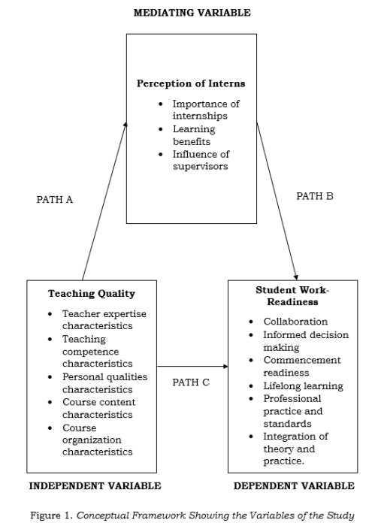

2. METHODOLOGY
2.1 Research Design
This study employed quantitative non-experimental descriptive correlational research to examine the data gathered concerning the levels of three variables including student work readiness, teaching quality, and the perception of interns. Primarily, it examined the significant relationship among the variables and the mediating effect of the perception of interns on the relationship between teaching quality and student work readiness. Descriptive correlational research identifies variables and examines the strength of the relationships between them (Aprecia et al., 2022). Through this analysis, researchers gain a better understanding of different phenomena (Aithor, 2024).
This investigation utilized mediation analysis, which was fundamentally focused on identifying and elucidating the mechanism or process through which the observed relationship between teaching quality and student work readiness was influenced by the inclusion of a third variable, the perception of interns, as a potential mediator. On the other hand, a mediation model proposed an indirect relationship, rather than establishing a direct link between two variables. In this model, the first variable influenced a middle variable, which subsequently impacted the final variable. This structure provided a clearer understanding of the connection between the first and last variables. Mediation occurs when a third variable significantly influences the association between two other variables.) Mediation analysis is employed to examine the mechanism or pathway through which an independent variable (X) influences a dependent variable (Y) through a mediating variable (M) (Lazaro & Tagadiad, 2023).
2.2 Research Subject
This study involved 246 respondents selected from a total population of 670 fourth-year students enrolled at a local college in Santo Tomas, Davao del Norte. The stratified random sampling technique was employed in the selection of respondents. This method consists of dividing the population into distinct subgroups based on specific characteristics, then randomly choosing individuals from each group to ensure balanced sampling (Simply Psychology, 2023). In addition, stratified random sampling allows for analysis of the overall population as well as specific subgroups within the population. This means researchers can gain insights into both general trends and the unique characteristics of different groups (Nguyen et al., 2020).
2.3 Research Instrument
The researchers utilized three (3) adapted survey questionnaires for the independent variable, dependent variable, and mediating variable. The questionnaires were validated by the panelists and an external validator to test their validity.
Teaching Quality Questionnaire. This survey questionnaire was used to get the level of teaching quality, it was from the research study titled “Student Perception of Teaching Quality in Higher Education” by Pavlina et al. (2011). The questionnaire consisted of 20 items covering the following aspects: Teacher Expertise Characteristics (3 items), Teaching Competence Characteristics (6 items), Personal Qualities Characteristics (4 items), Course Content Characteristics (4 items), and Course Organization Characteristics (3 items). Respondents rated each item using a 5-point Likert scale, where 5 for “Very High”, 4 for “High”, 3 for “Moderate”, 2 for “Low” and 1 for “Very Low".
List 1: 5-point Likert scale assessing Teaching Quality
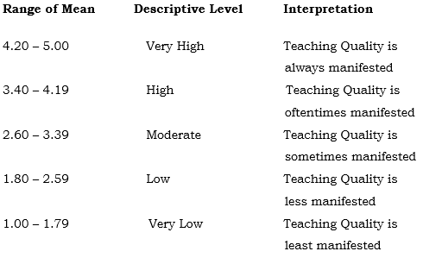

Perception of Interns Questionnaire. This survey questionnaire was used to get the level of perception of interns, it was from the research study titled “Perception of Communication Interns on their Internship Program” by Manalo et al. (2016). The questionnaire consisted of 30 items covering the following aspects: Importance of Internship (10 items), Learning Benefits (10 items), and Influence of Supervisors (10 items). Respondents rated each item using a 5-point Likert scale, where 5 for “Very High” 4 for “High”, 3 for “Moderate”, 2 for “Low” and 1 for “Very Low”.
List 2- 5-point Likert scale assessing Perception of Interns
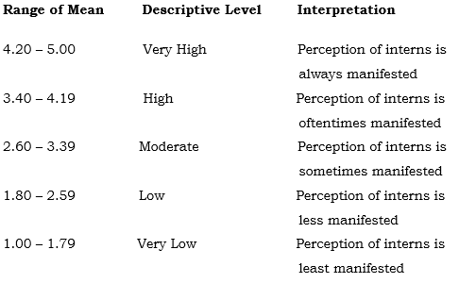

List 3- 5-point Likert scale assessing work readiness
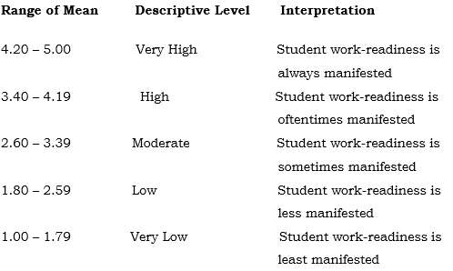
Work Readiness Questionnaire. This survey questionnaire was used to get the level of student work-readiness, it was from the research study titled “The impact of work integrated learning on student work-readiness” by Smith et al. (2014). The questionnaire consisted of 35 items covering the following aspects: Collaboration (7 items), Informed Decision Making (4 items), Commencement Readiness (6 items), Lifelong Learning (6 items), Professional Practice and Standards (9 items), and Integration of Theory and Practice (3 items). Respondents rated each item using a 5-point Likert scale, where 5 for “Very High” 4 for “High”, 3 for “Moderate”, 2 for “Low” and 1 for “Very Low”.

2.4 Statistical Treatment of Data
Mean. The mean is a fundamental statistical metric that represents the average value of a dataset and is crucial for comparing and understanding data distributions (Li et al., 2020). This was used to determine the level of teaching quality, perception of interns, and students' work readiness among graduating college students.
Pearson R. Pearson correlation coefficient (r) is a widely used statistic that quantifies the strength and direction of a linear relationship between two variables on a scale from –1 to 1 (Turney, 2022). This was used to determine the interrelationship between teaching quality, perception of interns, and students' work readiness among graduating college students.
Path Analysis. Path analysis assesses causal links between variables using multiple regression analysis (Mahapatra et al., 2020). This was utilized to ascertain the mediating effect of the perception of interns on the relationship between teaching quality and student work-readiness among graduating college students.

3. RESULTS AND DISCUSSIONS
Level of Teaching Quality
The results for the teaching quality were presented in Table 1. The mean was ranging from 4.29 to 4.37, with an equivalent overall mean of 4.34 and a standard deviation of 0.54. This was described as very high. Moreover, the data revealed that the indicators “Course Content Characteristics” and “Course Organization Characteristics” obtained the highest mean of 4.37, both described as very high. Meanwhile, the indicator “Teaching Competence Characteristics” recorded the lowest mean of 4.29, which was also described as very high.
The overall findings implied that teaching quality was always manifested when it comes to instructors’ expertise in providing examples and expert knowledge, utilizing modern technology with well-organized course content, and course structure. Therefore, instructors excel at creating a well-organized and engaging learning environment, providing students with clear, structured, and educational content. Although the overall quality was high, there were still certain aspects of teachers’ competence that required enhancement, specifically the improvement of instructional effectiveness and the implementation of additional interactive learning strategies to promote student involvement.
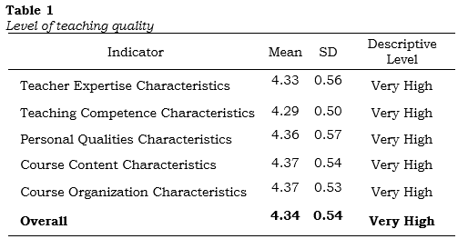

Table 1- Level of Teaching Quality based on mean and SD
The results of the study aligned with the study of Kulal et al. (2023) that effective teaching is essential for building students’ abilities to be ready for the job market. In addition, it supported the study of Indrawati et al. (2023) emphasizes that boosting work motivation with high-quality teaching can further enhance students’ preparedness for the workforce. Moreover, Magallanes (2022) highlighted that students must actively involve themselves in their education to acquire the necessary skills for successful employment.
Level of Student Work-Readiness of the students
The results for the student work-readiness were presented in Table 2. The mean was ranging from 4.34 to 4.47, with an equivalent overall mean of 4.42 and a standard deviation of 0.49. This was described as very high. Moreover, the data revealed that the indicator "Lifelong Learning" obtained the highest mean score of 4.47, which was described as very high. Meanwhile, the indicator "Commencement Readiness" recorded the lowest mean of 4.34, which was also described as very high.
The overall findings implied that the student work-readiness was always manifested in their effective collaboration, ability to organize continuous learning, and ability to apply academic knowledge and skills in professional contexts. Therefore, students demonstrated strong readiness for the workforce, possessing essential skills that enabled them to adapt and succeed in professional settings, but they still required further development to fully prepare for commencement.
Table 2- Level of Students’ Work-Readiness based on mean and SD
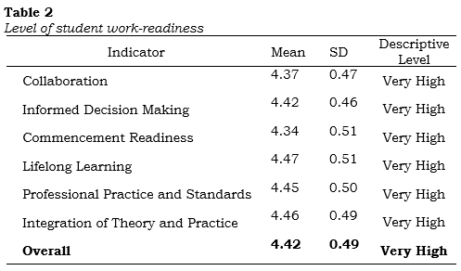

The results aligned with the study of Prayogo et al. (2022), which emphasized that workforce preparedness encompasses academic skills, real-world experience, and an understanding of job opportunities. Furthermore, it supported the study of Nisa et al. (2024) found that lifelong learning developed crucial skills, being recognized as having the most significant impact on how ready individuals are for employment. Moreover, Lizein et al. (2024) highlighted that student work readiness includes a blend of technical and soft skills crucial for employment.
Level of Perception of Interns
The results for the perception of interns were presented in Table 3. The mean was ranging from 4.45 to 4.57, with an equivalent overall mean of 4.53 and a standard deviation of 0.47. This was described as very high. Moreover, the data revealed that the indicator “Importance of Internship” obtained the highest mean score of 4.57, which was described as very high. Meanwhile, the indicator “Learning Benefits” recorded the lowest mean of 4.45, which was also described as very high.
The overall findings implied that the perception of interns were always manifested when it comes to the importance and benefits of internship such as career decision-making, enhancing skills, honing self-confidence, displaying positive attitude, dealing with people in the industry as well as receiving strong mentorship, guidance and support from supervisors which enhanced their personal development and professional preparedness. Therefore, interns had a very positive perception of their internship programs, particularly valuing the career-related benefits, skill development, and mentorship that foster both personal and professional growth. However, while interns appreciated the knowledge acquired, there was still a need to refine and expand the learning aspects of the internship experience, ensuring it better equipped them for the complexities of their future careers.
Table 3- Level of Perception of Interns based on mean and SD
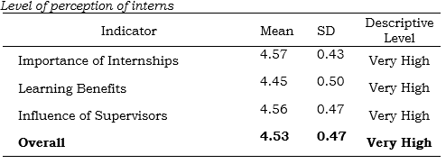

The results were similar to the study conducted by Kristoff et al. (2024) that a positive relationship with supervisors, characterized by frequent communication, helped interns with career planning and understanding their professional roles. In addition, it supported the study of Ebner et al. (2021) concluded that a positive outlook on internship programs leads to increased employability and less worry about entering the workforce. Moreover, Alenezi (2022) highlighted that interns find their training very satisfying when they understand the learning goals and have easy access to their supervisors.

Correlation between Teaching Quality and Student Work-Readiness
Table 4 showed the findings regarding the significance of the association between teaching quality and student work-readiness. The overall calculated r-value was .662, with a p-value of .001, which was below the established significance level of .05. This implied that the association of the variables got a positive, strong, and significant correlation. Also, this showed that teaching quality was associated with student work-readiness. Thus, the null hypothesis was rejected. Therefore, the strong and significant link between teaching quality and student work readiness indicates that improved teaching quality leads to better workforce preparation and emphasizes the crucial role of effective teaching in enhancing students’ employment readiness.
Table 4- Relationship between teaching quality and student work-readiness
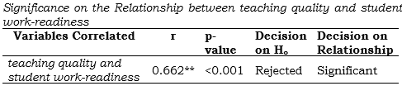

It aligned with the study of Enstroem and Schmaltz (2024), emphasized that teaching quality significantly boosts student employability by embedding professional skills in coursework, fostering active learning, customizing education, and ensuring curricula meet industry needs. In addition, it aligned with the study of Atem and Joseph (2020) that the quality of university instructors’ knowledge and teaching skills significantly influences how well-prepared graduates are for their careers, affecting their ability to find employment. Moreover, Lunkina et al. (2023) highlighted that proficient teachers cultivate conducive learning atmospheres that elevate student engagement and intrinsic motivation, both of which are paramount for workforce preparedness.
Correlation between Teaching Quality and Perception of Interns
Table 5 showed the findings regarding the significance of the association between teaching quality and perception of interns. The overall calculated r-value was .491, with a p-value of .001, which was below the established significance level of .05. This implied that the association of the variables had a positive, medium, and significant correlation. Also, this showed teaching quality was associated with the perception of interns. Thus, the null hypothesis was rejected. Therefore, the quality of instruction directly impacted interns’ sense of confidence, their readiness for professional tasks, and their general satisfaction in their internship experience.
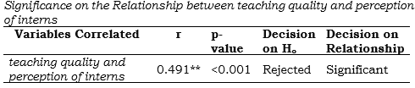
Table 5- Relationship between teaching quality and Perception of Interns

It was in line with the study of Machin et al. (2023), which indicated that academic mentors with expertise provide interns with the necessary guidance and support to foster confidence and personal development. Additionally, the result supported the study of Abdelkader et al. (2020) found that a strong educational foundation, including skills and knowledge, is vital for successful internship training and competence development. Moreover, Serin (2019) highlighted that interns' insights into their learning experiences can provide instructors with valuable feedback, which they can use to refine their teaching approaches and ultimately lead to better results for students.

Correlation between Perception of Interns and Student Work-Readiness
Table 6 showed the findings regarding the significance of the association between interns’ perceptions and student work-readiness. The overall calculated r-value was .729, with a p-value of .001, which was below the established significance level of .05. This implied that the association of the variables had a positive, strong and significant correlation. Also, this showed that perception of interns is associated with student work-readiness. Thus, the null hypothesis was rejected. Therefore, positive internships significantly contributed to students’ professional preparedness by enhancing their skills, confidence, and ability to adapt to professional settings.
Table 6- Relationship between Perception of Interns and Student Work-Readiness
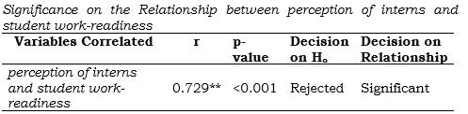

It corresponded to the study of Gustiawan et al. (2025), which found that through internships, students gain valuable job knowledge, develop essential skills, and cultivate positive work attitudes, resulting in increased workplace preparedness. In addition, it supported the study of Anggraini and Nurhaliza (2024) when interns approach their experiences with a positive mindset, they are more motivated and better prepared for career challenges. Moreover, Alhur et al. (2022), found that interns perceived their internship as helpful for their learning and future employment.
Mediation Analysis of the Three Variables using Path Analysis
Displayed in Figure 2 were the different steps taken in the path. The independent variable (IV) was Teaching Quality, the dependent variable (DV) was Student Work-Readiness, and the mediating variable (MV) was Perception of Interns.
In Step 1, path C (IV and DV), it was revealed in the regression analysis between teaching quality and student work readiness that there was a significant influence. Moreover, the result yielded an estimate of .569 and a standard error (SE) of .041 with a p<value of 0.000, which is lower than the 0.05 level. This means there was a significant influence between teaching quality and student work-readiness since the probability value is p<0.000. Thus, the null hypothesis of no significant relationship was therefore rejected.
In Step 2, which was path A (IV and MV), with the presence of mediating variables, it was revealed in the regression analysis between teaching quality and perception of interns that there was a significant influence. Moreover, the result yielded an estimate of .438 and a standard error (SE) of .050 with a p<value of 0.000, which is lower than the 0.05 level. This means there was a significant influence between teaching quality and perception of interns since the probability value was p<0.000. Thus, the null hypothesis of no significant relationship was therefore rejected.
In Step 3, which was path B (MV and DV), with the presence of mediating variables, it was revealed in the regression analysis between teaching quality and perception of interns that there is a significant influence. Moreover, the result yielded an estimate of .512 and a standard error (SE) of .042 with a p<value of 0.000, which is lower than the 0.05 level. This means there was a significant influence between teaching quality and perception of interns since the probability value is p<0.000. Thus, the null hypothesis of no significant relationship was therefore rejected.
In Step 4, which was the combined influence of IV and MV on DV. It was revealed that Student Work-Readiness (DV) regresses on Perception of Interns (MV) and Teaching Quality (IV), which the result yielded an estimate of .344 and standard error (SE) of .037 with a p<value of 0.000, which was lower than the 0.05 level of significance. This means a significant influence existed between the three variables since the probability value is p<0.000. Thus, the null hypothesis of no significant relationship is therefore rejected.
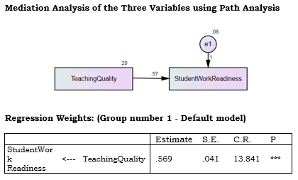
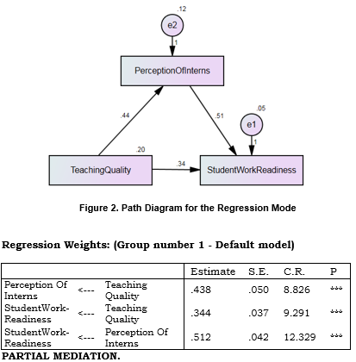

Since the three steps (paths A, B, and C) were all significant, mediation analysis through path analysis was warranted to assess the significance of the mediation effect. Furthermore, as stated in step 4, the effect of teaching quality on student work-readiness among graduating college students was even found to reduce after being mediated by perception of interns. With this, since the regression coefficient was substantially reduced at step 4 but remains significant, partial mediation occurred since the effect was found to be significant with a p<value of 0.000.
The findings of the effect size computation in the mediation test between the three variables were shown in figure 2. The effect size indicated how much of the indirect path’s effect on the student work-readiness of graduating college students can be attributed to teaching quality. The beta of teaching quality towards student work-readiness was .569, the total effect value. The beta of teaching quality towards student work-readiness with perception of interns included in the regression had a direct effect value of .344. The indirect effect value of .224 was the multiplied portion of the original correlation between teaching quality to perception of interns among graduating college students, which was .438, and perception of interns to student work-readiness, which was .512.
The ratio index was computed by dividing the indirect effect by the total effect; in this case, .224 by .569 equals .394. About 39.4 percent of the total effect of teaching quality towards student work-readiness goes through the perception of interns. About 60.6 percent of the total effect was either direct or mediated by other variables not included in the model.
The mediation analysis of the perception of interns on the relationship between teaching quality towards student work-readiness conformed to Human Capital Theory by Schultz (1961) which stated that education and practical experiences like internships, combined with effective teaching, are vital for students to develop skills that boost their employability and productivity that prepare them for the workforce. Moreover, it was also confirmed in the study of Nandini and Latif (2024) that in Schultz's theory, investing in learning and skill development is essential because students who understand their worth in the job market tend to thrive professionally.

4. SUMMARY OF FINDINGS, CONCLUSIONS, AND RECOMMENDATIONS
4.1 Summary of Findings
The major findings of the study were as follows:
1. The level of teaching quality was described as “very high” with an overall mean of 4.34 with a standard deviation of .54. Content characteristics and course organization characteristics, the highest indicators, were described as very having a mean of 4.37, contrasting with teaching competence characteristics, the lowest indicator, which had a very high descriptive level having a mean of 4.29.
2. The level of student work-readiness was described as “very high” with an overall mean of 4.42 with a standard deviation of .49. Lifelong learning, the highest indicator, was described as very having a mean of 4.47, contrasting with commencement readiness, the lowest indicator, which had a very high descriptive level having a mean of 4.34.
3. The level of perception of interns was described as “very high” with an overall mean of 4.53 with a standard deviation of .47. Importance of internship, the highest indicator, was described as very having a mean of 4.57, contrasting with learning benefits, the lowest indicator, which had a very high descriptive level having a mean of 4.45.
4. The relationship between teaching quality and student work readiness proved to have a strong positive correlation, with an r-value of .662 and p-value of .001, below the 0.05 significance level. This result indicated that the null hypothesis was rejected, confirming a significant relationship between teaching quality and student work-readiness.
5. The relationship between teaching quality and perception of interns proved to have a medium positive correlation, with an r-value of .491 and p-value of .001, below the 0.05 significance level. This result indicated that the null hypothesis was rejected, confirming a significant relationship between teaching quality and perception of interns.
6. The relationship between perception of interns and student work-readiness proved to have a strong positive correlation, with an r-value of .729 and p-value of .001, below the 0.05 significance level. This result indicated that the null hypothesis was rejected, confirming a significant relationship between perception of interns and student work-readiness.
7. The mediation analysis confirmed that perception of interns partially mediated the relationship between teaching quality and student work-readiness. Path analysis revealed that 39.4% of the effect of teaching quality on student work-readiness was mediated by perception of interns, while the remaining 60.6% was either direct or influenced by other factors not included in the study.
4.2 Conclusions
Based on the findings of this study, the following statements were constructed:
1. The level of teaching quality of the instructors was revealed to be very high, indicating that it was always manifested. Therefore, instructors excelled at creating a well-organized and engaging learning environment, providing students with clear, structured, and educational content.
2. The level of student work-readiness was very high, determined as always manifested. Therefore, students showed strong readiness for the workforce, possessing essential skills that allow them to adapt and succeed in professional settings, but they still require further development to fully prepare for commencement.
3. The level of perception of interns was very high, determined as always manifested. Therefore, interns had a very positive perception of their internship programs, particularly valuing the career-related benefits, skill development, and mentorship that foster both personal and professional growth.
4. A strong positive correlation existed between teaching quality and student work readiness among graduating college students. Based on the findings, the significant relationship indicated that improved teaching quality leads to better workforce preparation and emphasizes the crucial role of effective teaching in enhancing students’ employment readiness.
5. A medium positive correlation existed between teaching quality and perception of interns among graduating college students. Based on the findings, the significant relationship indicated that quality of instruction directly impacts interns’ sense of confidence, their readiness for professional tasks, and their general satisfaction in their internship experience.
6. A strong positive correlation existed between perception of interns and student work readiness among graduating college students. Based on the findings, the significant relationship indicated that positive internships significantly contribute to students’ professional preparedness by enhancing their skills, confidence, and ability to adapt to professional settings.
7. The mediation analysis confirmed that perception of interns partially mediates the relationship between teaching quality and student work-readiness. Therefore, positive interns' perception had a significant impact on student work-readiness, in addition to the direct influence of teaching quality. Improving internship programs would strengthen the positive correlation between teaching quality and student work preparedness.
4.3 Recommendations
Based on the findings, analysis, and conclusions drawn in this study, the following recommendations were outlined:
1. Teachers may enhance their teaching effectiveness by implementing a structured time-block approach to lesson organization, which may ensure a balanced pace and prevent rushed or disorganized sessions. Additionally, they may consider integrating modern educational tools, such as virtual simulations, collaborative platforms, educational apps, and AI-driven resources, as these can greatly improve lesson quality and keep students engaged. Building a supportive and engaging classroom may involve incorporating lighthearted humor, offering verbal encouragement, and maintaining a friendly demeanor. Teachers may ask thought-provoking questions, share surprising facts, and connect lessons to real-world applications to capture student interest, creating a more dynamic and engaging learning experience.
2. Students were encouraged to take the initiative to find work experience through part-time jobs, volunteering, and contacting alumni for employment opportunities relevant to their field. To perform well in interviews, students may prepare by practicing typical interview questions, refining their communication abilities, and presenting their qualifications and experiences in a compelling manner. Self-assessments may be beneficial for understanding how their skills and interests align with a career and identifying areas that may require further development. Gaps in skills may be filled through online courses, workshops, and mentorship focused on specific technical and soft skills.
3. School administrators may consider collaborating with industry partners to offer rotating internship experiences that expose students to various roles. Establishing a strong mentorship system with dedicated industry partners may provide interns with the guidance necessary for effective task execution. This support can help students manage their time effectively, handle criticism constructively, improve flexibility, and cultivate a positive attitude. Furthermore, administrators may incorporate constructive feedback sessions, allowing interns to engage openly with their supervisors. Recognizing top-performing interns through awards or certifications may significantly enhance their motivation. School administrators may prioritize building strong partnerships with various industries and provide interns with tailored development plans based on work readiness standards, incorporating feedback from educators and professionals. A structured micro-internship program, starting in the second year, may be implemented where students are exposed to diverse industries and jobs in (2-6 weeks), preparing them with essential skills for their final, longer internship. School administrators may also build an intervention or support system that helps struggling interns succeed by offering assistance, mentorship, and alternative placements to ensure their success.
4. To enhance student work readiness, the Commission on Higher Education (CHEd) may consider implementing a program, requiring higher education faculty to undergo industry-based training. Additionally, CHEd may collaborate with industry leaders to design at least 30% of core courses, aligning the curriculum with labor market demands. To improve graduate employability, CHEd may establish a ranking system that evaluates universities based on graduate employment rates, employer feedback, and skill assessments, with high-performing institutions receiving performance-based funding and recognition. The Commission on Higher Education (CHEd) may consider incorporating "Workplace Simulation-Based Learning" into curricula. This approach may replicate real job responsibilities through classroom activities, such as managing projects, communicating with clients, preparing reports and documents, and engaging in role-playing exercises to address workplace challenges. Additionally, a cross-disciplinary approach may be integrated into various courses to broaden students' knowledge across different fields, helping them become versatile professionals while enhancing their critical thinking, adaptability, and problem-solving skills. Furthermore, it may be beneficial to create a survey for students to assess the effectiveness of their teachers' classroom instruction. The findings may then be used to improve faculty development programs, specifically targeting areas that require enhancement.
5. Future researchers may explore other factors contributing to student work readiness, such as positive intern-supervisor relationships, teaching methods, industry demands, educational policies, the development of essential soft skills, and intern motivation. Moreover, future studies may investigate employer perspectives on interns to identify and address any mismatches between academic preparation and industry demands. Future researchers may use this study to develop educational policy changes to improve graduate employability through better internships, career programs, and skill development.
CONSENT
As per international standards or university standards, Participants’ written consent has been collected and preserved by the author(s).
ETHICAL APPROVAL
As per international standards or university standards written ethical approval has been collected and preserved by the author(s).
DISCLAIMER (ARTIFICIAL INTELLIGENCE)
Author(s) hereby declares that NO generative AI technologies such as Large Language Models (ChatGPT, COPILOT, etc.) and text-to-image generators have been used during the writing or editing of this manuscript.
COMPETING INTERESTS
Authors have declared that no competing interests exist.
REFERENCES
Abad, R. (2019). Work readiness of Filipino students and labor pushed | Roderick Abad. BusinessMirror. https://businessmirror.com.ph/2019/02/11/work-readiness-of-filipino-students-and-labor-pushed
Abdelkader, A., Abundo, R., & Baratas, G. (2020). Perceived level of preparation for nursing internship. International Journal of Nursing Education. https://doi.org/10.37506/ijone.v12i4.11260
Aithor. (2024). Descriptive Correlational Design in Research. aithor.com. https://aithor.com/essay-examples/descriptive-correlational-design-in-research
Alenezi, A. (2022). Dental interns’ perceptions of their training experiences at different training centers. Saudi Journal for Health Sciences, 11(1), 10–16. https://doi.org/10.4103/sjhs.sjhs_22_22
Alhur, A., Alhur, A., & Alanazi, D. N. (2022). The Examining The Clinical Nutrition Internship Effectiveness from Interns’ Perceptions. International Journal of Education, Teaching, and Social Sciences, 2(2), 52-61
Anggraini, A. D., & Nurhaliza, D. P. (2024). Analysis of Students’ Expectations, Perceptions, and Hopes regarding Internship Programs for Future Career Opportunities. Finance: International Journal of Management Finance, 2(2), 69-79.
Aprecia, N. A. B., Barrera, G. A., Cuares, K. R. A., Cuison, M. J. L., Lazaro, M. K. D., Pat-i, K. K. M., & Sayson, Y. J. H. (2022). A Descriptive Correlational Study on the Physical Environment and Perceived Academic Performance of STEM Online Learners.
Atem, N. S., & Joseph, B. J. (2020). Teachers’ quality and graduates Employability: The case of Public Universities in the North West and South West Regions of Cameroon.
Belle, M. A., Antwi, C. O., Ntim, S. Y., Affum-Osei, E., & Ren, J. (2021). Am I Gonna Get a Job? Graduating Students’ Psychological Capital, Coping Styles, and Employment Anxiety. Journal of Career Development, May, 2021, p. 1. https://doi.org/10.1177/08948453211020124
Black, R., Hoare, P. N., McDonald, N., & McIlveen, P. (2024). A Social Cognitive Career Theory Study of Agricultural Mechanical Trade Workers. Journal of Career Assessment. https://doi.org/10.1177/10690727241245962
CEDTyClea. (2021). Employers worried about SHS graduates’ readiness for work. BusinessWorld Online. https://www.bworldonline.com/labor-and-management/2021/06/25/377899/employers-worried-about-shs-graduates-readiness-for-work
Chi, C. (2023). Duterte: K-12 students ready for work right after graduation “still a promise.” Philstar.com. https://www.philstar.com/headlines2023/01/30/2241367/duterte-k-12-students-ready-work-right-after-graduation-still promise
Chowdhury, T. A., & Miah, M. K. (2019). Perceptions of students and employers regarding employability skills for entry-level positions in marketing and sales. Australian Journal of Career Development, 28, 3–13. https://doi.org/10.1177/1038416217751566
Ebner, K., Soucek, R., & Selenko, E. (2021). Perceived quality of internships and employability perceptions: the mediating role of career-entry worries. Education+ Training, 63(4), 579-596.
Enstroem, R., & Schmaltz, R. (2024). Striking gold: navigating the education massification maze for work readiness. Journal of Work-Applied Management. https://doi.org/10.1108/jwam-10-2023-0100
Gerçek, M., & Özveren, C. G. (2024). Developing Career Resources Through Work-Based Learning: A Qualitative Study on Internship Experiences. Business & Economics Research Journal, 15(3).
Gilchrest, C., Srnka, K., Gardner, L., Frye, W. S., Katzenstein, J., & Feldman, M. (2022). Trainee Perspectives on Internship and Fellowship Training Experiences in Pediatric Health Service Psychology during a Global Pandemic. Evidence-Based Practice in Child and Adolescent Mental Health, 7(3), 363– 373. https://doi.org/10.1080/23794925.2022.2081947
Gustiawan, W., Putri, B. K. D., Azra, T., & Sari, M. P. (2025). Internship programme and work readiness among vocational students. Issues and Perspectives in Business and Social Sciences, 15-26.
Hoque, N., Uddin, M., Ahmad, A., Mamun, A., Uddin, M. N., Chowdhury, R. A., & Noman Alam, A. H. M. (2023). The desired employability skills and work readiness of graduates: Evidence from the perspective of established and well-known employers of an emerging economy. Industry and Higher Education, 37(5), 716-730
Indrawati, C. D. S., Subarno, A., Winarno, W., Permansah, S., Wirawan, A. W., & Rusmana, D. (2023). Influence of work motivation, interpersonal skills, and knowledge construction on the work readiness of vocational students. Education Research International, 2023, 1–10. https://doi.org/10.1155/2023/4956337
Kristoff, C., Hill, S. C., Nakai, Y., & Daugherty, H. (2024). Do You See What I See? Examining College Internships From Both the Intern and Supervisor Perspectives. Journal of Experiential Education, 10538259241279765.
Kulal, A., N, A., Meghashree, & Kanchan, S. G. (2023). Impact of non-academic responsibilities of teachers on teaching quality. Journal of Teacher Education and Research, 17(02), 5–12. https://doi.org/10.36268/jter/17202
Lazaro, J. M. B., & Tagadiad, C. L. (2023). The Mediating Effect Of Ethical Climate On The Relationship Between Interpersonal Support And Socialization Among Public Secondary School Teachers. International Multidisciplinary Research Journal, 4(4). https://doi.org/10.54476/ioer-imrj/840593
Li, A., Zhang, S., Feng, Z., & Zhang, Q. (2020). Research on calculation method of mean in sports statistical data with excels. International Journal of Computer and Communication Engineering, 9(3), 141-148.
Lizein, B., Mulyadi, H., Supardi, E., & Triansyah, F. A. (2024). Exploring the Landscape of work readiness in vocational students: A Bibliometric Analysis. Kontigensi Jurnal Ilmiah Manajemen, 12(1), 1–11. https://doi.org/10.56457/jimk.v12i1.421
Lunkina, M. V., Gordeeva, T. O., Diryugina, E. G., & Pshenichnyuk, D. V. (2023). Teaching quality as predictor of student engagement, well-being and performance. RUDN Journal of Psychology and Pedagogics, 20(3), 628-649.
Machin, R. J., Allen, A., Ellidge, D., Griffiths, L., & Sanders, J. (2023). Teaching and lecturing internships–a case study from a UK university. Journal of Perspectives in Applied Academic Practice, 11(2), 157-169.
Magallanes, C. I. (2022). Engagement and work readiness of college students. Technium Social Sciences Journal, 35, 111–125. https://doi.org/10.47577/tssj.v35i1.7163
Mahapatra, S. K., Dash, A., & Pradhan, J. (2020). Application of path analysis in agricultural research. Biotica Research Today, 2(2), 18-20.
Manalo, R. A. P., Soliman, R. C. Y., Tibayan, C. A., & Muya, G. (2016). Perception of Communication Interns on Their Internship Program. Advanced Science Letters, 22(12), 4163-4166.
Nandini, N. A. P., & Latif, N. A. D. (2024). Human capital theory as a foundation for investment among the young generation. Fundamental and Applied Management Journal, 2(2). https://doi.org/10.61220/famj.v2i2.2248
Nguyen, T. D., Shih, M., Srivastava, D., Tirthapura, S., & Xu, B. (2020). Stratified random sampling from streaming and stored data. Distributed and Parallel Databases, 39(3), 665–710. = https://doi.org/10.1007/s10619-020-07315-w
Nisa, H., Ardias, W. S., & Bakhtiar, B. (2024). Pentingnya Lifelong Learning Skill untuk Kesiapan Kerja Lulusan Sarjana di Sumatera Barat. Syiah Kuala Psychology Journal, 2(2), 120-133.
Pattinson, S. R., Savelberg, H., & Atherley, A. (2024). Not ready in the ways that count– a qualitative exploration of junior doctor’s perceived preparedness for practice using legitimation code theory. Advances in Health Sciences Education. https://doi.org/10.1007/s10459-024-10380-w
Pavlina, K., Zorica, M. B., & Pongrac, A. (2011). Student perception of teaching quality in higher education. Procedia-Social and Behavioral Sciences, 15, 2288-2292.
Prayogo, D., Hermanto, A. W., Widiatmaka, F. P., Prasetyo, D., & Sugiyarto, S. (2022). The effect of practical experience, knowledge of job opportunities, teacher professionalism and work motivation on work readiness. Jurnal Iqra’: Kajian Ilmu Pendidikan, 7(1), 204-218.
Prikshat, V., Montague, A., Connell, J., & Burgess, J. (2020). Australian graduates work readiness-deficiencies, causes and potential solutions. Higher Education, Skills And Work-Based Learning, 10(2), 369-386
Priyono, S., & Nankervis, A. (2019). GraduateWork-Readiness Challenges in Indonesia-Findings from a Multiple Stakeholder Study. In S. Dhakal et al. (eds.), The Transition from Graduation o Work, Work, Organization, and Employment (pp. 107-123). Singapore: Springer Nature Singapore Pte Ltd.doi:10.1007/978-981-13-0974-8_7
Serin, H. (2019). Student Evaluations of Teaching Effectiveness: An instrument to increase teaching quality in Higher education. International Journal of Social Sciences and Educational Studies, 5(4). https://doi.org/10.23918/ijsses.v5i4p168
Simply Psychology. (2023). Stratified Random Sampling: Definition, Method &Examples.https://www.simplypsychology.org/strati fied-random sampling.html
Smith, C., Ferns, S., & Russell, L. (2014). The impact of work integrated learning on student work-readiness. The Office for Learning and Teaching.
Sutrisna, D., & Barliana, M. S. (2019). Readiness of Vocational School Students to Facing Global Competition. In 5th UPI International Conference on Technical and Vocational Education and Training (ICTVET 2018) (pp. 550-556). Atlantis Press.
Turney, S. (2022). Pearson correlation coefficient (r)| guide & examples. Retrieved from Scribbr: https://www. scribbr. com/statistics/pearson-correlation-coefficient.
Walters, G., Hoffart, N., Kring, D., Whitley, T., Horne, L., & Almotairy, M. (2022). Work readiness of newly licensed RNs. JONA: The Journal of Nursing Administration, 52(9), 469-473.

