Original Research Article

A Study on the Need of Social Emotional Learning among School Adolescents

.
Abstract

This study investigates social and emotional learning (SEL) needs among secondary and senior secondary adolescents in india. It aims to find students' familiarity with SEL concepts and understanding of SEL. It also explores classroom and school-based SEL activities as shared by responents. Expectations of students from schools regarding SEL education have also been recorded. Employing a cross-sectional survey design, data was collected from 57 adolescents aged 14-18 across eight schools under central, state, and private management in the Bhopal district, M.P., India. Questionnaire was developed to capture data on students familiarity with SEL was administered. Findings indicate moderate SEL awareness, limited structured activities (e.g., group iscussions and debates), and strong student demands for integrated programs, teacher training, and peer support to build emotional resilience. The findings underscore the urgency of embedding SEL in curricula to unlock adolescents' potential as productive citizens, offering policy and pedagogical insights for diverse school settings.

Key words: Adolescents, Social and Emotional learning, Self- awareness, Social awareness.

1. INTRODUCTION
Adolescence is a difficult intermediary stage transforming into an adult, no longer a child. For adoloscents its a journey of self-exploration and interaction with the world as they experience rapid physical, cognitive and psychosocial growth. This affects how they feel, think, make decisions, and interact with the world around them. (World Health Organization. n.d)
Though adoloscents is thought of as a healthy stage of life, there is significant death, illness and injury in the adolescent years. Harikrishnan and Sailo (2021) reported a significant ( little more than a tenth) of school-going adolescents as having emotional and behavioral problems.Similarly, Timalsina et al. (2018) reported that 12.9% of school-going adolescents in Nepal experienced psychosocial problems underscoring the need for focused social and emotional interventionsAdolescents is also a time when behavioural and health problems can emerge or worsen, with negative consequences that last long into adulthood. . (Yeager 2017) For instance, people who are victimized or bullied during adolescence can later become more aggressive and more depressed. Much of this is preventable .
According to WHO, to grow and develop in good health, adolescents need information, including age-appropriate comprehensive sexuality education; opportunities to develop life skills; health services that are acceptable, equitable, appropriate and effective; and safe and supportive environments. They also need opportunities to meaningfully participate in the design and delivery of interventions to improve and maintain their health. Expanding such opportunities is key to responding to adolescents’ specific needs and rights.(WHO) Jacob and Philip (2022) note that Damon (2004), Lerner et al. (2011), Phelps et al. (2009), and Shek et al. (2012) emphasize PYD's importance (Positive youth Development program. PYD offers educators a perspective that supports social and emotional learning (SEL) to enhance student protective factors, supports youth affected by bullying, and improves school climate.
India has over 253 million adolescents (10–19), (UNFPA India, 2025), who have immense potential to propel economic growth, spur innovation, and foster social advancement.A safe and successful passage from adolescence into adulthood is the right of every child. This right can only be fulfilled if families and societies make focused investments and provide opportunities to ensure that adolescents and youth progressively develop the knowledge, skills and resilience needed for a healthy, productive and fulfilling life. (UNFPA) Besides, Further, national and global development, security and social justice can only be achieved if adolescents and youth are included as full and active participants. Investments in young people now are in everyone’s interest and are everyone’s responsibility: families, community leaders, nongovernmental organizations, governments, the private sector, the international community, and others alike.
National Education policy 2020, lays particular emphasis on the development of the creative potential of each individual. It is based on the principle that education must develop not only cognitive capacities - both the ‘foundational capacities ’of literacy and numeracy and ‘higher-order’ cognitive capacities, such as critical thinking and problem solving – but also social, ethical, and emotional capacities and dispositions. ( NEP 2020, p. 4)
This can be addressed through social emotional learning (SEL). SEL programs try to help adolescents cope with their difficulties more successfully by improving skills and mind sets, and they try to create respectful school environments that young people want to be a part of by changing the school’s climate. (Yeager 2017)
Jacob and Philip (2022) using a cross sectional survey design and a SEL need assessment checklist collected data from 110 students. The results of the study demonstrate that 80 percent of the respondents felt a strong need to develop the five core SEL competencies, such as self-awareness, social awareness, relationship skills, self-management, and responsible decision-making skills. In addition, study examined social and emotional skills that adolescents require for success in school and prosper as perceived by students. Greenberg, M. (2023 ) also reiterated by a consensus among educators, parents, and policymakers that education should include a focus on supporting essential social and emotional capacities to help children navigate the world successfully.Grant et al.( 2023) reported limited attention to the integration of SEL approaches in the context of SEL offering practical strategies for measuring and using SEL implementation data in schools.
Social and emotional learning (SEL) programs for adolescents are appealing in part because they might prevent such problems. SEL programs try to help adolescents cope with their difficulties more successfully by improving skills and mind sets, and they try to create respectful school environments that young people want to be a part of by changing the school’s climate. (Yeager 2017)
Researches on SEL establish its need and importance as also suggesting systems for it. (Grant et al. 2023). However, it is equally important to familiarise aoloscents with SEL so that they are conscoiusly improve their SEL skills. The present study is to find out students’ perceptions about SEL and classroom practices that enable them to strengthen SEL, which was not seen previously.

2.1 Understanding Social and Emotional Learning
Social and emotional learning (SEL) is an integral part of education and human development. SEL is particularly important for our adolescents who are in the process of becoming a responsible adult. They need to acquire and apply the knowledge, skills, and attitudes to develop a healthy identity of self, manage emotions and achieve personal and collective goals. They need to be humane citizens and feel and show empathy for others, establish and maintain supportive relationships, and make responsible and caring decisions.
Collaborative for Academic, Social, and Emotional Learning (CASEL) a non- profit organization founded in 1994, has developed the SEL framework.
This model addresses five broad, interrelated areas of competence:

2.1.1 Self-Awareness: The ability to recognize and understand one's own emotions, thoughts, and values, and how they influence behaviour and how they influence behaviour across contexts. This includes capacities to recognize one’s strengths and limitations with a well-grounded sense of confidence and purpose. It includes integrating personal and social identities, identifying personal, cultural, and linguistic assets, identifying one’s emotions, demonstrating honesty and integrity, linking feelings, values, and thoughts, examining prejudices and biases, experiencing self-efficacy, having a growth mindset and developing interests and a sense of purpose ub-subheading
2.1.2 Self-management: The abilities to manage one’s emotions, thoughts, and behaviours effectively in different situations and to achieve goals and aspirations. This includes the capacities to delay gratification, manage stress, and feel motivation & agency to accomplish personal/collective goals.
This also includes managing one’s emotions. Identifying and using stress-management strategies. Exhibiting self-discipline and self-motivation. Setting personal and collective goals. Using planning and organizational skills. Showing the courage to take initiative. Demonstrating personal and collective agency. (CASEL)
2.1.3 Social-awareness: The abilities to understand the perspectives of and empathize with others, including those from diverse backgrounds, cultures, & contexts.
This includes the capacities to feel compassion for others, understand broader historical and social norms for behaviour in different settings, and recognize family, school, and community resources and supports. It includes taking others’ perspectives, recognizing strengths in others, demonstrating empathy and compassion, showing concern for the feelings of others, understanding and expressing gratitude , identifying diverse social norms, including unjust ones . It also includes, recognizing situational demands and opportunities and understanding the influences of organizations/systems on behaviour. (CASEL)
2.1.4 Relationship Skills: The abilities to establish and maintain healthy and supportive relationships and to effectively navigate settings with diverse individuals and groups. This includes the capacities to communicate clearly, listen actively, cooperate, work collaboratively to problem solve and negotiate conflict constructively, navigate settings with differing social and cultural demands and opportunities, provide leadership, and seek or offer help when needed. It includes communicating effectively, developing positive relationships, demonstrating cultural competency, practicing teamwork and collaborative problem-solving, resolving conflicts constructively, resisting negative social pressure, showing leadership in groups, seeking or offering support and help when needed and standing up for the rights of others.
2.1.5 Responsible decision-making: The abilities to make caring and constructive choices about personal behaviour and social interactions across diverse situations. This includes the capacities to consider ethical standards and safety concerns, and to evaluate the benefits and consequences of various actions for personal, social, and collective well-being. This includes demonstrating curiosity and open-mindedness, identifying solutions for personal and social problems • Learning to make a reasoned judgment after analysing information, data, facts, anticipating and evaluating the consequences of one’s actions, recognizing how critical thinking skills are useful both inside & outside of school, reflecting on one’s role to promote personal, family, and community well-being and evaluating personal, interpersonal, community, and institutional impacts . ( CASEL)

3.1 Why is SEL important?
SEL is pivotal to happy and healthy learning and growing. It advances educational equity and excellence, helps students to cope up better with emotional stress, solve problems, and avoid peer pressure. It prevents students from engaging in harmful activities. It also helps in building safe, healthy, and just communities.

But, what is adolescents' knowledge and perception about social and emotional behaviour? Are the students familiar with the concept of Social and Emotional Learning (SEL)? What kind of Social and Emotional learning activities are carried out in classroom practices and in the school. What are the expectations of the students from school viz a viz SEL education? This research paper tries to find answers to these questions. Despite extensive research on SEL effectiveness, gaps remain in understanding how different student demographics perceive SEL. More studies are needed on adolescents' perceptions on SEL.

Research Questions
The following research questions guide this study:
- Are the students familiar with the concept of Social and Emotional Learning (SEL)?
- What do students understand by Social and Emotional Learning?
- What kind of Social and Emotional learning activities are carried out in classroom practices and in the school.
- What are the expectations of the students from school viz a viz SEL education?
- What according to the students are the challenges in incorporating SEL in the teaching -learning process.
Objectives of the Study
- To study the students’ understanding of SEL.
- To examine the need for SEL as perceived by adolescents aged between 14 and 18 years.
- To identify the kind of Social and Emotional learning activities being carried out in schools
- To find out the expectations of students from school on Social and Emotional learning .
- To find out the challenges according to the students in the implementation of SEL in the teaching -learning processes.

Methodology
The aim of the study was to investigate the need for SEL among Secondary and Senior secondary students. For this the study adopted a cross-sectional survey design. The data was collected from 57 adolescents aged 14 to 18 spread over eight secondary schools run under Central Government, State Government and Private management. A need assessment checklist was administered to the students to examine the need of SEL among adolescents. The first part of the check list consisted of demographic details of the students. (Students names, contact numbers and name of school were not asked to ensure confidentiality and so that students may respond without hesitation. )The second part of the checklist consisted of items based on SEL. These consisted of both objective and subjective questions. The data collected was analysed and interpreted accordingly.

.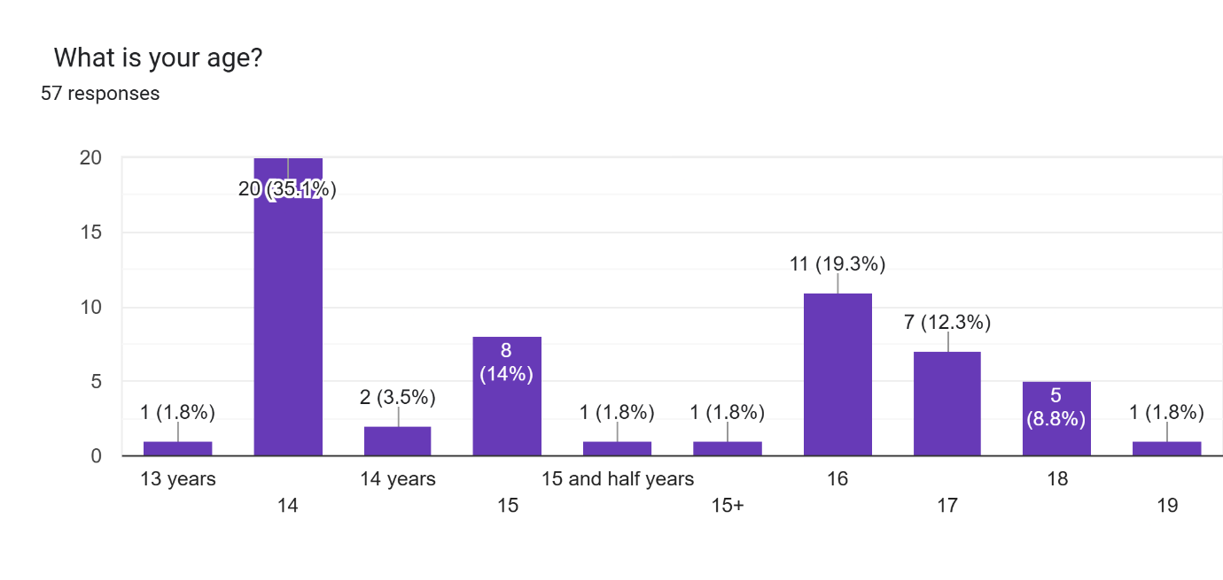
Fig. 1. Socio – Demographic profile of the respondents

As can be seen to be mostly between 14 to 18 years of age. The highest percentage of participants were 14 an 16 year old 35.1%)and 19.3% respectively.

Results

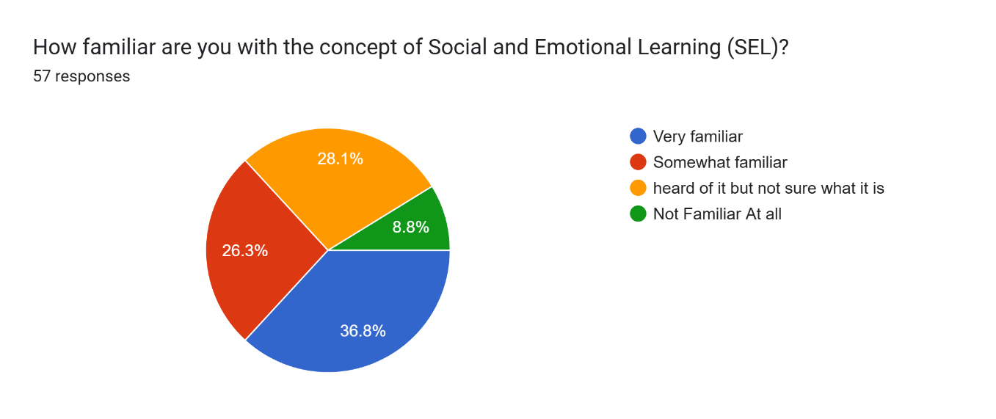
Fig 2: Students familiarity with social and emotional learning

As can be seen from the chart approximately 37% of the students are very familiar with Social And emotional Learning which shows their high level of awareness. 28 % had heard about it but are not sure what it is about. While almost 9% of the students shared that they were not familiar with SEL at all, This suggests that SEL has not been systematically or uniformly introduced to all students, underscoring the need for structured orientation, guided explanation, and consistent integration of SEL concepts within the school curriculum and classroom practices.
.

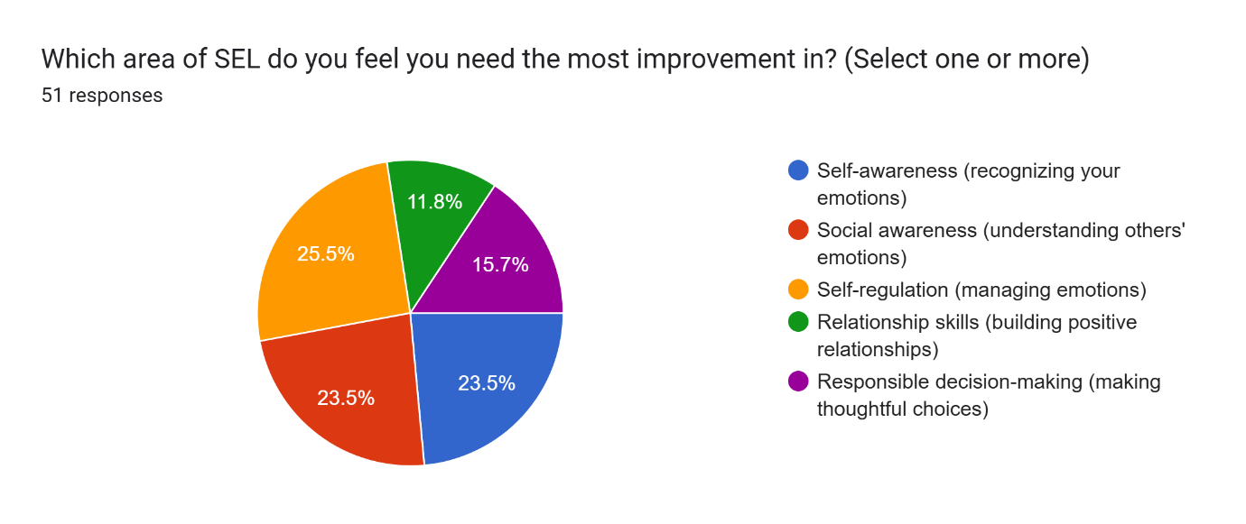
Fig 3: Areas in which students feel they need to improve.

These findings indicate that students perceive notable gaps across multiple domains of Social and Emotional Learning, with the strongest need for improvement in self-regulation, self-awareness, and social awareness. Nearly one-fourth of the students identify self-regulation (about 25%) as an area needing improvement, suggesting difficulties in managing emotions, impulses, and stress. A comparable proportion of students report the need to strengthen self-awareness (23%) and social awareness (23.5%), pointing to challenges in understanding their own emotions as well as empathizing with others. Although fewer students report difficulties in relationship skills (12%) and responsible decision-making (16%), these areas still represent significant concerns. Overall, the data suggest that SEL interventions should prioritize foundational competencies such as self-regulation, self-awareness, and social awareness, while also reinforcing relationship skills and decision-making to ensure holistic emotional and social development.
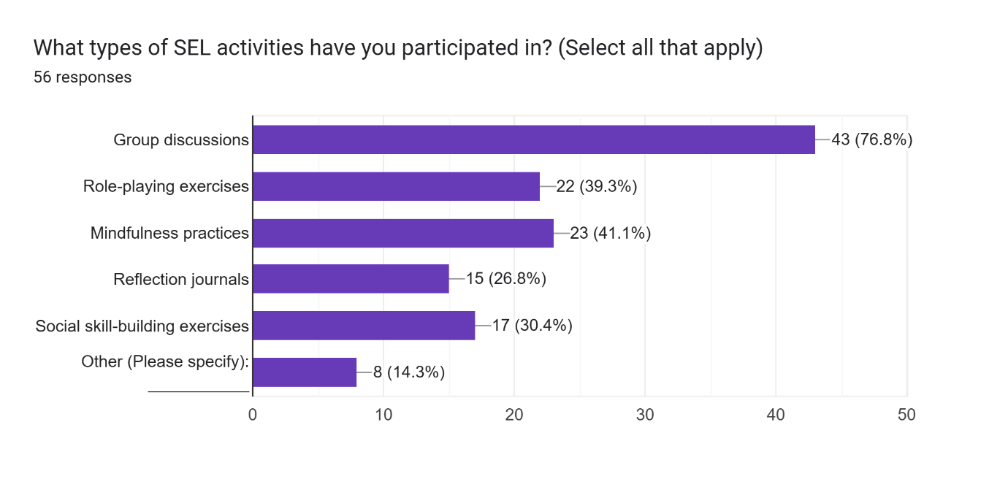

Fig 4: SEL activities in which students participated

As reflected in the chart, participation in group discussions as an SEL activity is the highest, with nearly 77% of students reporting involvement, indicating that collaborative and discussion-based approaches are the most commonly used SEL practices. A moderate proportion of students have participated in mindfulness activities (41%) and role-playing exercises (39%), suggesting some exposure to experiential and reflective SEL strategies. However, participation in social skill-building exercises (30%) and reflective journal writing (27%) remains relatively limited, pointing to underutilization of deeper self-reflection and interpersonal skill development activities. Additionally, 14% of students reported engagement in other SEL activities, though the lack of specification makes it difficult to assess their nature. Overall, the findings suggest that while interactive group discussions dominate SEL implementation, there is scope to diversify SEL activities by strengthening reflective, experiential, and skills-based practices for more balanced social and emotional development.

Whole School Activities related to SEL included:
- Activities related to stress, peer pressure. Having good behaviour with everyone, junior and senior. One student shared that in his/her school counselling session are carried out where the entire grade is assembled in a hall and counsellors tell them about stress management . There were career guidance sessions also.
- Some students shared teaching of subject knowledge only and not life skills.

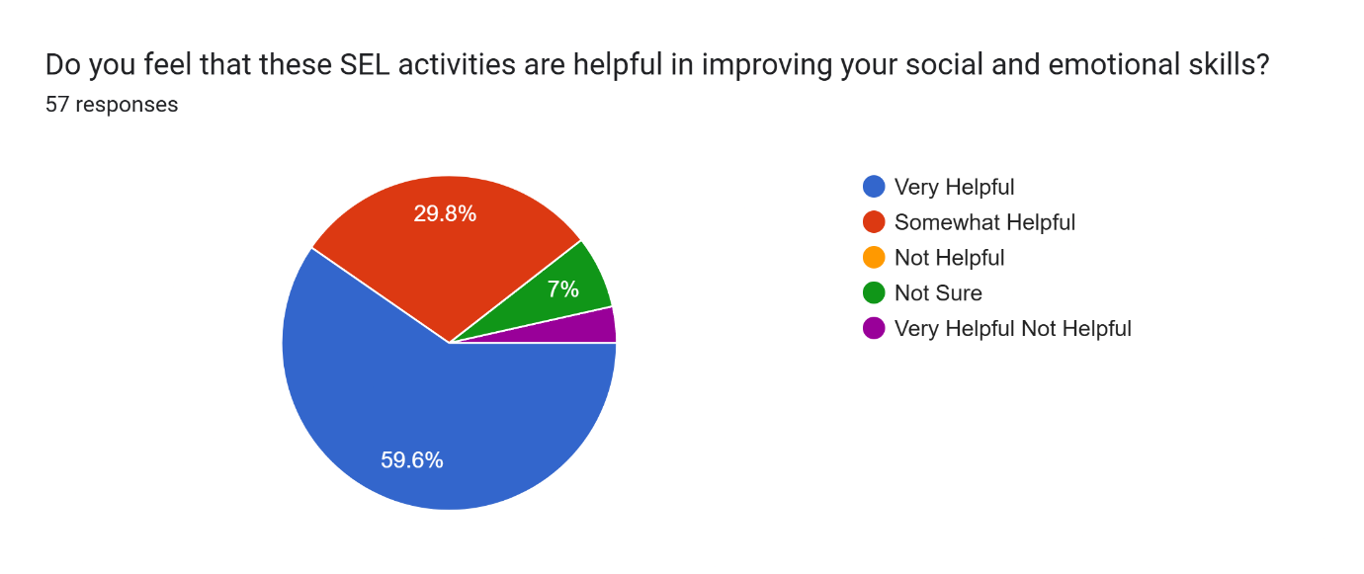
Fig 5: Students perception on effectiveness of SEL activities in improving social and emotional skills

The findings suggest a strongly positive perception of SEL activities among students. With nearly 60% of students rating SEL activities as very helpful and an additional 30% considering them somewhat helpful, a substantial majority perceive clear benefits from these activities. This indicates that SEL initiatives are largely effective in supporting students’ emotional and social development. The relatively small proportion of students who do not view SEL activities as helpful indicatesthat there is a need for better planning an effective implementation. There is a need to develop better unerstanding of SEL among the learners and also for better alignment with students’ needs or more engaging methods. This will convince stuents in understaing and appreciating the value of SEL i. Overall, the data underscore the relevance and positive impact of SEL activities in the school context.

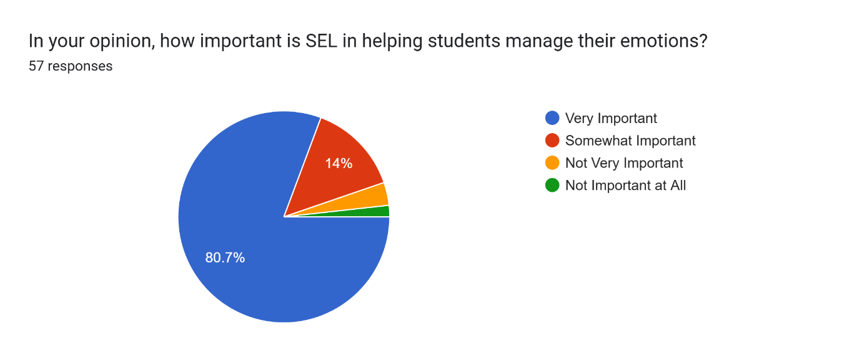
Fig:6: Importance of SEL in helping students in managing their emotions

Almost 81% of students perceiving SEL as important in helping them manage their emotions, which shows that an overwhelming majority acknowledes the core benefits of SEL. A further 14% of students consider it somewhat important, which may be ue to their limited understanding of SEL. Only a small minority regard SEL as not very important or not important at all, which may reflect limited engagement or understanding. Overall, the findings highlight that SEL is widely valued by students as an effective means of emotional management, reinforcing the need for its continued and systematic integration within the school curriculum.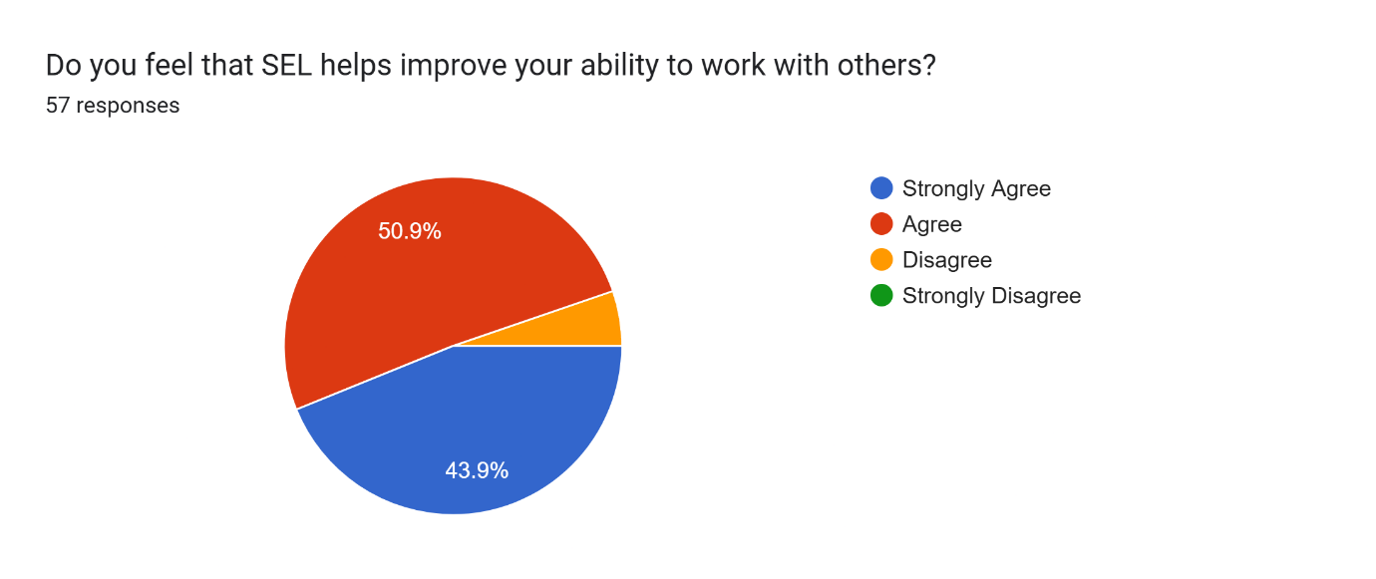
Fig :7 Role of SEL in improving the ability to work with others.

The findings reveal a strong consensus among students regarding the collaborative benefits of Social and Emotional Learning. An overwhelming majority (95%) agree or strongly agree that SEL enhances their ability to work effectively with others, highlighting its role in fostering cooperation and teamwork.
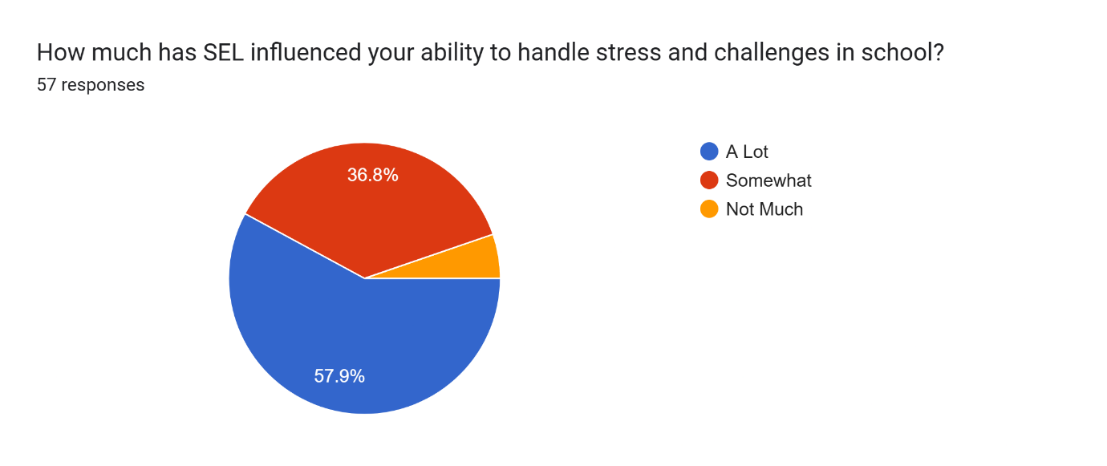

Fig:8 Influence of SEL in ability to handle stress and challenges in school

The findings indicate that Social and Emotional Learning has had a positive influence on students’ ability to handle stress and challenges in school. Nearly 58% of students report a strong positive impact, while an additional 36.8% perceive SEL as somewhat helpful in this regard. Only a small proportion of students feel that SEL has had little or no influence. Overall, the results suggest that SEL plays a significant role in enhancing students’ coping mechanisms and resilience within the school environment. Almost 58 percent students feel that SEL has influenced their ability to handle stress and challenges in school.

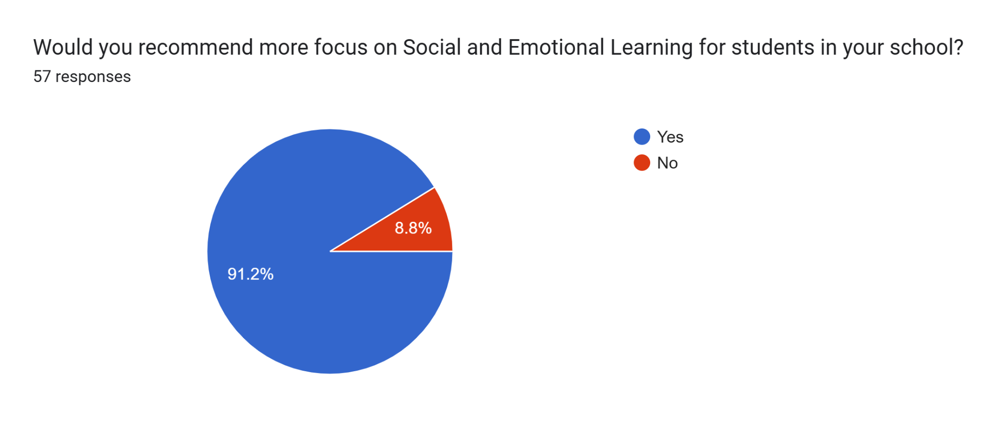

Fig:9 Recommendation of students for focus on SEL

An overwhelming majority of students (91 percent) are of the opinion that schools must focus more on SEL for students. This highlights a clear demand for stronger institutional focus on SEL within schools. It also suggests the need for systematic integration of SEL into curriculum planning, classroom practices, and a whole school approach to support students’ holistic development.

Discussion
1. The present study examined the need for SEL as perceived by the adolescents. The study results were identified based on the research questions of whether the students were familiar with the concept of Social and Emotional Learning (SEL). It was found that 63 percent were not very sure about SEL and therefore, schools need to take up integration of SEL in the teaching- learning process.
Students understood SEL to be the ability to understand and manage one's own emotions, build healthy relationships with others, make responsible decisions, and navigate social situations effectively, the ability to understand and manage your own emotions, build positive relationships with others, and make responsible decisions by developing skills like self-awareness, empathy, communication, and conflict resolution, interpersonal skills the process through which individuals learn and apply a set of social, emotional, and related
Some other response were SEL to be a methodology that helps students of all ages to better comprehend their emotions, to feel those emotions fully, and demonstrate empathy for others. This helps students of all ages to better understand their emotions and demonstrate empathy for others. ‘It gives confidence and make us learn many things.’ Some students were honest to write that they did not have a proper idea about it and were not sure. Perfect answers seemed to be directly taken from Net or Chat Gpt. However, the silver lining was that in the process of responding to the question, students apprised themselves about the meaning of SEL. Many students were not able to articulate effectively but they understand the importance of social and emotional learning in their lives.

2.Positive benefits of SEL as perceived by students upon practising SEL. These varied responses include experiencing positivity, refreshed minds, better academic achievements, healthy inter- personal relationships, improved health, improved self-esteem, understanding others better, increased sense of compassion and empathy, reducing stress. Other responses included support in overcoming anxiety, and making responsible decisions. Some students also shared that they had no understanding about it.
3.The response to research question on SEL activities in classrooms and schools as shared by respondents included:
Reading books, cooperation and helping each other, creating a good environment. Having good communication skills with friends and understanding them emotionally. They shared being empathetic more self- aware and better able to manage themselves. They acknowledged teachers and peer support in the classroom for taking decisions.
4. The sharing also inclued enabling them in improving inter-personal relations,uilding strong connections and being aware to be physically and mentally strong, avoiding unnecessary distractions, and being capable of taking stand for oneself.
It seems that in some classes there are no structure SEL integration but teachers help students in stress management and efficient working. One student shared, ‘…In my classroom there aren't exactly any social and emotional learning sessions carried out but teachers do tell us how to manage stress and work more efficiently’.
Group discussions, debates and role playing, dance and sports were shared as an SEL activity. Another student shared ‘... .in the classroom, I am very friendly with everyone and in school it has improved my confidence level so that I do not hesitate to take part in any competition.’
4. The other SEL activities undertaken as reported by students include teaching about controlling anger and emotions, managing stress, anxiety,and frustration.Some students also shared active engagement of srudents in SEL through collaborative work ‘…In my school, social and emotional learning is encouraged through activities like group discussion, teamwork projects and peer interactions. Teachers promote open communication, conflict resolution,and empathy building exercises.Additionally, events like debates, cultural programs and leadership activities help in developing confidence, decision making skills and emotional resilience.
6.The need and expectations shared for Social and Emotional learning of adolescents aged between 14 and 18 years included expectations from schools that they need to focus on building students' SEL skills. While some students shared their ignorance on the same, many wanted the schools to be more supportive. They wanted to be taught about managing emotions, communication skills, inter- personal relationships. Availability of counsellors in schools, and increased SEL activities.

Challenges faced by stuents while engaging with SEL activities
Challenges shared by the students while engaging with SEL activities at school include: limited time in the curriculum, lack of teacher training, difficulty adapting activities to diverse student needs, managing classroom dynamics during open discussions, addressing student resistance to self-reflection, balancing SEL with academic pressure, and potential lack of support from parents or administrators.
Distractions and disturbances, Lack of understanding, inhibition in sharing thoughts with others. Some students also shared that there were ‘No challenges because there is no SEL classes in our school.’ Lack of harmony and unity between the student and lack of help and support from peers . Discomfort in expressing emotions. Some students may feel shy or uncomfortable sharing their feelings in front of others. Fear of being judged or misunderstood can prevent open participation.
Educational Implications of the Study
The findings of the SEL assessment study demonstrate an urgent need for integrating SEL as a whole school approach. This need is felt by the students and they find SEL activities that have been taken up by the schools to be very helpful. There is a need to scale up these activities, in schools where these activities are already been carried out. Capacity building program for teachers can help in supporting teachers in integrating SEL in the teaching learning process. Further, steps for assessment of SEL must also be taken by schools , so as to help students in areas in which they require support.

Conclusion
Children’s social and emotional abilities are strongly associated with their academic skills and their ability to learn and be successful in school as well as their willingness to share their knowledge with their peers. It is important for educators to understand that they have the greatest potential to make a difference in their students’ learning.( Ee & Quek, 2013). Individual researches have shown increased exposure to SEL leads to improved student self-perception. These findings suggest that incorporating SEL in the classroom fosters greater student engagement, academic achievement, and self-confidence. It is recommended that schools provide educators with the necessary training and support to effectively implement SEL programs (Broderick, 2024). The majority of studies indicated that social and emotional learning programs aid high school students in reducing tension, adapting to new social environments, and coping with life’s challenges .( Tran-Chi, Huynh, Nguyen, Giang, & Luu-Thi, 2023). This study also establishes that students realize the importance of SEL for their personal well being. SEL, therefore needs to be taken up as a priority as a whole school approach.

Declaration: AI support has been taken for improvement of language but the ideas are of the authors.

COMPETING INTERESTS DISCLAIMER:
Authors have declared that they have no known competing financial interests OR non-financial interests OR personal relationships that could have appeared to influence the work reported in this paper.

References

- Broderick, T. (2024). Effects of social-emotional learning on student perceptions of themselves, their academics, and their behaviors (Master's thesis, Northwestern College, Iowa). NWCommons.
- Collaborative for Academic, Social, and Emotional Learning. (n.d.). What is SEL? Understanding social and emotional learning. CASEL. Retrieved from https://casel.org/what-is-SEL
- Ee, J. & C., Quek. (2013). Teachers’ Perceptions of Students’ Social Emotional Learning and their Infusion of SEL. Journal of Teaching and Teacher Education: An International Journal. 1. 59-72. 10.12785/jtte/010201.
- Government of India. (2020). National education policy 2020. Ministry of Education. https://www.education.gov.in/sites/upload_files/mhrd/files/NEP_Final_English_0.pdf
- Grant N, Meyer JL, Strambler MJ. Measuring social and emotional learning implementation in a research-practice partnership. Front Psychol. 2023 Jul 26;14:1052877. doi: 10.3389/fpsyg.2023.1052877. PMID: 37564314; PMCID: PMC10410557.
- Greenberg, M. (2023). Evidence for social and emotional learning in schools [Brief]. Learning Policy Institute. https://learningpolicyinstitute.org/product/evidence-social-emotional-learning-schools-brief
- Harikrishnan U, Sailo GL. Prevalence of Emotional and Behavioral Problems among School-Going Adolescents: A Cross-Sectional Study. Indian J Community Med. 2021 Apr-Jun;46(2):232-235. doi: 10.4103/ijcm.IJCM_451_20. Epub 2021 May 29. PMID: 34321732; PMCID: PMC8281858.
- Jacob, Annie & Philip, Smitha. (2023). A Study on the Need for Social Emotional Learning among Adolescents. 2022. 10.9756/INTJECSE/V14I5.436.
- Timalsina M, Kafle M, Timalsina R. Psychosocial Problems among School Going Adolescents in Nepal. Psychiatry J. 2018 Jul 2;2018:4675096. doi: 10.1155/2018/4675096. PMID: 30057903; PMCID: PMC6051039.
- Tran-Chi, V.-L., Huynh, S. V., Nguyen, H. T., Giang, T.-V., & Luu-Thi, H.-T. (2023). The perception of implementing social-emotional learning in soft skills among Vietnamese high school students. ASEAN Journal of Psychiatry, 24(2), 1-10. https://doi.org/10.54615/2231-7805.47331
- UNFPA India. (2025). UNFPA India annual report 2024. United Nations Population Fund (UNFPA) India. https://india.unfpa.org
- United Nations Population Fund. (n.d.). UNFPA adolescents and youth strategy. UNFPA. https://www.unfpa.org/sites/default/files/resourcepdf/UNFPA%20Adolescents%20and%20Youth%20Strategy.pdf
- World Health Organization. (n.d.). Adolescent health. https://www.who.int/health-topics/adoles
- Yeager, David. (2017). Social-Emotional Learning Programs for Adolescents. The Future of Children. 27. 10.1353/foc.2017.0004.

