Original Research Article
The Effect of Individual Differences and Mobile-Assisted Language Learning on Foreign Language Learning Adaptability

ABSTRACT
Aims: This research aimed to examine the link between Chinese undergraduates' mobile-assisted English learning, English learning adaptability, individual differences, and self-management learning.
Study design: A cross-sectional study design was employed, utilizing an online questionnaire to collect data from a sample of Chinese undergraduates.
Methodology: An online questionnaire was administered to 415 students. The collected data were then analyzed using SPSS and AMOS software.
Results: There was a positive correlation among intrinsic value, self-management learning, mobile-assisted language learning, and learning adaptability. Intrinsic value had both direct and indirect positive influences on learning adaptability. Self-management learning and mobile-assisted language learning partially mediated this relationship. There were differences in intrinsic value, self-management learning, mobile-assisted language learning, and learning adaptability based on gender, academic year, or disciplinary differences. Specifically, female learners had higher intrinsic value and performed better than male learners in mobile-assisted language learning, self-management learning, and learning adaptability. First-year university students outperformed second-year students in mobile-assisted language learning, self-management learning, and adaptability. Liberal arts students exhibited higher intrinsic value than their science and engineering counterparts.
Conclusion: The study reveals significant relationships and differences among mobile-assisted English learning, learning adaptability, intrinsic value, and self-management learning among Chinese undergraduates. These findings offer insights for educators to tailor teaching strategies according to students' gender, academic year, and discipline to enhance their English learning outcomes.

Keywords: Mediation, adaptability, mobile-assisted language learning, intrinsic value, self-management learning

- INTRODUCTION
As a global language, English plays a vital role in education. Examining the elements that may influence performance in English as a foreign language (EFL) is highly important.

Motivational beliefs, such as intrinsic value, play a significant part in influencing how students learn. Additionally, self-management learning is essential for EFL students because English instruction often occurs primarily within the classroom, so students have to learn on their own through various approaches outside of class. Studies indicate that intrinsic value contributes to promote and sustain self-management learning (Bai & Wang, 2020).

With the prevalence of mobile learning in education, researchers show increasing concern regarding students’ mobile-assisted language learning (MALL) and their adaptability to the new learning context. Emphasis has been placed on students and their perceptions of MALL in the language learning process (Briz-Ponce et al., 2017). Studies indicate that effectively acquiring a foreign language is influenced by multiple factors, such as self-management learning, progress in mobile-assisted language learning, and learners’ ability to adjust to new educational contexts (Viberg et al., 2020). Nevertheless, the connections between factors such as adaptability in learning EFL, mobile-assisted language learning, learners’ intrinsic value, and self-management learning have not been investigated empirically and comprehensively in earlier studies. The current research seeks to bridge the gap by exploring the relationships among these individual factors and English learning adaptability among Chinese university students.
2. LITERATURE REVIEW
2.1 Social Cognitive Theory (SCT)
Bandura (1986) considers that “there is a dynamic interaction in which personal factors, environmental events, and behavior operated as interacting determinants of each other” in his Social cognitive theory (SCT). Individual factors encompass the emotional, cognitive, and biological events of the learner (Maddux, 2013). Environmental factors include both social and physical elements (Schunk, 2001), while behavior refers to the actions that learners take to reach their objectives. Learners can build knowledge by proactively engaging with their learning environment, and they can modify their behaviors to achieve their intended goals (Schunk & DiBenedetto, 2021).

As a result, SCT provides a strong theoretical basis for the MALL approach, which helps learners gain knowledge through self-management learning. The current study used SCT as the theoretical grounding to bring MALL, intrinsic value, and self-management learning together to predict undergraduate students’ English learning adaptability.
2.2 Intrinsic value (IV)
Learners’ behaviors can be anticipated based on the values they assign to tasks according to Eccles and Wigfield’s (2002) expectancy-value theory. There are various kinds of task values, comprising importance, utility, and intrinsic value. Intrinsic value, often referred to as interest or perceived enjoyment, refers to learning driven by internal interest and pleasure (Deci & Ryan, 2008). As a kind of motivational belief, intrinsic value plays a vital role in fostering students’ learning and sustain self-management learning (SML). It serves as the motivation that enhances students’ interest in the tasks presented to them and affects their decisions to start, carry on, and return to learning tasks (Bai and Wang, 2020).

Researchers have claimed the significance of intrinsic value in language learning (Noels, et al., 2019). Self-determination theory (SDT) considers that activities out of intrinsic value are the most autonomous (Deci & Ryan, 2008). Bonney, et al. (2008) found that intrinsic value can predict students’ self-management learning activities.
2.3 Self-management learning (SML)
Self-management learning refers to “the extent to which an individual feels he or she is self-disciplined and can engage in autonomous learning” (Wang et al., 2009). It may play a crucial role in predicting learning outcomes (Broadbent, 2017). According to Ruan and Deng (2014), self-management learning involves the learning process or the capability of students to establish learning objectives, make learning plans, choose learning approaches, oversee the learning process, and evaluate learning outcomes. Self-management comprises three primary functions, namely, observation, evaluation, and reaction, which empower learners to effectively adjust to changing situations and conditions (Bandura, 1991).

Due to limited opportunities to use English in daily life, EFL learners need to learn on their own outside the classroom and utilize various self-management learning strategies (Bai & Wang, 2020). Gorbunovs, et al (2016) concluded that self-management plays an essential role in obtaining more preferable online learning outcomes in the e-learning environment.
2.4 Mobile-assisted language learning (MALL)
As information technology continues to develop, MALL has become an important way for university students to learn. According to Gonulal (2019), MALL refers to the process of learning a language with the support of mobile technologies. In China, electronic dictionaries, tablets, and smartphones rank among the most frequently utilized mobile devices in mobile-assisted language learning. The ability to learn English through mobile devices, free from the constraints of time and location, empowers EFL learners to take charge of their learning experiences (Vadivu & Chupradit, 2020), providing them with personalized learning experiences as well as intelligent tutoring systems and help them monitor their individual progress (Muhammad et al., 2024).

MALL is considered as a critical element in academic contexts because it provides language learners with opportunities to practice outside the classroom and facilitate their language learning process (Ebadi & Raygan, 2023). Currently, an obvious shift from teacher-centered learning to student-led learning empowered by MALL makes learners feel more interested and effective in using technology and provides language learners with a better environment (Habib et al., 2022).
2.5 Learning adaptability
Learning adaptability is a significant element in education, defined as the ability of students to adjust to the context of learning and to modify their learning plans, habits, and states to align themselves with the learning environment (Wang, 2002). Jiang and Shaibani (2022) defined learning adaptability as “a behavioral process in which learners are required to adjust to their environment and to utilize their ability to overcome difficulties and thus achieve positive learning outcomes.” Prior studies have highlighted the significance of learners’ ability to adapt within educational settings. Consequently, more and more researchers have investigated the elements that may influence learning adaptability. Ruan and Deng (2014) indicated that the factors affecting university students’ learning adaptability can primarily be categorized into two areas: environmental factors and personal factors.

Winne and Hadwin (2008) discovered a strong correlation between students’ learning adaptability and their self-regulation. Cao et al. (2008) suggested that the adaptability of students in online learning is affected by the learning environment, technology, and students’ meta-cognitive factors like self-efficacy, motivation, and willpower. Wang and Zhou (2010) identified that the learning environment and individual learning ability are important factors that influence the adaptability of Chinese adult learners. Abbacan-Tuguic (2021) noted that students’ attitudes and willingness to engage in blended learning can impact their learning adaptability in the blended learning environment.
2.6 Statement of the Study
In the past decade, an unprecedented development of MALL occurred all over the world due to the evolution of information technology and smart portable devices. The MALL approach has been widely accepted in higher education for self-management learning (Huang et al., 2023). Intrinsic value is a motivational variable closely linked to self-management and further academic performance (Ma et al., 2018). It is crucial for college students to study adaptively since they have access to more comprehensive learning materials and information and can customize their education to fit their unique interests and learning preferences (Clunis, 2023). As a result, research on students’ learning adaptability is of great significance (Ivemark & Ambrose, 2021).

Thus, this article, with SCT and SDT as the framework, explores the relationship between IV, SML, MALL, and learning adaptability by constructing a mediation model. The study hypothesizes that individual differences such as IV, SML, and MALL can predict students’ English learning adaptability, and there are gender, grade, and disciplinary differences in these learner differences. The study aims to verify these hypotheses with collected data.
3. THE PRESENT STUDY
3.1 Study hypotheses
Intrinsic value and SML
Pintrich and Groot (1990) noted a strong correlation between intrinsic value (IV) and students’ self-management learning (SML) (r=.73). They discovered that learners who found their schoolwork important and interesting “were more likely to be self-regulated and to report that they persisted on their academic work”. Similarly, Bai and Wang (2020) discovered that learners’ intrinsic value is a significant predictor of their SML. To further investigate the influence of IV on SML in the context of EFL learning, this research puts forth the following hypothesis:
H1: intrinsic value positively predicts self-management learning.

Mobile-assisted language learning and self-management learning
Huang and Yu (2019) discovered that SML positively affects MALL through research conducted with 323 Chinese undergraduates in Taiwan who have experience in mobile English learning. As a result, this study suggests the subsequent hypothesis:
H2: self-management learning positively predicts mobile-assisted language learning.
H3: intrinsic value has a positive effect on mobile-assisted language learning with self-management learning mediating the relationship.

Mobile-assisted language learning and learning adaptability
Yang and Hu (2023) found that students who preferred the mobile-assisted language learning format were more engaged than their counterparts. Cao and Li (2021) suggest that learning environment can have a positive influence on learning adaptability. Therefore, we have formulated the following hypothesis:
H4: mobile-assisted language learning positively predicts learning adaptability.

Learning adaptability and self-management learning
The research conducted by Zang et al. (2009) revealed a positive correlation between students’ self-management in learning and their adaptability in learning. Consequently, we formulated the subsequent hypothesis:
H5: self-management learning has a significantly positive effect on learning adaptability.
H6: intrinsic value has a positive influence on learning adaptability.
H7: intrinsic value positively influences the adaptability of learning, with self-managed learning and mobile-assisted language learning serving as mediators in this relationship.

Relationship between demographic factors and all the variables
Researchers (Korlat et al., 2021) discovered that girls exhibited higher intrinsic value compared to boys through a questionnaire survey. Viberg and Grönlund (2013) examined 345 Chinese and Swedish university students, revealing that gender differences exist in attitudes toward mobile-assisted language learning.

Zhang (2010) discovered that sophomores exhibited greater learning adaptability than freshmen by conducting a survey among 600 Chinese university students. Yu et al. (2019) revealed that boys had higher learning adaptability scores compared to female students based on a survey of 2434 Chinese middle school students. The study conducted by Zhang and He (2020) involving 726 non-English major Chinese university students revealed that female students demonstrated higher learning adaptability than their male counterparts, although the difference was not statistically significant. Huang (2015) explored the network learning adaptability of Chinese normal university students and discovered no significant differences related to major, grade, or gender in students’ network learning adaptability. Cao and Li (2021) surveyed 272 university students and found no significant differences in network learning adaptability across different genders, grades, or majors. Zang et al. (2009) examined self-management learning among college nursing students and stated that no significant statistical differences existed in students of different academic years. Given the differing results from various researchers, additional studies are needed to confirm these research findings. Therefore, the following hypotheses are put forth by this study:
H8: There are notable differences in students’ learning adaptability, mobile-assisted language learning, intrinsic value, and self-management learning based on grade, gender, and disciplinary differences. Figure 1 displays the hypothesized relationship between the variables.
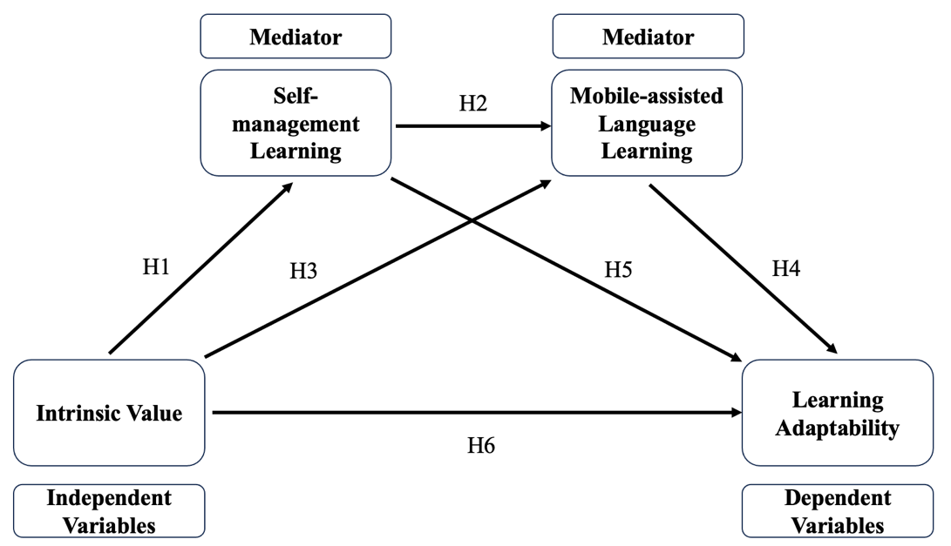
Fig. 1. The assumed relationship between different variables of the study
3.2 Research methods
3.2.1 Study design
Since research focusing on learners’ learning adaptability, intrinsic value, and SML in the MALL field has been limited and few studies have clarified the relationship between these variables, this study used an online questionnaire to explore the relationship between university students’ English learning adaptability, mobile-assisted language learning, intrinsic value, and self-management learning. The study took place in four cities with 499 non-English major students participated in the survey. A questionnaire with seven-point Likert scale questions was used in the online survey.
3.2.2 Sampling
The present study was conducted in four universities in China with one university in Beijing and three other universities in Jiangsu province. The research goal was explained to 499 non-English major students who participated in the project and their permission was obtained. The participants were entirely voluntary, and they were told all the information collected would only be used for research purposes. Nonetheless, the responses of 84 participants were removed due to their identical answers to all the questions or completing the questionnaire in a very short time which made it impossible to finish the survey. The effective response rate was 83.2%.
3.2.3 Data Collection
Prior to gathering data, researchers clarified the study's objective to the participants and obtained their written consent. The researcher collected data at the end of the semester. Initially, the combined questionnaire was uploaded to an online survey platform (http://www.wjx.cn/) and a quick response code was generated. Next, the assisting teachers shared the QR code for the online survey with the participants during the English class. The participants then used their mobile phones to scan the code and fill out the questionnaire. The researchers provided the participants with straightforward instructions on how to complete it. About 7 minutes were allotted for participants to finish the questionnaire.

In the study involving 415 participants, 211 (50.8%) were male and 204 (49.2%) were female. Their average age was 19.18 years (SD=1.08). Every participant had experiences with MALL during the semester when this research was carried out. As shown in Table 1, a significant portion of the participants were freshmen (69.2%). All individuals were enrolled in a college English course via mobile-assisted language learning.
Table 1. Demographics information
3.2.4 Survey measures
This study used a survey with 32 items drawn from several research to assess intrinsic value, self-management learning, MALL, and learning adaptability in mobile-assisted English learning. The survey used a seven-point Likert scale, with “7” representing “strongly agree” and “1” denoting “strongly disagree”. The questionnaire consisted of four subscales. The survey’s items were written in Chinese because all the participants were EFL learners whose first language was Chinese. To ensure the accuracy and equivalency of the translated content, a bilingual expert was invited to review the Chinese questionnaire. The subscales of the questionnaire are briefly described in the following paragraphs.
Intrinsic value scale (Cronbach’s α = .881). Following a literature review on intrinsic value, 4 items were created to evaluate students' intrinsic value by referring to the Intrinsic Value Scale (Pintrich and Groot, 1990). A sample item is “Learning English is very important to me.”

Self-Management Learning Scale (Cronbach’s α = .905). Seven items designed to assess SML were created using the Self-regulated Learning subscale from Huang and Yu (2019). An example of one item is “I proactively address challenges that arise during the English learning process.”

Mobile-assisted language learning Scale. Mobile-assisted language learning was evaluated using three subscales derived from the research conducted by Huang and Yu (2019). These three subscales consist of the Perceived Mobile Learning Performance Scale (6 items, Cronbach’s α = .922), the Perceived Flexibility Advantage Scale (4 items, Cronbach’s α = .896), and the Mobile Learning Continuance Intention Scale (2 items, Cronbach’s α = .809). One example item from the Perceived Mobile Learning Performance Scale is “In general, using mobile technology to learn English is helpful to improve my English ability”. An example item from the Perceived Flexibility Advantage Scale is “Using mobile technology makes it easier for me to arrange my English study time”. An example item from the Mobile Learning Continuance Intention Scale is “In the future, I will continue to use mobile technology to learn English”. The Mobile-assisted language learning scale comprises a total of 12 items.

Adaptability of English Learning Scale (Cronbach’s α = .892). The survey questions assessing students’ adaptability in learning English were adopted from the Foreign Language Learning Adaptability Scale created by Guo et al. (2021). According to the results of the pilot research, 9 items remained in the research.
3.2.5 Data Analysis
SPSS 26.0 was utilized to perform tests for common method bias, independent samples, correlation analysis, and reliability of scales. AMOS 24.0 was employed to evaluate the reliability and validity of the items in the questionnaire. To explore the indirect effects of intrinsic value on learning adaptability through self-management learning and mobile-assisted language learning, we computed the confidence interval for both the lower and upper bounds to determine the significance of the indirect effects.
4. RESULTS
4.1 Exploratory Factor Analyses (EFA)
Initially, we conducted EFA to determine the questionnaire’s factor structure. We implemented principal component analysis and utilized the varimax rotation method. Items with a loading greater than 0.4 on the relevant factor were maintained.

A total of 21 items grouped into four factors were retained in the questionnaire ( KMO = .949). These factors are “intrinsic value” (Cronbach’s α = .877), “self-management learning” (Cronbach’s α = .781), “mobile-assisted language learning” (Cronbach’s α = .958), and “learning adaptability” (Cronbach’s α = .834). Factor loadings for all items ranged from 0.584 to 0.829, indicating a high level of validity for the measurement. The total variance explained was 72.506%. The overall Cronbach’s α is 0.971, which presents acceptable credibility of the measurement.
4.2 Correlation Analysis
Bivariate correlations for IV, SML, MALL, and learning adaptability as well as descriptive statistics such as means and standard deviations are provided in Table 2. Participants exhibited moderate to high scores on all measures. The skewness, kurtosis, and coefficients for all the variables are also displayed in Table 2. Given that the absolute values of skewness and kurtosis for IV exceed 1, it suggests that the data do not follow a normal distribution. Consequently, we conducted Spearman correlation analysis.

Based on the information in Table 2, it is evident that all variances are significantly interconnected. IV was positively related to SML ( r = 0.54, P = .01), MALL ( r = 0.69, P = .01), and learning adaptability ( r = 0.68, P = .01). SML demonstrated a positive relationship with MALL ( r = 0.62, P = .01) and learning adaptability ( r = 0.49, P = .01). MALL positively related to learning adaptability ( r = 0.63, P = .01). Therefore, Hypothesis 1, Hypothesis 2, and Hypothesis 4 were validated.
Table 2. Correlation of main variables
4.3 Confirmatory Factor Analysis (CFA)
We then employed CFA to further confirm the validity of the instrument. Following the CFA, we removed six items that showed high value in modification indices and negatively impacted the model fit. In the end, we retained 15 items in the final instrument. The intrinsic value scale contained three items, the self-management learning scale also had three items, the MALL scale consisted of six items, and the learning adaptability scale comprised three items. According to the regression weight analysis, IV has a positive relationship with MALL but SML does not influence learning adaptability (P>0.05), so Hypothesis 3 was proved but Hypothesis 5 was rejected, and we got the following model in Figure 2.
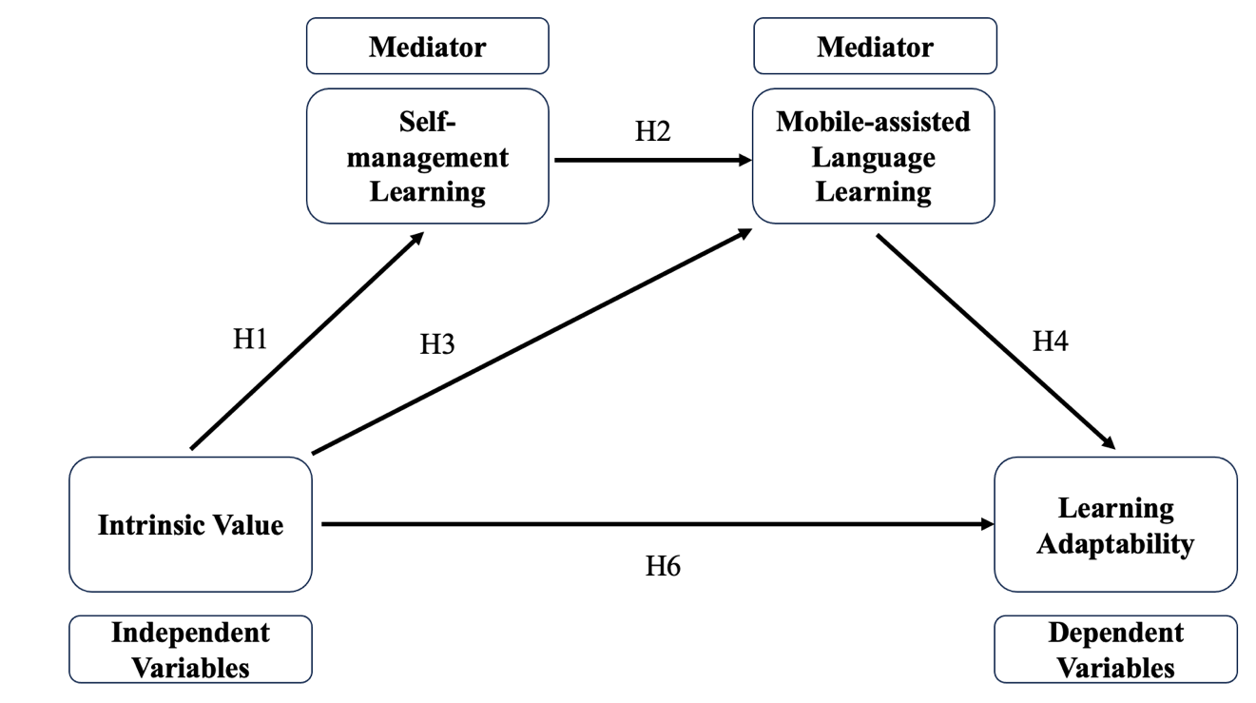
Figure 2. The relationship between different variables of the study
To measure the internal consistency reliability, discriminant validity, and convergent validity of the constructs in the model, we conducted a CFA analysis on all the constructs. The findings (refer to Table 3) indicated that the composite reliability for each construct ranged between 0.79 and 0.93, surpassing the 0.7 CR threshold and providing evidence of internal consistency reliability. Furthermore, the factor loadings for all items in the model were statistically significant (all P < .001). At the same time, the average variance extracted (AVE) for all constructs varied from 0.56 to 0.71, which is above the 0.5 AVE threshold, indicating the convergent validity was acceptable.
Table 3. Coefficient for the measurement model

Additionally, Table 4 demonstrates that the estimated interrelationships between all constructs were lower than the square roots of the AVE for each construct, offering support for the discriminant validity.
Table 4. Discriminant validity of the constructs
In addition, the results of the structural modeling (x2/df=2.728, IFI=0.976, CFI=0.976, GFI=0.956, AGFI=0.925, TLI=0.965, RMSEA=0.065, SRMR=0.038) demonstrate that the hypothesized model (Figure 3) adequately fits the data, as the recommended range for x2/df is between 2 and 5. The acceptable range for RMSEA is below 0.08, with SRMR values under 0.05, and the IFI, CFI, GFI, TLI, and AGFI values approaching 1, signifying a good fit of the model.
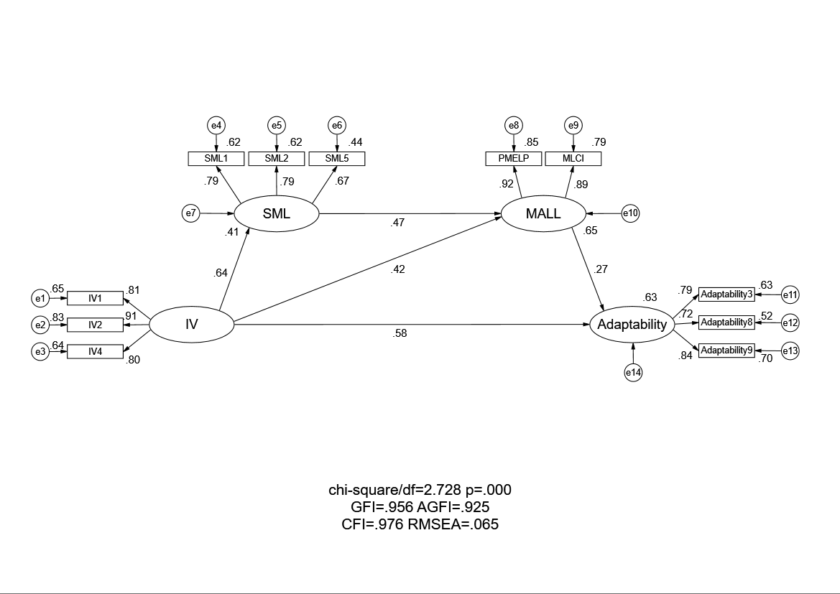
Figure 3. Path analysis results (standardized coefficients)
To demonstrate the mediating effect of SML and MALL, we performed both percentile bootstrapping and bias-corrected percentile bootstrapping based on 5000 bootstrap samples, as prior studies indicate that bootstrapping offers greater power than the Sobel test and the causal steps methodology for assessing the impact of intervening variables (Williams & MacKinnon, 2008). We computed the confidence intervals for the lower and upper bounds to determine if the indirect effects were significant. The results from the bootstrap test, detailed in Table 5, validated the presence of a significant partial mediating effect of SML and MALL on the relationship between intrinsic value and English learning adaptability (direct effect = 0.60, indirect effect1= 0.08, indirect effect2 = 0.12, total effect = 0.79). Consequently, this result of the study supports Hypothesis 6 and Hypothesis 7.
Table 5. Unstandardized direct, indirect, and total effects of the hypothesized model
 | point  estimation | Product of coef. |  | bias-correct |  | percentile |  | Two-tailed significance
 | point  estimation | SE | Z | Lower | Upper | Lower | Upper | Two-tailed significance
Direct effect
IV→Adaptability | 0.60 | 0.11 | 5.31 | 0.37 | 0.81 | 0.38 | 0.82 | .00***
Indirect effect
IV→SML→MALL→Adaptability | 0.08 | 0.04 | 2.37 | 0.03 | 0.17 | 0.02 | 0.16 | .00***
IV→MALL→Adaptability | 0.12 | 0.05 | 2.50 | 0.04 | 0.23 | 0.03 | 0.21 | .00***
Total effect
IV→Adaptability | 0.79 | 0.07 | 10.73 | 0.65 | 0.94 | 0.65 | 0.94 | .00***
Note. n=415. *** P < .001

4.4 Independent Sample Test
The means of all four variables were compared for gender, grade, and discipline differences using t-tests. Hedges’ effect size g was used to assess if the mean differences were practically significant because the numbers of the samples were different. As Table 6 demonstrates, there was a significant gender difference in all variables. The average intrinsic value, self-management learning, mobile-assisted language learning, and learning adaptability of female students were significantly higher than that of male students, though all the Hedges’ g effect sizes were small. All factors except intrinsic value showed a significant grade difference ( t = 1.82, P = .069). Even though all the Hedges’ g effect sizes were small, freshmen students’ average self-management learning, mobile-assisted language learning, and learning adaptability were significantly higher than that of sophomores. Furthermore, the results indicate that except intrinsic value ( t = -2.149, P = .033), there was no significant difference in any of the variables. Students in the liberal arts have greater intrinsic value than students in science and engineering with a small Hedges’ g effect size. Hence, Hypothesis 8 was partially proved. Significant gender differences exist in students’ intrinsic value, SML, MALL, and learning adaptability. There are significant grade differences in students’ SML, MALL, and learning adaptability but there is no significant grade difference in students’ intrinsic value. There is significant disciplinary difference in students’ intrinsic value but there is no significant grade difference in students’ SML, MALL, or learning adaptability.
Table 6. Demographic differences in IV, SML, MALL, and learning adaptability
Dependent  value | Independent  value | Classification | N | Mean | SD | t | Sig.  (two-tailed) | Effect size  (Hedges’ g)
IV | Gender | Male | 211 | 5.54 | 1.34 | -4.01 | .000*** | 0.49 (small)
IV | Gender | Female | 204 | 6.01 | 0.07 | -4.01 | .000*** | 0.49 (small)
SML | Gender | Male | 211 | 4.11 | 0.10 | -2.64 | .009** | 0.40 (small)
SML | Gender | Female | 204 | 4.45 | 1.22 | -2.64 | .009** | 0.40 (small)
MALL | Gender | Male | 211 | 5.11 | 1.34 | -2.06 | .040* | 0.20 (small)
MALL | Gender | Female | 204 | 5.35 | 1.06 | -2.06 | .040* | 0.20 (small)
Adaptability | Gender | Male | 211 | 5.63 | 1.07 | -2.38 | .018* | 0.23 (small)
Adaptability | Gender | Female | 204 | 5.87 | 0.93 | -2.38 | .018* | 0.23 (small)
IV | Grade | Freshman | 287 | 5.84 | 1.22 | 1.82 | 0.069 | 0.19 (small)
IV | Grade | Sophomore | 128 | 5.61 | 1.19 | 1.82 | 0.069 | 0.19 (small)
SML | Grade | Freshman | 287 | 4.42 | 1.33 | 3.27 | 0.001** | 0.35 (small)
SML | Grade | Sophomore | 128 | 3.96 | 1.33 | 3.27 | 0.001** | 0.35 (small)
MALL | Grade | Freshman | 287 | 5.32 | 1.24 | 2.41 | 0.016* | 0.26 (small)
MALL | Grade | Sophomore | 128 | 5.01 | 1.12 | 2.41 | 0.016* | 0.26 (small)
Adaptability | Grade | Freshman | 287 | 5.85 | 0.96 | 2.97 | .003** | 0.33 (small)
Adaptability | Grade | Sophomore | 128 | 5.52 | 1.09 | 2.97 | .003** | 0.33 (small)
IV | Major | Science & Engineering | 312 | 5.71 | 1.29 | -2.15 | .033* | 0.21 (small)
IV | Major | Liberal arts | 103 | 5.96 | 0.94 | -2.15 | .033* | 0.21 (small)
SML | Major | Science & Engineering | 312 | 4.26 | 1.41 | -0.59 | .557 | 0.06 (small)
SML | Major | Liberal arts | 103 | 4.34 | 1.14 | -0.59 | .557 | 0.06 (small)
MALL | Major | Science & Engineering | 312 | 5.23 | 1.26 | 0.00 | 1.000 | 0.000
MALL | Major | Liberal arts | 103 | 5.23 | 1.07 | 0.00 | 1.000 | 0.000
Adaptability | Major | Science & Engineering | 312 | 5.78 | 1.01 | 1.09 | .277 | 0.12 (small)
Adaptability | Major | Liberal arts | 103 | 5.65 | 1.02 | 1.09 | .277 | 0.12 (small)

5. DISCUSSION
This study examined the relationship among IV, SML, MALL, and English learning flexibility of non-English major Chinese undergraduates. The aim of the article was to explore how these variables are connected. SEM allowed us to discover the relations between these variables. The present research provides fresh insights into EFL learning in the following respects.

The first contribution of this study is the constructing of the SEM, which demonstrated that a positive and significant relationship exists between IV and SML ( r = 0.64, P < .001), IV and MALL ( r = 0.42, P < .001), IV and learning adaptability ( r = 0.58, P < .001), SML and MALL ( r = 0.47, P < .001), MALL and learning adaptability ( r = 0.27, P < .001). In the SEM model, Hypothesis 1, Hypothesis 2, Hypothesis 3, Hypothesis 4, and Hypothesis 6 were confirmed as we found a significant predictive relationship in the model. Whereas Hypothesis 5 was rejected because no significant direct predictive relationship exists between SML and learning adaptability.

The second contribution stems from establishing the mediation model of intrinsic value, SML, MALL, and learning adaptability and explore the effect of intrinsic value on learning adaptability through SML and MALL, which confirmed Hypothesis 8 in this study. Intrinsic value both directly and indirectly affects learning adaptability. SML and MALL partially mediate the relationship between intrinsic value and learning adaptability. This finding confirms and extends the findings about the positive relationship between intrinsic value and SML (Bai & Wang, 2020), SML and MALL (Huang &Yu, 2019), MALL and learning adaptability (Cao & Li, 2021), SML and learning adaptability (Zang et al.,2009). Based on this finding, language instructors should play a more important role in assisting learners to be more self-regulated and be more efficient in MALL context both in and beyond the class (Huang et al., 2023). Significance should be given to improving learners’ intrinsic value of English learning because students with higher intrinsic value tend to have higher learning adaptability at higher education level.

The third contribution of the study is the finding that gender, grade, and disciplinary differences exist in some of the variables discussed in this study, which partially supports Hypothesis 8. Female learners are found to have higher intrinsic value and do better in self-management learning, mobile-assisted language learning, and learning adaptability than male students. While not consistent with Yu et al.’s (2019) findings that male students’ learning adaptability is better than female students', these findings are consistent with other research which shows that in digital learning contexts, female learners possess higher intrinsic value and exhibit better self-management than male learners (Weis et al., 2013). This can be explained by the fact that female learners have more positive attitudes toward school and higher levels of learning engagement (Korlat et al., 2021), and are more motivated than male learners (Cox, 2000). Additionally, the results demonstrate that freshmen outperform sophomores in SML, MALL, and learning adaptability. This finding completely contradicts the findings that the learning adaptability of sophomores was higher than that of freshmen in Zhang’s (2010) study. It is possible that freshmen, who have recently finished high school and are still maintaining solid study habits, are more committed to EFL learning than sophomores. Furthermore, this study shows that liberal arts students had higher intrinsic value than science and engineering students. This can be explained by the fact that EFL learning is given more significance by liberal arts students than by scientific and engineering students. The result that the SML score of freshmen is higher than that of sophomores contradicts that in the research of Zang et al. (2009), which found there was no significant SML difference among students of different grades. In addition, the finding in this study partly contradicts that of previous studies which claimed there were no significant gender, grade, or disciplinary differences in students’ learning adaptability (Cao and Li, 2021; Huang, 2015).
6. CONCLUSION
Based on earlier studies that showed learning adaptability’s psychometric qualities, the present study verifies the research hypotheses by exploring the influence of individual differences and MALL on the adaptability of EFL. According to this study, three individual difference variables, which are intrinsic value, SML, and MALL as well as two demographic variables—gender and academic year—have an impact on students’ English learning adaptation in Chinese universities. Through the mediation function of SML and MALL, intrinsic value influences English learning adaptability both directly and indirectly. This study enriched the learning adaptability literature by providing statistical evidence and offered practical solutions to increase the adaptability of EFL learning for Chinese undergraduates.

This study also got contradictory results with some previous research concerning whether significant differences exist in learning adaptability with different genders, grades, or majors and whether there are significant statistical differences in students’ SML among students of different grades. Therefore, more research should be conducted in the future to test the findings of this study and of the previous ones. In the MALL context, students should define their learning goals, monitor learning, and make relative adjustments. Instructors should guide and oversee the learning process while encouraging the use of various English learning apps. Additionally, EFL instructors need to recognize differences in grade, gender, and discipline to help students improve their learning adaptability.
7. LIMITATIONS
The current study on language learning adaptation in tertiary education also has several limitations. Its quantitative design may not capture all unique perspectives, so future research should combine quantitative with qualitative methods. Although intrinsic value, SML, and MALL have been shown to predict adaptability, other factors like grit and emotions could be explored by incorporating more mediating or moderating variables. Using a convenient sample also restricts generalizability, so stratified or random sampling is recommended in future research.

CONSENT
The Ethics Committee of Jiangnan University examined and authorized this research (approval no. JNU202406RB044), which involved human subjects. All participants gave their informed consent. Every experiment in our research was carried out in compliance with the pertinent rules and regulations of the Helsinki Declaration of 1963 and its subsequent amendments.
DATA AVAILABILITY STATEMENT
The datasets generated in this study are available on request to the author.
COMPETING INTERESTS DISCLAIMER:
Authors have declared that they have no known competing financial interests OR non-financial interests OR personal relationships that could have appeared to influence the work reported in this paper.

REFERENCES
[1] Bai, B., & Wang, J., (2020). The role of growth mindset, self-efficacy and intrinsic value in self-regulated learning and English language learning achievements. Language Teaching Research, 27, 207-228. doi:10.1177/1362168820933190
[2] Briz-Ponce, L., Pereira, A., Carvalho, L., Juanes-Méndez, J.A., & García-Peñalvo, F.J. (2017). Learning with mobile technologies – Students’ behavior. Comput Hum Behav 72, 612-620. doi:10.1016/j.chb.2016.05.027
[3] Viberg, O., Wasson, B., & Kukulska-Hulme, A. (2020). Mobile-assisted language learning through learning analytics for self-regulated learning (MALLAS): A conceptual framework. Australasian Journal of Educational Technology. 36 (6), 34-52. doi:10.14742/ajet.6494
[4] Maddux, J. E. (2013). Self-efficacy, Adaptation, and Adjustment: Theory, Research, and Application. Berlin: Springer Science & Business Media.
[5] Schunk, D. H. (2001). “Social cognitive theory and self-regulated learning,” in Self-Regulated Learning and Academic Achievement: Theoretical Perspectivist Theories-An Educational Perspective, eds B. J. Zimmerman and D. H. Schunk (Hoboken, NJ: Prentice Hall), 125–151.
[6] Schunk, D. H., & DiBenedetto, M. K. (2021). Self-efficacy and human motivation. In A. J. Elliot (Ed.), Advances in motivation science (pp. 153–179). Elsevier Academic Press.
[7] Eccles, J.S., & Wigfield, A. (2002). Motivational beliefs, values, and goals. Annual Review of Psychology, 51, 109–132. doi:10.1146/annurev.psych.53.100901.135153
[8] Deci, E. L., & Ryan, R. M. (2008). Self-determination theory: A macro theory of human motivation, development, and health. Canadian Psychology, 49 (3), 182-185. doi:10.1037/a0012801
[9] Noels, K.A., Vargas Lascano, D.I., & Saumure, K. (2019). The development of self-determination across the language course. Studies in Second Language Acquisition, 41, 821–851. doi:10.1017/S0272263118000189
[10] Bonney, C.R., Cortina, K.S., Smith-Darden, J.P., & Fiori, K.L. (2008). Understanding strategies in foreign language learning: Are integrative and intrinsic motives distinct predictors? Learning and Individual Differences, 18, 1–10. doi:10.1016/j.lindif.2007.11.005
[11] Wang, Y., Wu, M., & Wang, H. (2009). Investigating the determinants and age and gender differences in the acceptance of mobile learning. British Journal of Educational Technology, 40 (1), 92–118. doi:10.1111/j.1467-8535.2007.00809.x
[12] Broadbent, J. (2017). Comparing online and blended learner's self-regulated learning strategies and academic performance. The Internet and Higher Education, 33, 24–32. doi:10.1016/j.iheduc.2017.01.004
[13] Ruan, J.; Deng, X. On Improving the E-learning Adaptability of the Postgraduate Freshmen, In Frontier and Future Development of Information Technology in Medicine and Education, Li, S., Jin, A., Jiang, X., Park, J. (Eds.), 2014, pp. 2799-2805.
[14] Bandura, A. (1991). Social cognitive theory of self-regulation. Organizational Behavior and Human Decision Processes, 50 (2), 248–287. doi:10.1016/0749-5978(91)90022-L
[15] Gorbunovs, A., Kapenieks, A., & Cakula, S. (2016). Self-discipline as a key indicator to improve learning outcomes in e-learning environment. Procedia - Social and Behavioral Sciences, 231, 256–262. doi:10.1016/j.sbspro.2016.09.100
[16] Gonulal, T. (2019). The development and validation of an attitude towards MALL instrument. Educational Technology Research and Development. 67, 733-748. doi:10.1007/s11423-019-09663-6
[17] Vadivu, S. V., & Chupradit, S. (2020). Psychosocial and occupational impact assessment due to internet addiction: A critical review. Syst. Rev. Pharm. 11, 152–155. doi:10.31838/srp.2020.7.24
[18] Muhammad A., Xiao S., Dong Y., & Muhammad Y. (2024). Mapping Artificial Intelligence Integration in Education: A Decade of Innovation and Impact (2013–2023)—A Bibliometric Analysis. IEEE Access, 113275-113299. doi:10.1109/access.2024.3443313
[19] Ebadi S. & Raygan A. (2023). Investigating the facilitating conditions, perceived ease of use and usefulness of mobile-assisted language learning. Smart Learning Environments. 1-15. doi:10.1186/s40561‐023‐00250‐0
[20] Habib S., Haider A., Suleman S. S. M., Akmal S. M. A. Khan M. A. (2022). Mobile Assisted Language Learning: Evaluation of Accessibility, Adoption, and Perceived Outcome among Students of Higher Education. Electronics, 11 (7). doi:10.1007/s10639-023-12301-7
[21] Wang, T. (2002). A perspective on problems of Chinese contemporary educational psychology. Journal of Southwest University Social Science Edition, 28 (1), 28–32. doi:10.13718/j.cnki.xdsk.2002.01.006
[22] Jiang, L., & Al-Shaibani, G.K.S., (2022). Influencing factors of students’ small private online course-based learning adaptability in a higher vocational college in China. Interact Learn Envir. doi:10.1080/10494820.2022.2105901
[23] Winne, P. H., & Hadwin, A. F. (2008). The weave of motivation and self-regulated learning. In D. H. Schunk & B. J. Zimmerman (Eds.), Motivation and self-regulated learning: Theory, research, and application (pp. 297–314). New York, NY: Routledge.
[24] Cao, X.-Z., He, R.-S., Zhen, C.-X., & Wang, F. (2008). Research on network learning adaptability in China. China Educ. Technol. 2, 52–55.
[25] Wang, J., & Zhou, C. E. (2010). Learning adaptability scale for adult learners to online courses. Zhejiang Soc. Sci. 12, 66–74.
[26] Abbacan-Tuguic, L. (2021). Challenges of the new normal: students’ attitude, readiness and adaptability to blended learning modality. Int. J. English Literature Soc. Sci. 6, 443–449. doi:10.22161/ijels
[27] Huang C., Wang T. & Li Y. (2023). Mobile‐assisted English learning beyond the classroom: Understanding the effects of language proficiency on Chinese undergraduate students’ behavioral engagement. Education and Information Technologies. 29 (1), 737-762. doi:10.1007/s10639-023-12301-7
[28] Ma, L. H., Du, X. F. & Liu, J. (2018). Intrinsic and Extrinsic Value for English Learning: Mediation Effects of Self- Efficacy in Chinese EFL Context. Chinese Journal of Applied Linguistics. 41(2), 150-168.
[29] Clunis, J. (2023). Enhancing health-care data integration via automated semantic mapping. The Electronic Library, 41(6), 801–816. doi:10.1108/EL-06-2023-0142
[30] Ivemark, B., & Ambrose, A. (2021). Habitus adaptation and first-generation university students’ adjustment to higher education: A life course perspective. Sociology of Education, 94 (3), 191–207. doi:10.1177/00380407211017060
[31] Pintrich, P.R. & Groot, E.V. D. (1990). Motivational and Self-Regulated Learning Components of Classroom Academic Performance. Journal of Educational Psychology, 33-40.
[32] Huang, R.T., & Yu, C.L. (2019). Exploring the impact of self-management of learning and personal learning initiative on mobile language learning: A moderated mediation model. Australasian Journal of Educational Technology, 35(3), 118-131.
[33] Yang X. & Hu J. (2023). Chinese college students’ preferences for mobile-assisted language learning classes and their effects on student engagement in English language classrooms. Innovation in Language Learning and Teaching, 17 (5), 953-966. doi:10.1080/17501229.2023.2207564
[34] Cao ,Y. H., & Li, F. L. (2021). Research on influencing factors of learning adaptability of higher vocational students’ network platform. Journal Of Weifang Engineering Vocational College. 34, 30-37.
[35] Zang, S., Li, X. H., & Zhang, X. Y. (2009). A related study on self-learning ability and learning adaptability of college nursing students. Chinese Nursing Research, 23 (7), 1800-1801.
[36] Korlat, S., Kollmayer, M., Holzer, J., Luftenegger, M., Pelikan, E.R., Schober, B., & Spiel, C., (2021). Gender Differences in Digital Learning During COVID-19: Competence Beliefs, Intrinsic Value, Learning Engagement, and Perceived Teacher Support. Frontiers in Psychology, 12, 12 pages. doi:10.3389/fpsyg.2021.637776
[37] Viberg, O., & Grönlund, Å., (2013). Cross-cultural analysis of users' attitudes toward the use of mobile devices in second and foreign language learning in higher education: A case from Sweden and China. Computers & Education, 69, 169-180. doi:10.1016/j.compedu.2013.07.014
[38] Zhang, J. L. (2010) An investigation and analysis on the adaptability of college students’ e-learning. China Electric Power Education, (13), 163-164.
[39] Yu, K., Martin, A.J., Hou, Y., Osborn, J., & Zhan, X. (2019). Motivation, Engagement, Academic Buoyancy, and Adaptability: The Roles of Socio-Demographics among Middle School Students in China. Measurement: Interdisciplinary Research and Perspectives, 17, 119-132. doi:10.1080/15366367.2019.1584518

[40] Zhang, M, & He, L. (2020). A Study on the Adaptability of Blended College English Learning. Technology Enhanced Foreign Language Education, (4), 89-93. doi:10.20139/j.issn.1001-5795.2020.04.012
[41] Huang, L. N. (2015) Research on the Status Quo of Students' Network Learning Adaptability in the Normal University by Taking Guangxi as a Case Study. Journal Of Liuzhou Vocational & Technical College. 15, 67-69. doi:10.16221/j.cnki.issn1671-1084.2015.05.014
[42] Guo, J. D., Li, Y., & Liu, X. H. (2021). Developing and validating a scale of foreign language learning adaptability of college students. Foreign Language World, (1), 46-53
[43] Williams, J., & MacKinnon, D. P. (2008). Resampling and distribution of the product methods for testing indirect effects in complex models. Structural Equation Modeling, 15, 23-51. doi:10.1080/10705510701758166
[44] Huang, R.T., & Yu, C.L., (2019). Exploring the impact of self-management of learning and personal learning initiative on mobile language learning: A moderated mediation model. Australasian Journal of Educational Technology, 35(3), 118-131. doi:10.14742/ajet.4188Bandura, A. (1986). Social Foundations of Thought and Action: A Social Cognitive Theory. Hoboken, NJ: Prentice-Hall.
[45] Weis M., Heikamp T, & Trommsdorff G. (2013). Gender differences in school achievement: The role of self-regulation. Frontiers in Psychology. 4:1-10. Article 442. doi:10.3389/fpsyg.2013.00442
[46] Cox, T. (2000). “Pupils’ perspectives on their education,” in Combating Educational Disadvantage. Meeting the Needs of Vulnerable Children. ed T. Cox (London: Falmer Press), 136–155.

