Original Research Article
Mapping Water Resources in Bhutan: Household Dependency and Vulnerability of Water Sources to Climate Change

Abstract
Water resources face significant threats to climate change impacts, including decreasing potable sources, rapid flooding and drying trends, and endangering water supply from natural springs and streams. Therefore, the Department of Forests and Parks Services (DoEPS) conducted a comprehensive enumeration of water sources with trained field officers for mapping sources across Bhutan's 20 districts (dzongkhags) in 2020-2021. Additional data covering household dependence, source types, water uses, source stability, proximity of settlements, and factors contributing to drying were gathered through Focus Group Discussions (FGDs). This study recorded 7401 water sources, with 142,251 households relying on these sources, among which Wangduephodrang dzongkhag hosted the maximum number of water sources. A majority (55.6%) of these sources are located at mid-altitude (1501-3000 m asl), with springs predominating the type (67.6%), followed by streams (25.6%), marshes (2.7%), ponds (2.3%), rivers (1.1%), and lakes, which are least represented at 0.7%. Drinking water accounted for 5,636 sources, reflecting its critical role. However, 24.8% of sources are in drying condition, and 1.2% has permanently dried up, signifying a lasting loss of resources. Local perceptions attributed approximately 36.5% of drying to climate change. Despite 73.5% of sources remaining stable, the vulnerability of nearly a quarter is worrisome, especially in the sectors reliant on water resources, such as hydropower, agriculture, tourism, and small-scale industries. This study emphasizes the need for a balanced water management strategy in Bhutan, combining policy initiatives with community-driven approaches. Given the fragile Himalayan ecosystem, sustained research and community involvement are essential to ensure resilience and sustainable water availability in the face of a rapidly changing climate.
Keywords: Potable water, Water mapping, Water security, Himalayas
Introduction
The Himalayan region's water supplies are one of the most important resources for both biodiversity and human survival (Mir et al. 2021; Pramanik et al., 2016). Water is key to life, which is supplied through natural springs, streams, and small rivers in the Himalayan region (Chapagain et al. 2019; Ghimire et al. 2019). The Himalayas are the sources of major rivers and have the highest concentration of snow and glaciers outside of the two poles (Qiu et al. 2019). They are sometimes referred to as "the third pole" or the "water towers of Asia" (Verma and Jamwal 2024). However, several studies indicated that the Himalayan regions are most vulnerable to climate change and are facing major threats of decreasing potable water sources, rapid flooding, and drying (Aryal et al. 2024; Tariq et al. 2021). According to Verma and Jamwal (2024), 60–70% of people living in the Himalayas are directly supplied by springs for their housing and means of livelihood. Moreover, increasing anthropogenic activities not only lead to the land use land cover changes but also a decline in the low discharge springs (Verma and Jamwal 2024) and degrading aquifer capacity of groundwater resources in the mountain watersheds of the Himalayas (Ghimire et al. 2023; Ghimire et al. 2019).
The present study area, Bhutan, is geographically positioned in the Eastern Himalayan region between longitudes 88°E and 93°E and latitudes 26°N and 29°N, covering a total area of 38,394 km² (Aryal et al. 2024; Tariq et al. 2021). The landscape is mainly dominated by high mountains and rugged terrain with an elevation ranging from 200 to 7,000 m a.s.l. (Rinzin et al. 2021). The country is characterized by a diverse hydrological system, featuring numerous perennial rivers and encompassing 2,674 glacial lakes (Tariq et al. 2021). Additionally, Bhutan hosts over 700 major glaciers, which contribute significantly to the hydrology of the region (Tariq et al. 2021; Dorjee et al. 2016). The southern part of the country is home to low-altitude wetland ecosystems, adding to the ecological diversity of the nation (Dorjee et al. 2016; Meenawat et al. 2011). Although Bhutan has one of the highest per capita water availability (Tariq et al. 2021), net carbon-negativity, and 69.71% under forest cover (National Forest Inventory 2023), numerous studies suggest that the changing climate in the Himalayas is likely to exacerbate water scarcity and increase variability in water availability (Dorjee et al. 2021). The decreasing spring discharge is a serious threat to the Himalayan communities since people living in the Himalayan region solely depend on springs near their village to sustain their livelihood (Dass et al. 2021), but limited attention has been paid. Therefore, the present study was taken up with the following objectives: (a) to assess the current status of water sources that are tapped and their uses to validate the existing information and take stock of the new sources (b) to build baseline information to study the trend of drying water sources across the country and their underlying causes (Dorji et al. 2016; Meenawat et al. 2011).
Materials and methods
Study area
The study was conducted covering the whole country, Bhutan (Fig. 1). It consists of three broad climatic zones: subtropical in the southern foothills, temperate in the central valleys and inner hills, and alpine in the northern parts (Tariq et al. 2021). The south-western monsoon originating in the Bay of Bengal governs the summer monsoon (Mool et al. 2001), which starts in late May and lasts until August. In 2017, the total annual rainfall was 1,816.74 mm, while the average yearly maximum and minimum temperatures were 22.3 and 12.3°C, respectively (NCHM 2019).
According to the second National Forest Inventory under the Royal Government of Bhutan, forests covered 69.71% of Bhutan’s total land area in 2023. Bhutan’s land use pattern indicates that total agricultural land amounts to 1,137.92 km² (2.96%) in 2020. 5.43% of Bhutan is covered by snow and water bodies (2086.49 sq. km.) (Nepal 2024; Gilani et al. 2015). As highlighted by Nepal et al. (2024), Bhutan’s cultivated land, comprising only 2.96% is limited due to the country’s rugged mountainous terrain. Research on Land Use and Land Cover (LULC), trends from 1930 to 2020, reveals that development has played a significant role in a slight decline in forest cover from 70.77% in 2016 to 69.71% in 2022, particularly in Thimphu Dzongkhag (Nepal et al. 2024). A notable increase in built-up areas, especially between 2005 and 2010, underscores the rapid urbanization affecting shrubs and meadows (Fig. 2).
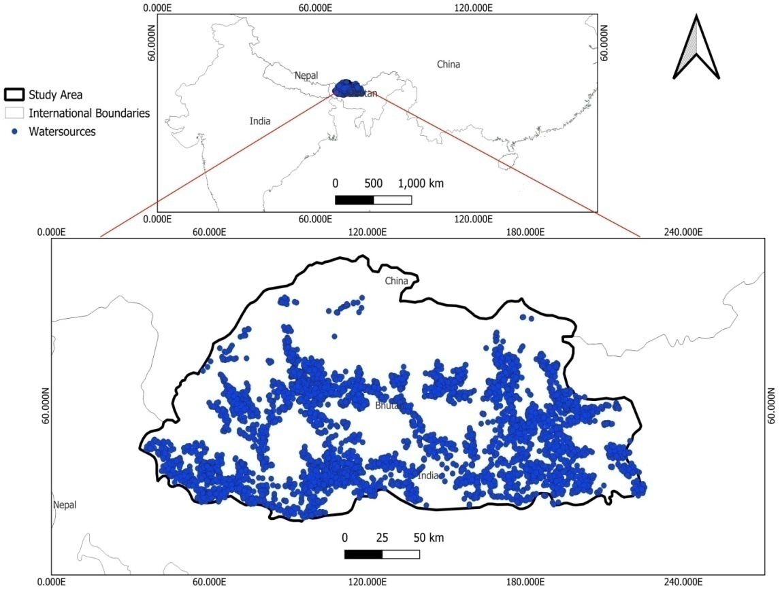
Fig. 1. Map of the study area
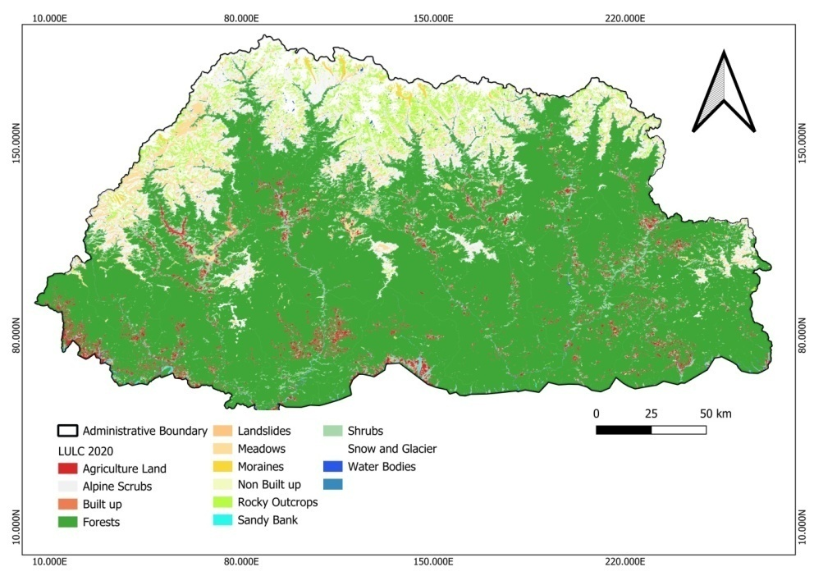
Fig. 2. Land Use and Land Cover map of Bhutan

Data collection
The country is administratively divided into 20 “dzongkhags,” and enumeration was carried out in the year 2020-2021 in all the dzongkhags, where water sources were present and tapped for use. Guided by Dzongkhag’s administrative boundary, respective field offices under the Department of Forests and Park Services (DoFPS) nominated one focal person from their head office as well as from range offices. The identified focal staff attended the training provided by the Watershed Management Division (WMD) so that each range can do the mapping within their jurisdiction to save time and resources. The focal point from the division head office coordinated the activities and liaised with the WMD and respective forest range offices. The mapping of water sources/springs was carried out based on the sources being tapped, rather than the number of tapping points, and their locations were recorded using the handheld GPS devices. After finalizing the water sources, further information related to household dependence on each source, type of water sources, uses of the water sources, status of water sources, distance of water sources from settlement, and a few reasons causing drying up of water sources were collected through key informant interviews and Focus Group Discussions (FGDs) (Adhikari et al. 2020; Dass et al. 2021). The data was recorded in the predetermined data collection sheets developed by WMD and finalized after consultation with the field data collectors.

Data analysis
The data collected by the field staff in the pre-designed format was submitted to WMD through their head office focal officials. The data from the whole country, covering 20 Dzongkhags, was received at WMD. The data compilation, data sorting, coding, and cleansing were done using the MS Excel platform. The data were further sorted Dzongkhag-wise since the respective territorial forest divisions and protected area boundaries don’t follow the Dzongkhag administrative boundary, and further, for better understanding, the areas were also categorized according to elevations i.e., lower elevation zones (100-1500 m asl), medium elevation zones (1501-3000 m asl), and higher elevations (3001-4500 m asl) to better understand the altitudinal variation in the distribution and availability of water resources. The data analysis of the water sources covering their type, status, uses distribution, and issues causing the drying up of water sources were done using the pivot table, plot, and V-lookup functions of the MS Excel software. ArcMap 10.2.2 and QGIS 3.34.0 were used for the production of maps.
Results
Distribution of water sources
The study identified a total of 7,401 water sources across Bhutan, supporting 142,251 households (Fig. 3 and 4). The number of households dependent on these water sources ranged from 1,039 to 15,748, with an average of 7,112.55 ± 3,573.7. While the primary focus of the survey was on water sources currently utilized for drinking, irrigation, commercial, and other purposes, an additional 269 potential water sources near settlement areas were also identified, which could be tapped for future use. Among the 20 dzongkhags, Wangduephodrang dzongkhag recorded the highest number of water sources, with 780 sources supporting 6,601 households, followed by Dagana with 719 sources serving 9,584 households. Punakha recorded 579 water sources with 5,484 household dependencies, while Samtse documented 535 sources serving 15,748 households. Mongar had 481 sources supporting 9,514 households, and Chukha recorded 471 sources with 7,208 households. Trashigang had 468 water sources serving 9,443 households, and Samdrup Jongkhar documented 389 sources supporting 11,401 households. Lhuentse recorded 362 water sources with 7,186 household dependencies. Further findings include Bumthang, with 331 water sources supporting 5,819 households, and Tsirang, with 306 water sources supporting 5,774 households. Trashiyangtse had 306 sources with 3,269 household dependencies, while Zhemgang recorded 296 sources serving 4,789 households. Sarpang had 282 water sources supporting 9,789 households, and Pemagatshel recorded 263 sources serving 4,601 households. Paro documented 237 water sources, with 12,354 households depending on them. Trongsa had 225 sources serving 3,164 households, and Thimphu reported 145 sources supporting 7,362 households. In contrast, the Dzongkhags with the fewest water sources were Haa and Gasa, characterized by their rugged terrain and lower population density. Haa recorded 101 water sources supporting 2,083 households, while Gasa documented 125 water sources serving 1,039 households (Fig. 3).
Further, the study area was divided into three altitudinal zones, i.e., lower elevation zones (100-1500 m asl), medium elevation zones (1501-3000 m asl), and higher elevations (3001-4500 m asl) (Fig. 5). In lower altitudes 37.3% (2764), middle 55.6% (4113) and in higher altitudes 7.1% (524) water sources were recorded. In lower altitudes, 15 districts (Chukha, Dagana, Haa, Lhuentse, Mongar, Pemagatshel, Punakha, Samdrup Jongkhar, Samtse, Sarpang, Trashigang, Trongsa, Tsirang, Wangduephodrang, Zhemgang) were recorded with a mean elevation of 989.14 ± 380.60, mostly from the southern parts of the country. All 20 dzongkahgs (recorded some areas with mid-altitude levels with a mean elevation of 2096 ± 444, with the majority of the areas falling from the northern, central, and western parts of the country. In higher altitudes (3001 - 4500 masl), 11 districts (Bumthang, Chukha, Gasa, Haa, Lhuentse, Mongar, Paro, Punakha, Thimphu, Trashigang, Wangduephodrang) ranged with an average elevation of 3351.14 ± 358.89 m asl.

Fig. 3. Distribution of water sources vs. Household dependency across dzongkhags
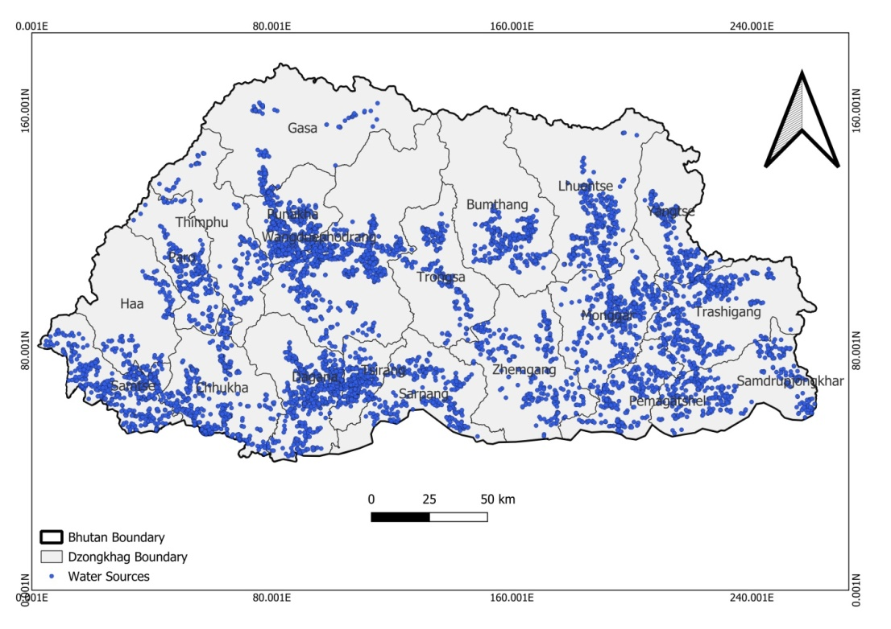
Fig. 4. Map showing the location of water sources across Bhutan
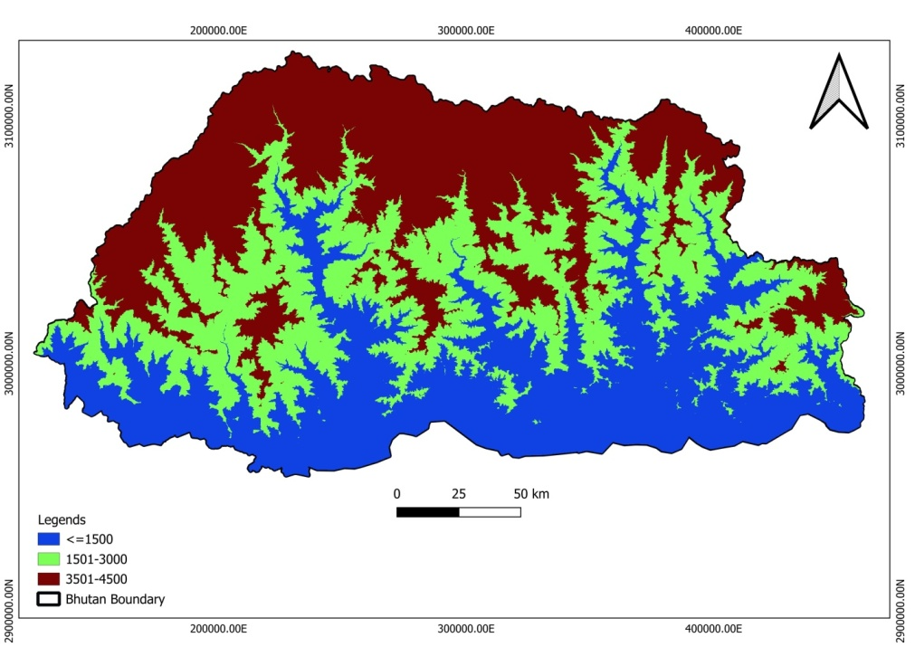
Fig. 5. Elevation map of the present study area
Types of water sources
Out of the 7401 water sources recorded, springs were the most common type, accounting for approximately 67.6% (5001) of the total. Streams followed with 25.6% (1898), while marshes constituted 2.7% (201), ponds 2.3% (169), and rivers 1.1% (81). Lakes were the least represented water source type, comprising only 0.7% (51), as shown in Fig. 6. The distribution of water resources across Bhutan’s Dzongkhags varies significantly. Dagana recorded the highest number of springs, with 551, while Thimphu had the fewest, with just 34. The number of streams was highest in Wangduephodrang at 194, whereas Gasa had the lowest, with only 16 streams. Regarding marshes, Punakha had the most (49), while Gasa had just one. Additionally, Zhemgang and Tsirang were the only Dzongkhags without any marshes. In terms of ponds, Punakha again recorded the highest number, with 69 ponds, while Sarpang had the fewest, with just one. Notably, Trashigang, Dagana, Thimphu, and Trongsa were found to have no ponds. The highest number of rivers used for human purposes was documented in Sarpang, while Bumthang, Zhemgang, Gasa, Chukha, and Mongar each recorded only one river for such use. Haa and Paro were the only Dzongkhags without rivers utilized for human purposes. Lastly, Punakha recorded the highest number of lakes (18), while five Dzongkhags- Zhemgang, Thimphu, Trashiyangtse, Pemagatshel, and Samtse had just one each.

Fig. 6.Types of Water Source
Uses of water sources
The uses of water sources were recorded through the Focus Group discussion (FGD), revealing notable overlaps in the utilization of single sources for multiple purposes. Drinking water emerged as the predominant use, accounting for 5,636 out of the total 7401 recorded sources. Irrigation followed with 841 sources designated for agricultural purposes. Notably, approximately 580 water sources were utilized for both drinking and irrigation, indicating a significant overlap in resource utilization. Additionally, 38 water sources served commercial purposes, primarily catering to cottage and small-scale industries. The survey also identified 271 unused water sources across 18 dzongkhags, representing potential opportunities for future development to meet the growing demands across various sectors.

Fig. 7. Utilization of Water Source
Status of water sources
According to local perceptions, the majority of water sources (73.5%) (5,440 ± 138.53) have remained stable over time, with no significant reduction in their discharge rates. This stability indicates that these sources continue to reliably meet the water demands of the communities they serve. However, a notable concern is emerging, as nearly a quarter (24.8%) (1,873 ± 62.76) of the water sources are in a vulnerable condition, showing clear signs of drying. If this trend persists, these sources may eventually fail to meet both human and ecological water needs. Furthermore, 1.2% (88 ± 5.65) of water sources has already dried up completely, representing a permanent loss of critical water resources. Additionally, 0.5% (36 ± 3.14) of the sources has an unclear status, making their current conditions uncertain and warranting further investigation. Among the 20 dzongkhags in Bhutan, Dagana recorded the highest number of both drying (264) and dried-up (22) water sources. Located in the southwestern part of Bhutan, the surveyed area in Dagana has an average elevation of 1,187 meters above sea level (asl). In contrast, Gasa dzongkhag, situated in the extreme northwest of the country at a higher average elevation of 2,304 m asl, reported the lowest number of drying water sources (16) and no dried-up sources. The highest incidence of water sources with unclear status was found in Thimphudzongkhag (12), followed by Mongar (8).
Table 1. Status of recorded water sources as per people’s perception and survey
Dzongkhag | Drying | Dried Up | No Change | Others | Total
Bumthang | 31 | 1 | 299 | 0 | 331
Chukha | 89 | 11 | 367 | 4 | 471
Dagana | 264 | 22 | 429 | 4 | 719
Gasa | 16 | 0 | 109 | 0 | 125
Haa | 20 | 2 | 79 | 0 | 101
Lhuentse | 128 | 6 | 227 | 1 | 362
Mongar | 77 | 1 | 395 | 8 | 481
Paro | 105 | 11 | 119 | 2 | 237
Pemagatshel | 44 | 2 | 217 | 0 | 263
Punakha | 170 | 4 | 405 | 0 | 579
S/jongkhar | 71 | 11 | 307 | 0 | 389
Samtse | 162 | 6 | 365 | 2 | 535
Sarpang | 134 | 0 | 147 | 1 | 282
Thimphu | 50 | 0 | 83 | 12 | 145
Trashigang | 130 | 2 | 335 | 1 | 468
Trashiyangtse | 47 | 0 | 259 | 0 | 306
Trongsa | 28 | 0 | 197 | 0 | 225
Tsirang | 59 | 6 | 241 | 0 | 306
Wangdue | 142 | 3 | 634 | 1 | 780
Zhemgang | 70 | 0 | 226 | 0 | 296
Total | 1837 | 88 | 5440 | 36 | 7401
Mean | 91.85 | 4.40 | 272.00 | 1.8 | 370.05
SD (±) | 62.76 | 5.65 | 138.53 | 3.14 | 184.88

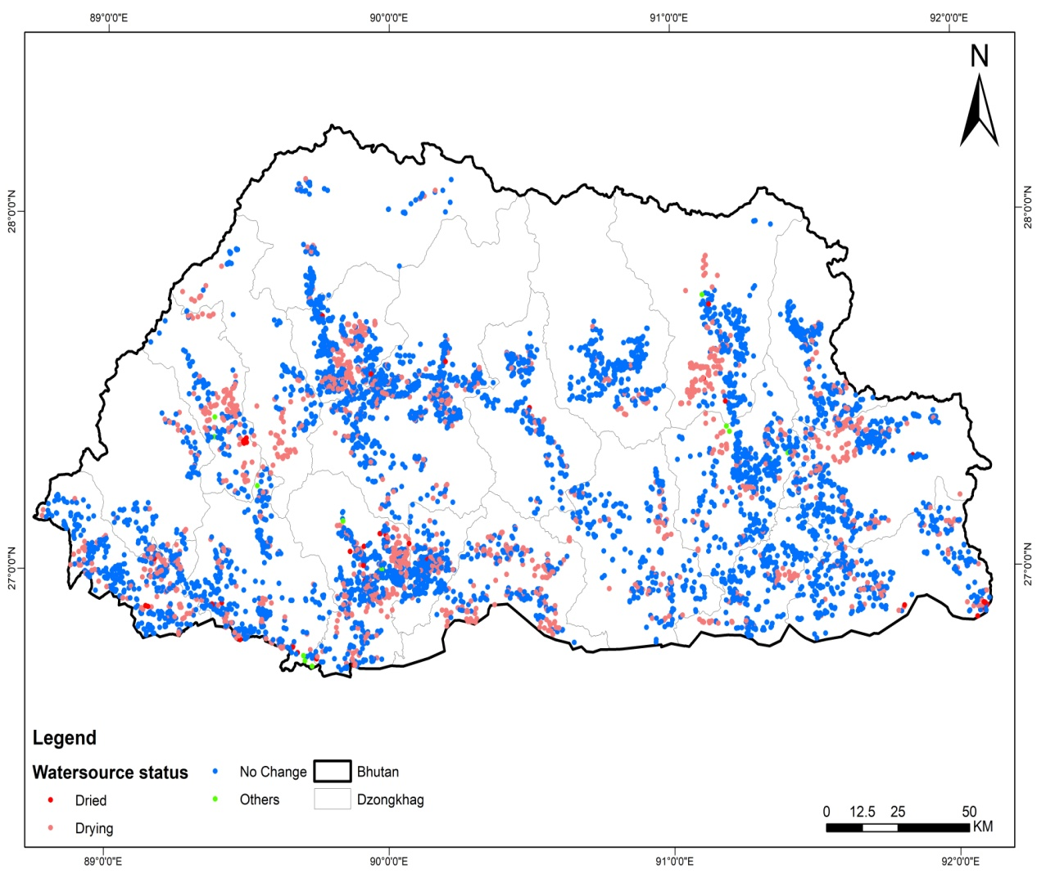
Fig. 8. Map showing water status across Bhutan
General issues contributing to the drying up of water sources, approximately 36.5% (555) of drying water sources are believed to be directly impacted by climate change. FDD (Forest degradation and deforestation) was identified as the second-largest contributor, affecting 28.03% (426) of the drying sources. Other contributing factors included unknown causes 12.30% (187), anthropogenic activities 7.30% (111), land use changes 4.08% (62), overgrazing 3.42% (52), earthquakes 3.36% (51), and unstable geological conditions 1.97% (30). Additionally, a smaller percentage of sources were attributed to a combination of climate change and forest degradation/deforestation, 0.86% (13), and climate change and land use changes, 0.20% (3) (Fig. 9).

Fig. 9. People's perception of the causes of water source drying in Bhutan
Discussion
In this study, 67.6% of water sources were springs, consistent with past hydrological studies in mountainous regions. A comparative analysis of water sources and household dependency across Bhutan’s dzongkhags reveals significant regional variations. Dzongkhags such as Samtse, despite having fewer water sources (535), recorded the highest household dependency, with 15,748 households reliant on these sources. The population density of Samtse is higher than in other districts because Samtse shares a border with India and is one of the important industrial regions and trade routes to other parts of Bhutan. The predominance of springs as a primary water source highlights the country's reliance on smaller, naturally occurring water systems. Springs are one of the most productive as well as most threatened ecosystems in the world (Verma and Jamwal et al. 2022). In contrast, Wangduephodrang, which had the highest number of water sources (780), supported a comparatively lower number of households (6,601). Similarly, Dagana and Mongar displayed high water source counts but with moderate household dependencies. On the other hand, Dzongkhags like Haa and Gasa, with their more rugged and sparsely populated terrain, recorded the fewest water sources and lowest household dependencies, further highlighting the influence of geography and population density on water resource utilization. This variation suggests that Dzongkhags with fewer water sources are often faced with higher pressure on available water resources, particularly with higher population densities (Tariq et al. 2021). Many previous studies reported a significant dependence on springs for drinking water and irrigation in rural communities of Himalayan areas (Kumar et al. 2023; Verma and Jamwal et al. 2022; Chapagain et al. 2019). The springs contribute to the majority of water supply in the mid-hills of the Eastern Himalayas, where over 50% of households rely on spring water for their domestic and agricultural needs (Kumar et al. 2023). Similarly, a study by Tambe et al. (2021) found that springs in Sikkim Himalayan are critical for water supply, yet are increasingly vulnerable to seasonal variability and depletion due to factors like deforestation and climate change. Adhikari et al. (2020) reported 4,222 springs across five watersheds and recorded that 50% were open springs, 15% were pond-type, another 15% were in concrete structures, and 1% were wells from western Nepal. In the present study area in 20 districts, 55.6 % of water sources were recorded in the altitudes ranging from1500-3000 m asl. Many studies suggested that altitude, slope gradient, slope shape, relative relief, flow accumulation, drainage density, geology, lineament density, land use, and vegetation density were considered in assessing the water sources (Kumar et al. 2024; Ghimire et al. 2019).
In the present study, FGDs reported drying of water sources and changes in the rate of discharge. This pattern reflects a global issue, as increasing populations and climate change drive communities to rely on fewer water sources for diverse needs (Kumar et al. 2024; Stringer et al. 2021). While analyzing the data shows the stability of 73.5% of water sources suggests resilience, yet nearly a quarter (24.8%) show signs of drying, a serious concern echoed in other mountainous regions (Immerzeel et al. 2020), where glacier retreat and changes in precipitation are threatening water availability (Chapagain et al. 2019). The permanent drying up of 1.2% of sources represents a critical loss of water resources, similar findings were reported from the different parts of the Himalaya region (Kumar et al. 2024; Kumar et al. 2023; Tambe et al. 2021) and from other part of the world, where overuse and climate pressures have led to the complete depletion of key aquifers (Karandish et al. 2025; Jomaa et al. 2025; Rastegaripour et al. 2024; Stringer et al. 2021). Dagana dzongkhag recorded the highest number of drying and dried-up sources, reflecting regional vulnerabilities often linked to elevation and climate. In contrast, Gasa dzongkhag, located at a higher elevation, reported fewer drying sources, suggesting that higher altitudes may offer some resilience to water depletion. However, the discovery of 269 unused sources offers an opportunity for development to address future water demands, a strategy recommended in water-scarce regions such as sub-Saharan Africa, where undeveloped water sources are being explored to combat water shortages (Mekonnen et al. 2016).
According to the NCHM (2019), Bhutan’s temperature is projected to rise by 0.8°C to 2.0°C between 2021 and 2050 and by approximately 3.2°C by the end of the century (2070-2099). This increase poses significant risks to the country’s water resources and may trigger natural disasters such as Glacial Lake Outburst Floods (GLOF) (Rinzin et al. 2021; Ukita et al. 2011). Additionally, it threatens biodiversity, increases the risk of forest fires, and reduces agricultural productivity and crop yields (NCHM 2019). In the present study, FGD revealed that local communities perceive a range of factors contributing to the drying of water sources, with climate change being the most significant. A total of 36.5% of the drying water sources are believed to be directly affected by shifting rainfall patterns, prolonged droughts and rising temperatures. This aligns with global findings, as numerous studies have shown that climate change is exacerbating water stress in vulnerable regions (Karandish et al. 2025; Jomaa et al. 2025; Immerzeelet al. 2020). Many previous studies highlight how rising temperatures and altered precipitation patterns in the Himalayas are reducing water availability in both glacial-fed and rain-fed systems (Tambe et al. 2021; Tariq et al. 2021; Meenawat et al. 2011; Qiu 2008). In addition to climate change, the focus group discussions identified forest degradation and deforestation as significant contributors to the drying of water sources, with 28% of the cases attributed to these factors. The community’s recognition of the link between forests and water resources is consistent with broader research. Forests play a critical role in maintaining hydrological cycles by regulating water flows, reducing soil erosion, and facilitating groundwater recharge (Jomaa et al. 2025; Esen et al. 2023; Stringer et al. 2021). Deforestation disrupts these processes, leading to reduced water availability and increased vulnerability to droughts (Kumar et al. 2018, 2024). The FGDs also revealed several additional factors driving water source depletion, including road construction, forest fires, overgrazing, land use changes, transmission lines, and infrastructure development. These human activities alter the landscape, degrade watersheds, and disrupt natural water flows, exacerbating the problem. Such findings are supported by previous case studies from Nepal (Ghimire et al. 2023, 2024; Adhikari et al. 2020; Chapagain et al. 2019), Sikkim Himalaya (Kumar et al. 2024; Tambe et al. 2021) and western Himalaya (Kumar et al. 2018, 2023; Pramanik et al. 2016). From other parts of the world, (Karandish et al. 2025; Esen et al. 2023; Stringer et al. 2021; Mekonnen et al. 2016) demonstrated that infrastructure development and land use had a profound impact on water availability, while Ferdowsi et al., (2024) emphasized the role of urban infrastructure projects in altering hydrological systems and contributing to water scarcity.
As noted by Mekonnen and Hoekstra (Mekonnen et al. 2016), community engagement and the incorporation of traditional knowledge are critical for ensuring the long-term sustainability of water resources in water-scarce regions. Water is a crucial component of Bhutan's economy, supporting sectors such as hydropower, agriculture, tourism, and small-scale industries (Tariq et al. 2021). Despite having one of the highest per capita water availabilities in the world, Bhutan experiences both floods and water scarcity (UNDP 2021). This paradox highlights a major water management challenge, the unavailability of water at the right time and place (Chathuranika et al. 2023). In the context of rapid climate change, the Himalayan region faces severe threats. Thus, Bhutan’s water resource management challenges, including the overlap in usage, drying sources, and regional disparities, reflect broader global trends. As climate change continues to impact water availability, integrated and adaptive management strategies will be essential to ensure sustainable water use across the country. Bhutan's future water security will depend on both the development of unused sources and the conservation of existing ones, aligning with global best practices for managing limited water resources.
Conclusion and recommendation
The study underscores the critical and complex nature of water resources in Bhutan, marked by significant regional disparities in availability and an increasing vulnerability due to climate change. The findings reveal that while Bhutan has an abundance of water sources i.e., 7401 in total, supporting 142,251 households, their distribution varies widely across regions. The mid-altitudes (3001-4500 m asl) have the largest number of sources, while the higher altitudes (3001-4500 m asl) have the least. Spring emerged as the predominant source, comprising 67.6% of the total, followed by streams (25.6%) and much smaller proportions of marshes, ponds, rivers, and lakes. Drinking water remains the primary purpose of the sources, with 5,636 recorded for this use, underscoring the essential role water plays in daily life and community health. However, the study also brings forth a significant concern that 24.8% (1873±62.76) of these water sources are already showing signs of drying, and 1.2% (88±5.65) have dried up completely, representing a permanent loss of vital resources. Local perceptions attribute the drying of approximately 36.5% of these sources to the direct impacts of climate change, reflecting a serious vulnerability to environmental shifts. Although 73.5% of sources show stability, the looming threat to nearly a quarter of water resources aligns with broader challenges in other mountainous regions. This study sheds light on Bhutan's unique challenge, having abundant water resources overall but limited access in certain areas or at certain times, complicating effective water management. Given the severe climate change impacts in the Himalayas, there is an urgent need for further research and proactive, community-led water management strategies that include local knowledge and engagement. Balancing policy-driven actions with grassroots solutions is essential to building resilience and ensuring sustainable water availability in Bhutan's mountainous regions.
Acknowledgments
We highly acknowledge the Department of Forests and Parks Services (DoFPS), the Royal Government of Bhutan, and the supporting staff and people who participated and shared valuable information. We are also grateful for all the people, in one way or another, involved in the completion of this mapping exercise.
References
Adhikari S, Gurung A, Chauhan R, Rijal D, Dongol BS, Aryal D, Talchabhadel R (2020) Status of springs in mountain watershed of western Nepal. Water Policy 23:142–156. https://doi.org/10.2166/wp.2020.187
Aryal JP, Bisht M, Rahut DB (2024) Bhutan and the geography of climate change. In: Khare N (ed) The Role of Tropics in Climate Change. Elsevier, pp 137–146. https://doi.org/10.1016/B978-0-323-99519-1.00004-1
Chapagain PS, Ghimire M, Shrestha S (2019) Status of natural springs in the Melamchi region of the Nepal Himalayas in the context of climate change. Environ Dev Sustain 21:263–280. https://doi.org/10.1007/s10668-017-0036-4
Chathuranika IM, Sachinthanie E, Zam P, Gunathilake MB, Denkar D, Muttil N, Abeynayaka A, Kantamaneni K, Rathnayake U (2023) Assessing the water quality and status of water resources in urban and rural areas of Bhutan. J Hazard Mater Adv 12:100377. https://doi.org/10.1016/j.hazadv.2023.100377
Dass B, Abhishek, Sen S, Bamola V, Sharma A, Sen D (2021) Assessment of spring flows in Indian Himalayan micro-watersheds: a hydro-geological approach. J Hydrol 598:126354. https://doi.org/10.1016/j.jhydrol.2021.126354
Department of Forests and Park Services (2023) National Forest Inventory: State of Forest Report, Vol I. Ministry of Energy and Natural Resources, Royal Government of Bhutan, pp IX.
Dorji U, Olesen JE, Bøcher PK, Seidenkrantz MS (2016) Spatial variation of temperature and precipitation in Bhutan and links to vegetation and land cover. Mt Res Dev 36:66. https://doi.org/10.1659/MRD-JOURNAL-D-15-00020.1
Esen SE, Hein L, Cuceloglu G (2023) Accounting for the water-related ecosystem services of forests in the Southern Aegean region of Turkey. Ecol Indic 154:110553. https://doi.org/10.1016/j.ecolind.2023.110553
Ferdowsi A, Piadeh F, Behzadian K, Mousavi SF, Ehteram M (2024) Urban water infrastructure: a critical review on climate change impacts and adaptation strategies. Urban Clim 58:102132. https://doi.org/10.1016/j.uclim.2024.102132
Ghimire M, Chapagain PS, Shrestha S (2019) Mapping of groundwater spring potential zone using geospatial techniques in the Central Nepal Himalayas: a case example of Melamchi–Larke area. J Earth Syst Sci 128:26. https://doi.org/10.1007/s12040-018-1048-7
Ghimire M, Timalsina N, Zhao W (2023) A geographical approach of watershed prioritization in the Himalayas: a case study in the middle mountain district of Nepal. Environ Dev Sustain 26:23527–23560. https://doi.org/10.1007/s10668-023-03610-5
Gilani H, Shrestha HL, Murthy MSR, Phuntso P, Pradhan S, Bajracharya B, Shrestha B (2015) Decadal land cover change dynamics in Bhutan. J Environ Manag 148:91–100. https://doi.org/10.1016/j.jenvman.2014.02.014
Immerzeel WW, Lutz AF, Andrade M, Bahl A, Biemans H, Bolch T, Hyde S et al (2020) Importance and vulnerability of the world's water towers. Nature 577:364–369. https://doi.org/10.1038/s41586-019-1822-y
Jomaa I (2025) The role of groundwater depletion in local and global climate change. Zenodo. https://doi.org/10.5281/zenodo.15192267
Karandish F, Liu S, Graaf I (2025) Global groundwater sustainability: a critical review of strategies and future pathways. J Hydrol 657:133060. https://doi.org/10.1016/j.jhydrol.2025.133060
Kumar M, Rathod R, Mukherji A (2023) Water security and spring conservation in the Himalaya. In: Ojha H, Schofield N, Camkin J (eds) Climate Risks to Water Security. Springer International Publishing, pp 15–36. https://doi.org/10.1007/978-3-031-16648-8_2
Kumar M, Sen S, Kulkarni H, Badiger S, Varma GR, Krishnaswamy J (2024) Ecohydrological and hydrogeological dynamics of groundwater springs in Eastern Himalaya, India. Groundw Sustain Dev 27:101311. https://doi.org/10.1016/j.gsd.2024.101311
Kumar V, Sen S (2018) Evaluation of spring discharge dynamics using recession curve analysis: a case study in data-scarce region, Lesser Himalayas, India. Sustain Water Resour Manag 4:539–557. https://doi.org/10.1007/s40899-017-0138-z
Meenawat H, Sovacool BK (2011) Improving adaptive capacity and resilience in Bhutan. Mitig Adapt Strateg Glob Change 16:515–533. https://doi.org/10.1007/s11027-010-9277-3
Mekonnen M, Hoekstra A (2016) Four billion people facing severe water scarcity. Sci Adv 2:e1500323. https://doi.org/10.1126/sciadv.1500323
Mir B, Kumar R, Lone MA, Tantary FA (2021) Climate change and water resources of Himalayan region: review of impacts and implications. Arab J Geosci 14:1088. https://doi.org/10.1007/s12517-021-07438-z
Mool PK, Wangda D, Bajracharya SR, Joshi SP, Kunzang K, Gurung DR (2001) Inventory of Glaciers, Glacial Lakes and Glacial Lake Outburst Floods: Monitoring and Early Warning Systems in the Hindu Kush-Himalayan Region – Bhutan. ICIMOD, Kathmandu, pp 71–85. https://doi.org/10.53055/ICIMOD.373
National Center for Hydrology and Meteorology (NCHM) (2019) Annual Report. Thimphu: Royal Government of Bhutan.
Nepal TK (2024) Change in Bhutan’s land use and land cover from 1930–2020. West Sci Soc Humanit Stud 2:267–276. https://doi.org/10.58812/wsshs.v2i02.595
Pramanik P, Bhaduri D (2016) Impact of climate change on water resources in Indian Himalaya. In: Bisht J, Meena V, Mishra P, Pattanayak A (eds) Conservation Agriculture: An Approach to Combat Climate Change in Indian Himalaya. Springer, Singapore, pp 487–507. https://doi.org/10.1007/978-981-10-2558-7_19
Qiu J (2008) China: the third pole. Nature 454:393–396. https://doi.org/10.1038/454393a
Rastegaripour F, Tavassoli A, Babaeian M, Fernández-Gálvez J, Caballero-Calvo A (2024) Assessing the impacts of climate change on water resource management and crop patterns in Eastern Iran. Agric Water Manag 295:108774. https://doi.org/10.1016/j.agwat.2024.108774
Rinzin S, Zhang G, Wangchuk S (2021) Glacial lake area change and potential outburst flood hazard assessment in the Bhutan Himalaya. Front Earth Sci 9:775195. https://doi.org/10.3389/feart.2021.775195
Stringer LC, Mirzabaev A, Benjaminsen TA, Harris RMB, Jafari M, Lissner TK, Stevens N, Pahlen CT (2021) Climate change impacts on water security in global drylands. One Earth 4:851–864. https://doi.org/10.1016/j.oneear.2021.05.010
Tambe S, Kharel G, Arrawatia ML, Kulkarni H, Mahamuni K, Ganeriwala AK (2021) Reviving dying springs: climate change adaptation experiments from the Sikkim Himalaya. Mt Res Dev 32:62–72. https://doi.org/10.1659/MRD-JOURNAL-D-11-00079.1
Tariq MAUR, Wangchuk K, Muttil N (2021) A critical review of water resources and their management in Bhutan. Hydrology 8:31. https://doi.org/10.3390/hydrology8010031
Ukita J, Narama C, Tadono T, Yamanokuchi T, Tomiyama N, Kawamoto S, Nishimura K (2011) Glacial lake inventory of Bhutan using ALOS data: methods and preliminary results. Ann Glaciol 52:65–71. https://doi.org/10.3189/172756411797252293
UNDP (2021) Towards a climate-resilient water sector. https://undp-bhutan.exposure.co/towards-a-climate-resilient-water-sector. Accessed 10 Feb 2025.
Verma R, Jamwal P (2022) Sustenance of Himalayan springs in an emerging water crisis. Environ Monit Assess 194:87. https://doi.org/10.1007/s10661-021-09731-6

