Integrated Geophysical and Hydrogeological Assessment of Groundwater Potential in Selected Urban Towns of Anambra state, Nigeria

Abstract
Groundwater remains the primary source of potable water in many urban centers of southeastern Nigeria, yet its potential, quality, and sustainability are often poorly understood. This study aimed to evaluate the groundwater potential and aquifer characteristics of selected urban towns such as Oba, Ojoto, Alor, Oraukwu, Nnobi, Awka-Etiti, and Nnewi in Anambra State, Nigeria for sustainable water resource management. Specific objectives were to delineate aquifer zones, determine hydraulic properties, and assess groundwater potential and variability using integrated geophysical and hydrogeological methods. Forty - nine Vertical Electrical Sounding (VES) stations were investigated using the Schlumberger array, complemented with 22 archived datasets from Rural Water Supply and Sanitation Agency (RUWASSA) Anambra State. Inversion modeling using Interpex IX1D and IPI2Win software generated layered resistivity models that defined subsurface lithologies and aquifer geometry. Thirty-five pumping test datasets were analyzed to estimate transmissivity (T) and hydraulic conductivity (K). Results showed multi-layered aquifer systems composed of sandy and sandstone formations interbedded with clayey units. Hydraulic conductivity ranged from 0.013 – 40.54 m/day, and transmissivity from 0.73–2,716 m²/day, indicating significant spatial variability. Three groundwater potential zones were delineated: shallow, pollution-prone aquifers at 80 – 150 m elevation; productive, middle aquifers at 150 – 220 m; and deep, confined aquifers above 220 m with excellent water quality. The study concludes that integrated VES and pumping test methods provide a reliable, cost-effective framework for urban groundwater evaluation. It recommends prioritizing high-transmissivity zones for water supply, enforcing aquifer protection in vulnerable areas, and establishing long-term groundwater monitoring and management frameworks for sustainable utilization.

Keywords: Groundwater potential, Vertical Electrical Sounding, pumping test, transmissivity, Anambra State, aquifer vulnerability, sustainable water management

1.0 Introduction
Groundwater is indisputably an indispensable resource for domestic, agricultural, and industrial use, particularly in regions where surface water is scarce or seasonally unreliable. In selected urban towns of Anambra State, Southeastern Nigeria, rapid population growth, urbanization, and expanding industrial activities have significantly increased the demand for reliable groundwater supplies. Despite its vital importance, groundwater development in these areas is often constrained by complex subsurface geology and inadequate hydrogeological data (Onyenweife & Nwozor, 2025).

Anambra State lies mostly within the Niger Delta Basin. The basin is characterized by alternating sequences of sandstone, shale, and limestone formations that host multiple aquifer systems (Nwajide, 2013). These stratigraphic units exhibit diverse hydrogeological properties that influence groundwater occurrence, storage, and flow dynamics across the region. Understanding these variations is crucial for sustainable groundwater exploitation and management.

This study adopts an integrated approach that combines Vertical Electrical Sounding (VES) and pumping test techniques to evaluate groundwater potential and aquifer characteristics in selected urban towns. VES surveys, conducted at 50 locations, provide subsurface resistivity profiles essential for delineating aquifer geometry and lithological variations. Complementary pumping tests performed at 27 boreholes yield key hydraulic parameters such as transmissivity, storativity, and hydraulic conductivity, which are fundamental for assessing aquifer performance (Nigate et al., 2025; Ha et al., 2020). Data interpretation was carried out using Ipi2Win, Ix1D v2, and Aqtesolv software to ensure accurate quantitative and qualitative analyses.

The integration of geophysical and hydrogeological datasets enhances the understanding of groundwater potential zones influenced by geological structures, recharge mechanisms, topography, and land use dynamics. Research shows that combining geophysical methods (VES) with hydrogeological testing (pumping tests) leads to more reliable aquifer assessments than single-method studies (Okeke et al., 2021; Onyenweife & Mgbolu, 2023).

Urban expansion and agricultural practices have notably altered recharge patterns and water quality in the region (Odoh & Nwokeabia, 2024). Hence, identifying areas with favorable groundwater potential is essential for guiding sustainable water resource management strategies. This study contributes to achieving the United Nations Sustainable Development Goal 6 (SDG 6), which advocates the sustainable availability and management of water for all.

Within Anambra State, prior studies have mapped aquifer zones using resistivity surveys (Okeke et al., 2021) and monitored land use changes and their effect on groundwater recharge (Eze & Chukwuma, 2023). However, there is a lack of town-scale studies across multiple adjacent urban centres that integrate dense VES data with calibrated pumping test results and link these to land-use dynamics. This gap restricts efficient groundwater resource planning and sustainable yield estimation in urbanising zones. The present study addresses this by conducting 50 VES soundings and 27 pumping tests in selected urban towns of Anambra State, thereby offering detailed aquifer characterisation and management-relevant insight.

- Description and Geology of the Study Area

The study area (Fig. 1) lies between longitudes 6°48′0′′E and 6°59′0′′E and latitudes 5°59′0′′N and 6°7′0′′N, encompassing Oba, Ojoto, Alor, Oraukwu, Nnobi, and Awka-Etiti in Anambra State, southeastern Nigeria. Accessibility is mainly through the Onitsha–Nkpor–Nnobi–Nnewi and Onitsha–Oba–Nnewi–Nnobi road networks.

2.1 Climate and Physiography

The climate exhibits a distinct bimodal pattern comprising a dry season (November–March) and a rainy season (April–October). The dry season is characterized by reduced humidity, dusty harmattan winds, and declining surface and groundwater levels. Conversely, the rainy season is marked by intense precipitation and thunderstorms that promote infiltration, flooding, and soil leaching typical of Nigeria’s rainforest belt (Egboka et al., 1985; Onwuemesi et al., 1991). Annual rainfall exceeds 2000 mm, contributing significantly to groundwater recharge and rock-water interaction processes that influence aquifer geochemistry (Adetokunbo, 2025).

However, rapid urbanization, deforestation, and land-use modifications have altered the hydrological balance. Between 2017 and 2023, tree cover in Anambra State declined from 1,807 km² to 1,345 km², while built-up areas expanded from 1,105 km² to 1,330 km², reducing infiltration and increasing surface runoff (Nwokeabia et al., 2024). These changes potentially constrain aquifer recharge and amplify groundwater vulnerability in the urban centers.

2.2 Drainage and Hydrology

The Idemili River and its tributaries constitute the major drainage system, with streams such as Akanmiri and Eze feeding into the Ulasi River, while Mmiri-John and Mmiri-Obiaja discharge into the Idemili River. A ridge along the Awka-Etiti–Nnobi–Uruagu–Nnewi axis serves as a watershed divide where streams north of it drain westward, whereas those south flow in a northeast–southwest direction. The limited stream presence along the Agulu–Ozubulu axis suggests dominance of precipitation-driven groundwater recharge. This drainage framework supports domestic and agricultural water needs, yet current modifications to natural recharge zones due to land-use changes have heightened surface runoff and reduced water availability (Odoh et al., 2024; Udochaogu, 2022).

2.3 Geology and Hydrogeological Setting

Geologically, the study area is underlain by Paleocene to Oligocene sedimentary successions comprising the Imo Formation, Ameki Group, Ogwashi–Asaba Formation, and parts of the Benin Formation. The Imo Formation, characterized by shales, sandstones, and occasional limestone, forms the basal unit in the northern sector, overlain by the sandy and fossiliferous Ameki Group. The Ogwashi–Asaba Formation consists of alternating layers of lignite, clay, and sands, while the Benin Formation comprises highly permeable, coarse-grained sandstones and gravels that form the region’s principal aquifer system (Nwajide, 2013).

Cenozoic transgressive and regressive cycles within these formations control the aquifer distribution, groundwater flow, and storage characteristics (Nfor et al., 2007). The River Niger, trending NNE–SSW to the west, serves as a regional discharge boundary, receiving contributions from the Idemili River alluvial valley. Structural features such as faults, joints, and bedding contacts further influence aquifer geometry and hydraulic connectivity within the basin. Overall, the interplay of climatic variability, geomorphology, and lithostratigraphy shapes the hydrogeological framework of the area, highlighting the need for integrated geophysical and pumping-test assessments to delineate sustainable groundwater potential zones.

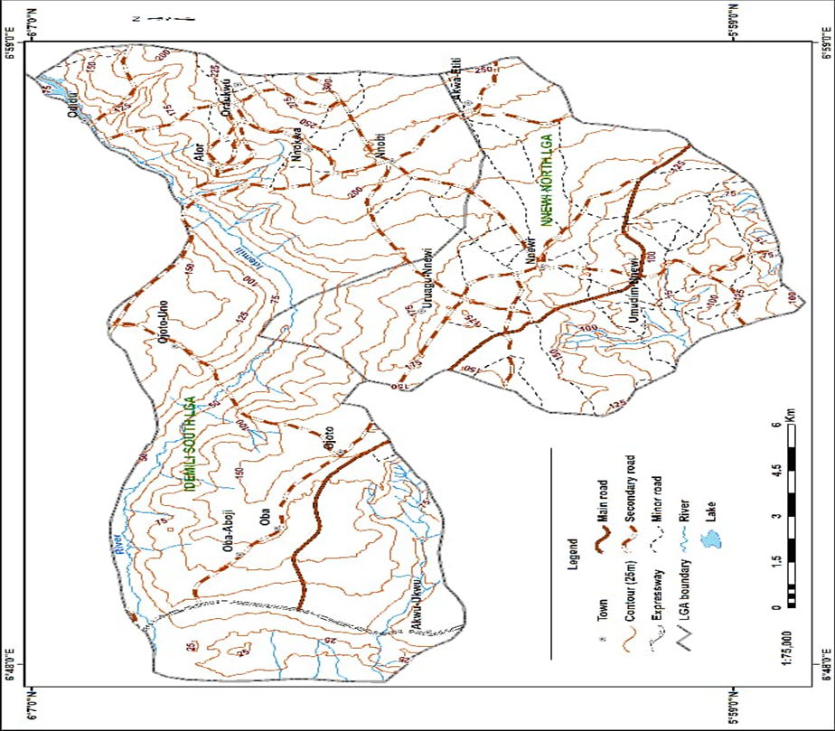
Fig: 1 Map of the study area
3.0 Methodology
This study adopted an integrated approach involving Vertical Electrical Sounding (VES) and pumping test analyses to characterize the groundwater potential of the study area. The combined use of these methods enhances the delineation of aquifer geometry and estimation of hydraulic parameters essential for sustainable groundwater management.
3.1 Vertical Electrical Sounding (VES) Survey
A total of 50 VES stations were established across Oba, Ojoto, Alor, Oraukwu, Nnobi, Awka-Etiti, and Nnewi to provide comprehensive subsurface coverage (Fig. 2). The Schlumberger electrode configuration was adopted because of its effective depth of investigation and ability to resolve multilayered subsurface structures (Adeleke et al., 2023). Electrode separations (AB/2) were progressively increased from 1 m to 300 m, depending on site accessibility and expected penetration depth.

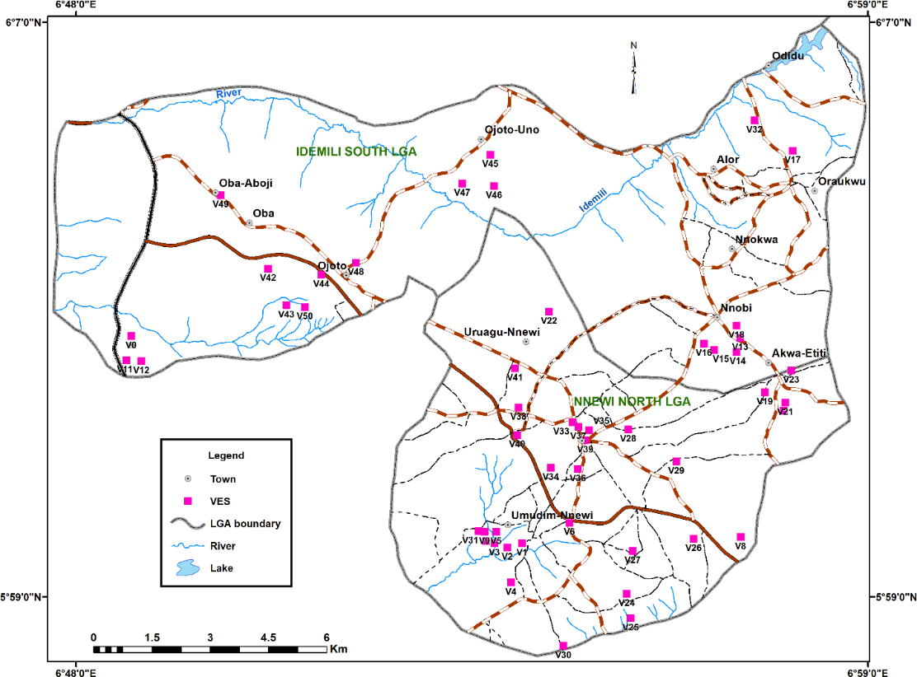
Fig. 2: Distribution of VES points across the Study Area
3.1.1 Field Procedure
VES measurements were obtained using an Omega System Terrameter, comprising current and potential electrodes connected via shielded cables and powered by a 12 V battery. At each site, electrodes were implanted firmly to ensure good ground contact, while current (I) and potential (V) readings were recorded for successive electrode spacings.
Apparent resistivity (ρₐ) was computed using the standard Schlumberger equation 1:
$ρₐ=K\frac{V}{I}$ 1
where K represents the geometric factor dependent on electrode spacing. Data quality control involved repeating readings at large electrode separations to check for consistency, minimizing electrode contact resistance, and verifying instrument calibration before each day’s fieldwork. In addition to newly acquired datasets, 22 archived VES profiles from the Anambra State Rural Water Supply and Sanitation Agency (RUWASSA) were retrieved and reprocessed to enhance spatial coverage.
3.1.2 Data Processing and Interpretation
The apparent resistivity data were plotted on log–log paper and subjected to computer-assisted inversion using IPI2Win and Interpex IX1D (v3.53) software. The inversion process applied an iterative least-squares optimization algorithm to minimize the root mean square (RMS) error between observed and modeled curves. The resulting layered-earth models (Figs. 3 and 4) provided estimates of true resistivity (ρᵢ) and thickness (hᵢ) of each subsurface layer (Bobachev, 2020; Interpex, 2008; Khan, 2024).
Aquifer horizons inferred from low- to moderate-resistivity zones corresponding to saturated sandy formations, supported by borehole lithologic logs where available. Spatial correlation of resistivity and lithological data allowed delineation of aquifer boundaries, depth to water table, and probable recharge zones.
3.2 Pumping Test Investigation
3.2.1 Field Procedure
Pumping tests were conducted at seven borehole locations to evaluate the hydraulic characteristics of the aquifers within the study area. These tests were carried out with technical support and equipment from the Anambra State Rural Water Supply and Sanitation Agency (RUWASSA). In addition, secondary data from 28 boreholes were obtained from RUWASSA archives to enhance spatial representation.
Prior to pumping, static water levels were measured to establish baseline conditions. A submersible pump was used for constant-discharge testing, and water-level fluctuations were monitored using an electric water-level indicator. Discharge rates were checked periodically with a calibrated flow container to ensure consistent pumping conditions (ASTM, 2017; EPA, 2025).
Measurements were recorded every minute during the first ten minutes, every five minutes for the next fifty minutes, every ten minutes up to 120 minutes, and every twenty to thirty minutes thereafter, until the test concluded at approximately 240 minutes.
Immediately after the pumping phase, a recovery test was performed to monitor the rebound of water levels. Readings were taken every minute for the first ten minutes and every five minutes thereafter for about 45 minutes. The recovery test data were used to validate the estimated aquifer parameters.

3.2.2 Data Analysis and Parameter Estimation
Pumping test data were analyzed using AQTESOLV software, applying the Cooper and Jacob (1946) straight-line method, a simplified form of the Theis analytical solution for confined aquifers. This approach is widely used for its computational efficiency and ability to provide reliable transmissivity and storativity values without complex curve matching (Kruseman & de Ridder, 2023; Singh et al., 2022).
The key hydraulic parameters; transmissivity (T), storativity (S), and hydraulic conductivity (K) were computed using equations 2-4 :
T = $\frac{0.183Q}{(ho-h)}$ 2
where (Q) is the constant discharge (m³/min) and (ho - h) is the slope of the drawdown versus log-time plot.
S = $\frac{2.25Tto}{r2}$ 3
where (to) is the time intercept at zero drawdown and (r) is the distance from the pumping well to the observation well.
K = $\frac{T}{b}$ 4
where (b) is the aquifer thickness derived from borehole lithologic logs.
From these parameters, the specific storage (Ss) and well yield were estimated. The derived values provided a quantitative basis for evaluating aquifer performance, groundwater potential, and recharge capacity across the study area.
3.2.3 Reliability and Interpretation
Pumping tests remain one of the most reliable techniques for obtaining in-situ aquifer parameters, as they integrate hydraulic responses over a representative aquifer volume (Houben et al., 2022; Kruseman & de Ridder, 2023). However, interpretations may be non-unique due to boundary effects and heterogeneity. The Cooper–Jacob method was adopted for its robustness in late-time drawdown interpretation, minimal data pre-processing requirements, and suitability for confined to semi-confined aquifer systems (Singh et al., 2022).

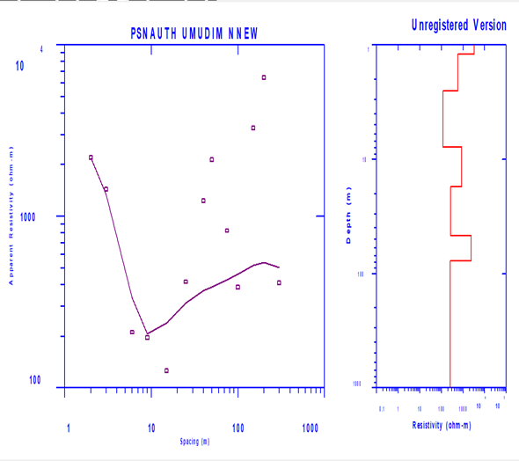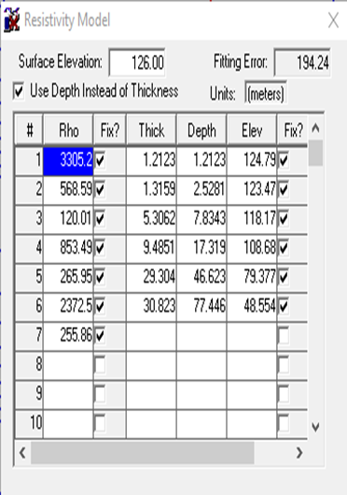
Fig. 3: Generated Geoelectric Layers from a VES Point
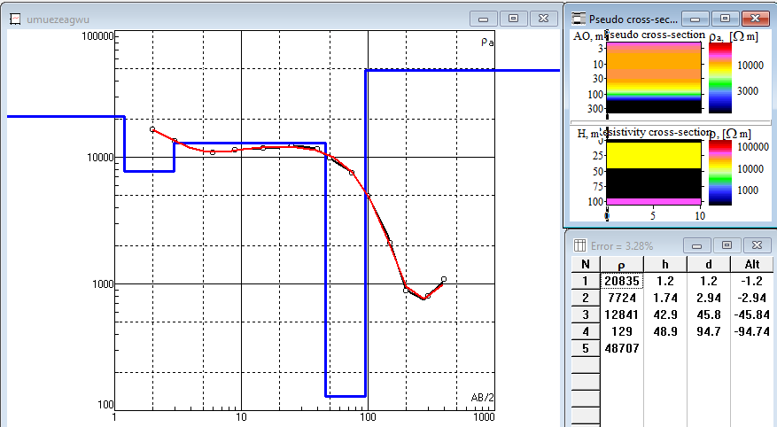
Fig. 4: One of the VES Points showing Type K curve

4.0 Results and Discussion
4.1 Interpretation for Vertical Electrical Sounding (VES)
A total of 50 Vertical Electrical Sounding VES stations were analyzed to delineate subsurface lithology, aquifer systems, and groundwater potential zones. The data, processed using IPI2WIN and IX1D software, provided robust inversion results that correlate well with known hydrostratigraphic units of the Ameki and Ogwashi–Asaba Formations in southeastern Nigeria. The integration of resistivity data with hydrogeological parameters enhanced the delineation of aquifer geometry, hydraulic properties, and vulnerability (Udoh et al., 2021; Singha et al., 2023).
4.1.1 Resistivity Curve Types
Three dominant curve types were identified from the VES interpretation (fig. 5):
1. H-Type (HAA, HKA, HAK): Characterized by decreasing–increasing resistivity with depth, indicative of interbedded sands and clays.
2. K-Type (KHK): Increasing–decreasing resistivity trend, typically representing a clay cap overlying sandy aquifers.
3. A-Type (AKQ): Monotonic increase in resistivity with depth, reflecting thick, coarse sand or sandstone aquifer formations.
These curve types confirm a heterogeneous depositional environment influenced by alternating fluvial and deltaic sedimentation, which significantly affects groundwater storage and flow continuity (Fig.4). The observed curve types reflect heterogeneous fluvial–deltaic sedimentation, where interbedded sands and muds create variable aquifer storage and irregular flow pathways (Hoque et al., 2020; Mahrez, 2023; Nwozor et al., 2025).

Fig. 5: Processed Resistivity Data Showing Sounding Curves of Each VES Points

4.1.2 Subsurface Lithology and Resistivity Distribution
The geoelectric layers derived from the VES inversion revealed a complex sedimentary sequence composed of:
Lateritic Topsoil: This lithology is present in most stations with resistivity ranging from 41.76–980 Ωm and thicknesses from 0.11–6.03 m. High resistivity indicates compact, dry laterite, while lower values signify clayey or moist zones.
Clay/Shale Layers: The resistivity values fall within 26.35–921.15 Ωm. This lithology acts as aquitards restricting vertical flow. Thin or discontinuous units may allow local leakage and increase aquifer vulnerability (Fashae et al., 2022).
Sandy Units: The variable resistivity (400–900 Ωm) reflects partial saturation or mixed sand–clay composition. Coarse sands often exceed 1000 Ωm, denoting high permeability and porosity.
Water-Saturated Sands (Aquifers): Their resistivity ranges from 169.36–48,707 Ωm in several stations (VES 8, 13, 15, 18, 23, 29, 35, 38, 44, 47). These represent productive aquifers with good groundwater potential (Ezeh et al., 2022; Okonkwo et al., 2021) (Table 1). The spatial variation in resistivity and layer thickness underscores the presence of multiple aquifer horizons with distinct hydraulic behaviors, consistent with established geoelectrical–hydrogeological relationships (Niwas & Singhal, 1981).

Table 1: Distribution of Aquifer hydraulic Properties with VES Locations
VES NO | Longitude | Latitude | Elevation (m) | Aquifer App. Res. (Ωm) | Depth to Water table | Hydraulic Conductivity (Km/day) | Transmissivity (m²/day) | Station
VES 1 | 6.9033 | 5.9958 | 134 | 255.86 | 77.45 | 0.1915 | 5.90 | Psnauth Umudim Nnewi
VES 2 | 6.8999 | 5.9948 | 121 | 2953.9 | 28.6 | 2.0447 | 196.03 | Owerri RD Umudim Nnewi
VES 3 | 6.8969 | 5.9958 | 89 | 47.242 | 87.02 | 0.0359 | 1.70 | Akamili Umudim Nnewi
VES 4 | 6.90074 | 5.98669 | 122 | 3610 | 103.5 | 2.5447 | 108.53 | Ebeleogo Umudim Nnewi
VES 5 | 6.8973 | 5.9985 | 155 | 885.52 | 76.00 | 0.6833 | 20.03 | Akwu Akamili Umudim Nnewi
VES 6 | 6.9033 | 6.00186 | 92 | 4130.5 | 84.54 | 2.9119 | 89.73 | St.Felix Umudim Nnewi
VES 7 | 6.9590 | 5.9874 | 101 | 205.12 | 142.5 | 0.1553 | 9.00 | St.John Akamili Nnewi
VES 8 | 6.9539 | 5.9872 | 122 | 48707 | 94.7 | 8.4947 | 711.29 | Umueagwu
VES 9 | 6.8946 | 5.9985 | 121 | 885.52 | 76.00 | 8.4519 | 315.51 | Akwu Akamili Umudim Nnewi
VES10 | 6.9336 | 6.1198 | 98 | 21.4 | 44.7 | 0.0163 | 0.73 | Akama Akwukwu
VES 11 | 6.9230 | 6.1209 | 104 | 150 | 45.6 | 0.1138 | 5.19 | Ekele Akwukwu
VES 12 | 6.9241 | 6.1216 | 99 | 1389 | 75.3 | 1.0447 | 78.71 | Umuosikpana
VES 13 | 6.9538 | 6.0435 | 89 | 19160 | 146.6 | 0.9119 | 315.51 | Amadunu Ebenesi Nnobi
VES 14 | 6.9529 | 6.0402 | 166 | 3329.7 | 123.2 | 2.3559 | 246.85 | Ifite Nnobi
VES 15 | 6.9477 | 6.0407 | 161 | 40851 | 119.7 | 7.9119 | 423.19 | Eziora Nnobi
VES 16 | 6.9454 | 6.0421 | 129 | 11355 | 155.62 | 5.3559 | 269.81 | Nnobi
VES 17 | 6.67067 | 6.02433 | 167 | 5157.0 | 121.4 | 7.5447 | 365.01 | Alor
VES 18 | 6.9529 | 6.0463 | 219 | 9289.7 | 207.7 | 4.6833 | 735.37 | Umuru Nnobi
VES 19 | 6.9595 | 6.0308 | 152 | 2443.4 | 201.0 | 1.7321 | 119.29 | St.Mary Ang.Awka Etiti
VES 20 | 6.9638 | 6.0265 | 282 | 6070.2 | 223.4 | 4.0447 | 685.39 | Odumodu Nnokwa
VES 21 | 6.9642 | 6.0284 | 252 | 2754.2 | 167.1 | 1.9119 | 50.05 | Isumgbede Etiti Nnokwa
VES 22 | 6.90953 | 6.04952 | 130 | 4062.6 | 106.6 | 2.8313 | 151.43 | Umuogbuo Obiofia Nnewi
VES 23 | 6.9656 | 6.0359 | 121 | 9289.7 | 132.5 | 6.6833 | 531.19 | Azubuogwu Nkpoka Nnewi
VES 24 | 6.9275 | 5.9841 | 139 | 652.23 | 97.68 | 0.4839 | 38.47 | Ndiakwu Otolo Nnewi
VES 25 | 6.9284 | 5.9784 | 144 | 9667.3 | 113 | 6.9119 | 397.39 | Egbu Otolo Nnewi
VES 26 | 6.9430 | 5.9968 | 153 | 1088.4 | 79.8 | 0.8313 | 33.00 | Abubo Nnewichi Nnewi
VES 27 | 6.9289 | 5.9940 | 101 | 1280.0 | 95.88 | 0.9119 | 62.55 | Okpuno Nnewichi Nnewi
VES 28 | 6.9419 | 5.9771 | 171 | 3317.4 | 94.93 | 2.3559 | 121.51 | Umuanuka Otolo Nnewi
VES 29 | 6.9436 | 5.9725 | 184 | 17014 | 109.7 | 8.0447 | 593.31 | Egbu Umuenem Otolo Nnewi
VES 30 | 6.91285 | 5.97198 | 198 | 3213.0 | 121.4 | 2.2833 | 124.19 | Umunnalam
VES 31 | 6.9356 | 6l1169 | 129 | 205.12 | 142.5 | 0.1553 | 9.00 | St.John Akamili Nnewi
VES 32 | 6.9571 | 6.0939 | 98 | 947.11 | 99.13 | 0.7254 | 60.83 | Odida Nnewichi Nnewi
VES 33 | 6.9477 | 6.0873 | 187 | 1540.3 | 121.4 | 1.0944 | 116.13 | Akabo Edoji Uruagu Nnewi
VES 34 | 6.9099 | 6.0133 | 125 | 1540.3 | 80.95 | 1.0944 | 77.29 | Akaboukwu Uruagu Nnewi
VES 35 | 6.65363 | 6.05247 | 190 | 9289.7 | 125.0 | 6.6833 | 710.51 | Akaboedoji Uruagu Nnewi
VES 36 | 6.9162 | 6.0130 | 163 | 2475.1 | 91.34 | 1.9119 | 129.59 | Okpuno Uzodike Uruagu Nnewi
VES 37 | 6.9163 | 6.0228 | 121 | 19.9 | 110 | 0.0141 | 0.91 | Nkwo Road
VES 38 | 6.68369 | 6.00571 | 143 | 48707 | 94.7 | 8.5447 | 687.31 | Umuezeagwu
VES 39 | 6.6531 | 6.05235 | 171 | 1540.3 | 121.4 | 1.0944 | 116.13 | Akabo Edoji Uruagu Nnewi
VES 40 | 6.90218 | 6.02092 | 92 | 4184.1 | 105.1 | 2.9447 | 187.19 | Okpunoeze Uruagu Nnewi
VES 41 | 6.8810 | 6.0714 | 159 | 18.1 | 115 | 0.0128 | 1.34 | Umumejiakwu
VES 42 | 6.8445 | 6.0595 | 103 | 2493.4 | 114.7 | 1.9119 | 127.49 | Abieme Oba
VES 43 | 6.8487 | 6.0510 | 156 | 618.87 | 114.7 | 0.4839 | 25.77 | Okuzu Mbana Oba
VES 44 | 6.8568 | 6.0581 | 144 | 9086.6 | 136.3 | 6.5447 | 549.51 | Oba
VES 45 | 6.9293 | 5.9293 | 134 | 1471.0 | 94.93 | 1.0447 | 73.03 | Obiofia Ojoto
VES 46 | 6.8968 | 6.0787 | 201 | 9844.7 | 94.93 | 7.0447 | 305.29 | Umuchem Ojoto Uno
VES 47 | 6.8894 | 6.0793 | 158 | 56916 | 117 | 8.5447 | 716.51 | Igwe Adirika
VES 48 | 6.8648 | 6.0609 | 124 | 3865.5 | 125.0 | 2.8313 | 244.59 | Isu Umuezedim Oba
VES 49 | 6.9356 | 6.1169 | 122 | 4668 | 100.6 | 3.3559 | 289.59 | St. Peters Anglican Church

4.3 Comprehensive Analysis of Hydraulic Conductivity and Transmissivity
The hydraulic conductivity (K) and transmissivity (T) values in the study area exhibit significant variability, indicating heterogeneous aquifer properties. Hydraulic conductivity, a measure of an aquifer's ability to transmit water, ranges from 0.0128 to 40.5447 meters per day. This wide range suggests that some areas have highly permeable aquifers, while others have relatively low permeability.
Areas with high hydraulic conductivity values, such as VES 8, 13, 15, 18, 23, 29, 35,44, 47, and 38, are likely to have high potential for groundwater flow and storage.
K and T values were estimated from interpreted resistivity and aquifer thickness data to assess the groundwater flow regime and storage potential. K and T were calculated from equations 5 and 6
K = 0.01(ρ/10)^{1.5} 5
T = K × b 6
where (ρ) is resistivity (Ωm) and (b) is aquifer thickness (m).
Hydraulic conductivity values ranged from 0.0128 to 40.5447 m/day, reflecting significant heterogeneity in aquifer material. High K values were found in stations 8, 13, 15, 18, 23, 29, 35, 38, 44, and 47, indicating coarse-grained, well-connected aquifers capable of high groundwater yield. In contrast, low K values were observed at VES 10, 37, and 41 reflecting fine-grained or clayey sediments with restricted permeability (Barry et al., 2020; Liu et al., 2023).
Transmissivity values ranged from 0.73 to 2716.51 m²/day, confirming wide variations in aquifer capacity. Zones with high transmissivity, particularly VES 15, 29, and 47, denote excellent groundwater storage and transmission potential. Moderate transmissivity areas (50–300 m²/day) represent semi-confined aquifers suitable for domestic and small-scale abstraction, whereas low-transmissivity areas (<50 m²/day) are associated with limited yield but greater natural protection (El-Bihery et al., 2021; Akhter & Hassan, 2016).

4.1.4 Spatial Variability and Groundwater Flow Zonation
Spatial interpolation of K and T values (Figs 6 – 7 and Table 2) shows three hydrogeological zones:
Table 2 : Distribution and classification of T Values in the Study Area
Transmissivity Rang (m²/day) | Category | Representative VES Stations
T < 50 | Low | 1, 3, 5, 7, 10, 11, 24, 26, 31, 37, 41, 43
T 50 ≤ T < 300 | Moderate | 2, 4, 6, 12, 14, 16, 19, 21, 22, 27, 28, 30, 32, 33, 34, 36, 39, 40, 42, 44, 48, 49, 50
T ≥ 300 | High | 8, 9, 13, 15, 17, 18, 20, 23, 25, 29, 35, 38, 45, 46,47
High-transmissivity zones correspond to coarse, water-saturated sand deposits which are ideal for large-yield wells but more vulnerable to contamination due to rapid groundwater movement. Low-transmissivity zones indicate confined or clay-rich layers that offer natural filtration and protection (El-Bihery et al., 2021).

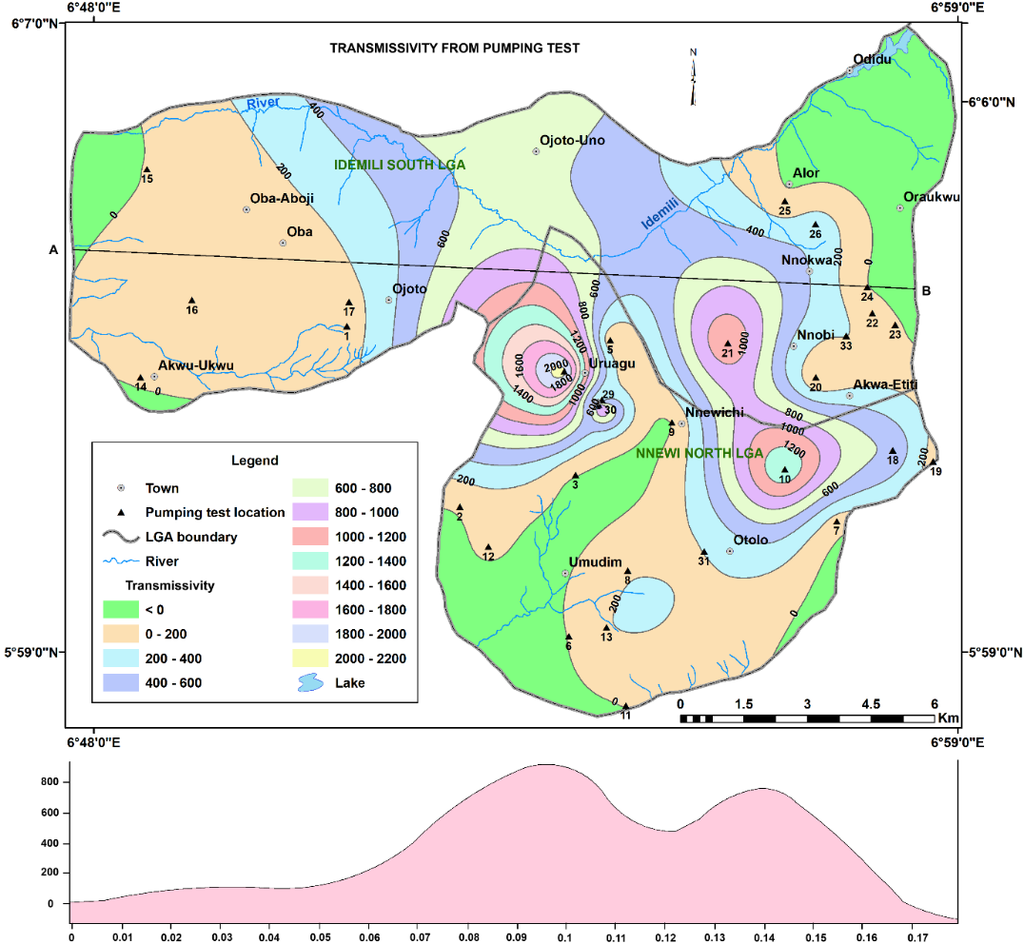
Fig 6 Spatial Distribution of Transmissivity Values From VES in the Study Area
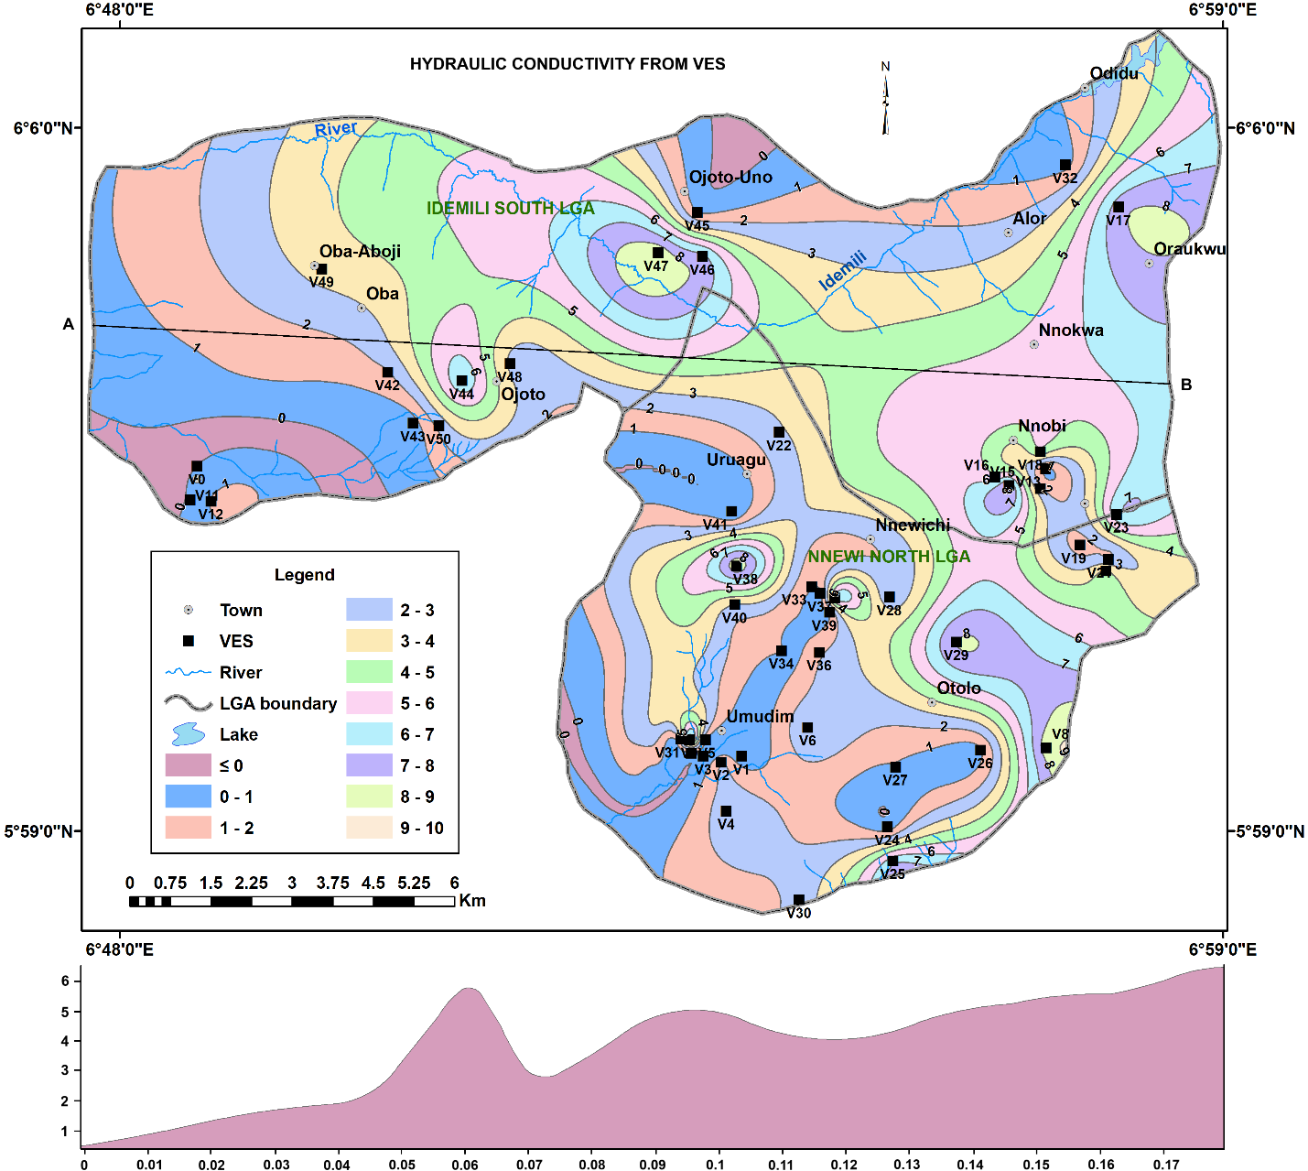
Fig. 7 Hydraulic Conductivity map of the Study Area calculated from VES
4.1.5 Groundwater Flow Dynamics and Vulnerability
Groundwater flow within the study area is primarily lateral, moving from elevated recharge zones toward lower drainage basins, a common pattern in sedimentary basins (Freeze & Cherry, 1979). High-transmissivity zones (VES stations 8, 9, 13, 15, 18, 20, 23, 25, 29, and 47) support rapid flow and reduced residence time, whereas low-transmissivity zones (stations 10, 37, and 41) restrict recharge and increase storage duration (Fetter, 2014). Similar relationships between transmissivity, aquifer thickness, and well-field potential have been documented in the Niger Delta, where geoelectric zones with strong hydraulic connectivity are preferred for municipal abstraction (Oseji & Onyeme, 2022). Additionally, aquifer vulnerability analysis reveals that shallow, high-transmissivity aquifers (VES 2, 10, 24, 27, 32, 37, 41, 43, 45, and 49) are prone to contamination from surface infiltration. High recharge rates in this zone accelerate pollutant transport. In contrast, deeper confined aquifers show better protection but limited replenishment (Udoh et al., 2022; Fashae et al., 2022).
The integrated interpretation of resistivity and hydraulic parameters demonstrates that the study area hosts a multi-layered aquifer system with both confined and unconfined zones. Productive aquifers occur mainly within the coarse sand and sandstone units of the Ameki and Ogwashi–Asaba Formations, characterized by high hydraulic conductivity and transmissivity values. High-yielding zones (e.g., Nnewi, Oba, Awka-Etiti) can sustain water supply projects if properly managed. However, shallow aquifers in areas such as Ojoto, Nnobi, and Alor are more vulnerable and require pollution control measures, protective buffer zones, and regulated abstraction to ensure long-term sustainability. The present observation aligns with the results obtained by Okonkwo et al. (2023) in Nnewi area.
4.1.6 Groundwater Potential Zonation Based on Elevation and Depth
The integration of elevation and depth data provides a clearer hydrogeological framework for groundwater development. Hence, on the basis of elevation groundwater in the study area is classified into three zones as follows:
Zone 1 (80–150 m elevation):
Dominated by shallow aquifers at VES 1–13 and 24–49, this zone exhibits moderate to high groundwater potential but high vulnerability to pollution due to shallow water tables and thin overburden. Groundwater flow is locally controlled, moving from upland recharge zones to adjacent low-lying discharge areas (Okonkwo et al., 2022).
Zone 2 (150–220 m elevation):
Includes VES 5, 14–19, 26–47. Aquifers are deeper and less vulnerable, with high transmissivity and storage potential. This aquifer can be referred to as the middle aquifer. Flow tends to be more regional, indicating well-connected aquifer systems. The zone represents the most promising target for sustainable groundwater abstraction (Ishaku et al., 2023).
Zone 3 (>220 m elevation):
Encompassing VES 18, 20, and 21, this zone features deep confined aquifers with limited recharge but good water quality due to natural filtration (Olarinoye et al., 2022). The aquifer is strategically important as long-term reserve.
This integrated assessment establishes that hydraulic conductivity and transmissivity are the key determinants of aquifer productivity, groundwater flow, and vulnerability. It can be summarised that the high-K and T zones are highly productive but environmentally sensitive while the low-K and T zones provide natural protection but have limited yield and finally the moderate K and T zones offer balanced conditions for sustainable abstraction. Elevation-based zonation complements the hydrogeophysical analysis, identifying recharge (higher elevation) and discharge (lower elevation) areas. These insights provide a scientific foundation for groundwater development, borehole siting, and contamination management across Oba, Ojoto, Alor, Oraukwu, Nnobi, Awka-Etiti, and Nnewi.
4.3 Aquifer Performance from Pumping Test Analysis
Transmissivity (T) values derived from 35 constant-rate pumping tests across the study area were evaluated to delineate transmissive zones (Table 3), assess groundwater development potential, and characterize flow dynamics and vulnerability patterns within the urban hydrogeological system.
4.3.1 Transmissivity Zonation
Transmissivity values ranged from 3.24 to 1,061.55 m²/day, demonstrating pronounced spatial variability (figs. 8 and 9) attributable to lithological heterogeneity, variations in aquifer thickness, and differences in hydraulic conductivity. On the basis of these values, the aquifers were classified into three performance zones: low, moderate, and high transmissivity.
4.3.1.1 Low Transmissivity Zone (T < 50 m²/day)
The low T zone include Okpuno Egbu Otolo (pt 2), Ebeleogo Umudim Nnewi (pt 6), Eziabubor Nnewichi (pt 9), Umunnalam (pt 11), Umuezeagwu Uruagwu (pt 12), St. John Sec. Akwu (pt 14), PHC Akwukwu (pt 15), Eziumuru (pt 22), and Umuoshie Alor (pt 27) areas. These locations are dominated by fine-grained sediments, predominantly clays and silty sands, or by comparatively thin saturated layers, resulting in low permeability and limited groundwater yield. Groundwater flow in these areas is typically localized and sluggish, limiting recharge efficiency. The shallow water table and fine-grained protective cover increase susceptibility to surface contamination, especially from domestic wastewater infiltration and agricultural inputs. This pattern aligns with findings from Olarinoye et al. (2022) and Okonkwo et al. (2022), who reported that shallow, clay-rich formations in southeastern Nigeria constrain aquifer productivity while enhancing vulnerability to contamination.
4.3.1.2 Moderate Transmissivity Zone (50–300 m²/day)
The moderate T zone include Edoji Uruagu Nnewi (pt 1), Okpunoeze Uruagu Nnewi (pt 3), Akabuezem Uruagu (pt 5), Obiofia Ojoto (pt 7), Umuele Umudim (pt 8), Uru Umudim Umudim (pt 13), Oba 2 PHC (pt 16), Umuezeokpala Oba (pt 17), Umunocha Awka-Etiti (pt 19), Ofoloagbon (pt 20), Abo Nnokwa (pt 24), and Akwudo Otolo Nnewi (pt 30) areas. This zone is underlain by moderately permeable sandy aquifers which provide stable and sustainable yields suitable for community-scale water supply systems. The transmissivity range reflects balanced recharge–discharge conditions and intermediate vulnerability, owing to partial confinement or the presence of protective vadose-zone materials. Comparable transmissivity ranges have been reported in similar hydrogeologic terrains by El-Bihery et al. (2021) and Ishaku et al. (2023), who emphasized the suitability of such zones for municipal water schemes.
4.3.1.3 High Transmissivity Zone (T > 300 m²/day)
Stations in the high T zone are Eziogwugwu Otolo Nnewi (pt 10), Umudunu Awka-Etiti (pt 18), Echemnakwo Nnobi (pt 21), Obi Memorial (pt 23), Nnaku Nnokwa (pt 25), Eziama (pt 26), Uhuowelle (pt 28), Urban Water PH (pt 29), and Isu Umuezedim Oba (pt 31) areas. They are high-productivity sites that correspond to thick, coarse-grained aquifers materials, including sandstone and gravel units, capable of delivering yields exceeding 10 m³/h. The elevated transmissivity suggests strong hydraulic connectivity, often indicative of regional flow systems or preferential recharge corridors. While this zone offer excellent prospects for municipal and industrial groundwater abstraction, the high permeability also creates heightened contamination risk, particularly in areas with inadequate land-use regulation. Similar transmissivity thresholds have been reported in highly productive aquifers of the Benin Formation and Nsukka Sandstone (Santos et al., 2023; Omoyoloye et al., 2024).

Table 3 Aquifer Parameters from Pumping Test in the Study Area
S_N | Water_leve | Elevation | HH | Specific_C | Transmissi | Average_fl | X | Y | S | K
1 | 92.44 | 139 | 46.56 | 17.1662 | 108.2484 | 1.1921 | 6.8536301 | 6.0524702 | 1.108E-05 | 4.82
2 | 66.13 | 90 | 23.87 | 1.3127 | 26.64 | 3.3912 | 6.8776598 | 6.0141501 | 0.0000582 | 1.17
3 | 103.63 | 160 | 56.37 | 0.6079 | 10.5104 | 0.7413 | 6.9021802 | 6.0209198 | 0.0000245 | 0.46
4 | 103.78 | 149 | 45.22 | 1.6225 | 2019.2857 | 0.8924 | 6.8997998 | 6.04287 | 0.0001319 | 4.82
5 | 89.38 | 171 | 81.62 | 2.6846 | 78.1799 | 1.1708 | 6.9095302 | 6.04952 | 1.338E-05 | 3.3
6 | 37.54 | 114 | 76.46 | 0.1487 | 4.2636 | 1.2219 | 6.9007401 | 5.98669 | 9.85 | 0.19
7 | 100.93 | 176 | 75.07 | 16.7776 | 105.7484 | 1.0719 | 6.9576302 | 6.0110898 | 9.85E-06 | 4.71
8 | 28.65 | 101 | 72.35 | 1.8523 | 180.6837 | 1.204 | 6.91326 | 6.0006499 | 0.0000107 | 8.05
9 | 93.19 | 160 | 66.81 | 10.1332 | 15.1437 | 0.6474 | 6.9226599 | 6.0320401 | 3.29E-06 | 0.67
10 | 112.98 | 185 | 72.02 | 6.4565 | 1324.23 | 1.8114 | 6.94661 | 6.0220699 | 0.0000269 | 58.95
11 | 53.37 | 102 | 48.63 | 0.3424 | 3.2361 | 1.3127 | 6.9128499 | 5.9719801 | 1.85E-06 | 0.14
12 | 71.53 | 143 | 71.47 | 2.2064 | 31.9245 | 1.759 | 6.8836899 | 6.0057101 | 0.0000183 | 1.42
13 | 54.3 | 123 | 68.7 | 2.0575 | 182.6771 | 2.0118 | 6.9087801 | 5.9885898 | 0.0000419 | 8.13
14 | 26.71 | 44 | 17.29 | 0.6011 | 12.2705 | 1.0821 | 6.8098402 | 6.0416298 | 0.0000383 | 0.55
15 | 32.7 | 118 | 85.3 | 0.6011 | 5.5248 | 1.151 | 6.8112302 | 6.0857801 | 0.0000145 | 0.25
16 | 41.23 | 240 | 198.77 | 1.7443 | 129.4125 | 0.7989 | 6.8207898 | 6.0580001 | 0.00135 | 0.49
17 | 81.07 | 266 | 184.93 | 4.735 | 126.5337 | 0.7234 | 6.8541002 | 6.0576401 | 0.000055 | 5.63
18 | 149.91 | 230 | 80.09 | 4.9814 | 534.1912 | 2.1171 | 6.9695301 | 6.0261402 | 0.00051 | 0.95
19 | 132.94 | 254 | 121.06 | 0.6955 | 122.8041 | 1.3524 | 6.9780502 | 6.0237398 | 0.00094 | 5.45
20 | 135.84 | 155 | 19.16 | 5.6382 | 35.5247 | 2.0047 | 6.9531598 | 6.0416002 | 0.00026 | 1.58
21 | 97.35 | 174 | 76.65 | 150.072 | 1135.5573 | 1.2506 | 6.9344902 | 6.0488701 | 0.0000207 | 50.57
22 | 178.69 | 250 | 71.31 | 3.5631 | 88.0831 | 1.5539 | 6.9651599 | 6.0551901 | 0.000015 | 3.92
23 | 188.45 | 249 | 60.55 | 0.9469 | 18.8815 | 1.665 | 6.9700198 | 6.0527701 | 0.00036 | 0.84
24 | 194.24 | 216 | 21.76 | 0.6265 | 13.7059 | 0.6648 | 6.9640899 | 6.06078 | 0.000085 | 0.61
25 | 160.68 | 276 | 115.32 | 7.9501 | 49.0488 | 1.0821 | 6.9465899 | 6.07902 | 0.00054 | 2.18
26 | 105 | 189 | 84 | 1.3277 | 306.1699 | 1.2134 | 6.9531398 | 6.07409 | 0.00155 | 13.63
27 | 117.45 | 175 | 57.55 | 62.6552 | 570.8854 | 4.5251 | 6.9067001 | 6.0356998 | 0.0069 | 25.44
28 | 115.24 | 175 | 59.76 | 0.4181 | 3.14 | 2.769 | 6.9067001 | 6.0356002 | 0.043 | 0.14
29 | 118.3 | 175 | 56.7 | 52.7322 | 1261.5496 | 27.83091 | 6.9071002 | 6.0358 | 0.041 | 56.17
30 | 119.4 | 174 | 54.6 | 192.3042 | 281.3667 | 12.2861 | 6.9078002 | 6.0367999 | 0.0034 | 12.52
31 | 31.77 | 107 | 75.23 | 2.9156 | 201.7516 | 1.3444 | 6.9295001 | 6.0047002 | 0.000579 | 8.98
33 | 150.34 | 181 | 30.66 | 23.3751 | 201.481 | 1.6882 | 6.95965 | 6.0504198 | 0.000076 | 8.97

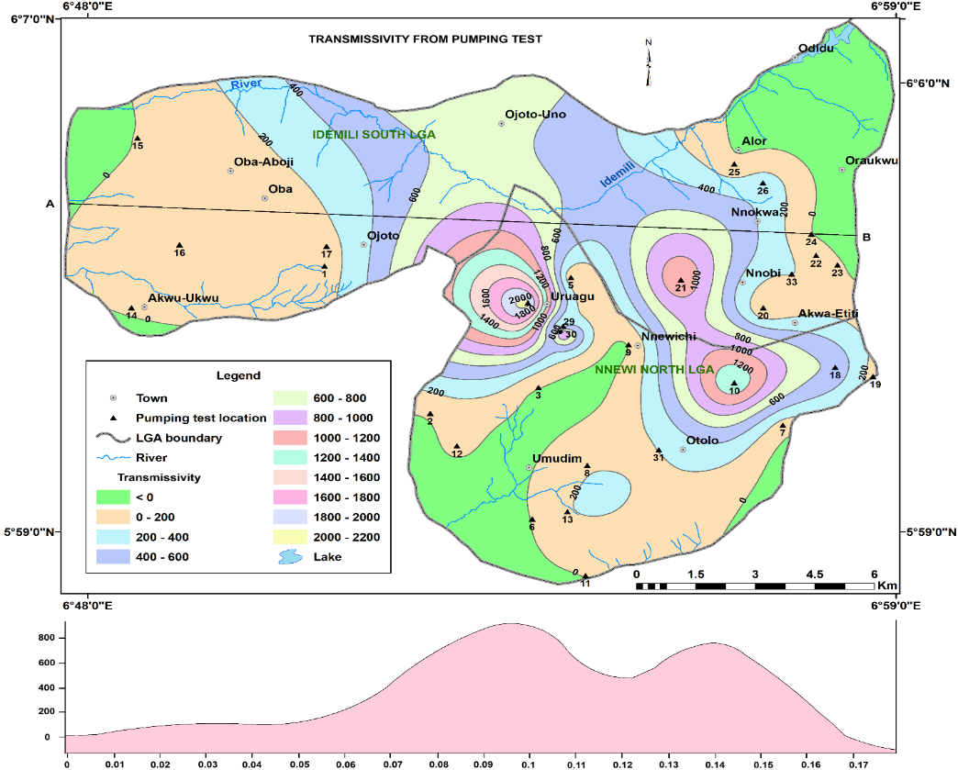
Fig. 8 Map showing the Spatial Distribution of Transmissivity from Pumping Test in the Study Area

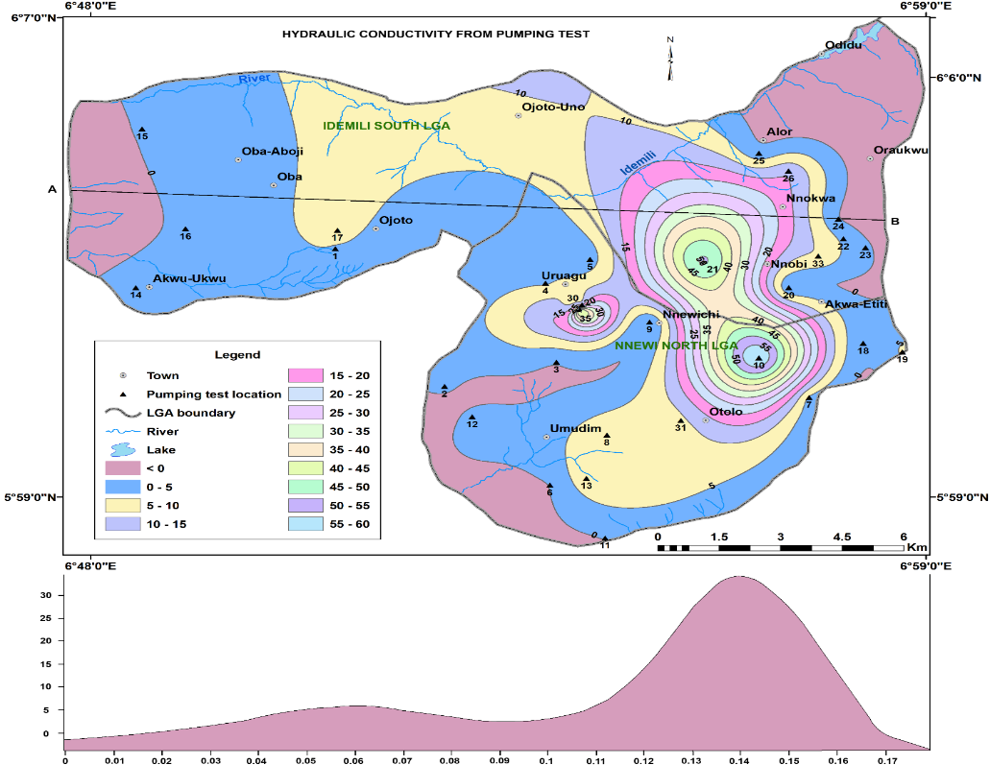
Fig. 9 Map showing the Spatial Distribution of Hydraulic Conductivity in the Study Area from Pumping Test
4.3.2 Interpretative Implications
4.3.2.1 Flow Pattern and Hydraulic Connectivity
Low-T zones indicate localized, perched systems with minimal lateral connectivity, while high-T zones signify regionally interconnected aquifers capable of transmitting water over longer distances. The spatial alignment of high-T areas with lower elevation zones suggests flow convergence toward topographic depressions and river valleys, supporting recharge–discharge coupling (Barry et al., 2020). This pattern agrees with the hydraulic conductivity zonation and elevation-based groundwater potential mapping discussed earlier.
4.3.2.2 Groundwater Potential and Development Suitability
High-T zones (>300 m²/day) represent the best targets for municipal and industrial boreholes, moderate-T zones (50–300 m²/day) for community or institutional supply, and low-T zones (<50 m²/day) for hand-dug wells or limited-yield boreholes. These classifications align with transmissivity-based yield criteria established in regional aquifer evaluation studies (Hasan et al., 2021; Omoyoloye et al., 2024).
4.3.2.3 Vulnerability and Water Quality
While high-T zones favor high yields, they also enable rapid contaminant transport, requiring proactive land-use and pollution control measures. Conversely, low-T areas experience longer residence times, which can enhance mineral dissolution and salinity build-up (UNESCO WWDR, 2022; Ikard et al., 2023). Hence, aquifer protection strategies must balance yield optimization with water quality preservation.
4.4 Comparative Interpretation: VES vs. Pumping Test Results
4.4.1 Methodological Overview
The VES approach derives hydraulic parameters such as K and T using Dar–Zarrouk parameters (transverse resistance and longitudinal conductance). This technique effectively captures vertical lithologic variability, whereas pumping tests evaluate in-situ aquifer performance under stress (Niwas & Celik, 2012; Maiti et al., 2020; Ikard et al., 2023).
In the study area, VES-derived transmissivity values (0.73–2716.5 m²/day) and pumping test results (3.24–1,061.55 m²/day) show broad correlation, confirming that high VES-transmissivity clusters generally correspond to high-yield borehole sites (e.g., Nnewi, Oba, and Nnobi). Discrepancies arise mainly due to partial penetration effects, salinity-induced resistivity bias, and layer anisotropy (Hasan et al., 2021; Ikard et al., 2023). High VES-derived T values sometimes overestimate aquifer potential where coarse units are laterally discontinuous or clay-influenced, whereas pumping tests provide realistic, stress-averaged transmissivity. This complementary relationship underscores the value of integrating both methods for aquifer zoning and borehole siting. Combined VES–pumping data delineate three operational tiers of borehole yield potential (<50, 50–300, >300 m²/day), aiding resource allocation, groundwater development and infrastructure design. The high-T and K corridors align with recharge and discharge zones previously identified from elevation and hydraulic gradient analyses, reinforcing regional flow model validity (figs. 10 and 11). Therefore, mapping T in conjunction with K supports a vulnerability framework, identifying areas needing strict pollution control versus those suitable for intensive extraction.

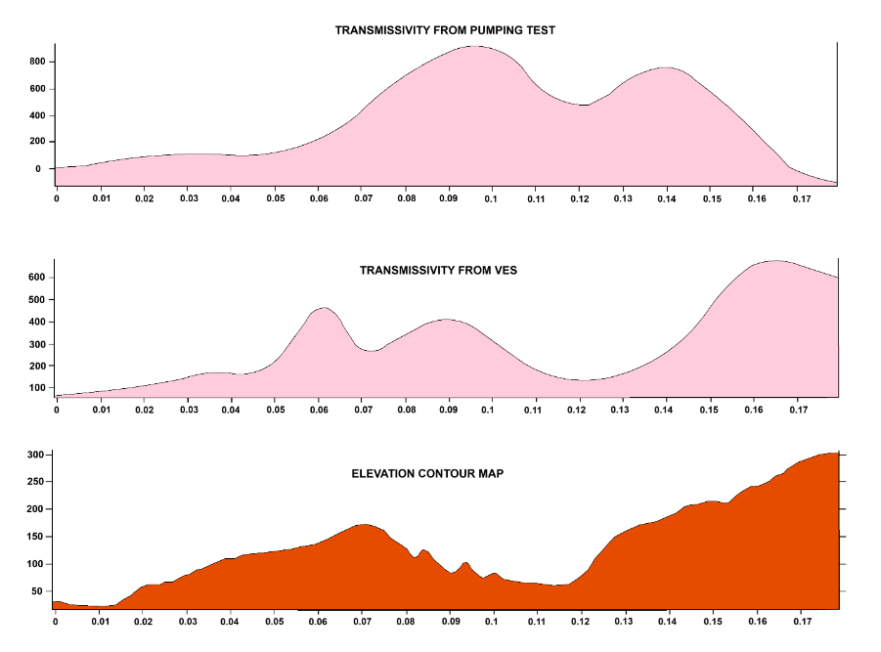
Fig. 10 Comparison of Transmissivity values from VES and Pumping Test in the East – West direction in the Study Area relative to the elevation

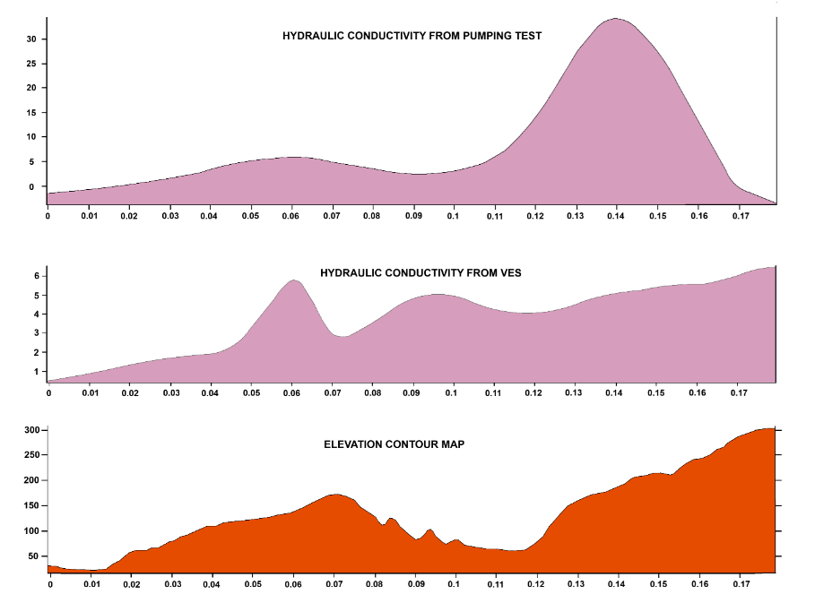
Fig. 11 Comparison of Hydraulic Conductivity values from VES and Pumping Test in the East – West direction in the Study Area relative to the elevation

5.0 Conclusion and Recommendations
The VES results reveal a heterogeneous, multi-aquifer system composed of lateritic topsoil, interbedded clay and shale, fine-to-coarse sands, and water-saturated sandstone units, consistent with previous studies in similar sedimentary terrains (Udoh et al., 2022; Ezeh et al., 2022; Okafor et al., 2020). K values ranged from 0.013 to 40.54 m/day, while T ranged between 0.73 and 2,716 m²/day, indicating significant variability in aquifer permeability and yield. Pumping test data supported these variations, with transmissivity values of 3.24–1,061 m²/day, confirming that the highest-yield zones correspond to thick, coarse-grained formations in Nnewi, Oba, and Nnobi areas. The close correlation between VES-derived and pumping test transmissivity underscores the reliability of integrated geophysical–hydrogeological assessment for groundwater exploration. Elevation-based analysis delineated three groundwater potential zones namely Zone 1 (80 – 150 m) indicating shallow aquifer, moderate yield and greater vulnerability, Zone 2 (150 – 220 m) middle aquifer, moderate contamination risk and high storage capacity and Zone 3 (> 220 m) deep confined aquifers with limited recharge but excellent water quality. The integration of resistivity patterns, hydraulic parameters, and elevation data reveals that lithological control and geomorphology jointly determine groundwater occurrence, flow, and quality. High-T corridors indicate favorable aquifer zones for municipal water supply, whereas low-T regions function as natural barriers against contamination but with limited yield potential.
Overall, the study validates that combining VES with pumping test evaluation provides a cost-effective and scientifically robust approach for characterizing complex aquifer systems. The findings contribute to sustainable groundwater resource planning, particularly in rapidly urbanizing environments of southeastern Nigeria. This research establishes a hydrogeophysical baseline for groundwater assessment in urban centers of southeastern Nigeria. It demonstrates that combining resistivity modeling with aquifer performance tests provides a reliable framework for identifying productive zones, predicting vulnerability, and guiding sustainable groundwater development policies. The outcomes directly support evidence-based water resource management, aiding government agencies and planners in optimizing borehole placement and protecting critical aquifers for long-term urban water security.

References
Adeleke, A. O., Ojo, J. S., Adebayo, O. B., & Afolabi, A. O. (2023). Application of Schlumberger configuration in multilayered subsurface investigations. Journal of Applied Geophysics, 215, 105–118.
Adetokunbo, O. S. (2025). Rainfall dynamics and groundwater recharge processes in southeastern Nigeria. Hydrology Research, 56(1), 22–34.
Akhter, G., & Hassan, M. (2016). Estimation of aquifer hydraulic parameters from surface geoelectrical methods. Environmental Earth Sciences, 75, 102–113.
ASTM International. (2017). ASTM D6034-17: Standard test method (analytical procedure) for determining the efficiency of a production well in a confined aquifer from a constant-rate pumping test. ASTM International.
Barry, K. E., Maiti, S., & Singh, A. (2020). Influence of aquifer heterogeneity on groundwater flow and hydraulic properties. Hydrogeology Journal, 28(5), 1453–1471.
Bobachev, C. (2002). IPI2Win: A Windows software for an automatic interpretation of resistivity-sounding data (Ph.D. thesis). Moscow State University, Russia.
Cooper, H. H., & Jacob, C. E. (1946). A generalized graphical method for evaluating formation constants and summarizing well-field history. American Geophysical Union Transactions, 27, 526–534.
Egboka, B. C., Nwankwor, G. I., Orajaka, S. O., & Ejiofor, A. O. (1985). Principles and problems of environmental pollution of groundwater resources with case examples from developing countries. Environmental Health Perspectives, 62, 57–64.
El-Bihery, M. M., Salem, A. S., & Waly, H. (2021). Aquifer transmissivity mapping using integrated geophysical methods. Arabian Journal of Geosciences, 14(6), 12–25.
Eze, C. L., & Chukwuma, L. O. (2023). Land use change and groundwater recharge variability in southeastern Nigeria. Environmental Monitoring and Assessment, 195, 100–118.
Ezeh, C. C., Okonkwo, U. C., & Nwoye, I. C. (2022). Geoelectric characterization of aquifers in sedimentary formations of southeastern Nigeria. Journal of Earth System Science, 131(3), 1–14.
Fashae, O. A., Akinluyi, F. O., & Adeoye, A. O. (2022). Aquifer vulnerability and protective capacity assessment using geoelectric parameters. Groundwater for Sustainable Development, 16, 100–124.
Ha, D., Zheng, G., Zhou, H., Zeng, C., & Zhang, H. (2020). Estimation of hydraulic parameters from pumping tests in a multiaquifer system. Underground Space, 5(3), 210–222. https://doi.org/10.1016/j.undsp.2019.03.006
Hasan, M., Rahman, M. M., & Alam, J. (2021). Evaluation of aquifer transmissivity using geoelectrical and pumping test methods. HydroResearch, 4, 26–38.
Hoque, M. A., & Burgess, W. G. (2020). Representing heterogeneity of fluvio-deltaic aquifers in models of groundwater flow and solute transport: A multi-model investigation in the Bengal Basin. Journal of Hydrology, 590, 125507. https://doi.org/10.1016/j.jhydrol.2020.125507
Houben, G., Cheng, X., & Rausch, R. (2022). Pumping test analysis: A practical guide to aquifer evaluation. Hydrology Journal, 30(2), 389–408.
Ikard, S. J., Celik, M., & Niwas, S. (2023). Resistivity-derived hydraulic parameters and their reliability in complex aquifers. Journal of Hydrology, 619, 128–144.
Interpex Limited. (2008). IX1D v2 instruction manual (Version 1.0) [Software manual]. Interpex Limit. 67 p.

Ishaku, J. M., Musa, A., & Ocheri, C. (2023). Transmissivity-based groundwater zoning in basement and sedimentary terrains of Nigeria. Hydrogeology Review, 12(1), 77–95.
Khan, A. Y., Ullah, W., Niaz, A., Bibi, T., Imtiaz, M. M., Fiaz, R., Gul, S., Hameed, K., & Islam, F. (2024). Integrated geophysical and geospatial techniques for surface and groundwater modeling. Scientific Reports, 14, 25514. https://doi.org/10.1038/s41598-024-76262-8
Kruseman, G. P., & de Ridder, N. A. (2023). Analysis and evaluation of pumping test data (4th ed.). International Institute for Land Reclamation and Improvement.
Liu, Y., Zhang, H., & Wen, D. (2023). Hydraulic conductivity variation in heterogeneous aquifers: A geophysical perspective. Journal of Applied Geophysics, 213, 104–120.
Mahrez, H. B., Márton, P., Márton, B., Mádl-Szőnyi, J., Kovács, J., & Sztanó, O. (2023). Hydrostratigraphic decomposition of fluvio-deltaic sediments inferred from seismic geomorphology and geophysical well logs in the Pannonian Basin, Hungary. Global and Planetary Change, 230, 104285. https://doi.org/10.1016/j.gloplacha.2023.104285
Maiti, S., Singh, A., & Kumar, P. (2020). Estimating aquifer parameters from Dar–Zarrouk and resistivity methods. Hydrological Sciences Journal, 65(10), 1675–1690.
Nigate, F., Yenehun, A., Belay, A. S., Asmamaw, D. K., & Walraevens, K. (2025). Application of pumping tests to estimate hydraulic parameters of volcanic aquifers in Lake Tana Basin, Ethiopia. Water, 17(1), 9. https://doi.org/10.3390/w17010009 MDPI+1
Niwas, S., & Celik, M. (2012). Equation estimation of aquifer hydraulic conductivity from geoelectrical data. Journal of Hydrology, 464–465, 1–11.
Niwas, S., & Singhal, D. C. (1981). Estimation of aquifer transmissivity from Dar‑Zarrouk parameters in porous media. Journal of Hydrology, 50, 393–399. https://doi.org/10.1016/0022-1694(81)90082-2
Nwajide, C.S. (2013) Geology of Nigeria’s Sedimentary Basins. CSS Bookshop Ltd., Lagos, 1-565.
Nwokeabia, T. C., Eze, B. E., & Umeadi, E. C. (2024). Land-use transitions and hydrological impacts in southeastern Nigeria. Geoenvironmental Studies, 19(2), 210–229.
Nwozor, R. N., Bassey, N. E., George, N. J., & Harry, T. A. (2025). Characterization of depositional environment within parts of the Benin Formation, Akwa Ibom State, Nigeria using vertical electrical sounding technique. European Journal of Environment and Earth Sciences, 6(4), 528. https://doi.org/10.24018/ejgeo.2025.6.4.528
Odoh, B. I., & Nwokeabia, T. (2024). Urbanization and groundwater recharge disruption in southeastern Nigeria. Sustainable Water Resources Management, 10(2), 33–47.
Odoh, B. E., Udoiwu, K., & Anione, C. (2024). Hydrological controls on groundwater yield in humid tropical terrains. Hydrology Research, 55(3), 255–271.
Okafor, F. O., Obi, D. A., & Uka, R. (2020). Resistivity-derived aquifer characteristics in the Benin Formation. Nigerian Journal of Applied Geophysics, 8(2), 122–138.
Okeke, C. C., Ude, B. O., & Mgbolu, C. (2021). Resistivity-based aquifer delineation in southeastern Nigeria. Environmental Earth Sciences, 80(5), 1–16.
Okonkwo, U. C., Ezeh, C. C., & Okechukwu, C. (2022). Groundwater potential mapping using geoelectric and elevation data. Journal of Hydrological Mapping, 6(4), 245–259.
Olarinoye, T., Elueze, A., & Omorinoye, O. (2022). Hydraulic behaviour of shallow aquifers in tropical humid environments. Journal of Hydrogeology, 28(4), 1221–1240.
Omoyoloye, A. B., Ilori, A. P., & Adegbite, K. (2024). Transmissivity-based groundwater evaluation in Nigerian sedimentary aquifers. Groundwater Studies, 14(1), 55–70.
Onwuemesi, A. G., Egboka, B. C., & Okeke, H. (1991). Hydrogeology of the southeastern lowlands of Nigeria. Journal of Hydrology, 123, 193–209.
Onyenweife, G. F., & Mgbolu, C. H. (2023). Integrated VES–hydrogeological modelling for groundwater assessment. Hydrogeophysics Review, 11(3), 80–102.
Onyenweife, G. F., & Nwozor, K. K. (2025). Groundwater development challenges in urban southeastern Nigeria. Journal of Water Resources and Environment, 21(1), 44–59.
Santos, J. A., Ukaegbu, V. U., & Okoro, B. (2023). High-yield aquifer systems in the Benin Formation. Journal of African Earth Sciences, 197, 104–138.
Singha, K., Slater, L., & Nyquist, J. (2023). Geoelectrical methods in hydrogeology. Hydrogeology Journal, 31(1), 201–225.
Singh, A., Reddy, V., & Bhattacharya, P. (2022). Cooper–Jacob method reliability in anisotropic aquifers. Journal of Groundwater Science, 9(2), 97–111.
Udochaogu, B. (2022). Hydrological alteration due to land use transitions in southeastern Nigeria. Journal of Environmental Hydrology, 30, 1–14.
Udoh, K. N., Eze, B. E., & Okoro, E. I. (2021). Hydrostratigraphic characterization using geoelectrical techniques. Environmental Earth Sciences, 80(12), 1–18.
Udoh, K. N., Nwosu, E., & Ononiwu, I. (2022). Aquifer vulnerability evaluation in humid tropical environments. Groundwater for Sustainable Development, 18, 100–140.
UNESCO World Water Development Report (WWDR). (2022). Groundwater: Making the invisible visible. UNESCO Publishing.
U.S. Environmental Protection Agency. (2025). Suggested Operating Procedures for Aquifer Pumping Tests (EPA 540-S-93-503). EPA.

