Original Research Article
Effects of Heavy Metals on Crop Production: Source Identification and Mitigation Strategy

ABSTRACT
Globally, plant life, human health, and the food supply are all gravely threatened by heavy metal contamination of agricultural soils. Crop health and yield are negatively impacted when hazardous concentrations of HM are present in agricultural soils. Due to both anthropogenic and natural causes, heavy metals can spread through the environment in innumerable ways. Mining, abandoned mining sites, fertilizer and pesticide use, and sewage irrigation are examples of human-related factors; natural causes, in general, can include any process involving wind erosion and migration, as well as the mechanical redistribution of soil debris or hydraulic migration of the soil parent rock as a result of high background values caused by winds and HM levels in agricultural soils can affect crop health and yield when they reach dangerous concentrations. They are far more harmful to both plants and people because, when mixed into the soil, they hinder plant growth, lower nutrient value, interfere with photosynthesis, and then negatively impact humankind. The physical and chemical makeup of the soil, crop type, growth conditions, elemental toxicity, development stage, and the presence and bioavailability of heavy metals in the soil solution are some of the factors that affect how harmful HM is to crops. Continuous and repeated high rates of manure application were found to significantly raise the overall concentration of Cd, Zn, Cr, and Cu in soil but not Pb, Ni, or As. The decomposition of organic matter, nutrient cycling, and plant growth support are all made possible by these soil microbes. However, microbial communities are seriously threatened by the growing levels of heavy metal contamination in soils, including Pb, Cd, Hg, and As. The origins of heavy metals in soil are discussed in this review, along with how they affect microbial diversity and abundance, enzyme activity, and functional activities. Further, adaptation and resistance mechanisms of microbes are reviewed. This knowledge is necessary in the assessment of environmental risks and for solving soil- related issues through sustainable management and bioremediation approaches. Methods for limiting heavy metal accumulation into crops, restoring contaminated land, and ensuring sustainable agricultural productivity are revisited in this review.

Keywords:- Metals, Metalloids, Integrated Nutrient Management, Biochar, Soil Pollution, Toxicity mitigation

PICTURE 1. Graphical Abstract
1. Introduction
The most basic natural resource on which humans rely is soil, an essential component of the terrestrial biosphere on Earth that allows for recycling and regeneration. Heavy metals in soil can come from a variety of sources, including weathered parent materials, mining operations, vehicle emissions, smelting operations, chemical fertilizer application, and other commercial, industrial, and agricultural operations (Jin et al., 2019). Soils are affected by heavy metals that generate several impediments to soil function, environment, agricultural production, food chains, and even human health (Adrianoet.al 2001).Heavy metal contamination, as a result of anthropogenic emissions (industrial, traffic, fossil fuel usage), agrochemicals, surface application of sludge, wastewater, etc., has been adversely affecting the increased level of heavy metals in agriculture since a long time now (Lokeshappa et.al 2014). According to Liu et al. (2018), heavy metals (HMs) such as zinc (Zn), lead (Pb), nickel (Ni), arsenic (As), mercury (Hg), copper (Cu), cadmium (Cd), and chromium (Cr) impact over 20 million hectares (ha) of land. As per the Bulletin of the National Survey of Soil Pollution, the levels of Cd, Hg, As, Cu, Pb, and Zn surpass the respective benchmarks of 7.0%, 1.6%, 2.7%, 2.1%, 1.5%, and 0.9% (Ministry of Ecology and Environment of the People's Republic of China, 2014). They degrade humans, animals, and plants to the point that they become contaminants and become the biggest problem. According to Holmeset al. (2008), heavy metals in the environment create a cyclical chain of contamination that affects the industry, atmosphere, soil, water, food, and people. Over the past 50 years, more than 0.03 million tons of Cr and 0.8 million tons of Pb have entered the global environment, mostly accumulating in soil and causing serious heavy metal pollution (Yang et al., 2018). To assess the soil load caused by heavy metals, it is necessary to understand the background levels of heavy metals, their inputs into soils, their behavior and fate in the soil environment, and their transfer into plants or groundwater (Kabata et al., 2000). Furthermore, trace elements including arsenic, lead, cadmium, and chromium in drinking water have previously caused the World Health Organization (WHO) to express alarm about the deterioration of ecosystems in numerous nations (Angonet al., 2024). Plant growth and production require a variety of minerals, including magnesium, copper, manganese, zinc, iron, calcium, molecular iron, and nickel. Many plant cellular processes, including pigment production, ion homeostasis, gene regulation, respiration, enzyme activity, sugar metabolism, photosynthesis, nitrogen fixation, etc., can be improved by these minerals at relatively low concentrations (Tiwari et al., 2018). One important factor influencing agricultural productivity is soil fertility. It is controlled by the activity of soil microbes, the availability of
vital nutrients, and suitable physical and chemical characteristics. However, anthropogenic activities like mining, industrial discharge, improper waste management, and excessive use of agrochemicals have caused heavy metals to accumulate in agricultural soils (Nagajyoti et al., 2010). Unlike organic contaminants, heavy metals are not biodegradable and can remain in the soil for decades, affecting its fertility and general health. Artificial or man-made sources have become the primary causes of heavy metal contamination globally due to the fast pace of industrialization and urbanization (Tchounwou et al., 2012). Sewage sludge and wastewater generation have increased exponentially as a result of rapid urbanization and industrialization. In agriculture, these by-products are frequently recycled to supply organic matter and vital nutrients. However, they might also contain heavy metals like cadmium (Cd), lead (Pb), chromium (Cr), copper (Cu), zinc (Zn), nickel (Ni), and mercury (Hg) that can be hazardous to human health and the environment when used for an extended length of time (Gupta & Sinha, 2007). Electronic waste, or "e-waste," has increased due to rapid technological development and is often handled improperly in developing nations. Solid waste, which includes leftovers from industry and municipalities, also contains significant amounts of heavy metals. Improper disposal and recycling practices release these metals into the environment, posing major risks to soil, water, crop productivity, and human health (Sepúlveda et al., 2010).

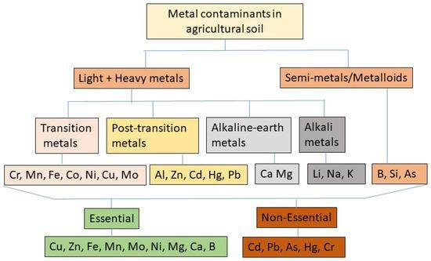
Figure 1. Categorization of metal contaminants found in agricultural soil
(Rashid et.al 2023)
Bibliometric analysis

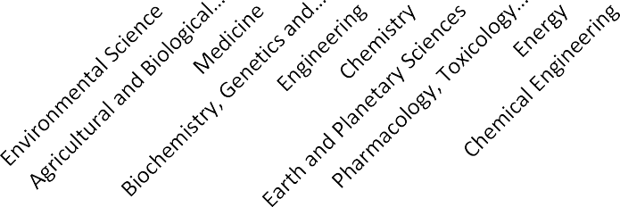
600
500
400
300
200
100
0
Series1

Figure 2: Distribution of research publications in various scientific disciplines.

Environmental Science leads with the most publications, followed by Agricultural and Biological Sciences and Medicine; other disciplines like Biochemistry, Genetics, and Molecular Biology also contribute significantly; the remaining disciplines, such as Engineering, Chemistry, Earth and Planetary Sciences, and Pharmacology, contribute moderately; and the fields with the fewest publications are Energy and Chemical Engineering. This bar graph shows how the Environmental and Biological Sciences dominate research output, indicating a strong focus on issues related to the environment, agriculture, and health in scientific studies.

Publications
600
500
400
300
200
100
0
No Of Publications

Article
ReviewBook chapter Conference paper
BookConference review
Erratum Editorial Data paper Retracted Short survey
Note
Letter

Figure 3: Distribution of various publication associated with biochar-related
studies.

The number of publications by publishing type is shown in the bar graph. The majority are articles, with reviews, book chapters, and conference papers coming in second and third, respectively, suggesting that they are the most prevalent types of academic production. Conference reviews and books also make a small contribution. Erratums, editorials, data papers, and retracted publications are among the other publication kinds with far lower counts. There is little representation in categories such as brief questionnaires, notes, and letters. As a reflection of their significance in sharing scientific knowledge and advancing the academic community, this distribution emphasizes the dominance of original research publications and reviews in scholarly communication.

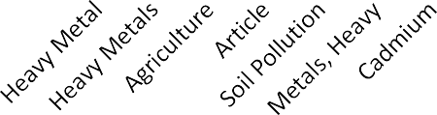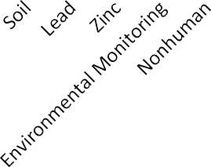
1,600
1,400
1,200
1,000
800
600
400
200
0
Series1

Figure 4: The frequency of keywords associated with biochar-related studies.

The frequency of important phrases used in research publications pertaining to agricultural and environmental studies is displayed in a bar graph. The terms "Heavy Metal" and "Heavy Metals" are the most commonly used, suggesting that heavy metal contamination is the main concern. Other often used terms are "Soil Pollution,""Agriculture,""Article," and special metals like "Cadmium,""Lead," and "Zinc." Additionally, words like "Environmental Monitoring,""Nonhuman," and "Soil" are frequently used. This implies that a sizable portion of study focuses on how heavy metals affect soil, agriculture, and environmental health, highlighting the growing worries about pollution and its effects on the environment and biology.

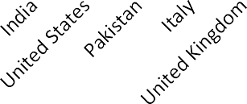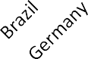

700
600
500
400
300
200
100
0
Figure 5: Participation in biochar research by different nation.

The number of research articles contributed by various nations is displayed in the bar graph. Strong research activity is evident in these countries, as China leads with the most papers, followed by India and the US. Italy and Pakistan also make modest amounts. Comparatively speaking, other nations with less publications include the UK, Egypt, Spain, Saudi Arabia, Brazil, Germany, and Iran. This data shows how research efforts are distributed around the world, especially in areas that are probably related to agricultural or environmental studies, where Asian nations are clearly making a substantial contribution.

Review of literature

Sources of Agriculture-Related Heavy Metal Pollution

Agricultural soil is one important non-renewable natural resource. Hazardous heavy metals (HM), including Cd, Pb, Cr, As, Hg, Cu, Ni, Zn, Al, and several other elements, can contaminate it due to both natural and man-made sources (Rashid et al., 2023). These heavy metals have been present in the crust naturally since the beginning of the Earth. The startling increase in the use of heavy metals will soon lead to an increase in metallic materials in both terrestrial and aquatic environments (Gautam et al., 2016). The accumulation of heavy metals (HMs) in soil can have negative health effects on humans and animals in addition to decreasing soil fertility and agricultural productivity. A variety of heavy metals (HMs) in contaminated soil are a threat to the environment and the general public, especially considering how swiftly the economy and culture are evolving (Min et al., 2018). Distinguishing between anthropogenic and natural (geogenic) metal concentrations in soil is crucial. A baseline for evaluating pollution is provided by geochemical background data. Because of mineral-rich parent materials, natural metal concentrations in soils may surpass regulatory thresholds in some areas, which could result in a misclassification as contaminated (Reimann & Garrett, 2005).
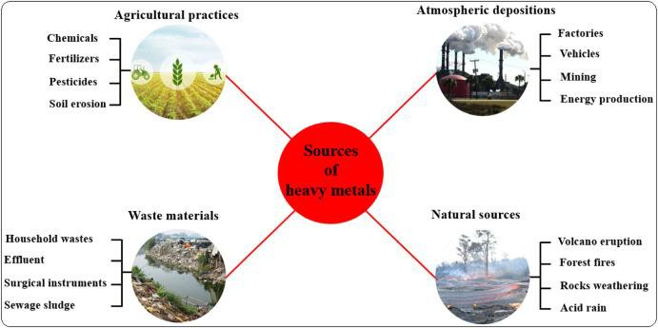

Fig 6:- Various sources of metal pollution (Khan et.al 2022).
Natural Sources
These are geogenic and usually ambient background sources of heavy metals.

Parent Material and Weathering of Rocks: Because rocks and minerals weather over time, soils naturally contain trace levels of heavy metals. Ultra mafic rocks naturally contain elements including Cr, Ni, and Zn, which geological processes can release into the soil (Kabata-Pendias, 2011). Which metals are released depends on the mineralogical makeup of the rocks. For example, black shales may have higher amounts of As, Mo, and U, whereas ultra mafic rocks are rich in Ni, Cr, and Co (De vries et al., 2013).

Types of Weathering and Their Role in Metal Release
Physical Weathering
Physical weathering, also referred to as mechanical weathering, is the breakdown of rocks into smaller particles without changing their chemical composition; it is facilitated by biological activity (e.g., root growth), salt crystallization, freeze-thaw cycles, and thermal expansion. Physical weathering does not directly release metals, but it increases surface area, which facilitates chemical weathering (Drever, 1994).

Chemical Weathering
The process by which mineral structures are changed by reactions with water, oxygen, acids, and other substances is known as chemical weathering. This procedure, which is essential for metal release, consists of:
Hydrolysis: The process by which silicate minerals are broken down into metal ions and clays.
Oxidation-Reduction: Metals are greatly released via redox reactions, particularly those involving minerals that contain iron, manganese, and sulfur (e.g., Fe²⁺ oxidizing to Fe³⁺).
Dissolution: As soluble minerals, such as gypsum and calcite, dissolve, related metals are released.
Acid weathering: Both man-made and natural acids, such as humic and carbonic, increase the solubility of metals (White & Blum, 1995).

Biological Weathering

By generating organic acid sand chelating agents that improve mineral dissolution and metal mobilization, living things like lichens, bacteria, fungi, and plant roots aid in weathering (Uroz et al., 2009).

Volcanic Eruptions :- It is a natural geological occurrence in which a volcano releases gasses, ash, magma (molten rock), and other components. When Earth's internal gases exert enough pressure to push magma to the surface, this process takes place.

Mechanisms of Heavy Metal Release during Volcanic Eruption

Volcanic Gases and Aerosols
Gases like SO₂, HCl, HF, and CO₂, which are released by volcanoes, can contain volatile heavy metals like selenium and mercury. These metals have the ability to combine with aerosols and travel throughout the world (Pyle & Mather, 2003).
Volcanic Ash and Particulate Matter
Many metals are transported via ash particles. Metals like Pb, Cd, Cr, and Ni can either be present as mineral inclusions or adsorb onto the surfaces of ash. The local chemistry is changed when these particles eventually settle on the surfaces of land or water (Witham et al., 2005).
Lava and Pyroclastic Deposits
Additionally, pyroclastic debris and molten rock, which may be abundant in trace metals, are released during eruptions. Metals seep into soils and water bodies as a result of these deposits degrading over time (Anthony et al., 2007).

Types of Heavy Metals Associated with Volcanic Activity
The following heavy metals are frequently linked to volcanic eruptions:
Mercury (Hg): Extremely poisonous and bioaccumulative; released as a gaseous element.
Lead (Pb), cadmium (Cd), chromium (Cr), and nickel (Ni) are found in volcanic ash and lava and are persistent in soils, according to Aiuppa et al. (2003).

C. Forest Fires

In light of land-use pressures and climate change, forest fires represent a significant ecological disturbance. In addition to the obvious damage they inflict on vegetation and infrastructure, wildfires also have a significant effect on biogeochemical cycles by volatilizing, altering, and dispersing heavy metals such as lead (Pb), mercury (Hg), cadmium (Cd), arsenic (As), chromium (Cr), and others.
These metals can be found naturally in forest soils and vegetation, or they can be brought in by industrial pollution, mining fallout, or atmospheric deposition. Acute and long-term environmental and public health hazards may arise from their mobilization during and after fires (Smith et al., 2011; Odigie & Flegal, 2014).

Mechanisms of Heavy Metal Mobilization

Combustion and Volatilization

Volatile metals including mercury, arsenic, and selenium can be released into the atmosphere when biomass and soil organic matter are burned at high temperatures. Prior to deposition, these metals may travel great distances (Xing et al., 2020).
Ash Deposition
Ash and char, which are fire left overs, frequently contain metals with lesser volatility, like Pb, Cr, and Cu. Through leaching or erosion, these materials can eventually find their way into soil and water systems after building up on the forest floor (Santín et al., 2015).
Post-Fire Erosion and Leaching
Runoff and erosion are more likely to occur in burned areas. Ash and topsoil contain heavy metals that can contaminate surface and groundwater by traveling to adjacent bodies of water (Neary et al., 2005).

CASE STUDY
High concentrations of Ni and Cr in soils formed from serpentine bedrock of (California, USA) restrict vegetation and have an impact on native biodiversity (Proctor & Woodell, 1975). Regardless of fertilizer application, naturally high Cd levels in (North Africa) of phosphate-rich parent material lead to higher Cd in soils and crops (Roberts, 2014). Similar to the Himalayan Foothills, arsenic-rich alluvial soils produced by geothermal and geological processes contribute to As contamination in paddy fields and groundwater (Smedley & Kinniburgh, 2002). Zn and Pb in Weathered Shales: Sulfide- rich shales in central Europe weather, adding metals to agricultural soils and affecting food safety (Salminen et al., 2005). Similar to the Bengal Delta, arsenic leaks into ground water used for drinking and irrigation when As-rich pyrite in alluvial sediments weathers under reducing conditions (Mukherjee et al., 2006). Significant amounts of mercury, arsenic, and lead are released from Mt. Etna, and research indicates that the elevated levels of these metals in nearby soils and flora are caused by decades of volcanic emissions (Pasta et al., 2001). Ash plumes with elevated levels of heavy metals were released as a result of the Soufrière Hills eruption, which started in 1995. According to Witham et al. (2005), The ash leachates contained high levels of Pb, Cu, and Zn. Nearby soils and water sources have accumulated these metals. The 2010 Eyjafjallajökull eruption had an impact on the ecosystem in addition to disrupting air travel, which garnered international attention. The ash contained trace amounts of harmful metals, such as As and Pb, which were carried throughout Northern Europe and impacted the air and soil quality in nations far from the eruption, according to research (Balić-Žunić et al., 2016). Nyiragongo is known for its rapid lava flows, but its gaseous emissions have received less attention than those of other volcanoes. High concentrations of metals like Co, Cr, and Ni have been discovered in its lava and related ash, which can be dangerous for drinking water supplies and agriculture (Verolino et al., 2022). According to studies, post-fire ash and air samples from the 2017–2018 California wildfires include high amounts of Pb and Cd, particularly in locations where urban fire spread has occurred (Odigie & Flegal, 2014). Significant mercury emissions from extensive fires in Canada were documented by Friedli et al. (2003), adding to mercury burdens in the Arctic and around the world. It has been demonstrated that post-fire runoff increases metal concentrations in rivers, posing issues for the environment and drinking water (Tuhý et al., 2021).

Anthtropogenic sources
The term "anthropogenic sources" describes heavy metal pollution that results from human activity. These sources are to blame for the environmental concentrations of heavy metals rising sharply, frequently to hazardous levels.
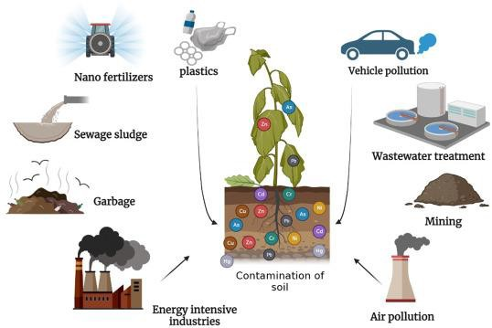

Fig 7:- Anthropogenic sources of heavy metal pollution (Angonet.al 2024)

Chemical Fertilizers and Pesticides
In agricultural soils, chemical fertilizers—especially those based on phosphate—are a significant source of arsenic, lead, and cadmium. The raw materials used to make fertilizer frequently contain these heavy metals as contaminants. When they are applied consistently overtime, they build up in the soil and become bio available to plants (Nicholsonet al., 2003). Likewise, trace levels of heavy metals are present in certain herbicides as contaminants or active components.
Phosphate fertilizers are the primary source of Cd and U contamination in agricultural soils, claim Loganathan et al. (2008).
Historically, orchards were contaminated with arsenical insecticides like lead arsenate, which have left lingering effects (Peryea, 1998).

B. Sewage Sludge and Waste water Irrigation
To improve soil fertility, sewage sludge and treated or untreated wastewater are frequently used to agricultural fields. However, these materials often contain high levels of heavy metals such as nickel, chromium, and mercury. These chemicals contribute to soil contamination and enter the food chain through plant uptake if they are not properly handled (Singh & Agrawal, 2008). Heavy metal mixtures are frequently found in municipal and industrial effluent. Long-term contamination may result from the use of untreated or insufficiently treated sewage sludge in agriculture (Jin et al., 2015).

C. Industrial Emissions and Atmospheric Deposition

Large volumes of heavy metals are discharged into the atmosphere. by mining, smelting, and manufacturing, and these emissions land on soil surfaces through dust, rain, or atmospheric deposition, progressively raising the heavy metal load in agricultural soils (Wuana & Okieimen, 2011). Farmlands close to industrial zones are especially vulnerable.

D. Urbanization and Traffic Emissions

Heavy metals like Pb, Zn, and Cu that are deposited from vehicle exhaust, brake linings, tires, and construction materials are carried by urban runoff from roads and construction sites (Hwang et al., 2016).

Example: Leaded gasoline was a major source of lead in the atmosphere before it was phased out. Remainders can still be found in urban soils (Filippellie et al., 2005).

E. Mining Activities

Mining activities expose heavy metal-rich rocks to weathering and leaching; the use of heavy metals in ore processing and the discharge of tailings causes widespread contamination of surrounding land and water bodies and runoff from tailings, mine drainage, and windborne particles contaminate nearby agricultural land, affecting soil quality and crop productivity (Sarma et al., 2005). The issue is exacerbated in regions where mining regulations are not adequately enforced. Toxic concentrations of Cu, Fe, Mn, and As are frequently found in acid mine drainage from coal and metal mines (Akcil & Koldas, 2006).

F. Animal Manure and Organic Amendments
Heavy metals from tainted feed, additives, or veterinary medications may be present in animal excrement, particularly from livestock raised intensively. Depending on their source materials, organic amendments such as compost and bio solids may also include heavy metals (Zhang et al., 2016).

G. Electronic and Solid Waste

Heavy metals including mercury, lead, and cadmium are released when electronic garbage, or "e-waste," is improperly disposed of. Open burning and acid leaching are common informal recycling practices in underdeveloped nations, which exacerbate pollution (Robinson, 2009).

H. Contaminated Irrigation Water
Heavy metals can enter agricultural systems directly through irrigation water that comes from contaminated lakes, rivers, or groundwater. The problem is particularly noticeable in urban and peri-urban agriculture, where discharges of household and industrial trash frequently affect water sources (Muchuweti et al., 2006).

As has accumulated widely in Bangladeshi agricultural soils as a result of arsenic-based insecticides and tainted irrigation water. Meharg and Rahman (2003) discovered that rice and soil had arsenic concentrations above allowable limits. Pesticides and water contaminated with As are the main causes of soil contamination. More than 30 million individuals suffer from chronic arsenic poisoning. Agricultural areas are treated with sewage sludge to increase fertility. However, repeated sludge treatment resulted in higher concentrations of Ni, Cr, and Zn in soil and wheat crops, according to Jamali et al. (2018). Soil Cr levels were three to four times higher than background levels. Contamination – related crop export restrictions and possible phy to toxicity. One of the biggest producers of heavy metals in Europe is the Rönnskär smelter. According to a research by Bergbäcket al. (2001), near by soils had higher Pb, Cd, and As deposition. More than 15 kilometers from the source, the soil was contaminated. Wild berries and locally consumed crops run the risk of absorbing metals. United States: East Chicago, Indiana region has long been contaminated by emissions from lead smelters and steel mills. Soil and dust samples collected from residential areas had extremely high levels of lead (Laidlaw et al., 2012). In more than 60% of samples, Pb levels were higher above the USEPA threshold (400 mg/kg). Listed as a Super fund cleanup site; elevated blood lead levels in youngsters. The Copper Belt region of Zambia has a long history of copper and cobalt mining. Studies carried out in locations such as Kitwe and Mufulira revealed elevated levels of Cu, Pb, and Zn in soils and water bodies (Tembo et al., 2006). High metal concentrations in nearby crops; soil Cu concentrations >5000 mg/kg. Health hazards and decreased agricultural productivity as a result of tainted drinking water. Metal buildup in vegetables like lettuce and amaranth, decreased soil fertility, and potential dietary hazards. Solid garbage dumping and informale in Delhi – waste dismantling are common in places like Seelampur and Mandoli. Hazardous levels of lead and mercury in soils that seep into nearby waterways (Leung et al., 2008). Soil microbial biomass decreased as a result of toxicity in contaminated crops that were irrigated with neighboring wastewater. In Faisalabad, Mahmood and Malik (2014) evaluated the effects of irrigation using textile and dyeing effluents. Vegetables and soils had noticeably higher levels of Cr and Ni. Decreased plant growth and chlorophyll concentration; possible carcinogenic risk associated with vegetable eating. Mapanda etal. (2005) investigated areas in Hararethat had been watered with municipal effluent for more than ten years. The soils had significantly higher levels of Cd, Pb, and Zn than rainfed controls. Long-term use raised questions about food safety and gradually reduced soil yield.

Mechanisms of Metal Uptake and Accumulation in Plants

Heavy metals such as chromium (Cr), lead (Pb), arsenic (As), mercury (Hg), and cadmium (Cd) are toxic to plants and unnecessary, even in trace amounts. However, trace amounts of vital metals like copper (Cu), manganese (Mn), iron (Fe), and zinc (Zn) are required and are absorbed through rigorously regulated processes. Developing phyto remediation techniques and improving crop resilience to metal stress require an understanding of the absorption and accumulation mechanisms (Clemens, 2006). Transport proteins and ion channels allow plants to absorb heavy metals through their roots. Through the xylem, metals can go to aerial areas and impact physiological processes (Benavides et al., 2005).

Rhizospheric Processes

Microbial activity, organic matter, redox potential, and pH all affect the amount of metals in the soil. By chelating metals and increasing their bioavailability, plant exudates (such as organic acids and phytosiderophores) can alter the rhizosphere (Marschner, 2012).

Transporters Involved in Uptake
Metal uptake across root plasma membranes is mediated by particular transporters:

ZIP (ZRT/IRT-like Protein) family: In charge of absorbing zinc and iron (Guerinot, 2000).
NRAMP (Natural Resistance-Associated Macrophage Protein): engaged in the uptake of Mn, Fe, and Cd (Cailliatte et al., 2010).
P-type ATPases: participate in the transfer of Cu and Zn (Axelsen & Palmgren, 2001).
Metal Translocation and Accumulation

Xylem and Phloem Transport
Metals are transported through the xylem to aerial parts after being chelated with organic acids (citrate, malate) or amino acids (histidine, nicotianamine) once they are inside root cells. A variety of transporters, including those belonging to the YSL (Yellow Stripe- Like) and HMA (Heavy Metal ATPase) families, facilitate long-distance transport (Krämer et al., 2007).

Sequestration in Vacuoles
To prevent metal toxicity, plants use tonoplast-localized transporters like CAX (Cation/H+ exchangers) and ABC (ATP-binding cassette) to compartmentalize excess metals into vacuoles (Martinoia et al., 2012).

Heavy Metals' Effect on the Physical Properties of Soil

Heavy metals (HMs), such as mercury, cadmium, chromium, nickel, lead, and arsenic, are characterized by their high density and comparatively large atomic weight (Ismanto et al., 2023). Because heavy metals alter the soil's porosity and structure, there is less water infiltration and aeration. By altering the way the soil aggregates and possibly raising bulk density, contamination decreases the soil's suitability for root penetration (Khanet al., 2010). Both plant growth and soil microbial activity are hampered by these alterations.
Soil Structure and Texture
Heavy metals can change the compaction and aggregation of soil. Chronic pollution impairs root penetration and water retention by decreasing aggregate stability (Wang et al., 2020). Lead (Pb), for example, is known to interfere with the cohesiveness of soil particles, increasing soil erosion and runoff.
Soil pH and Cation Exchange Capacity (CEC)
Soil acidification is sometimes caused by heavy metal contamination, particularly in regions that are susceptible to acid rain or industrial pollutants. The toxicity of heavy metals is increased by an acidic pH, which also increases their mobility and bioavailability (Yoon etal., 2006). By displacing necessary cations like Ca2+, Mg2+, and K+ from soil colloids, metals like Cd and Zn can simultaneously lower CEC (Mc Laughlin et al., 2000).

Heavy Metals' Effect on Soil Microbial Communities

The breakdown of organic matter, the formation of soil structure, and the biogeochemical cycle all depend on soil microorganisms, which include bacteria, fungi, archaea, protozoa, and viruses (Torsvik and Øvreås 2002). Overall soil fertility, nutrient availability, and plant health are all directly impacted by their activities. However, the makeup and function of these microbial communities can be changed by human activity and environmental changes (Fierer & Jackson, 2006).

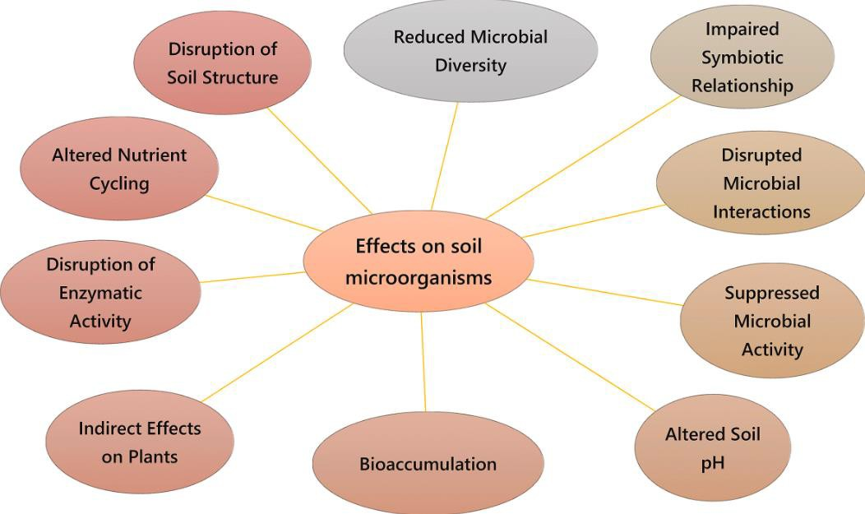

Fig 8:- Effects of heavy metal pollution on soil micro organisms (Angon et.al2024)

Microbial Biomass and Diversity
Heavy metals negatively affect the abundance, variety, and enzymatic activity of soil microorganisms. By interfering with protein synthesis and enzyme function, even low doses can prevent the growth of microorganisms (Giller et al., 2009). The efficiency of organic matter decomposition and nutrient cycling may be lowered by this disturbance.
Bacteria: According to Chodak et al. (2013), heavy metals inhibit bacterial growth and change the composition of bacterial communities to favor species that are resistant to them.
Fungus: Under heavy metal stress, fungus exhibit decreased diversity and altered metabolism, despite being more resistant than bacteria (Chander & Brookes, 1991).

In soils contaminated with zinc and cadmium, Kandeler et al. (1996) found a notable decrease in microbial biomass and activity.
Enzyme Activities
By attaching themselves to enzyme active sites or changing the structure of proteins, heavy metals obstruct enzymatic processes.
Inhibition of soil enzymes: Contaminated soils frequently exhibit decreased phosphatase, urease, and dehydrogenase activities (Dick, 1997).
Disruption of the nutrient cycle: Due to their extreme sensitivity to heavy metals, nitrogen-fixing and nitrifying bacteria have poor nitrogen transformation (Mertens et al., 2009). These disturbances have the potential to damages oil structure, limit organic matter breakdown, and decrease plant nutrition availability.
Nitrogen Fixation and Decomposition
According to García-Gil et al. (2003), metal toxicity hinders biological nitrogen fixation by lowering the population of nitrogen-fixing bacteria such as Rhizobium and Azotobacter. Additionally, metal toxicity slows down organic matter decomposition, which results in the buildup of residues that haven't broken down and decreased soil fertility.
Ecosystem Disruption
Microbial populations, aquatic ecosystems, and plant photosynthesis are all impacted by volcanic emissions. Forests can be defoliated by SO₂ and ash, while aquatic life is harmed by acidified waterways. Ash and fluoride contamination from Iceland's Eyjafjallajökull eruption caused a brief pasture die-off (Arnalds, 2013).

Impact of Heavy Metals on Soil Fertility
Soil Contamination
Higher levels of heavy metals in the soil can be caused by ash deposition and reduced plant absorption following a fire. This affects soil microbial populations and nutrient cycling (Certini, 2005).
Influence on Nutrient Cycling
Heavy metal toxicity dramatically reduces vital biogeochemical cycles including phosphorus solubilization and nitrogen fixation. According to Chibuike and Obiora (2014), Pb and Cd, for example, negatively impact nitrogen-fixing bacteria such as Rhizobium spp. and Azotobacter spp., causing nitrogen deficit in plants.
Soil Organic Matter (SOM)
The microbial breakdown of organic matter is slowed down by heavy metal contamination, which alters the content of SOM and how it interacts with metal ions. SOM has two functions: it can bind metals and lessen their toxicity, but it can also increase metal mobility when it degrades due to pollution (Violante et al., 2010).
Long-Term Ecological Impacts
Soil microbial populations undergo long-term alterations as a result of persistent heavy metal exposure. Reduced microbial diversity and function over time may lead to:
Decreases in crop yield and plant health
Poor soil aeration and structure
The build up of undecomposed organic materials.
Bioremediation techniques, such as the application of metal-accumulating plants (phytoremediation) and metal-resistant microbial inoculants (bioaugmentation), are necessary for the rehabilitation of such soils (Ali et al., 2013).
Microbial Adaptation and Resistance Mechanisms
There are various ways that microbes can be come resistant to heavy metals:
Efflux pumps: According to Nies (2003), transport proteins eliminate hazardous metals from cells.
Sequestration: Metals can be rendered immobile by the production of metallothioneins and biosorption by extracellular polymers or cell walls (Gadd, 2010).
Enzymatic transformation: Metals are changed into less hazardous forms by oxidation and reduction processes.
According to Viti and Giovannetti (2003), these modifications may decrease microbial metabolic efficiency while simultaneously enabling microbial survival in polluted environments.
Soil bacteria have extraordinary resilience in the face of these consequences. Depending on how severe the stressor is and how long it lasts, many communities can eventually recover from disturbances. Even in the event of the loss of certain taxa, ecosystem functioning can continue due to functional redundancy within microbial communities (Allison & Martiny, 2008).

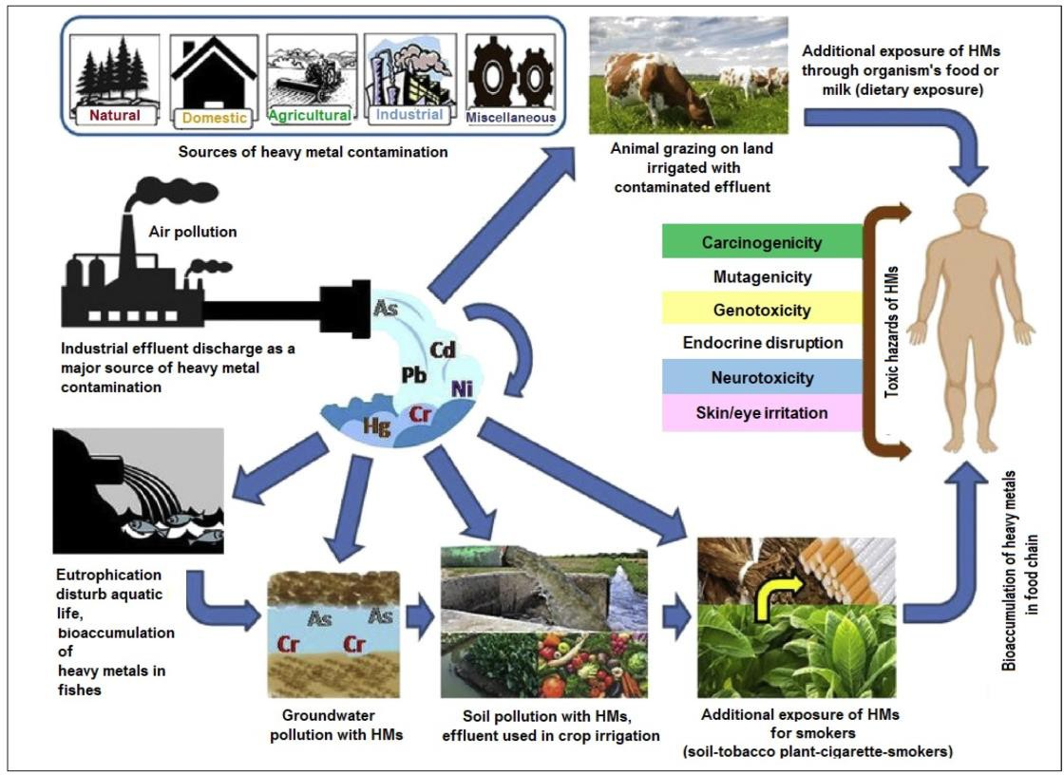

Fig 9:- Heavy metals' harmful effects on the environment (Vasilachi et al., 2023).

Heavy Metals' Effect on Crop Yield and Growth
Effects on Morphological and Physiological Attributes
Heavy metals have detrimental effects on plant morphology, including stunted growth, reduced leaf area, and root damage. By reducing chlorophyll content and suppressing photosystem II activity, they physiologically obstruct photosynthesis (Foy et al., 1978). Mercury and chromium damage root membranes, which interferes with the uptake of water and nutrients.
Issues with Human Health and Food Safety
Consumer health is seriously threatened by metal buildup in edible parts of crops cultivated on contaminated soils. Cancer, kidney damage, and neurological issues can result from prolonged dietary exposure to heavy metals (Järup, 2003). This emphasizes how important it is to keep an eye on the metal concentrations in food items and agricultural soils.
Water Quality Degradation
Metal runoff from fires affects aquatic life and bio accumulates in food chains, contributing to dangerous levels in streams. Studies in the US and Australia have discovered elevated Pb, Zn, and Cu levels in water after large wildfires (Thomas et al., 2023).
Mitigation Strategies

Soil-Based Remediation Techniques

Soil Amendments

Soil amendments are substances that are added to soils to immobilize and reduce the bioavailability of heavy metals.
Lime (CaCO3):
Raises the pH of soil and decreases the solubility of metals such as Cd and Pb.
Phosphate fertilizers:
Create insoluble lead phosphate minerals, which immobilize lead (Ma et al., 1995).
Heavy metals can be adsorbed by zeolites and clay minerals due to their high cation-exchange capacity.
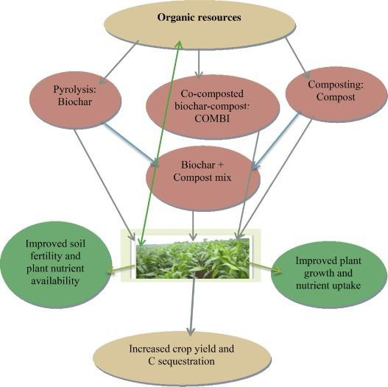
Fig 10:- Biochar's contribution to enhancing soil health (Agegnehu et al., 2017)

Biochar Application
Because it has been shown to significantly reduce crop uptake of Cd, Pb, and Zn while simultaneously enhancing soil structure, pH, and nutrient retention, the use of biochar—a carbon-rich byproduct of pyrolyzing biomass—as a soil amendment has attracted interest (Beesley et al., 2011).
Organic Manures and Compost
Compost and farmyard manure are examples of organic materials that may complex with heavy metals, reducing their mobility and bioavailability (Kwiatkowska-Malina et al., 2018). They also promote the development of microorganisms, which may aid in detoxification.
Biological Remediation Strategies
Phyto remediation: Using plants to eliminate, stabilize, or detoxify heavy metals from contaminated soils is known as phyto remediation.
Phyto extraction: Thlaspi caerulescens and Brassica juncea are examples of hyper accumulator plants that absorb metals.
Phyto stabilization: lowering leaching by immobilizing metals in the root zone
(Aliet al., 2013).
Use of Beneficial Micro organisms
Soil microorganisms that considerably lessen heavy metal stress include mycorrhizal fungi and plant growth-promoting rhizo bacteria (PGPR). They improve nutrient uptake and release enzymes or chelators that immobilize metals (Khan et al., 2009). For instance, by sequestering in fungal tissues, arbuscular mycorrhizal fungi (AMF) lower the buildup of Cd and Pb in plants.
Crop Selection and Rotation
Heavy metal intake into the food chain can be reduced by cultivating crop varieties that exclude or accumulate metals at low levels.
For instance, some rice varieties have lower grain accumulations of Cd and As (Uraguchi & Fujiwara et.al 2012). Metal buildup in edible portions can be decreased by rotating crops with non-food or bio energy crops.
Controlled Fertilizer Use
Phosphate fertilizers that include Cd should not be used excessively. It is advised to implement integrated nutrition management (INM), which combines biological, organic, and chemical sources (Rattan et al., 2005)
Physical and Chemical Engineering Approaches
Immobilization Agents
Metals can be stabilized and plant uptake decreased by applying materials such as bio available silica, bentonite, or iron oxide (Park et al., 2011).
Chelation by Phyto chelatins and Metallothioneins
Plants and some fungi are the main sources of PCs. When PCs are exposed to harmful metals such as Cd and Hg they quickly build PC-metal complexes, which are then trapped in vacuoles (Cobbett et.al2002).
Anti oxidative Defense Mechanisms
Exposure to heavy metals generates reactive oxygen species (ROS), and plants combat oxidative stress by triggering antioxidant enzymes like superoxide dismutase, catalase, and peroxidases (Sharma & Dietz, 2009)
Conclusion
Heavy metal pollution in agriculture comes from a variety of sources, but anthropogenic inputs are the primary offender. These metals are particularly dangerous due to their persistence and non-degradability. Limiting heavy metal contamination and protecting human health requires effective regulation, consistent soil monitoring, and the adoption of sustainable agriculture methods. Plants have complex chemical and physiological mechanisms for absorbing and storing heavy metals. Clarifying these processes presents encouraging opportunities for environmental remediation and sustainable agriculture. For the best metal management, future studies should concentrate on gene editing, transporter regulation, and micro biome interaction. Through their reduction of biodiversity, inhibition of enzyme activity, and impairment of vital soil activities, heavy metals have harmful impacts on soil microbial populations. Even while some microorganisms become resistant, there are substantial functional and ecological losses. To restore microbiological health and guarantee ongoing agricultural productivity, polluted soils must be continuously monitored and remedied. Heavy metal pollution is a persistent environmental and health concern that is increasingly associated with forest fires. Developing successful mitigation methods requires an understanding of the metal mobilization routes, from combustion to deposition. Interdisciplinary techniques combining ecology, toxicology, and land management are essential for lowering the dangers presented by heavy metals in forest ecosystems when fire frequency and intensity increase due to climate change.

COMPETING INTERESTS DISCLAIMER:
Authors have declared that they have no known competing financial interests OR non-financial interests OR personal relationships that could have appeared to influence the work reported in this paper.
REFERENCE
Adriano,D.C. (2001). Trace elements in terrestrial environments: biogeochemistry, bioavailability, and risks of metals (Vol. 860). New York: Springer.
Agegnehu, G., Srivastava, A. K., & Bird, M. I. (2017). The role of biochar and biochar-compost in improving soil quality and crop performance: A review. Applied soil ecology, 119, 156-170.
Aiuppa, A., Federico, C., Franco, A., Giudice, G., Gurrieri, S., Inguaggiato, S., ... & Valenza, M. (2005). Emission of bromine and iodine from Mount Etna volcano. Geochemistry, Geophysics, Geosystems, 6(8).
Akcil, A., & Koldas, S. (2006). Acid Mine Drainage (AMD): causes, treatment and case studies. Journal of cleaner production, 14(12-13), 1139-1145.
Ali, H., Khan, E., & Sajad, M. A. (2013). Phytoremediation of heavy metals—concepts and applications. Chemosphere, 91(7), 869-881.
Allison, S. D., & Martiny, J. B. (2008). Resistance, resilience, and redundancy in microbial communities. Proceedings of the National Academy of Sciences, 105(supplement_1), 11512-11519.
Angon, P. B., Islam, M. S., Das, A., Anjum, N., Poudel, A., & Suchi, S. A. (2024). Sources, effects and present perspectives of heavy metals contamination: Soil, plants and human food chain. Heliyon, 10(7).
Anthony, E. J., Marriner, N., & Morhange, C. (2014). Human influence and the changing geomorphology of Mediterranean deltas and coasts over the last 6000 years: From progradation to destruction phase?. Earth-Science Reviews, 139, 336-361.
Arnalds, O. (2013). The influence of volcanic tephra (ash) on ecosystems. Advances in agronomy, 121, 331-380.
Axelsen, K. B., & Palmgren, M. G. (2001). Inventory of the superfamily of P-type ion pumps in Arabidopsis. Plant physiology, 126(2), 696-706.
Balić-Žunić, T., Garavelli, A., Jakobsson, S. P., Jonasson, K., Katerinopoulos, A., Kyriakopoulos, K., ... & Nemeth, K. (2016). Updates in Volcanology− From Volcano Modelling to Volcano Geology.
Beesley, L., Moreno-Jiménez, E., & Gomez-Eyles, J. L. (2010). Effects of biochar and greenwaste compost amendments on mobility, bioavailability and toxicity of inorganic and organic contaminants in a multi-element polluted soil. Environmental pollution, 158(6), 2282-2287.
Bergbäck, B., Johansson, K., & Mohlander, U. (2001). Urban metal flows–a case study of Stockholm. Review and Conclusions. Water, air and soil pollution: Focus, 1(3), 3-24.
Cailliatte, R., Schikora, A., Briat, J. F., Mari, S., & Curie, C. (2010). High-affinity manganese uptake by the metal transporter NRAMP1 is essential for Arabidopsis growth in low manganese conditions. The Plant Cell, 22(3), 904-917.
Campo, J., Lorenzo, M., Cammeraat, E. L., Picó, Y., & Andreu, V. (2017). Emerging contaminants related to the occurrence of forest fires in the Spanish Mediterranean. Science of the Total Environment, 603, 330-339.
Certini, G. (2005). Effects of fire on properties of forest soils: a review. Oecologia, 143(1), 1-10.
Chibuike, G. U., & Obiora, S. C. (2014). Heavy metal polluted soils: effect on plants and bioremediation methods. Applied and environmental soil science, 2014(1), 752708.
Clemens, S. (2006). Toxic metal accumulation, responses to exposure and mechanisms of tolerance in plants. Biochimie, 88(11), 1707-1719.
Cobbett, C., & Goldsbrough, P. (2002). Phytochelatins and metallothioneins: roles in heavy metal detoxification and homeostasis. Annual review of plant biology, 53(1), 159-182.
De Vries, W., Groenenberg, J. E., Lofts, S., Tipping, E., & Posch, M. (2012). Critical loads of heavy metals for soils. In Heavy metals in soils: trace metals and metalloids in soils and their bioavailability (pp. 211-237). Dordrecht: Springer Netherlands.
Drever, J. I. (1988). The geochemistry of natural waters (Vol. 437). Englewood Cliffs: Prentice hall.
Fallahzadeh, R. A., Ghaneian, M. T., Miri, M., & Dashti, M. M. (2017). Spatial analysis and health risk assessment of heavy metals concentration in drinking water resources. Environmental Science and Pollution Research, 24(32), 24790-24802.
Fierer, N., & Jackson, R. B. (2006). The diversity and biogeography of soil bacterial communities. Proceedings of the National Academy of Sciences, 103(3), 626-631.
Filippelli, G. M., Laidlaw, M. A., Latimer, J. C., & Raftis, R. (2005). Urban lead poisoning and medical geology: An unfinished story. GSA today, 15(1), 4-11.
Foy, C. D., Chaney, R. T., & White, M. C. (1978). The physiology of metal toxicity in plants. Annual review of plant physiology, 29(1), 511-566.
Friedli, H. R., Radke, L. F., Lu, J. Y., Banic, C. M., Leaitch, W. R., & MacPherson, J. I. (2003). Mercury emissions from burning of biomass from temperate North American forests: laboratory and airborne measurements. Atmospheric Environment, 37(2), 253-267.
Garcıa-Gil, J. C., Plaza, C., Soler-Rovira, P., & Polo, A. (2000). Long-term effects of municipal solid waste compost application on soil enzyme activities and microbial biomass. Soil Biology and biochemistry, 32(13), 1907-1913.
Gautam, P. K., Gautam, R. K., Banerjee, S., Chattopadhyaya, M. C., & Pandey, J. D. (2016).
Giller, K. E., Witter, E., & McGrath, S. P. (2009). Heavy metals and soil microbes. Soil Biology and Biochemistry, 41(10), 2031-2037.
Guerinot, M. L. (2000). The ZIP family of metal transporters. Biochimica et Biophysica Acta (BBA)-Biomembranes, 1465(1-2), 190-198.
Gupta, A. K., & Sinha, S. (2007). Assessment of single extraction methods for the prediction of bioavailability of metals to Brassica juncea L. Czern.(var. Vaibhav) grown on tannery waste contaminated soil. Journal of hazardous materials, 149(1), 144-150.
Heavy metals in the environment: fate, transport, toxicity and remediation technologies. Nova Sci Publishers, 60, 101-130.
Holmes, A. L., Wise, S. S., & Wise, J. P. (2008). Carcinogenicity of hexavalent chromium. Indian journal of medical research, 128(4), 353-372.
https://www.who.int/publications/i/item/9789241565196
Huang, J., N krumah, P. N., Anim, D. O., & Mensah, E. (2013). E-waste disposal effects on the aquatic environment: Accra, Ghana. Reviews of environmental contamination and toxicology, 19-34.
Ismanto, A., Hadibarata, T., Widada, S., Indrayanti, E., Ismunarti, D. H., Safinatunnajah, N., ... & Alkahtani, J. (2023). Groundwater contamination status in Malaysia: level of heavy metal, source, health impact, and remediation technologies. Bioprocess and Biosystems Engineering, 46(3), 467-482.
Jamali, M. K., Kazi, T. G., Arain, M. B., Afridi, H. I., Jalbani, N., Kandhro, G. A., ... & Baig, J. A. (2009). Heavy metal accumulation in different varieties of wheat (Triticum aestivum L.) grown in soil amended with domestic sewage sludge. Journal of hazardous materials, 164(2-3), 1386-1391.
Järup, L. (2003). Hazards of heavy metal contamination. British medical bulletin, 68(1), 167-182.
Jin, J., Sun, K., Wang, Z., Han, L., Pan, Z., Wu, F., ... & Xing, B. (2015). Characterization and phthalate esters sorption of organic matter fractions isolated from soils and sediments. Environmental pollution, 206, 24-31.
Jin, Y., O'Connor, D., Ok, Y. S., Tsang, D. C., Liu, A., & Hou, D. (2019). Assessment of sources of heavy metals in soil and dust at children's playgrounds in Beijing using GIS and multivariate statistical analysis. Environment international, 124, 320-328.
Kabata-Pendias, A. (2000). Trace elements in soils and plants. CRC press.
Kabata-Pendias, A. (2000). Trace elements in soils and plants. CRC press.
Khan, M. S., Zaidi, A., & Wani, P. A. (2009). Role of phosphate solubilizing microorganisms in sustainable agriculture-a review. Sustainable agriculture, 551-570.
Khan, Z., Fan, X., Khan, M. N., Khan, M. A., Zhang, K., Fu, Y., & Shen, H. (2022). The toxicity of heavy metals and plant signaling facilitated by biochar application: Implications for stress mitigation and crop production. Chemosphere, 308, 136466.
Krämer, U., Talke, I. N., & Hanikenne, M. (2007). Transition metal transport. FEBS letters, 581(12), 2263-2272.
Kwiatkowska-Malina, J. (2018). Functions of organic matter in polluted soils: The effect of organic amendments on phyto availability of heavy metals. Applied Soil Ecology, 123, 542-545.
Laidlaw, M. A., Filippelli, G. M., Sadler, R. C., Gonzales, C. R., Ball, A. S., & Mielke, H. W. (2016). Children’s blood lead seasonality in flint, Michigan (USA), and soil-sourced lead hazard risks. International journal of environmental research and public health, 13(4), 358.
Lestinen, P., Savolainen, H., & Lahtinen, R. Geological Survey of Finland.
Leung, A. O., Duzgoren-Aydin, N. S., Cheung, K. C., & Wong, M. H. (2008). Heavy metals concentrations of surface dust from e-waste recycling and its human health implications in southeast China. Environmental science & technology, 42(7), 2674-2680.
Liu, L., Li, W., Song, W., & Guo, M. (2018). Remediation techniques for heavy metal-contaminated soils: Principles and applicability. Science of the total environment, 633, 206-219.
Liu, W. X., Liu, J. W., Wu, M. Z., Li, Y., Zhao, Y., & Li, S. R. (2009). Accumulation and translocation of toxic heavy metals in winter wheat (Triticum aestivum L.) growing in agricultural soil of Zhengzhou, China. Bulletin of environmental contamination and toxicology, 82(3), 343-347.
Lokeshappa, B., Dikshit, A. K., Luo, Y., Hutchinson, T. J., & Giammar, D. E. (2014). Assessing bioaccessible fractions of arsenic, chromium, lead, selenium and zinc in coal fly ashes. International Journal of Environmental Science and Technology, 11(6), 1601-1610.
Lottermoser, B. G., Gerstmann, B., & Fairclough, M. (2022, May). Uranium in Mine Waste: A Problem with an Opportunity. In Management of Naturally Occurring Radioactive Material (NORM) in Industry. Proceedings of an International Conference. Supplementary Files (pp. 8-8).
Ma, Q. Y., Logan, T. J., & Traina, S. J. (1995). Lead immobilization from aqueous solutions and contaminated soils using phosphate rocks. Environmental science & technology, 29(4), 1118-1126.
Mahmood, A., & Malik, R. N. (2014). Human health risk assessment of heavy metals via consumption of contaminated vegetables collected from different irrigation sources in Lahore, Pakistan. Arabian Journal of Chemistry, 7(1), 91-99.
Mapanda, F., Mangwayana, E. N., Nyamangara, J., & Giller, K. E. (2005). The effect of long-term irrigation using wastewater on heavy metal contents of soils under vegetables in Harare, Zimbabwe. Agriculture, Ecosystems & Environment, 107(2-3), 151-165.
Marschner, H. (2012). Marschner's mineral nutrition of higher plants. Academic press.
Martinoia, E., Meyer, S., De Angeli, A., & Nagy, R. (2012). Vacuolar transporters in their physiological context. Annual review of plant biology, 63, 183-213.
McLaughlin, M. J., Parker, D. R., & Clarke, J. M. (1999). Metals and micronutrients–food safety issues. Field crops research, 60(1-2), 143-163.
Meharg, A. A., & Rahman, M. M. (2003). Arsenic contamination of Bangladesh paddy field soils: implications for rice contribution to arsenic consumption. Environmental science & technology, 37(2), 229-234.
Mep, M. L. R. (2014). National soil pollution survey bulletin. Ministry of Environmental Protection and Ministry of Land and Resources Beijing.
Min, Y. T., Zhang, H. M., Shen, F. X., & Li, Y. (2018). Discussion on the protection and utilization of topsoil resources. Green Technol, 20, 18-20.
Muchuweti, M., Birkett, J. W., Chinyanga, E., Zvauya, R., Scrimshaw, M. D., & Lester, J. N. (2006). Heavy metal content of vegetables irrigated with mixtures of wastewater and sewage sludge in Zimbabwe: implications for human health. Agriculture, ecosystems & environment, 112(1), 41-48.
Mukherjee, A., Sengupta, M. K., Hossain, M. A., Ahamed, S., Das, B., Nayak, B., ... & Chakraborti, D. (2006). Arsenic contamination in groundwater: a global perspective with emphasis on the Asian scenario. Journal of Health, Population and Nutrition, 142-163.
Neary, D. G., Ryan, K. C., & DeBano, L. F. (2005). Wildland fire in ecosystems: effects of fire on soils and water. Gen. Tech. Rep. RMRS-GTR-42-vol. 4. Ogden, UT: US Department of Agriculture, Forest Service, Rocky Mountain Research Station. 250 p., 42.
Nicholson, F. A., Smith, S. R., Alloway, B. J., Carlton-Smith, C., & Chambers, B. J. (2003). An inventory of heavy metals inputs to agricultural soils in England and Wales. Science of the total environment, 311(1-3), 205-219.
Odigie, K. O., & Flegal, A. R. (2014). Trace metal inventories and lead isotopic composition chronicle a forest fire’s remobilization of industrial contaminants deposited in the Angeles National Forest. PloS one, 9(9), e107835.
Park, J. H., Lamb, D., Paneerselvam, P., Choppala, G., Bolan, N., & Chung, J. W. (2011). Role of organic amendments on enhanced bioremediation of heavy metal (loid) contaminated soils. Journal of hazardous materials, 185(2-3), 549-574.
Pasta, S., D’Amore, G., Di Maggio, C., Di Pasquale, G., Forgia, V., Incarbona, A., ... & Vacchi, M. (2022, October). Impact of climate, resource availability, natural disturbances and human subsistence strategies on the Sicilian landscape dynamics during Holocene. In Proceedings of the Interdisciplinary Colloquium ‘Watertraces: De l’hydrogéologie à l’archéologie hydraulique en Méditerranée antique (pp. 8-60).
Peryea, F. J. (1998, August). Historical use of lead arsenate insecticides, resulting soil contamination and implications for soil remediation. In 16th World congress of soil science, Montpellier, France (pp. 20-26).
Proctor, J., Woodell, S. R. J., & MacFadyen, A. (1975). The Ecology of Serpentine Soils Advances in Ecological Research (Vol. Volume 9, pp. 255–366).
Pyle, D. M., & Mather, T. A. (2003). The importance of volcanic emissions for the global atmospheric mercury cycle. Atmospheric Environment, 37(36), 5115-5124.
Rashid, A., Schutte, B. J., Ulery, A., Deyholos, M. K., Sanogo, S., Lehnhoff, E. A., & Beck, L. (2023). Heavy metal contamination in agricultural soil: environmental pollutants affecting crop health. Agronomy, 13(6), 1521.
Rattan, R. K., Datta, S. P., Chhonkar, P. K., Suribabu, K., & Singh, A. K. (2005). Long-term impact of irrigation with sewage effluents on heavy metal content in soils, crops and groundwater—a case study. Agriculture, ecosystems & environment, 109(3-4), 310-322.
Reimann, C., & Garrett, R. G. (2005). Geochemical background—concept and reality. Science of the total environment, 350(1-3), 12-27.
Reisen, F., & Brown, S. K. (2009). Australian firefighters' exposure to air toxics during bushfire burns of autumn 2005 and 2006. Environment international, 35(2), 342-352.
Roberts, T. L. (2014). Cadmium and phosphorus fertilizers: the issues and the science. Rrocedia Eng 83: 52–59.
Robinson, B. H. (2009). E-waste: an assessment of global production and environmental impacts. Science of the total environment, 408(2), 183-191.
Santín, C., Doerr, S. H., Preston, C. M., & González‐Rodríguez, G. (2015). Pyrogenic organic matter production from wildfires: a missing sink in the global carbon cycle. Global Change Biology, 21(4), 1621-1633.
Sarma, K. (2005). Impact of coal mining on vegetation: a case study in Jaintia Hills district of Meghalaya, India. International Institute for Geo-information Science and Earth Observation., Enschede, The Netharlands & IIRS, NRSA, Department of Space., Dehradun, India.
Sepúlveda, A., Schluep, M., Renaud, F. G., Streicher, M., Kuehr, R., Hagelüken, C., & Gerecke, A. C. (2010). A review of the environmental fate and effects of hazardous substances released from electrical and electronic equipments during recycling: Examples from China and India. Environmental impact assessment review, 30(1), 28-41.
Sharma, S. S., & Dietz, K. J. (2009). The relationship between metal toxicity and cellular redox imbalance. Trends in plant science, 14(1), 43-50.
Singh, R. P., & Agrawal, M. (2008). Potential benefits and risks of land application of sewage sludge. Waste management, 28(2), 347-358.
Smedley, P. L., & Kinniburgh, D. G. (2002). A review of the source, behaviour and distribution of arsenic in natural waters. Applied geochemistry, 17(5), 517-568.
Tchounwou, P. B., Yedjou, C. G., Patlolla, A. K., & Sutton, D. J. (2012). Heavy metal toxicity and the environment. Molecular, clinical and environmental toxicology: volume 3: environmental toxicology, 133-164.
Tembo, B. D., Sichilongo, K., & Cernak, J. (2006). Distribution of copper, lead, cadmium and zinc concentrations in soils around Kabwe town in Zambia. Chemosphere, 63(3), 497-501.
Thomas, M. A., Kean, J. W., McCoy, S. W., Lindsay, D. N., Kostelnik, J., Cavagnaro, D. B., ... & Collins, B. D. (2023). Postfire hydrologic response along the Central California (USA) coast: insights for the emergency assessment of postfire debris-flow hazards. Landslides, 20(11), 2421-2436.
Tiwari, S., & Lata, C. (2018). Heavy metal stress, signaling, and tolerance due to plant-associated microbes: an overview. Frontiers in plant science, 9, 452.
Torsvik, V., & Øvreås, L. (2002). Microbial diversity and function in soil: from genes to ecosystems. Current opinion in microbiology, 5(3), 240-245.
Tuhý, M., Ettler, V., Rohovec, J., Matoušková, Š., Mihaljevič, M., Kříbek, B., & Mapani, B. (2021). Metal (loid) s remobilization and mineralogical transformations in smelter-polluted savanna soils under simulated wildfire conditions. Journal of Environmental Management, 293, 112899.
Uraguchi, S., & Fujiwara, T. (2012). Cadmium transport and tolerance in rice: perspectives for reducing grain cadmium accumulation. Rice, 5(1), 5.
Uroz, S., Calvaruso, C., Turpault, M. P., & Frey-Klett, P. (2009). Mineral weathering by bacteria: ecology, actors and mechanisms. Trends in microbiology, 17(8), 378-387.
Vasilachi, I. C., Stoleru, V., & Gavrilescu, M. (2023). Analysis of heavy metal impacts on cereal crop growth and development in contaminated soils. Agriculture, 13(10), 1983.
Verolino, A., Jenkins, S. F., Sieh, K., Herrin, J. S., Schonwalder-Angel, D., Sihavong, V., & Oh, J. H. (2022). Assessing volcanic hazard and exposure to lava flows at remote volcanic fields: a case study from the Bolaven Volcanic Field, Laos. Journal of Applied Volcanology, 11(1), 6.
Violante, A. U. D. N., Cozzolino, V. U. D. N., Perelomov, L. P. S. U., Caporale, A. G., & Pigna, M. U. D. N. (2010). Mobility and bioavailability of heavy metals and metalloids in soil environments. Journal of soil science and plant nutrition, 10(3), 268-292.
Wang, Y., Shi, J., Wang, H., Lin, Q., Chen, X., & Chen, Y. (2007). The influence of soil heavy metals pollution on soil microbial biomass, enzyme activity, and community composition near a copper smelter. Ecotoxicology and environmental safety, 67(1), 75-81.
White, A. F., & Blum, A. E. (1995). Effects of climate on chemical_ weathering in watersheds. Geochimica et cosmochimica acta, 59(9), 1729-1747.
Wuana, R. A., & Okieimen, F. E. (2011). Heavy metals in contaminated soils: a review of sources, chemistry, risks and best available strategies for remediation. International Scholarly Research Notices, 2011(1), 402647.
Xing, X., Xiong, Y., Wang, R., Gao, Y., Xu, S., Ciais, P., ... & Zhang, R. Next Sustainability.
Yang, Q., Li, Z., Lu, X., Duan, Q., Huang, L., & Bi, J. (2018). A review of soil heavy metal pollution from industrial and agricultural regions in China: Pollution and risk assessment. Science of the total environment, 642, 690-700.
Yoon, J., Cao, X., Zhou, Q., & Ma, L. Q. (2006). Accumulation of Pb, Cu, and Zn in native plants growing on a contaminated Florida site. Science of the total environment, 368(2-3), 456-464.
Zhang, J., Chen, G., Sun, H., Zhou, S., & Zou, G. (2016). Straw biochar hastens organic matter degradation and produces nutrient-rich compost. Bioresource Technology, 200, 876-883.

