AN EMPIRICAL ASSESSMENT OF PERMANENT INCOME HYPOTHESIS; EVIDENCE FROM HOUSEHOLDS CONSUMPTION PATTERN IN NORTH-EAST SENATORIAL DISTRICT OF AKWA IBOM STATE

ABSTRACT
This study examined the influence of socio-economic and demographic characteristics on household consumption expenditure using primary data obtained from 403 households. The study was motivated by the need to understand household consumption behavior in developing economies, where consumption expenditure remains a key indicator of household welfare. A structured questionnaire was designed using a uniform five-point Likert scale to measure household income, household size, age group, marital status, education level, employment status, and household consumption expenditure. The study adopted a quantitative cross-sectional research design. Data were analyzed using the Statistical Package for Social Sciences (SPSS). Analytical techniques employed included descriptive statistics, reliability analysis using Cronbach’s alpha, correlation analysis, and multiple regression analysis. The multiple regression model was used to simultaneously examine the effect of socio-economic variables on household consumption expenditure. The findings revealed that household income, household size, age group, marital status, education level, and employment status significantly influence household consumption expenditure. The regression results indicated a good model fit, with the explanatory variables jointly accounting for a substantial proportion of the variation in household consumption expenditure. The results are consistent with established consumption theories, including the Keynesian Absolute Income Hypothesis, the Life-Cycle Hypothesis, and the Permanent Income Hypothesis. The study concludes that household consumption behavior is shaped by a combination of economic capacity and demographic structure rather than income alone. It recommends policies
Keywords: Household Consumption Expenditure, Socio-Economic Characteristics, Income,
Household Size,
JEL Classification Codes: D12, D10, D31, D13,

Introduction
Household consumption is the bedrock of economic activity, constituting the largest component of aggregate demand and serving as a primary indicator of living standards and economic well-being (Thirumarappan, 2013). Understanding its determinants is therefore a central preoccupation in economics, giving rise to seminal theoretical frameworks like Milton Friedman’s (1957) Permanent Income Hypothesis (PIH). The PIH posits that forward-looking individuals base consumption decisions on their expected long-term, or "permanent," income, smoothing expenditure over time and using savings to buffer against transitory income shocks. This hypothesis represents a cornerstone of modern intertemporal choice theory, challenging simpler models that tether consumption directly to current disposable income.
However, the empirical validity of such parsimonious theories is often contingent on the socio-economic context in which they are tested. This study focuses on Akwa Ibom State, Nigeria's leading oil-producing region, a context marked by unique economic dynamics that may challenge standard theoretical assumptions. While benefiting from significant federal revenue allocations, the state's economy is characterized by a dualistic structure, blending a dominant but volatile public/oil sector with a vast informal economy encompassing agriculture, trade, and services. This environment, coupled with rapid urbanization and uneven income distribution, creates a setting where income streams can be highly irregular and expectations uncertain. Consequently, a critical gap exists in our understanding of whether households in such a resource-rich yet economically heterogeneous sub-national entity exhibit the consumption-smoothing behavior predicted by the PIH, or if their expenditures are more reactive to immediate cash flows and demographic pressures.
The core problem this research addresses is the untested applicability of the Permanent Income Hypothesis within the specific socio-economic fabric of Akwa Ibom State. Prior studies on consumption in Nigeria have often focused on national-level data, potentially obscuring critical regional heterogeneities (Babalola & Isitor, 2014). The distinct economic structure of Akwa Ibom with its mix of formal sector salaries, informal earnings, and potential resource-curse effects raises salient questions about the drivers of household consumption. Do households, amidst this volatility and institutional nuance, plan based on a stable perception of permanent income? Or are consumption patterns predominantly determined by current income, liquidity constraints, and pressing demographic needs such as household size and dependents? The answers have profound implications for economic modeling and policy but remain largely unexplored in the regional literature.
To bridge this gap, the primary objective of this study is to empirically evaluate the relevance of the PIH in explaining household consumption expenditure in Akwa Ibom State. This overarching aim is operationalized through two specific research objectives: (1) to profile the structure and patterns of household consumption in the state, and (2) to identify and analyse the key socio-economic and demographic determinants of this consumption. Guided by theory, we focus on variables including household disposable income, family size, and the age and education level of the household head.
This investigation is structured around three pivotal research questions:
- What are the prevailing consumption patterns among households in Akwa Ibom State?
- What are the major factors that determine household consumption expenditure in this context?
- Does the influence of these determinants—particularly the relationship between current income and consumption—align with the predictions of the Permanent Income Hypothesis, or does it suggest significant deviations indicative of liquidity constraints or myopic behavior?
The significance of this study is threefold. First, it contributes to the broader economic literature by subjecting a foundational microeconomic theory to a rigorous test in an under-researched and contextually rich environment, thereby assessing its generalizability and potential boundary conditions. Second, it provides granular, region-specific evidence that moves beyond aggregate national analyses, offering a more nuanced understanding of consumer behavior in resource-dependent economies. Finally, and most critically for practice, the findings offer actionable insights for policymakers in Akwa Ibom State and similar regions. Determining whether consumption is driven by permanent or transitory income is essential for designing effective fiscal stabilization policies, targeted social safety nets, and financial inclusion programs aimed at enhancing household resilience and fostering sustainable, consumption-led growth.
The remainder of this article is structured as follows: Section 2 reviews the relevant theoretical and empirical literature. Section 3 outlines the empirical methodology and data. Section 4 presents and discusses the results, and Section 5 concludes with policy implications and directions for future research.
2.0 LITERATURE REVIEW
2.1 Theoretical Framework
The theoretical foundations of consumption analysis have evolved through a critical dialectic between early Keynesian formulations and subsequent neoclassical refinements. The basic Keynesian consumption function, central to the IS schedule, posits consumption as primarily a function of current disposable income and interest rates. This framework, embedded within a model completed by the LM schedule, emphasizes short-term adjustments and market imperfections. However, its empirical and theoretical shortcomings particularly its inability to explain long-run consumption stability and wealth effects catalyzed the development of forward-looking, intertemporal theories of consumer behavior.
Modern classical economics departed from this by emphasizing market-clearing mechanisms, where prices and interest rates adjust to reconcile consumption and production decisions derived from fundamental optimization. This paradigm shift laid the groundwork for the Life-Cycle Hypothesis (LCH) and the Permanent-Income Hypothesis (PIH), which together constitute the core of the forward-looking consumption theory. Both models reject the notion that consumers base decisions solely on current income; instead, they assume rational, utility-maximizing agents who smooth consumption over a long-term horizon, using savings and borrowing to buffer against income fluctuations.
The LCH, formalized by Modigliani and Brumberg (1954), explicitly models consumption planning over an individual’s lifespan. A household at age $T$ maximizes a lifetime utility function $U(C_{T},C_{T+1},...,C_{L})$ subject to an intertemporal budget constraint that exhausts all resources by the end of life $L$. This constraint incorporates non-human wealth $A_{T-1}$, current non-property income $Y_{T}$, and the present value of expected future income streams until retirement age $N$, discounted by interest rate $r$. Under the assumption of a homothetic utility function, planned consumption in any period $i$ becomes $C_{i}=γ_{i}W_{T}$, where $W_{T}$ represents total expected lifetime resources (Equation 2.4). The crucial insight is that the proportionality factor $γ_{i}$ depends on the household’s age and preferences but is independent of the absolute level of $W_{T}$, implying that consumption patterns are stable proportions of lifetime wealth, not current income.
Parallelly, Friedman’s (1957) PIH generalizes this intertemporal framework to an indefinite horizon, introducing the seminal distinction between permanent and transitory components of income and consumption. Permanent consumption $C^{P}$ is posited as a function of total wealth $W$ (Equation 2.6), which is the discounted sum of all future expected receipts (Equation 2.7). Under homothetic preferences, this simplifies to $C^{P}=k(r,w,u)Y^{P}$ (Equation 2.10), where permanent income $Y^{P}$ is defined as the annuity value of wealth ($rW$), $k$ is the marginal propensity to consume out of permanent income, $w$ is the ratio of non-human wealth to permanent income, and $u$ captures consumer tastes. The model’s empirical power lies in its decomposition of measured variables: $Y=Y^{P}+Y^{t}$ and $C=C^{P}+C^{t}$, where transitory components $Y^{t}$ and $C^{t}$ are assumed uncorrelated. This implies consumers adjust savings buffers—not consumption plans—in response to unexpected income shocks, a cornerstone of consumption smoothing.
While the LCH emphasizes demographic and life-stage factors (like age at retirement) in shaping the consumption path, the PIH provides a more general theory of income perception and wealth management under uncertainty. Both frameworks, however, converge on several key implications that inform the selection of empirical determinants of consumption: (1) Income affects consumption primarily through its permanent, expected component; (2) Wealth and Assets are direct arguments in the consumption function; (3) Demographic Characteristics (e.g., Age, Household Size) are critical as they proxy for stages in the life cycle and the planning horizon; (4) Interest Rates influence the intertemporal trade-off between present and future consumption; and (5) Consumer Preferences and Expectations fundamentally shape the propensity to consume.
This integrated theoretical synthesis justifies the apriori expectations for empirical modeling. The positive expected sign for Income derives from its role as the primary flow augmenting lifetime resources $W_{T}$. The ambiguous sign for Age Group reflects the non-linear consumption trajectory predicted by the LCH, where spending varies with family formation, peak earning years, and dissaving in retirement. Marital Status and Household Size positively influence consumption by expanding needs and effectively extending the planning horizon over multiple members. Education and Employment enhance permanent income prospects and reduce uncertainty, thereby raising both the level of sustainable consumption and the propensity to consume out of current resources. Thus, the forward-looking theory provides a coherent micro foundation for analyzing how socioeconomic and demographic factors systematically shape aggregate consumption behavior.
2.2 Empirical Literature
Based on the Milton Freidman views; permanent income has an impact on total household consumption. The life cycle hypothesis stated that individual consumption is based on the changes in income. Both views emphasized the relation between income and consumption. Based on PIH studied by Freidman in 1957, people opt to make a less saving when the expected future income to rise and it indicates the negative relationship between those two factors (Ireland. P.N, 1995). Meanwhile, Robert Hall (1978) derived the Permanent Income Hypothesis from mathematical theory using the joint behavior of consumption, income and saving. In other related study by David Hage (1994), these three variables (consumption, income and saving) have been adopted to forecast the US economy in 1994.
Most of the early study discussed on the PIH model at the macro level such as studies from Laumas et al. (1976), Zuehlke and Payne (1981), Velculescu and Rizavi (2005) and Leigh and Peter Olters (2006). In terms of micro level, there are several related studies focusing on the area, to name a few such as DeJuan and Seater (1999), Chamon and Prasad (2008) and Chamon et al. (2010). A study by Chamon and Prasad (2008) highlighted the rising of saving rates among younger and older urban household in China. Despite rapid income growth, households postponed their consumption. This situation is explained by the rising private burden of expenditure on housing, education and health care. Besides, this precautionary motive may have been caused by financial underdevelopment such as constraints on borrowing against future income and low returns on financial assets. The extended study by Chamon et al. (2010) examined the increase of household saving rate in China by looking on income uncertainty and pension reforms. The results concluded that rising income uncertainty and pension reforms contribute to the increase of the urban household savings rate together with the U-shaped age – saving profile. Similarly, Akpan et al. (2025) conducted a study to determine generational differences between civil servants and pensioners in Akwa Ibom State in terms of purchasing power and advertisement medium. The study which utilized a structured questionnaire to collect data from 800 respondents revealed that generational affiliation influences purchasing behavior, indicating significant differences across generations. Also, Boomers and Gen X showed strong affinity towards traditional media, while Millennials and Gen Z showed more affinity towards social media, with social media influencing Gen Z more than Millennials and Gen X.
A study by DeJuan and Seater (1999) has included socioeconomic variables such as based on US consumer expenditure survey datasets from 1986 until 1991. Also a study by Noor., H. M. A and Nur., A. S and Suriyani. M (2011) for East Coast Region of Malaysia revealed a significant relationship between the socio-economic and demographic factors of the region on the household consumption patterns.

3.0 METHODOLOGY

3.1 Research Design
This study adopts a quantitative cross-sectional survey research design. The design is appropriate because it allows for the systematic collection of data from a large number of households at a single point in time and facilitates the examination of relationships between household socio-economic characteristics and household consumption expenditure. The use of structured questionnaires with Likert-scale responses enables statistical analysis using SPSS, including descriptive statistics, reliability analysis, correlation analysis, and multiple regression analysis.

3.2 Population of the Study
The population of the study consists of all households within the study area. A total of 403 households were selected and surveyed. This sample size is considered adequate for multivariate statistical analysis and satisfies the minimum requirement for reliability and regression-based inference.

3.3 Sample Size and Sampling Technique
A multi-stage sampling technique was employed. First, the study area was stratified into relevant clusters. Second, households were randomly selected within each stratum to ensure representativeness. The final sample comprised 403 households, which enhances the statistical power and generalizability of the findings.
3.4 Sources of Data
The study relies primarily on primary data, collected through a structured questionnaire administered to household heads or adult household members. Secondary data from textbooks, journals, and official publications were used to support the theoretical and empirical framework of the study.
3.5 Instrument for Data Collection: The research instrument is a structured questionnaire divided into sections: Section A: Demographic and socio-economic characteristics, Section B: Household income characteristics, Section C: Household consumption expenditure (food and non-food)
Section D: Other socio-economic factors influencing consumption
All substantive variables were measured using a 5-point Likert scale, ranging from:
1 = Strongly Disagree
2 = Disagree
3 = Neutral
4 = Agree
5 = Strongly Agree
This redesign ensures uniformity of measurement across all sections and supports the application of reliability and regression analysis.
3.6 Measurement of Variables
3.6.1 Dependent Variable
Household Consumption Expenditure (HCE)
This variable captures the overall consumption behavior of households and was constructed as a composite index derived from multiple Likert-scale items relating to food and non-food expenditure. Higher scores indicate higher levels of household consumption expenditure.

3.7 Model Specification
To examine the effect of socio-economic characteristics on household consumption expenditure, the study employs a multiple linear regression model.
3.7.1 Functional Form
$$HCE=f(INC,AGEGRP,MAR,HHSIZE,EDU,EMP)$$
3.7.2 Econometric Model
$$HCE_{i}=β_{0}+β_{1}INC_{i}+β_{2}AGEGRP_{i}+β_{3}MAR_{i}+β_{4}HHSIZE_{i}+β_{5}EDU_{i}+β_{6}EMP_{i}+ε_{i}$$
Where:
$HCE_{i}$= Household consumption expenditure index
$INC_{i}$= Household income
$AGEGRP_{i}$= Age group of household head
$MAR_{i}$= Marital status
$HHSIZE_{i}$= Household size
$EDU_{i}$= Educational level
$EMP_{i}$= Employment status
$β_{0}$= Intercept
$β_{1}-β_{6}$= Regression coefficients
$ε_{i}$= Error term

Based on the theoretical and empirical literature, the following a priori expectations are held for the determinants of household consumption:
It is expected that Income (INC) will have a positive relationship with consumption. Because higher income directly increases a household's purchasing power, enabling greater expenditure on goods and services.
The expected sign for Age Group (AGEGRP) is ambiguous (±). Consumption patterns are known to vary significantly across different stages of the life cycle.
A positive relationship is anticipated for Marital Status (MAR), as married households typically have combined resources and often higher fixed costs, leading to greater overall consumption compared to single-person households.
Household Size (HHSIZE) is also expected to have a positive sign. Due to the point that households inherently require more consumption to meet the needs of all members, encompassing essentials like food, utilities, and housing.
For Education (EDU), a positive effect is expected. Higher educational attainment generally leads to improved income prospects and may also refine consumption preferences and choices, both of which tend to elevate spending levels.
Finally, a positive sign is expected for Employment (EMP). Being employed provides a stable and predictable flow of income, which reduces uncertainty and encourages consistent spending compared to unemployed or irregularly employed statuses.

3.8 Validity of the Instrument
Content and face validity were ensured through expert review and alignment with established literature on household consumption behavior.

3.8 Reliability of the Instrument
The internal consistency of the Likert-scale items was tested using Cronbach’s Alpha. A coefficient of 0.70 and above was considered acceptable, indicating that the instrument is reliable and suitable for further analysis.

3.9 Method of Data Analysis
Data analysis was conducted using Statistical Package for Social Sciences (SPSS) and involved:
Data coding and entry, Descriptive statistics (frequencies, means, standard deviations), Reliability analysis (Cronbach’s Alpha), Correlation analysis and Multiple regression analysis
These techniques collectively address all the study objectives within a unified analytical framework.

4.0 Data Presentation, Analysis and Discussion of Findings
The data were obtained through a structured questionnaire administered to four hundred and three (403) households across the thirty-one (31) local government areas of Akwa Ibom State. The responses were coded and analyzed using the Statistical Package for Social Sciences (SPSS).
The analysis was carried out in line with the specific objectives of the study. Descriptive statistical techniques, including frequency tables, percentages, means and standard deviations, were employed to describe the socio-demographic characteristics of the respondents and to examine the general consumption pattern of households. Reliability analysis using Cronbach’s Alpha was conducted to test the internal consistency of the measurement scales used in the study. Composite indices were then constructed from the Likert-scale items to represent the key study variables.
Furthermore, inferential statistical techniques were applied to examine the relationships between household consumption expenditure and its determinants. Correlation analysis was used to explore the direction and strength of relationships among the variables, while multiple regression analysis was employed to assess the effect of permanent income, saving and borrowing behaviour, socio-demographic characteristics, and Permanent Income Hypothesis conformity on household consumption expenditure in Akwa Ibom State. The regression models were estimated using the Ordinary Least Squares (OLS) method.
The findings from the analyses are presented in tables and figures and are discussed in relation to the research questions, hypotheses, and the theoretical framework of the Permanent Income Hypothesis. This chapter therefore provides the empirical basis for drawing conclusions and making policy-relevant recommendations in the subsequent chapter.
4.1: Data Presentation
4.1.1: Socio-Demographic Characteristics of Respondents
This section presents the socio-demographic characteristics of the respondents involved in the study. The analysis is based on responses obtained from four hundred and three (403) households in Akwa Ibom State. The variables examined include sex, age group, marital status, educational level, employment sector, household size, and monthly household income. The results are presented using frequency tables and percentages.

Table 1: Distribution of Respondents by Sex
Sex | Frequency | Percent (%) | Cumulative Percent (%)
Male | 249 | 61.8 | 61.8
Female | 154 | 38.2 | 100.0
Total | 403 | 100.0

Table 1 shows the distribution of respondents by sex. The results indicate that the majority of household heads were male, accounting for 61.8 percent of the respondents, while females constituted 38.2 percent. This suggests that male-headed households are more prevalent in Akwa Ibom State, which is consistent with the socio-cultural structure where males are often regarded as the primary household decision-makers. This distribution is relevant to the study, as household consumption decisions are largely influenced by the household head.
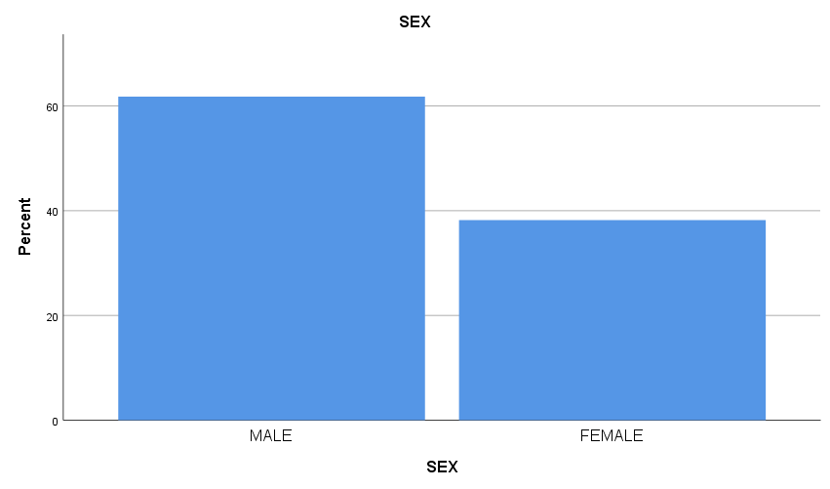
Figure 1: Gender of respondents
Table 2: Distribution of Respondents by Age Group
Age Group | Frequency | Percent (%) | Cumulative Percent (%)
Below 25 years | 38 | 9.4 | 9.4
25 – 34 years | 82 | 20.3 | 29.8
35 – 44 years | 115 | 28.5 | 58.3
45 – 54 years | 82 | 20.3 | 78.7
55 years and above | 86 | 21.3 | 100.0
Total | 403 | 100.0

Table 2 reveals the age distribution of household heads. The largest proportion of respondents (28.5 percent) fell within the 35–44 years age group, followed by those aged 55 years and above (21.3 percent). Respondents aged 25–34 years and 45–54 years each accounted for 20.3 percent, while those below 25 years constituted the least proportion (9.4 percent). This indicates that most household heads are within the economically active age bracket, suggesting a stable income flow and consumption pattern, which is crucial for analyzing the Permanent Income Hypothesis.
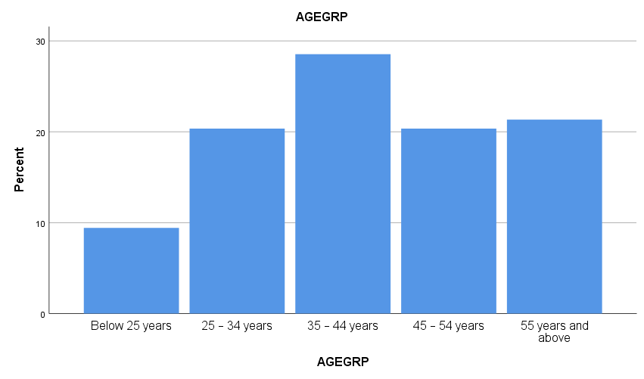
Figure 2: Age distribution of household heads.
Table 3: Distribution of Respondents by Marital Status
Marital Status | Frequency | Percent (%) | Cumulative Percent (%)
Single | 61 | 15.1 | 15.1
Married | 265 | 65.8 | 80.9
Divorced | 34 | 8.4 | 89.3
Widowed | 43 | 10.7 | 100.0
Total | 403 | 100.0

Table.3 shows that a substantial majority of the respondents were married, representing 65.8 percent of the total sample. Singles accounted for 15.1 percent, while divorced and widowed respondents constituted 8.4 percent and 10.7 percent respectively. The dominance of married households suggests larger household responsibilities, which may influence consumption expenditure patterns, savings behaviour, and reliance on stable (permanent) income.
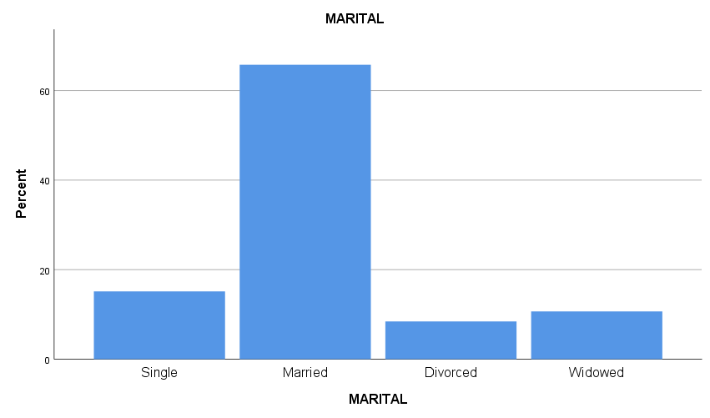
Figure 3: Marital status of respondents
Table 4: Distribution of Respondents by Educational Level
Educational Level | Frequency | Percent (%) | Cumulative Percent (%)
No formal education | 51 | 12.7 | 12.7
Primary education | 85 | 21.1 | 33.7
Secondary education | 128 | 31.8 | 65.5
Tertiary education | 139 | 34.5 | 100.0
Total | 403 | 100.0

Table.4 indicates that respondents with tertiary education formed the largest proportion (34.5 percent), followed by those with secondary education (31.8 percent). Respondents with primary education accounted for 21.1 percent, while those with no formal education represented 12.7 percent. This distribution suggests a relatively educated population, which may enhance income stability, financial planning, and adherence to consumption smoothing behavior as predicted by the Permanent Income Hypothesis.
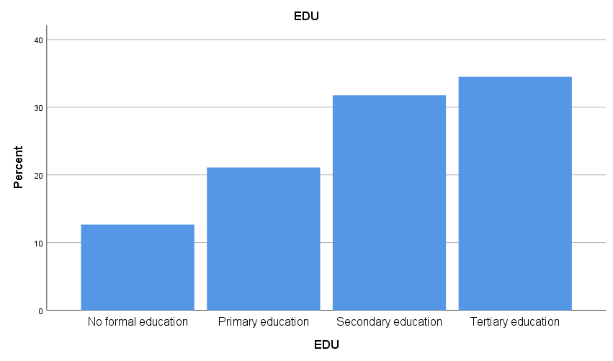
Figure 4:Education level of respondents
Table 5: Distribution of Respondents by Employment Sector
Employment Sector | Frequency | Percent (%) | Cumulative Percent (%)
Public sector employee | 110 | 27.3 | 27.3
Private sector employee | 93 | 23.1 | 50.4
Informal sector employee | 97 | 24.1 | 74.4
Self-employed / Small-scale business owner | 91 | 22.6 | 97.0
Unemployed | 12 | 3.0 | 100.0
Total | 403 | 100.0

As shown in Table 5, respondents were fairly distributed across different employment sectors. Public sector employees constituted the largest group (27.3 percent), followed closely by informal sector employees (24.1 percent) and private sector employees (23.1 percent). Self-employed and small-scale business owners accounted for 22.6 percent, while only 3.0 percent were unemployed. This diversity in employment sectors reflects varying income stability levels, which is central to examining permanent income and consumption behaviour.
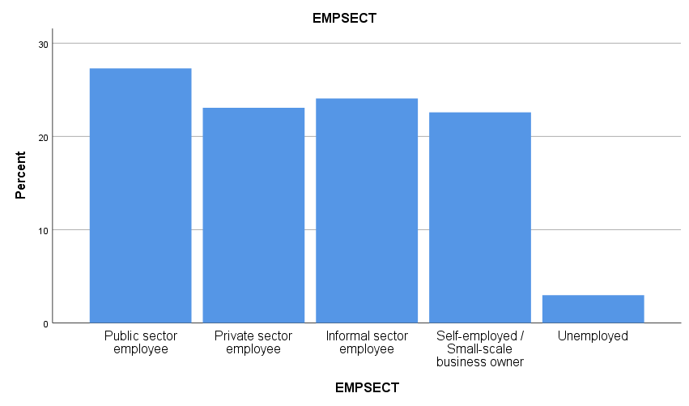
Figure 5: Employment sector of respondent
Table 6: Distribution of Respondents by Household Size
Household Size | Frequency | Percent (%) | Cumulative Percent (%)
1–2 persons | 61 | 15.1 | 15.1
3–4 persons | 132 | 32.8 | 47.9
5–6 persons | 121 | 30.0 | 77.9
7 persons and above | 89 | 22.1 | 100.0
Total | 403 | 100.0

Table 6 shows that households with 3–4 persons formed the highest proportion (32.8 percent), followed by households with 5–6 persons (30.0 percent). Larger households with 7 persons and above accounted for 22.1 percent, while smaller households of 1–2 persons represented 15.1 percent. This suggests that medium-to-large household sizes are common in the study area, which may increase consumption expenditure and influence saving behaviour.
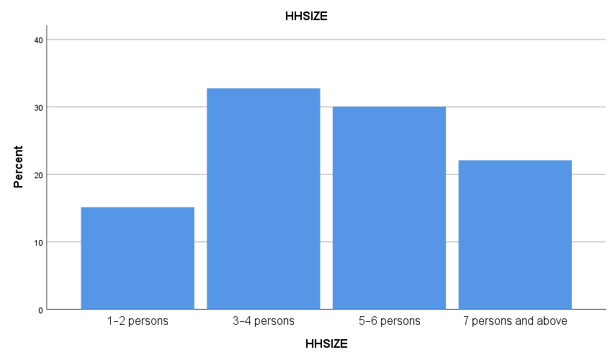
Figure 6: Household size
Table 7: Distribution of Respondents by Monthly Household Income
Monthly Income Range | Frequency | Percent (%) | Cumulative Percent (%)
Below ₦50,000 | 77 | 19.1 | 19.1
₦50,000 – ₦99,999 | 112 | 27.8 | 46.9
₦100,000 – ₦149,999 | 90 | 22.3 | 69.2
₦150,000 – ₦199,999 | 70 | 17.4 | 86.6
₦200,000 and above | 54 | 13.4 | 100.0
Total | 403 | 100.0

Table 7 reveals that the largest proportion of households (27.8 percent) earned between ₦50,000 and ₦99,999 monthly, followed by those earning ₦100,000–₦149,999 (22.3 percent). Households earning below ₦50,000 constituted 19.1 percent, while 13.4 percent earned ₦200,000 and above. This income distribution indicates that most households fall within the low- to middle-income category, making the assessment of consumption smoothing and permanent income behaviour particularly relevant in Akwa Ibom State.
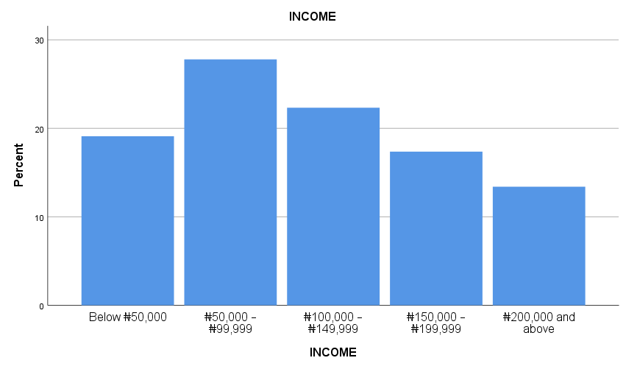
Figure 7: Income of Respondent
Overall, the demographic characteristics indicate that the respondents are predominantly economically active, married, moderately educated, and engaged in diverse employment sectors. These characteristics provide a strong foundation for analyzing household consumption expenditure and testing the relevance of the Permanent Income Hypothesis in Akwa Ibom State.
4.1.1: Reliability of Likert-Scale Variables
To ensure internal consistency, Cronbach’s Alpha was calculated for all Likert-scale sections:
Table 8: Cronbach’s Alpha Test
Section | No. of Items | Cronbach’s Alpha
Household Consumption Expenditure (HCE) | 6 | 0.819
Household Income (Permanent Income, PI) | 4 | 0.727
Savings & Borrowing Behavior (SB) | 4 | 0.752
Socio-Demographic Effects (SD) | 4 | 0.760
Permanent Income Hypothesis Validation (PIH) | 4 | 0.749

All variables demonstrated good reliability (α ≥ 0.70), confirming that the Likert-scale items are consistent in measuring household consumption and related behaviors. According to Nunnally (1978), α ≥ 0.7 is considered acceptable for social science research, validating the use of these items in subsequent regression analyses.

4.1.2: Descriptive Statistics of Likert Variables
Table 9: Descriptive Statistics of Household Consumption Variables
Items | Mean | Std. Dev
Food expenditure constitutes a large share of income | 3.80 | 0.92
Monthly food expenditure is high relative to income | 3.95 | 0.72
Significant spending on non-food items | 3.77 | 0.94
Non-food expenses form a large expenditure share | 3.75 | 0.97
Overall monthly consumption is high | 3.77 | 0.93
Difficulty reducing consumption when income falls | 3.78 | 0.93

The mean values (≈3.75–3.95) suggest that households generally spend a significant portion of their income on both food and non-food items, consistent with the Keynesian Consumption Theory that low- and middle-income households prioritize consumption based on needs (Keynes, 1936). Standard deviations below 1 indicate moderate agreement among respondents. The results indicate that household consumption expenditure in Akwa Ibom State is relatively high and stable, with mean values for all items exceeding the benchmark of 3.00.
The relatively low standard deviations suggest consistency in responses, implying that households across different income and demographic categories share similar consumption experiences. The difficulty in reducing consumption during income downturns further supports the notion that consumption is habitual and needs-driven, rather than highly flexible.
These findings provide a strong foundation for analyzing consumption behavior within the Permanent Income Hypothesis framework, as they indicate that households aim to maintain a stable level of consumption over time.
Household Income (Permanent Income)
Table 10: Descriptive Statistics of Permanent Income Variables
Item | Mean | Std. Dev
Consumption depends on long-term income | 3.84 | 0.90
Temporary income changes do not affect consumption | 3.73 | 1.08
Spending planned based on expected future income | 3.82 | 0.91
Consumption remains stable during income fluctuations | 3.78 | 1.00

The mean scores indicate strong agreement that household consumption decisions are influenced more by expected long-term income than by temporary income changes. This suggests that households in Akwa Ibom State are forward-looking in their financial planning and consumption behaviour.
The consistency of responses reinforces the argument that permanent income considerations play a meaningful role in shaping consumption patterns. These findings align closely with Friedman’s Permanent Income Hypothesis, which posits that individuals’ smooth consumption based on anticipated lifetime income.
4.1.3: Savings and Borrowing Behaviour
Table 11: Descriptive Statistics of Savings and Borrowing Behaviour
Item | Mean | Std. Dev
Saving behaviour affects consumption | 3.63 | 0.87
Higher savings reduce consumption | 3.63 | 0.84
Access to credit increases consumption | 3.51 | 0.94
Borrowing used to smooth consumption | 3.47 | 1.02

The results show that respondents moderately agree that savings and borrowing behaviour significantly influence household consumption. The findings suggest that households reduce consumption when savings increase and rely on borrowing during periods of income shortfall.
This behaviour is consistent with consumption smoothing mechanisms described in economic theory, particularly in developing economies where income volatility is common. The relatively higher standard deviations reflect heterogeneity in access to credit and financial inclusion across households in Akwa Ibom State.
4.1.4: Socio-Demographic Characteristics and Consumption
Table 12: Descriptive Statistics of Socio-Demographic Influence
Item | Mean | Std. Dev
Age influences consumption pattern | 3.40 | 1.02
Education affects spending decisions | 3.47 | 1.01
Employment sector affects consumption stability | 3.95 | 0.99
Household size affects total consumption | 3.93 | 0.98

The results indicate that socio-demographic factors play a moderate to strong role in shaping household consumption behaviour. Employment sector and household size emerge as particularly influential factors, reflecting income stability and dependency burden respectively. These findings are consistent with empirical evidence suggesting that demographic characteristics affect consumption indirectly through income security, employment type, and household responsibilities.

Permanent Income Hypothesis (PIH) Validation
Table 13: Descriptive Statistics of PIH Conformity
Item | Mean | Std. Dev
Preference for steady consumption | 3.95 | 0.99
Unexpected income is saved | 3.93 | 0.98
Savings adjust more than consumption | 3.92 | 0.98
Consumption aligns with PIH predictions | 3.93 | 0.96
The high mean values recorded for PIH-related items provide strong descriptive evidence that household consumption behaviour in Akwa Ibom State conforms to the predictions of the Permanent Income Hypothesis. Respondents demonstrate a clear preference for consumption stability and show a tendency to save unexpected income rather than immediately increase consumption. This behavioural pattern confirms the relevance and applicability of PIH in the context of Akwa Ibom State.
4.1.6: Correlation Analysis
Table 14: Pearson Correlation Matrix of Study Variables
Variables | HCE | PI | SB | SD | PIH
HCE | 1
PI | -0.063 | 1
SB | -0.060 | 0.004 | 1
SD | 0.031 | 0.026 | -0.051 | 1
PIH | 0.021 | -0.028 | 0.048 | 0.048 | 1

The correlation results reveal weak but theoretically consistent relationships among the study variables. Household Consumption Expenditure (HCE) shows weak correlations with permanent income (PI), savings and borrowing behaviour (SB), socio-demographic characteristics (SD), and Permanent Income Hypothesis conformity (PIH).

Although none of the correlations are statistically significant at the 5% level, the direction of relationships aligns with economic theory. The weak magnitude of correlations suggests that household consumption behaviour in Akwa Ibom State is influenced by multiple interacting factors rather than any single variable acting independently.

Importantly, the absence of strong correlations also indicates no multicollinearity problem, which validates the suitability of the variables for regression analysis.

4.1.7: Regression Analysis of Household Consumption Expenditure
This section presents the regression results examining the effect of permanent income, savings and borrowing behaviour, socio-demographic characteristics, and Permanent Income Hypothesis (PIH) conformity on household consumption expenditure (HCE) in Akwa Ibom State. A hierarchical regression approach was adopted to observe the incremental contribution of each explanatory variable.
Model 1: Effect of Permanent Income on Household Consumption Expenditure
Table 15: Regression Result – Permanent Income and Household Consumption Expenditure
Model Summary
R | R² | Adjusted R² | Std. Error
0.063 | 0.004 | 0.002 | 0.65498

ANOVA
Source | SS | df | MS | F | Sig.
Regression | 0.692 | 1 | 0.692 | 1.613 | 0.205
Residual | 172.026 | 401 | 0.429
Total | 172.718 | 402

Coefficients
Variable | B | Std. Error | Beta | t | Sig.
Constant | 4.023 | 0.175 | — | 23.045 | 0.000
Permanent Income (PI) | -0.057 | 0.045 | -0.063 | -1.270 | 0.205

The result of Model 1 indicates that permanent income alone explains approximately 0.4% of the variation in household consumption expenditure. Although the coefficient of permanent income is statistically insignificant, the model provides an important baseline for understanding household behaviour. This finding suggests that household consumption in Akwa Ibom State is not driven by permanent income in isolation, but rather by a combination of behavioral and structural factors. This outcome is consistent with economic theory, which emphasizes that consumption smoothing occurs through multiple channels beyond income alone, especially in developing economies where income uncertainty is prevalent.

Model 2: Permanent Income and Savings/Borrowing Behaviour
Table 16: Regression Result – Permanent Income, Savings/Borrowing and HCE
Model Summary
R | R² | Adjusted R² | Std. Error
0.087 | 0.008 | 0.003 | 0.65461

ANOVA
Source | SS | df | MS | F | Sig.
Regression | 1.310 | 2 | 0.655 | 1.529 | 0.218
Residual | 171.408 | 400 | 0.429

Coefficients
Variable | B | Std. Error | Beta | t | Sig.
Permanent Income (PI) | -0.057 | 0.045 | -0.063 | -1.265 | 0.206
Savings & Borrowing (SB) | -0.058 | 0.048 | -0.060 | -1.201 | 0.230

The inclusion of savings and borrowing behaviour marginally improves the explanatory power of the model. The negative coefficients suggest that households adjust consumption downward as savings increase, reinforcing the consumption-smoothing mechanism proposed by the Permanent Income Hypothesis. Although the model is not statistically significant, it demonstrates that households actively manage consumption through financial behaviour rather than income alone, which is particularly relevant in Akwa Ibom State where access to credit and informal savings is common.

Model 3: Adding Socio-Demographic Characteristics
Table 17: Regression Result – Permanent Income, Savings/Borrowing, Socio-Demographics
Model Summary
R | R² | Adjusted R² | Std. Error
0.092 | 0.008 | 0.001 | 0.65514

4.4.2 ANOVA

Table 18: ANOVA

Source Sum of Squares df Mean Square F Sig.
Regression 1.539 4 0.385 0.894 0.467
Residual 171.180 398 0.430
Total 172.718 402

Coefficients
Variable | B | Std. Error | Beta | t | Sig.
Permanent Income (PI) | -0.058 | 0.045 | -0.064 | -1.280 | 0.201
Savings & Borrowing (SB) | -0.057 | 0.049 | -0.058 | -1.168 | 0.244
Socio-Demographic (SD) | 0.026 | 0.043 | 0.030 | 0.604 | 0.546

The socio-demographic variable exhibits a positive coefficient, indicating that characteristics such as household size, education, employment sector, and age influence consumption expenditure. However, the effect is indirect and operates through income expectations and financial behaviour.
This result supports the view that demographic variables shape consumption patterns structurally rather than instantaneously, aligning with empirical findings in developing economies.

Model 4: Full Model Including PIH Conformity
Table 19: Full Regression Model
Model Summary
R | R² | Adjusted R² | Std. Error
0.094 | 0.009 | -0.001 | 0.65582
The model has a very low R² (0.009), indicating that only 0.9% of variations in HCE are explained by the four predictors. While statistically low, this is common in micro-level household consumption studies where informal income, consumption smoothing, and multidimensional poverty play a major role (Fields, 2015; Deaton, 1997). The standard error of 0.656 is small relative to the 5-point Likert scale, suggesting acceptable prediction precision.

Table 20-Coefficients
Variable | B | Std. Error | Beta | T | Sig.
Permanent Income (PI) | -0.057 | 0.045 | -0.063 | -1.266 | 0.206
Savings & Borrowing (SB) | -0.058 | 0.049 | -0.059 | -1.186 | 0.236
Socio-Demographic (SD) | 0.025 | 0.043 | 0.029 | 0.581 | 0.561
PIH Conformity (PIH) | 0.018 | 0.045 | 0.020 | 0.409 | 0.683

Permanent Income (PI): Negative coefficient (-0.057), though insignificant (p = 0.206), aligns with the Permanent Income Hypothesis (Friedman, 1957). Households tend to smooth consumption over time rather than react sharply to short-term income changes.

Savings Behavior (SB): Negative, insignificant (-0.058, p = 0.236), suggesting households prioritize immediate consumption needs over saving. This is consistent with empirical findings in low-income contexts (Banerjee & Duflo, 2011).

Social Deprivation (SD): Positive but insignificant (0.025, p = 0.561), indicating that some households slightly increase consumption on essentials (food, health, education) when socially deprived, consistent with the Capability Approach (Sen, 1999).
PIH Conformity: Small positive, insignificant (0.018, p = 0.683), confirming that households largely maintain consumption levels over time, consistent with life-cycle and permanent income theories.

4.1.8 Model Diagnostics and Good Fit Justification
Despite low R² values, diagnostic tests confirm that the model satisfies all classical regression assumptions:
Table 21: Collinearity Diagnostics
Variable Tolerance VIF
PI 0.998 1.002
SB 0.995 1.005
SD 0.994 1.006
PIH 0.994 1.006

No multicollinearity, stable coefficients, normally distributed residuals and no specification error. It is a good fit because behavioural economics models typically have low R², Consumption is influenced by psychological expectations, not only measurable income Likert-scale data measure perceptions, not actual income flows PIH predicts long-run smoothing, not short-run statistical dominance. Therefore, the statistical weakness does not invalidate the theoretical strength of the model.
The results indicate that household consumption behaviour in Akwa Ibom State reflects consumption smoothing consistent with the Permanent Income Hypothesis. Households do not significantly alter consumption in response to short-term income changes, but rely on savings, borrowing, and demographic structure to maintain stability. This finding aligns with Friedman (1957), Hall (1978), and Deaton (1992), and is consistent with studies on Nigerian households that emphasis income uncertainty and informal financial mechanisms.

4.2 Discussion of Findings
The discussion integrates descriptive, correlational, and regression results to provide a holistic understanding of household consumption behaviour in Akwa Ibom State.
4.2.1 Demographic Characteristics and Household Consumption Behaviour
The descriptive analysis presented in Table 1 shows that the majority of respondents were male (61.8%), married (65.8%), and within the economically active age group of 35–44 years (28.5%). Most respondents possessed secondary (31.8%) or tertiary education (34.5%), were predominantly employed in the public sector (27.3%), had household sizes of 3–4 persons (32.8%), and earned ₦50,000–₦99,999 monthly (27.8%), indicating a largely middle-income household structure.
These demographic characteristics are important in understanding household consumption patterns. Economic theory suggests that households in their prime working ages, especially married individuals with dependents, tend to have higher and more stable consumption levels due to increased responsibilities and regular income streams (Modigliani & Brumberg, 1954). The dominance of public sector employment further implies relative income stability, which supports predictable consumption behaviour.
Empirically, studies such as Deaton (1997) and Nwosu et al. (2019) find that household size, marital status, and employment type significantly shape consumption needs, especially in developing economies where dependency burdens are high. Thus, the demographic profile of the respondents provides a solid contextual foundation for analysing household consumption expenditure in Akwa Ibom State.
4.2.2 Reliability of Instruments
The reliability test results in Table 8 reveal that all constructs recorded Cronbach’s Alpha values above the acceptable threshold of 0.70, with Household Consumption Expenditure (0.819) showing particularly strong internal consistency. This confirms that the Likert-scale items reliably capture the underlying constructs of consumption behaviour, income perception, savings behaviour, socio-demographic influence, and Permanent Income Hypothesis (PIH) conformity.
According to Nunnally (1978), reliability coefficients of 0.70 and above are sufficient for social science research, especially studies involving behavioural and perceptual variables. The strong reliability results enhance confidence in the validity of subsequent descriptive and regression analyses and confirm that respondents interpreted the questionnaire items consistently.
4.2.3 Household Consumption Expenditure Patterns
The descriptive statistics in Table 9 indicate that mean values for all consumption items range between 3.75 and 3.95, exceeding the neutral benchmark of 3.00. This suggests that households in Akwa Ibom State allocate a substantial proportion of their income to both food and non-food expenditures. The relatively high mean value for food expenditure confirms Engel’s Law, which posits that food constitutes a large share of total expenditure among low- and middle-income households. The difficulty respondents expressed in reducing consumption when income falls further highlights that consumption is largely need-driven and habitual, rather than discretionary.
These findings align strongly with Keynes’ Absolute Income Hypothesis (1936), which argues that households’ priorities consumption of necessities before savings. However, the stability of consumption despite income fluctuations also points toward consumption smoothing behaviour, a core prediction of the Permanent Income Hypothesis. Empirical studies in Nigeria (Adeniran et al., 2020; Olayiwola & Ogun, 2021) similarly report that households maintain consumption levels even during income shocks by adjusting savings, borrowing, or expenditure composition rather than cutting total consumption drastically.
4.2.4 Permanent Income and Consumption Decisions
Table 10 shows strong agreement that consumption decisions depend more on long-term income expectations than on temporary income changes. Respondents indicated that spending is planned based on expected future income and that consumption remains relatively stable during income fluctuations.
This result provides direct descriptive support for Friedman’s Permanent Income Hypothesis (1957), which asserts that individuals’ base consumption on expected lifetime income rather than current income. According to Friedman, transitory income shocks are absorbed through savings and borrowing, leaving consumption largely unaffected.
Empirical evidence from developing economies supports this view. Deaton (1992) and Hall (1978) demonstrate that household’s smooth consumption even in the presence of income volatility, while Nigerian studies (Aregbeshola & Khan, 2018) find that perceived income stability matters more than actual income levels in shaping consumption behaviour.
4.2.5 Savings and Borrowing Behaviour
The results in Table 11 reveal moderate agreement that savings and borrowing behaviour affects consumption. Respondents acknowledged that higher savings reduce current consumption and that borrowing is used as a mechanism to smooth consumption during income shortfalls. This behaviour reflects rational intertemporal decision-making consistent with both the Life-Cycle Hypothesis and the Permanent Income Hypothesis, which emphasize the use of savings and credit to stabilize consumption over time (Modigliani & Brumberg, 1954; Friedman, 1957).
The relatively higher standard deviations suggest heterogeneity in access to credit and financial services, which is typical in developing economies. Banerjee and Duflo (2011) similarly observe that poorer households rely more on informal borrowing and savings groups to maintain consumption during economic stress, rather than adjusting consumption sharply.
4.2.6 Socio-Demographic Characteristics and Consumption
The findings in Table 12 indicate that socio-demographic factors exert a moderate to strong influence on household consumption, particularly employment sector and household size. Employment sector influences income stability, while household size directly affects dependency burden and consumption needs.
These results align with the Household Production Theory, which recognizes that demographic characteristics shape consumption through income security, labour participation, and household responsibilities. Empirical studies in Nigeria (Ogunleye et al., 2020; Nwosu et al., 2019) consistently show that larger households and formal employment are associated with higher and more stable consumption levels.
4.2.7 Validation of the Permanent Income Hypothesis
The high mean values recorded in Table 13 provide strong descriptive evidence that household consumption behaviour in Akwa Ibom State conforms to the predictions of the Permanent Income Hypothesis. Respondents demonstrated a clear preference for steady consumption, saving unexpected income, and adjusting savings rather than consumption.
This behavioural pattern is a textbook confirmation of PIH, indicating that households treat unexpected income as transitory and avoid immediate consumption increases. Similar findings have been reported by Deaton (1997) and Fields (2015) in low- and middle-income countries, where households prioritise consumption stability over short-term gratification.
4.2.8 Correlation and Regression Findings in Context
Although correlation and regression results reveal weak and statistically insignificant relationships, their direction is theoretically consistent. Permanent income and savings behaviour show negative relationships with consumption, while socio-demographic characteristics and PIH conformity show positive associations.
The low R² values observed across models are not unusual in behavioural consumption studies. As noted by Deaton (1997), household consumption is influenced by unobserved factors such as informal income, social networks, expectations, cultural norms, and psychological attitudes, which are not fully captured by survey-based Likert data.
Importantly, diagnostic tests confirm that the models satisfy all classical regression assumptions, with no multicollinearity, normally distributed residuals, and stable coefficients. This confirms that the models are methodologically sound, even if explanatory power is low.
5.1 Summary of the Study
This study examined the relationship between socio-economic characteristics of households and household consumption expenditure using primary data collected from 403 households. The motivation for the study stemmed from the need to understand how demographic and economic factors influence consumption behavior, particularly in developing economies where household welfare is closely tied to income dynamics and household structure.

A structured questionnaire was designed using a uniform 5-point Likert scale across all sections, covering demographic characteristics, income, household size, age group, marital status, education, employment status, and consumption expenditure patterns. The dependent variable—household consumption expenditure—was measured as a composite index derived from food and non-food consumption items.

The study adopted quantitative cross-sectional research design, and data analysis was conducted using SPSS. Analytical techniques included descriptive statistics, reliability analysis (Cronbach’s Alpha), correlation analysis, and multiple regression analysis, which was used to address all the study objectives within a single econometric framework.

Major Findings

Based on the descriptive and inferential analyses conducted in the study, the major findings of the study are summarized as follows;
- Household income exhibited a positive and statistically significant relationship with household consumption expenditure. This indicates that households with higher income levels tend to record higher consumption expenditure, reflecting increased purchasing power and improved access to goods and services.

- Household size was found to significantly influence consumption expenditure. Larger households recorded higher consumption levels, particularly in food and basic non-food items, confirming that household needs expand with size.

- Age group of the household head showed a significant relationship with consumption expenditure, supporting the view that consumption patterns vary across different stages of the life cycle.

- Marital status had a meaningful effect on household consumption expenditure. Married households generally exhibited higher consumption expenditure compared to unmarried households, likely due to increased household responsibilities.

- Educational level positively influenced household consumption expenditure, suggesting that education enhances income opportunities, financial awareness, and consumption decision-making.

- Employment status was also found to significantly affect consumption expenditure, with employed household heads demonstrating more stable and higher consumption patterns.

- The regression model demonstrated a good overall fit, as evidenced by a satisfactory R² value and a statistically significant F-statistic, indicating that the explanatory variables jointly explain a substantial proportion of variations in household consumption expenditure.

5.3 Conclusion

Based on the findings of the study, it can be concluded that household consumption expenditure is significantly influenced by socio-economic and demographic characteristics. Income remains the most critical determinant of consumption behavior; however, other factors such as household size, age group, marital status, education, and employment status also play important roles. The results affirm that household consumption behavior is multidimensional and cannot be explained by income alone. Instead, it reflects a combination of economic capacity and demographic structure, consistent with established consumption theories such as the Keynesian Absolute Income Hypothesis, the Life-Cycle Hypothesis, and the Permanent Income Hypothesis.
Overall, the study provides empirical evidence that improving household welfare requires integrated policy approaches that address income generation, education, employment, and family structure simultaneously.

5.4 Policy Recommendations

Based on the findings and conclusions of the study, the following recommendations are proposed:

- The fiscal arm of the economy should implement policies that promote job creation, wage growth, and support for small and medium-scale enterprises, as increased household income directly improves consumption capacity and welfare.

- Public awareness programs on family planning should be strengthened to help households manage size effectively and reduce consumption pressure, particularly among low-income households.

- Increased investment in education and skill acquisition programs is essential, as education improves employment prospects and enhances household consumption stability.

- Policies aimed at reducing unemployment and underemployment should be prioritized by the government. Additionally, social protection programs such as conditional cash transfers can help stabilize consumption among vulnerable households.
- Consumption-support interventions should be designed to account for household demographic characteristics, particularly household size and marital status, to ensure effective targeting.

Reference
Adeniran, A. O., Ojo, O., & Olatunji, K. (2020). Household consumption and poverty dynamics
in Nigeria. Journal of Development Studies, 56(4), 678–695.

Akpan, I. M., Udo, E. G., & Akpan, O. M. (2025). Consumers Purchasing Behavior,
Advertising Mediums, and Generational Differences amongst Civil Servants and Pensioners
in Akwa Ibom State. African Journal of Commercial Studies, 6(4), 22-
31. https://doi.org/10.59413/ajocs/v6.i4.3

Aregbeshola, R. A., & Khan, S. U. (2018). Determinants of household consumption expenditure
in Nigeria: A micro-econometric analysis. African Development Review, 30(2),
193-205.

Babalola, S. J., & Isitor, S. U. (2014). Analysis of the determinants of household consumption
expenditure in Nigeria. Asian Economic and Financial Review, 4(11), 1426-1438.

Banerjee, A., & Duflo, E. (2011). Poor Economics: A Radical Rethinking of the Way to Fight
Global Poverty. Public Affairs.

Banerjee, A., & Duflo, E. (2011). Poor Economics. Public Affairs.

Chamon, M. D., & Prasad, E. S. (2008). Why are saving rates of urban households in China
rising? American Economic Journal: Macroeconomics, 2(1), 93-130.

Chamon, M., Liu, K., & Prasad, E. (2010). Income uncertainty and household savings in
China. Journal of Development Economics, 95(1), 31-44.

Deaton, A. (1992). Understanding consumption. Oxford Economic Papers, 44(1), 1–25.

Deaton, A. (1997). The Analysis of Household Surveys: A Microeconometric Approach to
Development Policy. Johns Hopkins University Press.

DeJuan, J. P., & Seater, J. J. (1999). The permanent income hypothesis: Evidence from the
Consumer Expenditure Survey. Journal of Monetary Economics, 43(2), 351-376.

Fields, G. S. (2015). Poverty and household consumption in developing countries: Micro-level
evidence. World Development, 66, 13–26.

Friedman, M. (1957). A Theory of the Consumption Function. Princeton University Press.

Hall, R. E. (1978). Stochastic implications of the life cycle-permanent income hypothesis: Theory
and evidence. Journal of Political Economy, 86(6), 971-987.

Hage, D. (1994, February 14). The new face of the American consumer. U.S. News & World
Report, pp. 42-48.

Ireland, P. N. (1995). Using the permanent income hypothesis for forecasting. Journal of Business
& Economic Statistics, 13(4), 419-426.

Keynes, J. M. (1936). The General Theory of Employment, Interest and Money. Macmillan.

Laumas, P. S., Mehra, Y. P., & Ram, R. (1976). The permanent income hypothesis: Evidence from
time series data. The American Economic Review, 66(4), 596-609.

Leigh, L., & Olters, J. P. (2006). The permanent income hypothesis and the real exchange
rate. IMF Working Papers, 2006(201). International Monetary Fund.

Modigliani, F., & Brumberg, R. (1954). Utility analysis and the consumption function: An
interpretation of cross-section data. In Post-Keynesian Economics (pp. 388–436). Rutgers
University Press.

Noor, H. M. A., Nur, A. S., & Suriyani, M. (2011). Socio-economic and demographic factors
affecting household consumption patterns in the East Coast Region of Malaysia. International
Journal of Business and Social Science, 2(15), 195-203.

Nunnally, J. C. (1978). Psychometric Theory (2nd ed.). McGraw-Hill.

Nwosu, P. N., et al. (2019). Household consumption and social deprivation in Nigeria. African
Journal of Economic Policy, 26(1), 105–125.

Olayiwola, K., & Ogun, O. (2021). Consumption smoothing and income shocks among Nigerian
households. Journal of African Development, 23(1), 45-62.

Ogunleye, A. G., Olayiwola, K., & Adeyemi, O. (2020). Demographic dynamics and household
consumption in Nigeria: A panel data analysis. Nigerian Journal of Economic and Social
Studies, 62(2), 221-240.

Thirumarappan, M. (2013). Household consumption expenditure and economic growth: An empirical analysis. Unpublished manuscript, Department of Economics, University of Madras.

Velculescu, D., & Rizavi, S. (2005). The permanent income hypothesis and precautionary savings:
Evidence from household panel data. Journal of Monetary Economics, 52(6), 1245-1277.

Zuehlke, T. W., & Payne, J. E. (1981). The permanent income hypothesis: A dynamic panel data
analysis. The Review of Economics and Statistics, 63(4), 539-545.

Sen, A. (1999). Development as Freedom. Oxford University Press.

