Original Research Article

Forecasting Wheat Prices in the United States Using an ARIMA Model

.
ABSTRACT

Aims: This study aims to forecast future wheat prices in the United States using time-series ARIMA modeling to support farmers and traders in decision-making. The forecasts are intended to guide sowing, land allocation, and marketing decisions by providing price expectations ahead of planting seasons
Study design: Econometric time-series forecasting study using an Autoregressive Integrated Moving Average (ARIMA) model (Box–Jenkins methodology).
Place and Duration of Study: United States; the analysis covers annual wheat price data from 1991 to 2022.
Methodology: Yearly wheat price data were analyzed following the Box–Jenkins ARIMA framework. Stationarity was evaluated with graphical analysis and unit root tests, and the series was differenced to achieve stationarity. Autocorrelation and partial autocorrelation functions (ACF, PACF) guided model identification. Competing ARIMA specifications were assessed based on log-likelihood, SigmaSQ (error variance), Akaike and Bayesian information criteria (AIC, BIC), and 95% confidence intervals. Model parameters were estimated using STATA software.
Results: The ARIMA (2,2,2) model provided the best fit for the data. Forecasts indicate a steady upward trend in U.S. wheat prices from 2024 through 2032. Predicted prices rise from 322.39 USD/ton in 2024 to 338.46 USD/ton in 2025 (+0.5% from 2024), reaching 455.44 USD/ton by 2032 (approximately 41% higher than the 2024 value).
Conclusion: Wheat prices in the United States are projected to increase consistently over the next decade. These projections offer valuable insights for farmers and distributors, aiding in informed sowing, land allocation, and marketing strategies.

Keywords: ARIMA; Box–Jenkins methodology; Wheat price forecasting; Time series analysis; Autocorrelation function; United States.

1. INTRODUCTION

Wheat is the second most extensively cultivated grain globally in acreage and the second largest overall production volume. In the marketing year of 2023/24, worldwide wheat production reached around 785 million metric tons. According to Statista (2024), there was a reduction of almost four million tons compared to the previous year. Global wheat reserves will rise to around 281.7 million metric tons by 2023/2024.
China, the most significant wheat producer globally, has produced about 2.4 billion tons of wheat in the past two decades, accounting for around 17% of the total global production, according to Rastogi (2022). The European Union is the second-largest wheat-producing region. The estimate predicted that the region's wheat production will exceed 137.5 million metric tons by 2032, representing around 20% of global wheat production, according to Statista (2024).
In 2023, around 49.6 million wheat plants were cultivated, and 37.3 million acres of wheat were reaped in the United States. Most U.S. states participate in the country's wheat production, with North Dakota and Kansas, known as the 'Wheat State,' being the top producers. In 2021, Russia emerged as the leading global wheat exporter, with exports valued at over $7.3 billion. A significant reliance on wheat imports from Ukraine and Russia is observed in many developing countries; according to the World Population Review (2024), as of June 2022, Armenia and Mongolia entirely depended on Russia for their wheat supplies. Laos has a high reliance on wheat imports from Ukraine, accounting for more than 98 percent of its overall imports of these goods, according to US Wheat Associates (2024).
According to Statista (2024), wheat is a crucial basic food in significant quantities in a wide range of goods. Worldwide wheat consumption saw a recent decline, with a consumption of approximately 791 million metric tons during the marketing year of 2022/2023. China's wheat consumption was projected to reach approximately 153.5 million metric tons in 2023/24. In the past decade, the average annual per capita consumption of wheat worldwide consistently exceeded 66 kilos.
The International Grains Council's July report for 2022-23 predicts a global wheat production of 770 million tons, a decrease from the previous year's 781 million tons. According to World Grain, 195 million tons will be available for trade (2024).

1.1 International wheat markets
The United Nations Food and Agriculture Organization (FAO) states that most wheat production is concentrated in a few nations, and an even smaller number of countries are significant exporters. Table 1 shows the total output of wheat among the top wheat-producing countries and their % of global production.
Table 1: Top Wheat Producing Countries (2023/2024)
Market | % of Global Production | Total Production (2023/2024, Metric Tons)
China | 17% | 136.59 million
European Union | 17% | 134.15 million
India | 14% | 110.55 million
Russia | 12% | 91.5 million
United States | 6% | 49.31 million
Canada | 4% | 31.95 million
Pakistan | 4% | 28.2 million
Source: FAS-USDA from https://fas.usda.gov/data/production/commodity/0410000
The projected global wheat production for the 2023/24 season is expected to reach 784.9 million metric tons (MMT), representing an increase of 1.9 MMT compared to the last projections in December. Currently, global wheat demand stands at an unprecedented level of 796.4 MMT, surpassing global wheat production by 11.5 MMT, according to US Wheat Associates (2024).
Despite the shortage in supply, the January WASDE report indicated a 1.8 million metric ton increase in global ending stocks. The current estimate of 260.0 MMT is a 4% reduction compared to the previous year and is the lowest amount observed since 2015/16. Wheat stocks in crucial exporting countries currently stand at 58.7 million metric tons (MMT), better than earlier estimates but still lower than the 60.4 MMT recorded in the previous year. The latest rises were supported by ending stocks in the EU and Ukraine. The global wheat trade is projected to decline to 209.5 million metric tons (MMT) compared to 220.2 MMT in the 2022/23 period, according to US Wheat Associates (2024). Figure 1 shows global wheat production (MMT) and use from 14/15 to 23/24.

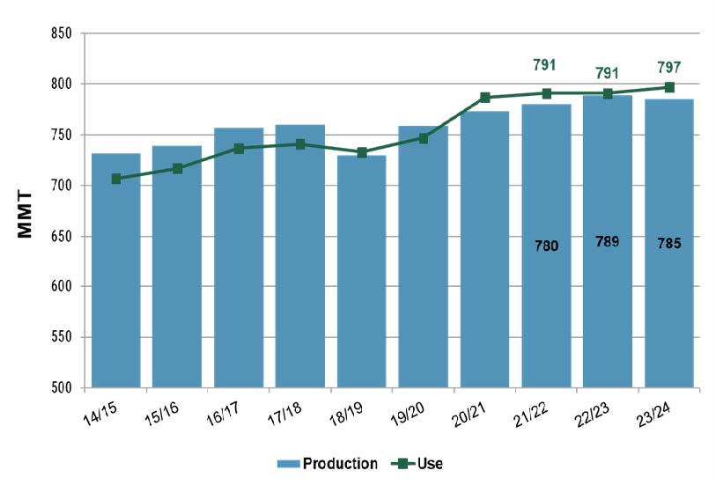
Figure 1: Global wheat production and use (Source: US Wheat Associates, 2024)
According to US Wheat Associates (2024), global consumption rose by 1.8 million metric tons (MMT) to 796.4 MMT, surpassing production by 11.5 MMT. This is the most significant difference between consumption and production since 2012/13. Figure 2 shows the wheat price (USD/Metric Ton) from March 2019 to February 2024, which indicates fluctuations in wheat prices over the long term.

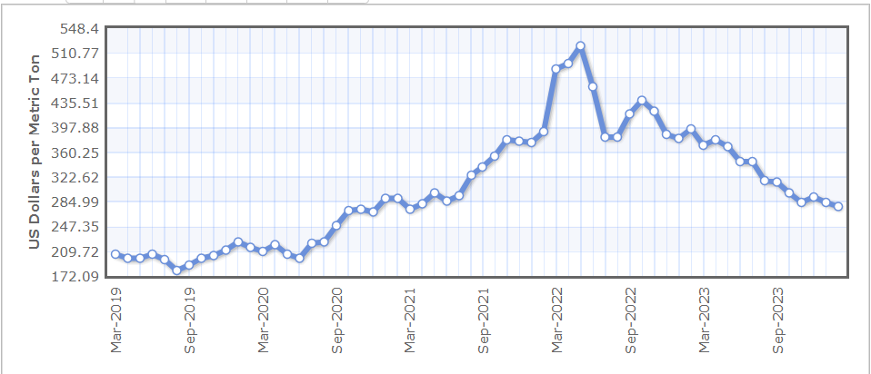
Figure 2: Wheat Price - US Dollars per Metric Ton (Mar 2019 - Feb 2024) (Source: Indexmundi, 2024)
1.2 USA wheat markets
While there has been an increase in the area, production, and productivity of wheat over the years, the price of grain is more prone to volatility due to market flaws. The table demonstrates a consistent decrease in the year-to-year fluctuations of wheat's area, production, and productivity in the United States. Although the area decreased in 2016, a considerable rise in production was attributed to higher productivity, according to Welch (2014).
An essential element of every market analysis for agricultural commodities is the projected production for the future year. Accurate assessments of the cultivated land area and crop productivity are crucial factors that significantly influence market dynamics. The 2024 March Prospective Plantings report indicated a decrease in the amount of land dedicated to growing wheat for the forthcoming season compared to the previous year. Nevertheless, other additional variables may influence the final production figures in 2024.
As of 2024, the current ratings for the national winter wheat crop condition are much higher than the previous year's average ratings. Improved crop condition ratings indicate a positive outlook for both an increase in the proportion of crops harvested and overall output. This is particularly evident in Kansas, the leading state in wheat production. In Kansas, the last instance of witnessing wheat ratings as excellent as the current ones was in 2016. Kansas achieved an unprecedented wheat yield of 57 bushels that year, setting a new record. Similarly, the overall wheat crop in the United States also reached a remarkable yield of 52.7 bushels. 88% of the planted acres were harvested that year. Remarkably, 2016 witnessed a historic achievement in producing U.S. grain sorghum, with Kansas leading as the top-producing state. The ultimate crop production for that particular year was 77.9 bushels per acre, with a harvesting efficiency of 93%, according to Welch (2014).
By international price patterns, the January World Agricultural Supply and Demand Estimates (WASDE) report projected that farm prices in the United States would be $7.20 per bushel, a decrease of 10 cents compared to the previous forecast. The January World Agricultural Supply and Demand Estimates (WASDE) report maintained the U.S. wheat output forecast at 49.3 million metric tons (MMT), which is the same as the December estimate and represents a 10% increase compared to the previous year (2022/23).
The U.S. export projections have risen to 19.7 million metric tons (MMT) from 19.07 MMT due to a sequence of significant wheat purchases made by China. The United States' ending stocks declined by 300,000 to 17.6 million metric tons (MMT). However, they are still 14% higher than last year. The projected growth of U.S. wheat production is expected to rise by 10% to reach 49.3 million metric tons (MMT), according to US Wheat Associates (Welch, 2014).
Table 2 shows the acreage (millions) and yield (bushels/acre) for the USA wheat market from 2014 to 2023, indicating the changes in wheat acreage over the years.
Table 2. Acreage (millions) and yield (bushels/acre) for U.S. wheat, 2014-2023

Years | 2014 | 2015 | 2016 | 2017 | 2018 | 2019 | 2020 | 2021 | 2022 | 2023
Prospective Plantings | 55.8 | 55.4 | 49.6 | 46.1 | 47.3 | 45.8 | 44.7 | 46.4 | 47.4 | 49.9
Final Acreage | 56.8 | 55.0 | 50.1 | 46.0 | 47.8 | 45.5 | 44.5 | 46.7 | 45.8 | 49.6
Difference | 1.0 | (0.4) | 0.5 | (0.1) | 0.5 | (0.3) | (0.3) | 0.3 | (1.6) | (0.3)
Harvested | 46.4 | 47.3 | 43.9 | 37.5 | 39.6 | 37.4 | 36.8 | 37.1 | 35.5 | 37.3
Percent Harvested | 82% | 86% | 88% | 82% | 83% | 82% | 83% | 79% | 78% | 75%
Average Yield | 43.7 | 43.6 | 52.7 | 46.3 | 47.6 | 51.7 | 49.7 | 44.3 | 46.5 | 48.6
Source: Southernagtoday. Prepared by Welch, (2014)
1.3 Objectives of the study
Wheat prices in the global market exhibit substantial fluctuations every month. The prices of wheat in the United States are influenced by global pricing because of the liberalized and open nature of food imports and exports. The procurement at MSP is limited to 20% of the total wheat crop. The remaining sales should be carried out in the public market, where they are subject to the influence of worldwide prices. Price forecasting is essential for decision-making, as it provides vital information to farmers in establishing the optimal allocation of land for wheat cultivation and helps traders decide the most opportune time to sell their products.

1.4 Limitation of the Forecast
Price forecasting requires understanding the causes or factors that influence price fluctuations. To make a price estimate, one must thoroughly understand these components and their significant impact on pricing. This study aims to determine, using statistical analysis, the factors that influence the price of wheat and the extent to which differences in these factors lead to changes in price.
Geographical emphasis
This research is confined to the geographical confines of the United States. Although insights from global wheat production may offer significant context, the main emphasis of this study is on comprehending the price of wheat (USD/ton) in the USA from 1992 to 2022, which will make a significant difference in the forecast wheat price.

Production of world wheat
Global wheat production is a crucial aspect that can impact the forecasted wheat price. This encompasses the current production quantity and the projected quantity that will be available shortly. Wheat is a relatively non-perishable commodity; thus, buyers and sellers often stockpile it in anticipation of potential changes in supply and price.
Climatic conditions
Climate variables, diseases, and insect pests influence crop or yield. It is important to additionally consider the time it takes for this crop to be sold and the potential for fluctuations in volume due to overall conditions impacting wheat production.
Carry-over from previous years
Carry-over from prior years is a significant supply element that can impact the price of wheat. It is crucial to consider this factor when forecasting the price of wheat. This encompasses the quantities of wheat held in terminal and rural elevators, the stocks on farms, and the supply in the form of flour.

Demand of wheat
The utilization of wheat as a source of sustenance for humans is the primary determining element. The level of consumption is contingent upon various factors, with the most crucial being the wages and spending power of all social strata, the prevailing practice of consuming specific wheat products, and the availability and costs of other options.
Correct statistical analysis
The availability of accurate statistical data on all these elements will significantly enhance the precision and satisfaction of analyzing prices. Initially, acquiring a precise statistical estimate of demand is exceedingly challenging, if not virtually unattainable. Demand is primarily an individual phenomenon subject to limitless fluctuation, just as human preferences, aversions, incomes, and caprices are.
Technological advances
Technological advances in wheat might increase wheat production in the future, ultimately affecting wheat prices. Technological improvements include hybrid varieties of wheat, drought-tolerant varieties, blast-tolerant varieties, and sustainable cultivation techniques that might increase grain yield, affecting the price.
Miscellaneous factors
The problem is compounded by the extensive scope within which these forces that determine prices have their influence. An analysis of wheat prices necessitates a global perspective. The reliability of the findings from a statistical study relies on the sufficiency and precision of the data employed. This leads to a study that relies on global data, which is gathered with various levels of precision, to be susceptible to an uncertain level of inaccuracy. Statistical data generally accurately represent past events and can be valuable for scientific and practical purposes. Farmers, speculators, millers, manufacturers, and retail dealers can benefit from conducting investigations based on this data, allowing them to make economic adjustments that align with future predictions.

2. REVIEW OF LITERATURE
Various studies have employed econometric models to forecast the consumer price index. Diverse econometric models are utilized to predict time series data. The mentioned methods include Moving Average (MA), Autoregressive (AR), Exponential Smoothing, Autoregressive Integrated Moving Average (ARIMA), Vector Autoregressive (VAR), Autoregressive Conditional Heteroscedasticity (ARCH), and Generalized Autoregressive Conditional Heteroscedasticity (GARCH) models conducted by Bhardwaj, (2014). The Autoregressive Integrated Moving Average (ARIMA) model is a commonly employed technique for predicting time series data.
The study conducted by Darekar (2018) determined that the ARIMA (0,1,0) model was a suitable match for the wheat monthly price series. Also, the ARIMA (0,1,1), (1,0,1), (1,0,1), (0,0,0), and (0,1,0) models were determined to be suitable for accurately predicting the prices of wheat in Uttar Pradesh Punjab, Haryana, Madhya Pradesh, and Rajasthan, respectively. The projected wheat prices closely matched the actual prices, demonstrating strong validity. The forecast indicates that market prices of wheat are expected to vary from Rs. 1,620 to 2,080 per quintal during the 2017-18 harvesting season.
According to Masood (2018), a varied pattern in wheat output within the specified period and the ARIMA (2,1,2) model was the most accurate in predicting wheat production based on near projections compared to the actual reported data. The projected wheat output for 2017-18, 2018-19, and 2019-2020 was estimated to be 26,824.3, 26,857.9, and 27,635.8 thousand tons, respectively.
According to Patowary (2017), the presence of a prominent spike in the partial autocorrelation function (PACF) at lag 1, along with an exponential decrease in the autocorrelation function (ACF) for the initial lags, indicates that an ARIMA (1, 0, 0) model was likely to be suitable for modeling the regression error series. The study projected wheat productivity had a consistent upward trend over the next decade, with an anticipated yield of 108380.66 MT in 2027.
In a study by Abdulla (2015), the values for the next ten years were predicted using the most appropriate model, ARIMA (0,2,1). The expected series deviated slightly from the original series, which indicated that the fitted series follows the same pattern as the original series. Hence, the projected series provides a more accurate depiction of the original wheat output in Bangladesh.
The study by Sharma (2015) noted the accuracy of using ARIMA (1,1,1) 92.68% to o 98.01% compared to several forecasting models in predicting the market price of wheat. The model closely approximated the pricing of other projected models. However, the analysis demonstrated that the ARIMA (1,1,1) model was the most suitable model for predicting the price of wheat in the Sriganganagar market throughout the specified period of investigation. The study forecasted wheat prices Jan-12 1131.99 (rupee/quintal), Feb-12 1147.61 (rupee/quintal), Mar-12 1162.02 (rupee/quintal), Apr-12 1175.37 (rupee/quintal), May-12 1187.77 (rupee/quintal), and Jun-12 1199.33 (rupee/quintal).
A study conducted by Amin (2014) determined that the optimal model was ARIMA (1, 2, 2). Based on this chosen model, the study determined that Pakistan's wheat production would reach 26,623.5 thousand tons in 2020 and quadruple by 2060 compared to 2010.
According to Biswas (2014), the 11-year production projection and its 95% confidence interval were produced and reported using ARIMA (0, 1, 1). The expected outcomes in wheat production revealed future production trends. Punjab can attain a significant gain of approximately 15.3 percent by 2020-21. The model predicts that production will expand from 15844.7 thousand tons in 2010-11 to 17058.2 thousand tons in 2015-16 and further to 18271.7 thousand tons in 2020-21. Also, the average production per hectare is projected to grow from 4458.2 to 5053.7 kg ha-1 between 2010-11 and 2020-21. Significant enhancement in wheat productivity could be attained despite climate change's impact by policy initiatives promoting farming. The study predicted that the improvement in minimum and maximum yield could be attributed to improved technology with a probability of 5 percent.
According to Du (2014), the best ARIMA (1,2,1) model was used to determine the wheat price (yuan/ton) in China and predicted the period from March 2014 to October 2014. They observed that there was minimal disparity between the anticipated value and the actual value. The average prediction error from March to June was just 0.8075%, suggesting that the ARIMA (1,2,1) model was superior in forecasting short-term wheat prices. Thus, the ARIMA (1,2,1) model forecasted wheat prices such as March 2014, 2520 (yuan/ton), April 2014, 2502 (yuan/ton), May 2014, 2492 (yuan/ton), and June 2014, 2426 (yuan/ton).
According to Iqbal and colleagues (2005) (The ARIMA (1,1,1) and ARIMA (2,1,2) models were used to anticipate wheat area and production over 20 years—the forecasts, together with their corresponding 95% confidence interval values. The projected wheat acreage for the 2000-2001 period was around 8451.5 thousand hectares, with a lower limit of 8095.6 thousand hectares and an upper limit of 8807.3 thousand hectares. The projected wheat cultivation area in 2022 was 8475.1 thousand hectares, with a lower limit of 3246.2 thousand hectares and an upper limit of 13704.2 thousand hectares. Projections for wheat production indicated a rising pattern. The projected wheat production for 2000-2001 was approximately 20,670.8 thousand tons, with a lower limit of 19,006.8 thousand tons and an upper limit of 22,334.0 thousand tons.
In their study, Kumar et al. (2002) found similar results when using the ARIMA (0,1,2) model for predicting wheat productivity in the alluvial plains of Bihar, India, over a period of 45 years from 1950-51 to 1996-97.

3. DATA AND METHODOLOGY
Forecasting the wheat Price in the US through the ARIMA model
3.1 Data Source
Data used in this study were records of Wheat prices (USD/ton) in the US from 1991 to 2022 from the FAOSTAT.
3.2 Autoregressive Integrated Moving Average Model
The model used in this study is the Autoregressive integrated moving average (ARIMA).
The AR (p) model can be written as
$Y_{t}{=θ_{0}+φ}_{1}Y_{t-1}+φ_{2}Y_{t-2}+…+φ_{p}Y_{t-p}+ε_{t}$ (1)
The MA (q) model can be written as
$Y_{t}=ε_{1}-θ_{1}ε_{t-1}+θ_{2}ε_{t-2}-…-θ_{q}ε_{t-q}$ (2)
The combination of the AR (p) and MA (q) model i.e. ARMA (p, q) model, is expressed in the following form:
$Y_{t}{=θ}_{0}+φ_{1}Y_{t-1}+φ_{2}Y_{t-2}+…+φ_{p}Y_{t-p}+ε_{t}-θ_{1}ε_{t-1}+θ_{2}ε_{t-2}-…-θ_{q}ε_{t-q}$(3)
The actual value and random error at time period t are represented by Y_{t} and $ε_{t}$ respectively; where the model parameters are $φ_{i}$ (i=1,2,3,…….,p) and $θ_{j}$ (j=1,2,3,……..,q). The terms order of autoregressive and moving average, respectively, relate to the integers p and q. It is assumed that the random error term $ε_{t}$ are independently and identically distributed (i.i.d.) with mean zero and constant variance $σ^{2}$.
The following form can be used to express the ARMA (p, q) model using the backward shift operator.
The following form can be used to express the ARMA (p, q) model using the backward shift operator.
$φ\left(B\right)Y_{t}=θ\left(B\right)ε_{t}$ (4)
Where $φ\left(B\right)=1-φ_{1}B-φ_{2}B^{2}-…φ_{p}B^{p}$ and $θ\left(B\right)=1+θ_{1}B+θ_{2}B^{2}+…+θ_{q}B^{q}$
We used differencing to transform a non-stationary time series into a stationary one. Consider the ARIMA (p, i, q) model as follows if i is the order of the difference series:

$φ\left(B\right)∆^{i}Y_{t}=θ(B)ε_{t}$ (5)

3.3 Box-Jenkins ARIMA Approach
To forecast using the ARIMA model consisted of three distinct modeling steps, as Box and Jenkins (1970) suggested: identification, estimation, and diagnostic checking. In order to determine the model, we first evaluate the stationarity of the original data using techniques such as time series plot, autocorrelation function (ACF), and unit root test. If the series does not exhibit stationarity, it is necessary to employ differencing techniques until the series achieves stationarity. After achieving stationarity, the ACF and PACF of the stationary time series are utilized to establish the suitable order for the Autoregressive (AR) process and Moving Average (MA) process in the ARIMA model. The integrated process entails stabilizing or transforming data to render it immovable. The utilization of the least squares method derived the model. As part of the diagnostic checking process, an analysis of the model residuals was performed, according to Mia (2019).
Here, figure 3 shows the steps were followed to forecast wheat price using ARIMA model.

No

Figure 3: Stages of Box-Jenkins approach.

3.4 Model Selection Criteria
The study used three metrics, including the SigmaSQ, Log Likelihood, Akaike Information Criterion (AIC), and the Bayesian Information Criterion (BIC), to select the appropriate ARIMA model. The ARIMA model with the lowest values of AIC (Akaike Information Criterion) and BIC (Bayesian Information Criterion) was the most optimum among the tentative models.
4. RESULTS AND DISCUSSION
4.1 Stationary Test and Model Identification
Stationarity: Graph, correlogram, and formal tests (ADF, PP)
- If data stationary: ARMA model (p, q)
- If Non-stationary: AR(I)MA (p, i, q)
To ascertain the ideal order of AR and MA, it is important to evaluate the stability of the series. The time series plot and Augmented Dickey-Fuller test are used to evaluate the stationarity of the series. Figure 4 illustrates that the USA's initial series of wheat prices (USD/ton) exhibited non-stationarity. The reason for this is that the series exhibited a consistent and continuous increasing pattern over time, suggesting that the average value of the series is not constant over the given period. Moreover, it was clear that the series does not display any seasonal patterns.
(a) Original series.
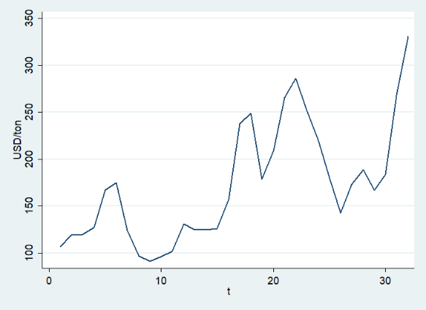
(b) 1st difference series. | (c) 2nd difference series.
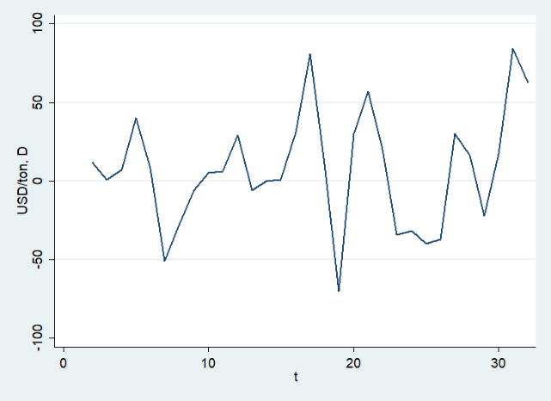 | 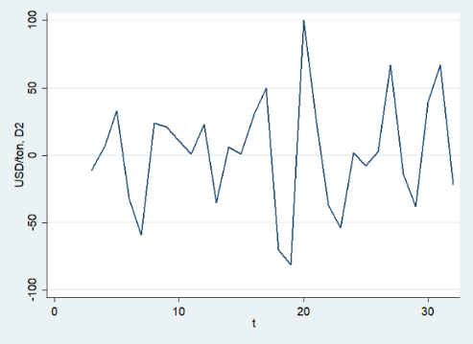
Figure 4: Time series plot of wheat price (USA/ton) in the USA.
Formal tests (ADF test and Phillips-Perron test)
The Augmented Dickey Fuller (ADF) test was also performed to confirm this. Table 4 shows that the p-value exceeds the 5 percent significance limit, suggesting that the series is non-stationary. To achieve stationarity, the trend component must be removed from the original series.
This was accomplished by applying different techniques. Because the trend exhibits a systematic pattern and the mean is not constant over time, the original series' initial discrepancy is also nonstationary (Figure 4). Based on the data in Table 3, it is possible to deduce that the series' initial difference remained nonstationary.
Despite the intercept and trend level being stationary, after applying the second differencing, FigureClick here to enter text. Five clarifies that there isn't any observable systematic pattern in the trend, either in increasing or decreasing movement. In addition, the meaning doesn't change over time. Therefore, the second difference between the original series and the second one is stationary.
We performed an Augmented Dickey-Fuller (ADF) test to verify this. Table 4 shows that the p-values for the different levels are less significant than the 5% threshold. As a result, the second difference in the wheat price series is thought to be steady.
After the series is second-differentiated into a stationary state, the next step in building an ARIMA model is figuring out how many autoregressive (AR) or moving average (MA) terms are needed to correct for any residual autocorrelation in the second differenced series. Therefore, by looking at the autocorrelation function (ACF) from Figure 6 and partial autocorrelation function (PACF) from Figure 5 plots of the second differenced series, we estimated the sequence of AR and MA terms needed to fit a model properly. We see that the series becomes stationary after taking the second difference. As a result, d, or the order of differencing, is 2. Figure 6, which shows the sample ACF of the second difference series, makes it abundantly evident that the most notable and statistically significant spike occurs at lag 2.
We now investigate as many preliminary models as possible, selecting the best model according to the model selection criterion. Suitability for large values of p and q is one desirable characteristic of a well-designed ARIMA model. The following potential models have been chosen in accordance with the model selection criteria. Table 4 data shows that compared to the other considered models, the ARIMA (2, 2, 2) model has the highest Log Likelihood and lower values for AIC and BIC.
Table 3: P-Value (ADF test and Phillips-Perron test)
Series | ADF Test | Phillips-Perron Test | Decision
Original | 0.7242 | 0.6079 | Non-Stationary
1st order | 0.0337 | 0.0643 | Non-Stationary
2nd order | 0.0000 | 0.0000 | Stationary

Determining the value of p (AR) and q (MA)
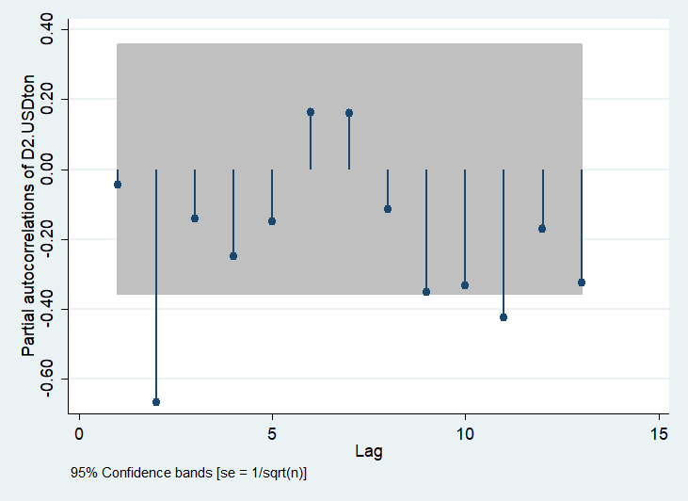 | 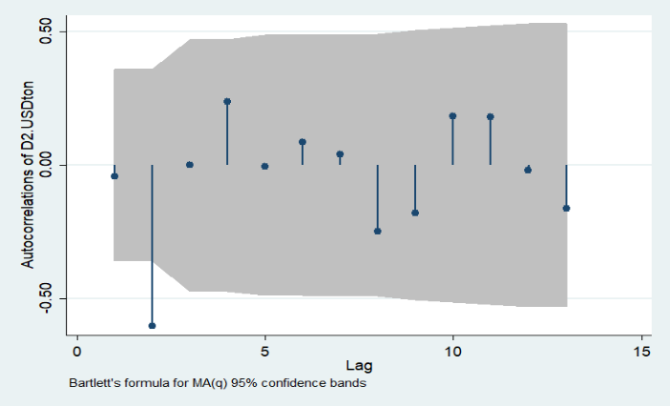
Figure 5: PACF plot of 2nd difference of wheat price (USA/ton) in the USA | Figure 6: ACF plot of 2nd difference of wheat price (USA/ton) in the USA.

Decision
Comparing different ARIMA models, we can confidently assert that the ARIMA (2, 2, 2) model was the most optimal choice, and we employed this model for our forecasting objectives.
4.2 Diagnostic checking
After selecting our prospective model, ARIMA (2,2,2), we tested the white test for the model's residual to check zero mean, constant variance, and zero correlation through the Portmanteau test indicated by Figure 7. The unit circle contained the AR roots indicated in Figure 8. Here, the ARIMA model (2, 2, 2) event satisfied the diagnostic check.
Table 4: Model Selection Criteria
Criteria |  | Model |  |  |  | Best model
 |  | Model A  ARIMA (2,2,2) | Model B  ARIMA (2,2,3) | Model C  ARIMA (3,2,3) | Model D  ARIMA (3,2,1) | Best model
AR, I, MA |  | 2, 2, 2 | 2, 2, 3 | 3,2,3 | 3,2,1 | -
SigmaSQ (Smaller is better) |  | 28.18 | 28.35 | 28.08 | 28.40 | C
Log Likelihood (Bigger is better) |  | -144.74 | -145.49 | -145.17 | -144.79 | A
Alaike (Smaller is better) |  | 299.48 | 304.98 | 304.34 | 301.58 | A
Bayesian (Smaller is better) |  | 306.48 | 314.78 | 314.15 | 309.99 | A
 | Model |  |  |  |  | A

A plot of the residuals indicates that there is no serial correlation and that the models are adequate. Figure 8's standard probability plot suggests that the residuals of ARIMA (2, 2, 2) follow a normal distribution. As a result, ARIMA (2,2,2) was chosen as a successful model to accurately predict the price of wheat in the United States.
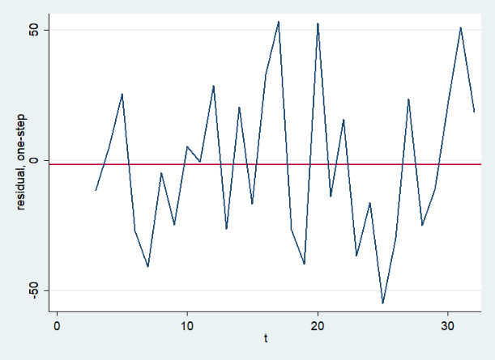 | 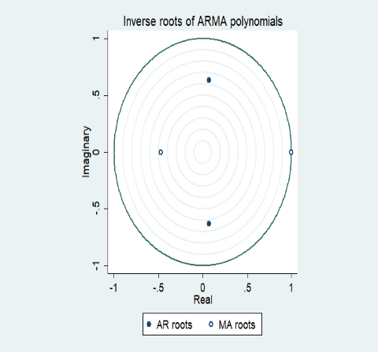
Figure 7: Normal probability plot of residuals of ARIMA (2, 2, 2) | Figure 8: Check AR and MA roots lies inside the unit circle

4.3 Forecasting
Forecasting is the technique of predicting the future using data from the past and present and examining trends. The ARIMA (2, 2, 2) model is our study's most effective model for predicting the US wheat price. Table 5 shows the wheat price estimate for the United States using the ARIMA (2, 2, 2) model for the years 2022 through 2032.
Figure 9 displays the observed value vs. predicted values and shows that the observed and predicted values are approximately equal. Therefore, the ARIMA (2, 2, 2) model appropriately fits the data.
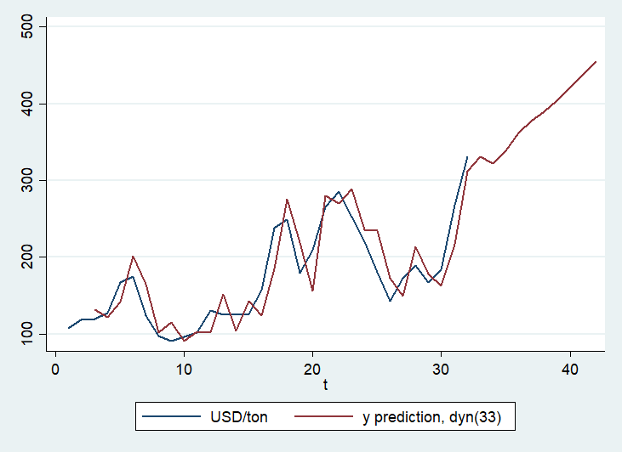
Figure 9: Wheat price forecasting using the selected ARIMA (2,2,2)
In Figure 10, we can see the wheat price comparison in the USA from 2013 to 2022. Also, in Figure 11, we can see that the predicted value of wheat prices in 2023 and 2024 is approximately the same compared to the forecasted wheat price. Also, the forecast model identified the price reduction 2024 caused by the reduction of wheat land acreage in 2023. However, in the consequent years, the forecast shows an increasing trend in wheat prices. This is obvious to predict as the population is increasing and there is less wheat cultivation in the USA. In contrast, the model did not consider technological improvements and climatic conditions that might increase wheat yield, as in 2016.
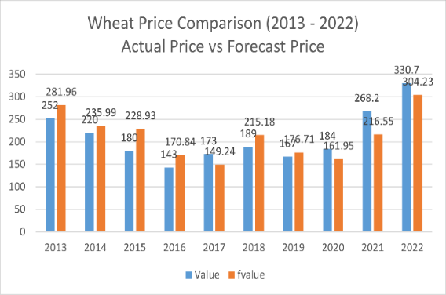 | 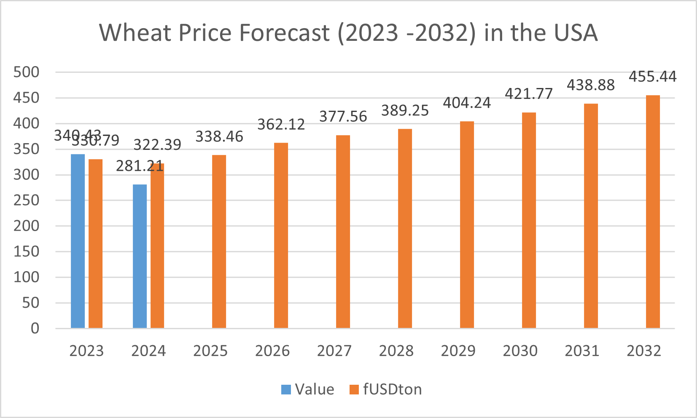
Figure 10: Wheat price comparison in the USA (2013 – 2022) | Figure 11: Wheat price forecast in the USA (2023 – 2032)
Table 5 shows the forecast price of wheat for the next years given by the data from 2023 to 2032 using the ARIMA model (2,2,2). This is a clear indication that the future wheat price will increase. The price will be 338.46 USD/ton in 2025, a 0.50% increase compared to 2024. By 2032, the wheat price in the USA will be 455.44 USD/ton, which is a 41.27% increase compared to 2024.
Table 5: Wheat price forecast of USA (2023 – 2032)
Year | Forecast wheat price (USD/ton)
2023 | 330.79
2024 | 322.39
2025 | 338.46
2026 | 362.12
2027 | 377.56
2028 | 389.25
2029 | 404.24
2030 | 421.77
2031 | 438.88
2032 | 455.44

4.4 Discussion
Another approach to address the challenge of forecasting wheat will be to determine changes in demand to clarify the correlation between supply and price. In that case, when analyzing worldwide wheat production and carry-over regarding purchasing power, it is evident that consumers’ purchasing power generally remains consistent. Still, there is a noticeable upward trend in production and carryover. Hence, it may be deduced that the pattern of output and carry-over has an ascending trajectory, signifying an increasing demand. Without this condition, purchasing power would not remain constant even with the decrease. Nevertheless, the ARIMA model of forecasting demand is indirect since it depends on knowledge about previous wheat pricing.
Given the insufficient data regarding the demand for wheat, the analysis will primarily concentrate on the factors that influence the price of wheat. If the market remains relatively stable or varies consistently, price variations will occur due to changes in supply quantity. If the supply for a particular year is twice the quantity for the previous year, we should expect a price reduction. In contrast, a decrease in supply would result in an anticipated price increase. Nevertheless, it is likely to consider the exact magnitude of the price movement in reaction to a specific change in supply and demand.
Accurate statistical methods are essential to measuring the correlation between price and supply and formulating a predictive equation that can estimate price fluctuations based on changes in supply.
Considering all these factors, the ARIMAX model will give more accurate and authentic price forecasts if price-affecting variables are included in the current ARIMA model. Further investigation of the price forecast using the ARIMAX model is required to predict the price of wheat in the USA market.
5. CONCLUSION
This study aims to identify the most effective ARIMA model for predicting future wheat values in the USA based on data collected from 1991 to 2022. The time series plot, autocorrelation function (ACF), partial autocorrelation function (PACF) plot, and unit root test indicate that the original series and first difference series of wheat price (USD/ton) in the USA are non-stationary. However, the second difference in the series is stationary. We subsequently utilized the Box-Jenkins approach on the second-order difference of the wheat price data to determine the appropriate ARMA (p,q) process. Subsequently, we choose several ARIMA (2, 2, 2) models from a range of potential models based on their lowest AIC and BIC values. The diagnostic test indicates that the residuals follow a normal distribution, and there is no evidence of serial correlation. Therefore, the selected model is deemed more suitable than other models. We have utilized the ARIMA (2, 2, 2) model to forecast the wheat price in the United States from 2023 to 2032. The study's findings indicate that wheat prices in the USA are projected to increase consistently over time.
Abbreviations
ACF = Autocorrelation Function
AIC = Akaike Information Criterion
ARIMA = Autoregressive Integrated Moving Average
ARIMAX = Autoregressive Integrated Moving Average with Exogenous Variables
BIC = Bayesian Information Criterion
MMT = Million Metric Tons
MSP = Minimum Support Price
PACF = Partial Autocorrelation Function
USD = United States dollar

Consent

Not applicable.
This study is based exclusively on secondary data obtained from publicly available sources and does not involve human participants, patients, or identifiable personal data.

Ethical approval

Not applicable.
This research does not involve experiments on humans or animals. The study relied solely on secondary data from publicly accessible databases; therefore, ethical approval or institutional review board (irb) clearance was not required.

References

Abdulla, F., & Hossain, M. M. (2015). Forecasting of Wheat Production in Kushtia District & Bangladesh by ARIMA Model: An Application of Box-Jenkin's Method. Journal of Statistics Applications & Probability, 4(3), 465.
Amin, M., Amanullah, M., & Akbar, A. (2014). Time series modeling for forecasting wheat production in Pakistan. JAPS: Journal of Animal & Plant Sciences, 24(5).
US Wheat Associates. (2024). World Wheat Supply and Demand Situation and Outlook. U.S. Wheat Associates (USW).
Bhardwaj, S. P., Paul, R. K., Singh, D. R., & Singh, K. N. (2014). An empirical investigation of ARIMA and GARCH models in agricultural price forecasting. Economic Affairs, 59(3), 415-428.
Biswas, B., Dhaliwal, L. K., Singh, S. P., & Sandhu, S. K. (2014). Forecasting wheat production using the ARIMA model in Punjab. International Journal of Agricultural Sciences, 10(1), 158-161.
Box, G. and Jenkins, G. (1970): Time Series Analysis: Forecasting and Control, San Francisco: Holden-Day.
Darekar, A., & Reddy, A. A. (2018). Forecasting wheat prices in India. Wheat and Barley Research, 10(1), 54-60.
Doshit, Y., Adabar, K., & Achuthan, S. (2011). ARIMA MODEL FOR FORECASTING OF WHEAT PRICES IN INDIA. GSTF Business Review (GBR), 1(2), 246.
Du, S. (2014). The wheat price prediction is based on the ARIMA model—comprehensive Evaluation System of College Foreign Language Cloud, 2(4), 239.
Dutta, S., & Maiti, S. (2021). Price forecasting of agricultural products using arima models. Indian Journal of Agricultural Marketing, 35(2), 149-164.
FAOSTAT. (2024). Crops and livestock products. Retrieved on 4.21.2024 from https://www.fao.org/faostat/en/#data/QCL.
FAS-USDA. (2024). Production – Wheat. Retrieved on 4.27.2024 from https://fas.usda.gov/data/production/commodity/0410000.
Index Mundi. (2024). Wheat Monthly Price - US Dollars per Metric Ton. Retrieved on 4.26.2024 from https://www.indexmundi.com/commodities/?commodity=wheat&months=60.
Iqbal, N., Bakhsh, K. H. U. D. A., Maqbool, A. S. I. F., & Ahmad, A. S. (2005). Use of the ARIMA model for forecasting wheat area and production in Pakistan. Journal of Agriculture and Social Sciences, 1(2), 120-122.
Kumar, M., Bharati, R.C. and Sinha, S.K. 2002. An ARIMA model for forecasting wheat productivity in the North-West alluvial plain of Bihar. Journal of Applied Biology 12(1/2): 101-104.
Ljung, G. M. and Box, G. E. P. (1978): On a measure of a lack of fit in time series models, Biometrika, 65(2), 297–303. Doi:10.1093/biomet/65.2.297.
Masood, M. A., Raza, I., & Abid, S. (2018). Forecasting wheat production using time series models in Pakistan. Asian Journal of Agriculture and Rural Development, 8(2), 172-177.
Mia, M. S., Nabeen, A. R., & Akter, M. M. (2019). Modeling and forecasting the consumer price index in Bangladesh through econometric models. American Academic Scientific Research Journal for Engineering, Technology, and Sciences, 59(1), 118-127.
Patowary, A. N., Bhuyan, P. C., Dutta, M. P., Hazarika, J., & Hazarika, P. J. (2017). Development of a time series model to forecast wheat production in India. Environment & Ecology, 35(4D), 3313-3318.
Rastogi, K. (2022). These are the top 10 countries that produce the most wheat. Retrieved on 4.26.2024 from https://www.weforum.org/agenda/2022/08/top-10-countries-produce-most-wheat/
Sharma, H. (2015). Applicability of ARIMA models in wholesale wheat market of Rajasthan: An investigation. Economic Affairs, 60(4), 687-691.
Statista. (2024). Wheat - statistics & facts. Retrieved on 4.26.2024 from https://www.statista.com/topics/1668/wheat/#topicOverview.
Welch, M. (2014). An Early Look at 2024 Production Expectations for U.S. Wheat and Sorghum. Retrieved on 4.26.2024 from https://southernagtoday.org/2024/04/22/an-early-look-at-2024-production-expectations-for-u-s-wheat-and-sorghum/
World Grain. (2024). World’s top wheat-producing countries. Retrieved on 4.27.2024 from https://www.world-grain.com/media/photos/154-world-s-top-wheat-producing-countries
World Population Review. (2024). Wheat Production by Country 2024. Retrieved on 4.27.2024 from https://worldpopulationreview.com/country-rankings/wheat-production-by-country.

