A Framework to Enhance Fraud and Error Detection in Information Technology (IT) Audit Systems for the Banking Sector in the United States of America

ABSTRACT
This research presents a comprehensive methodology for improving fraud and mistake detection in information technology (IT) audit systems in United States’ banking sector. With an increased reliance on IT infrastructure and digital systems, banks face considerable risks from fraudulent activity and errors that threaten the integrity and security of financial transactions. This study's objective is to offer a framework that addresses the specific difficulties that United States’ banking sector faces, while also keeping in mind the nation's distinct regulatory climate and technology landscape.

The research methodology includes a comprehensive examination of existing frameworks, standards, and best practices for IT audit systems, fraud detection, and mistake prevention. The study combines recognized frameworks like as COBIT, Fraud Triangle, and TAM to identify critical components and principles for fraud and error detection in the banking industry. Furthermore, case studies and interviews with industry professionals and IT auditors provide information about current practices, difficulties, and potential for change.

This study is significant because it has the potential to help American banks fortify their IT audit systems against rising risks and weaknesses. Banks that use the proposed framework can improve their identification and prevention of fraudulent actions and errors, protect consumer assets, preserve confidence, and ensure regulatory compliance. This study's results and recommendations advance the discipline of IT auditing and give practical insights for banking professional, auditors and regulators

Study design: Quantitative and qualitative research design using questionnaires and expert insights.
Place and Duration of Study: Banking sector in the United States of America (2024–2026).
Methodology: The study reviewed existing IT audit frameworks (e.g., COBIT) and fraud theories, and gathered primary data from practitioners using structured questionnaires. Findings were analyzed using descriptive statistics and supporting interpretation to identify gaps and validate the proposed framework.
Results: Results indicate that traditional IT audit practices face limitations due to evolving cyber threats, automation gaps and control weaknesses. Respondents emphasized the importance of systematic risk assessment, continuous monitoring, improved access controls and the use of data analytics for early detection.
Conclusion: A structured, technology-enabled IT audit framework can strengthen fraud prevention, improve error detection and enhance regulatory compliance in United States banks.
Keywords: IT audit; fraud detection; banking sector; COBIT; data analytics; continuous monitoring; United States.
1. INTRODUCTION
1.0 Introduction
Information technology (IT) audit is the assessment of the management controls in an information technology infrastructure and business applications. The United States’ banking sector is becoming more and more dependent on Information Technology (IT) systems, so it is critical to have strong audit processes in place to identify and stop fraud and mistakes. There is a rise in fraud and errors in IT systems, therefore traditional audit approaches which mostly rely on manual processes and sample-based testing are no longer adequate to handle the problem in order to overcome these obstacles, the aim of this research is to create a thorough framework for improving fraud and mistake detection in IT audit systems that are especially suited to United States’ banking industry. The framework will make use of cutting-edge technologies, data analytics, and best practices to facilitate the early detection, avoidance, and reduction of hazards. The findings of this study will give American banking institutions insightful advice on how to improve their IT auditing procedures. This chapter encompasses the contextual information of the study, the problem statement, the research objectives, the research hypotheses, the research scope, the challenges encountered during the investigation, and a summary that closes the chapter.
1.1 Background of the study
At the moment, auditing is at a crucial point. In particular, the auditing profession is facing challenges from real-time business methods and information technology advancements. Information technology auditing started as Electronic Data Processing (EDP) and has developed greatly as a result of the rise in technology in accounting systems and the need for IT control. In the past, auditing surrounding computers involved human, conventional processes that disregarded the existence of automated equipment.
The automated audit process is aided by the use of generalized audit software (GAS) and computer assisted audit methods (CAATS). Technology is ever evolving as noted above there has been a shift from manual auditing which was the traditional way of doing things to the use of auditing using computers. The use of CAATS and GAS constantly has to be updated in order to match with the skills of fraudsters and hackers, tighter controls and frameworks have to be in place to enhance fraud and error detection in IT audit systems. The banking sector in United States has embraced digital transformation to improve client experiences, increase efficiency, and streamline operations because to the rapid improvement of information technology (IT) systems. The United States’ retail sector has experienced an upswing in electronic payment system and this has led to high rates of electronic card fraud and counterfeit card fraud. Recently there has been high risks and concerns associated with this greater reliance on technology. In the banking industry, fraud and mistakes can have dire repercussions, such as monetary losses, harm to one's reputation, and a decline in public confidence. Recently there was a case at the U.S. courts, a U.S. commercial bank vs David the affected customer, illegal payments of U.S. dollars made by a bank for a reason of fraud and the IT audit trail detected the fraudulent transactions and the Bank was ordered by the courts to repay the affected customer.
In recent years, United States has witnessed a surge in fraudulent activities and errors, driven by factors such as technological advancements, cyber threats, and internal control weaknesses. In August 2022 a large U.S. commercial bank lost $31 000 000 due to fraud from an employee, the false transaction reversal was identified in the information systems department. According to Nichols (2021) a new analysis from LexisNexis Risk Solutions, banks experienced an increase in monthly fraud attacks in 2021 compared to the previous year. According to the research, since 2020, the average monthly volume of fraud attacks for banks with annual turnover of more than $10 million has climbed from 1,977 to 2,320. During the COVID-19 lockdown, United States saw a spike in the usage of mobile banking, online banking, and ecommerce, which increased the country's demand for cybersecurity. The efficacy of conventional audit methodologies, which predominantly depend on manual procedures and sample-based testing, has been demonstrated to be insufficient in identifying and mitigating these dynamic hazards present in IT systems. Additionally, the framework ought to make use of data analytics, best practices, and cutting-edge technology to offer a proactive method of detecting hazards and bolstering internal controls. United States’ banking institutions may lay a strong basis for identifying and averting fraud and mistakes in their IT systems by creating an extensive framework. With the help of this framework, organizations will be able to recognize vulnerabilities, put in place practical controls, and react quickly to new threats.
1.2 Problem Statement
There has been an increase in fraud and errors in United States’ banking industry pausing clients and banks at serious danger of financial loss and reputational harm. The banking industry is becoming more and more dependent on Information Technology (IT) systems, making traditional auditing techniques ineffective in identifying and averting fraud and mistakes. Comprehensive frameworks that are especially made to improve fraud and mistake detection in IT audit systems that are adapted to the particular needs and difficulties faced by banks in United States are scarce. Thus, the creation of a framework that closes these gaps and offers practical solutions to improve fraud and mistake detection in IT audit systems for United States’ banking industry is imperative.
1.3 Research Objectives
To review and analyze the existing IT audit systems and frameworks for fraud and error detection, identifying their limitations and areas for improvement
To identify the challenges and considerations in the implementation and adoption of the framework in real-world IT audit environments
To implement the framework using real-world, assessing its effectiveness, accuracy and efficiency in detecting fraud and errors
To investigate advanced analytical techniques that can be applied to enhance fraud and error detection in IT audit systems
1.4 Research Questions
What are the limitations and challenges of existing IT audit systems in detecting and preventing fraud and errors??
What are the key components and principles that affect fraud and error detection in IT audit systems??
How can the framework be implemented and validated using real-world or simulated data to assess its effectiveness in detecting fraud and errors??
What advanced analytical techniques can be applied to enhance fraud and error detection in IT audit systems??
1.5 Justification of the study
The purpose of this study is to create a thorough framework for improving the identification of fraud and errors in IT audit systems, with a focus on United States’ banking sector. By putting up a framework that combines cutting-edge technologies, industry best practices, and regional concerns, the study seeks to close the gaps and overcome the difficulties in the present audit methodologies. There has been a high rise in fraud cases in the U.S. Banking Sector due to weak information technology audit systems. Previous researchers have been looking at the theoretical side of the high rise in fraud, which we see with the Fraud Triangle theory on the reasons why employees commit fraud so this framework will be dealing with on the ground issues therefore using a quantitative and qualitative research method on how to detect fraud when it occurs and to prevent it as well. The framework will offer banking institutions in United States direction on how to enhance internal controls and better identify and stop fraud and mistakes in IT systems through practical steps, control mechanisms, and risk assessment approaches. Enhancing the banking sector's resilience, security, and dependability in United States is the ultimate goal in order to protect financial resources and uphold public confidence in the sector.
1.6 Significance of the study
The study's main contribution to the government will be to make clear to it how successfully information technology audit systems detect fraud and how closely banks follow regulations. The results of this investigation will assist the government to put in place measures to improve the effectiveness information technology audit systems to safeguard the assets, prevent and detect fraud, errors and irregularities
The conclusions of this academic work may assist United States’ banks and other financial institutions in strengthening their IT auditing procedures to more effectively identify and stop fraud and errors. Ensuring regulatory compliance, safeguarding consumer assets, and preserving the integrity of financial transactions. Banks may improve their capacity to recognize and reduce risks related to fraudulent transactions by putting the study’s suggested framework into practice.
The results of the researcher's work also contribute to the humanities' modern reserve, giving scholars and fellow students a better understanding of the thesis. The academic work can also be utilized to offer other researchers in academia insight into information sources.
For the study to be conducted, the researcher made the following assumptions.
The subjects will provide the researcher with necessary data for conducting the study, including historical transaction data, audit logs and relevant financial records.
The authorities of all respondents will give the researcher enough assistance and cooperation.
The subjects who will be asked to fill out questionnaires are familiar with information technology audit systems and will provide complete answers.
Because the researcher and the respondents will understand one another, the responses will be objective.
One of the significant limitations in research related to fraud and error detection in IT audit systems is the availability and quality of data. Some of the information was not available on bank portals, websites and other publications but however the researcher contacted managers and those charged with governance and collected the requisite information. Confidentiality of information restricted respondents in dishing out much information but necessary persuasion was done to obtain information as much as possible. Access to real-world audit data especially data containing actual instances of fraud errors, nay be restricted due to privacy concerns and proprietary reasons.
Developing and implementing a comprehensive framework for fraud and error detection in IT audit systems needs an extensive number of resources, such as technical, financial, and human resources. The availability of these resources may vary across organizations making it challenging for all organizations to adopt and maintain the framework effectively, the resource requirement should be carefully considered and balanced against the potential benefits of the framework.
It audits systems operate within a regulatory framework, and compliance requirements vary across industries and jurisdictions. In United States we have the Gramm–Leach–Bliley Act (GLBA) and applicable U.S. privacy/security requirements which governs the information which can be published and also one of the principles which managerial personnel follow is confidentiality. The framework should consider the legal and regulatory aspects related to data privacy, security, and audit standards. The framework should acknowledge that the proposed framework may need to be adapted to comply with specific regulations and guidelines.
The study focuses on enhancing fraud and error detection specifically within IT audit systems. A wide range of fraud and error types that could arise in business operations outside the purview of IT audit may not be covered. The framework’s applicability may be limited to fraud and errors that can be detected through data analysis and automated techniques within IT audit context.
The research topic primarily focuses on the framework itself and its impact on fraud and error detection within IT audit systems. It may not extensively address external factors, such as the changes in business environments, technological disruptions and social engineering tactics employed by fraudsters. The framework’s performance may be influenced by these external factors, but they may not be directly addressed within the research scope.
While the research may propose a framework for enhancing fraud and error detection, the full validation and adoption of the framework within real-world IT audit systems may not be within the scope of the study. The research may provide recommendations for validation and implementation, but the actual adoption and integration of the framework into the Banking sector may require further efforts beyond the research project.
section 1: introduction to this research, background to the study, its goals, its constraints, and its limitations plus summary
This section presents the researcher's history and context for the research topic, elucidates the research problem or questions, highlights the significance and goals of the research, and builds the study's justification.
section 2: review of related literature by other scholars about the research being carried out
The section includes an introduction, study objectives/questions, literature identification and selection, literature review and synthesis, gap analysis, and a conclusion summarizing the key findings. The goal is to build a theoretical framework, demonstrate a thorough comprehension of the topic and indicate any knowledge gaps that the study aims to address.
section 3: the methods that are going to be used in researching this study
The researcher describes the study's research design, data collection and analytic procedures, and any ethical issues in this chapter. Chapter 3 aims to guarantee the validity and credibility of the study's conclusions by offering a comprehensive and lucid account of the research methodology.
section 4: research findings
This chapter contains the researcher's presentation and thorough examination of the collected data. The aim of Chapter 4 is to give a thorough explanation of the research study's findings.
section 5: conclusions altogether with recommendations
The researcher provides an overview of the major discoveries in this chapter, analyses their implications, and interprets them in light of the goals or research questions. Chapter 5's goals are to analyze the consequences of the research findings, draw inferences from them, and offer suggestions for more study or real-world applications.
This section provided the study's background, an explanation of the problem, the research objectives, importance of the research, and range of the research and last but not least the limitations encountered during the groundwork. This chapter gives insight on the framework which the researcher wants to create and the gap that they are trying to fill up. The objectives of the research were to create a thorough framework for enhancing fraud error detection in IT audit systems in the banking sector of United States. Subsequent chapter will be looking on the related literature to information technology on audit systems. The following chapter will review the pertinent literature on the research issue.
THEORETICAL FRAMEWORK
Fraud Triangle Theory
The Fraud Triangle Theory explains why individuals commit fraud in organizations. It highlights three key drivers: pressure (incentives or financial need), opportunity (weak controls), and rationalization (justifying wrongdoing).
Figure 1: Fraud Triangle Model
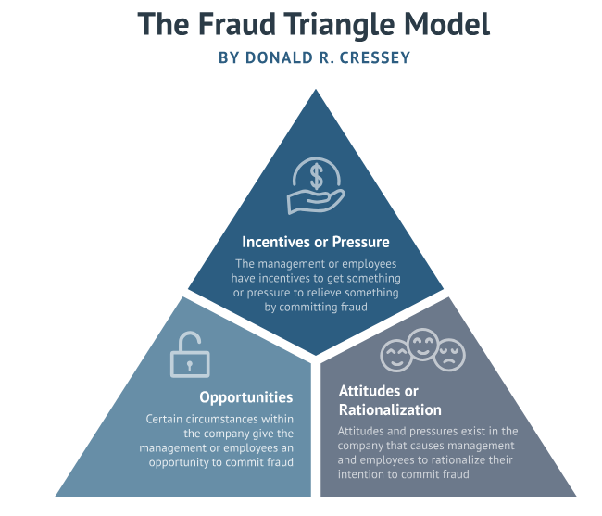
Source: Adapted from Donald R. Cressey (Fraud Triangle) – online illustration.
Technology Acceptance Model (TAM)
The Technology Acceptance Model (TAM) describes how users come to accept and use technology. It emphasizes that perceived usefulness and perceived ease of use influence intention to use, which then affects actual use of a system.
Figure 2: Technology Acceptance Model
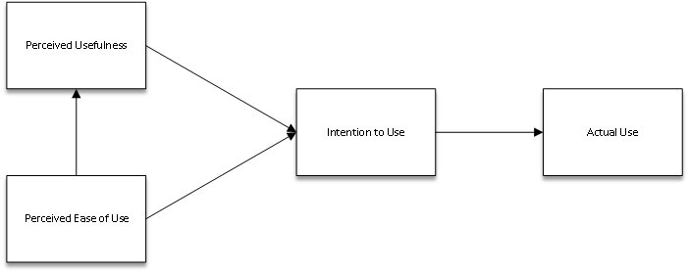
Source: Online illustration of TAM (adapted).
COBIT 5 Framework
COBIT (Control Objectives for Information and Related Technologies) provides guidance for governance and management of enterprise IT. COBIT 5 principles support aligning IT controls, risk management, and compliance with business objectives.
Figure 3: COBIT 5 Principles
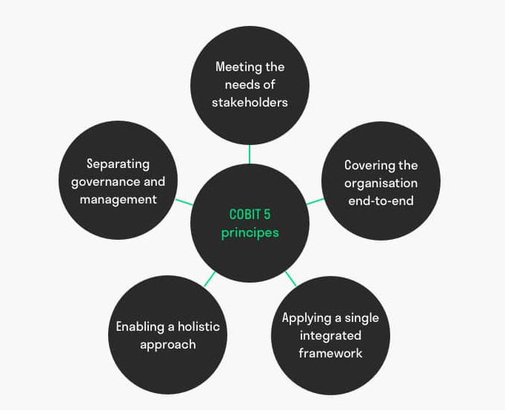
Source: ISACA COBIT 5 principles – online illustration.
Proposed Conceptual Framework (SECURE)
This study proposes the SECURE framework to strengthen fraud and error detection in IT audit systems for the banking sector. The framework integrates: Systematic risk assessment, Effective controls implementation, Continuous monitoring, Utilization of data analytics, Regulatory compliance, and Employee training & awareness.
Figure 4: Proposed SECURE Framework
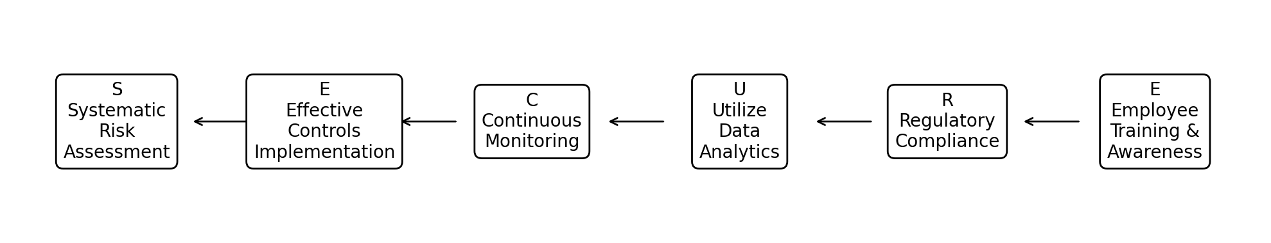
Source: Author’s conceptual framework (SECURE).
2. MATERIAL AND METHODS
This article focuses on the procedure of gathering research data and the statistical methods utilized to derive the study's conclusions. The chapter examines the study's philosophy, design, approach, study population, sampling methods, sample size, research tools, data collection procedures, validity, reliability, and ethical considerations. It concludes with a summary of the chapter's contents.
2.1 Research Philosophy
Research philosophy is the beliefs, traditions, and ideals that govern researchers' approaches to studying a specific topic. It provides a framework for the design of the study and the methodology used in it. According to Kumar (2021) research philosophy is crucial to understanding the researcher's viewpoint on reality, the researcher's role in the research process, and the reliability of the knowledge produced by the study. The researcher conducted a pragmatic research philosophy. The research can closely analyze the existing procedures and constraints of fraud and mistake detection in banks by adopting this research philosophy.
2.1.1 Pragmatic Philosophy
The research philosophy of pragmatism is a good fit for the problem at hand, which is improving fraud and error detection in banks. Pragmatism places a strong emphasis on problem-solving, practicality, and the application of knowledge to actual circumstances. The researcher can successfully address the real-world difficulties banks encounter in identifying and averting fraud and mistakes by embracing a pragmatic research methodology, which will result in observable enhancements to their operational procedures. Pragmatism emphasizes workable solutions and results. This theory recognizes the necessity of efficient fraud and error detection systems that can be applied in actual financial systems in the context of your research. It invites you to create and suggest workable frameworks that tackle the difficulties banks face while taking into account the resources, infrastructure, and limitations already in place. The focus of pragmatism is on recognizing and resolving practical issues. Research methods can be flexible with pragmatic approaches, which promotes the use of both quantitative and qualitative methodologies. Because fraud and mistake detection in banks entails intricate data analysis, statistical modelling, and an awareness of the contextual elements surrounding fraudulent activity. The researcher can collect extensive data, such as transaction histories, past trends, customer behavior analyses, and expert opinions, by using a mixed methods approach. This data can then be used to guide the framework's design and assessment.
2.1.2 Ontology Philosophy
Ontology research Philosophy is the field of philosophy that investigates the nature of reality or existence. The philosophy of ontological research places great emphasis on comprehending the fundamental nature of a phenomenon or object, as well as the interrelationships among different entities. To determine the ontological categories that explain the many kinds of entities and their relationships, ontology research philosophers attempt to unearth the fundamental structure of reality. Schatzki (2020) defined ontology as the study of being, with the goal of identifying the basic categories that underpin all that is. The philosophy of ontological study is essential for comprehending the nature of reality and for formulating theories that elucidate how it functions.
2.1.3 Realism Philosophy
Realism research philosophy, sometimes known as scientific realism, is a research approach that seeks to understand the objective world. The theory holds that empirical observation and experimentation produce precise and trustworthy hypotheses which can be verified and validated, resulting the creation of scientific knowledge. In many scientific domains, such as physics, psychology, and medicine, realism research philosophy is extensively employed to provide information that can be used to address real-world issues. According to Warren (2022), the development of therapies and treatments that are grounded in empirical data requires a realism research philosophy. This method guarantees accurate and dependable knowledge generation by highlighting the significance of objective observation and experimentation.
2.2 Research Design
2.2.1 Descriptive Design
A descriptive research design, according to Best (2022), is a research strategy in which the main study issue is posed. The researcher used descriptive designs as it is ideal for investigating and developing an initial grasp of a study topic or phenomenon. It let researchers to characterize the features, behaviors, and patterns connected with the variables under consideration. According to Thyer (2020), a descriptive research design helps researchers understand the variables they are examining and make a connection between the variables. They entail gathering information from a sample or population and analyzing it with descriptive statistics. Descriptive research sometimes entails gathering data from a large sample or population, allowing researchers to gain a large amount of information in a short period of time. This rapid data collecting allows for complete coverage of the variables under research and facilitates generalization to a broader population, hence increasing the external validity of the findings.
2.2.2 Explanatory design
Explanatory designs aim at comprehending the relationships between variables and find causal mechanisms. Statistical approaches like regression analysis and structural equation modelling are commonly used to analyze various variables in these studies. Explanatory designs are ideal for examining causal links between variables. These designs enable researchers to change independent variables and assess their impact on dependent variables while accounting for any confounding influences. Tests and improvements to theoretical frameworks can be achieved with the use of explanatory research designs. They make it possible for scholars to look at how different factors interact and add to the overall theoretical knowledge of a phenomenon. Explanatory research aids in the development of new theories as well as the validation or improvement of established ones by methodically examining the links between variables. Advanced statistical methods like regression analysis, structural equation modelling, or multilevel modelling are frequently used in explanatory research designs.
2.2.3 Experimental Design
The researcher's experimental design is appropriate for this research topic since it allows for the systematic manipulation of variables and the examination of cause-and-effect linkages. This methodology allows for the study of specific initiatives or improvements in fraud and error detection within a controlled setting, as well as the impact on detection outcomes.
2.3 Research Approach
2.2.1 Quantitative Approach
Quantitative research involves the collection and analysis of numerical data, which involves quantifying the size, extent, and frequency of occurrences (Heir, 2023). It is easily understood and well-structured, and the results may be gathered and presented statistically without being complicated. A quantitative methodology was applied to show the results in the form of tables and graphs.
2.2.2 Data Sources
Direct access to the original source constitutes a primary data source. The data sources classified as secondary were gathered by another party and made publicly available. The researcher will analyze primary data sources in this research.
2.2.3 Primary Data
Primary data sources provide researchers with an opportunity to obtain new and unprocessed data straight from the source. For example, a researcher may decide to interview or study particular people, companies, or groups. Important instances of primary data sources are surveys and interviews. Primary data sources are useful for research as they provide relevant and accurate data for specific studies.
2.4 Study Population
2.4.1 Target Population
The term "target population" describes the group of people or things that a given program or intervention is intended to help with a specific problem or need. Focusing on particular groups enables effective use of resources in addition to tight budgets to achieve the intended results. Identifying and defining the target population is crucial prior to implementing any program or intervention. The U.S. Banking sector information technology audit systems with their employees as well as other relevant parties impacted by the study, such as information technology auditors, were the target group in this instance.
2.4.2 Sample Population
A sample population is a subset of people chosen to represent the whole population of interest in a particular study. The main organizations in charge of identifying and stopping fraud and mistakes in their operations are banks and other financial organizations which is the sample population. They have established specialized divisions, protocols, and mechanisms to oversee transactions, detect questionable behavior, and reduce potential hazards. Banking professionals and fraud experts are an appropriate sample demographic for the research topic of improving fraud and mistake detection in banks. This sample group can give useful information on existing procedures, issues, and prospective solutions for fraud and error detection in the banking business. Specialized knowledge and expertise in the field of fraud and error detection are possessed by banking professionals and fraud experts. They've worked on fraud situations in the real world, putting detection mechanisms in place and creating risk-reduction plans.
3. 5 Sampling Method
2.5.1 Stratified Sampling
Using stratified sampling, the population (banks and financial institutions, for example) is divided into discrete subgroups or strata according to pertinent attributes (size, location, services provided, etc.). A representative sample of banks can be chosen from each stratum. This methodology guarantees that the sample comprises a proportionate representation from diverse subgroups, hence facilitating a thorough comprehension of fraud and error detection strategies across many banking business segments. Stratified sampling makes it possible to include a variety of banks and financial organizations in the sample, it is appropriate for the research topic. You can adjust for differences in size, location, and company emphasis by choosing banks from various strata. This makes your study findings more externally valid and gives you insights that may be used to many kinds of banks. Additionally, stratified sampling lowers sampling bias by guaranteeing that the sample fairly represents the population.
2.5.1 Random Sampling
Random sampling is the process of choosing individuals at random, without the use of prejudice or present criteria, from the population, banks and financial organizations. Every bank has an equal chance of being a part of the sample thanks to this technique. Random sampling lowers the possibility of systematic bias and permits statistical inferences about the greater population of banks, it permits generalizability. Random sampling is relevant to the research topic because it ensures a fair and unbiased representation of banks and financial organizations. By selecting participants at random, you can create a sample that corresponds to the typical of bank employees as a whole. This improves the external validity of your study findings, allowing you to make generalizations and draw conclusions that apply to a wider range of banks. Random sampling also helps statistical analysis and allows for the assessment of the prevalence and effectiveness of various fraud and error detection measures.
3. 6 Sample size
The research table below displays the sample size of this study. This study has 50 people in its sample. This was sampled against a total population of 65 participants. The researcher used this sample size for ease of use and to make sure the data being collected could be handled and there was a significant number of participants from banks and financial institutions
Table 1: Research Table
Research Target | Total Population | Sample Population | Sample %
Management | 10 | 7 | 70%
IT Auditors | 20 | 20 | 100%
Employees | 15 | 11 | 73%
Internal Auditors | 20 | 12 | 60%
Total | 65 | 50 | 77%
2.7 Research Instruments
2.7.1 Questionnaires
Rusere (2021) defines research instruments as strategies and processes that prepare researchers for their studies and collect data that is not readily available on public websites or published publications. Questionnaires were chosen because they are a quick, straightforward, and cost-effective tool to get more information from a big number of people. In questionnaires, both closed-ended and open-ended questions are frequently used to collect data, which improves the quality of the data obtained because respondents were given guidance on what answers to provide. Questionnaires are an effective and economical technique for gathering information from a big number of respondents. They provide quantifiable data that can be analyzed statistically, revealing the frequency of specific detection methods as well as the efficacy of current practices. Questionnaires also enable for cross-bank comparisons, enabling the discovery of best practices and areas for improvement in fraud and mistake detection. They provide quantifiable data that can be analyzed statistically, revealing the frequency of specific detection methods as well as the efficacy of current practices. Surveys also allow for comparisons between different banks, enabling the discovery of best practices and areas of improvement.
2.8 Data collection Procedure
2.8.1 Questionnaires
A questionnaire is a research tool that consists of a variety of questions and other artificial stimuli designed to elicit information from the target population. Through the use of a set number of questions, in order to fulfil the objectives of the study, the researcher was capable of to generate the data required for the questionnaire. This study's primary goal was to create an extensive framework for enhancing fraud error detection in IT audit systems. The researcher selected a closed-ended and open-ended question with Likert scaling for this purpose since it called for both quantitative and qualitative analysis. One way to scale respondents' responses is to use the Likert Scale. Prior to merging the points, Leary (2020) provides particular points to multiple thoughts in order to obtain a comprehensive attitude outlook on the topic under discussion. On the Likert scale, the five responses employed in this study work are strongly disagree, disagree, agree, and highly agree.
2.9 Data Analysis and Presentation
The research study utilized a quantitative method approach, which entails the examination of quantitative data. The quantitative method is governed by the pragmatic paradigm. According to Kumar (2021), a quantitative technique is characterized by greater precision, structure, thorough explanation, and acknowledgement; it has been subjected to validity and dependability assessments. In contrast, a qualitative technique is less precise and may include fewer qualities or none at all. The responses provided to the questionnaire's closed-ended questions formed the foundation for the quantitative analysis, which was coded and examined with the use of the Statistical Package for Social Sciences (SPSS). The collected raw data was entered into the SPSS program, where it was examined using fundamental methods like percentages and frequencies. The presentation was made with Microsoft Office Word and Excel and included tables, figures, and charts. In the presentation, tables, charts, and figures were used.
2.10 Validity and Reliability
Researchers are required to follow specific ethical guidelines when doing research. For instance, they must verify that participants are not harmed by the research, safeguard participant anonymity, and get informed consent from individuals. Additionally, researchers need to think about things like funding sources and academic pressure that could lead to conflicts of interest. Garland (2021) for instance, stress the importance of disclosing academic conflicts of interest in research papers in a transparent manner. The researcher will ensure data validity by employing acceptable data gathering techniques that are consistent with the research objectives. To ensure reliability and validity when collecting quantitative data, use standardized measuring tools and verified devices. Defining study objectives and questions helps drive data collecting and provide valuable insights on detecting fraud and errors in banks. Data collecting should be aligned with specific objectives to keep the research focused and relevant throughout the process. Reliability analysis evaluates the consistency and stability of study findings, making it a crucial part of research. The examination entails statistical techniques to evaluate the quality and correctness of the data gathered. In the analysis, methods like test-retest, parallel forms, and inter-observer reliability are frequently employed. Clearly define the variables, measurement scales, and operational definitions that will be employed. Providing clear instructions to reduce differences in data gathering methods and improve reliability. Extensive data cleaning techniques were implemented to detect and address mistakes, inconsistencies, and outliers within the gathered information.
2.11 Ethical Consideration
Ethical considerations include safeguarding the rights, privacy, and well-being of participants, maintaining confidentiality, and doing research in an ethical and responsible manner. All of the research participants provided informed consent. Giving clear and intelligible information on the objective, methods, potential dangers, advantages, and the voluntary nature of participation. Ensuring participants can ask questions and understand the repercussions of their involvement. The participant's information is kept private and secret by the researcher. Ensure that data acquired from banks and financial organizations is anonymous and cannot be traced back to specific individuals or businesses. Using secure data storage and transfer technologies to keep participants' information safe from unauthorized access. Participants were well informed about how their data will be handled, and they were assured of complete confidentiality. Garland (2021) for instance, stress the need of being open and honest when disclosing academic conflicts of interest in research papers. For research to continue being dependable, trustworthy, and advantageous for all parties involved, ethical issues must be managed effectively.
2.12 Chapter summary
Presenting the research's strategy, methodology, design, target population, sample size, sampling technique, research instruments, data collection protocols, data analysis, and presentation techniques was the primary goal of this chapter. Issues with validity, reliability, and ethics were also discussed. But the display, evaluation, and discussion for the gathered data will be the main topics of the next chapter.
3. RESULTS AND DISCUSSION
This article summarizes, evaluates, and discusses the key study data gathered to ascertain the effectiveness of IT audit systems on fraud and error detection in U.S. Banks. The data will be shown in tabular style, with diagrams and the previously mentioned order of the research objectives. Finally, a chapter summary offers an understanding of the topics that were discussed in the chapter.
3.1 Response rate
3.1.1 Questionnaires
This part of the chapter looks at the answers to the questionnaires provided by the respondents. The percentage of respondents that promptly completed and returned the provided surveys is displayed in this section.
Table 2 Sampling Survey (2024)
Description Stratum | Questionnaires  handed out | Questionnaires  returned | Response  Rate %
Management | 7 | 7 | 100%
IT Auditors | 20 | 20 | 100%
Employees | 11 | 11 | 100%
Internal Auditors | 12 | 12 | 100%
Total | 50 | 50 | 100%
Table 2 shows that of the 50 surveys that were sent out, 50 were duly filled out and promptly returned by the respondents selected from the sample. According to Sunders (2019), data gathered from more than 75% of the distributed questionnaires is regarded as trustworthy and can be used to generate study conclusions, endorsed the percentage response rate of 100%.
3.2 Demographic Profile of respondents
The characteristics of the demography that the participants were established based on their gender distribution, age and number of years in the banking sector.
Fig 5: Participants by Gender
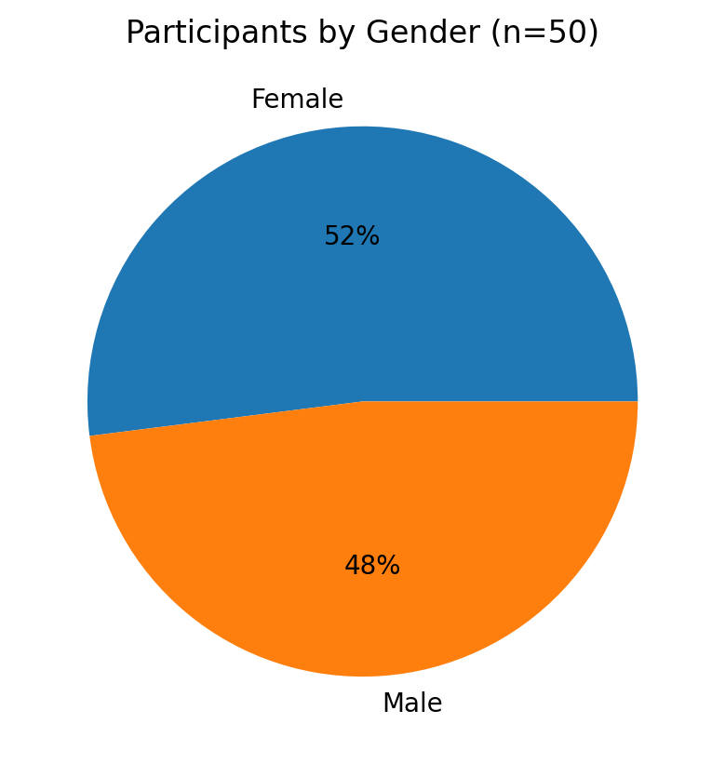
Source: primary data sources (2024)
As shown in Fig. 5 above, out of the 50 questionnaires that were distributed, 26 had a 52% response rate and were fully completed and returned by male respondents; the remaining 24 had a 48% response rate and were completed by female respondents. This demonstrated that responders were not subjected to discrimination due to their gender identity. Braun (2020) posits that data obtained from participants in research investigations that do not discriminate based on gender affiliation is deemed dependable and valuable. The responses show that both male and female were treated equally. Clarke (2020), who asserted that data equally gathered from all respondents is regarded as genuine and free from prejudice, endorsed the idea.
In addition, participants were requested to provide their ages. Fig. 6 below shows the participant results by age distribution.
Fig 6: Participants by age
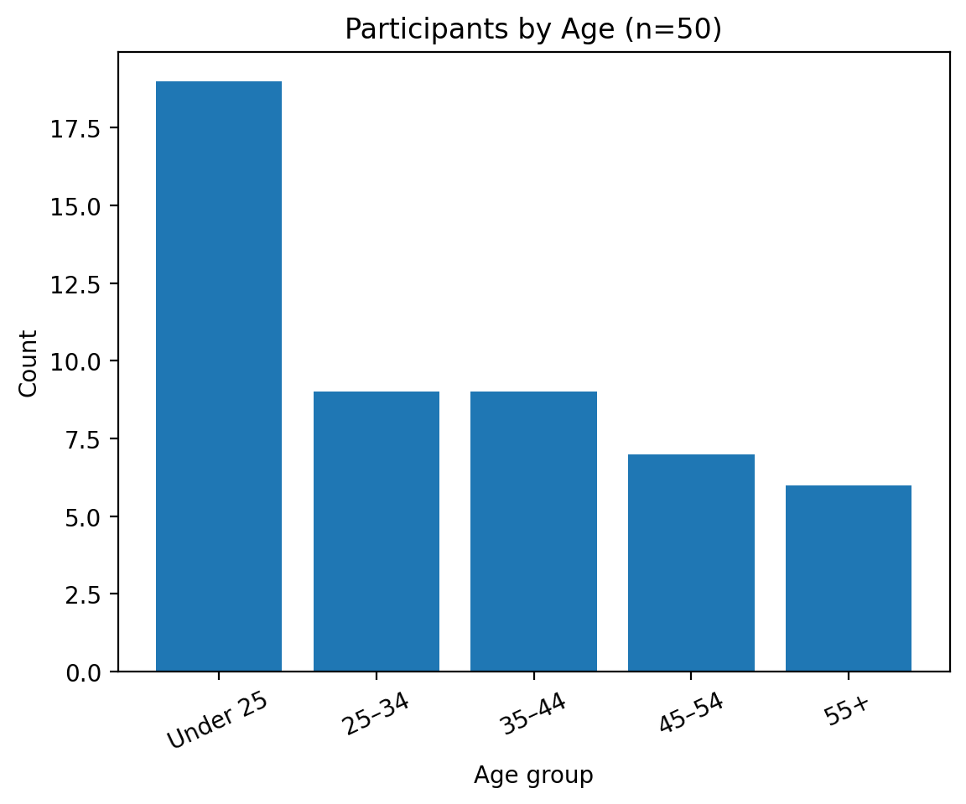
Source: primary data sources (2024)
Fig 7 illustrates that out of the total of 50 participants, 19 (38%) of them were Under 25 years, while 9 (18%) % of the total participants were between 25 to 34 years. Again 9 (18 %) of the participants were between 35 to 44 years. Only 7 (14%) of the participants was between 45 to 54 years and 6 (12%) was 55 above. This clearly indicates that the majority of the participants was the young generation which is more into technology and are willing to see change int0 the IT audit space to address the issues of fraud and error detection.
3.3 Analysis of Data
3.3.1 Primary Objective: To develop a comprehensive framework for enhancing fraud error detection in IT audit systems
The primary research objective is to create a comprehensive framework that enhances fraud and error detection and the findings for the research survey conducted shows the results of whether believe the framework will benefit the IT auditing systems used by United States’ banking industry.
3.3.1.2 Do you believe that a comprehensive framework specifically tailored for the banking sector in United States is necessary to enhance fraud and error detection in IT audit systems?
Fig 7: Importance of IT audit systems framework to improve fraud and error detection
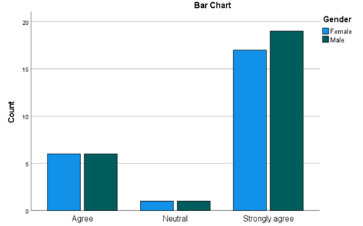
Source: primary data sources (2024)
The data presented indicates that a significant proportion of the participants hold the view that improving fraud and mistake detection in IT audit systems requires an all-encompassing framework designed especially for United States’ banking industry. 72% of the respondents believe that an IT audit systems framework is very necessary in order to reduce the numbers of fraud and errors in the Banking Sector. 24% agree with this notion and 4% are neutral towards having a framework that will aid in fraud and error detection. Research results showed that the framework for IT audit systems will greatly aid in the detection of fraud and errors. According to the majority of respondents, banks, auditors, regulators, and other stakeholders may all develop a common language and understanding by using a strong framework. It can encourage uniformity and cooperation in the detection, reporting, and correction of errors and fraud. 4% of respondents, however, are undecided about the idea that fraud and errors can be decreased with the use of an IT audit systems framework. These comprise, among other things, market fluctuations, regulatory restrictions, technical advancements, political meddling, financial illiteracy, and economic upheavals.
Fig 8: The number of men and women who respond to the need for the framework
Source: SPSS
The bar chart above show that above 15 males and female strongly agree that the comprehensive framework to enhance fraud error detection will work and is necessary. There is a slight difference on the number of males and females who strongly agree to this notion. A little over 5 males and females agree that the framework is necessary. This shows that the sample population believe in this framework and would want to give it a chance. The number of people who are neutral is a very insignificant figure.
3.3.1.3 Regression analysis
The numerical information acquired to determine the connection among gender and banking experience as noted above the males and female have slightly different opinions on whether the IT audit framework is necessary, it was analyzed using linear regression and coefficients of correlation. In this regard, Obrien (2020) claims that linear regression is an effective technique for efficiently looking at the relationship between two variables.
Table 3: Model Summary
Model R | R Square | Adjust R Square | Std. Error of the Estimate
.909a | .825 | .823 | .173
Model Summary
a. Predictors: (Constant), GENDER1, AGE1
b. Dependent Variable: BANKING_EXPERIENCE
The coefficient of determination, or R, was reported to be 0.909 in the model summary. There appears to be a high correlation between age, gender, and banking experience based on the close association between R 2 and 1. This demonstrated how the new IT audit framework's acceptance in United States’ banking industry depends on factors including age, gender, and banking experience. Moreover, the r-squared value of 0.825 demonstrated that age and gender can also influence the variety of banking experience. The correctness of the link between the implemented variables was demonstrated by the adjusted r-squared of 0.823. This suggests that the predictor variable (age and gender) may account for 0.823 x 100% = 82.3% of the dependent variable (banking experience).
Table 4: Anova
Model | Sum of Squares | df | Mean Square F | Sig
Regression | 15.381 | 2 | 7.691 | .004b
Residual | 23.999 | 47 | .511
Total | 39.380 | 49
ANOVA
a. Dependent Variable: BANKING_EXPERIENCE
b. Predictors: (Constant), GENDER1, AGE1
The one-way ANOVA table's p-value was 0.04, which is just below 0.05. This suggests that the model was significant since the dependent variable's (banking experience) results could be accurately predicted by the predictor variables, age and gender. This reveals a null hypothesis and encourages the researcher to use the alternative hypothesis (H1) instead of rejecting the hypothesis (H0). In contrast to the alternative theory, gender, age, and banking experience are positively correlated.
Table 5: Coefficients
Coefficients
Model |  | Unstandardized Coefficients |  | Standardized Coefficients | t | Sig.
 |  | B | Std. Error | Beta | t
1 | (Constant) | .343 | .350 |  | .978 | .333
1 | AGE1 | .170 | .068 | .298 | 2.511 | .016
1 | GENDER1 | .835 | .211 | .470 | 3.955 | .019
a. Dependent Variable: BANKING_EXPERIENCE
According to the unstandardized coefficients, the steepness of the line is represented by 0.170–0.835 if the correlation equation is drawn. y = (0.170-0.835) x + 0.343 was the formula. The t-test of 2.511-3.955 and the p-value of 0.016-0.019 demonstrate the model's significance and the variables' correlation.
3.3.1.4 Discussion of findings
Regression analysis results showed that there is a favorable link between survey participants' age and gender and their banking experience. Additionally, the model's p-value was less than 0.05, it was considered significant and that the predictor variables (age and gender) could account for 82.3% of the dependent variable (banking experience).
3.3.2 Objective 1: To review and analyze the existing IT audit systems and frameworks for fraud and error detection, identifying their limitations and areas for improvement
The first sub-research question presented in section 1.4.1 established the limitations and challenges of existing IT audit systems in detecting and preventing fraud and errors. The findings on the review and analysis of the existing IT audit systems and frameworks for fraud and error detection, identifying their limitations as seen in table 6 below.
3.3.2.1 How effective do you believe the current IT audit systems are in detecting and preventing fraud and errors in the banking sector in United States?
Table 6: Frequency Table
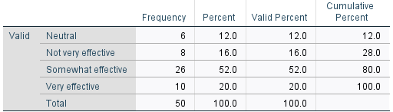

Source: SPSS
The frequency table figure above represents the total number of respondents to the survey—50. This shows that there were 100% respondents to the question of how effective the current IT audit systems are in fraud and error detection in United States.
Figure 9: Responses on the effectiveness of the current IT audit systems by gender
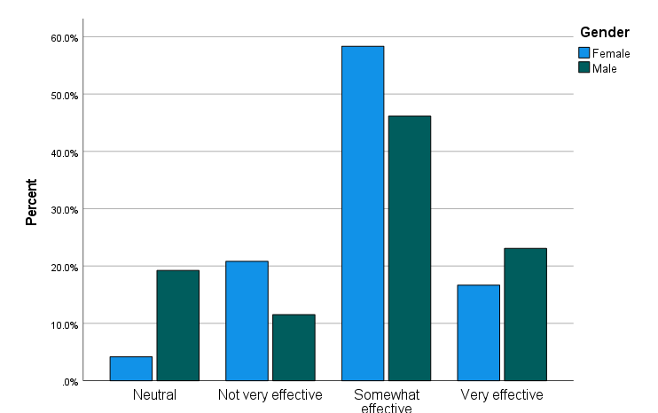

Source: SPSS
Figure 10 above shows that slightly more than 15% of men and women, respectively, think that fraud and mistake detection is effectively detected by the present IT audit methods. A framework and many security levels are needed to strengthen the current IT audit systems, as indicated by the belief held by nearly 60% of female respondents and 45% of male respondents that the current system is somewhat effective in detecting fraud and errors. According to the figure, 11% to 21% of men and women believe that the existing IT audit systems are ineffective. This belief is attributed to the rise in bank fraud as well as the frequency at which this fraud occurs as well as how long it takes the bank to realize they have been duped. Finally, the data shows that 19% of females and 3% of females are neutral about the efficacy of IT audit systems. This is because to a lack of employer-provided training and ignorance regarding the operation of the systems. According to the results, the majority of participants said that the current IT audit system is only somewhat successful. In other words, while banks have IT audit systems in place, they need to be enhanced and given an additional layer of security, which is what the SECURE framework is meant to provide. This is according to Charnes (2021), who states that if businesses want strong security that eliminates room for error and an efficient fraud detection system, they should think about putting in place an effective IT audit systems architecture.
3.3.3 Objective 2: To identify the challenges and considerations in the implementation and adoption of the framework in real-world IT audit environments
The second sub-research question presented in section 1.4.2 explored the key components and principles that affect fraud and error detection in IT audit systems? The findings on how challenges and considerations in the implementation and adoption of the framework in real-world IT audit environments were shown on Fig 10 below.
3.3.3.1 Which of the following do you consider as the major challenges in detecting and preventing fraud and errors in IT audit systems for the banking sector in United States?
Figure 10: Responses from participants on the major challenges in detecting and preventing fraud and errors in IT audit systems for the banking sector in United States
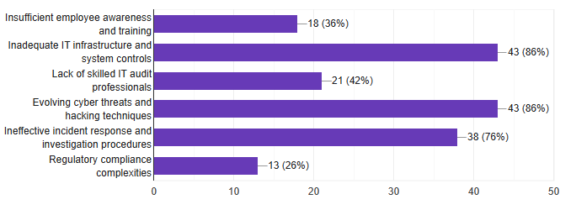

Source: primary data source (2024)
In addition, Figure 11 shows that 43 (86%) of the participants believe that inadequate IT infrastructure and systems control is the main obstacle to detecting and preventing fraud in U.S. banks. This suggests that the banking sector needs to invest in systems and software that are up to date and very efficient. Of the participants, 18 (36%) believe that one of the major challenges in fraud and error detection in IT audit systems in United States is lack of employee training awareness. This indicates that staff are not being trained on the use of their IT audit systems or to be aware of any malicious activities in the systems that they use on a daily basis. One of the difficulties in preventing fraud in banks is the shortage of IT audit professionals 21 (42%). To overcome this issue, workshops must be held. One of the main issues is the evolution of cyber threats and hacking techniques, with a value of 43 (86%). The fact that hackers are constantly experimenting with new hacking techniques to commit fraud indicates that this has been a serious problem, which the SECURE framework will attempt to address. One of the biggest obstacles to the discovery of fraud and errors in IT audit systems is ineffective incident response and investigation protocols, which have a rating of 38 (76%), indicating that the IT audit are not completing their work to perfection and close monitoring has to be implemented in order to enhance fraud and error detection. Finally, the statistic shows that 13 (26%) of the participants think that the complexity of regulatory compliance presents a problem when it comes to identifying fraud and errors in banks through intricate rules and procedures that must be adhered to. The findings show that most participants believe the two primary obstacles to fraud and mistake detection in U.S. banks are outdated IT infrastructure and system controls, as well as evolving cyber threats and hacking strategies. Harrington (2023) states that utilities should make every effort to implement robust control systems in order to reduce the amount of fraud and errors in their banking systems.
3.3.4 Objective 3: To implement the framework using real-world, assessing its effectiveness, accuracy and efficiency in detecting fraud and errors
The third sub-research question presented in section 1.4.3 explored how the framework can be implemented and validated using real-world or simulated data to assess its effectiveness in detecting fraud and errors. The findings on the components that should be included in the framework to enhance fraud and error detection in IT audit systems were shown on Fig 11 below.
3.3.3.1 Which of the following components do you think should be included in the framework to enhance fraud and error detection in IT audit systems?
Figure 11: Responses from participants on the components that should be included in the framework to enhance fraud and error detection in IT audit systems
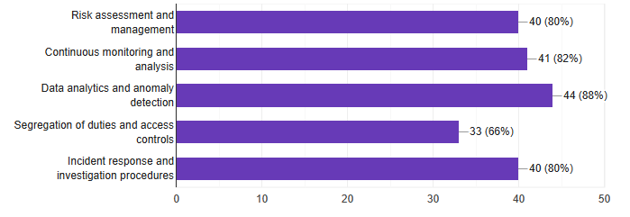

Source: primary data source (2024)
Furthermore, as Figure 12 demonstrates, 40 (80%) of the participants think that risk assessment and management are essential components of the framework that should be included in order to meet the goal of applying the framework in the real world to improve fraud and error detection in U.S. banks. Of the participants, 41 (82%) think that ongoing analysis and monitoring is a crucial element that needs to be included in the framework in order to decrease bank fraud because there are constant checks. Data analytics and anomaly detection are among the elements that must be included in the framework; 44 (88%) of the participants think that this is a crucial function that the framework must have as everything IT is always evolving. As shown by a figure of 33 (66%), the framework must handle the issue of segregation of roles with regard to signatures and payment processing. Lastly, the data reveals that 40 (80%) of the participants believe that the framework's components, including incident response and investigative processes, are necessary to ensure that the incident response plan is compliant with cyber security. According to Tingler (2022), a cybersecurity framework is crucial for organizations that handle large amounts of confidential data, like banks.
3.3.5 Objective 4: To investigate advanced analytical techniques that can be applied to enhance fraud and error detection in IT audit systems
The fourth sub-research question presented in section 1.4.3 looks at advanced analytical techniques can be applied to enhance fraud and error detection in IT audit systems. The findings on the advanced analytical techniques that can be applied to enhance fraud and error detection in IT audit systems were shown on Fig 12 below.
3.3.5.1 Do you think increasing the frequency of automated data reconciliations can help improve fraud and error detection in IT audit systems?
Figure 12: Responses from participants on whether increasing the frequency of automated data reconciliations can help improve fraud and error detection in IT audit systems
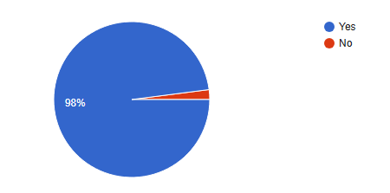

Source: primary data source (2024
The information above indicates that most respondents—98%—think that improving fraud and error detection in IT audit systems can be achieved by increasing the frequency of automated data reconciliations. Just 2% of participants don't think it will work, which is a very small percentage. Comparing several data sets to find any differences or inconsistencies is the process of automated data reconciliations. Banks can identify fraudulent activity or errors earlier and take appropriate steps to reduce risks by doing these reconciliations more regularly. Frequent reconciliations make it possible to identify irregularities early on. Banka can spot suspicious trends or transactions that depart from expected standards by routinely comparing data. The likelihood of stopping or lessening the effects of fraudulent activity is increased by this early discovery.
Table 7-: Case Processing Summary
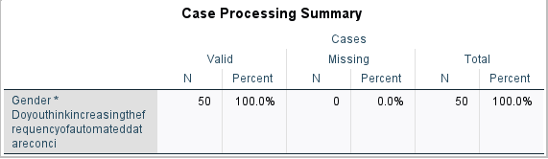
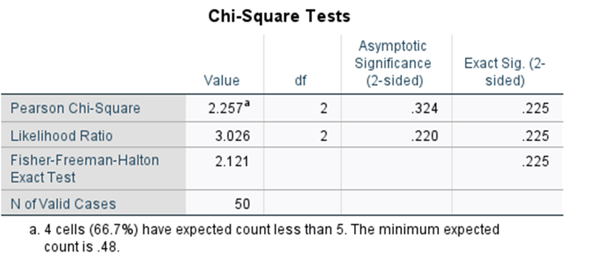
Source: SPSS
The case processing summary shows that 100% of the participants responded to the question on whether increasing the frequency of automated data reconciliations can help improve fraud and error detection in IT audit systems. The table is used to formulate the Chi-Square test below
Table 8-: Chi-Square Tests
Source: SPSS
The given value for the Pearson chi-square test statistic is 2.257. A higher divergence from independence is indicated by a larger chi-square value, of which on our data it has a low value meaning to say there is a small divergence from independence. A large likelihood ratio suggests stronger evidence against the independence hypothesis and the value is 3.026. Overall, these results provide details regarding the relationship's statistical significance and how it increases the frequency of automated data reconciliations can help improve fraud and error detection in IT audit systems and gender variables tested. The p-value is below a predetermined significance level of 0.05 our data shows 0.025, it suggests that there is enough data to rule out the null hypothesis of independence and determine that the variables have a meaningful relationship.
3.4 Summary
This section summarizes the study's findings on a framework for enhancing fraud and error detection in information technology (IT) audit systems for the U.S. banking system. In this portion of the study, data is provided and evaluated in order to draw conclusions from the research outcomes and address the three key research questions. This chapter included a discussion and review of the data that had been gathered. The statistics were shown using bar graphs and frequency tables. Conclusions, a summary, and recommendations will be included in the upcoming chapter.
4. CONCLUSION
This article presents an overview of the key study findings and explores conclusions drawn from the study objectives, and provides recommendations. Data from completed questionnaires was examined using descriptive statistical methods including frequency and factor analysis.
4.1 Summary of Research Findings
The research findings are based on the information acquired in chapter 4 about the questions provided in chapter 1. The findings from four questions will be described under their respective subheadings below.
4.1.1 To identify the limitations and challenges of existing IT audit systems in detecting and preventing fraud and errors
According to the research findings in Figure 6, present IT audit systems are somewhat effective due to numerous constraints and problems in detecting and preventing fraud and errors. The complexity of IT systems presents a huge challenge because they are intricate and constantly evolving. These systems frequently use established rules and patterns to detect anomalies, which may miss sophisticated and changing fraud schemes. This indicates the complexity of IT systems need auditors that possess specific knowledge and skills in system structures, data flows, and potential risks.
4.1.2 To examine the key components and principles that affect fraud and error detection in IT audit systems
The research findings identify the important components and concepts that have a major impact on fraud and mistake detection in IT audit systems. These components and principles are critical in improving the efficacy of IT audit systems at detecting and preventing fraudulent activity and errors. IT system design and configuration have a significant impact on fraud and mistake detection. Controls implemented into well-designed systems include access limitations, segregation of duties, and transaction tracking. This implies that implementing strong controls, utilizing data analytics, conducting continuous monitoring, and encouraging collaboration are critical steps toward improving the fraud detection capabilities of IT audit systems.
4.1.3 How the framework be implemented and validated using real-world or simulated data to assess its effectiveness in detecting fraud and errors
The research findings propose a paradigm for implementing and verifying the efficacy of fraud and mistake detection in IT audit systems using real-world or simulated data. Figure 8 illustrates how the framework should combine a variety of fraud detection tools, including data analytics, anomaly detection, and risk assessment and management. The framework should also take into account the unique characteristics and risks associated with the organization's IT systems and industry. This implies that validation with varied datasets and real-world scenarios contributes to increased trust in the framework's capacity to detect and prevent fraudulent acts and errors efficiently.
4.1.4 How advanced analytical techniques can be applied to enhance fraud and error detection in IT audit systems
The research findings stress the use of advanced analytical approaches to improve fraud and error detection in IT audit systems. These strategies use advanced data analysis tools to identify patterns, abnormalities, and evidence of fraudulent activity. Big data analytics approaches allow for the processing and analysis of massive and diverse datasets; which traditional systems may fail to handle. Auditors can gain significant insights from massive amounts of data by utilizing distributed computing frameworks and parallel processing, hence improving fraud and mistake detection skills. Advanced analytical tools, including as statistical modelling, machine learning algorithms, and data mining, can uncover anomalies in vast amounts of transactional data.
4.2 Conclusions
The overview of significant findings led to the following deductions.
4.2.1 To identify the limitations and challenges of existing IT audit systems in detecting and preventing fraud and errors
Existing IT audit systems have severe limits and problems for detecting and avoiding fraud and errors. These issues are caused by the complexity of IT systems, reliance on rule-based procedures, technical improvements, limited data integration and analytic skills, and a scarcity of competent IT auditors. Addressing these limits necessitates the use of increasingly advanced technology, comprehensive data integration and analytic frameworks, and an emphasis on auditor training and professional growth.
4.2.2 To examine the key components and principles that affect fraud and error detection in IT audit systems
Enhancing fraud and mistake detection in IT audit systems requires adherence to the essential elements and principles found in the research findings. The total efficacy of IT audit systems is strengthened by system design, data quality, control monitoring, data analytics, audit trail analysis, continuous monitoring, risk assessment, and cooperation. Organizations can enhance their capacity to identify and stop errors and fraudulent activity in IT environments by using these elements and principles.
4.2.3 How the framework be implemented and validated using real-world or simulated data to assess its effectiveness in detecting fraud and errors
The study's conclusions demonstrate how well the framework works in IT audit systems to implement and validate fraud and error detection features. Organizations can increase the efficacy of their IT audit systems in identifying and avoiding fraud and errors by using real-world or simulated data, carrying out extensive validation and testing, and encouraging ongoing development and alteration. More effective fraud detection systems can be achieved by using the framework, which offers an organized method that can be modified to meet the unique needs of the company.
4.2.4 How advanced analytical techniques can be applied to enhance fraud and error detection in IT audit systems
The results of the study show that using sophisticated analytical methods improves the efficiency of fraud and error detection in IT audit systems. With the aid of these methods, auditors can find hidden trends, spot irregularities, forecast future dangers, and obtain a greater understanding of possible fraudulent activity. Organizations may protect their assets and reduce financial and reputational risks by proactively detecting and preventing fraud and errors through the integration of these strategies into IT audit systems.
4.3 Implications of research findings
4.3.1 Strengthened Fraud Prevention
The research findings offer insightful information about the shortcomings and vulnerabilities of the current IT audit systems in United States’ banking industry. The research aids in the creation of a framework that improves fraud prevention strategies by pointing out these shortcomings. This can assist U.S. banks in putting in place more efficient policies and processes to identify and stop fraudulent activity.
4.3.2 Improved Error Detection
Banks may suffer financial losses and operational inefficiencies as a result of IT system failures. The research findings identify common problem locations and suggest ways to improve IT audit systems' error detection capabilities. This lowers the possibility of monetary losses and harm to banks' reputations by resulting in more accurate and trustworthy financial reporting.
4.3.3 Enhanced Compliance with Regulatory Requirements
The banking industry must comply with a number of regulations pertaining to data protection and IT systems. The results of your research can help build a framework that guarantees adherence to these rules. Banks can reduce legal and regulatory risks, stay out of trouble with the law, and avoid penalties by coordinating their IT audit systems with regulatory standards.
4.3.4 Cost Reduction through Automation
IT audit systems frequently require labor-and resource-intensive manual procedures. The study's conclusions investigate the possibilities for automation in IT audit procedures, including the application of artificial intelligence and data analytics. Banks in United States can increase the effectiveness of fraud and mistake detection, lower expenses, and speed audit processes by implementing automation.
4.3. 5 Enhanced Risk Management
Efficient IT auditing systems are essential for detecting and controlling hazards related to technology use in the banking industry. The research findings strengthen the foundation for risk management by enhancing the capacity to detect fraud and errors. This assists banks in protecting sensitive client data, proactively identifying and mitigating IT-related risks, and upholding the integrity and security of their IT systems.
4.4 Recommendations
Based on the research outcomes, the following is hereby recommended
4.4.1 To identify the limitations and challenges of existing IT audit systems in detecting and preventing fraud and errors
Improve Data Quality and Integrity
By putting strong data validation procedures and controls in place, Banks may improve the data's quality, completeness, and reliability. This entails setting up procedures for data reconciliation, evaluating data quality on a regular basis, and guaranteeing that data sources are consistent across IT systems.
Enhance Training and Awareness
To increase the expertise and proficiency of IT auditors and associated personnel in the domains of fraud detection and prevention, offer extensive training programs. This entails keeping abreast of newly developed fraud schemes, comprehending the most recent dangers to IT security, and encouraging a culture of knowledge and caution in the Banking sector.
Periodic System Reviews and Upgrades
Review IT audit systems on a regular basis to find areas for development and replace outmoded procedures or technologies. This entails analyzing the performance of analytical tools, gauging the efficacy of applied controls, and using new technology to improve fraud detection capabilities.
4.4.2 To examine the key components and principles that affect fraud and error detection in IT audit systems
Utilize Advanced Analytics and Machine Learning
Utilize sophisticated analytics methods, such as machine learning algorithms, to examine vast amounts of data and spot trends that point to mistakes or fraud. IT audit systems can improve detection and lower false positives by leveraging data mining, anomaly detection, and predictive modelling.
Enhance Incident Response and Investigation Processes
To efficiently address suspected fraud or errors, establish well-defined mechanisms for incident response and investigation in the Banking Sector. This entails recording protocols, assigning accountable persons or groups, and swiftly and thoroughly completing investigations.
Implement Effective Internal Controls
The framework will put into place robust internal controls that are intended to stop and identify fraud and mistakes. This entails thorough policies and processes, frequent evaluations of the efficacy of controls, and recurring audits to guarantee compliance
4.4.3 How the framework can be implemented and validated using real-world or simulated data to assess its effectiveness in detecting fraud and errors
Establish Baseline Performance
Utilize the gathered data to run the framework and determine a baseline performance. This entails evaluating how well the framework can identify known fraud cases and data inaccuracies. To determine initial effectiveness, use parameters like response time, false positive rate, and detection rate.
Simulated Data Testing
Create simulated datasets with known patterns and new threats that replicate various fraud and mistake scenarios. Examine the framework's ability to identify novel and developing fraud schemes using these datasets. This makes it possible to carefully test the framework's resilience to various fraud schemes and mistakes as well as its efficacy.
Comparative Analysis
Examine how well the developed framework performs in comparison to current methodologies or systems for fraud and mistake detection. Analyze its overall efficacy, response time, false positive rate, and detection rate to determine its advantages and disadvantages. This analysis can provide light on the framework's new benefits and areas of superiority over current solutions.
4.4.4 How advanced analytical techniques can be applied to enhance fraud and error detection in IT audit systems
Regular Model Validation and Performance Monitoring
Validate and track the effectiveness of the advanced analytical approaches being used on a constant basis. Keep an eye on the models' recall rates, accuracy, and precision on a regular basis. Update the models as needed to keep them dependable and efficient.
Big Data Analytics
To process and analyze massive amounts of data in real-time or almost real-time, make use of big data technologies and analytics tools. This makes it possible for businesses to quickly analyze enormous volumes of data from numerous sources and identify fraud and errors more effectively.
Data Mining and Pattern Recognition
Make use of data mining techniques to find anomalies and hidden patterns in massive amounts of data. This can assist in identifying anomalous patterns of transactions, dubious linkages, or departures from customary conduct that might point to possible fraud or mistakes.
4.5 Further Studies Recommendations
Further research should be performed on the use of certain machine learning strategies to enhance fraud and error detection in banks, such as random forests, support vector machines, or deep learning algorithms. Examine their performance in terms of detection accuracy, false positives, and computing efficiency. Compare the effectiveness of several algorithms to see which ones are most suited for United States’ banking sector. These additional study recommendations can help to broaden the knowledge base and contribute to current efforts to improve fraud and mistake detection in U.S. banks. By investigating these areas, academics can make substantial contributions to the field and help banks improve their fraud prevention and detection capacities.
4.6 Conclusion
To conclude the project, this section was intended to provide summary, conclusions outlining the major findings from each objective, and recommendations on a framework to enhance fraud and error detection in information technology audit systems for United States’ banking sector.

REFERENCES

Albrecht, W. (2020). Fraud examination. Cengage Learning (2), 413-431. Retrieved March 11, 2024, from http://www.whistleblower.org
Anthony, G. H. (2023). The role of internal audit in fraud risk management. In Business Ethics (pp. 79-140). London: Oxford Press. Retrieved January 24, 2024, from https://ssrn.com/abstract
Antle, R. (2019). Auditing, information technology and internal control for Banks. Journal of Contemporary Accounting and Economics, 3(12), 240-290.
Azzone, A. (2020). Measuring and assement of internal audit's effectiveness. In C. Palfi (Ed.), Annals of the University of Oradea, Economis Scienes Series (pp. 783-790).
Barry, K. (2019). Internal Controls. In A. Arens (Ed.), Auditing and Assurance Services (Vol. 2, pp. 1-20). Pearson.
Bell, A. (2021). Research Methods for business students (sixth ed.). Oxford University Press.
Bryman, A. (2022). Business Research Methods. In J. Corbin (Ed.), Basics of Qualitative Research: Techniques and Procedures for Developing Grounded Theory (4th ed., pp. 170-240). Oxford: Oxford University Press.
Brynman, B. (2021). Sampling techniques. Methodology daily.
Carmeli, D. (2021). Work ethics and controls. Accounting Daily.
Clarke, S. (2021). Creating Value in a dynamic business environment. In Auditing Information Systems (pp. 337-390). New York: New York Times.
Contrell, E. (2021). Qualitative study. Social Sciences.
Cooper. (2022). Research Questionnaires. Research Methodologies.
Cooper, J. (2022). The impact of information technology on internal auditing. In Emerging Technologies in Accounting (pp. 70-80). Chicago: Adventure Works Press.
Cressey, D. (2021). Fraud triangle theory. Auditing daily, 2(1), 43.
Creswell, J. (2017). Qualitative, Quantitative, and Mixed Methods Approaches (fifth ed.). Sage Publications.
Cyprian, W. (2021). Internal Controls in Auditing. Auditing.
Donald, W. (2020, November). The Internal Audit Function: Perceptions of IT Audit Functions (2nd ed.). Chicago: Chicago Press. Retrieved February 13, 2024, from https://us.aicpa.org
Field, A. (2020). Research Methods for Business Students (8th ed.). Pearson.
Garland, H. (2021). Social sciences. Retrieved March 27, 2024, from http://www.socialsciences.com
Garner, D. (2020). Data Reconciliations. In K. Johnstone (Ed.), Auditing: A Business Risk Approach (pp. 400-770). Cengage Learning.
Grand, A. L. (2021). Risk based auditing. Accounting daily.
Grembergen, V. (2023). COBIT framework. Journal of Information Systems, 1(27), 324.
Heir, D. (2023). Quantitative methods. Research Methods.
Hogan, N. (2022). Research Methodology. Social Sciences.
Hunt, G. (2023). Fraud risk assessment: Building a fraud audit program. John Wiley and Sons, 2(31), 40-70.
Johnson, T. (2019). security controls. Retrieved March 12, 2024, from http://www.securitycontrols.com
Karpadis, K. (2022). A fraud detection mode l: A must for auditors. Journal of Financial Regulation and Compliance, 10(3), 2-278.
Kimmel, P. (2020). Creating value in a dynamic business environment. In D. James (Ed.), Information Systems Technology (pp. 300-400). London: Oxford Press.
Kumar, A. (2024). wallstreetmojo. Retrieved March 11, 2024, from https://www.wallstreetmojo.com
Kumar, R. (2019). Research Methodology: A step-by-step guide (fifth ed.). Sage publications.
M Imran, S. H. (2023). Advancing Process Audits with process mining. 11, 440-477.
Marikyan, D. (2023). Technology Acceptance Model: A review. Theory hub.
Moore, R. (2002). Agency theory. Accounting daily.
Mutambirwa, P. R. (2022). A critical analysis the impact of internal auditing in fraud detection. Journal of Accounting and Management, 12(3), 78.
Neuman, W. (2020). Social Research Methods: Qualitative and Quantitative Approaches (7th ed.). Pearson.
Neuman, W. (2021). Quantitative and qualitative approach. In C. Teddlie (Ed.), Social Research Methods (pp. 90-120). London: Pearson education.
Parker, W. (2023). Security controls. In D. Wood (Ed.), Internal Audit Quality (pp. 90-100). London: Oxford Press. Retrieved March 12, 2024, from https://www.securitycontrols.com
Rezae, Z. (2022). Emerging technologies in Information Technology Audit systems. In T. Fisher (Ed.), Building a fraud audit program (pp. 400-470). New York: New York Times.
Rittenberg, D. (2021). Fraud in Accounting. Auditing daily.
Salehi, M. (2021). The impact of IT audit on internal controls effectiveness and efficiency. In R. Halperin (Ed.), IT governance and governance of enterprise IT based on COBIT (pp. 418-432). Oxford: Oxford Press.
Sekaran, R. (2021). Social Research Methods (7th ed.). Wiley.
Siam, K. (2021). The effects of using IT audits. Journal of Accounting and Information Management, 4(24), 20-70.
Smith, H. (2020). Enterprise risk management from incentives control. In S. Clark (Ed.), Auditing Information Systems (pp. 30-48). Chicago: Chicago Times.
Springer, N. (2020). Chi-Square test. Statistics Dissolved.
Thompson, G. (2023). IT Audit Process. In G. Blumberg (Ed.), Integrated Analyses in Audit Methods (pp. 30-90). London: Pearson.
Warren, A. (2021). Auditing. Accounting Daily.
Weber, K. (2021). Data Security. In L. Strawser (Ed.), Importance of IT Audit and IT controls in corporate governance (pp. 20-70). New York: New York City Press. Retrieved March 12, 2024, from https://www.accountingdaily.org
Wembley, J. (2022). Data Analysis. Oxford Press, 800.
Winher, G. (2021). Social sciences. Retrieved March 27, 2024, from http://www.socialsciences.com
Yin, R. (2020). Case Study Research and Applications: Design and Methods (sixth ed.). Sage publications.

