Case report

Peripheral Ossifying Fibroma: A Case Report and Literature Review

Abstract
Background: Peripheral ossifying fibroma (POF) is a relatively common reactive gingival lesion that presents diagnostic and management challenges due to its clinical similarity to other gingival proliferations and its tendency to recur.
A case of a 50-year-old male patient who presented with a pedunculated gingival growth in the mandibular anterior region. The lesion measured 3×3 cm and was located on the interdental gingiva between teeth 42 and 43. Clinical examination revealed a firm, non-tender, vascular growth with a corrugated surface. Excisional biopsy was performed, and histopathological examination confirmed the diagnosis of peripheral ossifying fibroma.
Conclusion: This case highlights the importance of histopathological examination in the definitive diagnosis of gingival proliferations. Despite its benign nature, POF requires complete excision and long-term follow-up due to its recurrence rate of 8-20%.
Keywords: Peripheral ossifying fibroma, gingival lesion, reactive lesion, excisional biopsy, recurrence

Introduction
Peripheral ossifying fibroma (POF) is a relatively common reactive gingival growth that exclusively occurs on the gingiva. First termed by Gardner in 1982, POF is reactive in nature and distinct from central ossifying fibroma of the maxilla and mandible [1]. The lesion accounts for approximately 3.1% of all oral tumors and 9.6% of gingival lesions [2].
POF predominantly affects teenagers and young adults, with a higher prevalence in females during the second decade of life, suggesting possible hormonal influences [3]. The lesion is believed to originate from the periodontal ligament, supported by its exclusive gingival occurrence, typically in the interdental papilla region [4].
The etiology of POF is multifactorial, with local irritants such as dental plaque, calculus, microorganisms, masticatory forces, ill-fitting dentures, and poor-quality restorations implicated in its pathogenesis [5]. The presence of oxytalan fibers within the mineralized matrix of some lesions further supports the periodontal ligament origin hypothesis.
This case report presents a comprehensive evaluation of POF in a 50-year-old male patient, emphasizing the clinical presentation, diagnostic approach, and management considerations for this common yet challenging gingival lesion.

Case Report

Patient Information

A 50-year-old male patient reported to the outpatient department of KVGDC, Sullia, with a chief complaint of a growth in the right lower anterior gingiva for the past three months, which was gradual in onset and progressive in nature, with a history of a similar growth on the dorsum of the tongue one year ago that was excised without complications. The patient was on treatment for hypothyroidism and hypertension, who had no relevant past dental history and no deleterious or parafunctional habits. He maintained oral hygiene with once-daily brushing and followed a mixed diet. General physical examination revealed a moderately built, well-nourished, conscious, cooperative, and oriented individual.

Intra-orally, a solitary pedunculated gingival growth measuring approximately 3 × 3 cm was present on the interdental gingiva with respect to teeth 42 and 43 (Figure 1); the lesion was corrugated, vascular in appearance, similar in color to the adjacent mucosa, firm, non-tender, and exhibited blanching on pressure. Additionally, generalized inflamed and edematous gingiva with periodontal pockets in posterior teeth, generalized Class II gingival recession, dental caries in teeth 18, 25, 27, and 47, and a partially edentulous mandibular arch with severe calculus deposits and moderate stains were noted.

Based on clinical findings, a provisional diagnosis of pyogenic granuloma in relation to teeth 42 and 43 was arrived at. Peripheral giant cell granuloma, fibrous epulis, and peripheral odontogenic fibroma considered as differential diagnoses. Panoramic radiography and IOPAR revealed a partially edentulous mandibular arch, moderate interdental bone loss in relation to teeth 42 and 43, a periodontal abscess with respect to tooth 17, deep caries in tooth 27, and a radiopaque mass with a central radiolucent line near the apex of tooth 12 suggestive of an impacted supernumerary tooth (shown in figure 2). Routine laboratory investigations were within normal limits. Excisional biopsy of the lesion was performed for definitive diagnosis( shown in figure 3A, B).

Histopathological examination revealed ulcerated stratified squamous epithelium overlying a highly cellular connective tissue stroma composed of plump proliferating fibroblasts with areas of calcification in the form of interconnecting trabeculae of bone or osteoid, showing maximum cellularity near calcified areas, confirming a diagnosis of Peripheral Ossifying Fibroma (shown in figure 4). Treatment included elimination of local irritants, complete surgical excision with adequate margins, scaling and root planing, restoration of carious teeth, and comprehensive periodontal therapy. The patient was followed up at 1, 3 and 6 months post-operatively, during which the surgical site healed uneventfully with no evidence of recurrence.

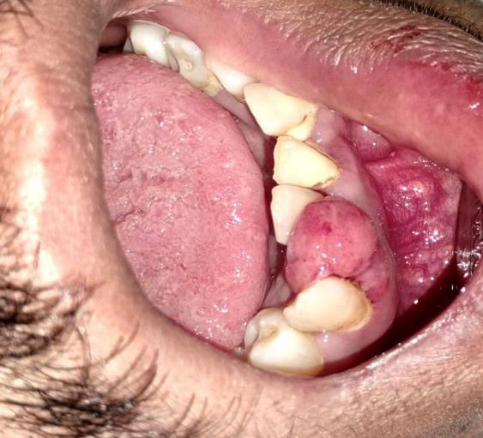

Fig.1 Pedunculated gingival growth

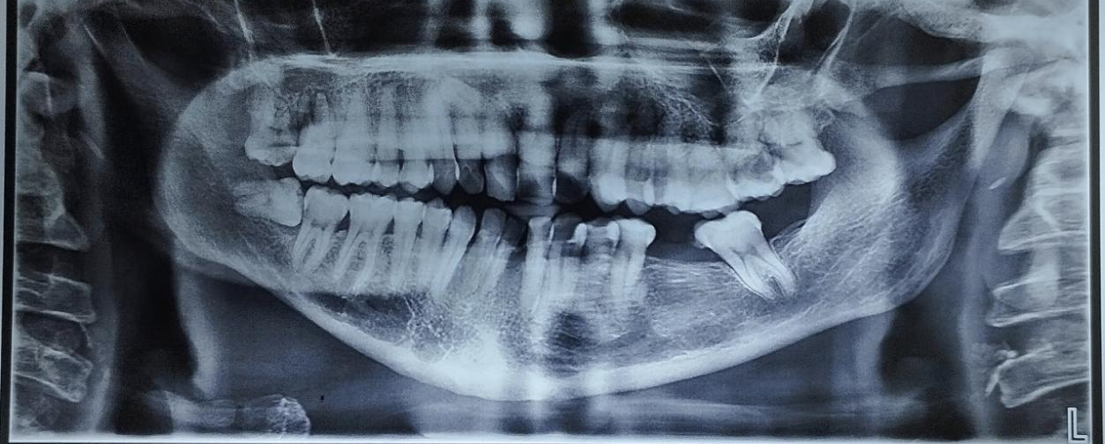

Fig.2 Radiopaque mass

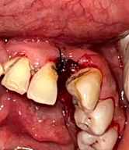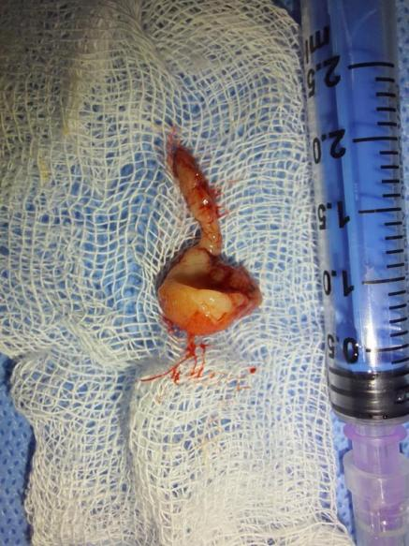

Fig.3A, B: Excisional biopsy of the lesion

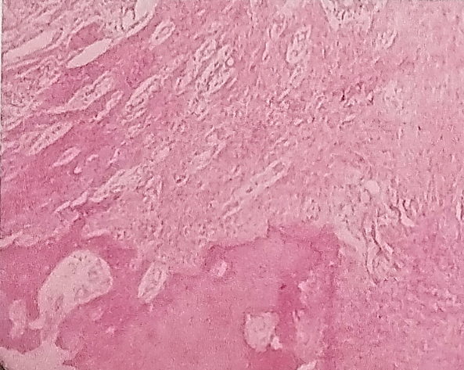

Fig.4 Histopathological examination Finding

Discussion

Peripheral ossifying fibroma occurs mostly in craniofacial bones and categorized into two types central and peripheral. The central type of ossifying fibroma arises from the endosteum or the periodontal ligament (PDL) adjacent to the root apex and expands from the medullary cavity of the bone, and the peripheral type occurs on the soft tissues overlying the alveolar process^{1,2,3}.

POF may initially develop as pyogenic granuloma that undergoes subsequent fibrous maturation and calcification. It represents the progressive stage of the same spectrum of pathosis. POF is due to inflammatory hyperplasia of cells of periodontal ligament/ periosteum. Metaplasia of the connective tissue leads to dystrophic calcification and bone formation². Hormonal influences may play a role, as it has higher incidence among females, increasing occurrence in the second decade and declining incidence after the third decade(Kenney et al,1989). The rate of recurrence has been reported to vary from 8.9%to20 % (Bhaskar & Jacoway, 1966;Kenneyet al,1989; Eversole & Rovin,1972)⁴ .

Triggering factors such as subgingival plaque and calculus, dental appliances, poor quality of dental restorations, micro-organisms and food lodgement initiate the inflammatory response⁵. Clinically POF presents as smooth lobulated pink mass on a pedunculated or sessile base. It has an increasing incidence in 2nd decade and declining incidence after 3rd decade⁶.

Clinical differential diagnosis for gingival growths includes fibroma, peripheral giant cell granuloma, pyogenic granuloma, peripheral odontogenic fibroma, and POF. The definitive diagnosis of POF is made by the histologic evaluation of biopsy specimen⁷. Although peripheral giant cell granuloma has clinical features similar to those of POF, the latter lacks the purple or blue discoloration commonly associated with peripheral giant cell granuloma and radiographically shows small flecks of calcification. Thus, the diagnosis based only on clinical aspects can be difficult, and histopathological examination of the surgical specimen obtained by excisional biopsy is mandatory for an accurate diagnosis of POF⁷.

Histopathologically, there is also a wide spectrum of changes changeable Journal of Interdisciplinary Dental Sciences, Vol.12, No.1 January-June 2023, 01-05 4 from chronically, well-off cellular granulation tissues to moderately noninflamed, avascular masses of collagen⁸.Treatment includes local surgical excision and oral prophylasis. Follow-upis essential because of the recurrence rates varying from 8 to 20%⁹.

Conclusion
This case report presents a comprehensive evaluation of peripheral ossifying fibroma in a 50-year-old male patient. POF is a common reactive gingival lesion that requires clinical suspicion, thorough diagnostic evaluation, and complete excision to prevent recurrence.
- POF should be included in the differential diagnosis of any gingival growth
- Histopathological examination is essential for definitive diagnosis
- Complete excision including periosteum and periodontal ligament is necessary
- Elimination of local irritants is crucial for preventing recurrence
- Long-term follow-up is mandatory due to the 8-20% recurrence rate
This case emphasizes the importance of maintaining a broad differential diagnosis for gingival proliferations and the necessity of histopathological confirmation. Despite its benign nature, POF requires careful surgical management and vigilant postoperative monitoring to ensure optimal patient outcomes.

Patient Perspective
The patient expressed satisfaction with the treatment outcome and understood the importance of maintaining good oral hygiene and attending regular follow-up appointments to prevent recurrence.

Informed Consent
Written informed consent was obtained from the patient for publication of this case report and accompanying images.

References
- Bhasin M, Bhasin V, Bhasin A. Peripheral ossifying fibroma. Case Rep Dent 2013;2013: 497234. doi:10.1155/2013/497234
- Mohiuddin K, Priya NS, Ravindra S, Murthy S. Peripheral ossifying fibroma. J Indian Soc Periodontol. 2013;17(4):507-509. doi: 10.4103 /0972-124 X.118325
- Poonacha KS, Shigli AL, Shirol D. Peripheral ossifying fibroma: A clinical report. Contemp Clin Dent. 2010;1(1):54-56. doi:10.4103/0976-237X. 62520
- Aena Jain DD. Recurrence of peripheral ossifying fibroma: A case report. People’s Journals cientific Research. 2010;3(1):24-6.
- Chatterjee A, Ajmera N, Singh A. Peripheral cemento-ossifying fibroma of maxilla. J Indian Soc Periodontol 2010;14:186-9.
- Jain A, Deepa D. Recurrence of peripheral ossifying fibroma: A case report. People’s J Sci Res 2010;3:23-5.
- Chaturvedy V, Gupta AK, Gupta HL, Chaturvedy S. Peripheral ossifying fibroma, some rare findings. J Indian Soc Periodontol. 2014 Jan;18(1):88-91. doi: 10.4103/0972-124X.128249. PMID: 24744553; PMCID: PMC3988653.
- Hunasgi S, Koneru A, Vanishree M, Manvikar V. Assessment of reactive gingival lesions of oral cavity: A histopathological study. J Oral Maxillofac Pathol. 2017 Jan-Apr;21(1):180
- Sujatha G, Sivakumar G, Muruganandhan J, Selvakumar J, Ramasamy M. Peripheralos sifying fibroma-report of a case. Ind J Multidisciplinary Dentistry. 2011; Nov1;2 (1) 415- 418.
- Buchner A, Hansen LS. The histomorphologic spectrum of peripheral ossifying fibroma. Oral Surg Oral Med Oral Pathol. 1987;63(4):452-461.
- Kenney JN, Kaugars GE, Abbey LM. Comparison between the peripheral ossifying fibroma and peripheral odontogenic fibroma. J Oral Maxillofac Surg. 1989;47(4):378-382.
- Neville BW, Damm DD, Allen CM, Chi AC. Oral and Maxillofacial Pathology. 4th ed. St. Louis: Elsevier; 2016.
- Barnes L, Eveson JW, Reichart P, Sidransky D, editors. World Health Organization Classification of Tumours: Pathology and Genetics of Head and Neck Tumours. Lyon: IARC Press; 2005.
- Kohli K, Christian A, Howell R. Peripheral ossifying fibroma associated with a neonatal tooth: case report. J Clin Pediatr Dent. 1998;23(1):49-51.
- Cuisia ZE, Brannon RB. Peripheral ossifying fibroma: a clinical evaluation of 134 pediatric cases. Pediatr Dent. 2001;23(3):245-248.
- Farquhar T, Maclellan J, Dyment H, Anderson RD. Peripheral ossifying fibroma: a case report. J Can Dent Assoc. 2008;74(9):809-812.
- Zhang W, Chen Y, An Z, Geng N, Bao D. Reactive gingival lesions: a retrospective study of 2439 cases. Quintessence Int. 2007;38(2):103-110.
- Pal S, Hegde S, Ajila V. The varying clinical presentations of peripheral ossifying fibroma: a report of three cases. Rev Odonto Ciênc. 2012;27(3):251-255.
- Moon WJ, Choi SY, Jeong HS, et al. Peripheral ossifying fibroma in the oral cavity: CT and MR findings. Dentomaxillofac Radiol. 2007;36(3):180-182.
- Chaudhari S, Umarji HR. Peripheral ossifying fibroma in the oral cavity: MRI findings. Case Rep Dent. 2011;2011:190592.

