Effect of Shelf Storage Temperature and Curing Time on the Microhardness of Zirconium Containing Nano-Hybrid Resin Composite – An In Vitro Study

Abstract
Background: Adequate polymerization is a fundamental factor in achieving optimal mechanical properties and enhanced clinical performance of composite materials. Surface hardness is an important property that enables the resin composite to resist plastic deformation, penetration and scratching which is necessary for aesthetic properties and indicates the easiness of finishing and polishing procedures.
Objective: The purpose of this study is to evaluate the effect of shelf storage temperature and different curing time on microhardness of composite.
Materials and methods: Specimens were divided into 3 groups. Group I storage at room temperature, Group II storage in refrigerator and Group III: 30 minutes post removal from refrigeration. A total of 36 RBC disc-shaped specimens (2mm thickness and 5mm diameter) were fabricated from a single restorative material (ESCOM 250). Again, specimens were divided into 2 subgroups. Subgroup A was light cured for 10seconds and Subgroup B was light cured for 20 second through Mylar strip and glass slide using light emitting diode curing device. The specimen was assessed for Vickers microhardness.
Results: For Group I and Group III, curing for 20 seconds results in significantly higher microhardness for both top and bottom surfaces (P- Value >0.05). This suggests that a 20-second curing time is more effective than 10 seconds. Specimens that were refrigerated and cured for 10seconds exhibited the lowest microhardness suggesting that both factor storage temperature and curing duration are interdependent.
Conclusion: Temperature and light-curing time significantly impact the surface microhardness of composite materials, with variations in these factors affecting microhardness values.
Keywords: Composite Resin, Microhardness, Storage Temperature, Curing Time

INTRODUCTION:
The effectiveness of dental composites in restorative dentistry is largely attributed to their excellent aesthetic properties and sufficient durability. The physical and mechanical properties of photocured composites, such as wear resistance, hardness, and flexural strength, are directly impacted by the degree of conversion achieved during the polymerization process (Ribeiro et al., 2012). A higher degree of conversion leads to enhanced mechanical properties, including improved wear resistance, increased hardness, and greater flexural strength (J. L. Ferracane et al., 1997). The clinical success of composite resins is highly dependent on the extent of monomer conversion achieved during photopolymerization. Several key factors influence this process, including the material's composition, shade, and translucency, as well as the light-curing unit's characteristics, curing distance, and duration of curing, and the temperature of composite. Understanding and controlling these parameters is essential to achieve optimal polymerization and ensure the success of composite restorations.^{1,2,15}
Microhardness measurements of resin composite serve as a reliable indicator of degree of conversion (DC), which in turn, is a crucial factor in determining the clinical success of resin composite restorations. A link between surface microhardness and degree of conversion has been identified, indicating that microhardness values (such as Vickers hardness number) can be used as a simple and effective measure of mechanical strength. ^{3,4}
Curing resin composite for an insufficient duration can result in a material with reduced hardness, elasticity, and resistance to deformation, ultimately affecting the restoration's overall performance. ⁽¹⁾The temperature at which composites are stored before curing has a profound effect on the polymerization process, impacting the final properties of the material. Although refrigerated storage is a common practice for extending the shelf life of resin-based materials, as recommended by manufacturers, there is a scarcity of research investigating the impact of cooling on resin-based composites. The existing studies have yielded conflicting results, highlighting the need for further investigation. Additionally, manufacturers typically advise storing composite syringes in the refrigerator, but the effects of precooling on the material's properties are not well understood. As there was no clear guideline on the optimal time to use composite restorative materials after taking them out of the refrigerator, a study was conducted to compare the effects of immediate and delayed use following refrigeration removal. ^{5,6}
Therefore, this study aims to evaluate the Effect of Shelf Storage Temperature and Different Curing Times on the Microhardness of Zirconium Containing Nano-Hybrid Resin Composite.
The objectives of this study are
To evaluate the effect of different curing times (10seconds and 20 seconds) on the microhardness of nano-hybrid zirconium resin based composite restorations.
To assess the impact of shelf storage on the microhardness of nano-hybrid zirconium resin based composite restorations.
To compare the microhardness of nano-hybrid zirconium resin based composite restorations cured for different time intervals and stored at different temperatures.
To determine correlation between curing time, storage temperature and microhardness.

METHODOLOGY:
Restorative materials
In this study Nanohybrid zirconium restorative composite (ESCOM 250) was used. A specimen was divided into 3 groups. Group I storage at room temperature, Group II storage in refrigerator and Group III: 30 minutes after removal from refrigeration. A total of 36 composite disc-shaped specimens was fabricated from a single restorative material (nano-hybrid zirconium restorative composite), 12 discs in each group. The composite was placed into a plastic mold with dimensions of 2 mm in thickness and 5 mm in diameter. The mold was prepared for resin packing by placing a mylar strip on a glass slab, followed by positioning the mold on the mylar strip, and then filling it with composite resin. After placing the composite, A mylar strip was placed over the composite, followed by a microscopic glass slide, to prevent the formation of an air-inhibited layer on the top surface. It was pressed to remove excess material, ensuring a smooth and uniform exterior surface.. Subsequently, the top of each specimen irradiated for the designated time. Samples were divided into 2 subgroups. Subgroup A was light cured for 10seconds and Subgroup B was light cured for 20 seconds through Mylar strip and glass slide using light emitting diode (LED) curing device. The tip of the light-curing device was positioned perpendicular to the specimen’s surface, maintaining direct contact with the glass slide. To ensure consistent curing, a standardized distance of 1 mm was maintained between the composite material and the light-curing device. ^{1,6} (image a,b,c,d)
For refrigerated composite materials, the composite syringe was stored in a refrigerator for at least 30 minutes to stabilize its temperature at 4–5 °C. After refrigeration, the syringe was promptly removed, and the composite material was immediately applied to the mold before significant temperature changes occurred. The syringe was then returned to the refrigerator and replaced with another refrigerated syringe for preparing the next specimen. All specimens were stored in a dry, dark environment at 37 °C for 24 hours before testing. ⁽⁴⁾ ⁽ figure 1)

Microhardness Test:
The microhardness of the composite resin materials was assessed by measuring the Vickers hardness values on both the top and bottom surfaces of each sample. The load applied was 1 newton and a dwell time of 10 seconds. Indentation was made using Vickers microhardness indenter which has a pyramidal diamond microindentor of 136° (where the two diagonals of the indentation left in the surface of the material are measured). diagonals of indentations were measured using digital microscope and D1, D2 values were obtained. (Figure 2,3 ) ¹⁴
Vickers microhardness was calculated using the following formula
VHN= 1.854F/d²
Where F is the load applied in Newtons and d is the mean length of the two diagonals of each indentation. 1.854 was a constant. ⁷
Statistical Analysis:
Data that were obtained from the microhardness tester were analysed using the statistical software SPSS version 27. A parametric Analysis of variance (ANOVA) was used for comparing more than two groups followed by post-hoc Tuckey test for in-between groups comparisons, and independent t-test for comparing two quantitative data. The level of significance was set at P<0.05.
Results:
Table 1: Mean values and P- value (VHN) of each experimental group for composite specimen

Groups | Subgroup | Top Mean | Bottom Mean | P - Value
I | 10s | 77.42 | 62.68 | 0.033
I | 20s | 92.65 | 87.76 | 0.153
II | 10s | 65.86 | 49.88 | 0.021
II | 20s | 68.65 | 53.65 | 0.067
III | 10s | 80.43 | 64.73 | 0.023
III | 20s | 89.53 | 85.14 | 0.189

GRAPH I Bar Chart showing the Top Mean and the Bottom Mean of each experimental group and subgroup

In Group I, the difference in microhardness values between the top and bottom surfaces is statistically significant for the 10-second curing time (p-value = 0.033), but not for the 20-second curing time (p-value = 0.153).
- In Group II, the difference in microhardness values between the top and bottom surfaces is statistically significant for both the 10-second (p-value = 0.021) and 20-second (p-value = 0.067) curing times.
- In Group III, the difference in microhardness values between the top and bottom surfaces is statistically significant for the 10-second curing time (p-value = 0.023), but not for the 20-second curing time (p-value = 0.189).
The p-value represents the probability of observing the difference in microhardness values between the top and bottom surfaces by chance. A p-value less than 0.05 indicates a statistically significant difference.
Table 2 Inter- Group Comparison Between Groups Using Post Hoc Tuckey

Comparison | Time | Surface | Mean Difference | F-Value (Approx) | p-Value (Approx)
Group I vs. Group II | 10 sec | Top | 11.56 | 34.05 | < 0.001
Group I vs. Group II | 10 sec | Bottom | 12.8S | 30.43 | < 0.001
Group I vs. Group III | 10 sec | Top | -3.01 | 1.9 | 0.19
Group I vs. Group III | 10 sec | Bottom | -2.05 | 0.64 | 0.43
Group II vs. Group III | 10 Sec | Top | -14.57 | 41.78 | < 0.001
Group II vs. Group III | 10 Sec | Bottom | -14.85 | 38.34 | < 0.001
Group I vs. Group II | 20 sec | Top | 24 | 98.43 | < 0.001
Group I vs. Group II | 20 sec | Bottom | 34.11 | 178.6 | < 0.001
Group I vs. Group III | 20 sec | Top | 3.12 | 1.72 | 0.2
Group I vs. Group III | 20 sec | Bottom | 2.62 | 1.06 | 0.32
Group II vs. Group III | 20 sec | Top | -20.88 | 75.69 | < 0.001
Group II vs. Group III | 20 sec | Bottom | -31.49 | 141.2 | < 0.001

For Group I and Group III, curing for 20 seconds results in significantly higher microhardness for both TOP and BOTTOM surfaces (P- Value >0.05). microhardness suggests that a 20-second curing time is more effective than 10 seconds.
There are no significant differences between microhardness scores of Group I and Group III in most comparisons.
Microhardness scores of Group II is significantly lower than Group I and Group III for both surfaces at both times (p < 0.001

DISCUSSION
Achieving optimal hardness in composite resin restorations is crucial for treatment success. Research has shown that two key factors significantly influence restoration hardness: the duration of curing light exposure and the temperature of the precured composite. By understanding the impact of these factors on the degree of polymerization, clinicians can optimize restoration hardness and ensure a favorable long-term prognosis.⁵
Hardness tests, particularly the Vickers microhardness test (VHN), are widely employed to assess the curing depth and polymer crosslinking of dental composites, as well as their wear resistance, polishability, and potential to abrade opposing teeth. Microhardness data provide valuable insights into a material's properties, with surface hardness often expressed as a percentage, where 100% represents the maximum achievable surface hardness. This comparative approach enables the evaluation of a material's hardness relative to its optimal potential. ⁶
If composite resin does not cure well, it results in a reduced monomer conversion rate which leads to 1) Reduced Mechanical Strength: Inadequate curing can lead to a lower monomer conversion rate, resulting in a weaker restoration that may be prone to cracking or breaking. 2) Color Changes and Allergic Reactions: Uncured monomers can oxidize, causing color changes or discoloration of the restoration. Additionally, these uncured monomers can leach out and cause allergic reactions or sensitivities. 3) Leakage and Pulp Irritation: Inadequate curing can lead to gaps or voids in the restoration, allowing bacteria, saliva, or other substances to leak into the pulp chamber and cause irritation or infection. 4) Retention Failures: A weak or inadequately cured restoration may not bond properly to the tooth structure, leading to retention failures or debonding. 5) Surface Finish Issues: Inadequate curing can make it challenging to achieve a smooth surface finish, leading to rough or uneven surfaces that can harbour bacteria or stain. 6) Poor Durability: Inadequate curing can compromise the restoration's resistance to degradation in the oral environment, leading to a shorter lifespan. ^{6,8}
In the present study, parameters that could alter the microhardness of resin composite were observed, including changes in its precured temperature, and curing time.
The results of this study showed that the top surfaces of the composite specimens consistently exhibited higher Vickers Hardness Numbers (VHNs) compared to the bottom surfaces across all experimental groups. This disparity can be attributed to two possible factors: 1) Proximity to the light source: The top surfaces, being closer to the light source, received a higher energy density, leading to increased polymerization and hardness. 2) Attenuation of light: As light travels through the composite material, its intensity decreases, resulting in reduced polymerization and hardness at the bottom surfaces. Alternatively, the observed difference in hardness may be due to the insufficient curing time recommended by the manufacturers and used in this study, which may not have allowed for adequate polymerization at the bottom surfaces. ^{6,9}
Impact of Storage Temperature on Microhardness:
The refrigerator-stored groups showed substantially lower microhardness values than the other two groups, due to the detrimental effects of low temperature on the material's properties, specifically increased viscosity, impeded monomer movement, and delayed polymerization reaction. This resulted in a reduced extent of monomer conversion. This finding coincides with Osternack et al. who reported that refrigerated composite materials had statistically lower hardness values. ¹³ Hassel et al. (2019) found that decreased temperatures can alter the polymerization kinetics, potentially leading to lower degrees of conversion and, consequently, reduced hardness. Daronch et al. also suggested that refrigerator-stored composites should not be used clinically until they reach room temperature. Studies by Kwon et al. (2018) and Caspino et al. (2020), storage at lower temperatures can lead to incomplete polymerization or a delay in the curing process, which often results in a reduction in the hardness and overall mechanical performance of the composite materials. Microhardness values obtained for group I (storage at room temperature) and for group II (30 minutes post removal from refrigerator) were almost same. Hence, refrigerated composite should be used once it reaches the room temperature ^{4,6}
Effect of Curing Time on Microhardness:
The study found that curing time has a significant impact on the microhardness of composites, with a 20-second curing time resulting in better microhardness compared to 10 seconds. This is because extended curing times allow for more complete cross-linking of the resin matrix, leading to improved mechanical properties and resistance to deformation. This finding is consistent with previous findings by Bertoldo et al. (2017) and Jung et al. (2021), which showed that increasing the curing time from 10 to 20 seconds enhances the polymerization process, resulting in higher microhardness values. These findings corroborate the recommendations by Bashir et al. (2018), which suggest that longer curing times are often necessary to achieve optimal hardness and mechanical performance in resin composites. ^{1,11}
Interaction Between Storage Temperature and Curing Time:
The lowest microhardness values were observed in specimens that were both refrigerated and cured for shorter durations, highlighting the interconnectedness of these two factors. This suggests that the material's properties are influenced by the interaction between storage conditions and curing duration, rather than either factor alone. According to Santos et al. (2016), the effectiveness of the curing process can be impaired if the composite material is exposed to less-than-ideal storage conditions prior to curing, emphasizing the importance of proper storage to ensure optimal curing outcomes.¹²
CLINICAL IMPLICATIONS
- Restoration Longevity: Achieving adequate hardness of composite materials is crucial for the longevity of dental restorations.
- Curing Protocols: Proper curing of composites is essential to achieving optimal hardness. Inadequate curing can result in lower hardness and reduced wear resistance, affecting the performance of the restoration.
- Storage Conditions: Proper storage of composite materials is essential to maintain their mechanical properties. Composites should ideally be stored at room temperature to avoid issues related to premature curing or alterations in resin viscosity. If storing in the refrigerator do not use composite materials immediately. Allow 30 minutes for temperature equilibration at room temperature to ensure optimal performance."^{13,14,15}

CONCLUSION:
The noticeable differences in hardness between the top and bottom surfaces of the composite material emphasize the crucial need for sufficient curing and uniform light penetration to achieve optimal hardness. Furthermore, the negative impact of refrigerated storage on hardness underscores the importance of proper storage conditions to ensure the material performs optimally.
Despite the limitations of this study, the findings highlight the significant role of both curing time and storage temperature in determining the microhardness of zirconium-containing nano-hybrid resin composites. Therefore, clinicians should carefully consider these factors to improve the quality and longevity of composite restorations.
Additional research is necessary to comprehensively evaluate the impact of refrigeration on polymerization shrinkage, fracture resistance, and wear rates of composite restorative materials, in order to inform optimal clinical practice and ensure the long-term success of composite restorations.

REFRENCES:

- Barakah H. Effect of different curing times and distances on the microhardness of nanofilled resin-based composite restoration polymerized with high-intensity LED light curing units. The Saudi Dental Journal. 2021 Dec 1;33(8):1035-41.
- Dionysopoulos D, Papadopoulos C, Koliniotou-Koumpia E. Effect of temperature, curing time, and filler composition on surface microhardness of composite resins. Journal of Conservative Dentistry and Endodontics. 2015 Mar 1;18(2):114-8.
- AlShaafi MM. Effects of different temperatures and storage time on the degree of conversion and microhardness of resin-based composites. J Contemp Dent Pract. 2016 Mar 1;17(3):217-3.
- El-Maksoud OA, Hamama HH, Wafaie RA, El-Wassefy N, Mahmoud SH. et al. Effect of shelf-storage temperature on degree of conversion and microhardness of composite restorative materials. BMC Oral Health. 2023 Jan 31;23(1):57.
- Torres R, Caneppele T, Borges AB, Torres A, Araújo MA. Influence of pre-cure temperature on Vickers microhardness of resin composite. Int J Contemp Dent. 2011;2(1):41-5.
- Almozainy M. Influence of storage temperature on vickers microhardness of resin composite. Annals and Essences of Dentistry. 2018;10(1):1-1.
- Contreras RG, Vilchis RJ, Torres LS, Arrocena MC, García-Garduño R, de la Fuente Hernández J. Vickers microhardness comparison of 4 composite resins with different types of filler. Journal of Oral Research. 2015;4(5):313-20.
- Puspitasari D, Prasetyo A, Rahman MD, Diana S, Nahzi MY. Storage temperature effect on degree of polymerization and surface hardness of bulk-fill composite resin. Journal of International Dental and Medical Research. 2019 May 1;12(2):405-10.
- Lin GS, Ghani NR, Ismail NH, Singbal K, Noorani TY, Mamat N. New experimental zirconia-reinforced rice husk nanohybrid composite and the outcome of Its surface roughness and microhardness in comparison with commercialized nanofilled and microhybrid composite resins. Contemporary clinical dentistry. 2021 Jan 1;12(1):21-7.
- Abouelmagd DM, Basheer RR. Microhardness evaluation of microhybrid versus nanofilled resin composite after exposure to acidic drinks. Journal of International Society of Preventive and Community Dentistry. 2022 May 1;12(3):353-9.
- Lima AF, de Andrade KM, da Cruz Alves LE, Soares GP, Marchi GM, Aguiar FH, Peris AR, Mitsui FH. Influence of light source and extended time of curing on microhardness and degree of conversion of different regions of a nanofilled composite resin. Eur J Dent. 2012 Apr;6(2):153-7. PMID: 22509117; PMCID: PMC3327489.
- Castro FL, Campos BB, Bruno KF, Reges RV. Temperature and curing time affect composite sorption and solubility. J Appl Oral Sci. 2013 Mar-Apr;21(2):157-62. doi: 10.1590/1678-7757201302298. PMID: 23739853; PMCID: PMC3881881.
- Osternack FH, Caldas DB, Rached RN, Vieira S, Platt JA, Almeida JB. Impact of refrigeration on the surface hardness of hybrid and microfilled composite resins. Brazilian Dental Journal. 2009;20:42-7.

- Lin GSS, Ghani NRNA, Ismail NH, Singbal K, Noorani TY, Mamat N. New Experimental Zirconia-Reinforced Rice Husk Nanohybrid Composite and the Outcome of Its Surface Roughness and Microhardness in Comparison with Commercialized Nanofilled and Microhybrid Composite Resins. Contemp Clin Dent. 2021 Jan-Mar;12(1):21-27. doi: 10.4103/ccd.ccd_298_20. Epub 2021 Mar 20. PMID: 33967533; PMCID: PMC8092096.
- Marovic D, Panduric V, Tarle Z, Ristic M, Sariri K, Demoli N, Klaric E, Jankovic B, Prskalo K. Degree of conversion and microhardness of dental composite resin materials. Journal of molecular structure. 2013 Jul 24;1044:299-302.

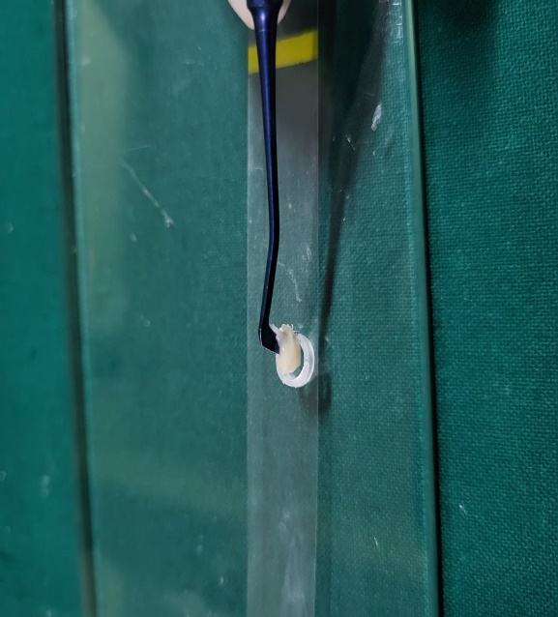
a

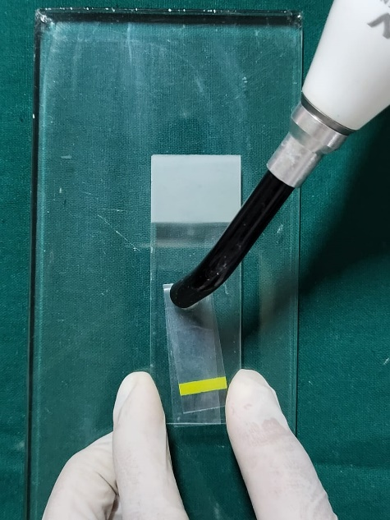
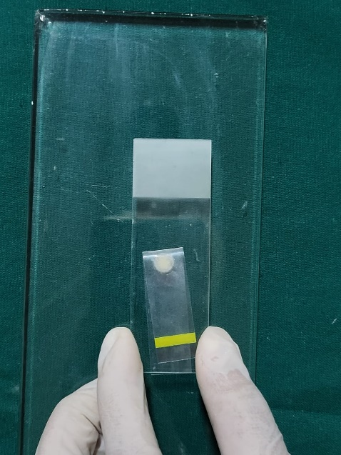
b
c

d

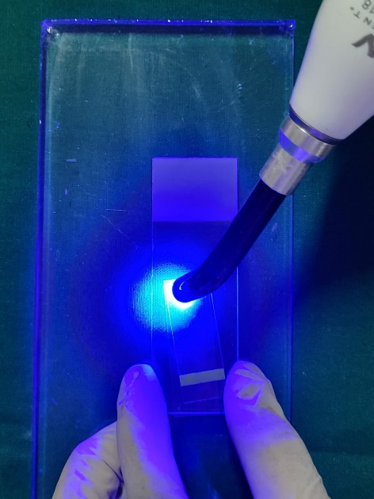

Figure 1: Specimens stored in a dry, dark environment at 37 °C for 24 hours before testing

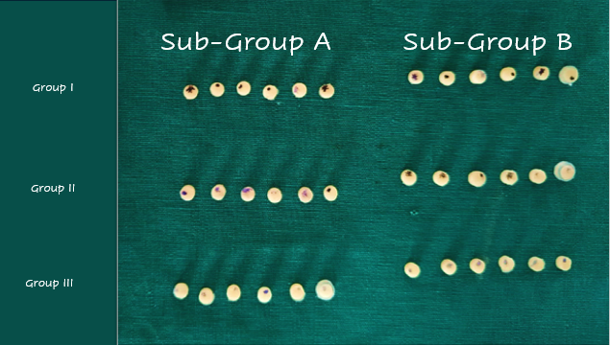

Figure 2: MICROHARDNESS INDENTER

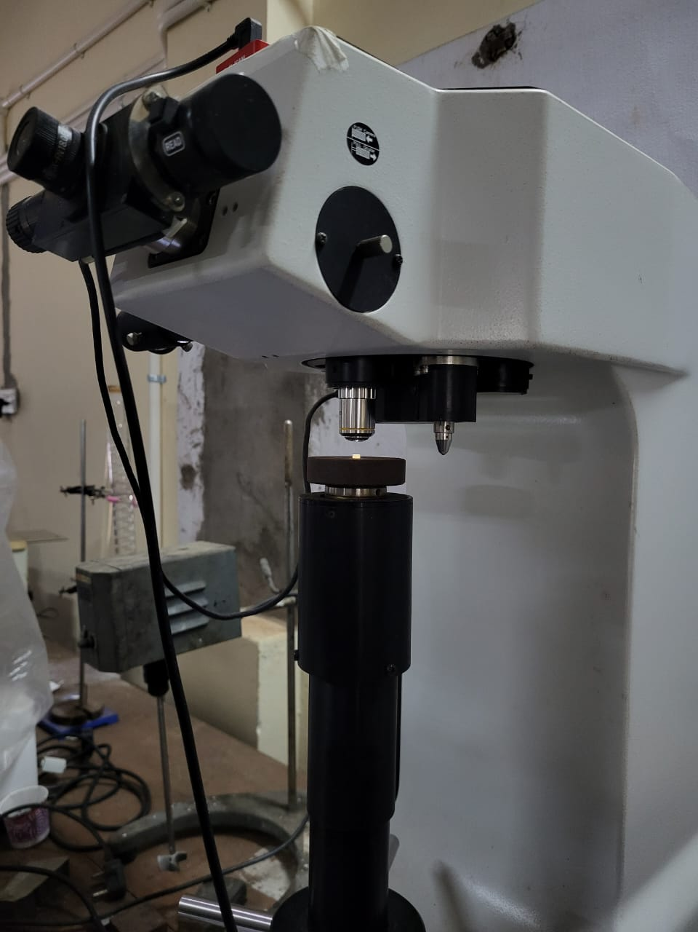

Figure3 : DIGITAL MICROSCOPE

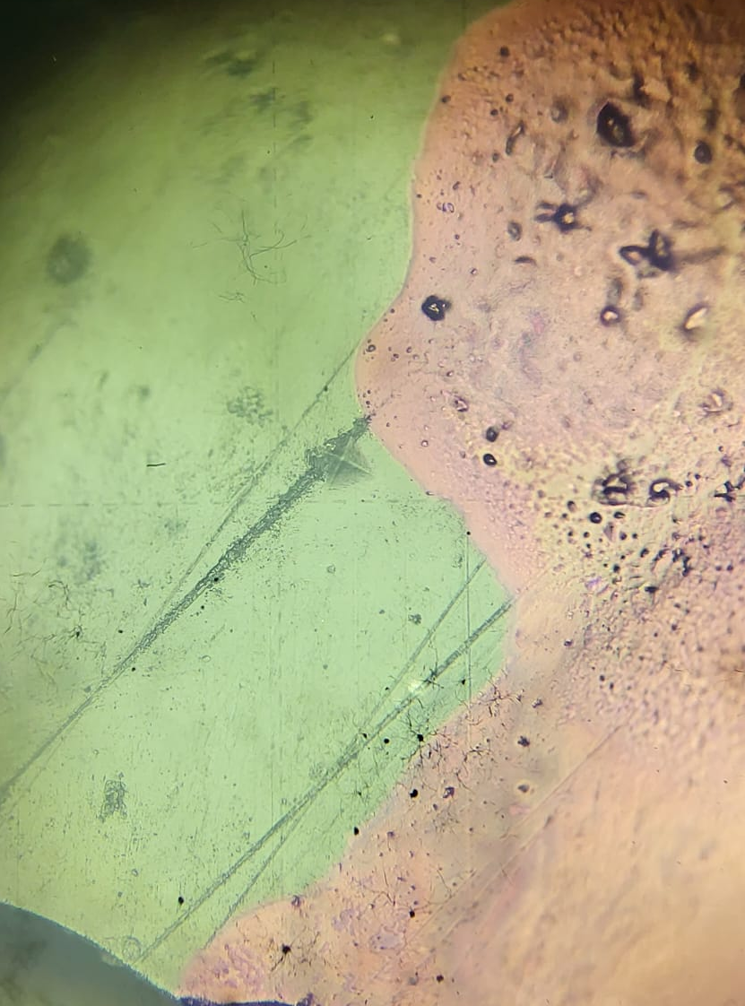
Figure 4: Microscopic Observation

