Case study
Rooted in Complexity - A case series on Radix Entomolarisin Mandibular Molar

Abstract
Radix entomolaris (RE) is an uncommon anatomical variation characterized by the presence of an additional distolingual root in mandibular molars, most frequently the first molar. Its presence poses diagnostic and clinical challenges, especially during endodontic treatment. This case series presents [insert number] clinical cases of mandibular first molars with RE, emphasizing the importance of accurate diagnosis, modified access preparation, and careful canal negotiation. Radiographic evaluation, including angled periapical radiographs and cone-beam computed tomography (CBCT), played a crucial role in detecting the extra root. All cases were managed using magnification and enhanced illumination to facilitate identification and treatment of the RE canal. Endodontic therapy was completed successfully in all cases, with favorable postoperative outcomes observed during follow-up. This series highlights the necessity for clinicians to be aware of root canal variations such as RE and to adapt their techniques accordingly to ensure successful treatment outcomes.
Keywords: Anatomical variation, endodontics, extra root, mandibular molar, Radix entomolaris.

Introduction
Endodontic treatment aims to eliminate microorganisms from the root canal system and prevent reinfection through effective cleaning, shaping, and sealing. A common reason for failure is complex canal anatomy and missed canals.^{[1]} Understanding root morphology, including variations like extra canals, fins, and supernumerary roots, is crucial—especially in mandibular molars. The mandibular first molar, typically with two roots and three canals, is the most frequently treated tooth in endodontics.^{[2]} A notable variation is the Radix Entomolaris (RE), a third root located distolingually, first described by Carabelli in 1844. Less commonly, a third root may appear mesiobuccally as the Radix Paramolaris (RP).^{[3]}
^{Prevelance}
The prevalence of three-rooted mandibular molars varies significantly among different ethnic groups. According to a 1993 study by Ferraz and Pecora, this anatomical variation was observed in 2.6% of individuals from Mongoloid populations, 1.8% among those of African descent, and 1.7% in Caucasians. Similarly, Costa Rocha et al. (1996) found a prevalence rate of 1.5% in the general population. A study by Segura-Egea and colleagues in 2002 reported that the incidence was below 5% in Caucasian, African, Eurasian, and Indian populations, but ranged from 5% to as high as 40% in Mongoloid populations.^{[⁴]}
That same year, Gulabivala et al. recorded a 13% occurrence rate of three-rooted mandibular molars in the Thai population. Calberson and De Moor also reported similar findings, noting a prevalence between 3.4% and 4.2% in European populations, under 5% in Eurasian and Indian populations, and between 5% and 40% in Mongoloid groups. Furthermore, Quackenbush highlighted that this additional root was unilateral in approximately 40% of cases, with a higher occurrence on the right side.
Ribeiro and Consolaro proposed a classification for radix entomolaris as following.^{[ 5]}
Type I refers to a straight root/root canal.
Type II to an initially curved entrance and the continuation as a straight root/root canals.
Type III to an initial curve in the coronal third of the root canal and a second buccally orientated curve starting from the middle to apical third.
This case series describes radix entomolaris , its challenges and various management protocol
Case Presentation
Case 1
A 26-year-old male presented to the Department of Conservative Dentistry and Endodontics, Adhiparasakthi Dental College, Melmaruvathur, with pain in the lower left back region. He reported intermittent pain for 6 months, which worsened over the past 3 days. Clinical examination revealed an extensive occlusal carious lesion in tooth 36 with tenderness on percussion. An electric pulp test showed a positive response. Preoperative radiographs revealed deep caries involving the pulp and an extra root between the mesial and distal roots. Additional angled radiographs confirmed a distolingual root. Local anesthesia (2% Lignocaine with 1:80,000 adrenaline) was administered, and the tooth was isolated with a rubber dam. After caries removal, a trapezoidal access cavity was prepared. Four canal orifices—two mesial and two distal (one lingually positioned)—were located. Working lengths were determined using radiographs and an apex locator (J Morita ZX Mini, Japan). Glide paths were established up to size 15 K-files. Shaping was performed with HyFlex rotary files up to size 30/4%. Irrigation was done with 5.25% sodium hypochlorite, using RC-Help as a lubricant. A final rinse with 5.25% NaOCl and 17% EDTA (Neo EDTA) was completed. Canals were obturated using matched Gutta Percha cones and bioceramic sealer (Safe Endo). [figure 1]

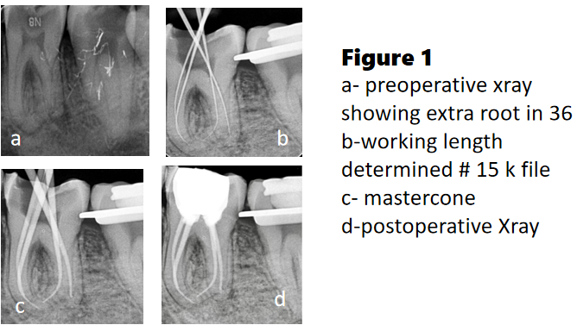
Case 2
A 20-year-old female presented to the Department of Conservative Dentistry and Endodontics, Adhiparasakthi Dental College, with pain in the lower right posterior region. Tooth 46 showed a positive pulp test, tenderness on percussion, and was diagnosed with apical periodontitis. Clinical exam revealed Class I caries. Radiograph showed deep caries and an additional root, indicating Radix Entomolaris (RE).,Under local anesthesia and rubber dam isolation, access was gained using an Endo Z bur. A buccal distal canal was located, suggesting a lingual one. The access was modified to a trapezoidal shape to locate four canals using a DG-16 explorer and #10 K-file.
Working lengths were established electronically and radiographically. Cleaning and shaping were done with rotary files, 2.5% NaOCl irrigation, and 17% EDTA as lubricant. The canals were obturated with gutta-percha and bioceramic sealer, followed by composite restoration and a post-op radiograph.
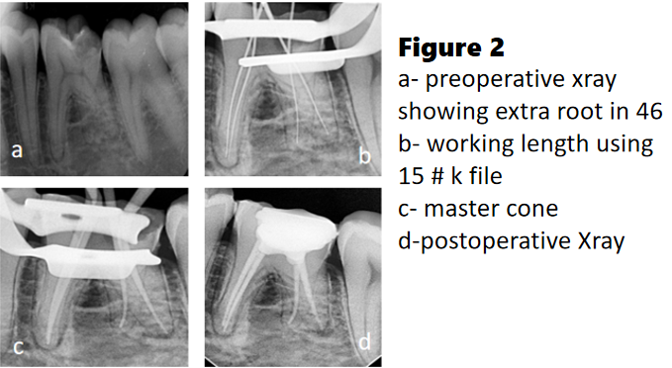

Case 3
A 30-year-old male presented with pain in the lower right molar region. Examination showed Class I caries in tooth 46. Radiographs revealed radiolucency near the pulp and an extra lingual root consistent with radix entomolaris. Diagnosed with acute irreversible pulpitis and apical periodontitis, root canal therapy was planned.
Under local anesthesia and rubber dam, access was prepared using an Endo Z bur. A buccal distal canal was found, indicating a second distal canal lingually. The access cavity was modified from triangular to trapezoidal. Canal orifices were located with a DG-16 explorer and #10 K-file. Working lengths were determined electronically and radiographically.
Cleaning and shaping were done with NT Rainbow rotary files up to size 30/0.04 (distal) and 25/0.04 (mesial). Irrigation used 2.5% sodium hypochlorite and 17% EDTA. Canals were obturated by cold lateral condensation with gutta-percha. The cavity was restored with amalgam, and a post-op radiograph taken..
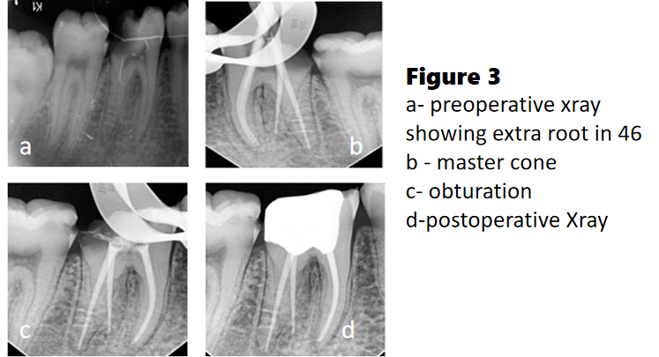
.

Discussion
Radix Entomolaris (RE) represents a distinct additional root rather than a simple division of the distal root, possessing its own separate canal orifice and apical exit. Recognizing this distinct anatomy is essential for accurate diagnosis and effective root canal therapy. Although the exact cause of Radix Entomolaris and Radix Paramolaris is still unknown, recent studies suggest that their development may be influenced by racial genetic factors, environmental conditions during tooth formation, and the activation of atavistic or polygenic genetic traits.
The standard triangular access cavity often requires modification to a trapezoidal or rectangular shape to effectively locate and access the Radix Entomolaris (RE) canal. Using a sharp endodontic explorer, magnification, and proper burs is vital to avoid perforation and ensure straight-line access.
A third root in mandibular molars commonly indicates the presence of two distinct distal canals. Typically, the distolingual canal follows a Type I pattern, emerging from the pulp chamber with a strong lingual tilt and sometimes curving slightly toward the buccal near the apex.^{[⁶]}
Studies show that about 30% of mandibular first molars have four root canals, reinforcing findings from various canal morphology research. This highlights the need for thorough assessment and careful planning in endodontic treatment. ^{[⁷]}
After initial cleaning and shaping, clinicians must continue to carefully examine the pulp chamber for additional canals. A systematic and diligent search increases the chance of locating all canals, which is vital for treatment success and minimizing post-treatment issues.
The champagne bubble test is a technique in endodontics to help locate hidden canal openings, particularly in radix entomolaris cases. Sodium hypochlorite is applied to the pulp chamber floor, and the emergence of tiny bubbles signals the presence of an extra canal orifice. ^{[8]}
Radix Entomolaris (RE) can be difficult to spot on standard radiographs due to overlapping roots and anatomical structures in 2D images. Taking multiple periapical radiographs at different horizontal angles is often necessary to detect the extra root. The “SLOB” (Same Lingual, Opposite Buccal) technique helps differentiate the position of canals. In this case, angled radiographs were crucial for identifying the third root. Nonetheless, cone-beam computed tomography (CBCT) has become the preferred method for diagnosing complex root anatomy, as it provides 3D visualization that significantly lowers the risk of missing canals.^{[9]}
The clinical treatment of Radix Entomolaris (RE) is challenging due to its narrow, curved distolingual canal, which complicates cleaning and filling. This canal often exits the pulp chamber with a marked lingual direction, requiring changes to the access cavity for better visualization and straight-line access.Missing this canal can cause incomplete debridement or ledging, affecting treatment outcomes. Enhanced magnification and lighting, such as dental microscopes, greatly assist in locating and managing these canals.^{[10]}
Conclusion:
The Radix Entomolaris represents a rare but clinically significant anatomical variation in mandibular molars that can complicate endodontic procedures if not properly identified. Accurate diagnosis, facilitated by thorough clinical examination and appropriate radiographic techniques—including the use of cone-beam computed tomography when indicated—is essential for successful management. This case emphasizes the necessity for clinicians to remain vigilant regarding root canal morphology variations, to modify treatment strategies accordingly, and to apply meticulous endodontic techniques to ensure favorable clinical outcomes
References
1. Pawar AM, Kokate SR, Hegde VR. Contemporary approach in successful endodontic intervention in radix entomolaris. World J Dent 2013;4(3):208–13. -
2. Segura-Egea JJ, Jiménez-Pinzón A, Ríos-Santos JV. Endodontic therapy in a 3-rooted mandibular first molar: Importance of a thorough radiographic examination. J Can Dent Assoc 2002;68:541-
3. Bolk L. The importance of endodontics in maxillary and mandibular molar root canals. J Can Dent Assoc 1994;60:527- 32.
4. Ravanshad S, Nabavizade MR. Endodontic treatment of a mandibular second molar with two mesial roots: report of a case. IEJ 2008;3(4):137-140.
5. Egea S, Jose V, Santos R. Endodontic therapy in a 3-rooted mandibular first molar: importance of a through radiographic examination. JCDA 2002 Oct;68(9):541-544.
6. Pineda F, Surgery YKO, Medicine O, Pathology O, 1972 undefined. Mesiodistal and buccolingual roentgenographic investigation of 7,275 root canals.
7. Dube M, Trivedi P, Pandya M, Health MKJIO. undefined. Incidence of radix entomolaris in the Indian population—an in vitro and in vivo analysis.
8. De Moor RJ, Calberson FL, Deroose CA. The radix entomolaris in mandibular first molars:
9. Calberson FL,, De Moor RJ,, Deroose CA. The radix entomolaris and paramolaris: clinical approach in endodontics. J Endod. 2007;;33
10.Abella F,, Patel S,, Duran-Sindreu F,, et al. Mandibular first molars with disto-lingual roots: Review and clinical management. Int Endod J. 2012;;45::963-–978.

