Case report
Evaluate the effectiveness of probiotic strips versus tetracycline fibres in chronic periodontitis patients for non-surgical pocket reduction therapy.

Abstract
Introduction:
Probiotics have gained attention in periodontal therapy due to their potential to modulate the oral microbiota and improve periodontal health. This study aims to evaluate the effectiveness of probiotic strips and tetracycline fibres in non-surgical pocket reduction in patients with periodontal disease.

Objectives:
The primary objective is to assess the reduction in pocket depth following the use of probiotic strips compared to a tetracycline fibres.
Secondary objectives include evaluating changes in clinical attachment level, bleeding on probing in the periodontal pockets.

Case presentation :
A split-mouth design will be employed, with participant receiving both interventions in different quadrants of the mouth. Pocket depths will be measured at baseline and after treatment with either probiotic strips or tetracycline fibres. The primary outcome measure will be the reduction in pocket depth following treatment. Secondary outcomes, including changes in clinical attachment level and bleeding on probing, will also be assessed.

Discussion :
The study results will be presented in terms of changes in pocket depth, clinical attachment level, bleeding on probing, between the site A and site B. Statistical analysis will be conducted to determine the significance of these changes.

Conclusion:
The findings of this study will provide valuable insights into the effectiveness of probiotic strips and tetracycline fibres in non-surgical pocket reduction in patients with periodontal disease. If proven effective, it could serve as a promising adjunctive therapy in periodontal treatment protocols.

Keywords
Probiotic, tetracycline, periodontitis, microbiota, periodontal pocket

Introduction
Periodontitis is a polymicrobial disease which is caused by dental plaque. [1] In periodontics, there is an ongoing quest to find effective non-surgical methods for pocket reduction. One of the current areas of interest is the evaluation of probiotic strips versus tetracycline fibres in addressing this concern. This study aims to compare the effectiveness of these two treatment methods and provide valuable insights into their outcomes. By exploring the potential benefits of probiotic strips and tetracycline fibres, this study holds the promise of enhancing the standard of care in periodontics and positively impacting patient well-being.

Overview of Probiotic Strips and Tetracycline Fibres
Probiotic Strips are thin, dissolvable strips infused with beneficial bacteria such as bacillus coagulans. They are designed to be placed directly into periodontal pockets, releasing the helpful microbes to restore the oral microbiome balance.
Tetracycline fibres are small, thread-like materials saturated with the antibiotic tetracycline. When inserted into periodontal pockets, they gradually release the antibiotic to combat the harmful bacteria causing the infection and inflammation.
Differences and Similarities: While probiotic strips aim to introduce beneficial microbes, tetracycline fibres focus on reducing harmful bacteria. Both methods target non-surgical pocket reduction, but through different mechanisms of action.
This article was previously presented as paper presentation at 22nd ISP PG CONVENTION 2024 ON 23rd march 2024.
Case presentation
Case series of 10 parients.
A split-mouth design was employed, with participant receiving both interventions in different quadrants of the mouth. After scaling and root planning local drug delivery was done using tetracycline fibres and probiotic strip. Periodontal dressing was given for a week. 21 days follow up was taken. The outcome measure was the reduction in pocket depth including changes in bleeding on probing and CAL was also assessed before and following treatment.

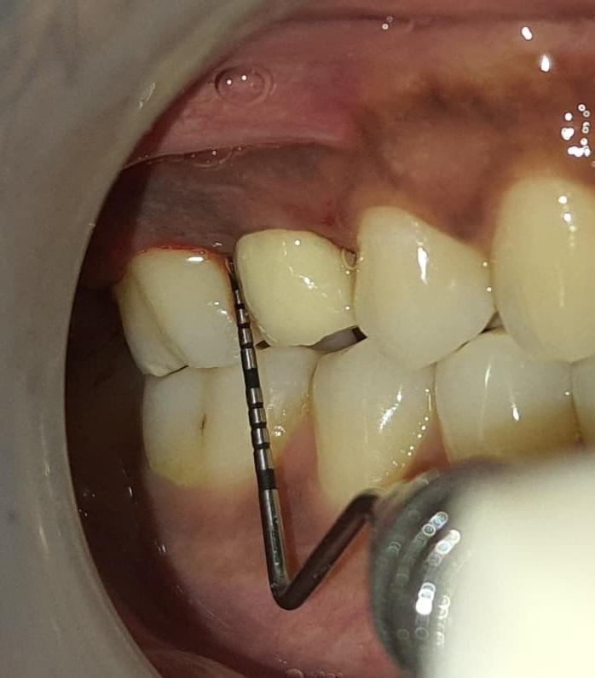
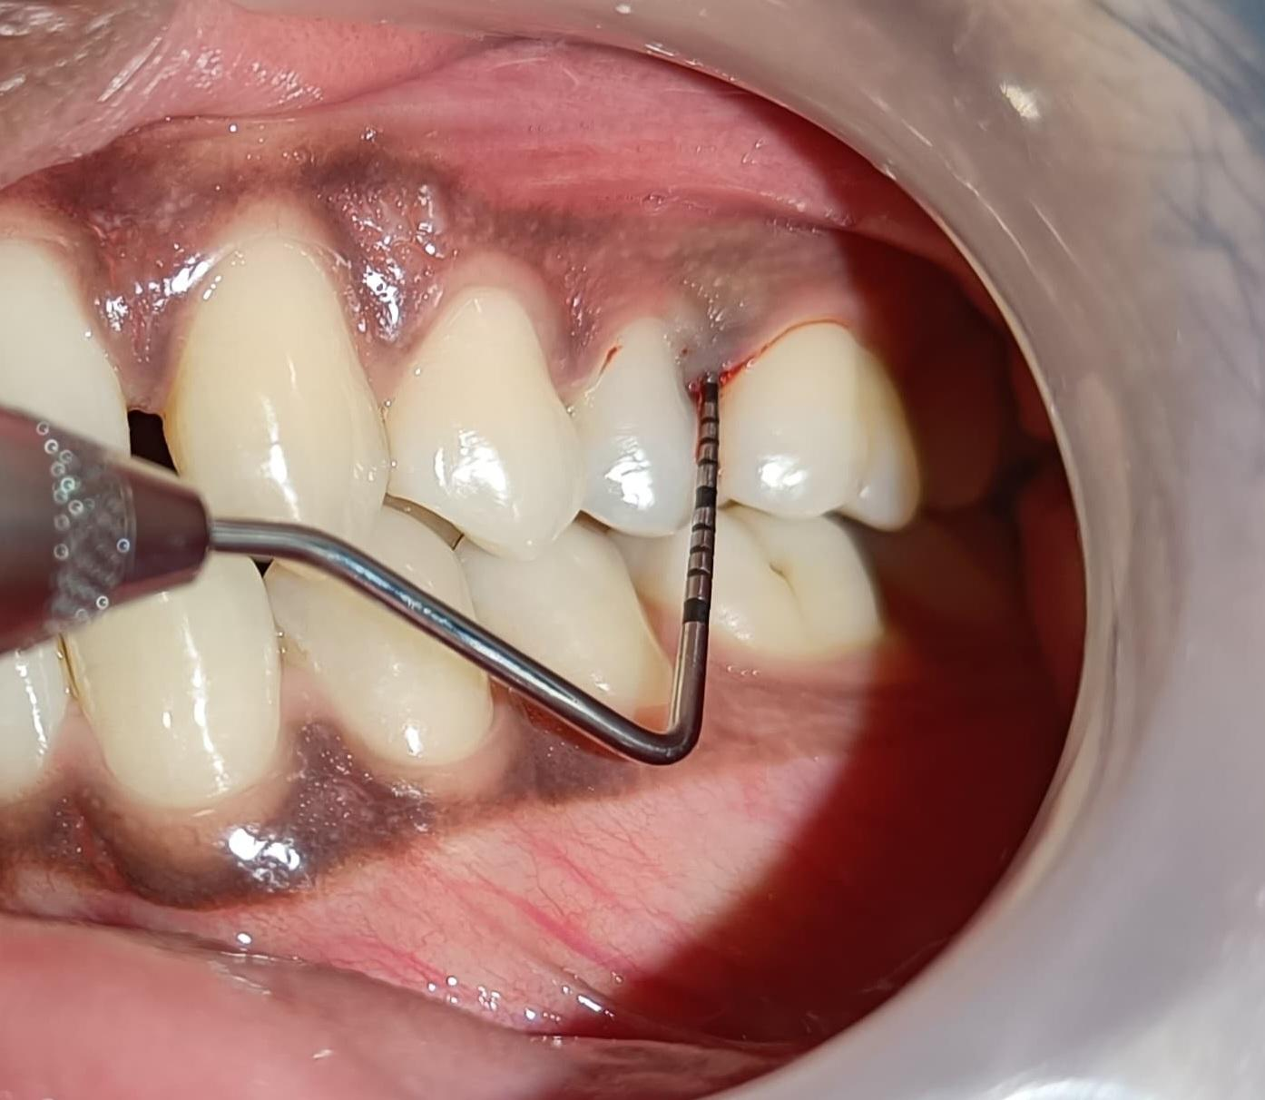
Fig 1 Baseline photographs of pocket depth Fig 2: Baseline photographs of pocket depth
using UNC 15 probe using UNC 15 probe
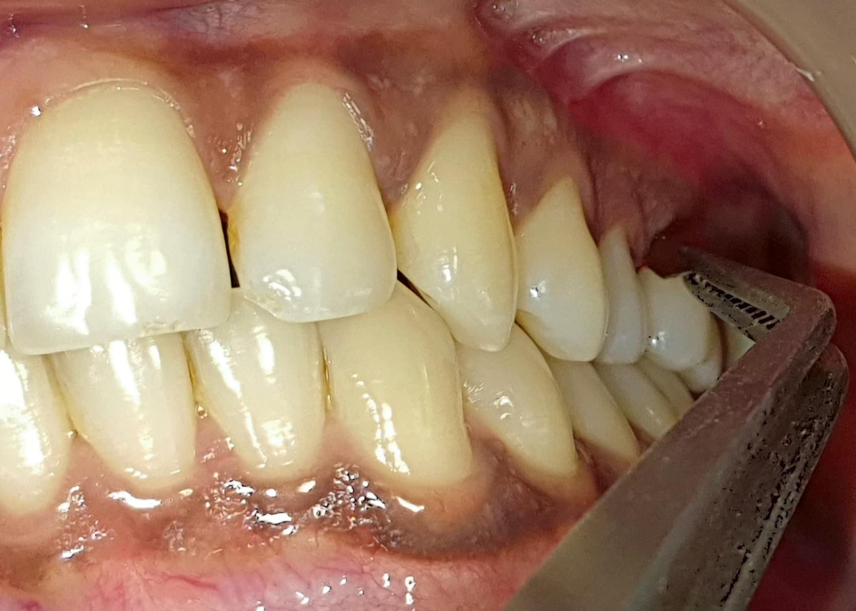
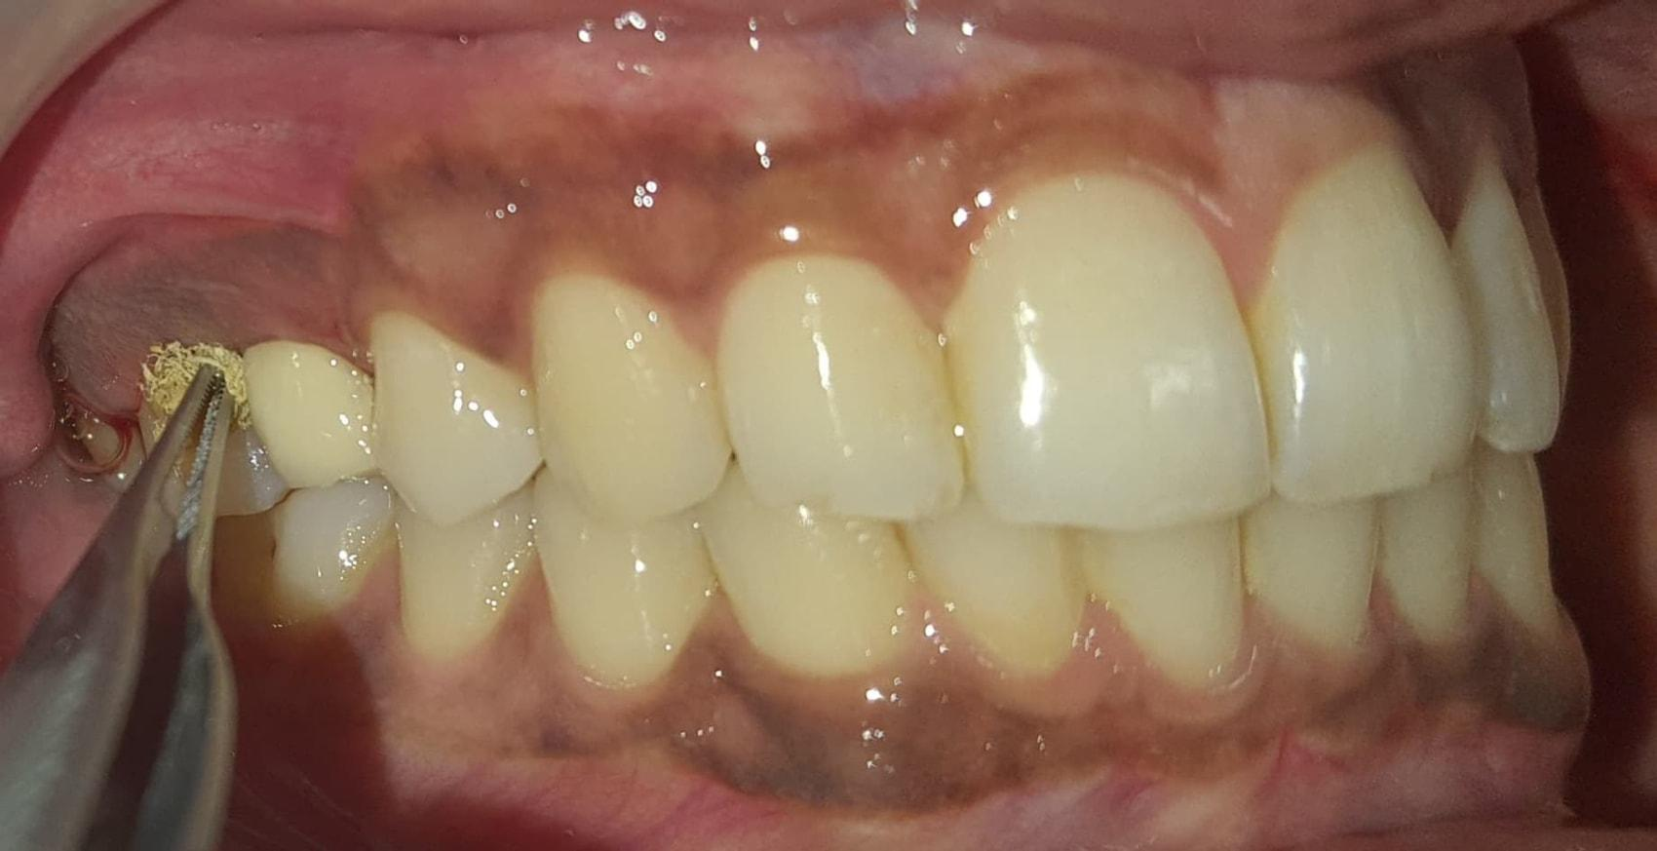
Fig 3 : Local drug delivery using tetracycline fibre Fig 4 : Local drug delivery using probiotic strip

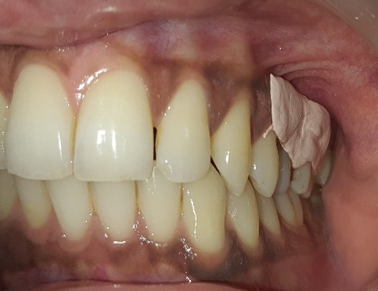
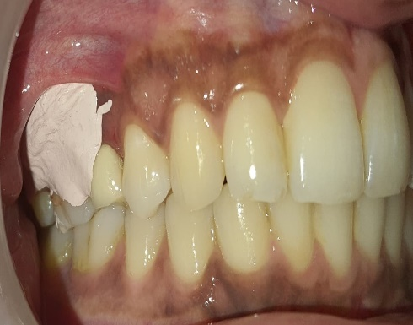

Fig 5: Periodontal dressing after tetracycline Fig 6 : Periodontal dressing after probiotic placement placement
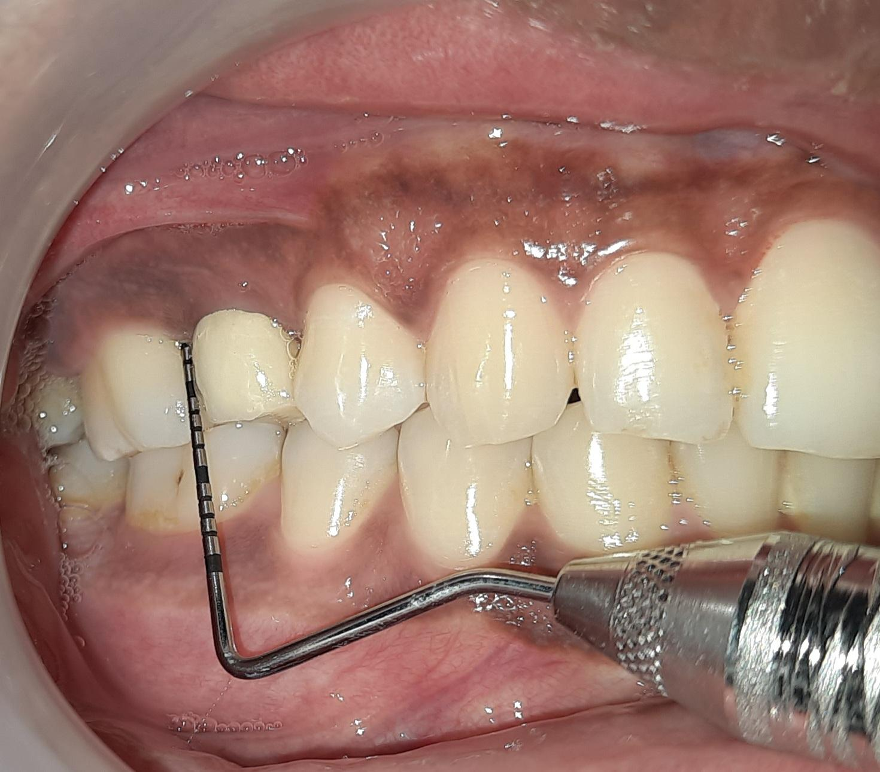
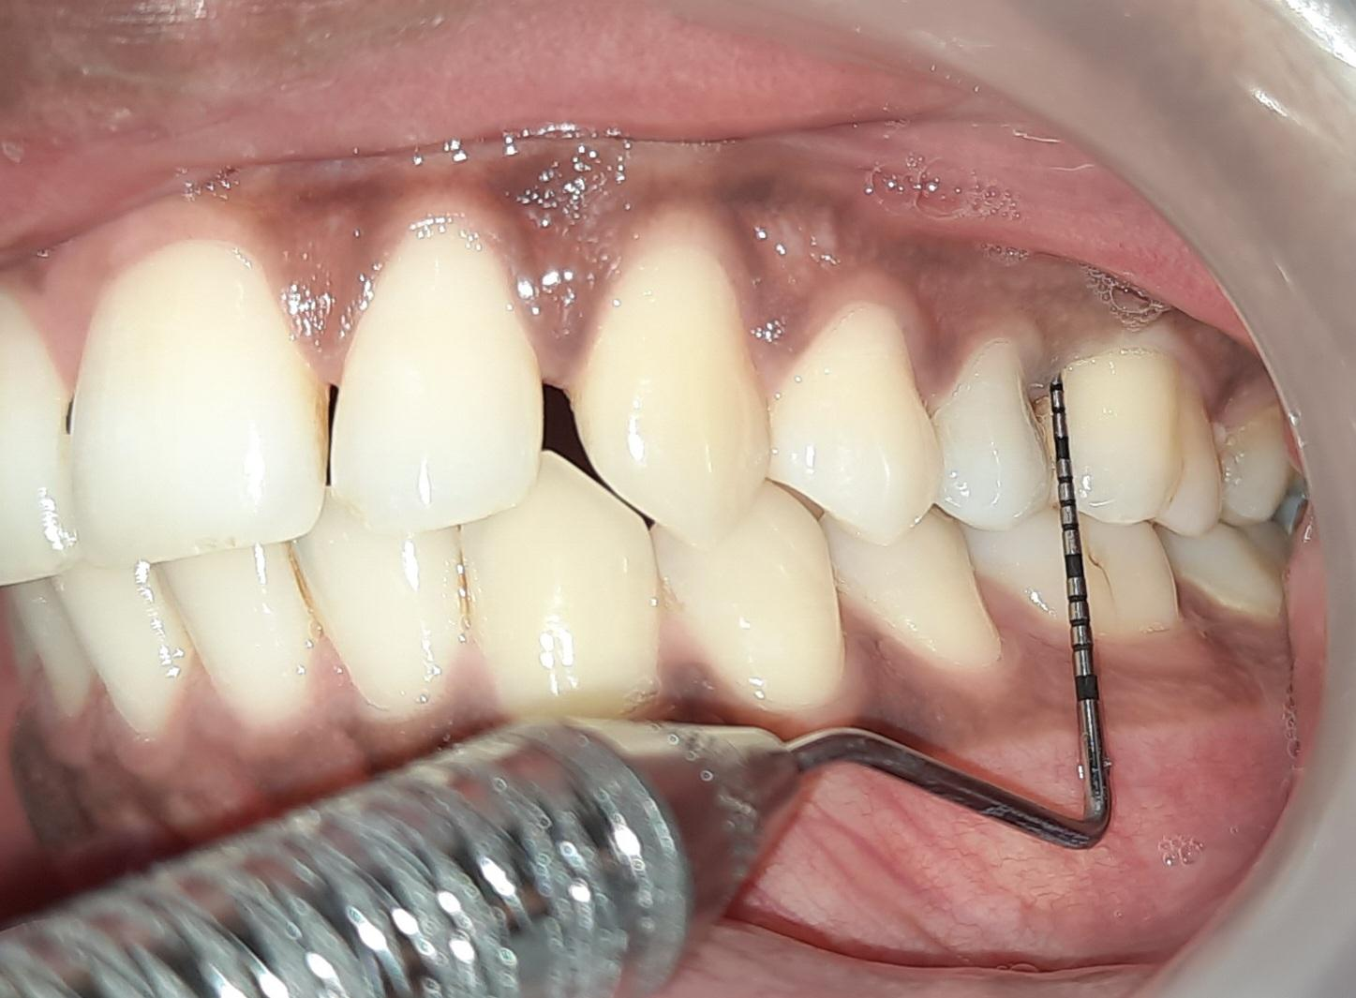

Fig 7 : Pocket depth after 21 days follow-up Fig 8 : Pocket depth after 21 days follow-up

Inclusion and Exclusion Criteria
Inclusion Criteria- Systemically healthy Patients having at least 20 teeth, with suprabony periodontal pockets which bleed on probing with probing depths (PDs) ≥5 mm, were included in the study.

Exclusion Criteria –
Smokers, systemically compromised individuals, patients taking medications, such as corticosteroids or calcium channel blockers, which are known to interfere with periodontal wound healing, patients allergic to medications, pregnant or lactating women, and patients who underwent periodontal therapy in the past 6 months were excluded from the study.

Discussion
On comparing site A (tetracycline fibres) and site B (probiotic strip), it was found that probotic strips are equally effective on comparison with tetracycline fibres in terms of pocket depth reduction, CAL and bleeding on probing.
Table 1 : Comparison of Probiotic strips and Tetracycline fibres in terms of pocket depth reduction, CAL and bleeding on probing
Site | Mean pocket depth at baseline(mm) | Mean CAL (mm) at baseline | Bleeding on probing at baseline
Probiotic strips | 5mm | 5mm | present
Tetracycline fibres | 5mm | 5mm | present

Table 2 : After 21 days
Site | Mean pocket depth at 21 day (mm) | Mean CAL (mm) at 21 day (mm) | Bleeding on probing at 21 day
Probiotic strips | 3mm | 3mm | absent
Tetracycline fibres | 3mm | 3mm | absent

The first objective of the study is to assess the effectiveness of probiotic strips in non-surgical pocket reduction. This will involve analyzing the impact of probiotic strips on the reduction of periodontal pockets and the improvement of gum health. When the probing depth at baseline and at 21 day is compared comparable results are seen.
Silva et al (1987) Lactobacillus acidophilus strains have been observed to inhibit the growth of a wide array of bacterial species due to the production of bacteriocins and are thus the most widely used probiotic therapeutic agents. [10]

Bunting et al (1999) The ability of the probiotic microorganisms to thrive and colonize in the oral cavity is still questioned. Studies employing the traditional culture methods have not been able to show the adherence of probiotic strains in the plaque or saliva of patients who have consumed the probiotics for a long period of time. [5,6,7]

Teughels et al (2007) LDD helps in reducing the microbial load of the pockets, thus helping in the repair of the periodontal tissues affected. Thus, this study was done to compare the beneficial effects of probiotics [2] tetracycline fibres and a combination of probiotics and tetracycline fibres in patients with periodontitis.

Ravn et al (2012) A study was conducted to assess if three probiotic bacteria present in the milk product Cultura dofilus naturell could be seen in saliva and on oral mucosal surfaces and if they colonized dental surfaces in situ of 8 caries inactive individuals after 8 daily exposures to the milk product for up to 3 days. Bacteria were identified by fluorescence in situ hybridization and confocal laser scanning microscopy. While probiotic bacteria were detected sporadically in the oral cavity, on mucosal surfaces and in the saliva after 3 days of use of the probiotic milk, they were not detected on dental surfaces. [8]
Krasse et al (2006) concluded that LR was efficacious in reducing both gingivitis and plaque in patients with moderate-to-severe gingivitis. [9]

Dhawan et al (2013) Probiotics work well as host-modulating agents, as they lower the salivary PH, thus preventing the formation of dental plaque as well as calculus. They also produce antioxidants which neutralize the free electrons which play a pivotal role in plaque formation as well as stain buildup. [3,4]

Pothoulakis, 2009 The beneficial effects of S. boulardii in gastrointestinal infl ammatory conditions are mediated through modulation of host proinfl ammatory responses by interfering with the host’s signaling molecules controlling infl ammation at different levels, such as the NF κB and MAP kinase pathways. Additionally, S. boulardii whole yeast administration substantially reduces mucosal levels of the proinfl ammatory mediators IL-1β, IL-6, TNF-α, and iNOS [18]

Teughels et al., 2007 The study confi rmed the hypothesis and provided a proof of concept for a guided pocket recolonization (GPR) approach in the treatment of periodontitis.[19]

Ann et al., 2007 this study utilizes S. boulardii – FOS as a probiotic-prebiotic mixture, no attempt was made to fi lter the effects of FOS in itself. No fi xed probiotic-prebiotic ratio exists, and ratios of 2:1 and 4:1 have been recommended if FOS is the intended prebiotic. A mixture at a 4:1 ratio was utilized in this study as it results in an increased concentration of the prebiotic. .[20]

Challa et al. (2013) evaluated the clinical and microbiological ef f i cacy of local delivery of probiotics in the treatment of chronic periodontitis and found a positive change in the subgingival microbiota. But in terms of clinical parameters, no signifi cant difference was found between the probiotic and the placebo groups.

Harini and Anegundi, 2010 study showed that there was a signifi cant difference in the gingival index between probiotic and chlorhexidine groups, with the probiotic group reduction being better when compared to the chlorhexidine group.

Canani et al., 2011 Saccharomyces boulardii is a non-pathogenic yeast used as a preventive and therapeutic agent for the treatment of a variety of gastrointestinal diseases. The pharmacokinetic data seem to indicate that S. boulardii reaches a steady-state concentration quickly and maintains a high stable level.

Riquelme et al., 2003 Studies on animal models and evidence from human volunteers indicate that administration of S. boulardii is safe for oral ingestion, and review of published cases indicates that S. boulardii results in a very low risk in immunocompetent subjects. Only 9 cases relating to the adverse effects of oral administration of S. boulardii have been reported.

Thomas et al., 2009 Culture of human dendritic cells in the presence of S. boulardii culture supernatant showed that secretion of key proinfl ammatory cytokines such as tumour necrosis factor-α and IL-6 were notably reduced, while the secretion of anti-infl ammatory IL-10 increased,which is pertinent in the context of pathogenic mechanisms in periodontitis.

Deepak et al., 2010 Studies have revealed that probiotic Lactobacillus strains (L. reuteri, L. salivarius, L. casei, L. acidophilus) were useful in reducing gingival infl ammation and the num ber of black-pigmented rods, including Porphyromonas gingivalis, in the saliva and subgingival plaque. Streptococcus sanguinis and S. uberis were found to inhibit the growth of periodontal pathogens, and a strong negative rela tion between Aggregatibacter actinomycetemcomitans and S. sanguinis was found.

Conclusion And future directions
After analyzing the results, we come to know that probiotic strips will give promising result as compared to tetracycline fibres. The findings of this study will provide valuable insights into the effectiveness of probiotic strips and tetracycline fibres in non-surgical pocket reduction in patients with periodontal disease. It could serve as a promising adjunctive therapy in periodontal treatment protocols.
Future directions should include establishing a framework for long-term efficacy monitoring. This involves tracking patient progress over an extended period to assess the sustained impact of the interventions.
Ethical clearance
Ethical clearance was obtained from the institutional ethical committee. [CSMSS/DCH/EC/SS/2024-02]

References
- Boyeena L, Koduganti RR, Panthula VR, Jammula SP. Comparison of efficacy of probiotic versus tetracycline fibers as adjuvants to scaling and root planning. J Indian Soc Periodontal. 2019 Nov-Dec;23(6):539-544. Doi:10.4103/jisp.jisp_590_18.

- Teughels W, Newman MG, Coucke W, Haffajee AD, Van Der Mei HC, Haake SK, et al. Guiding periodontal pocket recolonization: A proof of concept. J Dent Res. 2007;86:1078–82. 10.1177/154405910708601111

- Dhawan R, Dhawan S. Role of probiotics on oral health: A randomized, double-blind, placebo-controlled study. J Interdiscip Dent. 2013;3:71–8. 10.4103/2229-5194.126862

- Ishihara K, Miyakawa H, Hasegawa A, Takazoe I, Kawai Y. Growth inhibition of Streptococcus mutans by cellular extracts of human intestinal lactic acid bacteria. Infect Immun. 1985;49:692–4. 10.1128/iai.49.3.692-694.1985

- Bunting RW, Nickerson G, Hard DG, Crowley M. Further studies of the relation of Bacillus acidophilus to dental caries. J D Cosmos. 1928;70:1–8.

- Busscher HJ, Mulder AF, van der Mei HC. In vitro adhesion to enamel and in vivo colonization of tooth surfaces by lactobacilli from a bio-yoghurt. Caries Res. 1999;33:403–4. 10.1159/000016541

- Caglar E, Topcuoglu N, Cildir SK, Sandalli N, Kulekci G. Oral colonization by Lactobacillus reuteri ATCC 55730 after exposure to probiotics. Int J Paediatr Dent. 2009;19:377–81. 10.1111/j.1365-263X.2009.00989.x.

- Ravn I, Dige I, Meyer RL, Nyvad B. Colonization of the oral cavity by probiotic bacteria. Caries Res. 2012;46:107–12. 10.1159/000336960

- Krasse P, Carlsson B, Dahl C, Paulsson A, Nilsson A, Sinkiewicz G. Decreased gum bleeding and reduced gingivitis by the probiotic Lactobacillus reuteri. Swed Dent J. 2006;30:55–60. 16878680

- Silva M, Jacobus NV, Deneke C, Gorbach SL. Antimicrobial substance from a human Lactobacillus strain. Antimicrob Agents Chemother. 1987;31:1231–3. 10.1128/aac.31.8.1231

- Vivekananda MR, Vandana KL, Bhat KG. Effect of the probiotic Lactobacilli reuteri (Prodentis) in the management of periodontal disease: A preliminary randomized clinical trial. J Oral Microbiol. 2010;2:5344. 10.3402/jom.v2i0.5344

- Balaghi S, Mohammadifar MA, Zargaraan A, Gavlighi HA, Mohammadi M. Compositional analysis and rheological characterization of gum tragacanth exudates from six species of Iranian Astragalus. Food Hydrocoll. 2011;25:1775–84. 10.1016/j.foodhyd.2011.04.003

- Balaghi S, Mohammadifar MA, Zargaraan A. Physicochemical and rheological characterization of gum tragacanth exudates from six species of Iranian Astragalus. Food Biophys. 2010;5:59–71. 10.1007/s11483-009-9144-5

- Eastwood MA, Brydon WG, Anderson DM. The effects of dietary gum tragacanth in man. Toxicol Lett. 1984;21:73–81. 10.1016/0378-4274(84)90226-1

- Page RC, Offenbacher S, Schroeder HE, Seymour GJ, Kornman KS. Advances in the pathogenesis of periodontitis: Summary of developments, clinical implications and future directions. Periodontol 2000. 1997;14:216–48. 10.1111/j.1600-0757.1997.tb00199.x.

- Apatzidou DA, Kinane DF. Nonsurgical mechanical treatment strategies for periodontal disease. Dent Clin North Am. 2010;54:1–2. 10.1016/j.cden.2009.08.006.

- Siddharth T, Nikhil S, Rahul C. Local drug delivery: A current concept in periodontology. Mod Appl Bioequiv Availab. 2017;1:555552. 10.19080/MABB.2017.01.555552

- Pothoulakis C. Anti-infl ammatory mechanisms of action of Saccharomyces boulardii. Alimentary Pharmacology and Therapeutics 2009; 30:826-833.

- Teughels W, Newman MG, Coucke W, et al. Guiding periodontal pocket recolonization: a proof of con cept. Journal of Dental Research 2007; 86:1078-1082.

- Ann EY, Kim Y, Oh S, et al. Microencapsulation of Lactobacillus acidophilus ATCC 43121 with prebiotic substrates using a hybridization system. International Journal of Food Science and Technology 2007; 42:411-419.

- Challa R, Sylvia DS, Renuka V, Kumar RV, Vasudevan S and Reddy A. Effi cacy of probiotic gel on chronic periodontitis – A clinico-microbiological study. Journal of Research and Advancement of Dentistry 2013; 2:152-163.

- Harini PM and Anegundi RT. Effi cacy of a probiotic and chlorhexidine mouth rinses: A short-term clini cal study. Journal of the Indian Society of Pedodontics and Preventive Dentistry 2010; 28:179-182.

- Canani RB, Cucchiara S, Cuomo R, Pace F and Papale F. Saccharomyces boulardii: a summary of the evidence for gastroenterology clinical practice in adults and children. European Review for Medical and Pharmacological Sciences 2011; 15:809-822.

- Riquelme AJ, Calvo MA, Guzman AM, et al. Saccharomyces cerevisiae fungemia after Saccharomyces boulardii treat ment in immuno-compromised patients. Journal of Clinical Gastroenterology 2003; 36:41-43.

- Thomas S, Przesdzing I, Metzke D, Schmitz J, Radbruch A and Baumgart DC. Saccharomyces boulardii inhibits lipopolysaccharide-induced activation of human dendritic cells and T cell proliferation. Clinical and Experimental Immunology 2009; 156:78-87.

- Deepak TA, Manjunath M and Pewa S. Antibiotics are passé: take a look at probiotics. World Journal of Dentistry 2010; 25:109-111.

- Magnusson I, Lindhe J, Yoneyama T and Liljenberg B. Recolonization of a subgingival microbiota following scaling in deep pockets. Journal of Clinical Periodontology 1984; 11:193-207.

- Maiden MF, Tanner A, McArdle S, Najpauer K and Goodson JM. Tetracycline fi ber therapy monitored by DNA probe and cultural methods. Journal of Periodontal Research 1991; 26:452-459.

- Mcfarland LV, Surawicz CM, Greenberg RN, et al. Prevention of beta-lactam-associated diarrhea by Saccharomyces boulardii compared with placebo. The American Journal of Gastroenterology 1995; 90:439-448.

- Mitterdorfer G, Kneifel W and Viernstein H. Utilization of prebiotic carbohydrates by yeasts of therapeutic rel evance. Letters in Applied Microbiology 2001; 33:251-255.

- Mohanty R and Nazareth B. The potential role of pro biotics in periodontal health. Revista Sul-Brasileira de Odontologia 2012; 9:85-88.

- Mutanda T, Mokoena MP, Olaniran AO, Wilhelmi BS and Whiteley CG. Microbial enzymatic production and applications of short-chain fructooligosaccha rides and inulooligosaccharides: Recent advances and current perspectives. Journal of Industrial Microbiology and Biotechnology 2014; 41:893-906.

- Sanders ME. Probiotics: defi nition, sources, selection, and uses. Clinical Infectious Diseases 2008; 46(S2):S58 S61.

- Sareen M, Roy S, Singh SK and Gupta A. A review on probiotics and their implications in dentistry. Journal of Dentofacial Sciences 2012; 1:7-10.

- Sazawal S, Hiremath G, Dhingra U, Malik P, Deb S and Black RE. Effi cacy of probiotics in preven tion of acute diarrhoea: a meta-analysis of masked, randomised, placebo-controlled trials. The Lancet Infectious Diseases 2006; 6:374-382.

- Schneider SM, Girard-Pipau F, Filippi J, et al. Effects of Saccharomyces boulardii on fecal short-chain fatty acids and microfl ora in patients on long-term total enteral nutrition. World Journal of Gastroenterology 2005; 11:6165-6169.

- Shimazaki Y and Shirota T. Intake of dairy products and periodontal disease: The Hisayama study. Journal of Periodontology 2008; 79:131-137.

- Shinde PB. Probiotic: An overview for selection and evaluation. International Journal of Pharmacy and Phar maceutical Sciences 2011; 4:14-21. Silness J and Löe H. Correlation between oral hygiene and periodontal condition. Acta Odontologica Scandi navica 1964; 22:121-135. Socransky SS. Dental biofi lms: Diffi cult therapeutic targets. Periodontology 2000 2002; 28:12-55.

- Villarruel G, Rubio DM, Lopez F, et al. Saccharomyces boulardii in acute childhood diarrhoea: a randomized, placebo-controlled study. Acta Paediatrica 2007; 96:538-554.

- Rhemrev GE, Timmerman MF, Veldkamp I, Van Win kelhoff AJ and Van der Velden U. Immediate effect of instrumentation on the subgingival microfl ora in deep infl amed pockets under strict plaque control. Journal of Clinical Periodontology 2006; 33:42-48.

- DeSouza DM, Martins GB and Noguez SR. Probiotic actions of Bacillus cereus var. toyoi and Saccharomyces bou lardii in silver catfi sh larvae culture. Revista Brasileira de Zootecnia 2012; 41:3-7.

- Elmer GW, Macfarland LV and Surawicz CM. Biothera peutic Agents and Infectious Diseases, 1st ed. Totowa, New Jersey, USA: Humana Press, 1999; 647-652.

