Comparative Evaluation of Dentinal Tubule Occlusion Using Diode Laser And Potassium Oxalate Gel: An In Vitro Scanning Electron Microscopic Study

Abstract

Aim: The present in vitro study aimed to compare the effectiveness of diode laser and potassium oxalate gel in achieving dentinal tubule occlusion using scanning electron microscopy (SEM).

Materials and Methods: Extracted human permanent teeth were used to prepare standardized coronal dentin discs following smear layer removal. The specimens were randomly allocated into three groups: Group I—diode laser treatment, Group II—potassium oxalate gel application, and Group III—control. Diode laser irradiation and potassium oxalate gel application were performed using standardized protocols, while control specimens received no treatment. All samples were evaluated under SEM at 5000× magnification. Dentinal tubule occlusion was assessed using a five-point scoring system. Statistical analysis was performed using SPSS software version 27. Intergroup comparisons were carried out using the Kruskal–Wallis test followed by Mann–Whitney U test. A p-value ≤0.05 was considered statistically significant.

Results: SEM analysis revealed completely open dentinal tubules in the control group. Potassium oxalate-treated specimens demonstrated partial and superficial tubule occlusion with predominantly patent tubules. In contrast, diode laser-treated specimens showed marked narrowing and partial to near-complete occlusion of dentinal tubules due to surface melting and resolidification of dentin. The diode laser group exhibited significantly higher dentinal tubule occlusion scores compared to the potassium oxalate and control groups (p ≤0.05).

Conclusion: Within the limitations of this in vitro study, diode laser treatment demonstrated superior dentinal tubule occlusion compared to potassium oxalate gel. The findings suggest that diode laser therapy may provide more uniform and stable dentinal tubule sealing and may be a more effective modality for the management of dentinal hypersensitivity.

Keywords: Dentinal hypersensitivity; Diode laser; Potassium oxalate; Dentinal tubule occlusion; Scanning electron microscopy

Introduction
Dentinal hypersensitivity is a frequently encountered clinical condition characterized by short, sharp pain arising from exposed dentin in response to thermal, tactile, osmotic, evaporative, or chemical stimuli, which cannot be attributed to any other dental pathology. ¹ The prevalence of dentinal hypersensitivity has been reported to range between 25% and 46% in adults, significantly affecting quality of life.²
The most widely accepted explanation for dentinal hypersensitivity is the hydrodynamic theory proposed by Brännström, which suggests that pain is caused by rapid movement of fluid within exposed dentinal tubules, stimulating mechanoreceptors in the pulp. ³ The degree of dentinal hypersensitivity is directly related to the number and diameter of open dentinal tubules, with sensitive teeth demonstrating increased tubular density and wider tubule diameters compared to non-sensitive teeth.⁴
Effective occlusion of dentinal tubules is therefore considered a key therapeutic strategy in the management of dentinal hypersensitivity, as it reduces dentinal fluid movement and subsequent pulpal stimulation. ⁵ Various treatment modalities aimed at tubule occlusion include desensitizing dentifrices, mouth rinses, varnishes, restorative materials, and laser therapy.⁶
Potassium oxalate-based agents act by reacting with calcium ions present in dentin to form insoluble calcium oxalate crystals, which precipitate within the dentinal tubules and reduce dentinal permeability.⁷ Several in vitro and clinical studies have demonstrated the ability of potassium oxalate to occlude dentinal tubules and provide relief from hypersensitivity; however, the stability and long-term durability of the occluding deposits remain a concern.⁸
Laser therapy has gained increasing attention in recent years as a treatment modality for dentinal hypersensitivity due to its ability to induce morphological alterations in dentin without the need for restorative intervention.⁹ Diode lasers, in particular, have been shown to cause melting and recrystallization of peritubular dentin, leading to narrowing or sealing of dentinal tubules and a consequent reduction in dentinal fluid flow.¹⁰
Scanning electron microscopy (SEM) is a highly sensitive and reliable technique for evaluating dentinal surface morphology and the degree of dentinal tubule occlusion following various desensitizing treatments.¹¹ SEM enables direct visualization of dentinal tubule patency at high magnification, making it an ideal method for in vitro comparative studies.¹²
Therefore, the present in vitro study was undertaken to comparatively evaluate the effectiveness of diode laser and potassium oxalate gel in achieving dentinal tubule occlusion using scanning electron microscopy.

Materials and Methods

Study Design
This in vitro experimental study was conducted to evaluate and compare dentinal tubule occlusion following diode laser irradiation and potassium oxalate gel application using scanning electron microscopy (SEM).

Sample Selection
A total of 30 human maxillary premolar teeth were extracted for orthodontic, periodontal, or prosthetic reasons were used in the study purposes and gathered from Department of Oral and Maxillofacial surgery, KVG Dental College and hospital, Sullia .Teeth with intact coronal dentin and no evidence of caries, restorations, cracks, or developmental defects were included. Teeth with a history of endodontic treatment, root resorption, or internal pathology were excluded. All extracted teeth were stored in normal saline for a period not exceeding three months prior to use.

Sample Size and Preparation
A total of 30 dentin specimens were included in the study, with 10 specimens allocated to each group. The sample size was determined based on previous similar in vitro SEM studies and feasibility considerations.
The extracted teeth were sectioned using a low-speed diamond saw under continuous water coolant to obtain standardized coronal dentin discs measuring approximately 1.0–1.5 mm in thickness. The dentin surfaces were flattened and polished sequentially using silicon carbide abrasive papers of 400, 600, and 1200 grit under water irrigation to obtain a uniform surface.
The specimens were ultrasonically cleaned in distilled water for five minutes to remove surface debris. Smear layer removal was performed using 37% phosphoric acid for 15 seconds, followed by thorough rinsing with distilled water for 30 seconds. The specimens were then air-dried gently prior to treatment procedures.
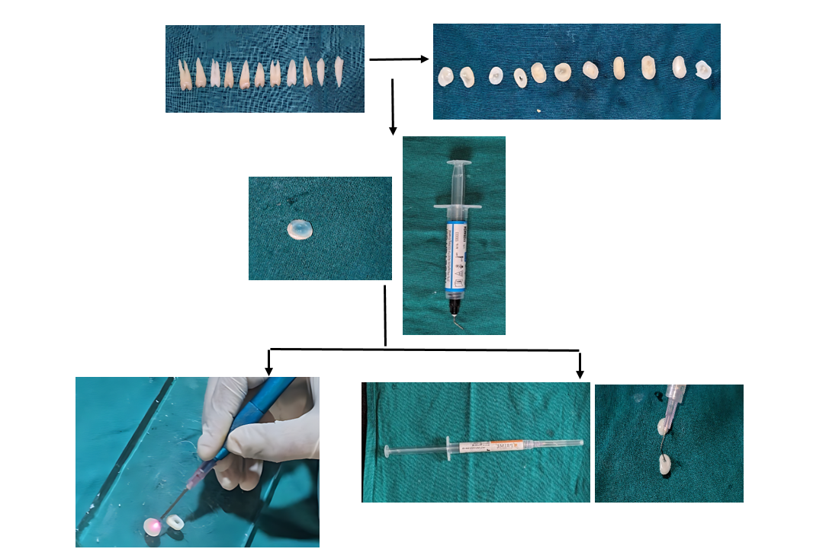

FIG-1 Flow diagram depicting preparation of dentin specimens and application of diode laser and potassium oxalate gel prior to SEM evaluation.

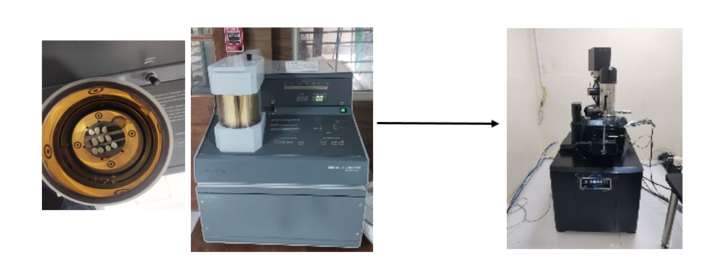
FIG-2 Sputter coating of dentin specimens followed by scanning electron microscopic imaging.

Grouping of Specimens
The prepared dentin specimens were randomly allocated into three groups:
Group I: Diode laser treatment
Group II: Potassium oxalate gel application
Group III: Control (no treatment)

Diode Laser Treatment (Group I)
The dentin specimens were placed on a sterile, heat-resistant holder at ambient room temperature. The dentin surface was gently dried using compressed air for 5–10 seconds. A diode laser with a wavelength ranging from approximately 810–980 nm was used at a power setting of 1.0 W in continuous wave mode. A fibre tip measuring 200–320 µm was positioned perpendicular to the dentin surface in a slightly contact or non-contact mode as recommended by the manufacturer.
Laser irradiation was performed in a sweeping motion to cover the entire test surface for 10 seconds per cycle. Three irradiation cycles were applied with a cooling interval of 20 seconds between cycles to prevent excessive temperature rise. After the final irradiation cycle, the specimens were allowed to cool for one minute without rinsing and were then stored in artificial saliva at 37°C until SEM processing.

Potassium Oxalate Gel Application (Group II):
The dentin surface was gently dried using compressed air for 5–10 seconds. Potassium oxalate gel was applied uniformly over the test surface using a micro brush. The gel was maintained in contact with the dentin surface for 60–120 seconds, during which gentle agitation was performed to facilitate penetration into the dentinal tubules.
Following the application period, excess gel was removed using a cotton pellet, and the specimens were rinsed with distilled water for 10–15 seconds to remove loosely adherent residues. The surfaces were then dried with compressed air for 5–10 seconds and stored in artificial saliva at 37°C until SEM evaluation.
Control Group (Group III)
Specimens in the control group underwent smear layer removal and drying procedures identical to the experimental groups but did not receive any laser irradiation or desensitizing agent. These specimens were stored in artificial saliva at 37°C for the same duration as the treated groups.

SEM Processing and Imaging
The specimens were fixed in 2.5% glutaraldehyde prepared in 0.1 M phosphate buffer for 24 hours, followed by rinsing in phosphate buffer solution. Dehydration was carried out using a graded ethanol series of 50%, 70%, 90%, 95%, and 100%, with each step lasting 10 minutes. The specimens were then dried using critical point drying. The SEM analysis was carried out in Advanced Facility for Microscopy and Microanalysis, Bengaluru.
All specimens were sputter-coated with a thin layer of gold or gold-palladium to a thickness of approximately 10 nm. SEM evaluation was performed at 5000× magnification. The examiner performing SEM analysis was blinded to group allocation.

Evaluation of Dentinal Tubule Occlusion
Dentinal tubule occlusion was assessed using a five-point scoring system, where a score of 1 represented completely open dentinal tubules and a score of 5 represented complete tubule occlusion.
Ethical Considerations
The study was conducted in accordance with institutional laboratory guidelines. Since the study was in vitro and did not involve human subjects or clinical procedures, ethical clearance from the Institutional Ethics Committee was not mandatory.

Statistical Analysis
Statistical analysis was performed using the Statistical Package for the Social Sciences (SPSS) software version 27. Dentinal tubule occlusion scores obtained from scanning electron microscopic evaluation were recorded for all specimens and summarized as mean values for graphical representation and as median with interquartile range for inferential analysis. Normality of data distribution was assessed using the Shapiro–Wilk test.
As the occlusion scores did not follow a normal distribution, non-parametric statistical tests were applied. Intergroup comparison of dentinal tubule occlusion scores among the three groups (diode laser, potassium oxalate gel, and control) was carried out using the Kruskal–Wallis analysis of variance. When a statistically significant difference was observed, pairwise comparisons were performed using the Mann–Whitney U test with Bonferroni correction.
The bar graph was used to visually depict the comparative mean dentinal tubule occlusion scores among the study groups. A p-value of ≤ 0.05 was considered statistically significant for all analyses.

Grouping of Specimens
The prepared dentin specimens were randomly allocated into three groups:
- Group I: Diode laser treatment
- Group II: Potassium oxalate gel application
- Group III: Control (no treatment)

Diode Laser Treatment (Group I)
The dentin specimens were placed on a sterile, heat-resistant holder at ambient room temperature. The dentin surface was gently dried using compressed air for 5–10 seconds. A diode laser with a wavelength range of approximately 810–980 nm was used at a power setting of 1.0 W in continuous wave mode. A fiber tip measuring 200–320 µm was positioned perpendicular to the dentin surface in a slight contact or non-contact mode, as recommended by the manufacturer.
Laser irradiation was performed using a sweeping motion to cover the entire test surface for 10 seconds per cycle. Three irradiation cycles were applied with a cooling interval of 20 seconds between cycles to prevent excessive temperature rise. After the final irradiation cycle, the specimens were allowed to cool for one minute and then stored in artificial saliva at 37 °C until SEM processing.

Potassium Oxalate Gel Application (Group II)
The dentin surface was gently dried using compressed air for 5–10 seconds. Potassium oxalate gel was applied uniformly over the test surface using a microbrush. The gel was maintained in contact with the dentin surface for 60–120 seconds, during which gentle agitation was performed to facilitate penetration into the dentinal tubules.
Following the application period, excess gel was removed using a cotton pellet, and the specimens were rinsed with distilled water for 10–15 seconds to remove loosely adherent residues. The surfaces were then dried using compressed air and stored in artificial saliva at 37 °C until SEM evaluation.

Control Group (Group III)
Specimens in the control group underwent smear layer removal and drying procedures identical to the experimental groups but did not receive any laser irradiation or desensitizing agent. These specimens were stored in artificial saliva at 37 °C for the same duration as the treated groups.

SEM Processing and Imaging
The specimens were fixed in 2.5% glutaraldehyde prepared in 0.1 M phosphate buffer for 24 hours, followed by rinsing in phosphate buffer solution. Dehydration was carried out using a graded ethanol series of 50%, 70%, 90%, 95%, and 100%, with each step lasting 10 minutes. The specimens were then dried using critical point drying.
All specimens were sputter-coated with a thin layer of gold or gold-palladium to a thickness of approximately 10 nm. SEM evaluation was performed under standardized conditions at 5000× magnification. The examiner performing SEM analysis was blinded to group allocation.

Evaluation of Dentinal Tubule Occlusion
Dentinal tubule occlusion was assessed using a five-point scoring system, where a score of 1 represented completely open dentinal tubules and a score of 5 represented complete tubule occlusion.

Ethical Considerations
The study was conducted in accordance with institutional laboratory guidelines. As the study was in vitro and did not involve human subjects or clinical procedures, ethical clearance from the Institutional Ethics Committee was not mandatory.

Results

Scanning Electron Microscopic Evaluation
Scanning electron microscopy was used to evaluate the degree of dentinal tubule occlusion in all three study groups at 5000× magnification. Representative micrographs from each group were analyzed to assess dentinal tubule patency, surface morphology, and the extent of tubule occlusion using the Zhao et al. scoring system.

Control Group (Group III)
SEM evaluation of the control group specimens revealed completely open and patent dentinal tubules at 5000× magnification. The tubule orifices appeared wide, round, and well defined, with uniform distribution across the dentinal surface. No evidence of tubule occlusion, surface melting, smear-like layer formation, or crystalline deposits was observed. The control group demonstrated the lowest dentinal tubule occlusion score, with a mean Zhao score of 1.0, representing untreated dentin surfaces.

Potassium Oxalate Gel Group (Group II)
Specimens treated with potassium oxalate gel exhibited partial occlusion of dentinal tubules at 5000× magnification. SEM micrographs showed predominantly open and clearly delineated dentinal tubules, with tubule orifices appearing wide and circular. Minimal, non-uniform superficial deposits were observed at the tubule openings, with no consistent intratubular crystal plugs or deep penetration of occluding material. The intertubular dentin remained intact, without evidence of surface melting or smear-like layer formation.
The potassium oxalate group demonstrated a moderate degree of dentinal tubule occlusion, with a mean Zhao score of 2.0, indicating partial tubule occlusion.

Diode Laser Group (Group I)
SEM analysis of diode laser–treated specimens revealed marked morphological alterations of the dentinal surface at 5000× magnification. A significant reduction in dentinal tubule diameter was observed, with many tubules exhibiting narrowing or partial to near-complete occlusion. The tubule orifices appeared irregular, and the dentinal surface showed evidence of melting and resolidification of peritubular dentin. A homogeneous smear-like amorphous layer was observed covering the intertubular dentin, contributing to effective tubule sealing.
No crystalline deposits were observed, indicating that tubule occlusion occurred through thermal modification rather than chemical precipitation. The diode laser group demonstrated the highest degree of dentinal tubule occlusion, with a mean Zhao score of 4.0.

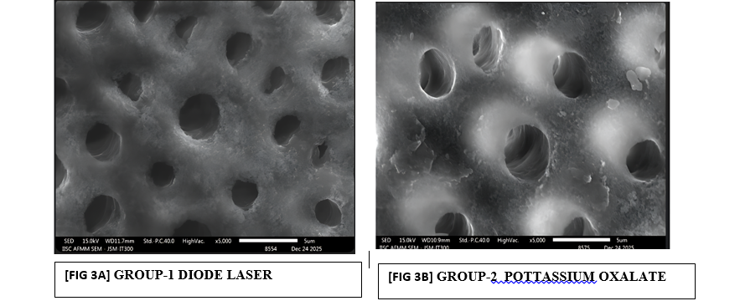

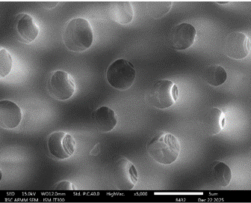

Comparative Evaluation of Dentinal Tubule Occlusion
Comparative analysis among the three groups demonstrated a progressive increase in dentinal tubule occlusion from the control group to the potassium oxalate gel group, with the diode laser group showing the maximum occlusion. The order of effectiveness in achieving dentinal tubule occlusion was:
Diode Laser Group > Potassium Oxalate Gel Group > Control Group

Distribution of Dentinal Tubule Occlusion Scores
The distribution of dentinal tubule occlusion scores based on the Zhao et al. scoring system among the three study groups is presented in Table 1. The Kruskal–Wallis test revealed a statistically significant difference in occlusion scores among the three groups (p ≤ 0.05).

Table 1. Distribution of dentinal tubule occlusion scores based on Zhao et al. scoring system.
Zhao Score | Interpretation | Control  n (%) | Potassium Oxalate  n (%) | Diode Laser  n (%) | p-value
Score 1 | Completely open tubules | 10 (100%) | 0 (0%) | 0 (0%) | <0.001*
Score 2 | Partially occluded tubules | 0 (0%) | 10 (100%) | 0 (0%) | <0.001*
Score 3 | Moderately occluded tubules | 0 (0%) | 0 (0%) | 2 (20%) | <0.001*
Score 4 | Mostly occluded tubules | 0 (0%) | 0 (0%) | 8 (80%) | <0.001*
Score 5 | Completely occluded tubules | 0 (0%) | 0 (0%) | 0 (0%) | <0.001*
Median (IQR) |  | 1 (1–1) | 2 (2–2) | 4 (4–4)

Intergroup Comparison of Dentinal Tubule Occlusion Scores
Pairwise intergroup comparison of dentinal tubule occlusion scores was performed using the Mann–Whitney U test with Bonferroni correction. Statistically significant differences were observed between the diode laser and potassium oxalate groups, diode laser and control groups, and potassium oxalate and control groups (p ≤ 0.05).
Table 2: Intergroup Comparison of Dentinal Tubule Occlusion Scores using the Mann–Whitney U test

P value (Mann-Whitney U test) | Group I  (Diode Laser) | Group II  (Potassium Oxalate) | Group III  (Control)
Group I (Diode Laser) | — | 0.003* | 0.001*
Group II (Potassium Oxalate) | 0.003* | — | 0.011*
Group III (Control) | 0.001* | 0.011* | —

Table 3 : Overall Group Comparison
Statistical Test | Test Statistic | P value | Interpretation
Kruskal-Wallis H Test | H = 26.87 | < 0.001* | Highly Significant

Quantitative and Graphical Analysis
The mean dentinal tubule occlusion scores were 1.0 ± 0.0 for the control group, 2.0 ± 0.0 for the potassium oxalate group, and 4.0 ± 0.0 for the diode laser group. Intergroup comparison demonstrated statistically significant differences among all study groups. The bar graph depicting mean dentinal tubule occlusion scores clearly illustrates the superior tubule sealing efficacy of diode laser treatment compared to potassium oxalate gel and untreated control specimens.

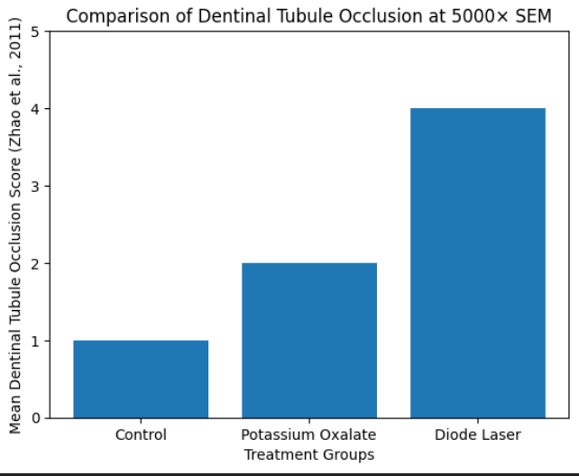

Fig4:Graphical Analysis of Mean Dentinal Tubule Occlusion Scores among three study groups

Discussion
Dentinal hypersensitivity is a frequently encountered clinical condition that arises due to dentin exposure and patency of dentinal tubules, resulting in hydrodynamic fluid movement and subsequent stimulation of pulpal nerve endings. According to Brännström’s hydrodynamic theory, later elaborated by Pashley and Carvalho, the severity of hypersensitivity is directly proportional to the number, diameter, and patency of open dentinal tubules.¹⁴ Hence, reduction of dentinal permeability through effective tubule occlusion remains the primary therapeutic objective in the management of dentinal hypersensitivity.
The present in vitro scanning electron microscopic study evaluated and compared the tubule-occluding potential of diode laser irradiation and potassium oxalate gel, with untreated dentin serving as the control. SEM analysis at 5000× magnification revealed distinct morphological variations among the three groups, with the diode laser group demonstrating superior dentinal tubule occlusion compared to potassium oxalate gel and control groups.
In the control group, SEM images showed completely open and patent dentinal tubules following smear layer removal. This observation is in accordance with the findings of Pashley, who demonstrated that exposed dentin surfaces without therapeutic intervention exhibit increased dentinal permeability and heightened susceptibility to hypersensitivity due to unrestricted fluid movement within the tubules.¹⁵
Specimens treated with potassium oxalate gel exhibited partial and irregular occlusion of dentinal tubules, characterized by superficial crystalline deposits with predominantly patent tubule orifices. The desensitizing action of oxalates is attributed to the chemical reaction between oxalate ions and calcium ions in dentin, resulting in the formation of insoluble calcium oxalate crystals within dentinal tubules. This mechanism was originally described by Greenhill and Pashley, who reported a reduction in dentin permeability following oxalate application.¹⁶
However, the SEM findings of the present study indicate that the occlusion achieved by potassium oxalate was superficial and non-uniform. Similar observations have been reported by Gillam et al., who demonstrated partial tubule occlusion following oxalate-based desensitizing agents and raised concerns regarding the stability and depth of crystal deposition.¹⁷ Furthermore, Wang et al. reported that oxalate precipitates may be susceptible to dissolution under acidic conditions and mechanical abrasion, thereby compromising their long-term clinical effectiveness.¹⁸
In contrast, specimens treated with diode laser irradiation exhibited marked morphological alterations, including narrowing and partial to near-complete occlusion of dentinal tubules, along with surface melting and resolidification of peritubular dentin. The mechanism underlying laser-induced desensitization involves thermal modification of the inorganic dentin matrix, leading to melting and subsequent recrystallization that mechanically seals the tubule orifices. This mechanism has been well documented by Moritz et al., who demonstrated effective dentinal tubule sealing following diode laser application.¹⁹
The superior tubule occlusion observed in the diode laser group in the present study is in agreement with SEM and clinical studies by Yilmaz et al., who reported a significant reduction in dentinal hypersensitivity following diode laser therapy.²⁰ Additionally, Walsh highlighted the advantages of diode lasers in dentistry, including ease of application, controlled energy delivery, minimal invasiveness, and favorable patient acceptance.²¹
The higher occlusion scores achieved by diode laser therapy compared to potassium oxalate gel highlight the importance of the mechanism of action in determining treatment efficacy. While chemical agents rely on surface-level precipitation within dentinal tubules, laser therapy induces structural modification of dentin, resulting in deeper, more homogeneous, and potentially more durable tubule sealing. Similar conclusions were drawn by Schwarz et al., who demonstrated superior and stable tubule occlusion following laser irradiation compared to topical desensitizing agents.²²
The use of scanning electron microscopy in the present study enabled detailed visualization of dentinal surface morphology and tubule patency, providing direct evidence of differences in occlusion patterns among the study groups. The reliability of SEM for evaluating dentinal tubule occlusion has been emphasized by Mordan, Barber, and Gillam, who described the dentin disc model as a valid and reproducible in vitro method for assessing desensitizing therapies.²³
Despite the promising findings, the results of this study should be interpreted in light of its limitations. As an in vitro investigation, the influence of oral factors such as salivary flow, pH fluctuations, thermal cycling, dietary acids, and mechanical abrasion could not be simulated. West et al. emphasized that these factors significantly influence dentin permeability and the longevity of desensitizing treatments.²⁴ Therefore, although diode laser therapy demonstrated superior tubule occlusion under laboratory conditions, further in vivo and long-term clinical studies are required to validate its effectiveness and durability in clinical practice.

Conclusion
Within the limitations of this in vitro scanning electron microscopic study, diode laser treatment demonstrated superior dentinal tubule occlusion compared to potassium oxalate gel. Diode laser–treated specimens exhibited marked narrowing and partial to near-complete occlusion of dentinal tubules due to surface melting and resolidification of peritubular dentin. In contrast, potassium oxalate gel produced only partial and superficial tubule occlusion, with most dentinal tubules remaining patent.
The findings of the present study indicate that the mechanism of action plays a critical role in the effectiveness of desensitizing therapies. Thermal modification induced by diode laser irradiation resulted in more uniform and stable dentinal tubule sealing than chemical precipitation achieved by potassium oxalate. Therefore, diode laser therapy may be considered a more effective modality for the management of dentinal hypersensitivity under in vitro conditions.

Limitations
Despite the encouraging results, the present study has certain limitations. Being an in vitro investigation, the complex oral environment—including the effects of saliva, pH fluctuations, thermal changes, and mechanical forces such as tooth brushing and mastication—could not be simulated. Additionally, the resistance of the occluding layers to acidic or abrasive challenges was not evaluated.
Furthermore, subjective assessment of pain relief associated with dentinal hypersensitivity was not possible in this study. Hence, the results should be interpreted with caution, and future in vivo and long-term clinical studies with larger sample sizes are recommended to validate the clinical effectiveness and durability of diode laser and potassium oxalate treatments.

REFERENCES
1. Addy M. Dentine hypersensitivity: Definition, prevalence, distribution and aetiology. In: Addy M, Embery G, Edgar WM, Orchardson R, editors. Tooth Wear and Sensitivity. London: Martin Dunitz; 2000. p. 239–248.
2. Rees JS, Jin LJ, Lam S, Kudanowska I, Vowles R. The prevalence of dentine hypersensitivity in a hospital clinic population in Hong Kong. J Dent. 2003;31(7):453–461.
3. Brännström M. Sensitivity of dentine. Oral Surg Oral Med Oral Pathol. 1966;21(4):517–526.
4. Absi EG, Addy M, Adams D. Dentine hypersensitivity: A study of the patency of dentinal tubules in sensitive and non-sensitive cervical dentine. J Clin Periodontol. 1987;14(5):280–284.
5. Pashley DH. Mechanisms of dentin sensitivity. Dent Clin North Am. 1990;34(3):449–473.
6. Orchardson R, Gillam DG. Managing dentin hypersensitivity. J Am Dent Assoc. 2006;137(7):990–998.
7. Greenhill JD, Pashley DH. The effects of desensitizing agents on the hydraulic conductance of human dentin in vitro. J Dent Res. 1981;60(3):686–698.
8. Pillon FL, Romani IG, Schmidt ER. Effect of a potassium oxalate desensitizing agent on dentin permeability. Am J Dent. 2004;17(5):368–372.
9. Kimura Y, Wilder-Smith P, Yonaga K, Matsumoto K. Treatment of dentine hypersensitivity by lasers: A review. J Clin Periodontol. 2000;27(10):715–721.
10. Sgolastra F, Petrucci A, Severino M, Gatto R, Monaco A. Effectiveness of laser in dentinal hypersensitivity treatment: A systematic review. J Endod. 2011;37(3):297–303.
11. Amaechi BT, Higham SM. Dentin hypersensitivity: Diagnosis and management. Dent Update. 2001;28(9):442–447.
12. Aranha ACC, Eduardo CP. Effects of Er:YAG and diode laser irradiation on dentin permeability in vitro. Lasers Med Sci. 2012;27(3):553–558.
13. Dowell P, Addy M. Dentine hypersensitivity—A review. Aetiology, symptoms and theories of pain production. J Clin Periodontol. 1983;10(4):341–350.
14. Pashley DH, Carvalho RM. Dentine permeability and dentine hypersensitivity. J Dent. 1997;25(5):355–372.
15. Pashley DH. Dentin permeability, dentin sensitivity, and treatment through tubule occlusion. J Endod. 1986;12(10):465–474.
16. Greenhill JD, Pashley DH. Evaluation of the effects of oxalate solutions on dentin permeability. J Endod. 1983;9(7):255–260.
17. Gillam DG, Tang JY, Mordan NJ, Newman HN. The effects of a novel desensitizing agent on dentine tubule patency: A scanning electron microscopy study. J Oral Rehabil. 2002;29(4):305–313.
18. Wang Z, Sa Y, Sauro S, et al. Effect of desensitizing toothpastes on dentinal tubule occlusion: A SEM investigation. J Dent. 2010;38(5):400–410.
19. Moritz A, Gutknecht N, Schoop U, et al. The advantage of diode laser application in the treatment of dentin hypersensitivity. J Clin Laser Med Surg. 1998;16(5):243–246.
20. Yilmaz HG, Kurtulmus-Yilmaz S, Cengiz E. Clinical evaluation of Er,Cr:YSGG and diode laser therapy for dentine hypersensitivity. Lasers Med Sci. 2011;26(5):591–598.
21. Walsh LJ. The current status of laser applications in dentistry. Aust Dent J. 2003;48(3):146–155.
22. Schwarz F, Arweiler N, Georg T, Reich E. Desensitizing effects of an Er:YAG laser on hypersensitive dentin. J Clin Periodontol. 2002;29(3):211–215.
23. Mordan NJ, Barber PM, Gillam DG. The dentine disc method: A review of its applicability as a model for assessing tubule occlusion in vitro. J Oral Rehabil. 1997;24(2):148–156.
24. West NX, Hughes JA, Addy M. Dentin hypersensitivity: The effects of brushing and dietary acid on dentin permeability. J Oral Rehabil. 2002;29(9):811–817.

