Original Research Article
Remote dielectric sensing versus lung ultrasound for detecting pulmonary congestion in heart failure: A prospective pragmatic diagnostic accuracy study

ABSTRACT
Aims: To compare the diagnostic accuracy of remote dielectric sensing (ReDS) and lung ultrasound (LUS) for detecting pulmonary congestion in stable ambulatory patients with chronic heart failure, using a blinded composite clinical reference standard.
Study Design: Prospective single-center diagnostic accuracy study.
Place and Duration of Study: Single center, conducted between March and November 2024.
Methodology: We enrolled 112 stable outpatients with chronic heart failure. All participants underwent sequential ReDS measurement and standardized eight-zone LUS during the same clinical visit. A blinded adjudicator classified congestion status using a composite clinical score combined with NT-proBNP levels ≥1500 ng/L as the reference standard. The primary outcome measure was area under the receiver operating characteristic curve (AUC). Secondary outcomes included sensitivity, specificity, positive and negative likelihood ratios, inter-method agreement, and correlation between continuous measurements.
Results: Fifty-nine patients (52.7%) met the reference standard criteria for pulmonary congestion. ReDS demonstrated an AUC of 0.831 (95% CI 0.748–0.899), while LUS showed an AUC of 0.845 (95% CI 0.764–0.909), with no significant difference between methods (P = .80). At the prespecified ReDS threshold of >35%, sensitivity was 71.2% and specificity was 81.1%. Using an exploratory Youden-optimized LUS threshold of ≥24 B-lines, sensitivity was 69.5% and specificity was 83.0%. Inter-method concordance was 83.0% (κ=0.65), indicating substantial agreement. Pearson correlation between continuous measures was modest at r=0.36 (P < .001). Inter-observer agreement for thresholded LUS classification was substantial (κ=0.75).
Conclusion: ReDS and LUS demonstrated similar discriminatory ability for detecting pulmonary congestion in stable heart failure outpatients. However, the modest correlation and clinically relevant discordance between methods suggest they may have complementary roles in congestion assessment. The absence of an independent hemodynamic reference standard represents a limitation. Further evaluation in integrated ambulatory care pathways is warranted.
Keywords: Heart failure; pulmonary congestion; remote dielectric sensing; lung ultrasound; diagnostic accuracy

1. INTRODUCTION
Heart failure affects more than 64 million people worldwide and remains a major cause of hospitalization and healthcare spending (Savarese et al., 2023). Pulmonary congestion drives most symptoms, clinical worsening, and admission risk (Gheorghiade et al., 2010; McDonagh et al., 2021). Clinicians managing patients in the outpatient setting need reliable ways to detect congestion early. Timely assessment guides treatment decisions and helps prevent avoidable deterioration. Physical examination alone performs poorly in this role. Signs such as crackles or elevated jugular venous pressure show low sensitivity and vary widely between observers (Thibodeau and Drazner, 2018; Wang et al., 2005). As a result, clinicians increasingly rely on objective tools to support bedside judgment and improve diagnostic consistency.
Lung ultrasound detects B-lines, vertical reverberation artifacts produced by thickened interlobular septa that reflect alveolar-interstitial edema. Meta-analyses report pooled sensitivities and specificities above 80% in heart failure populations (Platz et al., 2017). In ambulatory cohorts, higher B-line burden predicts hospitalization and mortality (Platz et al., 2016; Domingo et al., 2021; Rastogi et al., 2024). These findings support its clinical value. At the same time, accuracy depends on operator training, standardized acquisition, and consistent interpretation (Ceriani et al., 2021). Without these safeguards, performance declines.
Remote dielectric sensing estimates lung fluid percentage by measuring thoracic dielectric permittivity with low-power electromagnetic signals. Validation studies show correlation with pulmonary capillary wedge pressure and quantitative computed tomography measures of lung water (Amir et al., 2013; Bensimhon et al., 2016; Amir et al., 2016). Higher ReDS values associate with adverse outcomes and increased rehospitalization risk (Imamura et al., 2017; Abraham et al., 2017; Olesen et al., 2022; Lala et al., 2021). The automated output reduces observer dependence and shortens acquisition time, which may support use in busy outpatient clinics. Several studies have compared ReDS and lung ultrasound (Kato et al., 2023; Kobalava et al., 2023; Kobalava et al., 2024; Huang et al., 2026). Many, however, relied on unblinded clinical diagnosis or heterogeneous reference standards. Others focused mainly on hospitalized populations. Few investigations have applied blinded adjudication and standardized protocols in stable outpatient settings. This limits interpretation and generalizability.
We aimed to compare the diagnostic accuracy of ReDS and lung ultrasound for detecting pulmonary congestion in ambulatory heart failure patients using a blinded composite clinical–biomarker reference standard. Our goal was to clarify how these tools perform in routine outpatient practice and how you might integrate them into everyday care.

2. MATERIAL AND METHODS
2.1. Study Design
Prospective diagnostic accuracy study conducted at Apollo Hospital, Chennai (March-November 2024). Ethics approval: AMH – DNB-078/08-23. Written consent was obtained from all participants. STARD 2015 guidelines were followed (Bossuyt et al., 2015).
2.2. Participants
We included adults aged 18 years or older with established chronic heart failure (McDonagh et al., 2021) who attended the outpatient clinic during the study period. We excluded patients with cardiac implantable electronic devices, recent thoracic surgery, significant chest wall deformity, or active lung disease that could interfere with ReDS or LUS measurements. Of 125 patients screened for eligibility, 112 met inclusion criteria and were included in the final analysis.
2.3. ReDS
We performed remote dielectric sensing using a single-pad sensor system (Sensible Medical) applied to the right lateral thoracic wall, according to the manufacturer’s instructions. Patients remained seated during acquisition, and operators ensured correct positioning and contact. Each measurement required approximately 90 seconds. We applied a prespecified threshold of greater than 35 percent (Amir et al., 2013; Bensimhon et al., 2016; Abraham et al., 2017). Operators were blinded.
2.4. LUS
Eight-zone protocol using phased-array probe. Semi-recumbent position. Six-second cine clips per zone. Coalescent artifacts counted as single lines, capped at 10 per zone. Total B-lines summed. Two experienced cardiologists performed scans. Twenty-three studies (21%) were double-read. Exploratory cutoff ≥24 B-lines derived using Youden index.
2.5. Reference Standard: A blinded senior cardiologist adjudicated congestion status using predefined criteria.
Clinical Score (1–12): The composite score integrated objective bedside findings and symptom burden: jugular venous pressure (0–3), peripheral edema (0–4), lung crackles (0–1), and NYHA functional class (1–4). Higher scores reflected greater clinical evidence of volume overload.
Biomarker: NT-proBNP ≥1500 ng/L (Januzzi et al., 2018) was used to support classification in patients with intermediate clinical scores, providing biochemical confirmation of hemodynamic stress and reducing diagnostic uncertainty.
Criteria: We classified congestion using a structured two-step rule. Patients were considered congested if the clinical congestion score was ≥5, reflecting clear bedside evidence of volume overload. Patients with intermediate scores of 3–4 required NT-proBNP ≥1500 ng/L to confirm congestion. This approach reduced misclassification by combining clinical findings with objective biomarker support in borderline cases.
NYHA class and physical signs, including jugular venous pressure, peripheral edema, and crackles, were assessed by clinicians who did not perform or interpret ReDS or LUS. This separation minimized incorporation bias and strengthened the independence of the reference standard.
2.6. Statistical Analysis: Continuous variables are presented as mean ± SD when normally distributed and as median with interquartile range when skewed. Categorical variables are summarized as counts and percentages. We compared continuous variables using the independent t test or Mann–Whitney U test, based on distribution. Categorical variables were compared using the chi-square test or Fisher exact test as appropriate. We generated ROC curves and compared AUCs using the paired DeLong test. Agreement was assessed using Cohen κ and the McNemar test. Correlation between continuous measures was evaluated using Pearson or Spearman coefficients. Separate multivariable logistic regression models assessed ReDS and LUS, each adjusted for age and BMI. Python 3.11 software with standard scientific libraries, including pandas for data management, NumPy for numerical operations, SciPy for statistical testing, scikit-learn for receiver operating characteristic analysis, and statsmodels for regression modeling and confidence interval estimation.

3. RESULTS
3.1. Study Population: A total of 125 patients were assessed for eligibility during the study period. Thirteen were excluded, eight due to the presence of cardiac implantable electronic devices and five due to recent thoracic surgery. The remaining 112 patients met inclusion criteria and were enrolled. All enrolled participants underwent both index tests, remote dielectric sensing and lung ultrasound, along with reference standard assessment using the composite clinical congestion score and NT-proBNP measurement. No patients were lost after enrollment, and all 112 were included in the final analysis. Based on blinded adjudication, 59 patients were classified as having pulmonary congestion, while 53 were classified as non-congested. Study flow is shown in Figure 1.
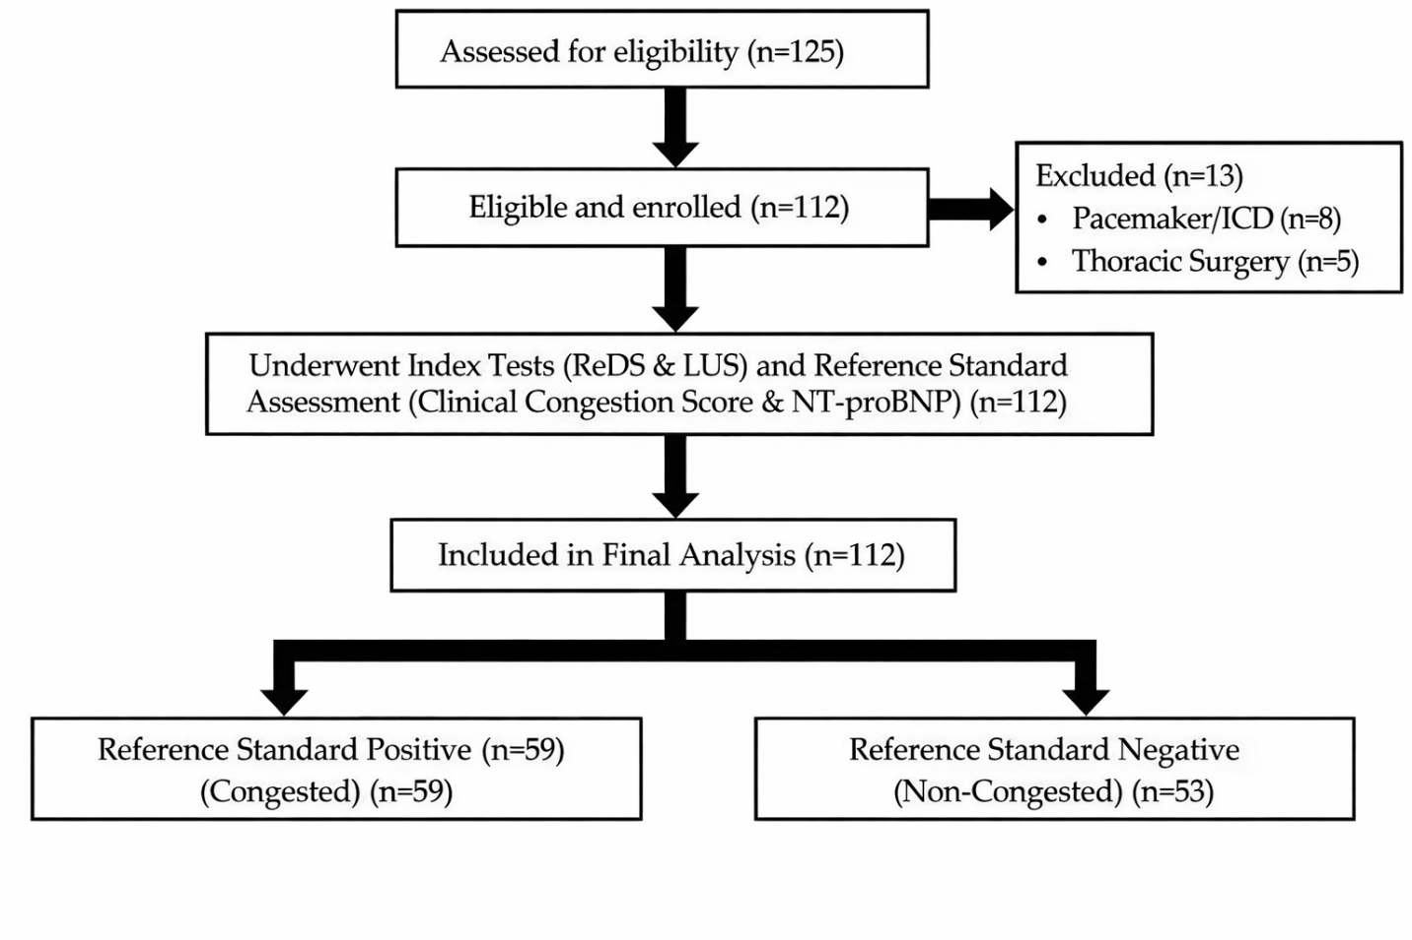
Figure 1. Study flow diagram
3.2 Baseline Characteristics: The cohort had a mean age of 68.7 years, and 46% were women. Left ventricular ejection fraction averaged 46%, with HFpEF accounting for 67% of cases. Baseline age, sex distribution, BMI, LVEF, and HF phenotype did not differ significantly between congested and non-congested groups. In contrast, markers of congestion showed clear separation. Patients classified as congested had higher NYHA class, markedly elevated NT-proBNP levels, and substantially higher ReDS values and total B-line counts, all with P values below .001. These findings (as shown in Table 1) confirm that objective congestion measures aligned with clinical adjudication, while demographic and structural characteristics remained comparable across groups.
Table 1. Baseline Characteristics
Variable | Total (n=112) | Congested (n=59) | Non-Congested (n=53) | P-value
Age, years | 68.7 ± 12.3 | 67.3 ± 11.8 | 70.2 ± 12.7 | .21
Female, n (%) | 52 (46.4) | 28 (47.5) | 24 (45.3) | .81
BMI, kg/m² | 27.2 ± 4.7 | 27.2 ± 5.3 | 27.2 ± 3.9 | .99
LVEF, % | 46.1 ± 11.2 | 45.3 ± 11.5 | 47.0 ± 10.8 | .43
HFrEF, n (%) | 37 (33.0) | 22 (37.3) | 15 (28.3) | .31
HFpEF, n (%) | 75 (67.0) | 37 (62.7) | 38 (71.7) | .31
NYHA class, median | 3 | 3 | 2 | <.001
NT-proBNP, ng/L | 1136 | 2139 | 537 | <.001
ReDS, % | 33.1 ± 8.8 | 37.9 ± 7.4 | 27.8 ± 7.1 | <.001
LUS B-lines | 22.3 ± 11.4 | 28.6 ± 10.1 | 15.4 ± 8.3 | <.001

3.3. Diagnostic Accuracy
Both modalities demonstrated similar discriminative performance for detecting pulmonary congestion. The area under the ROC curve (Figure 2) was 0.831 for ReDS and 0.845 for LUS, with no significant difference between them, P = .80. The ROC curves closely overlapped across most threshold ranges, indicating comparable sensitivity–specificity trade-offs. These findings support that ReDS and LUS provide similar overall diagnostic accuracy in this outpatient cohort, without clear superiority of one modality over the other.
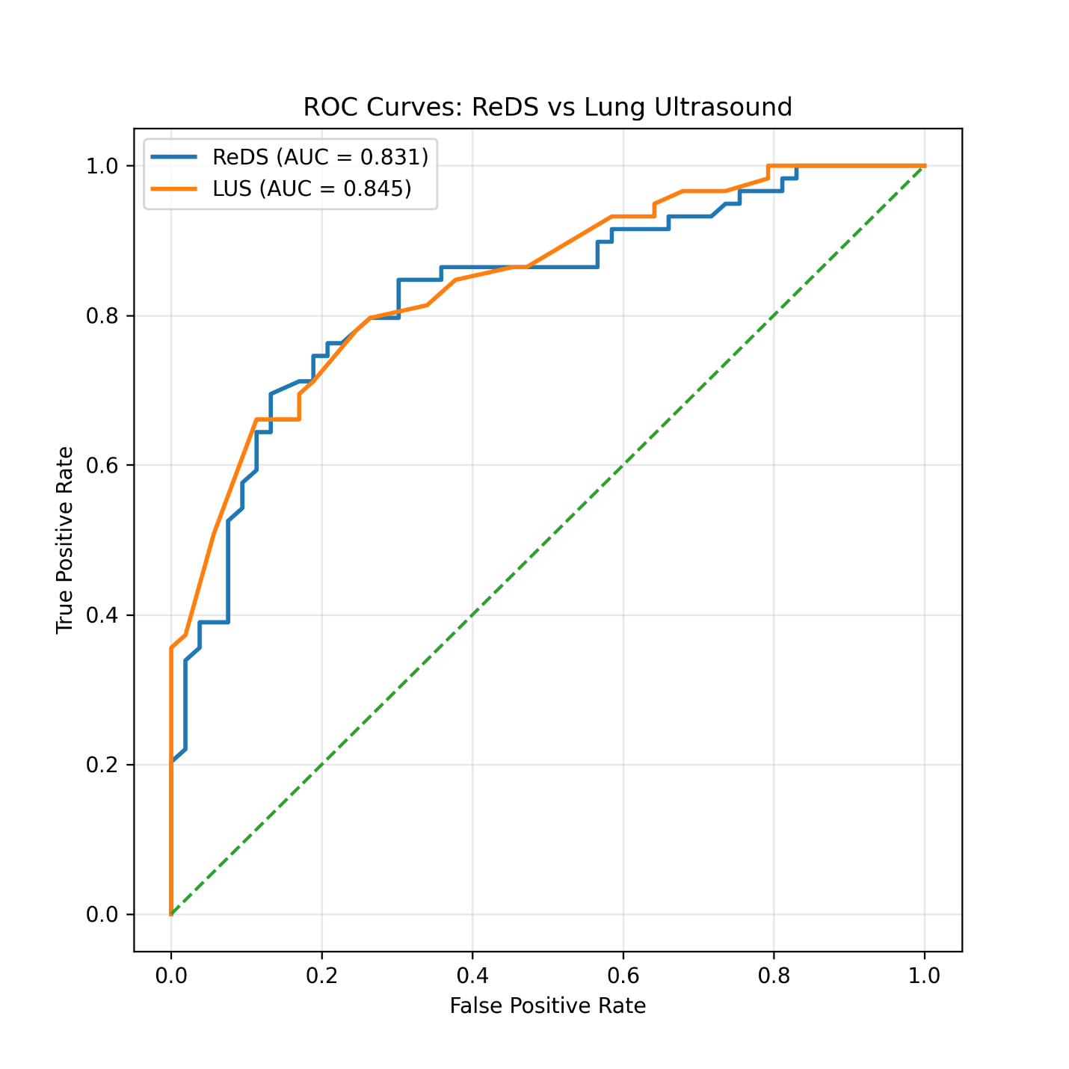
Figure 2. ROC Curves
3.4. Threshold performance
At the prespecified ReDS threshold of greater than 35 percent, sensitivity was 71 percent and specificity 81 percent. At the exploratory LUS cutoff of 24 B-lines or more, sensitivity was 70 percent and specificity 83 percent. Positive and negative predictive values were similar for both methods, and overall accuracy was identical at 75.9 percent. This is detailed in Table 2.
Likelihood ratios and diagnostic odds ratios were also comparable, with slightly higher rule-in performance for LUS. These findings indicate that, at clinically relevant thresholds, both tools perform similarly, with good specificity and moderate sensitivity in this outpatient population.

Table 2. Diagnostic Performance
Metric | ReDS >35% (95% CI) | LUS ≥24 B-lines (95% CI)
Sensitivity | 71.2% (58.1–81.8) | 69.5% (56.0–80.8)
Specificity | 81.1% (68.0–90.0) | 83.0% (70.2–92.0)
PPV | 80.8% (67.5–90.4) | 82.0% (68.6–91.4)
NPV | 71.7% (58.6–82.5) | 71.0% (57.9–82.2)
Accuracy | 75.9% | 75.9%
LR+ | 3.77 | 4.08
LR− | 0.36 | 0.37
DOR | 10.6 | 11.1

3.5. Concordance
ReDS and LUS agreed in 93 of 112 patients, yielding an overall concordance of 83.0 percent. Both tests were positive in 36 patients and negative in 57 patients. Discordant results occurred in 19 cases, with 6 patients classified as ReDS positive but LUS negative, and 13 classified as ReDS negative but LUS positive.
Inter-method agreement was substantial, with a Cohen kappa of 0.65. McNemar testing showed no significant asymmetry between discordant pairs, P = .16 (Table 3). These findings indicate consistent classification across modalities, with a moderate proportion of clinically meaningful discordance.
Table 3. Agreement Matrix
 | LUS Positive | LUS Negative | Total
ReDS Positive | 36 | 6 | 42
ReDS Negative | 13 | 57 | 70
Total | 49 | 63 | 112

3.6. Correlation
Continuous ReDS percentages showed a modest positive correlation with total B-line counts (Figure 3). Pearson correlation was r=0.36 with P < .001, indicating a statistically significant but moderate linear association. As ReDS values increased, B-line burden generally increased, although substantial scatter was present across the range of measurements.
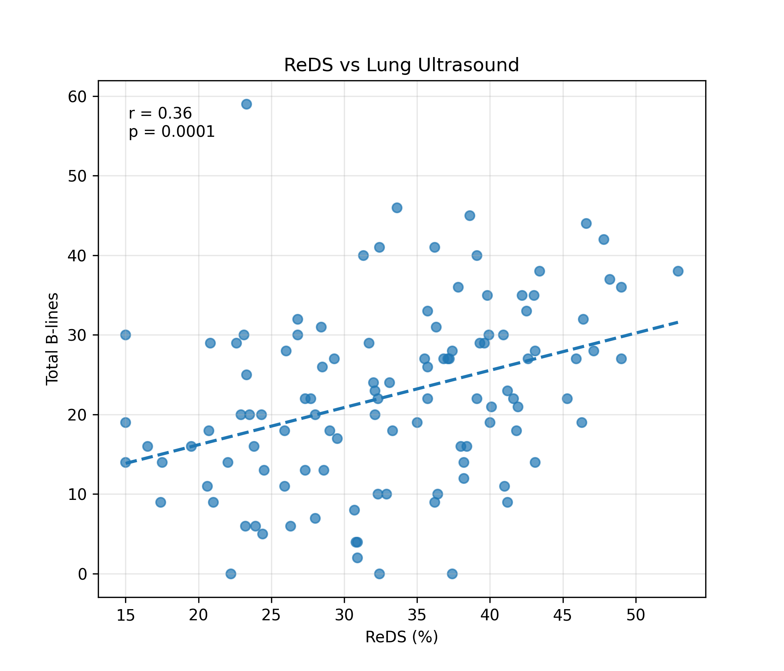
Figure 3. Scatter Plot showing correlation between ReDS % and number of B-lines on LUS
3.7. Subgroup analysis
Diagnostic performance remained broadly consistent across phenotypic subgroups. As seen in Table 4, in HFrEF patients, both modalities showed high discrimination, with AUCs of 0.862 for ReDS and 0.879 for LUS. In HFpEF, performance was slightly lower but remained acceptable, with AUCs of 0.812 and 0.828 respectively.
Body mass index influenced performance more noticeably. Among patients with BMI <30 kg/m², AUCs were strong for both ReDS and LUS at 0.871 and 0.865. In those with BMI ≥30 kg/m², discrimination declined, particularly for ReDS at 0.728, while LUS remained relatively preserved at 0.803. Confidence intervals were wider in higher BMI groups due to smaller sample size, so these findings should be interpreted as exploratory.
Table 4. Subgroup AUCs
Subgroup | ReDS AUC (95% CI) | LUS AUC (95% CI)
HFrEF (n=37) | 0.862 (0.71–0.96) | 0.879 (0.73–0.97)
HFpEF (n=75) | 0.812 (0.69–0.90) | 0.828 (0.71–0.91)
BMI <30 (n=78) | 0.871 (0.77–0.94) | 0.865 (0.76–0.93)
BMI ≥30 (n=34) | 0.728 (0.55–0.87) | 0.803 (0.63–0.92)

3.8. Multivariable analysis
In multivariable models adjusted for age and BMI, both ReDS and LUS remained independently associated with adjudicated congestion. In the ReDS-based model (Table 5), each 1 percent increase in ReDS was associated with a 20 percent higher odds of congestion, adjusted OR 1.20, 95% CI 1.12 to 1.29, P < .001. Age and BMI were not independently associated with congestion in this model. In the LUS-based model (Table 6), each 5-line increase in total B-lines was associated with a 48 percent higher odds of congestion, adjusted OR 1.48, 95% CI 1.22 to 1.79, P < .001. Again, age and BMI did not show significant independent associations.
Table 5: ReDS-Based Model
Variable | Adjusted OR | 95% Confidence Interval | P - value
ReDS (% per 1% increase) | 1.20 | 1.12 – 1.29 | <.001
Age (per year) | 0.98 | 0.94 – 1.02 | .31
BMI (per kg/m²) | 1.01 | 0.92 – 1.11 | .84

Table 6: Lung Ultrasound–Based Model (Comparator)
Variable | Adjusted OR | 95% Confidence Interval | P -value
LUS B-lines (per 5-line increase) | 1.48 | 1.22 – 1.79 | <.001
Age (per year) | 0.97 | 0.93 – 1.01 | .17
BMI (per kg/m²) | 0.99 | 0.90 – 1.09 | .82

3.9. Inter-observer reliability: Inter-observer reliability was evaluated in 23 randomly selected LUS examinations that were independently re-interpreted. Agreement for the predefined threshold of ≥24 B-lines was substantial, with Cohen’s κ of 0.75. This indicates consistent classification of congestion status between observers at the clinically relevant cutoff. Agreement analysis focused on threshold-based categorization. Continuous duplicate measurements were not systematically recorded; therefore, intraclass correlation for total B-line counts could not be calculated. ReDS provides an automated output and is less operator-dependent. Formal test–retest reproducibility was not assessed in this study.
3.10. Sensitivity analysis: Sensitivity analysis restricted to a clinical score ≥5 produced similar AUC estimates for both modalities.
4. DISCUSSION
Principal Findings
In this prospective outpatient cohort, ReDS and LUS showed similar discrimination for detecting pulmonary congestion in patients with chronic HF. Both methods achieved good specificity and moderate sensitivity, with substantial inter-method agreement. In most patients, you can rely on either tool to classify congestion status. At the same time, correlation between continuous ReDS values and total B-line counts remained modest. This finding indicates that each modality reflects related but distinct physiological processes. These results align with prior validation and prognostic studies showing that both ReDS and LUS provide clinically meaningful measures of pulmonary congestion in ambulatory and hospitalized populations (Platz et al., 2017; Platz et al., 2016; Amir et al., 2013; Bensimhon et al., 2016; Amir et al., 2016; Imamura et al., 2017). In daily practice, you should not view one modality as a substitute for the other. Each adds unique information. When interpreted together, they strengthen clinical assessment and reduce diagnostic uncertainty.
Interpretation
ReDS estimates lung fluid percentage by measuring thoracic dielectric properties and reflects global thoracic fluid content, including intravascular and extravascular components (Amir et al., 2013; Bensimhon et al., 2016; Amir et al., 2016). LUS detects B-lines generated by thickened interlobular septa and primarily reflects alveolar-interstitial edema (Platz et al., 2017; Platz et al., 2016). These physiological differences explain the modest correlation observed in this study. When ReDS values were elevated and LUS findings were negative, patients often showed features of early or predominantly systemic congestion. This pattern matches reports linking ReDS to invasive filling pressures and total lung water burden (Bensimhon et al., 2016; Amir et al., 2016). In contrast, patients with positive LUS findings and lower ReDS values often showed localized pulmonary changes, particularly among HFpEF phenotypes, as described in comparative studies (Kato et al., 2023; Kobalava et al., 2023; Kobalava et al., 2024; Huang et al., 2026). Together, these discordant patterns show that congestion is not uniform. It changes over time and varies in distribution. ReDS appears more sensitive to early volume accumulation. LUS detects structural changes within the lung interstitium. When you interpret both results together, you gain a clearer view of cardiopulmonary fluid status and disease trajectory.
Clinical Implications
In routine outpatient care, ReDS provides a rapid and standardized screening tool. A single automated measurement requires limited training and fits easily into high-volume clinics. When ReDS values exceed the prespecified threshold, you can identify patients at higher risk of decompensation, consistent with prior outcome studies (Imamura et al., 2017; Abraham et al., 2017; Olesen et al., 2022; Lala et al., 2021). LUS adds value by defining the anatomical pattern and extent of pulmonary congestion. It helps you distinguish diffuse edema from focal or patchy changes and assess treatment response in real time (Platz et al., 2017; Platz et al., 2016; Domingo et al., 2021; Rastogi et al., 2024). A sequential strategy is practical. Firstly, ReDS may be used to screen for subclinical congestion, LUS can then be used to guide targeted diuretic adjustment and follow-up if ReDS results are positive or uncertainty persists. This approach reflects emerging models of integrated congestion monitoring that combine objective measurements with bedside assessment (Kato et al., 2023; Kobalava et al., 2023; Kobalava et al., 2024; Huang et al., 2026). It also supports personalized volume management, which remains central to reducing hospitalization and symptom burden in HF (Savarese et al., 2023; Gheorghiade et al., 2010; McDonagh et al., 2021).
Strengths
This study has several methodological strengths. We used a prospective design with predefined protocols for both index tests. Blinded adjudication reduced assessment bias. Standardized acquisition and interpretation procedures improved reproducibility. Complete datasets limited selective reporting. These features strengthen internal validity and support confidence in the findings.
5. CONCLUSION
ReDS and LUS demonstrated comparable diagnostic accuracy for identifying pulmonary congestion in ambulatory HF patients. Their modest correlation and substantial agreement support complementary clinical roles. Combined use promotes structured and objective congestion assessment in outpatient care. Future studies should include independent reference standards, broader operator populations, and outcome-based validation to refine implementation strategies.
Limitations
Several limitations require attention. The composite reference standard lacks external validation and may misclassify some patients, particularly in stable outpatient settings (Gheorghiade et al., 2010; Januzzi et al., 2018). The absence of invasive hemodynamic confirmation limits mechanistic interpretation. The single-center design restricts generalizability. The moderate sample size limits power for subgroup analyses. LUS examinations were performed by experienced operators, which may overestimate performance in less specialized settings (Ceriani et al., 2021). ReDS reproducibility was not independently evaluated, and device positioning may influence measurements. Longitudinal outcomes, including hospitalization and mortality, were not assessed. Future multicenter studies should address these gaps.

INFORMED CONSENT
All authors declare that ‘written informed consent was obtained from the patient (or other approved parties) for publication of this case report and accompanying images. A copy of the written consent is available for review by the Editorial office/Chief Editor/Editorial Board members of this journal.
ETHICAL APPROVAL
Ethical committee approval was obtained prior to initiating study (Ethics Committee approval number- AMH – DNB-078/08-23). All study related protocols, consent and documents were submitted and approved by the committee.
ABBREVIATIONS
Abbreviation | Full Term
AUC | Area Under the Receiver Operating Characteristic Curve
BMI | Body Mass Index
CI | Confidence Interval
DOR | Diagnostic Odds Ratio
HF | Heart Failure
HFpEF | Heart Failure with Preserved Ejection Fraction
HFrEF | Heart Failure with Reduced Ejection Fraction
LUS | Lung Ultrasound
LR+ | Positive Likelihood Ratio
LR− | Negative Likelihood Ratio
LVEF | Left Ventricular Ejection Fraction
NT-proBNP | N-terminal pro–B-type Natriuretic Peptide
NPV | Negative Predictive Value
NYHA | New York Heart Association
OR | Odds Ratio
PPV | Positive Predictive Value
ReDS | Remote Dielectric Sensing
ROC | Receiver Operating Characteristic
SD | Standard Deviation
STARD | Standards for Reporting of Diagnostic Accuracy Studies

COMPETING INTERESTS DISCLAIMER:
Authors have declared that they have no known competing financial interests OR non-financial interests OR personal relationships that could have appeared to influence the work reported in this paper.

REFERENCES
- Savarese G, Becher PM, Lund LH, Seferovic P, Rosano GMC, Coats AJS. Global burden of heart failure: a comprehensive and updated review of epidemiology. Cardiovasc Res. 2023;118:3272–3287.
- Gheorghiade M, Follath F, Ponikowski P, et al. Assessing and grading congestion in acute heart failure: a scientific statement from the Heart Failure Association of the European Society of Cardiology. Eur J Heart Fail. 2010;12:423–433.
- McDonagh TA, Metra M, Adamo M, et al. 2021 ESC Guidelines for the diagnosis and treatment of acute and chronic heart failure. Eur Heart J. 2021;42:3599–3726.
- Thibodeau JT, Drazner MH. The role of the clinical examination in patients with heart failure. JACC Heart Fail. 2018;6:543–551.
- Wang CS, FitzGerald JM, Schulzer M, Mak E, Ayas NT. Does this dyspneic patient in the emergency department have congestive heart failure? JAMA. 2005;294:1944–1956.
- Platz E, Merz AA, Jhund PS, Vazir A, Campbell R, McMurray JJV. Dynamic changes and prognostic value of pulmonary congestion by lung ultrasound in acute and chronic heart failure. Eur J Heart Fail. 2017;19:1154–1163.
- Platz E, Merz AA, Jhund PS, Vazir A, Campbell R, McMurray JJV. Detection and prognostic value of pulmonary congestion by lung ultrasound in ambulatory heart failure patients. Eur Heart J. 2016;37:1244–1251.
- Domingo M, Conangla L, Lupón J, et al. Prognostic value of lung ultrasound in chronic stable ambulatory heart failure patients. Rev Esp Cardiol (Engl Ed). 2021;74:862–869.
- Rastogi T, Gargani L, Pellicori P, et al. Prognostic implication of lung ultrasound in heart failure: a pooled analysis of international cohorts. Eur Heart J Cardiovasc Imaging. 2024;25:1216–1225.
- Ceriani E, Knol MJ, van der Worp HB, et al. Methodological quality of diagnostic accuracy studies on lung ultrasound in patients with suspected heart failure. J Ultrasound Med. 2021;40:2553–2565.
- Amir O, Rappaport D, Zafrir B, Abraham WT. A novel approach to monitoring pulmonary congestion in heart failure. Congest Heart Fail. 2013;19:149–155.
- Bensimhon D, Burton J, Wang H, et al. Remote dielectric sensing for detecting pulmonary congestion. JACC Heart Fail. 2016;4:729–730.
- Amir O, Azzam ZS, Abraham WT, et al. Validation of remote dielectric sensing technology. Int J Cardiol. 2016;221:841–846.
- Imamura T, Narang N, Kim G, et al. Remote dielectric sensing and clinical outcomes. J Card Fail. 2017;23:577–579.
- Kato M, Stevenson LW, Goda A, et al. Remote dielectric sensing and lung ultrasound. Heart Vessels. 2023;38:672–681.
- Kobalava Z, Safarova AF, Tolkacheva V, et al. Pulmonary congestion in HFrEF. Arq Bras Cardiol Imagem Cardiovasc. 2023;36:e20230027.
- Kobalava Z, Safarova AF, Tolkacheva V, et al. Assessment in hospitalized HF. Arq Bras Cardiol. 2024;121:e20240128.
- Huang S, Sun G, Wu Y, et al. Association between ReDS and LUS. Front Cardiovasc Med. 2026;13:1723377.
- Bossuyt PM, Reitsma JB, Bruns DE, et al. STARD 2015. BMJ. 2015;351:h5527.
- Januzzi JL Jr, Chen-Tournoux AA, Christenson RH, et al. ICON-RELOADED. J Am Coll Cardiol. 2018;71:1191–1200.
- Alvarez-Garcia J, Lala A, Rivas-Lasarte M, et al. ReDS-SAFE HF. JACC Heart Fail. 2024;12:695–706.
- Lala A, Barghash MH, Lanfear DE, et al. Early ReDS use. ESC Heart Fail. 2021;8:1047–1054.
- Abraham WT, Bensimhon DR, Pinney SP, et al. ReDS-guided therapy. Int J Cardiol. 2017;240:279–284.
- Olesen ASO, Miger K, Fabricius-Bjerre A, et al. ReDS in ED dyspnea. Eur Heart J Open. 2022;2:oeac073.

