Case report

Duplicate Gallbladder Diagnosed on Ultrasonography Alone and Managed Conservatively in an Obese Patient: A Rare Case Report

  - ABSTRACT
Duplication of the gallbladder is a rare congenital biliary anomaly with significant clinical and surgical implications. Most cases are detected incidentally during surgery or advanced imaging, and preoperative diagnosis remains challenging, particularly in resource-limited settings. We report a rare case of gallbladder duplication diagnosed solely on ultrasonography in an obese adult presenting with postprandial upper abdominal pain. The patient was managed conservatively with dietary modification, proton pump inhibitors, and antispasmodics, resulting in complete symptom resolution. This case highlights the diagnostic value of ultrasonography and demonstrates that conservative management may be appropriate in carefully selected patients with uncomplicated duplicate gallbladder.

Keywords: Duplicate gallbladder, gallbladder duplication, ultrasonography, congenital biliary anomaly, conservative management

  - INTRODUCTION
Duplication of the gallbladder, also referred to as double or accessory gallbladder, is a rare congenital anomaly of the biliary system, with an estimated incidence of approximately 1 in 4000 individuals [1,2]. First described in the 18th century, this anomaly arises due to abnormal budding of the hepatic diverticulum during embryogenesis [3]. Various anatomical configurations have been described, including bilobed gallbladder, true duplication with two cystic ducts, and accessory gallbladders draining into the biliary tree at different levels [4].
Although many individuals with gallbladder duplication remain asymptomatic, the condition gains clinical significance when associated with gallstone disease, cholecystitis, or biliary colic [5]. Symptoms are often indistinguishable from those of a single gallbladder pathology, making preoperative diagnosis difficult. Failure to recognize duplication may result in persistent symptoms or biliary complications following cholecystectomy [6].
Ultrasonography is the first-line imaging modality for gallbladder evaluation due to its availability, safety, and cost-effectiveness. However, differentiating gallbladder duplication from other entities such as folded gallbladder, Phrygian cap, or pericholecystic fluid collections can be challenging [7]. While magnetic resonance cholangiopancreatography (MRCP) is considered superior for delineating biliary anatomy, it is not always available or necessary in uncomplicated cases [8].
We report a rare case of gallbladder duplication diagnosed solely on ultrasonography in an obese patient presenting with postprandial abdominal symptoms, who was successfully managed conservatively.

CASE REPORT
An adult obese 41 year old lady presented to the surgical outpatient department with complaints of intermittent upper abdominal pain for several months. The pain was predominantly postprandial, especially after ingestion of fatty meals, and was localized to the right upper quadrant and epigastrium. The discomfort was associated with bloating and dyspepsia but was not accompanied by fever, jaundice, vomiting, or weight loss.
There was no significant past medical or surgical history. The patient had no known metabolic disorders or history of alcohol intake. On general examination, the patient was obese with stable vital signs. Abdominal examination revealed mild epigastric tenderness without guarding, rigidity, or palpable mass. Murphy’s sign was negative.
Routine laboratory investigations, including complete blood count, liver function tests, lipid profile and serum amylase/lipase were within normal limits.
Imaging Findings:
Abdominal ultrasonography revealed two distinct pear shaped cystic structures located in the gallbladder fossa with echogenic septa in between, consistent with gallbladder duplication. Both sacs were anechoic. The gallbladder walls were not thickened, and no pericholecystic fluid collection was observed. The common bile duct was normal in calibre, with no evidence of intrahepatic biliary dilatation. Fatty liver grade1 was noted.
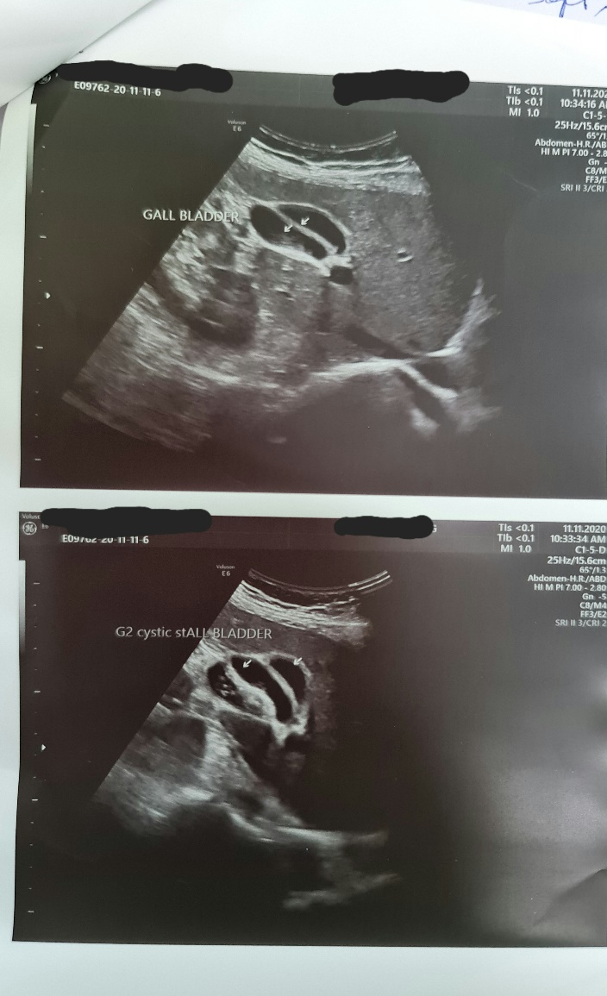
Figure 1: Ultrasonography of the abdomen demonstrating two distinct gallbladder sacs (arrows) within the gallbladder fossa, lumen anechoic, consistent with gallbladder duplication without features of acute inflammation.
No additional imaging such as CT scan or MRCP was performed, as the ultrasound findings were considered diagnostic and there were no features of complicated biliary disease.

  - MANAGEMENT AND OUTCOME
Given the absence of complications, stable clinical status, and patient preference, a conservative management approach was adopted. The patient was advised dietary modification with avoidance of fatty foods. Pharmacological therapy included proton pump inhibitors and antispasmodic agents.
The patient showed significant symptomatic improvement over the following weeks. At follow-up, postprandial pain and dyspeptic symptoms had resolved completely. No further episodes were reported during continued follow-up, and surgical intervention was deferred.

  - DISCUSSION
Gallbladder duplication is an uncommon congenital anomaly that poses diagnostic and therapeutic challenges. Embryologically, it results from excessive budding or splitting of the gallbladder primordium during the fifth to sixth week of gestation [3,9]. Several classification systems exist, with the most widely used being those proposed by Boyden and Harlaftis, based on anatomical and ductal variations [4].
Clinical presentation varies widely. While many cases remain asymptomatic, symptoms typically arise due to associated gallstone disease or inflammation, similar to pathology in a single gallbladder [10]. Obesity, as seen in our patient, further increases the risk of gallstone formation due to altered cholesterol metabolism and gallbladder hypomotility [11].
Preoperative diagnosis of gallbladder duplication is notoriously difficult. Ultrasonography, although operator-dependent, remains the most commonly used diagnostic modality. Previous reports have demonstrated that careful ultrasonographic examination can identify duplicated gallbladders, especially when two separate cystic structures are visualized [7,12]. However, misinterpretation may lead to missed diagnosis, with serious implications during surgery [6].
MRCP is considered the imaging modality of choice for detailed biliary anatomy mapping [8,13], but its routine use may not be justified in uncomplicated cases, particularly in resource-limited settings. Our case demonstrates that ultrasonography alone can be sufficient for diagnosis when characteristic features are clearly identified.
Surgical management is generally recommended for symptomatic duplicate gallbladder, with removal of both gallbladders to prevent recurrent symptoms [14]. However, conservative management may be appropriate in selected patients with mild symptoms, absence of complications, and good response to medical therapy. Very few reports have described non-operative management, making this case clinically relevant.

  - CONCLUSION
Gallbladder duplication is a rare congenital anomaly that should be considered in patients with biliary symptoms and atypical ultrasonographic findings. Ultrasonography alone can be diagnostic in experienced hands. Conservative management may be a viable option in selected, uncomplicated cases with careful follow-up, potentially avoiding unnecessary surgical intervention.

Additional Information

.
Ethical Approval: Not required

  - REFERENCES
- Desolneux G, Mucci S, Lebigot J, et al. Duplication of the gallbladder. Gastroenterol Res Pract. 2009;2009:1–3.
- Hishinuma M, Isogai Y, Matsuura Y, et al. Double gallbladder. J Gastroenterol Hepatol. 2004;19:233–235.
- Vijayaraghavan R, Belagavi C. Double gallbladder with different disease entities. J Minim Access Surg. 2006;2:23–26.
- Singh B, Ramsaroop L, Allopi L, et al. Duplicate gallbladder: an unusual case report. Surg Radiol Anat. 2006;28:654–657.
- Alfadlil A, et al. Double gallbladder: a rare congenital anomaly. Clinics in Surgery. 2016;1:1016.
- Smelt JLC, Wright H, Sagar J, et al. Laparoscopic removal of a double gallbladder for cholelithiasis. Ann R Coll Surg Engl. 2011;93:e105–e106.
- Bulus K, Koyuncu A, Coskun A. Preoperative diagnosis of double gallbladder: a case report. Turk J Gastroenterol. 2012;23:172–174.
- Mazziotti S, Minutoli F, Blandino A, et al. Gallbladder duplication: MR cholangiography demonstration. Abdom Imaging. 2001;26:287–289.
- Weibel D, Kaufmann M, Reidtmann-Klee H. Accessory gallbladder originating from the right hepatic duct. Surg Endosc. 2001;15:519.
- Roldan-Valadez E, Osorio-Peralta S, et al. Asymptomatic true gallbladder duplication. Acta Radiol. 2004;45:810–814.
- Portincasa P, Moschetta A, Palasciano G. Cholesterol gallstone disease. Lancet. 2006;368:230–239.
- Shea JA, Berlin JA, Escarce JJ, et al. Revised estimates of diagnostic test sensitivity in biliary disease. Arch Intern Med. 1994;154:2573–2581.
- Tazuma S. Gallstone disease. Best Pract Res Clin Gastroenterol. 2006;20:1075–1083.
- Everhart JE, Yeh F, Lee ET, et al. Prevalence of gallbladder disease in obesity. Gastroenterology. 2002;122:903–910.

