Case report
SUPERIOR MESENTERIC ARTERY SYNDROME ASSOCIATED WITH A MALROTATED ECTOPIC LEFT KIDNEY: A RARE CASE REPORT

ABSTRACT
Background:
Superior mesenteric artery (SMA) syndrome, also known as Wilkie syndrome, is a rare cause of upper gastrointestinal obstruction resulting from compression of the third part of the duodenum between the aorta and the superior mesenteric artery. The condition is often precipitated by rapid weight loss, leading to depletion of the mesenteric fat pad and narrowing of the aortomesenteric angle. Congenital anomalies associated with SMA syndrome are uncommon, and its coexistence with renal ectopia and malrotation is exceedingly rare.
Aim:
To report a rare case of SMA syndrome associated with a malrotated ectopic left kidney and to emphasize the importance of detailed preoperative imaging and anatomical understanding in surgical planning.
Case Presentation:
An 18-year-old female presented with chronic postprandial epigastric pain, recurrent bilious vomiting, early satiety, and significant weight loss. Symptoms were exacerbated during menstruation and partially relieved in the supine position. Contrast-enhanced computed tomography (CT) with angiography demonstrated a markedly reduced aortomesenteric angle and distance, confirming SMA syndrome. Additionally, a malrotated ectopic left kidney was identified in the pelvis with anomalous renal vasculature. Conservative management failed, following which the patient underwent an elective retrocolic side-to-side duodenojejunostomy, resulting in complete symptomatic resolution.
Conclusion:
This case highlights a rare association of SMA syndrome with a malrotated ectopic kidney. Awareness of such anatomical anomalies and meticulous preoperative imaging are crucial to ensure safe and effective surgical intervention.
Keywords: Superior mesenteric artery syndrome; Wilkie syndrome; Duodenojejunostomy; Renal ectopia; Renal malrotation

- INTRODUCTION
Superior mesenteric artery (SMA) syndrome is a rare but clinically significant cause of proximal intestinal obstruction, first described by Rokitansky in 1842 and later detailed by Wilkie in 1927. It results from compression of the third part of the duodenum between the abdominal aorta posteriorly and the SMA anteriorly. The normal aortomesenteric angle ranges between 38° and 65°, with an aortomesenteric distance of 10–28 mm. In SMA syndrome, these values are reduced to less than 22° and 8 mm, respectively, leading to duodenal compression and obstruction.

The condition predominantly affects young, thin individuals and is commonly associated with rapid weight loss due to chronic illness, eating disorders, trauma, burns, or postoperative states. Congenital and anatomical factors such as high insertion of the ligament of Treitz, low origin of the SMA, and spinal deformities have also been implicated.

Renal ectopia and malrotation are developmental anomalies resulting from abnormal ascent and rotation of the kidneys during embryogenesis. Although renal anomalies are relatively common, their association with SMA syndrome is extremely rare. The presence of aberrant renal vasculature and altered retroperitoneal anatomy in such cases poses additional challenges during surgical intervention.

We present a rare case of SMA syndrome associated with a malrotated ectopic left kidney, highlighting the diagnostic challenges, surgical considerations, and importance of comprehensive preoperative imaging.

- PRESENTATION OF CASE
An 18-year-old female presented with a 6-month history of postprandial epigastric pain, recurrent bilious vomiting, early satiety, and progressive weight loss. The pain was dull, non-radiating, and typically occurred within 20–30 minutes after meals. Notably, the patient reported worsening of pain during menstruation and partial relief when lying supine or in the left lateral decubitus position.

There was no history of abdominal surgery, trauma, tuberculosis, or eating disorders. Physical examination revealed a thin-built patient with a body mass index of 17 kg/m². Mild epigastric tenderness was present, with no palpable mass or organomegaly. Laboratory investigations, including complete blood count, liver function tests, renal function tests, and serum electrolytes, were within normal limits.

Contrast-enhanced CT of the abdomen with angiography revealed compression of the third part of the duodenum between the SMA and the aorta. The aortomesenteric angle was reduced to approximately 15°, and the aortomesenteric distance measured less than 6 mm. Proximal duodenal dilatation was noted.

Incidentally, imaging also demonstrated a malrotated ectopic left kidney located in the pelvis. The renal pelvis faced anteriorly, and anomalous renal vessels were seen arising from the right common iliac artery, contributing to distorted retroperitoneal anatomy.

Initial conservative management included nasogastric decompression, high-calorie nutritional supplementation, postural therapy, and correction of electrolyte imbalance. Despite adequate nutritional optimization over several weeks, the patient continued to experience persistent symptoms, necessitating surgical intervention.

An elective retrocolic side-to-side duodenojejunostomy was performed. Intraoperatively, the altered retroperitoneal anatomy and anomalous renal vessels were carefully identified and preserved. The postoperative course was uneventful, and the patient tolerated oral feeds by postoperative day 5. At 6-month follow-up, she remained asymptomatic with significant weight gain.
- DISCUSSION
SMA syndrome is an uncommon entity, with an estimated incidence of 0.013–0.3%. Its rarity and nonspecific symptoms often result in delayed diagnosis. Classic symptoms include postprandial epigastric pain, nausea, vomiting, early satiety, and weight loss, creating a vicious cycle that further exacerbates the condition.

CT angiography is currently the diagnostic modality of choice, as it allows direct visualization of duodenal compression and accurate measurement of the aortomesenteric angle and distance. Upper gastrointestinal contrast studies may show dilatation of the proximal duodenum with abrupt cut-off at the third part.

Conservative management remains the first-line treatment and focuses on nutritional rehabilitation to restore the mesenteric fat pad. However, surgical intervention is indicated in patients with persistent or severe symptoms. Duodenojejunostomy is considered the gold standard surgical procedure, with reported success rates exceeding 90%. Laparoscopic approaches have gained popularity due to reduced morbidity and faster recovery.

Renal ectopia and malrotation occur due to abnormal embryological ascent and rotation of the kidney between the 6th and 9th weeks of gestation. These anomalies are frequently associated with aberrant renal vessels, which may arise from the aorta, iliac arteries, or other unusual sources. Such vascular variations significantly alter retroperitoneal anatomy and increase the risk of inadvertent injury during abdominal surgery.

Although the renal anomaly in the present case did not directly cause duodenal compression, its coexistence added complexity to surgical planning. Awareness of such anomalies through meticulous preoperative imaging was crucial in preventing vascular injury and ensuring a safe operative course.

The association of SMA syndrome with other vascular compression syndromes such as nutcracker syndrome has been reported, but coexistence with renal ectopia is extremely rare, with only isolated cases described in the literature. This case adds to the limited body of evidence and highlights the importance of considering associated congenital anomalies in patients with SMA syndrome.

- CONCLUSION
Superior mesenteric artery syndrome is a rare but treatable cause of chronic duodenal obstruction. Its association with a malrotated ectopic kidney is exceedingly uncommon and poses unique diagnostic and surgical challenges. Comprehensive preoperative imaging and a thorough understanding of altered retroperitoneal anatomy are essential to guide safe and effective surgical management. Duodenojejunostomy remains a definitive and reliable treatment in patients who fail conservative therapy.

CONSENT
Written informed consent was obtained from the patient for publication of this case report and accompanying images.
ETHICAL APPROVAL
Ethical approval was not required in accordance with institutional policy.

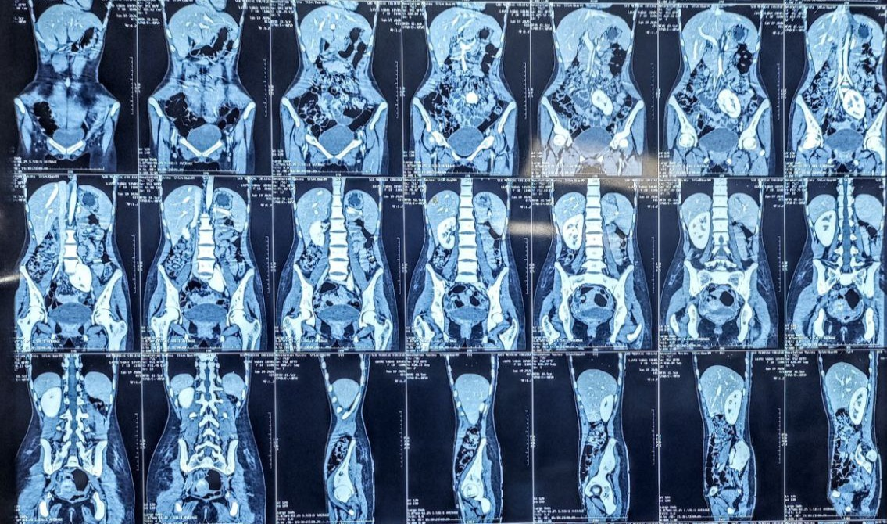
Figure 1 : CECT Abdomen & Pelvis showing reduced aortomesenteric angle and compression of the third part of the duodenum.

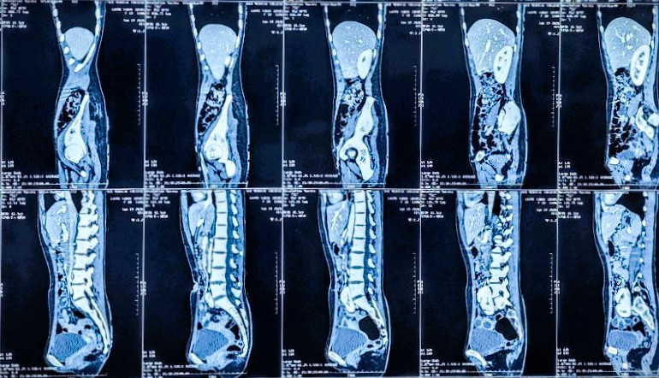
Figure 2 : CT abdomen demonstrating ectopic malrotated left kidney located in the pelvis.

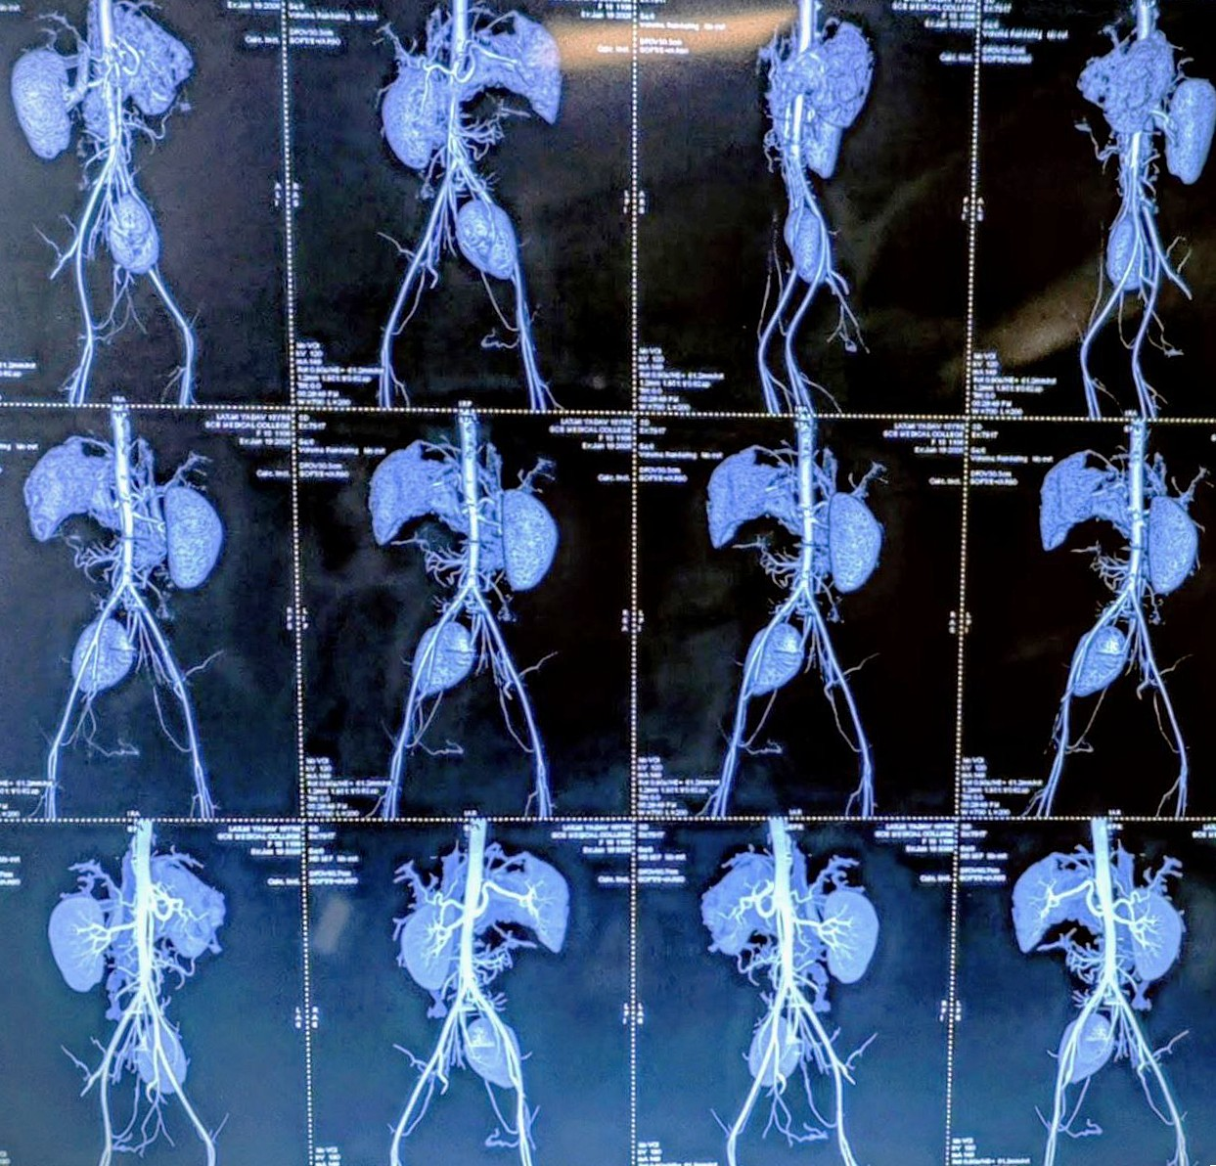
Figure 3: 3D CT angiography showing anomalous renal vessels, with left main renal artery arising from right common iliac artery.
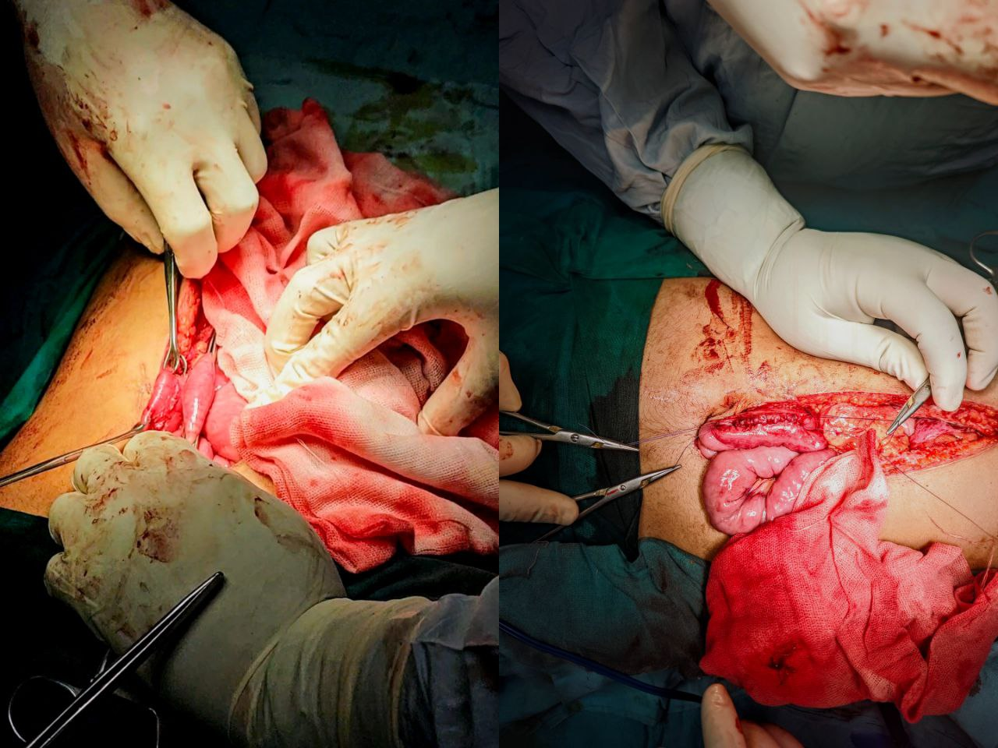
Figure 4 : Intraoperative image showing Retrocolic Side to Side Duodenojejunostomy
REFERENCES
- Lee TH, Lee JS, Jo Y, Park KS, Cheon JH, Kim YS, et al. Superior mesenteric artery syndrome: where do we stand today? J Gastrointest Surg. 2012;16(12):2203–2211. doi:10.1007/s11605-012-2049-5. Available from: https://pubmed.ncbi.nlm.nih.gov/23076975/
- Türkvatan A, Olçer T, Cumhur T. Multidetector CT urography of renal fusion anomalies. Diagn Interv Radiol. 2009;15(2):127–134. Available from: https://pubmed.ncbi.nlm.nih.gov/19517383/
- Shi Y, Shi G, Li Z, Chen Y, Tang S, Huang W. Superior mesenteric artery syndrome coexists with Nutcracker syndrome in a female: a case report. BMC Gastroenterol. 2019;19(1):15. doi:10.1186/s12876-019-0932-1. Available from: https://bmcgastroenterol.biomedcentral.com/articles/10.1186/s12876-019-0932-1
- Oka A, Awoniyi M, Hasegawa N, Yoshida Y, Tobita H, Ishimura N, et al. Superior mesenteric artery syndrome: diagnosis and management. World J Clin Cases. 2023;11(15):3369–3384. doi: https://doi.org/10.12998/wjcc.v11.i15.3369
Available from: https://www.wjgnet.com/2307-8960/full/v11/i15/3369.htm
- England J, Li N. Superior mesenteric artery syndrome: a review of the literature. J Am Coll Emerg Physicians Open. 2021;2(3):e12454. doi: https://doi.org/10.1002/emp2.12454
. Available from: https://pubmed.ncbi.nlm.nih.gov/34179879/
- Ledezma Flores E, Calderón Fernández A, Urias Pompa A, et al. Clinical insights into Wilkie’s syndrome: a case report and review of relevant literature. Radiol Case Rep. 2025;20(8):3964-3969. doi: https://doi.org/10.1016/j.radcr.2025.04.096.
Available from: https://pubmed.ncbi.nlm.nih.gov/40496073/

