Case report
Transanal long tube drainage for management of anastomotic leakage after left hemicolectomy for cancer of the descending colon: A case report

Abstract
Introduction: Anastomotic leakage after colectomy is a potentially life-threatening complication. We report the first case treated by the conservative management using the transanal long tube for major leakage after colectomy.
Presentation of Case: We report a 50-year-old woman who underwent a laparotomy for left hemicolectomy with end-to-end anastomosis to treat a cancer of the descending colon, as well as total hysterectomy, bilateral salpingo-oophorectomy, and pelvic lymphadenectomy to address endometrial cancer. On postoperative day (POD) 3, ascites containing feces was detected in her abdominal drainage tube, consistent with a major anastomotic leak. Fasting and intravenous antibiotics did not improve her condition, so a short transanal drainage tube was inserted on POD 5. This was also not effective enough to adequately drain the colon contents. Therefore, a long transanal drainage tube was inserted beyond the anastomosis the next day and placed at the splenic flexure. Adequate drainage was achieved, and ascites drainage from the abdominal tube was soon reduced. The patient’s symptoms, fever, and laboratory inflammatory parameters improved and the fistula closed on POD 51. At the 2-year follow-up she was alive and well without recurrence.
Discussion and Conclusion: Managing anastomotic leakage after colectomy using transanal long drainage tube might be effective in selected patients.

Keywords: Colon cancer, transanal drainage, anastomotic leakage
Introduction
Anastomotic leakage is a common and serious complication of colectomy with potentially life threatening consequences ^{(1, 2)}. If the leakage is severe or pan-peritonitis has developed, emergency laparotomy to irrigate the abdominal cavity and create a diverting stoma is typically necessary. Transanal drainage tube insertion can be effective for preventing anastomotic leakage after low anterior resection for rectal cancer ^{(3, 4)}. To the best of our knowledge, however, it has not been described for conservative management using transanal long tube for anastomotic leakage after colectomy of descending colon cancer, which we present here.

Presentation of Case
A 50-year-old woman with a body mass index of 35.6 and a history of type 2 diabetes mellitus was referred for treatment of cancer of the descending colon and endometrial cancer. She underwent a laparotomy for left hemicolectomy, total hysterectomy, bilateral salpingo-oophorectomy, and pelvic lymphadenectomy. An functional end-to-end bowel anastomosis was performed using a linear stapler. Histopathologically, the colon cancer was a well differentiated adenocarcinoma. The tumor stage was pT2N0M0.
On postoperative day (POD) 3, she complained of abdominal pain and developed a fever. Her white blood cell count (20,600/uL) and C-reactive protein concentration (16.3 mg/dL) were elevated, and her intra-abdominal drainage tube had drained 1280 mL of ascites fluid containing feces, consistent with a major anastomotic leak. Computed tomography revealed only a small fluid collection around the anastomosis site and in the pelvis, which suggested the intraabdominal tube was providing adequate drainage. The peritonitis was localized, so we elected to proceed with non-surgical treatment.
Unfortunately, fasting in conjunction with intravenous piperacillin/tazobactam and immunoglobulin did not improve her condition. A short (80 mm, 24 Fr) transanal MIT drainage tube (Create Medic Co., Ltd., Yokohama, Japan) was then inserted on POD 5, which drained 500 mL of rectal content, an inadequate amount. Therefore, the next day, a long 22 Fr Colonoscopic Retrograde Bowel Drainage tube (Create Medic Co., Ltd.) was inserted transanally beyond the anastomosis and placed at the splenic flexure under fluoroscopic guidance (Figure 1). This was successful in draining 940 mL of colon contents. As a result, the volume of feces-containing ascites from the abdominal drainage tube was soon reduced. The volumes of abdominal and transanal drainage and concentration of C-reactive protein over time are shown in Figure 2.
The patient’s symptoms, fever, and laboratory inflammatory parameters improved, and the transanal tube was removed on POD 12. A concentrated liquid diet was initiated, which was eventually advanced to a normal diet on POD 45 after fistula narrowing was confirmed. The fistula finally closed on POD 51 (Figure 3). At the 2-year follow-up, she was alive and well without recurrence.

Discussion
This is the first report of successfully managing an anastomotic leak after colectomy using a long transanal drainage tube. The efficacy of transanal tube drainage in preventing anastomotic leakage after low anterior resection for rectal cancer has been reported in several studies. In a randomized trial of patients undergoing low anterior resection ⁽³⁾, the incidence of anastomotic leakage was significantly lower in the transanal drainage tube group (4.0% vs. 9.6%; P = 0.026). Two recent meta-analyses have also reported the protective effect of transanal drainage after rectal surgery ^{(4, 5)}. However, in a prospective study, Tamura et al. ⁽⁶⁾ found no difference in incidence of leakage between patients with and without transanal drainage (10.1% and 14.1%, respectively; P = 0.445). Zhao et al. also reported no protective effect of transanal drainage (odds ratio, 0.95; 95% confidence interval, 0.52–1.77; P = 0.87) ⁽⁷⁾. Therefore, the evidence is inconsistent across studies.
In a study supporting the efficacy of transanal drainage for managing anastomotic leakage after laparoscopic low anterior resection, Okoshi et al. ⁽⁸⁾ reported that 10 of 12 patients with localized disease did not require emergent ileostomy. They noted that non-surgical treatment should be performed only if peritonitis is localized and if the patient is in stable condition. Shalaby et al. noted that transanal drainage is effective in the presence of a diverting ileostomy for preventing reoperation to address subclinical anastomotic leakage in patients who underwent rectal resection ⁽⁹⁾. However, all the reports above involved anastomotic leakage after rectal resection; we were unable to identify any regarding leakage after colectomy, where the anastomosis is more distant from the anal verge.
In our patient, there was a risk that transanal tube insertion and advancement under fluoroscopic guidance could have caused further injury at the site of leakage. However, fortunately no injury occurred. Tube insertion and advancement should always be performed carefully. In addition, non-surgical treatment of an anastomotic leak might be inferior to colostomy or ileostomy in terms of patient nutritional status. We initiated a concentrated liquid diet on POD 12 and a normal diet on POD 45 after fistula narrowing was confirmed. Had a stoma been created, her diet most likely could have been advanced much earlier, once flatus began and stoma output was confirmed.

Conclusions
Postoperative anastomotic leakage after colectomy and any resulting bacterial peritonitis can be life threatening. It appears that non-surgical management with transanal long drainage tube may be useful and could be considered in stable patients with localized peritonitis. However, for unstable patients or those with more widespread peritonitis, emergency surgery should be performed. Further studies are warranted.

List of abbreviations
POD: postoperative day
CRP: C-reaction protein

Declarations

Availability of data and materials: Not applicable

consent to participate: This work does not require ethical considerations or approval.

Consent for publication
Written informed consent was obtained from the patient for the publication of this report and any accompanying images.
Ethics approval: All procedures followed have been performed in accordance with the ethical standards laid down in the 1964 Declaration of Helsinki and its later amendments.

References
1.Sakr A, Emile SH, Abdallah E, Thabet W et al. Predictive factors for small intestinal and colonic anastomotic leak. A multivariate analysis. Indian J Surg 2017; 79:555-562. PMID: PMC5711717, DOI: 10.1007/s12262-016-1556-0
2 Mukai T, Maki A, Shimizu H et al. The economic burdens of anastomotic leakage for patients undergoing colorectal surgery in japan. Asian J Surg 2023; 46:4323-4329. PMID, DOI: 10.1016/j.asjsur.2023.06.123
3 Xiao L, Zhang WB, Jiang PC et al. Can transanal tube placement after anterior resection for rectal carcinoma reduce anastomotic leakage rate? A single-institution prospective randomized study. World J Surg 2011; 35:1367-1377. PMID, DOI: 10.1007/s00268-011-1053-3
4 Fujino S, Yasui M, Ohue M et al. Efficacy of transanal drainage tube in preventing anastomotic leakage after surgery for rectal cancer: A meta-analysis. World J Gastrointest Surg 2023;15:1202-1210. PMID: PMC10315128, DOI: 10.4240/wjgs.v15.i6.1202
5 Zhang YX, Jin T and Yang K. The role of transanal drainage tube in preventing the anastomotic leakage in rectal cancer surgery without a defunctioning stoma: A meta-analysis. Surgeon 2023; 21:e164-e172. PMID, DOI: 10.1016/j.surge.2022.11.002
6 Tamura K, Matsuda K, Horiuchi T et al. Laparoscopic anterior resection with or without transanal tube for rectal cancer patients - a multicenter randomized controlled trial. Am J Surg 2021; 222:606-612. PMID, DOI: 10.1016/j.amjsurg.2020.12.054
7 Zhao S, Zhang L, Gao F et al. Transanal drainage tube use for preventing anastomotic leakage after laparoscopic low anterior resection in patients with rectal cancer: A randomized clinical trial. JAMA Surg 2021; 156:1151-1158. PMID: PMC8495603, DOI: 10.1001/jamasurg.2021.4568
8 Okoshi K, Masano Y, Hasegawa S et al. Efficacy of transanal drainage for anastomotic leakage after laparoscopic low anterior resection of the rectum. Asian J Endosc Surg 2013; 6:90-95. PMID, DOI: 10.1111/ases.12010
9 Shalaby M, Thabet W, Buonomo O et al.Transanal tube drainage as a conservative treatment for anastomotic leakage following a rectal resection. Ann Coloproctol 2018; 34:317-321. PMID: PMC6347340, DOI: 10.3393/ac.2017.10.18

Figure 1: The insertion of transanal long tube on POD 6. (A) Colonoscopic Retrograde Bowel Drainage tube®, 22Fr (B)The tube was inserted beyond the anastomosis and place at splenic flexure. The arrowheads indicate the anastomosis and baloon.
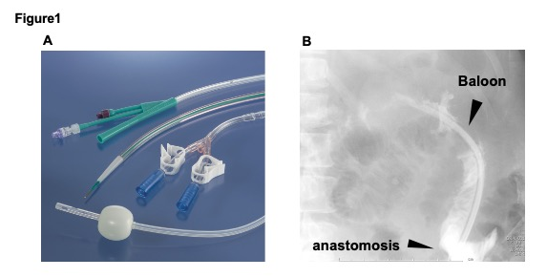

Figure 2: The time course of the amount of outflow from drainage tube and the value of C-reaction protein (CRP).

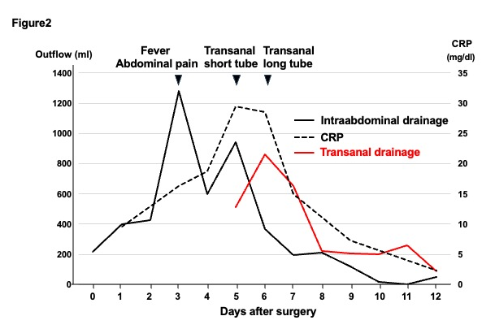

Figure 3: The findings of the fistula after removal of transanal long tube. (A) The apparent fistula exist at the anastomosis on POD 13. The arrowhead indicate the fistula (B)The fistula was closed on POD51.
POD: postoperative day
