Case study
Thalidomide in severe skin damage during systemic lupus erythematosus: two case studies

Abstract:
Introduction:
Skin and mucosal involvement in systemic lupus erythematosus (SLE) is the most common form of the disease. It can be the initial manifestation in up to 20% of cases. Thalidomide is an effective therapeutic alternative in severe cutaneous forms of the disease. The aim of our study is to highlight the efficacy of thalidomide in severe cutaneous lupus despite the occurrence of side effects.
Materials and methods: We report two clinical cases hospitalized in the internal medicine department for severe cutaneous SLE treated with thalidomide with good results.
Clinical case 1: This is a 25-year-old female patient who was diagnosed with SLE with severe skin, hematological, and joint involvement according to the 2019 ACR EULAR criteria. Therapeutically, the patient was placed on high-dose corticosteroid therapy combined with thalidomide at a dose of 100 mg/day with therapeutic windows, with good results.
Clinical case 2: This is a 16-year-old female patient diagnosed with SLE with severe skin, hematological, and joint involvement according to the 2019 ACR EULAR criteria. The patient was treated with corticosteroids and thalidomide at a dose of 50 mg/day, then 100 mg/day, with good results given the severity of the skin involvement.
Discussion and conclusion:
Thalidomide is a therapeutic alternative for skin lesions in SLE and should be indicated for severe skin lesions. The prescription of thalidomide is limited by the occurrence of potentially serious adverse effects such as peripheral neuropathies or thromboembolic events, which may lead to discontinuation of treatment and consequently to a relapse of the skin condition. Effective contraception is necessary to prevent fetal malformations, hence the importance of close and rigorous monitoring.

Keywords: systemic lupus erythematosus, severe skin lesions, thalidomide, peripheral neuropathy, thrombotic complications.

Introduction:
Cutaneous and mucosal manifestations are the most common symptoms of systemic lupus erythematosus (SLE). Together with rheumatological symptoms, they account for 75 to 80% of cases. They may be the initial symptoms in up to 20% of cases. (1) The first-line treatment for skin involvement in SLE is based on synthetic antimalarial drugs. If this fails or in severe cases, thalidomide is an effective alternative treatment. However, its prescription is limited by the occurrence of potentially serious adverse effects such as peripheral neuropathies or thromboembolic events. (2, 3) The aim of our study is to highlight the efficacy of thalidomide in severe lupus skin involvement despite the occurrence of side effects.
Case presentation:
We report two clinical cases hospitalized in the internal medicine department for severe LES skin involvement treated with thalidomide with good results.
Clinical case 1:
This is a 25-year-old female patient with no particular medical history who, since the age of 7, has had joint involvement consisting of inflammatory arthralgia affecting the large and medium-sized joints, associated with skin involvement consisting of erythematous squamous lesions, patches of alopecia, and malar erythema. A workup was performed, and the complete blood count revealed hematological involvement consisting of leukopenia at 3000 cells/mm3 and lymphopenia at 495 cells/mm3, which were checked twice. Serology tests (HIV, syphilis) were negative. Immunological tests revealed high levels of anti-nuclear antibodies at 1/320 with a homogeneous appearance and anti-DNA antibodies at 100. Overall, a diagnosis of systemic lupus erythematosus with skin, hematological, and joint involvement was made according to the 2019 ACR EULAR criteria. In terms of treatment, the patient was initially placed on high-dose corticosteroid therapy with tapering, combined with hydroxychloroquine at a dose of 400 mg/day, with good results. At the age of 25, her symptoms worsened with the reappearance of severe, widespread skin involvement consisting of erythematous-squamous lesions spreading across her entire body, associated with malar erythema. The patient was placed on Plaquenil at a dose of 400 mg/day and high-dose oral corticosteroid therapy was started at a dose of 40 mg per day. Subsequently, corticosteroid therapy was discontinued due to the onset of aseptic osteonecrosis of the left hip, requiring hip replacement surgery. She was then placed on methotrexate at a dose of 15 mg/week week due to persistent skin lesions for one year, then discontinued due to hepatotoxicity. and due to the severity of the skin lesions, the patient was placed on thalidomide at a dose of 100 mg/day with therapeutic windows. With good progress, the skin lesions disappeared. Two years later, the patient developed sensory neuropathy affecting both lower limbs, as confirmed by electromyography (EMG), requiring discontinuation of thalidomide. One week later, the patient experienced a skin relapse, requiring her to be placed on mycophenolate mofetil at a dose of 2 g/day in combination with plaquenil at a dose of 400 mg/day. The outcome was marked by regression of the skin signs with normalization of the progression assessment.

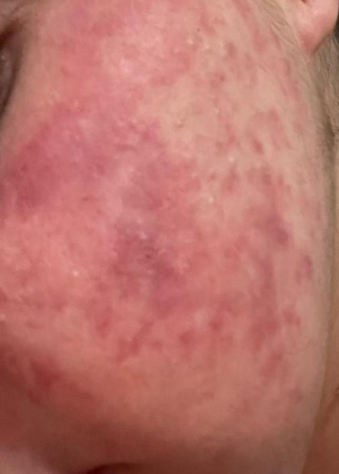

Figure I: Acute lupus lesion on the face

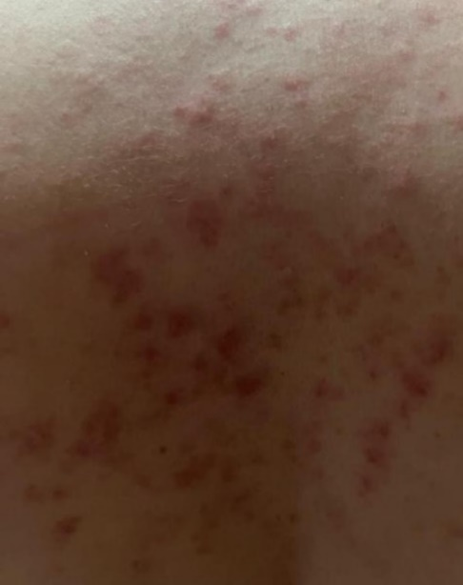
Figure II: Subacute cutaneous lupus lesion on the back

Clinical case no. 2:
This is a 16-year-old female patient who has had acute lupus lesions for 5 years, consisting of malar erythema and chronic diffuse lesions spread over the entire body, associated with inflammatory arthralgia affecting the large and medium joints, developing in a febrile context. Laboratory tests were performed, revealing: autoimmune hemolytic anemia at 9.7 g/mm3, lymphopenia at 960 el/mm3 (rechecked twice), positive antinuclear antibodies at 640, complement consumption at 0.57 g/l. An infectious disease workup was performed and came back negative (urinalysis, HIV, hepatitis B and C, echocardiogram), a skin biopsy was performed revealing a morphological appearance consistent with systemic lupus erythematosus with granular deposits (IgG, IgM, C1q) on immunofluorescence.
Overall, a diagnosis of SLE was made with severe skin, hematological, and joint involvement according to the 2019 ACR EULAR criteria, with a total of 11 points. Therapeutically, the patient was placed on Plaquenil at a dose of 400 mg/day and oral corticosteroid therapy at a dose of 60 mg/day. During the course of her illness, the patient experienced a severe skin relapse, which required her to be placed on thalidomide at a dose of 50 mg/day per day, then 100 mg/day, with good results, However, during follow-up, peripheral neuropathy was observed on electromyography (EMG), requiring discontinuation of thalidomide. One month later, the patient experienced a relapse of skin symptoms and was placed on mycophenolate mofetil at a dose of 2 g/day, with good clinical and biological response.
Discussion :
Systemic lupus erythematosus is a multifactorial autoimmune disease linked to several genetic, environmental, hormonal, and ethnic factors. Skin involvement in SLE can be acute, subacute, and/or chronic. The clinical presentation can be localized or generalized. The phenotype of these lesions is dynamic, with an initial hyperpigmented appearance that can lead to depigmentation and progress to painful, deeper scarring lesions, which are most often permanent. However, the discoid form is generally localized exclusively to the skin. (4)
The first-line treatment for cutaneous manifestations of SLE is based on synthetic antimalarial drugs and sun protection. 2,3 Other systemic treatments include dapsone, retinoids, clofazimine, and/or intralesional triamcinolone.2,4-6 In cases of failure or severe skin involvement, thalidomide is a therapeutic alternative. In our case, thalidomide was indicated due to the severity of the skin lesions and resistance to first-line treatment, particularly Plaquenil and methotrexate. (5)
The immunological mechanisms of thalidomide have been characterized as anti-inflammatory and immunosuppressive in at least 14 countries. It appears to have both inhibitory and stimulatory effects on the various effectors of cellular immunity: inhibitory action on mononuclear cells by decreasing their chemotactic and phagocytic abilities and on lymphocyte proliferation induced by allogeneic, superantigenic, or mitogenic stimulation; stimulatory and modulatory action on the balance between different classes of lymphocytes. In vitro studies show that in the presence of thalidomide, the cytotoxic CD8+ lymphocyte response is stimulated compared to the CD4+ lymphocyte response. Thalidomide also acts in vitro on activated T helper lymphocytes by diverting a Th1-type response to a Th2-type response. This action involves stimulation of interleukin 4 synthesis by Th2 lymphocytes and inhibition of interferon c synthesis by Th1 lymphocytes. This effect has not yet been observed in vivo, but could be of great interest in various diseases mediated by dysregulation of T helper lymphocyte subpopulations. One of the most important properties of thalidomide is the reduction in the synthesis of tumor necrosis factor alpha (TNF-a) by stimulated human monocytes by increasing the degradation of its messenger ribonucleic acid (RNA). This property has been confirmed in vivo in patients suffering from erythema nodosum leprosum (ENL), in tuberculosis patients, and in patients infected with human immunodeficiency virus type 1 (HIV-1). The anti-TNFa activity is due to the S enantiomer, stabilized derivatives of which with more potent anti-TNF-a activity have been synthesized; however, they cannot be used in humans due to their toxicity. (6.7)

Table 1: Modes of action of thalidomide (7)
Action | Description
Hypnosedative action | Activation of sleep centers through action on GABA receptors
Immunomodulatory action On cellular immunity | Inhibitory action on mononuclear cells: reduction in their chemotactic and phagocytic abilities Modulation of lymphocyte response: CD4 to CD8, Th1 to Th2
On cytokine production | Decreased synthesis of TNF-a by stimulated human monocytes by increasing the degradation of its messenger RNA
Anti-inflammatory action | Decreased chemotaxis of neutrophils and monocytes, and decreased generation of superoxide and hydroxyl radicals
Action on angiogenesis | Antiangiogenic activity mediated by inhibition of VEGF production
VEGF : vascular endothelial growth factor ; TNF-a :tumor necrosis factor alpha ; ARN : acide ribonucléique ; Th1 : théophylline 1 ; GABA : acide gamma aminobutyrique

Thalidomide has multiple indications, including lupus with severe skin involvement, severe skin involvement in sarcoidosis, Behcet's disease, severe oropharyngeal ulcers associated with HIV, and Kaposi's sarcoma. (8) Thalidomide has several side effects, some of which are serious: teratogenic effects, pearipheral neuropathy, and a risk of deep vein tharombosis. Others are minor, such as drowsiness, abdominal pain, skin reactions, and endocrine disorders such as amenorrhea. (7, 9) Fear of side effects, particularly neurological ones, should not delay the introduction of thalidomide in cases where standard treatments have failed. (10)
Thalidomide-induced peripheral neuropathy is the main problem that may limit its use over a prolonged period. This is a bilateral, symmetrical, distal-onset sensory axonal neuropathy. Clinical and electrical signs initially appear in the lower limbs. Electromyography (EMG) reveals a decrease in the amplitude of peripheral sensory nerve action potentials, without any decrease in amplitude. (7) In our two patients, thalidomide proved effective in clearing the skin lesions, but the onset of peripheral neuropathy limited the continuation of treatment, which led to a skin relapse.
Thalidomide can be used as “induction therapy” for patients with severe or refractory skin lesions with a high risk of scarring, and its use for prolonged periods should be avoided. This drug is associated with a very high response rate over a short period, but relapses are common after treatment is stopped. Polyneuropathy is a concern, and nerve conduction studies are recommended every 6 months for early diagnosis. Most patients experience clinical reversibility of this adverse effect. The overall risk of thrombosis can be minimized with the combination of hydroxychloroquine, while for those who are positive for antiphospholipid antibodies, aspirin is recommended. (11)
The efficacy of thalidomide in treating lupus skin lesions has been reported in the literature. (12) It may be effective in treating the skin manifestations of systemic lupus erythematosus, but does not appear to be effective in treating visceral lesions. Several conclusions can be drawn from these studies: the failure rate appears to be less than 20% and higher in men with hyperkeratotic lesions. Age, number of lesions, and failure of previous treatments do not influence the results. An initial dose of 100 to 200 mg/day is sufficient in most cases to achieve an effect within 2 weeks and complete remission within 1 to 2 months. Maintenance treatment of 25 to 50 mg/day is necessary for most patients. Relapses are controlled in the same way. Thalidomide should be reserved for lesions that are resistant to 3 months of treatment with synthetic antimalarials, or for patients who have an absolute contraindication to synthetic antimalarials. (7)
In a single-center retrospective study, the introduction of low-dose thalidomide (100 mg/day) in patients with chronic lupus resulted in clinical improvement in 83.3% of cases with good tolerance. (13)
The rules governing the prescription of thalidomide are very strict (authorized physician, exclusive hospital distribution, systematic monthly pregnancy testing and mandatory effective contraception for women of childbearing age, prohibition of procreation for men, reading and signing a document informing about the teratogenic risks involved, normal electromyogram with study of nerve conduction velocities).(14)
In lupus, thalidomide often has a clear effect on the stubborn skin manifestations of the disease but without any noticeable improvement in joint or systemic signs.

References:
1.F. Chasset . Lupus érythémateux cutané. Doi : 10.1016/S1634-6939(22)41524-9 05/07/22 . Service de dermatologie et allergologie, Hôpital Tenon, 4, rue de la Chine, 75020 Paris, France

2.T. Tounsi 1,∗, C. Francès 1, E. Cesbron1, A. Barbaud1, L. Arnaud2, F. Chasset 1 1 Efficacité et tolérance du thalidomide dans le lupus érythémateux cutané : revue systématique et méta-analyse Service de dermatologie et allergologie, hôpital Tenon, Paris 2 Service de rhumatologie, université de Strasbourg, hôpitaux universitaires de Strasbourg, Strasbourg, France

3.Adrien Jimenez, Université de Paris-Sud. Faculté de pharmacie (Châtenay-Malabry, Hauts-de-Seine). Utilisation du thalidomide dans la prise en charge du lupus érythémateux cutané. 2017 - 110 pages

4.Giovanna Malara ¹, Chiara Verduci ^{2,✉}, Maria Altomonte ³, Maria Cuzzola ⁴, Caterina Trifirò ¹, Cristina Politi ⁵, Giovanni Tripepi ⁵ Thalidomide and discoid lupus erythematosus: case series and review of literature

5.Tamara Salam Housman, MD; Joseph L. Jorizzo, MD; Martha A. McCarty, MS, PA-C; et alSarah E. Grummer; Alan B. Fleischer Jr, MD; Paul G. Sutej, MD Low-Dose Thalidomide Therapy for Refractory Cutaneous Lesions of LupusErythematosus Arch Dermatol. 2003;139(1):50-54. doi:10.1001/archderm.139.1.50 January 2003

6 . Michelle T Pelle ¹, Victoria P Werth . Thalidomide in cutaneous lupus erythematosus 2022 Mar 16;11:2021-9-8. doi: 10.7573/dic.2021-9-8

7. E. Laffitte, J. Revuz Thalidomide en dermatologie. 08/09/09 Doi : 10.1016/S0246-0319(09)48432-2

8 . Giovanna Malara,¹ Chiara Verduci,² Maria Altomonte,³ Maria Cuzzola,⁴ Caterina Trifirò,¹ Cristina Politi,⁵ and Giovanni Tripepi Thalidomide and discoid lupus erythematosus: case series and review of literature 2022; 11: 2021-9-8.

9. Michelle T. Pelle1 and Victoria P. Werth1. Thalidomide in Cutaneous Lupus Erythematosus Am J Clin Dermatol 2003; 4 (6): 379-387 1175-0561/03/0006-0379/$30.00/0 PMID: 12762830DOI: 10.2165/00128071-200304060-00002.
10. A. Brocard ^{[1]},S. Barbarot ^{[1]},B. Milpied ^{[1]},J.-F. Stalder ^{[1]} Lupus érythémateux chronique : traitement par thalidomide Doi : AD-11-2005-132-11-0151-9638-101019-200516227

11. Emily Figueiredo Neves Yuki ¹, Clovis A Silva ¹, Nadia E Aikawa ¹, Ricardo Romiti ², Carlos Otto Heise ³, Eloisa Bonfa ¹, Sandra Gofinet Pasoto ¹ Thalidomide and Lenalidomide for Refractory Systemic/Cutaneous Lupus Erythematosus Treatment 2021 Sep 1;27(6):248-259. doi: 10.1097/RHU.0000000000001160.

12. Stevens RJ, Andujar C, Edwards CJ, et al. Thalidomide in the treatment of the cutaneous manifestations of lupus erythematosus: experience in sixteen consecutive patients. Br J Rheumatol. 1997;36:353–359.

13. BROCARD A, BARBAROT S, MILPIED B, STALDER J-F. Lupus érythémateux chronique: traitement par thalidomide Ann Dermatol Venereol, 2005, 132 : 853-856

14. C. Francès ª, S. Barète ª ^{b}, J.-C. Piette ^{b}MANIFESTATIONS DERMATOLOGIQUES DU LUPUS La Revue de Médecine Interne Volume 29, Issue 9, September 2008, Pages 701-709

