Case report

Double Chin Deception: A Rare Case of Intraoral Dermoid Cyst in the Floor of the Mouth

ABSTRACT
Dermoid cysts of the oral cavity are rare, benign developmental lesions most commonly found in the midline of the floor of the mouth. They can present as painless swellings and may mimic other soft tissue masses, making diagnosis challenging¹.We report a case of a 35-year-old male who presented with a slow-growing, painless swelling in the submental region for over six months. Clinical examination revealed a midline swelling mimicking a “double chin” with intraoral extension elevating the floor of the mouth. MRI confirmed a well-defined, encapsulated cystic lesion situated above the mylohyoid muscle. Surgical excision was performed via an intraoral approach. Histopathology confirmed the diagnosis of a dermoid cyst².Although uncommon, dermoid cysts should be considered in the differential diagnosis of midline submental swellings, especially when intraoral involvement is present. Early diagnosis and complete excision are crucial to avoid complications and recurrence²⁻⁴.

INTRODUCTION
Dermoid cysts are benign, slow-growing lesions of ectodermal origin that arise due to the entrapment of epithelial elements during embryological development³. While more commonly encountered in gonadal and periorbital regions, their occurrence in the oral cavity—particularly the floor of the mouth—is rare, accounting for less than 2% of all dermoid cysts¹. These cysts can be classified based on their anatomical relationship to the mylohyoid muscle: sublingual, submental, or submandibular².
Clinically, intraoral dermoid cysts may present as painless swellings, often discovered incidentally or due to functional disturbances such as dysphagia, speech difficulty, or altered aesthetics⁴. The differential diagnosis includes ranula, thyroglossal duct cyst, lipoma, and lymphoepithelial cysts⁵. Imaging studies such as MRI are essential for preoperative evaluation and surgical planning³.
We present a rare case of a dermoid cyst located above the mylohyoid muscle in the floor of the mouth of a 35-year-old male, emphasizing the importance of thorough clinical and radiological evaluation for accurate diagnosis and management.

CASE REPORT

A 35 year old male patient presented to our department with chief complaint of swelling below his lower jaw in the midline since more than 6 months. Swelling was of slow growing, painless and complained of mild difficulty in swallowing. But no difficulty in speech or breathing.
Patient did not have any relevant medical history nor any drug allergy.

EXTRA ORAL EXAMINATION
- A diffuse swelling in the submental region mimicking a double chin noted in the midline.
- Overlying skin appeared normal with no erythema, ulceration.
- No movement of swelling while swallowing.
- Swelling was of semihard, non tender, fluctuant and not fixed to underlying structures.
- No local rise in temperature noted.
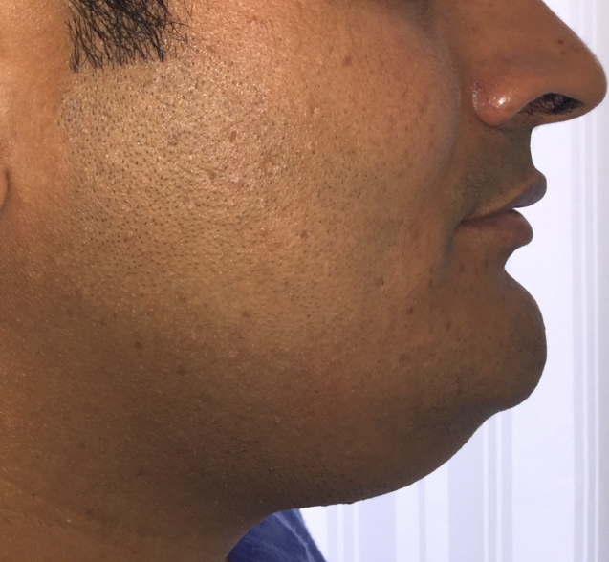
FIG -1 : DOUBLE CHIN APPEARANCE

INTRA ORAL EXAMINATION
- Mouth opening of 3 finger breadth noted.
- Raised floor of mouth noted on left side.
- Swelling was non tender, overlying mucosa appeared normal with no erythema, ulceration or sinus opening noted.
- Swelling was semi hard , fluctuant and fixated to underlying structures.

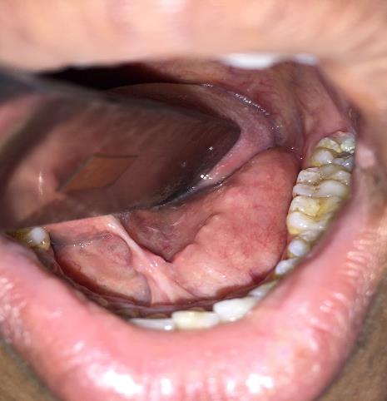
FIG 2 : RAISED FLOOR OF THE MOUTH NOTED.

INVESTIGATIONS
MRI revealed encapsulated cystic lesion above the attachment of mylohyoid with no invasion of adjacent structures or bone.
SURGICAL PROCEDURE
After basic blood investigations, patient was taken for the procedure under general anesthesia via nasal intubation.
- After achieving the general anesthesia via nasal intubation, lignocaine with adrenaline 1:80000 administered intraorally to the proposed surgical site.
- Tongue was retracted superiorly using the suture which was placed on the tip of tongue.
- After that an incision of 2-3 cm was given lateral to lingual frenum
- After the blunt dissection, cyst was located and was separated from surrounding tissues in toto.
- Closure was achieved using 3-0 vicryl.

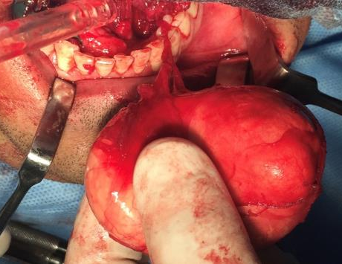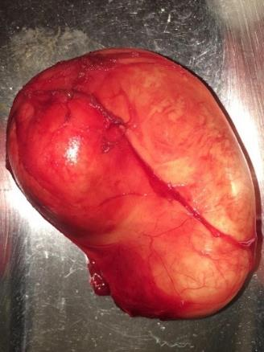
FIG 3 : CYST EXCISED IN TOTO

Patient was extubated and shifted to post operative recovery where he was under observation for 6 hours.
After 2 days of hospitalization, patient was discharged un eventfully.
Patient was followed up for every week in fisrt month and twice in the second month. No recurrence, bleeding or signs of infection noted.

DISCUSSION
Dermoid cysts in the oral cavity are considered developmental anomalies arising from pluripotent cells that become trapped during midline fusion of the first and second branchial arches¹. Histologically, they can be classified into three types: epidermoid (lined with squamous epithelium only), true dermoid (containing skin adnexa), and teratoid (containing multiple germ layer derivatives)². In this case, although histological details were not elaborated, the clinical and radiological features were consistent with a dermoid cyst.
The patient’s presentation was typical: a painless, slow-growing midline swelling in the submental region with a concurrent intraoral elevation of the floor of the mouth⁴. The absence of symptoms such as pain, infection, or respiratory difficulty helped rule out acute or aggressive pathology. MRI served as the ideal imaging modality, clearly delineating the cystic nature, location above the mylohyoid muscle, and absence of invasion into adjacent tissues³.
Surgical excision remains the definitive treatment, with the approach (intraoral vs. extraoral) guided by the cyst’s location in relation to the mylohyoid muscle²,⁴. In our case, an intraoral approach allowed complete removal of the lesion with minimal morbidity and satisfactory esthetic results.
Differential diagnoses considered included plunging ranula, thyroglossal duct cyst, and lymphadenopathy—all of which were ruled out based on location, consistency, and radiological findings.

CONCLUSION
Dermoid cysts of the floor of the mouth, though rare, should be considered in the differential diagnosis of midline submental swellings¹,². A careful clinical examination supported by imaging helps in accurate diagnosis and planning the surgical approach³. Complete surgical excision offers an excellent prognosis with minimal recurrence risk²,⁴. Early intervention also aids in preventing complications such as infection or interference with oral functions.

References

1. Koca H, Seçkin S, Sipahi A, Kazanç A. Dermoid cysts of the floor of the mouth: report of three cases. J Oral Maxillofac Surg. 2007;65(8):1539–42. doi:[10.1016/j.joms.2006.11.033](https://doi.org/10.1016/j.joms.2006.11.033)

2. Longo F, Maremonti P, Mangone GM, De Maria G, Califano L. Midline (dermoid) cysts of the floor of the mouth: report of 16 cases and review of surgical techniques. Plast Reconstr Surg. 2003;112(6):1560–5. doi:[10.1097/01.PRS.0000085598.25752.56](https://doi.org/10.1097/01.PRS.0000085598.25752.56)

3. Gadodia A, Bhalla AS, Sharma R, Thakar A, Parshad R. Congenital cystic masses of the neck: embryologic basis and imaging appearances. Indian J Radiol Imaging. 2011;21(1):69–74. doi:[10.4103/0971-3026.76063](https://doi.org/10.4103/0971-3026.76063)

4. De Ponte FS, Brunelli A, Marchetti E, Bottini DJ. Sublingual dermoid cysts: a clinical and surgical study of 16 cases. Int J Oral Maxillofac Surg. 2002;31(2):146–9. doi:[10.1054/ijom.2001.0124](https://doi.org/10.1054/ijom.2001.0124)

5. Walstad WR, Solomon JM, Schow SR, Ochs MW. Midline cystic lesion of the floor of the mouth. J Oral Maxillofac Surg. 1998;56(1):70–4. doi:[10.1016/S0278-2391(98)90895-3](https://doi.org/10.1016/S0278-2391%2898%2990895-3)

