Case report
A CASE REPORT OF PHENOBARBITONE POISONING AND CLINICAL MANAGEMENT

ABSTRACT: A 21-year-old female presented with altered sensorium following an intentional overdose of phenobarbitone (30 tablets of 60 mg each; total 1.8 g). On admission, her Glasgow Coma Scale was 8/15, and she was managed in the ICU with airway protection, gastric lavage, activated charcoal, forced alkaline diuresis, and supportive care. Due to persistent CNS depression, charcoal haemoperfusion was performed, leading to neurological improvement (GCS=15/15). She developed pneumonia, which was treated successfully with antibiotics. The patient showed complete clinical recovery and was discharged with psychiatric follow-up advice.
Keywords: Phenobarbital, Barbiturates, Poisoning, Hemoperfusion, Gastric lavage, Activated charcoal, Intensive care unit, Clinical Pharmacist.

INTRODUCTION
The Barbiturates are derivatives of barbituric acid (2,4,6-trioxohexahydropyrimidine)¹. Barbiturates are sedatives and hypnotics; they are frequently used as anesthetics and antiepileptics. In India, there is now a 1.08% sedative-hypnotic usage rate and 0.11% abuse rate². 1gm of barbiturates taken orally can cause toxicity, though this varies from person to person. The lethal dose is typically between 0.00004 and 0.00008gm, while doses over 2gm can be fatal⁴. The symptoms of the poisoning include areflexia, stupor or coma, and in more severe cases, acute respiratory depression and cardiovascular failure³. Artificial ventilation and other supportive therapy are used to treat most cases of barbiturate intoxication². We present a case of phenobarbitone poisoning in a young girl that was successfully managed with gut decontamination and charcoal hemoperfusion, with a good clinical outcome.
CASE PRESENTATION:
A 21-year-old female presented to the emergency department with an alleged history of intentional ingestion of phenobarbitone. As reported by her attendants, she had consumed approximately 30 tablets of phenobarbitone (60 mg each) at her residence around 7:45 PM. There was no history of fever, seizures, head injury, or vomiting prior to presentation.
On initial evaluation, the patient was found to have altered sensorium. Her Glasgow Coma Scale (GCS) score was E1V2M5 (8/15), and her blood pressure was approximately 100/60 mmHg. Despite the depressed neurological status, protective airway reflexes were present. She was admitted to the Emergency Medicine Intensive Care Unit (ICU) for intensive monitoring and intervention.
PARAMETERS | DAY 1 | DAY 2 | DAY 3 | DAY 4
ABG | pH =7.43  pCO₂ =32mmHg  pO₂ ₌57mmHg  cHCO₃ =21.2mmol/L BE(ecf) = -3.1mmol/L | pH =7.29  pCO₂ =26mmHg  pO₂ ₌47mmHg cHCO₃=12.5mmol/L BE(ecf) = -14.1mmol/L | pH =7.35  pCO₂ =25mmHg  pO₂ ₌90mmHg cHCO₃=13.8mmol/L BE(ecf) = -11.6mmol/L | pH =7.43  pCO₂ =30mmHg  pO₂ ₌66mmHg  cHCO₃ =19.9mmol/L BE(ecf) = -4.4mmol/L
Sr. ELECTROLYTES | Sodium =136mmol/L Potassium =3.2mmol/L Chloride =111mml/L | Sodium =140mmol/L Potassium=2.9mmol/L  Chloride =109mml/L | Sodium =138mmol/L Potassium=3.3mmol/L  Chloride =110mml/L | -
CRP | 68.2mg/L | 47.9mg/L | 43.7mg/L | -
LFT | Sr. T Protein =5.6gm/dl Sr. Albumin =2.4gm/dl SGOT(AST) =113U/L SGPT(ALT) =83U/L  GGT =185U/L | - | - | -
Table 1 : LABORATORY PARAMETERS
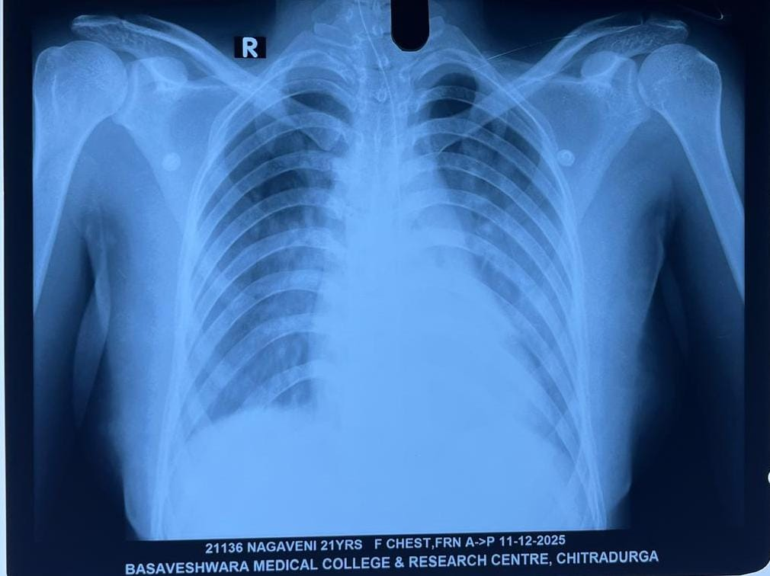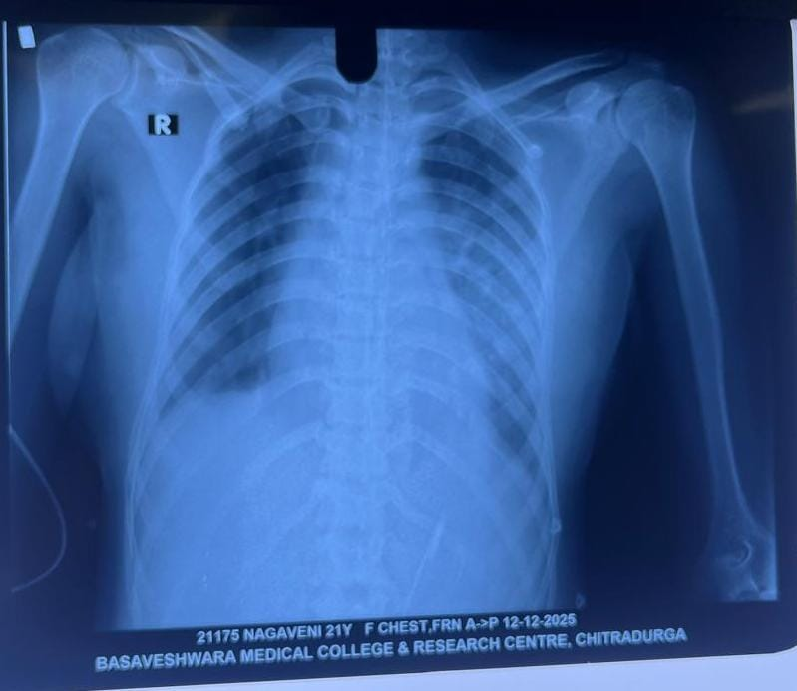
Fig 1 : Chest X-RAY showing a Pneumonia.

A provisional diagnosis of phenobarbitone toxicity with suspected pneumonia was made. The patient was stabilized in the ICU.
Gastrointestinal decontamination was initiated. The procedure of gastric lavage was explained to the attendants, and informed consent was obtained. In view of altered sensorium, endotracheal intubation was performed prior to the procedure for airway protection.
The patient was positioned in the left lateral head-down position, and an appropriately sized lubricated orogastric tube was inserted. Correct placement was confirmed by aspiration of gastric contents and air insufflation. Lavage was carried out using warm saline in sequential aliquots until the effluent became clear. The initial aspirate was preserved for toxicological analysis. Following completion of lavage, activated charcoal (1 g/kg) along with a cathartic was administered through the tube, which was subsequently removed.
Supportive management was continued, including forced alkaline diuresis with sodium bicarbonate infusion to enhance renal clearance of phenobarbitone.

Due to persistent central nervous system depression, the patient underwent extracorporeal detoxification via charcoal haemoperfusion. Haemoperfusion involves extracorporeal filtration of blood to remove circulating toxins. Vascular access was obtained using a suitable catheter, and the haemoperfusion circuit was primed with heparinized saline as per manufacturer instructions. A bolus of heparin was administered at initiation, followed by continuous heparinization during the procedure.
Following haemoperfusion, the patient demonstrated rapid neurological improvement, with GCS improving to E4V5M6 (15/15).

Table 2 : TREATMENT: During the 7days stay at hospital the patient was treated with the following drugs.

SL. NO | DRUGS GIVEN | DOSE | ROUTE | FREQ | NO OF DAYS
01 | INJ.PIPERACILLIN+TAZOBACTUM | 4000mg+500mg | IV | 1-1-1 | 5 DAYS
02 | INJ.VANCOMYCIN | 500mg | IV | 1-0-1 | 1 DAY
03 | INJ.ESOMEPRAZOLE | 40mg | IV | 1-0-0 | 7 DAYS
04 | INJ.ONDANSETRON | 4mg | IV | SOS | -
05 | INJ.PARACETAMOL | 1gm | IV | 1-1-1 | 4 DAYS
06 | INJ.SODIUM BICARBONATE | 25ml | IV | 1-1-1 | 2 DAYS
07 | IVF NS | 150ml/hr | IV | - | 7 DAYS
08 | INJ.MULTIVITAMIN | 1ampule | IV | 0-1-0 | 7 DAYS
09 | SYP.POTASSIUM CHLORIDE | 10ml | PO | 1-1-1 | 5 DAYS

On the third hospital day, the patient developed fever. Broad-spectrum antimicrobial therapy with Piperacillin–Tazobactam and Vancomycin was initiated for suspected pneumonia with pulmonary consolidation. Serial CRP levels were monitored to assess inflammatory response and therapeutic efficacy.
Table 3 : DISCHARGE MEDICATION
SL. NO | DRUGS GIVEN | DOSE | ROUTE | FREQ | NO OF DAYS
01 | TAB.AMOXYCILLIN+CLAVULANIC ACID | 500mg+125mg | PO | 1-1-1 | 3DAYS
02 | TAB.PANTOPRAZOLE | 40mg | PO | 1-0-0 | 5DAYS
03 | SYP.MULTIVITAMIN+MULTIMINERAL | 10 ml | PO | 0-1-0 | 10 DAYS

A psychiatric consultation was obtained after achieving hemodynamic and neurological stability. She attained complete clinical recovery and was discharged. At discharge, she was prescribed oral antibiotics and advised psychiatric outpatient follow-up within ten days.

DISCUSSION:
Barbiturate poisoning is a potentially fatal condition characterized by profound central nervous system and respiratory depression. Phenobarbital, a long-acting barbiturate, has a narrow therapeutic index and prolonged half-life, leading to delayed recovery and increased risk of complications such as aspiration and prolonged coma. Management is primarily supportive, with early airway protection, ventilatory support, and measures to enhance drug elimination. Phenobarbital possesses favorable pharmacokinetic properties for extracorporeal removal. In severe poisoning with persistent coma, hemodialysis can significantly accelerate drug clearance and improve clinical outcomes. It highlights the importance of early recognition and timely initiation of extracorporeal therapy in severe barbiturate toxicity³.
Phenobarbitone, a long-acting barbiturate with a narrow therapeutic index, can cause prolonged coma and respiratory depression in overdose. Management is primarily supportive, including airway protection, mechanical ventilation, multidose activated charcoal, and urinary alkalinization. Due to its long half-life, recovery may be delayed despite optimal care. The extracorporeal treatment in severe toxicity with prolonged coma or respiratory failure. A sustained low-efficiency dialysis led to a significant reduction in serum phenobarbitone levels and clinical improvement, enabling successful ventilator weaning. This highlights the role of extracorporeal therapy as an effective adjunct in severe phenobarbitone poisoning².

CONCLUSION:
Our case report underscores the clinical consequences of phenobarbitone misuse and highlights the importance of early recognition and a multidisciplinary approach in its management. In the absence of a specific antidote for phenobarbitone poisoning, timely supportive care remains the cornerstone of treatment.
The clinical pharmacist played a pivotal role in identifying drug misuse, optimizing pharmacotherapy, monitoring for complications, and providing patient education, thereby contributing significantly to improved patient safety and clinical outcomes.

REFERENCES:
- Pillay VV. Modern medical toxicology. 4th ed. New Delhi: Jaypee Brothers Medical Publishers; 2013.
- Shah HN, Jain A, Somani M, Gupta P, Jain SS, Jain R, et al. Role of extracorporeal treatment in barbiturate poisoning: a case report. Indian Journal of Critical Care Case Report 2024 [21 June 2024];3(4):105–108. DOI: https://doi.org/10.5005/jp-journals-11006-0113.
- Kiran S, Chhabra B, Nandini. Management of barbiturate poisoning: a case report. Indian Journal of Anaesthesia 2002 [December 2002];46(6):480–482.
- “Phenobarbital” entry on Stat Pearls (National Library of Medicine / NCBI Bookshelf; updated 28 Feb 2024). Source: https://www.ncbi.nlm.nih.gov/books/NBK532277/.
- Ayele BA, Ali K, Mulatu E, et al. Toxic epidermal necrosis associated with phenobarbitone: a case report and brief review of the literatures. Allergy Asthma Clin Immunol 2021 [23 August 2021]; 17:88. DOI: https://doi.org/10.1186/s13223-021-00589-4.
- Van de Plas A, Stolk L, Verhoeven MAM, Kooman JP, van Mook WNKA, et al. Successful treatment of acute phenobarbital intoxication by hemodiafiltration. Clinical Toxicology 2006;44(1):93–94. DOI: https://doi.org/10.1080/1556350500395040.
- Nanati Jemal, Zenebe B, Berhanu E, Alemnew T, Solomon Y, Debalkew B, et al. Acute phenobarbital poisoning in a resource-limited setting: a case report of successful management through high index of suspicion and immediate care. Pan African Journal of Emergency and Critical Care 2025 [24 March 2025];3(1):48–53.
- Tripathi KD. Essentials of medical pharmacology. 7th ed. New Delhi: Jaypee Brothers Medical Publishers; 2013.
- Bhuvana D, Raj SS, Sucharitha A, et al. Barbiturate poisoning. Pharmaceutical Sciences and Analytical Research Journal 2024 [22 February 2024];6(1):180038.
- Patel A, Parate T, Bhure N, Charde S. Effect of haemodialysis in phenobarbital toxicity: a case report. International Journal of Science and Research (IJSR). 2023 Dec;12(12):791–792. DOI: https://dx.doi.org/10.21275/SR231207222036.

