Case report
Unilateral exophthalmia revealing an orbital metastasis from esophageal adenocarcinoma: case report and literature review

Abstract
Orbital metastases are uncommon manifestations of systemic malignancies and are most frequently associated with breast, lung, and prostate cancers. Digestive tract tumors rarely metastasize to the orbit, and esophageal adenocarcinoma represents an exceptional cause. We report the case of a 56-year-old man in whom esophageal adenocarcinoma was revealed by unilateral exophthalmia secondary to an osteolytic orbital metastasis. The patient presented with progressive dysphagia and significant weight loss. Imaging revealed an orbital mass with fronto-temporal extension, and histopathological analysis confirmed metastatic disease of esophageal origin. Upper gastrointestinal endoscopy demonstrated a budding tumor of the lower esophagus, histologically consistent with moderately differentiated adenocarcinoma. The patient was managed with palliative intent. This case highlights the importance of considering esophageal cancer in the differential diagnosis of orbital masses and underscores the poor prognosis associated with such atypical metastatic presentations. A review of the literature is provided to place this case within the broader context of orbital metastases of digestive origin.

Keywords: Esophageal neoplasms; Orbital metastasis; Adenocarcinoma; Exophthalmia; Digestive cancers

Introduction
Orbital metastases account for 1–7% of secondary orbital masses, with a predominance of breast, lung, and prostate origins (1,2). They represent a diagnostic challenge, as orbital symptoms may precede the diagnosis of the primary tumor .Digestive tract metastases, particularly those from the esophagus, are exceptional and have been described in only a few case reports (3–6). Clinical presentation may include exophthalmia, diplopia, decreased visual acuity, or orbital pain (1,4).
Adenocarcinoma of the esophagus has shown an increasing incidence worldwide, yet its metastatic spread typically involves the liver, lungs, and bones. Orbital involvement is unusual and may lead to delayed diagnosis. This case highlights an atypical metastatic presentation and emphasizes the importance of considering digestive malignancies in patients presenting with unexplained unilateral exophthalmia.
Case presentation
A 56-year-old chronic smoker, with type 2 diabetes mellitus for six years and hypertension, presented with a one-year history of progressive dysphagia (initially to solids, progressing to mixed consistencies over the past three months), associated with a 30 kg weight loss in four months.
On examination, the patient had a poor general condition (PS = 1), BMI of 20 kg/m², epigastric tenderness , without palpable lymphadenopathy. Ophthalmological evaluation revealed non-pulsatile, progressive left-sided exophthalmia without diplopia or visual acuity loss. Neurological examination showed no focal deficits. (figure 1).
Cranio-orbital MRI demonstrated a heterogeneous osteolytic lesion involving the left orbit with extension to the fronto-temporal bone and associated soft tissue infiltration, suggesting secondary involvement (figure 3) . Given the association with progressive dysphagia and weight loss, a metastatic origin was strongly suspected. Histopathology and immunohistochemistry confirmed an esophageal origin.
Upper GI endoscopy revealed a budding tumor process in the lower esophagus (34–42 cm from the dental arches), bleeding on contact (figure 4) . Histology showed an invasive, moderately differentiated adenocarcinoma.
CT scan revealed two hypodense liver metastases: segment IV (12 × 13 mm) and segment III (23 × 26 mm), without lung involvement (figure 5) . Multidisciplinary tumor board recommended jejunostomy feeding tube placement and palliative care.

Discussion
Orbital metastases are rare clinical entities, representing approximately 1–7% of all orbital tumors, and usually indicate disseminated systemic malignancy (1–3). The most frequent primary origins are breast, lung, and prostate cancers, whereas gastrointestinal malignancies constitute an uncommon source of orbital metastases (2,4). Among digestive tumors, esophageal carcinoma is an exceptionally rare origin, with only isolated case reports available in the literature (5–8).
Large epidemiological series have confirmed the rarity of orbital metastatic disease. Bonavolontà et al. analyzed 2,480 space-occupying orbital lesions over a 35-year period and identified metastatic tumors in only a small fraction of cases (1). Similarly, Shields et al. emphasized that orbital metastases may pose significant diagnostic challenges, as they can clinically mimic inflammatory or infectious orbital conditions (3). This diagnostic pitfall is further illustrated by reports of orbital metastases presenting as orbital cellulitis or periorbital abscesses, particularly in patients with esophageal carcinoma (5,7).
The clinical presentation of orbital metastases is variable and often nonspecific. Common manifestations include unilateral exophthalmia, diplopia, decreased visual acuity, eyelid edema, and orbital pain (2,4). In several reported cases, orbital involvement was the initial manifestation leading to the diagnosis of an underlying esophageal carcinoma (6,8,9). George et al. described a case of esophageal adenocarcinoma with orbital metastasis initially misdiagnosed as an infectious process, highlighting the importance of maintaining a high index of suspicion in atypical or treatment-resistant orbital presentations (5). Our case similarly demonstrates how unilateral exophthalmia may reveal an advanced esophageal malignancy.
Histopathologically, most reported cases of orbital metastases from the esophagus involve squamous cell carcinoma; however, adenocarcinoma has also been documented, albeit less frequently (5,8). The mechanisms of metastatic spread to the orbit remain incompletely understood but are thought to occur predominantly through hematogenous dissemination, facilitated by the rich vascularization of orbital tissues (2,3). The vertebral venous plexus has also been proposed as an alternative route, allowing tumor cells to bypass pulmonary filtration (2).
Imaging plays a key role in the diagnostic workup of suspected orbital metastases. Computed tomography and magnetic resonance imaging typically demonstrate infiltrative or osteolytic orbital masses, often involving extraocular muscles or adjacent bony structures (2,4). Nevertheless, histopathological confirmation remains essential for definitive diagnosis, with immunohistochemical studies aiding in identifying the primary tumor origin (5,7).
The prognosis of patients with orbital metastases is generally poor, reflecting advanced systemic disease. Reported survival following diagnosis ranges from a few months to approximately one year, depending on tumor type and response to treatment (10,4). Management is predominantly palliative, focusing on symptom relief and preservation of visual function. Therapeutic strategies may include radiotherapy, systemic chemotherapy, or combined modalities tailored to the patient’s clinical condition (4). In selected cases of neuroendocrine tumors, targeted radionuclide therapies have shown promising outcomes (11,12); however, such approaches are not applicable to esophageal adenocarcinoma.
Conclusion : Although exceedingly rare, esophageal carcinoma should be considered in the differential diagnosis of orbital masses, particularly in patients presenting with unilateral exophthalmia associated with systemic symptoms such as dysphagia or weight loss. Early recognition and histological confirmation are crucial to avoid diagnostic delay. Orbital involvement generally indicates advanced disease and is associated with a poor prognosis, underscoring the need for multidisciplinary management.
Orbital metastasis is an extremely rare manifestation of esophageal adenocarcinoma and may represent the initial presentation of advanced disease. Awareness of this unusual metastatic pattern is essential for early recognition and appropriate diagnostic workup. Multidisciplinary management remains crucial, with treatment strategies focused on palliation and quality of life.
References :
- Bonavolontà G, Strianese D, Grassi P, Comune C, Tranfa F, Uccello G, et al.
An analysis of 2,480 space-occupying lesions of the orbit from 1976 to 2011.
Ophthal Plast Reconstr Surg. 2013;29(2):79–86.
- Ng E, Ilsen PF.
Orbital metastases.
Optometry. 2010;81(12):647–657.
- Shields CL, Shields JA, Peggs M.
Tumors metastatic to the orbit.
Ophthal Plast Reconstr Surg. 1988;4(2):73–80.
- Valenzuela AA, Archibald CW, Fleming B, Ong L, O’Donnell B, Crompton JL, et al.
Orbital metastasis: clinical features, management and outcome.
Orbit. 2009;28(2–3):153–159.
- George NM, Charles MP, Wade AR, et al.
Orbital metastases: a review of clinical features and outcomes.
Orbit. 2015;34(1):51–55.
- Aralikatti DA, Nylander AG.
Orbital metastasis as the presenting feature of systemic malignancy.
Eur J Ophthalmol. 2006;16(3):458–460.
- Lee JY, Lee HJ, Jung MS, Kim SY.
Metastatic esophageal squamous cell carcinoma to the orbit and periorbit masquerading as periorbital abscess.
Korean J Ophthalmol. 2010;24(2):123–125.
- Collins MJ, Wojno TH, Grossniklaus HE.
Metastatic esophageal carcinoma to the orbit.
Ophthalmology. 1999;106(2):228–229.
- Marinkovic M, van Lanschot JJ, Schlingemann RO, et al.
Orbital metastasis as the first manifestation of esophageal carcinoma.
Ned Tijdschr Geneeskd. 2002;146(50):2393–2396.
(Article in Dutch)
- Magliozzi P, Strianese D, Bonavolontà P, et al.
Orbital metastases: a multicenter retrospective study.
Int J Ophthalmol. 2015;8(5):1018–1023.
- Peixoto RD, Lim HJ, Cheung WY.
Neuroendocrine tumor metastatic to the orbit treated with radiotherapy.
World J Gastrointest Oncol. 2013;5(8):177–180.
- Dobson R, Vinjamuri S, Hsuan J, et al.
Treatment of orbital metastases from a primary midgut neuroendocrine tumor with peptide receptor radionuclide therapy using 177Lu-DOTATATE.
J Clin Oncol. 2013;31(17):e272–e275.


Figure 1: Left eye exophthalmia

Figure 2: Progressive exophthalmia over a two-month period
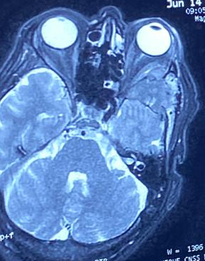 | 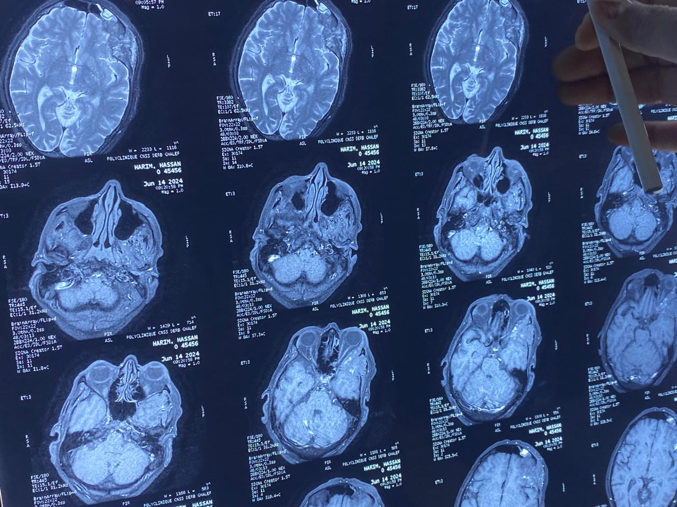

Figure 3 : Cranio-orbital MRI : a heterogeneous osteolytic lesion involving the left orbit with extension to the fronto-temporal bone.

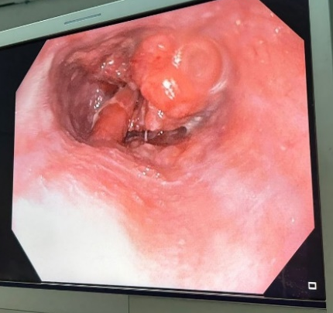
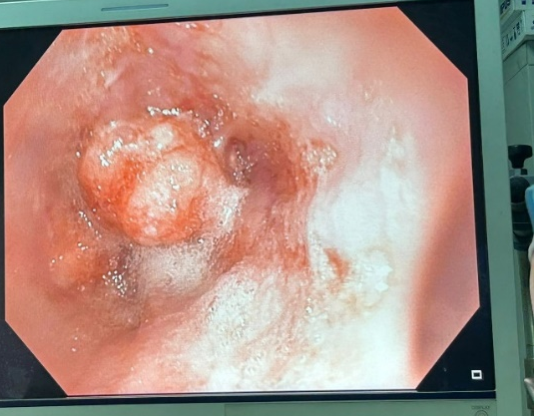
figure 4 : Upper GI endoscopy revealed a budding tumor process in the lower esophagus

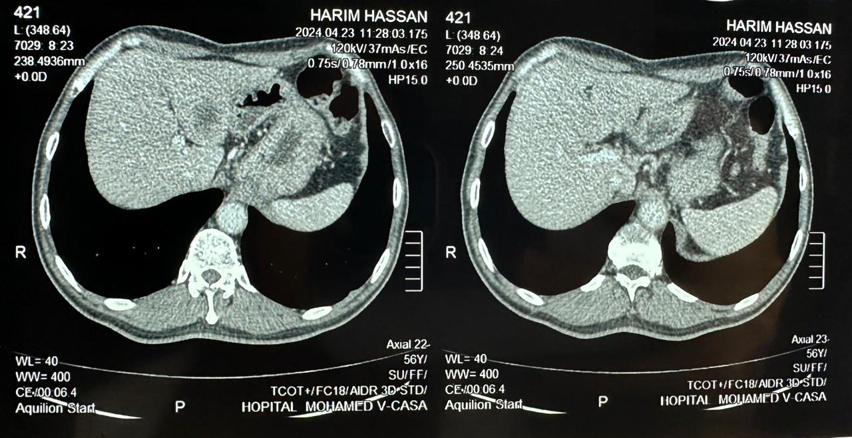Figure 5: CT scan revealed two hypodense liver metastases: segment IV and segment III

