Effect of Ethyl Acetate Leaf Extract of Gliricidia sepium on Thyroid and Reproductive Hormone Profiles in Wistar Rats

ABSTRACT
Aim: This study investigated the effects of oral administration of ethyl acetate leaf extract of Gliricidia sepium on thyroid and reproductive hormone profiles in Wistar rats.
Study Design: Completely randomized controlled experimental study.
Place and Duration of Study: The study was conducted at the Animal House, Faculty of Pharmaceutical Sciences, and the Chemical Pathology Laboratory, School of Medical Laboratory Science, Usmanu Danfodiyo University, Sokoto, Nigeria, between May 2024 and October 2025.
Methodology: Acute oral toxicity was assessed using Lorke’s method. Twelve male Wistar rats were assigned into four groups. In Phase I, groups I–III received 10, 100, and 1000 mg/kg body weight of the extract, respectively, while group IV served as the control. In Phase II, three rats received single oral doses of 1600, 2900, and 5000 mg/kg body weight.
For the sub-chronic toxicity study, forty-eight adult Wistar rats (24 males and 24 females) were divided into four groups. Group I received normal saline, while Groups II–IV received 500, 1000, and 1500 mg/kg body weight of the extract daily for 28 days. Blood samples were collected for hormonal analysis.
Results: The oral median lethal dose (LD₅₀) of the extract was greater than 5000 mg/kg body weight. Sub-chronic administration did not produce significant changes (p > 0.05) in TSH, T₃, T₄, testosterone, progesterone, prolactin, and FSH levels. Variations observed in LH and estradiol levels were attributable to physiological sex-related differences.
Conclusion: Oral administration of ethyl acetate leaf extract of Gliricidia sepium at therapeutic doses appears relatively safe and does not adversely affect thyroid or reproductive hormone function in Wistar rats.

Keywords: Gliricidia sepium, thyroid hormones, reproductive hormones, toxicity, Wistar rats.

1. INTRODUCTION
Herbal medicine continues to play an important role in global healthcare systems, serving both as a primary source of treatment for many populations and as a foundation for the development of modern pharmaceuticals [1]. It is estimated that nearly 60% of the world’s population utilizes traditional medicine, while approximately 80% of people in developing countries depend largely on herbal remedies for their primary healthcare needs [2]. The sustained patronage of herbal medicine has been attributed to its affordability, accessibility, cultural acceptance, and the perception that herbal products possess minimal adverse effects [3].
Despite their widespread use, the safety and efficacy of many medicinal plants have not been sufficiently validated through scientific investigation, raising concerns among researchers and regulatory authorities [4]. Gliricidia sepium, a member of the Fabaceae family, is among the medicinal plants commonly used by local communities in Nigeria for the management of various ailments [5].
Gliricidia sepium is a multipurpose leguminous plant of considerable economic and medicinal value. The Fabaceae family, to which it belongs, is one of the largest families of flowering plants, comprising over 700 genera and approximately 20,000 species [6]. The plant is commonly referred to as “mother of cocoa” and is locally known as Agunmaniye among the Yoruba-speaking population of southwestern Nigeria [7]. It is native to Central America and is now widely distributed across tropical and subtropical regions worldwide [8].
The plant thrives in tropical climates with temperatures between 20°C and 29°C and annual rainfall ranging from 900 to 1500 mm. It tolerates a wide range of soil conditions but is sensitive to frost and prolonged exposure to low temperatures [8].

Previous studies have reported that the leaves of G. sepium possess anti-inflammatory, antibacterial, and antioxidant properties, largely attributed to their phytochemical constituents, particularly flavonoids [8]. However, there is limited scientific information on the toxicological effects of G. sepium, particularly with respect to endocrine and metabolic functions. Therefore, this study was undertaken to evaluate the potential effects of ethyl acetate leaf extract of G. sepium on thyroid and reproductive hormone profiles in male and female Wistar rats.
2. MATERIALS AND METHODS
2.1 Plant Collection and Identification
Fresh leaves of G. sepium were collected from Osogbo metropolis, Osun State, Nigeria. Botanical identification and authentication were carried out at the Herbarium Unit, Department of Botany, Obafemi Awolowo University, Ile-Ife. A voucher specimen (IFE/17460) was deposited for reference (5).
2.2 Plant Extraction
The collected leaves were shade-dried at room temperature for six weeks and pulverized into fine powder using a mortar and pestle. A 1000 g portion of the powdered material was macerated in 5 L of 90% methanol for 48 hours with intermittent stirring. The mixture was filtered using Whatman No. 1 filter paper, and the filtrate was concentrated at 40°C to dryness.
A portion (200 g) of the crude extract was dissolved in distilled water and successively partitioned with n-hexane, ethyl acetate, and n-butanol to obtain the respective fractions.
2.3 Experimental Animals
Healthy male and female Wistar rats aged 8–12 weeks (120–140 g) were obtained from the Animal House, Faculty of Pharmaceutical Sciences, Usmanu Danfodiyo University, Sokoto. The animals were housed under standard laboratory conditions (25 ± 2°C, 12-hour light/dark cycle) and allowed free access to standard feed and water. All experimental procedures complied with international guidelines for laboratory animal care (9).
2.4 Experimental Design
2.4.1 Acute Oral Toxicity Study
Acute toxicity was evaluated using Lorke’s method. In Phase I, nine male rats were divided into three groups and administered 10, 100, and 1000 mg/kg body weight of the extract. In Phase II, three rats received 1600, 2900, and 5000 mg/kg body weight, respectively. Animals were monitored for clinical signs of toxicity and mortality. (10, 11 and 12).

2.4.2 Sub-chronic Toxicity Study
For the sub-chronic toxicity assessment, forty-eight adult Wistar rats (24 males and 24 females) were randomly assigned into four groups of twelve rats each. Group I received normal saline, while Groups II–IV were administered 500, 1000, and 1500 mg/kg body weight of the extract, respectively, for 28 consecutive days (13).
2.4.2.1 Sample Collection and Processing
At the end of the 28-day treatment period, the rats were fasted overnight with unrestricted access to water. Anaesthesia was induced using a ketamine–xylazine combination (50:10 mg/kg, respectively). Blood samples were obtained by cardiac puncture into lithium heparin tubes for thyroid and reproductive hormones analyses.
2.5 Hormonal Analysis
Plasma thyroid-stimulating hormone (TSH) levels were determined using a microplate enzyme-linked immunosorbent assay (ELISA) method as described by Hopton and Harrap (14) with commercial kits obtained from Monobind Inc. (Lake Forest, CA, USA). Triiodothyronine (T₃) was estimated using the ELISA technique described by Gharib et al. (15), while thyroxine (T₄) was quantified following the method of Barker (16), using Monobind diagnostic kits. Serum testosterone (17β-hydroxy-4-androstene-3-one), prolactin (PRL), and follicle-stimulating hormone (FSH) levels were measured using ELISA procedures described by Odell et al. (17). Luteinizing hormone (LH) was determined following the method of Kosasa (18), while estradiol (E₂) was estimated according to Corker and Exley (19). All analyses were performed using Monobind ELISA reagent kits.
2.6 Statistical Analysis
Data were analysed using Statistical Package for Social Sciences (SPSS) software version 23.0 (SPSS Inc., Chicago, IL, USA). Results were expressed as mean ± standard error of the mean (SEM). Data normality was assessed using the Shapiro–Wilk test. Group comparisons were performed using two-way analysis of variance (ANOVA), followed by least significant difference (LSD) post hoc test where appropriate. Statistical significance was accepted at p ≤ 0.05.

3. RESULTS AND DISCUSSION
The grouping of male Wistar rats used for the determination of the median lethal dose (LD₅₀) of the ethyl acetate leaf extract of Gliricidia sepium is presented in Table 1. No mortality or observable behavioural abnormalities were recorded in any of the animals during both phases of the acute toxicity study. These findings indicate that the oral LD₅₀ of the extract is greater than 5000 mg/kg body weight.
Acute toxicity testing is a fundamental step in the toxicological evaluation of plant extracts. In the present study, administration of single oral doses of G. sepium extract up to 5000 mg/kg body weight did not elicit any signs of toxicity or mortality, suggesting a wide margin of safety. Based on the Globally Harmonized System (GHS) for chemical classification (20), the extract may therefore be categorized as having low acute toxicity.
The sub-chronic toxicity study further demonstrated that repeated oral administration of the extract for 28 days did not produce mortality or adverse clinical signs. All treated animals remained active and exhibited normal behavioural responses throughout the experimental period. Repeated-dose toxicity studies are essential for identifying potential target organ toxicity and evaluating the long-term safety profile of test substances.

Table 1: Acute toxicity profile (LD₅₀) of G. sepium ethyl acetate leaves extract in male Wistar rats.
Dose (mg/kg) | Number of rats used | Observation period | Behavioral changes | Mortality
10 | 3 | 24 hours | None | 0/3
100 | 3 | 24 hours | None | 0/3
1000 | 3 | 24 hours | None | 0/3
1600 | 2 | 24 hours | None | 0/2
2900 | 2 | 24 hours | None | 0/2
5000 | 2 | 24 hours | None | 0/2

Sub-chronic oral administration of the ethyl acetate leaf extract of Gliricidia sepium for 28 days did not result in mortality or observable clinical signs of toxicity in rats. Evaluation of thyroid hormone profiles showed no significant differences (p > 0.05) in serum TSH, T₃, and T₄ levels between treated and control groups in both sexes, indicating that the extract did not impair thyroid function. Thyroid hormones are essential regulators of metabolic processes, thermogenesis, oxygen consumption, and energy utilization through their action on nuclear receptors (21). Although they influence carbohydrate metabolism, they do not directly regulate blood glucose levels, further supporting the metabolic safety of the extract (21).
Assessment of reproductive hormones demonstrated clear sex-related physiological differences rather than extract-induced effects. Testosterone levels were consistently higher in male rats, while progesterone, prolactin, FSH, LH, and estradiol concentrations were higher in females across all groups. These findings reflect normal endocrine patterns and suggest that the extract did not disrupt reproductive hormonal balance.
Reproductive hormones play critical roles in fertility and reproductive health, and any imbalance may result in infertility (22). Testosterone is essential for spermatogenesis and male reproductive function, while progesterone regulates ovulation, implantation, and maintenance of early pregnancy (23, 24). Prolactin, although necessary for lactation, can impair fertility when excessively secreted by suppressing gonadotropin release (25). Estradiol also contributes to both female reproductive function and male sexual health.
Overall, the absence of significant alterations in thyroid and reproductive hormone profiles indicates that sub-chronic exposure to G. sepium leaf extract is unlikely to exert endocrine-disrupting effects at the tested doses.
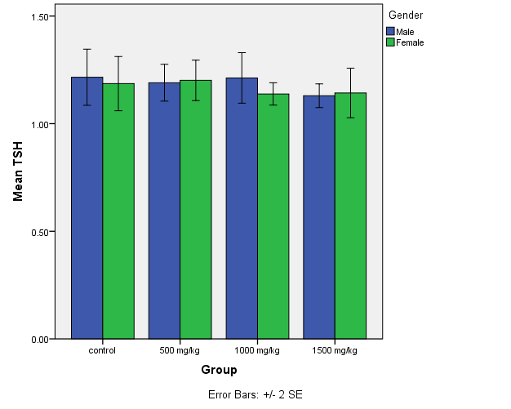
Figure 1: TSH level of male and female Wistar rats administered Gliricidia sepium ethyl acetate leaves extract in sub-chronic oral toxicity study
Key: TSH= thyroid stimulating hormone, control=group I, 500 mg/kg=group II, 1000 mg/kg= group III, 1500 mg/kg= group IV. Bars represent Mean±SEM, the values are not significantly different (p>0.05) when compared to control group, using two way analysis of variance SPSS version 23.0

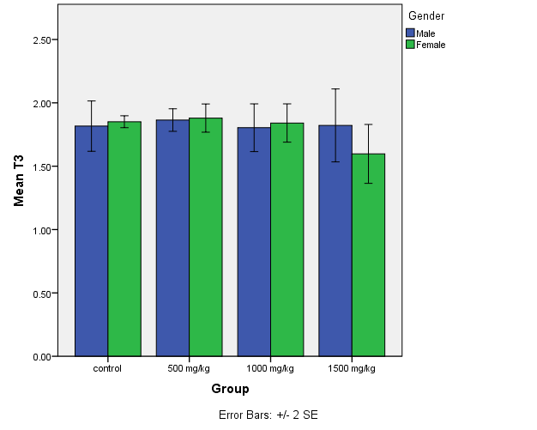
Figure 2: T3 level of male and female Wistar rats administered Gliricidia sepium ethyl acetate leaves extract in sub-chronic oral toxicity study
Key: T₃= triiodothyroxin, control=group I, 500 mg/kg=group II, 1000 mg/kg= group III, 1500 mg/kg= group IV. Bars represent Mean±SEM, the values are not significantly different (p>0.05) when compared to control group, using two way analysis of variance SPSS version 23.0

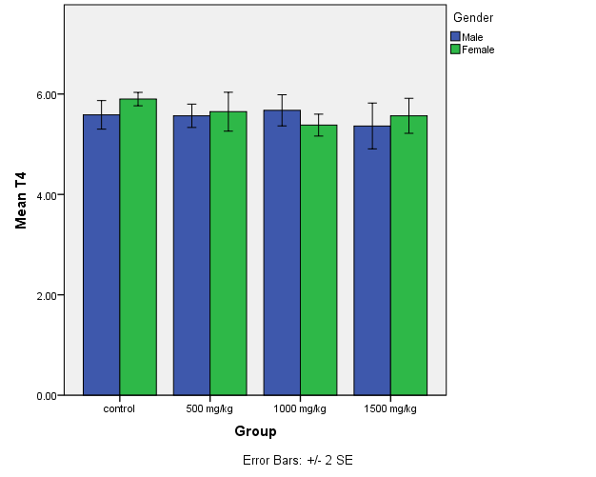
Figure 3: T₄ level of male and female Wistar rats administered Gliricidia sepium ethyl acetate leaves extract in sub-chronic oral toxicity study
Key: T₄= thyroxin, control=group I, 500 mg/kg=group II, 1000 mg/kg= group III, 1500 mg/kg= group IV. Bars represent Mean±SEM, the values are not significantly different (p>0.05) when compared to control group, using two way analysis of variance SPSS version 23.0

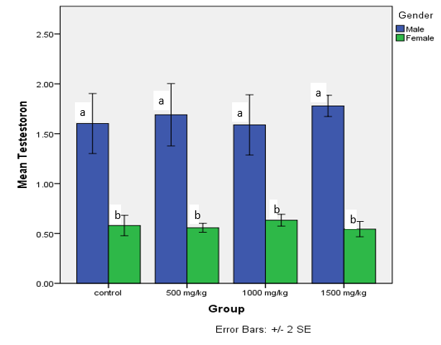
Figure 4: Testosterone level of male and female Wistar rats administered Gliricidia sepium ethyl acetate leaves extract in sub-chronic oral toxicity study
Key: control=group I, 500 mg/kg=group II, 1000 mg/kg= group III, 1500 mg/kg= group IV. Bars represent Mean±SEM, bars with different letters are significantly different (p<0.05), using two way analysis of variance SPSS version 23.0

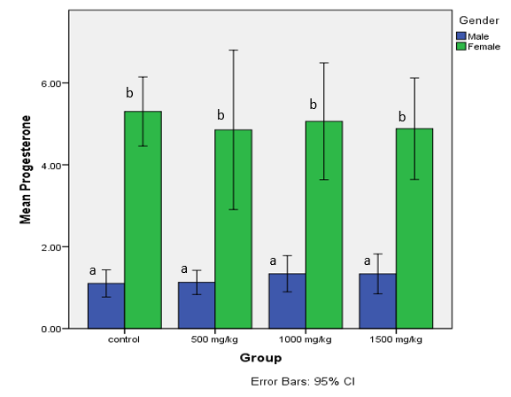
Figure 5: Progesterone level of male and female Wistar rats administered Gliricidia sepium ethyl acetate leaves extract in sub-chronic oral toxicity study
Key: control=group I, 500 mg/kg=group II, 1000 mg/kg= group III, 1500 mg/kg= group IV. Bars represent Mean±SEM, bars with different letters are significantly different (p<0.05), using two way analysis of variance SPSS version 23.0

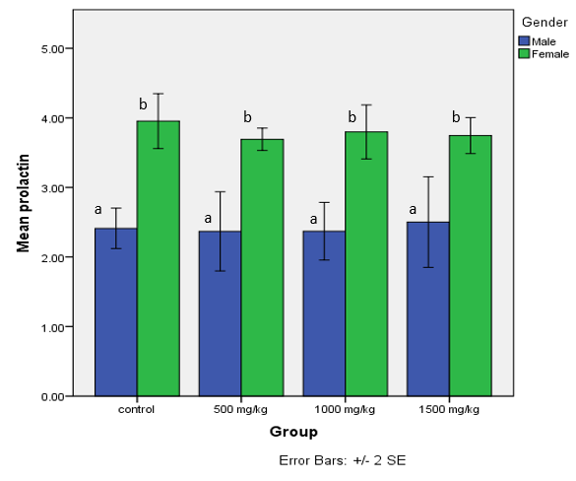Figure 6: Prolactin level of male and female Wistar rats administered Gliricidia sepium ethyl acetate leaves extract in sub-chronic oral toxicity study.
Key: control=group I, 500 mg/kg=group II, 1000 mg/kg= group III, 1500 mg/kg= group IV. Bars represent Mean±SEM, bars with different letters are significantly different (p<0.05), using two way analysis of variance SPSS version 23.0

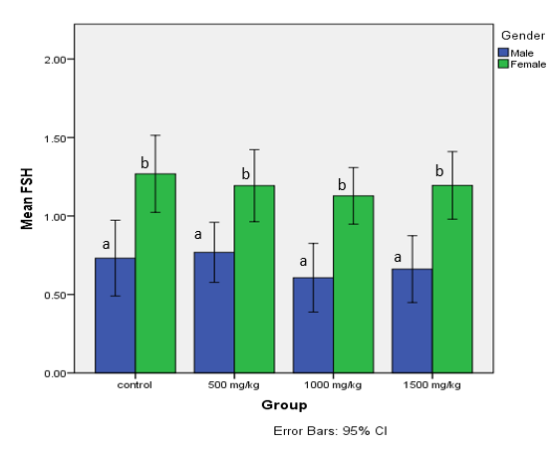
Figure 7: FSH level of male and female Wistar rats administered Gliricidia sepium ethyl acetate leaves extract in sub-chronic oral toxicity study
Key: FSH= follicle stimulating hormone, control=group I, 500 mg/kg=group II, 1000 mg/kg= group III, 1500 mg/kg= group IV. Bars represent Mean±SEM, bars with different letters are significantly different (p<0.05), using two way analysis of variance SPSS version 23.0

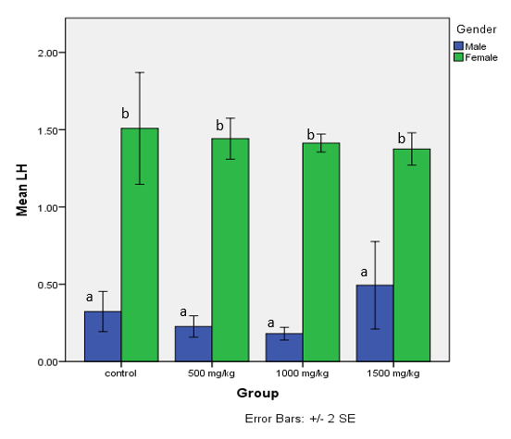
Figure 8: LH level of male and female Wistar rats administered Gliricidia sepium ethyl acetate leaves extract in sub-chronic oral toxicity study
Key: LH = luteinizing hormone, control=group I, 500 mg/kg=group II, 1000 mg/kg= group III, 1500 mg/kg= group IV. Bars represent Mean±SEM, bars with different letters are significantly different (p<0.05), using two way analysis of variance SPSS version 23.0

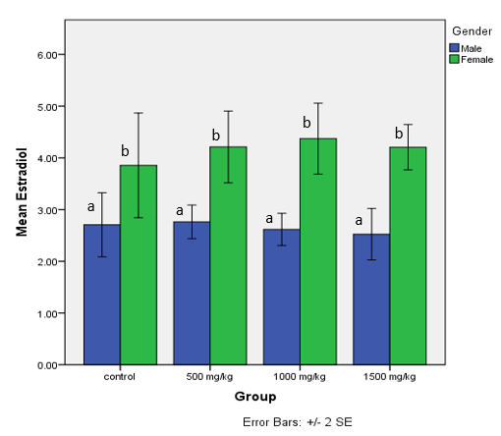
Figure 9: Estradiol level of male and female Wistar rats administered Gliricidia sepium ethyl acetate leaves extract in sub-chronic oral toxicity study
Keys: control=group I, 500 mg/kg=group II, 1000 mg/kg= group III, 1500 mg/kg= group IV. Bars represent Mean±SEM, bars with different letters are significantly different (p<0.05), using two way analysis of variance SPSS version 23.0

4. CONCLUSION
The oral median lethal dose (LD₅₀) of the ethyl acetate leaf extract of Gliricidia sepium was found to be greater than 5000 mg/kg body weight in Wistar rats, indicating low acute toxicity. Furthermore, sub-chronic oral administration of the extract at doses of 500, 1000, and 1500 mg/kg for 28 days did not produce adverse effects on thyroid or reproductive hormone profiles in either male or female rats. These findings suggest that the extract is relatively safe at the tested doses.
ETHICAL APPROVAL
Ethical approval was obtained from the Health and Biomedical Research Ethics Committee (HBREC), Usmanu Danfodiyo University, Sokoto. Approval number: NHREC/UDU-HREC/25/06/2023.
References

- Pathak, A., Gupta, A.P. & Pandey, P. (2025). Herbal Medicine and Sustainable Development Challenges and Opportunities. In S.C., Izah, M.C., Ogwu, M. Akram, (eds.), Herbal Medicine Phytochemistry (pp. 48). Reference Series in Phytochemistry: Springer, Cham.

Mapunda, P.E. & Mramba, R.P. (2025). Medicinal plant use and conservation in Tanzania: perspectives from university of Dodoma students. Discover Social Science & Health, 5, 77.
- Belayneh, Y.M., Yoseph, T. & Ahmed, S. (2022). A cross-sectional study of herbal medicine use and contributing factors among pregnant women on antenatal care follow-up at Dessie Referral Hospital, Northeast Ethiopia. BMC Complementary Medicine and Therapies, 22(1), 146.

Dubale, S., Usure, R. E., Mekasha, Y. T., Hasen, G., Hafiz, F., Kebebe, D. et al. (2025). Traditional herbal medicine legislative and regulatory framework: A cross-sectional quantitative study and archival review perspectives. Frontiers in Pharmacology, 16, 1475297.
- Oduola, T., Dallatu, M.K., Muhammed, A.O., Ndakotsu, M.A., Adebisi, I.M. & Hassan, S.W. (2016). Gliricidia sepium Aqueous Leaves Extract Possesses Antisickling Property. International Blood Research and Review, 5(3), 1-6.
- Wafaey, A.A., El-Hawary, S.S., Kirollos, F.N. & Abdelhameed, M.F. (2023). An Overview on Gliricidia Sepium in the Pharmaceutical Aspect: A Review Article Egyptian Journal of Chemistry, 66(1), 479-496.
- Oduola, T., Umar, R.A., Isah, B.A., Bello, M., Aiyelabegan, F., Isa, L.O. et al. (2018). Use of Gliricidia sepium Aqueous Leaves Extract as an Antisickling Agent: Oxidative stress biomarkers in wistar rats exposed to the extract. International Journal of Medical and Health Research, 4(8), 79-83.
- Aulanni’am, A., Ora, K.M., Ariandini, N.A., Wuragil, D.K., Permata, F.S. and Riawan, W. et al. (2021). Wound healing properties of Gliricidia sepium leaves from Indonesia and the Philippines in rats (Rattus norvegicus), Veterinary World, 14, 820–824.
- OECD, (2008). Test No. 407: Repeated Dose 28-Day Oral Toxicity Study in Rodents, Organization for Economic Co-operation and Development Publishing.
- Lorke, D. (1983). A new approach to practical acute toxicity testing. Archives of Toxicology, 54, 275–287.
- Enegide, C., David, A. & Fidelis, S.A. (2013). A New Method for Determining Acute Toxicity in Animal Models. Toxicology International, 20(3), 224–226
- Bulgheroni, A., Kinsner-Ovaskainen, A., Hofmann, S., Hartung, T. & Prieto P. (2009). Estimation of acute oral toxicity using the No observed adverse effect level (NOAEL) from the 28-day repeated dose toxicity studies in rats. Regulatory Toxicology and Pharmacology, 53 (1), 16–9.
- Lidji, C.J.S.R., Bolou, G.E.K., Droubly-Bouagnon, J.J.R., Konan, G.K.N.A., Kamo, I.L.B.E., N’Guessan, J. D. et al. (2024). Evaluation of the antiviral activity of different extracts of Gliricidia sepium and Xylopia aethiopica on entero viruses isolated in Côte d'Ivoire, Journal of Drug Delivery and Therapeutics, 14(10), 64-69
- Hopton, M., R. & Harrap, J., J. (1986). Immunoradiometric assay of thyrotropin as a first line thyroid function test in the routine laboratory. Clinical chemistry, 32:691.
- Gharib, H.,Ryan, R., J., Mayberry, W., E., & Hackett, T. (1971). Radioimmunoassay for triiodothyronine (T3): affinity and specificity of antibody for T3. Journal of clinical endocrinology. 33: 506
- Barker, S., B. (1948). Determination of protein bound iodine. Journal of biological chemistry; 173:715
- Odell, W., U., Parlow, A., Oster, G., Alberch, B. and Burnside, B. (1981). Journal of clinical.
Investigation, 4: 2551.
- Kosasa, T., S. (1981). Measurement of Human Luteinizing Hormone. Journal of reproductive medicine, 26: 201-2
- Corker, C.S. & Exley, D. (1970).The determination of plasma estradiol-17β by competitive protein binding radio assay. Steroids; 5(4): 469-694.06.
- OECD (2025). Guidance on Good Practices and Standardisation of Sample Collection for Omics Analysis. Series on Testing and Assessment, No. 405. OECD Publishing, Paris
- Shahid, M.A., Ashraf, M.A. & Sharma, S. (2023). Physiology, Thyroid Hormone. [Updated 2023 Jun 5]. In: StatPearls [Internet]. Treasure Island (FL): StatPearls Publishing.
- Lee, K.J., Choi, C.Y., Chung, Y.C., Kim, Y.S., Ryu, S.Y. (2004). Protective effect of saponins derived from roots of Platycodongrandiflorum on tertbutylhydroperoxide-induced oxidative hepatotoxicity. Toxicology letters; 147:271-82.
- Wirth, J.J., Mijal, R.S. (2010). Adverse Effects of Low Level Heavy Metal Exposure on Male Reproductive Function, Syst. Biology and Reproductive Medicine; 56 (2):147–67.
- Montaserti, A., Pourheydar, M., Khazaei, M., Ghorbani, R. (2007). Anti-Fertility Effects of Physalis Alkekengi Alcoholic Extract in Female Rat. Iranian Journal of Reproductive Medicine; 5(1): 13-16.

