Beyond Frequency: Measuring Climate Disaster Risk Concentration in Indonesia Using a Herfindahl Index Approach

Abstract
Climate change not only increases the frequency of hydrometeorological disasters but also shapes different risk structures across regions, depending on the prevalence or diversity of disaster types. This study aims to measure and compare the concentration of climate hazards in Indonesia by going beyond the frequency-based approach. Using provincial-level data on floods, droughts, forest and land fires, and extreme winds, this study adopts the Herfindahl–Hirschman Index (HHI) as a measure of disaster concentration. The analysis shows that most villages in Indonesia have a concentrated risk structure, although there is significant variation across regions. At the provincial level, the concentration pattern is relatively uniform, reflecting the prevalence of certain hazards shaped by regional geographic and climatic characteristics. This finding indicates that regions with similar event intensity can have very different risk profiles when viewed from the structure of disaster concentration. The main contribution of this study lies in providing a more structural climate risk measurement framework rarely used in the disaster literature, and offering an empirical basis for formulating mitigation and adaptation strategies that are more sensitive to regional risk characteristics.
Keywords: Climate disaster risk; Herfindahl–Hirschman Index; disaster concentration; multi-hazard exposure; subnational analysis; Indonesia.

- Introduction
Climate change has increased the frequency and complexity of hydrometeorological disasters in various parts of the world, particularly in developing countries with diverse geographic and socioeconomic conditions. In Indonesia, floods, droughts, forest and land fires, and extreme winds are recurring and interconnected phenomena, resulting in heterogeneous risks across regions (Bâra et al., 2024; Hendrawan et al., 2025; Kurniadi, 2024). The main challenge in climate risk assessment is not only the increasing number of disaster events, but also how these risks are distributed and structured spatially, thus affecting the adaptive capacity and mitigation strategies required at the provincial level.
Most disaster and climate risk studies still rely on indicators based on frequency or intensity of events, such as the number of disasters, the area affected, or the number of victims (Chapagain, 2024; Fernández-Gallardo Romero, 2025; Newman & Noy, 2022). This approach, while informative, tends to assume that all disaster types contribute linearly and separately to a region's risk. As a result, the structural dimension of risk—namely, whether a region faces a predominance of one type of disaster or exposure to multiple hazards—is often overlooked. Yet, two regions with the same number of disasters can have very different risk profiles depending on the degree of concentration of their disaster types.
The concept of risk concentration offers an alternative perspective for understanding climate vulnerability. Regions dominated by a single type of hazard may face more predictable risks, while areas exposed to multiple hazards face more complex adaptation challenges due to interactions between event types. However, measuring hazard concentration is still relatively rare in the disaster literature, particularly at the provincial level and based on detailed administrative data. The lack of quantitative measures capable of capturing this risk structure limits understanding of the dynamics of climate vulnerability across regions.
This study fills this gap by adopting the Herfindahl–Hirschman Index (HHI), traditionally used to measure market concentration, as a tool to quantify the concentration of climate hazard types. By utilizing the relative proportion of each hazard type to the total number of events, the index allows for the identification of regions with risks concentrated in a single dominant hazard as well as regions with more dispersed, multi-hazard exposure. This approach goes beyond simply counting events and provides a more structural representation of the climate risk profile.
Indonesia is a relevant empirical context for the application of this approach given the heterogeneity of climate, topography, and land use patterns between provinces (Hasanah et al., 2025; Withaningsih et al., 2022; Wiwoho et al., 2023). These variations have the potential to produce very different disaster risk configurations, even within a single national disaster policy framework. Using provincial-level disaster event data, this study highlights how the concentration of climate disaster risk varies across regions and how these differences do not always align with commonly used frequency-based indicators.
Specifically, this study aims to measure and compare the concentration of climate hazards across regions in Indonesia using the Herfindahl Index, and to identify patterns of disaster risk dominance and diversification. The primary contribution of this study lies in providing a more nuanced climate risk measurement framework rarely used in the disaster literature, while also opening up space for policy analysis that is more sensitive to regional risk structures. Thus, this study enriches the discourse on climate risk measurement and offers an alternative perspective for understanding provincial vulnerability.
- Data and Method
This study uses climate disaster data sourced from the 2021 Village Potential Data Collection conducted by the Central Statistics Agency (BPS). The unit of analysis is the provincial level, allowing for consistent spatial comparisons between regions within a single national framework. The types of disasters analyzed include floods, droughts, forest and land fires, and extreme winds, which represent the main groups of hydrometeorological disasters in Indonesia. The selection of these disaster types was based on the availability of consistent data across regions and their relevance in the context of climate change.
For each province, the number of incidents of each type of disaster was collected and used as a raw variable. The total number of incidents was calculated as the sum of all types of disasters observed in the same region. Next, each type of disaster was expressed as a proportion of the total number of incidents in that region. This process aimed to normalize the data and eliminate bias arising from differences in the scale of incidents between provinces, so that the analysis focused on the structure of risk distribution, rather than the absolute magnitude of incidents.
The concentration level of climate hazards is measured using the Herfindahl–Hirschman Index (HHI), which is calculated as the sum of the squares of the proportion of each type of hazard to the total number of occurrences in a region. Mathematically, the index value ranges from a minimum value reflecting a relatively even distribution of hazards across types to a maximum value indicating the dominance of one particular type of hazard. In the context of this study, a higher HHI value indicates that disaster risk in a region is concentrated in one dominant type of hazard (Brezina et al., 2016; Rhoades, 1993).
Analisis dilakukan secara deskriptif dan komparatif antar provinsi untuk mengidentifikasi variasi Spatial analysis of climate hazard concentration levels. The HHI calculation results are used to group regions based on their risk structure characteristics, without setting specific normative thresholds. This approach allows for more flexible interpretation of disaster risk heterogeneity and provides an empirical basis for further analysis of regional resilience and disaster mitigation planning. All data processing and analysis are conducted consistently to ensure comparability of results across regions.
- Result and Disscussion
Analysis of climate hazard concentration at the village level provides insight into how disaster risk is structured across Indonesia. Rather than simply reflecting the number of events, this approach highlights the dominant patterns or diversity of disaster types experienced by a region. This risk structure is important because regions dominated by a single type of disaster face different adaptation challenges than regions exposed to multiple hazards, even though the number of recorded events may be similar. Therefore, understanding the concentration of disaster types is key to interpreting risk dynamics more comprehensively.
Summary statistical presentations, index category distributions, and interprovincial average comparisons are then used to capture the heterogeneity of these risk patterns. The combination of descriptive measures and spatial visualizations allows for the identification of differences in risk structures across regions without prior association with specific normative implications. These initial findings provide the empirical context necessary to interpret variations in disaster concentration in greater detail through the tables and graphs presented below, and serve as a basis for further discussion of the characteristics of climate disaster risk in Indonesia.
Table 1. Descriptive Statistics of Village Herfindahl Index and Disaster Events in the Last 2 Years
Variable | Mean | SD | Min | Max
Herfindahl Index | 0.8907717 | 0.2078306 | 0.1666667 | 1
Total Disaster Events in the Last 2 Years | 0.8596604 | 1.9524330 | 0 | 36

The relatively high average value of the village Herfindahl Index indicates that the disaster risk structure in most parts of Indonesia tends to be concentrated around a single dominant type of disaster. Although the minimum value of the index indicates that some villages have a more balanced exposure to multiple hazards, the significant variation is reflected in the standard deviation. This finding indicates heterogeneity in the risk structure between villages, with most areas facing specific and recurring disaster patterns, while others experience a more diverse combination of disaster types. Conversely, statistics on total disaster events over the past two years show a relatively low average value but a wide maximum range, indicating that a small number of villages experience a significantly higher accumulation of disaster events than other areas.
This phenomenon aligns with Indonesia's highly diverse geographic and climatic characteristics, where topography, rainfall patterns, and land use factors shape the dominance of certain types of disasters in many regions, such as flooding in lowland areas and river basins, or forest and land fires in areas with dry vegetation cover and human activity pressure. This concentration of risk implies that disaster policy strategies do not necessarily require a uniform multi-hazard approach across all regions. Instead, areas with highly concentrated risks have the potential to benefit more from interventions specific to the dominant hazard, while areas with higher risk variation require more flexible and integrated planning. By understanding the structure of this risk concentration, mitigation and adaptation policies can be directed more efficiently without unduly increasing institutional complexity.
Table 2. Herfindahl Index of Villages by Category
Indeks Herfindahl Category | Frequency | Percentage (%) | Cumulative
Highly Concentrated | 78,363 | 93.18 | 93.18
Moderately Concentrated | 219 | 0.26 | 93.44
Multi-Disaster | 5,514 | 6.56 | 100.00
Total | 84,096 | 100.00

The distribution of the Herfindahl Index categories shows that the majority of villages in Indonesia fall into the low-index category, indicating a relatively dispersed disaster risk structure across multiple hazard types. This highly significant proportion confirms that at the village level, disaster exposure is generally not concentrated in a single event, but rather a combination of multiple hazard types with varying intensities. Conversely, only a small proportion of villages fall into the multi-hazard index category, reflecting the consistent dominance of a single hazard type in certain areas. This pattern reveals an imbalance in the risk structure, with the majority of villages facing complex multi-hazard risks, while a minority faces more focused but potentially recurring risks. (Gaborit, 2022).
This phenomenon reflects Indonesia's diverse geographic and climatic conditions, where the interaction between natural factors and human activities results in a diverse spectrum of risks, even within a single province. Villages with a low index are generally located in areas vulnerable to multiple disasters, such as seasonal flooding accompanied by extreme winds or periodic droughts, thus requiring broader and more integrated adaptive capacity. The policy implication is that village-based disaster management approaches need to consider these different risk structures, by encouraging more comprehensive adaptation planning in multi-hazard areas and more focused interventions in villages with concentrated risks. Such a differentiated approach has the potential to improve the effectiveness of resource allocation without having to implement a uniform disaster strategy across the region.
Comparison of the average Herfindahl Index across provinces shows that most regions in Indonesia have relatively high index values ​​within a narrow range. This pattern indicates that the disaster risk structure at the provincial level tends to be dominated by a single type of disaster, although the intensity of occurrences can vary across provinces. Some provinces with higher index values ​​reflect a very strong dominance of disasters, while provinces with relatively lower values ​​indicate a slightly more diverse risk structure. However, there are no extreme differences between provinces, indicating that the concentration of disaster types is a common characteristic across many regions in Indonesia at the provincial level.

Figure 1. Average Herfindahl Index by Province
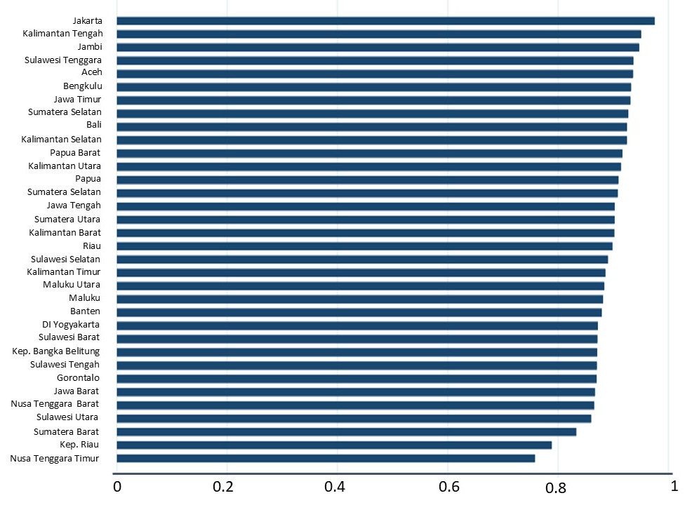
This phenomenon aligns with Indonesia's geographic characteristics, which create regionally dominant patterns of certain disasters, such as flooding in lowland and densely populated urban areas, or drought and land fires in areas with longer dry seasons. The policy implication is that provincial-level disaster mitigation planning can be more effective if it focuses on the dominant disasters most relevant to the characteristics of each region, without ignoring the potential for other events. This approach allows for more targeted and efficient resource allocation and encourages strengthening regional institutional capacity to address the most significant risks, compared to implementing a uniform disaster strategy across all provinces.
Table 3. Summary Statistics of Herfindahl Index and Disaster Occurrence Based on Concentration Category
Indeks Herfindahl Category | Indeks Herfindahl | Total Disaster Events
Highly Concentrated | 0.9999795  1 | 0.5854421  0
Moderately Concentrated | 0.801176  0.8024691 | 10.05023  9
Multi-Disaster | 0.5086766  0.5 | 4.39173  3
Total | 0.8907717  1 | 0.8596604  0

Summary statistics by disaster concentration category show clear differences in risk structure and event intensity across village groups. Villages in the highly concentrated category have HHI values ​​close to one, both at the mean and median, confirming the near-total dominance of a single disaster type. However, this group is characterized by a relatively low number of disaster events, reflected in mean and median total events approaching zero. Conversely, villages in the moderately concentrated category exhibit still high but more diverse HHI values, accompanied by a significantly higher average number of events. This pattern indicates that while risk in this region remains dominated by specific disasters, the higher frequency of events reflects more intense risk exposure.
In the multi-hazard category, a lower HHI value indicates a risk structure dispersed across several disaster types, with the number of events being intermediate compared to the other two categories. This finding confirms that areas with multi-hazard exposure do not necessarily experience the most frequent events, but rather face higher risk complexity due to the diversity of disaster types. Implicitly, this pattern implies that event intensity and risk concentration structure do not always move in the same direction. Consequently, disaster mitigation and adaptation strategies need to differentiate between areas with infrequent but highly concentrated events and areas with more frequent but diverse events, so that designed interventions can be more targeted and efficient.
Table 4. Correlation of Herfindahl Index and Disaster Occurrence
Variable | Indeks Herfindahl | Total Disaster Events
Indeks Herfindahl | 1.0000
Total Disaster Events | -0.3226 | 1.000

The correlation analysis results show a negative relationship between the Herfindahl Index (HHI) and total disaster occurrences. A correlation coefficient of -0.32 indicates that villages with a higher concentration of disasters tend to experience a lower number of disaster occurrences. Descriptively, this pattern means that areas dominated by a particular type of disaster are not always those with the highest frequency of disasters. Conversely, villages with a higher number of disaster occurrences tend to have a more dispersed risk structure across several types of disasters.
These findings emphasize that event intensity and risk concentration structure are not identical dimensions and can even move in opposite directions. In the Indonesian context, diverse geographic and climatic conditions allow for the occurrence of various types of disasters alternately in the same area, thus increasing the number of events but reducing the level of disaster concentration. Consequently, disaster risk assessments that rely solely on event frequency have the potential to overlook areas with highly concentrated risks but infrequent occurrences, which require more specific and targeted mitigation strategies.
- Conclusion
This study demonstrates that climate disaster risk in Indonesia is determined not only by the number of events, but also by the structure of the concentration of disaster types that shape the regional risk profile. Adopting the Herfindahl–Hirschman Index, this study reveals that at the village level there is heterogeneity in the risk structure, with a predominance of multi-hazard-exposed areas and a small number of areas facing a concentration of risk in a particular type of disaster, while at the provincial level the concentration pattern tends to be more uniform. This finding confirms that areas with similar event intensity can face fundamentally different adaptation challenges when viewed from their risk structure. The main contribution of this study lies in providing a more structural approach to climate risk measurement that is rarely used in the disaster literature, while also providing an empirical basis for the formulation of mitigation and adaptation strategies that are more contextual, efficient, and aligned with the characteristics of regional risks in Indonesia.

References
Bâra, A., Văduva, A. G., & Oprea, S.-V. (2024). Anomaly detection in weather phenomena: News and numerical data-driven insights into the climate change in Romania’s historical regions. International Journal of Computational Intelligence Systems, 17(1), 134.
Brezina, I., Pekár, J., Čičková, Z., & Reiff, M. (2016). Herfindahl–Hirschman index level of concentration values modification and analysis of their change. Central European Journal of Operations Research, 24(1), 49–72.
Chapagain, D. (2024). Detection and attribution of spatiotemporal trends of climatic disaster mortality in Nepal. Universitäts-und Landesbibliothek Bonn.
Fernández-Gallardo Romero, Á. (2025). The Economic Impact of Natural Disasters: A High Frequency Approach. Available at SSRN 5233144.
Gaborit, P. (2022). Climate adaptation to Multi-Hazard climate related risks in ten Indonesian Cities: Ambitions and challenges. Climate Risk Management, 37, 100453.
Hasanah, A., Jia, B., & Wu, J. (2025). Spatial heterogeneity in the impact of urban spatial structure on carbon emissions and storage in coastal region: a case study of Samarinda Metropolitan Area, Indonesia. Environment, Development and Sustainability, 1–33.
Hendrawan, V. S. A., Rahardjo, A. P., Mawandha, H. G., Aldrian, E., Muhari, A., & Komori, D. (2025). Past and future climate–related hazards in Indonesia. EGUsphere, 2025, 1–34.
Kurniadi, A. (2024). Improved Understanding of Extreme Precipitation over Indonesia and Future Projections Using GCMs. ResearchSpace@ Auckland.
Newman, R., & Noy, I. (2022). The global climate-change-attributed costs of extreme weather.
Rhoades, S. A. (1993). The herfindahl-hirschman index. Fed. Res. Bull., 79, 188.
Withaningsih, S., Parikesit, P., Malik, A. D., & Rahmi, M. A. (2022). Analysis of the structure and ecological function of an extreme landscape in a tropical region of West Java, Indonesia. Forests, 13(1), 115.
Wiwoho, B. S., Phinn, S., & McIntyre, N. (2023). Two decades of land-use dynamics in an urbanizing tropical watershed: understanding the patterns and drivers. ISPRS International Journal of Geo-Information, 12(3), 92.

