In Silico Investigation of 4-hydroxy-3-methoxycinnamic acid derivatives as Inhibitors of Key Oncogenic Targets Using Molecular Docking and ADMET Analysis

ABSTRACT
Objective: This study aims to evaluate derivative of 4-hydroxy-3-methoxycinnamic acid through computational methods, including Lipinski’s Rule of Five, ADMET prediction, Mol-inspiration analysis and molecular docking to assess its drug-likeness, pharmacokinetics, and therapeutic potential for cancer treatment specially lung cancer.
Methodology: This work assessed the physicochemical, pharmacokinetic, and pharmacodynamic characteristics of 4-hydroxy-3-methoxycinnamic acid substituted with aromatic amine using in-silico web tools using programs like Pre-ADMET, Mol-inspiration and Molegro Virtual Docker 6.0.
Result and discussion: The computational analysis of 15aromatic amine-substituted 4-hydroxy-3-methoxycinnamic acid derivatives revealed promising drug-likeness via Mol-inspiration and Lipinski’s Rule of Five compliance. ADMET profiling indicated favourable pharmacokinetics and low toxicity. Molecular docking against tyrosine kinase targets (PDB: 4ZSE, 8A27, 5T4B, 6CU6) showed strong binding affinities, particularly with 6CU6, suggesting potential inhibitory activity. Key interactions involved hydrogen bonding and π-π stacking with active site residues, supporting their candidacy as lead compounds for lung cancer therapeutics.
Conclusion: The study concludes that selected 4-hydroxy-3-methoxycinnamic acidderivatives exhibit favourable ADMET, drug-likeness, and strong tyrosine kinase inhibition, highlighting their potential as promising candidates for lung cancer therapy.
Key words: Lung cancer, 4-hydroxy-3-methoxycinnamic acid, ADMET, mol- inspiration, molecular docking.

INTRODUCTION
Cancer is a complex and multifactorial disease characterized by the uncontrolled growth and proliferation of abnormal cells, often driven by disruptions in cellular metabolism and enzyme activity (1).Lung cancer is one the leading causes of cancer-related mortality worldwide. According to global cancer statistics, lung cancer accounts for approximately 11.6% of all new cancer cases and is the leading cause of cancer-related deaths, responsible for 18.4% of all cancer deaths (2)
Tyrosine kinase receptors (RTKs) are main transmembrane glycoproteins that play significant role in tumor genesis and progression, and are major targets for cancer therapy. Small molecule inhibitors of tyrosine kinase prevent this enzyme from phosphorylating intracellular tyrosine residues on their substrates and thus blocking the downstream signalling pathways.(3)
An extracellular ligand binding domain, a single transmembrane helix, and an intracellular area comprising a juxtamembrane regulatory region, a tyrosine kinase domain (TKD), and a carboxyl terminal tail make up the common protein structure of RTKs. Typically, ligands unique to each receptor activate RTKs. These ligands, which include growth factors, attach to the outer regions of RTKs and cause ligand-induced receptor dimerization or oligomerization, which activates the receptor. These structural changes enable trans-autophosphorylation of each tyrosine kinase domain (TKD) in most RTKs.
Traditional chemotherapy and radiotherapy have increased patient survival to a certain extent, but many patients still face a high recurrence rate and poor prognosis(4).
Recent advancements in lung cancer therapy include next-generation tyrosine kinase inhibitors (TKIs) targeting EGFR and ALK mutations with improved specificity and reduced resistance. Immunotherapies, such as PD-1/PD-L1 checkpoint inhibitors, have shown durable responses in advanced cases. Additionally, liquid biopsies enable early detection and monitoring, while AI-driven diagnostics enhance personalized treatment planning, significantly improving patient outcomes and survival rates.
Tyrosine kinase inhibitors (TKIs) are a class of drugs that have anti-proliferative and anti-angiogenic properties.Tyrosine kinase inhibitors (TKIs) are targeted cancer therapies that block abnormal signalling pathways driving tumour growth. They are especially effective in treating cancers like lung and leukemia with specific genetic mutations.
TKIs received the approval for their use in clinical practice, such as gefitinib, erlotinib, dasatinib, sorafenib, and sunitinib. These agents have a common mechanism of action, that is represented by competitive ATP inhibition at the catalytic binding site of tyrosine kinase(5).
Gefitinib Erlitinib

Desatinib
Computational study: Computational chemistry research employs tools like and ROF (Rule of Five) for drug-likeness assessment pre-ADMET for pharmacokinetic prediction, Mol-inspiration for bioactivity analysis, and molecular docking for binding affinity evaluation, enabling efficient compound screening and rational drug design in modern science. Some computational tools are:
Lipinski's Rule of Five: Lipinski's Rule of Five is based on Four key Parameters: molecular weight, hydrogen bond donors, hydrogen bond acceptors, and the octanol-water partition coefficient (log P). According to the rule, a compound is more likely to have desirable pharmacokinetic and pharmaceutical properties if it has a molecular weight below 500 Da, no more than five hydrogen bond donors, no more than 10 hydrogen bond acceptors, and a calculated octanol water partition coefficient (log P) less than 5(6).Lipinski’s Rule of Five predicts drug-likeness by evaluating key molecular properties that influence oral absorption.
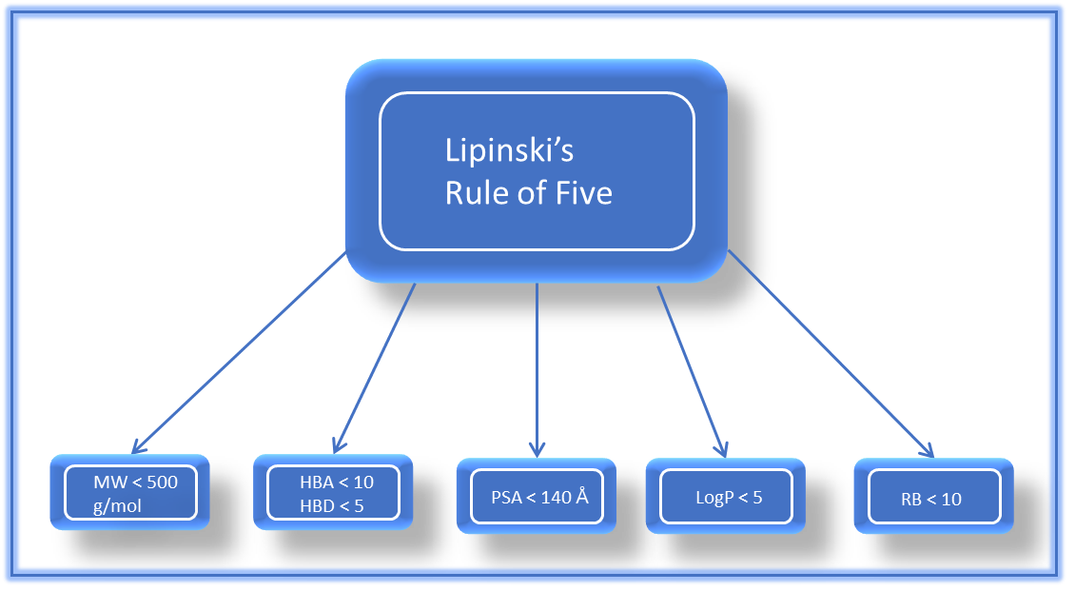
Figure 01: Lipinski’s rule of five
Pre-ADMET Analysis: Pre-ADMET studies play a pivotal role in during the initial phases of drug discovery and development, enabling to evaluate potential drug candidates for their pharmacokinetic, safety, efficacy and toxicity profiles before advancing to costly in vivo experiments or clinical trials(7). Pre-ADMET analysis evaluates key pharmacokinetic properties, including BBB penetration, CaCO₃ permeability, CYP2D6 inhibition, HIA, MDCK transport, plasma protein binding, and skin permeability to predict a compound’s overall drug-likeness and safety.
A Pre-ADMET toxicity assessment predicted acceptable safety, showing Ames test non-mutagenicity, low carcinogenicity risk in rats, and weak HERG channel inhibition, indicating a favourable preliminary toxicity profile for further drug development.
Mol-inspiration: Mol-inspiration offers a user-friendly web interface that allows for the calculation of various molecular descriptors. These include LogP (octanol-water partition coefficient), topological polar surface area (TPSA), molecular weight, number of hydrogen bond donors and acceptors, and the number of rotatable bonds. (8)Additionally, the platform forecasts bioactivity scores for important pharmaceutical targets, including nuclear receptor ligands, G-protein coupled receptors (GPCRs), ion channel modulators, kinase inhibitors, and general enzyme inhibitors. Large data sets of physiologically active compounds were used to create fragment-based models that form the basis of these predictions.
Molecular docking: Molecular docking is abundantly utilized compactization phenomenon in the field of computer aided drug design (CADD). Molecular docking depends on the two phenomena: ligand and protein where protein is a target site and ligand gives attachment to that protein.(9)Molecular docking evaluates how a small molecule fits within a protein’s active site by predicting binding affinity, orientation, and key molecular interactions. It helps identify potential inhibitors, understand structure–activity relationships, and prioritize compounds before experimental testing. By simulating ligand–receptor complementarity, docking accelerates early-stage drug discovery and supports rational design of more selective and potent therapeutic candidates. (10)
GMPPNP-bound G12R mutant of Human KRAS4b (6CU6): The receptor target selected for the anti-lung cancer study was GMPPNP-bound G12R mutant of human KRAS4b, an established oncogenic protein involved in cell proliferation and survival signalling pathways. The three-dimensional crystal structure of KRAS was retrieved from the Protein Data Bank (PDB ID: 6CU6). This protein is classified as an oncoprotein and originates from Homo sapiens, while its recombinant expression was carried out in Escherichia coli. The selected structure contains mutation(s) relevant to cancer progression, making it a suitable target for evaluating anticancer activity. The crystal structure was resolved at a high resolution of 1.50 Å, ensuring structural accuracy and reliability for molecular docking and in silico interaction studies related to lung cancer therapeutics.
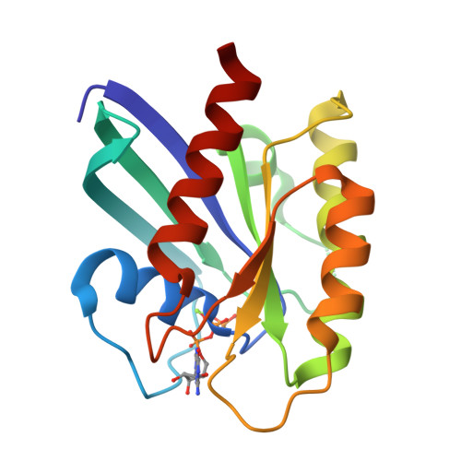
Figure 02: Crystal structure of GMPPNP-bound G12R mutant of human KRAS4b

Table 1: Computational tools for prediction of Drug likeness, Pharmacokinetics properties and Toxicity study
Sr. no. | Computational tool | Purpose | Key Applications
1. | Rule of Five (ROF) | Drug-likeness evaluation | Applies Lipinski’s criteria for oral bioavailability
2. | Pre-ADMET | Predicts pharmacokinetics (ADME/Tox) | Screens compounds for absorption, distribution, metabolism, excretion, and toxicity
3. | Mol-inspiration | Bioactivity prediction | Estimates activity against GPCRs, ion channels, nuclear receptors, and enzymes
4. | Molecular Docking | Binding affinity simulation | Models ligand–protein interactions to identify potential drug candidates

MATERIAL AND METHOD:
Dataset of compounds
Where R: Cl, NH_{2,} CH_{3,} C₂H₅,
Methodologies:
The methodology involved an in-silico study of derivative of 4-hydroxy-3-methoxycinnamic acidas a potential lung cancer treatment. The compound was first evaluated using Rule of Five (ROF) to assess drug-likeness, followed by Mol-inspiration for bioactivity prediction. Pre-ADMET analysis was conducted to estimate pharmacokinetic and toxicity profiles. Finally, molecular docking studies were performed to investigate binding affinity and interactions with lung cancer-related target proteins, ensuring therapeutic relevance.
Lipinski’s Rule of Five
Central to the pursuit of ﬁnding suitable drug candidates is the application of RO5. The RO5 was proposed by Lipinski in 1997, which effectively guided the design of small molecule drugs over the subsequent 20 years. This rule has been widely used in medicinal research and a molecule that obeys the physicochemical property guidelines of the rule would be labelled as an ideal drug molecule. (11)
Drug-likeness of compounds are measured by Lipinski Rule of Five
The methodology to evaluate the drug-likeness of 4-hydroxy-3-methoxycinnamic acid derivatives using Lipinski’s Rule of Five begins with the structural design of compounds in ChemDraw software. ChemDraw is a widely used chemical drawing application that allows researchers to accurately construct, visualize, and edit molecular structures with features such as bond alignment, stereochemistry representation, and automated generation of chemical names and properties. 4-hydroxy-3-methoxycinnamic acid derivatives were designed in ChemDraw by substituting aromatic amines onto the backbone structure. The finalized molecules were saved in .mol format for connectivity and stereochemistry, and in PDP format for computational evaluation. Using the ROF (Rule of Five) web tool, drug-likeness was assessed based on Lipinski’s criteria: molecular weight < 500 Da, logP< 5, ≤ 5 hydrogen bond donors, and ≤ 10 hydrogen bond acceptors. Prior to uploading, the system pH was adjusted to 7 to reflect physiological conditions and ensure accurate ionization states. The ROF platform then processed the PDP files, generating results that identified derivatives meeting Lipinski’s Rule of Five as drug-like with potential oral bioavailability, while non-compliant compounds required further optimization. (12)
Methodology of Mol-inspiration:
By applying computational methods, the various physicochemical features and pharmacokinetic descriptors were calculated for some selected organic crystalline compounds through the online tool Molinspiration Cheminformatics server. The drug likeness scores were assessed by considering MiLogP (partition coefficient), molecular weight, number of heavy atoms, number of hydrogen donor, number of hydrogen acceptor and number of violation, number of rotatable bonds and volume. (13)
The activity of 4-hydroxy-3-methoxycinnamic acidderivatives was assessed using the Mol-Inspiration cheminformatics platform, which predicts drug-likeness and receptor binding potential. Structures were saved in .mol format, opened in Notepad, and the coding in SMILES notation was copied into the platform’s input box. The tool reconstructed the compound for visual verification, after which the Submit option initiated computational analysis to generate activity predictions.(14)
In silico ADME properties, Drug Likeness and Toxicity study of designed compounds:
Four phases make up the pharmacokinetic Properties are: absorption, distribution, metabolism, and excretion (ADME). It recently included a phase for the toxicological assessment of new drug candidates, leading to the ADME-T research.(15)
ADMET analysis was performed using reliable online platforms such as Pre ADMET (16).These tools provide comprehensive in silico predictions of key pharmacokinetic parameters, including oral bioavailability, gastrointestinal absorption, blood–brain barrier permeability, and potential metabolic pathways. Their application enables early screening of drug-like properties, thereby streamlining the drug discovery process and facilitating the identification of compounds with favourable pharmacokinetic profiles.(17)
The methodology for ADMET analysis of 4-hydroxy-3-methoxycinnamic acid derivatives using the preADMET tool involves a systematic workflow to ensure accurate prediction of pharmacokinetic and toxicity parameters. 4-hydroxy-3-methoxycinnamic acid derivatives were prepared in .mol format using molecular modeling software, then opened in a text editor to access structural codes. These codes were pasted into the pre ADMET web interface, which reconstructed the compound for verification. After submission, the tool generated outputs covering key ADMET parameters: absorption (human intestinal uptake), distribution (blood–brain barrier penetration), metabolism (cytochrome P450 interactions), excretion tendencies, and toxicity (mutagenicity, carcinogenicity). (18)
Molecular docking: Molecular Docking be carried out using the program Molegro Virtual Docker 6.0Generally, the Docking process involve retrieval of ligand and target protein, protein preparation, lead/hit identification, active site prediction, protein-ligand docking, post docking analysis.
Ligand Preparation: It is the initial step for molecular docking studies. The compounds were used as ligands are the various derivatives of 4-hydroxy-3-methoxycinnamic acid. These compounds feature a variety of functional groups with different polarities, including amino, hydroxyl, carboxyl, acetoxy and halogen groups. The ligands were drawn using ChemDraw Ultra 2D 8.0 software, and Chem 3D Ultra software.
Protein preparation: The receptor targets for the anti-lung cancer study used areGMPPNP-bound G12R mutant of human KRAS(PDB ID: 6CU6), Human DipeptidylPeptidase 4 (PDB ID: 5T4B), Human Epidermal growth factor receptor (PDB ID: 8A27), Human Epidermal growth factor receptor (PDB ID: 4ZSE). The target protein receptor file can be downloaded at Protein Data Bank (http://www.rcsb.org).The structure is then completed by adding any extra atoms or residues. The protein is subsequently put through energy minimization to loosen up the structure and get rid of any steric interference. The protonation states of ionizable residues are then established to provide proper electrostatic interactions during docking. To further simplify the system, water molecules, and extraneous ligands are eliminated from the protein structure. To appropriately reflect the protein's behaviour during docking simulations, the proper force field parameters are lastly supplied to it. Through these preparation steps, the protein structure is optimized and refined, providing a suitable starting point for successful molecular docking studies. (19)
The ligands to be docked are selected based on various criteria, such as their chemical diversity, their known biological activity, or their potential for drug development. The ligands are then prepared for docking by assigning charges, generating conformers, and optimizing their geometry.(20)
Docking and analysis can be carried out using the program Molegro Virtual Docker, and all stages use a 3D image. Things that need to be considered in this process is the selection of docking compounds and cavity where the drug will interact (21). The binding cavity was identified using MVD’s cavity detection algorithm, focusing on the largest druggable pocket. Additionally, calculating the inhibition constant for docked ligands and proteins is an important step in evaluating the binding affinity and potential inhibitory activity of the ligands. However, it is not always necessary or applicable in all cases. The decision to calculate the inhibition constant depends on the specific research question, experimental design, and the objectives of the study. Ligand is docked against the protein and the interactions are analysed. The scoring function gives a score based on the best-docked ligand complex picked out. (22)
After the ligands have been docked to the protein, the results are analysed to identify the most promising candidates for further study. The binding affinity of each ligand is calculated based on the predicted interaction energy, and the ligands are ranked based on their affinity scores. The docked structures are also analysed to identify key interactions between the ligands and the protein, such as hydrogen bonds, hydrophobic interactions, and electrostatic interactions. These interactions can provide insights into the mechanism of action of the ligands and guide further optimization of their structure.(23)
The parameters measured in the docking process are the energy values involved, in the form of MolDock Score, Re-rank Score, and H-bond as well as the RMSD value. To measure the strength of drug-receptor binding, the parameter that is often used is value Re-rank Score.
RESULT AND DISCUSSION:
Result of physiochemical properties of designed compound using ROF: Results detailed in table 2reveal that all derivatives of 4-hydroxy-3-methoxycinnamic acid substituted with aromatic amine acquire acceptable drug-like properties, in addition to other drug-likeness parameters. This is because all the derivatives satisfied the rule, (MW ≤ 500 Da, LogP < 5, nHBD ≤ 5, nHBA ≤ 10).
Although molecular weight (MW < 500) of a drug plays a vital role in the drug oral bioavailability, the 500 Da cut-off mark does not significantly classify compounds into poor or good oral bioavailability. Besides, only compounds with two or more parameters violating the Lipinski rule of five, are considered orally not bioavailable. (24)
Table 2: Result of Molecular Properties using Lipinski rule of five
CODE | MW | HBA | HBD | MolLogP | MolPSA | MolVol | Drug likeness model  score
FA1 | 283.12 | 3 | 2 | 3.54 | 47.29 | 298.62 | -0.29
FA2 | 273.10 | 4 | 2 | 2.62 | 56.37 | 279.70 | -0.06
FA3 | 285.10 | 4 | 3 | 3.03 | 63.15 | 289.92 | -0.27
FA4 | 311.12 | 4 | 2 | 3.17 | 60.42 | 324.31 | 0.37
FA5 | 311.12 | 4 | 2 | 2.89 | 61.12 | 324.16 | -0.05
FA6 | 311.12 | 4 | 2 | 2.70 | 61.12 | 324.08 | 0.20
FA7 | 349.06 | 6 | 3 | -0.05 | 89.71 | 320.59 | -0.14
FA8 | 313.10 | 5 | 3 | 3.19 | 75.70 | 310.86 | 0.30
FA9 | 287.10 | 3 | 2 | 3.16 | 46.60 | 283.62 | -0.20
FA10 | 287.10 | 3 | 2 | 3.16 | 47.29 | 283.60 | 0.04
FA11 | 359.08 | 7 | 2 | 3.22 | 113.06 | 328.91 | -0.98
FA12 | 285.10 | 4 | 3 | 2.52 | 64.91 | 288.31 | -0.21
FA13 | 285.10 | 4 | 3 | 2.53 | 64.91 | 288.23 | -0.17
FA14 | 284.12 | 4 | 2 | 2.46 | 56.22 | 294.10 | 0.56
FA15 | 284.12 | 4 | 2 | 2.48 | 56.91 | 293.48 | 0.37

Result of pharmacokinetic properties by pre-ADMEtool:
Poor ADMET properties are usually one of the main causes of drug failure. Table 3 displays the theoretical ADMET characteristics of the developed derivatives. P glycoprotein(P-gp) and human intestinal absorption were employed to evaluate the intake potentials of the designed derivatives. The human stomach has good absorption when the score is greater than 30% (25)
Pharmacokinetics prediction study like GI absorption, BBB penetration, Caco2 absorption, p-gp, CYP2C19 Inhibitor, plasma protein binding and skin permeability mentioned in table 2.

Table 3: In silico pharmacokinetic (ADME) properties of designed compounds
Comp. | BBB | CaCO2 | CY2D6 | HIA | MDCK | Pgp | PPB | Skin permeability
FA1 | 1.714 | 26.13 | NON | 93.21 | 2.615 | NON | 83.74 | -2.72
FA2 | 0.246 | 28.32 | NON | 92.45 | 54.01 | NON | 73.00 | -3.35
FA3 | 0.806 | 20.87 | NON | 89.15 | 0.27 | NON | 79.62 | -3.72
FA4 | 0.199 | 22.53 | NON | 93.50 | 0.108 | NON | 79.65 | -2.94
FA5 | 0.205 | 22.53 | NON | 93.51 | 0.839 | NON | 78.43 | -2.97
FA6 | 0.205 | 22.71 | NON | 93.51 | 0.256 | NON | 80.87 | -2.98
FA7 | 0.012 | 0.517 | NON | 92.74 | 0.248 | NON | 93.54 | -2.35
FA8 | 0.097 | 20.94 | NON | 92.88 | 1.239 | NON | 77.38 | -3.07
FA9 | 1.300 | 25.67 | NON | 92.99 | 0.194 | NON | 84.08 | -3.10
FA10 | 1.345 | 26.58 | NON | 92.99 | 0.708 | NON | 84.18 | -3.14
FA11 | 0.030 | 19.74 | NON | 58.17 | 0.068 | INHIBITOR | 97.88 | -2.97
FA12 | 0..747 | 21.14 | NON | 89.16 | 1.513 | NON | 79.32 | -3.74
FA13 | 0.838 | 21.14 | NON | 89.16 | 1.527 | NON | 79.32 | -3.74
FA14 | 0.0999 | 24.87 | NON | 93.00 | 0.630 | NON | 63.25 | -3.41
FA15 | 0.272 | 23.30 | NON | 92.99 | 0.267 | NON | 78.88 | -3.20

The ADME analysis of 4-hydroxy-3-methoxycinnamic acid derivatives revealed a generally favourable pharmacokinetic profile across most parameters. In terms of human intestinal absorption (HIA), 14 compounds demonstrated high absorption while only one compound showed moderate absorption, indicating strong oral bioavailability potential. Plasma protein binding (PPB) results showed that 2 compounds (FA7 and FA11) were strongly bound, whereas the majority (13 compounds) were weakly bound, suggesting variability in distribution. For CaCO₃ permeation, nearly all compounds (14) exhibited moderate permeation, with just one compound showing lower permeation. Importantly, all compounds were non-inhibitors of CYP2D6, meeting acceptable criteria and minimizing risks of drug–drug interactions. In MDCK cell permeability assays, 1compound (FA) displayed moderate permeation while the remaining 14 were lower, highlighting limited transport efficiency in this model. Regarding P-glycoprotein (P-gp) interaction, 1 compound (FA11) acted as inhibitors while most (14) were non-inhibitors, reducing concerns about efflux-related bioavailability issues. Finally, blood–brain barrier (BBB) penetration results indicated that 3 compounds were CNS active, suggesting potential for neurological applications, while 12 compounds were non-CNS active. Overall, 4-hydroxy-3-methoxycinnamic acid derivatives showed promising absorption and metabolic safety, with notable CNS activity in the majority of compounds. The boiled egg model of FA11 is shown in figure.
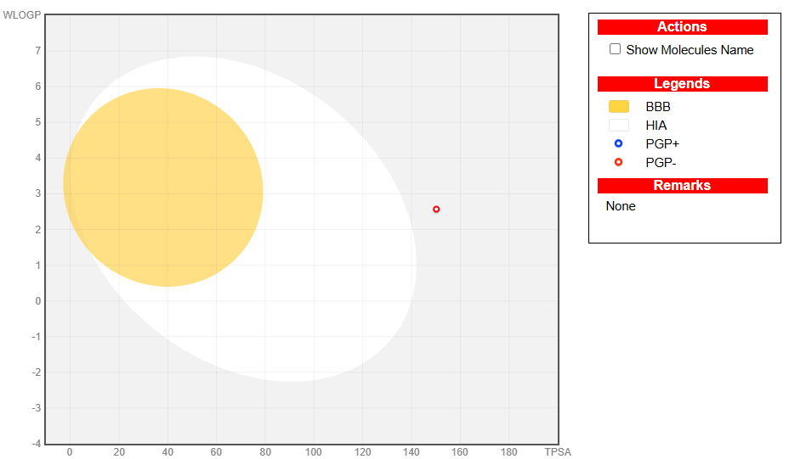
Figure 03: boiled egg model representing FA11 as PGP inhibitor
Result of toxicity of compounds by pre-ADMET tool
The result of toxicity of designed compounds are detailed in table 4
At the Ames test endpoint of PreADMET, there are 14mutagenic compounds and only 1 compound (FA7) are non-mutagenic compounds. The positive test results on Ames test indicate that the compound is mutagenic and has the possibility as carcinogenic. In the prediction of carcinogenicity in rat produced 14 carcinogenic positive compounds and only 1 compound are negative carcinogenic. While in the prediction of carcinogenicity in mouse 6 compounds are not carcinogenicity. At the HERG Inhibition all compounds show medium risk.
Table 4: Result of Toxicity studies and drug likeness of designed compounds
COMP | AMES TEST | CARCINO MOUSE | CARCINO RAT | HERG
FA1 | mutagen | +ve | +ve | Medium risk
FA2 | mutagen | +ve | -ve | Medium risk
FA3 | mutagen | -ve | +ve | Medium risk
FA4 | mutagen | -ve | +ve | Medium risk
FA5 | mutagen | +ve | +ve | Medium risk
FA6 | mutagen | -ve | +ve | Medium risk
FA7 | Non mutagen | +ve | +ve | Medium risk
FA8 | mutagen | -ve | +ve | Medium risk
FA9 | mutagen | +ve | +ve | Medium risk
FA10 | mutagen | +ve | +ve | Medium risk
FA11 | mutagen | +ve | +ve | Medium risk
FA12 | mutagen | -ve | +ve | Medium risk
FA13 | mutagen | -ve | +ve | Medium risk
FA14 | mutagen | +ve | +ve | Medium risk
FA15 | mutagen | +ve | +ve | Medium risk

Result of Drug likeness properties of designed derivatives of 4-hydroxy-3-methoxycinnamic acid
Table 5: Result of Molecular Properties using online program (Molinspiration)
code | miLogP | TPSA | natoms | MW | nON | nOHNH | nviolations | nrotb | volume
FA1 | 3.25 | 58.56 | 21 | 283.33 | 4 | 2 | 0 | 4 | 264.38
FA2 | 1.76 | 71.70 | 20 | 273.29 | 5 | 2 | 0 | 5 | 246.19
FA3 | 2.54 | 78.79 | 21 | 285.30 | 5 | 3 | 0 | 4 | 255.84
FA4 | 2.66 | 75.63 | 23 | 311.34 | 5 | 2 | 0 | 5 | 283.36
FA5 | 2.68 | 75.63 | 23 | 311.34 | 5 | 2 | 0 | 5 | 283.36
FA6 | 2.71 | 75.63 | 23 | 311.34 | 5 | 2 | 0 | 5 | 283.36
FA7 | -0.20 | 112.93 | 24 | 349.36 | 7 | 3 | 0 | 5 | 287.27
FA8 | 2.69 | 95.86 | 23 | 313.31 | 6 | 3 | 0 | 5 | 274.82
FA9 | 2.92 | 58.56 | 21 | 287.29 | 4 | 2 | 0 | 4 | 252.75
FA10 | 2.97 | 58.56 | 21 | 287.29 | 4 | 2 | 0 | 4 | 252.75
FA11 | 2.65 | 150.21 | 26 | 359.29 | 10 | 20 | 0 | 6 | 294.49
FA12 | 2.30 | 78.79 | 21 | 285.30 | 5 | 3 | 0 | 4 | 255.84
FA13 | 2.33 | 78.79 | 21 | 285.30 | 5 | 3 | 0 | 4 | 255.84
FA14 | 1.96 | 71.45 | 21 | 284.31 | 5 | 2 | 0 | 4 | 260.22
FA15 | 2.31 | 71.45 | 21 | 284.31 | 5 | 2 | 0 | 4 | 260.22

Result of molecular docking with 6CU6 pdb:
To understand the molecular interaction, all compounds were docked with the GMPPNP-bound G12R mutant of human KRAS4b (6CU6 PDB ID). Organic compounds can link to proteins via creating chemical bonds and non-covalent interactions between the ligand and the protein (26). Hydrogen bond interaction and hydrophobic interaction are important considerations in evaluating binding affinity and the effectiveness of a new drug molecule to gain suitable pharmacologic properties. H-bonds play a critical role in drug-receptor interactions and the structural integrity of numerous biological components, including proteins and DNA. (27).The poses with the highest negative docking scores were selected for the final presentation that signifies the best affinities of the compounds towards the target receptors.The results were shown in table 6.
Table 6: Result of molecular docking with human KRAS pdb (6CU6)
Sr No. | code | Moldock score | H bond | Steric interaction
 | Co-crystallized  ligand | -250.535 | ASP119, Ala 146, Asn 116, lys117, Ser 11, Ala18, Lys 16, Gly 16, Gly15, Thr 35, Tyr 32, Arg 12, Asp 30, Val 29 | Arg 12, Thr 35, Gly 13, Gly 60
 | FA1 | -136.76 | Ala 146, Lys 147, Asp 119, | Ala 146
 | FA2 | -141.721 | Ser 17, ser 145, Asp 119, Lys 147 | Ala 146
 | FA3 | -136.065 | Lys 16, Gly 15,Asp 119, Gly 13 | Gly 15, Ala 18
 | FA4 | -132.126 | Ala 146, Lys 16, Gly 13, Ser 17, Thr 35, Lys 117 | Ala 18, Ala 146, Asn 116, Lys 117, Gly 13
 | FA5 | -163.464 | Tyr 32, Gly 13, Lys 147, Asp 119, Ser 145 | Asp 33, Gly 15, Asn116, Ala 146
 | FA6 | -149.977 | Thr 35, Arg 12, Tyr 32, Lys 147, Ser 145, Ala 146, Asp 119 | Ala 146, Asn 116, Lys 117, Asp 119, Gly 15
 | FA7 | -166.593 | Lys 16, Gly 60, Arg 12, Tyr 32, Thr 35, Ala 146, Lys 147, Asp 119 | Thr 35, Gly 15, Ala 18, Lys 117, Ala 146, Asp 119
 | FA8 | -169.702 | Asn 116, Ala 146, Gly 13, Lys 16, Ser 17, Thr 35 | Ala `8, Ala 146, Asn116,Gly13
 | FA9 | -129.335 | Lys 16, Thr 35,Ser 17, Asp 33 | Asp 119, Asn 116, Ala 146
 | FA10 | -136.39 | Asp 119, Ala 146, Lys 147 | Ala 146
 | FA11 | -181.092 | Asp 33, Ser 17, Thr 35, Thr 32, Arg 12, Ser 145, Lys 147, Asp 119 | Tyr 32, Pro 34, Thr 35, Gly15, Ser 17, Asp 33, Asn 116, Ala 146, Lys 147
 | FA12 | -137.653 | Asp 119, Ser 17, Thr 35, Asp 33 | Asn 116, Ala 146, Asp119, Lys 16
 | FA13 | -141.709 | Ser 145, Asp 119, Lys 147, Gly13, Lys 16, Thr 35 | Asn 116, Gly 15, Ala 146
 | FA14 | -142.505 | Ser 17, Lys 147, Asp 119, Ser 145, | Gly 15, Asn 116, Ala 146
 | FA15 | -142.771 | Asn 116, Gly 13, Lys 16, Thr 35, Asp 33 | Ala 146, Asp 119, Lys 16

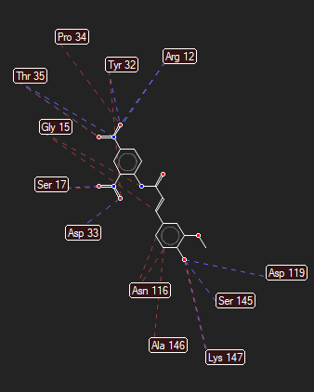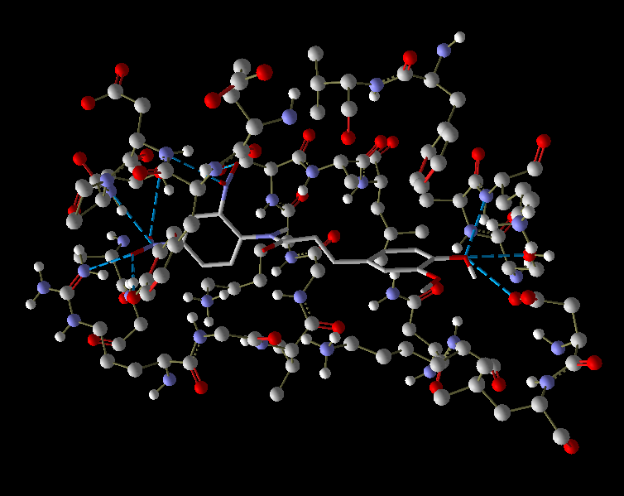
Figure 04: H-bond interaction and docking pose of FA11
Result of molecular docking when standard tyrosine kinase inhibitor such as gefitinib is docked with GMPPNP-bound G12R mutant of human KRAS4b (6CU6 PDB ID).
Table 7: Result of molecular docking of standard TKIs
Sr No. | Standard TKI | Moldock score | H bond | Steric interaction
 | Gefitinib | -157.872 | Thr 35, Ser 17, Glu 31 | Asp 119, Lys 147, Gly 13, Gly15, Thr32, Asp 33, Ser 17, Val 29

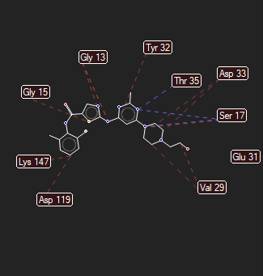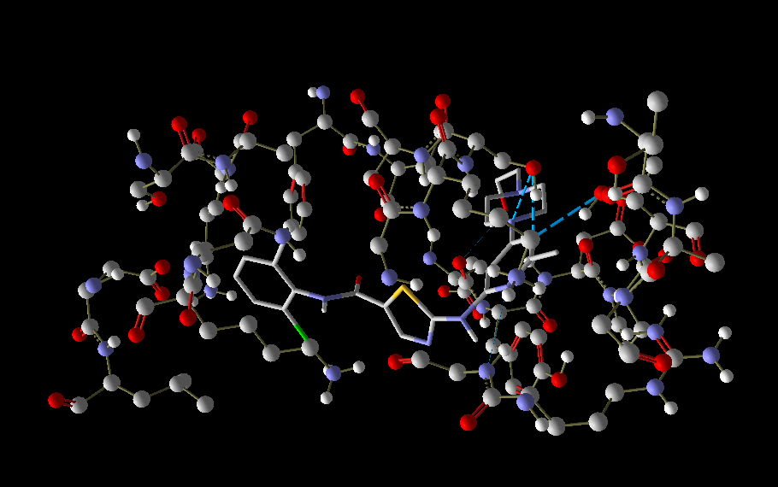
Figure 05: H- bond interaction and docking pose of Gefitinib (standard tyrosine kinase inhibitor)
Among all the 15 derivatives compound FA11 which is derivative of 4-hydroxy-3-methoxycinnamic acid with 2,4 dinitro aniline shows the relatable results with standard tyrosine kinase inhibitors in terms of binding affinity and interactions.
4-hydroxy-3-methoxycinnamic acid with 2,4dinitro aniline
DISCUSSION:
Drug-likeness and pharmacokinetic profiling are essential steps in early-stage drug discovery to identify compounds with favorable oral bioavailability and safety characteristics. In the present study, all designed 4-hydroxy-3-methoxycinnamic acid derivatives substituted with aromatic amines demonstrated acceptable drug-like properties, as evidenced by their compliance with Lipinski’s rule of five. All compounds satisfied the established criteria for molecular weight (≤ 500 Da), lipophilicity (LogP< 5), hydrogen bond donors (≤ 5), and hydrogen bond acceptors (≤ 10), indicating their suitability as orally active drug candidates. Although molecular weight plays a significant role in oral bioavailability, the commonly applied 500 Da threshold does not strictly differentiate compounds with good or poor absorption. Importantly, compounds are generally regarded as orally non-bioavailable only when two or more Lipinski parameters are violated, which was not observed for any of the studied derivatives.
The ADME predictions further supported the favorable pharmacokinetic behavior of the designed compounds. Human intestinal absorption (HIA) analysis revealed that the majority of the derivatives (14 compounds) exhibited high absorption, while only one compound showed moderate absorption, indicating strong potential for oral bioavailability. Plasma protein binding (PPB) analysis demonstrated variability in distribution characteristics, with two compounds (FA7 and FA11) showing strong binding, whereas the remaining derivatives were weakly bound. This moderate PPB profile is advantageous, as excessive plasma protein binding can reduce the free fraction of drug available for therapeutic action.
CaCO₃ permeability analysis showed that nearly all derivatives exhibited moderate permeation, suggesting acceptable intestinal transport properties. In contrast, MDCK cell permeability results indicated predominantly low permeability for most compounds, with only one compound displaying moderate permeation. This discrepancy may reflect differences between in vitro permeability models and highlights the complexity of membrane transport mechanisms. Nevertheless, the absence of CYP2D6 inhibition across all compounds is a highly favorable outcome, as it minimizes the risk of metabolic instability and potential drug–drug interactions.
Evaluation of P-glycoprotein (P-gp) interactions revealed that only one compound (FA11) acted as a P-gp inhibitor, while the remaining derivatives were non-inhibitors. This finding suggests a reduced likelihood of efflux-mediated limitations in oral bioavailability for most compounds. Blood–brain barrier (BBB) penetration analysis indicated that three compounds were CNS-active, whereas the majority were non-CNS active, suggesting limited central nervous system exposure. Such a profile may be advantageous for anticancer agents intended for peripheral targets, reducing the risk of CNS-related side effects. The BOILED-Egg model for FA11 further supports its predicted absorption and distribution behavior.
Despite the favorable ADME characteristics, toxicity predictions revealed certain limitations. Ames mutagenicity analysis showed that most compounds were predicted to be mutagenic, with only FA7 identified as non-mutagenic. Positive Ames test predictions suggest a potential risk of genotoxicity and carcinogenicity, which warrants further structural optimization. Similarly, carcinogenicity predictions indicated that most compounds were carcinogenic in rats, while a subset of compounds were predicted to be non-carcinogenic in mice, highlighting species-dependent variability. Additionally, all compounds exhibited a medium risk of hERG inhibition, suggesting a moderate potential for cardiotoxicity that should be carefully evaluated in subsequent experimental studies.
Overall, the in silico evaluation indicates that 4-hydroxy-3-methoxycinnamic acid derivatives possess promising drug-likeness and pharmacokinetic profiles, particularly with respect to oral absorption, metabolic safety, and enzyme inhibition. However, the predicted mutagenicity and carcinogenicity emphasize the need for further molecular refinement and experimental validation. These findings provide a valuable foundation for the rational design and optimization of 4-hydroxy-3-methoxycinnamic acid–based derivatives as potential anticancer agents.
CONCLUSION:
In conclusion, our study aimed to investigate the potential role of substituted 4-hydroxy-3-methoxycinnamic acid derivative in anti-lung cancer activity by targeting GMPPNP-bound G12R mutant of Human KRAS4b. The observations from our docking results suggested that substituted 4-hydroxy-3-methoxycinnamic acid may be a better ligand for Human KRAS4bin comparison to gefitinib, erlitinib, desatinib in terms of binding affinity and interactions. Further based upon the prediction of the drug like qualities of substituted 4-hydroxy-3-methoxycinnamic acid we observed that it can be a potential drug candidate. The bioactivity prediction also suggested that substituted may exhibit 4-hydroxy-3-methoxycinnamic acid a promising activity for kinase receptor ligands. Altogether, substituted 4-hydroxy-3-methoxycinnamic acid may be proposed as a potential ligand for GMPPNP-bound G12R mutant of human KRAS and based on their bioactivity score and may also be suggested to be used as a future drug candidate as anti-cancer for lung cancer.

REFERENCES:
- Aftab H, Islam M,Şenol H, Batoo Z, Ateşoğlu S, Çakır F, Akbaş F, Taslimi F, Alanazi A K, Noreen F&ShafiqZ.Synthesis, antiproliferative activity targeting lung cancer and in silico studies of hydroxypiperidine substituted thiosemicarbazones. Scientific records 2025.Article number: 18735 (2026). DOI:https://doi.org/10.1038/s41598-025-18735-y
- Bray F, laversanne M, Sung H, Ferlay J, Siegel R, Soejomataram I, Jemel A. Global cancer statistics 2022: GLOBOCAN estimates of incidence and mortality worldwide for 36 cancers in 185 countries.2024; 74(3): 229–263. https://doi.org/10.3322/cFAc.21834
- Shivika, Sharma M, Bajpai A, Dar ZA, Singh R, Bansa R. Therapeutic dominance of tyrosine kinase inhibitors in non-small cell lung cancer(NSCLC). National library of medicine. 2025;18(3): DOI: 10.1016/j.bioorg.2025.108660
- Li Y, Xue J, Zhang L. New advances in lung cancer treatment: Efficacy, safety, and future research directions. National library of medicine. 2024;17(9):181-182. doi:https://doi.org/10.1016/j.cpt.2024.09.005.
- Fazio N, La Salvia A. Newly emerging tyrosine kinase inhibitors for the treatment of neuroendocrine neoplasms. Expert OpinEmerg Drugs. 2025;30(2):149-157. doi:https://doi.org/10.1080/14728214.2025.2508994.
- Phogat D.Pati J C, Lipinski’s rule and biological activity of molecules. IntAdv J EngSciManag. 2020;July–Dec:46-52. ISSN 2393-8048.
- Sen DJ, Chaudhary PK, Sharma UD, Oza MV, Raval DH, Chaudhary DP. Molinspiration is inspiration to molecule by software in drug discovery. World J Pharm Med Res. 2025;11(5):165-173. ISSN 2455-3301.
- Dubey R, Deshmukh N, Patud A, Trivedi G, Soni P, Patidar M. Oxadiazole derivatives as potential EGFR protein kinase inhibitors: prediction of in-silico ADMET properties and molecular docking study. Int J Adv Res. 2025;13(5):112-120. doi:https://doi.org/10.21474/IJAR01/53789.
- Nadaf T, Mulla M, Chougule S, Khot S, Shinde S, Nevrekar S, Chavan S, Patil A, Chaugule N. Molecular docking: types, applications and approach in novel drug design. Journal of Pharmaceutical Technology research. 2020;13(12):6029-6035. doi:https://doi.org/10.5958/0974-360X.2020.01052.9
- Patidar M, Dubey R, Deshmukh N. Exploring 1,3,4-oxadiazole derivatives for hepatocellular carcinoma: synthesis and bioactivity evaluation. Journal of Applied Pharmaceutical Research. 2025; 13(2): 127–138.
- Nhlapho S, Nyathi MHL, Ngwenya BL, Dube T, Telukdarie A, Munien I, Vermeulen A, Chude-Okonkwo UAK. Druggability of pharmaceutical compounds using Lipinski rules with machine learning. Sci Pharm. 2024;3(4):177-192. doi:https://doi.org/10.58920/sciphar0304264
- Deshmukh N, Kumar SL. Prediction of in-silico ADMET properties and molecular docking study of substituted thiadiazole for screening of antiviral activity against protein target COVID-19 main protease. Research Journal of Pharmacy and Technology. 2023; 16(12): 5802–5807
- Suganya M, Hemamalini M, Kavitha SJ, Rajakannan V. Insilico studies of molecular property and bioactivity of organic crystalline compounds using Molinspiration. Int Res J Eng Technol. 2020;7(11):1220-1226. ISSN 2395-0072.
- Ibrahim ZY, Uzairu A, Shallangwa GA, Abechi SE, Isyaku S. Homology modeling, docking, and ADMET studies of benzoheterocyclic 4-aminoquinolines analogs as inhibitors of Plasmodium falciparum. J BiomolStructDyn. 2025;43(5):1123-1135. doi:https://doi.org/10.1080/07391102.2025.1234567
- Patadiya N. Vaghela V. Design, in-silico ADME Study and molecular docking study of novel quinoline-4-on derivatives as Factor Xa Inhibitor as Potential anti-coagulating agents. Asian Journal of Pharmaceutical Research. 2022; 12(3):207-1. https://doi.org/10.52711/2231-5691.2022.00034
- Available online:PreADMET | Prediction of ADME/Tox – Just another BMDRC Sites site
- Ahmed IIJ, AbdulHamidFA, AbdHalim KB, Che Has AT. P-glycoprotein: new insights into structure, physiological function, regulation and alterations in disease. Heliyon. 2022;8(6):e09777. Doi:https://doi.org/10.1016/j.heliyon.2022.e09777
- Abelian A, Dybek M, Wallach J, Gaye B, Adejare A. Pharmaceutical chemistry. In: Adejare A, editor. Remington: The Science and Practice of Pharmacy. 23rd ed. Philadelphia: Elsevier; 2021. p.105-128.
- Mansouri R, Bouzina A, Frissou N. Docking and in silico ADMET analysis of flavone glucoside compounds as antioxidant agents.MDPI chemistry proceeding. 2025;18(1):45-52. doi:https://doi.org/10.5958/0974-360X.2025.00008.7
- Agu PC, Afiukwa CA, Orji OU, Ezeh EM, Ofoke IH, Ogbu CO, Ugwuja EI, Aja PM. Molecular docking as a tool for the discovery of molecular targets of nutraceuticals in diseases management. Sci Rep. 2023;13:40160. doi:https://doi.org/10.1038/s41598-023-40160-2
- Chaudhary KK, Mishra N. A review on molecular docking: novel tool for drug discovery. JSM Chem. 2016;4(3):1029. doi:https://doi.org/10.47739/2334-1831/1029
- Yuliani NN, Siswandono, Erawati T, Sambara J, Mandala MS. Molecule docking using molegro virtual docker method from ethanol extract of Bougainvillea spectabilisWilldbractea as an inhibitor in tyrosinase for sunscreen. Int J ChemChemEng Syst. 2024;9(1):16-23. doi:https://doi.org/10.52711/0974-360X.2024.00131
- Torres PHM, Sodero ACR, Jofily P, Silva-Jr FP. Key topics in molecular docking for drug design. Int J Mol Sci. 2019;20(18):4574. doi:https://doi.org/10.3390/ijms20184574
- Pinzi L, Rastelli G. Molecular docking: shifting paradigms in drug discovery. Int J Mol Sci. 2019;20(18):4331. doi:https://doi.org/10.3390/ijms2018433
- Ibrahim ZY, Uzairu A, Shallangwa G, Abechi S. Molecular docking studies, drug-likeness and in-silico ADMET prediction of some novel β-amino alcohol grafted 1,4,5-trisubstituted 1,2,3-triazoles derivatives as elevators of p53 protein levels. J Mol Graph Model. 2025;124:108119. doi:https://doi.org/10.1016/j.jmgm.2025.108119
- Bors L, Erdo F. Overcoming the blood–brain barrier: challenges and tricks for CNS drug delivery. Sci Pharm. 2019;87(1):6. doi:https://doi.org/10.3390/scipharm87010006
- Hasan MM, Khan Z, Chowdhury MS, Khan MA, Moni MA, Rahman MH. In silico molecular docking and ADME/T analysis of quercetin compound with its evaluation of broad-spectrum therapeutic potential against particular diseases. Sci Rep. 2024;14:22345. doi:https://doi.org/10.1038/s41598-024-22345-9

