Multivariate Regression Model for TPH Prediction during Phytoremediation of Crude Oil-Contaminated Soil

ABSTRACT
Phytoremediation is a cost-effective and environmentally friendly approach for the treatment of crude oil contaminated soil. Costus afer is widely available in the Niger Delta region, and has shown strong potential for the remediation of polluted sandy loam soils. This study developed a predictive model describing the phytoremediation performance of Costus afer on total petroleum hydrocarbon (TPH) concentration over 90 days of treatment. A multivariate regression model was applied to quantify the relationship between TPH removal and two independent variables: crude oil volume (0.5, 1.0 and 1.5 litres) and remediation time (30, 60, and 90 days). The correlation coefficients between the measured and predicted TPH removal ranged from 0.808 to 0.828, with low root mean square error (RMSE) values ranging from 3.06 to 5.60, and residual prediction to deviation (RPD) values of 2.05 to 8.21. More than 80% of the variance in TPH removal was explained by the model (R2 > 0.80), indicating strong predictive performance. The developed model can be used to estimate the crude oil volume and remediation time required for efficient cleanup of contaminated dandy loam soils using Costus afer plant of known age. Overall, this study supports the use of predictive modelling to optimize phytoremediation system design and management in crude oil-impacted environments.

KEYWORDS: Phytoremediation, bioremediation, TPH, regression model, Costus afer plant.

INTRODUCTION
The crude oil exploration and production activities are considered to be the major source of petroleum hydrocarbon contamination, which can be attributed to vandalization and rupturing of pipelines, storage tanks etc. (NNPC, 2021; Okparanma et al; 2023; Emeka et al; 2023). Petroleum contamination of soil causes alterations of the physical, chemical and biological characteristics of the soil as well poses threat on the environment and human health (Sales da siva et al., 2020). Petroleum consists of thousands of organic materials. Mostly, hazardous hydrophobic compounds. Petroleum hydrocarbons account for 50–98% of crude oil and are considered an important component depending on the source of the petroleum (Al-Dhabaan, 2019). The chemical composition of crude oil contains the following four main compounds saturates, aromatics, resins, and asphaltenes (Al-hawash et al., 2018).
Soil is known to be one of the most essential natural resources on earth (Bhattacharya et al., 2015). Thus, a healthy soil is crucial for the well-being of humans, animals, and plants (Okparanman et al., 2023). Contaminants enter the soil through ruptured pipeline, storage tanks, and vandalization thereby altering the functional properties of soil. Several research has discussed different methods and approaches for soil remediation (Muttaleb & Ali, 2022). Ex-situ phytoremediation is environmental friendly and cost-effective technology proven to be widely used for remediation of organic contaminants including total petroleum hydrocarbon (TPH), Benzene, tuolene, ethyl benzene and Xylene (BTEX), Polychlorinated biphenyls (PCBs).
Phytoremediation method has several approaches such phytoaccumulation, phytostabilization, volatilization, phytofiltration, phytoextraction and rhizodegradation (Thijs, et al., 2017). In this study, the phytoremediation mechanism adopted was phytostabilization, which involves the use of green plants to immobilize contaminants at contaminated sites through accumulation by roots through root hairs, adsorption onto root surface, or precipitation within the rhizosphere of certain plant species (Berti & Cunningham 2000; Muthusaravanan et al; 2018).
Several plants have been reported to remediate crude oil-contaminated soil such as Abelmoschus esculentus, Moench, Corchorus Olitorius L (Njoku et al., 2012), Cordia myxa (Rad et al., 2020), corn and elephant grass (Ayotamuno et al., 2006), spear grass, guinea grass, elephant grass, and gamba grass (Kogbara et al., 2018), etc. These studies have shown that some of the plants have more remediation potential than others. However, the study of Emeka et al. (2023) confirms that plant age and type are among factors that affects phytoremediation of contaminated soils, which when properly selected enhanced the remediation of contaminated soil. Costus afer plant are enormous within the tropical moist region and they grow like weed (Plate 1), despite its usefulness in the pharmaceutical industry.
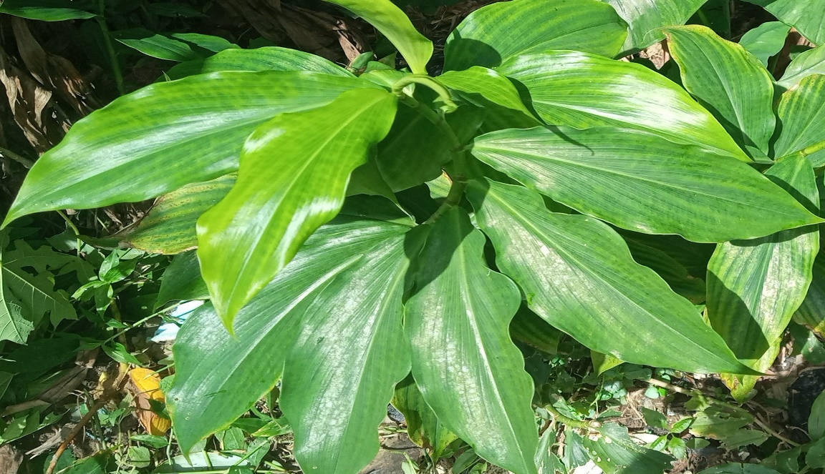Plate 1: Costus afer Plant
Therefore, this study provides information on regression of TPH percentage removed with different contamination levels (low, medium and high) and different ages of costus afer plant. The absorptive mechanism of costus afer brings about restoration of petroleum hydrocarbon–contaminated sites, which adds to the list of what plant at different ages can do to get rid the environment of harmful organic compounds. The objective was to develop mutltivariate regression model for prediction of phytoremediation of crude oil polluted sandy loam soil with different ages of costus afer plant.

2. MATERIALS AND METHODS
2.1 The Study Area
The study was carried out at the research farm of the Rivers State Institute of Agricultural Research and Training (RIAT), which is situated in the Rivers State University, Port-Harcourt, with a predominance of oxisols according to the United States Department of Agriculture (USDA) soil taxonomic order and its soil texture is Sandy loam (Ayotamuno & Kogbara, 2007). Rivers state is characterized by tropical rainforest vegetation with rainfall ranging from 2000 – 2484mm per annum of which 70% occurs between the months of May and August with an average temperature of 27ºC (Ayotamuno et al., 2006; Fubara-Manuel et al., 2021).

2.2 Experimental Design and Setup
The experimental design used in this study was the group-balanced block design (GBBD). The procedure used by Ayotamuno et al. (2006) was adopted to arrive at the three working concentrations (low, medium, and high) of crude oil in the soil used in this study. To do this, about 48kg of sandy-loam soil was placed in four separate reactors. Then, three of the reactors were contaminated with 0.5, 1.0, and 1,5 litres of Bonny-Light crude oil, in turn, to achieve conditions of low-, medium-, and high-level contaminations, respectively. The medium-level contamination was duplicated to create a fourth reactor, which was used as the control. The two main variables were crude oil concentration (C) as factor A having 3 levels including low concentration (C₁) medium concentration (C₂), and high concentration (C₃); and age of Costus afer plant (T) as factor B with 6 levels including 7 days old (T₁), 14 days old (T₂), 21 days old (T₃), 28 days old (T₄), 35 days old (T₅), and 42 days old (T₆).

Wide-mouth black plastic basins (reactors) with 0.5m top diameter and 0.3m depth were employed to accommodate the mixture of soil and crude oil used as planting medium (Plate 2.1). The reactors were kept in an open barn to shield them from direct rainfall for moisture control. Before transplanting the nursed Costus afer plants, the contaminated soil in the reactors was allowed for a three-day incubation period. Each reactor was irrigated with 0.5L of water at three days intervals until the cessation of remediation. This water application rate was in line with the application rates used by Ayotamuno et al. (2010), which showed its effectiveness in the remediation of crude oil-polluted soils. Costus afer plants were nursed for 7, 14, 21, 28, 35, and 42 days. Thereafter, they were transplanted to the planting medium.
2.4 Sampling and Analytical Methods
Soil samples were collected from uncontaminated soil before mixing with crude and soil-crude oil mixtures. The samples were collected from different spots and bulked together for analysis. About 5g of soil sample was used for the analysis. Sample was dried chemically by use of 5g anhydrous sodium sulphate. Extraction was carried out separately by using 10ml Dichloromethane and O-Terphenyl used as surrogate. Combination of extraction solvent and sample was agitated by shaking for 45mins with vortex mixer and glass wool. Glass funnel was used to decant extract. The extract was allowed to concentrate to I ml before injecting to GC for TPH analysis. Nitrification of TPH compounds was by the external standard method. Then, TPH removal (%) was deduced using equation 1.
$TPH removal (\%)=\frac{IC-FC}{IC}×100$ (1)
Where IC is the initial concentration and FC is the final concentration of TPH.

Modelling Procedure
Theoretical Development
Regression can be expressed as the functional relationship between independent and dependent variables. The independent variable (X) is the predictor or regressor while the dependent variable (Y) is the predicted (Chikwue et al., 2020). When there are more than two variables and one of them is assumed to be dependent upon the others, the functional relationship between the variables is known as multiple regressions. The multiple linear regression analysis of the function with two independent variables namely the remediation time (X₁) and crude oil volume (X₂) of the petroleum hydrocarbon while the percentage removal of TPH was the dependent variables as shown in equation 2. The linear regression model was strictly based on changes in the remediation period and crude oil volume. As shown in equation 2, the linear regression of Y on X₁ and X₂ because the dependent variable Y varies partially due to variation in X₁ and X₂ respectively. The coefficient β_{o}, β_{1,} β₂ represents partial regression coefficient on Y on X₁ with X₂ held constant and Y on X₂ with X₁ held constant respectively.
Formulation of predictive multiple linear regression model for phytoremediation of petroleum hydrocarbon contaminated soil can be expressed using equation (2)
$Y = βo + β_{1}X_{1} + β_{2}X_{2}+ e$ (2)
Where TPH is the dependent variables, equation 2 can be rewritten as;
$TPH (\%) = βo + β_{1}X_{1}+ β_{2}X_{2} + e$ (3)
In considering percentage reduction of TPH equation 3 can be expressed as
$TPH \left(\%\right)= f(R_{t}, V)$ (4)
Y = the percentage of TPH Removal (%)
X₁ = Remediation Periods (Days)
X₂ = Crude oil volume
e = error
β_{o}, β_{1,} β₂, represents partial regression coefficients of the variables
The error can be evaluated by rearranging equation (3) as follows.
$e = y-\left(βo + β_{1}X_{1}+ β_{2}X_{2}\right)$ (5)
The sum of square is expressed as
$Sr= ∑e^{2}=∑( y-βo-β_{1}X_{1}-β_{2}X_{2})^{2}$ (6)
Partial differential of equation (6) with respect to partial regression coefficients, are as follows.
Differentiating partially with respect to $βo$
$\frac{∂S_{r}}{∂a_{0}}$ = $-2∑( y-βo-β_{1}X_{1}-β_{2}X_{2})$ (7)
Differentiating partially with respect to $β_{1}$
$\frac{∂S_{r}}{∂a_{1}}$ = $-2∑( y-βo-β_{1}X_{1}-β_{2}X_{2})X_{1}$ (8)
Differentiating partially with respect to $β_{2}$
$\frac{∂S_{r}}{∂a_{2}}$ = $-2∑( y-βo-β_{1}X_{1}-β_{2}X_{2})X_{2}$ (9)
Reduce to zero to minimize error.
$\frac{∂S_{r}}{∂a_{0}}$ = $0$ (10)
$\frac{∂S_{r}}{∂a_{1}}$ =$0$ (11)
$\frac{∂S_{r}}{∂a_{2}}$ = $0$ (12)
Rearranging of equation 7, 8 and 9 by substituting equation 10, 11 and 12 respectively
0 = $-2∑( y-βo-β_{1}X_{1}-β_{2}X_{2})$ (13)
$0$= $-2∑( y-βo-β_{1}X_{1}-β_{2}X_{2})X_{1}$ (14)
$0$= $-2∑( y-βo-β_{1}X_{1}-β_{2}X_{2})X_{2}$ (15)
Arrangement and simplification of equation (13 to 15)
$∑βo+ β_{1} ∑X_{1}+ β_{2 }∑X_{2}= ∑ y$ (16)
$∑βo$ is the number samples which is represented by n
$∑βo=n$, then the equation (15) becomes
$n+β_{1}∑X_{1}+ β_{2} ∑X_{2}= ∑ y$ (17)
From equation (13), we have
$βo∑X_{1}+β_{1}∑X_{1}^{2}+β_{2}∑X_{1}X_{2 }= ∑X_{1}y$ (18)
From equation (14), we have
$βo∑X_{2}+β_{1}∑X_{1}X_{2 }+β_{2}∑X_{2}^{2}+= ∑X_{2}y$ (19)
Using matrix form to rearrange equation (17 to 19), can be expressed as follows
{A} {X} = {B}
{A} is the partial regression coefficient matrix
{X} is the independent variables
{B} is the dependent variable
n ∑X₁ ∑X₂ $β$₀ ∑ y
∑X₁ ∑X₁² ∑X₁ X₂ $β$₁ ∑ X₁ y (20)
∑X₂ ∑X₁ X₂ ∑X₂² $β$₂ ∑X₂y
The summation required for equation (20) are computed in Table 3.1 to 3.6 and substituting the values using cramer’s rule with the aid of MDETERM in Microsoft excel toolbox.
Evaluation of Model Quality
Remediation periods and crude oil volume were the varying factors, the phytoremediation potential of Costus afer plant was determined experimentally and fitted into the multiple regression model. The models were determined by statistical method using Minitab 19 software (Microsoft Inc, USA) at experimental periods of remediation (0, 30, 60 and 90 days), and crude oil volume ( 0.5, 1.0 and 1.5 litres). The validity (goodness of fit) of the phytoremediation potential models were tested by comparison with the experimental data and the prediction ability was determined by the following indicators: coefficient of determination (r²), adjusted coefficient of determination, residual prediction deviation (RPD) and root mean square error (RMSE). The best model describing the phytoremediation potential of petroleum hydrocarbon contaminated soil treated with different ages of Costus afer at various periods of remediation and levels of contamination was opted for based on the greater value of r² and lesser value of RMSE (Munawar & Kusumiyati, 2019; Hayati et al., 2020). Model prediction ability was categorized based on the following criteria: excellent if RPD $>$2.0, almost good if RPD $≤1.4 or <2.0$ and unreliable if RPD$<1.4$ (Chang et al., 2001) $RMSE=\sqrt{\frac{\sum_{i-1}^{i-N}{{\left(\hat{γ}-Y_{i}\right)}^{2}}}{N}}$
Where:
$\hat{γ}$ = Predicted reference value
$Y_{i}$ = Measured refence value
N = Number of samples in the set
$$r_{Adj}^{2}=1-\frac{{{SS}_{E}}/{\left(n-p\right)}}{{{SS}_{T}}/{\left(n-1\right)}}$$
Where:
n = number of samples
p = predicted value
$r^{2}=\frac{{SS}_{model}}{{SS}_{T}}$
Where:
SS_{model} = Model sum of squares,
SS_{T} = Total sum of squares
RPD = $\frac{SD}{RMSE}$
Where SD = Standard deviation of the measured reference values
RESULTS AND DISCUSSION
3.1 Effect of Costus afer Plant on Percentage TPH Removal
Figure 1 shows that TPH concentration reduction generally declines with increasing plant age (T1 to T6) across all contamination levels (C1–C3), with the highest removal at early ages and the lowest in the control (C4). Specifically, younger plants achieve greater hydrocarbon reduction, while older plants show a gradual decrease in effectiveness. This trend likely reflects more vigorous root growth and metabolic activity in younger Costus afer plants, which can enhance rhizodegradation and stimulate microbial communities that degrade total petroleum hydrocarbons (TPH) in the rhizosphere. Such patterns mirror findings in related studies, where plant species and age influence TPH dissipation through root exudates and associated microbial stimulation that catalyze hydrocarbon breakdown. Okparanma et al. (2022) reported highest TPH reduction with younger Costus afer plants at early ages (7 days) relative to older ages after 90 days of treatment. Likewise, recent literature highlights that effective phytoremediation depends on plant vigor, root biomass, and rhizosphere interactions for hydrocarbon loss from soils (Cheng et al., 2025). The low TPH removal in the control (C4) also aligns with other studies showing limited natural attenuation without active vegetative remediation, reinforcing that plant-driven mechanisms accelerate TPH dissipation relative to unplanted soils (Fang et al., 2025). The sustained high removal rates for C1 -C3 shown in Figure 3 align with the findings of (Okparanma et al., 2022), showing the robust plant-microbe interactions enhanced rhizosphere activity, which can maintain hydrocarbon degradation across extended growth periods.

Fig 1: TPH Removal Percentage in Crude oil Contaminated Soil Treated with Costus afer at Different ages of Plant over Time: (a) 4 Weeks after Planting; (b) 8 Weeks after Planting; (c) 12 Weeks After planting. Treatments (T1 =7 Days Old Plant; T2 =14 Days Old Plant; T3 =21 days Old Plant; T4 = 28 days Old Plant; T5: 35 Days Old Plant; T6 = 42 Days Old Plant; C1: Low Contamination Level; C2: Medium Contamination Level; C3: High Contamination Level; C4: Medium contamination Without Treatment; Error bar is standard error)

The model prediction in Table 1 described the TPH reduction (Y) as a function of remediation time (R_{t}) and crude oil volume (V) for six plant ages (T1 – T6). The positive coefficients of R_{t (}0.27 – 0.29) indicate that TPH removal increases with remediation time, confirming time-dependent degradation kinetics. Conversely, the negative coefficient of V (-0.54 to –1.70) showed that higher crude oil loading reduces removal efficiency, reflecting contaminant-stress inhibition. The progressive decrease in T1 to T6 suggests slightly lower baseline remediation with increasing plant age. Variation in V coefficients also implies age-dependent tolerance to hydrocarbon loads.
Overall, the models indicate statistically consistent trends: time enhances phytoremediation performance, whereas contaminant volume exerts a suppressive effect, with plant age modulating both influences.
Table 1: Model for Percentage TPH removed from Soil Treated with Costus Afer Plant
Treatment | Multivariate Regression Model
T1 | Y = 74.0222 + 0.2857R_{t} – 1.7033V
T2 | Y = 72.7744 + 0.2738R_{t} – 0.7533V
T3 | Y = 70.6856 + 0.2677R_{t} – 0.95V
T4 | Y = 70.6856 + 0.2684R_{t} – 0.5367V
T5 | Y = 69.5989 + 0.274R_{t} – 0.77V
T6 | Y = 68.3544 + 0.2798R_{t} – 1.1933V
The result of percentage TPH removed in crude oil-contaminated soil at a constant age of Costus afer plant at different crude oil volume are as presented in Table 2 to 7 generated from equations in Table 1.
Table 2: Predicted and Percentage TPH removed in Crude Oil-Contaminated Soil with 7 days Old Costus afer Plant
Rt | V | Measured (%) | Predicted (%) | Error | Error²
30 | 0.5 | 79.81 | 81.74 | -1.93 | 3.7249
60 | 0.5 | 93.63 | 90.31 | 3.32 | 11.0224
90 | 0.5 | 97.42 | 98.88 | -1.46 | 2.1316
30 | 1 | 79.69 | 80.89 | -1.2 | 1.44
60 | 1 | 93.92 | 89.46 | 4.46 | 19.8916
90 | 1 | 94.91 | 98.03 | -3.12 | 9.7344
30 | 1.5 | 76.53 | 80.04 | -3.51 | 12.3201
60 | 1.5 | 94.1 | 88.61 | 5.49 | 30.1401
90 | 1.5 | 95.12 | 97.18 | -2.06 | 4.2436
 |  |  |  |  | ∑94.6487

Table 3: Predicted and Percentage TPH removed in Crude Oil-Contaminated Soil with 14 days Old Costus afer Plant
Rt | V | Measured (%) | Predicted (%) | error | error²
30 | 0.5 | 79.54 | 80.6118 | -1.072 | 1.1486
60 | 0.5 | 91.3 | 88.8258 | 2.47 | 6.1219
90 | 0.5 | 95.34 | 97.0398 | -1.700 | 2.8892
30 | 1 | 79.27 | 80.2351 | -0.965 | 0.9314
60 | 1 | 92.73 | 88.4491 | 4.281 | 18.3261
90 | 1 | 93.96 | 96.6631 | -2.703 | 7.3067
30 | 1.5 | 75.84 | 79.8585 | -4.018 | 16.1479
60 | 1.5 | 93.44 | 88.0725 | 5.368 | 28.8106
90 | 1.5 | 94.64 | 96.2865 | -1.646 | 2.7108
 |  |  |  |  | ∑84.3933

Table 4: Predicted and Percentage TPH removed in Crude Oil-Contaminated soil with 21 days Old Costus afer Plant
Rt | V | Measured (%) | Predicted (%) | Error | Error²
30 | 0.5 | 78.69 | 78.2416 | 0.4484 | 0.2011
60 | 0.5 | 88.68 | 86.2726 | 2.4074 | 5.7956
90 | 0.5 | 93.4 | 94.3036 | -0.9036 | 0.8165
30 | 1 | 79.13 | 77.7666 | 1.3634 | 1.8589
60 | 1 | 92.07 | 85.7976 | 6.2724 | 39.3430
90 | 1 | 93.7 | 93.8286 | -0.1286 | 0.0165
30 | 1.5 | 75.69 | 77.2916 | -1.6016 | 2.5651
60 | 1.5 | 93.33 | 85.3226 | 8.0074 | 64.1185
90 | 1.5 | 94.6 | 93.3536 | 1.2464 | 1.5535
 |  |  |  |  | ∑116.2686

Table 5: Predicted and Percentage TPH removed in Crude Oil-Contaminated soil with 28 days Old Costus afer Plant
Rt | V | Measured (%) | Predicted (%) | Error | Error²
30 | 0.5 | 78.62 | 78.4696 | 0.1504 | 0.0227
60 | 0.5 | 88.26 | 86.5216 | 1.7384 | 3.0220
90 | 0.5 | 93.16 | 94.5736 | -1.4136 | 1.9983
30 | 1 | 79.13 | 78.2016 | 0.9284 | 0.8619
60 | 1 | 91.5 | 86.2536 | 5.2464 | 27.5247
90 | 1 | 93.66 | 94.3056 | -0.6456 | 0.4168
30 | 1.5 | 74.66 | 77.9336 | -3.2736 | 10.7165
60 | 1.5 | 93.08 | 85.9856 | 7.0944 | 50.3305
90 | 1.5 | 93.91 | 94.0376 | -0.1276 | 0.0163
 |  |  |  |  | ∑94.9096

Table 6: Predicted and Percentage TPH removed in Crude Oil-Contaminated soil with 35 days Old Costus afer Plant
Rt | V | Measured (%) | Predicted (%) | Error | Error²
30 | 0.5 | 77.99 | 77.4339 | 0.5561 | 0.3092
60 | 0.5 | 86.87 | 85.6539 | 1.2161 | 1.4789
90 | 0.5 | 92.84 | 93.8739 | -1.0339 | 1.0689
30 | 1 | 78.95 | 77.0489 | 1.9011 | 3.6142
60 | 1 | 91.27 | 85.2689 | 6.0011 | 36.0132
90 | 1 | 93.35 | 93.4889 | -0.1389 | 0.0193
30 | 1.5 | 73.57 | 76.6639 | -3.0939 | 9.5722
60 | 1.5 | 92.8 | 84.8839 | 7.9161 | 62.6646
90 | 1.5 | 93.64 | 93.1039 | 0.5361 | 0.2874
 |  |  |  |  | ∑115.028

Table 7: Predicted and Percentage TPH removed in Crude Oil-Contaminated soil with 42 days Old Costus afer Plant
Rt | V | Measured (%) | Predicted (%) | Error | Error²
30 | 0.5 | 77.2 | 76.15175 | 1.0483 | 1.0988
60 | 0.5 | 85.94 | 84.54575 | 1.3943 | 1.9439
90 | 0.5 | 92.78 | 92.93975 | -0.1598 | 0.0255
30 | 1 | 78.22 | 75.5551 | 2.6649 | 7.1017
60 | 1 | 90.71 | 83.9491 | 6.7609 | 45.7098
90 | 1 | 92.66 | 92.3431 | 0.3169 | 0.1004
30 | 1.5 | 73.22 | 74.95845 | -1.7385 | 3.0222
60 | 1.5 | 92.72 | 83.35245 | 9.3676 | 87.751
90 | 1.5 | 93.56 | 91.74645 | 1.8136 | 3.2890
 |  |  |  |  | ∑150.0423

Model Prediction Ability
The multivariate linear regression model was generated from phytoremediation experiment. The model validation was done by using constant plant age at different remediation period and levels of contamination. The regression analysis as computed using MINITAB computer software to establish the relationships. The values obtained showed a strong correlation between phytoremediation with crude oil volumes and remediation periods. The graph of phytoremediation experimental values vs predicted values was to determine the coefficient of determination (r²), root square mean error (RMSE) and residual prediction to deviation (RPD) values. The RMSE as presented in Figure 2 ranged from 3.06 to 5.60, R² (80.8 to 82.8%), standard error (3.46 to 3.76) with an RPD value ranging from 2.05 to 8.21. The model prediction ability can be described as excellent (Chang et al., 2001).
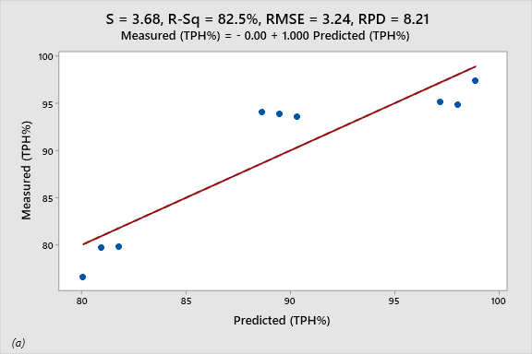
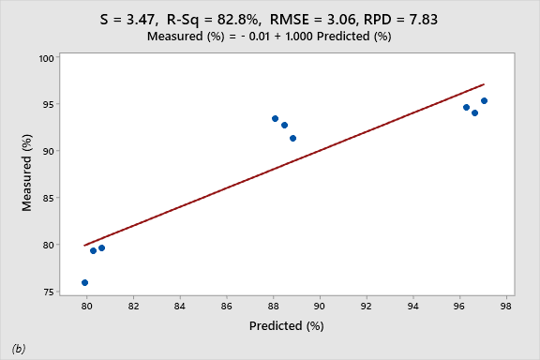
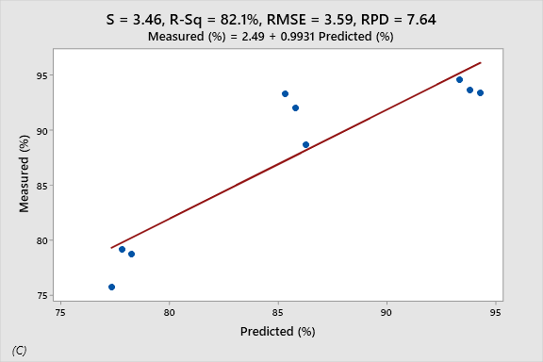
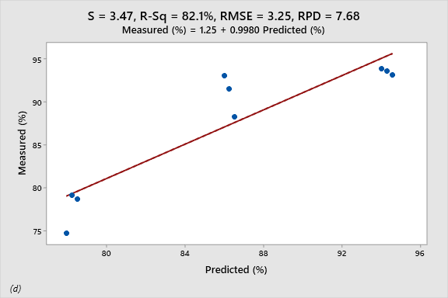

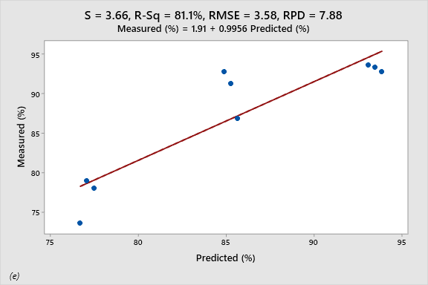
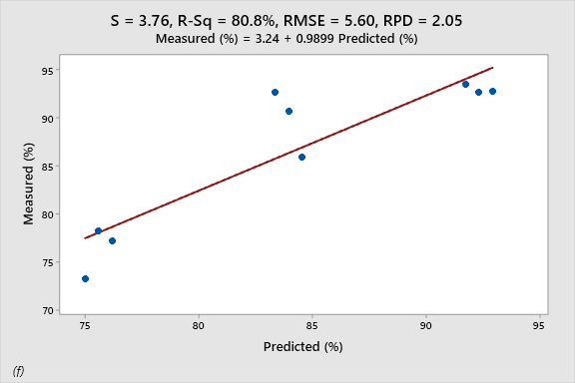
Fig 2. Measured and predicted percentage TPH removed from Different crude oil contamination levels (Low, medium, and high) treated with (a) 7 days old plant;(b) 14 days old plant;(c) 21 days old plant; (d) 28 days old plant; (e) 35 days old plant; (f) 42 days old plant (S: Standard error; R²: Coefficient of determination; RMSE: Root mean square error; RPD: Residual prediction deviation).
Conclusion
In this study, the multivariate linear regression would be suitable to obtain an effective TPH reduction in contaminated soil at different crude oil volume (0.5, 1.0 and 1.5 Liters) and remediation period (30, 60, and 90 days). It was observed that the coefficient of determination (R²) was high and residual prediction deviation (RPD), standard error (S), and root mean square error (RMSE) were within the acceptable range. Hence, the mix model can be applied to predict phytoremediation of TPH in crude oil-contaminated sandy loam soil using costus afer plant.

COMPETING INTERESTS DISCLAIMER:
Authors have declared that they have no known competing financial interests OR non-financial interests OR personal relationships that could have appeared to influence the work reported in this paper.

Referee(s)
Cheng, P-C., Lin, M-s., Huamg, C-Y., Cheng, S-F., & Lin, Y-C. Adaptation and carbon reduction for petroleum contaminated soil remediation in response to climate change-a case study of phytoremediation combined with biochar. Journal of Environmental Management. 2025. 393: 126956. https://doi.org/10.1016/j.jenvman.2025.126956.
Fang, X., Zheng, P., Wang, H., Wang, K., Shi, C., & Shi, F. Phytoremediation of oil-contaminated soil by Tagetes erecta L. combined with biochar and microbial agent. Plant, 2025, 14, 243: https://doi.org/10.3390/plants14020243.
Muthusaravanan, N., Sivarajasekar, J. S., Vivek, T., Paramasivan, M., Naushad, J., Prakashmaran, V., Gayathri, Omar, K., & Al‑Duaij. Phytoremediation of heavy metals: Mechanisms,methods and enhancements. 2018. Available from:https://www.researchgate.net/publication/325661073
Thijs, S.; Sillen, W.; Weyens, N.; & Vangronsveld, J. Phytoremediation: state-of-the-art and a key role for the plant microbiome in future trends and research prospects. International journal of phytoremediation 2017, 19, 23-38
Muttaleb, W. H.; Ali, Z. H. Bioremediation and eco-friendly method for administration of environmental contaminants. International Journal of Applied Sciences and Technology, 2022, 4 (6)22-32.
Okparanma, R. N.; Emeka, C.; Igoni, A. H. Phytoremediation of Petroleum Hydrocarbon- Contaminated Soil using Costus afer Plant. Journal of Newviews in Engineering and Technology. 2022, 4(3), 27 – 38.
Rad, K.V.; Motesharezadeh, B.; Alikhani, H.A.; Dadrasnia, A. The potential use of Cordia myxa in the remediation of crude oil pollution, International Journal of Phytoremediation, 2020, 5(23), 445-453.
Njoku,K. L.; Oboh,B.O.; Akinola, M.O.; Ajasa, A.O. Comparative Effects of Abelmoschus esculentus (L) Moench (Okro) and Corchorus olitorius L (Jew Mallow) on Soil Contaminated with Mixture of Petroleum Products. Research Journal of Environmental and Earth Sciences 2012, 4(4): 413.
Kogbara, R. B.; Badom, B. K.; Ayotamuno, M. J. Tolerance and phytoremediation potential of four tropical grass species to land applied drill cuttings, International Journal of Phytoremediation 2018, 20 (14), 1446-1455.
Ayotamuno, M. J., Kogbara, R. B., & Taleat, M. O.(2006) Bioremediation of a petroleum hydrocarbon polluted agricultural soil at different levels of water application, Nigeria, Journal of Food, Agriculture & Environment 2006, 4 (3 &4): 214 – 217.
Emeka, C., Okparanma, R. N., & Achinike, O.-W. (2023). Bioremediation of Total Polycyclic Aromatic Hydrocarbon in Crude Oil-Contaminated Soil using Costus afer Plant. Research Journal of Ecology and Environmental Sciences, 3(1), 26–36.

