Original Research Article

Probabilistic Break-even analysis of field crops in Madhya Pradesh

ABSTRACT
A study was conducted to assess farmer’s profitability for field crops in Madhya Pradesh. For estimating the break-even yield cross-sectional data for the year 2019-20 on plot and state level of cost of cultivation for various crops was obtained from Directorate of Economics and Statistics, Government of India official website. Break-even yield was calculated and probability of not achieving break-even yield by farmer in the state was obtained. The results revealed that for Cotton crop probability of not breaking even was 1 while for Pigeon pea it was 0.66. The study suggested annual policy review after assessment of probabilities to address the needs of farming community.

Key words: break-even yield, probability, profitability
1. INTRODUCTION
After the green revolution there has been an increase in the availability of rice and wheat per person whereas a decrease in the availability of pulses and millets per person have been seen. The major reason for this unavailability was due to the focus given to wheat and rice production alone during the Green Revolution. Per capita availability of pulses had decreased from 22.1kg/year in 1951 to 19.9 kg/year in 2017. (Eliazer Nelson et.al.,2019). But question loomed over the fate of profitability of agriculture in India. The income levels in non-agricultural occupations was atleast three times that of average income of a cultivator in India since 1983-84. The lagging income growth motivated Government of India to launch programme “Doubling Farmers Income in India” (Chand, Ramesh, 2017).
A summary measure of profitability of agriculture is how fast can farmer achieve break-even output and how many farmers can achieve such output levels. A break-even output is the output level which when produced will lead to zero profit and zero loss situation (Rajput & Vani, 2021). It shows the ability of producer to recover fixed cost after tidying over variable costs. Rajput et al., (2023), while analysing major field crops of Madhya Pradesh, reported that break-even output is highly sensitive to output prices and that many farmers fail to achieve break-even even under small adverse price or cost shocks, revealing risks not captured by static point estimates. Recent policy and market-analyses highlight that price volatility and gaps in organized storage/market access substantially increase revenue risk for growers, implying that break-even calculations must explicitly incorporate price and market-risk dimensions for realistic profitability assessment (Price risk management for agricultural commodities, 2023). National-level assessments also document rising spatial and temporal variability in yields and production outcomes, reinforcing the need to move beyond static point estimates when evaluating farm incomes and viability (Ministry of Agriculture and Farmers Welfare, 2024).
The recent estimates of break-even yield for Madhya Pradesh by Rajput & Vani, (2021), Kolar et. al (2021), Sahu et al., (2021) and Kolar et al. (2020) were point estimates which neither inform about how many or what proportion of farmers achieve break-even output nor do these publications provide estimates on how fast farmer’s achieve break-even output. Giaoutzi (2012) suggested using scenario building to overcome such problems. Working in this direction Rajput (2020) developed scenarios and also assessed sensitivity of the break-even output to changes in price, average variable cost and fixed cost for period 2000-01 to 2016-17. This study was very elaborate and as such conducting scenario building exercise is cumbersome. Thus, search for alternate methods must begin. Also, recent estimates for 2019-20 and onwards for break-even yield and output are missing. Field-level evaluations of recent frontline demonstrations and improved practices find substantial differences between demonstration and farmer yields, and show that break-even yields for crops such as soybean are sensitive to the adoption of improved technologies, a point that strengthens the case for probabilistic, technology-aware break-even assessment (Jaybhay et al., 2025).
Thus, with this background, this study was conducted to find break-even yield for major field crops of Madhya Pradesh and to find suitable methodology to assess the probability of achieving break-even yield in the state.
2. METHODOLOGY
The Madhya Pradesh is the second largest state in the country in area with 9.36 percent of the total area of the country. Out of the total geographical area 307.56 lakh hectares of the state, only about 151.91 lakh hectares are arable. Economy of the Madhya Pradesh is primarily agrarian in nature with nearly 62 percent of labor force employed in agriculture. At current prices, the Gross State Domestic Product (GSDP) of Madhya Pradesh for 2020-21 stood at Rs. 9.18 trillion. In rupee terms between 2015-16 and 2020-2 state’s GSDP grew at a CAGR of 11.14 percent and Net State Domestic Product (NSDP) grew at a CAGR of around 11.22 percent. The contribution of primary sector to the state’s Gross Value Added (GVA) increased from 33.85% in 2011-12 to 46.98 percent in 2020-21.
The cross-sectional data for the year 2019-20 on plot and state level of cost of cultivation for various crops was obtained from Directorate of Economics and Statistics, Government of India official website (https://eands.dacnet.nic.in/) (Government of India, n.d.). Summary statistics of yield of sample plots were obtained using Tukey’s five numbers which are the minimum, first quartile, median, third quartile and the maximum value of the distribution. The break-yield, minimum yield required on a unit area under production for achieving zero-profit zero-loss situation, was calculated using following formula.
where, F was total fixed cost (Rs. per hectare), Y was the average yield (Quintal per hectare) obtained from sample, TR was total revenue from both main and by-product sale (Rs. per hectare) and TVC was total variable cost (Rs. per hectare). This formula can be derived by dividing both sides of break-even production formula by area under the crop production and multiplying numerator and denominator of right-hand side by actual yield of crop.
To find out the extent of farmers who could break-even two different approaches were used. Both the approaches involved estimation of area under the curve. In the first approach which is developed on lines of Jaedicke & Robichek (1964), if the distribution of yield follows normal distribution, then area under curve below break-even yield provides the probability that farmer on average would not be able to break-even. The one minus this probability would be probability of achieving at-least break-even yield. To find out whether distribution of the yield of different crops was normal distribution, Shapiro-Wilk test was used. This test has null hypothesis of population parameter follows normal distribution versus alternate hypothesis of population parameter not following normal distribution. If for some crops, yield was not found to follow normal distribution then box-cox power transformation can be used to find the value of $λ$such that ${yield}^{λ}$follows normal distribution. But it is not guaranteed that when box-cox power transformations are applied to yield data, then transformed variable would follow normal distribution. Hence use of this method was limited to validation of second approach. Second approach was based on numerical integration techniques. While first approach was statistical in nature, the second approach was mathematical in nature. Thus, the second approach provides estimates of area under curve without assuming normality of data.
The R software for statistical computing (R Core Team, 2022) was used along with car package (Fox and Weisberg, 2019) for computing the box-cox transformation of variables. Shapiro-Wilk test for testing normality of yield of sample farmers was used in R software. Numerical integration techniques were used in R software with DescTools package (Andri Signorell et mult. al., 2022).
3. results and discussion
Table 1 provides summary statistics for yield of several crops in Madhya Pradesh for 2019-20. Among all the crops, yield of Maize had the highest inter-quartile range of 10.81 quintals per hectare followed by Paddy (10.4) and Wheat (10.19). But IQR to Median was the highest for Black gram of 79.62 percent followed by Cotton (44.81%) and Maize (38.61%). The higher IQR to Median ratio is indicative of wider spread of the density curve around the median. Figure 1 provides the boxplot of yield of various crops. The observation made about spread of the data can be visualized by the height of the box. Cotton, Lentil, and Mustard have no outliers while Pigeonpea and Black gram each have one outlier in the data. All other yield data had several outliers. The presence of outliers and wider spread weakens the probability that data follows normal distribution.
Table 2 provided results for normality (Shapiro-Wilk test) before and after Box-Cox transformation of yield data of crops. It can be seen that before transformation except for pigeon pea and lentil, all other crops do not follow normal distribution. Only three crops namely Pigeon pea, Lentil and Mustard yields follow normality even after transformation. Thus, using normal distribution parameters only probabilities associated with some crops can be found. This was situation was already discussed in methodology section and therefore second approach has to be used.
Table 3 provides result of break-even yield. It can be seen from the table that for soybean and black gram break-even yields were negative which was result of total variable cost being greater than total revenue. These meant that farmers in the state suffered loss for soybean and black gram and were operating below shut down point. Further break-even yields for Cotton and Pigeon pea were higher than the average yield levels observed for the sample. Greater the observed sample yields over break-even yields, greater is margin of safety.
Table 4 provides the probability of not achieving break-even yields from two different approaches. The results were available from both approaches for crops where yields followed normal distribution. Accordingly, for Pigeon pea, Lentil and Mustard, the probabilities estimate from both the approaches were very close. The difference between two estimates can be grasped by observing Figure 2. From this figure it can be observed that for Lentil where difference was higher, the shape of density curve was not exactly normal and hence estimates from approach 1 were higher than from approach 2. Thus, second method got validated and now the estimates of remaining crop from second approach are also valid. Overall, probability of not achieving break-even yields was the highest for Cotton at 1 followed by for Pigeon pea at 0.6651 and Maize at 0.3996.
Table 1. Tukey’s five number summary of yield of various crops in Madhya Pradesh Unit: Qtl/ha
Crops | Minimum | 1st Q | Median | 3rd Q | Maximum | Inter-Quartile Range (IQR) | IQR to Median (%)
Pigeon pea | 5 | 7.07 | 8 | 9.19 | 12.5 | 2.12 | 26.5
Cotton | 8.02 | 10.58 | 15.6 | 17.57 | 19.73 | 6.99 | 44.81
Gram | 6.25 | 13 | 14.34 | 15.83 | 25 | 2.83 | 19.74
Maize | 14.74 | 21.82 | 28 | 32.63 | 70 | 10.81 | 38.61
Lentil | 7.5 | 9.35 | 11 | 12 | 13.55 | 2.65 | 24.09
Paddy | 10 | 27.24 | 31.75 | 37.64 | 66.67 | 10.4 | 32.76
Mustard | 5 | 14.36 | 17.78 | 18.8 | 20.83 | 4.44 | 24.97
Soybean | 1.6 | 5.88 | 7.89 | 9.36 | 16.98 | 3.48 | 44.11
Black gram | 1.25 | 2.5 | 3.14 | 5 | 8.67 | 2.5 | 79.62
Wheat | 17.89 | 37.5 | 43 | 47.69 | 61.4 | 10.19 | 23.7
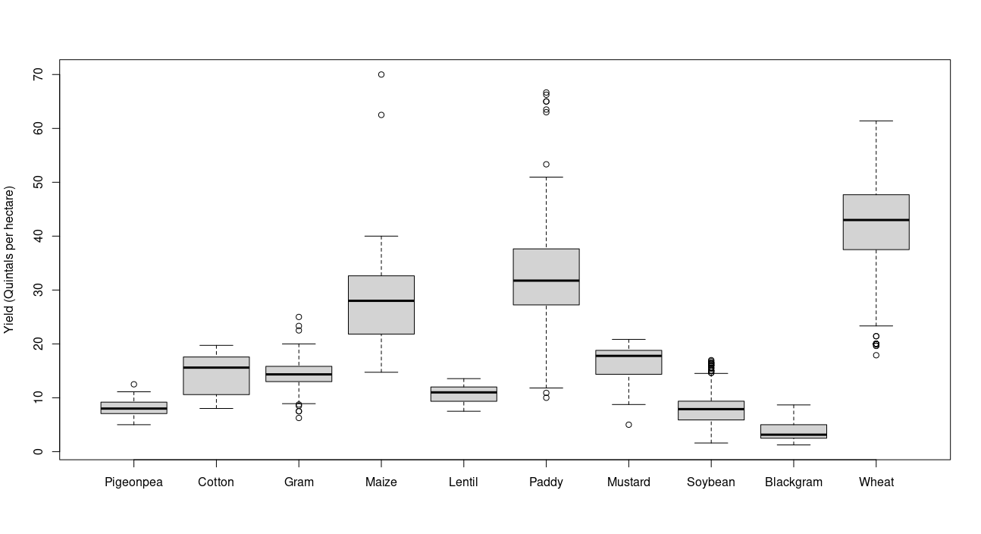
Figure 1. Boxplot of yield (Qtl./ha.) of various crops in Madhya Pradesh for 2019-20
Table 2. Shapiro-Wilk test results before and after BC transformation of various crops yield
Crop | Before Transformation |  | Box-Cox power | After Transformation
Crop | W | p-value | Box-Cox power | W | p-value
Pigeon pea | 0.98 | 0.87 | 0.41 | 0.99 | 0.98
Cotton | 0.91 | 0.01 | 1.23 | 0.91 | 0.01
Gram | 0.96 | 0 | 0.87 | 0.96 | 0
Maize | 0.86 | 0 | -0.08 | 0.94 | 0
Lentil | 0.96 | 0.29 | 1.17 | 0.96 | 0.3
Paddy | 0.94 | 0 | 0.6 | 0.95 | 0
Mustard | 0.85 | 0 | 3.22 | 0.96 | 0.14
Soybean | 0.96 | 0 | 0.38 | 0.99 | 0
Black gram | 0.89 | 0 | -0.15 | 0.97 | 0
Wheat | 0.97 | 0 | 1.73 | 0.99 | 0

Table 3. Information on cost, revenue and break-even yield of various crops in Madhya Pradesh (2019-20)
Crop | Fixed cost  (Rs. per hectare) | Operational Cost  (Rs. per hectare) | Derived Yield (Quintal per hectare) | Total revenue (Rs. per hectare) | Break-even yield (Quintal per hectare)
Pigeon pea | 12823 | 26921 | 8.52 | 39317 | 8.81
Cotton | 19781 | 57359 | 13.73 | 62888 | 49.13
Gram | 14750 | 29340 | 14.33 | 57244 | 7.58
Maize | 12766 | 38530 | 27.61 | 52283 | 25.63
Lentil | 12239 | 22730 | 10.58 | 45897 | 5.59
Paddy | 14563 | 38102 | 23.19 | 52645 | 20.52
Mustard | 19717 | 30030 | 17.84 | 66370 | 9.68
Soybean | 8800 | 27524 | 7.7 | 25972 | -43.63
Blackgram | 5150 | 20220 | 3.71 | 14817 | -3.54
Wheat | 18896 | 33457 | 39.71 | 81904 | 15.49

Table 4. Probability of not achieving break-even yield in Madhya Pradesh (2019-20)
Crop | Approach 1 | Approach 2
Pigeon pea | 0.6756 | 0.6651
Lentil | 0.0011 | 5.807387e-05
Mustard | 0.0308 | 0.0548
Cotton | - | 1.0000
Gram | - | 0.0160
Maize | - | 0.3996
Paddy | - | 0.1108
Wheat | - | 0.0004

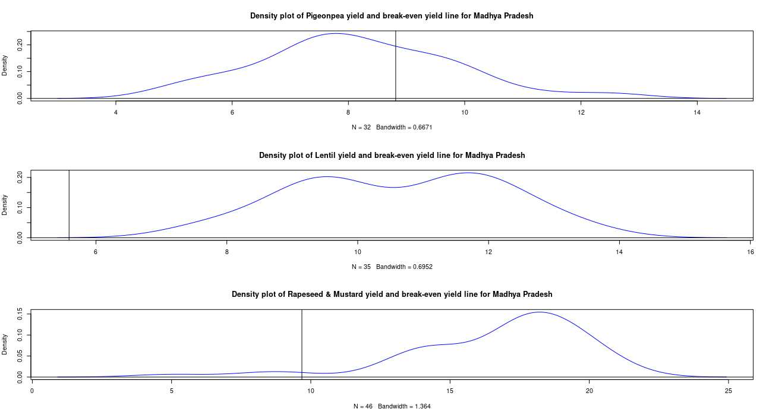
Figure 2. Density plot of Pigeon pea, Lentil and Rapeseed & Mustard yield in Madhya Pradesh (2019-20) with break-even yield.
4. Conclusion
The break-even analysis of field crop in Madhya Pradesh offered interesting insight into agriculture in Madhya Pradesh. The results of the study provided first of its kind estimates for probability of achieving break-eve output or yields. The policy makers must now use these estimates to redesign the schemes in Madhya Pradesh to better cater to needs of the farming community. Focus should be on legumes specially Pigeon pea, Soybean, Black gram and also on Maize where probability of not achieving break-even yield was very high. It is also needed that at policy levels such probabilities should be worked out regularly for annual assessments.

References

Andri Signorell et mult. al. (2022). DescTools: Tools for descriptive statistics. R package version 0.99.45.
Chand, Ramesh. (2017). DOUBLING FARMERS INCOME Rational, Strategy, Prospects and Action Plan (Policy Paper NITI Policy Paper No. 1/2017). National Institute for Transforming India, GOI, New Delhi. https://www.niti.gov.in/writereaddata/files/document_publication/DOUBLING%20FARMERS%20INCOME.pdf
Eliazer Nelson, A. R. L., Ravichandran, K., & Antony, U. (2019). The impact of the Green Revolution on indigenous crops of India. Journal of Ethnic Foods, 6(1), 1-10.
Fox, John, and Sanford Weisberg. (2019). “An R Companion to Applied Regression.” https://socialsciences.mcmaster.ca/jfox/Books/Companion/.
Government of India, Directorate of Economics and Statistics. (n.d.). Cost of cultivation/production & related data. Ministry of Agriculture & Farmers Welfare. Retrieved from https://eands.dacnet.nic.in/Cost_of_Cultivation.htm.
Giaoutzi, M., Stratigea, A., Van Leeuwen, E., & Nijkamp, P. (2012). Scenario analysis as a foresight tool in agriculture. International Journal of Foresight and Innovation Policy, 8(2-3), 105-128.
Jaedicke, R. K., & Robichek, A. A. (1964). Cost-Volume-Profit Analysis under Conditions of Uncertainty. The Accounting Review, 39(4), 917–926.
Jaybhay, S. A., Idhol, B. D., Waghmare, B. N., & Salunkhe, D. H. (2025). Impact of improved practices on soybean yield and profitability: Insights from frontline demonstrations. Journal of Farm Sciences, 38(2), 98–103.
Kolar, P., Awasthi, P. K., & Sahu, A. (2020). An economic analysis of cost, return and profitability of groundnut across leading states of India. International Research Journal of Agricultural Economics & Statistics, 11(2), 278-284.
Kolar, P., Awasthi, P. K., Vani, G., & Sahu, A. (2021). Dynamics of Cost, Returns and Profitability of Soybean across Leading States of India. Indian Journal of Economics and Development, 17, 282–288. https://doi.org/10.35716/IJED/20307
Ministry of Agriculture and Farmers Welfare. (2024). Agricultural sector assessments 2024 [Government report]. Government of India. (Report summary cited for national-level yield and variability trends)
Price risk management for agricultural commodities (Consultancy report submitted to National Commodity & Derivatives Exchange Limited). (2023). National Commodity & Derivatives Exchange Limited.
R Core Team. 2022. “R: A Language and Environment for Statistical Computing.” https://www.R-project.org/.
Rajput, Ankita. (2020). Break Even and Sensitivity Analysis of Cost of Cultivation for Major Crops of Madhya Pradesh [Jawaharlal Nehru Krishi Vishwa Vidyalay]. https://krishikosh.egranth.ac.in/handle/1/5810179117
Rajput, A., Vani, G. K., & Chaturvedi, P. (2023). Decomposition of changes in break-even output and scenario building for major crops of Madhya Pradesh. Indian Journal of Economics and Development, 19(1), 243–259. https://doi.org/10.35716/IJED/22238
Tripathi, A. K. (2017). Price and profitability analysis of major pulses in India. Asian Journal of Agriculture and Development, 14(1362-2017-3063), 83-102.
Sahu, Ankita, Nahatkar, Sunil, Vani, Gourav Kumar, & Kolar, Prasanna. (2021). Study on Profitability of Wheat in Major Wheat Producing States of India. Asian Archive, 39(7). https://asianarchive.co.in/index.php/AJAEES/article/view/10246

