Review Article
Navigating Socio-Technical Constraints in Chemistry Education: Pandemic Insights and Future Perspectives on IoT and Artificial Intelligence

Abstract
The global education sector endured a massive disruption in early 2020 because of the pandemic caused by the spread of the coronavirus, thus requiring an instant shift from conventional pedagogy to emergency remote teaching. This review is specifically concerned with the distinctions of chemistry education, a subject of study that is heavily based on empirical demonstration and hands-on learning. By examining the educational landscape in three countries - India, Spain and the Philippines, the text helps to highlight the impact of diverse socio-economic factors on the adoption of digital tools. The analysis of literature shows that the transition had a complex balancing act of synchronous (real-time) interactions versus asynchronous (self-paced) resources. One of the major barriers that was found in this shift was the "digital divide", which furthered the inequities around student access to reliable internet connectivity and devices. Furthermore, chemistry educators were faced with the unique challenge of duplicating the experience of the laboratory in the virtual world that is essential for the development of scientific aptitude. This shift also made assessment of students more complicated, and there was much concern about the integrity of academic work and the validity of testing online. Despite all these structural and technological barriers, the review paints a positive picture. It points out the efficacy of structured interventions, and specifically mentions the DLPCA (Discover, Learn, Practice, Collaborate, and Assess) model (presumably referring to a particular digitally-integrated cycle of learning). There is evidence to show that when blended learning strategies are implemented with pedagogical intent (as opposed to as a stopgap) student academic performance may be maintained and even improved. Eventually, this period of crisis proved that the academic community is mighty enough and that the path to the future of teaching science lies in hybrid structures that help to take advantage of the flexibility of digital means, without sacrificing scientific rigor. The future of chemistry education is in adopting a proactive approach to integrate hybrid pedagogy and AI-driven tools in order to develop digitally-skilled experimentalists.

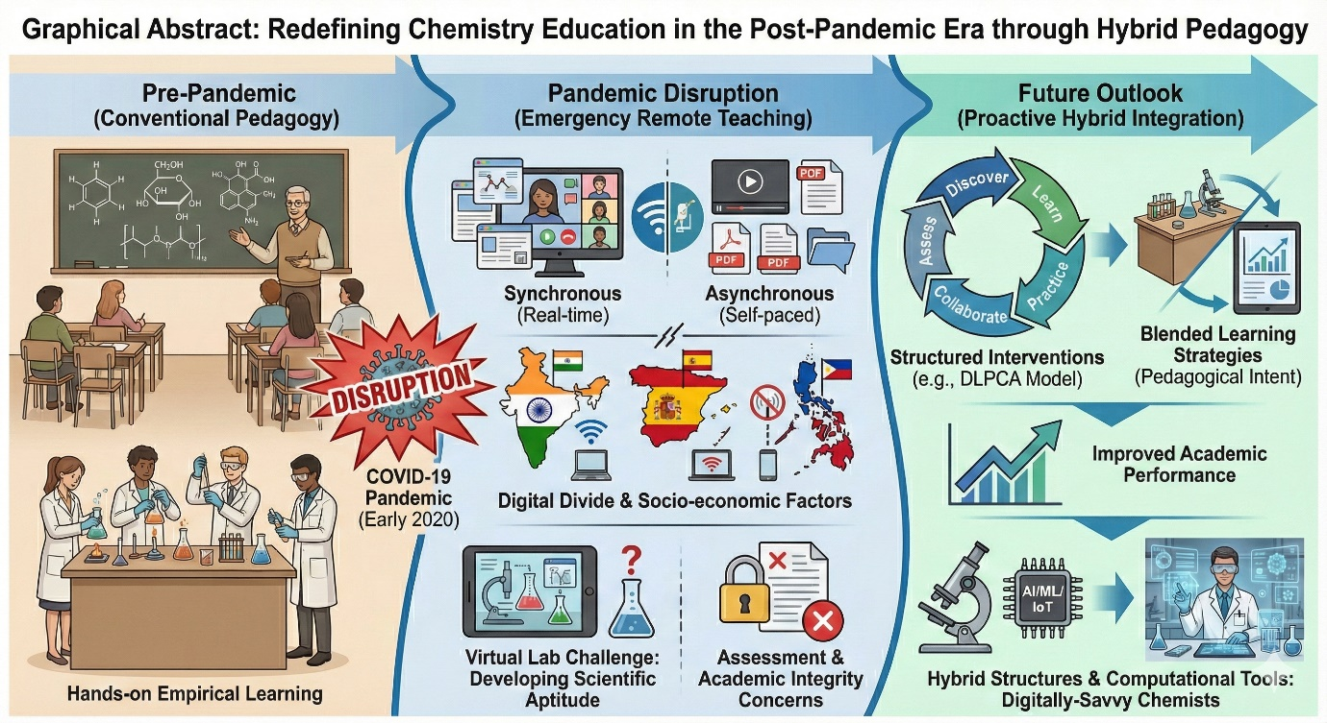

1. Introduction

Graphical Abstract: Redefining Chemistry Education in the Post-Pandemic Era through Hybrid Pedagogy

Keywords: Chemistry Education; Emergency Remote Teaching; Digital Divide; Blended Learning; DLPCA Model

Introduction
The beginning of the Covid 19 pandemic in early 2020 was a watershed in the history of higher education (Li and Ali, 2022, Purcell and Lumbreras, 2021). Almost overnight, the institutions around the world were forced to close their physical campuses to curb the spread of the virus, precipitating Emergency Remote Teaching (ERT), a mass migration from traditional face-to-face instruction unlike any in history. Unlike planned online distance education, which is designed using systematic pedagogical strategies and resource development, ERT was a crisis response a rapid, temporary shift of instructional delivery to an alternate mode due to crisis circumstances. This abrupt paradigm shift created special and difficult problems for the science disciplines, especially chemistry (Erduran and Akış, 2023). By its very nature chemistry education is fundamentally based on the tension between theoretical knowledge and practical experience. It is based intrinsically on laboratory experimentation to reinforce concepts and the visualization of complex molecular interactions which often are abstract and invisible to the naked eye. The shutting of laboratories threatened to cut off the essential connection between macroscopic observation of chemical phenomena and their sub microscopic explanations, and forced educators to rethink entirely the way to teach the essence of scientific inquiry through a computer or even mobile screen (Watts et al., 2022). As the academic community worked through this tumult a deep change took place in the role of the educator. The absence of physical presence and easy with which the students could disengage in a virtual environment required a shift to the "guide on the side." In this new role, educators became facilitators of learning and curators of digital content and environments where students could learn to navigate the information on their own. This shift of teaching and learning required faculty to quickly learn and become well versed in digital literacy, often learning to use Learning Management Systems (LMS), video conferencing software, and virtual simulation software in real-time. However, implementation of the following strategies was very far from uniformity. The response of the world to the pandemic has uncovered more profound socio-technical disparity, suggesting that while ensuring continuity of education was a universal aim, the avenues of achieving it would be highly dependent on the local infrastructure, economic resources, and cultural contexts (Wells et al., 2020). This review looks in depth at three different geographical and socio-economic contexts, India, Spain and the Philippines, to try to understand how chemistry education adapted to the crisis. In the event of India, the shift to online learning ended up being a harsh stress and anxiety test for the digital infrastructure of the nation. The sheer size of the student population combined with the huge economic disparities made for a complex environment for educators. The Indian government had pre-emptively set up digital initiatives like SWAYAM (Study Webs of Active-Learning for Young Aspiring Minds) and e-Pathshala which offered a repository of massive open online courses (MOOCs) and digital textbooks (Gupta et al., 2022). These centralised resources provided an important backbone for the delivery of content, and theoretically quality educational material was available to all. However, the practical application of remote teaching in India highlighted a very severe "digital divide." For a good number of the student body, especially in rural areas and semi-urban areas, access to high-speed internet and reliable electricity were luxuries and not guarantees. Consequently, the need to use high bandwidth synchronous platforms (such as Zoom or MS Teams) was not always feasible. To fill this void a tremendous flexibility of Indian chemistry educators to switch to low tech and accessible solutions was shown. The ubiquitous messaging platform WhatsApp was born as an unlikely but important educational tool, serving as a primary tool for doubt clearance, dissemination of notes and keeping the student-teacher connection intact (Singh et al., 2020). Such dependency on mobile-first, low-bandwidth tools can be taken to mean how the infrastructural constraints of developing countries led to the need to simplify pedagogy to make it inclusive. On the other hand, the experience of a public university in Spain is revealing of the challenges in the Global North, where the digital infrastructure was better developed, but pedagogical obstacles were still a challenge (Luque-Martínez et al., 2025). With existing institutional Virtual Campuses and platforms such as Blackboard Collaborate, Spanish educators were able to put into practice a mixed model of synchronous and asynchronous learning with relative technical ease. The stable internet and institutional subscriptions made it possible to provide real-time lectures, which were very similar to the traditional classroom experience. However, availability of technology did not address the "laboratory problem." Chemistry students in Spain experienced that while it was easy enough to understand theoretical content, the conversion of practical laboratory sessions into an online format using virtual simulations or videos was a lot more work to understand (Rodríguez-Rodríguez et al., 2020). Student feedback suggested a strong preference for face-to-face interaction for practical work to perform certain tasks indicating that even with the most sophisticated digital tools, practical skills and critical thinking involved at the laboratory bench are extremely hard to replicate virtually. This context exposes that although technology has been able to resolve the delivery of information, it has not been able to replicate the experiential learning characteristic particularly of chemistry. While, a private university in Philippines provides interesting case study of Pedagogical innovation rather than pure technological solutions (Joaquin et al., 2020). Facing a middle ground of the improved resources but still constricted bandwidths (which is common in the archipelagic nation) educators put in practice structured strategy called DLPCA (Discover, Learn, Practice, Collaborate and Assess) (Setiawan and Rosli, 2022). This approach was an effective way to operationalize the "flipped classroom" model for the remote era. Understanding that live streaming was not always feasible for students using small amounts of data, the university used pre-recorded videos hosted on YouTube. This way, students were able to "Discover" and "Learn" the theoretical concepts asynchronously, at their own pace and resolution settings which bypasses bandwidth bottlenecks (Baig and Yadegaridehkordi, 2023). Synchronous sessions were then set aside for high value interaction such as collaborative problem-solving and "Practice." The results of this strategic pivot were striking; the University said that it has seen improvement in student performance, and hate a significantly lower rate of students failing, as compared to previous face-to-face semesters. This raises the question that the same forced restructuring of the curriculum breaking content into digestible and self-paced modules may have inadvertently improved student engagement and retention and validates the efficacy of the flipped model in resource constrained environments. Finally, for all three contexts, there was a forced evolution of the assessment landscape. The movement to online platforms raised immediate concerns for the academic integrity because of the inability to have traditional invigilated examinations (Holden et al., 2021). Educators were forced to go beyond simple recall-based testing, which is prone to cheating in an unmonitored setting. Instead, the emphasis began to be placed on creative assignments, open book exams requiring amalgamation of concepts and questions and timed release requiring immediate application of knowledge. In conclusion, this synthesis of experiences in India, Spain and Philippines shows that there was no one "pandemic pedagogy". Whether government portals and WhatsApp in India, strong Virtual Campuses in Spain or the structured DLPCA model in the Philippines, the one common point was the pedagogical resiliency of the educators (Ramirez, 2020). They successfully negotiated the transition from "sage" to "guide" and the continuity of scientific learning could be maintained, despite the lack of physical classrooms and laboratories, the transmission of chemical knowledge could survive. Despite the reactive pivot of chemistry education to digital due to the pandemic, the future of chemistry education is the proactive integration. This combination of a hybrid pedagogy and cutting-edge computational technologies (AI/ML/IoT) should yield chemists that are both good experimentalists and data scientists. (Huang, 2025; , Reyes and Regala, 2025)

2. Adaption of Delivery Models in New Pedagogical Approach
The shift to online learning required leaving behind traditional lecture models in favour of flexible models of delivery that could accommodate restrictions on physical gatherings.

2.1. Revolution in Blended and Hybrid Learning
A common theme found among the reviewed literature is the effectiveness of synchronous (live) and asynchronous (self-paced) instruction when combined. In Philippines, the Department of Chemical Engineering, University of Santo Tomas adopted a systematic five component strategy called DLPCA (Discover, Learn, Practice, Collaborate and Assess). This 'flipped classroom' approach involved the use of pre-recorded lecture videos for asynchronous (nonface-to-face) content consumption, while synchronous sessions (using Zoom or Google Meet) were reserved for collaborative problem-solving and clarification (Lapitan Jr, 2023). This approach was intended to alleviate the cognitive burden, which gave students the opportunity to process complex concepts in Physical and Analytical Chemistry at their own pace before high-level discussion.
Similarly in Spain the Complutense University of Madrid has adopted a mixed model for their Pharmacy and Food Science degrees (Giner-Murillo et al., 2021). Theoretical content was provided through the Virtual Campus (Moodle) and Blackboard Collaborate and the practical seminars were provided using Google Meet for synchronous interaction. This impersonal blend enabled students to have a sense of community whilst also benefiting from the flexibility of recorded materials.

2.2. Institutional Platforms and Government’s Initiative.
In India, where there is much variation in the development of the digital infrastructure across different regions, the transition was largely government supported. The National Council of Educational Research and Training (NCERT) took advantage of various platforms like SWAYAM, e-Pathshala (a repository of e-books and audio), 'NCERT OFFICIAL' YouTube channel etc. to spread content (Khan, 2023). Unlike the integrated LMS approaches seen in Spain and the Philippines, the Indian situation adopted a wider range of accessible tools such as WhatsApp for doubt clearance and distribution of study material, so that education was accessible even within a low bandwidth environment (Bozkurt, 2020).

2.3. Instructor perspectives: Digital interface adjustment.
The shift to virtual instruction required a quick change in personal teaching methods, especially for a discipline with high visual and quantitative content as chemistry. As the author of this review and an active educator during the pandemic, the immediate shift from physical blackboards to digital screens forced the immediate adaptation of the new hardware/software to continue being pedagogically effective. A very important adaptation was the use of a digital pen tablet (pen tab) as part of the everyday teaching routine. In a traditional classroom an indispensable tool is the blackboard to derive not only complex chemical calculations but also sketch reaction mechanisms in real-time. The pen tablet was able to overcome this deficit and enabled the natural handwriting of chemical equations and the drawing of molecular structures with precision, directly onto the virtual whiteboard (Lee, 2021). This tool was extremely useful in emulating "chalk and talk" method where the instruction would not be a static slide presentation but the students could follow the logical flow of mathematical derivations step by step.

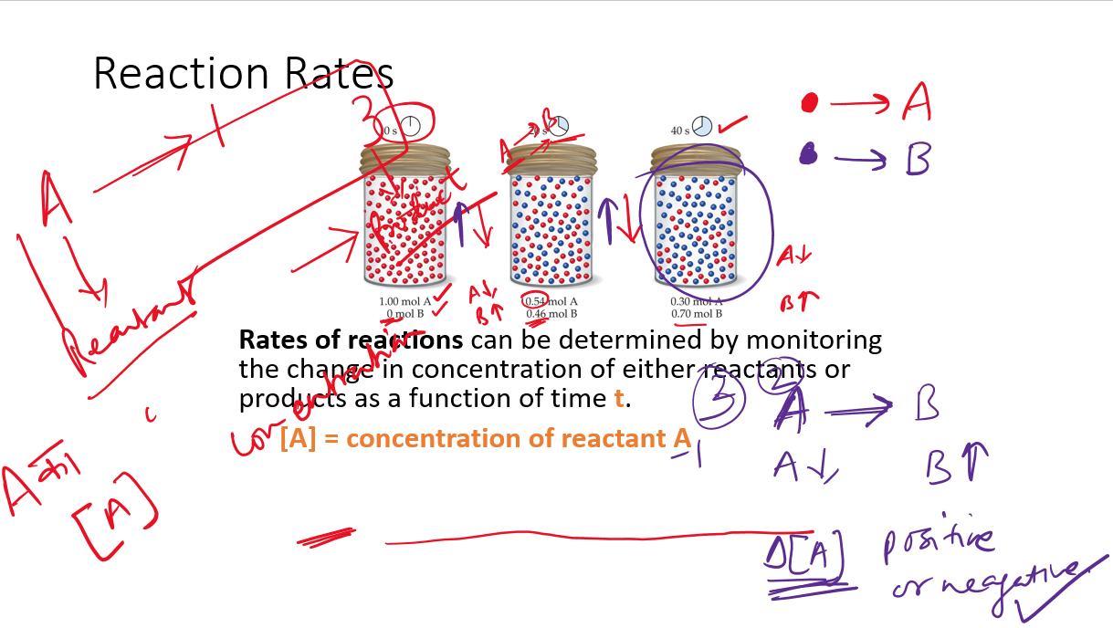

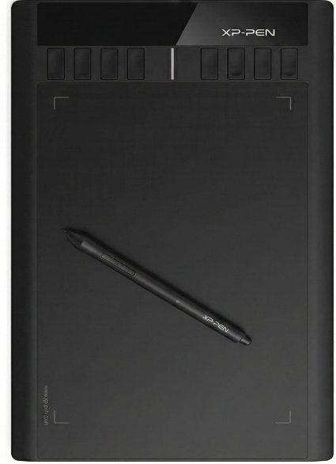

- (b)
Figure 1: A digital pen tablet (a) used by author to perform the chemical calculations in a live virtual session (b)

Furthermore, the teaching of stereochemistry (which requires a good understanding of spatial relationships and visualization in three dimensions) was seen as a special challenge in a 2D virtual environment (KL et al., 2018). To overcome this, the application of physical 3D organic molecular models was made possible using the audio-visual platform. By dabbling about with these models on camera author was able to show concepts such as chirality, steric hindrance and conformational isomerism much better than using flat diagrams alone.
This approach triggered a reciprocal innovation from the students. Despite their restricted access to their homes and the standard education materials, many students were extremely resourceful and managed to build their own molecular models with household materials including matchsticks and thermocol balls.

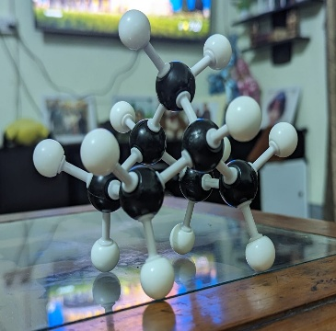
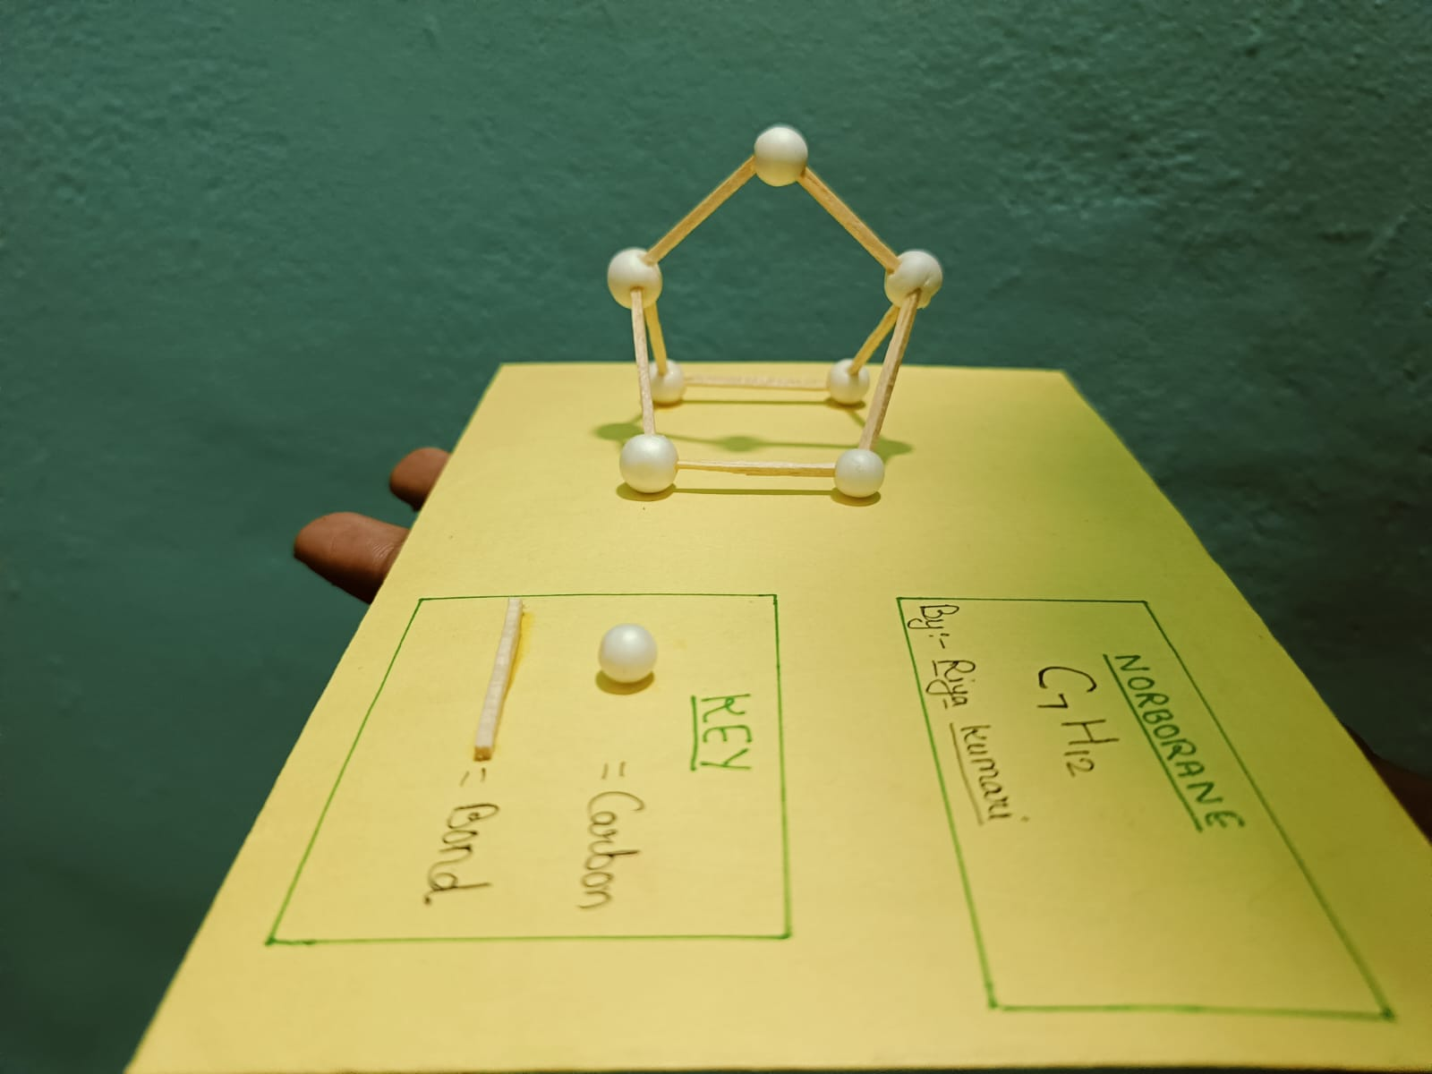
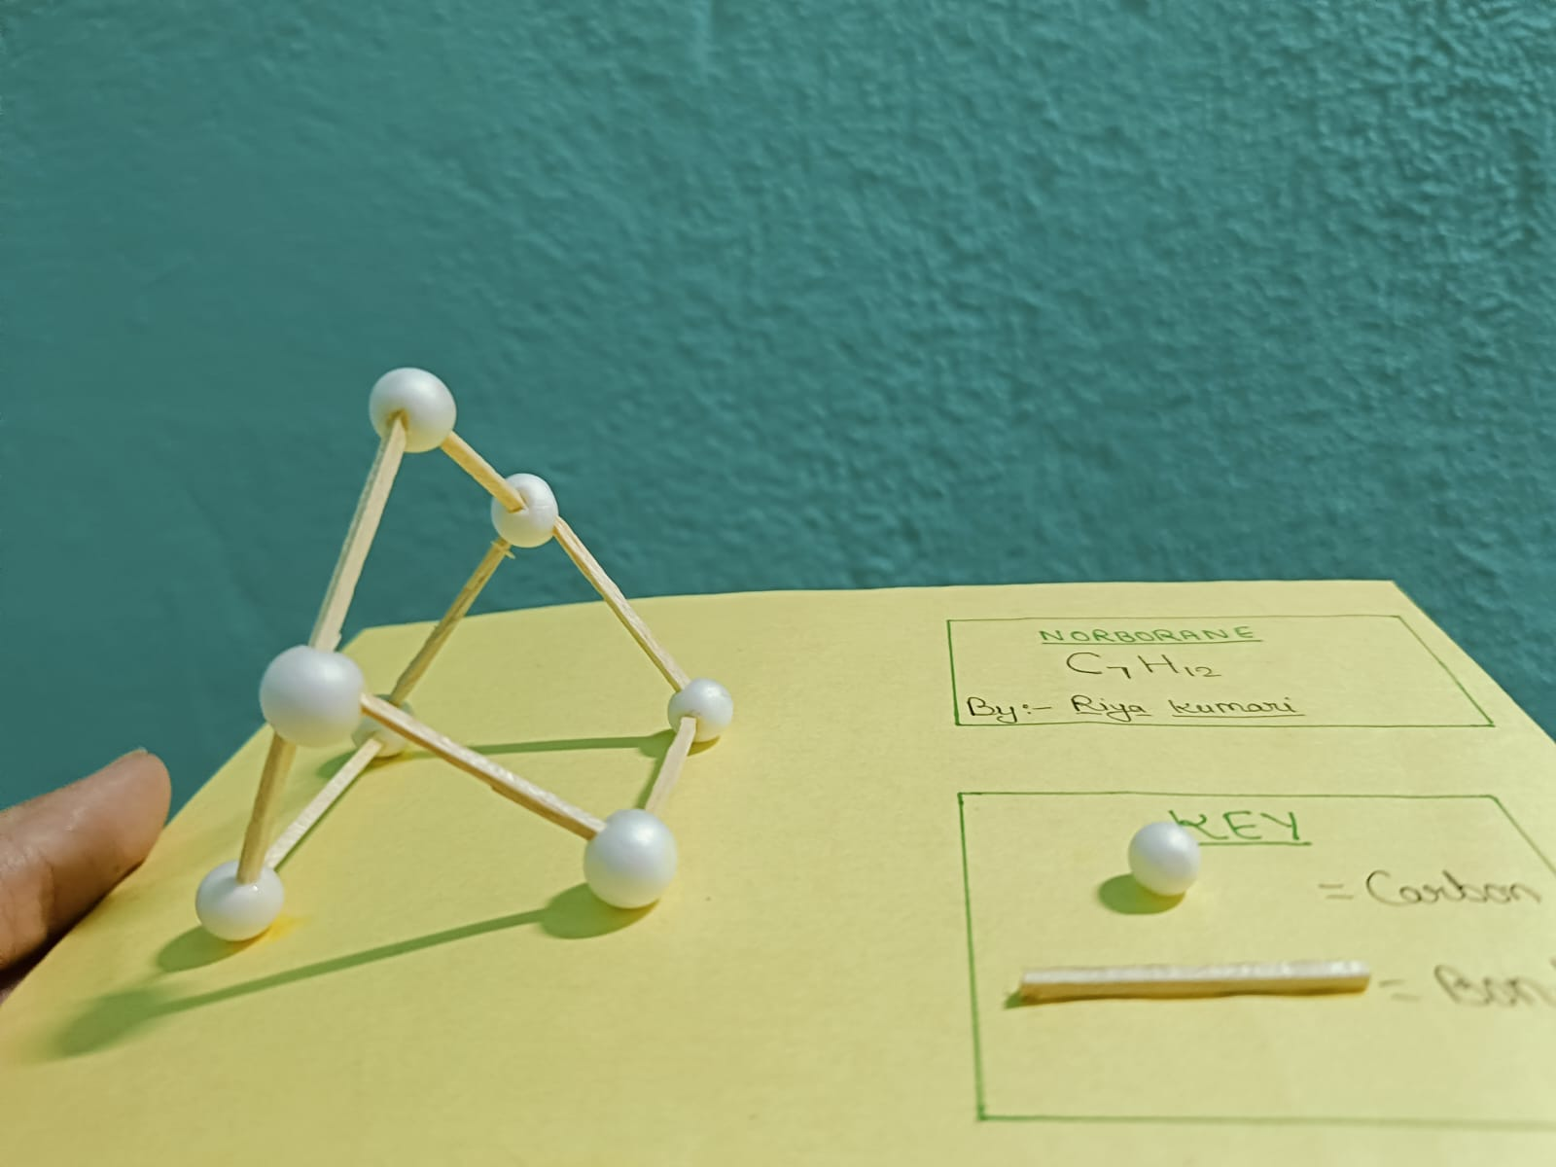

Figure 2: Virtual demonstration of stereochemistry with 3D models by author (left) and resourceful replica prepared with thermocol and Matchsticks by students (right).

While it must be acknowledged that this remote interaction was not as vibrant and exciting as face-to-face teaching (where interaction between peers and immediate feedback are organic), these technological adaptations made the process manageable. The combination of the digital writing tool and physical demonstrations resulted in a "middle path" that offered a teaching-learning experience that, although it was not ideal, managed to carry out the continuity of education in a critical period (Cui, 2023).

3. The Digital Divide and Problems of Infrastructure.
The success of the online teaching strategies depended inextricably on the socio-technical constraints of the student body. The presented studies focus on the unambiguous difference in challenges experienced in developing and developed economies.

3.1. Connection and Hardware limitations.
In India the "digital divide" was a formidable obstacle. Data showed that there were around 31 million households that still do not have electricity and average internet speeds were far below global standards (Giri and Dutta, 2020). Furthermore, many teachers and students did not have access to their own laptops, using mobile devices for learning, which are less favourable for viewing detailed chemical structures or typing up assignments. Super cyclones, like Amphan in May 2020, caused even further destruction of infrastructure in certain areas, on top of the disruption to education (Goswami and Tabrez, 2025). The Philippines had similar issues with the stability of the internet. Instructors observed that slow connections frequently resulted in students being disconnected from sync sessions which caused anxiety and disruption. To mitigate this, the DLPCA strategy focused on elements of the web that had asynchronous components (such as YouTube videos) that could be streamed at lower bandwidths or downloaded for offline viewing.
In contrast, the Spanish cohort had fewer infrastructural deficits. A survey of students found that the majority had sufficient technical resources (computers and broadband) to follow online classes (Pérez-Amaral et al., 2021). The university was well ahead in addressing the minority of students experiencing the "digital divide" by setting up a system of loans for laptops and internet cards.

3.2. The Laboratory Conundrum
Perhaps the most major loss occurred during the pandemic in terms of suspended wet-lab activities. In Spain, practical laboratory sessions for Food Science students were modified into synchronous online explanations with videos and protocols, which 79.6% of the students considered needed "extra effort" and did not work as well as face-to-face practice (Rodríguez-Rodríguez et al., 2020). In India, the absence of hands-on experiments was found as a crucial gap which makes the students find it difficult to build strong conceptual knowledge based on self-observation. While virtual labs were referred to as alternatives, the immediate implementation of these was often prevented due to safety concerns or unavailability of software (Giri and Dutta, 2020).

4. Assessment, Academic and Performance Integrity.
The shift to online platforms necessitated a re-think of how knowledge in chemistry is assessed and this meant that grading patterns changed and the issue of academic honesty was raised.
4.1. Impact on Student Grades
Contrary to the fear that learning online would decrease the level of academic performance, evidence obtained from Spain and the Philippines suggests that the opposite is true. In the Philippines, a comparison of grades in Analytical Chemistry revealed that the student performance significantly improved during the online term compared to the previous face-to-face term. Specifically, the percentage of failing grades was reduced from 18.2% to 4.1% (Lapitan Jr, et al., 2021). This improvement was attributed to the flexible nature of the DLPCA strategy which allowed students to go back to lecture materials repeatedly.
In Spain, a similar trend was found where the number of accomplished tasks during the online period was significantly higher than in the face-to-face instruction (Rodríguez-Rodríguez, et al., 2020). Though, in India, the results came out to be more nuanced. While there was an increase in the minimum scores of students (which indicates that lower performing students improved), there was a slight decrease in the scores of top performing students. This dip at the top end was ascribed to the inability of accessing to physical library resources and specialized reference texts (Giri and Dutta, 2020).

4.2. Academic Integrity and Designs of Assessment.
With the impossibility of proctored physical exams, institutions switched to other means of assessment. In India, the internal assessments changed to assignment submissions through emails (Kundu and Bej, 2021). However, this caused a concern around plagiarism, in that there were many instances of students submitting assignments that were not creative, or were seemingly direct copies from a text. To combat this, educators started to make questions course specific and require responses that were not readily found on the internet. In the Philippines, the integrity of online exams was ensured with "timed-release" questions and creating unique sets of problems that students tackle to prevent collaboration (Lapitan Jr et al., 2021). Despite these measures, the way in which assessments were designed continued to be a tension point. Some students reported that the amount of time given to upload solutions was not enough given slow internet speeds, and caused unnecessary stress.

5. Students Perception and Satisfaction.
Student feedback gathered in these different studies indicates a complex relationship with online learning.
5.1. Face-to-Face Preference: In all three contexts, there was a significant majority preference for face-to-face learning, with reference to the absence of human contact and difficulty of concentration in isolation.
5.2. Flexibility Appreciation: Despite the preference to the physical classrooms, students appreciated the "time-saving" aspect and "schedule flexibility" of online learning (Almeida, 2023). In the Philippines, the fact that lecture videos can be re-watched was reported to be a significant benefit, to explain difficult concepts that may be overlooked in a live lecture (Cavanlit et al., 2023).

5.3. Teacher Adaptation: Students mostly looked upon the efforts of their instructors with positive feelings. Good ratings were given by students on teacher adaptation and accessibility (4.4 out of 5) in recognition of the difficulty of the situation in Spain (Parra-González et al., 2021).

6. Post-Pandemic Paradigms: The Future of Chemistry Education
The subsiding of the crisis of the Covid-19 pandemic did not mean a return to the pedagogical norms of pre-2020; on the contrary, it triggered a permanent change in the field of chemistry education. The biggest shift has been from the "Emergency Remote Teaching" to intentional hybrid learning models. Institutions have kept the digital infrastructure built during the pandemic (Learning Management Systems - LMS, video conferencing tools, etc.) and have incorporated them into the traditional curriculum. One of the changes that seems to be prevalent is the use of "Flipped Classroom" in chemistry classes. Theoretical concepts, which often involve a lot of nomenclature and memorizing of mechanism, are now often taught in a pre-recorded module or curated online content, leaving time for face-to-face interaction such as problem solving and critical discussion. Furthermore, the role of Virtual Laboratories has changed from a replacement to a prerequisite. Virtual simulations are now increasingly being used as "pre-lab" exercises, where students can become familiar with the protocols of experiments, safety measures, and apparatus handling in a risk-free and digital environment before moving into the physical laboratory. This type of hybrid approach has been shown to have the potential to reduce chemical waste and increase safety compliance during actual experimentation. Finally, assessment strategies have become more diversified; the pandemic revealed the shortcomings of rote memorization exams and there has been a lasting preference for continuous assessment strategies, open-book assessments, and project-based learning that resembles the research of the scientific community.

Table 1: Comparative adaptation of higher education pedagogy during the pandemic: Developed (Spain) vs. Developing nations (India, Philippines)
Aspect | Developed Context (e.g., Spain) | Developing Context (e.g., India, Philippines)
Adoption & Platforms | Rapid & Institutional:  Fast transition using Moodle, Blackboard Collaborate, and Virtual Campus. Utilized specialized software for virtual labs and synchronous online assessments. | Public & Government-Led:  Reliance on government initiatives like SHAGUN, NROER, and e-Pathshala to bridge gaps.  Heavy use of accessible public platforms like YouTube (e.g., "NCERT Official"), WhatsApp, and Facebook due to ease of access.
Technology Infrastructure | High Stability & Access:  Infrastructure is generally adequate with 91.4% of households having internet access.  Students mostly possessed necessary devices (laptops/desktops); universities provided loaner equipment for the minority (1–3%) with connection issues. | Infrastructural Deficits:  Significant challenges including limited electricity (31 million homes in India lack power) and slow upload speeds (avg 4.31 Mbps).  Mobile Reliance: ~71% of users access the internet via mobile phones rather than computers, limiting the complexity of tasks.
Teaching Strategy & Interaction | Synchronous Focus:  Real-time (synchronous) sessions fostered better interaction and motivation, preferred by 63.6% of students. Focus on managing group sizes to maintain interaction quality. | Asynchronous & Flexible:  Shifted to "Guide on the Side" model with asynchronous methods (recorded videos) to accommodate lag.  Interaction often hampered by technological issues; teachers faced difficulties monitoring student engagement remotely.
Student Performance & Feedback | General Success:  Students adapted well; online students performed better or comparable to face-to-face students in some metrics.  Students appreciated the "Save Time" factor and schedule flexibility. | Mixed Results (The "Gap"):  Low-Scorers Improved: Online teaching helped low-scoring students improve performance significantly.  Top-Scorers Declined: High-performing students saw a slight decline, attributed to a lack of access to library resources and advanced materials.
Practical & Laboratory Work | Virtual Adaptation:  Labs conducted via video explanations and virtual simulations.  While students preferred in-person labs, they adapted to online tools without significant loss of theoretical understanding. | Severe Disruption:  Critical lack of hands-on experiments; virtual labs were often not viable due to data limits.  Reliance on TV broadcasting or simple videos, leading to a gap in experiential learning.
Challenges Faced | Management & Adaptation:  Primary challenges were managing interaction, ensuring engagement in large groups, and maintaining student commitment.  Workload perception was high among students. | Environmental & Skill Gaps:  Digital Divide: Distracting home environments (noise, lack of space).  Skills: Teachers often inexperienced with modern web tools.  Integrity: High concern regarding plagiarism in assignment-based assessments.
Overall Effectiveness | Viable Supplement:  Successful adaptation with emphasis on planning; online education is viewed as a viable supplement that offers flexibility. | Alternative with Limitations:  Effective as an emergency alternative but lags in engagement and practical skill development.  Highlighted the urgent need for infrastructural improvements to make online learning equitable.

7. Future Prospects: AI, IoT, and ML in Higher Education of Chemistry
As higher education enters the "Industry 4.0" era; the combination of Artificial Intelligence (AI), Internet of Things (IoT) and Machine Learning (ML) promises to change the way chemistry is taught and practiced.

7.1. Artificial Intelligence (AI) & Customized Learning
AI-driven systems of Intelligent Tutoring Systems (ITS) have the potential to democratise personalised instruction. In subjects such as thermodynamics or quantum chemistry, which are complex, AI algorithms can analyze a student's performance real-time and detect certain gaps in the concepts and develop customized quizzes or explanations to overcome them. In addition to tutoring, Generative AI is changing the process of writing in science and literature review, though it requires new curricula on digital ethics and academic integrity.

7.2. Machine Learning (ML) in Chemical Research Training
Integrating ML into the undergraduate and postgraduate chemistry curriculum is not an option anymore but is an essential requirement to be ready for modernization in the workforce. Future curricula will likely include "Cheminformatics" where students learn to use ML algorithms for predicting molecular properties, optimizing reaction conditions and accelerating drug discovery processes.3 This changes the emphasis from pure wet-lab skills to becoming a "hybrid chemist" with the profile of a chemist who is good at synthesis and data science.
Internet of Things (IoT) with Smart Laboratory
The application of IoT makes the physical lab a "Smart Lab." Connected sensors can be used to monitor reaction parameters (temperature, pressure, pH) remotely, which makes it possible for students to monitor long duration experiments from their smart phones without being physically present 24X7. Furthermore, IoT improves safety management by automatic gas leak detection or volatile organic compound (VOC) level detection and automatic ventilation system start-up or detecting and alerting to help achieve a safer learning environment for young chemists.

8. Conclusion
The incident of the corona virus known as Covid-19 became a definite catalyst for catalyzing the digital transformation of chemistry education. By the beginning of 2022, the fact that although emergency remote teaching managed to fill the gaps during the pandemic's lockdowns, it highlighted the disparity in the world's educational infrastructure significantly. The "one-size-fits-all" approach was no longer possible; to teach effectively, localization was necessary. The DLPCA model in the Philippines and the mixed-method approach in Spain showed that blended learning (an approach that combines asynchronous content delivery with synchronous active learning) can contribute to better engagement and grades among students. However, the Indian experience points out that unless the basic "digital divide" (electricity, connectivity and devices) is addressed, the benefits of online education are inaccessible to the most vulnerable populations40. Moving forward, the incorporation of virtual resources and various relevant tools (like, Pentab and 3D models) have been developed/employed during this time (video repositories and e-modules, for example) into the traditional curriculum is an avenue for a more resilient hybrid future for chemistry education. While the pandemic has created a reactive leap to the digital option, the future of chemistry education will be in proactive integration. The intersection of hybrid pedagogy and state-of-the-art computational tools (AI/ML/IoT) can be expected to give rise to a generation of chemists that are not only good experimentalists but also digitally-savvy data scientists.

References
- Almeida, D., 2023. Measuring Students´ e-Learning Satisfaction and Flexibility Impacts in Individual Performance During Covid-19 in Higher Education Institutions (Master's thesis, Universidade NOVA de Lisboa (Portugal).
- Baig, M.I. and Yadegaridehkordi, E., 2023. Flipped classroom in higher education: a systematic literature review and research challenges. International Journal of Educational Technology in Higher Education, 20(1), p.61.
- Bozkurt, A., Jung, I., Xiao, J., Vladimirschi, V., Schuwer, R., Egorov, G., Lambert, S., Al-Freih, M., Pete, J., Olcott Jr, D. and Rodes, V., 2020. A global outlook to the interruption of education due to COVID-19 pandemic: Navigating in a time of uncertainty and crisis. Asian journal of distance education, 15(1), pp.1-126.
- Cavanlit, K.L., Encabo, E.M. and Vilbar, A., 2023, September. Using recorded lectures in teaching higher education in an online remote learning context. In Novel & Intelligent Digital Systems Conferences (pp. 187-194). Cham: Springer Nature Switzerland
- Cui, J., 2023. Hybrid course model in physical education: enhancing undergraduate learning experience in a leading Chinese public university (Doctoral dissertation, Northeastern University.
- Erduran, S. and Akış, A.P., 2023. Chemistry education research: Recent trends and the onset of the pandemic era. Handbook of research on science education, pp.657-691.
- Giner-Murillo, M., Atienza-Carbonell, B., Cervera-Martinez, J., Bobes-Bascaran, T., Crespo-Facorro, B., De Boni, R.B., Esteban, C., Garcia-Portilla, M.P., Gomes-da-Costa, S., Gonzalez-Pinto, A. and Jaen-Moreno, M.J., 2021. Lifestyle in undergraduate students and demographically matched controls during the COVID-19 pandemic in Spain. International journal of environmental research and public health, 18(15), p.8133.
- Giri, S. and Dutta, P., 2020. Identifying challenges and opportunities in teaching chemistry online in India amid COVID-19. Journal of Chemical Education, 98(2), pp.694-699.
- Goswami, T. and Tabrez, Z., 2025. School education amid crisis: a secondary data analysis of cyclone Amphan and COVID-19 in North & South 24 Parganas, West Bengal. Discover Global Society, 3(1), p.61.
- Gupta, A., Rana, N. and Raj, M., 2022. ROLE OF DIGITAL MEDIA IN BUILDING WORLD CLASS INSTITUTIONS WITH SPECIAL REFERENCE TO TEACHING-LEARNING: A SURVEY. European Journal of Education Studies, 9(7)
- Holden, O.L., Norris, M.E. and Kuhlmeier, V.A., 2021, July. Academic integrity in online assessment: A research review. In Frontiers in education (Vol. 6, p. 639814). Frontiers Media SA.
- Huang, Z.J., 2025. Integrating Artificial-Intelligence Assistance into Chemical Process Control Education. Education for Chemical Engineers.
- Joaquin, J.J.B., Biana, H.T. and Dacela, M.A., 2020, October. The Philippine higher education sector in the time of COVID-19. In Frontiers in Education (Vol. 5, p. 576371). Frontiers Media SA.
- Khan, A., 2023. ICT and digital revolution: implications for teacher education. In Teaching and Teacher Education in India: Perspectives, Concerns and Trends (pp. 299-321). Singapore: Springer Nature Singapore.
- KL, N.S., Chavan, P.S. and Murthy, S., 2018, July. StereoChem: Augmented reality 3D molecular model visualization app for teaching and learning stereochemistry. In 2018 IEEE 18th international conference on advanced learning technologies (ICALT) (pp. 252-256). IEEE.
- Kundu, A. and Bej, T., 2021. Experiencing e-assessment during COVID-19: an analysis of Indian students' perception. Higher Education Evaluation and Development, 15(2), pp.114-134.
- Lapitan Jr, L.D., Chan, A.L.A., Sabarillo, N.S., Sumalinog, D.A.G. and Diaz, J.M.S., 2023. Design, implementation, and evaluation of an online flipped classroom with collaborative learning model in an undergraduate chemical engineering course. Education for Chemical Engineers, 43, pp.58-72.
- Lapitan Jr, L.D., Tiangco, C.E., Sumalinog, D.A.G., Sabarillo, N.S. and Diaz, J.M., 2021. An effective blended online teaching and learning strategy during the COVID-19 pandemic. Education for chemical engineers, 35, pp.116-131.
- Lapitan Jr, L.D., Tiangco, C.E., Sumalinog, D.A.G., Sabarillo, N.S. and Diaz, J.M., 2021. An effective blended online teaching and learning strategy during the COVID-19 pandemic. Education for chemical engineers, 35, pp.116-131.
- Lee, C.B., Hanham, J., Kannangara, K. and Qi, J., 2021. Exploring user experience of digital pen and tablet technology for learning chemistry: applying an activity theory lens. Heliyon, 7(1).
- Li, M. and Ai, N., 2022. The COVID‐19 pandemic: The watershed moment for student mobility in Chinese universities?. Higher Education Quarterly, 76(2), pp.247-259
- Luque-Martínez, T., Doña-Toledo, L. and Faraoni, N., 2025. The digital future of Spanish universities: Facing the challenge of a digital transformation. The Bottom Line, 38(1), pp.28-48.
- Parra-González, M.E., López-Belmonte, J., Segura-Robles, A. and Moreno-Guerrero, A.J., 2021. Spanish adaptation and validation of the teaching and learning experiences questionnaire. International Journal of Environmental Research and Public Health, 18(7), p.3518.
- Pérez-Amaral, T., Valarezo, A., López, R. and Garín-Muñoz, T., 2021. Digital divides across consumers of internet services in Spain using panel data 2007–2019. Narrowing or not?. Telecommunications Policy, 45(2), p.102093.
- Purcell, W.M. and Lumbreras, J., 2021. Higher education and the COVID-19 pandemic: navigating disruption using the sustainable development goals. Discover Sustainability, 2(1), p.6
- Ramirez, V.E., 2020. Resilience amidst pandemic: HEI sustaining quality assurance in a digital world. Higher Education Quality Assurance, pp.1-32.
- Reyes, R.L. and Regala, J.D., 2025. Reimagining the Philosophy of Experimentation in Chemistry Education: Embracing AI as a Tool for Scientific Inquiry. Science & Education, pp.1-46
- Rodríguez-Rodríguez, E., Sánchez-Paniagua, M., Sanz-Landaluze, J. and Moreno-Guzmán, M., 2020. Analytical chemistry teaching adaptation in the COVID-19 period: experiences and students’ opinion. Journal of Chemical Education, 97(9), pp.2556-2564.
- Setiawan, N.C.E. and Rosli, M.S., 2022. Experience using a five-component blended learning strategy during the Covid-19 pandemic. In Improving Assessment and Evaluation Strategies on Online Learning (pp. 68-74). Routledge.
- Singh, M., Adebayo, S.O., Saini, M. and Singh, J., 2021. Indian government E-learning initiatives in response to COVID-19 crisis: A case study on online learning in Indian higher education system. Education and Information Technologies, 26(6), pp.7569-7607.
- Watts, J., Crippen, K.J., Payne, C., Imperial, L. and Veige, M., 2022. The varied experience of undergraduate students during the transition to mandatory online chem lab during the initial lockdown of the COVID-19 pandemic. Disciplinary and Interdisciplinary Science Education Research, 4(1), p.14
- Wells, P., Abouarghoub, W., Pettit, S. and Beresford, A., 2020. A socio-technical transitions perspective for assessing future sustainability following the COVID-19 pandemic. Sustainability: Science, Practice and Policy, 16(1), pp.29-36

