GENETIC POLYMORPHISM OF THE LIPOPROTEIN LIPASE GENE IN MALLARD (Anas plathyrhynchos) AND MUSCOVY (Cairinamoschata) DUCKS IN NIGERIA

ABSTRACT:
Aims:To identify polymorphic forms of exon 7 of Lipoprotein Lipase (LPL) gene in locally adapted Mallard and Muscovy duck breeds in Nigeria.
Study design: Case-control study with candidate gene approach could not be used due to monomorphic results obtained from gel electrophoresis analysis of the extracted DNAs from both breeds.
Place and Duration of Study: Samples collection was carried out at some markets in Ogun State while the laboratory work was carried out at the Animal Science Laboratory of University of Ibadan between May and June, 2023.
Methodology: 80 ducks; 40 Mallard and 40 Muscovy ducks were used to carry out the study. Blood samples of 3 ml each, were collected from 80 ducks. Blood samples were collected through the jugular vein; of 40 mallard breed and 40 Muscovy breed. The DNA was extracted and amplified using exon 7 LPL gene primer and HinfI digestive enzyme. The products obtained from PCR-RFLP were analyzed with 2% agarose gel electrophoresis.
Results: 33 of all the samples in both Mallard and Muscovy were amplified. The percentage of which was 37.50% for both breeds. While 18 of Mallard samples were amplified, 15 of Muscovy were amplified and their percentages were 22.50% and 18.75% respectively. Considering the percentage of each of the breeds that were amplified, Mallard percentage of amplified sample was 45% while that of Muscovy was 37.5%. Similar gel patters was obtained in all amplified samples. Therefore, there was no polymorphism detected at exon 7 of LPL gene but instead the breeds were monomorphic. The result obtained could be due to fewer population of selected samples, non polymorphic of the gene at exon 7 and it may also be as a result of closeness in relationship due to proximity of birds sampled from one another.
Keywords: duck, polymorphism, Mallard, Muscovy, breed

1. INTRODUCTION
Poultry meat is widely consumed, with duck being the third most preferred after chicken and guinea fowl, respectively. Duck is very high in protein and fat content and could be required in Africa to meet the shortfall in animal protein due to its potentials like high feed efficiency, early maturity, high disease resistance and adaptability among others (Liu et al., 2006; Wang et al., 2017).. Despite these huge qualities, studies had only been conducted on morphological, biochemical and physiological differences, neglecting or paying insufficient attention to the genetic improvement and characterization of duck breeds (Adeola et al.,2022; Oguntunji& Ayorinde, 2014).
Meat from ducks needed to be monitored for fatness and carcass qualities as excessive fat deposition affects carcass traits, flavor, feed efficient usage, and disease resistance (Wu et al., 2008; Zhang et al., 2016). In order to sustain quality duck meat production, pedigree and trait phenotypes selection was adopted (Adeola et al., 2022). The process of selection could be better carried out using molecular techniques which saved both time and resources due to its accuracy;
Mallard was reported to be the ducks ancestor with heavier weight. Likewise in male compared to their female counterpart, the weight of male was more than that of the female (Janiszewski et al., 2018; Susanti, 2021). However, Mallard breed causeed genetic pollution due to their non migratory nature and in the process caused extinction of other local breeds (BirdLife international, 2019).. Muscovy is predominant locally adapted duck in Nigeria with good foraging and incubation behavior, tasty and high yield breast meat with low calories (Raji, Igwebuike & Usman, 2009).
Lipoprotein lipase (LPL) gene through lipoprotein lipase (enzyme) had been fingered to be one of the factors responsible for variations associated with abdominal fat weight, subcutaneous fat, subcutaneous thickness and intramuscular fat width in duck, cattle, pig, chicken and other farm animals (Susanti, 2021). The enzyme could be found on capillaries in muscles and adipose tissues breaking down forms of triglycerides, carrying them to blood stream from various organs. chylomicron carries triglycerides from intestine and Very Low Density Lipase from liver to the blood stream.
Genetic polymorphism could also be referred to as genotypic polymorphism or genetic variation in a population. It occurs when individuals of a species are different in forms or traits and such differences occur at the genomic level, first,. before reflecting in the physical traits. DNA or gene could be polymorphic, if at a specific position variation in sequence or more than one allele is found at the locus respectively (Biology Online Dictionary, 2020).
In duck breeds, exon 2 of Growth hormone, exons 5, 7 and 8 of Lipoprotein-lipase (LPL) gene and Perilin gene were associated with meat quality; fatness, carcass traits and growth (Zhang et al., 2016). Wu et al. (2008) reported that the leanness of modern ducks to traditional ducks was as a result of fat composition and that excess fat composition reduces weight. Many studies have been carried out on LPL and effect of its polymorphisms in other animals but few were on ducks. Therefore his study aimed to identify the polymorphic forms of exon 7 of LPL genes in adapted Muscovy and Mallard ducks in Nigeria.

2. MATERIALS AND METHODS

Experimental Animals; The ducks used for the experiment were sourced from Ogun State in the south west region of Nigeria. The birds were purchased at various markets in the state. They were kept in two different pens according to their breeds. Each of the birds was tagged for easy identification and for immediate blood collection. Forty birds per breeds, Muscovy and Mallard, were purchased.
Forty (40) birds per breeds (Muscovy and Mallard ducks) were tagged with corresponding EDTA (ethylene diamine tetra acetic acid) containing eppendorf labeled tubes for easy identification and blood collection.
Genomic DNA extraction was done using solution-based Jena Bioscience Blood DNA Preparation Column Kit following manufacturer instructions in the laboratory of Animal Breeding and Genetics, Animal Science Department, University of Ibadan, Nigeria. After the DNA isolation, the samples were amplified with PCR techniques using the following pair of primer GSP 1-F, 5’-AACAA GACCT TCTCC TTCCT G3’ and GSP-R, 5’-TTTCT GAGTT TCGCC TGAC-3’ which was designed from chicken LPL gene sequence (ABO16987). The products of the amplification were digested using the enzyme HinfI and the results or products obtained from the digestion process were later analyzed by 2% gel electrophoresis.

Each PCR reaction mixture consised of 6μl mastermix (5x), 1.5μl (10pmol) each of LPL primer (forward and reverse), 4μl DNA template and 17μl sterile nuclease free water to make up a total reaction volume of 30 μl. PCR amplification was carried out in an Applied Biosystem 2720 Thermocycler. The mixture was subjected to an initial denaturation at 95°C for 4min; followed by 35 cycles of denaturation at 95°C for 35s, annealing at 47°C for 35s and extension at 72°C for 30 seconds; and a final extension at 72°C for 10 mins.
The reaction mixture contained 10μl of PCR product, 3μl of 10x buffer and 1μl HinfI Restriction Enzyme (Jena Bioscience, Germany) and 12μl nuclease free water. The mixture was incubated at 37°C for 10mins and inactivated at 80°C for 20mins. The PCR products were analyzed on a 2% (wt/vol) agarose gel dissolved in 0.5x Tris-borate buffer, stained with maestrosafe and visualized under blue light transilluminator (New England BioGroup, USA). A known midrange DNA ladder marker (Jena bioscience, Germany) was run simultaneously to assess the size of the digested products (DNA bands).

3. RESULTS AND DUSCUSSION
3.1 Polymorphic forms of exon 7 of LPL gene
Table 1 presents the results of PCR-RFLP products of samples analyzed with gel electrophoresis for results of exon 7 of LPL gene. The gel electrophoresis analysis (Figure 1,3,4, and 6) showed monomorphic results obtained with 176 base pair (bp) length while samples of RFLP products in Figure 2 and 5 did not show any observable bands . The RFLP products showed a band with the size of DNA which were without variations for Mallard and Muscovy Ducks. The monomorphic results obtained for some samples showed that the exon 7 of LPL did not have cutting site for HinfI enzyme used for the digestion of the amplification product (result of PCR techniques) of samples (Susanti and Yuniastuti, 2020) The results observed in Figure 1. 3, 4 and 6 were monomorphic as there was no variation obtained from the electrophoresis results. This implied that, the fragments of the homologous DNA sequences obtained after the digestion of amplified samples by the restriction enzyme were not different for samples collected from the two duck breeds at the locus of the gene. Saez (2019) Submitted that, LPL gene expression was not different in duck breeds. The report corroborates the result of this study. Wu et al. (2008) findings on exon 7 of LPL gene on its association with fatness traits in native and Cherry Valley Pekin were at variance with the result of this study. Genetic variations were recorded in the research based on geographical distance from which the birds where sourced (China and England) which was not so with the ducks used in this study (Ogun State). Though, both of the studies used different breeds, but same exon 7 of LPL gene; this might make one to envisage that the result would be similar. The result obtained in this study might be due to the sedentary and interbreeding nature of Mallards (BirdLife international, 2019).
Table 1: Results of Gel Electrophoresis products
Breed Amplified sample C⁺C⁺ Unamplified sample T⁻T⁻
Mallard 18 22
Muscovy 15 25
Total 33 47
C⁺C⁺ Genotype of amplified samples, T⁻T⁻ Genotype of unamplified samples
However, the monomorphic results obtained in this study were similar with the result of Susanti (2021) on another gene (Perilipin) but different for Exon 2 of LPL gene which had homologous DNA sequences that was polymorphic for the locus. Meanwhile, all the ducks with the amplified samples could be said to be homozygous for the gene at exon 7 of LPL gene. Founder effect could be responsible for, monomorphism; low genetic variations in the results of this study. The number of individuals that establish the population of a species may be few and have the same genotype at most of their loci. The frequencies of the alleles can be changed through introduction of organisms of same species into the population. This process is called gene flow and it could lead to increase or decrease in the numbers of alleles in a population and at the same time, increase or decrease genetic variations (Cole and Biesboer, 1992). Reduction in variation was experienced in the case of this study and this would increase homozygosity of pair of alleles of genes as a result of lack of recombination. Some factors might be responsible for the failure of the samples that were not observable after gel electrophoresis analysis.
Moreover, reasons responsible for this could be the introduction of contaminating agents through proteins, phenol or ethanol and failure in handling of the samples used for DNA extraction properly. Table 1 showed the number of few PCR products samples that were successfully amplified and those samples that were unamplified. Some endogenous and exogenous factors were concluded to affect DNA extraction. In the case of endogenous: hydrolysis, oxidation, alkylation and bases mismatch, in the DNA, could damage the DNA (Hakem, 2008). The samples used might have been affected by external factors like ionizing radiation, ultraviolet radiation or various chemicals. EDTA concentration, volume and pH, incubation temperature and time were suggested to be responsible as well (Booncharoenn et al., 2021).
Figure 1: Gel picture of exon 7 of LPL gene showing similar DNA bands for Mallard (L) and Muscovy (M) Samples

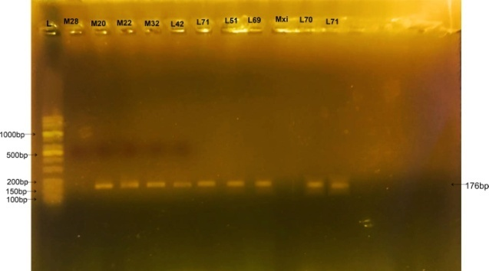

Figure 2: Gel picture of exon 7 of LPL gene of unamplified DNA of Muscovy samples 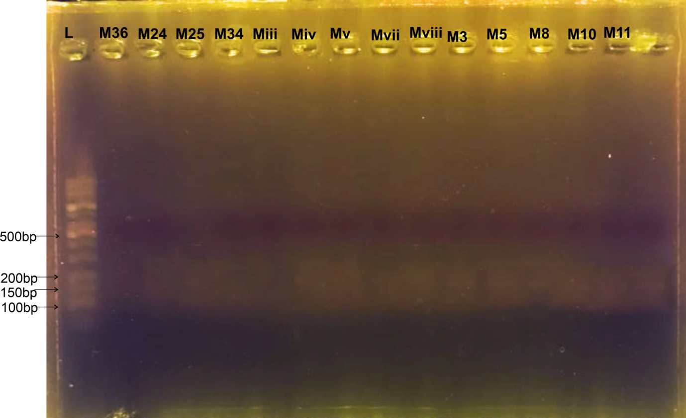

Figure 3: Gel picture of exon 7 of LPL gene for amplified DNA of Mallard samples
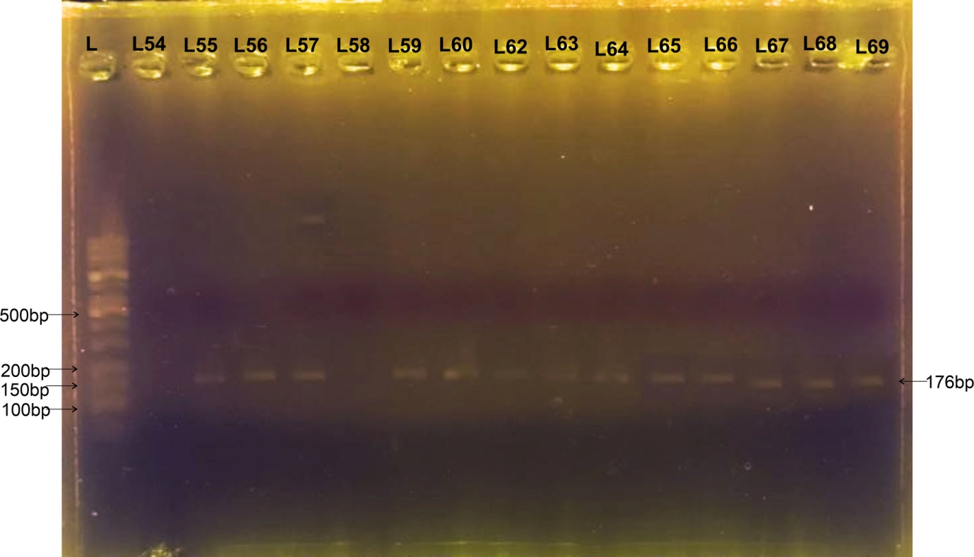

Figure 4: Gel picture of exon 7 of LPL gene for amplified and unamplified DNA of Muscovy samples
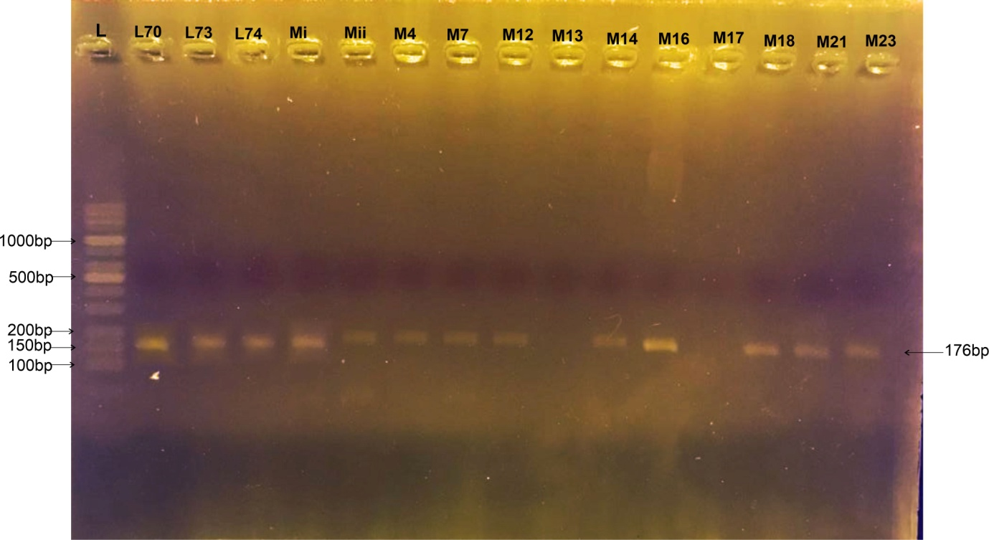

Figure 5: Gel picture of exon 7 of LPL gene for unamplified DNA of Mallard
Samples
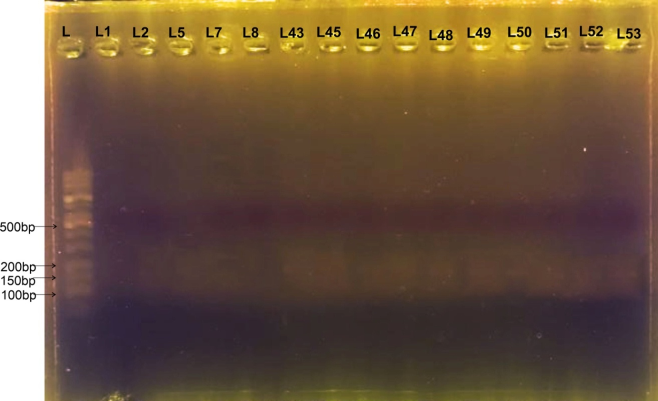

Figure 6: Gel picture of exon 7 of LPL gene for amplified DNA of Mallard
Samples
Table 2 showed the percentage of gel electrophoresis products for amplified and unamplified samples. The table could only show the genotypes obtained from analysis of RFLP products which was one predominant genotype C⁺C⁺ detected due to lack of variation. With these results, 33 samples (41.25%) out of 80 (100%) were C⁺C⁺ for Mallard (22,5%) and Muscovy (18.75%) ducks.Studies on the LPL exon 7, concluded that polymorphisms detected in exon 7 of LPL gene could make the exon the major loci influencing fatness traits. Though in some cases, RFLP product might show various bands for the samples exposed to gel electrophoresis analysis but in the case of this study one band was observed (Wu et al. 2008; Abdulaziz et al., 2012,).
Table 2: Results of percentage of Gel Electrophoresis products
Breed Amplified sample (%) In all (%) Unamplified sample (%) In all (%)
Mallard 45 22.50 55.00 27.50
Muscovy 37.50 18.75 62.50 31.25

In Table 3, all of the samples of birds that were successfully analyzed, as observed in Figure 1, 3, 4, and 6, were of the same genotype (Zeng et al.,2016). The observed plates showed a similar band across the samples analyzed with gel electrophoresis. The alleles displayed on the pictures from gel electrophoresis were homozygous, since no variation was observed on them. The implication of which is that genotypic and allelic frequencies would only be estimated for the dominant genotype C⁺C⁺ and recessive TT for the samples of the birds considered.
Table 3: Genotype and allele frequency of Duck based on Exon 7 of LPL gene
Breed Genotypic Frequency Allelic Frequency
CC CT TT C T
Mallard 1.000 0.000 0.000 1.000 0.000
(18)
Muscovy 1.000 0.000 0.000 1.000 0.000
(15)

CONCLUSION
The PCR-RFLP analysis using Hinf I revealed that exon 7 of LPL gene was monomorphic in the studied samples of adapted Mallard and Muscovy duck population in Nigeria. Thus, genetic polymorphism of exon 7 of LPL gene in Mallard and Muscovy cannot be estimated. The cutting site for enzyme used for the digestion of amplified DNA was not present in the exon 7 of LPL gene. Further studies can be carried out using larger sample size or other restriction enzymes in order to validate the results obtained in this study and provide insight into the variations within each breed and many other Nigerian locally adapted ducks at LPL gene locus.

REFERENCES
- Adeola, A. C., Sola-Ojo, F. E., Opeyemi, Y. A., Oguntunji, A. O., Nneji, L. M., Ewuola, M. K., Bello, S. F., Olaniyi, W. A., Adesoji, A. T., Karuno, A. P., Sanke, O. J., & Daniel, E. L. (2022). Genetic diversity and population structure of muscovy duck (Cairina moschata) from Nigeria. PeerJ. https://doi.org/10.7717/peerj.13236
- Al-Shammari, R. T., Al-Serri, A. E., Barhoush, S. A., & Al-Bustan, S. A. (2022). Identification and Characterization of Variants in Intron 6 of the LPL Gene Locus among a Sample of the Kuwaiti Population. Genes. https://doi.org/10.3390/genes13040664
- Biology Online Dictionary. (2020). Genetic polymorphism. https://www.biologyonline.com/dictionary/polymorphism

- BirdLife International. (2019). *Anas platyrhynchos* (amended version of 2017 assessment). The IUCN Red List of Threatened Species. https://doi.org/10.2305/IUCN.UK.2019-3.RLTS.T22680186A155457360.en
- Booncharoen, P., Khachananda, S., Kanchai, C., & Ruengdit, S. (2021). Factors influencing DNA extraction from human skeletal remains: bone characteristic and total demineralization process. *Egyptian Journal of Forensic Sciences*, *11*(2). https://doi.org/10.1186/s41935-021-00216-8
- Cole, C. T. and Biesboer, D. D. 1992. Monomorphism, Reduced Gene Flow, and Cleistogamy in Rare and Common Species of Lespedeza (Fabaceae). American Journal of Botany 79.(5):567-575. Janiszewski et al., 2018
- Hakem, R. (2008). DNA-damage repair; the good, the bad, and the ugly. The EMBO Journal, 27(4), 589-605. https://doi.org/10.1038/emboj.2008.15
- Liu, R., Wang, Y., Sun, D., Yu, Y., & Zhang, Y. (2006). Association between polymorphisms of lipoprotein lipase gene and chicken fat deposition. Asian-Australasian Journal of Animal Sciences, 19(10), 1409-1414. https://doi.org/10.5713/ajas.2006.1409
- Oguntunji, A. O., & Ayorinde, K. L. (2014). Multivariate analysis of morphological traits of the Nigerian Muscovy ducks (Cairina moschata). Archivos de Zootecnia, 63(243), 483-493. https://doi.org/10.4321/S0004-05922014000300009
- Raji, A. O., Igwebuike, J. U., & Usman, M. T. (2009). Zoometrical body measurements and their relation with live weight in matured local Muscovy ducks in Borno State, Nigeria. ARPN Journal of Agricultural and Biological Science, 4(3), 58-62. http://www.arpnjournals.com/jabs/volume_04_2009.htm
- Saez, G., Davail, S., Gentès, G., Hocquette, J. F., Jourdan, T., Degrace, P., & Baéza, E. (2009). Gene expression and protein content in relation to intramuscular fat content in Muscovy and Pekin ducks. Poultry Science, 88(11), 2382–2391. https://doi.org/10.3382/ps.2009-00208
- Susanti, R. (2021). Carcass and fatness traits of Central Javanese local ducks based on Lipoprotein Lipase (LPL) and Perilipin (PLIN) genes. Journal of Physics: Conference Series, 1918(5), 052003. https://doi.org/10.1088/1742-6596/1918/5/052003
- Susanti, R., & Yuniastuti, A. (2020). Hatchability genotype of Central Javanese local ducks based on ovomucoid gene. Journal of Physics: Conference Series, 1567(3), 032042. https://doi.org/10.1088/1742-6596/1567/3/032042
- Wang, L., Li, W., Ma, J., & Zhang, Y. (2017). Integrating genome and transcriptome profiling for elucidating the mechanism of muscle growth and lipid deposition in Pekin ducks. Scientific Reports, 7(1), 3837. https://doi.org/10.1038/s41598-017-04178-7
- Wu, Y., Zhang, H. L., Wang, J., & Liu, X. L. (2008). Discovery of a SNP in exon 7 of the lipoprotein lipase gene and its association with fatness traits in native and Cherry Valley Peking ducks. Animal Genetics, 39(5), 564–566. https://doi.org/10.1111/j.1365-2052.2008.01761.x
- Zhang, Y.-Y., Li, W.-G., & Wang, D.-D. (2016). An novel SNP in LPL gene exon 8 associated with meat quality traits in ducks. *Pakistan Journal of Zoology*, *48*(5), 1459-1464. https://doi.org/10.1079/PAJZ20160179

