ARCHITEXTILES: A STRUCTURAL AND FUNCTIONAL REVOLUTION

Abstract

Architextiles encompass "next-generation advanced textile materials" that offer unique characteristics, enhancing the functionality, aesthetics and expressiveness of built structures. These materials are increasingly preferred over conventional building materials due to their lightweight nature, energy efficiency and adaptability in various architectural applications. Woven fabrics are an accessory of modern architectural construction, and they provide special options of flexibility, strength and beauty. Woven fabrics in architectural textiles will be designed to perform both functional and decorative tasks, including lightweight shading systems and acoustic panels and tensile structures high-performance structures. Weatherability refers to the ability of architextiles to withstand a range of environmental factors such as moisture, temperature variations and other atmospheric conditions. Different base fabrics and coatings offer varying levels of weather resistance. It is noted that highly engineered textile materials have been increasingly valued as a result of their high input in other architectural applications with the aim of closing the performance gap between the performance and structures.

Keywords: Architextiles, atmospheric conditions, architectural construction, tensile structures

- Introduction
According to Garcia (2006), contemporary textile architecture or what is called “Architextiles,” is a hybrid term resulting from the combination of the words architecture and textiles to produce what is called “Architextiles.” It includes a wide range of projects and ways of thinking that unite, join, connect and combine architecture and textiles together. Architectural textiles are materials used in structural or aesthetic architectural applications, often as membranes, facades, roofs or interior elements.
According to Singh and Kapoor (2021), Architextiles encompass "next-generation advanced textile materials" that offer unique characteristics, enhancing the functionality, aesthetics and expressiveness of built structures. These materials are increasingly preferred over conventional building materials due to their lightweight nature, energy efficiency and adaptability in various architectural applications. This multidisciplinary concept draws upon the creative approaches, materials, and structures integral to both architecture and textile disciplines, exploring their cross-fertilization to redefine spatial design towards a more networked, communicative and multifunctional state.
- History of Architextiles
Table 1: History of Architextiles
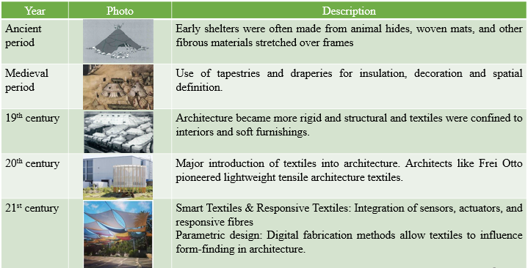
List. 1 History of Architextiles

This paper explores the fibres, fabrics, etc being used along with major properties required for architecture. Application of textiles in architecture is also explored along with the opportunity of phase change material, nanotechnology and biomimicry is discussed.
- Textile Materials used in ArchiTextiles
3.1. Fibres used in ArchiTextiles: The fibres majorly being used in architextiles for their properties are as follows:
- Cotton: Breathable, soft, good dye affinity and sustainable
- Polyester: Good tensile strength and elasticity
- Polyethylene: Thermoplastic and can bear tension
- Melamine: For their inherent thermal resistance and outstanding heat blocking capability in direct flame applications
- Polyamide (Nylon): Fibres have high strength and tenacity, excellent abrasion resistance
- Vectran: High strength and is not sensible to creep
- Carbon: High tensile strength and low elongation
- Utlra-high molecular weight polyethylene: High strength and chemical resistance with low weight
- Polyethylene Terephthalate: High strength, tenacity, highest bending recovery values, resistant against chemicals and low price
- Aramid: Higher tensile strength and thermal resistance
- FibreGlass: Glass has a high strength, low elongation and displays very low creep
- Stainless Steel: Stainless steel is weatherproof and gives the construction a high quality appearance

3.2 Fabrics used in ArchiTextiles
3.2.1 Woven Fabric: Woven fabrics are an accessory of modern architectural construction, and they provide special options of flexibility, strength and beauty. Woven fabrics in architectural textiles will be designed to perform both functional and decorative tasks, including lightweight shading systems and acoustic panels and tensile structures high-performance structures.
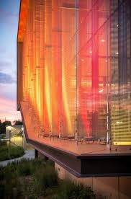
Fig 1- Woven Fabric
Example: GKD (image along) provides woven metal mesh facades constructed of Stainless Steel, which integrate beauty with functionality as they offer sun shading, ventilation and privacy.​ It is resistant to weather and can withstand natural light penetration and minimize the heat gain through the solar aspect and also improves the energy efficiency of a building.​
3.2.2 Knitted Fabric: The natural elasticity and the three dimensional flexibility of knitted fabrics make them especially applicable for multi-purpose applications requiring installations of sculptural or dynamical nature. They are regularly employed in strained buildings, shading systems, inside divisions and outside appearances, where a blend of aesthetic gentleness, strength and output is needed. Knitted fabrics are light and pliant, lessens consumption of material in building and increases the imperial performance. They are also useful in exterior architecture and in interior architecture as they can be controlled in their light transmission, ventilation and acoustic control due to their open or mesh-like structures.
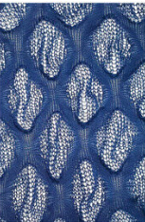

Fig 2- Knitted Fabric
Horteborn et al (2025) experimented to produce architectural knitted windbreaks to improve wind comfort in the city. Five knitted prototypes of cotton yarn were produced by drop stitch knitting technique to allow varying porosity within the fabric by creating larger loops and providing three dimensional structure. Two reference screens (porous and solid screen) were constructed for comparative analysis. The knitted textile models demonstrated a significant reduction in wind speed, with decreases ranging from approximately 60% to 90%. Thus suggested that knitted windbreaks can provide more uniform wind shielding across different wind directions.​
3.2.3 Braided/Narrow Fabric: The narrow weaving and braiding technologies are used in the manufacture of belts and ropes with a large variety of dimensions. Sewn-on textiles and foils that are made in narrow woven belts can have a significant effect in a maximum span length. Tensile connections between textiles/foils and bigger components of a primary construction are created using braided or narrow ropes as they are very strong, rigid, lightweight and durable.
Shang et al (2025) produced a flexible structure based on braiding technology and fibre jamming. They used Nylon PA66 fibres to form braided fabric by using circular braiding technique resulting in a flexible skeleton that can deform to various shapes. The structure demonstrates significant foldability. When subjected to lateral compression, the volume reduces from 54.3 cm³ to 21.5 cm³, showcasing its potential for compact storage and transportation.​ The study reported a stiffness ratio of 14.2 and a volume ratio of 4.56, highlighting the structure's efficiency in terms of load-bearing capacity and space utilization.
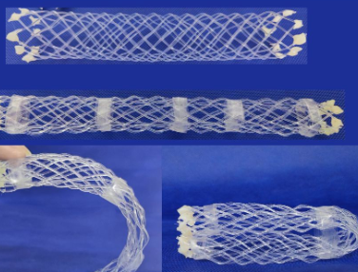

Fig 3- Braided/Narrow Fabric
3.2.4 Non-woven Fabric: In architecture, the non-wovens are popular in insulation, acoustics, filters, barriers, membranes, etc. They are very permeable, when it comes to the filtration capacity, they are more stable than the soil in question, and resist erosion and environmental factors. Various non wovens used are:
- Heavier and thicker nonwovens: Geotextiles, underlays, insulation
- Very thin fibres nonwovens: Vapour barrier, breathable membranes, filtration media
- Bicomponent fibres nonwoven fabric: Thermal bonding, membranes
- Micro/nano coated nonwoven: Filtration systems, self-cleaning, thermal insulation, energy efficiency
Singh S and Kapoor R (2023) investigated the acoustic properties of nonwoven fabrics made from jute, coir and their blend. They measured the sound absorption coefficients of these materials using the impedance tube method as per ASTM E-1050 standards. The findings indicate that increasing the thickness of the nonwoven fabric samples (from 15 to 45 mm) significantly improved the sound absorption capabilities. Additionally, blending jute with coir and creating air gaps within the fabric further enhanced its acoustic performance. The study highlights the potential of natural fibre-based nonwoven fabrics in architectural applications for noise reduction.

Fig 4- Non-woven Fabric
3.2.5 Spacer Fabric: The last few years saw new innovation in the field of spacer textiles. ITV denkendorf has come up with a process where two layers of textile fabric that have been separated are united creating a spacer fabric. As a result of this particular construction, an air space is created that offers a high level of heat and acoustic insulation. Spacer fabrics are becoming popular as thermal insulation and sound proofing fabrics that are laminated or coated on both sides with a transparent foil.
3.3 Coatings used in ArchiTextiles
Finishing and post-treatment also offer a huge range of desirable properties to membranes before the fabric production process. Various coatings provided to textiles for better functioning in architecture are:
- Polytetrafluoroethylene (PTFE): Good chemical stability, transparent, resistant to ageing, weather and UV radiations, self-cleaning
- Polyurethane (PU): High resistance to wear, high strength, good flexibility
- Polyvinylchlorides (PVC): Barrier function
- Polyvinylfluoride (PVF): Stronger, chemical inertness, high service of temperature
- Silicone: Water-repellent, flame-retardant, resistant to ageing and to chemicals, and highly transparent, better transparency, life, heat resistance and better mechanical properties and is halogen-free, but it is more expensive
Ritter A (2016) experimented with polyvinylidene fluoride (PVDF)-coated polyester fabric for durability in architectural applications. Digital Image Correlation (DIC) was employed to assess the distribution of shear strain within the specimens. The shear stiffness of the PVDF-coated fabrics decreased from 11.4 to 4.2 MPa as the maximum shear stress increased, indicating a nonlinear relationship between shear stiffness and applied stress.​ Normal stresses in the warp and filling directions were found to enhance the shear stiffness, suggesting that biaxial prestress can influence the shear behaviour of the fabrics.​
3.4 Composites used in ArchiTextiles
The fibre-reinforced composite materials are currently in interest to be used as primary constructions, which are relatively new. These materials are light and can be readily converted into complicated forms. The new developments in major characteristic properties, which include very high fatigue resistance, increased strength/weight ratio, high stiffness/weight ratio, absent catastrophic failure, low thermal expansion, excellent resistance to chemical and environmental factors, etc are the advantages of fibre-reinforced composite over the conventional materials. Owing to the special attributes provided by these enhanced fibre-reinforced composites, they are applicable in several ways in architecture according to the demands.
Dahy H (2019) fabricated natural fibre reinforced polymer composites (NFRP) panel from lignocellulosic fibres for sustainable architectural applications. They used flax, jute, hemp and kenaf fibres along with epoxy and bio based resins to form composite. NFRP composites exhibited good mechanical properties such as tensile strength, flexural strength and impact resistance. Flax and hemp composites showed the highest strength-to-weight ratios, making them ideal for load-bearing applications in architecture. Kenaf was found to offer excellent soundproofing abilities, providing an alternative to synthetic acoustic materials. Composites showed potential for thermal insulation, a valuable characteristic for building materials in architecture. Thus, research presented natural fibre-reinforced polymer composites (NFRP) as a promising material for sustainable architectural applications.
- Properties required for ArchiTextiles
4.1 Tensile Strength: One essential property of architextiles is tensile strength, which is important for structures such as tensioned membrane structures. Textiles with high tensile strength are less prone to tear or create holes thus enhancing their longevity and giving stability to diverse structural designs such as building surfacing and car parks. Li M et al (2022) explored the influence on tensile strength properties of 3D warp interlock fabrics (3DWIFs). They designed five different 3DWIFs with varying interlock structures, all made from high-molecular-weight polyethylene (HMWPE) yarns. They conducted uniaxial tensile tests to assess the mechanical behaviour of these fabrics. The crimp angles of the binding warp yarns significantly affected the inter-yarn friction and consequently, the tensile properties, indicating better energy absorption capabilities.​ It was concluded that optimizing factors like crimp angles and binding paths, it's possible to enhance the performance of architextiles in architectural applications.
4.2 Tear Strength: Tear strength is the property of a material to resist the propagation of a tear and is another critical mechanical property for architextiles, particularly in ensuring the longevity and safety of structures. According to Eltahan E (2018), Higher tear strength is generally achieved when:
Fig 5- Tear Strength
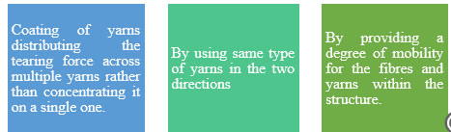
4.3 Flexibility: Flexibility is the ability of a textile to bend, move and adapt under the influence of external forces. The flexible nature of textiles helps in the creation of architectural spaces that are foldable, portable and adaptable to various required needs offering unique design possibilities that are often not achievable with traditional rigid materials.
4.4 UV Resistance: Ultraviolet protection is a property that protects a fabric from degradation of polymers within the fabric coating due to prolonged exposure to solar radiation, which can result in loss of mechanical properties and aesthetic quality. This resistance can be achieved through various methods such as including the incorporation of UV-protective additives into the polymer during manufacturing or by applying UV-resistant finishes or coatings to the fabric. Coatings of PVC, ETFE and silicone, when formulated with UV stabilizers, can significantly enhance a fabric's resistance to UV degradation.
4.5 Fire Resistance: Fire resistance is an essential property for architextiles to ensure safety in the event of a fire. Certain architextile materials inherently offer good fire resistance such as silicon-coated fibreglass is non-combustible and PTFE is appreciated for its use as an advanced facade material partly due to its fire-resistant properties. Similarly, high-density polyethylene (HDPE) fabric also offers Class A fire resistance rating as per ASTM E-84 standards and vinyl-coated polyester is also noted for its fire-resistant properties.
4.6 Weatherability: Weatherability refers to the ability of architextiles to withstand a range of environmental factors such as moisture, temperature variations and other atmospheric conditions. Different base fabrics and coatings offer varying levels of weather resistance. PVC-coated polyester, silicone-coated glass, ETFE and PTFE are all known for their ability to withstand different weather elements and SEFAR Architecture fabric, made from PTFE, is specifically noted for its resistance to UV rays, acid rain and salt water.
Asadi H (2021) explored the strength deterioration of architectural fabrics under single and combined artificial weathering impacts by using PET-PVC and glass-PTFE woven fabrics. It was observed that PET-PVC fabrics revealed no significant loss of strength due to any of the water effects and recommended it for architectural use.
4.7 Light Transmission: Light transmission is a key property that allows the light to pass through the fabric layer and it can be carefully balanced to achieve specific design and functional goals in architecture. The opacity and transparency of textile surfaces are considered important aspects of architectural language, offering a spectrum of possibilities for visual and functional design.
4.8 Energy Efficiency: Advanced and high performance textile materials are increasingly being They can dramatically reduce energy consumption by providing shade and deflecting solar heat gain, thus lowering the demand for air conditioning. Phase Change Materials, Green roofs, etc are some of the energy efficient materials used in Architextiles.
4.9 Acoustics and Thermal Properties: Architextiles offer significant potential for improving the acoustic performance of buildings by providing sound absorption and insulation qualities suitable for a wide range of architectural space. Karimi F et al (2022) investigated the effect of non woven polypropylene fabric on thermal and acoustical properties in building applications. It was found that fabrics made of finer fibres provide superior acoustic absorption and thermal insulation performance. An increase in through-plane fibre orientation adversely affected the thermal insulation properties, while its effect on acoustic properties depends on the porosity of samples and the sound frequency. The performance of these samples was compared with some commercial products and literature data. The results pointed out that the designed samples had superior acoustic and thermal properties.
- Applications of ArchiTextiles
5.1 Textile Structures: Textile structures are defined by tension (such as tensile, pneumatic and cable-net systems) and are lightweight, flexible and efficient architectural solutions.
5.1.1 Tensile Structures: Tensile structures use fabric membranes stretched between supports to form stable and self-supporting forms. The tension in the fabric resists external loads, creating lightweight and efficient designs. ​Materials used in tensile structure are PTFE-coated fibreglass, PVC-coated polyester and ETFE films.​
5.1.2 Pneumatic Structures: Pneumatic structures use air pressure to maintain their shape. They consist of airtight membranes inflated to create a stable form, relying on internal air pressure to resist external loads. Materials used for pneumatic structures are typically made from flexible and airtight materials such as PVC or ETFE films.​
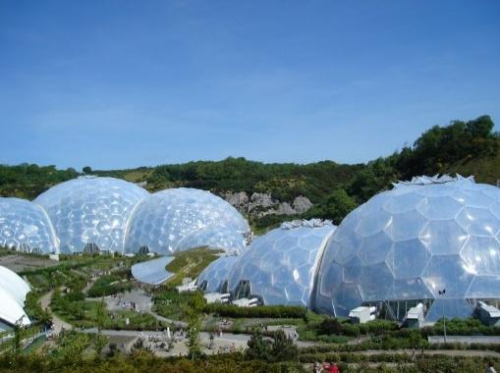

Fig 6- Pneumatic Structures
5.1.3 Cable-net structures: Cable-net structures consist of a network of pre-tensioned cables that form a flexible, lightweight framework. They are often used as support systems for tensile membranes or as stand-alone structures. Materials used for cable net structure are made of steel cables and fabric membranes such as PTFE-coated fibreglass or PVC-coated polyester.​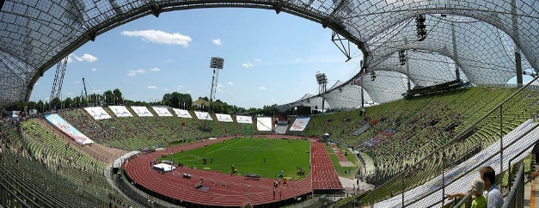
Fig 7- Cable-net structures
5.2 Facade: A fabric facade is a non-load-bearing architectural element used to cover the exterior of a building. These facades serve as a skin that can control light, regulate temperature and offer significant design flexibility. They can be either permanent or temporary and can be used to add dynamic layers to both new and existing structures. Textile material can be used as an alternative to traditional materials for facade cladding. A high performance façade in low energy building design using advanced textile materials is a sustainable architectural approach. The popular textile materials used in building façade are PVC coated polyester, ETFE (ethylenetetrafluoro ethylene) and PTFE (polytetrafluoroethylene).
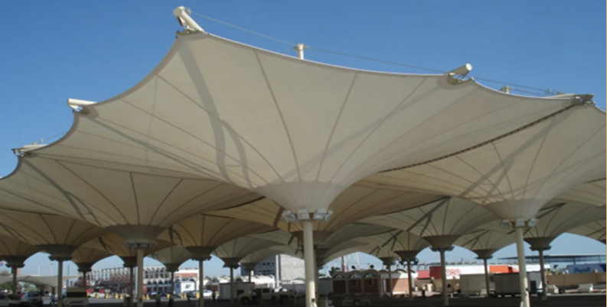

Fig 8- Facade
5.3 Shading Devices: Architectural textiles are often employed as shading devices in building facades or windows to control sunlight and heat gain, thus improving energy efficiency. Denz et al (2021) developed an adaptive, energy-efficient woven textile sunshading system using the smart material Shape Memory Alloy (SMA) under the United Nations’ “Transforming our world: the 2030 Agenda for Sustainable Development”. They used the pulling, pushing and rotating scenarios to shrink and extend. Two types of prototypes, Adaptex Wave and Adaptex Mesh were created and tested successfully for textile based sun shading solutions.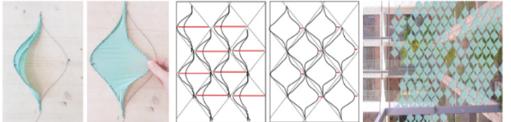
Fig 9- Shading Devices
5.4 Acoustics Insulation and Noise Reduction: Advanced textile materials are increasingly used for acoustic applications to absorb, block or dampen sound within built environments, providing sound absorption and insulation to enhance comfort and functionality. Texlon Cladding System is a foil cushion of ETFE and PTFE provides reduced rain noise and observed less drumming effect of the rain. Patnaik et al (2015) studied the sound insulation property from blended fabric of waste wool and recycled polyester fibres. The fibres were mixed in 50/50 proportions in the form of a two layer mat and samples were prepared from 100% waste wool and 100% RPET fibres. All samples were tested for thermal insulation, acoustic, moisture absorption and fire properties. It was observed that the prepared sample provided good insulation, acoustic, moisture absorption and fire properties. The RPET/waste wool mats were absorbing more than 70% incident noise in the frequency range of 50–5700 Hz.
5.5 Thermal Insulation: Thermal insulation textiles in architecture refer to textile-based materials specifically engineered or repurposed to reduce heat transfer through building envelopes. It includes applications in interior wall linings, curtains or drapes with insulative properties, roof and ceiling panels, temporary or modular architectural structures (e.g., tents, pavilions), facade systems with thermal and aesthetic functions
Palanisamy et al (2025) developed a sustainable multilayer nonwoven composite assembly for thermal insulation application in buildings. Needle punched non woven fabrics of kapok, jute and banana fibres were prepared and punched together to form the final three layered nonwoven sample. The thermal properties were tested for the prepared sample. It was observed that the better thermal insulation of multilayered nonwoven fabrics was contributed by the presence of a thin air layer between the assembled fabric layers and influenced by the fabric combinations assembled. This study confirms that the abundant availability of biodegradable natural fibres, that is, kapok, jute, and banana, and their transformation into nonwoven fabrics through needle punching offers a potential alternative to non-biodegradable synthetic fibre based thermal insulating materials.
5.6 Low Cost Living Spaces: The shrinking of living spaces in many countries is due to the high cost of land available for structural development. Hence, there exists a strong need for low cost portable or non-portable living spaces which are easy to erect in a short time.
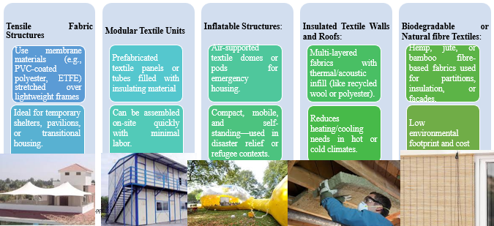
Fig 10- Low Cost Living Spaces
5.7 Roofing Systems: Architextile roofing systems use fabric or membrane-based materials often with high tensile strength to provide shelter, environmental protection and architectural expression. These systems range from simple fabric canopies and complex tensile membrane structures integrated with smart technologies.
Common Types of Architextile Roofing Systems are:
- Tensile Membrane Roofs: Ideal for stadiums, airports, amphitheatres or pavilions
- Inflatable Roofs (Pneumatic Structures): Common in greenhouses, exhibition halls, and pop-up architecture
- Fabric Canopy Roofs: Popular for shading in courtyards, schools, marketplaces or outdoor venues
- Green/Hybrid Textile Roofs: Textile mesh used as structural support for plant growth and solar shading
- Modular Textile Roofing Panels: Used in low-cost or disaster-relief housing
5.8 Green Textile Roof: The green textile roofs help in making the buildings environmentally friendly with exclusive appearance. The green roofs built with the sophisticated layer textiles are more beneficial for air quality, biodiversity and the sewage system requirement of the architectural feature as they functions as a buffer on rainwater, helps to reduce the urban heat, optimizing the sound noise pollution with provision of sound insulation and reduces the need of energy in cooling a building in hot climate and enhances the overall architectural design. Green textile roofs greatly help in improving the microclimate of nearby environments and it also aids in preventing heat loss during winter and at the same time makes buildings comparatively cooler in summers. It is also noted that the application of textile based green roofs lead to reduced run-offs during precipitation.
5.9 Interior Textile Systems: Interior textile systems in architextiles refer to the strategic use of textile-based materials and structures within interior architectural spaces to perform both functional and aesthetic roles. These systems go far beyond decoration to leveraging acoustic control, thermal comfort, spatial flexibility, light modulation and even smart interactivity.
Applications of textiles in interior systems include:
1. Acoustic Panels & Wall Systems: Made from porous or multilayered textiles (e.g., wool, polyester felts).
2. Movable or Modular Partitions: Textile screens or fabric-covered frames define flexible zones.
3. Thermal and Light Regulation: Curtains, blinds, or room dividers made of reflective, insulating, or phase-change textiles.
4. Stretch Ceiling and Wall Systems: Tensioned fabrics (like PVC, polyester) stretched over frames.
5. Smart or Interactive Textiles: E-textiles embedded with LEDs, sensors, or actuators.
6. Textile Flooring (Soft Architecture): Modular rugs or felt tiles used not just for comfort, but acoustic and spatial definition, often made from recycled fibres or natural wool.
5.10 Energy Textile Systems: Architectural Energy systems are innovative textile systems that produce, store or handle energy within architectural application. These systems combine photovoltaic (PV) fabrics, thermoelectric materials and energy harvesting fibres into the building envelopes including facades, roofs or interior partitions that make buildings smarter, more self-sufficient and sustainable. Dongen et al (2022) created a novel form of architectural cloth that integrates the ability to generate energy along with its functional and aesthetic performance. Their goal was to develop a lightweight, flexible and transparent organic photovoltaic (OPV) material to be used as building facades by weaving of the thin-film cells with electrically conductive yarns into a textile. In order to evaluate the practical implementation of Suntex, the authors tested it on the Westraven building in Utrecht, Netherlands. It was discovered that the four facades of the building that have Suntex were capable of producing enough electricity to supply the lighting of the building all year round. As indicated by this case study, Suntex has the potential to help in making urban buildings more efficient in energy consumption. Tensile strength and aging tests were also done and the results proved the practicability of Suntex as a stable and strong material to be used in building construction.
5.11 Landscape Architecture: Landscape textiles include functional and aesthetic textile based systems for landscaping and outdoor environment. These textiles help in environmental sustainability, structural stabilization and spatial design by integrating textile technologies into green infrastructure, landform shaping, erosion control and temporary or flexible outdoor spaces such as:
- Geotextiles: Used in soil reinforcement, erosion control and drainage layers. Common in green roofs, embankments, bioswales, and retaining walls.
- Biodegradable Erosion Mats: Natural fibre textiles (coir, jute, straw) that stabilize slopes or riverbanks. Decompose over time as vegetation takes over, leaving no waste.
- Root Barrier Fabrics: Prevent invasive plant roots from damaging paths or building foundations. Also used to guide root growth in controlled directions.
- Shade and Climate Textiles: High-strength UV-resistant mesh fabrics used for pergolas, canopies and agricultural shade works to control microclimates in outdoor spaces (e.g., playgrounds, urban gardens).
- Tensile Membrane Landscape Structures: Textile-based pavilions or shelters that define outdoor rooms or event spaces.
- Water Management Fabrics: Geotextile liners for rain gardens, retention basins, or permeable paving systems. Support filtration, storage, and distribution of rainwater.
6. Nanotechnology in ArchiTextiles: Nanotechnology is revolutionizing architectural textiles by imparting advanced functionalities that were previously impossible. By manipulating materials at the nanoscale (1 to 100 nanometers), engineers can create textiles with enhanced properties, opening up new possibilities for building envelopes, interior spaces and even structural elements. Nano coatings, such titanium dioxide (TiO₂) coatings and photocatalytic materials, can be employed as topcoats, which are applied to the membrane's outer layers to maintain a clean surface with a self-cleaning property (a permanent membrane structure, with TiO₂ and photocatalytic, self-cleaning membrane skin).
7. Phase Change Materials in Architextiles: Phase Change Materials (PCMs) are increasingly being integrated into architectural textiles to enhance thermal comfort and energy efficiency in buildings. These intelligent materials have the unique ability to absorb, store and release significant amounts of latent heat during their phase transition (typically from solid to liquid and vice versa) at a nearly constant temperature. Rubino et al (2021) states that PCM treated facade membranes will be opaque in absence of sunlight and translucent during daytime. Furthermore, such facade membranes not just provide privacy to occupants but also use natural light to optimize the artificial light requirements. Hence, the uses of PCMs treated facade contribute towards sustainable architecture through improving energy efficiency of buildings. It was also reported that the PCMs heat flux control feature is beneficial for plants grown in a greenhouse. The overheating problem of inside space can be resolved by the use of PCMs in greenhouse applications and the use of PCMs also contribute in making greenhouse building energy efficient. The PCM treated silicone rubber coated fibreglass membrane is also used in constructing emergency shelters with improved thermal comfort.
8. Biomimicry and ArchiTextiles: Biomimicry in architextiles, also known as bio-inspired textile design, is an innovative field that seeks inspiration from nature's forms, processes, and ecosystems to create high-performance, sustainable, and aesthetically unique architectural fabrics. Image tries to explain the different nature inspired themes being used in architecture.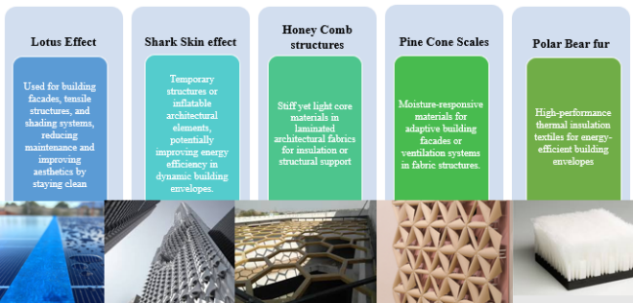
Fig 11- Biomimicry and ArchiTextiles
9. Problems of Architextiles: The textile materials mostly used in architecture are manufactured as per American Society for Testing and Materials ASTM E 108 & ASTM E84 standards with a lifespan of approximately 25 years but also faces some problems like:
9.1 Durability and Maintenance: Despite being resistant to UV rays and water, architectural textiles can degrade over time due to exposure to harsh environmental conditions such as high winds, extreme temperatures, or pollution. Unlike traditional building materials, architectural textiles require regular maintenance, including cleaning and inspections. In some cases, periodic re-coating or treatment may be needed to maintain their performance, which can add to the overall cost and effort.
9.2 Limited Lifespan: Architectural textiles, particularly those made from synthetic materials, are more prone to physical damage such as cuts, punctures, or abrasions, especially when subjected to mechanical stress or sharp objects and may not have as long a lifespan. This can be a concern in high-traffic or industrial areas. This can be a limiting factor for large-scale or permanent installations.
9.3 Limited Thermal Insulation: Architectural textiles generally offer limited thermal insulation properties compared to traditional building materials like brick, concrete, or glass. This may lead to higher energy consumption for heating or cooling in certain climates unless additional insulation layers or shading systems are incorporated.
9.4 Installation Complexity: Designing and installing architectural textile structures requires advanced engineering knowledge and expertise. The process is more complex than traditional construction, as it involves precise tensioning of the fabric, proper anchoring systems and ensuring the stability of the structure under varying environmental conditions. This can lead to higher upfront costs and longer installation timelines.
9.5 Limited Color and Texture Options: While modern textile materials are available in various colors and textures, the options may still be more limited compared to traditional construction materials like wood, stone, or concrete. Achieving a specific aesthetic with architectural textiles may require additional treatments or coatings, which could impact the cost and visual appeal.
9.6 Cost Considerations: While architectural textiles can be cost-effective for certain applications, the initial cost of the fabric, engineering design, and installation can be higher compared to traditional materials, especially for large-scale structures.
10. Opportunities of Architextiles: New developments in fibres, coatings and nanomaterials shall allow architextiles to be lighter, stronger, more durable and multifunctional. These advancements open doors for applications in extreme environments and improve building performance. Architextiles often use less material and energy in production and installation compared to traditional building systems. They offer natural light diffusion, passive ventilation and recyclability, making them ideal for eco-conscious designs and reducing the carbon footprint of construction. Their flexibility and ease of assembly make Architextiles ideal for modular construction, pop-up architecture, disaster relief shelters and event pavilions. Architextiles push the boundaries of architectural expression by enabling fluid, organic and non-rectilinear forms. These innovations expand creative possibilities for architects while also responding to performance and aesthetic needs. Embedding sensors, photovoltaic fibres or reactive materials within textiles creates opportunities for smart building skins to help in adapting to environmental conditions, generating energy or providing real-time data about usage, weather or structural health. Rapid urban growth and densification call for efficient, lightweight and adaptable construction methods. Architextiles offer scalable solutions suitable for both developed and emerging markets, including low-cost housing and urban public infrastructure.
11. Market of Architextiles
As of 2025, the market was valued at around USD 3.07 billion, and it is expected to grow at a compound annual growth rate (CAGR) of 11.56 % over the next several years, reaching over USD 6.60 billion by 2032. North America and Europe are the largest markets for architectural textiles due to their long-standing adoption of sustainable construction practices. Asia-Pacific, especially countries like India and China, is expected to witness the fastest growth in the architectural textiles market due to rapid urbanization, infrastructure development, and an increasing demand for innovative construction solutions.
Key Players at Global level: Serge Ferrari (France), Mehler Texnologies (Germany), Sattler AG (Austria), Günter Köhler AG (Germany), Birdair Inc. (USA), Kvadrat (Denmark), Création Baumann (Switzerland), Vescom (Netherlands), Carnegie Fabrics (USA), F. Schumacher & Co. (USA).
Key Players at National level: Formtech Infra Pvt. Ltd.; Technospan Structures Pvt. Ltd.; Tensile Factory Pvt. Ltd.; Architractile; Aakruti Tenso; Tensile Structures India; Tensile Engineering India Pvt. Ltd.
13. Conclusion
These innovative manufactured high performing textile materials enhance functionality, appeal and general expressiveness of the textile based structural architectural designs by conserving desired microclimate within a building, enhance glare, enhance durability, enhance energy efficiency of a building, lightweight, weather resistant, ultraviolet resistant, fire resistant, cost effective and enhanced acoustic performance. Therefore, it is noted that highly engineered textile materials have been increasingly valued as a result of their high input in other architectural applications with the aim of closing the performance gap between the performance and structures.

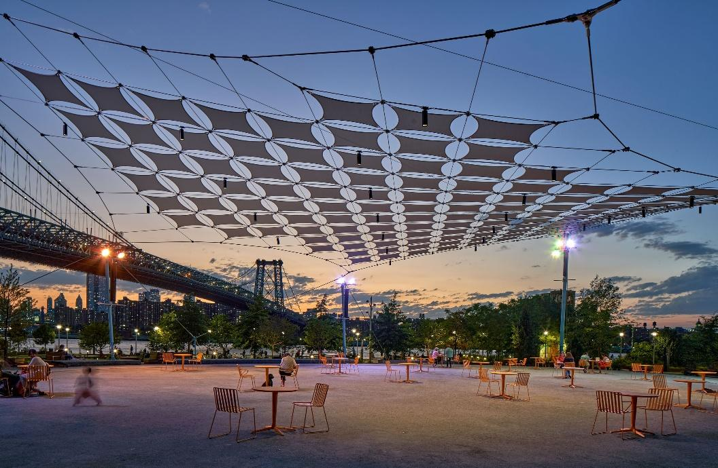
REFERENCES:
Asadi, H. (2022). Strength deterioration of architectural fabrics under single and combined artificial weathering impacts (Doctoral dissertation, Dissertation, Duisburg, Essen, Universität Duisburg-Essen, 2021).
Dahy, H. (2019). Natural fibre-reinforced polymer composites (NFRP) fabricated from lignocellulosic fibres for future sustainable architectural applications, case studies: segmented-shell construction, acoustic panels, and furniture. Sensors, 19(3), 738.
Denz, P. R., Sauer, C., Waldhör, E. F., Schneider, M., & Vongsingha, P. (2021). Smart textile sun-shading: development of functional adaptex prototypes. Journal of Facade Design and Engineering, 9(1), 101-116.
Dongen, PV Britton, E., Wetzel, A., Houtman, R., Ahmed, A. M., & Ramos, S. (2022). Suntex: weaving solar energy into building skin. Journal of Facade Design and Engineering, 10(2), 141-160.
Eltahan, E. (2018). Structural parameters affecting tear strength of the fabrics tents. Alexandria engineering journal, 57(1), 97-105.
Garcia, M. (2006). Architecture+ textiles= architextiles. Architectural Design, 76(6), 5-11.
Hörteborn, E., Zboinska, M. A., Chernoray, V., & Ander, M. (2023). Architectural Knitted Windbreaks for Improved Wind Comfort in the City: A Wind Tunnel Study of Custom-Designed Porous Textile Screens. Buildings, 13(1), 34.
Karimi, F., Soltani, P., Zarrebini, M., & Hassanpour, A. (2022). Acoustic and thermal performance of polypropylene nonwoven fabrics for insulation in buildings. Journal of Building Engineering, 50, 104125.
Li, M., Wang, P., Boussu, F., & Soulat, D. (2020). Effect of fabric architecture on tensile behaviour of the high-molecular-weight polyethylene 3-dimensional interlock composite reinforcements. Polymers, 12(5), 1045.
Palanisamy, S., Yadav, A., Bajya, M., & Choudhary, A. K. (2025). Development of Sustainable Multilayer Composite Nonwoven Fibrous Assembly for Thermal Insulation Application. AATCC Journal of Research, 12(1), 24723444241300382.
Retrieved from https://www.archdaily.com/1003462/pushing-boundaries-11-exteriors-that-use-fabric-for-protection-shape-and-longevity on April 1, 2024.
Retrieved from https://www.gkdmetalfabrics.com/applications-category/facades/ on April 20, 2025.
Retrieved from https://www.linkedin.com/pulse/fabric-facades-future-sustainable-building-design-saif-ullah-shah-5ehcf/ on April 15, 2025.
Ritter, A. (2016). Smart coatings for textiles in architecture. In Active Coatings for Smart Textiles (pp. 429-453). Woodhead Publishing.
Rubino, C., Liuzzi, S., Martellotta, F., Stefanizzi, P., & Straziota, P. (2021). Nonwoven textile waste added with PCM for building applications. Applied Sciences, 11(3), 1262.
Shang, Z., Chen, J., Zhou, Z., Zhuang, H., & Ren, X. (2024). Flexible furniture structure based on braiding technology and fibre jamming. Mechanics of Advanced Materials and Structures, 31(28), 10735-10744.
Singh, S. (2021). ArchiTextile: A Review on Application of Textiles in Architecture. Journal of Textile & Apparel Technology & Management (JTATM), 12(1).
Singh, S., & Kapoor, R. R. (2023). Acoustic characteristics of jute and coir non-woven fabric. Text Leather Rev, 6, 306-319.

