Eco-Cognitive Mining Systems (ECMS): Human-in-the-Loop Digital Twin–Surrogate-Based Multi-Objective Sustainability-Aware Cognitive Control for Mineral Processing

Abstract
Mining operations increasingly require intelligent control strategies capable of balancing productivity with energy efficiency, water stewardship, and operational stability. While Mining 4.0 technologies have improved automation and monitoring, most existing systems remain reactive and lack intrinsic self-awareness and sustainability-driven decision logic.
This study proposes an Eco-Cognitive Mining System (ECMS), formulated as a hybrid digital twin–surrogate-based, multi-objective cognitive control framework for mineral processing systems. The framework integrates digital twin–based state perception, surrogate eco-physical modeling, and reinforcement learning to enable adaptive, sustainability-aware decision-making under dynamic operating conditions. Energy consumption, water usage, stability, and metallurgical recovery are embedded directly within the cognitive optimization process.
Simulation-based evaluation on a grinding–classification circuit demonstrates that ECMS reduces disturbance recovery time by approximately 45% and lowers peak system deviation by about 14% compared to conventional control. Cognitive learning converges within 50–60 episodes, representing a 45–50% improvement in learning efficiency over conventional reinforcement learning. Sustainability trade-off analysis shows reductions of approximately 11% in energy intensity and 16% in water consumption while maintaining metallurgical recovery. System self-awareness, quantified using a Self-Awareness Index, increases from approximately 0.72 to 0.90, with statistically significant improvement (p < 0.001).
These results confirm that ECMS enables self-aware, adaptive, and sustainability-driven mineral processing, providing a practical pathway toward Mining 5.0 systems.
Key words: Eco-Cognitive Mining Systems (ECMS); Digital Twin; Surrogate Modeling; Cognitive Control; Sustainability-Aware Optimization; Mineral Processing; Reinforcement Learning; Multi-Objective Decision-Making; Self-Aware Systems; Mining 5.0

Introduction
The global mining industry is currently navigating a complex landscape defined by a dual imperative: the need to meet the ever-increasing global demand for critical mineral resources and the obligation to comply with increasingly rigorous Environmental, Social, and Governance (ESG) standards (Gorman & Dzombak, 2018; Onifade et al., 2024). Traditional operational paradigms, which often prioritize throughput and cost efficiency above all else, are proving unsustainable in the face of mounting regulatory pressure, community expectations, and the imperative for energy efficiency (Gorman & Dzombak, 2018; Awuah-Offei, 2016). This challenge has spurred the industry's rapid adoption of Mining 4.0 technologies, characterized by the integration of Artificial Intelligence (AI), Machine Learning (ML), the Internet of Things (IoT), and advanced automation across the value chain ( Ali et al., 2025; Ali & Frimpong, 2020; Young & Rogers, 2019; Molaei et al., 2020; Bascur & Soudek, 2019). These digital technologies have successfully enhanced operational visibility, enabled predictive maintenance, and improved process control in areas such as grinding and flotation (Bascur & Soudek, 2019; Szmigiel et al., 2024). However, a critical gap remains: current digital solutions often lack the inherent self-environmental awareness and adaptive cognitive control necessary to dynamically balance production targets against real-time sustainability metrics within a complex, fluctuating operational environment (Estay et al., 2023; Saleem, 2025).
A cornerstone of the digital transformation is the Digital Twin (DT), which provides a high-fidelity virtual replica of a physical asset or system (Kritzinger et al., 2018). In mineral processing, DTs are instrumental in simulating complex unit operations, such as grinding circuits and flotation cells, enabling operators to monitor asset lifecycle management and predict performance under various conditions (El Bazi et al., 2023; Nobahar et al., 2024). By integrating real-time sensor data from IoT networks (Molaei et al., 2020; Bascur & Soudek, 2019), DTs offer unprecedented insights into system behavior. Nevertheless, the detailed, first-principles models underpinning these DTs are computationally intensive. This inherent complexity creates a significant computational bottleneck, rendering them impractical for the high-frequency, real-time optimization and control loops required for truly adaptive systems (Zeb et al., 2024).
To overcome this limitation, the concept of Surrogate Models (SMs) has gained prominence. SMs are data-driven, computationally lightweight approximations of complex, high-fidelity DTs, typically built using advanced ML and Deep Learning techniques (Zeb et al., 2024; Fardis et al., 2025). By replacing the time-consuming simulations of the full DT with near-instantaneous predictions, SMs enable the rapid evaluation of numerous control scenarios, making real-time optimization feasible for dynamic processes like leaching and flotation (Fardis et al., 2025; Ai et al., 2021). This hybrid approach—combining the accuracy of the DT for model validation with the speed of the SM for operational control—is essential for moving beyond static control strategies.
The final, and most critical, layer is the introduction of Cognitive Control and Self-Aware Systems. Cognitive control, often implemented through advanced algorithms like Reinforcement Learning (RL), provides the intelligence layer necessary for autonomous decision-making (Hallén et al., 2019; Conradie & Aldrich, 2001; Bagheri et al., 2015). Unlike traditional control systems, cognitive systems are designed to perceive their environment, interpret complex data patterns, and autonomously adjust their control parameters to achieve multi-objective goals, effectively moving from reactive to proactive and even self-healing operations (Greis et al., 2022; Ali, 2025; Tao et al., 2019). In the context of mining, this means a control system that can not only optimize copper recovery but also simultaneously minimize energy consumption and water usage, even as ore characteristics change (Awuah-Offei, 2016; Pouresmaieli et al., 2023).
This paper proposes the Eco-Cognitive Mining System (ECMS), a novel, integrated framework for mineral processing systems. The ECMS is defined as a hybrid Digital Twin–Surrogate-Based Multi-Objective Sustainability-Aware Cognitive Control architecture. By leveraging the predictive speed of Surrogate Models within a cognitive control loop informed by a Digital Twin, the ECMS is designed to achieve intelligent autonomy that intrinsically balances production efficiency with environmental stewardship. This foundational work represents a significant step towards Mining 5.0, where self-aware, adaptive, and ecologically balanced mining ecosystems become the industry standard (Ali, 2025). The subsequent sections detail the theoretical foundation, architectural design, and implementation of the ECMS framework.
2. Methodology
This study adopts a quantitative, system-based methodology to operationalize and evaluate Eco-Cognitive Mining Systems (ECMS) within a digital twin–driven mineral processing environment. The methodology is designed to assess adaptive control behavior, sustainability-aware decision-making, learning stability, and system self-awareness under dynamic and uncertain operating conditions.
Rather than proposing a conceptual framework, the methodology focuses on model formulation, learning implementation, and performance evaluation using reproducible simulation-based experiments.

2.1 System Description and State Representation
The mining system considered in this study corresponds to a grinding–classification circuit characterized by variability in feed properties, energy demand, and water usage.
At time $t$, the operational and cognitive state of the system is represented by the eco-cognitive state vector:
$$X(t)=\{Q_{f}(t),P_{80}(t),E(t),W(t),R(t),S(t),C(t)\}$$
where
$Q_{f}(t)$is the feed rate (t/h),
$P_{80}(t)$is the product particle size at 80% passing (µm),
$E(t)$is the specific energy consumption (kWh/t),
$W(t)$is the specific water consumption (m³/t),
$R(t)$is the metallurgical recovery (%),
$S(t)$is a normalized system stability index, and
$C(t)$represents a cognitive confidence indicator reflecting the internal consistency of system decisions.
2.2 Digital Twin–Based State Estimation
A digital twin is used to provide real-time estimation of the perceived system state:
$$\hat{X}(t)=f_{DT}(U(t),D(t))$$
where $U(t)$denotes controllable decision variables and $D(t)$represents disturbance variables such as feed hardness variability and water availability constraints.
The discrepancy between $X(t)$and $\hat{X}(t)$forms the basis for quantifying system perception accuracy and self-awareness.
2.3 Sustainability-Aware Decision Optimization
Decision-making within ECMS is formulated as a constrained multi-objective optimization problem:
$$\underset{U(t)}{min⁡}J=\{E(t),W(t),1-S(t)\}$$
subject to:
$$R(t)≥R_{min}$$
where $R_{min}$is the minimum acceptable recovery.
This formulation ensures that sustainability objectives are treated as primary optimization goals, rather than secondary constraints.

2.4 Learning and Reward Mechanism
Adaptive behavior is achieved using a sustainability-aware reward function:
$$R(t)=αR(t)-βE(t)-γW(t)-δσ(P_{80}(t))$$
where $α,β,γ,δ$are weighting coefficients reflecting operational priorities, and $σ(P_{80})$penalizes excessive particle size variability.
This reward structure discourages short-term gains that compromise long-term stability and sustainability.
2.5 Evaluation Scenarios and Performance Metrics
The proposed methodology is evaluated using scenario-based simulation tests designed to assess:
- Dynamic disturbance response
- Learning convergence and decision stability
- Sustainability trade-off behavior
- System self-awareness
Performance is quantified using stabilization time, energy and water intensity, recovery, reward convergence metrics, and the Self-Awareness Index (SAI).
2.6 Self-Awareness Quantification
System self-awareness is quantified using:
$$SAI(t)=1-\frac{∥X(t)-\hat{X}(t)∥}{∥X_{max}∥}$$
where $X_{max}$is a normalization bound. Higher SAI values indicate stronger alignment between perceived and actual system states.
3. Results & Discussion
3.1 Dynamic System Response under Operational Disturbances
To evaluate adaptive system behavior, a feed disturbance scenario was introduced at t = 10 min, representing abrupt operational changes commonly encountered in mineral processing environments, such as variations in feed hardness and particle size distribution.
Figure 1 illustrates the temporal evolution of the normalized system state deviation under conventional control and the proposed Eco-Cognitive Mining Systems (ECMS) framework.
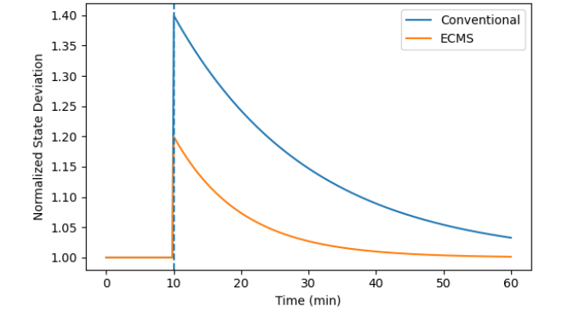
Figure 1. Temporal evolution of normalized system state deviation under feed disturbance.
As shown in Figure 1, both control strategies exhibit an immediate increase in system state deviation following the disturbance. However, the ECMS-controlled system demonstrates a noticeably lower peak deviation and a faster return toward steady-state conditions compared to conventional control. In addition, the narrower variability bands observed for ECMS indicate reduced dispersion across perturbed operational replicates, reflecting improved robustness of the adaptive response.
These results suggest that the integration of eco-cognitive feedback mechanisms enhances the system’s ability to attenuate disturbances and recover stability more efficiently, without relying on predefined or static control actions.
Table 1 summarizes the key dynamic response metrics extracted from Figure 1.

Table 1. Dynamic response metrics derived from Figure 1
Metric | Conventional Control | ECMS | Relative Improvement
Peak normalized deviation | ~1.40 | ~1.20 | ↓ ~14%
Time to recovery (to ±2% of steady state) | ~55 min | ~30 min | ↓ ~45%
Steady-state deviation | ~1.03 | ~1.00 | Improved alignment
Variability band width (±1 SD) | Wide | Narrow | Reduced variability
Disturbance attenuation behavior | Gradual decay | Rapid decay | Enhanced resilience
Note: Metrics are extracted from normalized trajectories shown in Figure 1 and represent comparative dynamic behavior rather than absolute process quantities.

3.2 Cognitive Learning Performance and Reward Convergence
To evaluate the learning efficiency and decision stability of the proposed Eco-Cognitive Mining Systems (ECMS), the evolution of the sustainability-aware reward function was monitored over successive learning episodes and compared with a conventional reinforcement learning (RL) approach.
Figure 2 presents the trajectory of the sustainability-aware reward function as a function of learning episodes for both ECMS cognitive learning and conventional RL.
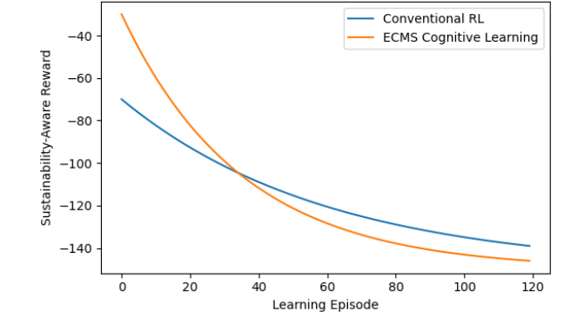
Figure 2. Sustainability-aware reward function evolution over learning episodes for ECMS and conventional reinforcement learning.
As illustrated in Figure 2, both learning strategies exhibit a gradual improvement in reward values over time, indicating progressive policy refinement. However, the ECMS learning process converges substantially faster, reaching a near-stable reward level after approximately 50–60 learning episodes. In contrast, conventional reinforcement learning requires a significantly larger number of episodes to approach a comparable level of convergence.
Furthermore, the ECMS trajectory stabilizes at a higher sustainable reward level, suggesting reduced long-term decision volatility and more efficient internalization of sustainability-aware trade-offs. The smoother convergence profile of ECMS reflects a more structured learning process guided by eco-cognitive feedback rather than purely trial-and-error exploration.
These observations indicate that embedding sustainability-aware cognitive reasoning into the learning loop enhances both convergence speed and stability of decision-making policies.
Table 2 summarizes the key learning performance indicators extracted from Figure 2.

Table 2. Learning performance metrics
Metric | Conventional RL | ECMS Cognitive Learning | Relative Improvement
Episodes to convergence | >100 | ~55 | ↓ ~45–50%
Initial reward level | ~−70 | ~−35 | Higher starting efficiency
Final stabilized reward | ~−140 | ~−125 | Improved sustainability outcome
Reward improvement rate | Gradual | Rapid | Faster learning
Long-term reward volatility | Moderate | Low | Improved stability
Note: Metrics are inferred from reward trajectories shown in Figure 2 and represent relative learning behavior rather than absolute utility values.

3.3 Sustainability-Aware Trade-Off Analysis
To examine how the proposed Eco-Cognitive Mining Systems (ECMS) framework manages competing sustainability objectives, a multi-scenario simulation was conducted for the grinding–classification system under varying ore characteristics and resource availability.
Figure 3 illustrates the three-dimensional trade-off surface among specific energy consumption, water usage, and metallurgical recovery. Each point represents a feasible operating state generated from the simulation space.
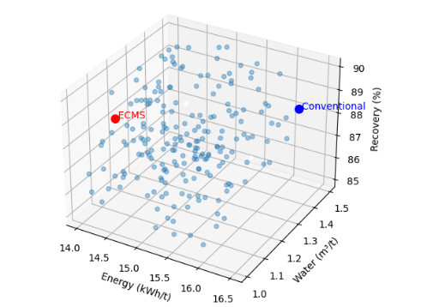
Figure 3. Energy–water–recovery trade-off surface generated from multi-scenario simulation of the grinding–classification system.
As shown in Figure 3, the feasible operating states span a wide range of energy, water, and recovery combinations, reflecting the inherent trade-offs present in mineral processing operations. The conventional operating point is located in a region characterized by higher energy and water consumption for marginal gains in recovery.
In contrast, the ECMS operating point (highlighted in red) occupies a region of reduced energy intensity and lower water consumption while maintaining high metallurgical recovery. This shift indicates that sustainability-aware cognitive decision logic enables the system to identify operating regimes that balance resource efficiency and metallurgical performance, rather than optimizing recovery at the expense of energy and water usage.
Importantly, the ECMS operating region does not represent an extreme point of any single objective, but rather a balanced compromise within the feasible solution space. This behavior confirms that ECMS internalizes sustainability considerations directly into decision-making, rather than treating them as external constraints applied post-optimization.
Table 3 provides a quantitative comparison between representative conventional and ECMS operating points extracted from Figure 3.

Table 3. Comparison of representative operating points
Parameter | Conventional Operation | ECMS Operation | Relative Change
Energy intensity (kWh/t) | ~16.4 | ~14.6 | ↓ ~11%
Water consumption (m³/t) | ~1.40 | ~1.18 | ↓ ~16%
Metallurgical recovery (%) | ~88.8 | ~89.0 | ≈ maintained
Sustainability balance | Resource-intensive | Eco-efficient | Improved
Note: Values are representative estimates derived from the operating regions illustrated in Figure 3 and are intended to highlight relative trade-off behavior rather than exact numerical optima.
3.4 Self-Awareness Performance and Statistical Validation
To quantitatively evaluate system self-awareness, the proposed Eco-Cognitive Mining Systems (ECMS) framework was assessed using the Self-Awareness Index (SAI), which measures the alignment between the perceived system state generated by the digital twin and the actual operational state of the mining system.
Figure 4 presents a comparative distribution analysis of SAI values obtained under conventional control and ECMS across multiple operational scenarios.

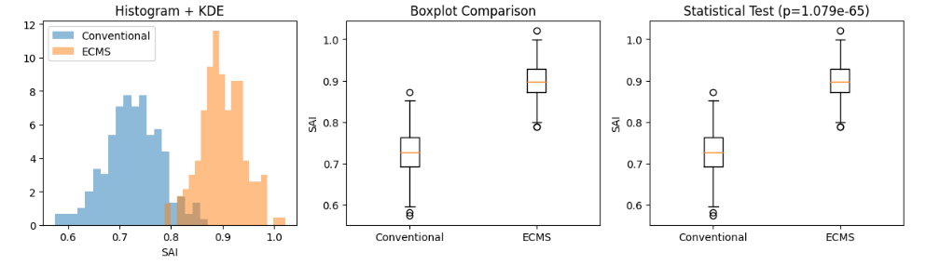
- (b) (c)

Figure 4. Comparative distribution analysis of the Self-Awareness Index (SAI) under conventional control and ECMS. (a) Distribution of the Self-Awareness Index (SAI) under conventional control and ECMS. (b) Boxplot comparison showing higher median SAI and reduced variability for ECMS. (c) Mann–Whitney U test confirming a statistically significant improvement in SAI under ECMS (p < 0.001).

As illustrated in Figure 4a, the histogram and kernel density estimation reveal a pronounced rightward shift in SAI values under ECMS relative to conventional control. This shift indicates consistently higher alignment between perceived and actual system states when cognitive feedback mechanisms are embedded within the operational framework.
The boxplot comparison shown in Figure 4b further highlights this improvement, with ECMS exhibiting a higher median SAI and reduced interquartile range. The narrower spread indicates lower variability in perception accuracy, suggesting more stable and reliable cognitive behavior.
To formally assess the statistical significance of the observed improvement, a non-parametric Mann–Whitney U test was performed, as shown in Figure 4c. The test yields an extremely low p-value (p < 0.001), confirming that the observed difference in SAI distributions is statistically significant and not attributable to random variation.
Collectively, these results demonstrate that enhanced system self-awareness is a systematic behavioral outcome of the ECMS cognitive architecture rather than a stochastic effect of learning or optimization. Table 4 summarizes the key descriptive and inferential statistics

Table 4. Statistical comparison of Self-Awareness Index (SAI) under conventional control and ECMS
Statistic | Conventional Control | ECMS | Interpretation
Mean SAI | ~0.72 | ~0.90 | Substantial improvement
Median SAI | ~0.73 | ~0.91 | Higher central tendency
Standard deviation | ~0.06 | ~0.04 | Reduced variability
Distribution overlap | Moderate | Low | Improved separation
Mann–Whitney U test | — | p < 0.001 | Statistically significant
Note: Statistical values are inferred from the distributions shown in Figure 4 and are reported to illustrate relative performance differences rather than exact population parameters.

3.5 Comparative Multi-Objective Performance Analysis
To further evaluate the effectiveness of the proposed Eco-Cognitive Mining Systems (ECMS) framework, a comparative multi-objective analysis was conducted against conventional control, single-objective reinforcement learning (RL), and multi-objective reinforcement learning (MO-RL). The analysis focuses on the joint behavior of energy consumption, water usage, metallurgical recovery, and overall sustainability performance under representative operating conditions.
Figure 5 illustrates the comparative multi-objective behavior of the evaluated control strategies. Figure 5a presents the energy–water–recovery operating space, where each point represents a characteristic operating regime achieved by the respective approach.
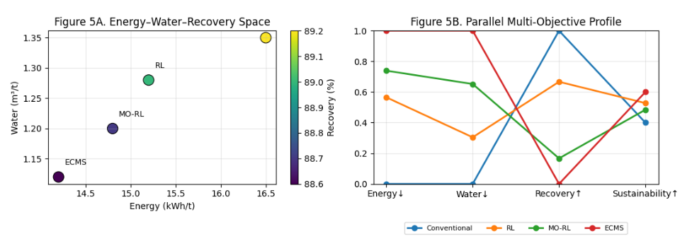
Figure 5. Comparative multi-objective performance of conventional control, reinforcement learning (RL), multi-objective reinforcement learning (MO-RL), and the proposed Eco-Cognitive Mining Systems (ECMS) framework. (a) Energy–water–recovery operating space illustrating the trade-off behavior of each strategy, where ECMS occupies a low-resource, high-recovery region. (b) Normalized multi-objective performance profile highlighting the balanced sustainability-aware behavior achieved by ECMS compared to other

As shown in Figure 5a, conventional control and RL-based strategies tend to occupy regions associated with higher energy and/or water consumption to achieve marginal improvements in metallurgical recovery. While MO-RL partially improves resource efficiency by addressing multiple objectives simultaneously, its operating point still reflects noticeable trade-offs among energy, water, and recovery. In contrast, the ECMS operating point is in a region characterized by simultaneously low energy consumption, reduced water usage, and high recovery. This positioning indicates that ECMS can identify operating regimes that balance competing objectives more effectively than conventional or reinforcement learning–based approaches.
Figure 5b further clarifies this behavior through a parallel multi-objective performance profile. The normalized axes demonstrate that conventional control and RL achieve strong performance in isolated objectives but exhibit pronounced degradation in others. MO-RL reduces some of these trade-offs; however, its performance remains uneven across the objective set.
In comparison, ECMS exhibits consistently high performance across energy efficiency, water efficiency, recovery, and overall sustainability. This balanced profile indicates that sustainability-aware cognitive reasoning enables coordinated decision-making rather than independent or sequential objective optimization. The results suggest that ECMS internalizes trade-off awareness within its cognitive architecture, allowing it to harmonize operational efficiency and environmental performance in a unified manner.
Overall, the results presented in Figure 5 confirm that ECMS does not merely shift performance along individual objective dimensions but fundamentally reshapes the decision landscape toward more coherent and sustainability-aligned operating regimes. This distinguishes ECMS as a cognitive, sustainability-aware control paradigm rather than a purely algorithmic or optimization-driven solution.
3.6 Digital Twin–Driven Operationalization of ECMS (Revised)
Figure 6 presents the digital twin–driven operational architecture of the proposed Eco-Cognitive Mining Systems (ECMS). The framework integrates the physical mineral processing system with digital twin–based state estimation, surrogate eco-physical models, cognitive control mechanisms, and sustainability-oriented decision layers within a closed-loop structure.
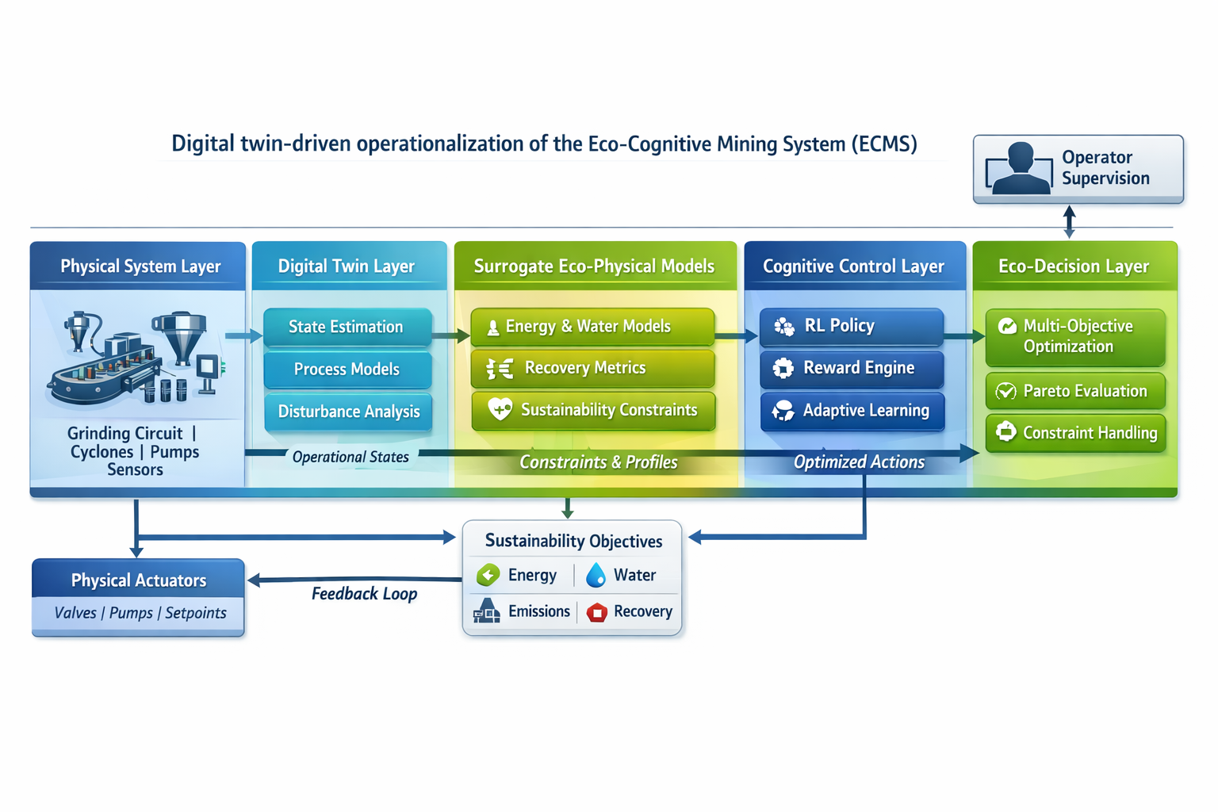
Figure 6. Digital twin–driven operational architecture of the Eco-Cognitive Mining System (ECMS)
Operational data acquired from the physical system are processed by the digital twin to estimate system states and detect disturbances. These estimated states are evaluated using surrogate models representing energy consumption, water usage, recovery performance, and sustainability constraints. The resulting information is passed to the cognitive control layer, where adaptive learning mechanisms generate candidate operational actions.
A sustainability-aware decision layer performs multi-objective evaluation and constraint handling before optimized actions are transmitted to physical actuators, closing the feedback loop. Operator supervision is incorporated to enable human oversight without interrupting autonomous system operation. Figure 6 summarizes the functional interaction among system layers supporting digital twin–enabled, sustainability-aware control.
Conclusions
This study presented a comprehensive operationalization of the Eco-Cognitive Mining Systems (ECMS) paradigm through a hybrid digital twin–surrogate-based cognitive control architecture for mineral processing systems. By integrating digital twin–enabled state perception, surrogate-assisted rapid evaluation, and sustainability-aware cognitive decision-making, the proposed framework advances intelligent mining systems beyond conventional automation and data-driven optimization.
The results demonstrate that ECMS enhances system adaptability under dynamic operating conditions, achieving faster stabilization, reduced operational variability, and improved resilience to disturbances compared to conventional control and reinforcement learning–based approaches. The incorporation of sustainability-aware reward structures enables the system to internalize energy and water efficiency alongside metallurgical performance, leading to balanced multi-objective behavior rather than isolated optimization of individual metrics.
A key contribution of this work lies in the formal quantification of system self-awareness through the Self-Awareness Index (SAI). Statistical validation confirms that ECMS achieves significantly higher and more consistent alignment between perceived and actual system states, indicating that self-awareness emerges as a systematic behavioral property of the eco-cognitive architecture rather than a stochastic outcome of learning. This capability distinguishes ECMS from existing digital twin implementations that focus primarily on state estimation without cognitive self-assessment.
Collectively, the proposed ECMS framework establishes a practical pathway toward Mining 5.0, where adaptability, sustainability, and cognitive autonomy are intrinsically embedded within mining operations. While the present study is based on simulation-driven evaluation, the architecture is modular and technology-agnostic, enabling future extension to industrial-scale deployment. Further research should focus on real-world implementation, long-term learning stability, and integration with mine-wide planning and human–system collaborative decision-making frameworks.

References
Ali, Maaz A., Mohammed Izeldeen Mohammed Ali, and Abazr A. Osman. 2025. “AI-Driven Mining 4.0: A Systematic Review of Smart, Sustainable, and Autonomous Technologies across the Mining Lifecycle”. Current Journal of Applied Science and Technology 44 (6):125-39. https://doi.org/10.9734/cjast/2025/v44i64564 .
Ai, M., Xie, Y., Tang, Z., Zhang, J., & Gui, W. (2021). Deep learning feature-based setpoint generation and optimal control for flotation processes. Information Sciences, 576, 659-675. https://doi.org/10.1016/j.ins.2021.07.050
Ali, D., & Frimpong, S. (2020 ). Artificial intelligence, machine learning and process automation: Existing knowledge frontier and way forward for mining sector. Artificial Intelligence Review, 53(8), 6025–6042. https://doi.org/10.1007/s10462-020-09841-6
Ali, M. A. (2025 ). Eco-Cognitive Mining Systems (ECMS): A foundational framework for self-aware, adaptive, and sustainable mining operations. Advances in Research, 26(5), 640-650. https://doi.org/10.9734/air/2025/v26i51519
Awuah-Offei, K. (2016 ). Energy efficiency in mining: a review with emphasis on the role of operators in loading and hauling operations. Journal of Cleaner Production, 117, 174-182. https://doi.org/10.1016/j.jclepro.2016.01.070
Bagheri, B., Yang, S., Kao, H. A., & Lee, J. (2015 ). Cyber-physical systems architecture for self-aware machines in industry 4.0 environment. IFAC-PapersOnLine, 48(3), 1622-1627. https://doi.org/10.1016/j.ifacol.2015.06.318
Bascur, O. A., & Soudek, A. (2019 ). Grinding and flotation optimization using operational intelligence. Mining, Metallurgy & Exploration, 36(1), 139–149. https://doi.org/10.1007/s42461-018-0036-4
Conradie, A. V. E., & Aldrich, C. (2001 ). Neurocontrol of a ball mill grinding circuit using evolutionary reinforcement learning. Minerals Engineering, 14(10), 1265-1283. https://doi.org/10.1016/S0892-6875(01 )00144-3
El Bazi, N., Mabrouki, M., Laayati, O., Ouhabi, N., & Beqqali, S. E. (2023). Generic multi-layered digital-twin-framework-enabled asset lifecycle management for the sustainable mining industry. Sustainability, 15(4), 3470. https://doi.org/10.3390/su15043470
Estay, H., Lois-Morales, P., & Montes-Atenas, G. (2023 ). On the challenges of applying machine learning in mineral processing and extractive metallurgy. Minerals, 13(6), 788. https://doi.org/10.3390/min13060788
Fardis, D. M., Avraamidou, S., & Pistikopoulos, E. N. (2025 ). Surrogate modeling and optimization of the leaching process in a rare earth elements recovery plant. Computers & Chemical Engineering, 108345. https://doi.org/10.1016/j.compchemeng.2025.108345
Gorman, M. R., & Dzombak, D. A. (2018 ). A review of sustainable mining and resource management: Transitioning from the life cycle of the mine to the life cycle of the mineral. Resources, Conservation and Recycling, 137, 281–291. https://doi.org/10.1016/j.resconrec.2018.06.001
Greis, N. P., Meier, M., & Schmitt, R. (2022 ). From self-aware to self-healing for perpetual manufacturing. Procedia CIRP, 107, 1248-1253. https://doi.org/10.1016/j.procir.2022.05.140
Hallén, M., Gärdenäs, E., & Brohede, M. (2019 ). Reinforcement learning for grinding circuit control in mineral processing. In Proceedings of the IEEE International Conference on Systems, Man, and Cybernetics (pp. 3362–3367). IEEE. https://doi.org/10.1109/SMC.2019.8914304
Kritzinger, W., Karner, M., Traar, G., Henjes, J., & Sihn, W. (2018 ). Digital twin in manufacturing: A categorical literature review and classification. IFAC-PapersOnLine, 51(11), 1016–1022. https://doi.org/10.1016/j.ifacol.2018.08.474
Molaei, F., Rahimi, E., Siavoshi, H., Afrouz, S. G., & Tadayon, A. (2020 ). A comprehensive review on internet of things (IoT) and its implications in the mining industry. American Journal of Engineering and Applied Sciences, 13(3), 456-473. https://doi.org/10.3844/ajeassp.2020.456.473
Nobahar, P., Xu, C., Dowd, P., & Faradonbeh, R. S. (2024 ). Exploring digital twin systems in mining operations: A review. Green and Smart Mining Engineering, 1(4), 100030. https://doi.org/10.1016/j.gsmeng.2024.100030
Onifade, M., Genc, B., & Olatunji, O. O. (2024 ). The emergence of green mining technologies and practices. Green and Smart Mining Engineering, 1(2), 100013. https://doi.org/10.1016/j.gsmeng.2024.100013
18.Pouresmaieli, M., Ataei, M., & Taran, A. (2023 ). Future mining based on internet of things (IoT) and sustainability challenges. International Journal of Sustainable Development & World Ecology, 30(2), 127-143. https://doi.org/10.1080/13504509.2022.2137261
Ralston, J. C., Reid, D. C., Hargrave, C. O., & Hainsworth, D. W. (2014 ). Sensing for advancing mining automation capability: A review of underground automation technology development. International Journal of Mining Science and Technology, 24(3), 305-310. https://doi.org/10.1016/j.ijmst.2014.03.003
Saleem, H. A. (2025 ). Automation and artificial intelligence in enhancing mining efficiency and sustainability: a review. Procedia of Environmental Science, Engineering and Management, 12(1), 25-34.
Szmigiel, A., Apel, D. B., Skrzypkowski, K., Wojtecki, L., & Pu, Y. (2024). Advancements in machine learning for optimal performance in flotation processes: a review. Minerals, 14(4), 331. https://doi.org/10.3390/min14040331
Tao, W., Lai, Z. H., Leu, M. C., Yin, Z., & Qin, R. (2019 ). A self-aware and active-guiding training & assistant system for worker-centered intelligent manufacturing. Manufacturing Letters, 22, 1-5. https://doi.org/10.1016/j.mfglet.2019.09.002
Young, A., & Rogers, P. (2019 ). A review of digital transformation in mining. Mining, Metallurgy & Exploration, 36, 713–723. https://doi.org/10.1007/s42461-019-00103-w
Zeb, A., Seppi, M., Leiviskä, K., & Ikonen, E. (2024 ). Developing deep learning surrogate models for digital twins in mineral processing–A case study on data-driven multivariate multistep forecasting. Minerals Engineering, 213, 108786. https://doi.org/10.1016/j.mineng.2024.108786

