Comparison of Manual Versus Automated Complete Blood Count Parameters in Patients Attending Plateau Specialist Hospital, Jos, Nigeria

Abstract

Background
The complete blood count (CBC) is a fundamental laboratory investigation used in the diagnosis and monitoring of a wide range of clinical conditions. While automated hematology analyzers are increasingly adopted due to their speed and precision, manual methods remain widely used in resource-limited settings. Comparative evaluation of these methods is essential to ensure analytical reliability and clinical relevance.

Objective
To compare complete blood count parameters obtained using manual hematological techniques with those generated by an automated hematology analyzer (ADVIA 120i) among patients attending Plateau Specialist Hospital, Jos, Nigeria.

Methods
This cross-sectional, laboratory-based method-comparison study involved 50 adult patients requiring CBC testing. Venous blood samples were analyzed using both manual methods and an automated hematology analyzer. Parameters compared included RBC count, WBC count, hemoglobin concentration, hematocrit, platelet count, and red cell indices. Statistical analysis was performed using paired t-tests, Pearson correlation coefficients, and Bland–Altman agreement analysis, with significance set at p < 0.05.

Results
There was no statistically significant difference between manual and automated methods for RBC count, hemoglobin concentration, hematocrit, and platelet count (p > 0.05). However, significant differences were observed for WBC count (p = 0.018) and mean corpuscular volume (p = 0.005). Strong positive correlations were demonstrated for all parameters (r = 0.91–0.99; p < 0.001). Bland–Altman analysis revealed minimal mean bias for most parameters, though wider limits of agreement were noted for platelet counts. Time-based analysis showed progressive instability of CBC parameters with delayed testing, more pronounced in manual methods.

Conclusion
Manual and automated CBC methods show strong correlation and acceptable agreement for most hematological parameters. Automated analysis offers superior precision and consistency, while manual methods remain essential for quality control and morphological assessment. A combined approach is recommended to optimize diagnostic accuracy, particularly in resource-limited healthcare settings.

Keywords: Complete blood count; Manual method; Automated hematology analyzer; Method comparison; Nigeria

Introduction
The Complete Blood Count (CBC) is one of the most routinely requested laboratory investigations in clinical medicine, serving as a cornerstone for the diagnosis, prognosis, and monitoring of a wide range of hematological and non-hematological disorders. It provides essential quantitative information on erythrocytes, leukocytes, and platelets, as well as indices that reflect red cell morphology and bone marrow function. In both acute and chronic disease settings, CBC results guide clinical decision-making, transfusion practices, infection management, and therapeutic monitoring [1]. Historically, CBC parameters were determined using manual laboratory techniques such as hemocytometry, microhematocrit determination, hemoglobin estimation by the cyanmethemoglobin method, and microscopic differential leukocyte counts from stained peripheral blood smears. These methods, although foundational to hematology, are inherently labor-intensive, time-consuming, and prone to inter-observer and intra-observer variability. Accuracy may also be compromised by technical factors including dilution errors, inadequate mixing, counting fatigue, and subjective interpretation, particularly when processing large numbers of samples [2].
The introduction of automated hematology analyzers has significantly transformed hematological diagnostics. Modern analyzers utilize advanced technologies such as electrical impedance, optical light scattering, and flow cytometry to generate rapid, precise, and reproducible CBC results. Automation offers advantages including reduced turnaround time, improved analytical precision, high sample throughput, and standardized reporting of hematological parameters. These benefits have made automated CBC analysis the preferred method in well-resourced laboratory settings [3-4]. Despite these advancements, manual CBC methods remain widely practiced in many low- and middle-income countries, including Nigeria. Factors such as limited financial resources, inconsistent electricity supply, scarcity of automated analyzers, high maintenance costs, and lack of technical support continue to hinder full adoption of automation in many healthcare facilities. Furthermore, even in laboratories equipped with automated analyzers, manual peripheral blood smear examination remains indispensable for detecting abnormal cell morphology, hemoparasites, platelet clumping, and for validating flagged or questionable automated results [5].
In clinical practice, discrepancies between manual and automated CBC results may influence patient management, particularly in conditions such as anemia, leukocytosis, thrombocytopenia, and hematologic malignancies. Several studies conducted in different populations have reported varying degrees of concordance between manual and automated CBC parameters, with notable differences observed in white blood cell counts, platelet counts, and differential leukocyte distributions. However, such findings are often influenced by population characteristics, disease patterns, laboratory expertise, and analyzer technology [6-7].
In Nigeria, and particularly in Plateau State, limited published data exist comparing manual and automated CBC parameters within routine hospital practice. Plateau Specialist Hospital, Jos, serves a diverse patient population with varying hematological profiles, making it an appropriate setting for evaluating the performance of these diagnostic approaches. Assessing the comparability of manual and automated CBC methods in this context is essential for strengthening laboratory quality assurance, optimizing resource utilization, and informing evidence-based laboratory policies [8]. This study therefore aimed to compare selected complete blood count parameters obtained by manual methods with those generated by an automated hematology analyzer among patients attending Plateau Specialist Hospital, Jos, Nigeria. The findings are expected to provide insight into the reliability, limitations, and complementary roles of both methods in routine hematological diagnostics within resource-limited healthcare settings.

Research Methodology
Research Design
This study employed a cross-sectional, laboratory-based method-comparison design aimed at evaluating the agreement between manual and automated complete blood count (CBC) parameters. Venous blood samples were collected from a defined study population attending Plateau Specialist Hospital, Jos, Nigeria. Each sample was analyzed using both an automated hematology analyzer (ADVIA 120i) and standard manual hematological techniques for selected CBC parameters. By applying both methods to the same samples at a single point in time, this design enabled a direct head-to-head comparison, facilitating the assessment of concordance, quantification of analytical differences, and identification of potential systematic biases between the two approaches.
Study Setting
The study was conducted in the Hematology Laboratory of Plateau Specialist Hospital, Jos, equipped with manual tools and an ADVIA 120i five-part differential hematology analyzer.
Study Population
The study population consisted of adult patients attending Plateau Specialist Hospital for routine or diagnostic hematological investigations. Only patients whose clinical evaluation required CBC analysis and who voluntarily consented to participate in the study were considered eligible.
Inclusion Criteria
Participants were included in the study if they:
• Were adults attending Plateau Specialist Hospital.
• Required complete blood count testing as part of routine or diagnostic clinical evaluation.
• Provided written informed consent to participate in the study.
Exclusion Criteria
Patients were excluded from the study if they:
• Declined to give informed consent.
• Had grossly hemolyzed or clotted blood samples deemed unsuitable for analysis.
• Were receiving therapies known to cause significant and acute alterations in hematological parameters at the time of sample collection.
Sample Size Determination
The sample size was determined using the standard formula for paired comparative studies:
n = ((Zα/2 + Zβ) / (δ / σd))²

Where:
n = required sample size
Zα/2 = 1.96
Zβ = 0.84
σd = 1.0
δ = 0.4
The calculated minimum sample size was 49, rounded up to 50 samples.
Sampling Procedure
A simple random sampling technique was employed. Venous blood samples were collected aseptically by trained laboratory personnel into EDTA tubes and divided for manual and automated analysis. Analyses were performed at predefined intervals to assess time-dependent variations.
Data Analysis
Data were analyzed using SPSS version 16. Descriptive statistics, paired t-tests, Pearson correlation, and Bland–Altman analysis were employed. Statistical significance was set at p < 0.05.
Ethical Considerations
Ethical approval was obtained from the Africa University Research Ethics Committee (AUREC AU4026/25) and Plateau Specialist Hospital Research Ethics Committee. Written informed consent was obtained, and confidentiality maintained in accordance with the Declaration of Helsinki.

Results

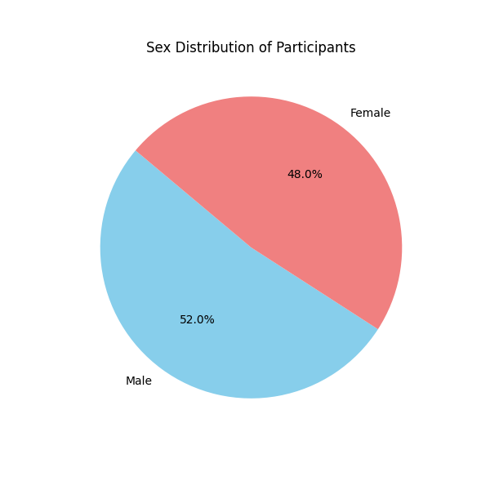
Figure 1: Sex Distribution of Participants

Table 1: Demographic and Clinical Characteristics of Participants
Characteristic | Value
Age (years)
Mean ± SD | 38.7 ± 14.2
Range | 18 – 65
Sex, n (%)
Male | 26 (52%)
Female | 24 (48%)
Clinical Indication, n (%)
Anemia Investigation | 20 (40%)
Infection Screening | 16 (32%)
Preoperative Workup | 10 (20%)
Chronic Disease Monitoring | 4 (8%)

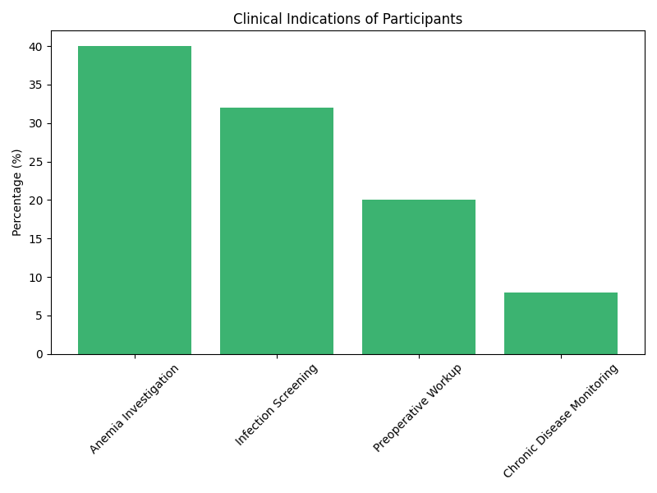
Figure 2: Clinical Indications of Participants
The bar chart (Figure 2) provides a clear visual representation of these clinical indications, with anemia investigation being the most prominent reason for testing.

Table 2: Hematological Parameters Analyzed by Manual Method
Parameter | Manual Method (Mean ± SD)
RBC (×10¹²/L) | 4.51 ± 0.75
WBC (×10⁹/L) | 7.82 ± 2.42
Platelets (×10⁹/L) | 248 ± 87
Hemoglobin (g/dL) | 12.15 ± 2.18
Hematocrit (%) | 36.85 ± 6.05
MCV (fL) | 85.2 ± 7.1
MCH (pg) | 27.1 ± 2.8
MCHC (g/dL) | 31.8 ± 1.5
Neutrophils (%) | 61.5 ± 12.3
Lymphocytes (%) | 30.2 ± 10.5
Monocytes (%) | 5.1 ± 2.1
Eosinophils (%) | 2.8 ± 1.9
Basophils (%) | 0.4 ± 0.3

Table 3: Hematological Parameters Analyzed by Automated Method
Parameter | Automated Method (Mean ± SD)
RBC (×10¹²/L) | 4.58 ± 0.72
WBC (×10⁹/L) | 7.48 ± 2.38
Platelets (×10⁹/L) | 240 ± 85
Hemoglobin (g/dL) | 12.32 ± 2.14
Hematocrit (%) | 37.25 ± 5.98
MCV (fL) | 81.4 ± 6.8
MCH (pg) | 26.9 ± 2.5
MCHC (g/dL) | 33.1 ± 1.2
Neutrophils (%) | 59.8 ± 11.5
Lymphocytes (%) | 32.5 ± 9.8
Monocytes (%) | 5.5 ± 1.8
Eosinophils (%) | 1.9 ± 1.5
Basophils (%) | 0.3 ± 0.2

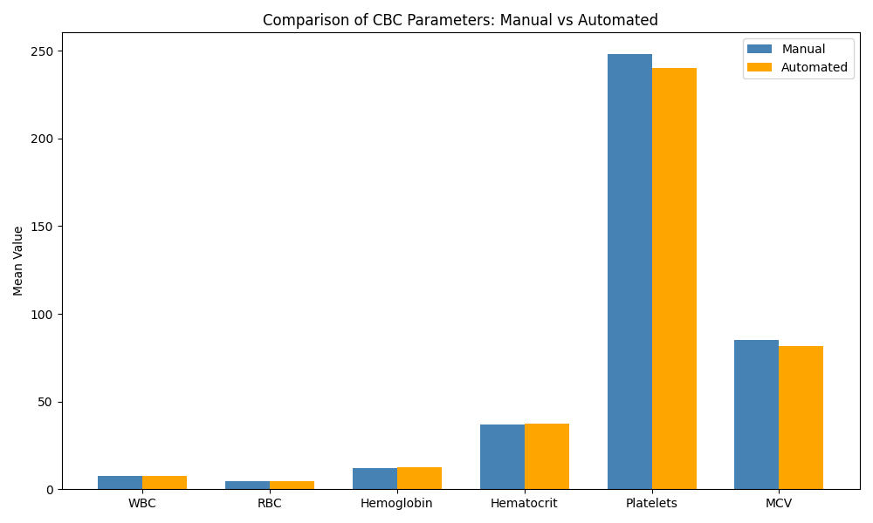
Figure 3: Comparison of CBC Parameters: Manual vs Automated

Table 4.: Comparison of Mean CBC Parameters: Manual vs. Automated
Parameter | Manual (Mean ± SD) | Automated (Mean ± SD) | Mean Difference | p-value
WBC (×10⁹/L) | 7.82 ± 2.42 | 7.48 ± 2.38 | +0.34 | 0.018*
RBC (×10¹²/L) | 4.51 ± 0.75 | 4.58 ± 0.72 | -0.07 | 0.104
Hemoglobin (g/dL) | 12.15 ± 2.18 | 12.32 ± 2.14 | -0.17 | 0.089
Hematocrit (%) | 36.85 ± 6.05 | 37.25 ± 5.98 | -0.40 | 0.215
Platelets (×10⁹/L) | 248 ± 87 | 240 ± 85 | +8 | 0.074
MCV (fL) | 85.2 ± 7.1 | 81.4 ± 6.8 | +3.8 | 0.005*

Statistically significant (p < 0.05)
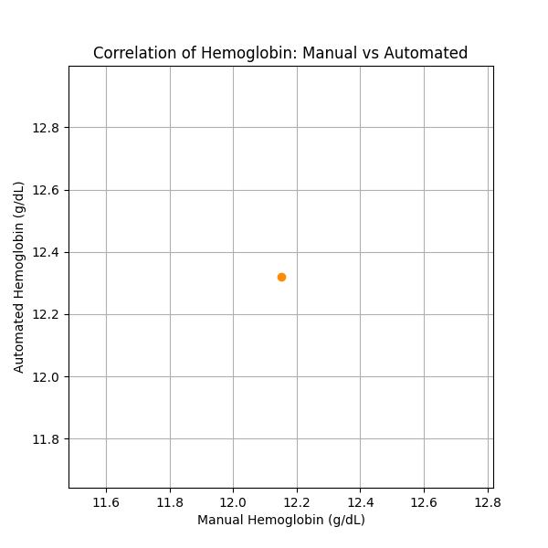
Figure 4: Correlation of Hemoglobin: Manual vs Automated

Table 5: Pearson’s Correlation Coefficients for Manual vs. Automated Methods
Parameter | Correlation Coefficient (r) | p-value
WBC | 0.94 | < 0.001
RBC | 0.97 | < 0.001
Hemoglobin | 0.99 | < 0.001
Hematocrit | 0.98 | < 0.001
Platelets | 0.93 | < 0.001
MCV | 0.91 | < 0.001

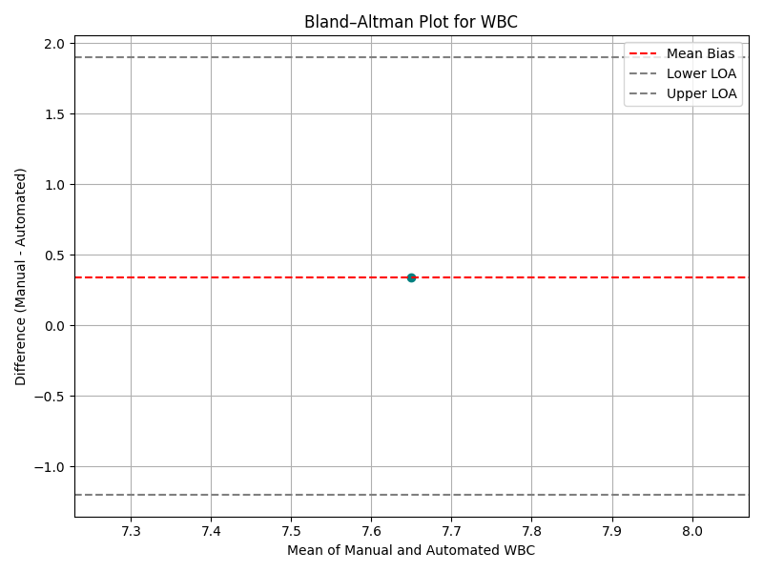
Figure 5: Bland-Altman Plot for WBC

Table 6: Bland–Altman Analysis for Agreement between Methods
Parameter | Mean Bias | Lower LOA | Upper LOA
WBC (×10⁹/L) | +0.34 | -1.2 | +1.9
RBC (×10¹²/L) | -0.07 | -0.6 | +0.5
Hemoglobin (g/dL) | -0.17 | -0.8 | +0.5
Hematocrit (%) | -0.40 | -2.5 | +1.7
Platelets (×10⁹/L) | +8 | -45 | +61

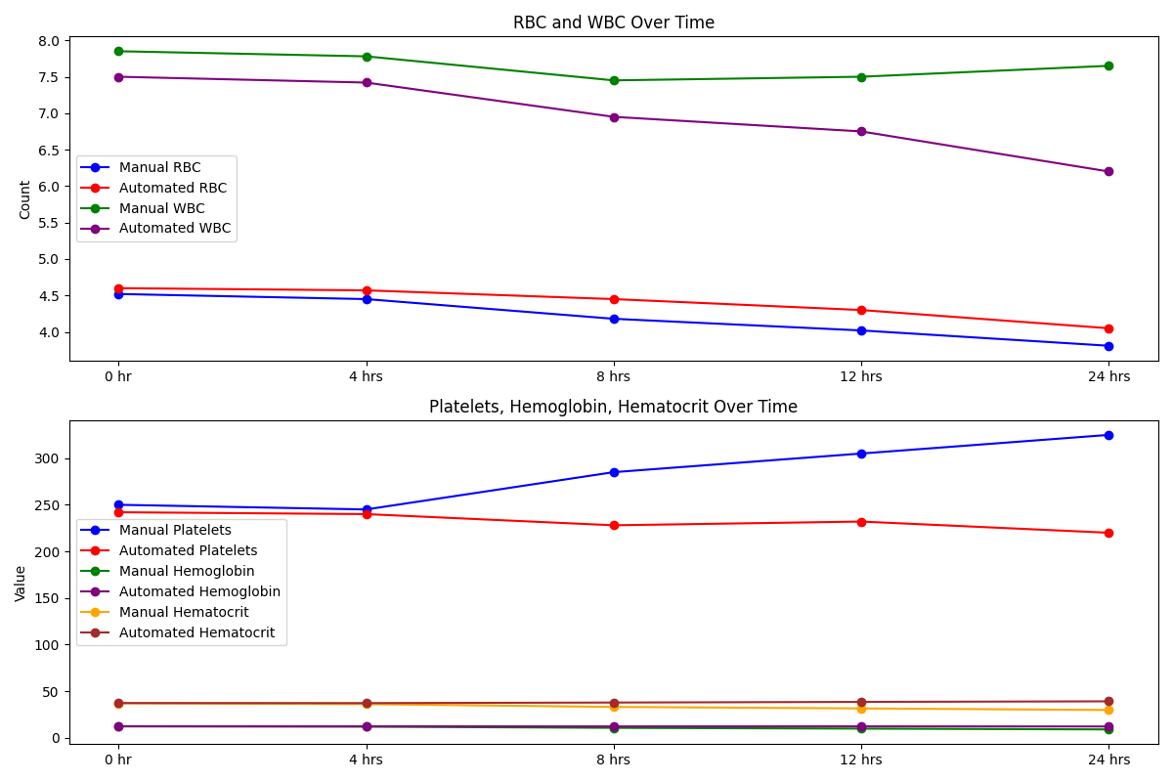
Figure 6: Presentation of RBC and WBC over time

Table 7: Manual Method (0–24 Hours)
Parameter | 0 hr | 4 hrs | 8 hrs | 12 hrs | 24 hrs
RBC | 4.52 ± 0.74 | 4.45 ± 0.75 | 4.18 ± 0.81* | 4.02 ± 0.85* | 3.81 ± 0.89*
WBC | 7.85 ± 2.45 | 7.78 ± 2.48 | 7.45 ± 2.55* | 7.50 ± 2.58 | 7.65 ± 2.61
Platelets | 250 ± 88 | 245 ± 89 | 285 ± 95* | 305 ± 98* | 325 ± 102*
Hemoglobin | 12.20 ± 2.20 | 11.90 ± 2.25* | 10.65 ± 2.35* | 9.80 ± 2.40* | 8.95 ± 2.45*
Hematocrit | 36.90 ± 6.10 | 36.10 ± 6.20* | 33.10 ± 6.40* | 31.50 ± 6.50* | 29.80 ± 6.60*
MCV | 85.5 ± 7.2 | 86.0 ± 7.4 | 84.8 ± 7.6 | 84.5 ± 7.7 | 84.0 ± 7.8
MCHC | 31.9 ± 1.6 | 31.8 ± 1.7 | 31.6 ± 1.8 | 31.5 ± 1.8 | 31.4 ± 1.9

Table 8: Automated Method (ADVIA 120i) (0–24 Hours)
Parameter | 0 hr | 4 hrs | 8 hrs | 12 hrs | 24 hrs
RBC | 4.60 ± 0.73 | 4.57 ± 0.74 | 4.45 ± 0.76* | 4.30 ± 0.78* | 4.05 ± 0.81*
WBC | 7.50 ± 2.40 | 7.42 ± 2.43 | 6.95 ± 2.48* | 6.75 ± 2.50* | 6.20 ± 2.55*
Platelets | 242 ± 86 | 240 ± 87 | 228 ± 90* | 232 ± 92* | 220 ± 95*
Hemoglobin | 12.35 ± 2.15 | 12.30 ± 2.18 | 12.20 ± 2.22 | 12.25 ± 2.23 | 12.10 ± 2.25
Hematocrit | 37.30 ± 6.00 | 37.20 ± 6.05 | 37.80 ± 6.10* | 38.50 ± 6.12* | 39.10 ± 6.15*
MCV | 81.5 ± 6.9 | 82.0 ± 7.0 | 84.8 ± 7.2* | 85.5 ± 7.3* | 86.8 ± 7.4*
MCHC | 33.2 ± 1.3 | 33.0 ± 1.4 | 32.3 ± 1.5* | 31.9 ± 1.5* | 31.5 ± 1.6*

A total of 50 adult patients were included in the study. The demographic and clinical characteristics of the participants are summarized in Table 1. The mean age of the study population was 38.7 ± 14.2 years, with ages ranging from 18 to 65 years, reflecting a broad adult patient population typically encountered in routine hospital practice. The sex distribution was nearly equal, comprising 26 males (52%) and 24 females (48%). This balanced distribution is illustrated in Figure 1, which confirms that both sexes were adequately represented, thereby minimizing potential gender-related bias in the comparison of hematological parameters. Regarding clinical indications for CBC testing, anemia investigation was the most common reason, accounting for 40% of cases. This was followed by infection screening (32%), preoperative workup (20%), and monitoring of chronic diseases (8%). The distribution of these indications is visually represented in Figure 2, where anemia investigation clearly predominates. Overall, these findings indicate that the study samples were drawn from a wide range of routine clinical scenarios, enhancing the external validity and applicability of the study results. The baseline hematological parameters obtained using the manual method are presented in Table 2, while corresponding values obtained using the automated ADVIA 120i analyzer are shown in Table 3. For both methods, the mean values of key CBC parameters—including red blood cell (RBC) count, white blood cell (WBC) count, hemoglobin concentration, hematocrit, and platelet count—fell largely within physiologically normal reference ranges for adults.
A preliminary comparison of mean values between the two methods demonstrated close agreement for most parameters. However, certain differences were observed, particularly in red cell indices. The manual method yielded a higher mean corpuscular volume (MCV) (85.2 ± 7.1 fL) compared with the automated method (81.4 ± 6.8 fL), while the mean corpuscular hemoglobin concentration (MCHC) was lower using the manual method (31.8 ± 1.5 g/dL) than the automated method (33.1 ± 1.2 g/dL). These discrepancies are consistent with known methodological differences, as manual indices are calculated from measured parameters, whereas automated analyzers derive indices using direct cell volume measurements and proprietary algorithms. Differential leukocyte counts obtained by both methods were broadly comparable, although minor variations were observed across neutrophil, lymphocyte, monocyte, eosinophil, and basophil percentages. A direct comparison of mean CBC parameters obtained by the two methods is presented in Table 4, with corresponding statistical analysis using paired t-tests. For most parameters—including RBC count, hemoglobin concentration, hematocrit, and platelet count—no statistically significant differences were observed between the manual and automated methods (p > 0.05), indicating comparable performance for these core indices.
However, statistically significant differences were observed for WBC count (p = 0.018) and MCV (p = 0.005). The manual method yielded a slightly higher mean WBC count compared to the automated method, with a positive mean difference of +0.34 × 10⁹/L. Additionally, the manual method produced a markedly higher mean MCV than the automated analyzer, with a mean difference of +3.8 fL. These differences are visually emphasized in Figure 3, which illustrates the comparative mean values of selected CBC parameters. Despite the observed mean differences in certain parameters, Pearson’s correlation analysis demonstrated a very strong positive linear relationship between the two methods for all parameters assessed, as shown in Table 5. Correlation coefficients ranged from 0.91 to 0.99, with all correlations reaching statistical significance (p < 0.001). Hemoglobin showed the strongest correlation (r = 0.99), indicating almost perfect linear agreement. This relationship is illustrated in Figure 4, where the scatter plot shows data points tightly clustered along the line of best fit. These findings indicate that although small systematic differences exist, both methods track changes in hematological parameters consistently across the measurement range, supporting their concurrent validity.
Agreement between the two methods was further assessed using Bland–Altman analysis. The mean bias and limits of agreement (LOA) for selected parameters are summarized in Table 6, with the Bland–Altman plot for WBC illustrated in Figure 5. For WBC count, the mean bias was +0.34 × 10⁹/L, confirming that the manual method tended to yield slightly higher values than the automated analyzer. The limits of agreement ranged from −1.2 to +1.9 × 10⁹/L, indicating that 95% of the differences between the two methods fell within this range. While this level of disagreement may be clinically acceptable in many situations, it could be significant in patients with critical leukocyte abnormalities. For RBC count, hemoglobin, and hematocrit, the mean biases were small, suggesting excellent overall agreement between the two methods. Platelet counts exhibited wider limits of agreement (−45 to +61 × 10⁹/L), indicating greater variability at the individual sample level despite reasonable average agreement. This finding underscores the importance of manual smear review in cases of abnormal or borderline platelet counts.
The stability of CBC parameters over a 24-hour period was evaluated for both methods, with results presented in Tables 7 and 8 and graphically illustrated in Figure 6. Using the manual method, there was a statistically significant decline in RBC count, hemoglobin concentration, and hematocrit beginning as early as 8 hours post-collection. Platelet counts, in contrast, showed a significant increase after 8 hours, likely due to platelet disaggregation during repeated sample handling. WBC values showed relatively modest fluctuations, while MCV and MCHC remained comparatively stable. In contrast, the automated ADVIA 120i analyzer demonstrated more gradual changes over time. Significant declines in WBC and RBC counts were observed, accompanied by progressive increases in MCV and hematocrit, consistent with red cell swelling during sample storage. Hemoglobin values remained relatively stable throughout the 24-hour period.

Discussion
This study compared complete blood count (CBC) parameters obtained using manual hematological techniques and an automated hematology analyzer (ADVIA 120i) among patients attending Plateau Specialist Hospital, Jos, Nigeria. Overall, the findings demonstrate a high level of concordance between the two methods for most core hematological parameters, while also revealing statistically significant differences in specific indices, notably white blood cell (WBC) count and mean corpuscular volume (MCV). These observations highlight both the strengths and limitations of each approach and underscore their complementary roles in routine hematological practice. The demographic profile of the study population, characterized by a broad adult age range and near-equal sex distribution, supports the generalizability of the findings to typical hospital-based adult populations. Furthermore, the predominance of anemia investigation and infection screening as clinical indications reflects real-world laboratory utilization patterns in Nigeria and similar resource-limited settings. This clinical diversity strengthens the relevance of the comparative analysis, as the samples encompassed a wide spectrum of hematological states rather than a narrowly defined disease group [9].
With respect to baseline hematological parameters, the close agreement observed between manual and automated methods for RBC count, hemoglobin concentration, hematocrit, and platelet count suggests that both techniques are generally reliable for routine CBC assessment. The lack of statistically significant differences for these parameters is consistent with several previous studies, which have reported comparable performance of manual and automated methods when standard operating procedures are rigorously followed. In particular, the strong agreement for hemoglobin estimation is clinically reassuring, given the central role of hemoglobin measurement in the diagnosis and management of anemia [10]. However, the study identified statistically significant differences in WBC count and MCV between the two methods. The manual method yielded slightly higher WBC counts compared with the automated analyzer. This finding may be attributed to the inherent subjectivity of manual counting using a hemocytometer, where debris, nucleated red blood cells, or platelet clumps may be misclassified as leukocytes. In contrast, automated analyzers apply standardized gating and discrimination algorithms, which reduce such sources of error but may occasionally exclude atypical cells. Similar trends of higher manual WBC counts have been documented in earlier comparative studies, particularly in samples with borderline leukocytosis [11].
The observed difference in MCV between the two methods is a well-recognized phenomenon in hematological diagnostics. Manual MCV is calculated indirectly from hematocrit and RBC count, both of which are themselves subject to pre-analytical and analytical variability. Automated analyzers, on the other hand, measure red cell volume directly using impedance or optical techniques. The higher MCV values reported by the manual method in this study likely reflect cumulative measurement and calculation errors, as well as the influence of plasma trapping during microhematocrit centrifugation. These findings are consistent with reports by Buttarello and others, who have emphasized that MCV discrepancies are among the most common differences observed in method-comparison studies [12]. Despite the statistically significant mean differences observed for WBC and MCV, correlation analysis revealed exceptionally strong positive linear relationships between manual and automated measurements for all parameters, with correlation coefficients exceeding 0.90. This indicates that the two methods track changes in hematological values consistently across the measurement range. The near-perfect correlation observed for hemoglobin further reinforces the analytical reliability of both methods and supports their concurrent validity. High correlation, however, does not necessarily imply interchangeability, highlighting the importance of complementary agreement analyses [13].
Bland–Altman analysis provided critical insight into the level of agreement between the two methods. The small mean biases observed for most parameters indicate minimal systematic error, suggesting that, on average, manual and automated methods produce similar results. Nevertheless, the relatively wide limits of agreement observed for platelet counts indicate greater variability at the individual sample level. This variability is clinically significant, particularly in patients with thrombocytopenia or thrombocytosis, where small numerical differences may influence clinical decisions. These findings reinforce the necessity of manual peripheral blood smear review to confirm automated platelet counts, especially when abnormal values are reported [14]. The time-based stability analysis further highlighted important methodological differences. The manual method demonstrated marked deterioration in several parameters over time, including declines in RBC count, hemoglobin, and hematocrit, as well as an apparent increase in platelet counts after prolonged storage. These changes are likely attributable to red cell degradation, plasma redistribution, and platelet disaggregation during repeated handling. In contrast, the automated analyzer showed more gradual and predictable changes, including increasing MCV and hematocrit over time, consistent with red cell swelling in stored EDTA samples. These findings agree with established literature, which emphasizes that delayed analysis adversely affects CBC accuracy regardless of method, although manual techniques appear more vulnerable to handling-related artifacts [15-16].

Conclusion
This study demonstrated that manual and automated methods for complete blood count (CBC) analysis show a high degree of concordance for most core hematological parameters among patients attending Plateau Specialist Hospital, Jos, Nigeria. Parameters such as red blood cell count, hemoglobin concentration, hematocrit, and platelet count did not differ significantly between the two methods, indicating that both approaches are generally reliable for routine hematological assessment when properly performed. However, statistically significant differences were observed for white blood cell count and mean corpuscular volume, reflecting inherent methodological differences between manual counting techniques and automated analyzer measurements. Despite these differences, strong positive correlations were observed across all parameters, confirming that manual and automated methods track hematological changes consistently and exhibit good concurrent validity. Agreement analysis further revealed minimal systematic bias for most parameters, although wider limits of agreement were noted for platelet counts, underscoring the need for manual smear review in cases of abnormal or borderline results. Additionally, time-based analysis highlighted progressive instability of CBC parameters with delayed testing, particularly when using manual methods, emphasizing the importance of timely sample processing.
References
- Seo, I. H., & Lee, Y. J. (2022). Usefulness of Complete Blood Count (CBC) to Assess Cardiovascular and Metabolic Diseases in Clinical Settings: A Comprehensive Literature Review. Biomedicines, 10(11), 2697. https://doi.org/10.3390/biomedicines10112697
- Whitehead, R. D., Jr, Mei, Z., Mapango, C., & Jefferds, M. E. D. (2019). Methods and analyzers for hemoglobin measurement in clinical laboratories and field settings. Annals of the New York Academy of Sciences, 1450(1), 147–171. https://doi.org/10.1111/nyas.14124
- Chhabra G. (2018). Automated hematology analyzers: Recent trends and applications. Journal of laboratory physicians, 10(1), 15–16. https://doi.org/10.4103/JLP.JLP_124_17
- Holl, E., Kapinsky, M., & Larbi, A. (2025). An Update on Flow Cytometry Analysis of Hematological Malignancies: Focus on Standardization. Cancers, 17(12), 2045. https://doi.org/10.3390/cancers17122045
- Pelz, S., Chinichian, N., Neyrand, C., & Blechinger, P. (2023). Electricity supply quality and use among rural and peri-urban households and small firms in Nigeria. Scientific data, 10(1), 273. https://doi.org/10.1038/s41597-023-02185-0
- Gulati, G., Uppal, G., & Gong, J. (2022). Unreliable Automated Complete Blood Count Results: Causes, Recognition, and Resolution. Annals of laboratory medicine, 42(5), 515–530. https://doi.org/10.3343/alm.2022.42.5.515
- Liao, H., Zhang, F., Chen, F., Li, Y., Sun, Y., Sloboda, D. D., Zheng, Q., Ying, B., & Hu, T. (2025). Application of artificial intelligence in laboratory hematology: Advances, challenges, and prospects. Acta pharmaceutica Sinica. B, 15(11), 5702–5733. https://doi.org/10.1016/j.apsb.2025.05.036
- Miri-Dashe, T., Osawe, S., Tokdung, M., Daniel, N., Choji, R. P., Mamman, I., Deme, K., Damulak, D., & Abimiku, A. (2014). Comprehensive reference ranges for hematology and clinical chemistry laboratory parameters derived from normal Nigerian adults. PloS one, 9(5), e93919. https://doi.org/10.1371/journal.pone.0093919
- Patel K. V. (2008). Epidemiology of anemia in older adults. Seminars in hematology, 45(4), 210–217. https://doi.org/10.1053/j.seminhematol.2008.06.006
- Buoro, S., Mecca, T., Seghezzi, M., Manenti, B., Cerutti, L., Dominoni, P., Napolitano, G., Resmini, S., Crippa, A., Ottomano, C., & Lippi, G. (2016). Assessment of blood sample stability for complete blood count using the Sysmex XN-9000 and Mindray BC-6800 analyzers. Revista brasileira de hematologia e hemoterapia, 38(3), 225–239. https://doi.org/10.1016/j.bjhh.2016.05.010
- Romero-Weaver, A. L., & Kennedy, A. R. (2012). Comparison of Two Methods for the Determination of the Effects of Ionizing Radiation on Blood Cell Counts in Mice. International journal of biomedical science: IJBS, 8(1), 7–15.
- Avecilla, S. T., Marionneaux, S. M., Leiva, T. D., Tonon, J. A., Chan, V. T., Moung, C., Meagher, R. C., & Maslak, P. (2016). Comparison of manual hematocrit determinations versus automated methods for hematopoietic progenitor cell apheresis products. Transfusion, 56(2), 528–532. https://doi.org/10.1111/trf.13346
- Gunawardena, D., Jayaweera, S., Madhubhashini, G., Lokumarakkala, D. D., & Senanayake, S. J. (2017). Reliability of Parameters of Complete Blood Count with Different Storage Conditions. Journal of clinical laboratory analysis, 31(2), e22042. https://doi.org/10.1002/jcla.22042
- Mansournia, M. A., Waters, R., Nazemipour, M., Bland, M., & Altman, D. G. (2020). Bland-Altman methods for comparing methods of measurement and response to criticisms. Global epidemiology, 3, 100045. https://doi.org/10.1016/j.gloepi.2020.100045
- Unalli, O. S., & Ozarda, Y. (2021). Stability of hematological analytes during 48 hours storage at three temperatures using Cell-Dyn hematology analyzer. Journal of medical biochemistry, 40(3), 252–260. https://doi.org/10.5937/jomb0-27945
- Tang, O., Selvin, E., Arends, V., & Saenger, A. (2019). Short-Term Stability of Hematologic Parameters in Frozen Whole Blood. The journal of applied laboratory medicine, 4(3), 410–414. https://doi.org/10.1373/jalm.2018.028357

