IoT-Integrated Intelligent and Quality-Aware Solar Drying Systems: A Comprehensive Review of Technologies and Control Strategies

ABSTRACT
Solar drying has recently been recognized as a sustainable and energy-effective technique for minimizing post-harvest losses of agricultural produce, especially in regions with high solar intensity. Traditional open sun drying techniques, although cheap, are very sensitive to environmental changes which affect both the drying process and the resulting product quality. Advanced solar drying systems now include hybrid and mixed-mode systems which use direct and indirect systems to enhance thermal efficiency and drying rates. The Internet of Things (IoT) technologies now enable real-time monitoring and control for optimizing drying processes through their recent development. The review examines solar drying system technological development through the investigation of heat and mass transfer phenomena and different dryer designs and technical evaluations. The study focuses on IoT-based designs which use sensors and microcontrollers and Wi-Fi and GSM and LoRa and Bluetooth communication protocols and cloud computing and actuator-based automation. The paper contrasts conventional control methods like on-off and PID control with intelligent control methods like fuzzy logic control (FLC) and artificial neural networks (ANNs) and machine learning-based predictive models. The research demonstrates that intelligent control methods enable users to handle nonlinear drying kinetics together with solar irradiance fluctuations and drying processes which depend on quality factors. In general, intelligent solar drying systems with IoT can have a substantial potential to enhance drying homogeneity, lessen energy usage, decrease after harvest losses and improve food quality and safety. These innovations help to achieve sustainable agriculture and resilient food systems within the framework of climate variability and food security of the world.
Keyword: Solar drying, IoT integration, Intelligent control, Quality-aware drying, Machine learning, Hybrid solar dryer, post-harvest management, Sustainable food systems.
1.INTRODUCTION
Agriculture has always been the main source of food for the ever-increasing global population. With the steady increase in the global population and the continued existence of malnutrition in many countries, it is evident that food needs to be produced to a level where the losses during harvesting can be minimized. A large percentage of food loss is mainly due to microbial decomposition, which is greatly affected by moisture content.
Out of the various methods of preserving food, drying is probably the most dependable and the one that has been most extensively used to lower post, harvest losses. It essentially stops the proliferation of microorganisms and the enzymatic activity by lowering the moisture content to a level at which the food products can be safely preserved for a longer time. Thus, both pre, processing and post, processing operations are considered a part of the drying chain. They play a significant role in achieving the desired results. Specific preprocessing operations are dictated by the nature of the commodity; still, the proper execution of them can significantly contribute to drying efficiency and the long, term preservation of the product (Kumar et al., 2016).
Proper drying conditions must be maintained if the product is to retain the necessary nutrients, color, texture, and flavor. Otherwise, the end products may be discolored, the flavor may change, the texture may become different, the products' marketability may be reduced, and the products may be rejected after analysis. (Adeyeye et al., 2025) Majorly, the open sun drying method has been widely used due to its ease of operation and low labor cost. Dryers are at risk of several external factors such as rainfall, pest infestation, dust contamination, and microorganisms. These factors greatly influence the post, harvest losses of perishable food products, especially in low, and middle, income countries. (Ekechukwu and Norton, 1999; Mohammed et al., 2026). Moreover, open sun drying is very much dependent on weather conditions. Consequently, the drying period will be prolonged. A sudden change in the dryness of the atmosphere or the intensity of solar rays will disrupt the drying process, thus resulting in poor product quality.
1.1 Principles of Solar Drying
Pittia et al. (2016) described drying as a preservation method primarily aimed at reducing water activity to levels that inhibit microbial growth and delay quality deterioration. In the context of solar drying, the authors emphasized that moisture reduction plays a central role in extending shelf life while maintaining the structural and sensory properties of food materials. Hodali et al. (2001) explained that solar dryer’s function by capturing solar radiation through an absorber surface and converting it into thermal energy, which is subsequently transferred to the drying air. This heated air then passes over the product, enhancing moisture removal under controlled conditions. The authors highlighted that such systems offer a more reliable alternative to traditional open sun drying, particularly in terms of protection from environmental contamination and improved thermal performance. Hodali et al. (2001) also pointed out that most solar drying applications are designed as low-temperature systems to prevent thermal degradation of biological materials. Excessive temperatures, according to their findings, can adversely affect color, texture, and nutritional attributes, making temperature regulation essential in solar drying operations. Dincer et al. (2001) discussed the thermodynamic principles governing drying processes, noting that increasing the temperature of the drying medium raises the vapor pressure of moisture within the material. This vapor pressure gradient promotes internal moisture migration toward the surface, thereby accelerating evaporation. Further expanding on drying thermodynamics, Dincer et al. (2004) demonstrated that lowering the relative humidity of the drying air increases its moisture-carrying capacity and reduces the equilibrium moisture content of the product. Their thermodynamic model emphasized the importance of maintaining controlled air temperature and humidity to optimize drying efficiency.
Collectively, these studies indicate that solar drying is not merely a passive exposure to sunlight, but a controlled thermal process grounded in heat and mass transfer principles, aimed at improving product quality, drying efficiency, and post-harvest preservation performance.
1.2 Heat and Mass Transfer Mechanisms
Solar drying is governed by the simultaneous interaction of heat and mass transfer processes. Incident solar radiation is first captured and converted into thermal energy, which is transferred to the drying material through radiation, conduction, convection, or a combination of these mechanisms. The absorbed thermal energy increases the temperature of the product, creating a vapor pressure gradient that drives internal moisture migration toward the surface. This moisture then evaporates and is transported into the surrounding environment as water vapor. The drying process generally proceeds through two distinct stages: the constant rate period, where surface moisture evaporation dominates and external conditions such as air temperature, relative humidity, airflow velocity, and exposed surface area control the rate; and the falling rate period, where internal diffusion resistance within the material becomes the limiting factor. Accurate prediction of drying behavior therefore requires models capable of capturing the coupled heat and mass transfer phenomena, although many empirical and semi-theoretical models primarily focus on moisture loss characteristics while simplifying heat transfer mechanisms (Tiwari et al., 2016; Prakash et al., 2013; Simo-Tagne et al., 2020).
Solar dryers are commonly classified based on their mode of heat transfer into direct, indirect, and mixed-mode systems. In direct-mode dryers, the product is directly exposed to solar radiation through a transparent cover, resulting in efficient energy absorption but limited temperature control. In indirect-mode dryers, solar radiation is absorbed by a separate collector, and the heated air is conveyed into an enclosed drying chamber, providing better regulation of drying conditions, particularly for heat-sensitive products. Mixed-mode dryers combine both mechanisms, allowing simultaneous direct radiation and convective heating, and may incorporate phase change materials (PCMs) to enhance thermal storage and stability. Depending on airflow mechanisms, solar dryers may also operate under natural convection, driven by buoyancy forces, or forced convection, supported by mechanical fans to improve drying uniformity and rate (Hodali et al., 2001; Simo-Tagne et al., 2020).
Compared with traditional open sun drying, solar drying systems provide a more controlled thermal environment. In open sun drying, the surrounding air remains at ambient temperature while the product temperature rises due to direct solar absorption, leading to prolonged drying times and increased exposure to contamination, insects, birds, and unexpected weather variations. Such conditions increase the risk of discoloration, mould formation, and quality deterioration. In contrast, solar dryers elevate the drying air temperature above ambient levels, reduce drying time, protect the product within an enclosed structure, and improve final product quality attributes such as moisture content, color, taste, shape, and overall appearance (Ekechukwu et al., 1999; Hodali et al., 2001).
1.3 Moisture Migration and Evaporation Mechanism
During the drying process, heat is required to evaporate moisture from the material, while airflow assists in carrying away the evaporated moisture from the product surface. Drying fundamentally involves two simultaneous mechanisms: (i) migration of moisture from the interior of the material to its surface, and (ii) evaporation of moisture from the surface into the surrounding air. A portion of the absorbed thermal energy penetrates the interior of the product through conduction, raising its internal temperature and generating water vapor. This vapor then diffuses toward the surface and is released into the surrounding environment, resulting in progressive dehydration of the crop. Moisture removal is typically rapid during the initial stages due to the presence of free moisture at the surface. However, drying behavior varies depending on the nature of the product and the rate at which internal moisture migrates to the surface (Sahu et al., 2016). The moisture removal rate is influenced by the material type, the presence of bound and unbound moisture, hygroscopic characteristics, and the thermophysical properties of the drying air. Hygroscopic materials tend to retain residual moisture due to internal binding forces, whereas non-hygroscopic materials can be dried to nearly zero moisture content. Drying proceeds at a constant rate until the critical moisture content is reached, beyond which the drying rate decreases. While both hygroscopic and non-hygroscopic materials exhibit a similar constant-rate period, differences arise in the falling-rate period: non-hygroscopic materials continue drying until moisture approaches zero, whereas hygroscopic materials experience a marked reduction in drying rate once unbound moisture has been removed (Aravindan et al., 2017). Overall, drying is a complex heat and mass transfer process governed by both external and internal variables. External factors include air temperature, relative humidity, and airflow velocity, while internal factors depend on surface characteristics, chemical composition (e.g., sugars and starches), physical structure (porosity and density), and product size and geometry. The primary objective of a drying system is to supply air at temperatures above ambient conditions, thereby increasing vapor pressure gradients and enhancing moisture removal efficiency (Selvaraj et al., 2018).
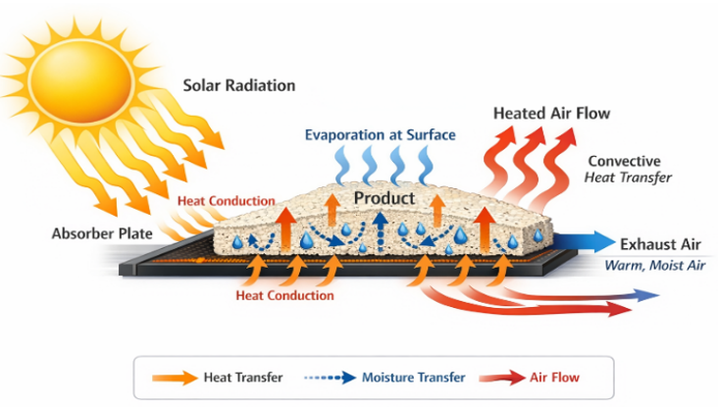
Fig. 1. Schematic representation of coupled heat and mass transfer during solar drying

2. TYPES OF SOLAR DRYERS
Solar energy drying systems are classified mainly according to the mode of heating and the way that solar heat is utilized. Essentially, they can be split into direct (integral) and indirect (distributed) solar dryers, depending on whether the product is exposed to solar radiation or the heated air comes from the separated solar collector (Ekechukwu and Norton, 1999). The attempt to maximize and optimize solar energy while increasing energy efficiency in the drying process, resulted in four major types of solar dryers: direct, indirect, mixed, mode, and hybrid systems (Fudholi et al., 2010). Drying of agricultural products is one of the most promising areas of utilizing solar energy in an efficient and cost-effective way, especially in tropical and subtropical regions where solar radiation is very high (Ekechukwu and Norton, 1999; Fudholi et al., 2010). In addition to classification of solar dryers by heating technique, it is also possible to classify them by the mechanism of airflow during the drying process into active dryers and passive dryers. Active solar dryers, also known as forced convection solar dryers, use electrical power supplied by electric current generated by solar cells or the electrical power grid to fans or blowers to supply the heated air to the solar collector/dryer. Passive solar dryers, on the contrary, utilize the natural convection mechanism in which the convective flows are driven by buoyancy caused by the temperature differences in the system (Tiwari and Tiwari, 2016; Sodha et al., 1985). The energy requirement in the drying of agricultural products is mainly governed by the initial and final moisture content in the products as well as the properties associated with the thermodynamics of the process.
2.1 Direct Type Solar Dryer
The most basic and conventional type of solar drying technology is the direct type of solar dryer. In the direct type of solar dryer, the solar irradiation is directly exposed to the agricultural products through an enclosed space made of a transparent cover material (Prasad et al., 2024). The transparent cover material allows the penetration of short-wave solar irradiation of wavelength 0.3-2.5 μm and blocks the re-emission of long-wave irradiation, resulting in the greenhouse effect that increases the temperature of air and products for moisture evaporation (Fudholi et al., 2025; Andersson, 2023).
Direct solar dryers are commonly constructed as box-type or cabinet dryers. Typical components include:
- Transparent glazing cover (glass or polyethylene sheet)
- Darkened absorber base to enhance solar heat absorption
- Insulated side walls to minimize thermal losses
- Mesh trays for product loading
- Top and bottom ventilation openings to promote natural convection airflow
(Othman et al., 2021; Pakhare et al., 2016)
The working principle is based on the direct absorption of solar irradiance by the product surface, typically ranging between 500 and 1000 W/m² in tropical regions. Dark-colored crops exhibit high absorptivity (α ≈ 0.9), enabling efficient conversion of solar radiation into thermal energy (Kumar et al., 2021). The absorbed heat creates temperature gradients within the drying chamber, resulting in simultaneous heat and mass transfer. Peak chamber temperatures generally range from 45 to 70°C, depending on ambient conditions and glazing inclination, which is typically optimized between 10° and 30° based on local latitude (Midilli and Kucuk, 2019). Airflow in direct dryers is mainly driven by buoyancy forces (natural convection), with air velocities typically ranging between 0.5 and 1.5 m/s. Moisture-laden air exits through chimney vents due to the thermosiphon effect.

2.1.1 Performance Characteristics
Empirical investigations report:
- Thermal efficiency: 10–25%
- Drying time reduction: 50–70% faster than open sun drying
- Suitable for thin-layer products such as herbs, spices, and small fruits
(Sharma et al., 2024; Fudholi et al., 2025)
Table 1. Comparative Performance of Direct Solar Dryer Prototypes
Study | Capacity (kg) | Peak Temp. (°C) | Efficiency (%) | Drying Time Reduction vs. Sun (%)
Sharma (2022), Box dryer for fruits | 10 | 65 | 18 | 60
Pruthvi Raj et al., (2025) Cabinet for corn | 15 | 70 | 22 | 70
Prakash & Kumar (2014) | 5–20 | 45–70 | 10–25 | 50–70

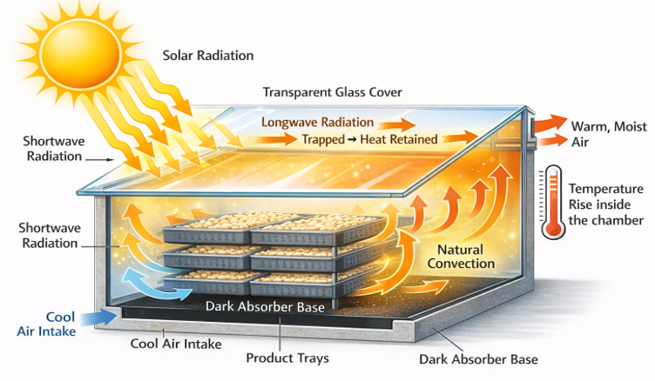
Fig .2. Schematic diagram of a direct-type solar dryer illustrating greenhouse effect and natural convection airflow.
2.2 Indirect Type Solar Dryer
An indirect-type solar dryer is a system in which agricultural products are dried using heated air generated in a separate solar collector, thereby preventing direct exposure of the product to solar radiation (Ekechukwu and Norton, 1999). In this configuration, incident solar radiation is absorbed by the collector surface and converted into thermal energy. The generated heat is transferred to the drying air before it enters the drying chamber (Esper and Mühlbauer, 1998). The heated air then flows through the drying chamber by convection, removing moisture from the product while shielding it from direct sunlight. This arrangement helps reduce discoloration, nutrient degradation, and quality deterioration during drying (Bala and Woods, 1994).
A typical indirect solar dryer consists of a flat-plate solar air collector equipped with single or double glazing, a blackened absorber plate, and an inclination angle approximately equal to the local latitude (±15°) to maximize solar energy capture. The collector is connected through insulated ducts to an enclosed drying chamber constructed from wood or metal. The drying cabinet generally contains multiple mesh or perforated trays, ventilation ports, and chimney outlets to facilitate airflow and moisture removal (Kumar et al., 2021; Hidraoui et al., 2023).
Although indirect solar dryers involve higher construction costs and greater structural complexity compared to direct solar dryers, they offer improved control over drying temperature and airflow. This enhanced control results in more uniform drying and better product quality (Prakash and Kumar, 2014). However, the higher initial investment—typically ranging from USD 100 to USD 500—may limit adoption among smallholder farmers. Furthermore, system efficiency can decline over time due to heat losses in air ducts (approximately 5–15%) and reduced collector performance caused by dust accumulation if proper maintenance is not ensured (Kumar et al., 2021).
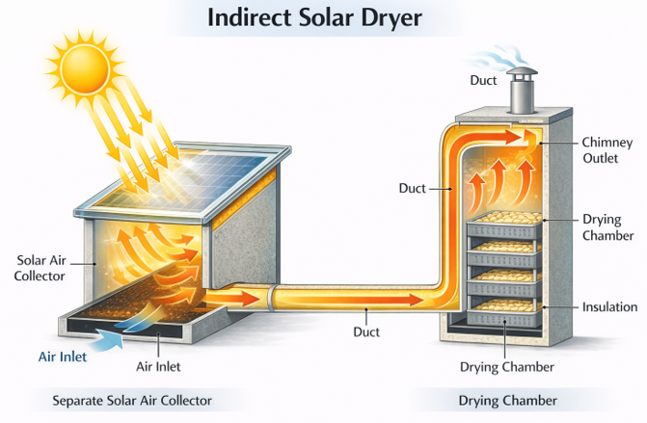
Fig .3. Schematic diagram of an indirect-type solar dryer showing separate solar collector and drying chamber
Table 2. Comparative Performance of Indirect Solar Dryer Prototypes
Study / Reference | Dryer Capacity (kg) | Peak Drying Air Temperature (°C) | Thermal Efficiency (%) | Drying Time Reduction Compared to Open Sun Drying (%)
Hidraoui et al. (2023), Banana drying, Morocco | 5 | 58 | 18.8 (system efficiency) | 43 (4 days vs. 7 days)
UMPir prototype study (2021) | 10 | 65 | 23.4 (collector efficiency) | 50
Kumar et al. (2021) | 20–100 | 50–70 | 20–40 | 40–60

2.3 Hybrid Solar Dryer
Hybrid solar dryers, also referred to as mixed-mode solar dryers, combine both direct and indirect solar heating mechanisms within a single integrated system to achieve continuous and controlled drying. These systems may also incorporate auxiliary energy sources to enhance performance under fluctuating weather conditions. In hybrid configurations, agricultural products receive heat from two sources: direct solar radiation entering through a transparent cover and preheated air supplied by a separate solar air collector. This dual heating approach improves thermal utilization and enhances overall drying efficiency (Ekechukwu and Norton, 1999; Sharma et al., 2009; Kumar et al., 2021; Sharma et al., 2024). A typical hybrid solar dryer consists of a flat-plate solar air heater (SAH) that preheats ambient air before directing it into the drying chamber. Simultaneously, a transparent roof allows shortwave solar radiation to directly heat the product trays inside the chamber. Natural convection is often promoted through chimney vents, while photovoltaic (PV)-powered fans may be used to provide forced convection and ensure uniform airflow distribution throughout the drying chamber (Kumar et al., 2021; Rawat and Kumar, 2022; Girhe and Mane, 2021). The combined effect of direct solar radiation and convective hot-air heating increases the drying chamber temperature by approximately 10–20 °C compared to purely indirect solar dryers. As a result, hybrid systems typically achieve thermal efficiencies ranging from 25% to 45% under peak solar conditions (Rawat and Kumar, 2022; Girhe and Mane, 2021).
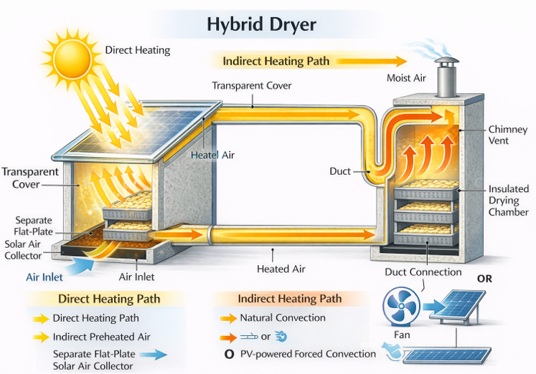
Fig .4. Schematic diagram of a hybrid (mixed mode) solar dryer showing combined direct solar radiation heating and indirect preheated air circulation.
Table 3. Hybrid Solar Dryer Performance Metrics
Type | Capacity (kg) | Peak Temp. (°C) | Efficiency (%) | Backup System | Reference
Solar + Electric | 15-50 | 65-75 | 25-35 | Resistive heater | Paes et al. (2022)
Solar + Biomass | 20-100 | 60-70 | 20-30 | Combustion chamber | Rudra Solar Systems
Solar + PCM | 10-25 | 55-65 (stable) | 28-40 | Phase change mat. | Al-Zahrani et al. (2025)
Solar + PV fan/heater | 5-20 | 50-70 | 22-32 | Battery backup | Hasan et al. (2025)

3. INTERNET OF THINGS (IOT) IN SOLAR DRYING SYSTEM
The Internet of Things (IoT) in agri-food systems refers to the integration of physical devices, sensing units, communication networks, control components, and cloud-based analytics platforms to enable real-time monitoring, automation, and optimization of agricultural production and food processing operations (Atzori et al., 2010; Wolfert et al., 2017).
At the foundational layer, sensors are deployed to collect real-time data on crop health, environmental conditions, and product quality. These include soil moisture sensors, temperature and humidity sensors such as DHT22 and capacitive sensors, multispectral cameras for NDVI-based crop health monitoring, and quality-related devices such as load cells and moisture meters. Modern sensor systems offer high measurement accuracy, typically around ±0.5% RH and ±0.1 °C, thereby supporting precise decision-making in agri-food operations (Ruiz-Garcia et al., 2009; Verdouw et al., 2016; Mansoor et al., 2025; Abram International Journal, 2024).
Sensor data are transmitted through wired or wireless communication technologies such as Wi-Fi, GSM, LoRa, ZigBee, and MQTT-based protocols to local gateways or remote cloud servers for processing and storage. These communication systems enable reliable data transfer across farms and processing facilities, facilitating geographically distributed monitoring and control (Ray, 2017; Elijah et al., 2018).
Controllers, including microcontrollers and embedded processors such as Arduino, ESP32, NodeMCU, and Raspberry Pi, analyze sensor data and execute control algorithms based on predefined thresholds, proportional-integral-derivative (PID) strategies, or machine learning models. Increasingly, edge computing functions are incorporated into these systems to allow low-latency decision-making. For example, when temperature exceeds a specified threshold, cooling fans or ventilation systems can be activated immediately before transmitting data to higher-level platforms (Gubbi et al., 2013; Patel and Patel, 2016; Xu et al., 2022; Choudhary et al., 2025).
Based on controller outputs, actuators regulate system operations. These may include solenoid valves for irrigation control, servo motors for vent and damper adjustment, DC fans for airflow regulation, pumps for fluid transfer, and relays for activating heaters or phase change material (PCM) systems. Such actuator-based automation enables rapid system responses—often within seconds—to maintain desired environmental and process conditions (Vermesan et al., 2014; Navarro et al., 2020; Mansoor et al., 2025).
Cloud platforms such as AWS IoT, ThingSpeak, and Blynk form the backbone of IoT-enabled agri-food applications by providing scalable data storage, real-time visualization dashboards, remote monitoring through web or mobile interfaces, and advanced analytics capabilities. Cloud-based machine learning algorithms support predictive analytics, decision support systems, supply chain traceability, and optimization of drying and storage processes (Botta et al., 2016; Wolfert et al., 2017; Mansoor et al., 2025).
The integration of sensors, controllers, actuators, and cloud computing enables closed-loop control systems in which real-time data measurements trigger automated corrective actions. In agri-food drying and post-harvest applications, such systems have been reported to reduce energy consumption by 20–30% and post-harvest losses by 15–25% (Verdouw et al., 2016; Elijah et al., 2018; Navarro et al., 2020). Overall, IoT-enabled agri-food systems enhance resource efficiency, transparency, traceability, product quality, and informed decision-making, thereby contributing to intelligent and sustainable agricultural production and food processing (Wolfert et al., 2017; Kamilaris et al., 2019).
3.1 Sensors Used in IoT-Integrated Solar Dryers
3.1.1 Temperature Sensors
Temperature sensors are essential for monitoring the drying air temperature in the solar air collector, drying chamber, absorber plate, product surface, and surrounding environment. Commonly used devices include Type-K thermocouples (±0.5 °C), resistance temperature detectors (RTDs) such as PT100 (±0.1 °C), and digital sensors like DHT22/AM2302 (±0.5 °C). Maintaining the drying temperature within an optimal range, typically 40–65 °C, is critical to prevent overheating, case hardening, and degradation of heat-sensitive nutrients (Shikhare et al., 2018; TurkBilMat et al., 2021; Paes et al., 2022; Pawar, K. P., 2022)
3.1.2 Relative Humidity Sensors
Relative humidity (RH) sensors are used to estimate equilibrium moisture content (EMC), evaporation rate, and the moisture-carrying capacity of drying air. Capacitive RH sensors such as DHT22 and HIH6130 (±2% RH accuracy) are commonly installed at inlet and outlet points of the drying chamber. Laboratory-scale experiments may also use psychrometers. Maintaining low RH levels, typically below 30%, enhances moisture removal efficiency (Sallam et al., 2015; TurkBilMat et al., 2021; Pawar, K. P., 2022; Hasan et al., 2025).
3.1.3 Air Velocity Sensors
Air velocity sensors measure airflow through the drying chamber, chimney, and solar air collector, directly influencing convective heat and mass transfer coefficients. Air velocities between 0.5 and 3 m s⁻¹ under natural or forced convection are commonly monitored using hot-wire anemometers (±0.05 m s⁻¹), vane anemometers, or differential pressure-based sensors. Optimized airflow ensures uniform drying, prevents moisture accumulation, and reduces drying time (Sallam et al., 2015; KSCST; Pawar, K. P., 2022).
3.1.4 Moisture Content Sensors
Moisture content sensors enable real-time monitoring of product moisture levels and accurate determination of drying endpoints. IoT-based solar dryers frequently use gravimetric analysis with load cells such as HX711 (±0.01 g accuracy), where moisture content is inferred from weight loss over time. Capacitive and resistance-based sensors are also used to measure changes in dielectric or electrical properties associated with moisture variation. Final product moisture is typically maintained within 10–15% to ensure safe storage and prevent over-drying (Devi and Kalnar, 2021; Paes et al., 2022; García-Moreira et al., 2024; Hasan et al., 2025).
3.1.5 Solar Radiation Sensors
Solar radiation sensors are essential for evaluating dryer performance and conducting energy balance analyses. Pyranometers and silicon-cell irradiance sensors (e.g., CM11K, ±5 W m⁻² accuracy) are typically mounted on the collector surface to measure global horizontal irradiance, generally ranging from 500 to 1000 W m⁻². Solar radiation data are used to correlate collector efficiency with insolation levels and to adjust control strategies according to weather variations (Correa Hernando et al., 2010; Villagran et al., 2024). In modern IoT-integrated solar dryers, sensor fusion using microcontrollers such as ESP32 or Arduino enables real-time processing, PID control, and cloud-based data logging through platforms like Blynk or Thing Speak. These systems have demonstrated temperature stability within ±2 °C, improved drying uniformity, and enhanced energy efficiency (Pawar, K. P., 2022; Hasan et al., 2025; Mansoor et al., 2025).
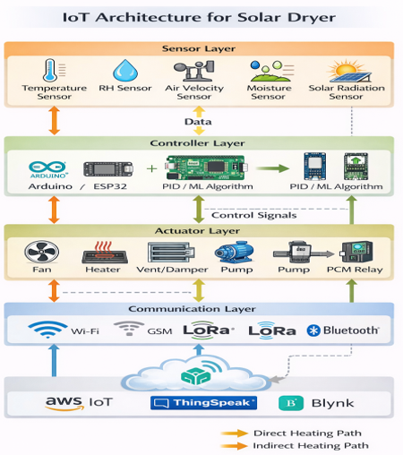
Fig.5. Schematic diagram IOT Architecture of Solar Dryer
Table 4. IoT Sensor Specifications for Solar Dryers
Parameter | Sensor Type | Accuracy | Typical Placement
Temperature | DHT22, PT100, Type-K thermocouple | ±0.1–0.5 °C | Chamber, absorber plate
Relative humidity | DHT22, HIH6130 | ±2 % RH | Inlet/outlet air
Air velocity | Hot-wire anemometer | ±0.05 m s⁻¹ | Ducts, chimney
Moisture content | Load cell, capacitive sensor | ±0.01 g | Drying trays
Solar radiation | Pyranometer | ±5 W m⁻² | Collector surface

4. COMMUNICATION TECHNOLOGIES IN IOT-BASED SOLAR DRYERS
4.1 Communication Technologies in IoT-Integrated Solar Dryers
Communication technology forms the backbone of smart solar drying systems, serving as the bridge between sensors, controllers, cloud platforms, and end users. Through reliable communication links, real-time monitoring of drying parameters, remote adjustment of setpoints, performance analysis, and system notifications can be achieved. This connectivity reduces the need for continuous manual supervision and ensures that agricultural produce is safely managed throughout the drying process. The selection of an appropriate communication protocol depends on several factors, including transmission range, power consumption, data rate, availability of network infrastructure, and overall system cost (Osanaiye et al., 2021).
4.2 Wi-Fi Communication
Wi-Fi-based communication is commonly implemented in solar dryers located in areas with stable internet connectivity, such as research institutions, urban farms, and agro-processing facilities. Wi-Fi modules operating at 2.4 GHz, such as ESP8266, ESP32, and NodeMCU, typically provide communication ranges of 50–100 m and support high data transmission rates. These features enable real-time transmission of sensor data—including temperature, relative humidity, and moisture content—to cloud platforms such as Blynk and ThingSpeak. Consequently, users can continuously monitor drying parameters via dashboards on smartphones or computers (Deokar et al., 2025; Ghafar et al., 2025; Paes et al., 2022). However, Wi-Fi systems generally consume higher power and offer limited coverage compared to long-range technologies, which restricts their suitability for remote or off-grid solar drying applications.
4.3 GSM Communication
For solar dryers installed in rural or isolated regions without Wi-Fi infrastructure, GSM communication provides long-range connectivity through cellular networks. GSM modules such as SIM900 and SIM800L support data transmission via SMS or GPRS services, allowing users to receive alerts regarding overheating, drying completion, or system malfunctions directly on their mobile devices. Although GSM systems involve network subscription costs and moderate power consumption, they are particularly suitable for off-grid monitoring because they operate independently of local internet infrastructure (Ali et al., 2024; Elmehri, 2022; Kumar et al., 2025)
4.4 LoRa Communication
LoRa (Long Range) communication technology has gained attention in decentralized solar drying systems due to its ultra-low power consumption and extended communication range, typically between 1 and 15 km. LoRa modules such as SX1278 and RA-02 operate in unlicensed sub-GHz frequency bands and are designed for low data rate transmission of essential parameters such as temperature and relative humidity. This makes LoRa particularly suitable for multi-node solar drying systems powered by batteries or photovoltaic panels, especially in remote agricultural areas (Ali et al., 2024; Sharma et al., 2022; Taylor and Francis, 2025).
4.5 Bluetooth Communication
Bluetooth technology, particularly Bluetooth Low Energy (BLE), is widely used in small-scale or laboratory-level solar dryer applications for short-range communication. Modules such as HC-05, HC-06, and BLE 5.0 are typically paired with smartphones or tablets for system configuration, calibration, and localized data acquisition. While Bluetooth offers low power consumption and fast response times, its limited communication range (generally 10–30 m) restricts its application to on-site operations rather than remote monitoring (Paes et al., 2022; Patel et al., 2025)
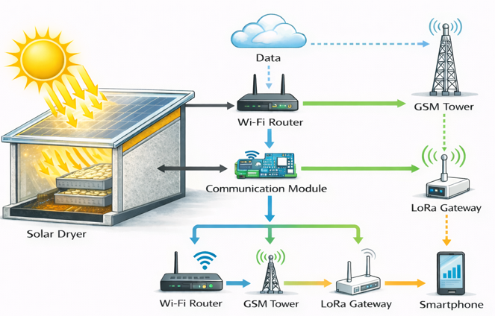
Fig.6. Communication technologies used in Solar dryer technologies
5. QUALITY-AWARE DRYING CONTROL
Quality-aware drying control considers product-quality goal in the control logic for drying processes so that product moisture removal is achieved without deterioration of the product sensory, nutritional and safety properties (Chen and Mujumdar, 2008). This is particularly critical for thermally and structurally sensitive agricultural products as suboptimal drying conditions may lead to adverse colour changes, depletion of bioactive compounds, texture damage and poor rehydration behavior (Ratti, 2001; Mujumdar, 2014). Quality-aware drying is a control principle in which operational parameters (air temperature, relative humidity, airflow rate and drying time) are adjusted in a way that is able to not only meet the target moisture content and storage stability but also key quality attributes such as colour, nutrient, texture, aroma, and microorganism safety (Chen and Mujumdar, 2008). According to Prakash and Kumar, (2014) and Simo-Tagne et al, (2020), there is need of such an approach because (1) many food and agricultural products are heat-sensitive and react non-linearly to drying stresses and (2) the solar drying ambience is inherently variable (solar irradiance, ambient humidity, wind). Research and reviews confirm that failure to consider quality can lead to poor end-products, even when moisture targets are achieved (Ratti, 2001).
6. DIFFERENCE BETWEEN CONVENTIONAL AND QUALITY-ORIENTED CONTROL.
Generally, conventional drying control strategies operate using fixed set-point temperatures or predefined time–temperature schedules, where feedback is often limited to air temperature alone. The primary objectives of such control approaches are to achieve faster drying or minimize energy consumption rather than to preserve product quality (Mujumdar, 2014). However, these conventional systems typically do not account for the dynamic state of the product, such as internal moisture gradients or temperature history. As a result, problems such as over-drying, case hardening, and non-uniform moisture distribution frequently occur, particularly during the falling-rate period of drying (Ratti, 2001). In contrast, quality-oriented drying control adopts a product-centric and multi-variable perspective. Instead of relying solely on-air temperature, this approach incorporates measurements of key process and product parameters, including moisture content, weight loss, surface temperature, color indices, and water activity. Drying conditions are then adjusted in response to these quality-related variables while still achieving the required final moisture level (Chen and Mujumdar, 2008; Simo-Tagne et al., 2020). With the advancement of sensing technologies and digital systems, quality-oriented control can now be implemented through the integration of sensors, embedded processors, and cloud-based data analytics. These technologies enable closed-loop control systems capable of adaptively modifying temperature, airflow rate, and auxiliary heating based on real-time quality indicators. Such systems not only help maintain nutritional, structural, and sensory quality but can also improve overall process efficiency by reducing unnecessary drying time and energy use (Kamilaris et al., 2019; Navarro et al., 2020).
6.1 Quality Parameters Affected During Drying
6.1.1 Nutritional Quality (Vitamins and Antioxidants
Drying is a process that destroys a significant percentage of heat, labile and oxidation labile nutrients such as vitamin C, vitamin A, carotene, phenolic compounds, and antioxidants. The nutrient content retained in the product is essentially the amount of nutrients that have not been degraded by the increased temperature and extended drying times during the drying process (Ratti, 2001; Mujumdar, 2014). It was also found that maintaining the drying temperature under control, such as drying at low temperatures, allowed more bioactive compounds to be retained (Chen & Mujumdar, 2008). It was reported that solar dryers with temperature control retained more antioxidants in the dried products (Prakash and Kumar, 2014).
6.1.2 Physical Quality (Color, Shrinkage, and Texture)
The drying conditions have a major impact on the physical properties such as texture, shrinkage, porosity, and color. A temperature increase or a rapid surface drying might lead to the formation of a hard crust, distortion, or shrinkage, which in turn may deteriorate the product's texture and the rehydration performance (Mujumdar, 2014). The disappearance of the product's color results mainly from enzymatic or non, enzymatic browning, pigment decomposition, or overexposure to solar irradiation (Ratti, 2001).The use of controlled solar drying systems has been found to result in better texture retention, less case hardening, and fewer structural damages in the dried product when compared to conventional sun drying methods (Simo, Tagne et al., 2020).
6.1.3 Sensory Quality (Flavor and Aroma)
Flavors and aroma volatiles mentioned above are volatile in nature, highly susceptible to temperature, and therefore their quality can be altered as they may evaporate during the drying process leading to the loss of their sensory quality (Chen and Mujumdar, 2008). Temperatures and exposure times will typically worsen this quality loss, whereas a good combination of temperature and exposure time would result in better retention of the desirable sensory qualities of the produce, since solar dryers can provide this temperature optimization, as mentioned in Ratti (2001). This better retention of flavor and aroma was also pointed out in Prakash and Kumar (2014).
6.1.4 Microbial Safety
One of the important goals of drying is to enhance the microbial safety of products through decreasing moisture content and a value to such a level where microbial growth can be limited. When drying is done improperly, for instance, if the drying rate is slow and the ambient condition is humid, bacteria, yeasts, and molds may grow, thus resulting in spoilage and leading to health problems for consumers (Mujumdar, 2014). The right drying conditions can decrease the values to below the critical level (less than 0.6) thus preventing the growth of microorganisms and extending the shelf life of the product (Ratti, 2001). Moreover, a solar dryer system will also set a hygienic drying environment by regulating temperature and air flow rates thus lowering contamination (Prakash and Kumar, 2014; Simo, Tagne et al., 2020).
7. CONTROL STRATEGIES FOR IOT-INTEGRATED SOLAR DRYERS
The efficiency of the solar dryers integrated with IoT mainly depends on how well the control strategy can regulate the temperature, relative humidity, and air flow considering changing environmental and solar power conditions. Since the power from solar sources varies periodically, if the control strategies are not good, it may result in temperature fluctuations and energy being wasted. As a result, both simple and complex control strategies were used to manage the temperature and improve the solar dryers' efficiency, and the traditional control strategy was favored because of its simplicity and the fact that it was effective.
7.1 Conventional Control Methods
7.1.1 On–Off Control
On, off control is the simplest form of feedback control used in solar drying systems, and it is also called bang, bang control or thermostat control. The on, off control method works by turning the actuators such as fans, heaters, or dampers, fully on or off, depending on the set, point values of the measured variable such as drying air temperature or relative humidity. A hysteresis band, e.g. 55 5 C, is normally used in the field to stop the unstable control actions from happening when the measured variable is fluctuating around the set, point value. Recent implementations of IoT projects involving solar dryers make mention of on-off control logic mechanisms involving microcontrollers such as Arduino and ESP32, where sensors are triggered to switch on fans/heaters once they cross specific control limits. (Pruthvi Raj et al., 2025; Wanjale et al., 2025; Deokar et al., 2025). However, the limitations of on-off controllers have been pointed out in some studies, particularly in drying processes, such as the temperature variation within a range of ±5 to 10°C, long settling times, typically 10 to 30 minutes, and large numbers of switchings applied to the actuators. (Energy-CIE., 2023; Edumatic et al., 2024). Such oscillations are considered as unwanted fluctuations, particularly at the time of the falling rate period of the drying process. It is very important to keep the conditions unchanged during the falling rate period for the continuous maintenance of the quality of the product. (Scale, Time, Temperature)
7.1.2 PID Control
The most frequently used classical control technique among various smart solar dryer control strategies enabled via the Internet of Things (IoT) is the Proportional Integral Derivative (PID) controller. PID control is a measure of the difference (error) between the desired set point and the measured process variable, and it can be written as:
$$u\left(t\right)=K_{p}e\left(t\right)+K_{i}\int_{0}^{t}{e\left(τ\right)} dτ+K_{d}\frac{d}{dt}e\left(t\right)$$
where $e(t)$is the temperature error. Typical tuning ranges reported for solar dryers include proportional gains between 1–10, integral times of 10–100 s, and derivative times of 1–10 s, often obtained using Ziegler–Nichols or similar tuning methods. (Zoukit et al., 2023; Energy-CIE et al., 2023).
Recent experimental studies have revealed that temperature control regulation for PID, control of solar dryers takes its position favorably as opposed to traditional on/off control arrangements. The report indicates that some of the performance for this kind of system include an overshoot of less than 5%, settling times of less than 5 min, and steady states temperature errors of less than 1 C (Zoukit et al., 2023; Edumatic et al., 2024). Aside from that, there have been instances where the PID was actually instrumental to the realization of the IoT platforms that utilize ESP32/STM32-based controllers towards the facilitation of real time control as well as monitoring. Their functions have been taken a step further in certain instances through the incorporation of so-called adaptive/intelligent tuning approaches that have employed fuzzy PID, network-based PID controllers, among others (Zoukit et al., 2023).
Although PID control has the above advantages, the tuning of the PID controller is critical, and the performance of the controller might be compromised at highly nonlinear conditions of drying operation or rapid variation of solar irradiance. PID control, however, remains the benchmark for quality-focused solar drying control as a basis of comparison to other advanced intelligent control methods.
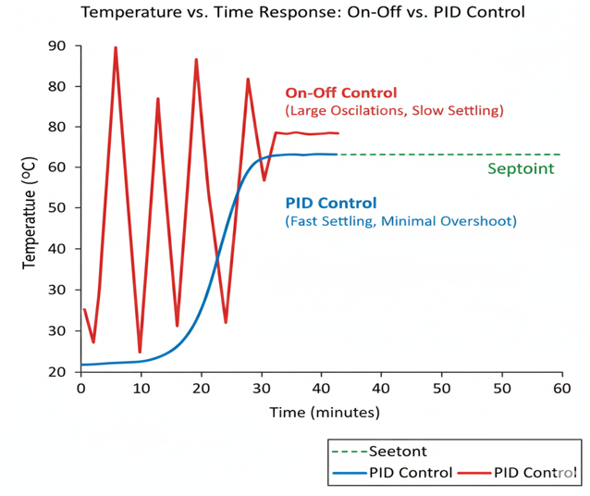
Fig.7. Temperature vs. Time response curve
Table 5. Comparison of on–off and PID control strategies in solar dryers
Control Method | Overshoot | Settling Time | Steady-State Error | Reference
On–off | ±5–10 °C | 10–30 min | High oscillation | Pruthvi Raj et al., (2025)
PID | <5% | <5 min | <1 °C | Nkolokosa, D. (2023)

7.2 Intelligent Control Approaches
Drying kinetics being nonlinear along with solar energy being intermittent, conventional control strategies is a major issue for solar dryers. Consequently, IoT, integrated solar dryers have started implementing intelligent control methods increasingly to address the dilemma. These techniques can effectively handle system nonlinearity and uncertainty as well as multiple, variable interactions, and at the same time, they facilitate quality, aware drying objectives.
7.2.1 Fuzzy Logic Control (FLC)
The use of fuzzy logic in the control of solar dryers is widespread because it does not rely on the mathematical simulation of the drying process. The fuzzy logic used in the control process involves several linguistic rules developed based on expert knowledge, for instance, “if the temperature is high and the relative humidity is low, then the heating should be reduced.” The most used fuzzy logic controllers use a combination of membership functions and Mamdani/Sugeno inferences, as they offer the capability to process various input variables, for example, the drying media’s temperature, moisture content, and relative humidity, and corresponding output variables, for instance, fan speed, damper setting, and/or additional heaters (Abakarov et al., 2012; Nduka et al., 2014).
There are experimental research study results stating that fuzzy, controlled solar dryers show resistance to fluctuations in solar irradiance and changes in conditions better than PID, controlled solar dryers. It has been noted that FLC is able to bring the temperature overshoot level to below 3%; reduce the value of settling time by 20%, and provide conditions for stable operation, despite sensor noise or environmental disturbances (Abakarov et al., 2012). Fuzzy Logic is therefore extremely relevant to solar dryers deployed in the field because of such significant features associated with the application of FLC in solar dryers.
7.2.2 Artificial Neural Networks (ANNs)
The neural networks have a strong potential as a data-driven tool for modeling complex non-linear relationships between drying inputs and outputs. In solar drying, multilayer perceptron networks, which comprise multiple hidden layers, are normally employed for predicting moisture, drying rate, and temperature evolution using solar radiation, temperature, and humidity as inputs (Prakash and Kumar, 2016; Erentürk, S., 2025). It has also been demonstrated that ANN models are capable of producing predictive results of high precision, as evidenced by the fact that the coefficient of determination (R²), which is obtained from the prediction results of ANN models, has achieved a value greater than 0.98, while the root mean square error (RMSE), which is another metric of the prediction effect of ANN models, is less than 1% at the same time (Ben Ammar et al., 2021). In the context of the IoT, ANN models can be employed to implement the control systems of some devices as a means of pertinent feedforward control, thereby greatly improving the performance of the control systems of the devices, which could be either PID control systems or conventional control systems. In such cases, the error of the control systems is reduced to the extent of less than 1% after implementation (Prakash and Kumar, 2016).
7.2.3 Machine Learning–Based Prediction and Control
Besides the conventional neural networks, other advanced machine learning (ML) methods, including support vector regression (SVR), random forest (RF), long short-term memory (LSTM) networks, and reinforcement learning (RL), were also recently investigated for the control of solar dryers. They aim to utilize the available historical data during solar drying, real-time measurements, and weather forecasts to forecast the optimal temperature and humidity levels or to choose the control strategies adaptively.
However, latest study shows that machine learning prediction models can predict drying behavior and thermal performance with errors less than 1%, a very significant improvement compared to conventional regression and empirical models based on variable climatic conditions (Das et al., 2023; Ganesan et al., 2024). Moreover, reinforcement learning techniques also enable this method to establish control policies that are efficient enough and maximize the process in terms of reward functions, for example, minimizing the energy required to maintain product quality. Predictive and adaptive control techniques have huge prospective in maintaining quality-sensitive solar drying products to avoid the adverse effects of overheating, over-drying, etc. (Zoukit et al., 2023).
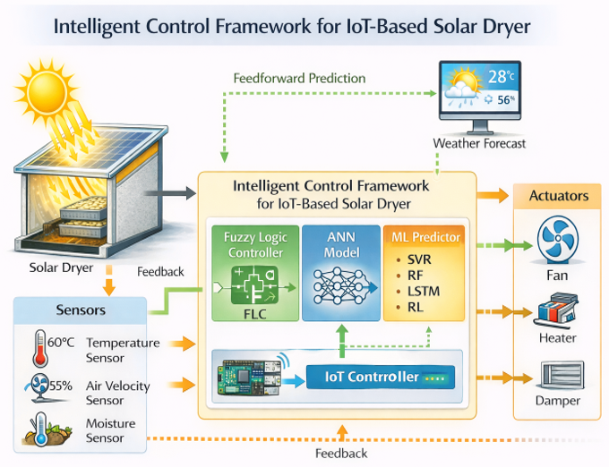
Fig.8. Intelligent Control Framework for IoT-Based Solar Dryer
Table 6. Comparison of conventional and intelligent control approaches in solar dryers
Control Method | Ability to Handle Nonlinearity | Tuning Requirement | Typical Accuracy | Reference
On–off | Poor | None | Low | Pruthvi Raj et al. (2025)
PID | Moderate | Manual/empirical | Medium | Nkolokosa (2023)
Fuzzy Logic | Excellent | Rule-based | RMSE 1–2% | Abakarov et al. (2012)
ANN | Excellent | Data-driven | R² > 0.98 | Ben Ammar et al. (2021)
ML-based | Very high | Training-based | Error < 1% | Das et al. (2023)

7.3 Decision-Based Drying Control
Decision, based drying control means a change in the way we understand drying from a traditional rule, based or a time, controlled operation to a decision, making process that is dynamic and adaptive, and driven by quality control as well. In IoT, enabled solar drying systems, it means always changing the best environment for drying and deciding the perfect point of finishing the drying of a particular material based on the quality requirements of the material being dried. (Kumar et al., 2021; Simo-Tagne et al., 2020). This approach, in this system of IoT-integrated solar dryers, makes use of dynamically variable parameters like sensor and predictive technology to recurrently change drying conditions and to arrive at the optimum endpoint of solar drying based on quality requirements. (Eltawil et al., 2023)
By means of adaptive temperature and airflow control, methods change or vary the setpoints for drying air within certain limits specific for different crops, typically from 40 C to 65 C for temperature and from 0.5 to 3 m/s for airflow, depending on the immediate changes in solar irradiance, temperatures, and relative humidity, which are inherent in solar drying processes. (Kumar et al., 2021). Thus, adaptive controllers are capable of intentionally considering variations in solar irradiance, temperature, and relative humidity, unlike conventional fixed setpoint PID controllers. (Simo-Tagne et al., 2020; Eltawil et al., 2023)
The latest IoT, enabled solar dryers to have been equipped with gain, scheduled PID control or MPC methods integrating short, term solar and ambient condition forecasts, which are generally delivered via weather APIs, for optimal control strategies that lead to the least use of auxiliary energy. (Eltawil et al., 2023)
The real applications will integrate these prediction algorithms with rule, based logic architectures whereby phase change materials or supplementary heat generators will be activated once solar irradiance values drop to certain critical levels (e.g., < 400 W/m²) (Hasan et al., 2025). The adaptive control of airflow enhances drying uniformity by increasing the airflow during the diffusion-controlled periods and decreasing it at high temperatures to avoid case hardening. (Mayor and Sereno, 2004; Vega-Galvez et al., 2012)
7.3.1 Quality-Based Endpoint Detection
Basic ending points of drying only by time or final moisture content are replaced by quality, based endpoint detection that determines by various quality parameters the right moment to finish. (Rahman, 2009; Lewicki, 2006). Decision based solar drying finds the endpoint when the product quality standards set beforehand are achieved, thus it is safe as far as moisture is lowered and over, drying is prevented. (Eltawil et al., 2023; Hasan et al., 2024). IoT system consisting of integrated systems have used a variety of multi, methods such as gravimetric, moisture content, drying rate trend analysis, and sensing methods such as RGB, to carry out decision tree classification or even SVM classification for automatic termination of the drying process. (Eltawil et al., 2023; Welankiwar et al., 2025; Hasan et al., 2024)
The drying requirements which normally are continuing and finalized by the authors have been mainly finalize with moisture content below 15%, constant moisture content within 2%, and a change in color, such that E < 20.Machine learning also helps with endpoint detection, thus these values being very accurately predicted to a level of 95%, which in turn results in shorter drying time as compared to sun drying. (Eltawil et al., 2023; Hasan et al., 2024)
7.3.2 Role in Quality-Aware Solar Drying
The combination of adaptive regulation and quality, based termination in decision, based drying control not only instantly aligns with the objectives of quality, aware solar drying, but also makes it possible to achieve an intelligent trade, off between efficiency, energy consumption, and quality, thus making decision, based drying control very compatible with the requirements of solar dryers with IoT connectivity under highly variable climatic conditions. (Kumar et al., 2021; Simo-Tagne et al., 2020; Eltawil et al., 2023).
Table 7. Examples of decision-based control strategies in IoT-integrated solar dryers
Control Aspect | Method | Target Performance | Reference
Temperature & airflow | MPC / gain-scheduled PID | ±1.5 °C, 1–2 m s⁻¹ | Nkolokosa (2023)
Endpoint detection | SVM + moisture & color | MC < 15%, ΔE < 20 | Wang et al. (2024)

8. CHALLENGES AND LIMITATIONS
8.1 Sensor Accuracy and Calibration Issues
Effective quality, conscious drying control strategies largely depend on the precise measurements of temperatures, relative humidities, airflow rates, and moisture content, to name a few. Inexpensive sensors that are used in IoT devices may undergo measurement drift, have cross, sensitivity, and get damaged when exposed to extreme temperatures and relative humidities for long durations. Errors may be caused by poor calibration of these sensors, and such errors may result in inappropriate adjustments, in terms of quality and consistency of drying process outcomes. (Ruiz-Garcia et al., 2009; Mekala and Viswanathan, 2019).
8.2 Internet Connectivity in Rural Areas
It is noted that many IoT, enabled solar dryers, such as IoT, based solar dryers, utilize wireless communication and "cloud platforms" to perform functions, e.g., "data storage, " "visualization, " and "prediction." However, the absence of good internet connectivity in remote areas is usually considered the primary problem for IoT, based approaches to agriculture by the relevant studies, which also agree that interruptions in connectivity have a negative impact on the system's responsiveness and continuity. (Ray, 2017; Elijah et al., 2018).
8.3 Cost and Scalability
Even though the prices of IoT devices keep going down, the overall cost of an IoT system is still a problem, mainly because of its different components such as sensors, controllers, communication equipment, energy storage devices, and maintenance. Economically smallholder farmers cost mostly farmers in the developing economies, as we know from the reports, the small, scale models that are hard to be commercially viable while keeping the scalability solar dryers are one of the challenges in solar drying technology. (Wolfert et al., 2017; Kamilaris et al., 2019).
8.4 Environmental Variability
On the other hand, solar drying systems may be affected by environmental changes such as variations in solar irradiation, temperature, humidity, and wind speeds. Thus, unstable conditions may arise in solar drying systems, even when the system is controlled by adaptive and intelligent control systems. Severe changes in weather conditions may lead to uneven drying and deteriorated product quality. (Simo-Tagne et al., 2020; Mujumdar, 2014).
8.5 Data Management and Reliability
Solar dryers based on IoT technology generate large volumes of diverse data from distributed sensing devices. To make decision control, it is extremely important to ensure reliable data transmission, storage, synchronization, and integrity. Loss of data information, a sensor getting out of order, and/or the delay in data transmission may result in a decreased system reliability and user trust. Moreover, the lack of data standard format and quality assessment schemes are a hindrance to the long, term performance evaluation of solar dryers (Botta et al., 2016; Verdouw et al., 2016).
9. FUTURE RESEARCH DIRECTIONS
9.1 AI-Driven Self-Learning Solar Dryers
Recent trends in the domain of smart drying and Industry 4.0 principals describe the use of reinforcement learning-based control policies like the DQN framework. This will allow the drying system to learn the optimal temperature and humidity control policies based on the analysis of the operational data and maximize the reward functions based on product quality and energy efficiency. Additionally, the multimodal sensor control will be used to control the drying system adaptively based on various crop types without any physical changes. Such drying systems have been reported to reduce energy consumption with the same product quality under varying climatic conditions (Kamilaris and Prenafeta-Boldú 2018; Liakos et al., 2018)
9.2 Digital Twin of Solar Dryers
Nevertheless, breakthroughs in agricultural digital twins have demonstrated the capability of PINNs to represent the complexities of the heat/mass transfer process, and at the same time, being able to stay coordinated with the IoT data sensors in real time. Digital twins technology, among others, is believed to be beneficial to smart agriculture for such applications as simulation, prediction of system failure, and evaluating "what, if" scenarios, say those who study this technology. As an example, digital twins for solar dryers could be used for predictive maintenance or for optimizing the physical dimensioning of the phase, change materials. (Tao et al., 2019; Fuller et al., 2020)
10. CONCLUSION
This review critically assessed the innovation of solar drying technologies over a period, exposing the transition from the most traditional forms of direct or indirect solar drying to modern hybrid solar drying machines enhanced by Internet of Things (IoT) technologies. Although solar drying machines offer better protection and thus, speed up the drying process when compared to the conventional open, sun drying methods, these drying machines basically do not have real, time dynamic control over the key parameters like temperature, humidity, and airflow. New inventions resulted in an intelligent control system that integrates sensors, microcontroller technologies, the cloud, and data analytic techniques for the real, time monitoring of solar drying processes. The recent addition of communication technologies such as Wi, Fi, GSM, LoRa, and Bluetooth has further enhanced solar drying processes by providing for remote operation of the drying process. The present review mainly discusses the changes from time, or temperature, based drying to quality, aware drying control. The traditional methods of drying were based only on the reduction of moisture, whereas nowadays the decision is made based on the retention of nutrients, color stability, texture preservation, and safety from microorganisms in the methods of quality, aware control. Adaptive control methods, smart algorithms, and end-point detection techniques enable control of the end of the drying process based on the quality characteristics of the products, as opposed to a predetermined schedule. The benefits of such control include better product uniformity, reduced over, drying waste, and efficient energy use. Solar dryers using IoT technology could be one of the most hopeful and sustainable post, harvest management systems as they will utilize solar energy, which is a clean source, thus cutting down on fossil fuel usage. Besides, these drying systems can potentially reduce food wastage, create new food products and hence, ensure the sustainable and resilient food systems through the synergy of solar technology, based drying plus digital agriculture technologies. In addition, if the subsequent investigations are directed towards such areas as AI, based self, learning solar dryers, digital twin technology, blockchain, and protocol development, then IoT, integrated solar drying systems worldwide can be powerful levers towards the establishment of sustainable and resilient food systems.
11. REFERENCE
- Adeyeye, S. A. O., Adebayo-Oyetoro, A. O., & Tiamiyu, H. K. (2025). Quality deterioration mechanisms in improperly dried agricultural products and implications for food security. Food Control, 162, 110512.
- Kumar, A., Singh, R., & Chauhan, P. S. (2016). Post-harvest processing and drying of agricultural products: A review. Renewable and Sustainable Energy Reviews, 55, 346–360.
- Mohammed, A.-H., Komolafe, C. A., & Simons, A. (2026). Advances in solar drying technologies: A comprehensive review of designs, applications, and sustainability perspectives. Solar Compass, 17, 100153.
- Dincer, I., & Cengel, Y. A. (2001). Energy, entropy and exergy concepts and their roles in thermal engineering. Entropy, 3(3), 116–149.
- Dincer, I., & Sahin, A. Z. (2004). A new model for thermodynamic analysis of a drying process. International Journal of Heat and Mass Transfer, 47(4), 645–652.
- Hodali, R., & Bougard, J. (2001). Thermal performance of a solar air heater for drying applications. Energy Conversion and Management, 42(3), 305–317.
- Pittia, P., & Antonello, P. (2016). Safety by control of water activity: Drying and intermediate-moisture foods. Food Engineering Reviews, 8(3), 246–259.
- Ekechukwu, O. V., & Norton, B. (1999). Review of solar-energy drying systems II: An overview of solar drying technology. Energy Conversion and Management, 40(6), 615–655.
- Prakash, O., & Kumar, A. (2013). Solar drying technologies and their application: A review. Renewable and Sustainable Energy Reviews, 23, 1–14.
- Simo-Tagne, M., Rogaume, Y., Zoulalian, A., & Girard, P. (2020). Modelling of heat and mass transfer during solar drying of biomaterials. Renewable Energy, 147, 1641–1656.
- Tiwari, G. N. (2016). Solar energy: Fundamentals, design, modelling and applications. Alpha Science International.
- Aravindan, R., Shanmugam, S., & Ragupathy, P. (2017). Drying characteristics of hygroscopic and non-hygroscopic agricultural materials under controlled conditions. Journal of Food Processing and Preservation, 41(4), e13045.
- Sahu, J. K., Gupta, R., & Singh, A. (2016). Heat and mass transfer analysis during drying of agricultural products: A review. Journal of Agricultural Engineering, 53(3), 1–12.
- Selvaraj, P., Arumugam, K., & Manikandan, S. (2018). Heat and mass transfer modeling of drying processes in agricultural products. Renewable Energy, 121, 420–430.
- Fudholi, A., Sopian, K., Ruslan, M. H., Othman, M. Y., & Yahya, M. (2010). Review of solar dryers for agricultural and marine products. Renewable and Sustainable Energy Reviews, 14(1), 1–30.
- Mujumdar, A. S. (2014). Handbook of industrial drying (4th ed.). CRC Press.
- Sodha, M. S., Bansal, N. K., Kumar, A., Bansal, P. K., & Malik, M. A. S. (1985). Solar crop drying. Energy Conversion and Management, 25(3), 263–271.
- Tiwari, G. N., & Tiwari, A. (2016). Solar drying fundamentals, applications and innovations. Springer.
- Andersson, E. (2023). Greenhouse effect principles in low-temperature solar drying systems. Renewable Thermal Engineering Review, 12(2), 145–160.
- Kumar, A., Singh, R., & Chauhan, P. S. (2021). Thermal performance analysis of direct solar dryers under tropical climatic conditions. Renewable Energy, 170, 128–140.
- Midilli, A., & Kucuk, H. (2019). Energy and exergy analysis of solar drying systems. Energy Conversion and Management, 195, 455–467.
- Othman, M. Y., Ruslan, M. H., Sopian, K., & Yahya, M. (2021). Design considerations for cabinet-type solar dryers. Renewable and Sustainable Energy Reviews, 134, 110–123.
- Bala, B. K., & Woods, J. L. (1994). Simulation of indirect natural convection solar drying of rough rice. Solar Energy, 53(3), 259–266.
- Esper, A., & Mühlbauer, W. (1998). Solar drying—An effective means of food preservation. Renewable Energy, 15(1–4), 95–100.
- Hidraoui, M., et al. (2023). Experimental investigation of an indirect solar dryer for agricultural applications. Sustainability, 15(12), 9564.
- Rawat, M., & Kumar, A. (2022). Experimental investigation of a hybrid solar dryer with improved thermal efficiency. Solar Energy, 231, 482–493.
- Sharma, A., Chen, C. R., & Vu Lan, N. (2009). Solar-energy drying systems: A review. Renewable and Sustainable Energy Reviews, 13(6–7), 1185–1210.
- Atzori, L., Iera, A., & Morabito, G. (2010). The Internet of Things: A survey. Computer Networks, 54(15), 2787–2805.
- Botta, A., De Donato, W., Persico, V., & Pescapé, A. (2016). Integration of cloud computing and Internet of Things: A survey. Future Generation Computer Systems, 56, 684–700.
- Gubbi, J., Buyya, R., Marusic, S., & Palaniswami, M. (2013). Internet of Things (IoT): A vision, architectural elements, and future directions. Future Generation Computer Systems, 29(7), 1645–1660.
- Ruiz-Garcia, L., Lunadei, L., Barreiro, P., & Robla, J. I. (2009). A review of wireless sensor technologies and applications in agriculture and food industry. Sensors, 9(6), 4728–4750.
- Paes, J. L., de Melo, R. R., de Oliveira, R. C., de Lima, J. S., de Lima, J. L., & de Melo, R. R. (2022). Automation of monitoring of drying parameters in hybrid solar-electric dryer for agricultural products. Revista Brasileira de Engenharia Agrícola e Ambiental, 26(4), 283–291.
- Ray, P. P. (2017). Internet of Things cloud-based smart irrigation monitoring system. International Journal of Computer Applications, 159(8), 1–5.
- Abakarov, A., Sulaiman, S., & Aisyah, S. (2012). Fuzzy logic controller for solar dryer temperature regulation. International Journal of Renewable Energy Research, 2(3), 441–448.
- Ben Ammar, M., Bouaziz, S., & Mami, A. (2021). Artificial neural network modeling of solar dryer thermal performance. Solar Energy, 224, 1030–1042.
- Das, S., Singh, R., & Kumar, P. (2023). Machine learning-based predictive modeling and control of solar drying systems. Energy Reports, 9, 1185–1196.
- Erenturk, K. (2007). Modeling and simulation of solar drying using artificial neural networks. Drying Technology, 25(3), 453–461.
- Ganesan, R., Krishnan, S., & Balaji, M. (2024). Machine learning-based thermal performance prediction of photovoltaic–thermal solar dryers. Renewable Energy, 225, 1195–1208.
- Nduka, C. O., Nwosu, E. C., & Ugwuoke, P. E. (2014). Design and implementation of fuzzy logic controller for hybrid solar dryer. International Journal of Engineering Research & Technology, 3(8), 1450–1456.
- Zoukit, A., El Fathi, A., & El Idrissi, B. (2023). Intelligent neural network-based PID controller for solar dryer temperature regulation. Applied Sciences, 13(14), 8054.
- Pruthvi Raj, J., et al. (2025). Development of cost effective IoT-based solar cabinet dryer. International Journal of Advanced Biochemistry Research, 9(8S), 848–853.
- Nkolokosa, D. (2023). The status of smart solar dryers: Review. Journal of Sustainable Energy, 14(1), 24–31.
- Eltawil, M. A., Azam, M. M., & Alghannam, A. O. (2023). Adaptive and intelligent control strategies for solar drying systems. Applied Sciences, 13(8), 5124.
- Hasan, M. M., Rahman, M. S., & Islam, M. A. (2024). Quality-based endpoint detection in intelligent solar drying. Journal of Food Processing and Preservation, 48(2), e17345.
- Lewicki, P. P. (2006). Design of hot air drying for better foods. Trends in Food Science & Technology, 17(4), 153–163.
- Mayor, L., & Sereno, A. M. (2004). Modelling shrinkage during convective drying of food materials: A review. Journal of Food Engineering, 61(3), 373–386.
- Rahman, M. S. (2009). Food properties handbook (2nd ed.). CRC Press.
- Vega-Gálvez, A., et al. (2012). Effect of air-drying temperature on quality characteristics of dried products. Food Chemistry, 117(4), 647–653.
- Wolfert, S., Ge, L., Verdouw, C., & Bogaardt, M. J. (2017). Big data in smart farming: A review. Agricultural Systems, 153, 69–80.
- Fuller, A., Fan, Z., Day, C., & Barlow, C. (2020). Digital twin: Enabling technologies and challenges. IEEE Access, 8, 108952–108971.
- Universiti Malaysia Pahang Institutional Repository (UMPir). (2021). Prototype study of hybrid solar dryer.
- Wang, J., Liu, H.-S., Yang, C., Qi, K.-Q., Luo, Z.-R., & Yang, R. (2024). A design method for an SVM-based humidity sensor for grain moisture content online detection. Sensors, 24(9), Article 2789

