Original Research Article

Effect of various Yoghurt blends on Indomethacin-induced Ulcerogenic Wistar rats

.
ABSTRACT

Peptic ulcer disease, characterized by gastric mucosal injury, is a global health concern. A major cause of this disease is non-steroidal anti-inflammatory drugs (NSAIDs) such as indomethacin. The present study evaluated the effects of Dairy-Based Yoghurt (DBY), Plant-Based Yoghurt (PBY), and a blend of Dairy/ Plant-Based (DPBY) yoghurt on indomethacin-induced gastric ulceration in adult Wistar rats using standard methods. A total of thirty (30) Wistar rats of both sexes were arbitrarily assigned to six groups (n=5). Group I (Normal Control), Group II (Negative Control; indomethacin only), Group III (Positive Control; Omeprazole 2.5 mg/kg bw), Group IV (PBY 1.2 ml/kg/day), Group V (DPBY 1.2 ml/kg/day), and Group VI (DBY 0.8 ml/kg/day). All treatments were administered orally for 14 days. Afterwards, Groups 2–6 received indomethacin (30 mg/kg), and the experimental rats were sacrificed 4 h later. The stomach was carefully dissected out, scored for ulceration, and used for histological evaluation. Indomethacin produced severe mucosal damage. However, administration of omeprazole and the various yoghurt blends significantly (p < 0.05) reduced ulcer scores, ulcer index, total acidity, and improved gastric pH. Histopathological analysis of the gastric tissue revealed severe mucosal distortion in the negative control, while omeprazole and yoghurt-treated rats showed near-normal mucosa with only mild epithelial changes. This study concludes that plant-based yoghurt (PBY) compared favourably with omeprazole, followed by DBY and DPBY blends, in exerting gastroprotective effects against indomethacin-induced ulcers, supporting their potential as a functional food in ulcer management.

Keywords: Yoghurt blends, Indomethacin, Ulcer, Wistar rats

1. INTRODUCTION

An ulcer is generally defined as a sore or breach in a bodily membrane that impairs the normal function of the affected organ (Kumar et al., 2018). A peptic ulcer is a mucosal breach in the gastrointestinal tract that extends through the muscularis mucosae, typically occurring in areas exposed to gastric acid and pepsin (Kim, 2025) These lesions most frequently develop in the stomach and proximal duodenum, and less commonly in the distal oesophagus or surgically created gastric pouches (Malik et al., 2023). Peptic ulcers result from the alteration of HCl and pepsin. Ulcer indices provide a quantitative measure of ulcer severity and serve as a reliable indicator of gastroprotective efficacy in experimental models (Saranya et al., 2011). Histopathological examination of the stomach provides qualitative and microscopic confirmation of alterations in gastric tissue (Atiq et al., 2023). Ulcer indices and histopathology are used together in experimental models to offer a comprehensive evaluation of gastric injury and healing.
Indomethacin, although prescribed for its analgesic, anti-inflammatory, and antipyretic properties, inhibits prostaglandin production in the stomach and intestines as a side effect. Prostaglandins are responsible for maintaining the mucous lining of the gastrointestinal tract (Munjal & Allam, 2020). Idomethacin, therefore, like other non-selective COX inhibitors, can cause peptic ulcers (Drini, 2017). This side effect is leveraged in experimental pharmacology to induce gastric ulceration in experimental animals. Indomethacin is often a preferred choice when inducing ulcers in experimental animals because of its capacity to consistently produce gastrointestinal mucosal damage in a relatively short period of time (Danisman et al., 2023).
Plant-based yoghurt is a non-dairy alternative to conventional yoghurt, made from milks derived from plant sources such as soy, almond, coconut, and tigernut. Plant-based yoghurt is more than just a dairy alternative. Beyond its role as a substitute, it shows promising potential in protecting the stomach from mucosal damage and supporting overall digestive health. Plant-based yoghurts display unique benefits that arise from a combination of their rich nutritional profile, bioactive compounds produced during fermentation, the presence of healthy probiotics, and the unique properties of the plant ingredients (Ogundipe et al., 2021). The side effects associated with the use of omeprazole have necessitated the use of probiotics as an alternative in the treatment of drug-mediated ulcer in this study.

2. material and methods

2.1 Drugs and Reagents

Indomethacin and Omeprazole were purchased from Med Chem Express in Port Harcourt, Rivers State, Nigeria. The yoghurt was formulated at the laboratory of the Department of Food Science and Technology, Rivers State University of Science and Technology, Port Harcourt, Rivers State, Nigeria.

2.2 Sample Collection and Preparation

The raw materials used included fresh pasteurized cow’s milk, fresh tigernut milk, fresh coconut milk, dried date fruit, yoghurt starter culture, and carboxy methyl cellulose (CMC) powder, which were purchased from Mile 3 market in Port Harcourt, Rivers State, Nigeria.

Plant- Based Yoghurt
Sweetening with Date Paste
Incubation at 45 °C
Final Cooling to 4 °C
Dairy Based Yoghurt
Blending (50:50 ratio)
Pasteurization
Cooling to 42 °C
Inoculation with Starter Culture
Addition of CMC
Preparation of Coconut Milk
Preparation of Date Paste
Preparation of Dairy Milk
Preparation of Tigernut Milk
Materials Selection
Plant/Diary Based Yoghurt (50:50)
Packaging and Storage
50%
50%

Figure 1: Flow Chart for Yoghurt Preparation

2.3 Experimental rats

A total of 30 adult Wistar rats were used for the study. The rats were randomly assigned to experimental groups to minimize bias and ensure homogeneity in baseline characteristics. Each group consisted of 5 rats, weighing between 150 and 200 g. The rats were obtained from the Animal House of Basic Medical Sciences, University of Port Harcourt, Nigeria. They were housed in well-ventilated cages under standard laboratory conditions (12-hour light/dark cycle, temperature 22 ± 2 °C, relative humidity 50–60%). The animals were allowed to acclimatize for two weeks before the commencement of the experiment. During this period of acclimatisation, they were fed with grower mash (Top Feed Ltd.) and provided water ad libitum. All rats were handled ethically (Approval no. UPH/CEREMAD/REC/MM104/003) in the course of this research.

2.4 Experimental design

A total of 30 adult Wistar rats were used for this study according to the method of Bhattacharya et al. (2007) & Ajayi et al. (2024). The rats were assigned to 6 groups of 5 rats each and pre-treated as stated below:
Group 1. (Normal Control n=5): pretreated with distilled water for 14 days.
Group 2. (Negative Control, n = 5): pretreated with distilled water for 14 days and thereafter administered a single dose of indomethacin (30 mg/kg)
Group 3. (Standard Control, n = 5): pretreated with omeprazole (2.5 mg/kg) for 14 days and thereafter administered a single dose of indomethacin (30 mg/kg)
Group 4. (Plant-Based Yoghurt, n = 5): pretreated with plant-based yoghurt (1.2 mL/day) for 14 days and thereafter administered with a single dose of indomethacin (30 mg/kg).
Group 5. (Plant-Based/Dairy Yoghurt Blend, n = 5): pretreated with plant-based/dairy yoghurt blend (1.2 mL/day) for 14 days and thereafter administered with a single dose of indomethacin (30 mg/kg).
Group 6. (Dairy Yoghurt, n = 5): pretreated with dairy yoghurt (0.8 mL/day) for 14 days and thereafter administered a single dose of indomethacin (30 mg/kg).

2.5 Ulcer induction

On day 14, all groups except the normal control (Group I) received a single oral dose of indomethacin (30 mg/kg body weight) by gavage to induce gastric ulceration according to the procedure described by Bhattacharya et al. (2007). Before ulcer induction, animals were fasted for 24 hours with free access to water to ensure emptying of stomach contents and to enhance susceptibility to ulcerogenic agents. Indomethacin was freshly prepared on the day of the experiment by suspending the required dose in 0.5% carboxymethyl cellulose (CMC)
solution, which served as a vehicle.

2.6 Stomach sample collection

At the end of the experimental period, the animals were sacrificed. The stomachs were carefully excised, opened along the greater curvature, and rinsed gently with normal saline to remove gastric contents. Gastric juice was collected into clean centrifuge tubes for the determination of pH and total acidity. The stomach tissues were inspected for visible lesions, which were scored for ulcer index and subsequently fixed in 10% buffered formalin for histopathological examination.

2.7 Gastric pH

Gastric pH refers to the level of acidity within the stomach, measured as the concentration of hydrogen ions in gastric juice. The pH of the gastric juice was determined immediately after collection to prevent alterations due to prolonged exposure. An aliquot of the supernatant (approximately 1 mL) was placed in a clean beaker, and the pH was measured using a digital pH meter (previously calibrated with standard buffer solutions at pH 4.0 and 7.0). The readings were taken in triplicate for each sample, and the mean value was recorded to ensure accuracy (Armstrong, 2004).

2.8 Total acidity

In ulcer research, total acidity refers to the overall concentration of acidic components present in the gastric juice (Lu et al., 2010) The total acidity of the gastric juice was determined by the titrimetric method. Exactly 1 mL of the gastric juice was measured and diluted with 9 mL of distilled water in a conical flask. Two to three drops of Topfer’s reagent (0.5% dimethylaminoazobenzene in ethanol) were added as an indicator, giving the solution an orange colour. The mixture was titrated against 0.01 N sodium hydroxide (NaOH) until the solution turned yellow, indicating the neutralization of free hydrochloric acid. Subsequently, phenolphthalein indicator (0.5% in ethanol) was added, and titration was continued until a persistent pale pink colour appeared, signifying neutralization of combined acids. The total volume of NaOH used was recorded, and the total acidity was calculated using the formula:
Total Acidity (mEq/L) = (Volume of NaOH (ml) ×Normality of NaOH ×1000)/(Volume of gastric juice sample (ml))

2.9 Ulcer score

Ulcer score refers to the numerical grading assigned to gastric lesions based on their number, size, and severity. It is one of the most direct parameters used to assess the extent of mucosal damage in experimental models. By providing a systematic way to classify lesions, the ulcer score allows researchers to quantify injury in a consistent and reproducible manner.
The scoring scale used is outlined as follows:
0 = Normal stomach, no visible lesions
0.5 = Redness or slight mucosal discolouration
= Small petechial haemorrhages
2= Haemorrhagic streaks or linear lesions < 4 mm
3= Lesions > 4 mm without perforation
4= Deep ulcers with perforation
An elevated ulcer score indicates more severe mucosal damage and is typically associated with increased vulnerability of the stomach lining to acid and other injurious agents (Ahmed et al., 2022).

2.10 Ulcer index

While the ulcer score is a qualitative grading system, an ulcer index is a quantitative metric used to quantify the severity of gastric mucosal damage. It is calculated based on the number, size, and depth of lesions observed in the stomach (Ahmed et al., 2022). The ulcer index provides a standardized way to compare the extent of ulceration across different experimental groups.
A commonly used formula is:
"U.I. = [Ulcerated area/total stomach area] × 100
2.11.Percentage ulcer inhibition

This is a calculated parameter that quantifies how effectively a treatment reduces gastric ulcer formation. It compares the extent of ulceration in treated animals against untreated controls, with higher percentages indicating stronger protective effects (Sabiu et al., 2015).
The percentage ulcer inhibition in treated groups relative to the ulcer control group was calculated as:
Percentage Inhibition (%)=((UI_control- UI_treated ))/UI_control ×100

2.12.Histopathological Examination of Gastric Tissue

Following the collection of gastric juice, the excised stomach tissues from each experimental group were rinsed gently with ice-cold saline to remove any gastric contents and blood clots. The tissues were then fixed in 10% neutral buffered formalin for a minimum of 24 hours to preserve cellular and structural integrity. After fixation, the tissues were processed through a graded alcohol series for dehydration, cleared in xylene, and embedded in paraffin wax. Thin sections of approximately 5 μm thickness were cut using a microtome and mounted on glass slides. The sections were subsequently stained with haematoxylin and eosin (H&E) following standard histological protocols to visualize gastric mucosal architecture, epithelial integrity, glandular arrangement, and inflammatory infiltration. The stained slides were examined under a light microscope (×40 magnification) by an experienced histopathologist who was blinded to the treatment groups. Microscopic images were captured for documentation, and representative photomicrographs were selected. The degree of mucosal injury, necrosis, oedema, haemorrhage, and ulceration was assessed and compared across experimental groups, providing qualitative and supportive evidence for the gastroprotective effects of the plant-based yoghurt samples. This procedure was done by modifying the procedure described by Yulizal et al. (2021).

2.13 Statistical analysis

All data were expressed as mean ± standard error of the mean (SEM). Statistical analyses were performed using SPSS version 25.0. Differences between treatment groups were assessed using one-way analysis of variance (ANOVA) followed by both Tukey’s post hoc test and Duncan’s multiple range tests for multiple comparisons. A p-value < 0.05 was considered statistically significant.

3. results and discussion

This study evaluated the gastroprotective efficacy of a coconut–tigernut plant-based yoghurt against indomethacin-induced gastric ulceration in Wistar rats. It compared its effects with dairy yoghurt, a plant–dairy yoghurt blend, and omeprazole (the reference drug). Ulcer indices, gastric parameters, and histopathological features were used to assess mucosal protection.

3.1 Effect on gastric pH

The mean gastric pH values across the experimental groups are presented in Fig. 1. The normal control group recorded a mean gastric pH of 3.79 ± 0.52, while the negative control group showed an elevated mean value of 4.72 ± 2.18. The positive control group (omeprazole-treated) exhibited a reduced gastric pH of 3.18 ± 0.57, consistent with the standard drug's acid-suppressive effect. Among the yoghurt-treated groups, the PBY group exhibited a mean gastric pH of 4.21 ± 1.13, the DPBY group exhibited a mean gastric pH of 3.22 ± 1.18, while the DBY group had a mean pH value of 2.94 ± 0.48. Indomethacin (30 mg/kg) successfully decreased gastric pH in the negative control group, indicating acid hypersecretion and mucosal irritation, a confirmation of NSAID-induced ulcers (Suleyman et al., 2010; Zaki & Mohamed, 2014). Pretreatment with yoghurt formulations increased gastric pH, suggesting buffering and acid-neutralizing activity. The PBY group recorded the highest pH, exceeding omeprazole and DBY, likely due to the presence of bioactive phytochemicals, such as alkaloids, saponins, and flavonoids. These phytochemicals regulate acid secretion and enhance mucosal stability (Yasin et al., 2020).

3.2 Effect on total acidity

The normal control group recorded a total acidity of 50.00 ± 8.66 mEq/L. In contrast, the negative control group showed a total acidity of 26.67 ± 20.21 mEq/L. The positive control group (omeprazole-treated) showed a further reduction in acidity (20.00 ± 8.66 mEq/L), consistent with the standard drug's acid-suppressive properties. Among the yoghurt-treated groups, the PBY group demonstrated an acidity of 13.33 ± 2.89 mEq/L, the DPBY group demonstrated an acidity of 25.00 ± 21.80 mEq/L, while the DBY group demonstrated an acidity of 25.00 ± 5.00 mEq/L (Fig. 2). Total acidity was highest in the negative control and lowest in the PBY group. This effect may result from the buffering capacity of coconut milk and the prebiotic influence of tigernut on gut microbiota (Ajeigbe et al., 2017).

3.3 Effect on ulcer score

The ulcer scores for the different experimental groups are presented in Fig. 3. The normal control and DBY groups showed no ulceration (0.00 ± 0.00), reflecting intact gastric mucosa. The negative control group had the highest mean ulcer score (1.67 ± 0.29), confirming the ulcerogenic effect of indomethacin administration. Treatment with omeprazole reduced the ulcer score to 0.67 ± 0.58. Similarly, the PBY group showed a comparable reduction (0.67 ± 0.29), while the DPBY group had a mean ulcer score of 1.00 ± 1.00. The ulcer score, which reflects visible mucosal damage, was highest in the negative control (1.67 ± 0.29) and lowest in the DBY group, indicating full gastric protection in the DBY group. Both PBY and omeprazole groups showed lower scores, suggesting substantial mucosal defence, while DPBY showed moderate protection. This aligns with reports that probiotic-fermented foods promote mucosal regeneration through antioxidant and anti-inflammatory mechanisms (Latif
et al., 2023).

3.4. Effect on ulcer index

The ulcer index values across the experimental groups are presented in Fig.4. The normal control and DBY groups recorded no ulceration (0.00 ± 0.00), confirming intact gastric mucosa. In contrast, the negative control group exhibited the highest ulcer index (31.72 ± 10.27), highlighting the ulcerogenic effect of indomethacin. Treatment with omeprazole significantly reduced the ulcer index to 10.29 ± 12.50. The PBY group recorded an ulcer index of 10.58 ± 2.61, while the DPBY group recorded an ulcer index of 13.12 ± 14.24.

3.5 Effect on the percentage of ulcer inhibition

The percentage ulcer inhibition values for the experimental groups are shown in Fig. 5. By design, the normal control and DBY groups exhibited complete ulcer protection (100% inhibition), consistent with their absence of gastric lesions. The negative control group, as expected, showed 0% inhibition, reflecting the severe mucosal damage induced by indomethacin. Treatment with omeprazole resulted in 67.56 ± 39.41% inhibition, indicating partial but notable gastroprotection. Interestingly, the PBY group showed a very similar protective effect (66.64 ± 8.24% inhibition), suggesting that its anti-ulcer efficacy was comparable to that of the standard drug, while the DPBY group showed a percentage ulcer inhibition of 58.63 ± 44.88%. Percentage ulcer inhibition was highest in DBY (100%), followed by omeprazole (67.56%) and PBY (66.64%). The Activities of Lactobacillus bulgaricus and Streptococcus thermophilus, which enhance mucin secretion and inhibit inflammation, may have contributed to the strong inhibition noticed in DBY (Fernandez et al., 2018). The comparable inhibition of PBY and omeprazole suggests that bioactive compounds and probiotics confer protection through antioxidant and cytoprotective pathways rather than acid suppression (Indira et al., 2019). Ulcer index values supported these findings. DBY showed complete protection, while PBY, DPBY, and omeprazole demonstrated similar reductions.

Fig. 2. Effect of yoghurt on gastric Ph

Fig.3. Effect of yoghurt on total acidity

Fig. 4. Effect of yoghurt on ulcer score

Fig. 5. Effect of yoghurt on ulcer index

Fig. 6. Effect of yoghurt on percentage ulcer inhibition

3.6. Effect of yoghurt on histopathological observations

Histopathological examination of the gastric tissue revealed a well-preserved architecture with intact gastric pits, parietal cells, muscularis mucosa, and submucosa in the normal control group. The negative control group showed severe mucosal injury, while the yoghurt and omeprazole-treated groups exhibited minimal mucosal inflammation. Among the yoghurt-treated groups, the DBY group exhibited the most similar mucosa to the normal control group (Fig. 6a-f). Histological observation of the negative control showed epithelial necrosis and mucosal erosion, while the yoghurt-treated groups displayed progressive healing. PBY group showed signs of glandular repair and re-epithelialization. The DBY group showed normal mucosa with minimal inflammation, and DPBY showed mild recovery. These findings confirm that yoghurt formulations, especially plant-based and dairy, ameliorate indomethacin-induced mucosal injury through antioxidant defence and epithelial repair (Ajayi et al., 2024).
The maximum protection of DBY may be as a result of attributes such as its optimal environment for probiotic viability, high protein buffering capacity, and casein-derived peptides that reinforce mucosal defence (Nielsen et al., 2019). Nevertheless, the strong performance of PBY indicates that probiotic-fermented plant formulations can achieve gastroprotection through antioxidant enhancement and mucosal regeneration (Cherrada et al., 2024; Gohari et al., 2021).

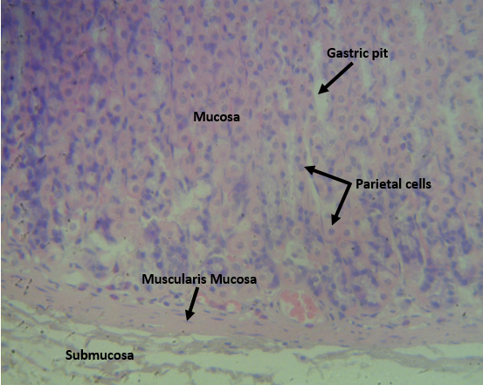
Fig. 6a. Photomicrograph (H&E X400) of the stomach for the normal control. Intact mucosa and submucosa.

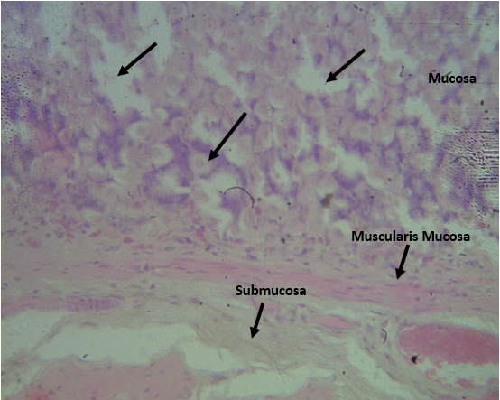
Fig. 6b. Photomicrograph (H&E X400) of the stomach for the negative control. Severe mucosal injury is characterized by vacuolation of the deep mucosa, loss of parietal cells, and distortion of normal architecture.
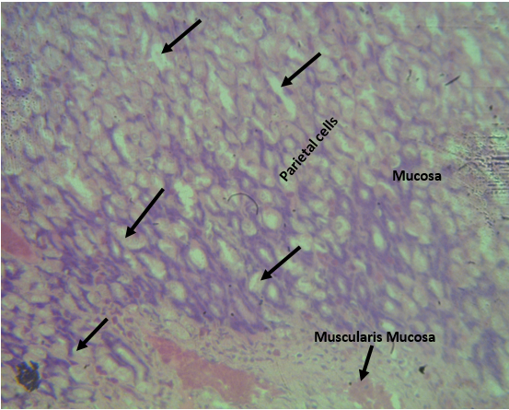
Fig. 6c. Photomicrograph (H&E X400) of the stomach for the positive control. Mild vacuolation of the mucosa with reduced parietal cells, corresponding to mild atrophic gastritis.

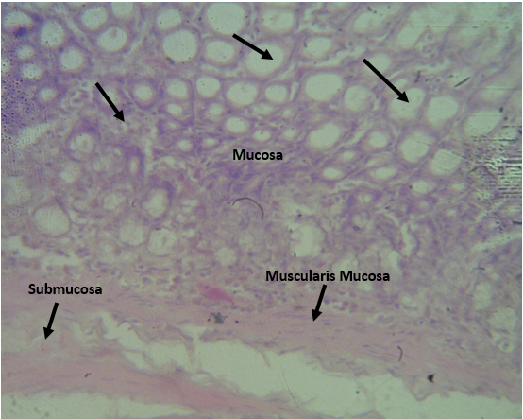
Fig. 6d. Photomicrograph (H&E X400) of the stomach for the PBY. Multifocal enlargement and disruption of mucosal glands and epithelial cells, suggesting partial distortion of the mucosal wall.

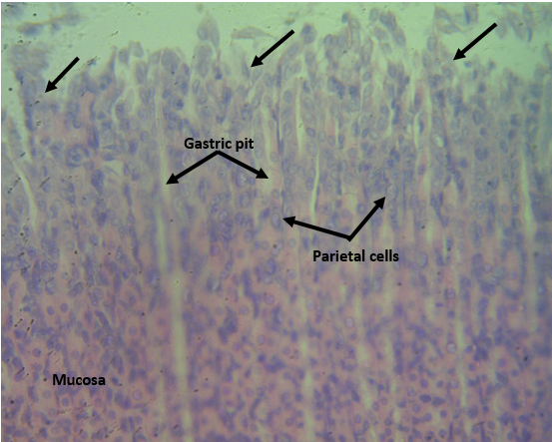
Fig. 6e. Photomicrograph (H&E X400) of the stomach for the DPBY. Mild distortion of the stomach mucosa.

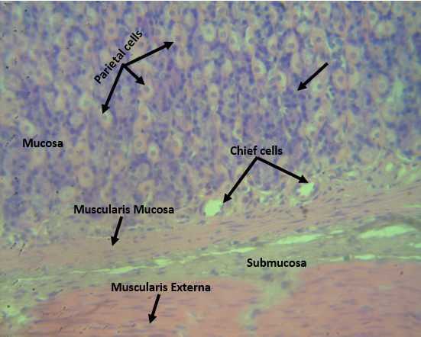

Fig. 6f. Photomicrograph (H&E X400) of the stomach for the DBY. Exhibited minimal mucosal inflammation, with chief and parietal cells largely preserved and intact muscularis mucosa and submucosa.

4. Conclusion

In conclusion, this study examined the effect of plant-based yoghurt prepared from a coconut-tigernut blend on indomethacin-induced gastric ulceration in Wistar rats, comparing these effects with those of dairy and dairy/plant-based yoghurt blends. This work demonstrated that plant-based yoghurt exhibits a gastroprotective effect and represents a promising dietary substitute to conventional anti-ulcer drugs.

References

Ahmed, O., Nedi, T., & Yimer, E. M. (2022). Evaluation of anti-gastric ulcer activity of aqueous and 80% methanol leaf extracts of Urtica simensis in rats. Metabolism Open, 14, 100172. https://doi.org/10.1016/j.metop.2022.100172
Ajayi, O. V., Omolaso, B. O., Omayone, T. P., Adeniran, A. G., Adu, A. O., & Olorunfemi, O. E. (2024). Anti-inflammatory and anti-oxidative effect of pasterurised yoghurt in indomethacin-induced gastric ulceration in male Wistar rats. Heliyon, 10(24), e40770. https://doi.org/10.1016/j.heliyon.2024.e40770
Ajeigbe, K. O., Owonikoko, W. M., Egbe, V., Iquere, I., & Adeleye, G. (2017). Gastroprotective and mucosa homeostatic activities of coconut milk and water on experimentally induced gastropathies in male Wistar rats. Tissue & cell, 49(5), 528–536. https://doi.org/10.1016/j.tice.2017.06.004
Armstrong D. (2004). Review article: gastric pH -- the most relevant predictor of benefit in reflux disease?. Alimentary pharmacology & therapeutics, 20 Suppl 5, 19–39. https://doi.org/10.1111/j.1365-2036.2004.02140.x
Atiq, A., Hashim, M. M. A., Khan, F. W., Bashir, A., Zafar, A., Jamil, A., & Chughtai, A. S. (2023). Morphological Spectrum of Gastritis in Endoscopic Biopsies and Its Association With Helicobacter pylori Infection. Cureus, 15(8), e43084. https://doi.org/10.7759/cureus.43084
Bhattacharya, S., Chaudhuri, S. R., Chattopadhyay, S., & Bandyopadhyay, S. K. (2007). Healing Properties of Some Indian Medicinal Plants against Indomethacin-Induced Gastric Ulceration of Rats. Journal of clinical biochemistry and nutrition, 41(2), 106–114. https://doi.org/10.3164/jcbn.2007015
Cherrada, N., Chemsa, A. E., Gheraissa, N., Laib, I., Gueboudji, Z., El-Shazly, M., Zaater, A., Abid, A., Sweilam, S. H., Emran, T. B., Nani, S., Benamor, B., Ghemam Amara, D., Atoki, A. V., & Messaoudi, M. (2024). Gastroprotective Efficacy of North African Medicinal Plants: A Review on Their Therapeutic Potential for Peptic Ulcers. Food science & nutrition, 12(11), 8793–8824. https://doi.org/10.1002/fsn3.4536
Danisman, B., Cicek, B., Yildirim, S., Bolat, I., Kantar, D., Golokhvast, K. S., Nikitovic, D., Tsatsakis, A., & Taghizadehghalehjoughi, A. (2023). Carnosic Acid Ameliorates Indomethacin-Induced Gastric Ulceration in Rats by Alleviating Oxidative Stress and Inflammation. Biomedicines, 11(3), 829. https://doi.org/10.3390/biomedicines11030829
Drini M. (2017). Peptic ulcer disease and non-steroidal anti-inflammatory drugs. Australian prescriber, 40(3), 91–93. https://doi.org/10.18773/austprescr.2017.037
Fernandez, N., Wrzosek, L., Radziwill-Bienkowska, J. M., Ringot-Destrez, B., Duviau, M. P., Noordine, M. L., Laroute, V., Robert, V., Cherbuy, C., Daveran-Mingot, M. L., Cocaign-Bousquet, M., Léonard, R., Robbe-Masselot, C., Rul, F., Ogier-Denis, E., Thomas, M., & Mercier-Bonin, M. (2018). Characterization of Mucus-Related Properties of Streptococcus thermophilus: From Adhesion to Induction. Frontiers in physiology, 9, 980. https://doi.org/10.3389/fphys.2018.00980
Gohari, S. T., Mahmoud, M. H., & Mahdy, S. M. (2021). Antioxidant and Anti-ulcer Activities of Fermented Soybean (Natto) and Moringa oleifera Leaves in Male Albino Rats. Egyptian Journal of Nutrition, 36(3), 129-189. doi: 10.21608/enj 2021.209923
Indira, M., Venkateswarulu, T. C., Abraham Peele, K., Nazneen Bobby, M., & Krupanidhi, S. (2019). Bioactive molecules of probiotic bacteria and their mechanism of action: a review. 3 Biotech, 9(8), 306. https://doi.org/10.1007/s13205-019-1841-2
Kim S. H. (2025). Peptic Ulcer Disease. The Korean journal of helicobacter and upper gastrointestinal research, 25(1), 13–16. https://doi.org/10.7704/kjhugr.2024.0075
Kumar, V., Abbas, A. K., & Aster, J. C. (2018). Robbins Basic Pathology (10th ed.). Philadelphia, Pennsylvania, Elsevier.
Latif, A., Shehzad, A., Niazi, S., Zahid, A., Ashraf, W., Iqbal, M. W., Rehman, A., Riaz, T., Aadil, R. M., Khan, I. M., Özogul, F., Rocha, J. M., Esatbeyoglu, T., & Korma, S. A. (2023). Probiotics: mechanism of action, health benefits and their application in food industries. Frontiers in microbiology, 14, 1216674. https://doi.org/10.3389/fmicb.2023.1216674
Lu, P. J., Hsu, P. I., Chen, C. H., Hsiao, M., Chang, W. C., Tseng, H. H., Lin, K. H., Chuah, S. K., & Chen, H. C. (2010). Gastric juice acidity in upper gastrointestinal diseases. World journal of gastroenterology, 16(43), 5496–5501. https://doi.org/10.3748/wjg.v16.i43.5496
Malik, T. F., Singh, K., & Gnanapandithan, K. (2023). Peptic Ulcer Disease. National Library of Medicine; StatPearls Publishing. https://www.ncbi.nlm.nih.gov/books/NBK534792/
Munjal, A., & Allam, A. E. (2020). Indomethacin. PubMed; StatPearls Publishing. https://www.ncbi.nlm.nih.gov/books/NBK555936
Nielsen, S. D., Purup, S., & Larsen, L. B. (2019). Effect of Casein Hydrolysates on Intestinal Cell Migration and Their Peptide Profiles by LC-ESI/MS/MS. Foods (Basel, Switzerland), 8(3), 91. https://doi.org/10.3390/foods8030091
Ogundipe, O. O., Fasogbon, B. M., Ogundipe, F. O., Oredope, O., & Amaezenanbu, R. U. (2021). Nutritional composition of non‐dairy yoghurt from sprouted tigernut tubers. Journal of Food Processing and Preservation, 45(11). https://doi.org/10.1111/jfpp.15884
Sabiu, S., Garuba, T., Sunmonu, T., Ajani, E., Sulyman, A., Nurain, I., & Balogun, A. (2015). Indomethacin-induced gastric ulceration in rats: Protective roles of Spondias mombin and Ficus exasperata. Toxicology Reports, 2, 261–267. https://doi.org/10.1016/j.toxrep.2015.01.002
Saranya, P., Geetha, A., & Selvamathy, S. M. (2011). A biochemical study on the gastroprotective effect of andrographolide in rats induced with gastric ulcer. Indian journal of pharmaceutical sciences, 73(5), 550–557. https://doi.org/10.4103/0250-474X.99012
Suleyman, H., Albayrak, A., Bilici, M., Cadirci, E., & Halici, Z. (2010). Different mechanisms in the formation and prevention of indomethacin-induced gastric ulcers. Inflammation, 33(4), 224–234. https://doi.org/10.1007/s10753-009-9176-5
Yasin, H., Tariq, F., Sameen, A., Ahmad, N., Manzoor, M. F., Yasin, M., Tariq, T., Iqbal, M. W., Ishfaq, B., Mahmood, S., & Siddeeg, A. (2020). Ethanolic extract of okra has a potential gastroprotective effect on acute gastric lesions in Sprague Dawley rats. Food science & nutrition, 8(12), 6691–6698. https://doi.org/10.1002/fsn3.1963
Yulizal, O. K., Tarigan, S. B., Isnainul, O. K., & Muttaqin, Z. (2021). Gastric histopathological features after the administration of omeprazole, amoxicillin, and clarithromycin in a Helicobacter pylori rat model. Journal of advanced veterinary and animal research, 8(1), 158–163. https://doi.org/10.5455/javar.2021.h498
Zaki, S. M. & Mohammed, E. A. (2014). Experimental study: Effect of glucocorticoids on indomethacin-induced gastric ulcer in the adult male albino rat – histological, morphometric and electron microscopy study. Archives of Medical Science, 10(2), 381–388. https://doi.org/10.5114/aoms.2012.28807

