Characterization and quantification of urinary electrolytes in the populations of Grand Sido and Kouh-Est in southern Chad.

Abstract
Urinary electrolytes play a key role in assessing hydration status, metabolism and renal function. This study aims to characterise and quantify the major urinary electrolytes (Na⁺, K⁺, Ca²⁺, Cl⁻) in two rural areas of southern Chad: Grand Sido and Kouh-Est. Urine samples were collected and analysed according to rigorous biochemical protocols. The results reveal significant disparities between the two areas, highlighting the influence of dietary habits, access to drinking water and environmental conditions. These data provide an important basis for the implementation of targeted public health and nutrition strategies.
Keywords: Urinary electrolytes, Sido, Kouh-Est, Chad, community health.
Introduction
Urinary electrolytes play a fundamental role in maintaining bodily homeostasis, particularly by regulating water balance, acidity (pH), and neuromuscular and cardiac activity. Their renal excretion is a valuable biological indicator for assessing individuals' nutritional, metabolic, and renal status (WHO, 2012). In many parts of the world, particularly in sub-Saharan Africa, data-t-on the composition and concentration of urinary electrolytes remain limited, especially in rural areas (Kamel et al. 2017; Kamel et al. 2019).
In Chad, the Grand Sido and Kouh-Est regions in the south of the country are characterised by ecological, nutritional and health diversity that can influence electrolyte metabolism. These areas, which have not yet been extensively studied from a biomedical perspective, present specific challenges related to access to drinking water and food, as well as exposure to certain endemic diseases such as schistosomiasis, all of which can disrupt the urinary electrolyte profile (West et al. 1986; Ethier et al. 1990).
The lack of reliable local data is a major obstacle to the development of appropriate public health policies, particularly in the areas of nutrition, preventive nephrology and early diagnosis of electrolyte imbalances. Indeed, international recommendations on sodium, potassium and magnesium in take are difficult to apply without context-specific reference values (WHO, 2012-2018; Aburto et al. 2013).
Thus, rigorous characterisation and quantification of urinary electrolytes in these populations would not only enable the establishment of reference values adapted to the local context, but also provide a better understanding of the biological and environmental determinants influencing their variation (Mancilha-Carvalho et al. 1989; Kamel et al. 2019).
The objective of this study is therefore to characterise and quantify the main urinary electrolytes (sodium, potassium, calcium, magnesium, chloride, etc.) in the populations of Grand Sido and Kouh-Est in southern Chad, taking into account socio-demographic, nutritional and health factors. This research aims to fill an important scientific gap, while contributing to knowledge of biological markers of health in a Sahelian context.

Materials & Methods
Study area
This cross-sectional, prospective study was conducted in the regions of Kouh-Est, located at 8°12.375'N, 17°08.063'E in the province of Logone-Oriental, and Grand Sido, located at 8°24.807'N, 18°46.139'E in the province of Moyen-Chari (Figure 1). Annual rainfall in this area varies from 600 mm to 1000 mm (Steverding, 2008) (Desquesnes, 2004). There are two seasons: the rainy season from May to October and the dry season from November to April (Desquesnes, 2004). The population of Kouh-Est is approximately 38,600, and that of Grande Sido is approximately 14,500, spread across 45 localities (Ibrahim et al. 2021). Households were selected as described in (Ibrahim et al. 2021) and (Ibrahim et al. 2025).
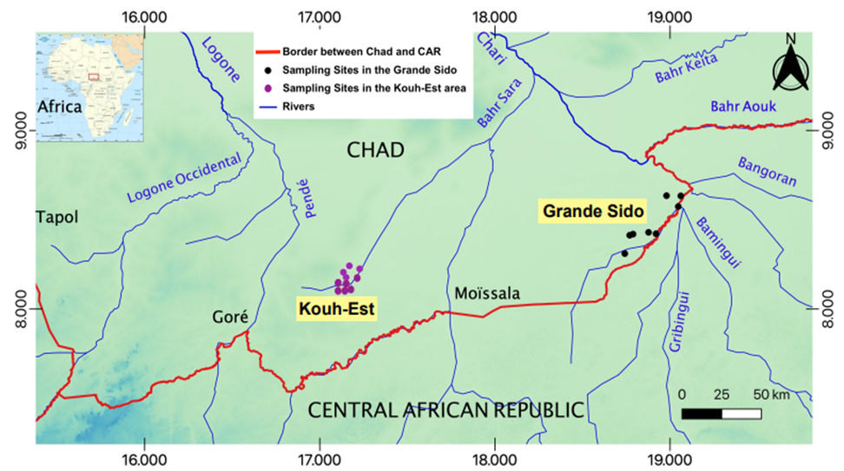
Figure 1: Map showing sampling sites in Kouh-Est and Grand-Sido in southern Chad (sources:
Map adapted from (Ibrahim M.A.M. et al. 2021), https://earthexplorer.usgs.gov/).
Inclusion and exclusion criteria
Participants were eligible for inclusion if they were between 5 and 90 years of age and resided in the Kouh-Est or Grand-Sido regions. Children under the age of 5 and elderly people were excluded for ethical, practical and safety reasons related to invasive procedures such as blood sampling. Individuals who refused to participate or who did not reside in the specified regions were also excluded.
Ethics statement:
Prior to data collection, ethical approval for this study protocol was obtained from the National Bioethics Committee of Chad under No. 585/PR/PM/MESRI/SEESRI/SG/2016. Authorisation for sampling surveys was also obtained from the Ministry of Public Health.

Urine collection
Urine collection cups, labelled with participants' identification numbers, were distributed to each household for morning urine collection (10 to 30 ml). Parents collected urine samples from younger children.
Data analysis
All data obtained during the study were entered into Microsoft Excel 2010 and analysed using SPSS version 25.0. The chi-square test was used to compare variables such as age, gender and other parameters, with a p-value threshold set at 0.05.
Results and Discussion
Description of urinary parameters: urine strip test results
In general, whether in men or women, in the populations of Kouh-Est or Grand Sido (Table 1), few positive cases were recorded for either parameter. However, the percentage of positive cases for almost all parameters was higher in the Grand Sido population.
The interpretation of the results was based on the manufacturer's instructions.
Table 1. Results of urinary parameters measured using test strips according to gender (male and female) and region (Kouh-East and Grand Sido).
Paramètres | Paramètres2 | Male n=406 (%) | Female n=377 (%) | Total n=783 (%) | Kouh-Est n=430 (%) | Grand Sido n=353 (%) | Total n=783 (%)
Urinary specific gravity
 | 1.000 | 12 (2.9) | 14 (3.7) | 26 (3.3) | 6 (1.39) | 17 (4.8) | 23 (2.9)
 | 1.010 | 110 (27.0) | 131 (34.) | 241 (30.7) | 116 (26.9) | 104 (29.4) | 220 (28.0)
 | 1.015 | 1 (0.2) | 0 (0.0) | 1 (0.1) | 0 (0.0) | 1 (0.2) | 1 (0.1)
 | 1.020 | 207 (50.9) | 210 (55.7) | 417 (53.2) | 262 (60.9) | 189 (53.5) | 451 (57.5)
 | 1.030 | 76 (18.7) | 22 (5.8) | 98 (12.5) | 46 (10.6) | 42 (11.8) | 88 (11.2)
Leukocytes
 | Negatif | 399 (98.2) | 344 (91.2) | 743 (94.8) | 413 (96.0) | 330 (93.4) | 743 (94.8)
 | ~ 10–25 Leu/µL | 3 (0.7) | 5 (0.6) | 8 (1.2) | 2 (0.4) | 6 (1.6) | 8 (1.0)
 | ~ 75 Leu/µL | 3 (0.7) | 18 (2.3) | 21 (2.6) | 8 (1.8) | 13 (3.6) | 21 (2.6)
 | ~ 500 Leu/µL | 1 (0.2) | 10 (1.3) | 11 (1.4) | 7 (1.6) | 4 (1.1) | 11 (1.4)
Nitrite
 | Negatif | 352 (86.6) | 317 (36.6) | 669(85.4) | 425 (98.8) | 275 (77.9) | 700 (89.3)
 | Positif (1+) | 54 (6.8) | 60 (6.3) | 114(14.5) | 5 (1.1) | 78 (22.0) | 83 (10.6)
Proteins
 | Negatif | 370 (91.1) | 364 (96.5) | 734 (93.7) | 420 (97.6) | 334 (94.6) | 754 (96.2)
 | 0.3 g/L | 22 (5.4) | 10 (2.6) | 32 (4.0) | 8 (1.8) | 14 (3.9) | 22 (2.8)
 | 1 g/L | 14 (3.4) | 3 (0.7) | 17 (2.1) | 2 (0.4) | 5 (1.4) | 7 (0.8)
Glucose
 | Negatif | 396 (97.5) | 370 (98.1) | 766 (97.8) | 424 (98.6) | 342 (96.8) | 776 (99.1)
 | 50 mg/ dL | 7 (1.2) | 7 (1.8) | 14 (1.8) | 6 (1.3) | 8 (2.2) | 14 (1.7)
 | 100 mg/dL | 1 (0.2) | 0 (0.0) | 1 (0.1) | 0 (0.0) | 1 (0.2) | 1 (0.1)
 | 300 mg/dL | 2 (0.4) | 0 (0.0) | 2 (0.2) | 0 (0.0) | 2 (0.5) | 2 (0.2)
Ketones
 | Normal | 405 (99.7) | 376 (99.7) | 781 (99.7) | 429 (99.7) | 352 (99.7) | 781 (99.7)
 | 10 mg/dL | 1 (0.24) | 1 (0.26) | 2 (0.25) | 1 (0.2) | 1 (0.2) | 2 (0.2)
Urobilinogenes
 | Négatif | 389 (95.8) | 368 (90.6) | 757 (96.6) | 420 (97.6) | 337 (95.4) | 757 (96.6)
 | 1 mg/dL | 15 (3.6) | 7 (1.85) | 22 (2.8) | 9 (2.0) | 13 (3.6) | 22 (2.8)
 | 4 mg/dL | 2 (0.4) | 2 (0.53) | 4 (0.5) | 1 (0.2) | 3 (0.8) | 4 (0.5)
Bilirubin
 | Négatif | 405 (99.7) | 373 (98.9) | 778 (99.3) | 426 (99.0) | 352 (99.7) | 778 (99.3)
 | Positif 1+ | 1 (0.2) | 2 (0.5) | 3 (0.3) | 3 (0.6) | 0 (0.0) | 3 (0.3)
 | Positif 2+ | 0 (0.0) | 2 (0.5) | 2 (0.2) | 1 (0.2) | 1 (0.2) | 2 (0.2)
Red blood cells
 | Négatif | 401 (98.7) | 370 (98.1) | 771 (98.4) | 427 (99.3) | 344 (97.4) | 771 (98.4)
 | ~ 25 Ery/µL | 2 (0.4) | 0 (0.0) | 2 (0.2) | 0 (0.0) | 2 (0.5) | 2 (0.2)
 | ~ 50 Ery/µL | 2 (0.4) | 1 (0.2) | 3 (0.3) | 1 (0.2) | 2 (0.5) | 3 (0.3)
 | ~ 250 Ery/µL | 1 (0.2) | 6 (1.5) | 7 (0.8) | 2 (0.4) | 5 (1.4) | 7 (0.8)
Hemoglobin
 | Négatif | 395 (97.2) | 358 (94.9) | 753 (97.8) | 419 (97.4) | 334(94.6) | 753 (96.1)
 | ~ 10 Ery/µL | 4 (0.9) | 3 (0.7) | 7 (0.8) | 3 (0.6) | 4 (1.1) | 7 (0.8)
 | ~ 25 Ery/µL | 3 (0.7) | 7 (1.8) | 10 (1.2) | 4 (0.9) | 6 (1.6) | 10 (1.2)
 | ~ 50 Ery/µL | 1 (0.2) | 2 (0.5) | 3 (0.3) | 1 (0.2) | 2 (0.5) | 3 (0.3)
 | ~ 250 Ery/µL | 3 (0.7) | 7 (1.8) | 10 (1.2) | 3 (0.6) | 7 (1.9) | 10 (1.2)

Description of urinary electrolytes in target populations
Figure 2. Shows the average value of analytes by age group and gender, while Figure 3 shows the individual values of each electrolyte for each participant.
Urinary calcium concentration (UCa, in mmol/L) varies slightly between age groups (Figure 2) ; however, this difference is not statistically significant. UCa concentrations in this study population were generally low compared to other studies. For example, previous studies (Paccaud et al. 2020), (Reusz et al. 1995) reported values between 0.10 and 0.13 mg/ml (i.e. 0.28 to 0.37 mmol/L) in children aged 6 to 16 years, which is higher than the average observed in children in the present study: 0.18 ± 0.03 mmol/L in boys (n=64) and 0.16 ± 0.02 mmol/L in girls (n=68). A similar trend (low mean values) was observed in participants over 15 years of age, compared to known references. Interestingly, no participant had a UCa concentration exceeding the threshold for hypercalcaemia, which is >2.55 mmol/L in adults (Gallagher et al. 2014) and >1.12 mmol/L in children (Paccaud et al. 2020).
No statistically significant differences were observed between urinary sodium concentrations (UNa) according to age group and gender. However, the mean values reported in previous studies (100.8 ± 47.8 mmol/L (Iwahori et al. 2017) (Conkle et al. 2016) and 72 mmol/L Gallagher et al. 2014) reveal a wide variation in urinary sodium concentrations depending on the participants' diet and health status. This significant variability was also observed in the samples analysed in this study (Figure 2). Urinary sodium concentration can be used to estimate salt intake in a population (Iwahori et al. 2017). Although this was not a primary objective of our study, this analysis could be considered in future studies. A high sodium/potassium ratio is associated with increased blood pressure and an increased risk of cardiovascular disease. In this context, we measured the urinary potassium (UK) concentration of the individuals surveyed. When considered in isolation, UK concentration does not differ significantly according to age and gender. This finding is consistent with that reported by (Iwahori et al. 2017), who observed an average concentration of 26.0 ± 13.0 mmol/L in the first morning urination in individuals with an average age of 38.9 ± 10.1 years. Table 2 shows the sodium/potassium (Na⁺/K⁺) ratio observed in this study, which can be used to predict the risk of cardiovascular disease. Among the 54 individuals with high systolic blood pressure (SBP), 36 individuals over the age of 40 (data available) had an average Na⁺/K⁺ ratio of 3.94, compared to 3.44 in 108 individuals with low blood pressure.
Table 2. Na⁺/K⁺ ratio by age group and gender.
Gender | Age (years) | Mean | SD
Male | 5 - 15 | 3.3 | 1.8
Female | 5 - 15 | 4.1 | 2.115
Male | Above 15 | 3.4 | 1.749
Female | Above 15 | 3.9 | 1.862
Overall (Male& Female) | Above 5 | 3.7 | 1.867
Ref. (38.9±10.1) [180] | 25 - 69 | 4.5 | 2.55

The mean pH values were statistically significant (p = 0.011 between boys and girls; p < 0.0001 between men and women). Nevertheless, these means ranged from 7.25 to 7.36 and were within the normal range for urinary pH [23], [24].
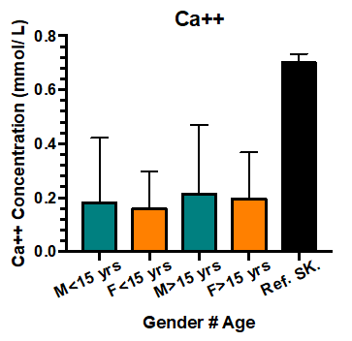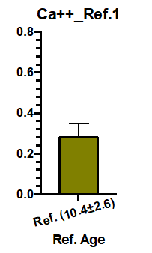
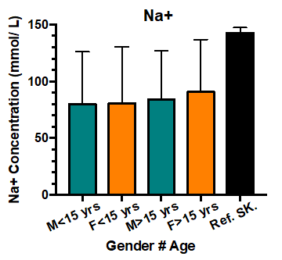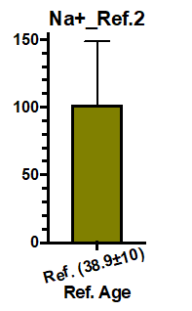
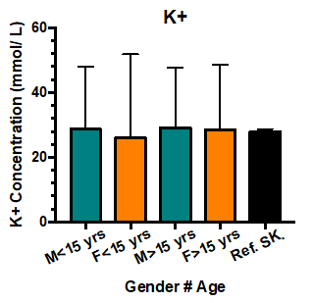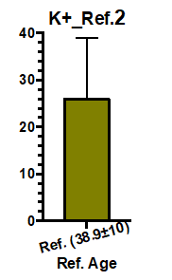
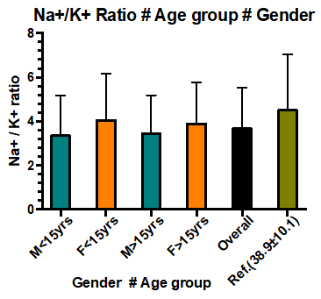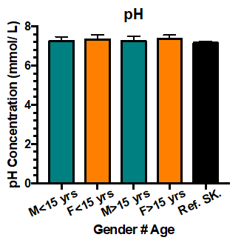

Figure 2. Urinary sodium, potassium, calcium, pH, and sodium/potassium ratio by age group and gender. Ref. 1 : (Paccaud et al. 2020) ; Ref. 2 : (Iwahori et al. 2017). The error bars represent standard deviations.
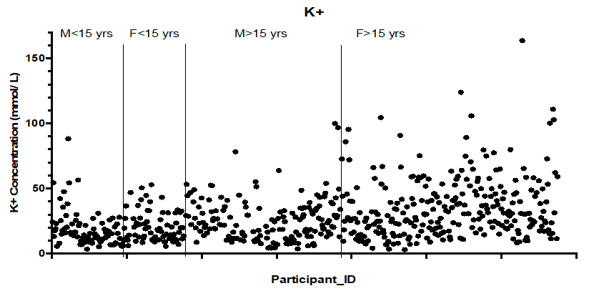

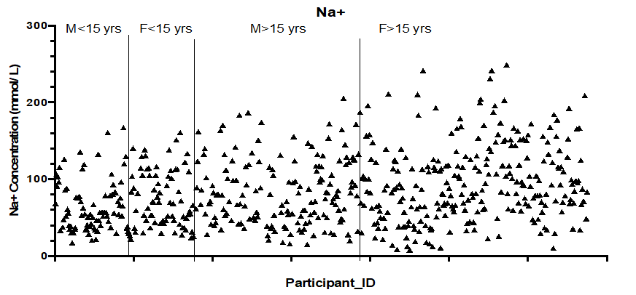
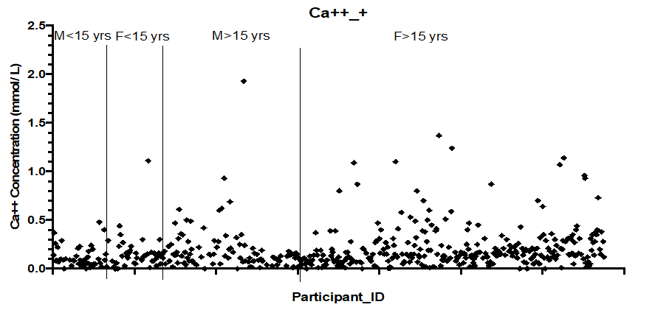
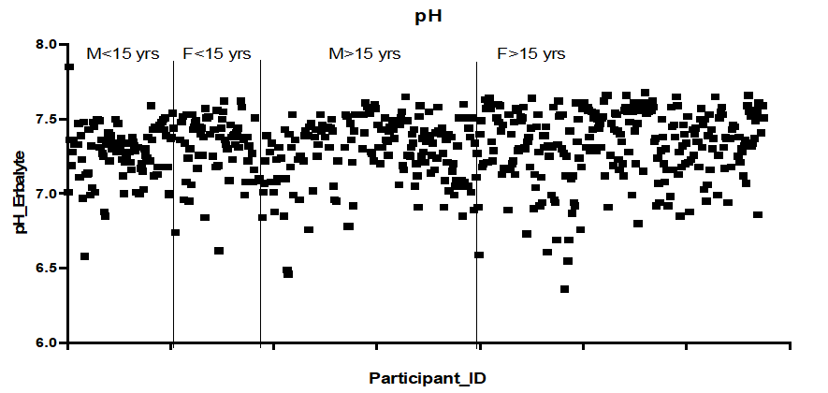
Figure 3. Distribution of analyte concentrations. The vertical lines indicate the boundaries between age and gender groups. M: male and F: female.
It should be noted that the amount of a substance in urine may vary depending on diet, medication or changes in physiological balance. In addition, urine concentration may vary by a factor of 1 to 20 depending on the action of the antidiuretic hormone.
Concentrated urine will result in higher measured concentrations of any substance, regardless of the absolute amount excreted. Conversely, diluted urine will produce lower results (Mutter and Korzelius, 2012).
Nevertheless, as mentioned above, urine composition cannot be interpreted in isolation and often requires simultaneous serum measurements, particularly of renal function parameters, as well as essential clinical information such as medication use. For example, an individual's urinary potassium concentration may be within the ‘normal’ range, but if that person has hypokalaemia, the appropriate renal response would be potassium conservation, resulting in low urinary potassium excretion (Mutter and Korzelius, 2012).
The analysis of urinary electrolytes in the Grand Sido and Kouh-Est populations in southern Chad has enabled the establishment of a biochemical profile that is useful for assessing the water-mineral balance and the risks of nutritional and cardiovascular disorders in this region. The average levels of urinary excretion of sodium (Na⁺), potassium (K⁺), calcium (Ca²⁺) and magnesium (Mg²⁺) observed in this study show significant variations, linked to local dietary habits, access to drinking water, and the lack of regular medical monitoring.
The urinary sodium load observed, although moderate, seems to indicate salt consumption above WHO recommendations, which could ultimately contribute to an increased risk of high blood pressure in the study population (Aburto et al. 2013; Kamel et al. 1990). These results are consistent with those of the INTERSALT study, which showed a positive correlation between urinary sodium excretion and elevated blood pressure (Intersalt, 1988).
Furthermore, potassium excretion remains low in a significant proportion of subjects, which may reflect an insufficient dietary intake of fresh fruit and vegetables, which are essential for counterbalancing the effects of sodium on blood pressure (Aburto et al. 2013; Kamel et al. 2019). This trend is worrying given the importance of the sodium/potassium ratio in regulating blood pressure and preventing cardiovascular disease (Aburto et al. 2013; Kamel et al. 2017).
With regard to calcium and magnesium, variable levels were noted. Calcium excretion could be influenced by reduced consumption of dairy products, which is common in rural areas of Chad, and by urinary losses associated with secondary nutritional hyperparathyroidism. Magnesium, meanwhile, is an indirect indicator of nutritional status and renal tubular function. Low levels may be associated with an increased risk of metabolic syndrome and renal dysfunction (Marsden and Richardson, 1986; Ethier et al. 1990). The individual variability observed could also be explained by genetic factors, physical activity, hydration levels, and environmental conditions. Similar studies on isolated populations, such as the Yanomamo Indians, have shown very different electrolyte excretion patterns in the absence of refined salt consumption (Kamel et al. 2019).
Finally, urinary electrolyte ratios, such as the K⁺/Na⁺ ratio or the K⁺/creatinine ratio, may be useful tools for the clinical assessment of acid-base and hydroelectrolytic disorders in low-resource settings (Kamel et al. 2017; Halperin, 2017; WHO, 2018). The limitations of this study include the absence of systematic measurement of urinary creatinine and acid-base parameters, as well as the lack of data on participants' specific dietary habits. However, it provides an initial regional basis for further research.

Conclusion
Creatinine analysis in participants' urine should be performed. Combined with the electrolyte analysis reported here, it will provide a good indicator of renal filtration efficiency in participants.
This study enabled an in-depth biochemical characterisation and rigorous quantification of the main urinary electrolytes (Na⁺, K⁺, Ca²⁺, Mg²⁺, Cl⁻) in the populations of Grand Sido and Kouh-Est, located in southern Chad. The results reveal electrolyte profiles with significant inter-individual variations, likely related to nutritional, hydric, environmental and pathological factors specific to these geographical areas. The observed prevalence of certain electrolyte imbalances, such as hyponatraemia or hypocalcaemia, indicates a state of nutritional and metabolic vulnerability. These disturbances may be correlated with an unbalanced diet, increased hydroelectrolytic losses, or the presence of chronic or endemic parasitic diseases, particularly kidney disease or schistosomiasis.
This research, which is unprecedented in this region, makes an important contribution to our understanding of the urinary biochemical status of rural populations in Chad. It provides a scientific database that can be used for epidemiological surveillance, health planning, and public health policy guidance. Ultimately, further studies incorporating clinical, nutritional and parasitological markers would be necessary in order to better understand the determinants of the electrolyte imbalances observed and to develop appropriate intervention strategies based on scientific evidence and local realities.

Compliance with ethical standards
Disclosure of conflict of interest
The authors declare that they have no conflicts of interest.
Statement of informed consent
Yes, informed consent was obtained from all individual participants included in the study.

Référence

- A.L.A.R. Osório, C.R. Madruga, M. Desquesnes, C.O. Soares, L.R.R. Ribeiro, and S.C. G. da Costa, 2008. Trypanosoma (Duttonella) vivax: its biology, epidemiology, pathogenesis, and introduction in the New World - a review. Memórias do Instituto Oswaldo Cruz, vol. 103, no. 1, pp. 1–13, doi: 10.1590/S0074-02762008000100001.
- Aburto NJ, Ziolkovska A, Hooper L, Elliott P, Cappuccio FP, Meerpohl JJ. Effect of lower sodium intake on health : systematic review and meta-analyses. BMJ. 2013 ;346 : f1326.
- D. Steverding, 2008. The history of African trypanosomiasis. Parasites & Vectors, vol. 1, no. 1, p. 3, doi: 10.1186/1756-3305-1-3.
- Ethier JH, Kamel KS, Magner PO. Transtubular potassium concentration in patients with hypokalemia and hyperkalemia. Am J Kidney Dis. 1990 ;15 :309–15.
- G. K. Dayo et al., 2012. Association studies in QTL regions linked to bovine trypanotolerance in a West African crossbred population: Association study in bovine trypanotolerance. Animal Genetics, vol. 43, no. 2, pp. 123–132, doi: 10.1111/j.1365-2052.2011.02227. x.
- G. S. Reusz, M. Dobos, D. Byrd, P. Sallay, M. Miltinyi, and T. Tulassay, 1995. Urinary calcium and oxalate excretion in children. Pediatric Nephrology, vol. 9, no. 1, pp. 39–44, doi: 10.1007/BF00858966.
- Halperin ML. Evaluating renal response in patients with potassium disorders: a shift in emphasis from TTKG to the urinary K+/creatinine ratio. Afr J Nephrol. 2017 ;20
- Intersalt Cooperative Research Group. Intersalt: an international study of electrolyte excretion and blood pressure. BMJ. 1988 ;297(6644) :319–28.
- J. C. Gallagher, L. M. Smith, and V. Yalamanchili, 2014. Incidence of hypercalciuria and hypercalcemia during vitamin D and calcium supplementation in older women. Menopause, vol. 21, no. 11, pp. 1173–1180, doi: 10.1097/GME.0000000000000270.
- J. Conkle and F. van der Haar, 2016. The Use and Interpretation of Sodium Concentrations in Casual (Spot) Urine Collections for Population Surveillance and Partitioning of Dietary Iodine Intake Sources. Nutrients, vol. 9, no. 1, p. 7, doi: 10.3390/nu9010007.
- Kamel KS, Ethier JH, Richardson RM, Bear RA, Halperin ML. Urine electrolytes and osmolality: when and how to use them. Am J Nephrol. 1990 ;10 :89–102.
- Kamel KS, Halperin ML. Fluid, Electrolyte, and Acid-Base Physiology: A Problem-Based Approach. Philadelphia: Elsevier; 2017.
- Kamel KS, Halperin ML. Interpretation of electrolytes and acid-base parameters in blood and urine. In: Skorecki K, Chertow GM, Marsden PA, editors. Brenner and Rector’s The Kidney. 11th ed. Philadelphia : Elsevier ; 2019. p. 758–95.
- M. Desquesnes, 2004, Livestock trypanosomoses and their vectors in Latin America. Paris: OIE,
- M. R. Clarkson, C. N. Magee, and B. M. Brenner, 2011. Chapter 2 - Laboratory Assessment of Kidney Disease,
- Mancilha-Carvalho J, de Oliveira R, Esposito RJ. Blood pressure and electrolyte excretion in the Yanomamo Indians, an isolated population. J Hum Hypertens. 1989 ;3(5) :309–14.
- Marsden PA, Richardson RM. A new clinical approach to evaluating potassium excretion disorders. Electrolyte Metab. 1986 ;12 :234–238.
- Poster_ Combur10 Test parameters.pdf.
- T. Iwahori, H. Ueshima, S. Torii, Y. Saito and K. Kondo. 2017. Diurnal variation of urinary sodium-to-potassium ratio in free-living Japanese individuals. Hypertension Research, vol. 40, no. 7, pp. 658–664, doi: 10.1038/hr.2016.187.
- Urine pH - an overview | ScienceDirect Topics. https://www.sciencedirect.com/topics/immunology-and-microbiology/urine-ph (accessed Nov. 15, 2020).
- W. P. Mutter and C. A. Korzelius, 2012. Urine Chemistries. Hospital Medicine Clinics, vol. 1, no. 3, pp. e338–e352, doi: 10.1016/j.ehmc.2012.04.007.
- West ML, Marsden PA, Richardson RM. A new clinical approach to evaluating disorders of potassium excretion. Miner Electrolyte Metab. 1986 ;12 :234–8.
- WHO. Guideline: Sodium intake for adults and children. Geneva: World Health Organization; 2012.
- WHO. How to obtain measures of population-level sodium intake in 24-hour urine samples (No. WHO-EM/NUT/279/E). Regional Office for the Eastern Mediterranean, World Health Organization; 2018.
- Y. Paccaud, M. Rios-Leyvraz, M. Bochud, R. Tabin, B. Genin, and M. Russo. 2020. Spot urine samples to estimate 24-hour urinary calcium excretion in school-age children. European Journal of Pediatrics, vol. 179, no. 11, pp. 1673–1681, doi: 10.1007/s00431-020-03662-z.

