Design, development and performance evaluation of a semi-automatic paddy drum seeder with motor-assisted seed metering for direct-seeded rice cultivation

Abstract
Labour scarcity, high seed requirement, and non-uniform crop establishment are major challenges limiting the large-scale adoption of direct-seeded rice, particularly under smallholder farming systems. Conventional manual broadcasting and manually operated drum seeders often exhibit high variability in seed placement due to dependence on operator walking speed, resulting in excessive seed usage and reduced operational efficiency. To overcome these limitations, a semi-automatic paddy drum seeder with motor-assisted seed metering was designed, developed, and evaluated under puddled field conditions.
The proposed design decouples seed metering from forward motion by integrating a low-power DC motor to drive the seed drum, while forward movement remains manual. Field performance was quantitatively compared with conventional manual broadcasting through replicated trials. The semi-automatic drum seeder achieved a significantly lower seed rate (55 ± 4.2 kg ha⁻¹) than manual broadcasting (110 ± 8.6 kg ha⁻¹), representing a reduction of approximately 50%. Time required for sowing decreased from 5.5 ± 0.7 h ha⁻¹ to 2.5 ± 0.4 h ha⁻¹, while labour requirement was reduced from 8.0 ± 0.6 h ha⁻¹ to 4.0 ± 0.3 h ha⁻¹. Effective field capacity increased from 0.18 ± 0.03 ha h⁻¹ to 0.40 ± 0.05 ha h⁻¹, and field efficiency improved significantly from 36.9 ± 2.8% to 86.1 ± 3.5%. Statistical analysis using Student’s t-test confirmed that differences between sowing methods were significant (p < 0.05), and one-way ANOVA indicated consistent performance across replications.
The results demonstrate that motor-assisted seed metering substantially enhances precision, labour productivity, and operational efficiency in direct-seeded rice. The developed semi-automatic paddy drum seeder provides a low-cost, energy-efficient, and scalable mechanization solution that supports sustainable rice production for small and marginal farmers.
Keywords: Paddy drum seeder; direct-seeded rice; seed rate; field efficiency; labour saving; agricultural mechanization.

1. Introduction
Rice (Oryza sativa L.) is one of the most widely cultivated cereals globally and a staple for billions of people, accounting for a significant portion of caloric intake in Asia and Africa. Traditional rice production through transplanting is labour-intensive, time-consuming, and involves high input and water requirements, making it less sustainable under increasing labour shortages and resource constraints (Liu, 2025; Singh et al., 2014; Zhang et al., 2025). Direct-seeded rice (DSR), which involves sowing seeds directly into the field, has emerged as a promising alternative because it eliminates the need for nursery raising and transplanting, thereby reducing labour and water requirements while improving crop establishment flexibility (Nguyen-Van-Hung et al., 2024; Devi 2023). Mechanization of DSR can further enhance operational efficiency, reduce input costs, and support sustainable crop production systems.
Among mechanized options for rice seeding, drum seeders have been widely adopted due to their simplicity, low cost, and ability to provide row sowing of pre-germinated seeds, which improves geometry and facilitates better early crop growth compared to broadcasting (Singh et al., 2014; Al Mamun et al., 2024). Drum seeders also reduce labour and time requirements relative to manual methods and enable more precise seed placement compared with hand broadcasting, which often results in uneven stands and higher seed rates (Nguyen-Van-Hung et al., 2024). However, conventional manually operated drum seeders still depend on operator walking speed and uneven seed meter performance, resulting in inconsistent seed rate and spacing (Kaur et al., 2017; Singh et al., 2014; Sadhukhan, et al., 2021) and limiting their effectiveness in achieving precision seeding.
Research on drum seeder performance has reported variations in seed rate, field efficiency, and crop yield associated with machine design and operating conditions (Sudharani et al 2019; Zhang et al., 2025). Efforts to improve seed metering, such as modifying slot geometry, integrating agitators (Didarul Islam, 2006), and applying additive manufacturing techniques for complex components (Nguyen-Van-Hung et al., 2024), highlight ongoing attempts to enhance seeder functionality. Meanwhile, mechanized direct seeding methods have also been shown to reduce seed rate, operational costs, and carbon footprint compared with broadcast systems (Nguyen-Van-Hung et al., 2024; Sreenivasulu et al., 2026).
Despite these advancements, there is still a need for practical, low-cost, and technically robust seeding systems that can deliver consistent seed placement and higher field efficiency under varying field conditions, particularly for small and marginal farmers. This research addresses this gap by designing, developing, and evaluating a semi-automatic paddy drum seeder with motor-assisted seed metering and comparing its performance with conventional manual broadcasting under puddled field conditions.
2. Materials and Methods
2.1 Design Considerations
The semi-automatic paddy drum seeder was designed to achieve uniform seed metering independent of operator walking speed, while maintaining simplicity, low cost, and suitability for small and marginal farmers. The primary design objectives were to (i) reduce seed rate variability, (ii) improve field efficiency, (iii) minimize labour requirement, and (iv) ensure ease of operation under puddled field conditions typical of wet direct-seeded rice cultivation.
Motor-assisted seed metering was adopted to decouple drum rotation from ground wheel motion, thereby overcoming the limitations of manually operated drum seeders, where variations in forward speed directly influence seed discharge rate.
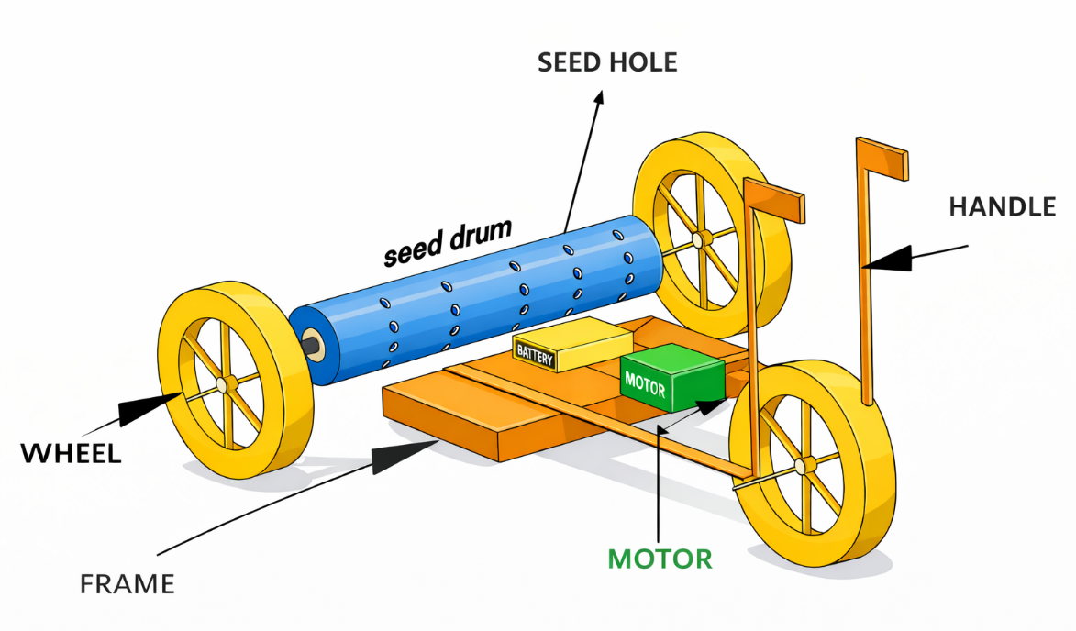
Figure 1. Design configuration of the semi-automatic paddy drum seeder
2.2 Description of the Semi-Automatic Paddy Drum Seeder
The developed seeder consists of a mild steel frame supporting a cylindrical perforated PVC seed drum mounted on a horizontal shaft. The seed drum is driven by a low-power DC motor powered by a rechargeable battery. Power transmission from the motor to the drum shaft is achieved through a chain and sprocket mechanism to ensure smooth and uniform rotation.
The forward movement of the machine is manually operated using ground wheels, while the seed metering operation is controlled independently by the motor. A control switch mounted on the handle allows the operator to start or stop the seed drum rotation as required. The overall configuration ensures uniform seed discharge regardless of minor variations in operator walking speed.
Table 1. Technical specifications of the developed semi-automatic paddy drum seeder
Parameter | Specification
Type of machine | Semi-automatic paddy drum seeder
Frame material | Mild steel
Seed metering mechanism | Perforated PVC drum
Number of seed drums | One
Drum drive system | DC motor (12 v) with chain and sprocket
Power source | Rechargeable battery (12 v)
Mode of operation | Manual forward movement with motor-assisted seed metering
Suitable crop | Paddy (pre-germinated seeds)
Field condition | Puddled wetland
Operator requirement | Single operator

2.3 Seed Metering Mechanism
Pre-germinated paddy seeds were metered through uniformly spaced perforations on the surface of the drum. The drum rotation speed was selected based on preliminary trials to achieve the desired seed rate for direct-seeded rice. The motor-assisted rotation enabled consistent seed flow, reduced seed clumping, and minimized seed loss during operation.

2.4 Field Experimental Conditions
Field evaluation was conducted M.S Swaminathan vayal kudam, department of agricultural engineering, Paavai engineering college under puddled wetland conditions using pre-germinated rice seeds. The soil was prepared by standard puddling operations prior to sowing. The performance of the semi-automatic paddy drum seeder was compared with conventional manual broadcasting, which served as the control treatment.
Each sowing method was tested in replicated field trials to ensure reliability and repeatability of the results. All field operations were conducted under similar soil moisture and field conditions to minimize experimental variability.
2.5 Performance Parameters
The performance of the developed seeder was evaluated based on the following parameters:
- Seed rate (kg ha⁻¹)
- Time required for sowing (h ha⁻¹)
- Labour requirement (h ha⁻¹)
- Effective field capacity (ha h⁻¹)
- Field efficiency (%)
These parameters were selected to capture both operational efficiency and labour-saving potential of the developed machine.
2.6 Performance Evaluation Equations
The performance of the semi-automatic paddy drum seeder and the conventional manual broadcasting method was evaluated using standard agricultural engineering performance indices. All parameters were calculated on a per-hectare basis to enable direct comparison between sowing methods.
2.6.1 Seed Rate
Seed rate was determined as the total quantity of seed used to sow a known area and expressed on a hectare basis using Eq. (1):
$$\begin{matrix} & {\text{Seed rate (kg ha}}^{-1})=\frac{W_{s}}{A}×10,000 & & \text{(1)}\end{matrix}$$
where
$W_{s}$= weight of seed used for sowing (kg)
$A$= area covered during sowing (m²)
2.6.2 Effective Field Capacity
Effective field capacity represents the actual area covered by the machine per unit time under field conditions, accounting for turning, overlap, and minor stoppages. It was calculated using Eq. (2):
$$\begin{matrix} & {\text{Effective field capacity (ha h}}^{-1})=\frac{A}{T×10,000} & & \text{(2)}\end{matrix}$$
where
$A$= effective area covered (m²)
$T$= total time required for sowing (h)
2.6.3 Theoretical Field Capacity
Theoretical field capacity was estimated based on the rated working width of the seeder and the forward speed of operation, assuming ideal field conditions without losses, using Eq. (3):
$$\begin{matrix} & {\text{Theoretical field capacity (ha h}}^{-1})=\frac{W×S}{10} & & \text{(3)}\end{matrix}$$
where
$W$= effective working width of the seeder (m)
$S$= forward speed of operation (km h⁻¹)
2.6.4 Field Efficiency
Field efficiency indicates the effectiveness of machine utilization under actual field conditions and was calculated as the ratio of effective field capacity to theoretical field capacity using Eq. (4):
$$\begin{matrix} & \text{Field efficiency (\%)}=\frac{\text{Effective field capacity}}{\text{Theoretical field capacity}}×100 & & \text{(4)}\end{matrix}$$
2.6.5 Labour Requirement
Labour requirement was expressed as the total labour hours required to complete sowing of one hectare and was calculated using Eq. (5):
$$\begin{matrix} & {\text{Labour requirement (h ha}}^{-1})=\frac{N×T}{A} & & \text{(5)}\end{matrix}$$
where
$N$= number of labourers involved in the operation
$T$= total time required for sowing (h)
$A$= area covered (ha)
2.6.6 Data Processing
All measured and derived performance parameters were averaged across replications and expressed as mean ± standard deviation (SD). These values were subsequently used for statistical comparison between the semi-automatic drum seeder and manual broadcasting.
2.7 Experimental Design and Statistical Analysis
The experiment was laid out using a completely randomized design with multiple replications for each sowing method. Mean values and standard deviations were calculated for all performance parameters.
Statistical significance between the semi-automatic drum seeder and manual broadcasting was evaluated using Student’s t-test at a 5% level of significance (p < 0.05). One-way analysis of variance (ANOVA) was employed to assess variability among replications and to confirm consistency of machine performance across field trials. All statistical analyses were performed using standard statistical software.
3. Results and Discussion
3.1 Seed Rate
Seed rate is a critical parameter influencing crop establishment, input cost, and yield potential in direct-seeded rice systems. The semi-automatic paddy drum seeder recorded a significantly lower seed rate of 55 ± 4.2 kg ha⁻¹ compared to 110 ± 8.6 kg ha⁻¹ for conventional manual broadcasting (Table 1). Statistical analysis using Student’s t-test indicated that the difference was significant at p < 0.01.
The reduction in seed rate can be attributed to the motor-assisted seed metering mechanism, which ensured uniform drum rotation independent of operator walking speed. In manual broadcasting, excessive seed usage is common due to uneven hand distribution and overlapping, leading to higher variability, as reflected by the larger standard deviation. Similar reductions in seed rate with mechanized direct seeding have been reported by Singh et al. (2014) and Rahman et al. (2019), who emphasized the role of controlled seed placement in improving resource-use efficiency.
3.2 Time Required for Sowing
The time required to complete sowing of one hectare using the semi-automatic drum seeder was 2.5 ± 0.4 h ha⁻¹, which was significantly lower than the 5.5 ± 0.7 h ha⁻¹ recorded for manual broadcasting. The observed reduction of more than 50% was statistically significant (p < 0.05).
This improvement is mainly due to continuous and uniform seed discharge, which minimized stoppages and re-sowing operations. Manual broadcasting typically involves frequent interruptions to ensure coverage, thereby increasing operational time. Comparable reductions in sowing time using drum seeders over manual methods have been reported by Baruah (2009) and Sudharani et al. (2019).
3.3 Labour Requirement
Labour requirement decreased significantly from 8.0 ± 0.6 h ha⁻¹ under manual broadcasting to 4.0 ± 0.3 h ha⁻¹ with the semi-automatic drum seeder. The difference was statistically significant at p < 0.05.
Labour savings achieved through mechanized direct seeding are particularly important in regions facing acute labour shortages and rising wage rates. The present results are consistent with findings reported by Al Mamun et al. (2024), who highlighted labour efficiency as a key driver for adoption of drum seeders in smallholder rice systems.

3.4 Effective Field Capacity
The effective field capacity of the semi-automatic drum seeder was 0.40 ± 0.05 ha h⁻¹, which was more than double that of manual broadcasting (0.18 ± 0.03 ha h⁻¹). The difference was statistically significant (p < 0.01).
Higher effective field capacity resulted from uninterrupted operation and reduced overlap losses, which are common in manual broadcasting. The integration of motor-assisted drum rotation ensured consistent seed flow, thereby improving operational efficiency. Similar improvements in field capacity using mechanized wet direct seeding systems have been reported by (Nguyen-Van-Hung et al., 2024).
3.5 Field Efficiency
Field efficiency was significantly higher for the semi-automatic drum seeder (86.1 ± 3.5%) compared to manual broadcasting (36.9 ± 2.8%). One-way ANOVA revealed no significant variation among replications (p > 0.05), indicating stable and consistent machine performance across field trials.
High field efficiency reflects effective utilization of operating time and minimized non-productive losses. The present results confirm that partial automation at the seed metering stage can substantially enhance machine efficiency without the complexity of full automation. Similar conclusions were drawn by Selvam et al. (2024) in their study on advanced drum seeder designs.
3.6 Engineering and Sustainability Implications
The improved performance of the semi-automatic paddy drum seeder demonstrates that decoupling seed metering from operator motion is an effective engineering strategy for enhancing precision in direct-seeded rice. Reduced seed rate directly lowers input cost, while lower labour requirement and higher field efficiency improve economic viability. From a sustainability perspective, optimized seed use and reduced operational time contribute to lower energy consumption and reduced environmental footprint, aligning with the findings of Nguyen-Van-Hung et al. (2024) and Sadhukhan et al. (2023).

Table 2. Performance comparison of the developed semi-automatic paddy drum seeder and conventional manual broadcasting
Performance parameter | Semi-automatic drum seeder | Manual broadcasting
Seed rate (kg ha⁻¹) | 55 ± 4.2ᵃ | 110 ± 8.6ᵇ
Time required for sowing (h ha⁻¹) | 2.5 ± 0.4ᵃ | 5.5 ± 0.7ᵇ
Labour requirement (h ha⁻¹) | 4.0 ± 0.3ᵃ | 8.0 ± 0.6ᵇ
Effective field capacity (ha h⁻¹) | 0.40 ± 0.05ᵃ | 0.18 ± 0.03ᵇ
Field efficiency (%) | 86.1 ± 3.5ᵃ | - ± 2.8ᵇ
(Values are expressed as mean ± standard deviation (SD). Means followed by different superscript letters (a, b) within a row are significantly different at p < 0.05 based on Student’s t-test. Consistency across replications was verified using one-way ANOVA (p > 0.05
Bars represent mean values obtained from replicated field trials. Numerical values are displayed above each bar for clarity.
(Statistical significance is reported in Table 2; differences were significant at p < 0.05.)
Figure 2. Overall comparative performance of the semi-automatic paddy drum seeder and conventional manual broadcasting.

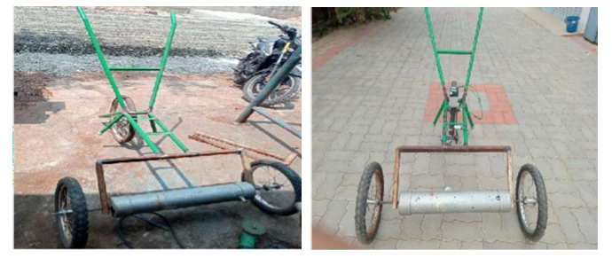
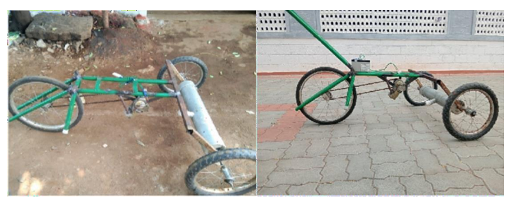
Figure 3. Schematic diagram of the semi-automatic drum seeder

4. Conclusion
A semi-automatic paddy drum seeder with motor-assisted seed metering was successfully designed, developed, and evaluated under puddled field conditions for direct-seeded rice cultivation. The integration of motor-assisted drum rotation effectively decoupled seed metering from operator walking speed, resulting in uniform seed discharge and improved operational consistency. Field evaluation demonstrated that the developed seeder significantly reduced seed rate and labour requirement while substantially improving effective field capacity and field efficiency when compared with conventional manual broadcasting. Statistical analysis confirmed that all key performance parameters differed significantly between sowing methods (p < 0.05), and performance stability across replications was validated using one-way ANOVA.

The reduction in seed rate and labour input directly contributes to lower production costs, while improved field efficiency enhances timeliness of sowing—an important factor in rice productivity. The proposed design achieves these benefits through a simple electromechanical modification without full automation, maintaining affordability, ease of operation, and suitability for small and marginal farmers. Overall, the semi-automatic paddy drum seeder represents a practical, energy-efficient, and sustainable mechanization option that can support wider adoption of direct-seeded rice and improve resource-use efficiency in rice-based cropping systems.
5. Implications and Future Scope
The findings of this study demonstrate that targeted motor assistance at the seed metering stage can significantly enhance the efficiency and precision of direct-seeded rice operations without increasing system complexity. From a practical standpoint, the developed semi-automatic paddy drum seeder has strong potential for adoption by small and marginal farmers due to its low cost, ease of operation, and reduced labour dependency.
Future work may focus on optimizing drum perforation geometry and motor speed control to further improve seed spacing uniformity across different rice varieties and seed sizes. Integration of a simple speed controller or sensor-based feedback mechanism could enhance adaptability under varying field conditions. Long-term field trials across multiple locations and seasons are also recommended to evaluate agronomic performance, crop yield response, and economic benefits. Additionally, assessment of energy consumption and life-cycle environmental impacts would strengthen the sustainability evaluation of the system. Such refinements could further improve the scalability and impact of semi-automatic seeders in mechanized rice production systems.
Declaration of Conflict
The authors declare that they have no known competing financial interests or personal relationships that could have appeared to influence the work reported in this paper.

COMPETING INTERESTS DISCLAIMER:
Authors have declared that they have no known competing financial interests OR non-financial interests OR personal relationships that could have appeared to influence the work reported in this paper.
References
- Liu D.J., 2025, Improving rice yield under direct seeding through synergistic water and fertilizer management, Rice Genomics and Genetics, 16(2): 61-70 (doi: 10.5376/rgg.2025.16.0006)
- Nguyen-Van-Hung, N. V., et al. (2024). Mechanized wet direct seeding for increased rice production efficiency and reduced carbon footprint. Precision Agriculture, 25, 2226–2244. https://doi.org/10.1007/s11119-024-10163-8
- Wang, W., Du, J., Zhou, Y., Zeng, Y., Tan, X., Pan, X., Shi, Q., Wu, Z., & Zeng, Y. (2021). Effects of different mechanical direct seeding methods on grain yield and lodging resistance of early indica rice in South China. Journal of Integrative Agriculture, 20(5), 1204–1215. https://doi.org/10.1016/S2095-3119(20)63191-4.
- Al Mamun, M. R. (2024). Design and fabrication of a low-cost drum seeder for rice direct seeding considering seed spacing accuracy and cost optimization. CIGR Journal. https://cigrjournal.org/index.php/Ejounral/article/view/9099
- Singh, P. K., Singh, R. N., Singh, S. K., Kumar, B., & Singh, S. K. (2014). Assessment of drum seeder on direct seeded rice (Oryza sativa) under puddled condition. Annals of Agricultural Research, 30(3&4). https://epubs.icar.org.in/index.php/AAR/article/view/42753
- Devi, B. R. (2023). Direct seeded rice as resource efficient technology. International Journal of Environment and Climate Change, 13(8), 1169–1174. https://doi.org/10.9734/ijecc/2023/v13i82056
- Sreenivasulu, S., Bala Hussain Reddy, P., & Manohar, C. (2026). Performance of rice under direct seeding using drum seeder during Kharif in Chittoor District of Andhra Pradesh. Madras Agricultural Journal, 100(4–6), 377–379. https://doi.org/10.29321/MAJ.10.001313
- Zhang, Y., Sultan, H., Shah, A., Mu, Y., Li, Y., Li, L., Huang, Z., Song, S., Tao, Y., Zhou, Z., & Nie, L. (2025). Regulation effect of seed priming on sowing rate of direct seeding of rice under salt stress. Frontiers in Plant Science, 16, Article 1541736. https://doi.org/10.3389/fpls.2025.1541736
- Yadav, D. B., Yadav, A., Vats, A. K., et al. (2021). Direct-seeded rice in sequence with zero-tillage wheat in north-western India: addressing system-based sustainability issues. SN Applied Sciences, 3, Article 844. https://doi.org/10.1007/s42452-021-04827-7
- Sadhukhan, R., Kumar, D., Sen, S., Sepat, S., Ghosh, A., Shivay, Y. S., Meena, M. C., Anand, A., Kumar, R., Sharma, L. D., Patra, K., Pratap, V., Alsuhaibani, A. M., Gaber, A., & Hossain, A. (2023). Precision nutrient management in zero-till direct-seeded rice influences productivity, profitability, nutrient and water use efficiency. Agriculture, 13(4), 784. https://doi.org/10.3390/agriculture13040784
- Sudharani, J. S., Aruna, K., & Ramakrishna Babu, A. (2019). Drum seeder: A promising low-cost technology in rice production system for small and marginal farmers. International Journal of Current Microbiology and Applied Sciences, 8(2), 784–788. https://doi.org/10.20546/ijcmas.2019.802.090
- Didarul Islam · (2006) · Improvement of Performance of A Drum Seeder. Thesis work, https://saulibrary.edu.bd/daatj/public/uploads/BAU200601_01-ae_5.pdf
- Rahman, M. M., Masood, M. M., & Sarkar, M. A. R. (2019). Effect of seed rate on yield performance of dry direct-seeded winter rice. Fundamental and Applied Agriculture, 4(1), 735–741. https://doi.org/10.5455/faa.4469
- Baruah, D. C. (2009). Comparative Assessment of Manual Paddy Drum Seeders. Journal of Agricultural Engineering, 43(2). https://epubs.icar.org.in/index.php/JAE/article/view/14422
- Kaur J, Singh A. Direct Seeded Rice: Prospects, Problems/Constraints and Researchable Issues in India. Curr Agri Res 2017;5(1). doi : http://dx.doi.org/10.12944/CARJ.5.1.03
- Selvam, R. N., Singh, S. P., Kushwaha, H. L., Kumar, A., Sarkar, S. K., & Shekhawat, K. (2024). Innovative fabrication methods for agricultural equipment: A 3D-printed paddy drum seeder-cum-fertilizer applicator. Indian Journal of Engineering and Materials Sciences, 31(3), 356–364. https://doi.org/10.56042/ijems.v31i3.8020

