Review Article
Review of Computer-Aided Garden Landscape Design Software

Abstract
Garden landscape designing software has revolutionized the way landscape architects, designers, and homeowners conceptualize and execute outdoor spaces. These digital tools provide advanced features for planning, visualizing, and managing garden layouts, incorporating elements such as plant selection, hardscaping, irrigation systems, and lighting. With 3D modeling, real-time rendering, and integration with Building Information Modeling (BIM), modern software enhances design accuracy and project efficiency. Applications like AutoCAD, SketchUp, and specialized tools such as Realtime Landscaping and PRO Landscape cater to both professionals and hobbyists, offering customizable templates and AI-driven design suggestions. Additionally, environmental and sustainability considerations are increasingly integrated, allowing designers to assess factors like water conservatiorafeekher.mn, soil health, and climate adaptability. As garden landscape software continues to evolve, it plays a crucial role in sustainable urban planning, smart gardening solutions, and the seamless execution of aesthetically pleasing, functional, and eco-friendly outdoor environments.
Keywords: - Landscape, Architects, 3D Modeling, AutoCAD, SketchUp, Realtime Landscaping, PRO Landscape.
Introduction
Garden landscape software is a digital tool designed to help with the planning, design, and visualization of garden and outdoor spaces. It enables users to create digital models of landscapes, incorporating elements such as plants, hardscapes (like paths, walls, and patios), water features, lighting, and other design components. Grand garden landscapes, like the opulent palace gardens of the West or the classical gardens of China, are often intricate and expansive, making their design and communication a challenge. Conveying these complex concepts isn’t always straightforward. However, with advancements in technology, landscape architects no longer have to rely on outdated, time-consuming methods. The rapid progress in computing, enhanced hardware capabilities, and ever-evolving design software have revolutionized the field, making it easier than ever to bring these visionary landscapes to life. Today, garden landscape design is no longer confined to paper and pencil. The advent of drawing software has revolutionized the design process, significantly improving efficiency and freeing designers from the time-consuming task of manual drawing. Additionally, as economic and social development accelerates, environmental challenges have become more pressing, emphasizing the need for innovative solutions in landscape design (Mikhail and Dimitris, 2021; Jozef and Tibo, 2018; Guo and Zhang, 2021).
The expectations for garden landscapes, both nationally and individually, have reached unprecedented levels. Governments have introduced initiatives for garden cities, ecological urban designs, and green corridors to meet the growing demand for green spaces. These efforts have laid a strong foundation for garden landscape development. Advances in computer-aided technology have significantly improved landscape design tools, with platforms like SketchUp becoming specialized technologies for the field (Bhange et al., 2019; Biying et al., 2021).
Among the many design tools available, AutoCAD remains the most widely used computer-aided design software. Known for its advanced 3D modeling and image processing capabilities, it also comes with a robust set of additional tools that enhance efficiency. AutoCAD supports ActiveX automation programming, advanced network drawing functions, and multiple image access formats, ensuring seamless compatibility with various CAD systems. Its intuitive interface, smart editing tools, and impressive graphical features have made it a favorite among engineers and designers who value its flexibility. The software also offers extensive customization options, allowing users to refine and develop their designs with ease. Moreover, its enhanced 3D modeling capabilities make it particularly useful for landscape architects looking to create detailed and realistic garden layouts.
In the past, garden designs were often brought to life through hand-drawn sketches. While these traditional methods had their charm, the rise of technology and advancements in computer software and hardware have made 3D drawing an increasingly popular choice. Such 3D drawings complement the manual sketches which often play a crucial role in the initial design stages, while 3D drawings shine in creating polished, detailed presentations. With each update, 3D technology, particularly Editable Poly, has evolved significantly, becoming a go-to tool for polygon modelling. It’s not just about editing meshes anymore; 3D tools offer a fresh perspective for landscape planning, allowing designers to create models, virtual tours, and even integrate designs with real landscapes. These advancements make it easier to express design ideas and intentions clearly and effectively (Sun et al., 2019).
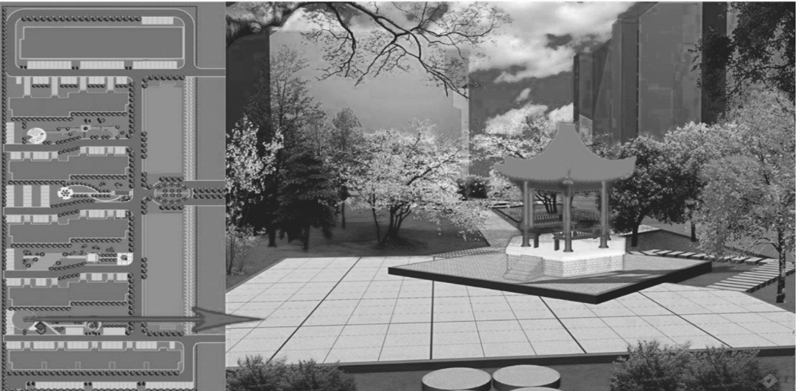
Today’s designers are expected to master 3D drafting software, as seen in Figure 1, (Zhiyong 2021) but that’s just the beginning. The bar for design professionals keeps getting higher, requiring them to juggle multiple software tools to make the most of their unique features. As technology advances, designers are moving beyond using 3D tools just to replace paper sketches. They’re leveraging these tools to boost the quality of their work, freeing up their time and energy to focus on more creative and meaningful aspects of their projects
Figure- 1 3D-assisted garden drafting (Source: - Zhiyong 2021)
Advancements in information technology have significantly improved the efficiency of landscape design, ushering the field into a new era.
Landscape Design Using Computer-Aided Design (CAD) Software
Landscape architects often rely on computer-aided design (CAD) software to plan, create templates, and develop layouts before bringing their designs to life. These digital tools streamline the design process by enabling analysis, modification, and optimization, making it easier to refine ideas and ensure precision (Lalit, 2008). Beyond landscape architecture, CAD software is widely used by engineers and designers across various construction and engineering projects, proving its versatility and efficiency in the field. It allows for the creation of two-dimensional (2D) drawings, as well as three-dimensional (3D) models of curves, solids, and surfaces (Pihlak and Barrett 2000). However, there are fewer software options specifically tailored for professional landscape architects, as most are designed with engineers and architects in mind. In recent years, these software tools have increasingly replaced hand-drawn designs and are now commonly used in professional consultations (Hu 2018).
AutoCAD Software
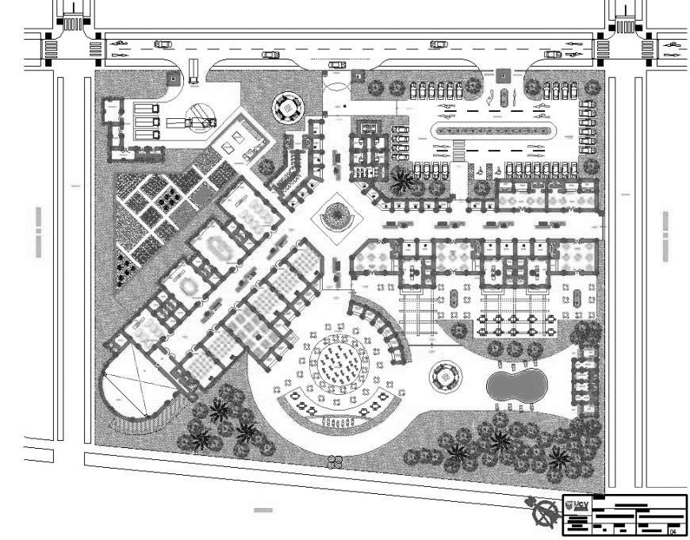
AutoCAD, developed by Autodesk, is a leading computer-aided design (CAD) software widely used for creating both 2D and 3D drawings. It has become an essential tool for architects and engineers due to its versatility and precision. Although its application in landscape design is a more recent development, AutoCAD provides powerful tools for drafting, editing, annotating, and adding blocks in 2D, making it a valuable asset for landscape architects as well. The software is known for its strong performance and user-friendly interface. While AutoCAD does offer 3D modeling features, it is primarily used for base plans and design concept drawings rather than detailed 3D visualization. A recent survey of 482 members of the American Society of Landscape Architects (ASLA) revealed that AutoCAD is the most widely used CAD software, with 82% of respondents using it regularly-either daily or weekly. Originally launched in 1982, AutoCAD is compatible with multiple operating systems, including Windows, macOS, Android, and iOS. Users can either purchase the software outright or opt for a subscription model, which grants full access to all its features. Additionally, Autodesk provides a renewable 12-month educational license for students and academic institutions. For those looking for a more budget-friendly option, AutoCAD LT serves as an entry- level alternative. While it includes essential design tools, it lacks 3D rendering capabilities and network licensing, making it a streamlined version suited for simpler projects.
Figure: - 2 Auto CAD software
Key Features and Fundamental Principles of AutoCAD
- AutoCAD is accessible via both web and mobile apps, allowing users to create, edit, and view drawings across multiple devices.

- The software saves 2D and 3D drawings using the .dwg file format, while customized templates with predefined settings are stored as .dwt files.
- The Quick Access Toolbar provides essential tools for creating, opening, exporting, and saving projects.
- Below the Quick Access Toolbar, the Ribbon organizes tools and commands into categorized tabs, each containing panels with icons for functions like drawing, modifying, blocks, dimensions, and text.
- Users can manually enter commands in the Command Bar, which also displays the steps needed to execute each function.
- The X and Y coordinate system allows precise placement of drawing elements by entering specific coordinates.
- The View Cube, visible in both 2D and 3D models, enables users to switch between standard and isometric views by clicking and dragging.
- Positioned below the View Cube, the compass indicates the model’s predefined North direction.
- Blocks represent reusable design elements that can be created or imported from CAD block libraries, and they can be modified by moving, copying, or scaling them as needed.
- Drawings can be saved and shared effortlessly, allowing users to access and edit them from any location.
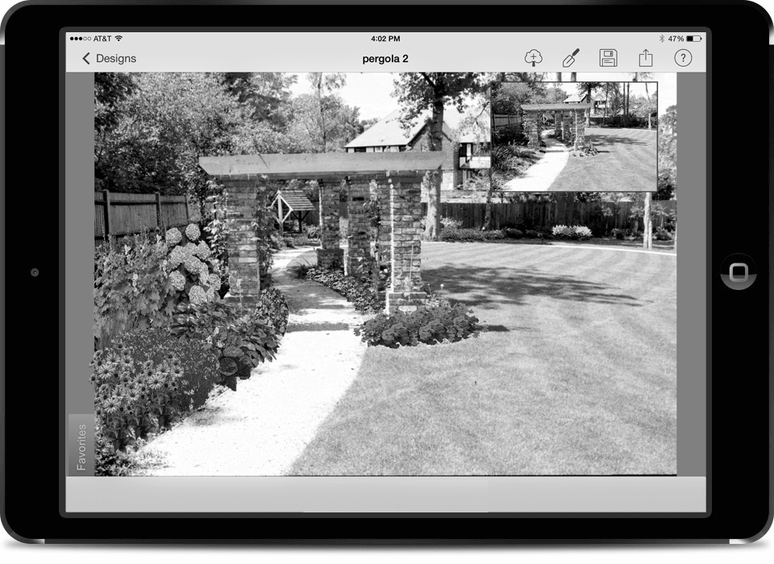
PRO Landscape Software
PRO Landscape is a cloud-based design tool that helps landscape architects and designers create CAD drawings for various landscaping projects. It comes with a range of features, including 3D rendering, lighting design, photo imaging, and proposal creation, all of which can be accessed on up to three devices (Mendoza, 2023). The software also includes specialized CAD tools that allow users to incorporate elements like plants, furniture, and other garden features into their design database. Developed by Drafix Software Inc., PRO Landscape is designed to streamline the landscape design process and enhance creativity.
Figure:- 3 Pro Landscape software (Source: - Pinterest)
Key Features of PRO Landscape
- CAD File Compatibility: Allows importing and exporting of CAD files from AutoDesk.
- Accurate Landscape Plans: Enables users to create accurately scaled landscape drawings in any desired size or scale.
- Easy Base Plan Creation: Simplifies the creation of base plans by easily importing Google Earth images, plot plans, and surveys.
- Extensive Symbol Library: Provides a customizable library with pre-assigned symbols for various plant species, along with a diverse selection of hardscape symbols such as pavers, walls, boulders, landscape statues, and water features.
- File Sharing and Compatibility: Supports importing, exporting, and sharing files in commonly used formats.
- Mobile Design Application: Includes a feature-rich application for creating and editing designs on iPads and Android tablets.

Sketch Up
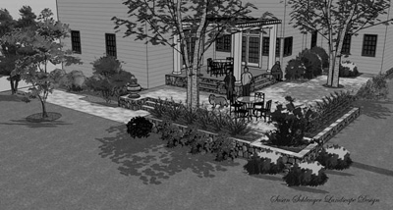
SketchUp is a powerful and flexible design toolset, offering versions like SketchUp Pro, SketchUp Go, and SketchUp Studio, each catering to different needs in architecture, civil engineering, and landscape design. It has become a key player in modern architectural design (Bilous et al., 2021), providing an intuitive platform to create, refine, and present 3D models with ease (Rosener, 2014). With features like layout drawing, surface rendering in various styles, and seamless integration with Google Earth for model positioning (Song and Jing, 2021), SketchUp is a powerful and creative tool. SketchUp streamlines every phase of a project, from brainstorming ideas to bringing designs to life in construction. Originally launched by Last Software in 1999, it changed hands over the years-first acquired by Google in 2006 and later by Trimble Inc. in 2012. Since then, it has grown into one of the most popular and widely used design platforms in the industry.
Figure: - 4 Sketch UP Software (Source: - Pinterest)
Key Function of SketchUp
- Bringing in Pre-existing Files: It allows you to import both 2D CAD files and 3D models, ensuring they integrate smoothly.
- Geo-location Tool: Provides precise terrain imagery of a site by specifying longitude and latitude directly into the model.
- 3D Warehouse Library: Offers a vast collection of downloadable objects, including vegetation, vehicles, people, and animals.
- Terrain and Hardscape Modifications: Enables quick adjustment of contour lines, draping of hardscape elements, and modification of existing terrain.
- Ease of Customization: Allows direct import of personalized imagery and data effortlessly.
- Exporting Design Vision: Facilitates communication of design concepts through exportable images, animations, and videos showcasing variations and details
Revit (The Revit Environment)
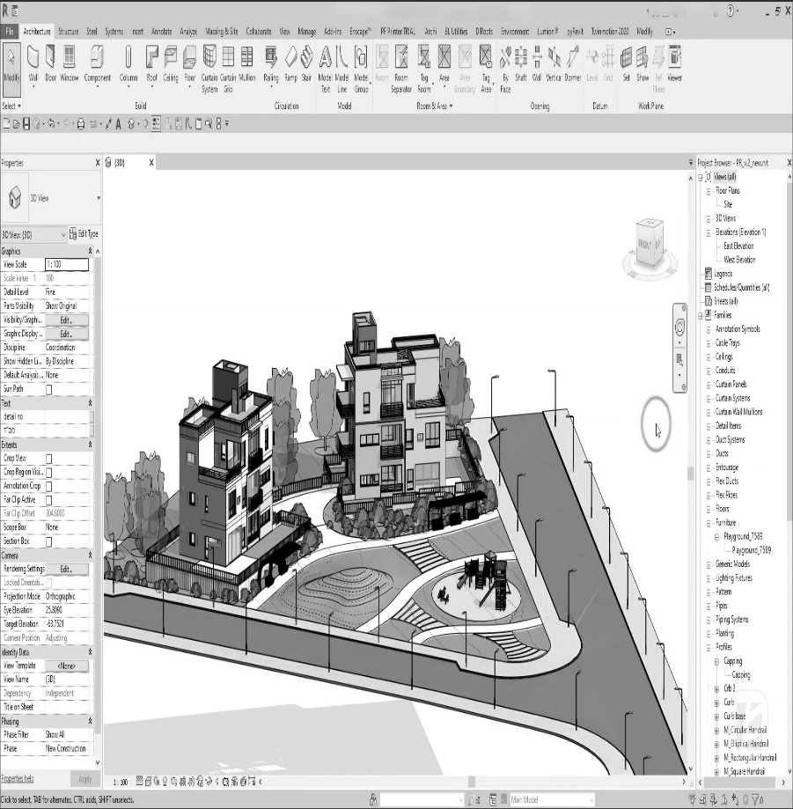
Autodesk Revit is a robust modeling software designed for architects, engineers, and landscape architects, allowing them to design and visualize building structures and components in 3D. Revit allows for the annotation of models with 2D drafting elements and offers access to critical building data (Graves, 2012). Recognized as a leading Building Information Modelling (BIM) platform, Revit supports the design, documentation, visualization, and execution of architecture, engineering, and construction (AEC) projects (Ahmad & Aliyu, 2012). Although Revit is primarily designed for building modelling, its application in landscape architecture remains limited due to the absence of specialized features for this field. To address this challenge, the Environment for Revit plug-in was created, allowing landscape architects to work more efficiently within the Revit platform. This extension supports every stage of the landscape design process, filling a long-standing gap in the AEC industry, where dedicated tools for landscape architecture have been limited-especially in Revit. Recognizing this need, a team of landscape architects came together to develop the toolset, which was later brought to life by Arch-Intelligence, a member of the Autodesk Developer Network. Figure: - 5 Revit Landscape Software (Source: - Novatr)
Features of environment for Revit
- The Environment ribbon in Revit offers a suite of over 40 specialized tools designed for landscape design tasks, such as grading and slopes, walls, fences, and planting.
- These tools enable the creation of color-coded analyses for topographic slopes and elevations.
- The scatter tool facilitates the generation of forest models or the placement of multiple plant species based on planting proposals.
- The toolset streamlines workflow by automating repetitive tasks and enhancing the visual quality of site plans.
SmartDraw
SmartDraw is a web-based design and diagramming tool widely used by professionals for creating flowcharts, organisational charts and various other visual layouts. It also enables users to design and modify drawings, including landscape projects. It also allows users to design and edit drawings, including landscape projects. Particularly useful for basic urban landscape design, it offers a rich plant encyclopedia and a variety of templates to streamline landscaping tasks. Originally developed by SmartDraw LLC and launched in 1994, the software is available through a subscription model (Fayad AM, 2014).
Features of SmartDraw
- SmartDraw drawings are saved with the .sdr file extension, while document templates with preferred settings use the. sdt format.
- The tool works effortlessly with Microsoft Office applications like Word, PowerPoint, and Excel, making it easy for users to collaborate and manage their work. It also supports cloud storage, allowing projects to be saved directly to platforms like OneDrive and Google Drive for easy access from anywhere.
- Files and projects can be accessed and shared seamlessly across multiple devices.
- For landscape designs, simple outlines can be drawn to define boundaries like garden edges, yard borders, or fences.
- Landscape elements such as shrubs, trees, and flowers can be incorporated, along with symbols representing lawns, furniture, pools, sheds, gazebos, buildings, and fountains.
Realtime Landscaping Professional
Realtime Landscaping Pro is a powerful landscape design software that supports both 2D and 3D renderings, enabling users to create and customize a wide range of landscape elements. With an extensive library of plant and non-plant objects, it offers an efficient and intuitive way to design outdoor spaces. The tool utilizes advanced 3D graphics technology to produce realistic designs (O’rmonov BI, 2021; Juraboyev et al., 2022).
Features of realtime landscaping pro
- The software features a collection of over 4,000 customizable non-plant items, including furniture, walls, gates, fences, and lighting, as well as a variety of materials like brick, concrete, wood, and stone.
- The software offers a vast library with over 5,000 lifelike plants and thousands of additional garden accessories.
- With realistic effects like lighting, shadows, flowing water, and swaying leaves, the 3D walkthrough mode brings designs to life, helping users vividly experience and visualize their finished garden.
- Users can upload a photo of the site and design their landscape directly on top of it.
- Finalized designs can be effortlessly shared or printed for presentations or execution.
Adobe Photoshop
Adobe Photoshop is a versatile image editing software available for both Windows and Mac, widely recognized as an essential tool for digital artists and graphic designers. It provides precise control over visual concepts, making it ideal for creative projects. In landscape design, Photoshop is primarily used for post-production, allowing designers to enhance and fine-tune images after they've been created in other design programs (Rekittke & Paar, 2008).
Lumion
Lumion is a cutting-edge 3D rendering and visualization software that revolutionizes the way desi gners present their projects. It’s extensively used in industries such as architecture, landscape design, urban planning, interior design, and real estate. By converting 3D models into breathtaking visualizations, Lumion enhances the presentation and storytelling process, enabling professionals to communicate their vision effectively.
Feature of Lumion
- User-Friendly Interface: Designed to be intuitive, even for users with limited technical expertise.
- Real-Time Rendering: Allows users to see changes in real-time, speeding up the workflow.
- High-Quality Visuals: Delivers photorealistic lighting, shadows, reflections, and materials.
- Extensive Library: Includes thousands of objects, materials, and textures, such as trees, plants, furniture, and vehicles, which enhance the realism of renderings.
- Animation Capabilities: Enables the creation of walkthroughs, flyovers, and other animations for presentations.
- Weather Effects: Simulates environmental conditions like rain, snow, fog, and lighting changes for day or night scenes.
- Landscape and Urban Design Tools: Includes features for terrain sculpting, water elements, and outdoor scenes, making it ideal for landscaping projects.
- Integration: It integrates smoothly with leading 3D modeling software such as SketchUp, Revit, Rhino, and ArchiCAD.
Application of AI
AI in landscape design goes beyond creating visually appealing designs—it also makes landscapes more practical and sustainable. By analysing site factors like sunlight, wind, and drainage, AI ensures that the right plants are selected and reduces the need for maintenance. It also optimizes irrigation, adjusting schedules based on weather and soil conditions to conserve water and keep landscapes healthy. Urban planners use AI to design greener cities, while environmentalists apply it for reforestation and habitat restoration with native plants, making outdoor spaces eco-friendlier and more resilient. AI-driven landscape design tools use machine learning to analyze data and user inputs, generating designs that are both functional and visually appealing. By analysing real-time data and user preferences, these tools can quickly turn sketches or prompts into photorealistic renderings. AI improves efficiency by automating tasks like plant selection and analysing factors such as climate and soil, allowing designers to focus more on creativity (Yasmine Hafza., 2024).
Major Artificial Intelligence tools for landscaping gardening
- iScape is a user-friendly AI-powered landscape design tool designed for both professional landscapers and DIY enthusiasts. It enables users to create, modify, and visualize outdoor spaces in 2D and 3D (AR), providing a realistic preview before implementation.
- VegPlotter is a flexible AI-powered landscape design tool designed for gardeners of all experience levels, ideal for planning and organizing vegetable gardens. Its distinctive month-by-month feature allows users to visualize the growth of their garden throughout the year. With an easy-to-use drag-and-drop interface, VegPlotter simplifies the process of designing layouts, scheduling plantings, and maintaining detailed records.
- DreamzAR is an innovative AI-driven landscape design app that seamlessly turns your outdoor ideas into reality. Perfect for homeowners and professionals alike, it integrates artificial intelligence with augmented reality to deliver an immersive design experience.
- Fotor AI Landscape Generator is a powerful tool that leverages advanced algorithms to create stunning digital landscapes. Designed for game developers, filmmakers, architects, and artists, it transforms text prompts into breathtaking scenery while offering control over terrain, ecosystems, and atmospheric effects. With support for both 2D and 3D designs, it caters to a wide range of creative applications.
- PRO Landscape, developed by Drafix Software, is a robust landscape design tool tailored for architects, designers, and contractors of all levels. It streamlines the entire design process, from the first concept to the final implementation.
- Land F/X is an all-in-one platform offering specialized software solutions for landscape design. Its Irrigation F/X tool, a CAD plugin designed for irrigation planning, enables users to pull data from manufacturer catalogs, position equipment, draw piping layouts, and accurately calculate pressure and flow rates.
Incorporating CAD software into landscaping design
Many CAD software programs are designed to work seamlessly together, making it simple to share files and transfer data as needed. This compatibility allows landscape designers to combine various tools within a single project, resulting in more polished and detailed plans that take advantage of each platform’s unique features. Research indicates that integrating multiple CAD programs enhances efficiency in the design process. For example, professional landscape architects often rely on AutoCAD for 2D drafting, while Pro Landscape and Revit are popular choices for 3D modeling (Lallawmzuali and Pal, 2023).
Photoshop, known for its versatility in image editing and graphic design, plays a valuable role in pre-processing landscape designs. It complements other software by addressing gaps in tools or features and enhancing object libraries.
However, while software integration is possible, it often comes with functional limitations. Designers must focus on ensuring program compatibility and understanding the strengths and weaknesses of each platform to fully leverage their capabilities. This approach enables the creation of precise and comprehensive designs by utilizing multiple CAD tools effectively (Singureanu, 2009).
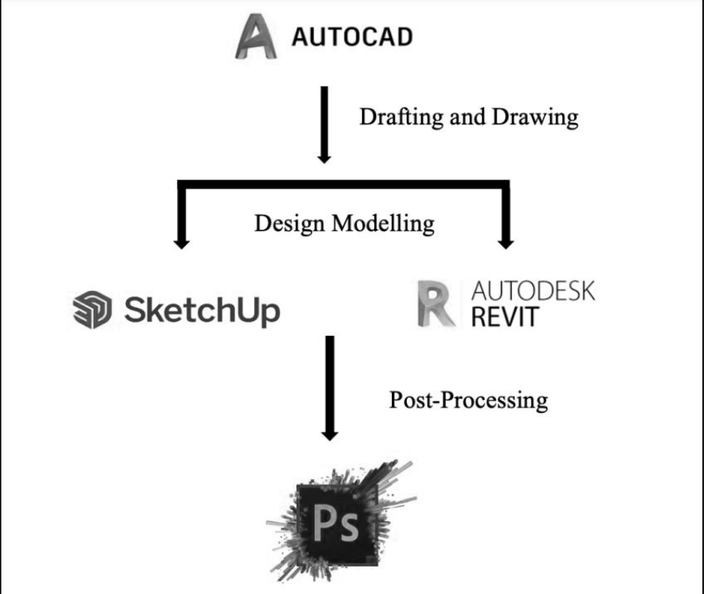
Additionally, objects and files created in SketchUp can easily be imported into Realtime Landscaping software, allowing further processing and refinement to enhance the final design.
Figure: 6 A landscape design step using CAD-SketchUp-Photoshop
Advantages of CAD in designing and drafting
Using CAD software offers several advantages over traditional drawing methods. It enhances productivity and improves product quality by reducing process time and lowering production costs.
The benefits of using these software programs can be outlined as follows: -
Makes Tasks Easier
Historically, landscape architects designed their projects entirely by hand or used traditional drafting techniques, which took a lot of time. Any changes or adjustments required redrawing the entire design from scratch, which was both time-intensive and laborious. In contrast, CAD software simplifies the process, making it easy to implement changes with just a click, thanks to its user-friendly tools and functions.
Boost Efficiency
This results in high-quality, cost-effective products being produced at a quicker pace, with the ability to easily make changes as needed. With CAD, designers can visualize their plans and test them against real-world variables. Additionally, any required modifications can be swiftly made to the same file, streamlining the revision process.
Enhance Design Quality
The software offers a variety of design tools that support pre-calculation methods and maintain quality control throughout the project. This helps prevent design errors that may arise during the process, ensuring improved overall quality.
Improved Accuracy
The level of accuracy you can achieve with CAD software far exceeds that of manual drawings. It offers a variety of tools to ensure precise measurements and high-quality designs.
Simple to Redesign and Adjust
Designs can be easily adjusted when changes are needed. CAD software allows users to create virtual models of their plans to ensure the design aligns with the intended purpose. Any necessary modifications can be made effortlessly using the software's various tools. Once the main plan is complete, the saved files can be reused for future revisions or modifications, eliminating the need to start the drawings from scratch.
Engaged in Landscape Design
The landscape design process is typically divided into two key phases: design and construction. Although projects may differ in size and complexity, they generally follow a similar sequence of steps.
Step 1: Preliminary Consultation and Discussion
The first meeting between the landscape designer and the client is an essential step. It should involve an on-site meeting to discuss the project's purpose, scope, key elements, budget, and guiding principles. Clearly communicating the vision for the landscape ensures that the architect fully understands the client’s ideas and intentions.
Step 2: Site Assessment and Base Plan Development
This phase involves performing a site survey and analysis, enabling the landscape architect to compile a site inventory and draft a base plan. The inventory includes details such as location, existing elevation, structures, vegetation, soil conditions, topography, and environmental factors. A thorough review of the surrounding area, including public utilities and boundary lines, is also essential. Taking photographs can serve as useful references throughout the design process.
Step 3: Conceptual Design
At this stage, the landscape architect creates an initial design concept using the information collected in earlier phases. This includes producing scaled ground plans and sketches that depict the overall design. The concept features the layout of plants alongside hardscape elements like pools, patios, walkways, benches, lighting, fences, and trellises. The main objective is to present a draft or sketch with supporting documents, giving the client a clear vision of the proposed plan while identifying possible opportunities and limitations. Client feedback is taken into account at every stage of the process.
Step 4: Design Refinement / Master Plan Development
After refining the concept plan with the necessary changes and adjustments based on client feedback, the master plan is completed. At this stage, the landscape architect develops a more detailed plan that includes all the proposed features. A full plant list is compiled, detailing common names, botanical names, and quantities according to the design. Colored photos of the plants may also be added for reference. The plan specifies the exact placement and details of all elements.
This phase involves addressing potential major issues such as access, topography, services, and budget, providing a thorough analys is. The design development is highly detailed, accompanied by all necessary documents for implementation. These include procurement information, recommendations for construction companies, local pricing data, and any required documentation to meet the project’s needs.
Step 5: Design Execution and Building Phase
The implementation of the design includes several construction phases. Required materials are procured, and tenders are issued. The construction process is carried out in collaboration between the landscape architect and the clients.
Table 1. Advantages and Disadvantages of CAD Software
Cad software | Advantages | Disadvantages
AutoCAD | It serves as the benchmark for computer-aided design and is compatible with various platforms. | It demands high-performance hardware or equipment for optimal functionality, which may lead to increased costs.
Pro Landscape | It features advanced 3D rendering tools and a comprehensive object library, allowing the use of real images for enhanced reference. | The software is costly and does not offer a free trial option.
Revit | The Revit BIM software helps generate realistic visualizations and enables the storage of all relevant information, boosting work productivity. | It is not particularly user-friendly and only provides the necessary functionality when the 'Environment for Revit' toolset or plugin is used.
SketchUp | It is a robust engine equipped with advanced modeling tools and customizable palettes. | The features are primarily centred around 3D design, with fewer options available for 2D design.
SmartDraw | It is user-friendly, offering a variety of templates and objects, and is relatively more affordable. | There is no option for 3D graphics.
Realtime Landscaping Pro | The design cost can be easily estimated, which is a crucial feature for managing large projects. | The software is available only as a Windows package.
Conclusion
As science and technology continue to advance, computer-aided landscape design is becoming increasingly relevant and convenient. It offers a comprehensive approach to landscape development and enables more precise planning. To create realistic and innovative designs, it is essential for professionals in the field to understand the fundamentals of computer-aided modeling, allowing them to fully leverage the technology for superior results. Current research is exploring advanced CAD concepts, including virtual reality integration and enhanced documentation tools.

COMPETING INTERESTS DISCLAIMER:
Authors have declared that they have no known competing financial interests OR non-financial interests OR personal relationships that could have appeared to influence the work reported in this paper.
References
Ahmad, A.M., and Aliyu, A.A. 2012. The need for landscape information modelling (LIM) in landscape architecture. In Proceedings of the 13th Digital Landscape Architecture Conference, Weimar, Germany (Vol. 31).
Beard, J.B., and Green, R.L. 1994. The role of turfgrasses in environmental protection and their benefits to humans. J. Environ. Qual. 23: 452–460.
Bhange, V.P., Bhivgade, U.V., and Vaidya, A.N. 2019. Artificial neural network modeling in pretreatment of garden biomass for lignocellulose degradation. Waste and Biomass Valorization, 10: 1571–1583.
Bilous, L., Samoilenko, V., Shyshchenko, P., and Havrylenko, O. 2021. GIS in landscape architecture and design. In Geoinformatics, (2021) 1 : 1-7. Eur. Assoc. Geoscientists & Eng.
De, L.C., 2018. Impact of climate change on floriculture and landscape gardening. Int. J. of Agric Sci. 10(11): 6253-6256.
Elyashberg, M. and Argyropoulos, D. 2021. Computer assisted structure elucidation (CASE): current and future perspectives. Magnetic Resonance in Chem. 59: 669–690.
Fayad, A.M., 2014. School of Science and Engineering Construction and Architectural Engineering Department. Doctoral dissertation, The Am. Univ. Cairo.
Gaidhani, A., Dalal, S.R., and Nagre, P.K. 2020. Effect of different planting dates and pinching on growth and flowering of China aster. Int. J. Chem. Stud. 8(2): 1120–1124.
Ganesh, S., Jawaharlal, M., Rajamani, K., Visalakshi, M., Karthikeyan, S., Ganga, M., Thamaraiselvi, S., and Eevera, T. 2024. Investigating the physiological effects of LEDs with combined spectral emittances in floriculture. Appl. Ecol. Environ. Res. 22(1).
Graves, M., 2012. Architecture and the lost art of drawing. The New York Times, 1.
Guo, F., and Zhang, Q. 2021. Computer aided modeling design of external gear pump. In IOP Conference Series: Earth and Environ. Sci., (769)4 :042086. IOP Publishing.
Hu, J., 2018. Research on computer-aided teaching system of landscape design. Int. Conf. Educ. Psychol. Manag. Sci.
Juraboyev, A.T.U.J., Toshpulatova, B.R. and Nurmatov, D.O.U.N., 2022. The role and importance of compositional methods in landscape architecture. Nazariy va amaliy tadqiqotlar xalqaro jurnali. 2: 74-80.
Lallawmzuali, R. and Pal, A.K., 2023. Computer Aided Design and Drafting in Landscape Architecture. Curr. J. Appl Sci. Technol. 42: 1-11.
O’rmonov, B.I., 2021. The Integration of Modern Decorative Building Materials in Fergana-Style Interior Design. Cent. Asian J. Arts Des. 2: 64–70.
Pihlak, M. and Barrett, S., 2000. Design computing for the real world. In ASLA Annual Meeting, St. Louis, MO.
Rekittke, J. and Paar, P., 2008. Real-time collage in landscape architecture. Digital Design in Landscape Architecture, 88–95.
Rosener, B., 2014. 3D modeling programs: comparison of SketchUp and Blender. In Proceedings of the 12th Int. Conf. Educ. Inf. Syst. Technol. Appl (EISTA 2014).
Sarcar, M.M.M., Rao, K.M. and Narayan, K.L., 2008. Computer aided design and manufacturing. PHI Learning Pvt. Ltd.
Singureanu, V., 2009. Software compatibility for realtime landscaping architect, Google SketchUp 7 and Corel graphics suite in the general term intitled CAD (computer assisted design). Seria Hortic., 1233.
Song, Y. and Jing, Y., 2020. Application prospect of CAD-SketchUp-PS integrated software technology in landscape planning and design. Computer-Aided Design and Applications, 18: 153–163. DOI: https://doi.org/10.14733/cadaps.2021.
Sun, Z., Xie, J., Zhang, Y., and Cao, Y. 2019. As-built BIM for a fifteenth-century Chinese brick structure at various LoDs. ISPRS Int. J. Geo Inf. 8: 577.
Ulicny, J. and Kozar, T., 2018. Roadmap for computer-aided modeling of theranostics and related nanosystems. EPJ Web of Conferences, 173 : 05017. EDP Sciences.
Yu, B., Zhao, Z., Zhao, G., An, R., Sun, F., Li, R., and Peng, X. 2021. Provincial renewable energy dispatch optimization in line with Renewable Portfolio Standard policy in China. Renewable Energy, 174: 236–252.

