Original Research Article
Correlations Among Diverse Morphometric Traits and Live Body Weight in Growing Surti Goats (Capra hircus)

ABSTRACT
The present study was carried out on 124 Surti goats kids aged between 6 to 12 months. Various body measurements viz. height at wither, height at hipbone, height at pinbone, hock height, chest height, ground to stomach height, humerus height, femur height, body length, heart girth, bicostal girth, paunch girth, fore cannon bone girth, rump length, ilium width of the rump, medium width of the rump and ischium width of the rump were taken. Live body weight of all animals was recorded on the day their body morphometry was done and body weight of animals at different age was was examined using the registers maintained on the farm. These animals were classified into 2 different groups based on their age viz. group 1 (> 6 to 9 months) and group 2 (> 9 to 12 months). For group 1 and 2, the corresponding mean and standard error of live body weight were 16.99 ± 00.52 and 21.39 ± 00.62 kg, respectively. In group 2, live body weight was positively and significantly (P<0.001) correlated with heart girth with r of value 0.859.
KEY WORDS
Surti Goats, Body Morphometry, Corelation, Live Body Weight, Height at Wither

- INTRODUCTION
Goats (Capra hircus) represent a vital component of smallholder farming systems in resource-limited settings of developing nations, supplying critical animal-source foods (meat and milk), fiber, hides, and supplementary income to rural households (Kosgey et al., 2006). India maintains the world's second-largest goat population, totaling 148.88 million goats according to the 20th Livestock Census, reflecting a notable 10.1% rise compared to the preceding enumeration (Department of Animal Husbandry and Dairying, 2019).
Linear body measurements constitute practical, non-invasive indicators for evaluating body conformation, growth performance, and productive efficiency in goats (Villiers et al., 2009). Phenotypic associations between these linear traits and live body weight frequently demonstrate strong positive relationships, facilitating dependable body weight estimation under field conditions lacking calibrated scales (Yakubu, 2010; Mallick et al., 2025). Across Indian goat populations, heart girth repeatedly emerges as the trait most strongly linked to body weight, with body length and withers height following closely (Mallick et al., 2025; Bansode et al., 2026). For example, in Surti goats, live weight displayed highly significant positive correlations with body length (r = 0.80) and withers height (r = 0.75) (Bansode et al., 2026), whereas in Ganjam goats, heart girth exhibited the predominant relationship, yielding robust predictive models (R² = 0.914) when integrated with withers and rump height (Mallick et al., 2025).
The current investigation assesses body morphometric parameters and their correlations to live body weight, offering insights relevant to the formulation of effective, sustainable breeding initiatives and resource-efficient husbandry practices.
- MATERIALS AND METHODS
  - Description of study animals and management
The study was conducted on Surti goats maintain at Livestock Research Station, Kamdhenu University, Navsari. This unit is located at 20.95°N 72.93°E and at an elevation of 11.89 m above mean sea level. The climate of the area is tropical. The average maximum and minimum temperatures are 40°C (104°F) and 17 °C (62.6°F) respectively. The average annual temperature is 27.1°C or 80.8°F. May month being the warmest has an average temperature of 31.1°C or 88.0°F. January has the lowest average temperature of 22.3°C or 72.1°F. The rainfall received is 1555mm or 61.2 inch per year. Most rainfalls occur in July with average precipitation of 629 mm or 24.8 inch. Rainy season mainly sustains from June to September, winter from October to January and summer from February to May.
  - Description of study animals and management
Every experimental animal was kept in a loose housing arrangement. The animals were housed in a concrete (pakka) shed with a concrete floor. The Livestock Research Station's usual routine management procedures were implemented, and they were all kept in same housing circumstances.
2.3 Sampling technique and sample size determination
This study included 124 apparently healthy Surti goat kids aged between 6 to 12 months. These animals were divided in 2 different groups based on their age as mentioned below:
Sr. No. | Group | Age | No. of Animals
1 | Group 1 | > 6 to 9 months | 73
2 | Group 2 | > 9 to 12 months | 51
Total |  |  | 124
The body weight of animals at various ages was examined using the growth/body weight register maintained on the farm. Additionally, on the day that their body morphometry was completed, the live body weight of every animal involved in this study was noted. When recording, the constant weight was taken into account. The unit of measurement for animal weight was kilograms.
2.4 Data collections
Using a measuring tape, the animals' body measurements were taken as precisely as possible to the closest centimeter scale. Measurements were taken when animal stands comfortably and evenly on its feet on hard plain ground with its neck elevated to a position level with back for maximum precision. The various body measurements which were recorded in this study are; Height at Wither (HaW): The vertical distance from ground to the highest point of the withers; Height at Hip bone (HaH): The vertical distance from ground to highest point of hip bone; Height at Pin bone (HaP): The vertical distance from ground to highest point of pin bone; Hock Height (HoH): The vertical distance from ground to point of hock joint; Chest Height (CH): The vertical distance from ground to portion between two fore limbs just behind the point of elbow; Ground to Stomach Height (GtSH): The vertical distance from ground to point on the lower side of the belly; Humerus height (HS): The vertical distance from ground to head of humorous bone; Femur Height (FH): The vertical distance from ground to head of femur bone; Body Length (BDL): The oblique distance between tip of the shoulder to the tip of the pin bone; Heart Girth (HG): The circumference of chest just behind the point of elbow; Bicostal Girth (BG): The circumference around the abdomen region; Paunch Girth (PG): The circumference around the abdomen ahead of the udder; Fore Cannon Bone Girth (FCBG): The circumference of left cannon bone in the middle area; Rump Length (RL): The distance between the tip of the ilium and the tip of the ischium; Ilium Width of the Rump (ILWR): Measured between the two tips of the ilium bone; Medium width of the Rump (MDR): Measured between the trochanter (coxofemoral articulation) and Ischium Width of the Rump (ISWR): Measured between the two tips of the ischium bone.
2.4 Data analysis
Descriptive statistics were used to tabulate the collected data, which were then subjected to one-way ANOVA analysis and the Duncan multiple range test (DMRT) for group mean comparison. The Duncan multiple range test (DMRT) was employed to determine the mean separation at the significance levels of 5% and 1%. Additionally, a correlation test was conducted using SPSS software to determine the correlation coefficients between live body weight and body measurements.
- RESULTS AND DISCUSSION
3.1 Body morphometric measurements of Surti goats
The overall mean and standard error for body weight of Surti goats at birth (BW), 9 months and 12 months of age were 02.45 ± 00.03, 16.80 ± 00.37 and 20.29 ± 00.44 kg, respectively. The mean and standard error for live body weight of groups 1 and 2 were found to be 16.99 ± 00.52 and 21.39 ± 00.62 kg, respectively. The overall mean and standard error of body measurements of both age groups of Surti goats are shown in table 1.
Table 1: Means and standard error (Mean ± SE) of various body morphometric traits of Surti goats.
Body Morphometric Traits | Group 1 | Group 2
BL | 55.56 ± 0.73 | 58.67 ± 0.68
HG | 58.27 ± 0.80 | 64.06 ± 0.75
BG | 65.50 ± 0.83 | 70.75 ± 0.95
PG | 62.20 ± 0.82 | 68.92 ± 0.96
FCBG | 07.04 ± 0.10 | 07.55 ± 0.09
RL | 15.97 ± 0.27 | 17.25 ± 0.23
ILWoR | 08.48 ± 0.86 | 08.69 ± 0.18
MWoR | 16.34 ± 0.32 | 18.63 ± 0.38
IWoR | 04.23 ± 0.11 | 04.55 ± 0.13
HaW | 57.70 ± 0.66 | 62.60 ± 0.74
HaH | 58.92 ± 0.70 | 64.22 ± 0.73
Hap | 48.84 ± 0.66 | 52.06 ± 0.55
HoH | 21.95 ± 0.28 | 24.29 ± 0.38
CH | 32.81 ± 0.44 | 35.88 ± 0.50
GtSH | 33.61 ± 0.47 | 37.84 ± 0.49
HS | 41.03 ± 0.44 | 45.92 ± 0.51
FH | 50.00 ± 0.56 | 54.64 ± 0.65
(All measurements are in centimetres (cm))
3.2 Relationship between Live Body Weight and Body Measurements in Group 1 Surti Goats
Live body weight and height at wither, height at hipbone, height at pinbone, hock height, chest height, ground to stomach height, humerus height, Femur height, body length, heart girth, bicostal girth, paunch girth, fore cannon bone girth, rump length and medial width of the rump were positively and significantly (P<0.001) correlated with r values of 0.768, 0.837, 0.559, 0.654, 0.441, 0.513, 0.599, 0.739, 0.765, 0.829, 0.758, 0.8, 0.76, 0.792 and 0.657, respectively.
Table 2: Correlation coefficients between body weight and height at wither (HaW), height at hipbone (HaH), height at pinbone (HaP), hock height (HoH), chest height (CH), ground to stomach height (GtSH), humerus height (HS) and femur height (FH) in group 1 Surti goats.
 | Live weight | Sex | HaW | HaH | HaP | HoH | CH | GtSH | HS | FH
Live weight | 1 | -0.508** | 0.768** | 0.837** | 0.559** | 0.654** | 0.441** | 0.513** | 0.599** | 0.739**
Sex |  | 1 | -0.447** | -0.404** | -0.146 | -0.334** | -0.319** | -0.297* | -0.448** | -0.378**
HaW |  |  | 1 | 0.932** | 0.733** | 0.769** | 0.524** | 0.599** | 0.771** | 0.840**
HaH |  |  |  | 1 | 0.761** | 0.751** | 0.493** | 0.655** | 0.758** | 0.895**
HaP |  |  |  |  | 1 | 0.771** | 0.509** | 0.579** | 0.752** | 0.778**
HoH |  |  |  |  |  | 1 | 0.597** | 0.606** | 0.804** | 0.752**
CH |  |  |  |  |  |  | 1 | 0.815** | 0.700** | 0.629**
GtSH |  |  |  |  |  |  |  | 1 | 0.713** | 0.753**
HS |  |  |  |  |  |  |  |  | 1 | 0.781**
FH |  |  |  |  |  |  |  |  |  | 1
(** Correlation is significant at 0.01 level; * Correlation is significant at 0.05 level)
There was a non-significant correlation between live body weight and the ilium width of the rump, with an r value of 0.133 in this group of animals. The ischium width of the rump was negative and not significantly correlated (r value: -0.124) with live body weight in this group of animals. Further, we observed the highest correlation for height at hipbone (r value: 0.837) and the lowest correlation for ischium width of the rump (r value: -0.124) with live body weight.
Table 3: Correlation coefficients between body weight and body length (BL), heart girth (HG), bicostal girth (BG), paunch girth (PG), fore cannon bone girth (FCBG), rump length (RL), ilium width of the rump (ILWoR), medial width of the rump (MWoR) and ischium width of the rump (IWoR) in group 1 Surti goats.
 | BL | HG | BG | PG | FCBG | RL | ILWoR | MWoR | IWoR
Live weight | 0.765** | 0.829** | 0.758** | 0.800** | 0.760** | 0.792** | 0.133 | 0.657** | -0.124
Sex | -0.483** | -0.358** | -0.387** | -0.375** | -0.374** | -0.353** | 0.076 | -0.303** | 0.621**
HaW | 0.759** | 0.792** | 0.702** | 0.787** | 0.757** | 0.789** | 0.129 | 0.701** | 0.002
HaH | 0.726** | 0.845** | 0.721** | 0.839** | 0.803** | 0.810** | 0.193 | 0.756** | 0.002
HaP | 0.718** | 0.759** | 0.703** | 0.724** | 0.686** | 0.717** | 0.193 | 0.681** | 0.205
HoH | 0.846** | 0.829** | 0.748** | 0.720** | 0.720** | 0.837** | 0.242* | 0.641** | 0.128
CH | 0.621** | 0.485** | 0.45** | 0.413** | 0.357** | 0.493** | 0.513** | 0.419** | 0.147
GtSH | 0.547** | 0.588** | 0.469** | 0.490** | 0.430** | 0.505** | 0.645** | 0.541** | 0.074
HS | 0.796** | 0.762** | 0.692** | 0.664** | 0.656** | 0.700** | 0.221 | 0.666** | 0.020
FH | 0.742** | 0.818** | 0.686** | 0.773** | 0.695** | 0.752** | 0.260* | 0.696** | 0.086
BL | 1 | 0.798** | 0.766** | 0.698** | 0.668** | 0.828** | 0.117 | 0.685** | 0.067
HG |  | 1 | 0.846** | 0.853** | 0.824** | 0.863** | 0.230 | 0.758** | 0.056
BG |  |  | 1 | 0.858** | 0.732** | 0.738** | 0.128 | 0.606** | 0.024
PG |  |  |  | 1 | 0.812** | 0.795** | 0.134 | 0.671** | -0.015
FCBG |  |  |  |  | 1 | 0.831** | 0.132 | 0.653** | -0.085
RL |  |  |  |  |  | 1 | 0.196 | 0.679** | 0.080
ILWoR |  |  |  |  |  |  | 1 | 0.161 | 0.125
MWoR |  |  |  |  |  |  |  | 1 | 0.036
IWoR |  |  |  |  |  |  |  |  | 1
(** Correlation is significant at 0.01 level; * Correlation is significant at 0.05 level)
3.3 Relationship between Live Body Weight and Body Measurements in Group 2 Surti Goats
A positive and significant (P < 0.001) correlation was found between live body weight and height at wither, height at hipbone, height at pinbone, hock height, chest height, ground to stomach height, humerus height, femur height, body length, heart girth, bicostal girth, paunch girth, fore cannon bone girth, rump length, ilium width of the rump and medial width of the rump with r values of 0.731, 0.805, 0.725, 0.562, 0.618, 0.543, 0.525, 0.739, 0.663, 0.859, 0.821, 0.81, 0.72, 0.747, 0.592 and 0.524, respectively. The highest correlation was for heart girth with an r value of 0.859 and the lowest correlation for ischium width of the rump with an r value of 0.088 with live body weight.
Table 4: Correlation coefficients between body weight and height at wither (HaW), height at hipbone (HaH), height at pinbone (HaP), hock height (HoH), chest height (CH), ground to stomach height (GtSH), humerus height (HS) and femur height (FH) in group 2 Surti goats.
 | Live weight | Sex | HaW | HaH | HaP | HoH | CH | GtSH | HS | FH
Live weight | 1 | -0.328* | 0.731** | 0.805** | 0.725** | 0.562** | 0.618** | 0.543** | 0.525** | 0.739**
Sex |  | 1 | -0.478** | -0.438** | -0.323* | -0.362** | -0.438** | -0.213 | -0.290* | -0.288*
HaW |  |  | 1 | 0.941** | 0.817** | 0.535** | 0.870** | 0.811** | 0.756** | 0.722**
HaH |  |  |  | 1 | 0.877** | 0.595** | 0.769** | 0.783** | 0.681** | 0.793**
HaP |  |  |  |  | 1 | 0.538** | 0.719** | 0.694** | 0.546** | 0.771**
HoH |  |  |  |  |  | 1 | 0.480** | 0.468** | 0.290* | 0.609**
CH |  |  |  |  |  |  | 1 | 0.753** | 0.654** | 0.712**
GtSH |  |  |  |  |  |  |  | 1 | 0.855** | 0.609**
HS |  |  |  |  |  |  |  |  | 1 | 0.432**
FH |  |  |  |  |  |  |  |  |  | 1
(** Correlation is significant at 0.01 level; * Correlation is significant at 0.05 level)

Table 5: Correlation coefficients between weight and body length (BL), heart girth (HG), bicostal girth (BG), paunch girth (PG), fore cannon bone girth (FCBG), rump length (RL), ilium width of the rump (ILWoR), medial width of the rump (MWoR) and ischium width of the rump (IWoR) in group 2 Surti goats.
 | BL | HG | BG | PG | FCBG | RL | ILWoR | MWoR | IWoR
Live weight | 0.663** | 0.859** | 0.821** | 0.810** | 0.720** | 0.747** | 0.592** | 0.524** | 0.088
Sex | -0.385** | -0.372** | -0.436** | -0.403** | -0.351* | -0.363** | 0.084 | -0.132 | 0.687**
HaW | 0.671** | 0.723** | 0.604** | 0.627** | 0.625** | 0.641** | 0.457** | 0.545** | -0.112
HaH | 0.700** | 0.823** | 0.696** | 0.702** | 0.696** | 0.716** | 0.545** | 0.526** | -0.029
HaP | 0.637** | 0.692** | 0.613** | 0.575** | 0.634** | 0.616** | 0.490** | 0.493** | 0.074
HoH | 0.554** | 0.543** | 0.530** | 0.484** | 0.407** | 0.527** | 0.309* | 0.323* | -0.129
CH | 0.581** | 0.566** | 0.540** | 0.522** | 0.514** | 0.623** | 0.393** | 0.532** | -0.028
GtSH | 0.626** | 0.508** | 0.305* | 0.309* | 0.495** | 0.442** | 0.345* | 0.415** | -0.034
HS | 0.490** | 0.472** | 0.246 | 0.294* | 0.491** | 0.305* | 0.269 | 0.303* | -0.143
FH | 0.611** | 0.724** | 0.663** | 0.652** | 0.625** | 0.665** | 0.537** | 0.597** | 0.163
BL | 1 | 0.691** | 0.553** | 0.576** | 0.470** | 0.673** | 0.469** | 0.678** | 0.027
HG |  | 1 | 0.900** | 0.872** | 0.704** | 0.77** | 0.654** | 0.572** | 0.023
BG |  |  | 1 | 0.923** | 0.638** | 0.741** | 0.567** | 0.480** | -0.026
PG |  |  |  | 1 | 0.576** | 0.730** | 0.546** | 0.501** | -0.069
FCBG |  |  |  |  | 1 | 0.582** | 0.522** | 0.393** | -0.008
RL |  |  |  |  |  | 1 | 0.625** | 0.657** | 0.143
ILWoR |  |  |  |  |  |  | 1 | 0.616** | 0.479**
MWoR |  |  |  |  |  |  |  | 1 | 0.239
IWoR |  |  |  |  |  |  |  |  | 1
(** Correlation is significant at 0.01 level; * Correlation is significant at 0.05 level)
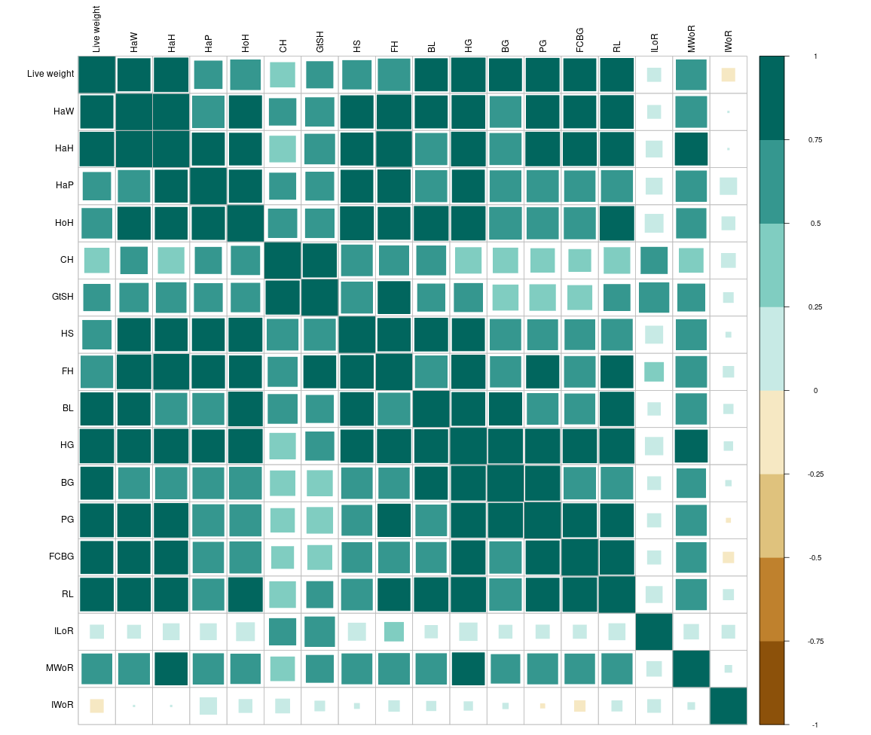
Figure 1: Correlation Plot of morphometric measurements of group 1
Fahim et al. (2013) carried out an experiment on goats and discovered that birth weight and chest girth, body length, height at withers, and pelvic width, which were 0.579, 0.357, 0.682, and 0.361, respectively, had a positive and significant correlation (P < 0.01). They also found a positive and significant (P<0.01) correlation between mature body weight and chest girth, body length, height at withers, neck length, and pelvic width, and it was 0.615, 0.319, 0.439, 0.430 and 0.614, respectively. Significant and positive correlation coefficients were found between live weight and other body characteristics, including body length, height at withers, heart girth, rump, and forehead, which were 0.805, 0.766, 0.767, 0.088, and 0.229, respectively, in a study conducted on 230 goats between the ages of 13 and 18 months (Iqbal et al., 2013).
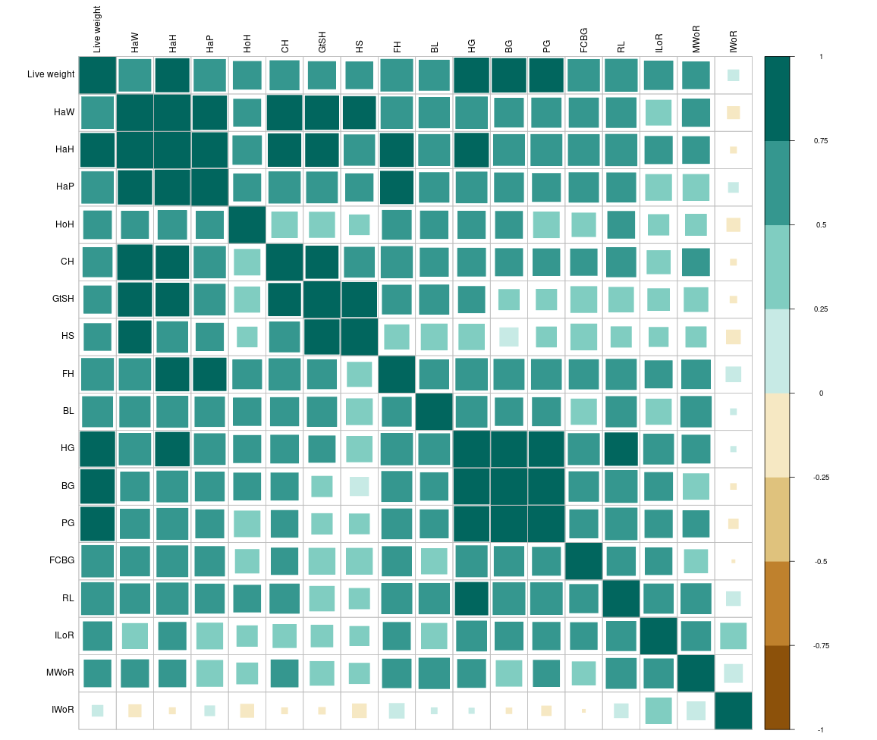
Figure 2: Correlation Plot of morphometric measurements of group 2
Slippers et al. (2000) found a strong correlation (P < 0.01) between heart girth measurement and body weight. Two commercial meat-type chickens' body weight and body measurements showed a positive and highly significant (P < 0.001) correlation (Ajayi et al., 2007). Body weight and body measurements at various ages showed a strong and positive correlation for Malabari goats (Alex et al., 2010). Cam et al. (2010) examined the potential of morphometric traits for predicting body weight in Turkish Hair goats (Kilkeci) and discovered the strongest associations between body weight and heart girth (0.847) and chest depth (0.775).
Mule et al. (2014) found that mean body weight was highly positively (P < 0.01) correlated body length, height at wither and chest girth. Zergaw et al. (2017) conducted a study to differentiate the Woyto-Guji and Central Highland goat breeds of Ethiopia and observed positive and highly significant (P<0.001) correlations between body weight and most independent body measurement variables in both breeds.
BW and independent variables (chest girth, abdominal circumference and spiral circumference, height at withers, and body length) showed positive and highly significant (P<0.001) correlations, according to Ouchene-Khelifi and Ouchene (2021). The highest relationship was illustrated between CG and BW (r = 0.922). Chest girth, body length and shoulder height positively and significantly correlated with BW, with correlation values of 0.90, 0.85 and 0.79, respectively, while combination of chest girth, body length, and shoulder height produced the highest correlation value (r = 0.92) in an experiment carried out by Shoimah et al. (2021).
Bedada et al. (2019) found a positive and significant correlation between live body weight and the majority of the parameters taken into consideration, including chest girth, body length, wither height, pelvic width, body condition score, and ear length. Adhianto et al. (2020) reported correlation coefficient value between BW and HG in goats was the highest and most positive (0.85).
- CONCLUSION
The present study on Surti goat kids aged 6–12 months revealed a distinct and consistent pattern of progressive development in linear body dimensions as the animals advanced in age and live body weight. Live body weight was highly correlated (P < 0.001) height at hipbone (r = 0.837) in 6 to 9 months age group. In groups 2, heart girth (0.859) was highly correlated with live body weight. This observation demonstrates a strong positive relationship between chronological age and morphometric development, whereby incremental age progression drives simultaneous and proportionate increases across multiple body measurements. These findings provide fresh insights into the growth dynamics of Surti goats reinforcing the potential for targeted management interventions that capitalize on this predictable developmental pattern to optimize performance and productivity in herd improvement programs.
REFERENCE
Adhianto, K., Harris, I., Nugroho, P., & Putra, W. P. B. (2020). Prediction of body weight through body measurements in Boerawa (Boer×Etawah crossbred) bucks at Tanggamus regency of Indonesia. Bulg. J. Agric. Sci., 20(6), 1273-1279.
Ajayi, F. O., Ejiofor, O., & Ironkwe, M. O. (2008). Estimation of body weight from linear body measurements in two commercial meat-type chicken. Global Journal of Agricultural Sciences, 7(1), 57-59.
Alex, R., Raghavan, K. C., & Mercey, K. A. (2010). Prediction of body weight of malabari goats from body measurements under field conditions. J. Vet. Anim. Sci., 41, 21-27.
Bansode, P. S., Birari, D.R., Choudhari, D.M., Desale, R.J., Korde, R.S. (2026). Correlation analysis of morphometric traits, body weight, age and body condition score in Surti goats. International Journal of Veterinary Sciences and Animal Husbandry 11(1): 640-645.
Bedada, Z. E., Gilo, B. N., & Debela, G. T. (2019). Morphometric and physical characterization of Borana indigenous goats in Southern Oromia, Ethiopia. Univers. J. Agric. Res., 7(1), 25-31.
Cam, M. A., Olfaz, M., & Soydan, E. (2010). Possibilities of using morphometrics characteristics as a tool for body weight prediction in Turkish Hair goats (Kilkeci). Asian J. Anim. Vet. Adv., 5(1), 52-59.
Department of Animal Husbandry and Dairying (2019) 20th Livestock Census: All India Report. Ministry of Fisheries, Animal Husbandry & Dairying, Government of India, New Delhi.
Fahim, A., Patel, B. H. M., & Rijasnaz, V. V. (2013). Relationship of body weight with linear body measurements in Rohilkhand local goats. Indian J. Anim. Res., 47(6), 521-526.
Iqbal, M., Javed, K., & Ahmad, N. (2013). Prediction of body weight through body measurements in Beetal goats. Pak. J. Sci., 65(4), 458.
Kosgey, I. S., Baker, R. L., Udo, H. M. J., & Van Arendonk, J. A. (2006). Successes and failures of small ruminant breeding programmes in the tropics: a review. Small ruminant research, 61(1), 13-28.
Mallick, S. K., Babu, L. K., Karna, D. K., Panigrahi, B., Behera, K., Joshi, S. K., ... & Sahoo, A. (2025). Morphometric Traits and Body Indices to Assess the Type and Function of Native Ganjam Goats Reared on Different Flooring Systems in Coastal Odisha. Indian Journal of Animal Research, 59(3).
Mule, M. R., Barbind, R. P., & Korake, R. L. (2014). Relationship of body weight with linear body measurement in Osmanabadi goats. Indian J. Anim. Res., 48(2), 155-158. http://dx.doi.org/10.5958/j.0976-0555.48.2.033.
Ouchene-Khelifi, N. A., & Ouchene, N. (2021). Statistical models based on morphometric traits for live body weight estimation in goats. Agricultural Science & Technology, 13(2), 1313-8820.
Shoimah, U. S., Dakhlan, A., & Hamdani, M. D. I. (2021). Use of body measurements to predict live body weight of Simmental bull in Lembang Artificial Insemination Center, West Java. In IOP Conference Series: Earth and Environmental Science, 888, 012030. doi:10.1088/1755-1315/888/1/012030
Slippers, S. C., Letty, B. A., & De Villiers, J. F. (2000). Prediction of the body weight of Nguni goats. S. Afr. J. Anim. Sci., 30(1-1), 127-128.
Villiers, J. D., Gcumisa, S. T., Gumede, S. A., Thusi, S. P., Dugmore, T. J., Cole, M., ... & Stevens, C. (2009). Estimation of live body weight from the heart girth measurement in KwaZulu-Natal goats.
Yakubu, A. (2010). Path coefficient and path Analysis of body weight and biometric traits of Yankasa lambs. Slovak Journal of Animal Science, 43(1), 17-25.
Zergaw, N., Dessie, T., & Kebede, K. (2017). Using morphometric traits for live body weight estimation and multivariate analysis in Central Highland and Woyto-Guji Goat Breeds, Ethiopia. Afr. J. Agric. Res., 12(15), 1326-1331.

