Case report
Surgical Management of Cherry Eye in a Rabbit: A Rare Clinical Case Report

Abstract Prolapse of the third eyelid gland, commonly known as cherry eye, is frequently observed in dogs but rarely reported in rabbits. The third eyelid gland contributes substantially to tear production, and its excision predisposes animals to keratoconjunctivitis sicca. Therefore, surgical repositioning rather than removal is recommended. This report describes the successful surgical management of cherry eye in a one-year-old New Zealand White rabbit using the modified Morgan’s pocket technique. The rabbit presented with a soft, reddish-pink swelling at the medial canthus of the right eye, accompanied by mild conjunctival hyperemia and ocular discharge. Clinical examination confirmed prolapse of the third eyelid gland without corneal involvement. General anaesthesia was induced with xylazine and ketamine, and a conjunctival pocket was created to reposition the prolapsed gland. The incision was closed with absorbable sutures, and postoperative care included systemic antibiotics, anti-inflammatory therapy, and topical eye drops. The rabbit recovered uneventfully, resumed normal feeding within 24 hours, and showed complete resolution of clinical signs without recurrence during a 30-day follow-up. It is concluded that cherry eye in rabbits can be effectively managed through surgical repositioning using the modified Morgan’s pocket technique. Keywords: Cherry eye, Third eyelid gland, Ketamine, Modified Morgan’s pocket technique and Surgical management Introduction: Prolapse of the third eyelid gland, commonly referred to as cherry eye (White and Brennan, 2018). Third eyelid gland also known as harderian gland, nictitating gland or accessory lacrimal gland of the third eyelid. In rabbits, the harderian gland is located within the eye orbit at the nasal base of the third eyelid. Prolapse is generally observed in young animals, especially before one year of age. It is a common condition in dogs, however rare in rabbits (Janssens et al., 1999). The prolapse mainly occurs due to weakening of the supportive ligament that anchors the gland (Raza et al., 2013). A genetic predisposition is responsible, as certain canine breeds show increased prevalence (Dakhane et al., 2022). Clinically, affected animals present with a pink to reddish mass at the medial canthus, often accompanied by conjunctival hyperemia, irritation, and ocular discharge. Excision of the prolapsed gland is generally not recommended, as the third eyelid gland contributes significantly (30–50%) to the aqueous portion of the tear film (Kaswan and Martin, 1985). Removal may predispose animals to keratoconjunctivitis sicca (KCS). Therefore, surgical repositioning is considered the treatment of choice. Several techniques have been described, including anchoring methods, the conjunctival pocket technique, and modifications of the Morgan’s pocket method. Among these, the modified Morgan’s pocket technique is most commonly used in dogs; however, its application in rabbits is rarely reported. This case report describes the successful surgical management of cherry eye in a rabbit using modified Morgan’s pocket technique.
Case presentation
The study was conducted on a clinical case of prolapse of the third eyelid gland (cherry eye) in a one-year-old New Zealand White rabbit presented to the Department of Veterinary Surgery and Radiology, Bihar Veterinary College, Patna (Bihar, India), with a history of swelling at the medial canthus of the right eye. Clinical examination revealed a soft, round, reddish-pink mass protruding from the medial canthus. The rabbit exhibited mild conjunctival hyperemia and ocular discharge. Physiological parameters, including rectal temperature, respiration rate, and heart rate, were within normal limits. Ophthalmic examination ruled out corneal ulceration and confirmed the diagnosis of cherry eye. Surgical management was planned to reposition the gland using the modified Morgan’s pocket technique under general anaesthesia. The rabbit was pre-medicated with xylazine (6 mg/kg IM) and induced with ketamine (60 mg/kg IM). Anaesthesia was maintained with intermittent boluses of ketamine as required. After aseptic preparation of the periocular region, the rabbit was positioned in lateral recumbency with the affected eye uppermost. The surgical site was isolated using drapes, and the eyelids were gently retracted with eyelid retractors. The prolapsed gland was irrigated with sterile normal saline to remove discharge. A curvilinear conjunctival incision was made on both sides of the gland, parallel to the free margin of the third eyelid, creating a conjunctival pocket. Blunt dissection was performed to create a tunnel beneath the conjunctiva, and the gland was carefully repositioned into the pocket. The conjunctival edges were closed with absorbable polyglactin 9 (6-0) sutures in a simple continuous pattern. Postoperatively, the rabbit treated with azithromycin (20 mg/kg orally once daily for 5 days), meloxicam (0.4 mg/kg orally once daily for 3 days), and topical moxifloxacin–olopatadine eye drops thrice daily for 7 days. The rabbit was monitored daily for wound healing, recurrence, and ocular complications.
Discussion:
The rabbit recovered smoothly from the surgery, without intraoperative or postoperative complications. Postoperatively, the conjunctival pocket remained intact, and the third eyelid gland was successfully repositioned in its anatomical location. The rabbit resumed normal feeding and activity the day after surgery. No recurrence of gland prolapse was observed during the 30-day follow-up period. Prolapse of the third eyelid gland can lead to inflammation and conjunctival irritation, resulting in altered tear production, chronic conjunctivitis, and ocular discharge (Dehghan et al., 2012) Surgical repositioning is preferred over excision to preserve lacrimal function and prevent keratoconjunctivitis sicca (Thamizharasan et al., 2016). The Morgan’s pocket technique is simple to perform, minimizes recurrence, and preserves tear production (Morgan et al., 1993; Hendrix, 2007). The only reported limitation is reduced gland mobility (Plummer et al., 2008). In the present case, surgical management was satisfactory, with complete resolution of clinical signs and restoration of normal ocular appearance. The gland remained in its normal position without recurrence, demonstrating the effectiveness of the modified Morgan’s pocket technique in rabbits. Postoperative care, including systemic antibiotics (azithromycin), anti-inflammatory drugs (meloxicam), and topical moxifloxacin–olopatadine drops, helped prevent infection, reduce inflammation, and relieve discomfort. Proper handling of the gland and precise creation of the conjunctival pocket are crucial to prevent tissue trauma and recurrence (Yaygingul et al., 2020). Conclusion Surgical management of cherry eye in rabbits can be successfully performed using the modified Morgan’s pocket technique without any major complications. The modified Morgan’s pocket technique effectively repositions the prolapsed gland, prevents recurrence, and preserves its physiological function.

Conflict of Interest Statement The authors declare that there are no conflicts of interest regarding the publication of this manuscript.

Ethical Approval The surgical case was conducted with informed owner consent, and all procedures followed standard clinical and ethical guidelines of the Bihar Veterinary College, Bihar Animal Sciences University, Patna. References
Dakhane, P. S., Kale, P. D., & Lokhande, D. U. (2022). Successful surgical correction of cherry eye by modified Morgan’s pocket technique in four dogs. The Pharma Innovation Journal, 11(SP-11), 92–94.
Dehghan, M. M., Pedram, M. S., Azari, O., Mehrjerdi, H. K., & Azad, E. (2012). Clinical evaluation of the pocket technique for replacement of prolapsed gland of the third eyelid in dogs. Turkish Journal of Veterinary and Animal Sciences, 36(4), 352–356.
Hendrix, D. V. H. (2007). Canine conjunctiva and nictitating membrane. In K. N. Gelatt ( Ed.), Veterinary ophthalmology (4th ed., pp. 662–689). Ames, IA: Blackwell Publishing.
Janssens, G., Simoens, P., Muylle, S., & Lauwers, H. (1999). Bilateral prolapse of the deep gland of the third eyelid in a rabbit: Diagnosis and treatment. Laboratory Animal Science, 49(1), 105–109.
Kaswan, R. L., & Martin, C. L. (1985). Keratoconjunctivitis sicca: Dry eye in the dog. Journal of the American Veterinary Medical Association, 186(11), 1182–1187.
Morgan, R. V., Duddy, J. M., & McClurg, K. (1993). Prolapse of the gland of the third eyelid in dogs: A retrospective study of 89 cases. Journal of the American Animal Hospital Association, 29, 56–60.
Plummer, C. E., Källberg, M. E., Gelatt, K. N., Gelatt, J. P., Barrie, K. P., & Brooks, D. E. (2008). Intranictitans tacking for replacement of prolapsed gland of the third eyelid in dogs. Veterinary Ophthalmology, 11, 228–233.
Raza, A., Naeem, M. A., Ahmad, M., Manzoor, A., & Ijaz, M. (2013). Cherry eye: Prolapse of third eyelid gland in dog – A case report. International Journal of Molecular Veterinary Research, 3(1), 1–3. https://doi.org/10.5376/ijmvr.2013.03.0001
Thamizharasan, A., Murugan, M. S., & Parthiban, S. (2016). Surgical management of cherry eye in a dog. Intas Polivet, 17(II), 420–421.
White, C., & Brennan, M. (2018). An evidence-based rapid review of surgical techniques for correction of prolapsed nictitans glands in dogs. Veterinary Sciences, 5(3), 75.
Yaygingul, R., Bozkan, Z., Bilgen, Z., Kurt Kibar, B., Bulut, O., & Belge, A. (2020). Surgical treatment of prolapse of the third eyelid gland in dogs using modified Morgan pocket technique. Indian Journal of Animal Research, 54(5), 619–622.

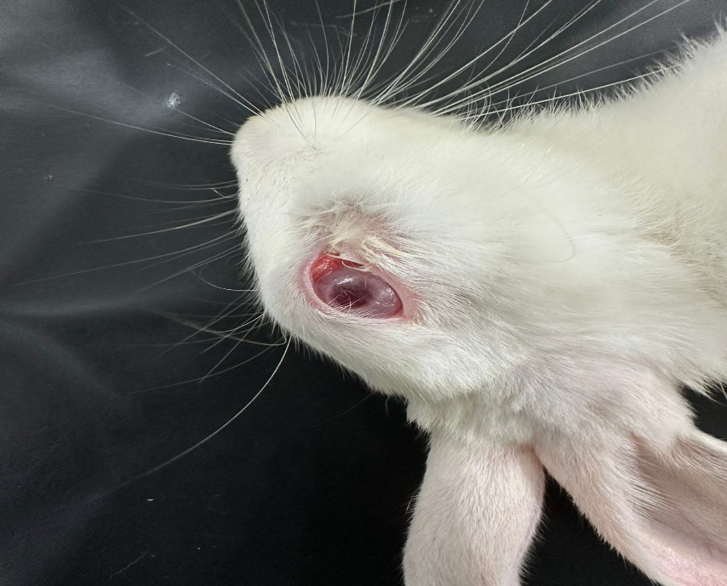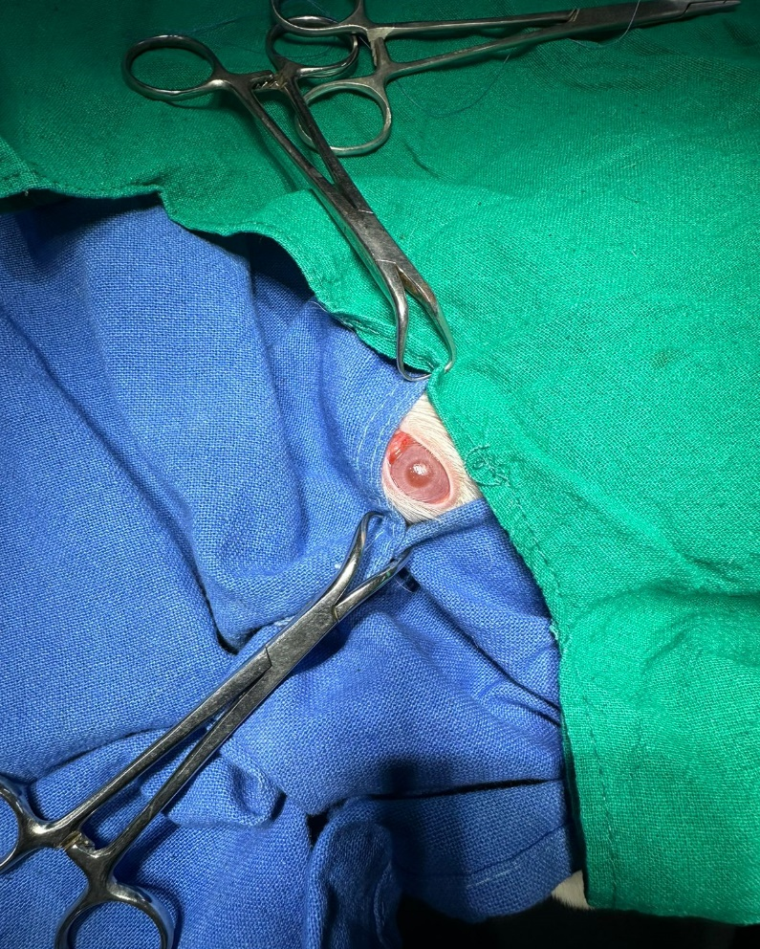
Fig.1. Clinical case of cherry eye Fig.2. Draping of surgical site
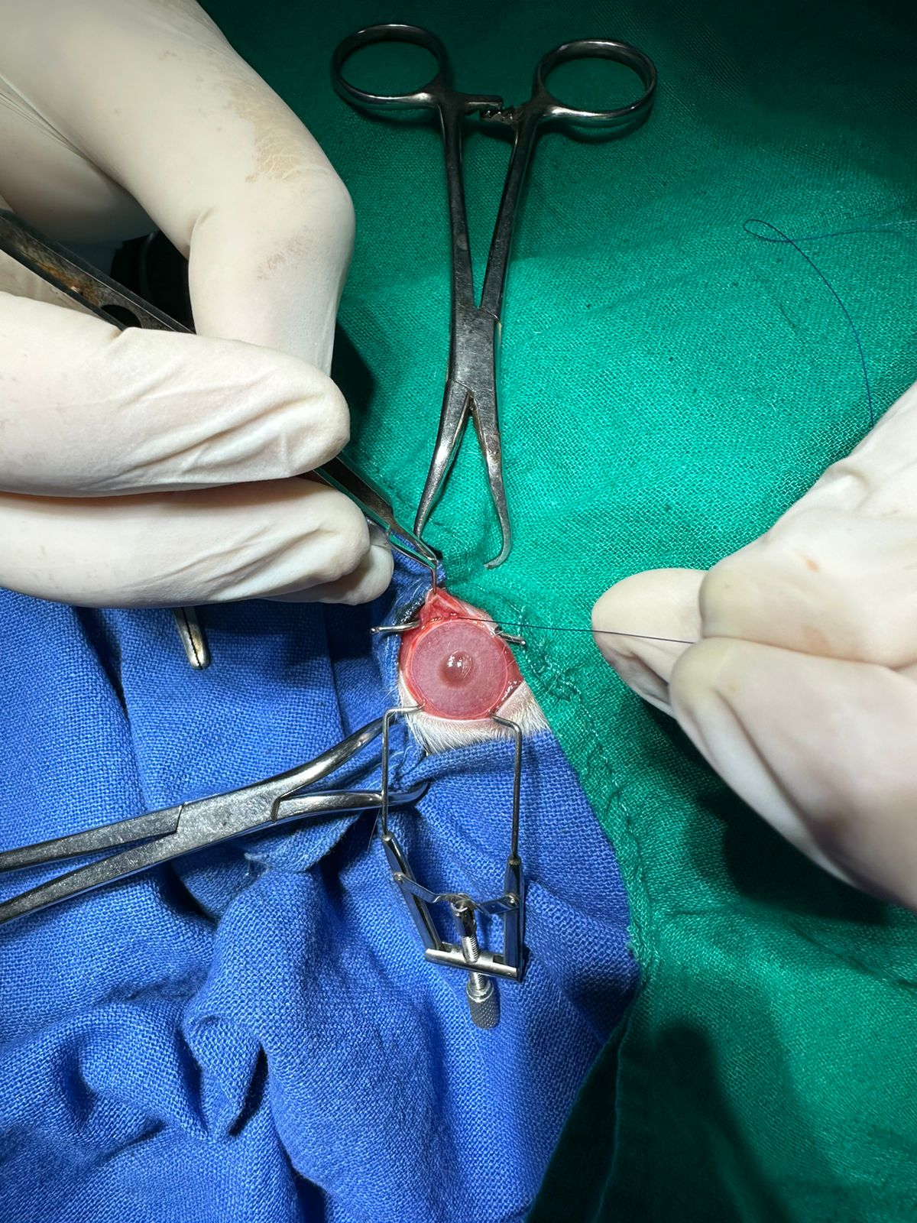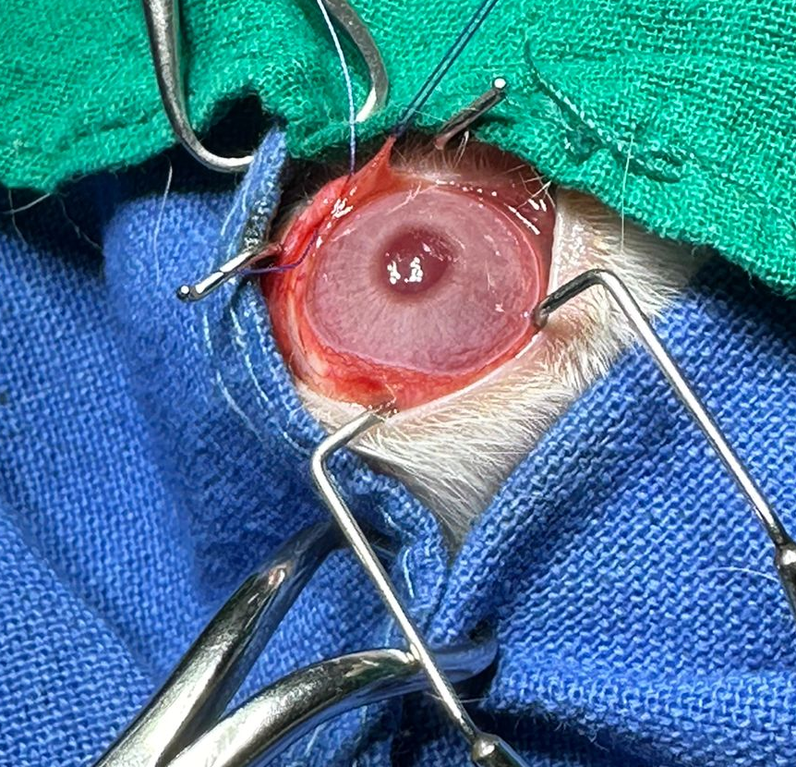
Fig. 3. conjunctival incision on gland Fig. 4. Suturing of conjunctival edges

