DESIGN AND DEVELOPMENT OF SOLAR OPERATED GROUNDNUT DECORTICATOR

.
ABSTRACT

Groundnut (Arachis hypogaea) is a major oilseed crop extensively cultivated in tropical and subtropical regions, with India contributing 17–19% to global production. Shelling, a key post-harvest operation, is traditionally performed using manual or semi-mechanized methods, which are labour-intensive and inefficient for small-scale farmers. Although electric or diesel-powered decorticators improve efficiency, they are costly, require regular maintenance, and are unsuitable for remote, off-grid areas. To address these limitations, a solar-powered groundnut decorticator was developed at Alva’s Institute of Engineering and Technology, Karnataka, integrating renewable energy into agricultural mechanization. The design was based on detailed analysis of groundnut engineering properties, including roundness (0.76), sphericity (0.72), bulk density (238 kg/m³), and angle of repose (24°), to optimize the feed system and shelling unit. The machine features a cylindrical drum and concave sieve mechanism powered by a 1 HP BLDC motor operating between 200–300 rpm, driven by a solar panel–battery hybrid system. It includes a modular frame, manual feed hopper, and dual sieves (10 mm and 8 mm) for effective separation. Performance evaluation at three speeds—100, 200, and 300 rpm—showed maximum shelling efficiency (97.5%) at 300 rpm, but the optimal speed was 200 rpm, achieving 93.75% efficiency, 50 kg/h throughput, and minimal kernel damage (7.4%). Germination percentage was highest at this speed, indicating preserved seed viability. With a power requirement of only 350 W, 3–4 hours of battery backup and low maintenance, the machine is ideal for smallholders in rural areas. Its ergonomic design, affordability, and portability make it a sustainable alternative to conventional decorticators. The integration of solar power supports energy-efficient farming, reduces post-harvest losses, and offers a viable, environment-friendly solution to enhance productivity and rural livelihoods.

Keywords: Groundnut, Shelling, Decorticator, Sustainable energy and De-shelling

1. INTRODUCTION

Groundnut (Arachis hypogaea) called monkey-nut is a vital oilseed crop grown widely in tropical and subtropical regions, with India contributing 17 to 19 % to global production. The major producing states in India include Gujarat, Andhra Pradesh, Tamil Nadu, and Karnataka [1]. Groundnuts are consumed in multiple forms, and are key to both agricultural income and industrial use, particularly in oil extraction and food processing. Nutritionally rich groundnuts also support livestock feed and sustainable practices through shell use in bio fuel and bio fertilizer as a cack dung.
The traditional groundnut decortications methods, including manual and semi-powered equipment, are time-consuming, inefficient, and costly for small and medium-sized farmers. Electric or diesel-powered decorticators, though effective, are expensive, complex, and not viable in remote, off-grid areas. These machines often cause high kernel breakage rates, consume more power, and are ergonomically poor. The primary constraints are high operational expenditures, maintenance requirements, and limited accessibility in rural areas [2][3].
The efficiency and sustainability are taken up in the innovative integration of renewable energy with agricultural processing through the design and development of a solar-operated groundnut decorticator. A vital procedure in post-harvest management is groundnut decortications, which involves removing the outer shell in order to reveal the edible kernel. Conventional methods, whether mechanically powered or manual, may need a large amount of work and energy. An environmentally friendly substitute that fits in with the increased focus on sustainable farming methods is a solar-powered system [4][5].
The ground research work for the design and development of groundnut decorticating equipment has been established by numerous research initiatives. In order to feasibly optimize the beater drum's groundnut decortications performance and minimal kernel loss during shelling, [6] investigated the mechanical shelling action utilizing several materials. In his study of the engineering properties of peanuts and kernels, [7] emphasized the significance of understanding the dimensions, hardness, and sphericity of kernels in order to build effective decorticating equipment. Similarly, power-operated groundnut shellers, developed and enhanced shelling efficiency and stimulated the use of renewable energy sources [8].
The shelling mechanism, solar energy harnessing, and power transmission system are critical components in the design of a solar powered groundnut decorticator. Photovoltaic panels are installed in a typical system to capture solar energy and convert it into electrical energy. The shelling mechanism is driven by a motor that is powered by this stored solar electricity. The shelling mechanism could be made up of wing-type splitters, beaters, or a revolving drum. In order to ensure optimum shelling and minimize kernel percentage, these parts must be optimized to maintain a balance within speed and torque [9].
In the context of groundnuts, [10] highlighted the need of evaluating the shelling performance for various nut crop varieties. Energy efficiency needs to be meticulously considered while incorporating solar electricity. The prime mover and other electrical components need to be designed to work effectively with the varying power source as solar panels usually provide. Even when there is little sunlight, continuous operation can be ensured by including a battery backup.
Mobility and cost effectiveness are even more factors in the solar operation's sustainability. The small-scale farmers in remote areas can use it due to its lightweight and compact design and development, rendering transportation easy. The potential of pedal-powered multi-purpose machines were demonstrated and showed that these devices may be modified for solar power while maintaining their multi-functionality [11]. In addition to lowering dependence on the electrical grid, integrating solar panels eventually lowers running costs.
In order to overcome the constraints of traditional and powered shelling methods, the research work undertook on the design and development of a solar-powered groundnut decorticator that runs on solar power. In India, groundnuts are a crucial crop that is used to make sustainable goods, oil, and food. The decorticators that are at present in use are costly, energy-intensive, and inadequate for remote locations. The proposed equipment utilizes solar energy to run effectively at 200 rpm, ensuring minimum kernel damage, effective shelling efficiency, and low maintenance. Optimized shelling mechanisms and solar-powered drive systems are important design components that provide small-scale farmers in remote regions with an affordable, accessible, and sustainable alternative.
2. material and methods

Research and development work on groundnut decorticator design and development was carried out at the Alva's Institute of Engineering and Technology in Mijar, Karnataka. The research consisted of the following phases:
- Measurement and determination of design values of groundnuts
- Development of the groundnut decorticator
- Field performance of the developed solar powered groundnut decorticator
2.1. Measurement and Determination of design values
The moisture content and dimensional characteristics such as and length, width and thickness of groundnut pods were measured and used to determine the design values such as sphericity, roundness, shape, bulk density and terminal velocity.
2.1.1. Moisture content (%)
The high moisture content leads to clogging/blocking, high energy consumption, lowering shelling efficiency and risk associated with mechanical damage. The oven drying method was used to determine the moisture content (%) [12].
$$Moisture content (\%) =\frac{W_{1}}{W_{2}}×100$$
Where,
W₁ = Initial weight of groundnut
W₂ = Final weight of groundnut
2.1.2. Physical dimensions of groundnut
The dimensional characteristics (Plate 1) of groundnut pods were measured using a Digital Vernier Caliper (LC: 0.01 mm) to ensure high accuracy. The length (L) was defined as the maximum dimension along the natural longitudinal axis of the pod. The width (W) was recorded as the maximum span perpendicular to the length across the widest part of the pod, while the thickness (T) represented the minimum dimension, oriented normal to both the length and width axes. These geometric parameters are essential for determining key design aspects of the decortications mechanism, such as the dimensions of groundnut hopper, cylinder-concave clearance, aspirator blower and chute design which were influence the efficiency of decortications and shelling of groundnut.
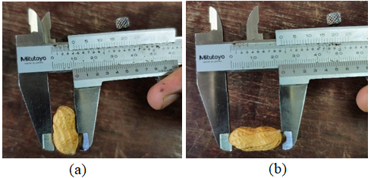
Plate 1. Measurement of groundnut dimensions
2.1.3. Engineering properties of groundnut pods
Understanding of the engineering properties of groundnut pods is essential for designing the efficient shelling and separating mechanisms of the decorticator. The engineering properties such as roundness, sphericity, bulk density, angle of repose and moisture content were measured and detail discussed as bellows:
2.1.3.1. Size or equivalent diameter or geometric mean diameter
Size or equivalent diameter is the geometric mean of the three dimensions viz., length, breadth and thickness [13]. The size was calculated by using following relationship:
$$∅= \sqrt[3]{LBT}$$
Where,
$∅$= Size or equivalent diameter
L= Length (Major diameter)
B= Breadth (intermediate diameter)
T= Thickness (minor diameter)
2.1.3.2. Sphericity
The shape of Groundnut kernel resembles like that of elongated. The volume of the
solid was assumed as equal to the volume of the tri-axial elongated ellipsoid with intercept L, B, T and that the diameter of the circumscribed sphere is the longest intercept (L) [13], the degree of sphericity was determined with the help of following formula.
$$S = \sqrt[3]{LBT}/L$$
2.1.3.3. Roundness
Roundness (R) provides a measure of how close the shape of the pod is to a circle in its natural rest position.
$$R = \frac{A_{P}}{A_{C}}$$
Where,
A_{p} = Largest projected area of object in its natural rest position in mm²,
A_{c} = Area of the smallest circumscribing circle in mm²
2.1.3.4. Bulk Density
Bulk density was determined by filling a specific mass of sample in known volume
of rectangular box. The sample was weighed which required for filling the box. The bulk density of Nutmeg fruit expressed as below [13].
$$Bulk density (kg/m^{3}) =\frac{Weight of material}{Volume of material}$$
2.1.3.5. Angle of Repose
The angle of repose indicates the natural slope formed when pods are poured, influencing hopper and chute designs.
$$θ = \tan^{-1}\left(\frac{2h}{D}\right)$$
Where,
θ = Angle of repose (degree),
h = Height of pile, mm
D = Diameter of circular platform, mm
2.2. Development of hybrid solar operated groundnut decorticator
The solar-operated groundnut decorticator was developed at Department of Agricultural Engineering, Alva’s Institute of Engineering and Technology, Mijar. In designing, various physical properties of the groundnuts were measured to optimize the decorticating unit and concave sieve, facilitating effective selection of sieves for the cleaning and grading mechanism. The critical design considerations included simple and robust structure, affordability, high decortications capacity and low broken percentage compared to manual shelling, and minimizing operational and maintenance costs.
2.2.1. Components of the groundnut decorticator
The hybrid solar-operated groundnut decorticator's conceptual drawing was drawn using Solid Work 2018 Software with the groundnuts measured and determined design values. The design helps to visualize the machine design, both as the interaction between all parts of the machine and individual parts. Isometric view of the model and different views of the hybrid solar-operated groundnut decorticator with dimensions. The functional components of the machine include (Fig. 1 and Plate 2): (1) Solar panel (2) Main frame (3) Hopper (4) Decorticating unit (5) Concave sieve (6) Cylinder shaft (7) Concave sieve (8) Prime mover (BLDC motor) (9) Lead acid battery (10) Potentiometer.
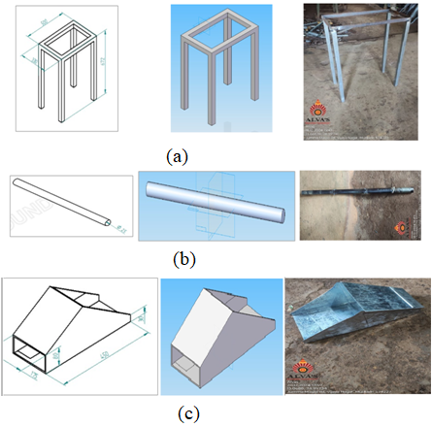
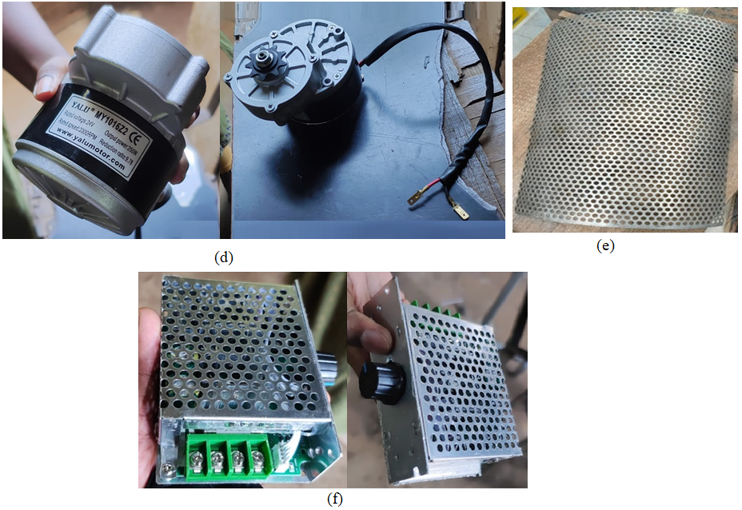
Plate 2. Components of Groundnut decorticator: (a) Main Frame (b) Cylinder shaft (c) hopper (d) Prime mover (e) Concave Sieve (f) Speed potentiometer
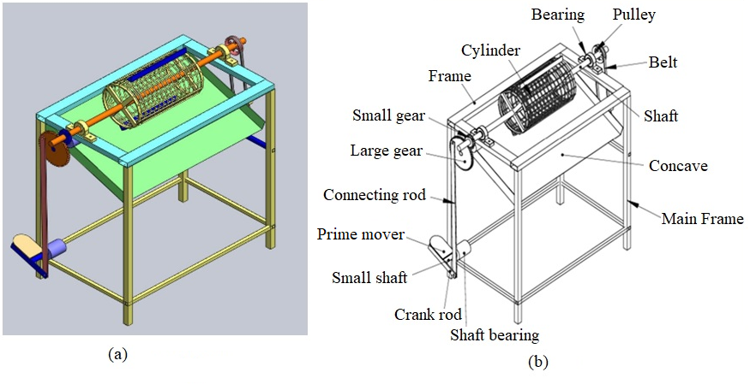
Fig. 1. Groundnut decorticator: (a) Exploded view of components (b) Isometric view
The hybrid groundnut decorticator (Fig.1-a) designed for efficient separation of groundnut kernels from their shells. The system consists of a MS main frame housing a rotating cylinder above a concave surface. Groundnuts are feed into the cylinder, where shelling occurs due to impact, rubbing, and compression between the drum and concave clearance. A driven mechanism converts electrical effort into mechanical motion via a crank rod, small shaft, and gears. This motion is transferred through a belt and pulley to rotate the main shaft and drive the decorticator cylinder. Bearings reduce friction and support rotation. The labelled schematic shows (Fig. 1-b) all mechanical linkages, while the 3D view clarifies component placement and structure. The design is simple, low-cost, and ideal for small-scale or rural use
The primary mechanical components of the decorticator include the hopper, concave sieve, cylinder, and shaft, which together facilitate the feeding and shelling process. The hopper, designed with angular geometry and dimensions of 450 × 220 × 100 mm, ensures a uniform flow of groundnut pods into the shelling chamber. It features a manual gate to regulate the feeding rate and a covered top to minimize spillage and maintain control during operation. Within the decorticating unit, the rotating cylinder and concave sieve interact to crack the pods by applying controlled mechanical force. Power transmission is handled by a 25 mm diameter shaft constructed from high-strength iron, which efficiently conveys torque from the motor to the shelling mechanism while withstanding operational stresses.
Post-shelling separation and structural support are managed by the sieving system and main frame. Two sieves with apertures of 10 mm and 8 mm are used in sequence to segregate kernels from shell debris, ensuring cleaner output and consistent sizing of shelled groundnuts. The 10 mm sieve allows larger kernels to pass, while finer shell fragments are filtered out by the 8 mm mesh. These components are housed within a mild steel frame measuring 510 mm in length, 250 mm in height, and 320 mm in width. This frame not only provides the necessary rigidity for high-speed operation but also ensures alignment and stability for all mounted components (Plate 3).
The electrical subsystem integrates solar power generation, energy storage, and motor control to enhance operational efficiency and sustainability. A mono-crystalline solar panel, selected for its high energy conversion rate and environmental durability, is mounted on an adjustable frame to optimize sun exposure throughout the day. The energy captured is stored in a rechargeable battery, which powers the machine during operation or when sunlight is insufficient. A 1 HP motor, rated at 3500 rpm, serves as the prime mover, delivering reliable torque for effective decortications without kernel damage. An integrated speed controller allows adjustment to 100, 200, or 300 rpm, enabling the operator to fine-tune shelling speed according to material load and desired performance, while minimizing energy use and kernel breakage. The Table 1 and 2 shows the detail measurement, determined design values and specifications of the developed hybrid groundnut decorticator respectively.
Table 1. Measured and determined design values for the solar-powered groundnut decorticator
Parameters | Measured Value | Parameters | Designed Value
Dimensions (l×b×h), mm | 1050×600×1200 | Machine weight, kg | 42
Ground clearance, mm | 180 | Frame material | Mild steel (MS angle 25×25×3 mm)
Feed hopper capacity, kg | 6–8 | Decorticating drum diameter, mm | 200
Hopper inclination angle, degrees | 45 | Decorticating chamber length, mm | 300
Shelling System | Drum and Blades
Shelling type | Rubbing + Impact mechanism | Number of blades | 4 (flat bar, spring steel)
Blade dimensions (L×W×T), mm | 120 × 40 × 4 | Blade rotation speed, rpm | 350–400
Shelling efficiency | 95–97% | Damage percentage | < 3%
Output capacity, kg/h | 60–80 | Shell removal efficiency | ≥ 98%
Power System | Battery and Motor
Power requirement, W | 300 | Prime mover | BLDC motor
Motor power, W | 350 | Motor speed, rpm | 1440
Battery type | Lead-acid | Battery capacity | 12V, 42Ah × 6 = 72 V system
Battery backup duration | 3–4 hours of continuous use | Solar panel rating | 250W × 2 = 500W
Charging method | Solar + Optional AC adapter | Charge time (solar), hours | 6–7 under full sun
Human Parameters | Operator Comfort
Feeding height, mm | 1000 | Discharge height, mm | 500
Handle grip diameter, mm | 35–45 | Material feeding force, N | < 50 N
Safe noise level, dB | < 45 | Vibration range, m/s² | ≤ 2.5
Workplace/Ergonomics | Manual feed, stationary operator | Operator area (l × b), mm | 800 × 600
Transmission System | Belt and pulley drive | Belt type | V-belt, A-section
Pulley ratio | 1:2 (Motor:Drum) | Mounting type | Portable, wheeled frame

Table 2. Detail specifications of the developed groundnut decorticator
Sr. No | Particulars | Specifications
 | Mono-crystalline solar panel | 200 W, 24V, 20Ah
 | Prime mover: BLDC motor | 1 HP, 3500 rpm
 | Lead acid battery | 12V, 8Ah
 | MS main frame | 510 x 250 x 5
 | MS Hopper | 450 x 220 x 100
 | MS cylindrical shaft | $⌀$ = 25 mm and $l$= 450 mm
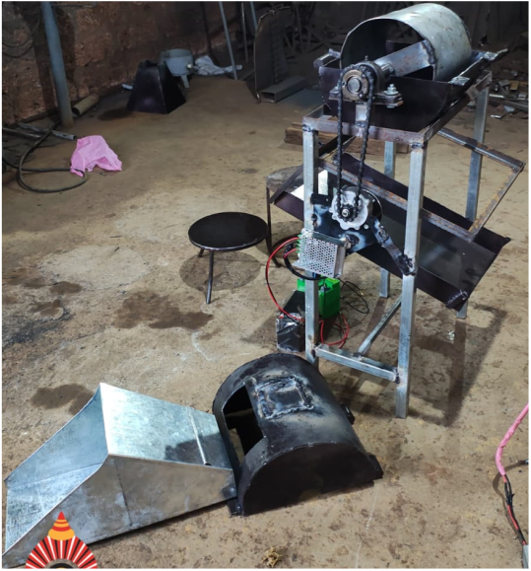
Plate 3. Developed hybrid groundnut decorticator
2.2.2. Evaluation Methodology
The performance of the solar-operated groundnut decorticator was evaluated using one kg of groundnuts (Plate 5), with key parameters such as decorticating capacity, efficiency, unshelled pods percentage, broken seed percentage, and germination percentage assessed.
Decorticating capacity was calculated by measuring the weight of groundnuts fed into the machine and the time taken for decortications, providing throughput in kg/h. Efficiency was determined as the ratio of shelled pods to the total weight of groundnuts fed, while unshelled pods were measured as a percentage of total output. The broken seed percentage was calculated by comparing broken kernels to the total kernels collected, indicating seed damage during processing. Germination percentage was evaluated by testing the seeds' ability to germinate post-decortications.
By-products, including unshelled pods, broken kernels, and shelled grains, were segregated based on weight using an electronic balance. From one kg of groundnuts processed, approximately 850 gm of shelled grains, 80 gm of unshelled pods, and 30 gm of broken kernels were obtained. These metrics were used to calculate the machine's efficiency in producing usable groundnuts versus by-products.
The highest efficiency was achieved at a decorticating speed of 200 rpm, where the machine displayed optimal decorticating efficiency, minimal kernel breakage, and high seed quality preservation. The results indicated a well-balanced operation, maximizing throughput while maintaining kernel integrity and minimizing waste.
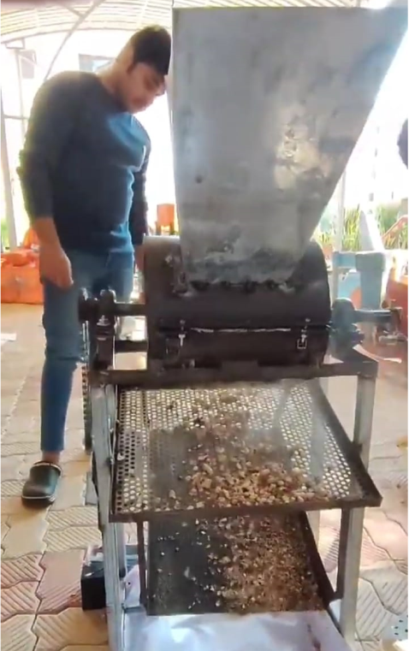
Plate 4. Evaluation of developed groundnut decorticator

3. results and discussion

3.1. Measured and determined design values
The engineering characteristics of groundnut seeds were studied to support the effective design of the decortications system. The results indicated a mean roundness of 0.76 and a sphericity of 0.72, suggesting that the seeds possess a moderately round and nearly spherical shape. These geometrical properties play a crucial role in determining how the seeds interact with the shelling mechanism and affect the clearance between the cylinder and concave.
In addition, bulk density and angle of repose were examined to evaluate the handling and flow behaviour of the seeds. A bulk density of 238 kg/m³ and an angle of repose of 24° suggest good flow characteristics, which are vital for the smooth operation of the hopper and feed system. These properties help ensure continuous feeding with reduced clogging and minimal mechanical damage to the seeds during operation.
The physical dimensions of groundnut pods were also measured, as they are essential for developing both the shelling and grading units of the machine. The average length, width, and thickness of the pods were found to be 19.96 mm, 12.32 mm, and 11.65 mm, respectively. These measurements were obtained using standardized procedures and are fundamental in determining the appropriate concave clearance, sieve size, and overall configuration of the decorticator.
3.2. Performance Parameters Summary for Groundnut Decortications
Operating the decorticator at 200 rpm offers the best combination of efficiency, capacity, and seed quality, ensuring minimal damage and maximum germination potential. The highest shelling percentage (93.75%) was achieved at a cylinder speed of 200 rpm with a combination of high decorticating capacity (50 kg/h), and minimised broken percentage (7.4 %). The measurement after evaluation of equipment shown in Plate 5.
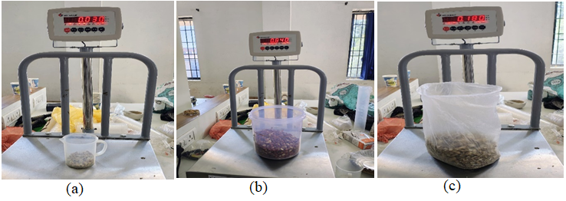
Plate 5. Measurement of decorticated groundnut: (a) Broken percentage (b) Decorticating capacity (c) shelling percentage
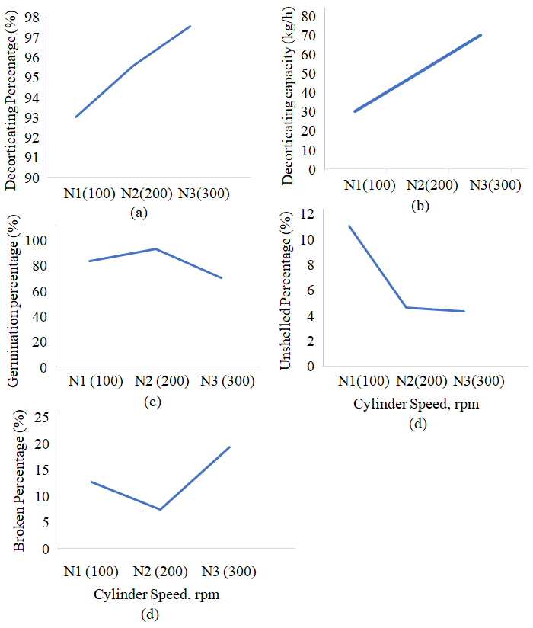
Fig. 2. Performance parameters of the groundnut decorticator
The performance of the solar-operated groundnut decorticator was evaluated at three different cylinder speeds: N1 (100 rpm), N2 (200 rpm), and N3 (300 rpm). The decorticating percentage (Fig. 2-a) showed a consistent upward trend with increasing cylinder speed. It increased from approximately 93% at N1 to about 97.5% at N3, indicating that higher rotational speed enhances the shelling effectiveness due to increased mechanical impact and friction between the pod and the shelling surface.
The decorticating capacity (Fig. 2-b), measured in kg/h, also exhibited a significant rise with increased cylinder speed. At 100 rpm, the capacity was relatively low but showed a sharp incline at higher speeds, reaching approximately 70 kg/h at 300 rpm. This improvement in throughput is attributed to the increased number of pods processed per unit time as the drum speed increases, resulting in higher overall productivity.
The germination percentage (Fig. 2-c), however, followed a slightly different trend. It peaked at N2 (200 rpm), indicating that moderate mechanical impact preserves seed viability better than either too low or too high speeds. At N1, germination was lower due to incomplete shelling, while at N3, the aggressive action of the cylinder may have led to internal damage of the kernels, reducing their viability.
In terms of unshelled percentage (Fig. 2-d), a decreasing pattern was observed as the speed increased. At the lowest speed (N1), the unshelled percentage was the highest, around 11%, which drastically dropped to under 5% at N3. This suggests that slower speeds are insufficient to effectively crack a significant number of pods, whereas higher speeds provide the necessary impact energy for complete shelling.
Finally, the broken percentage (Fig. 2-e) of kernels increased at higher cylinder speeds. While N2 exhibited the lowest breakage, speeds beyond this point led to a noticeable increase in damage, with N3 recording the highest percentage of broken kernels. This reflects a trade-off between higher decortications efficiency and the integrity of the kernel, highlighting the need for selecting an optimal speed that balances shelling performance with seed preservation.
4. Conclusion

The development and evaluation of the solar-powered groundnut decorticator represent a significant advancement in sustainable post-harvest agricultural processing, particularly for smallholder and rural farmers. By addressing the core limitations of existing shelling technologies—such as high operational cost, dependence on grid electricity or fossil fuels, and poor adaptability in remote areas—this study introduces a viable and eco-friendly alternative that aligns with the current push for renewable energy integration in agriculture.
The decorticator was designed using a detailed understanding of the engineering and physical properties of groundnut pods and kernels. Properties like roundness, sphericity, bulk density, and angle of repose directly influenced the geometry and design of components such as the hopper, cylinder, concave sieve, and feeding system. Accurate determination of these parameters ensured that the machine was not only structurally robust but also functionally optimized for maximum shelling efficiency and minimal kernel damage.
From a mechanical standpoint, the decorticating unit’s configuration—including a rotating drum, a concave sieve, and a V-belt pulley system—was meticulously engineered for efficient operation. The integration of a 1 HP BLDC motor powered by a solar panel–battery setup provided a reliable and renewable power source. The use of mono-crystalline solar panels, known for high efficiency, along with a lead-acid battery system, offered uninterrupted operation even under low sunlight conditions. The hybrid design also featured a potentiometer-based speed controller, enabling the operator to adjust cylinder speed based on the quantity and type of groundnuts processed.
Experimental evaluation was carried out fewer than three speed settings: 100, 200, and 300 rpm. Among these, 200 rpm emerged as the optimal speed for operation. At this setting, the machine delivered a decorticating capacity of 50 kg/h, shelling efficiency of 93.75%, and a minimal kernel breakage rate of 7.4%. Germination percentage was also highest at 200 rpm, suggesting that moderate mechanical forces preserve seed viability better than extremes. While the highest decortications efficiency was recorded at 300 rpm, it came at the cost of increased seed breakage and reduced germination rates—underscoring the need for a performance balance.
Another important aspect was the machine’s ability to minimize operational challenges such as clogging, excessive vibration, and seed damage. The feeding hopper, designed with an optimal inclination angle and controlled gate, provided a steady flow of material into the shelling chamber. The dual-sieve system effectively separated kernels from shells and debris, contributing to higher output quality. Structurally, the mild steel frame and iron shaft provided durability and rigidity, ensuring smooth operation even under extended use.
The decorticator's power system, combining a 500W solar panel array with a 72V battery bank, allowed 3–4 hours of continuous operation without the need for grid power. This makes the unit highly suitable for remote agricultural areas where electricity access is limited or unreliable. Additionally, the ergonomic design, low noise levels (<45 dB), and minimal feeding force (<50 N) made the machine user-friendly and safe for extended operation by farmers of varying skill levels.
Economically, the machine offers a cost-effective alternative to diesel or electric-powered Shellers. With minimal running costs, low maintenance needs, and an efficient energy source, the machine ensures rapid return on investment. Its portability and compact design also enhance usability and mobility, allowing it to be deployed across different farm locations or shared among community groups.
In conclusion, the solar-powered groundnut decorticator developed in this study provides a sustainable, efficient, and accessible solution for groundnut shelling. It leverages renewable energy to address the pressing needs of small and medium-scale farmers in off-grid regions. The machine successfully integrates engineering design, agricultural knowledge, and solar technology to offer a practical alternative to conventional decortications methods. This innovation has the potential to significantly reduce post-harvest losses, enhance the quality of processed groundnuts, and contribute to the economic upliftment of rural communities while promoting environmentally sustainable farming practices.

Competing interests

Authors have declared that no competing interests exist.

References

- Anonymous 2025. Groundnut outlook 2025. Acceded
https://www.pjtau.edu.in/files/AgriMkt/2025/January/groundnut-January-2025.pdf. on 30.06.2025.
- Goyal, R., & Bansal, S. (2015). A review on mechanical decortications of groundnut for rural application. Indian Journal of Agricultural Engineering, 25(2), 120–128.
- Jain, A. K., Sahay, K. M., and Srivastava, A. P. (2016). Design and performance analysis of low-cost groundnut decorticator. Agricultural Mechanization in Asia, Africa and Latin America, 47(1), 38–42.
- Mehta, C. R., Chandel, N. S., and Mandal, D. (2020). Development and performance evaluation of a solar-powered groundnut decorticator. International Journal of Renewable Energy Research, 10(3), 1420–1427.
- Patel, S. K., Singh, P.P., and Sahu, H. D. (2019). Solar powered devices for post-harvest agricultural processing: A sustainable approach. Renewable Energy Focus, 30, 45–54.
- Abou EL- Kheir; M. M. and A. Z. Shoukr (1993). Modeling of the action of mechanical shelling of peanut for different materials of beater drum. Misr, J.Agril. Engg., 10 (1) : 123-135.
- Ugargol, M., Gowtham, and Santosh (2024). Engineering Properties of Groundnut for Designing a Battery-operated Decorticator. Journal of Scientific Research and Reports, 30(9), 205-216. https://doi.org/10.9734/jsrr/2024/v30i92345.
- Gore, K. L., C.P. Gupta and C. Singh (1990) Development of power operated groundnut sheller. Agricultural Mechanization in Asia, Africa and Latin America Vol. 21 (3): 38-44.
- Esaki, M., & Yashiro, T. (1985). Shelling characteristics and mechanism of groundnut pods. Transactions of the ASAE, 28(3), 868-872.
- Duraisamy, K., and Manin, R. A. (1973). Evaluation of shelling performance for nut crops. Journal of Agricultural Engineering Research, 18(2), 102–110
- Bahaley, S. G., Awate, A. U., and Saharkar, S. V. (2012). Performance analysis of pedal powered multipurpose machine. International Journal of Engineering Research and Technology, Vol. 1(5): 2012.
- Ganesh, M., et al. (2019). Design and Fabrication of Groundnut Shell Remover. International Journal of Scientific Research in Science, Engineering and Technology, 6(2), 316-323.
- Mohesnin, N. N. 1950. The physical properties of plant and animal materials. Gordan and Breach, Science Publishers, Inc. New York: 51-78.

