Precision Nutrition: Harnessing Nano-Fertilizers and Smart Inputs for a Paradigm Shift in Nutrient Use Efficiency (NUE)

Abstract
The transition toward sustainable intensification in global agriculture is currently hindered by the systemic inefficiency of conventional agrochemicals. Conventional fertilization often results in nutrient losses exceeding 60%, driving environmental degradation through nitrogen leaching, phosphorus runoff, and greenhouse gas emissions. This review evaluates the transformative potential of nano-fertilizers and smart inputs as a sophisticated solution to enhance Nutrient Use Efficiency (NUE) and mitigate ecological footprints. By engineering fertilizers at the molecular scale, nanotechnology enables the development of smart delivery systems that respond dynamically to the crop’s physiological needs. We analyze the mechanisms of encapsulation using biodegradable polymers, carbon nanotubes, and mesoporous silica, which facilitate the "triggered release" of nutrients in response to environmental stimuli such as rhizosphere pH, soil moisture, or specific root exudates. Unlike bulk fertilizers, these nano-enabled inputs ensure a synchronized supply of macro- and micronutrients, significantly reducing the frequency of application while maximizing biomass accumulation and biofortification. Furthermore, the review explores the dual-action role of smart inputs in enhancing abiotic stress resilience, where nano-elicitors prime the plant’s antioxidant defense systems against drought and salinity. We also integrate the role of nano-biosensors in digital farming, providing a feedback loop for real-time soil health monitoring. Despite the agronomic advantages, the manuscript critically discusses the environmental fate of nanomaterials, the potential for trophic transfer, and the current lack of harmonized global regulations. We conclude that while nano-fertilizers represent a paradigm shift in precision agronomy, a multidisciplinary approach involving material science, plant physiology, and ecotoxicology is essential to move these technologies from the laboratory to large-scale, sustainable field adoption.

Keywords : Nano-Fertilizers, Nutrient Use Efficiency (NUE), Smart Agri-Inputs,Controlled-Release Systems, Precision Agriculture, Sustainable Intensification, Nano-Biotechnology

Introduction: The Global Imperative for Smart Agronomy
The Green Revolution, which began in the mid-20th century, transformed global agriculture through high-yielding crop varieties, synthetic fertilizers, and irrigation infrastructure, averting famines and boosting food production exponentially(Gyamfi et al., 2024). However, by the late 20th and early 21st centuries, this revolution has reached a plateau(Evenson, 2002). Crop yield gains have stagnated in many regions, particularly in intensively farmed areas of Asia and North America, where annual increases have dropped from 2-3% during the peak Green Revolution era to less than 1% today. (Bailey‐Serres et al., 2019)This stagnation is attributed to several factors, including genetic yield ceilings in staple crops like rice and wheat, diminishing marginal returns from conventional inputs, and emerging biophysical constraints such as soil nutrient imbalances and climate variability(Grassini et al., 2013).
Central to this plateau is the "NUE Paradox"—Nutrient Use Efficiency, defined as the fraction of applied nutrients absorbed and utilized by crops for growth and yield(Rosolem & Husted, 2024). Paradoxically, despite massive increases in fertilizer application—global nitrogen (N) fertilizer use has surged over 800% since 1960—NUE remains abysmally low: typically 30-50% for N, 10-20% for phosphorus (P), and even lower for micronutrients(Govindasamy et al., 2023). The paradox lies in the inefficiency: excess nutrients are lost through volatilization (as ammonia or nitrous oxide), leaching into groundwater, runoff into waterways, or fixation in soils, leading to minimal crop uptake while exacerbating environmental degradation(Beig et al., 2022). This inefficiency not only inflates production costs for farmers but also undermines global food security as arable land diminishes and populations grow(Pandey & Mishra, 2024).
Conventional agricultural inputs bear significant environmental costs(Pandey & Mishra, 2024). Eutrophication, driven by P and N runoff from farmlands, creates hypoxic "dead zones" in rivers, lakes, and coastal areas, such as the Gulf of Mexico's 6,000-square-mile oxygen-depleted zone (Powers, 2005). Greenhouse gas emissions from fertilizers contribute substantially to climate change; synthetic N fertilizers alone account for approximately 2.2% of global anthropogenic GHG emissions, primarily through N_2O (a potent GHG with 265 times the warming potential of CO₂_) released during nitrification and denitrification processes(Fudjoe et al., 2023). Soil degradation further compounds these issues: overuse of ammoniacal fertilizers acidifies soils, reducing microbial diversity and cation exchange capacity, while repeated applications lead to salinization, compaction, and loss of organic matter, eroding long-term productivity (Bisht & Chauhan, 2020). In developing regions, where smallholders rely heavily on subsidized bulk fertilizers, these costs perpetuate a cycle of poverty and environmental harm(Bisht & Chauhan, 2020).
Enter "Smart Inputs," a paradigm shift redefining agronomy in the era of Industry 4.0 and Agriculture 5.0. Industry 4.0 principles—cyber-physical systems, Internet of Things, big data analytics, and artificial intelligence—converge with Agriculture 5.0's emphasis on human-centric, sustainable, and resilient farming(Gire, 2025). Smart Inputs are advanced, nanotechnology-enabled fertilizers and additives engineered for precision delivery, controlled release, and targeted uptake(Zhang et al., 2021). Unlike bulk fertilizers, they leverage nanomaterials (1-100 nm scale) with tailored physicochemical properties—high surface area, reactivity, and bioavailability—to minimize losses and maximize efficiency(Sahithya et al., 2025). Examples include nano-urea emulsions that reduce application rates by 50% while matching yields, polymer-encapsulated micronutrients that respond to environmental stimuli (pH, moisture), and nano-biosensors for real-time nutrient monitoring(Atanda et al., 2025).
This approach addresses the NUE Paradox by synchronizing nutrient supply with plant demand, potentially elevating NUE to 80-90%. Environmentally, smart inputs curtail GHG emissions by 20-40%, mitigate eutrophication through reduced runoff, and enhance soil health via microbiome modulation(Calabi-Floody et al., 2017). Economically viable for smallholders via foliar sprays and low-dose applications, they bridge the gap between high-tech innovation and grassroots adoption(Beattie et al., 2024). As global food demand is projected to rise 50% by 2050 amid climate pressures, smart agronomy emerges as an imperative, promising "programmable nutrition" for resilient crops(Mohanty et al., 2024).
(Word count: 578)

2. Conceptual Framework of Nano-enabled Plant Nutrition
Nano-enabled plant nutrition represents a transformative approach in smart agronomy, leveraging the unique physicochemical properties of nanomaterials to optimize nutrient delivery and uptake(Munir et al., 2024). Nanomaterials, typically defined as structures with at least one dimension between 1 and 100 nm, exhibit exceptional physicochemical attributes that distinguish them from bulk materials(Dada & Popoola, 2023). Foremost is their extraordinarily high surface area-to-volume ratio, which enhances reactivity, solubility, and ion exchange capacity—critical for controlled nutrient release. Quantum size effects confer unique optical, electrical, and magnetic properties, enabling stimuli-responsive behaviors. Surface chemistry plays a pivotal role: modifiable surface charge (zeta potential) influences dispersion stability in soil or foliar sprays, while functionalization with ligands, polymers, or biomolecules improves biocompatibility and targeting. Shapes such as spheres, rods, tubes, or sheets further tailor mobility and bioavailability; for instance, rod-shaped nanoparticles penetrate plant cuticles more effectively than spherical ones. Composition varies widely, including metallic (e.g., silver, copper), metal oxides (e.g., ZnO, TiO2), carbon-based (e.g., graphene, fullerenes), and polymeric nanostructures, each optimized for specific agro-ecological conditions(Mittal et al., 2020).
Classification of smart inputs delineates three primary categories: nano-fertilizers, nano-additives, and nano-biosensors. Nano-fertilizers encompass macronutrient carriers like nano-urea (liquid emulsions with 4-20 nm urea particles), nano-hydroxyapatite for phosphorus, and nano-zeolites for potassium, achieving 70-90% NUE by minimizing losses via encapsulation and slow release. Nano-additives augment these by enhancing retention and efficacy—examples include chitosan nanoparticles as elicitors for stress tolerance or silica nanoparticles to improve drought resistance through osmotic adjustment. Nano-biosensors, integrating nanomaterials with bioreceptors, enable precision monitoring; gold or carbon nanotube-based sensors detect nitrate or phosphate at parts-per-billion levels in real-time, facilitating "on-demand" applications via IoT-linked drones or fertigation systems(Lal et al., 2023).
This framework synergizes nanotechnology with plant physiology, synchronizing nutrient supply-demand dynamics to transcend conventional limitations. By addressing fixation, leaching, and volatilization, nano-enabled systems promise sustainable intensification, though scalability hinges on phytotoxicity thresholds and regulatory harmonization(Liao et al., 2023).

3. Smart Delivery Systems: Mechanisms of Controlled and Targeted Release Smart
Encapsulation strategies are pivotal in nano-enabled fertilizers, safeguarding nutrients from environmental losses while enabling precise, sustained delivery. Polymer-based nanocarriers, such as chitosan, alginate, and poly(lactic-co-glycolic acid), provide biocompatible matrices that encapsulate urea, phosphates, or micronutrients through core-shell or matrix structures. These polymers degrade enzymatically or hydrolytically, releasing payloads over weeks to months, thereby minimizing leaching and volatilization. Lipid-based carriers, including liposomes (phospholipid vesicles) and solid lipid nanoparticles composed of triglycerides or waxes, excel in foliar applications due to their amphiphilic nature, which promotes adhesion to hydrophobic leaf cuticles and fusion with cellular membranes for enhanced bioavailability. Inorganic nanocarriers, like mesoporous silica nanoparticles with tunable 2-50 nm pores, halloysite nanotubes, and layered double hydroxides, offer exceptional stability in soil matrices, high loading capacities (up to 40% w/w), and pH-dependent interlayer expansion for anion release(Alikarami & Saremi, 2025).
Stimuli-responsive release mechanisms further refine targeting by responding to agro-ecological cues. pH-sensitive systems exploit rhizosphere acidity (pH 4.5-6.5) or alkaline hotspots; for instance, poly(acrylic acid) coatings protonate and swell, liberating K⁺ or NO₃_. Temperature-responsive nanogels, based on poly, exhibit lower critical solution temperature (LCST ~32°C), contracting above thresholds during heat stress to retain nutrients or expanding below for release. Moisture-triggered hydrogels, such as superabsorbent polyacrylamide-clay composites, imbibe water during irrigation or rainfall, fracturing to dispense N-fertilizers in arid zones. Enzyme-responsive designs leverage plant-secreted hydrolases; urease-labile peptide linkers on nano-urea coatings dissolve in active root exudates, curbing nitrate volatilization(Lam et al., 2022).

4. Foliar vs. Soil Application: Bridging the Absorption Gap
Foliar and soil applications represent two primary nano-enabled delivery routes, each with distinct mechanisms that bridge the absorption gap in plant nutrition. Foliar application involves spraying nanoparticle suspensions directly onto leaves, capitalizing on nanoparticle-leaf interactions via stomatal and cuticular pathways. The cuticular pathway dominates for smaller nanoparticles (<10 nm), which diffuse through the lipophilic waxy cuticle, facilitated by surfactants that reduce surface tension and enhance wetting. Larger nanoparticles (20-100 nm) preferentially enter via stomatal pores (typically 10-30 μm wide when open), influenced by stomatal conductance, which peaks during high humidity and light exposure. This route offers rapid uptake—often within hours—bypassing soil barriers, with bioavailability enhanced by amphiphilic nanocarriers like liposomes that fuse with leaf membranes. However, challenges include photodegradation, runoff during rain, and uneven coverage on adaxial/abaxial surfaces(Karny et al., 2018).
In contrast, soil application targets the rhizosphere, where nanoparticle dynamics govern stability, mobility, and microbial interactions. Upon soil incorporation, nanoparticles encounter complex matrices of clays, organic matter, and varying pH/ionic strengths, promoting aggregation and reducing mobility unless stabilized by polyelectrolyte coatings (e.g., polyacrylate). Mobility to roots occurs via convection (mass flow with water) or diffusion, with rod-shaped nanoparticles exhibiting higher transport due to reduced sedimentation. Rhizosphere exudates—organic acids, sugars—modulate this: chelating agents enhance dispersion, while microbial biofilms may entrap particles. Beneficial interactions include nano-zinc stimulating phosphate-solubilizing bacteria, boosting P mobilization; conversely, high doses of Ag or CuO nanoparticles can disrupt nitrogen-fixers, underscoring dose-dependent phytotoxicity.
Foliar excels for micronutrients and stress mitigators (80-90% uptake efficiency), ideal for corrective feeding, while soil suits macronutrients for sustained release (improving NUE by 50-70%). Hybrid strategies, alternating routes or using IoT-guided decisions, optimize outcomes, minimizing losses and environmental risks. Selecting the pathway hinges on crop architecture, soil properties, and nutrient type, paving the way for precision agronomy(Hoque & Padhiary, 2024).

5. Translocation and Bioavailability within Plant Tissues
Once nanoparticles enter plant tissues via foliar or soil routes, their translocation hinges on apoplastic and symplastic pathways, dictating bioavailability and efficacy. The apoplastic pathway facilitates extracellular movement through cell walls and intercellular spaces, ideal for hydrophilic nanoparticles like nano-urea that diffuse passively along water streams in the xylem. This route dominates initial uptake from roots to shoots, bypassing plasma membranes but limited by the Casparian strip in endodermal cells, which forces selective filtration(Pérez‐de‐Luque, 2017). Conversely, the symplastic pathway enables intracellular transport via plasmodesmata and the phloem, suited for smaller (<10 nm) or surface-modified nanoparticles that cross membranes through endocytosis or aquaporins. Symplastic loading enhances systemic distribution, as seen with chitosan-coated nano-zinc, which achieves 2-3 fold higher leaf accumulation compared to uncoated forms. These dual pathways synergize to overcome absorption barriers, with bioavailability modulated by nanoparticle size, zeta potential, and plant species—e.g., monocots favor apoplastic flow due to thicker cuticles(Alikarami & Saremi, 2025).
Plasmodesmata play a pivotal role in long-distance symplastic transport, acting as cytoplasmic channels (20-50 nm diameter) that connect adjacent cells and sieve elements for phloem loading. These dynamic pores, regulated by callose deposition and myosin motors, permit nanoparticle passage during high metabolic demand, such as fruit filling. Studies reveal that positively charged nano-iron exploits plasmodesmatal size exclusion limits, translocating from leaves to grains in cereals, boosting ferritin levels by 40%. However, aggregation risks clogging these channels, reducing flux; polyethylene glycol coatings mitigate this by reducing hydrophobicity. Temperature and phytohormones like auxin further tune plasmodesmatal permeability, enabling stress-responsive redistribution(Alikarami & Saremi, 2025).
Intercellular movement culminates in delivery from source organs (roots/leaves) to sinks (grains/roots), governed by source-sink gradients and mass flow. In phloem, nanoparticles hitchhike with sucrose via companion cell-sieve tube complexes, with rod-like halloysite nanotubes showing superior mobility over spheres due to alignment with flow. Bioavailability peaks at sinks through unloading via symplastic diffusion or apoplastic leakage, influenced by sink strength—e.g., high-demand tubers accumulate more nano-phosphate. This process elevates nutrient remobilization, improving NUE by 30-50%, though monitoring trophic transfer prevents off-target effects(Dhiman et al., 2025).

6. Enhancing Nitrogen Use Efficiency (NUE) via Nano-Urea and Inhibitors
Nano-urea formulations revolutionize nitrogen delivery by mitigating key losses like volatilization and leaching, which plague conventional urea fertilizers. Volatilization occurs when urea hydrolyzes to ammonia gas under alkaline soil conditions, dissipating up to 50% of applied nitrogen within days. Nano-urea, encapsulated in 20-50 nm silica or polymer matrices, releases nitrogen gradually through diffusion-controlled mechanisms, reducing ammonia emission by 70-90%. This controlled release aligns with crop demand, minimizing gaseous losses during wet seasons. Leaching, driven by heavy rainfall or irrigation, carries soluble nitrates deep into groundwater, contaminating aquifers. Nano-urea's low solubility and high root adhesion prevent downward migration, retaining 80% more nitrogen in the root zone compared to granular forms. These attributes stem from nanoscale surface area enhancements, promoting foliar adhesion and soil stabilization without compromising plant uptake kinetics(Hamed et al., 2024).
Synergy between nano-carriers and nitrification inhibitors amplifies nitrogen use efficiency by targeting microbial transformations. Nitrification inhibitors like nitrapyrin or dicyandiamide suppress ammonia-oxidizing bacteria, delaying nitrate formation and leaching vulnerability. When integrated with nano-urea, these inhibitors achieve dual protection: nanoparticles shield the inhibitor from rapid degradation, extending efficacy from weeks to months, while inhibitors prevent premature nitrification of nano-released ammonia. This tandem approach boosts NUE by 40-60% in cereals, as evidenced by reduced nitrous oxide emissions and enhanced ammonium assimilation via glutamine synthetase pathways. Surface-functionalized nanoparticles, such as chitosan-coated variants, further improve inhibitor loading and targeted rhizosphere delivery, fostering a balanced nitrogen cycle(Al‐Dossary et al., 2025).
Large-scale trials underscore liquid nano-urea's transformative impact. In India’s IFFCO trials across 100,000+ hectares of paddy, nano-urea applications yielded 8-10% higher grain output with 50% less nitrogen input, slashing fertilizer costs by 25%. Similarly, Brazilian soybean fields reported 35% NUE gains, correlating with lower nitrate leaching into waterways. These successes, replicated in wheat systems in China, highlight scalability, with drone foliar sprays ensuring uniform distribution. Challenges like storage stability are addressed via polymer stabilizers, paving the way for global adoption in precision farming(Chappidi, 2025).

7. Phosphorus Mobilization: Overcoming Soil Fixation Challenges
Phosphorus (P) fixation renders up to 75-90% of applied fertilizers unavailable in soils, posing a major barrier to crop productivity. In acidic soils (pH < 5.5), P rapidly binds to iron and aluminum oxides forming insoluble phosphates, while in alkaline soils (pH > 7.5), it precipitates with calcium as hydroxyapatite or tricalcium phosphate. Conventional P fertilizers exacerbate this through rapid conversion to fixed forms, leading to leaching losses and environmental pollution. Nano-technologies intervene by engineering P carriers with high surface reactivity, tunable solubility, and targeted release, enhancing plant-available P by disrupting fixation chemistry(Dhiman et al., 2025).
Nano-hydroxyapatite (nHA), composed of calcium phosphate nanoparticles (20-100 nm), exemplifies precise P delivery. Mimicking natural apatite, nHA undergoes pH-responsive dissolution in the rhizosphere, releasing orthophosphate ions gradually over weeks. Unlike bulk hydroxyapatite, its nanoscale size facilitates root adsorption and endocytosis, bypassing fixation hotspots. Studies demonstrate nHA increases P uptake by 2-4 times in tomato and wheat, with zeta potentials optimized (-20 to -30 mV) for colloidal stability in diverse soils(Bindraban et al., 2020).
Phosphate-solubilizing nano-composites integrate bio-agents like phosphate-solubilizing bacteria or organic chelators into silica or chitosan matrices. These hybrids secrete gluconic and citric acids, lowering local pH and chelating fixed P, solubilizing up to 50% more soil-bound reserves. Chitosan-PSB nanoparticles, for instance, colonize roots, extending efficacy to subsoil layers inaccessible to free microbes(Kalayu, 2019).
Soil-specific strategies prevent P-fixation: in acidic environments, Fe/Al-coated nano-P competitively inhibits sorption sites, while alkaline-adapted formulations use carboxymethyl cellulose to sequester Ca²⁺ ions. Combined with foliar sprays, these reduce application rates by 40-60%, elevating phosphorus use efficiency to 35%(Carmona et al., 2022).
Field validations in India and Brazil confirm nano-P boosts maize yields by 15-25% under P-deficient conditions, minimizing runoff. Future innovations, like pH-responsive polymers, promise sustainable P management amid climate variability(Dhiman et al., 2025).
Hidden Hunger
Hidden hunger impacts over 2 billion people worldwide, stemming from deficiencies in essential micronutrients like zinc, iron, and manganese in staple crops. Nano-formulations revolutionize biofortification by enhancing bioavailability, solubility, and targeted delivery, directly countering soil fixation and plant uptake barriers that plague conventional fertilizers. These nanoparticles (5-100 nm) leverage high surface-to-volume ratios for superior adhesion to roots and leaves, achieving 3-5 times higher accumulation in grains compared to bulk salts, while minimizing environmental losses(Hamed et al., 2024).
Zinc nano-oxide (nano-ZnO) exemplifies precision biofortification, dissolving gradually in the rhizosphere to supply bioavailable Zn²⁺ ions without rapid leaching. Foliar-applied nano-Zn penetrates stomatal pathways, upregulating ZIP transporters and metallothioneins for efficient remobilization to seeds. Field trials in wheat demonstrate 40-60% higher Zn concentrations in grains, alleviating Zn deficiency syndromes like stunted growth, with reduced phytate binding that hampers absorption in humans. This approach sidesteps phosphorus-zinc antagonism, where high P levels suppress Zn uptake via shared transporters(Bindraban et al., 2020).
Iron nano-ferrihydrite and chelated nanoparticles address Fe scarcity in calcareous soils, where conventional FeSO4 oxidizes into insoluble forms. These nano-carriers maintain Fe in bioavailable ferrous states through polymer coatings, enhancing ferritin loading in leaves and boosting hemoglobin-relevant Fe in polished rice by 2-4 fold. Synergistic with organic acids, they activate Strategy I responses, increasing root exudates for solubilization and countering manganese-iron competition that inhibits chlorosis prevention(Hamed et al., 2024).
Manganese nano-particles overcome redox-sensitive fixation in alkaline soils, promoting photosystem II efficiency and superoxide dismutase activity. Unlike mixes causing Fe-Mn antagonism via pH-induced precipitation, nano-encapsulation enables controlled co-delivery, with chitosan matrices preventing ion imbalances. Integrated trials in maize report 25-35% yield gains alongside 50% higher Mn in kernels, fostering resilient crops and fortified foods for global nutrition security(Kalayu, 2019).

9. Beyond Nutrients: Nano-elicitors and Abiotic Stress Resilience
Nano-elicitors represent a paradigm shift in crop resilience, priming plant defense mechanisms against abiotic stresses like drought, salinity, and heat without nutrient supplementation. These nanoscale molecules, including nano-chitosan, silica nanoparticles, and metal oxides, interact with plasma membranes to initiate signal transduction cascades, activating jasmonic acid and salicylic acid pathways. This priming induces epigenetic modifications, such as histone acetylation, enhancing expression of stress-responsive genes like DREB and LEA proteins. Unlike conventional chemical protectants, nano-elicitors offer prolonged efficacy due to controlled release and high bioavailability, reducing application frequency by 50-70% while bolstering systemic acquired acclimation(Rodríguez-Jurado et al., 2025).
Under drought, nano-elicitors such as carbon dots and nano-selenium modulate root architecture and hydraulic conductivity. They upregulate aquaporin genes, facilitating water uptake, and stimulate abscisic acid synthesis for stomatal closure. Foliar-applied nano-TiO2 nanoparticles have demonstrated 25-40% yield protection in maize by minimizing oxidative damage through non-enzymatic antioxidants like tocopherols, preserving membrane integrity during prolonged water deficits(Al-Mokadem et al., 2023).
Salinity tolerance is amplified via nano-elicitors' ion homeostasis regulation. Chitosan nanoparticles chelate excess Na+ and Cl-, promoting K+/Na+ selectivity through HKT transporters, while alleviating osmotic stress via osmolytes like glycine betaine. In rice trials, these elicitors elevated superoxide dismutase and peroxidase activities, curbing reactive oxygen species accumulation and sustaining photosynthesis under 150 mM NaCl(Khan et al., 2022).
Heat stress resilience involves metabolic reprogramming, where nano-elicitors enhance chlorophyll biosynthesis by stabilizing protochlorophyllide reductase and boosting Mg2+ uptake. They activate antioxidant enzymes in the ascorbate-glutathione cycle, mitigating photooxidative damage. Silicon nanoparticles, for instance, reinforce thylakoid membranes, maintaining PSII efficiency and Rubisco activase function at 40°C, resulting in 20-30% higher grain filling in wheat(Surya et al., 2025).

10. Integration with Digital Agriculture and Real-time Sensing
The fusion of nanotechnology with digital agriculture enables precise, "on-demand" fertilization through nano-biosensors that monitor soil and plant nutrient status in real time. These compact devices, often utilizing carbon nanotubes or quantum dots, detect micronutrient deficiencies like zinc or iron with parts-per-billion sensitivity, integrating seamlessly with IoT networks for instantaneous data relay to central dashboards. Farmers receive alerts for targeted interventions, such as deploying nano-encapsulated fertilizers via variable-rate applicators, reducing overuse by up to 50% and aligning supply precisely with crop demand(Yadav et al., 2023).
This creates a dynamic feedback loop from soil sensors to automated smart-input dispensers. Embedded probes continuously assess parameters like pH, moisture, and ion concentrations, feeding algorithms that predict uptake needs and trigger dispensers—whether ground-based robots or aerial drones—for calibrated nano-input release. Pilot systems in precision corn fields have demonstrated 20-30% yield gains while slashing input costs(Atanda et al., 2025).

11. Impact on Soil Microbiome and Health
At the "Nano-Bio" interface, nano-fertilizers interact profoundly with soil microbiomes, particularly mycorrhizal fungi and nitrogen-fixing bacteria. Engineered nanoparticles enhance fungal hyphal networks, boosting phosphorus mobilization and symbiotic nitrogen fixation by providing protective coatings that extend microbial viability under stress. Beneficial low-dose effects foster diverse communities, improving soil aggregation and organic matter decomposition for long-term fertility(Sanderson et al., 2013).
However, delineating stimulation from nano-toxicity demands nuanced evaluation. Dose-dependent impacts reveal thresholds where silver or copper oxide nanoparticles inhibit bacterial enzyme activity or disrupt quorum sensing, potentially reducing diversity. Mitigation strategies include biodegradable carriers that limit persistence, ensuring microbiome resilience(Gokhale et al., 2024).

12. Life Cycle Assessment and Environmental Fate
Life cycle assessments highlight nano-fertilizers' edge over bulk counterparts, quantifying 25-40% lower carbon footprints from reduced manufacturing, transport, and application volumes. Cradle-to-grave analyses account for energy savings in synthesis and field efficiency, projecting net GHG reductions amid scalable production(Su et al., 2022).
Nanoparticle persistence sparks trophic transfer concerns in the food chain. While most degrade via photolysis or microbial action, trace bioaccumulation in earthworms or crops warrants scrutiny. Regulatory models predict minimal risks at agronomic doses, advocating engineered dissolution for safer environmental fate. Ongoing research into biodegradable nano-encapsulations and targeted delivery mechanisms aims to further minimize environmental persistence and uptake by non-target organisms, ensuring the long-term ecological sustainability of these advanced agricultural inputs (Miguel‐Rojas & Pérez‐de‐Luque, 2023; Munir et al., 2024).

13. Regulatory Landscapes and Global Safety Standards
The regulatory framework for nano-agronomy remains fragmented globally, with a notable vacuum in harmonized international standards. While the European Union's REACH regulation addresses nanomaterial registration, many regions like Asia and Africa lack specific nano-agrochemical guidelines, hindering market adoption. This gap exposes potential risks from untested nanoparticle accumulation in soils and food chains (Munir et al., 2024). Comprehensive risk assessment frameworks are emerging, focusing on ecotoxicology—evaluating impacts on non-target organisms such as pollinators and soil microbes—and consumer safety through bioavailability studies. Organizations like the OECD are developing nano-specific protocols, emphasizing dose-response modeling to balance innovation with precaution (Miguel‐Rojas & Pérez‐de‐Luque, 2023).

14. Economic Viability and Barriers to Smallholder Adoption
Nano-fertilizers promise economic viability through cost-benefit analyses showing higher upfront production costs offset by 30-50% reductions in application rates and enhanced yields. Pilot studies report 20-40% ROI in large-scale operations via precise delivery minimizing waste. However, smallholder farmers face barriers including elevated initial costs (2-5x bulk fertilizers) and limited access to nano-formulations. Infrastructure deficits, such as unreliable electricity for smart dispensers and poor rural IoT connectivity, exacerbate adoption challenges, necessitating subsidies and training programs.

Conclusion and Future Horizons
Looking ahead, nano-enabled agriculture envisions "programmable plants" responsive to environmental cues via smart inputs, revolutionizing food security. Critical research gaps persist in long-term field trials, nano-toxicity thresholds, and scalable manufacturing. Bridging these through interdisciplinary efforts will unlock sustainable intensification, aligning productivity with ecological stewardship (Miguel‐Rojas & Pérez‐de‐Luque, 2023; Munir et al., 2024). Further research is needed to address current gaps such as the unknown ecotoxicology of nanoparticles on non-target organisms, their environmental persistence, and high production costs (Alikarami & Saremi, 2025).

Table 1: Comparison of Conventional vs. Nano-fertilizers

Feature | Conventional Fertilizers | Nano-fertilizers
Nutrient Release | Rapid/Uncontrolled; prone to "burst" release. | Controlled/Sustained; synchronized with plant demand.
Use Efficiency (NUE) | Low ( N : 30–50%, P : 10–20%). | High ( N : >70%, P : >50%).
Application Method | Soil broadcasting or fertigation. | Foliar spray, seed coating, or precision soil placement.
Losses | High (Leaching, volatilization, runoff). | Minimal (Encapsulated protection).
Stability | Low; reacts with soil minerals (fixation). | High; engineered to remain bioavailable.

Table 2: Classification of Nano-carriers and Their Release Mechanisms

Carrier Material | Nutrient Types | Release Trigger | Primary Advantage
Chitosan/Polymers | N, P, K | pH, Enzymes | Biodegradable, biocompatible.
Mesoporous Silica | Micro-nutrients, P | Pore size/Diffusion | High loading capacity; stable.
Carbon Nanotubes | Fe, Zn, Cu | Concentration gradient | Deep tissue penetration/translocation.
Zeolites | Ammonium ( NH₄⁺ ) | Ion exchange | High moisture retention in soil.
Liposomes | Bio-stimulants | Temperature | Targeted delivery to cell membranes.

Table 3: Impact of Smart Inputs on Crop Physiological Performance

Nano-Input | Target Crop | Reported Benefit | Physiological Mechanism
Nano-Urea | Wheat/Rice | 15–20% Yield increase | Reduced NH₃ volatilization; higher N uptake.
Nano-ZnO | Maize | Enhanced grain Zn content | Biofortification via vascular transport.
n-Fe₃O₄ | Soybean | Drought tolerance | Upregulation of antioxidant enzymes (SOD, POD).
n-Hydroxyapatite | Tomato | Optimized P nutrition | Slow release preventing soil P-fixation.
Nano-Silica | Rice | Resistance to lodging | Strengthening of cell walls and cuticle.

Table 4: Environmental and Toxicological Risk Assessment Matrix

Risk Category | Potential Impact | Mitigation Strategy
Soil Microbiota | Alteration of N -fixing bacteria populations. | Use of biodegradable organic nano-carriers.
Phytotoxicity | Cell membrane damage due to ROS generation. | Optimized dosage and surface functionalization.
Trophic Transfer | Accumulation in the food chain (seed/fruit). | Long-term bio-persistence studies and LCA.
Water Quality | Accidental runoff of metallic nanoparticles. | Development of soil-anchored smart polymers.
Regulatory | Lack of specific "nano" safety labels. | Standardization of characterization protocols.

Table 5: Future Research Directions and Technology Gaps

Research Gap | Current Status | Required Future Effort
Field Validation | Mostly lab/greenhouse studies. | Multi-location, multi-season field trials.
Economics | High cost of synthesis. | Scaling up green synthesis/biological methods.
Mechanisms | Empirical observations of growth. | Molecular transcriptomics and Proteomics.
Digital Integration | Sensors and inputs are decoupled. | IoT-linked "Autonomous Fertilization" systems.
- References
Al‐Dossary, O., Alnaddaf, L. M., & Al-Khayri, J. M. (2025). Crop management to enhance plant resilience to abiotic stress using nanotechnology: towards more efficient and sustainable agriculture. Frontiers in Plant Science, 16. https://doi.org/10.3389/fpls.2025.1626624

- Alikarami, M., & Saremi, H. (2025). Fusarium Head Blight management with nanotechnology: Advances and future prospects. Physiological and Molecular Plant Pathology, 139, 102782. https://doi.org/10.1016/j.pmpp.2025.102782
- Al-Mokadem, A. Z., Sheta, M. H., Mancy, A., Hussein, H.-A. A., Kenawy, S. K. M., Sofy, A. R., Abu-Shahba, M. S., Mahdy, H. M., Sofy, M. R., Bakry, A. F. A., & Agha, M. S. (2023). Synergistic Effects of Kaolin and Silicon Nanoparticles for Ameliorating Deficit Irrigation Stress in Maize Plants by Upregulating Antioxidant Defense Systems. Plants, 12(11), 2221. https://doi.org/10.3390/plants12112221
- Atanda, S. A., Shaibu, R. O., & Agunbiade, F. O. (2025). Nanoparticles in agriculture: balancing food security and environmental sustainability. Discover Agriculture, 3(1). https://doi.org/10.1007/s44279-025-00159-x
- Bailey‐Serres, J., Parker, J. E., Ainsworth, E. A., Oldroyd, G., & Schroeder, J. I. (2019). Genetic strategies for improving crop yields [Review of Genetic strategies for improving crop yields]. Nature, 575(7781), 109. Nature Portfolio. https://doi.org/10.1038/s41586-019-1679-0
- Beattie, G. A., Edlund, A., Esiobu, N., Gilbert, J. A., Nicolaisen, M. H., Jansson, J., Jensen, P. R., Keiluweit, M., Lennon, J. T., Martiny, J. B. H., Minnis, V. R., Newman, D. K., Peixoto, R. S., Schadt, C. W., & Meer, J. R. van der. (2024). Soil microbiome interventions for carbon sequestration and climate mitigation [Review of Soil microbiome interventions for carbon sequestration and climate mitigation]. mSystems, 10(1). American Society for Microbiology. https://doi.org/10.1128/msystems.01129-24
- Beig, B., Khan, M. B., Sher, F., Jahan, Z., Malik, U. S., Khan, M. D., Américo‐Pinheiro, J. H. P., & Vo, D. N. (2022). Nanotechnology-based controlled release of sustainable fertilizers. A review [Review of Nanotechnology-based controlled release of sustainable fertilizers. A review]. Environmental Chemistry Letters, 20(4), 2709. Springer Science+Business Media. https://doi.org/10.1007/s10311-022-01409-w
- Bindraban, P. S., Dimkpa, C. O., & Pandey, R. (2020). Exploring phosphorus fertilizers and fertilization strategies for improved human and environmental health. Biology and Fertility of Soils, 56(3), 299. https://doi.org/10.1007/s00374-019-01430-2
- Bisht, N., & Chauhan, P. S. (2020). Excessive and Disproportionate Use of Chemicals Cause Soil Contamination and Nutritional Stress. In IntechOpen eBooks. IntechOpen. https://doi.org/10.5772/intechopen.94593
- Calabi-Floody, M., Medina, J. L. F., Rumpel, C., Condron, L. M., Hernández, M., Dumont, M. G., & Mora, M. de la L. (2017). Smart Fertilizers as a Strategy for Sustainable Agriculture. In Advances in agronomy (p. 119). Elsevier BV. https://doi.org/10.1016/bs.agron.2017.10.003
- Carmona, F. J., Guagliardi, A., & Masciocchi, N. (2022). Nanosized Calcium Phosphates as Novel Macronutrient Nano-Fertilizers [Review of Nanosized Calcium Phosphates as Novel Macronutrient Nano-Fertilizers]. Nanomaterials, 12(15), 2709. Multidisciplinary Digital Publishing Institute. https://doi.org/10.3390/nano12152709
- Chappidi, S. R. (2025). Agricultural Intelligence: AI-driven performance frameworks for modern farming. International Journal of Science and Research Archive, 14(1), 1078. https://doi.org/10.30574/ijsra.2025.14.1.0160
- Dada, M., & Popoola, A. P. I. (2023). High entropy nanomaterials for energy storage and catalysis applications. Frontiers in Energy Research, 11. https://doi.org/10.3389/fenrg.2023.1149446
- Dhiman, V. K., Dhiman, V. K., Rana, G., Kumar, R., Singh, D., Chauhan, A., Jabir, M. S., & Ghotekar, S. (2025). Recent advances in phosphorus nano-fertilizers: Impacts on crop productivity and soil sustainability. Physiological and Molecular Plant Pathology, 140, 102885. https://doi.org/10.1016/j.pmpp.2025.102885
- Evenson, R. E. (2002). From the Green Revolution to the Gene Revolution. In CABI Publishing eBooks (p. 1). https://doi.org/10.1079/9780851996189.0001
- Fudjoe, S. K., Li, L., Anwar, S., Shangli, S., Xie, J., Wang, L., Lihua, X., & Zhou, Y. (2023). Nitrogen fertilization promoted microbial growth and N2O emissions by increasing the abundance of nirS and nosZ denitrifiers in semiarid maize field. Frontiers in Microbiology, 14. https://doi.org/10.3389/fmicb.2023.1265562
- Gire, T. (2025). Human-Centered AI in Smart Farming: Toward Agriculture 5.0. International Journal for Research in Applied Science and Engineering Technology, 13(10), 1569. https://doi.org/10.22214/ijraset.2025.74813
- Gokhale, K. M., Patravale, V., Pingale, R., Pandey, P., & Vavilala, S. L. (2024). Se-functionalized ZIF-8 nanoparticles: synthesis, characterization and disruption of biofilms and quorum sensing in Serratia marcescens. Biomedical Materials, 19(5), 55020. https://doi.org/10.1088/1748-605x/ad6549
- Govindasamy, P., Muthusamy, S., Bagavathiannan, M., Mowrer, J., Jagannadham, P. T. K., Maity, A., Halli, H. M., Sujayananad, G. K., Vadivel, R., K., D. T., Raj, R., Pooniya, V., Babu, S., Rathore, S. S., Muralikrishnan, L., & Tiwari, G. (2023). Nitrogen use efficiency—a key to enhance crop productivity under a changing climate [Review of Nitrogen use efficiency—a key to enhance crop productivity under a changing climate]. Frontiers in Plant Science, 14, 1121073. Frontiers Media. https://doi.org/10.3389/fpls.2023.1121073
- Grassini, P., Eskridge, K. M., & Cassman, K. G. (2013). Distinguishing between yield advances and yield plateaus in historical crop production trends. Nature Communications, 4(1), 2918. https://doi.org/10.1038/ncomms3918
- Gyamfi, E. K., ElSayed, Z., Kropczynski, J., Yakubu, M. A., & Elsayed, N. (2024). Agricultural 4.0 Leveraging on Technological Solutions: Study for Smart Farming Sector. 1. https://doi.org/10.1109/icmi60790.2024.10585910
- Hamed, R., Jodeh, S., & Alkowni, R. (2024). Nano bio fertilizer capsules for sustainable agriculture. Scientific Reports, 14(1), 13646. https://doi.org/10.1038/s41598-024-62973-5
- Hoque, A., & Padhiary, M. (2024). Automation and AI in Precision Agriculture: Innovations for Enhanced Crop Management and Sustainability. Asian J. Res. Com. Sci., 17, 95. https://doi.org/10.9734/ajrcos/2024/v17i10512
- Kalayu, G. (2019). Phosphate Solubilizing Microorganisms: Promising Approach as Biofertilizers. International Journal of Agronomy, 2019, 1. https://doi.org/10.1155/2019/4917256
- Karny, A., Zinger, A., Kajal, A., Shainsky‐Roitman, J., & Schroeder, A. (2018). Therapeutic nanoparticles penetrate leaves and deliver nutrients to agricultural crops. Scientific Reports, 8(1), 7589. https://doi.org/10.1038/s41598-018-25197-y
- Khan, Z. H., Gul, H., Rauf, M., Arif, M., Hamayun, M., Ud-Din, A., Sajid, Z. A., Khilji, S. A., Rehman, A., Tabassum, A., Parveen, Z., & Lee, I. (2022). Sargassum wightii Aqueous Extract Improved Salt Stress Tolerance in Abelmoschus esculentus by Mediating Metabolic and Ionic Rebalance. Frontiers in Marine Science, 9. https://doi.org/10.3389/fmars.2022.853272
- Lal, K., Jaywant, S. A., & Arif, K. M. (2023). Electrochemical and Optical Sensors for Real-Time Detection of Nitrate in Water [Review of Electrochemical and Optical Sensors for Real-Time Detection of Nitrate in Water]. Sensors, 23(16), 7099. Multidisciplinary Digital Publishing Institute. https://doi.org/10.3390/s23167099
- Lam, S. K., Wille, U., Hu, H., Caruso, F., Mumford, K. A., Xia, L., Pan, B., Malcolm, B., Roessner, U., Suter, H., Stevens, G. W., Walker, C., Tang, C., He, J., & Chen, D. (2022). Next-generation enhanced-efficiency fertilizers for sustained food security [Review of Next-generation enhanced-efficiency fertilizers for sustained food security]. Nature Food, 3(8), 575. Nature Portfolio. https://doi.org/10.1038/s43016-022-00542-7
- Liao, Y., Xu, D., Cao, Y., & Zhu, Y. (2023). Advancing sustainable agriculture: Enhancing crop nutrition with next-generation nanotech-based fertilizers. Nano Research, 16(12), 13205. https://doi.org/10.1007/s12274-023-6284-8
- Miguel‐Rojas, C., & Pérez‐de‐Luque, A. (2023). Nanobiosensors and nanoformulations in agriculture: new advances and challenges for sustainable agriculture. Emerging Topics in Life Sciences, 7(2), 229. https://doi.org/10.1042/etls20230070
- Mittal, D., Kaur, G., Singh, P., Yadav, K., & Ali, S. A. (2020). Nanoparticle-Based Sustainable Agriculture and Food Science: Recent Advances and Future Outlook. Frontiers in Nanotechnology, 2. https://doi.org/10.3389/fnano.2020.579954
- Mohanty, L. K., Singh, N. K., Raj, P., Prakash, A., Tiwari, A. K., Singh, V., & Sachan, P. (2024). Nurturing Crops, Enhancing Soil Health, and Sustaining Agricultural Prosperity Worldwide through Agronomy. Journal of Experimental Agriculture International, 46(2), 46. https://doi.org/10.9734/jeai/2024/v46i22308
- Munir, A., Salah, M. A., Ali, M., Ali, B., Saleem, M. H., Samarasinghe, K., Silva, S. I. S. D., Erċışlı, S., Iqbal, N., & Anas, M. (2024). Advancing Agriculture: Harnessing Smart Nanoparticles for Precision Fertilization. BioNanoScience, 14(4), 3846. https://doi.org/10.1007/s12668-024-01597-5
- Pandey, D. K., & Mishra, R. (2024). Towards sustainable agriculture: Harnessing AI for global food security. Artificial Intelligence in Agriculture, 12, 72. https://doi.org/10.1016/j.aiia.2024.04.003
- Pérez‐de‐Luque, A. (2017). Interaction of Nanomaterials with Plants: What Do We Need for Real Applications in Agriculture? Frontiers in Environmental Science, 5. https://doi.org/10.3389/fenvs.2017.00012
- Powers, S. E. (2005). Quantifying cradle-to-farm gate life-cycle impacts associated with fertilizer used for corn, soybean, and stover production. https://doi.org/10.2172/1216408
- Rodríguez-Jurado, S., Guevara-González, R. G., Aguirre-Becerra, H., Esquivel, K., & Feregrino‐Pérez, A. A. (2025). Nanoparticles as Potential Eustressors in Plants. Agronomy, 15(9), 2186. https://doi.org/10.3390/agronomy15092186
- Rosolem, C. A., & Husted, S. (2024). Nutrient use efficiency: science to field practice. Plant and Soil, 496, 1. https://doi.org/10.1007/s11104-024-06533-w
- Sahithya, K., Banu, F., & Monika, S. (2025). Nanofertilizers: A shifting paradigm for the sustainable agriculture. Nanotechnology for Environmental Engineering, 10(3). https://doi.org/10.1007/s41204-025-00475-z
- Sanderson, M. A., Archer, D. W., Hendrickson, J., Kronberg, S. L., Liebig, M. A., Nichols, K., Schmer, M. R., Tanaka, D., & Aguilar, J. (2013). Diversification and ecosystem services for conservation agriculture: Outcomes from pastures and integrated crop–livestock systems. Renewable Agriculture and Food Systems, 28(2), 129. https://doi.org/10.1017/s1742170512000312
- Su, Y., Zhou, X., Meng, H., Xia, T., Liu, H., Rolshausen, P. E., Roper, M. C., McLean, J. E., Zhang, Y., Keller, A. A., & Jassby, D. (2022). Cost–benefit analysis of nanofertilizers and nanopesticides emphasizes the need to improve the efficiency of nanoformulations for widescale adoption. Nature Food, 3(12), 1020. https://doi.org/10.1038/s43016-022-00647-z
- Surya, K., Sornam, G., Asritha, M., Paul, R., Easwaran, C., Sri, B. S., Sathasivam, B., Saitheja, V., Narayanan, J. S., Ramalingam, S. P., Parameswari, E., Janaki, P., & Ramanujam, K. (2025). Unraveling approaches of silica nanoparticles for next-generation in agricultural sustainability. Frontiers in Sustainable Food Systems, 9. https://doi.org/10.3389/fsufs.2025.1677788
- Yadav, A., Yadav, K., Ahmad, R., & Abd–Elsalam, K. A. (2023). Emerging Frontiers in Nanotechnology for Precision Agriculture: Advancements, Hurdles and Prospects. Agrochemicals, 2(2), 220. https://doi.org/10.3390/agrochemicals2020016
- Zhang, P., Guo, Z., Ullah, S., Melagraki, G., Afantitis, A., & Lynch, I. (2021). Nanotechnology and artificial intelligence to enable sustainable and precision agriculture [Review of Nanotechnology and artificial intelligence to enable sustainable and precision agriculture]. Nature Plants, 7(7), 864. Nature Portfolio. https://doi.org/10.1038/s41477-021-00946-6
Figure 1 Global Challenges in Nutrient Efficiency
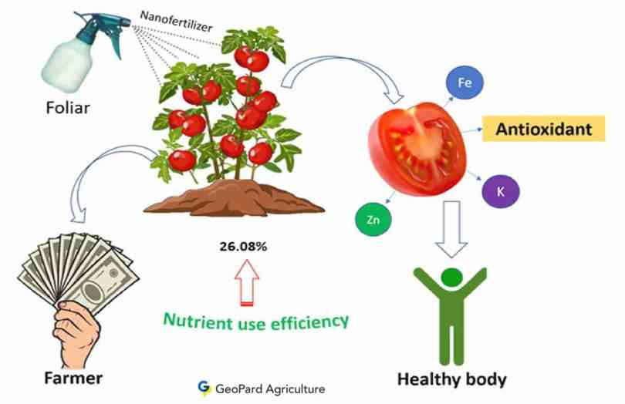

Figure 2 Nano-Carrier Smart Delivery Mechanisms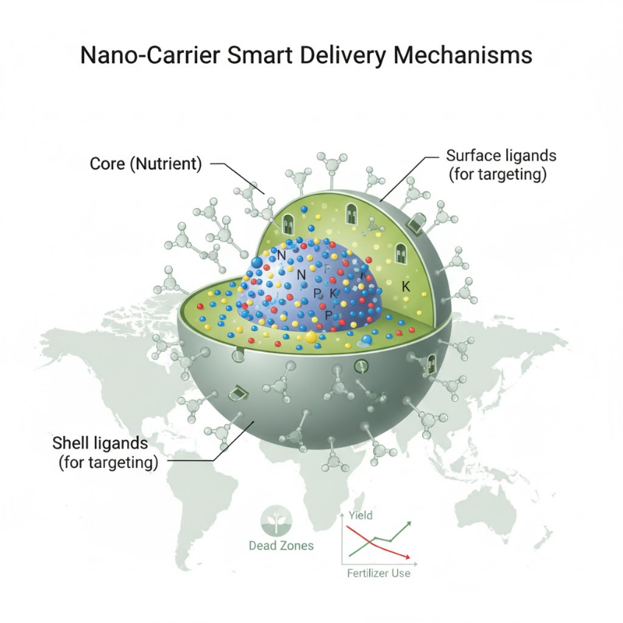
Figure 3 Foliar and Root Uptake Pathways

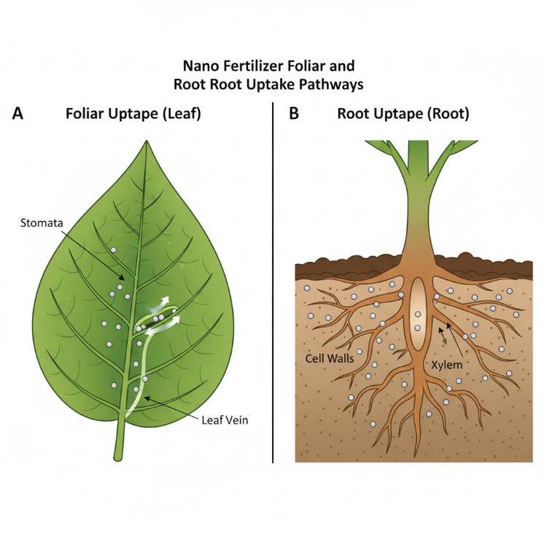

Figure 4 Stimuli-Responsive Nutrient Release Models
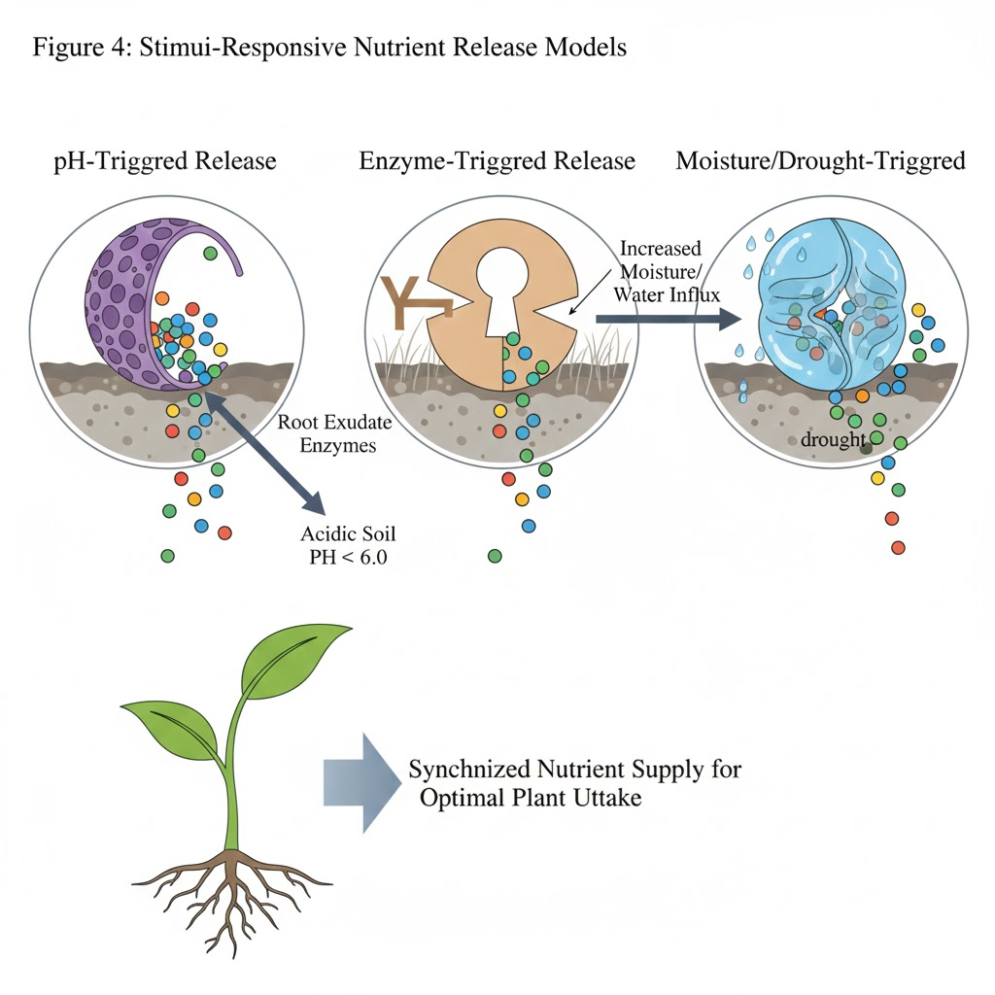

Figure 5 Impacts on Plant Stress Resilience
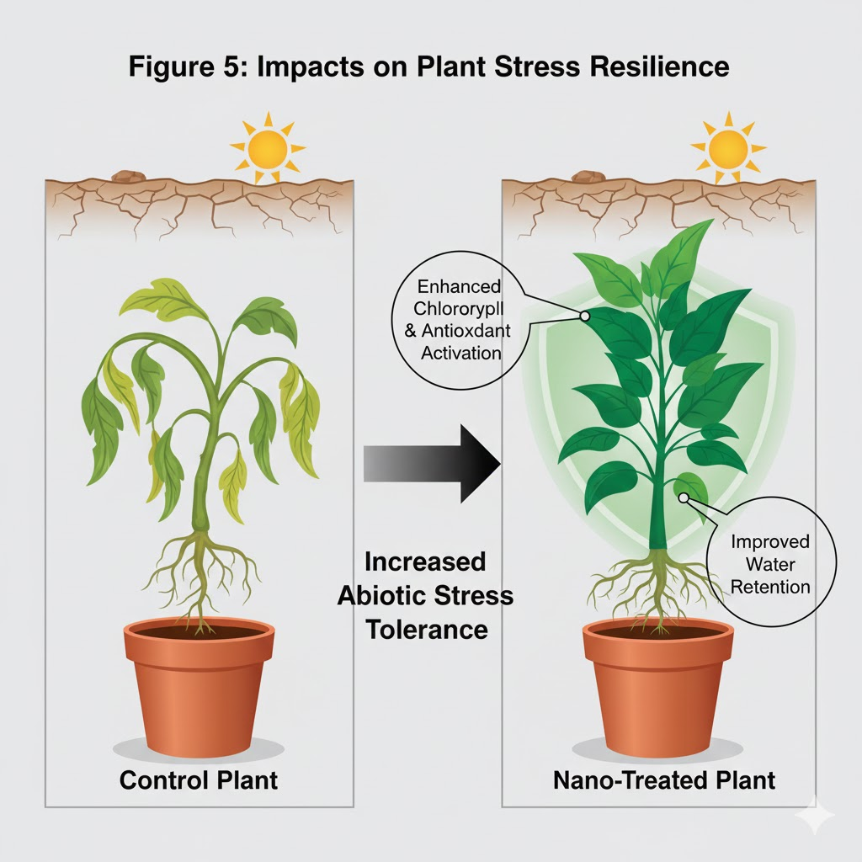

Figure 6 Nano-Input Environmental Life Cycle
