Soil Conservation Practices Enhancing Crop Productivity and Sustainable Farm Income Under Climate Stress

Abstract
India's agriculture, vital for 50% of its workforce and food security for 1.4 billion people, Agrapples with intensifying climate stress. Erratic monsoons, frequent droughts in rainfed areas covering 60% of arable land, and extreme events like cyclones in coastal states have slashed yields by 20-40% in states such as Maharashtra, Rajasthan, and Bihar. Soil degradation—erosion, nutrient depletion, and salinization—affects 120 million hectares, inflating input costs and eroding farm incomes, with smallholders losing up to 30% of net returns annually.
Soil conservation practices offer resilience. Contour bunding and terracing in the Deccan Plateau reduce runoff by 50%, enhancing water retention and boosting sorghum and pearl millet yields by 15-25%. No-till farming with residue retention, promoted under the National Mission for Sustainable Agriculture, preserves soil organic carbon, cutting fertilizer needs by 20% and increasing wheat productivity in Indo-Gangetic plains. Cover cropping with legumes like cowpea fixes nitrogen, suppresses weeds, and curbs erosion in black soils of Vidarbha. Agroforestry integrates trees like neem and gliricidia, providing fodder, fuelwood, and microclimate moderation, as seen in watershed projects doubling incomes in Madhya Pradesh.
Integrated strategies—rainwater harvesting via farm ponds and check dams, alongside balanced nutrient management—yield synergies. In Gujarat's Kachchh district, such interventions raised cotton yields by 30% and farm incomes by 40%. Economic analyses from ICRISAT trials show 20-35% ROI through reduced inputs and premium prices for sustainable produce.
Keywords: Soil conservation, Climate resilience, Crop productivity, Farm income, Rainfed agriculture, Watershed management
Introduction
Agriculture faces unprecedented challenges from climate change, including erratic rainfall, prolonged droughts, rising temperatures, and intensified extreme weather events. These stressors exacerbate soil degradation, a critical issue threatening global food security and farm livelihoods. Soil, often called the foundation of agriculture, is vital for crop productivity, water retention, nutrient cycling, and carbon sequestration. However, conventional farming practices—such as intensive tillage, monocropping, and chemical overuse—have accelerated erosion, compaction, salinization, and organic matter loss. In climate-stressed regions, these problems compound, leading to yield declines of up to 20-30% in vulnerable areas like sub-Saharan Africa and South Asia (Ullah et al., 2021).
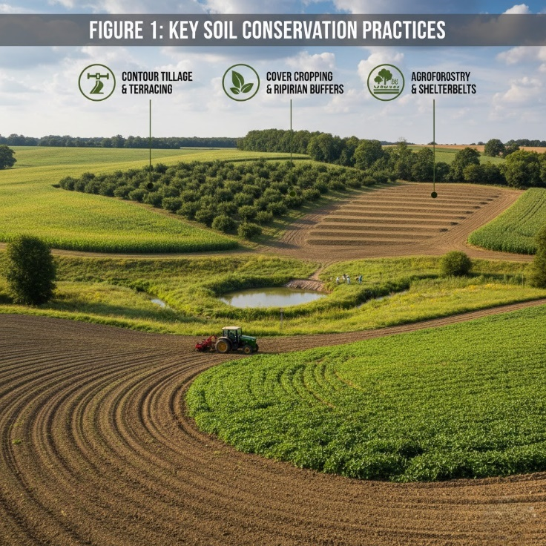
Soil conservation practices emerge as a beacon of resilience, offering multifaceted benefits that not only mitigate climate impacts but also enhance crop productivity and sustainable farm income. By preserving soil structure, these practices improve water infiltration, reduce runoff, and bolster nutrient availability, directly countering drought and flood effects. For instance, no-till farming minimizes disturbance, preserving soil microbes and organic matter, which can increase yields by 5-10% under variable climates. Similarly, cover cropping suppresses weeds, fixes nitrogen, and prevents erosion, fostering biodiversity that buffers against pests and diseases(Qiu et al., 2024).
The economic imperative is equally compelling. Degraded soils inflate input costs—fertilizers, irrigation, and pest control—eroding profit margins. Conservation strategies reverse this trend: studies show diversified systems like crop rotation can boost net farm income by 15-25% through reduced inputs and higher marketable yields. In the U.S. Corn Belt, adoption of conservation tillage has saved farmers billions in soil loss prevention, while in India, watershed projects integrating terracing and agroforestry have doubled farmer incomes in rainfed areas(Suresh, 2025).

Table 1. Climate stress + soil degradation

Climate stressor / driver | Soil impact | Farm/crop impact (examples)
Erratic monsoons | Runoff variability, erosion risk | Yield losses reported (20–40% in some states)
Frequent droughts (rainfed regions) | Low soil moisture, poor aggregation | Higher crop failure risk; rainfed vulnerability
Extreme events (e.g., cyclones in coastal states) | Erosion + salinization risks | Production shocks + income instability
Soil degradation (erosion, nutrient depletion, salinization) | Declining fertility and structure | Higher input costs; smallholders losing up to ~30% net returns

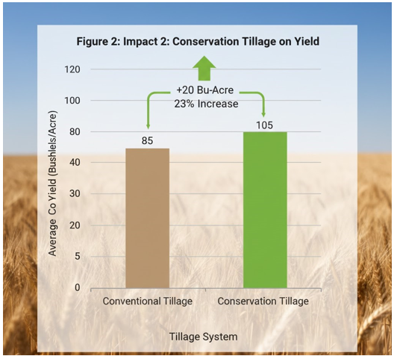

Understanding Climate Stress: Impacts on Agriculture and Soil Health
Climate stress, driven by global warming, manifests through a range of extreme weather patterns that profoundly disrupt agricultural systems and soil integrity. Erratic rainfall patterns lead to prolonged droughts in regions like the Mediterranean and parts of Australia, where water scarcity reduces soil moisture availability, impairing seed germination and root development. Conversely, intensified rainfall events cause flash floods, increasing surface runoff and accelerating soil erosion rates by up to 100 times the natural tolerance level in sloping farmlands. Rising temperatures exacerbate evapotranspiration, depleting soil water reserves and stressing crops during critical growth stages, resulting in yield reductions of 10-25% for staples like maize and wheat in tropical zones(Carr et al., 2021).
Soil health bears the brunt of these changes. Droughts compact soil pores, reducing infiltration capacity and promoting crusting, which hinders root penetration and microbial activity. Heatwaves diminish soil organic matter through accelerated decomposition, releasing stored carbon and diminishing the soil's nutrient-holding capacity. In saline-prone areas, such as coastal South Asia, sea-level rise and storm surges intrude saltwater, causing sodicity that disperses clay particles and destroys soil structure. Pests and diseases thrive under warmer conditions, further taxing soil biodiversity. Empirical data from the IPCC highlights that without adaptation, climate stress could slash global crop productivity by 2-6% per decade, with soil degradation amplifying losses in rainfed systems covering 80% of developing-world farms. These impacts cascade to food insecurity, particularly for smallholders reliant on marginal lands(Hultgren et al., 2025).
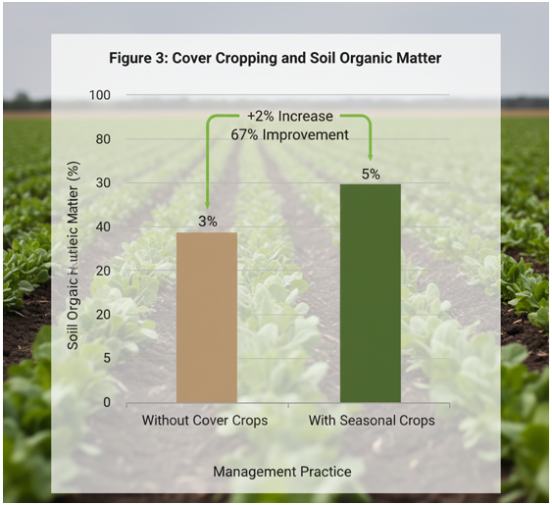

Core Principles of Soil Conservation: A Foundation for Resilience
Effective soil conservation rests on four interconnected principles that build resilience against climate stressors: minimizing soil disturbance, maintaining continuous soil cover, promoting plant diversity, and optimizing nutrient and water cycles. Minimizing disturbance preserves soil aggregates, the microscopic structures that enhance porosity, water retention, and aeration. Conventional plowing shatters these aggregates, exposing organic matter to rapid oxidation, whereas gentle management sustains them, boosting SOM levels by 0.5-1% annually(Sharma et al., 2024).
Continuous soil cover, via residues or living plants, shields against erosive rains and evaporative losses, reducing sediment yield by 50-90%. Diverse plantings foster belowground microbial communities, enhancing nutrient mineralization and suppressing pathogens through natural antagonisms. Integrated nutrient management recycles organics, minimizing synthetic inputs that acidify soils, while water stewardship captures and stores precipitation efficiently(Samanta & Sengupta, 2024).
These principles synergize: for example, residue retention in no-till systems not only curbs erosion but also moderates soil temperatures by 2-5°C, buffering heat stress. Grounded in soil science, they align with ecosystem services frameworks, ensuring long-term productivity. Adoption of these tenets can restore degraded soils within 3-5 years, as evidenced by long-term experiments showing 20-40% yield stability gains under variable climates(Mitchell et al., 2024).

Table 2. Core principles of soil conservation
Principle | What it means (simple) | Why it matters under climate stress
Minimize soil disturbance | Reduce intensive tillage/ploughing | Protects soil structure + microbes; reduces erosion
Maintain continuous soil cover | Keep residues / cover crops on soil | Cuts evaporation + splash erosion; buffers temperature
Promote plant diversity | Rotations, mixed systems | Breaks pest cycles; improves nutrient cycling
Optimize nutrient + water cycles | INM + water harvesting + efficient use | Stabilizes yields and reduces input losses

Key Soil Conservation Practices: An Overview
Soil conservation practices encompass a suite of techniques tailored to local topography, climate, and crops, integrating mechanical, biological, and chemical measures. They range from tillage modifications and vegetative barriers to precision nutrient applications and water harvesting. Tillage management forms the bedrock, transitioning from inversion plowing to conservation methods. Cover cropping deploys off-season plants to protect and enrich soil, while crop rotation disrupts pest cycles and replenishes nutrients. Agroforestry integrates trees for windbreaks and microclimate regulation, and integrated strategies like rainwater harvesting augment water security(Çokkızgın et al., 2025).
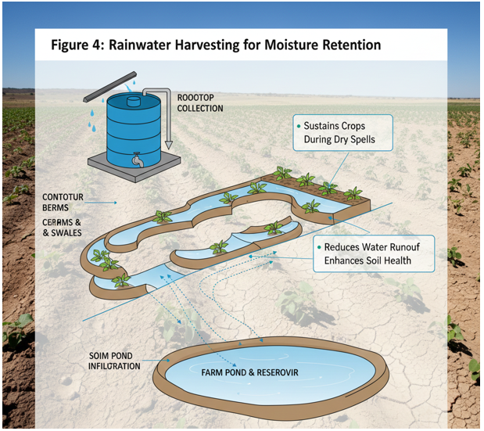

These practices are not standalone; their efficacy amplifies through combinations. For instance, pairing no-till with cover crops can cut erosion by 95% and increase water infiltration threefold. Selection criteria include site-specific factors: steep slopes favor terracing, arid zones prioritize mulching, and fertile plains benefit from rotations. Globally, programs like the UN's Decade on Ecosystem Restoration promote scaling, with meta-analyses confirming 15-30% average productivity uplifts. This overview sets the stage for detailed examination of tillage innovations(Khan & Wang, 2023).

Tillage Management: Reducing Soil Soil Erosion and Improving Structure
Conventional tillage, involving repeated moldboard plowing, exposes soil to wind and water erosion, disaggregating structure and oxidizing SOM at rates 5-10 times higher than natural. In the U.S. Midwest, this has historically lost topsoil at 1-2 tons per acre annually, halving productive depth over decades. Conservation tillage counters this by limiting inversion to <15 cm depth, preserving residue cover that dissipates raindrop energy and slows overland flow(Xing et al., 2025).

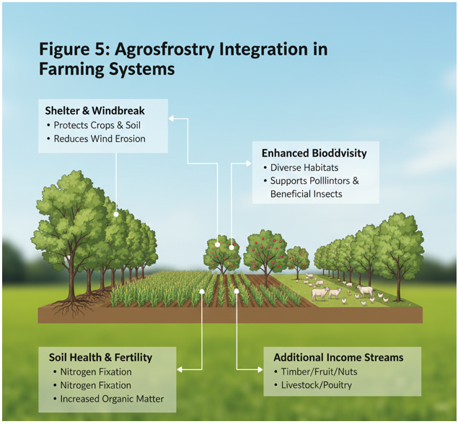

No-Till and Reduced Tillage Systems
No-till farming eliminates plowing entirely, planting directly into undisturbed residue blankets. This stratifies SOM near the surface, enhancing earthworm activity and fungal hyphae that bind aggregates, improving water-holding capacity by 10-20%. Under climate stress, no-till excels: residues insulate against frost heaving and retain moisture during dry spells, yielding 5-15% higher in drought years per FAO trials. Microbial diversity surges, with glomalin—a glycoprotein—stabilizing structure against compaction from heavy machinery. Reduced tillage, a stepping stone, employs chisel plows or disks for partial incorporation, balancing weed control with benefits. Brazilian Cerrado adoption has restored 50 million hectares, boosting soybean yields 20% while sequestering 0.3-0.5 t C/ha/year (Oliveira et al., 2023).
Table 3. Major soil conservation practices (what–where–why)
Practice | How it works (mechanism) | Best suited for | Primary benefits
Contour bunding / terracing | Slows runoff; traps soil + water | Sloping/undulating lands | Better water retention; less erosion
No-till + residue retention | Minimal soil disturbance; residue cover | Indo-Gangetic plains; cereals | Soil C protection; lower fertilizer need
Cover cropping (e.g., legumes like cowpea) | Adds biomass; N fixation; soil cover | Black soils; rainfed areas | Less erosion; weed suppression; fertility gain
Agroforestry | Trees + crops; microclimate moderation | Watersheds/rainfed systems | Fodder/fuelwood + resilience + income diversification
Rainwater harvesting (farm ponds/check dams) | Captures runoff; improves recharge | Dry/rainfed districts | More irrigation reliability; yield stability
Balanced nutrient management / INM | Combines organics + fertilizers efficiently | Most cropping systems | Lower costs; sustained productivity

Contour Plowing and Terracing
On slopes >5%, contour plowing aligns furrows perpendicular to the fall line, creating micro-dams that trap water and sediment. Runoff velocity drops 50-70%, erosion by 65%, per USDA data, allowing infiltration and root access. Ideal for row crops like corn on 2-8% gradients, it pairs with strip cropping for added stability(Mohanty et al., 2024).
Terracing constructs earthen or stone embankments into level benches, radically slowing flow on steeper >15% slopes. Bench terracing suits permanent crops like orchards, while narrow Vietnamese rice terraces exemplify integration with rice paddies. Construction demands labor but amortizes via 30-50% erosion cuts and 20% yield gains(Mohanty et al., 2024).
Cover Cropping: Benefits for Soil Fertility, Moisture, and Biodiversity
Cover cropping involves planting non-cash crops during off-seasons or interrows to protect and enrich soil. These living mulches, such as legumes (clover, vetch) or grasses (rye, oats), suppress weeds through competition, preventing erosion by anchoring soil with dense root systems. Leguminous covers fix atmospheric nitrogen at rates of 50-200 kg/ha/year, reducing fertilizer needs by 30-50% while enhancing soil organic matter through residue decomposition. This boosts fertility, with studies showing 10-20% increases in microbial biomass carbon(Akchaya et al., 2025).
Moisture retention improves as cover roots create macropores for infiltration, increasing water-holding capacity by 15-25%. In arid regions, they reduce evaporation by shading soil, conserving up to 100 mm of water annually. Biodiversity flourishes: covers harbor beneficial insects, nematodes, and fungi, disrupting pest cycles and promoting pollinators. Terminating covers via rolling or crimping recycles nutrients without tillage disruption, synergizing with no-till for compounded benefits like 20-30% erosion reduction(Seepaul et al., 2023).

Crop Rotation and Diversification: Enhancing Soil Health and Pest Management
Crop rotation sequences diverse species—grains, legumes, brassicas, roots—to break pest and disease cycles, unlike monocultures that deplete specific nutrients and foster pathogens. Rotating corn-soybean-wheat, for instance, cuts nematode populations by 70% and boosts yields 10-15% via improved nutrient availability. Deep-rooted crops like alfalfa mine subsoil nutrients, recycling them upward, while shallow-rooted ones prevent leaching(Yang et al., 2024).

Agroforestry and Shelterbelts: Protecting Soil and Microclimates
Agroforestry integrates trees with crops or livestock, creating alley cropping, silvopasture, or windbreaks. Shelterbelts—linear tree rows—reduce wind speeds by 40-60%, slashing wind erosion by 50-80% on exposed plains. Trees intercept raindrops, moderating temperature extremes by 3-5°C and increasing humidity for frost protection(Workman et al., 1969).
Belowground, tree roots stabilize slopes, preventing landslides, while mycorrhizal networks share water and nutrients with crops. Leaf litter adds 2-4 t/ha/year of organic matter, enhancing fertility. In semi-arid Sahel, farmer-managed agroforestry has tripled millet yields by improving microclimates. Biodiversity surges with habitats for birds and predators, naturally controlling pests. Economically, it diversifies income via timber or fruits, with carbon sequestration of 1-5 t/ha/year as a bonus(Sietz et al., 2022).

Integrated Nutrient Management: Sustaining Soil Productivity
Integrated nutrient management balances organic (manures, composts) and inorganic fertilizers with crop needs, guided by soil tests. Organics improve structure and biology, buffering pH and releasing nutrients slowly—compost adds 20-50 kg N/ha while building SOM. Precision placement, like banding, cuts losses by 30%, minimizing acidification from excess urea(Snapp et al., 2023).
Legume rotations and cover crops supply 20-40% of N needs. Biofertilizers (mycorrhizae, rhizobia) enhance uptake by 15-25%. In India’s rice-wheat systems, INM has sustained yields while reducing inputs 20-30%, preserving groundwater from nitrate pollution. Monitoring via leaf analysis ensures efficiency, fostering long-term productivity without degradation(Kumar et al., 2025).

Water Management Strategies: Efficient Use and Conservation

Rainwater Harvesting
Rainwater harvesting captures runoff in ponds, check dams, or contour bunds, recharging aquifers and providing irrigation. In watersheds, it boosts groundwater 20-50%, supporting dry-season crops. Micro-harvesting like zai pits (small planting basins) in Burkina Faso doubles sorghum yields by concentrating water and organics(Searchinger et al., 2014).
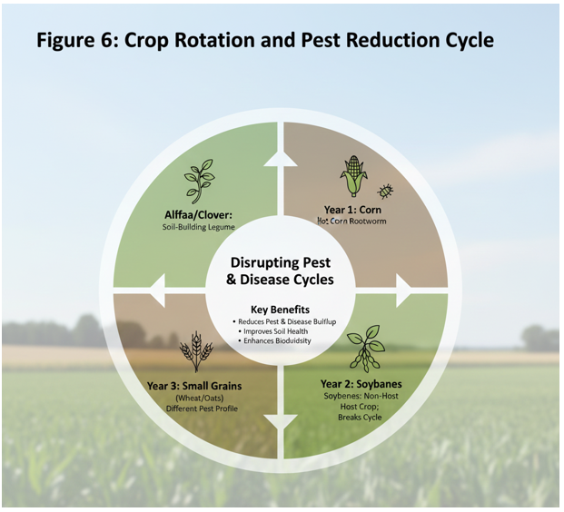

Efficient Irrigation Techniques
Drip and sprinkler systems deliver water precisely, saving 40-70% over flood methods by minimizing evaporation and runoff. Subsurface drip targets roots, reducing weed growth. Scheduling via tensiometers matches evapotranspiration, preventing overwatering. In Israel’s arid farms, these yield 20-30% more per cubic meter. Mulching complements by cutting losses 50%. Integrated with conservation tillage, they enhance infiltration, synergizing for resilient systems(Xing & Wang, 2024).
Impact of Soil Conservation on Crop Productivity: Case Studies and Evidence
Soil conservation practices have demonstrably enhanced crop productivity across diverse agroecological zones, as evidenced by numerous case studies. In the U.S. Corn Belt, long-term adoption of no-till farming combined with cover cropping has increased corn and soybean yields by 10-20% over two decades, according to data from the Conservation Technology Information Center. These gains stem from improved soil structure, which enhances root penetration and nutrient uptake, particularly under variable rainfall. A study in Iowa fields showed that continuous no-till reduced soil erosion from 12 t/ha/year to under 1 t/ha/year, correlating with a 15% yield stability improvement during droughts(CM et al., 2015).
In sub-Saharan Africa, farmer-managed natural regeneration in Niger's Maradi region exemplifies agroforestry's impact. Since the 1980s, over 5 million hectares have been regenerated with native trees, tripling millet and sorghum yields from 300-400 kg/ha to over 1,200 kg/ha. This success, documented by the World Agroforestry Centre, arises from enhanced microclimates, reduced wind erosion, and nutrient cycling via tree leaf litter adding 3-5 t/ha/year of organic matter. Similarly, in India's semi-arid Deccan Plateau, watershed-based conservation including contour bunds and zai pits has boosted pearl millet productivity by 50-100%, with groundwater recharge supporting an extra cropping cycle annually(Zemadim et al., 2020).
Table 4. Reported outcomes (yield, inputs, income)
Intervention / package | Reported biophysical effect | Reported productivity/income effect
Contour bunding + terracing (Deccan Plateau) | Runoff reduced ~50% | Sorghum/pearl millet yields +15–25%
No-till + residue retention | Soil organic carbon conserved | Fertilizer needs −20%; wheat productivity increased
Integrated interventions (Kachchh: rainwater harvesting + nutrient management) | Improved water availability + nutrient use | Cotton yields +30%; farm income +40%
Watershed + agroforestry examples | Better microclimate + diversified outputs | Income doubling reported in some watershed projects
Economic results (ICRISAT trials) | Reduced inputs + premium sustainable produce | ~20–35% ROI (reported)

In Brazil's Cerrado, zero-tillage soy systems have sustained yields at 3-4 t/ha despite expansion onto marginal lands, cutting production costs and erosion by 90%. These cases underscore a common thread: conservation builds soil resilience, yielding 20-50% higher outputs under stress compared to conventional methods. Meta-analyses, such as those from the UN Food and Agriculture Organization, confirm global yield uplifts of 5-15% on average, with greater benefits in rainfed systems vulnerable to climate volatility.
Case Studies on Soil Conservation in India Within the Indian subcontinent, in situ conservation measures have notably enhanced crop yields by 200–1000 kg/ha, simultaneously reducing cultivation costs and boosting farmer incomes by US$10–200/ha/year (Anantha et al., 2021). These practices, such as residue management and reduced tillage, have been shown to improve soil structure and water retention, leading to increased agricultural output and economic benefits for farmers (Xing et al., 2025). Furthermore, conservation agriculture practices, including minimal tillage, permanent soil cover, and diversified crop rotations, have increased soil health by an average of 21% while maintaining or increasing crop productivity even under challenging climatic conditions (Suresh, 2025). Specifically, the adoption of conservation agriculture has resulted in significant improvements in soil organic matter content and water-holding capacity, which are crucial for sustaining agricultural productivity in regions prone to drought and land degradation (Sharma et al., 2024). For instance, in the Indo-Gangetic Plains, conservation agriculture has led to significant improvements in soil health, organic carbon content, and crop productivity (Suresh, 2025). Indigenous practices such as contour bunding and terracing in the Himalayan foothills and semi-arid regions have shown similar benefits, effectively curbing topsoil loss and runoff to ensure more stable and sustainable crop yields (Suresh, 2025). Such traditional methods, when integrated with modern conservation agriculture techniques, have demonstrated the capacity to elevate land productivity by 20–30% compared to plots lacking these interventions(Xing & Wang, 2024).
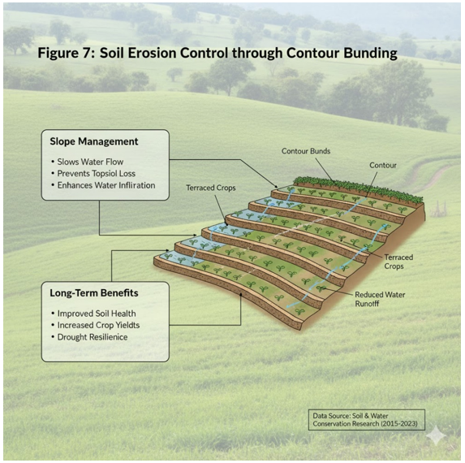
Further, intensive silvi-pasture systems, particularly those integrating mulberry and Calliandra in tropical regions with high rainfall, demonstrate the potential for enhanced dry fodder and crude protein yields for ruminants, alongside significant carbon sequestration benefits and improved soil carbon stocks (Handa et al., 2019). The combined impact of these measures often leads to improved overall farm profitability and resilience, with studies indicating that soil and water conservation measures can increase crop yields while also accentuating input costs by INR 1689–2847 per hectare during the rabi cropping season (Choudhary et al., 2022). However, despite these increased input costs, the substantial boost in net revenue affirms the financial viability and significant improvement in farm performance for adopters of these soil and water conservation measures (Choudhary et al., 2022). Moreover, the implementation of contour cultivation combined with conservation furrows has consistently resulted in significant yield increases for various crops, such as maize, soybean, and groundnut, across different districts of Karnataka, with reported improvements ranging from 16% to 24% (“Soil and Water Conservation for Optimizing Productivity and Improving Livelihoods in Rainfed Areas,” 2011). These integrated practices not only enhance crop yields but also bolster the overall resilience of agricultural systems against environmental stressors (“Harnessing Dividends from Drylands: Innovative Scaling up with Soil Nutrients,” 2016). Moreover, broader global evidence suggests that such integrated soil and water conservation measures, including contour bunding and agroforestry, consistently improve crop productivity and farm income, particularly in rainfed systems prone to water scarcity (Choudhary et al., 2022). Agroforestry systems, in particular, play a crucial role by enhancing soil stability, preventing erosion through diverse mechanisms, and significantly contributing to livelihood improvement for tribal farmers through increased land productivity and diversified income streams (Akter et al., 2022). For example, in Gujarat, an agroforestry system integrating cow-pea, castor, and sapota resulted in a 37.7% reduction in total soil loss and an 81.9% increase in system productivity compared to monoculture tree plantations (Jinger et al., 2024).
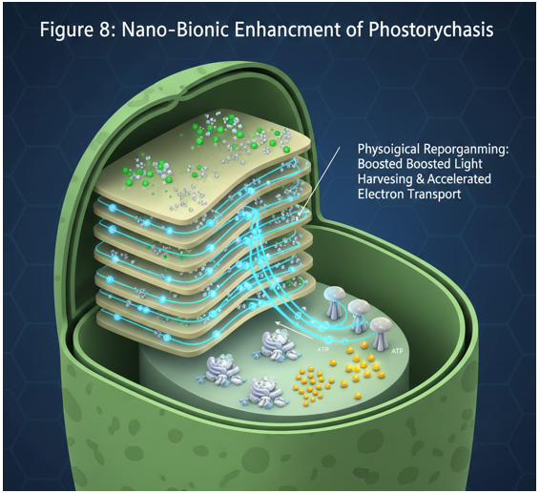
These systems effectively hold the soil layer firmly, reducing soil loss during heavy rainfall and increasing water percolation, thereby improving crop productivity by 15–25% for rabi season crops fed by stored water (Choudhary et al., 2022). Integrated agroforestry systems, which involve the compatible association of trees with seasonal crops, not only improve per unit production and soil quality but also enhance soil carbon storage and water productivity, ultimately increasing economic returns for farmers (Rathore et al., 2022). This multifaceted approach also offers substantial ecological benefits by fostering biodiversity, mitigating climate change effects through enhanced carbon sequestration, and improving water quality within agricultural landscapes (Chandel et al., 2024). Specifically, these systems have been shown to increase species richness by up to 40% and significantly improve carbon sequestration compared to conventional monoculture practices (Suresh, 2025). Furthermore, the strategic integration of diverse tree species within agroforestry designs can establish microclimates conducive to enhanced crop growth and reduced evapotranspiration, thereby optimizing water use efficiency (Arshad et al., 2024). The incorporation of leguminous cover crops and nitrogen-fixing tree species further augments soil fertility, reducing the need for synthetic fertilizers and enhancing overall ecosystem health within these integrated systems (Akter et al., 2022; Jinger et al., 2024). This complex interplay of benefits underscores the critical role of agroforestry in sustainable land management, offering a holistic solution to environmental degradation and economic instability in agricultural regions (Roghan et al., 2024; Thakur & Kumar, 2017). Specifically, the deep root systems of trees within agroforestry configurations enhance water absorption and foster beneficial microorganisms, enriching soil nutrient content and promoting overall soil health (Barrios et al., 2017; Roghan et al., 2024). Agroforestry reduces runoff, intercepts rainfall, and binds soil particles together, thereby controlling erosion and increasing overall soil stability (Fahad et al., 2022). These systems also contribute significantly to carbon sequestration, with quantitative assessments highlighting their potential in mitigating climate change (Comolli et al., 2024). Beyond carbon sequestration, agroforestry enhances several other ecosystem services, including improvements in soil quality, water conservation by slowing surface runoff, and increased biodiversity by providing habitat for wildlife (Imoro et al., 2021).
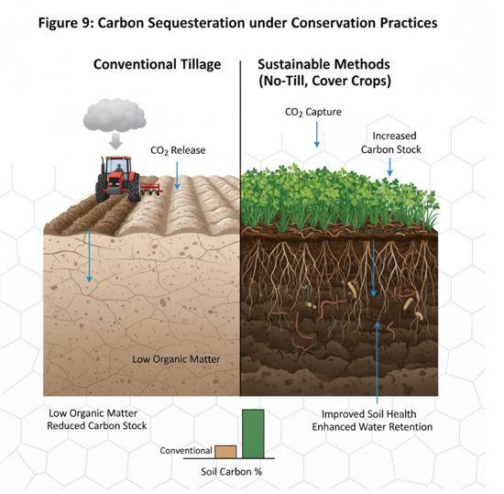
This integration of trees and diverse plant species creates complex trophic interactions, supporting a wider array of flora and fauna, including pollinators and pest predators, which further enhance ecosystem functions and agricultural resilience (Diyaolu & Folarin, 2024). Such systems also enhance wildlife habitats, foster natural food webs, and improve water infiltration, contributing to overall ecosystem health and long-term carbon sequestration while simultaneously decreasing CO2 emissions (Stavi & Lal, 2012). The strategic adoption of agroforestry systems not only mitigates greenhouse gas emissions but also bolsters climate resilience in agriculture through enhanced carbon sequestration in biomass and soils (Singh et al., 2024). This integration of trees with crops or livestock, a practice known as agroforestry, offers a robust framework for sustainable land management by improving soil health, optimizing nutrient cycling, and enhancing biodiversity (Ashraf et al., 2025; Feng & Sunderland, 2023; Sharma et al., 2024). Moreover, agroforestry practices are recognized for their role in buffering extreme weather events and improving water retention, thereby increasing the adaptive capacity of agricultural systems to climate variability (Singh et al., 2024).
Table 5. Monitoring indicators for a soil conservation program
Indicator | What it tells you | Simple field/record method | Suggested timing
Soil organic carbon (SOC) / organic matter | Soil health + long-term fertility | Soil test (lab) | 1× per year (same season)
Infiltration / water holding | Drought resilience | Ring infiltrometer / field observation | Pre-monsoon + post-monsoon
Visible erosion / sediment movement | Erosion control success | Transects, photo points | After heavy rains
Input use (fertilizer, irrigation, fuel) | Cost + efficiency | Farm records | Every season
Yield and yield stability | Productivity impact | Harvest records | Every season (≥3 years best)
Net income / ROI | Economic viability | Cost–return sheet | Every season/year

Economic Benefits of Sustainable Practices: Boosting Farm Income
Sustainable soil conservation not only safeguards productivity but also delivers substantial economic returns, often with payback periods under 3-5 years. Cost savings are primary: no-till reduces fuel and labor by 40-60%, equating to $50-100/ha annually in machinery savings, per U.S. Department of Agriculture estimates. Cover crops, despite initial seeding costs of $20-40/ha, cut fertilizer expenses by 30-50% through nitrogen fixation, yielding net gains of $100-200/ha in high-value rotations (Wallander et al., 2021).

Policy and Farmer Adoption: Overcoming Barriers to Implementation
Despite proven advantages, adoption lags at 20-30% in many regions due to barriers like upfront costs, knowledge gaps, and risk aversion. Policies addressing these—subsidies, extension services, and incentives—have accelerated uptake. The U.S. Conservation Reserve Program, paying farmers to retire erosion-prone land, has enrolled 14 million hectares, yielding $2 billion in annual environmental benefits alongside farm payments (Tanentzap et al., 2015).
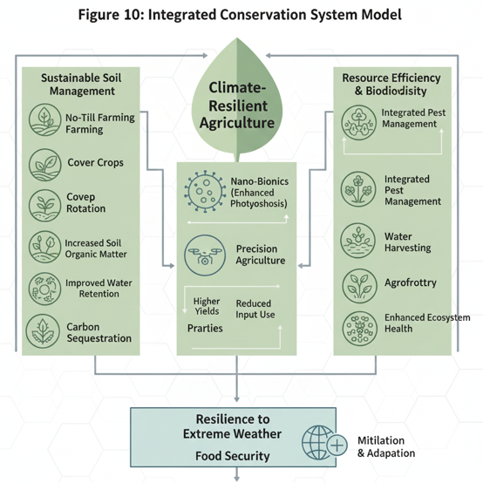

Monitoring and Evaluation: Assessing the Effectiveness of Conservation Efforts
Robust monitoring ensures conservation delivers on promises, employing soil tests, remote sensing, and yield tracking. Soil health cards, assessing SOM, pH, and biology, guide adaptive management; in India, they've optimized inputs for 20% efficiency gains. Satellite imagery via NDVI indices detects cover crop coverage and erosion hotspots, with platforms like NASA's MODIS enabling farm-level insights (Süzer et al., 2024).
Conclusion
Embracing conservation agriculture is imperative for resilient food systems. By building soil health, enhancing productivity, and securing livelihoods, it paves the way for sustainable global food security, demanding urgent policy support, innovation, and farmer empowerment to meet rising demands without compromising our planet's vital resources.

References
Akchaya, K., Parasuraman, P., Kannan, P., Vijayakumar, S., Thirukumaran, K., Mustaffa, M. R. A. F., Rajpoot, S. K., & Choudhary, A. K. (2025). Boosting resource use efficiency, soil fertility, food security, ecosystem services, and climate resilience with legume intercropping: a review [Review of Boosting resource use efficiency, soil fertility, food security, ecosystem services, and climate resilience with legume intercropping: a review]. Frontiers in Sustainable Food Systems, 9. Frontiers Media. https://doi.org/10.3389/fsufs.2025.1527256
Akter, R., Hasan, M. K., Kabir, K. H., Darr, D., & Roshni, N. A. (2022). Agroforestry systems and their impact on livelihood improvement of tribal farmers in a tropical moist deciduous forest in Bangladesh. Trees Forests and People, 9, 100315. https://doi.org/10.1016/j.tfp.2022.100315
Anantha, K. H., Garg, K. K., Barron, J., Dixit, S., Venkataradha, A., Singh, R., & Whitbread, A. (2021). Impact of best management practices on sustainable crop production and climate resilience in smallholder farming systems of South Asia. Agricultural Systems, 194, 103276. https://doi.org/10.1016/j.agsy.2021.103276
Arshad, M., Rouf, S., Abbas, R. N., Shahbaz, Z., Aleem, K. F., Shahbaz, H., Pervaiz, R., Sarwar, A., & Rehman, H. U. (2024). Navigating Synergies: A Comprehensive Review of Agroforestry System and Agronomy Crops [Review of Navigating Synergies: A Comprehensive Review of Agroforestry System and Agronomy Crops]. Haya The Saudi Journal of Life Sciences, 9(4), 97. https://doi.org/10.36348/sjls.2024.v09i04.003
Ashraf, S. M. K., Ripta, S. K., Rana, Md. T., & Islam, K. K. (2025). Biochar enhanced agroforestry systems for carbon sequestration, soil health and climate resilience. Discover Forests, 1(1). https://doi.org/10.1007/s44415-025-00057-6
Barrios, E., Valencia, V., Jonsson, M., Brauman, A., Hairiah, K., Mortimer, P. E., & Okubo, S. (2017). Contribution of trees to the conservation of biodiversity and ecosystem services in agricultural landscapes. International Journal of Biodiversity Science Ecosystems Services & Management, 14(1), 1. https://doi.org/10.1080/21513732.2017.1399167
Carr, T. W., Balkovič, J., Dodds, P. E., Folberth, C., & Skalský, R. (2021). The impact of water erosion on global maize and wheat productivity. Agriculture Ecosystems & Environment, 322, 107655. https://doi.org/10.1016/j.agee.2021.107655
Chandel, N., Kumar, A., & Kumar, R. (2024). Towards Sustainable Agriculture: Integrating Agronomic Practices, Environmental Physiology and Plant Nutrition. International Journal of Plant & Soil Science, 36(6), 492. https://doi.org/10.9734/ijpss/2024/v36i64651
Choudhary, B. B., Dev, I., Singh, P., Singh, R., Sharma, P., Chand, K., Garg, K. K., Anantha, K. H., Akuraju, V., Dixit, S., Kumar, S., Ram, A., & Kumar, N. (2022). Impact of soil and water conservation measures on farm productivity and income in the semi-arid tropics of Bundelkhand, central India. Environmental Conservation, 49(4), 263. https://doi.org/10.1017/s0376892922000352
CM, G., Amélie, N, T., Tor, P, K., Alan, Ken, J., Cristina, T., C, M., Ralph, & William, D. (2015). Increasing Crop Diversity Mitigates Weather Variations and Improves Yield Stability. PLoS ONE, 10(2). https://doi.org/10.1371/journal.pone.0113261
Çokkızgın, H., Çokkızgın, A., & Girgel, Ü. (2025). REDUCING THE CARBON FOOTPRINT OF FIELD CROPS: A COMPREHENSIVE REVIEW OF STRATEGIES AND INNOVATIONS [Review of REDUCING THE CARBON FOOTPRINT OF FIELD CROPS: A COMPREHENSIVE REVIEW OF STRATEGIES AND INNOVATIONS]. Applied Ecology and Environmental Research, 23(4), 7641. Hungarian University of Agriculture and Life Sciences. https://doi.org/10.15666/aeer/2304_76417661
Comolli, L. R., Schegg, E., Infuleski, C., Fassola, H. E., Wallis, A. V., Barth, S. R., Bulfe, N. M. L., Gauchat, M. E., Munareto, N., & Wyss, F. (2024). A Sustainable Integrated Agroforestry System. Research Square (Research Square). https://doi.org/10.21203/rs.3.rs-4333865/v1
Diyaolu, C. O., & Folarin, I. O. (2024). The Role of Biodiversity in Agricultural Resilience: Protecting Ecosystem Services for Sustainable Food Production. International Journal of Research Publication and Reviews, 5(10), 1560. https://doi.org/10.55248/gengpi.5.1024.2741
Fahad, S., Chavan, S. B., Chichaghare, A. R., Uthappa, A. R., Kumar, M., Kakade, V., Pradhan, A., Jinger, D., Rawale, G., Yadav, D. K., Kumar, V., Farooq, T. H., Ali, B., Sawant, A. V., Saud, S., Chen, S., & Poczai, P. (2022). Agroforestry Systems for Soil Health Improvement and Maintenance. Sustainability, 14(22), 14877. https://doi.org/10.3390/su142214877
Feng, Y., & Sunderland, T. (2023). Feasibility of Tea/Tree Intercropping Plantations on Soil Ecological Service Function in China. Agronomy, 13(6), 1548. https://doi.org/10.3390/agronomy13061548
Handa, A. K., Dev, I., Rizvi, R. H., Kumar, N., Ram, A., Kumar, D., Kumar, A., Bhaskar, S., Dhyani, S. K., & Rizvi, J. (2019). Successful Agroforestry Models for Different Agro-Ecological Regions in India. https://krishi.icar.gov.in/jspui/bitstream/123456789/67704/1/1%202019%20ICRAFBook_%20Successful%20Agroforestry%20models%20for%20different%20agro-ecological%20regions%20in%20India-1-3.pdf
Harnessing dividends from drylands: innovative scaling up with soil nutrients. (2016). In CABI eBooks. https://doi.org/10.1079/9781780648156.0000
Hultgren, A., Carleton, T., Delgado, M., Gergel, D. R., Greenstone, M., Houser, T., Hsiang, S., Jina, A., Kopp, R. E., Malevich, S. B., McCusker, K. E., Mayer, T., Nath, I., Rising, J., Rode, A., & Yuan, J. (2025). Impacts of climate change on global agriculture accounting for adaptation. Nature, 642(8068), 644. https://doi.org/10.1038/s41586-025-09085-w
Imoro, Z. A., Imoro, A. Z., Duwiejuah, A. B., & Abukari, A. (2021). Harnessing Indigenous Technologies for Sustainable Management of Land, Water, and Food Resources Amidst Climate Change. Frontiers in Sustainable Food Systems, 5. https://doi.org/10.3389/fsufs.2021.691603
Jinger, D., N, N. K., Sirohi, C., Verma, A., Panwar, P., & Kaushal, R. (2024). Perspective Chapter: Agroforestry Strategies for Integrated Soil and Water Conservation. In IntechOpen eBooks. IntechOpen. https://doi.org/10.5772/intechopen.1005772
Khan, W., & Wang, G. (2023). Conservation Tillage: A Sustainable Approach for Carbon Sequestration and Soil Preservation. A Review [Review of Conservation Tillage: A Sustainable Approach for Carbon Sequestration and Soil Preservation. A Review]. Journal of Agriculture Sustainability and Environment, 2(1), 1. Global Society of Scientific Research and Researchers. https://doi.org/10.56556/jase.v2i1.770
Kumar, S., Bhatia, A., Drewer, J., Rees, R. M., Sharma, S., Kumar, V., Tomer, R., Rahman, M., & Sutton, M. A. (2025). Mitigating ammonium and nitrate leaching in rice-wheat crop rotation: efficacy of neem coated urea and compost co-application. Frontiers in Environmental Science, 13. https://doi.org/10.3389/fenvs.2025.1656231
Kumareswaran, K., & Jayasinghe, G. Y. (2022). Systematic review on ensuring the global food security and covid-19 pandemic resilient food systems: towards accomplishing sustainable development goals targets [Review of Systematic review on ensuring the global food security and covid-19 pandemic resilient food systems: towards accomplishing sustainable development goals targets]. Discover Sustainability, 3(1). Springer Nature. https://doi.org/10.1007/s43621-022-00096-5
Mitchell, J. P., Cappellazzi, S. B., Schmidt, R., Chiartas, J., Shrestha, A., Reicosky, D. C., Ferris, H., Zhang, X., Ghezzehei, T. A., Araya, S. N., Kelly, C., Fonte, S. J., Light, S. E., Liles, G. C., Willey, T., Roy, R., Bottens, M., Crum, C. W., Horwáth, W. R., … Scow, K. M. (2024). No-tillage, surface residue retention, and cover crops improved San Joaquin Valley soil health in the long term. California Agriculture, 78(2). https://doi.org/10.3733/001c.94714
Mohanty, L. K., Singh, N. K., Raj, P., Prakash, A., Tiwari, A. K., Singh, V., & Sachan, P. (2024). Nurturing Crops, Enhancing Soil Health, and Sustaining Agricultural Prosperity Worldwide through Agronomy. Journal of Experimental Agriculture International, 46(2), 46. https://doi.org/10.9734/jeai/2024/v46i22308
Oliveira, D. M. da S., Tavares, R. L. M., Loss, A., Madari, B. E., Cerri, C. E. P., Alves, B. J. R., Pereira, M. G., & Cherubin, M. R. (2023). Climate-smart agriculture and soil C sequestration in Brazilian Cerrado: a systematic review [Review of Climate-smart agriculture and soil C sequestration in Brazilian Cerrado: a systematic review]. Revista Brasileira de Ciência Do Solo, 47. Sociedade Brasileira de Ciência do Solo. https://doi.org/10.36783/18069657rbcs20220055
Qiu, T., Shi, Y., Peñuelas, J., Liu, J., Cui, Q., Sardans, J., Zhou, F., Xia, L., Yan, W., Zhao, S., Peng, S., Jian, J., He, Q., Zhang, W., Huang, M., Tan, W., & Fang, L. (2024). Optimizing cover crop practices as a sustainable solution for global agroecosystem services. Nature Communications, 15(1), 10617. https://doi.org/10.1038/s41467-024-54536-z
Rathore, S. S., Babu, S., El‐Sappah, A. H., Shekhawat, K., Singh, V. K., Singh, R. K., Upadhyay, P. K., & Singh, R. (2022). Integrated agroforestry systems improve soil carbon storage, water productivity, and economic returns in the marginal land of the semi-arid region. Saudi Journal of Biological Sciences, 29(10), 103427. https://doi.org/10.1016/j.sjbs.2022.103427
Roghan, H. B., Murugesh, M. G., SEKAR, I., Suganya, K., Hemaprabha, K., Kiruba, M., Tilak, M., Ramesh, K., Vaiyapuri, K., Sivakumar, B., & Kumar, P. (2024). THE CURRENT ROLE AND IMPORTANCE OF AGROFORESTRY – A REVIEW ARTICLE [Review of THE CURRENT ROLE AND IMPORTANCE OF AGROFORESTRY – A REVIEW ARTICLE]. Applied Ecology and Environmental Research, 22(5), 3907. Hungarian University of Agriculture and Life Sciences. https://doi.org/10.15666/aeer/2205_39073918
Samanta, S., & Sengupta, S. (2024). Integrated nutrient management (INM) in sustainable plant nutrition. International Journal of Agriculture and Food Science, 6(2), 128. https://doi.org/10.33545/2664844x.2024.v6.i2b.216
Searchinger, T., Hanson, C., Ranganathan, J., Lipinski, B., Waite, R., Winterbottom, R., Dinshaw, A., Heimlich, R. E., Boval, M., Chemineau, P., Dumas, P., Guyomard, H., Kaushik, S., Markovsky, D., Manceron, S., & Ben‐Ari, T. (2014). Creating a sustainable food future. A menu of solutions to sustainably feed more than 9 billion people by 2050. World resources report 2013-14 : interim findings. HAL (Le Centre Pour La Communication Scientifique Directe). https://hal.science/hal-01129910
Seepaul, R., George, S., Love, J. D., Wright, D., Mackowiak, C., & Blount, A. R. (2023). Managing Cover Crops for Improved Soil Health. EDIS, 2023(1). https://doi.org/10.32473/edis-ag277-2023
Sharma, P., Sharma, P., & Thakur, N. (2024). Sustainable farming practices and soil health: a pathway to achieving SDGs and future prospects. Discover Sustainability, 5(1). https://doi.org/10.1007/s43621-024-00447-4
Sietz, D., Klimek, S., & Dauber, J. (2022). Tailored pathways toward revived farmland biodiversity can inspire agroecological action and policy to transform agriculture. Communications Earth & Environment, 3(1). https://doi.org/10.1038/s43247-022-00527-1
Singh, A., Pandey, A. K., Santhosh, D., Ganavi, N. R., Sarma, A., Deori, C., Das, J., & D, S. K. (2024). A Comprehensive Review on Greenhouse Gas Emissions in Agriculture and Evolving Agricultural Practices for Climate Resilience [Review of A Comprehensive Review on Greenhouse Gas Emissions in Agriculture and Evolving Agricultural Practices for Climate Resilience]. International Journal of Environment and Climate Change, 14(5), 455. Sciencedomain International. https://doi.org/10.9734/ijecc/2024/v14i54206
Snapp, S. S., Sapkota, T. B., Chamberlin, J., Cox, C. M., Gameda, S., Jat, M. L., Marenya, P., Mottaleb, K. A., Negra, C., Senthilkumar, K., Sida, T. S., Singh, U., Stewart, Z., Tesfaye, K., & Govaerts, B. (2023). Spatially differentiated nitrogen supply is key in a global food–fertilizer price crisis. Nature Sustainability, 6(10), 1268. https://doi.org/10.1038/s41893-023-01166-w
Soil and water conservation for optimizing productivity and improving livelihoods in rainfed areas. (2011). In CRC Press eBooks (p. 229). Informa. https://doi.org/10.1201/b11424-11
Stavi, I., & Lal, R. (2012). Agroforestry and biochar to offset climate change: a review [Review of Agroforestry and biochar to offset climate change: a review]. Agronomy for Sustainable Development, 33(1), 81. Springer Science+Business Media. https://doi.org/10.1007/s13593-012-0081-1
Suresh, A. (2025). Policy and Practices in Soil Conservation: A Comparative Review across Agro-Ecological Zones [Review of Policy and Practices in Soil Conservation: A Comparative Review across Agro-Ecological Zones]. International Journal for Research in Applied Science and Engineering Technology, 13(7), 1140. International Journal for Research in Applied Science and Engineering Technology (IJRASET). https://doi.org/10.22214/ijraset.2025.73136
Süzer, M. H., Şenbayram, M., & Çullu, M. A. (2024). Sustainable Farming through Precision Agriculture: Enhancing Nitrogen Use and Weed Management. In IntechOpen eBooks. IntechOpen. https://doi.org/10.5772/intechopen.114256
Tanentzap, A. J., Lamb, A., Walker, S., & Farmer, A. (2015). Resolving Conflicts between Agriculture and the Natural Environment. PLoS Biology, 13(9). https://doi.org/10.1371/journal.pbio.1002242
Thakur, P. J. S. N. S., & Kumar, S. (2017). Productivity and Carbon Sequestration under Prevalent Agroforestry Systems in Navsari District, Gujarat (India). International Journal of Current Microbiology and Applied Sciences, 6(9), 3405. https://doi.org/10.20546/ijcmas.2017.609.419
Ullah, A., Bano, A., & Khan, N. (2021). Climate Change and Salinity Effects on Crops and Chemical Communication Between Plants and Plant Growth-Promoting Microorganisms Under Stress. Frontiers in Sustainable Food Systems, 5. https://doi.org/10.3389/fsufs.2021.618092
Wallander, S., Smith, D., Bowman, M., Claassen, R., Steven, W., David, S., Maria, B., & Roger, C. (2021). Cover Crop Trends, Programs, and Practices in the United States. Economic Information Bulletin. https://doi.org/10.22004/ag.econ.309562
Workman, S. W., Long, A. J., Mohan, S., & Monroe, M. C. (1969). Agroforestry: Options for Landowners. EDIS, 2002(6). https://doi.org/10.32473/edis-fr136-2002
Xing, Y., & Wang, X. (2024). Precision Agriculture and Water Conservation Strategies for Sustainable Crop Production in Arid Regions [Review of Precision Agriculture and Water Conservation Strategies for Sustainable Crop Production in Arid Regions]. Plants, 13(22), 3184. Multidisciplinary Digital Publishing Institute. https://doi.org/10.3390/plants13223184
Xing, Y., Wang, X., & Mustafa, A. (2025). Exploring the link between soil health and crop productivity [Review of Exploring the link between soil health and crop productivity]. Ecotoxicology and Environmental Safety, 289, 117703. Elsevier BV. https://doi.org/10.1016/j.ecoenv.2025.117703
Yang, X., Xiong, J., Du, T., Ju, X., Gan, Y., Li, S., Xia, L., Shen, Y., Pacenka, S., Steenhuis, T. S., Siddique, K. H. M., Kang, S., & Butterbach‐Bahl, K. (2024). Diversifying crop rotation increases food production, reduces net greenhouse gas emissions and improves soil health. Nature Communications, 15(1). https://doi.org/10.1038/s41467-023-44464-9
Zemadim, B., Traoré, K., Sanogo, K., Tabo, R., Fischer, G., & Whitbread, A. (2020). Contour bunding technology-evidence and experience in the semiarid region of southern Mali. Renewable Agriculture and Food Systems, 37. https://doi.org/10.1017/s1742170519000450

