Short Research Article

Services provided by the farmer producer organizations in Marathwada region of Maharashtra

Abstract
This research article discussed about the Services provided by the farmer producer organizations in Marathwada region of Maharashtra. An FPO is a specific type of PO where the members are farmers. It brings together small and marginal farmers and other small producers to create their own business enterprise managed by professionals. The Small Farmers' Agribusiness Consortium (SFAC) supports the promotion of FPOs. An FPO, also known as a Farmers’ Producer Company (FPC), is a general term for an organization of producers who produce agricultural products. The table presents a ranking of various service types essential for supporting farmers, using Garrett Mean Scores (GMS) as a prioritization tool. Among the eight identified service categories, Organizational Services ranked highest (GMS: 147.85), highlighting the importance of organizing farmers, promoting collective action, and capacity building. Production Services (GMS: 136.42) and Marketing Services (GMS: 121.34) followed as the second and third priorities, emphasizing the need for input facilitation, output marketing, and market intelligence. Financial Services ranked fourth (GMS: 112.29), indicating farmers' reliance on credit and financial management support. Lower-ranked services included Technology Services (V), Education Services (VI), Management of Resources (VII), and Welfare Services (VIII), suggesting comparatively less perceived urgency but still essential roles. The findings underscore the critical need for structured organizational support, production facilitation, and market access mechanisms in strengthening farmer resilience and productivity.
Keywords: Services, Farmer producer organizations, Garret ranking.

- INTRODUCTION
Agriculture significantly influences every aspect of economic life in India. The sector is characterized by a large number of dispersed and fragmented small holdings. Small and marginal farmers dominate the agricultural landscape, comprising about 75% of the total farming community. To address land fragmentation and achieve economies of scale, it is essential to aggregate these farmers (Asha, 2018). Organizing producers into formal management entities facilitates collective decision-making, optimizes market intelligence use, and creates opportunities for farmers to engage in value-added activities like input supply, credit, pre-cooling, processing, marketing, and distribution (Kumar et al., 2021). The majority of farmers in India are small and marginal, with 85% of operated holdings being smaller than or about two hectares, and 66% of these being less than one hectare (Singh, 2012). Over 90% of these farmers depend on rain for their crops. Approximately 90-100 million small and marginal farmers in India rely on agriculture for their income and employment. Due to fragmentation and disorganization, it is economically unviable for farmers to adopt the latest technology, use high-yielding variety seeds, and procure inputs like fertilizers and agrochemicals. They also struggle to realize good value from their marketable surplus when selling individually.
The agricultural marketing process in India is complex; farmers often lack market access and sell their produce to intermediaries, reducing their profit margins and making farming non-viable. The increasing number of agricultural suicides among small and marginal farmers (National Crime Records Bureau, 2011) highlights their struggle. Indebtedness is often cited as the immediate cause of distress (Reserve Bank of India, 2006; Satish, 2007), but deeper issues include vulnerability and risks in agricultural production, lower scale of operation, lack of timely inputs, lack of information, poor communication with wider markets, and exploitation by intermediaries. Additionally, challenges include access to and cost of credit, and aggressive loan recovery practices (Dev, 2005). Improving farmers status is possible through diversification and commercialization of their activities. This can be achieved by collectivizing small and marginal farmers into producer organizations. These organizations effectively address many agricultural challenges, particularly improving access to investments, technology, inputs, and markets. The Department of Agriculture and Cooperation, Ministry of Agriculture, Government of India, has identified farmer producer organizations registered under the special provisions of the Companies Act, 1956, as the most suitable institutional form to mobilize farmers and build their capacity to leverage their production and marketing strength collectively. As such, Garrett’s Ranking Technique is used to Services provided by the farmer producer organizations in Marathwada region of Maharashtra. Garrett’s ranking technique was used to rank the preference indicated by the respondents on different factors. As per this method, respondents have been asked to assign the rank for all factors and the outcomes of such ranking have been converted into score value.
- METHODOLOGY
The present study was conducted in the Latur district of Marathwada division in Maharashtra state, which was selected purposively because Maharashtra has the largest number of Farmer Producer Organizations (FPOs) in India. Within Maharashtra, Latur district was chosen due to its significant concentration of FPOs—approximately 90—making it convenient for the researcher to obtain factual data from farmers. All nine development blocks of Latur district, namely Ahmadpur, Ausa, Udgir, Chakur, Jalkot, Nilanga, Devani, Shirur Anantpal, and Renapur, were selected purposively for the study. From each block, a list of existing FPOs was procured from the block headquarters. From this list, one FPO was randomly selected from each block. Thus, a total of nine FPOs were selected for the study. A separate list of farmers was prepared from each selected FPO. From each FPO, 20 farmers were selected randomly, resulting in a total sample size of 180 farmers for the study. The simple random sampling technique was used to ensure fair representation from each FPO.A semi-structured interview schedule was used to collect primary data from the farmers. The study focused on gathering information regarding the services provided by FPOs and the constraints faced by farmers associated with these organizations. Farmers were asked to express the type of services they avail and the challenges they face according to their own experiences. Garrett’s Ranking Technique was used to convert the farmers' preferences, constraint ordering, and service rankings into numerical scores for further analysis and interpretation. Garrett's Ranking Technique was used to convert preferences, changes in constraint ordering, and benefits into numerical scores.
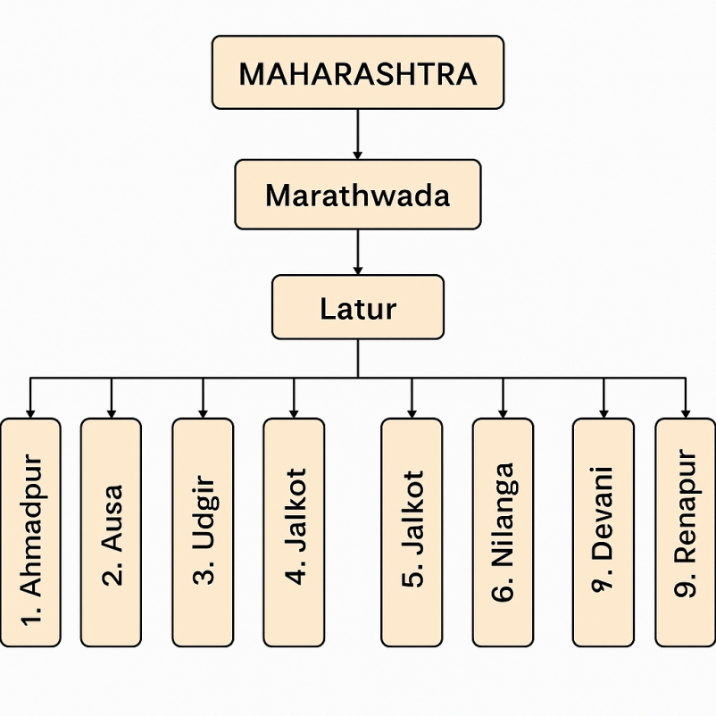
Figure 1. Sampling procedure of selection of State, Zone, Districts and Blocks

- RESULTS AND DISCUSSION
3.1 Services provided by the farmer producer organizations in Marathwada region of Maharashtra
Farmers' organizations provide a variety of essential services aimed at improving members' livelihoods and promoting sustainable farming practices. These include organizational services such as uniting farmers, encouraging collective action, capacity building, and establishing monitoring systems. Production services focus on supplying inputs and coordinating collective production activities. Marketing services help farmers with transport, storage, output marketing, processing, market information, branding, and certification. Financial services offer savings, loans, credit facilities, and financial management support. Technology services provide education, extension, and research for better farming methods. Education services enhance farmers' business skills, health knowledge, and production-related training. Welfare services cover health initiatives and social safety nets. Lastly, management of resources ensures the conservation and sustainable use of water, soil, forests, pastures, and fisheries. So they ranked the services according to their availability. Table 1 shows Services provided by the farmer producer organizations in Marathwada region of Maharashtra and the rank given by the farmers to Service. This data was recorded by the field survey.
Table 1: Services provided by the farmer producer organizations in Marathwada region of Maharashtra
S.No. | Services provide to the farmers | Rank given by the respondents
S.No. | Services provide to the farmers | I | II | III | IV | V | VI | VII | VIII
1 | Production Services | 35 | 28 | 28 | 25 | 20 | 15 | 15 | 14
2 | Financial Services | 25 | 25 | 25 | 25 | 22 | 20 | 20 | 18
3 | Organizational Services | 43 | 30 | 25 | 20 | 18 | 15 | 15 | 14
4 | Marketing Services | 30 | 28 | 25 | 23 | 20 | 18 | 18 | 18
5 | Technology Services | 20 | 22 | 23 | 25 | 25 | 23 | 22 | 20
6 | Welfare Services | 3 | 15 | 17 | 19 | 25 | 34 | 30 | 37
7 | Education Services | 15 | 18 | 20 | 23 | 25 | 25 | 27 | 27
8 | Management of Resources | 9 | 14 | 17 | 20 | 25 | 30 | 33 | 32

3.2 The Percent Positions and Garret Values
The Garret ranks had been calculated through the usage of suitable Garret Ranking formula. The based on the Garret ranks, the garret value was calculated through Garret Ranking Table.
Percent position = $\frac{100(Rij-0.5)}{Nj}$
Where,
Rij = Rank given for the i^{th} variable by j^{th} respondents
Nj = Number of variable
Table 2: Percent positions and Garret Values
S. No. | 100(Rij-0.5)/ Nj | Calculated Value | Garret Value
1. | 100(1-0.5)/8 | 6.25 | 80
2. | 100(2-0.5)/8 | 18.75 | 68
3. | 100(3-0.5)/8 | 31.25 | 60
4. | 100(4-0.5)/8 | 43.75 | 54
5. | 100(5-0.5)/8 | 56.25 | 47
6. | 100(6-0.5)/8 | 68.75 | 40
7. | 100(7-0.5)/8 | 81.25 | 32
8. | 100(8-0.5)/8 | 93.75 | 20

3.3 Calculation of Garret Value and Ranking
The Garret tables and scores of each problem in Table 1 were multiplied by the Garret value to record scores for each rank and constraint in Table 3, and finally, by adding each row, the total Garret score was obtained. Total Garret scores were divided by the number of respondents, i.e., 180, to calculate the average, and the ranking was given on the basis of the average value. The Garret value calculation and ranking of problems encountered by farmers when adopting climate smart agriculture are shown below.
Table 3: The calculation of ranking
S. No. | Services Provide to the Farmers | Rank given by the respondents
S. No. | Services Provide to the Farmers | I | II | III | IV | V | VI | VII | VIII | Total | Average | Rank
1 | Production Services | 2800 | 1400 | 1680 | 1500 | 1000 | 600 | 480 | 280 | 9740 | 1217.5 | II
2 | Financial Services | 2000 | 1000 | 1500 | 1800 | 1200 | 720 | 640 | 440 | 9300 | 1162.5 | IV
3 | Organizational Services | 3440 | 1700 | 1500 | 1200 | 800 | 600 | 480 | 280 | 10000 | 1250 | I
4 | Marketing Services | 2400 | 1200 | 1500 | 1500 | 1000 | 720 | 576 | 360 | 9256 | 1157 | III
5 | Technology Services | 1600 | 880 | 1380 | 1500 | 1200 | 880 | 704 | 440 | 8584 | 1073 | VI
6 | Welfare Services | 240 | 440 | 1020 | 1140 | 1000 | 1360 | 1184 | 740 | 8128 | 1016 | VIII
7 | Education Services | 1200 | 1320 | 1200 | 1800 | 1500 | 1000 | 864 | 540 | 9424 | 1178 | V
8 | Management of Resources | 720 | 660 | 1020 | 1200 | 1500 | 1200 | 1056 | 640 | 7996 | 999.5 | VII

It was observed from Table 3 that, based on Garret’s Ranking Technique, farmers ranked ‘Organizational Services’ as the most important service. This category received the highest Garrett score (10,000) and an average of 1250, placing it in the first rank. These services include farmer cooperatives, producer organizations, and self-help groups, which enhance collective bargaining and streamline service access. This finding aligns with Singh et al. (2021) and corroborates earlier observations by FAO (2014) in their global review of farmer organizations’ role in sustainable agriculture. Following this, ‘Production Services’ ranked second with a score of 9,740 and an average of 1217.5. These include seed distribution, fertilizer supply, and input services. Similar patterns were observed by Babu et al. (2012), who reported that production inputs are core priorities for smallholder farmers across Asia and Africa. The third highest-ranked service was ‘Marketing Services’ with a score of 9,256 and an average of 1157. This reflects the importance of market linkages, fair pricing mechanisms, and supply chain services. The observation is supported by Chand et al. (2011) who emphasized the need for reforming agricultural marketing systems in India for inclusive growth. Ranked fourth was ‘Financial Services’ with a score of 9,300 and an average of 1162.5. Farmers rely on credit, insurance, and subsidies to manage financial risks. The importance of these services was highlighted by Sharma (2016), who discussed the critical role of rural financial institutions in farm sustainability. ‘Education Services’ occupied the fifth rank with a score of 9,424 and an average of 1178. Training and awareness-building programs help farmers adopt new technologies and best practices. The result is in line with findings from the World Bank (2020) report on agricultural extension systems globally. ‘Technology Services’ ranked sixth, scoring 8,584 and averaging 1073. Although essential, farmers perceived gaps in access and affordability of modern agricultural technologies. Manjunath (2018) and IFPRI (2019) both reported similar constraints. ‘Management of Resources’ took the seventh rank with a score of 7,996 and an average of 999.5. This service category includes efficient use of land, water, fertilizers, and energy. FAO (2021) emphasized this area as a critical lever for climate-smart agriculture. Finally, ‘Welfare Services’ were ranked the lowest (eighth), with a score of 8,128 and an average of 1016. While vital for social security and farmer well-being, these services tend to receive lower priority in rural service structures, as noted by IFAD (2015) in its rural development assessments.
CONCLUSION
The study concludes that among services provided by Farmer Producer Organizations (FPOs) in Marathwada, Organizational Services rank as the top priority, highlighting the importance of collective action for small and marginal farmers. Production Services, Marketing Services, and Financial Services follow as key support areas essential for improving productivity, market access, and financial security. Lower-ranked services like Technology, Education, Resource Management, and Welfare are important but perceived as less urgent by farmers. Strengthening FPOs with a focus on organizational, production, and marketing services is crucial for enhancing farmer resilience and economic stability.

COMPETING INTERESTS DISCLAIMER:
Authors have declared that they have no known competing financial interests OR non-financial interests OR personal relationships that could have appeared to influence the work reported in this paper.

REFERENCES
Autio, E. et al. (2021). Agricultural Extension Services and Adoption of Climate Smart Agriculture. Global Food Security.
Babu, S. C., Glendenning, C. J., Asenso-Okyere, K. and Govindarajan, S. K. (2012). Farmer Information Services and ICT: Global Experiences and Lessons Learned. IFPRI Discussion Paper.
Chand, R., Prasanna, P. L., & Singh, A. (2011). Farm size and productivity: Understanding the strengths of smallholders and improving their livelihoods. Economic and Political Weekly, 5-11.
FAO. (2014). The State of Food and Agriculture: Innovation in Family Farming. Rome: Food and Agriculture Organization of the United Nations.
IFAD. (2015). Rural Development Report 2015: Inclusive Rural Transformation. International Fund for Agricultural Development.
FAO. (2021). Climate Smart Agriculture Sourcebook. Rome: Food and Agriculture Organization of the United Nations.
IFPRI. (2019). Digital Agriculture and Extension: Current Trends and Future Directions. IFPRI Report.
Kumar, V. et al. (2020). Role of Farm Service Centers in Farmer Welfare. International Journal of Agricultural Research.
Manjunath, B. (2018). Constraints in Agricultural Technology Adoption. Karnataka Journal of Agricultural Sciences.
Meena, R. et al. (2019). Accessibility of Agricultural Credit: Challenges in Rural India. Journal of Rural Development.
Panda, S. (2017). Agricultural Marketing in India: A Review. Indian Journal of Agricultural Sciences.
Sharma, A. (2016). Rural Credit in India: Status and Challenges. NABARD Occasional Paper Series.
Singh, R. et al. (2021). Farmer Producer Organizations in India: Challenges and Opportunities. Agricultural Economics Research Review.
Warner, K. et al. (2022). Climate Information Services and Smallholder Agriculture. Climate and Development Journal.
World Bank. (2020). Agricultural Extension Services: Global Review and Recommendations. Washington DC: World Bank Publications.

