Original Research Article

ISOLATION, PRODUCTION AND PURIFICATION OF ANTIMICROBIAL PEPTIDES FORM THE SOIL

ABTRACT
Aim: This study focused on isolating and purifying AMPs from soil bacteria collected from manure and banana farm soil samples. Antimicrobial peptides (AMPs) are natural antibiotics produced by a variety of organisms, including microorganisms and plants.
Study Design: Isolation of Soil bacteria was done from Manure soil, Peepal tree, and Banana Farm & were screened for AMP isolate. Production and Purification of AMP’s was carried out and were studied for their antimicrobial activity
Place and Duration: Dr. D. Y. Patil, Art’s, Commerce & Science, College, Pimpri, Pune- 18, December 2022 to March 2023.
Methodology: The bacteria were cultured on nutrient agar plates, and the antimicrobial peptide producers were identified using the Agar overlay assay method, where clear zones of inhibition indicated the presence of antimicrobial-producing bacteria. Isolates with significant antimicrobial peptide producing potential, which inhibited the growth of sensitive strains in applied assay proceed for bulk production. After production antimicrobial peptides were purified by chloroform.
Result: Antimicrobial activity of partially purified antimicrobial peptides was checked against E. coli and S. aureus. Maximum antimicrobial activity was found against S. aureus on MH agar, with an inhibitory zone of 17 mm, increasing to 25 mm after partial purification with chloroform.
Conclusion: This study indicates that valuable antibacterial peptide compounds can be derived from unexplored ecological niches. Antimicrobial peptides are increasingly recognized as promising alternatives for clinical therapies and as preservatives in the food industry, helping to prevent food spoilage. Their appeal lies in their broader antimicrobial spectrum, particularly effective against closely related bacteria.
Keyword:- Antimicrobial peptides, preservatives, Overlay assay, clinical therapies, broader antimicrobial spectrum.

INTRODUCTION
Antibiotics are substances that kill or inhibit the growth of microbes and can be produced either naturally by microbes or synthesized chemically. Recent research has highlighted the significance of cationic peptides isolated from various species [1], including marine bacteria, as promising sources of antimicrobial compounds. These peptides exhibit diverse mechanisms for targeting and eliminating pathogens, playing a crucial role in the innate immune system as the first line of defense. They typically weigh ≤10 kDa and are efficient in diffusing to the site of infection, contributing to host immunity and biological responses. Soil rhizosphere hosts functional microbial communities, where some produce antimicrobial peptides to defend against others. These ribosomally synthesized proteins target bacteria of the same [2] or different species and are present across all major bacterial lineages [3], including both Gram-negative and Gram-positive bacteria [4]. Antimicrobial peptides exhibit diverse biochemical properties, molecular weights, activity spectra, and modes of action [5]. Antimicrobial peptides are increasingly recognized for their potential as alternative therapeutic agents in clinical applications and as preservatives in the food industry, aimed at preventing food spoilage [6]. Researchers are particularly interested in these peptides due to their broad antimicrobial spectrum, primarily targeting closely related bacteria.
Antimicrobial peptides (AMPs) are oligopeptides composed of five to over a hundred amino acids, targeting a wide range of organisms including viruses and parasites. They have been historically known by various names such as cationic host defence peptides and α-helical antimicrobial peptides. The first discovery of AMPs was in 1939 when Dubos isolated an antimicrobial agent from a soil Bacillus strain, which was shown to protect mice from pneumococci infection. 2Most AMPs reported to date can be characterized as one of the following four types based on their secondary structures: β-sheet, α-helix, extended, and loop. Among these structural groups, α-helix and β-sheet structures are more common; and α-helical peptides are the most studied AMPs to date [6].
Antimicrobial peptides (AMPs) demonstrate significant antiviral [7], antibacterial [7], and antifungal effects by disrupting cell membrane integrity, inhibiting protein and nucleic acid synthesis, and interacting with intracellular targets [6]. Key physiochemical properties of AMPs include length, net charge, helicity, amphipathicity, solubility, and hydrophobicity [8]. They target biofilms, persister cells, and drug-resistant bacteria [6]. Environmental factors influencing AMPs' efficacy include metal ions, pH, proteases, and contexts such as animal husbandry, aquaculture, medicine, and food [9].
MATERIAL AND METHODS
- Collection of soil sample:- Soil samples were collected from manure soil, peepal tree, and banana farms in the Latur region. Surface soil was placed in plastic bags, transported to the laboratory, air dried, and sieved through mesh before bacterial screening.
- Isolation of bacteria from soil sample:- Soil samples were serially diluted up to 10⁻⁶ in sterilized distilled water. From the 10⁻⁵ and 10⁻⁶ dilutions, 100 μl was spread on Nutrient Agar plates and incubated at 37 °C for 24 hours. Bacterial colonies were then isolated and sub-cultured on Nutrient agar, labelled as A1, A11, A12, B10, C3, C12, S1, and S3 for further analysis.
- Screening of soil isolates:- The antimicrobial activity of soil isolates was assessed using the Agar overlay assay [10] and Lacuna assay technique [11] to evaluate antimicrobial peptide production. Isolated colonies were cultured overnight on nutrient agar plates at 37 ºC. Effective producers were identified by inactivating bacterial growth in control plates with chloroform and overlaying with soft agar containing S. aureus and E. coli. After incubation, the inhibition zones were measured, confirming antimicrobial peptide production.
- Target Strain inoculums preparation:- Inoculated loopful cultures of S. aureus and E. coli were incubated in nutrient broth at 37ºC overnight. Subsequently, 100 μl of these cultures were mixed with soft agar and spread on pre-poured nutrient agar plates.
- Production of antimicrobial peptides :- Producer soil isolates were grown in 100 ml of 1% nutrient broth at 37 ºC for 24 hours, then centrifuged at 4000 rpm for 20 minutes to collect the cell-free supernatant, identified as antimicrobial peptides. The presence of antimicrobial peptides was confirmed using the agar well diffusion method, where overnight cultures of the isolates were inoculated into wells on Muller Hinton agar plates and assessed for zones of inhibition [12].
- Partial purification of antimicrobial peptides:- After centrifugation, 100ml of culture supernatant was mixed vigorously with 100ml of chloroform and transferred to a separating funnel. The interface layer containing antimicrobial peptides was collected. Residual chloroform was evaporated, and the resulting pallete was resuspended in phosphate buffer and stored at 4 ºC for future use [12].
- Antimicrobial activity of antimicrobial peptides:- To assess the antimicrobial activity of partially purified antimicrobial peptides, the agar well diffusion method was utilized, demonstrating effectiveness against all tested isolates. Cultures of S. aureus and E. coli were spread on Muller Hinton agar plates, and wells were created for the peptides. After adding 100 μl of the peptides to the wells, the plates were incubated at 37 ºC for 24 hours, during which the zones of inhibition were observed [13].

RESULT
- Isolation of soil bacteria:- Soil bacteria isolates after serial dilution. On different morphological character, isolated colonies are sub-cultured on nutrient agar.
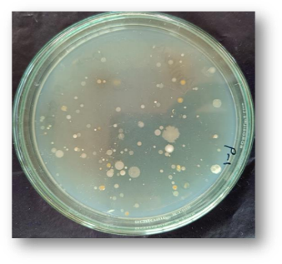
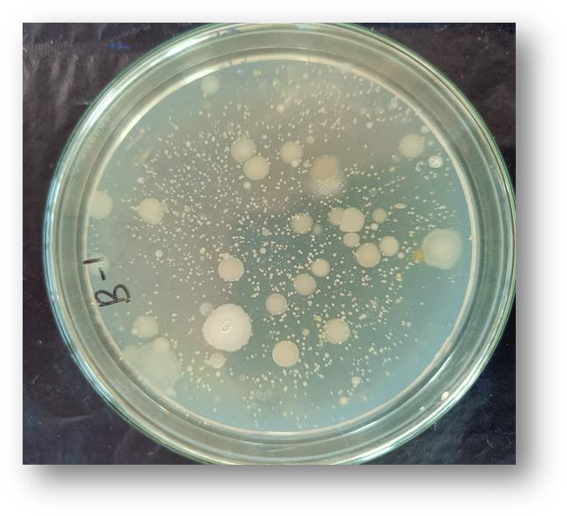
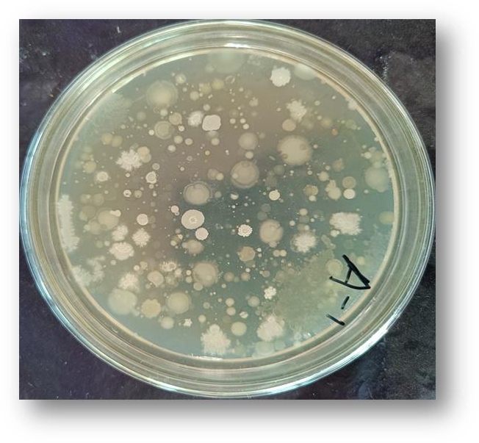
Fig 1- Banana soil isolates fig-2 Manure soil isolates fig 3. Peepal soil isolates

- Screening of soil isolates :- Agar overlay assay showed clear zone of inhibition, confirmed Production of antimicrobial peptides.
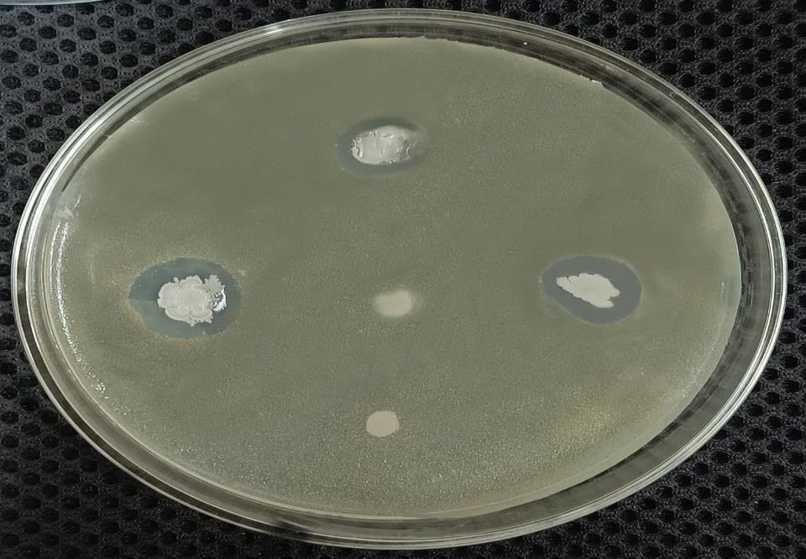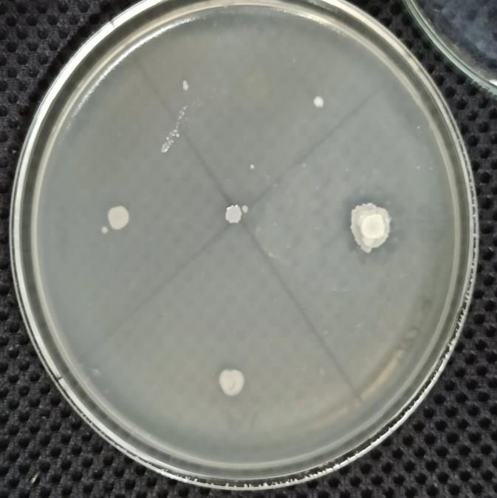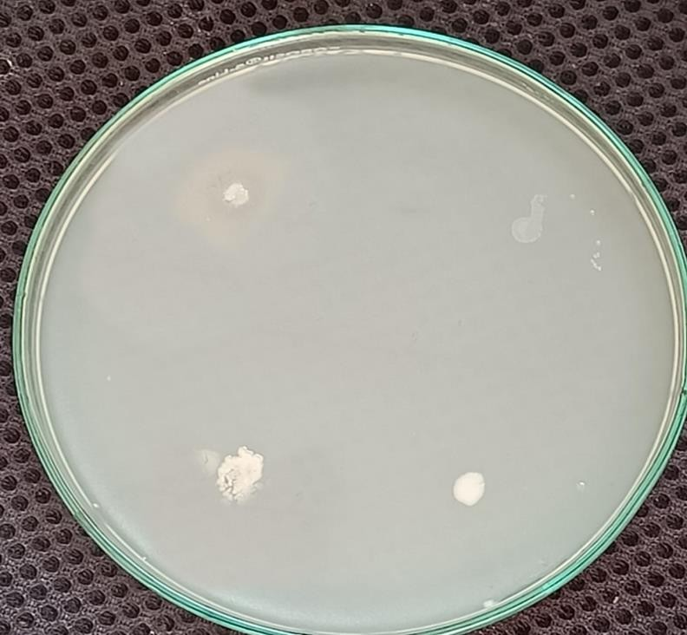
S3
B10
R1
A12
R2
R2
A12
R1
S3
B10
S3
C1
B10
A12
Fig 6: Negative control without any target strain
Fig 4 :- Agar overlay assay plates showed a clear zone of inhibition of S. aureus strain

Sr. No | Bacterial Strain | Zone of inhibition (mm)
1 | S. aureus | S3- 10mm
1 | S. aureus | B10- 16mm
1 | S. aureus | A12- 13mm
1 | S. aureus | R1- No Zone
1 | S. aureus | R2- No Zone
2 | E. coli | S3- 14mm
2 | E. coli | B10- 8mm
2 | E. coli | A12- No Zone
2 | E. coli | R1- No Zone
Fig 2.1 :- Agar overlay assay plates showed a clear zone of inhibition of S. aureus strain
Fig 5 : Agar overlay assay plates showed a clear zone of inhibition of E. coli strain

Sr. No | Bacterial Strain | Zone of inhibition (mm)
1 | S. aureus | S3- 10mm
1 | S. aureus | B10- 16mm
1 | S. aureus | A12- 13mm
1 | S. aureus | R1- No Zone
1 | S. aureus | R2- No Zone
2 | E. coli | S3- 14mm
2 | E. coli | B10- 8mm
2 | E. coli | A12- No Zone
2 | E. coli | R1- No Zone
Fig 2.1 :- Agar overlay assay plates showed a clear zone of inhibition of S. aureus strain
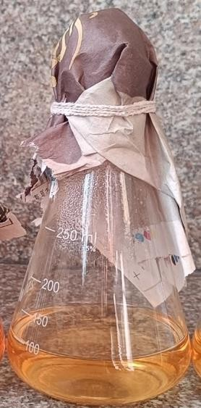
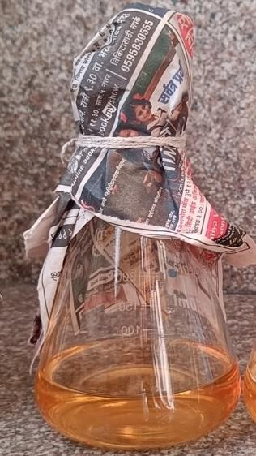
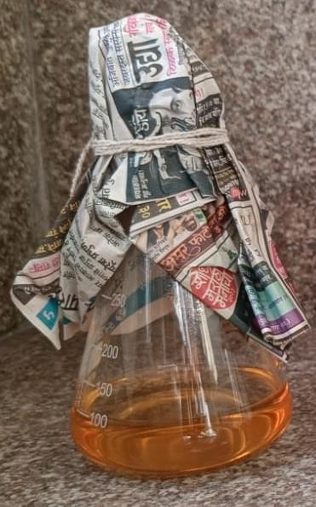
Table 1 :- Showing zone of inhibition of S. aureus and E. coli by soil isolates
Sr. No | Bacterial Strain | Zone of inhibition (mm)
1 | S. aureus | S3- 10mm
1 | S. aureus | B10- 16mm
1 | S. aureus | A12- 13mm
1 | S. aureus | R1- No Zone
1 | S. aureus | R2- No Zone
2 | E. coli | S3- 14mm
2 | E. coli | B10- 8mm
2 | E. coli | A12- No Zone
2 | E. coli | R1- No Zone

Fig 7- AMP producer isolates S3, B10, A12 inoculated in Nutrient Broth
- Production of antimicrobial peptides:-

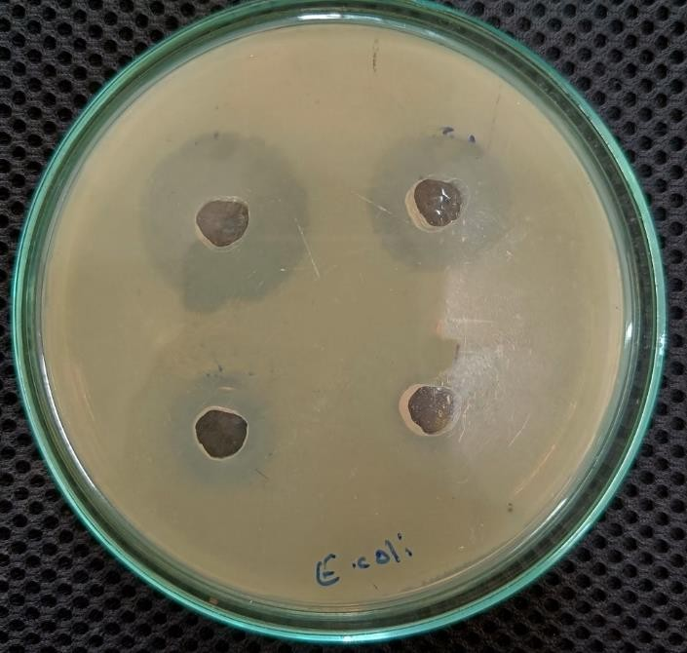
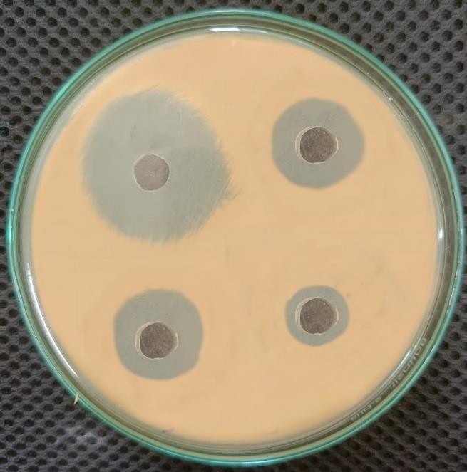
B10

B10
A12

A12
Positive control

Positive control
A12

A12
B10

B10
S3

S3
Positive control S3

Positive control S3
Fig 9 Cell free supernatant shows zone of inhibition of E. coli

Fig 3.3 Cell free supernatant shows zone of inhibition of E.coli
Fig 8 Cell free supernatant shows zone of inhibition of S. aureus

Fig 3.2 Cell free supernatant shows zone of inhibition of s. aureus

Table 2 :- Showing zone of inhibition of S. aureus and E. coli of by cell free supernatant of Soil isolates

Sr. No. | Bacterial Strain | Zone of inhibition (mm)
1 | S. aureus | S3 – 12 mm
1 | S. aureus | B10- 17 mm
1 | S. aureus | A12- 15 mm
2 | E. coli | S3 – 17 mm
2 | E. coli | B10- 14 mm
2 | E. coli | A12- No zone

- Partial purification of antimicrobial Peptides

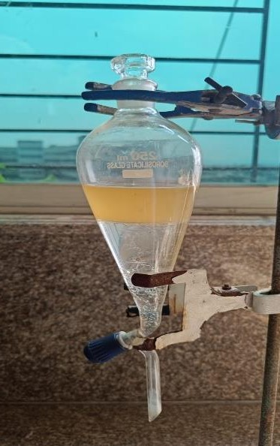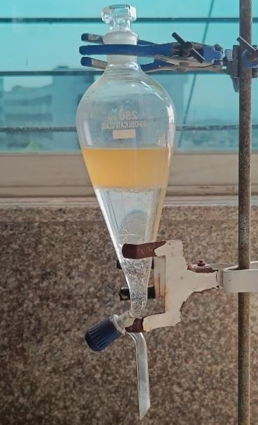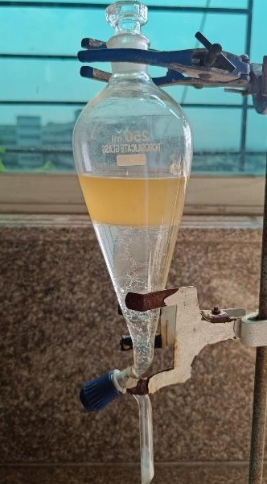
Supernatant of Isolate A12 and chloroform in separating funnel

Supernatant of Isolate A12 and chloroform in separating funnel
Supernatant of Isolate S3 and chloroform in separating funnel

Supernatant of Isolate S3 and chloroform in separating funnel
Supernatant of Isolate B10 and chloroform in separating funnel

Supernatant of Isolate B10 and chloroform in separating funnel

Fig 10 Partial purification of Antimicrobial Peptides

Fig 4.1 Partial purification of Antimicrobial Peptides

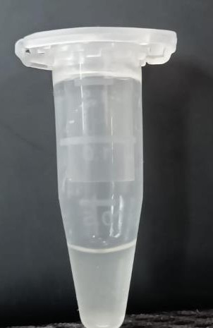
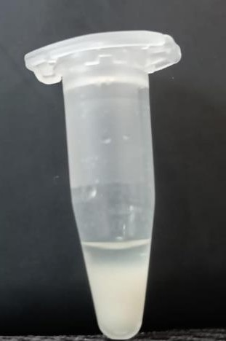
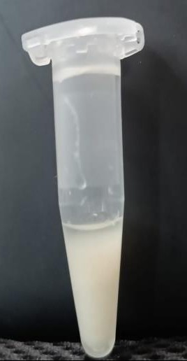
Partially Purified AMP of S3

Partially Purified AMP of S3
Partially Purified AMP of A12

Partially Purified AMP of A12
Partially Purified AMP of B10

Partially Purified AMP of B10

Fig 11. Partially purified Antimicrobial Peptides

Antimicrobial activity of partially purified antimicrobial peptide
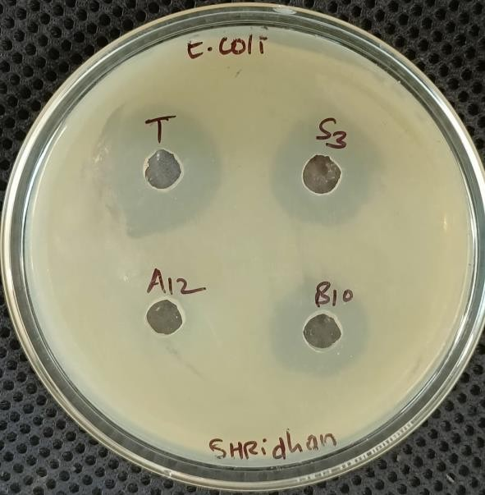
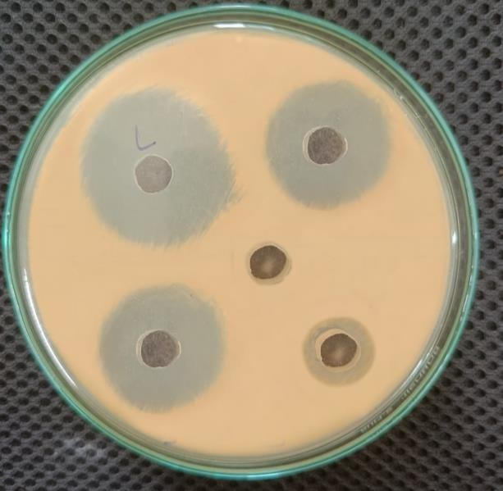
Positive control

Positive control
Positive control

Positive control
A12

A12
Negetive control

Negetive control
B10

B10
S3

S3

Fig 13:- Antimicrobial activity of partially purified antimicrobial peptides against E. coli

Fig 5.2:- Antimicrobial activity of partially purified antimicrobial peptides against E.coli
Fig 12:- Antimicrobial activity of partially purified antimicrobial peptides against S. aureus

Fig 5.1:- Antimicrobial activity of partially purified antimicrobial peptides against S. aureus

Table 3 :- Showing zone of inhibition of S. aureus and E. coli of by partially purified Antimicrobial peptides.
Sr. no | Bacterial Strain | Zone of inhibition (mm)
1 | S. aureus | S3- 14mm
1 | S. aureus | B10- 25mm
1 | S. aureus | A12- 24mm
1 | S. aureus | + control – 33mm
1 | S. aureus | - control – No zone
2 | E. coli | S3- 22mm
2 | E. coli | B10- 19mm
2 | E. coli | A12- No zone
2 | E. coli | + control – 27mm
2 | E. coli | -control – No zone

DISCUSSION
This study identified and purified the antimicrobial peptide from soil bacteria. Soil samples were taken from the banana farm's peepal trees and manure soil for this. The isolated bacterial colonies were obtained by diluting soil samples and cultivating them in nutrient agar plates. Three distinct soil samples yielded five distinct bacterial species, three of which were discovered to produce antibiotic peptides [14]. The agar overly assay method was used to measure the producer strain's capacity to generate antimicrobial peptides. The sensitive strain was greatly inhibited by the producing strain in this screening method [15]. Isolates that produce antimicrobial peptides are then produced in large quantities in nutrient broth. Following production, the supernatant was partially purified using the chloroform technique.
Antimicrobial activity of partially purified antimicrobial peptides was tested against strains of S. aureus and E. coli. The inhibitory zone was initially 17 mm under ideal growth conditions, and it grew to 25 mm following partial chloroform purification [12].
The study verified that a variety of microbial species with the capacity to produce antimicrobial peptides are present in soil ecological environments. Clinical probiotics can be made from these species [16]. These antimicrobial compounds are thought to have strong effectiveness against clinically isolated pathogenic bacteria and minimal adverse effects on consumers and the environment. These antimicrobial peptides are becoming more and more popular as preservatives in the food industry to stop food degradation and spoiling, as well as an alternative therapeutic agent for clinical purposes. Researchers were drawn to the antimicrobial peptides because of their wider range of antibacterial activity, usually against closely related bacteria. There are now several AMP formulations undergoing clinical studies, although the most of these are topical in nature and would not have the same range of applications as systemic traditional antibiotic therapy [17]. Antimicrobial peptides have been promoted as immune modulators, indicators for infection identification, and even for the diagnosis and treatment of cancer. The number of potential uses for AMPs is growing far more quickly than the amount of clinical data that supports the peptides' used [18].
The resistance of pathogenic bacteria, which is growing over time as a result of over prescription and insufficient usage of antibiotics, is the impending problem in therapeutic agents. Investigating novel antimicrobial compounds from natural sources, such as bacterial strains with low virulence and broad antibiotic action against therapeutically relevant pathogens, is a challenge for scientists.

CONCLUSION
Soil samples from various habitats were found to contain microbial species capable of producing antimicrobial peptides. Screening of these soil isolates demonstrated significant antimicrobial activity, evidenced by clear zones of inhibition against S. aureus and E. coli. This research serves as a groundwork for potential medical applications.

ACKNOWLEDGMENT
Authors acknowledge the Management of Institute for supporting and providing the opportunity to carry out this research work.

CONFLICT OF INTEREST
The authors declare that they have no conflict of interest.

REFERENCES
- Aley S B, M Zimmirman, E Hetsko, Selsted and Gillin F D. Killing of Giardia lamblia by cryptdins and cationic neutrophil peptides. Infect Immu.1994; 62: 5397-5403.
- Cotter P D, C Hill, R P Ross. Bacteriocins: developing innate immunity for food. Nat Rev Microbiol. 2005; 3:777-778.
- Riley M A, and J E Wertz. Bacteriocin: evolution, ecology and application. Ann. Rev.Microbiol. 2002; 56:117-137.
- Savadogo A, C A T Ouattara, I H N Basssole, S A Traoer. Bacteriocins and lactic acid bacteria- a minireview. Afr J Biotechnol. 2006; 5:678-683.
- Klaenahmmer T R, Bacteriocins of lactic acid bacteria. Biochemie.1998; 70: 337-349.
- Yuchen Huan, Qing Kong, Haijin Mou, Huaxi Yi, Antimicrobial Peptides: Classification, Design, Application and Research Progress in Multiple Fields. Fronties in Microbiology. 2020; 11: 582779.
- Qi Yu Zhang, Zhi Bin Yan, Yue Ming Meng. Xiang Yu Hong, Gang Shao, Jun Jie Ma, Xu Rui Cheng, Jun Liu, Jian Kang, Cai Yun Fu. Antimicrobial peptides: mechanism of action, activity and clinical potential. Military medical research. 2021; 8:48
- Narjes Hosseini Goki, Zeinab Amiri Tehranizadeh , Mohammad Reza Saberi , Bahman Khameneh, Bibi Sedigheh Fazly BazzazStructure. Function, and Physicochemical Properties of Pore-forming Antimicrobial Peptides 2024; 25(8):1041-1057. doi: 10.2174/0113892010194428231017051836.
- Parente E, and A Ricciardi. Influence of pH on the production of enterocin 1146 during batch fermentation, Lett. In Appl. Microbiol.1994 19: 12-15.
- Kevin L Hockett, David A Baltrus Use of the Soft-agar Overlay Technique to Screen for Bacterially Produced Inhibitory Compounds. 2017 Jan 14 ;(119):55064. doi: 10.3791/55064
- Elpinickie Ninou , Artemis Michail, Panagiotis K Politis. Long Non-Coding RNA Lacuna Regulates Neuronal Differentiation of Neural Stem Cells During Brain Development 2021 Nov 24; 9:726857. doi: 10.3389/fcell.2021.726857
- N. Muhammad., A. Akbar., A. Shah., G. Abbas., M. Hussain., T. A. Khan., (2015). Isolation optimization and characterization of antimicrobial peptide producing bacteria from soil. The Journal of Animal & Plant Sciences. 25(4): 1107-1113.
- Mounyr Balouiri, Moulay Sadiki, Saad Koraichi Ibnsouda. Methods for in vitro evaluating antimicrobial activity: J Pharm Anal. 2015 Dec 2;6(2):71–79. doi: 10.1016/j.jpha.2015.11.005
- Yahya G, Ebada A, Khalaf E M, Mansour B, Nouh N A, Mosbah R A, Saber S, Moustafa M, Negm S, El-Sokkary M M A, & El-Baz A M. Soil-Associated Bacillus Species: A Reservoir of Bioactive Compounds with Potential Therapeutic Activity against Human Pathogens. Microorganisms. 2021; 9(6), 1131.
- Hockett K L, & Baltrus D A. Use of the Soft-agar Overlay Technique to Screen for Bacterially Produced Inhibitory Compounds. Journal of visualized experiments : JoVE, 2017; (119), 55064.
- Amaning Danquah C, Minkah P A B, Osei Duah Junior I, Amankwah K B, & Somuah S O. Antimicrobial Compounds from Microorganisms. Antibiotics (Basel, Switzerland). 2022; 11(3), 285.
- Cresti L, Cappello G, & Pini A. Antimicrobial Peptides towards Clinical Application-A Long History to Be Concluded. International journal of molecular sciences 2024; 25(9), 4870.
- Bahar A, Porbaran M, Khazaei M, & Tahmasebi H. Antimicrobial peptides for anticancer and antiviral therapy: last promising update. Discover oncology. 2025; 16(1), 1991.

