Original Research Article

Motivational Factors Influencing Perceived Difficulty in Mathematics among Lebanese Middle School Students

.
ABSTRACT

Aims: This study examined the relationship between students’ motivational beliefs and their perceptions of difficulty in mathematics, with attention to differences across mathematical domains and gender during the transition from elementary to middle school in Lebanon.
Study design: Descriptive cross-sectional survey study.
Place and Duration of Study: The study was conducted in eleven private schools in Lebanon during a middle school academic year.
Methodology: The sample consisted of 992 seventh-grade students (493 males and 497 females). Data were collected using a closed-ended questionnaire grounded in the MUSIC model of academic motivation, assessing perceived usefulness, interest, confidence in success, and teacher care, alongside perceived difficulty in mathematics overall and across Geometry, Algebra, Numbers, and Word Problems. Descriptive statistics, Pearson correlations, multiple linear regression analyses, and Fisher’s z-tests were used.
Results: Students reported relatively high motivation and generally low overall perceived difficulty in mathematics. Geometry and Word Problems were identified as the most challenging domains, while Numbers was perceived as the least difficult. Domain-specific difficulties significantly predicted overall perceived difficulty (F = 130.53, p < .001), explaining 35% of the variance, with Geometry showing the strongest effect (β = .37). Interest (r = −.48), usefulness (r = −.47), and confidence in success (r = −.50) were significantly and negatively associated with perceived difficulty, accounting for 31% of the variance (F = 111.3, p < .001). Gender analyses showed stronger associations between Geometry-related difficulty and overall perceived difficulty among female students, as well as a stronger link between perceived usefulness and difficulty for girls. These findings suggest that instructional strategies that enhance relevance, interest, and confidence (particularly in Geometry) may help reduce students’ perceived difficulty in mathematics.
Conclusion: Perceived difficulty in mathematics is more closely related to students’ motivational beliefs and domain-specific learning experiences than to ability alone. Strengthening interest, highlighting relevance, and supporting confidence, especially in Geometry, may promote more positive and equitable mathematics learning experiences during early adolescence. Given the cross-sectional design and focus on private schools, the findings should be interpreted within these contextual boundaries.

Keywords: Mathematics education; Student motivation; MUSIC model; Middle school; Perceived difficulty

1. INTRODUCTION

Educational research has increasingly focused on students’ perceptions of mathematics because of their role in shaping motivation, engagement, and long-term academic outcomes. This focus is particularly relevant in the Lebanese context, where many students report increased difficulty in mathematics during the transition from elementary to middle school. This transition is often accompanied by an expansion of mathematical content, shifts in the language of instruction from Arabic to English or French, and heightened academic expectations. Together, these changes make mathematics a key domain for understanding students’ learning experiences during this critical stage (Akos et al., 2007; Alspaugh, 1998).
In this study, difficulty in mathematics is conceptualized at the level of the subject as a whole, reflecting its overall complexity and perceived attainability rather than the difficulty of specific tasks. Perceptions of difficulty are shaped by cumulative experiences with instructional methods, curricular domains, and motivational appraisals. This perspective differs from task difficulty, which refers to the immediate challenge posed by a particular mathematical activity. The distinction aligns with Bjork’s (1994) theory of desirable difficulties, which suggests that effortful learning experiences, although perceived as difficult, can support long-term retention and mastery.
Perceived difficulty should not be understood as inherently negative. Rather, it reflects an interaction between students’ prior knowledge, the cognitive demands of mathematics, and their motivational orientation toward learning. Students may perceive mathematics as difficult due to the abstract nature of its content, challenges associated with specific domains such as geometry or algebra, or features of the instructional environment. Central to these perceptions are students’ beliefs about their ability to succeed, as well as motivational factors such as interest, perceived usefulness, and confidence in success, which influence whether difficulty is interpreted as a challenge or an obstacle (Clements & Sarama, 2020; Mahendra & Slamet, 2017; Simzar et al., 2016). This view is consistent with research distinguishing between learning experiences that are challenging and motivating and those that are perceived as purely difficult and threatening to students’ sense of competence, with important consequences for motivation and achievement (Schweinle et al., 2013).
Accordingly, difficulty in mathematics is approached in this study as a subjective cognitive appraisal shaped by motivational beliefs, instructional context, and curriculum demands, rather than as an indicator of low ability. Research in educational psychology suggests that difficulty can support learning when accompanied by appropriate instructional and motivational support (Eccles & Wigfield, 2002). In contrast, low interest, limited confidence, or perceptions of irrelevance are often associated with disengagement and avoidance of mathematics over time (El-Adl & Elkharusi, 2020; Rodrigues et al., 2021). These processes are particularly salient during school transitions, when students’ motivation and academic self-concept are still developing and responsive to classroom experiences (Ayebale et al., 2020; Wardat et al., 2023). From a growth mindset perspective, students who view difficulty as an opportunity for learning are more likely to demonstrate resilience and stronger academic outcomes. This highlights the importance of instructional scaffolding and supportive teaching practices (Mangels et al., 2006).

Within the Lebanese educational system, examining students’ perceptions of mathematics is especially important. Mathematics instruction occurs in multiple languages, and curricular design and socioeconomic conditions vary widely across schools. Although these contextual factors are not examined directly in the present study, they provide an important backdrop for understanding students’ motivational responses to mathematics. Accordingly, this research focuses on the motivational dimension of students’ experiences, as conceptualized within the MUSIC model of academic motivation (Jones, 2009), and its role in shaping perceptions of mathematical difficulty, while recognizing that these processes are embedded within broader cognitive and contextual influences (Evans, 2020; Silver & Libertus, 2022).

Gender has also been widely examined in relation to students’ experiences with mathematics, particularly regarding perceptions, attitudes, and motivation. While some studies report minimal gender differences in mathematical performance (Hyde et al., 1990; Jabor & Nordin, 2011), others highlight gender-based variations in attitudes, self-efficacy, and motivational orientations (Reilly et al., 2016). In the Lebanese context, Sarouphim and Chartouny (2017) documented gender-related differences in both attitudes and performance, underscoring the need for context-sensitive investigation. By examining these patterns during the transition to middle school, the present study contributes to understanding how gender moderates the relationship between motivation and perceived difficulty in mathematics.

2. Theoretical Framework

This study is grounded in the MUSIC model of academic motivation, which conceptualizes student engagement as shaped by five key motivational constructs: eMpowerment, Usefulness, Success, Interest, and Caring. The model draws on principles from expectancy–value theory (Eccles-Parsons et al., 1983), self-determination theory (Ryan & Deci, 2000), and social cognitive theory (Bandura et al., 2001), which are integrated to explain how students experience and respond to learning situations. Through this theoretical grounding, the MUSIC model offers a multidimensional perspective on how students interpret academic challenges and engage with learning tasks. Each component of the model provides a specific lens:
- Usefulness refers to students’ beliefs that the content is relevant to their current or future lives (Sansone & Harackiewicz, 2000).
- Success reflects students’ confidence in their ability to perform well (Bandura et al., 2001).
- Interest captures emotional engagement and enjoyment in the subject (Hidi & Renninger, 2006).
- Caring measures students’ perception of support from teachers (Jones & Skaggs, 2016).
- Empowerment, which relates to autonomy and decision-making in the learning environment, was included in the initial instrument but excluded from analysis due to low internal consistency (Cronbach’s α = 0.49).
Accordingly, the current study uses a MUSIC-based model, incorporating only Usefulness, Success, Interest, and Care; the four components with acceptable to strong internal consistency (Cronbach’s α ≥ 0.71).
Within this framework, motivational beliefs are understood as cognitive and affective appraisals that shape how students make sense of mathematical difficulty. When students feel confident in their ability to succeed (Success), experience emotional engagement with learning activities (Interest), and perceive mathematics as relevant and valuable (Usefulness), they are more likely to interpret challenging content as manageable rather than discouraging. Conversely, in the absence of these motivational supports, even relatively routine mathematical tasks may be experienced as demanding or overwhelming. This conceptualization is consistent with prior research emphasizing the motivational basis of students’ judgments of difficulty (Guven, 2012; Naidoo & Kapofu, 2020; Rodrigues et al., 2021).
Although the MUSIC model has been widely used to examine general academic motivation (Jones & Skaggs, 2016), its application to mathematics warrants particular attention given the subject’s abstract structure, cumulative progression, and evaluative demands (DeWolf et al., 2016; Obersteiner et al., 2019). Building on this line of research, the present study investigates how motivational beliefs associated with the MUSIC model are related not only to students’ overall perceptions of mathematical difficulty, but also to their perceived difficulty across specific mathematical domains, namely Geometry, Algebra, Numbers, and Word Problems.
Motivation does not operate independently of broader contextual and cognitive processes. Although factors such as instructional quality, language of instruction (French or English), prior conceptual knowledge, and working memory are not examined directly in the present study, they may nonetheless influence how students interpret mathematical difficulty (Raj Acharya, 2017; Sarabi & Gafoor, 2017). These elements form part of the educational context within which motivational processes unfold and should be considered in future research seeking a more comprehensive understanding of students’ learning experiences.
Accordingly, perceived difficulty in mathematics is treated in this study as a subjective motivational judgment rather than a direct reflection of cognitive demand alone. This perception is shaped by students’ views of relevance, confidence in success, interest, and the support they experience from teachers. From this standpoint, difficulty is not inherently detrimental; when approached within a growth mindset framework, it may instead function as a productive component of learning (Mangels et al., 2006). With sufficient motivational support and instructional scaffolding, challenging mathematical content can promote engagement and the development of mastery.
Taken together, this study adopts a MUSIC-based motivational perspective to examine how both intrinsic and extrinsic motivational beliefs relate to students’ perceptions of difficulty in mathematics, and how these relationships may vary across curriculum domains and by gender. By situating these processes within the context of the transition to middle school in Lebanon, the study offers insights into ways educators might more effectively support student persistence and achievement during a critical phase of mathematical learning.

3. Purpose of the Study

This study examines the relationship between students’ motivational beliefs and their perceptions of difficulty in mathematics. Although prior research has extensively investigated factors associated with mathematics achievement, comparatively fewer studies have focused on how motivational constructs such as interest, perceived usefulness, confidence in success, and perceived teacher support relate to the ways students interpret mathematics as difficult. This distinction is important because perceptions of difficulty, even when not directly linked to low performance, can influence students’ engagement, emotional responses, and long term academic choices, particularly in relation to mathematics intensive fields (Hurst & Cordes, 2017).
Grounded in the MUSIC Model of Academic Motivation, the present study investigates how specific motivational constructs are associated with students’ perceptions of difficulty in mathematics, both overall and across specific mathematical domains. This investigation is situated within the transition from elementary to middle school in Lebanon, a stage during which students’ motivational beliefs and academic perceptions are particularly sensitive to change.
The study addresses the following research questions:

- How are the intrinsic and extrinsic components of the MUSIC model related to students’ overall perceptions of difficulty in mathematics, and do these relationships differ by gender?
- How are the intrinsic and extrinsic components of the MUSIC model related to students’ perceived difficulty across specific mathematical domains including Geometry, Algebra, Numbers, and Word Problems?
- How are students’ reported difficulties in specific mathematical domains associated with their overall perception of mathematics as a difficult subject, and do these associations vary by gender?

4. methodology

This study adopted a descriptive survey design to collect data from students in the transitional phase from elementary to middle school in Lebanon. The aim was to assess their perceptions of mathematics difficulty across various content areas and their motivation toward learning mathematics. The survey research was adapted according to the User Guide for Assessing the Components of the MUSIC® Model of Academic Motivation (Jones & Skaggs, 2016) and based on the MUSIC model, which covers five key principles of motivation (eMpowerment, Usefulness, Success, Interest, and Caring), to study certain motivations, behaviors, and opinions of students in the educational field, without attempting to manipulate any variables. Although the MUSIC model includes five motivational components, the empowerment dimension demonstrated low internal consistency in the present study and was therefore excluded from subsequent analyses. This low reliability may be related to students’ age and their limited autonomy in classroom decision-making, as mathematics instruction in Lebanese middle schools is often highly structured and teacher-directed. As a result, empowerment items may not have fully captured students’ perceived autonomy in learning mathematics. The data collection was conducted using a closed-ended questionnaire. The questionnaire items were rated on a five-point Likert scale: Strongly Agree (5), Agree (4), Uncertain (3), Disagree (2), and Strongly Disagree (1). It was divided into two main sections: the first section gathered demographic information, while the second focused on participants' views on their motivation and perceptions of difficulties in mathematics. Examples of potential questions are provided in the User Guide. Ethical approval was obtained from the participating schools. Written informed consent was obtained from parents or legal guardians prior to data collection. Participation was voluntary, and students’ responses were anonymous and treated confidentially.

4.1 Ethical considerations

Ethical approval for this study was obtained from the Institutional Review Board (IRB), as well as from the participating schools, prior to data collection. Written informed consent was obtained from parents or legal guardians of all participating students. Participation was voluntary, and students were informed that they could withdraw at any time without penalty. All responses were collected anonymously and treated confidentially throughout the research process

4.2 Participants

The research took place in eleven private schools in Lebanon. Based on the Lebanese education statistics, about half of the number of Lebanese students are females (CRDP, 2023). The Lebanese education system consists of primary education from Grades 1 to 6, then continues to middle school from Grades 7 to 9 (CRDP, 2023).
The sample for this study comprised 992 grade seven students who actively participated, with 493 males and 497 females. The schools included in this analysis represent various socio-economic groups. The study did not include students diagnosed as having learning or sensory impairments. This is because all students should have the same level of cognitive and educational factors. It was necessary that only students who obtained written permission from their parents or guardians were chosen for this study.
4.3 Materials

To get a comprehensive understanding of all the challenges the participating students are facing in understanding the math curriculum, the authors adapted a structured closed-ended survey composed of 30 items to assess the students' motivations toward mathematics and to identify its influence on the perceived difficulty of math. The survey was designed to collect numerical data that can be analyzed statistically on various aspects of students' experiences with the math curriculum, including:
- General Information: It includes questions about gender, school name, the language the students are learning math in (French or English), and their enrollment in private classes.
- Motivation: It includes questions/items that assess the student’s motivation toward the math classes. These questions were classified into different domains of motivation according to the MUSIC Model. The interest factors were addressed by using items such as “My only interest in math is getting a passing score”. The usefulness component was highlighted through questions such as “I use math in my daily life” and “Math helps in solving real-world problems”. Success was also assessed with statements like “I am capable of understanding math classes”. Empowerment was explored through items like “I like to share ideas and math solutions with my classmates”. Finally, the caring aspect encompassed perceptions of teacher involvement, including items like “My teacher cares about how well I do in math exams” and “My teacher cares about me understanding math”.
- Perceived Difficulty: It includes questions that assess the students learning experience in math and how they perceive math difficulty, the clarity and relevance of the curriculum and activities, the difficulty experienced in language, and questions to identify perceived difficulty in specific areas or topics within the math curriculum (numbers, geometry, measurement, algebra, word problems...). A single question/item was used to assess participants' perceived difficulty in mathematics of the specific areas in math as well as in mathematics overall. This choice is supported by research suggesting that single-item measures can be valid for constructs that are narrow and unambiguous in scope (Allen et al., 2022).
4.4 The reliability of the questionnaire

This questionnaire underwent a structured validation process to ensure its reliability and relevance to the research objectives. Several steps were then taken as follows:
- Content Validity: This study utilized items from the well-validated MUSIC Model survey, which has been extensively used in prior research (Jones & Skaggs, 2016). Additionally, new items were developed to capture general information and students' perceived difficulties with mathematics. To ensure the survey effectively addressed key aspects of students' experiences and difficulties with the math curriculum, a panel of three subject matter experts in mathematics education reviewed the additional items. The experts provided feedback on the clarity, relevance, and alignment of the items with the study’s objectives.
- Internal Consistency: The researchers employed Cronbach's alpha to evaluate the internal consistency of the motivational domains of the survey instrument, as this method is widely recognized in psychological and educational research (Cronbach, 1951). As shown in Table 1, the results revealed Cronbach’s α values exceeding 0.8 for the Usefulness, Success, and Care domains, 0.71 for the Interest domain, and 0.49 for the Empowerment domain. These results indicate strong internal consistency for the Usefulness, Success, and Care domains, acceptable consistency for the Interest domain, and low internal consistency for the Empowerment domain. The low reliability of the Empowerment scale may be related to limited student autonomy and the highly structured nature of mathematics instruction at this educational level, which may have constrained students’ ability to meaningfully respond to autonomy-related items. Based on these findings, the analysis focused on the four domains (Usefulness, Success, Interest, and Caring) that demonstrated acceptable to strong reliability.
Table 1. Cronbach’s α of the different items in Motivation
Factor | Cronbach’s α
Empowerment | 0.49
Usefulness | 0.9
Success | 0.8
Interest | 0.71
Care | 0.94

The surveys were completed on papers in coordination with schoolteachers and administration during regular class hours. Data was then introduced on a Microsoft Excel sheet and analyzed carefully using this software. The analysis consisted of descriptive statistics to summarize responses, and of analytical statistics to highlight the correlation between variables such as the key components with the difficulties in math.

5. results

5.1 Descriptive analysis

Motivation toward mathematics was assessed through the four principles of the MUSIC model: Usefulness, Success, Interest, and Care. The overall motivation scale indicated that males had a mean score of 3.92 (SD = 0.92, Skewness = −0.86), whereas females had a mean score of 3.69 (SD = 0.97, Skewness = −0.84), as shown in Table 2. Regarding overall perceived difficulty, 294 males and 325 females reported facing difficulties in understanding the mathematics curriculum or specific components. Males reported a mean perceived difficulty score of 1.67 (SD = 0.61, Range = 4.00, Skewness = 0.28), while females reported a slightly higher mean score of 1.75 (SD = 0.62, Range = 4.00, Skewness = 0.23). When examined by topic, Geometry and Word Problems showed higher mean difficulty scores for both genders. Geometry difficulty was reported as M = 2.51 (SD = 1.40, Skewness = 0.56) for males and M = 2.54 (SD = 1.52, Skewness = 0.53) for females. Word Problems followed a similar pattern. Numbers was consistently rated as the least difficult domain, particularly among males (M = 2.16, SD = 1.23, Skewness = 0.84). Descriptive statistics for all domains are presented in Table 2.

Table 2. Descriptive statistics of the study
Domains |  | Males |  |  | Females
 |  | Mean | SD | Skew | Mean | SD | Skew
Overall perceived difficulty |  | 1.67 | 0.61 | 0.28 | 1.75 | 0.62 | 0.23
Motivation | Interest | 3.91 | 0.86 | -0.7 | 3.73 | 0.95 | -0.7
Motivation | Usefulness | 3.92 | 0.95 | -0.89 | 3.58 | 1.01 | -0.77
Motivation | Success | 4.03 | 0.88 | -0.95 | 3.76 | 0.98 | -0.63
Motivation | Care | 4.1 | 1.02 | -1.37 | 4.01 | 1.1 | -1.11
Motivation | Total | 3.92 | 0.92 | -0.86 | 3.69 | 0.97 | -0.84
Perceived difficulty in specific areas | Geometry | 2.51 | 1.4 | 0.56 | 2.54 | 1.52 | 0.53
Perceived difficulty in specific areas | Numbers | 2.16 | 1.23 | 0.84 | 2.37 | 1.23 | 0.5
Perceived difficulty in specific areas | Algebra | 2.47 | 1.38 | 0.55 | 2.5 | 1.32 | 0.45
Perceived difficulty in specific areas | Word Problems | 2.47 | 1.23 | 0.35 | 2.61 | 1.26 | 0.33
Perceived difficulty in specific areas | Total | 2.4 | 1.31 | 0.58 | 2.51 | 1.33 | 0.45
Note: “Total” scores reflect the average of all questionnaire items within each domain (Motivation or Perceived Difficulty), not a direct average of subdomain means.

5.2 Statistical Analysis

5.2.1 Predictive Correlation Between Topic-Specific Difficulty and Overall Perceived Difficulty

In order to examine whether difficulty in specific math concepts contributed to overall perceptions of difficulty, a multiple linear regression test was carried out on Geometry, Algebra, Numbers, and Word Problems. The results showed that this test is statistically significant (F= 130.53; p <0.001) and that it explained 35% of the data's variability (R²= 0.35). The f² value for this test, as calculated per the suggestions of Cohen, is 0.54. While the model was statistically significant, the effect sizes indicate that topic-specific difficulties account for a moderate proportion of variance in overall perceived difficulty, suggesting meaningful but not deterministic relationships.
Geometry turned out as the most prominent predictor (β = 0.37, p < 0.001), and then came Algebra (β = 0.21, p < 0.001) and Numbers (β = 0.13, p < 0.001). Word Problems showed a less prominent and non-significant relationship (β = 0.05, p > 0.05) (Figure 1).

Participants | Male  𝑓²=0.47 | 0.35** | 0.19** | 0.10** | 0.10* |  | 0.40 | Standardized β Coefficient
 |  |  |  |  |  |  | 0.35 | Standardized β Coefficient
 |  |  |  |  |  |  | 0.30 | Standardized β Coefficient
Participants | Female  𝑓²=0.64 | 0.40** | 0.23** | 0.16** | 0.02 |  | 0.25 | Standardized β Coefficient
 |  |  |  |  |  |  | 0.20 | Standardized β Coefficient
 |  |  |  |  |  |  | 0.15 | Standardized β Coefficient
Participants | All  𝑓²=0.54 | 0.37** | 0.21** | 0.13** | 0.05 |  | 0.10 | Standardized β Coefficient
 |  |  |  |  |  |  | 0.05 | Standardized β Coefficient
 |  |  |  |  |  |  | 0.00 | Standardized β Coefficient
 |  | Geometry | Algebra | Numbers | Word Problems
 |  | Mathematics Topics
Fig. 1. Heatmap of standardized β coefficients from regression models predicting overall perceived mathematics difficulty based on topic-specific difficulties. Darker green shades indicate stronger associations. (*) denote levels of statistical significance: *p < .05, **p < .001.

5.2.2 Correlational Patterns and Gender Comparisons

To better understand this relationship, Pearson Correlation Coefficients were computed to examine the strength and direction of correlation between students’ perceived difficulty in specific math topics and their overall perception of mathematics difficulty. This correlational analysis can also be used to visualize the linear relationships between variables and provide a sense of the practical magnitude of correlation.
Figure 2 presents the Pearson Correlation Coefficients for Geometry, Algebra, Numbers, and Word Problems. The highest association was observed with Geometry (r= 0.50), while Algebra had a high association (r= 0.35), followed by Numbers at r= 0.32 and Word Problems (r= 0.13). Whereas all the associations are significant statistically because of the large sample size, regards to effect size should be viewed with caution since the lower coefficients reflect weak practical associations.

Correlation | Overall Difficulty | Geometry | Numbers | Algebra | Word Problems
Overall Difficulty | 1.00 | 0.50 | 0.32 | 0.35 | 0.12
Geometry | 0.50 | 1.00 | 0.24 | 0.16 | 0.06
Numbers | 0.32 | 0.24 | 1.00 | 0.36 | 0.12
Algebra | 0.35 | 0.16 | 0.36 | 1.00 | 0.15
Word Problems | 0.12 | 0.06 | 0.12 | 0.15 | 1.00
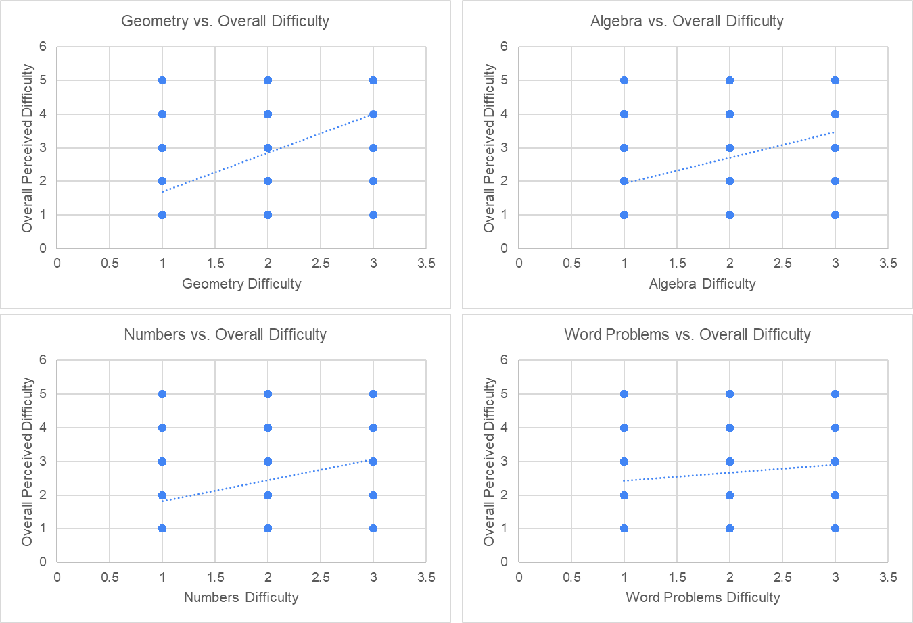
Fig. 2. Composite visualization of the relationship between overall perceived difficulty in mathematics and topic-specific difficulty domains. The upper panel presents a correlation matrix with Pairwise Pearson Correlation Coefficients (darker green = stronger correlation). The lower panel displays scatterplots with trendlines for each topic-specific difficulty (Geometry, Algebra, Numbers, and Word Problems) against overall perceived difficulty. Trendlines illustrate general patterns rather than predictive models.

To assess gender differences in these relationships, Fisher’s z-transformation was applied. Geometry yielded a significant gender difference (z = 4.12, p < .01), with females showing a stronger correlation (r = 0.55) than males (r = 0.45). No significant differences were found for Algebra (z = 0.49, p = .62) or Numbers (z = 1.27, p = .20). Word Problems were excluded due to non-significant associations (Table 3).

Table 3. Fisher’s z-Test Comparing Correlation Strengths by Gender
Domain | r (Male) | r (Female) | z-score | Significance
Geometry | 0.45 | 0.55 | 4.12 | Significant
Algebra | 0.30 | 0.40 | 0.49 | Not Sig.
Numbers | 0.28 | 0.36 | 1.27 | Not Sig.

5.2.3 Motivation and Overall Perceived Difficulty

Pearson correlations revealed significant negative associations between motivation components and overall perceived difficulty. Interest (r = −0.48), Usefulness (r = −0.47), and Success (r = −0.49) demonstrated strong inverse relationships, while Care showed a weaker negative correlation (r = −0.26). A multiple regression analysis further assessed the predictive influence of motivational factors. The model was significant (F = 111.3, p < .001) and explained 31% of the variance in perceived difficulty (R² = 0.31). Cohen’s f² was calculated to be 0.45, indicating a medium effect size. The magnitude of these effects suggests that motivational factors play a practically relevant role in shaping students’ perceived difficulty, although additional instructional and contextual factors are also likely involved. Regression results are presented in Figure 3.

Correlation | Overall Difficulty | Interest | Usefulness | Success | Care
Overall Difficulty | 1 | -0.48215 | -0.47876 | -0.49574 | -0.26181
Interest | -0.48 | 1.00 | 0.50 | 0.45 | 0.27
Usefulness | -0.48 | 0.50 | 1.00 | 0.40 | 0.28
Success | -0.50 | 0.45 | 0.40 | 1.00 | 0.39
Care | -0.26 | 0.27 | 0.28 | 0.39 | 1.00
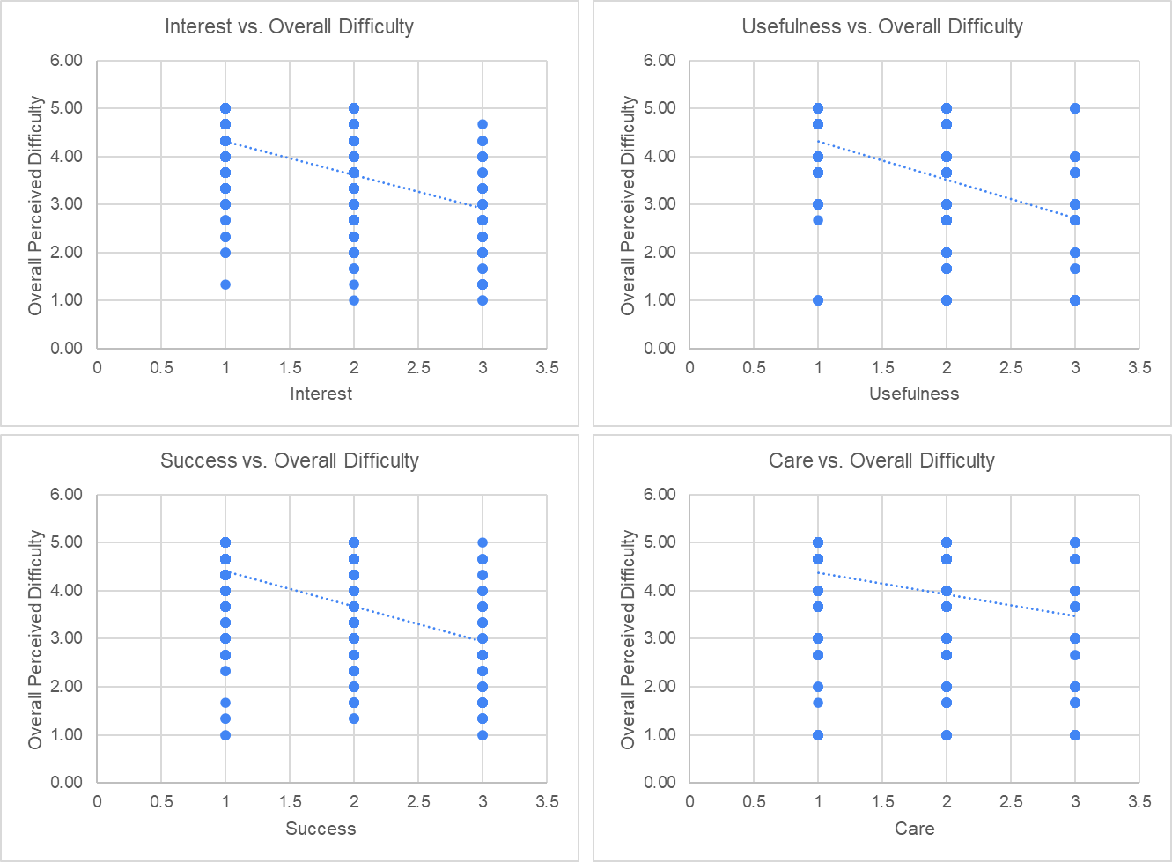
Fig. 3. Composite visualization of the relationship between students' motivation and perceived difficulty in mathematics. The upper matrix presents Pearson Correlation Coefficients between overall perceived difficulty and motivational constructs from the MUSIC model (darker green = stronger correlation). The lower scatterplots illustrate the negative associations between each motivational component and perceived difficult.
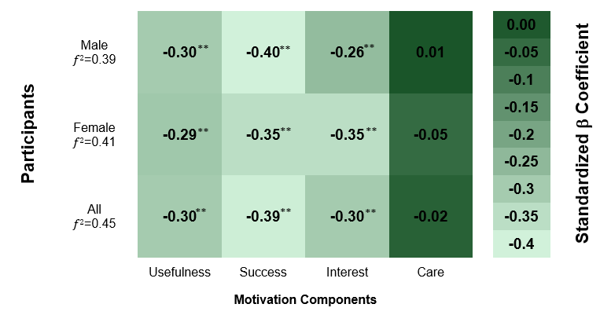
Fig. 4. Heatmap showing Linear Regression Coefficients (β) from models predicting Overall Perceived Mathematics Difficulty from Motivational Components in the MUSIC model. Results of all participants and disaggregated by gender are presented. Darker shades indicate stronger negative associations. (**p < .001).

5.2.4 Gender Differences in Motivation-Difficulty Correlation

Fisher’s z-tests assessed whether motivation-difficulty correlations varied by gender. Only the Usefulness factor showed a significant gender difference (z = 2.19, p < .05), with females reporting a stronger correlation (r = -0.50) than males (r = -0.45) (Table 4).

Table 4. Gender Differences in Motivation-Difficulty Relationships (Fisher’s z)
Factor | r (Male) | r (Female) | z-score | Significance
Usefulness | -0.45 | -0.50 | 2.19 | Significant
Success | -0.47 | -0.51 | 1.24 | Not Sig.
Interest | -0.41 | -0.54 | 1.47 | Not Sig.
Care | -0.19 | -0.32 | 1.52 | Not Sig.

5.2.5 Motivation and Domain-Specific Difficulties

Finally, four separate regression models were conducted to examine how motivational components predicted perceived difficulty in the domains of Geometry, Algebra, Numbers, and Word Problems. Across all models, Interest emerged as the most consistent predictor, while Usefulness did not significantly predict difficulty in any domain. The Success component significantly predicted perceived difficulty in Geometry, Algebra, and Numbers, but not in Word Problems. In contrast, the Care component showed predictive value only for Geometry and Word Problems. To evaluate the strength of these models, Cohen’s f² effect sizes were computed, yielding medium effects for Geometry (f² = 0.27), Algebra (f² = 0.29), and Numbers (f² = 0.26), and a small effect for Word Problems (f² = 0.10) (Figure 5). The observed effect sizes indicate that motivational influences are more substantial in some domains than others, highlighting domain-specific differences in the practical impact of motivation on perceived difficulty.
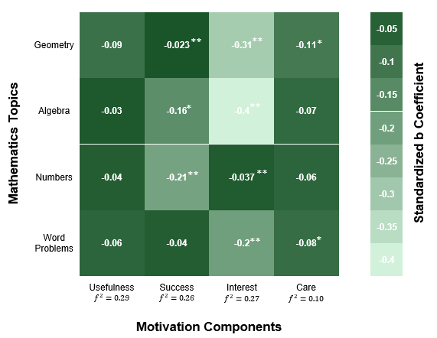
Fig. 5. Heatmap illustrating standardized regression coefficients (β) from models predicting perceived difficulty across mathematics domains based on motivational components of the MUSIC model. Darker shades indicate stronger negative associations. Significance levels (*p < .05, *p < .001) and Cohen’s f² effect sizes are shown.

6. Discussion

This study examines the relationship between students’ perceptions of mathematics and their motivational beliefs across specific mathematical domains, with particular attention to Lebanese students during the transition from elementary to middle school. The findings highlight several key patterns. Significant negative associations were identified between selected motivational constructs and students’ perceived difficulty in mathematics, both at the overall level and within specific mathematical domains during this transitional period. In addition, gender-related differences emerged in certain motivational dimensions and mathematical domains, pointing to the importance of examining how motivation and gender interact during early adolescence.
Taken together, these findings underscore the value of adopting a multidimensional perspective when examining students’ experiences of mathematical difficulty. Such an approach integrates cognitive, emotional, and behavioral aspects of learning and highlights the role of both intrinsic factors, including usefulness, confidence in success, and interest, and extrinsic factors, such as empowerment and caring, in shaping how students perceive and respond to mathematics.

6.1 Correlation between motivation and perceived difficulty

The results of this study revealed a significant negative relationship between students’ perceived difficulty in mathematics and three intrinsic motivational components of the MUSIC model, namely usefulness, confidence in success, and interest. In contrast, the caring component did not show a statistically significant association with perceived difficulty, suggesting limited evidence for its direct influence on how students experience mathematical challenge. These findings point to the importance of further research to better understand how extrinsic motivational factors, such as caring and support, may shape students’ attitudes toward mathematics in different instructional contexts.

The findings suggest that students’ perceptions of mathematics as an inherently difficult subject are not fixed and can be reshaped through targeted motivational support. In particular, fostering students’ interest in mathematics, highlighting its practical relevance, and strengthening their confidence in their own abilities appear to play an important role in reducing perceived difficulty. These conclusions are consistent with previous research indicating that internal motivational factors, such as confidence in success, perceived usefulness, and interest, exert a stronger influence on students’ learning experiences than external factors alone (El-Adl & Elkharusi, 2020; Rodrigues et al., 2021; Yurt, 2015). In this regard, cultivating a supportive mathematics learning environment through strategies such as collaborative learning, framing mistakes as opportunities for growth, and reinforcing students’ beliefs in their mathematical competence may contribute to lowering perceptions of difficulty (Wigfield et al., 2015).

The analyses also indicated meaningful associations between students’ perceived difficulty in specific mathematical topics and certain motivational dimensions. In particular, higher levels of interest were consistently associated with lower perceived difficulty across Geometry, Algebra, Numbers, and Word Problems, suggesting that students who are more engaged and interested in these topics tend to experience them as less challenging. These findings align with previous research highlighting the central role of intrinsic motivation in shaping students’ attitudes and experiences in mathematics learning (El-Adl & Elkharusi, 2020; Yurt, 2015).

By contrast, perceived usefulness did not show significant relationships with difficulty across the examined mathematical domains, indicating that recognizing the relevance of mathematics alone may not be sufficient to reduce perceptions of difficulty at the topic level. In addition, confidence in success was negatively related to perceived difficulty in Geometry and Algebra, emphasizing the importance of self-efficacy in how students experience more abstract mathematical content. This result aligns with Bandura’s (1997) work on self-efficacy and its influence on academic engagement and performance. Taken together, these findings point to the need for instructional approaches that strengthen students’ interest and confidence within specific mathematical topics, supporting existing literature on the role of intrinsic motivation in reducing perceived difficulty and enhancing learning experiences (Wigfield et al., 2015).

The distribution of skewness values provides additional insight into these findings. Motivation scores for both male and female students were negatively skewed, indicating that a large proportion of participants reported relatively high levels of motivation toward mathematics. In contrast, perceived difficulty scores were positively skewed, showing that most students did not experience mathematics as highly difficult, while a smaller group reported greater levels of challenge. Together, these patterns highlight the importance of sustaining motivational support, as higher motivation appears to be associated with lower perceptions of difficulty for the majority of learners.

One important consequence of perceiving mathematics as difficult is the potential development of negative attitudes toward the subject. Over time, such attitudes may contribute to students avoiding mathematics-related studies and career pathways, an issue that deserves further investigation. This concern is particularly relevant given the increasing demand for individuals with strong mathematical and analytical skills in contemporary, technology-oriented societies (Rawat & Mishra, 2022).

In response to these challenges, the integration of technology into mathematics instruction has been identified as a promising avenue for enhancing student engagement (Serin, 2023). Technology-supported learning environments can offer interactive and personalized experiences, provide timely feedback, and help connect mathematical concepts to real-world contexts. This interpretation is supported by a context-specific meta-analysis demonstrating that the use of digital tools in secondary mathematics and science education has a significant positive effect on student learning outcomes, particularly when technology is used alongside instruction and supported by teacher training (Hillmayr et al., 2020). Building on these possibilities, adopting an interdisciplinary STEM-oriented approach that integrates mathematics with science and technology may further strengthen students’ motivation and improve their perceptions of mathematics (Berisha & Vula, 2023; Wan et al., 2023).

6.2 Topic-specific perceived Difficulty

The findings of this study support the assumption that difficulties encountered in specific mathematical domains contribute to students’ broader perceptions of mathematics as a difficult subject. This relationship was evidenced by significant associations between perceived difficulty in individual curriculum areas and students’ overall perceptions of mathematics, with Geometry showing the strongest link, followed by Algebra and Numbers. These results suggest that addressing challenges within high difficulty domains may have wider benefits for improving students’ general attitudes toward mathematics.

Patterns observed in the skewness of domain specific difficulty scores further reinforce this interpretation. Geometry and Word Problems exhibited mild positive skewness, indicating that although these areas were perceived as more challenging overall, most students still rated them as relatively manageable, with fewer students reporting very high levels of difficulty. By contrast, the Numbers domain demonstrated a stronger positive skew, particularly among male students, suggesting that it was widely perceived as less difficult. Examining these distribution patterns provides a more nuanced understanding of students’ experiences and helps identify domains where targeted instructional support may be most needed.

From a cognitive perspective, difficulties in domains such as Geometry may be linked to increased demands on visual spatial reasoning, working memory, and the management of cognitive load. Successfully engaging with geometry often requires students to interpret diagrams, mentally manipulate shapes, track transformations, and apply abstract principles, all of which place substantial demands on working memory. These challenges may be especially pronounced during early adolescence, a period marked by ongoing cognitive development (Geary, 2011). Prior research has shown that weaker visual spatial abilities are associated with lower performance in geometry related tasks (Mix et al., 2016). When students are not provided with sufficient scaffolding or opportunities to gradually develop these cognitive skills, their learning experiences may reinforce perceptions of mathematics, and geometry in particular, as excessively difficult (Passolunghi & Siegel, 2004).

The transition from elementary to middle school is characterized by increasing academic expectations and greater curricular complexity, which may further intensify students’ perceptions of difficulty, particularly in conceptually demanding areas such as Geometry and Algebra. Recognizing this stage as a critical period for intervention is therefore essential for supporting students’ mathematical development.

Consistent with these findings, Simzar et al. (2016) reported declines in both self efficacy and task value among students enrolled in Algebra courses compared to peers studying general mathematics. Similarly, Mahendra and Slamet (2017) demonstrated that instructional approaches such as Realistic Mathematics Education can promote more active engagement in Geometry learning. Additional research suggests that the integration of technological tools may help reduce perceived difficulty in specific mathematical domains by making abstract concepts more concrete and accessible. Interactive visualizations, geometry construction software, virtual reality, and augmented reality applications have been shown to support conceptual understanding and problem solving in Geometry (Hwang & Hu, 2013). In Algebra, the use of interactive platforms, mobile applications, and graphing tools has likewise been associated with improved learning experiences and student engagement (Del Cerro Velázquez & Morales Méndez, 2021). By supporting understanding and reducing cognitive overload, such tools may enhance students’ confidence and foster more positive perceptions of mathematics as an approachable and manageable subject.

6.3 Gender-based differences
An examination of gender related differences offers important insight into how motivation and domain specific challenges shape students’ overall perceptions of mathematics. The findings indicate that female students who report greater difficulty in Geometry, Algebra, and Numbers are more likely to perceive mathematics as difficult overall, suggesting that these domains play a particularly influential role in shaping girls’ experiences of the subject. In addition, intrinsic motivational factors, including interest, perceived usefulness, and confidence in success, were more strongly associated with perceived mathematical difficulty among female students than among males. Notably, perceived usefulness demonstrated a significant gender difference, with girls showing a stronger negative association between motivation and perceived difficulty. This pattern highlights the potential importance of emphasizing the relevance and value of mathematics for female students, as such perceptions may have a more pronounced impact on how they experience mathematical challenge.

Patterns observed in the skewness of motivation and difficulty scores further contextualize these gender differences. Although both male and female students displayed negatively skewed motivation scores, indicating generally high motivation levels, the distribution for male students was slightly more concentrated, suggesting a higher clustering of very motivated individuals. Conversely, perceived difficulty scores for female students showed a less pronounced positive skew compared to males, which may reflect a wider range of difficulty experiences among girls. These distributional differences point to subtle variations in how motivation relates to perceived competence across genders and underscore the need to address both cognitive and affective dimensions of mathematics learning.

These findings are broadly consistent with earlier research emphasizing the importance of motivational support for girls in mathematics education (Rustemeyer & Fischer, 2005). At the same time, they diverge from studies conducted in the Lebanese context that have reported minimal gender differences in mathematics attitudes and self-efficacy (Mozahem et al., 2020; Sarouphim & Ayurouny, 2017). Such discrepancies may be explained by differences in research design, sample characteristics, or the specific constructs examined. Unlike prior work, the present study focuses explicitly on the relationship between intrinsic motivational beliefs and perceived difficulty, both at the general level and within specific mathematical domains. By examining students during the transition from elementary to middle school and grounding the analysis in the MUSIC model, this study offers a more nuanced and context sensitive perspective on how gender may shape mathematical experiences in Lebanon. These results reinforce the importance of situating gender related findings within local educational contexts rather than relying on generalized assumptions.

Further analysis revealed that the relationship between difficulties in specific mathematical domains and overall perceptions of mathematics was stronger for female students, particularly in Geometry. This pattern may be partially influenced by gender differences in cognitive processing or spatial abilities, as suggested in prior research (Reilly et al., 2016). Although no substantial gender differences were observed for Algebra or Numbers, the relatively weaker associations in these domains suggest that they contribute less to students’ overall perceptions of difficulty compared to Geometry. Addressing challenges in highly demanding areas through supportive instructional environments, meaningful real world applications, effective use of technology, and responsive teaching strategies may therefore be especially beneficial for improving girls’ attitudes toward mathematics. Without such support, negative perceptions may persist and reduce the likelihood that female students pursue mathematics related pathways. Overall, these findings highlight the importance of educational approaches that simultaneously address motivational and cognitive factors in order to promote more equitable learning experiences for all students.

8. Conclusion
This study examined how students’ motivational beliefs relate to their perceptions of difficulty in mathematics, as well as the challenges they experience in specific mathematical domains during the transition from elementary to middle school in Lebanon. The findings indicate that intrinsic motivational factors, particularly interest, perceived usefulness, and confidence in success, are closely linked to lower perceptions of mathematical difficulty, underscoring the potential value of motivation oriented approaches in shaping more positive student attitudes toward mathematics. In addition, difficulties reported in specific content areas, including Geometry, Algebra, and Numbers, were strongly associated with students’ overall perceptions of mathematics, pointing to the importance of providing targeted instructional support within these domains.
The results also suggest that the thoughtful integration of technology into mathematics instruction may offer meaningful opportunities to enhance student engagement and conceptual understanding. Gender related analyses further revealed that motivational factors were more strongly associated with perceived difficulty among female students, highlighting the need for instructional strategies that attend to both cognitive and emotional dimensions of learning. Taken together, these findings offer context sensitive insights that may inform curriculum design, classroom practice, and educational policy, with the goal of fostering more positive, supportive, and equitable experiences of mathematics for middle school students in Lebanon. Future research may further strengthen this contextual understanding by drawing on recent empirical studies and policy analyses within the Lebanese educational system, including reports published by the Centre for Educational Research and Development (CRDP).

Disclaimer (Artificial intelligence)
The authors declare that no generative artificial intelligence technologies (such as large language models, including ChatGPT or Copilot, or text-to-image generators) were used in the writing or editing of this manuscript.

References

Alspaugh, J. W. (1998). Achievement loss associated with the transition to middle school and high school. The Journal of Educational Research, 92(1), 20–25.

Akos, P., Shoffner, M., & Ellis, M. (2007). Mathematics placement and the transition to middle school. Professional School Counseling, 10(3), 215–222. https://doi.org/10.1177/2156759X0701000304

Allen, M. S., Iliescu, D., & Greiff, S. (2022). Single item measures in psychological science. European Journal of Psychological Assessment, 38(1), 1–5. https://doi.org/10.1027/1015-5759/a000699

Ayebale, L., Habaasa, G., & Tweheyo, S. (2020). Factors affecting students’ achievement in mathematics in secondary schools in developing countries: A rapid systematic review. Statistical Journal of the IAOS, 36(1), 73–76. https://doi.org/10.3233/SJI-200713

Bandura, A., Barbaranelli, C., Caprara, G. V., & Pastorelli, C. (2001). Self-efficacy beliefs as shapers of children’s aspirations and career trajectories. Child Development, 72(1), 187–206. https://doi.org/10.1111/1467-8624.00273

Berisha, F., & Vula, E. (2023). Introduction of integrated STEM education to pre-service teachers through collaborative action research practices. International Journal of Science and Mathematics Education. https://doi.org/10.1007/s10763-023-10417-3

Bjork, R. A. (1994). Memory and metamemory considerations in the training of human beings. In J. Metcalfe & A. P. Shimamura (Eds.), Metacognition: Knowing about knowing (pp. 185–205). MIT Press.

Clements, D. H., & Sarama, J. (2020). Learning and teaching early math: The learning trajectories approach. Routledge.

CRDP. (2023). Center for Educational Research and Development. https://www.crdp.org/en_test_crd

Cronbach, L. J. (1951). Coefficient alpha and the internal structure of tests. Psychometrika, 16(3), 297–334.

Del Cerro Velázquez, F., & Morales Méndez, G. (2021). Application in augmented reality for learning mathematical functions: A study for the development of spatial intelligence in secondary education students. Mathematics, 9(4), 369. https://doi.org/10.3390/math9040369

DeWolf, M., Bassok, M., & Holyoak, K. J. (2016). A set for relational reasoning: Facilitation of algebraic modeling by a fraction task. Journal of Experimental Child Psychology, 152, 351–366. https://doi.org/10.1016/j.jecp.2016.06.016

Eccles, J. S., & Wigfield, A. (2002). Motivational beliefs, values, and goals. Annual Review of Psychology, 53, 109–132. https://doi.org/10.1146/annurev.psych.53.100901.135153

Eccles-Parsons, J. S., Adler, T. F., Futterman, R., Goff, S. B., Kaczala, C. M., Meece, J. L., & et al. (1983). Expectancies, values, and academic behaviors. In J. T. Spence (Ed.), Achievement and achievement motives (pp. 75–146).

El-Adl, A., & Elkharusi, H. (2020). Relationships between self-regulated learning strategies, learning motivation and mathematics achievement. Cypriot Journal of Educational Sciences, 15(1), 104–111.

Evans, S. (2020). The self-efficacy of rural middle school teachers working with families in relation to student achievement (Doctoral dissertation, Liberty University).

Geary, D. C. (2011). Cognitive predictors of achievement growth in mathematics: A 5-year longitudinal study. Developmental Psychology, 47(6), 1539–1552.

Guven, B. (2012). Using dynamic geometry software to improve eighth grade students’ understanding of transformation geometry. Australasian Journal of Educational Technology, 28(2). https://doi.org/10.14742/ajet.878

Hidi, S., & Renninger, K. A. (2006). The four-phase model of interest development. Educational Psychologist, 41(2), 111–127.

Hillmayr, D., Ziernwald, L., Reinhold, F., Hofer, S. I., & Reiss, K. M. (2020). The potential of digital tools to enhance mathematics and science learning in secondary schools: A context-specific meta-analysis. Computers & Education, 153, 103897. https://doi.org/10.1016/j.compedu.2020.103897

Hurst, M., & Cordes, S. (2017). When being good at math is not enough: How students’ beliefs about the nature of mathematics impact decisions to pursue optional math education. In U. X. Eligio (Ed.), Understanding emotions in mathematical thinking and learning (pp. 221–241). Academic Press. https://doi.org/10.1016/B978-0-12-802218-4.00008-X

Hyde, J. S., Fennema, E., & Lamon, S. J. (1990). Gender differences in mathematics performance: A meta-analysis. Psychological Bulletin, 107(2), 139–155.

Hwang, W.-Y., & Hu, S.-S. (2013). Analysis of peer learning behaviors using multiple representations in virtual reality and their impacts on geometry problem solving. Computers & Education, 62, 308–319. https://doi.org/10.1016/j.compedu.2012.10.005

Jabor, M. K., Machtmes, K., Kungu, K., Buntat, Y., & Nordin, M. S. (2011, February). Does parent educational status matter on the students’ achievement in science. In International Conference on Social Science and Humanity (Vol. 5, No. 1, pp. 309-313).

Jones, B. D. (2009). Motivating students to engage in learning: The MUSIC model of academic motivation. International Journal of Teaching and Learning in Higher Education, 21(2), 272–285.

Jones, B. D., & Skaggs, G. (2016). Measuring students’ motivation: Validity evidence for the MUSIC Model of Academic Motivation Inventory. International Journal for the Scholarship of Teaching and Learning, 10(1).

Mahendra, R., & Slamet, I. (2017). Problem posing with realistic mathematics education approach in geometry learning. Journal of Physics: Conference Series, 895(1), 012046. https://doi.org/10.1088/1742-6596/895/1/012046

Mangels, J. A., Butterfield, B., Lamb, J., Good, C., & Dweck, C. S. (2006). Why do beliefs about intelligence influence learning success? A social cognitive neuroscience model. Social Cognitive and Affective Neuroscience, 1(2), 75–86.

Mix, K. S., Levine, S. C., Cheng, Y.-L., Young, C., Hambrick, D. Z., Ping, R., & et al. (2016). Separate but correlated: The latent structure of space and mathematics across development. Journal of Experimental Psychology: General, 145(9), 1206–1227. https://doi.org/10.1037/xge0000182

Mozahem, N. A., Boulad, F. M., & Ghanem, C. M. (2020). Secondary school students and self-efficacy in mathematics: Gender and age differences. International Journal of School & Educational Psychology, 9(1), 1–11. https://doi.org/10.1080/21683603.2020.1763877

Naidoo, J., & Kapofu, W. (2020). Exploring female learners’ perceptions of learning geometry in mathematics. South African Journal of Education, 40(2), 1–11.

Obersteiner, A., Dresler, T., Bieck, S. M., & Moeller, K. (2019). Understanding fractions: Integrating results from mathematics education, cognitive psychology, and neuroscience. In A. Norton & M. W. Alibali (Eds.), Constructing number (pp. 135–162). Springer. https://doi.org/10.1007/978-3-030-00491-0_7

Passolunghi, M. C., & Siegel, L. S. (2004). Working memory and access to numerical information in children with disability in mathematics. Journal of Experimental Child Psychology, 88(4), 348–367. https://doi.org/10.1016/j.jecp.2004.04.002

Raj Acharya, B. (2017). Factors affecting difficulties in learning mathematics by mathematics learners. International Journal of Elementary Education, 6(2), 8–15. https://doi.org/10.11648/j.ijeedu.20170602.11

Rawat, K., & Mishra, M. K. (2022). Role of mathematics in novel artificial intelligence realm. In Mathematics in computational science and engineering (pp. 211–231).

Reilly, D., Neumann, D. L., & Andrews, G. (2016). Gender differences in spatial ability: Implications for STEM education and approaches to reducing the gender gap for parents and educators. In M. S. Khine (Ed.), Visual-spatial ability in STEM (pp. 195–224). Springer. https://doi.org/10.1007/978-3-319-44385-0_10

Rodrigues, S. N., Henriques, H. R., & Henriques, M. A. (2021). Effectiveness of preoperative breathing exercise interventions in patients undergoing cardiac surgery: A systematic review. Revista Portuguesa de Cardiologia, 40(3), 229–244. https://doi.org/10.1016/j.repc.2020.08.013

Ryan, R. M., & Deci, E. L. (2000). Self-determination theory and the facilitation of intrinsic motivation, social development, and well-being. American Psychologist, 55(1), 68–78. https://doi.org/10.1037/0003-066X.55.1.68

Sarabi, M. K., & Gafoor, K. A. (2017). Influence of linguistic challenges on attitude towards mathematics learning among upper primary students of Kerala. Online Submission.

Sarouphim, K. M., & Chartouny, M. (2017). Mathematics education in Lebanon: Gender differences in attitudes and achievement. Educational Studies in Mathematics, 94(1), 55–68. https://doi.org/10.1007/s10649-016-9712-9

Sansone, C., & Harackiewicz, J. M. (Eds.). (2000). Intrinsic and extrinsic motivation: The search for optimal motivation and performance. Elsevier.

Schweinle, A., Berg, P. J., & Sorenson, A. R. (2013). Preadolescent perceptions of challenging and difficult course activities and their motivational distinctions. Educational Psychology, 33(7), 797-816.

Serin, H. (2023). Teaching mathematics: The role of project-based learning. International Journal of Social Sciences & Educational Studies, 10(1).

Silver, A. M., & Libertus, M. E. (2022). Environmental influences on mathematics performance in early childhood. Nature Reviews Psychology, 1(7), 407–418. https://doi.org/10.1038/s44159-022-00061-z

Simzar, R. M., Domina, T., & Tran, C. (2016). Eighth grade algebra course placement and student motivation for mathematics. AERA Open, 2(1), 1–26. https://doi.org/10.1177/2332858415625227

Center for Educational Research and Development (CRDP). (2023). Education in Lebanon: Structure and system overview. Beirut, Lebanon: CRDP. https://www.crdp.org

Wan, Z. H., English, L., So, W. W. M., & Skilling, K. (2023). STEM integration in primary schools: Theory, implementation and impact. International Journal of Science and Mathematics Education, 21(1), 1–9. https://doi.org/10.1007/s10763-023-10401-x

Wardat, Y., Belbase, S., Tairab, H., Takriti, R. A., Efstratopoulou, M., & Dodeen, H. (2023). The influence of student factors on students’ achievement in the Trends in International Mathematics and Science Study in Abu Dhabi Emirate schools. Frontiers in Psychology, 14. https://doi.org/10.3389/fpsyg.2023.1168032

Wigfield, A., Eccles, J. S., Fredricks, J. A., Simpkins, S., Roeser, R. W., & Schiefele, U. (2015). Development of achievement, motivation and engagement. In M. E. Lamb & R. M. Lerner (Eds.), Handbook of child psychology and developmental science: Socioemotional processes (7th ed., pp. 657–700). Wiley.

Yurt, E. (2015). Understanding middle school students’ motivation in math class: The expectancy-value model perspective. International Journal of Education in Mathematics, Science and Technology, 3(4), 288–297.

