Housing Affordability in Urban Ghana: Prospects and Challenges in Asokore Mampong, Kumasi
ABSTRACT
Housing affordability had emerged as a critical urban challenge in Ghana, yet empirical evidence at the sub-city level remained limited. This study examined the dynamics of rental affordability in Asokore Mampong, a rapidly urbanizing municipality within the Kumasi Metropolis. Using a mixed-methods design, the study integrated survey data from 120 households with qualitative insights from 10 key informants to assess the prospects and constraints shaping access to affordable housing. Guided by Shelter Poverty Theory and Institutional Theory, the analysis explored how income levels, rent structures, cultural tenure systems, and governance inefficiencies interacted to influence affordability outcomes. By providing one of the few localized, municipal-level assessments of rental affordability in Ghana, the study offered empirical insights that remain largely absent from current scholarship. The findings showed that 74% of households spent more than 30% of their income on rent, indicating widespread shelter poverty. Two-year advance rent payments, agent exploitation, and weak rent regulation were identified as the most severe constraints. Although compound houses and family-based tenure systems provided partial affordability buffers, these were increasingly undermined by rising land values, overcrowding, and infrastructural deficits. Institutional weaknesses, particularly limited enforcement capacity, low public awareness of housing programmes, and fragmented land-governance systems further restricted affordable housing access. The paper concluded that affordability challenges in Asokore Mampong resulted from the combined effects of household-level vulnerability and systemic governance deficits. Strengthening rent regulation, improving institutional coordination, upgrading informal housing stock, and expanding financial support for low-income tenants were recommended.
Keywords: Housing affordability; Rental housing; Institutional governance; Shelter poverty; Urban Ghana.
1. INTRODUCTION
Housing affordability has become one of the most pressing urban challenges globally, with rising housing costs, rapid urbanization, and widening socio-economic inequalities deepening disparities in access to adequate shelter. International evidence illustrates how affordability constraints have intensified across diverse contexts. In Europe, low-income households increasingly spend more than 40 percent of their disposable income on rent and utilities (OECD, 2021). In the United States, homelessness reached 771,488 individuals in January 2024, marking an 18 percent rise and underscoring the consequences of housing unaffordability (HUD, 2024). Similar pressures have been recorded in Asia and Australia, where rising land values, informal settlements, and socio-political dissatisfaction reflect deepening affordability crises (Mrani et al., 2025; World Economic Forum, 2019). These global trends demonstrate that housing affordability is a multidimensional issue with profound implications for welfare, productivity, and inclusive urban development.
The challenge is particularly acute in Sub-Saharan Africa, where the region faces a housing deficit exceeding 50 million units, and nearly 85 percent of urban residents remain outside formal housing finance systems (CAHF, 2024). Weak institutional frameworks, limited access to mortgages, and rapid urbanization exacerbate affordability problems, pushing the majority of low-income households into informal or substandard housing arrangements (Khan, 2018). These deficits intersect with broader development challenges, including poverty, unemployment, and environmental degradation, making affordable housing a central concern for sustainable urban development in the region (UN-Habitat, 2020).
Ghana reflects these continental patterns. Urbanization has accelerated significantly, with the urban population projected to increase from 50.9 percent in 2010 to 65 percent by 2030 (Ghana Statistical Service [GSS], 2013). However, the pace of housing delivery has not matched population growth, resulting in a widening affordability gap and the proliferation of slums, overcrowded dwellings, and rent burdens that exceed internationally accepted thresholds (Arku, 2009; GSS, 2021). Policy interventions, including the 2005 Affordable Housing Project, have struggled due to high construction costs, limited political commitment, and misalignment between target beneficiaries and actual low-income needs (Yeboah, 2005; Damoah et al., 2020). Consequently, informal rental systems, particularly compound houses, continue to dominate Ghana’s urban housing landscape (GSS, 2021; Gough & Yankson, 2000).
Within the Ashanti Region, Kumasi and its surrounding municipalities illustrate these challenges vividly. Kumasi experienced rapid expansion in the 2000s and 2010s, accompanied by significant loss of peri-urban land, speculative development, and rising housing costs (Cobbinah & Amoako, 2012; Cobbinah, Erdiaw-Kwasie, & Amoateng, 2015). Asokore Mampong, carved out as a municipality in 2012, has since emerged as a major residential hub characterized by dense compound housing, a highly mobile population, and intensifying land values. These conditions reflect growing pressure on the rental sector, where households increasingly face affordability constraints, tenure insecurity, and infrastructural deficits (GSS, 2014; Adjei-Poku et al., 2023). Yet despite its rapid urbanization and distinctive socio-cultural configuration, Asokore Mampong remains under-examined in scholarly discourse relative to Accra and central Kumasi.
A review of existing literature reveals three persistent gaps. First, localized, municipal-level studies of affordability remain limited in Ghana, even though affordability dynamics vary significantly across urban neighbourhoods and municipalities (Cobbinah et al., 2015; GSS, 2021). Second, few studies integrate household-level affordability metrics with institutional analysis, despite evidence that governance failures such as weak rent regulation, fragmented land management, and limited coordination between traditional and formal authorities significantly shape housing outcomes (Yeboah, 2005; North, 1990; Damoah et al., 2020). Third, the influence of cultural tenure systems, including family-based housing and inheritance, remains insufficiently explored, even though these systems continue to shape access to shelter for a large proportion of urban residents (Gough & Yankson, 2000; Cobbinah & Amoako, 2012).
This study addresses these gaps by examining the prospects and challenges of housing affordability in Asokore Mampong through a mixed-methods approach integrating quantitative survey data and qualitative interviews. Guided by Shelter Poverty Theory (Stone, 2006, 2010) and Institutional Theory (North, 1990), the study investigates how rent burdens, income characteristics, cultural tenure systems, and institutional inefficiencies interact to shape affordability outcomes. By providing one of the few municipal-level assessments of rental affordability in Ghana, this study contributes new empirical evidence to the discourse on housing in rapidly urbanizing Sub-Saharan African contexts and offers policy-relevant insights for strengthening affordable housing governance.
2. OVERVIEW OF LITERATURE
Housing is widely recognized as both a social good and an economic asset, shaping individual welfare, productivity, and national development trajectories (Stone, 2006; Igwe et al., 2017). The discourse on housing affordability has expanded globally as rising housing costs, demographic shifts, and inequality intensify pressure on urban housing systems (World Economic Forum, 2019; OECD, 2021). This section synthesizes conceptual, theoretical, and empirical literature to situate the present study within broader scholarly debates.
2.1 Conceptual Foundations of Housing Affordability
Affordable housing is most commonly defined using the expenditure-to-income ratio, where households are considered burdened if they spend more than 30 percent of their income on housing (Stone, 2006). However, this metric has been critiqued for its inability to capture variations in household needs, family composition, and local economic conditions. Alternative approaches, particularly the residual-income perspective, define affordability by the income remaining after housing costs (Ndubueze, 2009; Ezennia & Hoskara, 2022). This perspective is especially relevant in low- and middle-income contexts, where households balance housing expenditures with essential non-housing goods such as education, food, and healthcare.
In Sub-Saharan Africa, affordability encompasses not only cost but also housing quality, tenure security, and access to infrastructure (CAHF, 2024). Informal housing systems are widespread, shaped by weak mortgage markets, high land values, and extensive customary tenure arrangements (Kasanga & Kotey, 2001; Gough & Yankson, 2000). In Ghana, affordability definitions emphasize “reasonably priced” housing accessible to average-income households (Damoah et al., 2020), but implementation has been inconsistent, and formal housing delivery remains limited.
2.2 Global and Regional Empirical Perspectives
International studies show persistent affordability crises even in advanced economies. In Europe, rent burdens exceeding 40 percent of income have become common among low-income households (OECD, 2021). In the United States, the 2024 Annual Homeless Assessment Report documented more than 771,000 homeless individuals, reflecting structural affordability challenges (HUD, 2024). Across Asia, rapid urbanization and rising land prices have intensified informal settlements and triggered social unrest over housing deficits (Mrani et al., 2025; UN-Habitat, 2020).
In Sub-Saharan Africa, affordability challenges are intensified by rapid population growth, limited access to housing finance, and widespread informality. South Africa’s Reconstruction and Development Programme (RDP) attempted large-scale housing delivery but often fell short in meeting location and quality needs (Khan, 2018). In Nigeria, affordability remains constrained by high construction costs and inadequate financial access (Ndubueze, 2009). Across East Africa, mortgage penetration remains below 5 percent, forcing households into self-build or informal rental markets (CAHF, 2024).
2.3 Housing Affordability in Ghana
Ghana faces a housing deficit exceeding 1.7 million units, with demand expected to rise as urbanization accelerates (GSS, 2014). Despite policy commitments, state-led affordable housing projects have frequently stalled due to limited funding, political discontinuity, and misalignment between target groups and actual low-income needs (Yeboah, 2005; Damoah et al., 2020). Consequently, informal housing, particularly compound houses, dominates urban landscapes and provides shelter for diverse socio-economic groups (GSS, 2021; Gough & Yankson, 2000). Empirical studies highlight persistent rent burdens, tenure insecurity, land management conflicts, and weak regulation of rental markets (Cobbinah & Amoako, 2012; Adjei-Poku et al., 2023). Kumasi, in particular, has experienced rapid peri-urban expansion driven by population growth, informal land conversion, and speculative development (Cobbinah, Erdiaw-Kwasie, & Amoateng, 2015). These pressures have intensified rental demand, contributing to overcrowding and affordability stress.
2.4 Gaps in the Literature
Despite extensive scholarship on Ghana’s housing sector, three gaps remain significant:
- Limited municipal-level evidence. Studies rarely focus on smaller urban municipalities such as Asokore Mampong, even though affordability dynamics differ across urban sub-centres (Cobbinah et al., 2015; GSS, 2021).
- Inadequate integration of institutional analysis. Few studies simultaneously examine household-level affordability and institutional constraints such as rent regulation, land governance, and enforcement gaps (North, 1990; Yeboah, 2005; Damoah et al., 2020).
- Insufficient attention to cultural tenure systems. Compound housing, inheritance, family-based tenure, and informal renting remain understudied despite their centrality to housing access in Ghana (Gough & Yankson, 2000; Cobbinah & Amoako, 2012).
This study addresses these gaps by providing a localized, mixed-methods analysis of rental affordability in Asokore Mampong, which integrates income dynamics, cultural tenure systems, and institutional governance.
2.5 Rent Control Regulation and Landlord–Tenant Dispute Resolution in Ghana
Rental housing in Ghana is regulated primarily under the Rent Act, 1963 (Act 220), which establishes the Rent Control Department (RCD) as the statutory body responsible for regulating rental practices, preventing excessive rent charges, and mediating disputes between landlords and tenants. The Act empowers rent officers to assess rent levels, adjudicate complaints, and resolve landlord–tenant conflicts through administrative procedures at regional and district offices.
In practice, however, the operationalisation of the Rent Act has remained weak. The Rent Control Department faces persistent challenges, including limited staffing, inadequate logistical support, and low institutional presence at the municipal level. These constraints significantly limit enforcement capacity and reduce the effectiveness of rent regulation. As a result, informal rental practices, most notably the widespread requirement for one- to two-year advance rent payments, continue to dominate Ghana’s urban rental markets despite being inconsistent with the spirit of the Act.
Conflict redress between landlords and tenants is therefore often handled through informal negotiation, social mediation, or traditional authorities rather than formal legal channels. This weakens tenant protection, discourages reporting of exploitative practices, and allows unregulated rental arrangements to persist. These enforcement and redress challenges are particularly evident in rapidly urbanising municipalities, where rental demand is high and institutional oversight remains limited.
2.6 Institutional Framework for Urban Housing Governance in Ghana
Urban housing governance in Ghana operates through a multi-layered institutional framework involving statutory agencies, local governments, and customary authorities. At the national level, the Ministry of Works and Housing is responsible for housing policy formulation, while implementation is largely decentralised to metropolitan, municipal, and district assemblies (MMDAs) (Yeboah, 2005; UN-Habitat, 2020). These local authorities oversee physical planning, development control, and housing-related service delivery within urban jurisdictions (Cobbinah & Amoako, 2012; GSS, 2021).
The Rent Control Department functions as the primary institution regulating landlord–tenant relations under the Rent Act, 1963 (Act 220), while land access and tenure arrangements are governed by the Lands Commission alongside customary land authorities (Kasanga & Kotey, 2001; Bugri, 2012). Empirical studies consistently highlight weak coordination among these institutions, resulting in fragmented responsibilities, limited enforcement capacity, and ineffective regulation of rental markets in urban areas (Yeboah, 2005; Damoah et al., 2020).
Customary institutions continue to play a significant role in land allocation and housing access, particularly in inner-city and peri-urban areas. While these institutions provide socially embedded access to housing through family-based tenure and compound housing systems, they often operate outside formal regulatory oversight (Gough & Yankson, 2000; Ubink, 2008). The coexistence of statutory regulation and customary practices has been widely identified as a key source of governance gaps, contributing to tenure insecurity, unregulated rental practices, and affordability stress in urban Ghana (Kasanga & Kotey, 2001; Cobbinah, Erdiaw-Kwasie, & Amoateng, 2015).
This fragmented institutional environment constrains effective housing policy implementation and weakens tenant protection in urban Ghana. Understanding these institutional dynamics is therefore essential for explaining persistent affordability challenges and provides an important contextual foundation for the analytical framework adopted in this study (Bugri, 2012; UN-Habitat, 2020).
2.7 Theoretical Review
This study is guided by two core theories that best explain the dynamics of housing affordability in Asokore Mampong: Shelter Poverty Theory and Institutional Theory. These theories were selected because they align with both the empirical patterns observed in the municipality and contemporary debates on rental housing in urban Ghana.
Shelter Poverty Theory: Shelter Poverty Theory, introduced by Stone (2006; 2010), argues that housing affordability should be assessed based on a household’s residual income, the amount left after paying for housing, rather than simply the proportion of income spent on rent. According to this theory, a household becomes shelter-poor when high housing costs reduce its ability to meet essential non-housing needs such as food, education, healthcare, and transportation. The theory challenges the traditional “30 percent rule” by emphasizing that families with similar rent burdens may experience very different levels of welfare stress depending on their income, household size, and basic consumption needs. Shelter Poverty Theory is therefore highly suited to contexts where rent markets are weakly regulated, advance rent payments are required, and households frequently struggle to balance rent with daily living costs. In this study, Shelter Poverty Theory guides the understanding of how housing expenditures shape welfare outcomes and provides a conceptual basis for examining rental burdens, household vulnerability, and the adequacy of disposable income in urban Ghana.
Institutional Theory: Institutional Theory, as articulated by North (1990), emphasizes the role of institutions, both formal (laws, regulations, agencies) and informal (customary norms, social practices), in shaping economic and social outcomes. Institutions determine how resources are allocated, how markets function, and how individuals access essential services, including housing. In the context of urban housing, Institutional Theory explains how regulatory effectiveness, land administration, rent control, governance structures, and enforcement capacity influence housing supply, rental practices, and affordability. Weak or fragmented institutions can produce unregulated markets, tenure insecurity, inefficient land allocation, and high transaction costs, all of which directly affect access to housing. For this study, Institutional Theory provides a framework for analyzing how governance systems such as rent regulation, municipal oversight, traditional land authorities, and housing policy implementation shape affordability dynamics in Asokore Mampong.
2.8 Conceptual Framework
Figure 1 presents the conceptual framework underpinning this study. The model illustrates how housing affordability outcomes in Asokore Mampong emerge from the interaction between household-level economic pressures, institutional conditions, and contextual livelihood systems. Guided by Shelter Poverty Theory and Institutional Theory, the framework clarifies both the foundational theoretical logic and the pathways that link different factors shaping affordability.
Shelter Poverty Theory (Stone, 2006, 2010) positions income welfare constraints as a primary driver of affordability outcomes. As shown in Figure 1, this theory feeds directly into the central box Affordable Housing Outcomes, highlighting how rent-to-income burdens, advance rent requirements, and reduced disposable income affect households' ability to secure adequate shelter.
Institutional Theory (North, 1990) also connects to the central outcome by emphasizing how weak governance and fragmented regulatory mechanisms contribute to unaffordable rental conditions. This includes weak enforcement of rent control, poor monitoring of landlords and agents, and limited institutional intervention in the local housing market. The arrows in Figure 1 show this parallel influence of institutional effectiveness on household affordability outcomes.
Beneath the central outcome box, Sustainable Livelihoods appears as a contextual mediating factor. This placement reflects its role in shaping how households navigate affordability challenges through compound-house systems, family-based tenure, inheritance, and social networks. As indicated in Figure 1, these livelihood strategies help mediate or cushion the effects of rent burdens, even though they are not formal components of the regulatory system. This aligns with existing literature on Ghana’s urban housing systems, where cultural and social arrangements significantly influence access to shelter.
At the bottom of the framework, the final box translates these dynamics into policy implications and actions. As Figure 1 shows, both the mediating livelihood systems and the affordability outcomes feed into recommended interventions. These include strengthening institutional enforcement, regulating advance rent, upgrading compound houses, and expanding pro-poor financing. This bottom section signals the application value of the conceptual model and ties the analytical logic to practical urban housing policy. Figure 1 demonstrates that housing affordability in Asokore Mampong is shaped by a dual influence of household-level constraints and institutional structures, moderated by contextual livelihood systems. This integrated model provides the analytical foundation for examining both the prospects and challenges of affordable housing within the municipality.

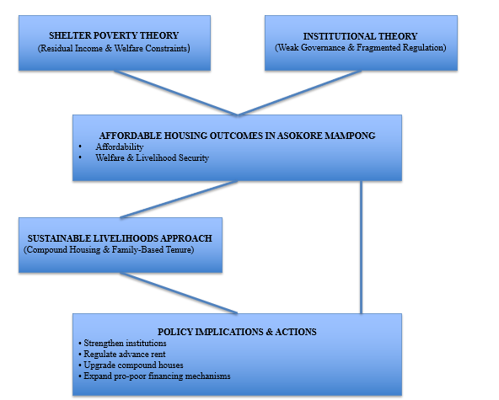
Fig. 1. Conceptual Framework for Housing Affordability in Asokore Mampong
Source: Author’s construct
3. METHODOLOGY
3.1 Study Area
Asokore Mampong Municipality is located within the Greater Kumasi Metropolitan Area, a region experiencing rapid urban expansion and rising housing demand (Cobbinah, Erdiaw-Kwasie & Amoateng, 2015; GSS, 2014). The municipality’s dual customary–statutory land administration system (Kasanga & Kotey, 2001) and its dominance of compound-house rentals (Gough & Yankson, 2000) make it an ideal environment for analyzing rental affordability.
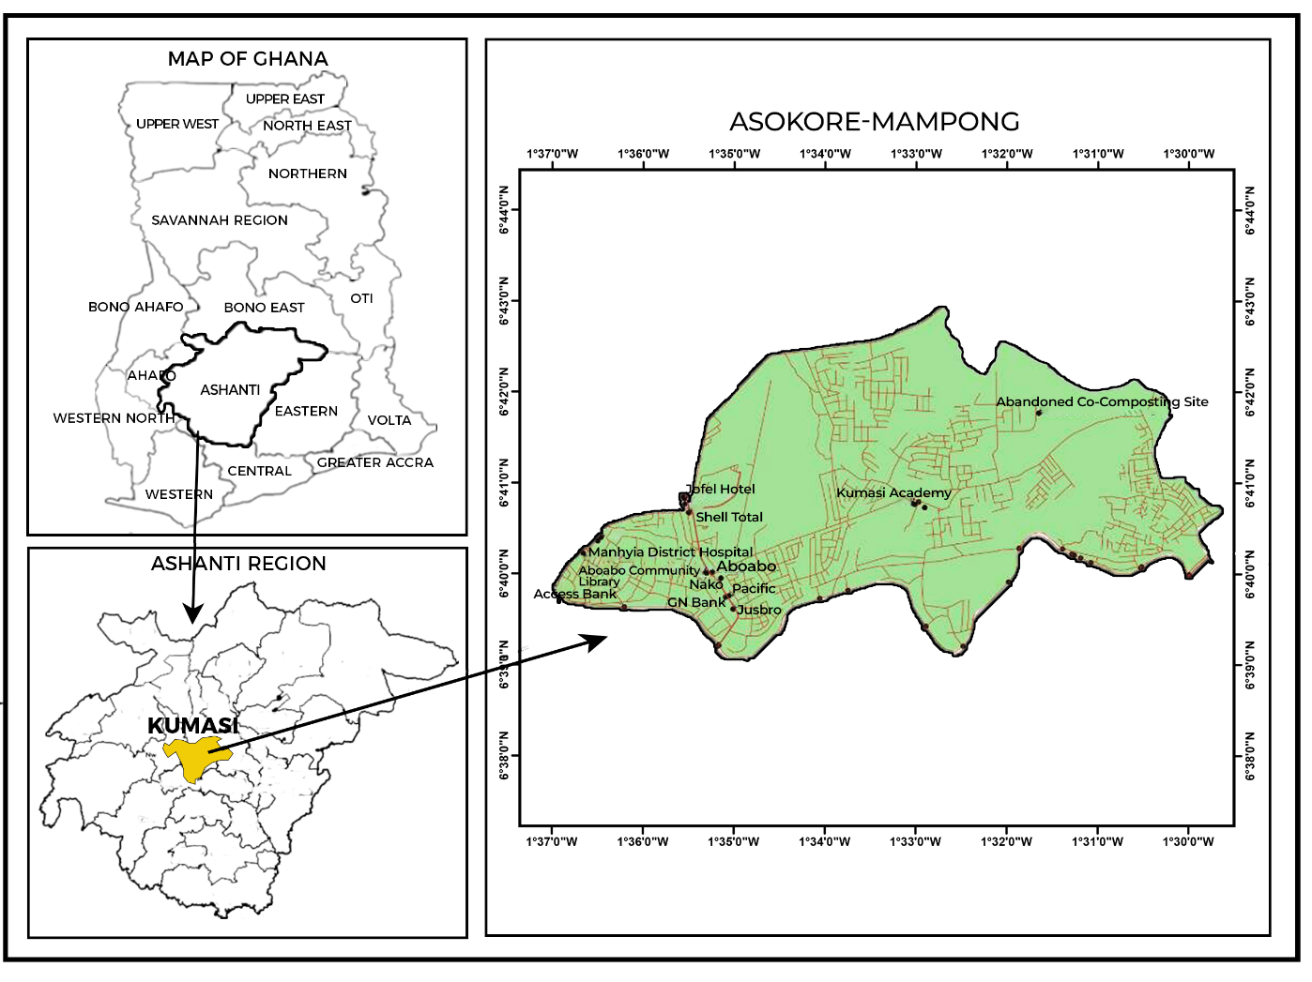
Fig. 2. Map of Asokore Mampong
Source: Authors’ construct
3.2 Research Design
This study employed a mixed-methods design, which is widely recommended for urban affordability studies that involve both quantitative measurement and qualitative institutional assessment (Creswell, 2014). The mixed-methods approach allowed triangulation of survey evidence with institutional insights, consistent with the conceptual framework informed by Shelter Poverty Theory (Stone, 2006; 2010) and Institutional Theory (North, 1990).

3.3 Population and Sampling
The study population included rental households and institutional actors involved in the governance of land and rental markets. A total of 120 households were selected using systematic random sampling to ensure adequate representation across neighbourhood clusters within Asokore Mampong. The sample size is consistent with similar municipal-level housing affordability studies in Sub-Saharan Africa, where household surveys typically range between 100 and 200 respondents for localized urban analysis (Ndubueze, 2009; Ezennia & Hoskara, 2022). This sample size was considered sufficient to capture variations in income, housing typology, and affordability conditions within the municipality while remaining feasible given resource and time constraints.
In addition, ten (10) key informants were purposively selected based on their direct involvement in housing governance, land administration, and rental regulation. Purposive sampling was employed to obtain in-depth institutional insights from actors with specialised knowledge, including municipal officials, Rent Control Department officers, traditional authorities, and community leaders. Such a sample size is widely regarded as adequate for achieving informational saturation in qualitative institutional studies at the municipal level (Patton, 2002).
3.4 Data Collection
A structured questionnaire was used to collect information on income, rent, advance rent payments, housing characteristics, and neighbourhood access. Prior to the main survey, the questionnaire was pretested through a pilot survey involving a small number of rental households in a neighbouring community with similar socio-economic characteristics. The pretest helped assess question clarity, sequencing, and response consistency, leading to minor revisions that improved the reliability and comprehensibility of the instrument before full deployment. Structured surveys are commonly used in affordability research to allow quantitative comparison across socio-economic groups (Stone, 2010; UN-Habitat, 2020).
Semi-structured interviews were conducted with municipal officials, rent control officers, traditional authorities, and community leaders. This approach aligns with qualitative best practices for exploring institutional processes (Yeboah, 2005; Damoah et al., 2020). Field observations captured physical housing conditions, neighbourhood layout, and infrastructural availability, complementing survey and interview data and enhancing data triangulation (Creswell, 2014).
3.5 Data Analysis
Survey responses were cleaned, coded, and analyzed using descriptive statistics and the Relative Importance Index (RII), a method widely used in housing and infrastructure assessment studies to rank the severity of constraints (Badu et al., 2013). The RII was computed using the formula:
$$\text{RII}=\frac{∑W}{A×N}$$
where $W$represents the weight assigned to each factor by respondents on a five-point Likert scale, $A$is the highest possible weight (5), and $N$is the total number of respondents. The index ranges from 0 to 1, with values closer to 1 indicating higher perceived severity of the affordability constraint.
Rent-to-income ratios were computed following standard shelter-poverty procedures (Stone, 2006). Cross-tabulations examined how affordability varied across income groups, housing typologies, neighbourhoods, and tenure categories. Interview transcripts were analyzed using thematic analysis, a widely applied method for interpreting institutional and governance processes (Braun & Clarke, 2006). Themes were organized around the institutional dimensions described by North (1990) and the contextual livelihood systems identified in compound-house literature (Gough & Yankson, 2000). A triangulation approach integrated quantitative findings with qualitative insights to enhance validity, as recommended in mixed-methods research (Creswell, 2014). Quantitative variations (e.g., rent burden, income effects) were interpreted alongside institutional explanations provided by key informants. Participation was voluntary, guided by informed consent procedures. Respondents were assured anonymity and confidentiality. Ethical principles followed standard social-science research guidelines (Babbie, 2010).
4. RESULTS
This section presents the empirical results of the study by integrating quantitative survey data with qualitative interview insights to examine the prospects and constraints of rental housing affordability in Asokore Mampong. The interpretation is guided by Shelter Poverty Theory (Stone, 2006, 2010) and Institutional Theory (North, 1990), which together provide a framework for understanding affordability outcomes as products of both economic limitations and governance dynamics.
4.1 Housing Typologies, Spatial Variation, and Accessibility Prospects
Rental housing in Asokore Mampong is dominated by detached houses (41.6%) and compound houses (31.2%), with the remaining 27.2% distributed across other dwelling types. Detached housing is concentrated in better-serviced neighbourhoods such as Parkoso and Asokore Mampong Central, whereas compound houses cluster in older areas such as Sawaba and Aboabo, where limited sanitation, aging structures, and poor infrastructure reflect long-standing affordability constraints reported in earlier Ghanaian studies (Gough & Yankson, 2000; Kasanga & Kotey, 2001).
To examine whether income influences dwelling choice, a Chi-square test of independence was conducted. Initial cross-tabulation indicated that some housing-type categories recorded low cell frequencies, which violates the minimum expected count assumption of the Chi-square test. To address this limitation, housing types were reclassified into broader analytical categories representing formal/self-contained housing and compound housing, consistent with Ghana’s rental housing structure.
After reclassification, the Chi-square test was recalculated. The test did not indicate a statistically significant association between income group and housing type (p > 0.05). Despite this result, descriptive patterns remain analytically meaningful. Nearly 30% of high-income households reside in compound houses, often due to inheritance or lineage-based access rather than market-based rental choice. Conversely, a substantial proportion of low-income households occupy detached units through extended family arrangements that enable low-cost or rent-free access. These findings underscore the influence of informal institutions, rather than formal market forces, in shaping access to housing, consistent with Institutional Theory.
Spatial variation reinforces this institutional dynamic. Households with limited financial capacity are concentrated in low-cost but deteriorating neighbourhoods, aligning with Shelter Poverty Theory, which argues that financially constrained households tend to prioritise low rents over housing quality. This pattern illustrates how affordability concerns intersect with spatial inequality in the municipality. Table 1 presents the distribution of housing typologies, while Figure 3 provides a visual summary.

Table 1. Housing Typologies in Asokore Mampong
Housing Type | % of Households | Typical Rent Range (GHS) | Target Income Group
Detached house | 41.6% | 800–1200 | Middle–high income
Compound house | 31.2% | 300–600 | Low–middle income
Other dwelling types | 27.2% | 200–1000 | Mixed

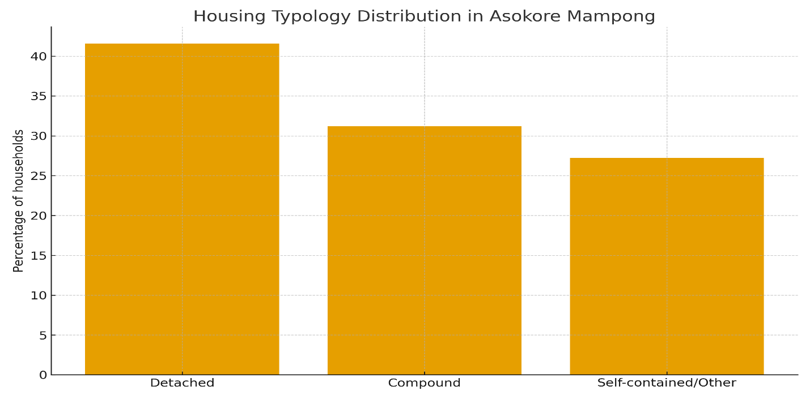
Fig. 3. Housing Typology Distribution in Asokore Mampong
Source: Field Data, 2025

Table 2. Cross-Tabulation of Income Group and Housing Type
Income Group | Detached | Compound | Storey | Apartment | Other | Total
High-income | 6 | 5 | 1 | 3 | 2 | 17
Middle-income | 15 | 7 | 0 | 1 | 5 | 28
Low-income | 11 | 12 | 4 | 2 | 3 | 32
Total | 32 | 24 | 5 | 6 | 10 | 77
Table 3. Chi-Square Test Results for Income Group × Housing Type
Statistic | Value
Chi-Square (χ²) | 10.84
Degrees of Freedom (df) | 8
p-Value | 0.210
Significance | Not significant (p > 0.05)
Source: Field Data, 2025
4.2 Socioeconomic Conditions and Affordability Prospects
Socioeconomic characteristics further shape affordability outcomes. Low-income households (41.6%) have the lowest employment rate (34.4%), lowest financial stability (12.5%), and lowest education attainment (45.5% with secondary education or above). In contrast, 88.2% of high-income households report financial stability, and 82.4% are employed, giving them far greater ability to access higher-quality rental housing.
These socioeconomic characteristics demonstrate a clear interaction between household conditions and housing affordability outcomes. Low-income households in Asokore Mampong are more likely to experience unstable employment, limited educational attainment, and weak financial resilience, which collectively constrain income-generating capacity. This reduces households’ ability to absorb rental costs and increases their exposure to high rent-to-income ratios and shelter poverty.
In contrast, households with higher and more stable incomes, stronger employment security, and higher education levels demonstrate greater capacity to manage rental obligations and access better-quality rental housing. The interaction between income, employment, and education therefore directly shapes affordability outcomes by determining households’ residual income after rent payments. Table 4 summarises employment patterns, financial stability, and education levels across income groups.
Table 4. Income Group Characteristics
Income Group | % of Residents | Employment Rate | Financially Stable | Education (Secondary+)
Low-income | 41.6% | 34.4% | 12.5% | 45.5%
Middle-income | 36.4% | 57.1% | 53.6% | 68.2%
High-income | 22.1% | 82.4% | 88.2% | 85.3%
Source: Field Data, 2025

4.3 Rent Burden, Advance Rent, and Widespread Shelter Poverty
The most critical affordability constraint is the rent-to-income burden. As shown in Table 5, only 9.1% of households fall within the acceptable affordability threshold of spending less than 30% of income on rent. A substantial 74% of tenants exceed this threshold, placing them in shelter poverty. High rent burdens are compounded by the requirement to pay one to two years of rent upfront, a practice that reduces household welfare and exacerbates financial stress.
These findings strongly support Shelter Poverty Theory, which emphasizes that affordability must be evaluated not only by rent levels but also by the welfare sacrifices households make to meet housing costs. Qualitative interview evidence revealed that tenants often reduce spending on food, health, and education to meet rent obligations, demonstrating the broader social consequences of shelter poverty.
Table 5. Rent-to-Income Burden Categories
Rent Category | % of Residents
Affordable (<30%) | 9.1%
Moderate burden | 16.9%
Shelter-poor (>30%) | 74.0%

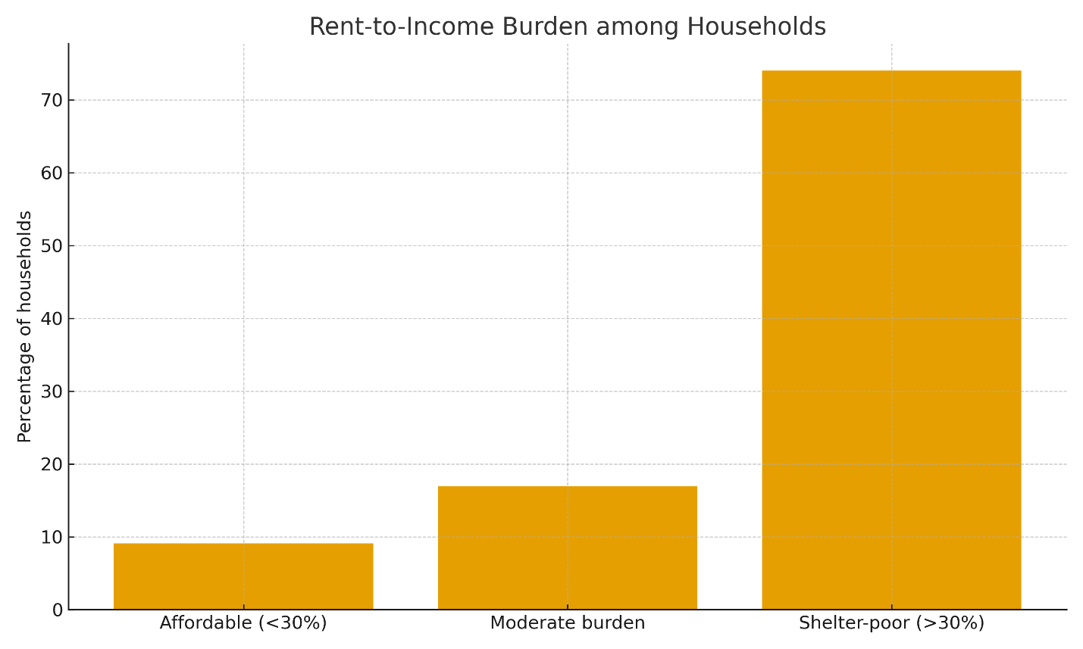
Fig. 4. Rent-to-Income Burden Among Households
Source: Field Data, 2025
4.4 Institutional Weaknesses and Awareness Gaps
Institutional factors significantly contribute to affordability challenges. Only 16.9% of respondents were aware of any government housing initiative, and RII scores for institutional performance, government responsiveness (58.77%), housing availability (48.80%), and policy awareness (44.89%) highlight substantial governance weaknesses. Interview narratives emphasised inadequate staffing and weak enforcement capacity at the Rent Control Department, enabling landlords to impose high rents and prolonged advance payments with minimal oversight.
These institutional gaps align with Institutional Theory, which posits that weak formal institutions and strong informal norms shape market behaviour more profoundly than policy frameworks alone. Low awareness of housing policies and ineffective regulation perpetuate conditions where affordability challenges persist unaddressed.
4.5 Ranked Affordability Challenges (RII Analysis)
The RII results, summarised in Table 6, underscore the severity of affordability challenges. Advance rent burdens (RII = 100) and high rent-to-income ratios (RII = 92.71) emerge as the most critical constraints. Other challenges, such as income mismatch (84.6), policy failures (69.2), and agent exploitation (61.5), further exacerbate affordability pressures. Qualitative interviews reinforce these findings, with tenants describing advance rent as “impossible to pay” and rent costs as “taking everything we earn.” These insights reveal the dual role of economic stress (Shelter Poverty) and institutional failure (Institutional Theory) in shaping tenants’ lived experiences.
Table 6. Key Affordability Challenges (RII and Qualitative Insights)
Challenge Area | RII | Interpretation | Interview Evidence
High rent-to-income ratio | 92.71 | Very High | “Rent takes everything we earn.”
Advance rent burden | 100 | Very High | “Two years’ rent upfront makes it impossible.”
Agent exploitation | 61.5 | High | “Agents add fees on top of rent.”
Policy failure | 69.2 | Very High | “Affordable housing is only for the rich.”
Income mismatch | 84.6 | Very High | “Our salaries can’t keep up.”

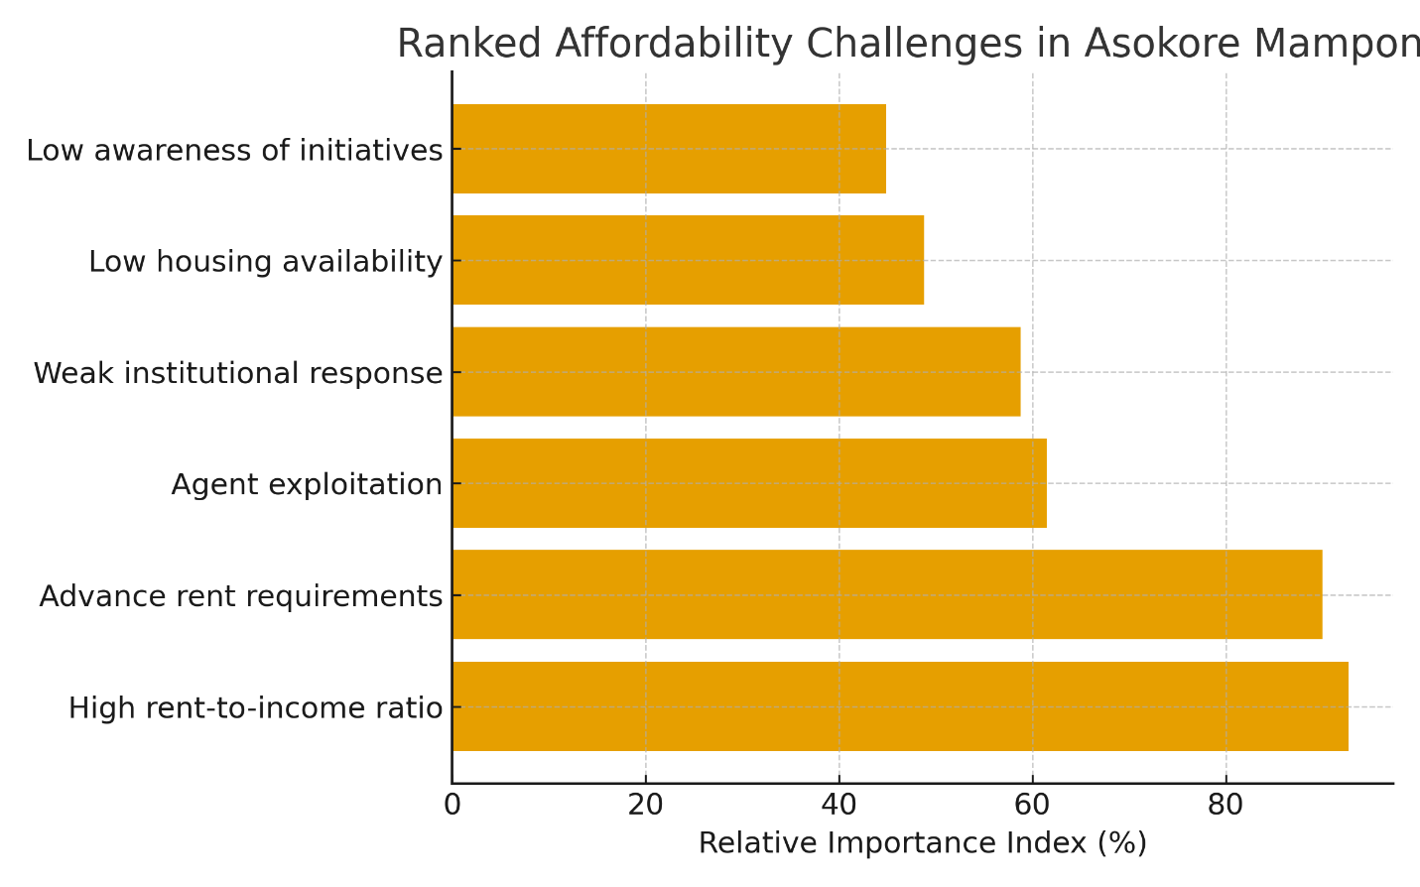
Fig. 5. Ranked Affordability Challenges (RII)
Source: Field Data, 2025
5. DISCUSSION
The findings demonstrate that rental housing affordability in Asokore Mampong is shaped by the interaction of economic pressures, institutional weaknesses, spatial disparities, and culturally embedded tenure arrangements. These results align with the core assumptions of Shelter Poverty Theory, which emphasises the significance of residual income for determining housing adequacy (Stone, 2006, 2010), and with Institutional Theory, which highlights the influence of formal and informal institutional arrangements on market behaviour (North, 1990).
The high prevalence of shelter poverty, where 74 percent of tenants spend more than 30 percent of their income on rent, strengthens Shelter Poverty Theory’s central proposition that affordability should be evaluated in relation to overall household welfare, not merely rent levels. Tenants’ accounts of cutting back on food, health, and education expenditures to secure rental housing illustrate the broader social consequences of excessive rent burdens. The widespread requirement of one to two years’ advance rent, reported across income groups, further compounds housing stress by limiting financial flexibility. These practices demonstrate how economic constraints intersect with weak regulatory enforcement to shape affordability outcomes.
Institutional dynamics play a critical role in sustaining these affordability challenges. The study shows low awareness of government housing initiatives (16.9%) and weak institutional responsiveness, as reflected in RII scores for policy awareness, housing availability, and government engagement. Qualitative accounts highlight limited capacity at the Rent Control Department, inadequate monitoring of landlord practices, and weak enforcement of rental regulations. These governance failures create conditions where landlords can set rents arbitrarily and impose burdensome advance payments without oversight. Such patterns are consistent with Institutional Theory, which argues that the effectiveness of formal rules depends on the capacity and incentives of institutions to enforce them.
Cultural and lineage-based tenure systems continue to shape access to housing and explain the descriptive mismatch between income levels and dwelling types. A significant share of high-income households occupy compound houses, while some low-income households reside in detached units due to inheritance and extended family arrangements. This pattern reflects long-standing practices documented in earlier Ghanaian studies (Gough & Yankson, 2000; Kasanga & Kotey, 2001), where access to rental units is mediated by social networks rather than market-based allocation. However, qualitative evidence and neighbourhood-level disparities suggest that the protective role of these systems is weakening under pressures of urbanisation and land commodification.
Spatial variation further reinforces affordability constraints and mirrors broader patterns of urban inequality in rapidly growing African cities (Cobbinah & Amoako, 2012; Damoah et al., 2020). Low-income tenants are concentrated in older neighbourhoods such as Sawaba and Aboabo, where deteriorating compound houses, aging infrastructure, and environmental stressors coincide with lower rents. Better-serviced neighbourhoods offer higher-quality dwellings but remain inaccessible to the majority of tenants due to high costs and stringent advance rent demands. This spatial segmentation limits upward mobility and perpetuates housing precarity for low-income households.
Taken together, the findings contribute to the housing affordability discourse by providing a municipal-level analysis that integrates socioeconomic conditions, affordability metrics, institutional performance, and qualitative lived experiences. The study highlights that improving rental housing affordability in Asokore Mampong requires more than increasing supply; it demands coordinated action to strengthen institutional capacity, regulate advance rent practices, upgrade deteriorating compound houses, and enhance public awareness of housing policies. These insights offer practical value for policymakers and urban planners seeking to address affordability challenges in similar rapidly urbanising contexts.
5.1 Study Limitations
This study is geographically limited to Asokore Mampong Municipality, which constrains the extent to which the findings can be generalised to other urban contexts in Ghana. While the municipality provides a relevant case for examining rental housing affordability under conditions of rapid urbanisation and institutional fragmentation, affordability dynamics may differ across cities with varying scales, housing market structures, and governance arrangements. In addition, the cross-sectional nature of the data captures affordability conditions at a single point in time and does not account for temporal changes in income, rental prices, or institutional performance. Future research could extend this work through multi-location or comparative designs and longitudinal approaches to better capture spatial and temporal variation in housing affordability and institutional effectiveness across urban Ghana.
6. REFLECTIONS, POLICY IMPLICATIONS, AND CONCLUSION
The study offers important insights into the structural and institutional factors that shape rental housing affordability in Asokore Mampong. By integrating quantitative evidence with tenants’ lived experiences, the analysis demonstrates that affordability challenges are deeply rooted in the municipality’s governance environment and the evolving nature of urban housing markets. These results highlight the need for a coordinated policy approach that recognises the interdependence between rental market behaviour, institutional capacity, and local socio-cultural contexts.
6.1 Policy Implications
Improving rental housing conditions will require strengthening the institutional environment governing the rental sector. A targeted expansion of the Rent Control Department’s operational capacity is essential to ensure timely enforcement of regulations and greater oversight of landlord–tenant relations. Enhanced institutional visibility at the community level can also help increase public confidence and encourage compliance with rental standards.
A second policy priority is the improvement of existing low-cost rental stock. Compound houses remain the backbone of affordable rental housing in Asokore Mampong, yet many of these dwellings require structural and environmental upgrades. Municipal authorities can work with private actors, traditional leaders, and community groups to upgrade sanitation systems, improve ventilation, and address building safety concerns without displacing low-income tenants.
Increasing access to information is also essential. Many tenants remain unaware of existing housing initiatives and their own rights under rental regulations. Public education campaigns, tenant-support desks, and community-based housing information centres can help close this awareness gap and strengthen tenant protections. Finally, long-term affordability will benefit from policies that encourage the development of new affordable rental units through incentives, partnerships, and flexible financing mechanisms.
6.2 Conclusion
This study provides new empirical evidence on urban rental housing dynamics in Ghana by offering a municipal-level assessment of affordability pressures in Asokore Mampong. The findings demonstrate that improving rental housing affordability requires moving beyond supply-focused approaches to address the governance and institutional conditions that shape tenants’ everyday experiences. Effective regulation, strategic investment in existing rental stock, and stronger alignment between customary and statutory actors will be critical to ensuring that rental housing becomes more secure, adequate, and accessible. By highlighting these interconnected challenges, the study offers a foundation for policy reform and future research aimed at strengthening urban rental systems in rapidly growing municipalities.
Disclaimer (Artificial intelligence)
Option 1:
The authors declare that they used Grammarly to check the grammar in this document.

REFERENCES
- Adjei-Poku, B., Afrane, S. K., Amoako, C., & Inkoom, D. K. B. (2023). Customary land ownership and land use change in Kumasi: An issue of chieftaincy sustenance?. Land Use Policy, 125, 106483. https://doi.org/10.1016/j.landusepol.2022.106483
- Arku, G. (2009). Housing policy changes in Ghana in the 1990s: Policy review. Housing Studies, 24(2), 261-272. https://doi.org/10.1080/02673030902719763
- Babbie, E. (2010). Research design. The practice of social research, 12, 90-123.
- Badu, E., Owusu-Manu, D. G., Edwards, D. J., Adesi, M., & Lichtenstein, S. (2013). Rural infrastructure development in the Volta region of Ghana: barriers and interventions. Journal of Financial Management of Property and Construction, 18(2), 142-159. https://doi.org/10.1108/JFMPC-11-2012-0040
- Braun, V., & Clarke, V. (2006). Using thematic analysis in psychology. Qualitative research in psychology, 3(2), 77-101. https://doi.org/10.1191/1478088706qp063oa
- Centre for Affordable Housing Finance in Africa. (2024). Housing finance in Africa: 2024 yearbook. Johannesburg, South Africa: Centre for Affordable Housing Finance in Africa. https://housingfinanceafrica.org/app/uploads/2024/10/CAHF-2024-Yearbook-web.pdf
- Cobbinah, P. B., & Amoako, C. (2012). Urban sprawl and the loss of peri-urban land in Kumasi, Ghana. International Journal of Social and Human Sciences. https://doi.org/10.5281/zenodo.1090862
- Cobbinah, P. B., Erdiaw-Kwasie, M. O., & Amoateng, P. (2015). Africa’s urbanisation: Implications for sustainable development. Cities, 47, 62-72. https://doi.org/10.1016/j.cities.2015.03.013
- Creswell, J. W. (2014). Research design: Qualitative, quantitative, and mixed methods approaches. Sage Publications. https://books.google.com/books/about/Research_Design.html?id=t_2oAgAAQBAJ
- Damoah, I. S., Ayakwah, A., Aryee, K. J., & Twum, P. (2020). The rise of PPPs in public sector affordable housing project delivery in Ghana: challenges and policy direction. International Journal of Construction Management, 20(6), 690-703. https://doi.org/10.1080/15623599.2020.1763897
- Ezennia, I. S., & Hoskara, S. O. (2022). Applications of housing affordability measurement approaches used in planning affordable housing: A systematic review. Journal of Building Construction and Planning Research, 10(1), 1-36. https://doi.org/10.4236/jbcpr.2022.101001
- Ghana Statistical Service. (2021). Ghana 2021 Population and Housing Census: Housing Characteristics (Volume 3K). Accra, Ghana: Ghana Statistical Service. https://statsghana.gov.gh/gssmain/fileUpload/pressrelease/Housing%20in%20Ghana.pdf
- Ghana Statistical Service. (2013). 2010 Population and Housing Census National Analytical Report. https://www.statsghana.gov.gh/gssmain/fileUpload/pressrelease/2010%20PHC%20National%20Analytical%20Report.pdf
- Gough, K. V., & Yankson, P. W. K. (2000). Land Markets in African Cities: The Case of Peri-urban Accra, Ghana. Urban Studies, 37(13), 2485-2500. https://doi.org/10.1080/00420980020080651
- Igwe, P. U., Okeke, C. A., Onwurah, K. O., Nwafor, D. C., & Umeh, C. N. (2017). A review of housing problems. International Journal of Environment, Agriculture and Biotechnology, 2(6), 3092–3099. https://doi.org/10.22161/ijeab/2.6.40
- Kasanga, R. K., & Kotey, N. A. (2001). Land management in Ghana: Building on tradition and modernity. International Institute for Environment and Development. https://www.iied.org/9002iied
- Khan, F. (2018). The case of housing policy in the 'New' South Africa (circa 1992–2003). In R. J. Lewis (Ed.), Public policymaking in a globalized world (pp. 266–306). Routledge. https://doi.org/10.4324/9780203712429-14
- Mrani, R., Radoine, H., Chenal, J., & Kamana, A. (2025). Trends, Methods, Drivers, and Impacts of Housing Informalities (HI): A Systematic Literature Review. Urban Science, 9(4), 101. https://doi.org/10.3390/urbansci9040101
- Ndubueze, O. J. (2009). Urban housing affordability and housing policy dilemmas in Nigeria (Doctoral dissertation, University of Birmingham) https://etheses.bham.ac.uk/id/eprint/400/1/Ndubueze09PhD.pdf
- North, D. C. (1990). Institutions, institutional change and economic performance. Cambridge University Press. https://www.cambridge.org/core/books/institutions-institutional-change-and-economic-performance/F2220222222222222222222222222222
- Organisation for Economic Co-operation and Development (OECD). (2021). Brick by brick: Building better housing policies. Paris: OECD Publishing. https://doi.org/10.1787/b453b043-en
- Patton, M. Q. (2002). Two decades of developments in qualitative inquiry: A personal, experiential perspective. Qualitative Social Work, 1(3), 261-283. https://doi.org/10.1177/147332500200100363
- Stone, M. E. (2010). Shelter poverty: New ideas on housing affordability. Temple University Press. https://muse.jhu.edu/book/1000
- Stone, M. E. (2006). What is housing affordability? The case for the residual income approach. Housing Policy Debate, 17(1), 151-184. https://doi.org/10.1080/10511482.2006.9521564
- U.S. Department of Housing and Urban Development, Office of Community Planning and Development. (2024). The 2024 Annual Homelessness Assessment Report (AHAR) to Congress: Part 1 – Point-in-Time Estimates of Homelessness. U.S. Department of Housing and Urban Development. https://www.huduser.gov/portal/sites/default/files/pdf/2024-AHAR-Part-1.pdf
- UN-Habitat. (2020). World cities report 2020: The value of sustainable urbanization. Nairobi, Kenya: UN-Habitat. https://unhabitat.org/world-cities-report-2020-the-value-of-sustainable-urbanization
- World Economic Forum. (2019). Making affordable housing a reality in cities. https://www3.weforum.org/docs/WEF_Making_Affordable_Housing_a_Reality_in_Cities.pdf
- Yeboah, I. E. (2005). Housing the urban poor in twenty-first century Sub-Saharan Africa: Policy mismatch and a way forward for Ghana. GeoJournal, 62(1), 147-161. https://doi.org/10.1007/s10708-005-8182-x

