Original Research Article

Foreign Direct Investment in India – A Time Series Analysis and Forecasting using ARIMA Model

ABSTRACT
Foreign Direct Investment (FDI) plays a vital role in the economic development of emerging economies like India. It has driven growth through inflow of capital, new and advanced technology, and management expertise to various sectors. This study is an attempt to investigate the volume, composition, and trends of Foreign Direct Investment inflows to India from 2000–01 to 2023–24. The study addresses the existing gap in predictive analysis by forecasting FDI inflows into the country, thereby providing insights for policy formulation given the economic and global conditions. By using comprehensive historical data obtained from the website of Reserve Bank of India study aims to model, interpret, and forecast FDI trends in the country. The Auto Regressive Integrated Moving Average (ARIMA) model is applied for forecasting FDI inflows. Consistent dominance of Government Automatic Acquisition Route in India’s FDI composition, followed by reinvested earnings is evident from the descriptive analysis. The results of Augmented Dickey-Fuller (ADF) tests confirm non-stationarity at level and stationarity after first differencing for all components. The ARIMA model-based forecasting demonstrates a stable and gradually increasing trend in total FDI inflows, reaching approximately USD 71.75 billion by 2028–29, primarily driven by steady contributions from the Government Automatic Acquisition Route and increasing reinvested earnings. The findings of the study provide valuable insights for policy formulation aimed at promoting investment and macroeconomic stability. The sustained dominance of the Government Automatic Route in FDI inflows highlights the effectiveness of liberalized investment policies. Policymakers should continue to simplify procedures, expand sectoral coverage under the automatic route, and ensure regulatory transparency to maintain investor confidence and attract long-term capital.
Keywords: Foreign Direct Investment, ARIMA, Forecasting, Time Series, India
JEL Classification: F21, C53, E22, O53
1.INTRODUCTION
Foreign Direct Investment is a key driver of economic development and modernisation, especially in developing and emerging economies. FDI facilitates the acquisition of technological expertise and fosters job creation and various ancillary benefits. It serves as a major source of non-debt financial resource for the economic development of a country (1). FDI augments capital formation along with improved competitiveness and greater productivity by way of technological spillovers and managerial knowhow (2,3). Maguid and Saiydy highlighted the transformative role played by FDI in small economies such as Djibouti, (4) while Meyer and Shera emphasized on its macroeconomic effects across developing economies (5).
Liberalisation policy adopted by India in 1991 marked a turning point, ushering in sustained FDI inflows backed by favourable policy measures and improved investment climate (6,7). As shown by Sahoo and others long-term capital formation in India has been largely facilitated by post-liberalization FDI targeting key infrastructure and manufacturing sectors (8). Studies found that FDI has significant and positive short run and long run impact on economic growth, particularly when it was reinforced by human capital and institutional frameworks (9,10). However, the FDI-growth relationship is not uniform across contexts. Mire Mohamed and Isak caution that there is possibility of FDI exhibiting limited developmental effects and exacerbating volatility in fragile or conflict-prone economies (11). Mijiyawa and Goh and others stated that for FDI yielding sustainable growth, an important role was played by institutional quality, market openness, and political stability (12,13).
FDI’s impact may vary across regions. Evidence of regional variability of FDI’s impact can be found from many empirical studies. Minota Seiko found that FDI has caused the convergence in Eastern African countries (14). In contrast, Amuedo-Dorantes and Pozo confirmed inflationary pressures and real exchange rate appreciation undermining competitiveness caused by capital inflows (15). Ridzuan and others argued that in East Asia and Singapore, policy coherence and institutional strength mediate the positive outcomes of FDI (10). Tsai.P.L conducted one of the early time-series analyses of FDI determinants, emphasizing the role of macroeconomic variables and policy environment in attracting foreign investment in Taiwan. The study grouped the determinants of FDI into demand-side and supply-side factors. The demand-side determinants include political stability, market size, regional economic integration, and investment incentives offered by the host country. The supply-side determinants consist of economies of scale, oligopoly reaction, product life cycle, and intangible assets (23).
In India, the nature and composition of FDI have evolved over time. Equity inflows via the automatic route, reinvested earnings, and inter-corporate borrowings have emerged as dominant components, reflecting deepening market integration (16). Vinit and Agrawal and Chakraborty and Nunnenkamp (17,18) used panel and time series models to validate causality between FDI and GDP growth. As per the reports of Foreign Investment Promotion Borad, India has reached a significant milestone in its economic development, with gross foreign direct investment inflows totalling an amount of Rs. 86,87,000 crores since April 2000. This achievement has been further strengthened by a nearly 13% increase in FDI, during the financial year 2024 – 25 amounting to Rs. 4,21,929 crores with significant investments in services and computer software and hardware sectors (21). Such growth underscores India's rising attractiveness as a global investment destination, fuelled by a proactive policy framework.
Despite a rich literature examining the effects of FDI, not much attention has been paid to forecasting the future trends in FDI with aid of time series tools based on real-world data. The available research words mostly concentrated on contemporaneous or lagged causal relationships using econometric frameworks (19,20). The present study is an attempt to address this research gap by utilising ARIMA model for ex-ante FDI forecasting so that policymakers can anticipate potential shifts and make informed strategic decisions. Tang et al. find that in China (1988–2003), FDI is growth-enhancing, complementary to domestic investment, FDI helps to alleviate capital shortages and stimulates growth by boosting domestic investment and directly contributing to output (22). Kumari et al. examined the long-term and causal relationship among foreign direct investment inflows, trade openness, and economic growth from India. Annual time series data from the period 1985–2018 are used and applied the Johansen cointegration and vector autoregression (VAR) model. Findings highlight that no long-term relationship among three variables of FDI, trade openness and economic growth.
Although FDI has been widely acknowledged as a crucial determinant of macroeconomic growth in India, existing studies remains largely confined to causal analysis, often overlooking the significance of predictive modelling. Given the dynamic nature of India’s evolving policy framework, volatile global capital movements, and sectoral shifts in the allocation of FDI, there is a persistent need to adopt time series forecasting approaches to estimate future trends. To bridge this gap the present study applies ARIMA modelling to Indian FDI inflow data, thereby offering policy-relevant foresight for effective investment planning.
2.DATA AND METHODOLOGY
The study uses annual FDI inflow data spanning from 2000–01 to 2023–24 compiled from the sources such as the Reserve Bank of India (RBI) and Foreign Investment Facilitation Portal - Department for Promotion of Industry and Internal Trade (DPIIT). FDI inflows are categorized into: (i) Government Automatic Acquisition Route; (ii) Reinvested Earnings; (iii) Equity Capital of Unincorporated Bodies and Other Capital; and (iv) Total FDI Inflow. R Studio Posit IDE 2024.12.0 + 467 is used for analysis of data
Table 1: Components of FDI Inflow (USD Million, 2000–01 to 2023–24)
Financial Year | Govt Auto  Acquisition  Route | Reinvested Earnings | Equity of Unincorporated Bodies and Other Capital | Total FDI Inflow
2000-01 | 2339 | 1350 | 340 | 4029
2001-02 | 3904 | 1645 | 581 | 6130
2002-03 | 2574 | 1833 | 628 | 5035
2003-04 | 2197 | 1460 | 665 | 4322
2004-05 | 3250 | 1904 | 897 | 6051
2005-06 | 5540 | 2760 | 661 | 8961
2006-07 | 15585 | 5828 | 1413 | 22826
2007-08 | 24573 | 7679 | 2591 | 34843
2008-09 | 31364 | 9030 | 1479 | 41873
2009-10 | 25606 | 8668 | 3471 | 37745
2010-11 | 21376 | 11939 | 1532 | 34847
2011-12 | 34833 | 8206 | 3517 | 46556
2012-13 | 21825 | 9880 | 2593 | 34298
2013-14 | 24299 | 8978 | 2769 | 36046
2014-15 | 30933 | 9988 | 4227 | 45148
2015-16 | 40001 | 10413 | 5145 | 55559
2016-17 | 43478 | 12343 | 4399 | 60220
2017-18 | 44857 | 12542 | 3575 | 60974
2018-19 | 44366 | 13672 | 3963 | 62001
2019-20 | 49977 | 14175 | 10239 | 74391
2020-21 | 59636 | 16935 | 5402 | 81973
2021-22 | 58773 | 19347 | 6715 | 84835
2022-23 | 46034 | 19105 | 6216 | 71355
2023-24 | 44423 | 19533 | 6998 | 70954
Source: RBI’s Bulletin for May, 2024 dt. 21.05.2024
The Auto Regressive Integrated Moving Average (ARIMA) model is used to analyze and forecast Total FDI Inflow. The ARIMA model is denoted as ARIMA $(p, d, q)$, where:
p represents the number of autoregressive terms,
d is the number of non-seasonal differences needed to make the series stationary,
q is the number of lagged forecast errors in the prediction equation.
The general ARIMA model is expressed as:
$$Y_{t}=c+∅_{1}Y_{t-1}+∅_{2}Y_{t-2}+ . . . +∅_{p}Y_{t-p}+θ_{1}ϵ_{t-1}+θ_{2}ϵ_{t-2}+ . . . + θ_{q}ϵ_{t-q}+ϵ_{t}$$
where:
$Y_{t}$is the differenced FDI inflow at time $t$,
$∅_{i}$are the autoregressive coefficients,
$θ_{j}$are the moving average coefficients,
$ϵ_{t}$is the white noise error term.
The steps followed include:
- Stationarity Check: Augmented Dickey-Fuller (ADF) test was used to check for unit root in the original series. Differencing was performed to make the series stationary.
- Model Identification: Autocorrelation Function (ACF) and Partial Autocorrelation Function (PACF) plots guided the selection of AR and MA terms.
- Model Estimation: The ARIMA model was estimated based on AR and MA terms suggestions of ACF and PACF.
- Model Validation: Residual diagnostics were performed to ensure that residuals were white noise.
- Forecasting: The model was used to forecast Total FDI Inflow and its components for the next five years.
3.EMPIRICAL RESULTS AND DISCUSSION
Table 2: Descriptive Statistics of FDI Inflows
Category | Mean | Standard Deviation | Minimum value | Maximum value
Govt Auto Acquisition Route | 28405.96 | 18211.38 | 2197 | 59636
Reinvested Earnings | 9550.54 | 5712.54 | 1350 | 19533
Equity of Unincorporated Bodies and Other Capital | 3334 | 2472.404 | 340 | 10239
Total FDI Inflow | 41290.5 | 25785.72 | 4029 | 84835
Source: Estimated from RBI’s Bulletin for May, 2024 dt. 21.05.2024
The analysis reveals a significant upward trend in FDI inflows over the study period, reflecting India’s growing attractiveness as an investment destination. The average annual total inflow was approximately USD 41.29 billion, with the highest inflow of more than USD 84 billion recorded in 2021–22. Government auto acquisition route and reinvested earnings have become increasingly dominant over time. Line plots for each FDI component (Figure 1) shows consistent growth in all segments, with a notable rise in reinvested earnings post-2014. This trend is an indication of the fact that foreign companies are increasingly reinvesting profits within India, reflecting investor confidence.
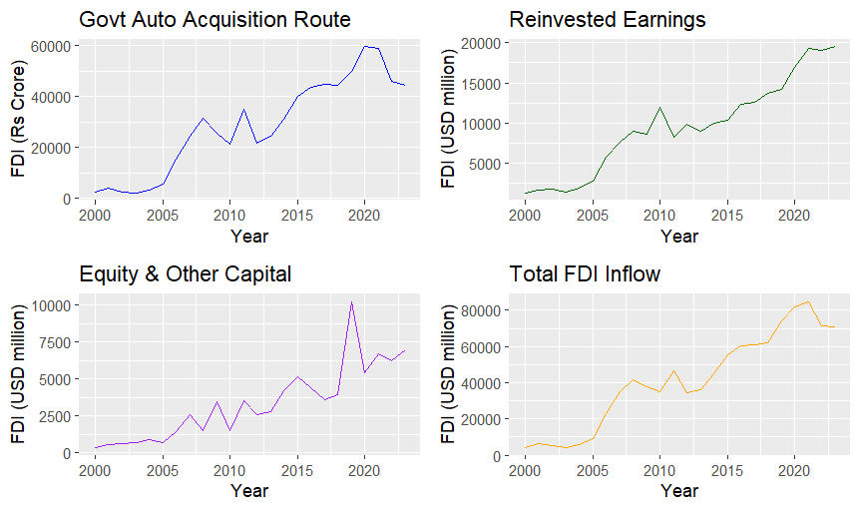
Figure 1: Timeseries Plots of Disaggregated FDI Inflows (2000-01 to 2023-24)
Source: Estimated from RBI’s Bulletin for May, 2024 dt. 21.05.2024
To assess the adequacy of the fitted ARIMA models, the Autocorrelation Function (ACF) plots of residuals were examined for all four FDI inflow components. The ACF plots are presented in Figure 2.
In each subplot, the autocorrelations of residuals across lags up to 12 are displayed, along with 95% confidence bounds (dashed blue lines). For a well-specified ARIMA model, the residuals should resemble white noise, meaning the autocorrelations should be statistically insignificant and fall within the confidence bounds. The ACF plot for Govt Auto Acquisition Route shows all autocorrelations falling within the confidence bounds. This confirms that the residuals are uncorrelated, supporting the validity of the ARIMA (2,1,0) model. The absence of significant autocorrelation suggests that the model has adequately captured the time-dependent structure in the data.
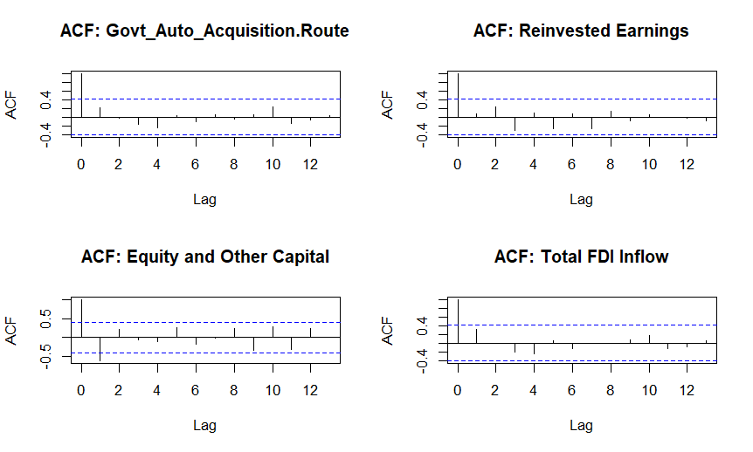
Figure 2: ACF Plots of Residuals from ARIMA Models for FDI Inflow Components
Source: Estimated from RBI’s Bulletin for May, 2024 dt. 21.05.2024

The residuals of the ARIMA (2,1,0) model for Reinvested Earnings also exhibit no statistically significant autocorrelation. The ACF plot is flat and well-contained within the bounds, further affirming that the model’s assumptions are satisfied and the error terms behave as white noise. While the ARIMA (1,1,1) model for Equity of Unincorporated Bodies and Other Capital passed the Ljung-Box test, the ACF plot indicates a slightly more volatile structure in the residuals. Nonetheless, no autocorrelations exceed the confidence bounds, and the residuals are largely uncorrelated. This supports the model’s statistical adequacy, although its relatively high forecast error suggests a less optimal fit.
The ACF plot of residuals for the ARIMA (3,1,0) model for Total FDI Inflow shows a pattern consistent with white noise, with all lags well within the 95% limits. This indicates that the model has effectively filtered out temporal dependencies, reinforcing its suitability for forecasting purposes. Thus, the ACF plots collectively demonstrate that all four ARIMA models produce residuals that are free from significant autocorrelation, meeting a key requirement for model validity. These results are consistent with the Ljung-Box test outcomes and confirm that the selected models are well-specified for their respective FDI components.
The Partial Autocorrelation Function (PACF) plots for the four log-differenced FDI inflow components are presented in Figure 3. These plots were used to identify appropriate autoregressive (AR) orders for the ARIMA models.
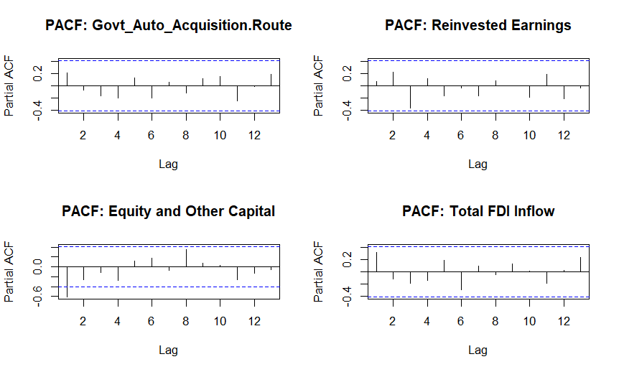
Figure 3: PACF Plots for Log-Differenced FDI Inflow Components
Source: Estimated from RBI’s Bulletin for May, 2024 dt. 21.05.2024
The PACF plot for each series displays the partial autocorrelations across lags, with 95% confidence bounds (dashed blue lines). Spikes that fall outside these bounds suggest the presence of significant autoregressive structure at the corresponding lag. The PACF plot in the case of Govt Auto Acquisition Route indicates a noticeable spike at lag 1, with smaller but present spikes at higher lags. This pattern justifies the inclusion of at least one AR term, and aligns with the choice of an ARIMA (2,1,0) model, as both lag 1 and lag 2 appear relevant. For Reinvested Earnings, significant spikes are observed at lag 2 and possibly lag 4, indicating a short-memory AR process. The PACF supports the selected ARIMA (2,1,0) specification, suggesting that past values up to the second lag contribute meaningfully to the current observation.
The PACF of Equity of Unincorporated Bodies and Other Capital exhibits a strong negative spike at lag 1, with residual autocorrelations diminishing at higher lags. This pattern supports the use of a low-order AR term, consistent with the ARIMA (1,1,1) model chosen for this component. The PACF plot for Total FDI Inflow displays moderate spikes at lags 1 and 4, with trailing values near the boundary of statistical significance. This structure justifies the use of multiple AR terms, supporting the final ARIMA (3,1,0) model.
To assess the temporal dynamics and forecasting potential of the four disaggregated FDI inflow components, ARIMA models were estimated and evaluated based on standard goodness-of-fit and residual diagnostics. The comparative performance of each model is summarized in Table 3.
Table 3: ARIMA Models for Disaggregated FDI Inflow Components
Variable | ARIMA(p,d,q) | AIC | σ² (Residual Var) | MAPE (%) | Ljung-Box p-value
Govt/Auto/Acquisition Route | (2,1,0) | 22.32 | 0.1185 | 2.62 | 0.55
Reinvested Earnings | (2,1,0) | 1.56 | 0.0476 | 1.77 | 0.745
Equity of Unincorporated Bodies and Other Capital | (1,1,1) | 31.69 | 0.1765 | 3.95 | 0.298
Total FDI Inflow | (3,1,0) | 11.83 | 0.0685 | 1.77 | 0.431
Source: Estimated from RBI’s Bulletin for May, 2024 dt. 21.05.2024
All selected models exhibited residuals that were statistically indistinguishable from white noise, as confirmed by non-significant Ljung-Box test p-values (all > 0.05). This indicates that the respective models effectively captured the autocorrelation structures in the series. The ARIMA (2,1,0) model for Govt Auto Acquisition Route produced a moderate fit, with an AIC of 22.32 and a MAPE of 2.62%. Although the model's residual variance (σ² = 0.1185) was higher than that of other series, the absence of residual autocorrelation (Ljung-Box p = 0.550) suggests statistical adequacy. The relatively low forecast error implies that the model is suitable for short-term forecasting purposes, though there may be scope for improvement through alternate specifications or inclusion of exogenous factors.
Reinvested Earnings exhibited the best overall model performance, with an AIC of just 1.56, the lowest residual variance (σ² = 0.0476), and a MAPE of only 1.77%. The model's residuals passed the Ljung-Box test with a p-value of 0.745, confirming the effectiveness of the ARIMA (2,1,0) specification in capturing the underlying dynamics. These diagnostics suggest that reinvested earnings follow a relatively stable and predictable pattern, and this component can be forecasted with high confidence using the chosen model.
The ARIMA (1,1,1) model fitted to Equity of Unincorporated Bodies and Other Capital resulted in the highest AIC (31.69) and highest forecast error (MAPE = 3.95%) among all models. While the model passed the residual autocorrelation test (p = 0.298), the relatively large residual variance (σ² = 0.1765) indicates a weaker statistical fit. These results suggest that the model only partially captures the dynamics of this component and could benefit from re-specification—possibly through higher-order ARIMA or seasonal models. The ARIMA (3,1,0) model for Total FDI Inflow provided a strong and reliable fit, as evidenced by a low AIC (11.83), small residual variance (σ² = 0.0685), and a MAPE of 1.77%. The Ljung-Box p-value of 0.431 further confirms residual independence. This model is particularly well-suited for projecting aggregate FDI inflows and can serve as a dependable basis for policy simulations or economic forecasting scenarios.
Across the four models, Reinvested Earnings and Total FDI Inflow demonstrated superior forecast accuracy and model parsimony. These series can be modelled effectively using relatively simple ARIMA structures, while Equity of Unincorporated Bodies and Other Capital displayed more volatility and less predictability. The Govt Auto Acquisition Route model yielded statistically acceptable results but may be enhanced with further tuning or the incorporation of structural breaks. Collectively, these findings highlight the importance of disaggregated modelling in understanding FDI behaviour, as each component exhibits distinct temporal characteristics and forecastability.
Forecasting Trends in Disaggregated FDI Inflows (2024–2028)
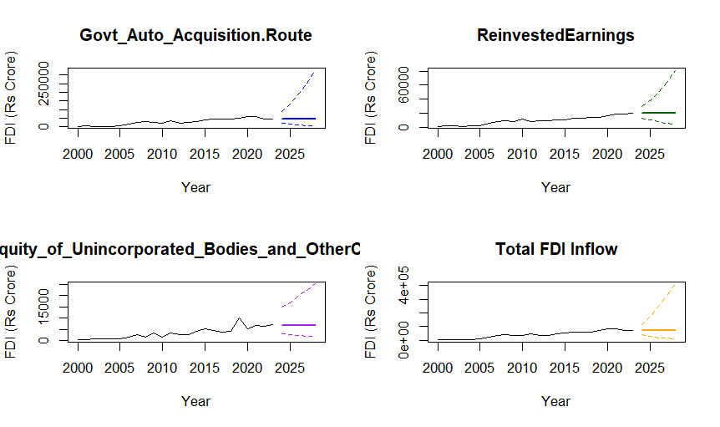
Figure 4: Forecasted FDI Inflow Components for 2024–2028 Using ARIMA Models
Source: Estimated from RBI’s Bulletin for May, 2024 dt. 21.05.2024
Figure 4 presents the forecasted trends for four disaggregated components of Foreign Direct Investment (FDI) inflows— Govt Auto Acquisition Route, Reinvested Earnings, Equity of Unincorporated Bodies and Other Capital, and Total FDI Inflow—based on ARIMA models estimated over the historical period 2000 to 2023.
The plots display the observed data (solid black line), forecasted mean values (coloured solid line), and the 95% confidence intervals (coloured dashed lines) for the five-year horizon from 2024 to 2028. The forecasts are back-transformed from the log scale to reflect actual FDI values in USD (USD million).The forecast for Govt Auto Acquisition Route shows a modest upward trend with a wide confidence interval, indicating greater uncertainty in projections. This aligns with the moderate fit of the underlying ARIMA (2,1,0) model, as previously noted. Policy shifts or regulatory changes could significantly influence this trajectory.
Reinvested earnings are projected to continue their upward momentum with relatively narrow confidence bounds, reflecting the high precision of the model. The forecast supports the interpretation that reinvestment by existing foreign firms remains a stable and growing component of FDI. Forecasts for Equity of Unincorporated Bodies and Other Capital display more volatility and wider uncertainty bounds, consistent with the higher residual variance observed in the ARIMA (1,1,1) model. This suggests caution in relying heavily on this source for future capital formation estimates.
The forecast for Total FDI inflows reflects a clear upward trend with moderate uncertainty, supporting the view that India’s FDI climate is likely to improve steadily, conditional on macroeconomic stability and policy continuity. The robust performance of the ARIMA (3,1,0) model provides added confidence in these projections.
4.SUMMARY AND CONCLUSIONS
This study undertook a detailed time series analysis of disaggregated Foreign Direct Investment (FDI) inflows into India—specifically, Govt Auto Acquisition Route, Reinvested Earnings, Equity of Unincorporated Bodies and Other Capital, and Total FDI Inflow—using ARIMA models to forecast their future behaviour. All time series were log-transformed to stabilize variance and differenced to achieve stationarity. After conducting comprehensive ACF and PACF analyses, appropriate ARIMA models were identified and fitted using Maximum Likelihood Estimation (MLE). Diagnostic checks confirmed that residuals from the fitted models were white noise, validating the adequacy of the selected ARIMA structures. Among the components analysed, Reinvested Earnings and Total FDI Inflow yielded the best model fit in terms of AIC and MAPE, indicating highly predictable and stable flows. Govt Auto Acquisition Route presented a moderate fit, while Equity of Unincorporated Bodies and Other Capital showed greater volatility and higher forecast error, suggesting less predictability. The forecasted trends for 2024–2028 reveal; A steady rise in Total FDI Inflow, supported by strong fundamentals, continued growth in Reinvested Earnings, reflecting investor confidence and business retention, modest increases in Govt Auto Acquisition Route inflows with some uncertainty, a volatile trajectory for Equity of Unincorporated Bodies and Other Capital, necessitating close monitoring.
The findings of this study hold significant policy and practical relevance in the context of India's foreign investment landscape. The disaggregated ARIMA-based forecasting of FDI inflows highlights varying patterns of stability, predictability, and volatility across components such as Reinvested Earnings, Govt/Auto/Acquisition Route, Equity of Unincorporated Bodies and Other Capital, and Total FDI Inflow. The strong predictability of reinvested earnings suggests that policies should focus on retaining and expanding existing foreign investments through improved ease of doing business and reinvestment incentives. Meanwhile, the moderate and less stable flows through approval-based routes and equity components underscore the need for streamlined regulatory processes, transparent policy frameworks, and improved investor sentiment to reduce volatility. In real-world terms, these forecasts can serve as valuable inputs for national budgeting, foreign exchange planning, and investment promotion strategies, giving policymakers a proactive tool to align macroeconomic priorities with capital flow expectations. The study concludes that disaggregated time series modelling of FDI using ARIMA not only enhances forecasting precision but also presents valuable guidance to reinforce and accelerate foreign investment growth in India.

DECLARATION OF GENERATIVE AI AND AI-ASSISTED TECHNOLOGIES
During the preparation of this work, the authors used generative AI tools for language refinement and to assist in drafting parts of the manuscript. The final content was reviewed and approved by the authors, who take full responsibility for the integrity and originality of the work.

REFERENCES
- Government of India. (2020). Consolidated FDI Policy (Effective from October 15, 2020). Department for Promotion of Industry and Internal Trade, Ministry of Commerce and Industry. https://www.mofpi.gov.in/sites/default/files/fdi-policycircular-2020-28october2020.pdf
- Alfaro, L. (2003). Foreign direct investment and growth: Does the sector matter. Harvard Business School. https://www.researchgate.net/publication/23720000_Foreign_Direct_Investment_and_Growth_Does_the_Sector_Matter
- Blomström, M., & Kokko, A. (1998). Multinational Corporations and Spillovers. Journal of Economic Surveys, 12(3), 247–277. https://doi.org/10.1111/1467-6419.00056
- Maguid Hayel, N., & Es. Saiydy, B. (2021). The Impact of Foreign Direct Investment (FDI) on Economic Growth (EG): Evidence from Djibouti. International Research in Education https://doi.org/10.5296/ire.v9i2.19134
- Meyer, D., & Shera, A. (2017). The impact of remittances on economic growth: An econometric model. EconomiA, 18(2), 147–155. https://doi.org/10.1016/j.econ.2016.06.001
- Banga, R. (2003). Impact of government policies and investment agreements on FDI inflows. Indian Council for Research on International Economic Relations (ICRIER). https://hdl.handle.net/10419/189636
- Kumar, N. (2005). Liberalisation, Foreign Direct Investment Flows and Development: Indian Experience in the 1990s. Economic and Political Weekly, 40, 1459–1469. https://doi.org/10.2307/4416435
- Sahoo, D., Nayak, S., & Behera, J. (2021). Digitalization and economic performance of two fast-growing Asian economies: India and the People’s Republic of China. ADBI Working Paper No. 1243. https://doi.org/10.22617/ADBIWP1243
- Dinh, T., Vo, D., Vo, A., & Cong Nguyen, T. (2019). Foreign Direct Investment and Economic Growth in the Short Run and Long Run: Empirical Evidence from Developing Countries. Journal of Risk and Financial Management, 12(4), 176. https://doi.org/10.3390/jrfm12040176
- Ridzuan, A. R., Khalid, M. W., Zarin, N. I., Ridzuan, A. R., Ismail, I., & Norizan, N. (2018). The Impact of Foreign Direct Investment, Domestic Investment, Trade Openness and Population on Economic Growth: Evidence from Asean-5 Countries. International Journal of Academic Research in Business and Social Sciences, 8, 128–143. https://doi.org/10.6007/IJARBSS/v8-i1/3799
- Mohamed, M. M., & Isak, N. (2017). The Impact of Foreign Direct Investment on Economic Growth in Somalia. International Journal of Economics and Management Studies. https://doi.org/10.14445/23939125/IJEMS-V4I8P105
- Mijiyawa, A. G. (2015). What Drives Foreign Direct Investment in Africa? An Empirical Investigation with Panel Data. African Development Review. https://doi.org/10.1111/1467-8268.12155
- Goh, S. K., Sam, C. Y., & McNown, R. (2017). Re-examining foreign direct investment, exports, and economic growth in Asian economies using a bootstrap ARDL test for cointegration. Journal of Asian Economics, 51, 12–22. https://doi.org/10.1016/j.asieco.2017.06.001
- Seiko Minota Zekarias. (2016). The Impact of Foreign Direct Investment (FDI) on Economic Growth in Eastern Africa: Evidence from Panel Data Analysis. Applied Economics and Finance. https://doi.org/10.11114/aef.v3i1.1317
- Amuedo-Dorantes, C., & Pozo, S. (2004). Workers' Remittances and the Real Exchange Rate: A Paradox of Gifts. World Development, 32(8), 1407–1417. https://doi.org/10.1016/j.worlddev.2004.02.004
- Liu, H., Chen, X., & Wu, Y. (2018). Political Environment and Chinese OFDI Under RMB Appreciation: A Panel Data Analysis. Emerging Markets Finance and Trade. https://doi.org/10.1080/1540496X.2018.1504208
- Vinit, R., and Agrawal, G. (2011). FDI Inflow Determinants in BRIC countries:A Panel Data Analysis. International Business Research, 4, 255–255. https://doi.org/10.5539/ibr.v4n4p255
- Chakraborty, C., & Nunnenkamp, P. (2008). Economic Reforms, FDI, and Economic Growth in India: A Sector Level Analysis. World Development, 36(7), 1192–1212. https://doi.org/10.1016/j.worlddev.2007.06.014
- Jiang, J., & Kim, D. (2013). Exchange rate pass-through to inflation in China. Economic Modelling, 33(C), 900–912. https://doi.org/10.1016/j.econmod.2013.05.021
- Jin, B., García, F., & Salomon, R. (2019). Inward foreign direct investment and local firm innovation: The moderating role of technological capabilities. Journal of International Business Studies, 50(5), 847–855. https://doi.org/10.1057/s41267-018-0177-1
- IBEF. (2025). Foreign Direct Investment (FDI) - Overview, Benefits & Disadvantages. India Brand Equity Foundation. https://www.ibef.org/economy/foreign-direct-investment
- Tang, S., Selvanathan, E. A., & Selvanathan, S. (2008). Foreign direct investment, domestic investment and economic growth in China: A time series analysis. World Economy, 31(10), 1292-1309.
https://onlinelibrary.wiley.com/doi/abs/10.1111/j.1467-9701.2008.01129.x
- Tsai, P. L. (1991). Determinants of foreign direct investment in Taiwan: an alternative approach with time-series data. World Development, 19(2-3), 275-285. https://www.sciencedirect.com/science/article/pii/0305750X9190261F
- Kumari, R., Shabbir, M. S., Saleem, S., Yahya Khan, G., Abbasi, B. A., & Lopez, L. B. (2023). An empirical analysis among foreign direct investment, trade openness and economic growth: Evidence from the Indian economy. South Asian Journal of Business Studies, 12(1), 127–149. https://doi.org/10.1108/SAJBS-06-2020-0199

